Establishment of an integrated salinity intrusion data sharing system for adaptation to the climate change in the Mekong Delta of Viet Nam
Deliverable 2.1. Report with findings from preliminary stock-take of salinity monitoring in Mekong Delta of Viet Nam

07 July 2026
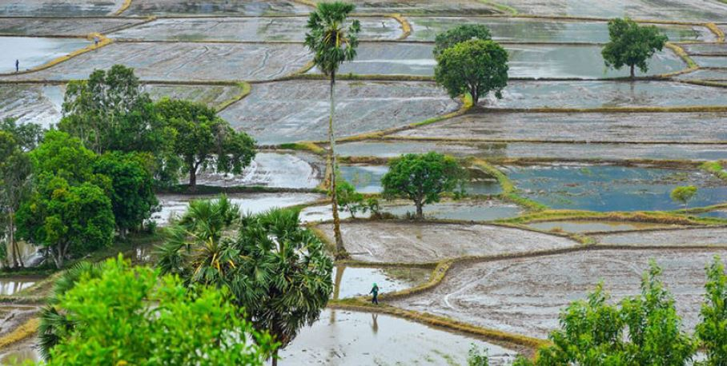
Prepared for CTCN and VNMC

Establishment of an integrated salinity intrusion data sharing system for adaptation to the climate change in the Mekong Delta of Viet Nam

Deliverable 2.1. Report with findings from preliminary stock-take of salinity monitoring in Mekong Delta of Viet Nam

CTCN Ref. RFP 3100006172
Prepared for: CTCN and VNMC
Disclaimer
This report has been prepared by DHI staff exclusively for CTCN and VNMC, based on information provided by stakeholders and published reports believed to be reliable at the time of this document’s preparation. DHI makes no warranties regarding the accuracy or completeness of the information and accepts no liability for any loss or damage arising from reliance on this report. We have not independently verified the data or otherwise examined it to determine its accuracy, completeness, sufficiency for any purpose, or feasibility for any particular outcome, including financial ones. Recommendations and conclusions drawn in this report represent professional judgment only, with no guarantee of outcomes. We accept no responsibility for any error or omission in the report that is due to an error or omission in data, information, or statements supplied to us by other parties, including the Client. Information and opinions are current only as of the date of this report, and we accept no responsibility for updating such information or opinions. It should, therefore, not be assumed that any such information or opinion continues to be accurate after the date of the report.
This report has been prepared solely for use by the party that commissioned it in connection with the captioned project. It is intended solely for the stated purpose and should not be relied upon by third parties. For the avoidance of doubt, this report does not in any way purport to include legal, insurance, or financial advice or opinion. Basin management, infrastructure operation, and business decisions remain the Client's sole responsibility.

Approved by



Contents
Abbreviations 5
1 Executive summary 6
2 Assessment approach 7
2.1 Salinity monitoring stock-taking assessment approach 7
2.2 Focus areas for the assessment 7
2.3 Key information sources 8
2.4 National institutions consulted (including bilateral interviews) 8
3 Salinity intrusion in Viet Nam Mekong Delta - overview 9
3.1 The socio-economic setting of VMD 9
3.2 Main driving forces behind salinity intrusion 9
3.3 Impacts on agricultural production 11
3.4 Impacts on rural domestic water supply 11
3.5 Gender-specific impacts of SWI in the VMD 12
4 Institutional setup for salinity monitoring 14
4.1 The Vietnam National Mekong Committee (VNMC) 18
4.2 Ministry of Agriculture and Environment (MAE) 18
4.3 Vietnam Meteorological and Hydrological Administration (VNMHA) 19
4.4 The Southern Regional Hydrometeorological Center (SRHMC) 19
4.5 The National Centre for Water Resources Planning and Investigation (NAWAPI) 20
4.6 Mekong Delta Regional Data Center (MDRDC) 20
4.7 Provincial Departments of Agriculture & Environment 21
4.8 Southern Institute of Water Resources Planning (SIWRP) 22
4.9 Southern Institute of Water Resources Research (SIWRR) 22
4.10 Mekong River Commission (MRC) 23
4.11 Local Disaster Prevention and Control Steering Committees 24
4.12 Other ministries 25
5 Salinity monitoring infrastruture 26
5.1 Physical salinity monitoring network in the Delta 26
5.2 Salinity monitoring by the SHRMC 26
5.3 Salinity monitoring by Southern Regional Hydrometeorological Center (SRHMC) 28
5.4 Salinity monitoring by Southern Institute for Water Resources Research 28
5.5 Salinity monitoring activities and responsibilities of VNMC 31
6 Existing salinity data sharing protocols 33
6.1 General overview of salinity data sharing protocols in VMD 33
6.1.1 Data sharing arrangements with Hydromet service 33
6.1.2 Salinity data sharing between VNMC and other institutions 34
7 Key challenges in salinity data collection and sharing in VMD 35
7.1 Summary of challenges 35
7.2 Regional and national initiatives addressing challenges 35
8 Studies and projects on salinity monitoring and forecasting in VMD 38
8.1 Previous studies on salinity in the Delta 38
8.2 Ongoing or planned salinity projects 40
9 Conclusion and recommendations regarding salinity data sharing platform 41

Figures
Figure 2-1 TA implementation approach overview 7
Figure 3-1 Maximum salinity in Mekong delta from 27-31 May 2024 (Source: SHRMC) 20
Figure 3-2 Location of salinity monitoring stations in 2024 (Source: SIWRR) 23

Tables
Table ‎4-1 List of key organizations engaged in salinity monitoring and their roles and responsibilities 14
Table ‎4-2 Key institutions utilizing salinity data for analysis and decision-support 16
Table ‎5-1 Frequency, format and distribution channels 26
Table ‎5-2 Salinity monitoring stations by the Hydromet service 26
Table ‎5-3 List of salinity monitoring station under SIWRR 29

Appendices
No table of contents entries found.

Abbreviations
CDH Central data hub
CTCN Climate Technology Centre and Network
DAE Departments of Agriculture and Environment
DRR Disaster risk reduction
DSP Data Sharing Platform
DSS Decision Support System
GIS Geographic Information System
ICRSL Integrated Climate Resilience and Sustainable Livelihoods in the Mekong Delta
IMS Integrated Salinity Monitoring System
LDPCSCs Local Disaster Prevention and Control Steering Committees
LMB Lower Mekong Basin
MAE Ministry of Agriculture and Environment
MD Mekong Delta
MDIRP Mekong Delta Integrated Regional Plan
MDRDC Mekong Delta Regional Data Center
MONRE The Ministry of Natural Resources and Environment (NB: merged into MAE in 2025)
MOST Ministry of Science and Technology
MRB-IF Mekong River Basin Indicator Framework
MRC DSF MRC Decision Support Framework
MRC Mekong River Commission
MSIT Ministry of Science and ICT
NAWAPI National Center for Water Resources Planning and Investigation
PI Ministry of Planning and Investment
ROK Republic of Korea
SI Saline intrusion
SIWRP Southern Institute for Water Resource Planning
SIWRR Southern Institute of Water Resources Research
SOBR State of the Basin Reports
SRHMC Southern Regional Hydrometeorological Center
SWAT Soil and Water Assessment Tool
SWI Salt-water intrusion
TA Technical Assistance
UNOSSC The United Nations Office for South-South Cooperation
VMD Vietnam Mekong Delta
VNMC Vietnam National Mekong Committee
VNMHA Vietnam Meteorological and Hydrological Administration
WQMN Water Quality Monitoring Network

Executive summary
This report pertains project that is the result of a request received by CTCN (Climate Technology Centre and Network) from Viet Nam to provide technical assistance on “Establishment of an integrated salinity intrusion data sharing system for adaptation to the climate change impacts in the Mekong Delta of Viet Nam”.
The proponent of this technical assistance (TA) request is the Viet Nam National Mekong Committee (VNMC)/Cuu Long River Basin Commission, and the respective CTCN project reference number is RFP 3100006172.
Project kick-off meeting was held with the client (CTCN) and project proponent (VNMC) on 3rd of March 2025 to officially start the work on project.
This report pertains project Deliverable 2.1: Report with findings from preliminary stock-take of salinity monitoring in VMD (including a chapter on gender aspects) for delivery on project by DHI.
The Deliverable 2.1 contributes to achievement of the technical assistance Output 2: Stakeholder engagement and assessment of available data and existing salinity monitoring & forecasting systems in VMD.

This report presents the key results from TA activity 2.1 that undertook preparatory analysis on current infrastructure and processes regarding monitoring of salinity intrusion in VMD.
Key actions undertaken by DHI team under this activity includ following:
• Review of existing documents, protocols and agreements pertaining to salinity monitoring in the Viet Nam Mekong Delta (VMD).
• Bilateral meetings with key stakeholders of the project, including the VNMC, NDE and MAE, in order to verify the full picture of current processes/protocols for the generation, provision, management and sharing arrangements of salinity forecasting & monitoring data as well as current prevailing technologies and risks associated with saline intrusion.
• Engagement of a national gender expert review of any aspects relating to the gender sensitivities – e.g. in how impacts of salinity intrusion are distributed among different water users, the technical capacities of the staff managing salinity data, the ability to receive and interpret salinity monitoring results and other.

Assessment approach
This section outlines the overall approach taken to undertake the salinity monitoring stock take assessment, describing key focus areas, stakeholders, information sources and findings.

Salinity monitoring stock-taking assessment approach
This initial stock-taking assessment activity was driven by the need to create a full picture of the current situation on salinity monitoring data and systems in Viet Nam Mekong Delta as well as the wish to establish stakeholder needs and current gaps.
The outcomes of this stock-taking assessment will inform the technical solution design specifications for the salinity data sharing platform (DSP) as well as the capacity development programme associated with it.
During this phase of the Technical Assistance (TA) implementation (see Figure 2-1) the DHI team focused on three aspects of the assessment:
- Collecting data on existing salinity monitoring systems, including physical and data infrastructure, key stakeholders, and existing data collection and sharing protocols.
- Preliminary stakeholder consultations with selected key stakeholders. These will be further supplemented with the interactions with the project Stakeholder Working Group.
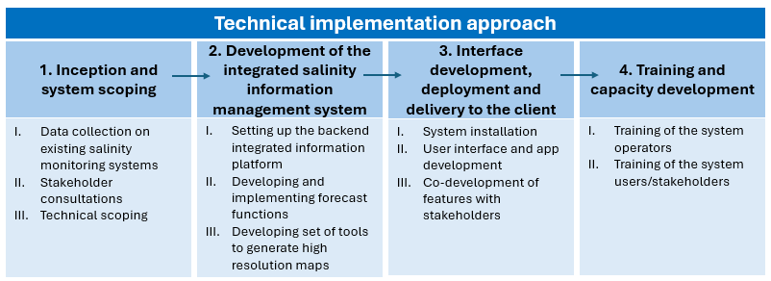
- Initial technical scoping to synthesize findings that will inform the design of the salinity monitoring platform.
Figure 2-1 TA implementation approach overview

Focus areas for the assessment
As part of the preparatory analysis on current infrastructure and processes regarding monitoring of salinity intrusion in VMD, the technical team focused on following aspects:
- Existing salinity data collection infrastructure
- Salinity data depositories and databases and the respective institutions managing these
- Exist processes/protocols for the generation, provision, management and sharing arrangements of salinity forecasting & monitoring data and the institutions involved therein
- Aspects relating to the gender sensitivities – e.g. how impacts of salinity intrusion are distributed among different water users, the technical capacities of the staff managing salinity data, the ability to receive and interpret, and act on salinity monitoring results.

The stakeholder mapping undertaken under this activity also lays foundation to the identification of which stakeholders will need to be involved at different levels/stages during and after implementation of this CTCN TA project. The national gender expert will advise on appropriate representation of vulnerable groups and gender-balanced representation in the stakeholder working group and further project activities involving national and regional stakeholders.

Key information sources
Key data and information sources informing the results of this stock-taking assessment are summarized below.
- Consultations and meetings with the VNMC and project background documentation submitted as part of the TA and Response Plan
- Project on Prevention and Control of Land Subsidence, Landslides, Flooding, Drought, and Saltwater Intrusion in the Mekong Delta Region to 2035, with Vision to 2050, from Southern Institute for Water Resources Planning (SIWRP) (2025)
- Hydrometeorological report, Project on Irrigation Planning for the Mekong River Basin for the Period 2022–2030, with Vision to 2050 from Southern Institute of Water Resources Planning (2025)
- Project on Investigation and Monitoring of Saltwater Intrusion in the Mekong Delta to Support Agricultural Production Management - Southern Institute of Water Resources Research (SIWRR) (2024)
- Vietnam National Mekong Committee website (https://vnmc.gov.vn)
- Vietnam Meteorological and Hydrological Administration website (https://nchmf.gov.vn/)
- DHI expert knowledge from previous and ongoing technical assignments in Viet Nam and the Mekong Delta, including assignments for the Mekong River Commission (MRC).

National institutions consulted (including bilateral interviews)
Please refer to Stakeholder Working Group and stakeholder Workshop reports.

Salinity intrusion in Viet Nam Mekong Delta - overview

The socio-economic setting of VMD
The Mekong Delta is the largest delta in Viet Nam and the third largest delta in the world. The area of the Viet Nam Mekong Delta (VMD) is around 40,000 km2 (accounting for about 12% of the country's area), the population is about 18 million people (accounting for about 18% of the country's total population).
Livelihoods in the VMD heavily depend on agricultural and fishery activities. Rice production plays a particularly important role in terms of food security, rural employment and foreign exchange, employing about 2/3 of the rural workforce, and Viet Nam consistently ranking as one of top rice exporters in the world.
As one of the most vulnerable places to climate change in Southeast Asia, the Mekong Delta region often suffers from the impacts of climate change related to extreme weather events such as floods, droughts, and saltwater intrusion. Saltwater intrusion (SWI) in particular has become a burning issue in the region today.
SWI, also known as saline intrusion, occurs when seawater encroaches into the mainland during high tides, rising sea levels, or depletion of freshwater resources, leading to salt concentrations that exceed acceptable limits in both freshwater and soils. The effects of SWI are far-reaching, threatening both people’s livelihoods and the country’s key economic activities on a broader scale.

Main driving forces behind salinity intrusion
The Mekong Delta is located at the downstream end of the Mekong River basin and borders the sea, so saltwater intrusion (SWI) during the dry season is a characteristic of the region. The severity of drought and salinity intrusion each year mainly depends on the upstream flow to the delta. Here the regulation of upstream reservoirs also plays a crucial role in determining the extent of SWI and water availability in the Delta.
Since 2013, with the addition of large hydropower reservoirs in China - Xiaowan and Nuozhadu - the total storage capacity of hydropower reservoirs has doubled compared to the previous period. As a result, the average flow during the first two months of the dry season (December to January) through Tan Chau and Chau Doc decreased by approximately 900 m³/s, while the average flow during the mid and late dry season months (February to May) increased by 1000 m³/s. The reduction in flow during the early dry season mainly occurs in years with extreme drought. Excluding those years, the dry season flow tends to increase due to the hydropower regulation, although the distribution across months is generally uneven.
Figure 3-1 shows the change and fluctuations in salinity intrusion boundaries over years 2016, 2020 and 2024.
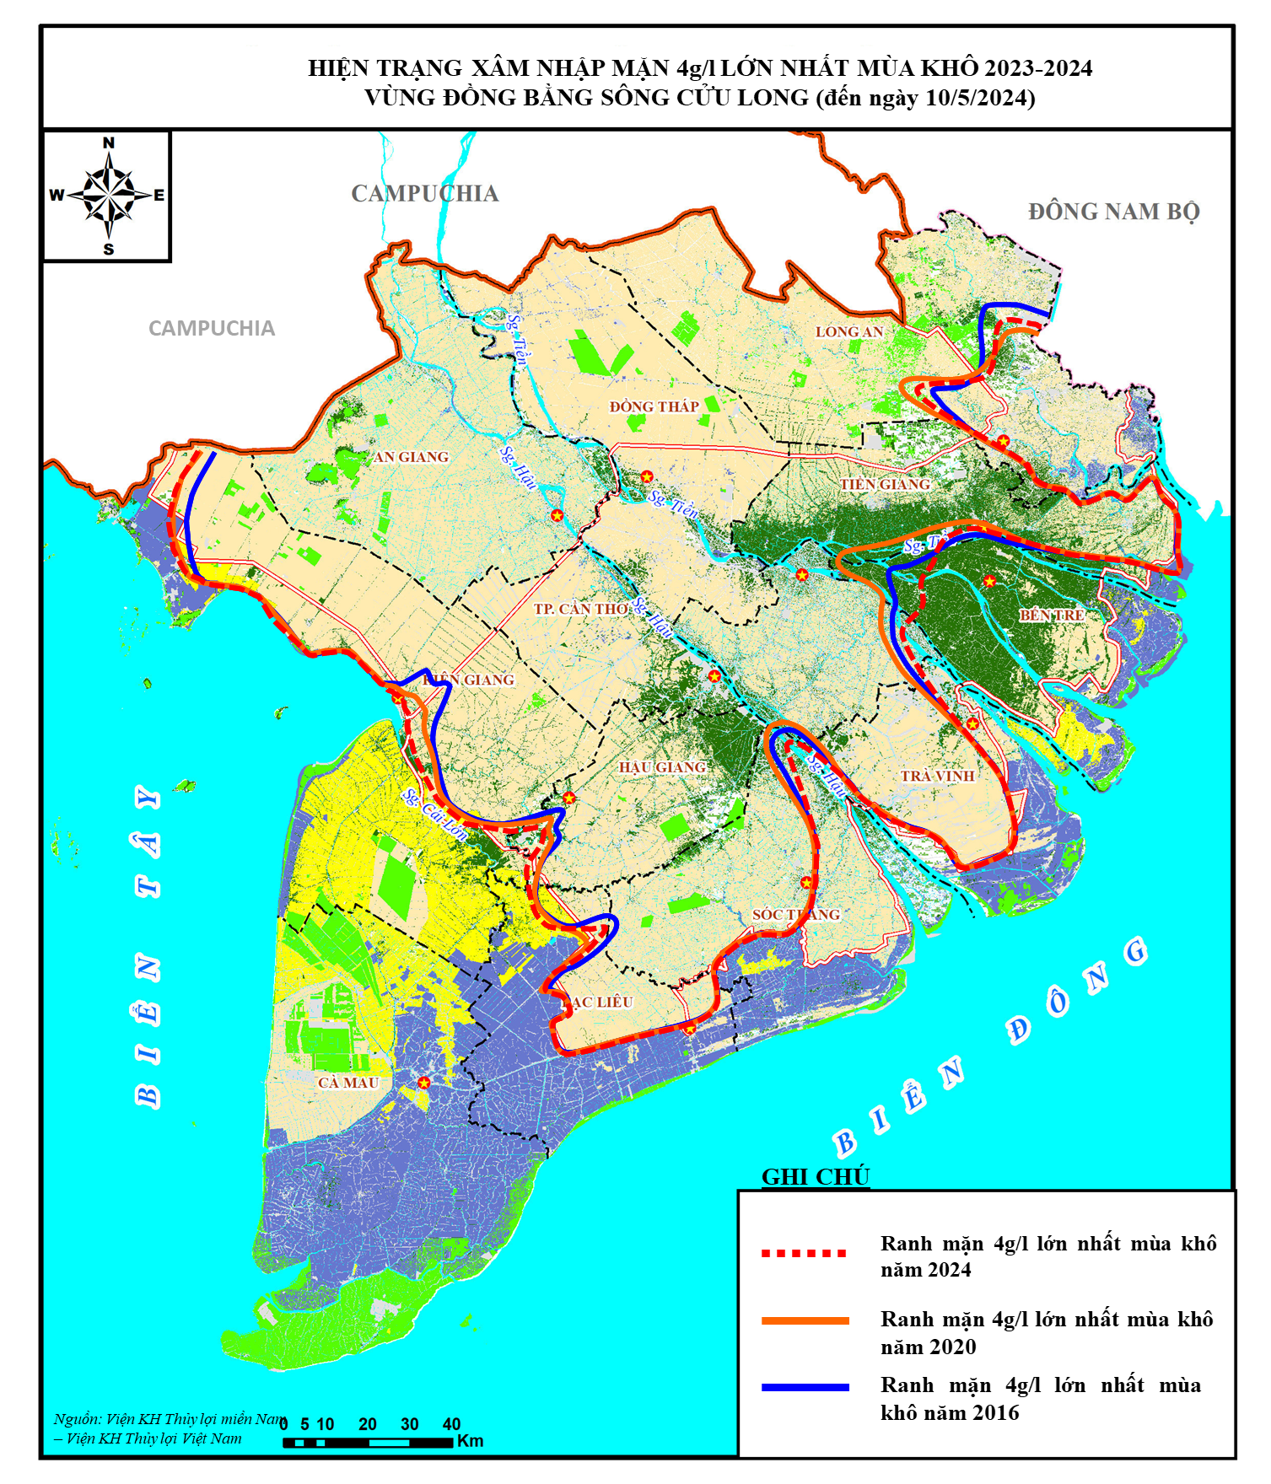
Figure 3‑1 Saltwater intrusion boundaries over years (Source: SIWRR data 10 May 2024). Red dotted line represents Maximum intrusion limit of the 4 g/L salinity front in the 2024 dry season, orange line Maximum intrusion limit of the 4 g/L salinity front in the 2020 dry season. and blue line Maximum intrusion limit of the 4 g/L salinity front in the 2016 dry season.
Due to significant changes in river flow to the Delta since 2013, SWI tends to affect water resources from 1 to 1.5 months earlier than observed in previous periods. In years when upstream flow is low, SWI begins as early as mid-December of the previous year, with salinity peaks occurring in February and March of the following year. By April, the dry season flow usually increases, causing SWI to decline rapidly.
Additionally, the return frequency of historical drought and salinity events has become shorter. In recent years, the Mekong Delta has experienced three severe drought and SWI events, including two historically high peaks (at the time of occurrence): the 2015 - 2016 and 2019 - 2020 dry seasons. The 2023 - 2024 season is considered milder in comparison.
During the 2015-2016 drought event, saltwater was estimated to have intruded around 70 to 90 kilometres into the mainland, which is 20 to 25 kilometres further inland in comparison with the seasonal averages.

Impacts on agricultural production
The SWI impacts on critical socioeconomic activities in the Delta, including agriculture and aquaculture activities, presenting a serious threat to food security and livelihoods.
The SWI event of 2015 - 2016 season caused damage to approximately 405,000 hectares of rice across the late 2015 and 2016 crop seasons, and 8,100 hectares of other crops. For rice yield, in the winter - spring 2015 - 2016 crop alone, productivity decreased by 390 kg/ha (down to 6.73 tons/ha). The total rice output was estimated at 10,707,000 tons; a reduction of 424,000 tons compared to the winter-spring 2014 - 2015 crop.
Additionally, many areas of summer - autumn 2016 rice in coastal provinces were delayed due to saline soils, requiring rainfall to flush out the salt before sowing. Regarding fruit trees, about 28,500 hectares of fruit tree production were damaged.
The SWI event of 2019 - 2020 affected 10 out of 13 provinces in the Mekong Delta, with saline intrusion lasting nearly 6 months. SWI of 4g/l was had entered up to 125km inland (Vam Co Dong, Vam Co Tay), more than 30km beyond the highest long-term average levels at the time.
The affected area with a salinity threshold of 4g/l reached 1,688,600 hectares, accounting for 42.5% of the region’s total natural area. This was an increase of affected areas by 50,376 hectares, compared to 2016. The total rice area damaged by SI in 2020 was 59,624 hectares, equivalent to 14.8% of the damage in 2016 (405,139 hectares).
In the 2023 - 2024 dry season, about 1,391 hectares of rice in Sóc Trăng (1,232 ha, including 1,189 ha with reduced yield and 43 ha completely lost) and Bến Tre (159 ha with reduced yield) were affected due to spontaneous sowing by farmers, not following recommended safe production zoning.

Impacts on rural domestic water supply
Currently, around 67% of households in the region use clean water from centralized water supply systems, while the remaining 33% rely on household-level water supply methods (such as jars, storage tanks, drilled wells, etc.). Among these, approximately 53,500 households are scattered and dispersed, mainly in the provinces of Long An, Tien Giang, Ben Tre, Soc Trang, Bac Lieu, Ca Mau, and Kien Giang, making it difficult for them to access centralized water supply systems.
The percentage of households using clean water from centralized systems varies by province: Ca Mau 18%, Kien Giang 33%, Bac Lieu 43%, Ben Tre 60%, while provinces with higher rates include Tien Giang, Vinh Long, and An Giang, ranging from 90-94%.
In recent years, the decline in water sources and saline intrusion has increased the risk of salinization of surface and groundwater sources, affecting rural domestic water supply during the dry season - especially for households without access to centralized water supply systems. The level of impact depends on water source conditions and the duration of drought and water shortages.
Statistics show that the average water storage capacity per dispersed household is only about 1 cubic meter, which is sufficient for drinking and cooking for 10 - 20 days. However, drought and salinity often occur early and last up to 3 months, leading to water shortages or a complete lack of fresh water for daily use.
The extreme drought events in the Mekong Delta, such as those in 2016 and 2020, had significant impacts on the drinking water supply in the region.
In the record 2015 - 2016 event, due to the low levels of rainfall and upstream water diversion, and the subsequent low water levels in the Mekong River, the saltwater was able to penetrate and contaminate drinking water sources such as wells and rivers. As a result, local governments and residents were forced to rely on bottled water and emergency water supplies transported from other regions, which put significant pressure on the already scarce resources at the time of the drought. As of March 2016, more than 409,000 were estimated to have been affected, with estimated 976,000 million people lacking water for daily consumption. Saltwater intrusion made up to 20% of freshwater wells in the region undrinkable.
During the 2019 - 2020 SWI event, more than 685,000 people in the Mekong Delta provinces were affected and approximately 200,000 households were reported to be lacking safe water for domestic uses in March of 2020, still in the midst of the drought.

Gender-specific impacts of SWI in the VMD
Women and men are affected differently by climate change, natural disasters, and their responses to disasters are also different due to their different roles in the family and community. Even within a household, the impacts of climate change and natural disasters can be unevenly distributed among members, with women, children, and the elderly often being more vulnerable.
Division of labour, social stereotypes and norms, and gender disparities have all contributed to preventing women from acquiring the skills and resources needed to respond to and mitigate the impacts of climate change. Following a more traditional division of labour, women often use water for daily household purposes, personal hygiene needs, and traditional agriculture, with little use of advanced technology. In many rural areas of Viet Nam, especially in the more water-scarce areas, women spend several hours a day collecting and storing water for cooking, laundry and other essential household needs. Men often spend much less time on these kinds of tasks.
The time-consuming housework that traditionally falls to women, means that many rural women often have little time to participate in the community activities and meetings where decisions pertaining community issues are made, reducing their say over how water management and other issues are to be addressed. They also often have limited access to information on water resource management and protection, including that on managing SWI. Combined, the gender inequality, lack of training and lack of formal mechanisms to promote women’s leadership lead to women being underrepresented in decision-making bodies, especially at the local level. Women’s lower participation in community organizations hinders their participation in preparedness activities and devalues their knowledge and experience in mitigation and recovery actions when it comes to tackling impacts of such events as SWI. When there is underrepresentation of women in decision-making bodies, this results in women’s priorities being less considered in the disaster risk reduction and adaptation planning strategies and approaches.
When natural disasters do occur, women not only face reduced agricultural production, but they also have to take on additional workloads to restore and replant the land affected by, for example, SWI. Landless rural women often work as seasonal agricultural workers and have no alternative source of income when agricultural production is interrupted by such natural disasters, making them particularly vulnerable to disruptions caused by severe SWI events.
The most direct impacts of SWI events are summarized below:
Lack of clean water. Women are often the ones who directly collect water for their families, so when fresh water is scarce, they have to go further to find water. This affects the time available for household and economic activities.
Risk of disease. Lack of clean water also leads to poor sanitation, increasing the risk of diseases such as dengue fever, especially affecting the health of women and girls.
Increasing household chores. Women have to spend more time fetching water, doing laundry, cooking with limited water, or finding alternative water sources.
Pushing women into difficult situations. Water shortages and loss of income due to SWI can cause women to face poverty, migration or and in general create greater pressure to maintain family life.
Loss of livelihoods. Saltwater causes severe damage to agriculture (rice, fruit trees) and aquaculture, directly affecting the main source of income for many families, of which women are often the main contributors.
Increasing economic burden on families. When livelihoods are affected, women have to take on more work to make ends meet.
Psychological health. The pressures on economy and daily life created by severe events of SWI, can cause stress, anxiety and affect women's mental health.
Particularly vulnerable groups to the effects of SWI include:
The poor. The poorest members of the communities have few financial resources to combat the impacts of saltwater intrusion using the more costly response options such as purchasing or storing water, changing crops or investing in new infrastructure.
Single women with dependents: This is one of the groups in communities that bears the greatest burden in finding clean water and taking care of the health of their families (children, elderly parents, etc.) in the context of water shortages and SWI impacts.
Children and the elderly. Their weaker health makes them more vulnerable to health and nutritional impacts caused by SWI events.
The historic drought events and saltwater intrusion events that have occurred in recent years in the VMD have forced many women in the Mekong Delta region to seek alternative ways to earn a living, as their already unstable income from agriculture has plummeted and has been put at increasing risk. However, the more traditional gender roles in Viet Nam often stipulate that women are responsible for household chores such as cooking and caring for other family members, and it is this tight bond of responsibility and societal expectation that sometimes makes it difficult for the women in the Mekong Delta region to change jobs.
While these changes demonstrate an adapting society, it is also clear evidence of the vulnerability of women and communities in general in the Mekong Delta region. The recurring drought and saltwater intrusion events force people, especially women, to increase their working hours to provide fresh water for crops and care for crops and livestock. The rate of increase in agricultural labour productivity has stalled, meaning that workers have to spend more effort to protect crops than before. As the impacts of climate change continue to wreak havoc in the VMD region the livelihoods of many families are in danger, if adaptive actions are not put in place.

Institutional setup for salinity monitoring
In the Mekong Delta, there are there are several organizations, both nationally and regionally, that are engaging in and collaborating on- salinity monitoring and management. The below Table ‎4-1 represents the list of those organizations and their respective roles and responsibilities.
Table ‎4-1 List of key organizations engaged in salinity monitoring and their roles and responsibilities
Institution | Role/Mandate | Protocols & Responsibilities | Salinity measurement role | Salinity data mgt. role
Ministry of Agriculture & Environment (MAE) | Lead coordination, monitoring, forecasting, policy development.  Environmental monitoring, data management. | Operates salinity monitoring systems, builds databases, forecasts saltwater intrusion, manages irrigation systems.  Collects hydrometeorological data, supports water resource planning. | YES | YES
Vietnam Meteorological and Hydrological Administration (VNMHA) | Collecting and analyzing salinity data from hydrological stations.  Issuing forecasts and alerts related to salinity intrusion, especially during the dry season.  Supporting national and provincial planning for agriculture, water supply, and climate resilience | VNMHA oversees a network of 232 hydrological stations and marine meteorological stations that monitor:  - Salinity levels  - Water temperature  - Sea level  - Tidal fluctuations  Data is collected using automated tide gauges, pressure sensors, and acoustic instruments.  All data is processed using standardized software (e.g., ORKAN, TIDE) and follows protocols issued by VNMHA.  Data is stored digitally and shared with relevant agencies for forecasting and planning  VNMHA collaborates with VNMC and international partners (e.g., DHI, CTCN) to:  - Develop an Integrated Salinity Monitoring System (IMS).  - Share near-real-time data and forecasts.  - Build capacity for provincial agencies to interpret and use salinity data effectively. |  | Yes (Policy and strategy development, standardization of data collection methods)
Southern Regional Hydrometeorological Center (SRHMC) | Providing hydrometeorological services for Southern Vietnam, including the Mekong Delta.  Operating and managing a network of hydrological, meteorological, and oceanographic stations.  Monitoring water and air quality, including salinity levels in coastal and estuarine zones.  Supporting regional planning and disaster preparedness through data and forecasts | SRHMC manages a real-time hydro-meteorological monitoring network consisting, and also provides daily, monthly, seasonal, and annual forecasts fir various hazards, including saltwater intrusion  SRHMC also provides agricultural weather forecasts tailored to inform agricultural decision-making. | YES  Surface water  Main rivers | YES
National Center for Water Resources Planning and Investigation (NAWAPI) | Leading efforts in groundwater protection, salinity intrusion monitoring, and climate adaptation in vulnerable regions like the Mekong Delta  Advises MONRE and provincial governments on:  - Salinity intrusion mitigation strategies  - Groundwater abstraction regulations | NAWAPI conducts groundwater salinity distribution mapping, especially in coastal provinces like Ca Mau, Soc Trang, and Bac Lieu.  Uses 3D groundwater flow and transport models to simulate salinity dynamics and assess risks to freshwater supply and land subsidence. [mdpi.com]  Collaborates with international partners (e.g., BGR Germany) to enhance technical capacity and data accuracy.  NAWAPI operates a network of groundwater observation wells and surface water monitoring stations.  NAWAPI participates in the development of an Information Management System for the Mekong Delta, in collaboration with VNMC. | YES  Ground water | YES
Provincial Departments of Agriculture & Environment | Local data collection, implementation of actions. | Operates local monitoring stations, reports salinity data, and implements mitigation measures. | YES | YES
Southern Institute of Water Resources Planning (SIWRP) | Develop regional water resource plans, including salinity intrusion mitigation strategies.  Conduct technical assessments and hydrological modelling to support sustainable water use.  Advise MARD and provincial governments on infrastructure planning, irrigation systems, and climate adaptation.  Collaborate with national and international partners on research and pilot projects related to salinity and water security | Provides technical input for:  - Mekong Delta Integrated Regional Plan (MDIRP)  - National water resource strategies  - Climate-resilient infrastructure development  - Advises on salinity control structures, such as sluice gates and canal systems. | YES
Southern Institute of Water Resources Research (SIWRR) | Scientific research, technical support to national institutions. | Conducts studies, develops models, supports decision-making. | YES  Monitoringnetwork of stations in 2nd/3rd level canals/rivers | YES
Others |  | Local (farm-level) salinity measurement, especially for shrimp farming. | YES | YES

In addition, several key institutions in the country are utilizing the salinity measurement data for operational and short-term and long-term planning processes. These actors do not collect any primary salinity measurements themselves but are important in receiving and utilizing salinity data for decision-making.
The most important institutions at the MVD region level are listed in the table below.
Table ‎4-2 Key institutions utilizing salinity data for analysis and decision-support
Institution | Role/Mandate | Protocols & Responsibilities | Salinity measurement role | Salinity data mgt. role
Vietnam National Mekong Committee (VNMC) | Advise the Prime Minister on transboundary water issues, including salinity intrusion.  Propose strategies, policies, and legal frameworks for sustainable water resource management.  Coordinate with ministries, provinces, and international partners to address climate change impacts, including salinity intrusion.  Monitor and assess upstream developments and their potential impacts on Vietnam’s water resources. | Consolidating fragmented data from various institutions.  Ensuring inter-agency coordination for salinity data collection and dissemination.  Facilitating transboundary data exchange with MRC member countries.  VNMC oversees the operation and maintenance of salinity monitoring stations in the Mekong Delta.  Works with the National Centre for Hydro-Meteorological Forecasting and other agencies to ensure consistent data quality and coverage. | NO | NO
Mekong Delta Regional Data Center | Serve as a centralized hub for collecting, storing, analyzing, and sharing salinity intrusion data in the Mekong Delta.  Support climate change adaptation and disaster risk reduction through data-driven decision-making.  Facilitate inter-agency coordination and transboundary data exchange within the Mekong River Basin | Stakeholder Engagement and Data Assessment:  - Local communities  - Government agencies  - Technical institutions  Operates a platform for near-real-time data exchange among:  - VNMC  - VNMHA  - NAWAPI  - Provincial departments  - Supports early warning systems and seasonal planning for agriculture and water supply | NO
Mekong River Commission (MRC) | International cooperation between the region countries. | Shares transboundary data, supports early warning systems in the region. | NO | NO
Local Disaster Prevention and Control Steering Committees | Coordinating disaster preparedness and response at the local level.  Implementing early warning systems and disseminating alerts to communities.  Organizing emergency response and recovery operations.  Integrating disaster risk reduction (DRR) into local socio-economic development plans.  Monitoring and managing risks related to floods, droughts, and salinity intrusion, especially in vulnerable areas like the Mekong Delta | Collaborate with technical agencies (e.g., VNMHA, NAWAPI, SRHMC) to:  - Collect salinity data from local monitoring stations.  - Report anomalies or rising salinity levels to provincial and national authorities.  - Maintain local databases for disaster risk management (DRM).  Use systems like PDMS (Provincial Disaster Management System) and VNDMS (Vietnam Disaster Management System) to:  - Receive and disseminate salinity intrusion forecasts.  - Alert farmers, water users, and vulnerable communities.  - Coordinate with media and local leaders for public awareness | NO
Other Ministries (Science & Tech, Construction, Finance) | Supporting infrastructure development, technology advances, and funding for the Delta. | Supports development of technologies, allocate budgets, provides guidelines for urban and also broader planning. | NO | NO

While several institutions are involved in salinity data collection and sharing, one of the most difficult challenges facing the VMD is the lack of coordinated data infrastructure and salinity data sharing protocols. These would enable more coordinated collection of all data related to salinity in one database or platform that could inform decision-making and operational decisions in the provinces.
Thus, currently the key institutions involved in salinity data collection and management in VMD are:
- Ministry of Agriculture & Environment, including the institutions reporting to the MAE:
  - Southern Regional Hydrometeorological Center (SRHMC)
  - National Center for Water Resources Planning and Investigation (NAWAPI)
  - Southern Institute of Water Resources Research (SIWRR)
  - Southern Institute of Water Resources Planning (SIWRP)
  - Vietnam National Mekong Committee (VNMC)
  - Mekong Delta Regional Data Center (MDRDC)
- Provincial Departments of Agriculture & Environment

The Vietnam National Mekong Committee (VNMC)
VNMC is an inter-ministerial coordinating body under MAE, representing Viet Nam in regional Mekong cooperation, and it represents Viet Nam to the MRC.
Within the salinity monitoring, VNMC works to unify fragmented salinity data collected by various agencies (Hydromet, NAWAPI, local governments, research institutes) and promotes inter-agency data sharing mechanisms to support real-time forecasting and decision-making. As part the MRC, VNMC facilitates data exchange and joint forecasting efforts with upstream countries to better understand and manage cross-border salinity dynamics.
This work includes following types of activities addressing the issue of salinity intrusion in VMD:
- VNMC collaborates with international partners (e.g., CTCN, UNDP, World Bank) to enhance forecasting capacity through training, system upgrades, and technical support.
- VNMC supports the development and deployment of integrated salinity intrusion forecasting systems, including real-time monitoring platforms, predictive models using upstream discharge and tidal data and scenario-based forecasting under climate change conditions.
- VNMC provides scientific input for national and regional planning, including climate adaptation strategies, water resource management plans and agricultural zoning based on salinity risk.
- VNMC helps disseminate salinity forecasts and risk information to local authorities, farmers, and stakeholders, enabling timely response and adaptation.

Ministry of Agriculture and Environment (MAE)
MAE (a result of merger between the previous Ministry of Agriculture and Rural Development and the Ministry of Natural Resources and Environment, since 2025) has the overall national responsibility tor matters relating to monitoring weather, hydrology, water resources, and providing timely information and forecasts about risks of drought, water shortage and salt‐water intrusion (including for the Mekong Delta region). This includes national level responsibilities in relation to water resources management and planning, which also includes planning and addressing matters in relation to saltwater intrusion. It also provides guidance to provincial level governments on how to plan for and address salinity intrusion problems, affecting agricultural activities as well as broader water quality issues.
There are several specialized bodies/institutions under the MAE that have relevance in salinity data collection sharing and utilization for decision-making. These are summarized further in the text.

Vietnam Meteorological and Hydrological Administration (VNMHA)
VNMHA is an organization under the Ministry of Agriculture and Environment. The department is responsible for developing, managing, and operating the national hydrometeorological station network and organizing the implementation of observation, investigation, and survey activities related to hydrometeorology in Viet Nam.
Under the VNMHA, the Southern Regional Hydrometeorological Centre (SRHMC) is the regional office that has the duty and function to collect, monitor and store salinity data in Mekong (see below).

The Southern Regional Hydrometeorological Center (SRHMC)
The Southern Regional Hydrometeorological Center has monitored salinity and issued early warnings for areas in the Mekong Delta that are affected, aiming to provide timely information to local residents and authorities for agricultural planning. As a result of receiving this information, some locations have been able to take proactive measures to minimize negative impacts of the salinity intrusion such as sowing crops early and storing water.
Currently, SRHMC regularly provides forecast and saline intrusion warning information to the local Disaster Prevention and Control Steering Committees. In cases of sudden salinity increases, enhanced bulletins are issued to ensure timely response. These updates are shared via Zalo, Facebook, and local disaster prevention groups.
Saline intrusion forecast bulletins are issued every 10 days, predicting the highest salinity levels at each monitoring point, and forecasting the 1‰ and 4‰ salinity boundaries for each major river in the provinces. Salinity data is updated and sent daily to provincial authorities and stakeholders such as departments of agriculture and environment at the monitoring points. See example from map from the bulletin from 2024 in Figure 3-1.

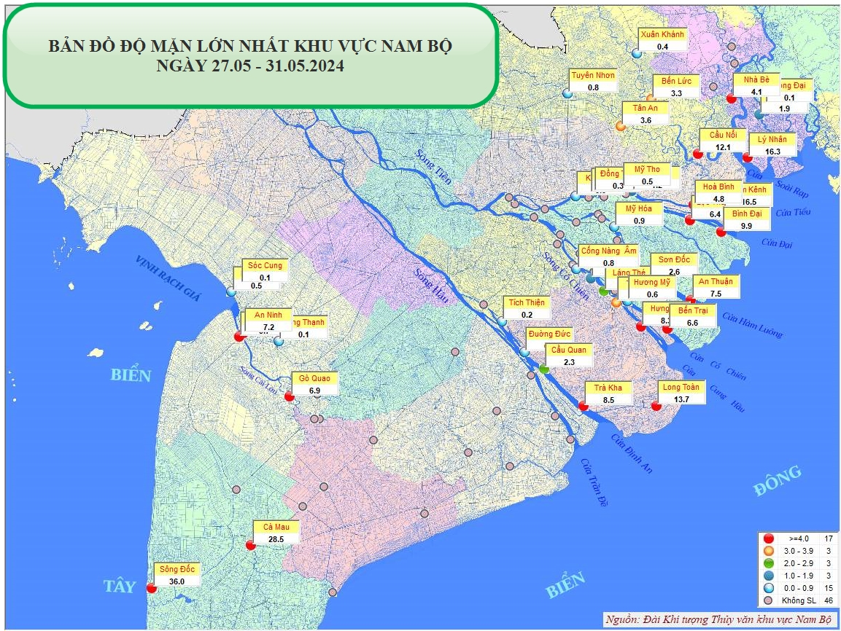
Figure 3-1 Maximum salinity in Mekong delta from 27-31 May 2024 (Source: SHRMC, May 2024 salinity bulletin)

The National Centre for Water Resources Planning and Investigation (NAWAPI)
NAWAPI is a public service organization under the Ministry of Natural Resources and Environment (now MAE). It is responsible for planning, conducting baseline investigations, monitoring, forecasting, issuing warnings, and protecting water resources nationwide; and for providing public services related to natural resources and the environment.
NAWAPI carries out baseline investigations of water resources, monitors and supervises water resources, and conducts forecasting and warning activities. These include forecasting changes in water levels, flow rates, total water volume, water quality, drought, water shortages, and saline intrusion in inter-provincial and transboundary river basins.
Salinity data is used by NAWAPI in forecasting and warning of saline intrusion in water resources, as well as in integrated river basin planning.

Mekong Delta Regional Data Center (MDRDC)
The Mekong Delta Regional Data Center, officially inaugurated in December 2024 in Can Tho City, was a strategic initiative led by the previous Ministry of Natural Resources and Environment (now under the new Ministry of Agriculture and Environment) . It was developed under the framework of the Integrated Climate Resilience and Sustainable Livelihoods in the Mekong Delta (ICRSL) project, which spans across 13 provinces and cities in the region.
The center has mandates as listed below:
- Serve as a centralized hub for collecting, integrating, and sharing salinity intrusion data.
- Support climate change adaptation, disaster risk reduction, and sustainable water resource management.
- Facilitate inter-agency coordination and transboundary data exchange within the Mekong River Basin
MDRDC is responsible for implementing an Integrated Salinity Monitoring System (IMS) that includes:
- A central database for salinity data
- Software and applications for real-time data exchange
- Forecasting models to predict salinity intrusion based on upstream discharge, tidal levels, and climate variables
In addition, the MDRDC is tasked with following:
- Stakeholder engagement and system assessment, and conducting consultations and assessments to:
  - Evaluate existing salinity monitoring and forecasting systems.
  - Identify data gaps and integration opportunities.
  - Ensure that the IMS reflects local needs and realities.

- Real-time data sharing and visualization, and facilitating near-real-time data exchange among:
  - VNMC
  - VNMHA
  - NAWAPI
  - Provincial departments
- Supporting early warning systems and seasonal planning for agriculture and water supply.

Provincial Departments of Agriculture & Environment
Provincial Departments of Agriculture and Environment (DAE) in the Mekong Delta operate under the guidance of the Ministry of Agriculture and Environment (MAE). Their core mandate includes:
- Managing agricultural production and environmental protection at the provincial level.
- Monitoring and responding to climate-related risks, including salinity intrusion, drought, and flooding.
- Supporting the implementation of national strategies such as Resolution 120/NQ-CP on sustainable development and climate adaptation in the Mekong Delta.
DAE collect data to support provincial needs with following aspects:
- Salinity levels in surface and groundwater
- Water quality parameters
- Agricultural impacts (e.g., crop damage, irrigation challenges)
They report findings to provincial authorities and national agencies for coordinated response.

Southern Institute of Water Resources Planning (SIWRP)
The Southern Institute of Water Resources Planning (SIWRP) is a specialized planning agency under the Ministry of Agriculture and Environment (MAE). Based in Ho Chi Minh City, SIWRP is responsible for:
- Planning and managing water resources in Southern Vietnam, including the Mekong Delta.
- Conducting technical studies, hydrological modeling, and infrastructure planning to support sustainable water use.
- Advising on salinity intrusion mitigation, irrigation systems, and climate adaptation strategies.
- Collaborating with national and international partners to promote resilient water resource development.
SIWRP plays a key role in supporting Vietnam’s efforts to adapt to climate change and ensure water security in one of the country’s most vulnerable regions

Southern Institute of Water Resources Research (SIWRR)
The Southern Institute of Water Resources Research (SIWRR) is a scientific and governmental institute under the Ministry of Agriculture and Environment. Established in 1978, SIWRR operates as a regional institute within the Vietnam Academy for Water Resources.
SIWRR is dedicated to:
- Research and development in water resources, irrigation, and environmental management.
- Providing scientific and technical support for sustainable water use in Southern Vietnam, especially the Mekong Delta.
- Advising ministries and provincial governments on issues such as:
- Salinity intrusion
- Flood control
- Water quality
- Hydraulic infrastructure planning
From the 2019 - 2020 dry season, the Ministry of Agriculture and Rural Development (MARD, but now MAE after the administrative reform of 2025) assigned the task (hereinafter referred to as the ‘project’ namely as “Investigation and monitoring of salinity intrusion in the Mekong Delta to support agricultural production management and decision-making”) of monitoring saline intrusion and forecasting water resources in the Mekong Delta to the Southern Institute of Water Resources Research (SIWRR). The SIWRR began continuous implementation of this task from June 2019 till present.
Saline intrusion were monitored regularly, and forecasting efforts were initiated early to clearly identify the scope and severity of impacts. This served as the basis for reporting to the Prime Minister, enabling prompt and decisive implementation of response measures for Winter-Spring rice crop. The scope of monitoring and measuring saline intrusion dynamics during the dry season months covers the main rivers within the territories of 10 Mekong Delta provinces affected by salinity, including: Long An, Tien Giang, Tra Vinh, Ben Tre, Vinh Long, Soc Trang, Hau Giang, Bac Lieu, Ca Mau, and Kien Giang.
The project's outputs include: a comprehensive implementation report, a summary report of results, appendices with salinity measurement data and related documents (including measurement data from 71 monitoring stations and 25 data collection stations).
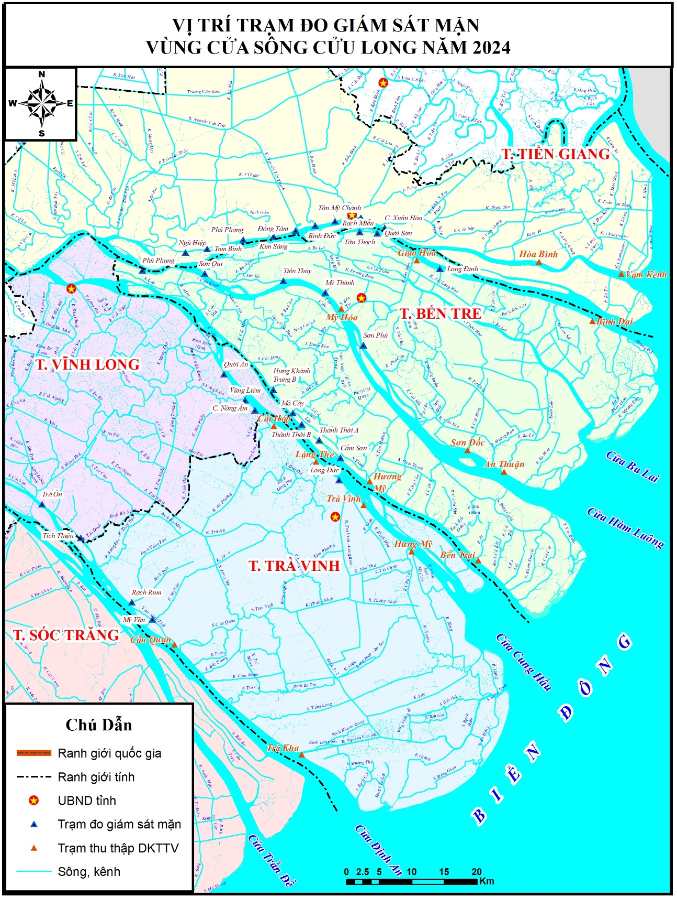
Figure 3-2 Location of salinity monitoring stations in 2024 (Source: SIWRR)

Mekong River Commission (MRC)
The MRC is an intergovernmental organization established under the 1995 Mekong Agreement to promote and coordinate the sustainable development and management of water and related resources in the Lower Mekong Basin (LMB), which includes Cambodia, Laos, Thailand, and Vietnam.
- Facilitate transboundary cooperation on water resource management.
- Provide scientific analysis, technical support, and policy advice.
- Support Integrated Water Resources Management (IWRM) across the basin.
- Monitor and assess water quality, hydrology, climate impacts, and salinity intrusion.
The MRC operates a Water Quality Monitoring Network (WQMN) with 48 stations across the LMB.
These stations collect information on following parameters such as:
- Electrical conductivity (a proxy for salinity)
- Dissolved oxygen
- Biochemical oxygen demand
- Temperature and pH
The MRC has several ways to share data with the region countries and institutions. These include publishing findings in key MRC reports such as:
- State of the Basin Reports (SOBR) published every five years.
- Annual Water Quality Monitoring Reports
- Online databases and interactive maps.
MRC also shares data with member countries, researchers, and the public through its website and information management and data platforms
At MRC, there are several projects, research, studies related to salinity that have taken place over the last years. Some of the most important ones are listed below:
- Water Quality Monitoring Reports (2020–2022) documenting salinity intrusion trends, especially at My Tho station.
- SOBR 2023 included salinity intrusion mapping and habitat impact assessments using satellite data [futurewater.nl].
- Pilot mapping methodology developed by FutureWater showed a threefold increase in areas affected by salinity >4g/L over 30 years [futurewater.eu].
The efforts on salinity intrusion are continuing with following projects under MRC:
- Enhancement of salinity monitoring networks in collaboration with local governments (e.g., Can Tho City project with online monitoring stations transmitting data every 10 minutes) [mekongrok.org]
- Integration of salinity data into early warning systems and disaster risk zoning maps.
- Development of the Mekong River Basin Indicator Framework (MRB-IF) to track salinity as part of broader environmental and climate change indicators.

Local Disaster Prevention and Control Steering Committees
Local Disaster Prevention and Control Steering Committees (LDPCSCs) are established at provincial, district, and commune levels under the framework of the Law on Natural Disaster Prevention and Control and Decree 66/2021/ND-CP.
Their core mandate includes following responsibilities:
- Coordinating disaster preparedness and response at the local level
- Implementing early warning systems and disseminating alerts to communities
- Integrating disaster risk reduction (DRR) into local development plans
- Monitoring and managing risks related to floods, droughts, and salinity intrusion, especially in vulnerable areas of the Mekong Delta.
LDPCSCs collaborate with key technical agencies such as:
- Vietnam Meteorological and Hydrological Administration (VNMHA)
- National Center for Water Resources Planning and Investigation (NAWAPI)
- Southern Regional Hydrometeorological Center (SRHMC)
These local committees also collect and validate salinity data from local monitoring stations, where such exist. Following this they may report anomalies or rising salinity levels to provincial and national authorities for coordinated response where necessary.

Other ministries
Other national ministries of mention, in relation to use of salinity intrusion related data or information include:
- Ministry of Planning and Investment (MPI), which integrates salinity data into regional development plans and infrastructure investment strategies under programs like the Mekong Delta Integrated Regional Plan (MDIRP).
- Ministry of Science and Technology (MOST), which supports research and innovation in salinity monitoring technologies and modeling tools. MOST also funds pilot projects and scientific studies on salinity intrusion impacts and facilitates data sharing platforms, early warning systems, and digital infrastructure for salinity monitoring and public communication.

Salinity monitoring infrastruture

Physical salinity monitoring network in the Delta
The frequency, format and distribution channels of the key salinity intrusion-related data collected in the VMD are summarized in Table 3-2 below. The tables that gives a high level overview of the most important types of data that are being collected to inform salinity intrusion in the VMD by the key institutions listed under Chapter 4.
Table ‎5-1 Frequency, format and distribution channels
Type of Data | Details
Measurements | Salinity (g/l), conductivity, water level, rainfall, flow rate
Depth/Location | Surface and groundwater; river mouths, canals, inland fields
Frequency | Seasonal (dry season), weekly/monthly updates, emergency alerts
Format | Digital maps (WebGIS), reports, real-time dashboards (limited)
Channels | Websites, email, Zalo, social media, local government, MRC

Salinity intrusion data are predominantly collected and managed by following institutions:
- Ministry of Agriculture & Environment (MAE) and the affiliated institutions
- Hydro-meteorological office
- International partners (e.g., Mekong River Commission)
- A Mekong Delta Data Center is also being developed to integrate and share water-related data.
Some of the most important physical infrastructure enabling monitoring of saline intrusion in the VMD is summarized below.

Salinity monitoring by the SHRMC
There are 23 monitoring salinity stations under management of hydro-met service.
Types of data collected by the Hydromet service include:
- Salinity (mainly at river mouth)
- Meteorological, hydrological, groundwater, rainfall.
The frequency of data collection is as follows:
- Daily flood forecasts (66 stations)
- 10-day drought/salinity bulletins
- Seasonal/annual forecasts
Real-time monitoring of salinity by the Hydromet service is limited at present day. The monitoring station network of Hydromet service is summarized below:

Table ‎5-2 Salinity monitoring stations by the Hydromet service
No | Station name | Longtude | Latitude | Data availability
1 | An Thuận | 106032' E | 10002' N | 1980-present
2 | Bến Lức | 106029' E | 10038' N | 1977-present
3 | Bến Trại | 106022' E | 10001' N | 1980-present
4 | Cà Mau | 105008' E | 09010' N | 1980-present
5 | Cần Thơ* | 105046' E | 10002' N | 1977-present
6 | Đại Ngãi | 105004' E | 09044' N | 1980-present
7 | Gành Hào | 105037' E | 09001' N | 1980-present
8 | Kiên Bình | 105039' E | 10025' N | 1980-present
9 | Long Định | 106015' E | 10024' N | 1980-present
10 | Mỹ Hóa | 106023' E | 10015' N | 1980-present
11 | Mỹ Thanh | 106010' E | 09025' N | 1980-present
12 | Mỹ Tho | 106021' E | 10021' N | 1980-present
13 | Năm Căn | 105002' E | 08057' N | 1980-present
14 | Ông Đốc | 104054' E | 09008' N | 1980-present
15 | Phụng Hiệp | 105003' E | 09045' N | 1980-present
16 | Phước Long | 105041' E | 09019' N | 1980-present
17 | Rạch Giá | 105005' E | 10001' N | 1978-present
18 | Tân An | 106025' E | 10034' N | 1977-present
19 | Trà Vinh | 106021’ E | 09058’ N | 1980-present
20 | Tuyên Nhơn | 105056' E | 10025' N | 1980-present
21 | Vàm Kênh | 106044' E | 10016' N | 1980-present
22 | Vị Thanh | 105027' E | 09046' N | 1980-present
23 | Xẻo Rô | 105004' E | 09056' N | 1980-present
Salinity data collection methods utilized by the Hydromet service include:
- In-situ monitoring stations:
  - Permanent water quality stations operated by the Mekong River Commission and Vietnam Hydro-Meteorological Service.
  - Surface water samples taken mid-stream every 2 months or more frequently during dry seasons.
  - Laboratory analysis for salinity expressed in Practical Salinity Units (PSU) or g/L.
- Continuous sensor-based monitoring:
  - Automated stations record salinity, water level, and temperature at hourly intervals.
  - Data transmitted via telemetry to central servers for real-time monitoring and forecasting.
Equipment used by Hydromet service include:
- Portable salinity meters: Handheld conductivity meters (e.g., YSI Pro30, Hanna Instruments) for spot measurements. These measure electrical conductivity and convert to salinity (PSU or ppt).
- Multi-parameter water quality sensors: Installed at fixed stations and measure salinity, temperature, pH, and dissolved oxygen. These are equipped with data loggers and telemetry systems for real-time transmission.
Most of the data measured and collected will be shared with Mekong Delta Regional Data Center (MDRDC).

Salinity monitoring by Southern Regional Hydrometeorological Center (SRHMC)
SRHMC manages a real-time hydro-meteorological monitoring network consisting of:
- 101 automatic stations across the Mekong Delta.
- 13 provincial control centers.
- 1 regional data center in Ho Chi Minh City.
These stations measure following parameters:
- Water level
- Rainfall
- Meteorological parameters
- Salinity levels in estuarine and coastal zones
SRHMC also provides daily, monthly, seasonal, and annual forecasts for following hazards:
- Saltwater intrusion
- Drought
- Flooding
- Tidal surges
The forecasts are shared with following stakeholders to inform action and local decision-making:
- Local governments
- Disaster prevention agencies
- Agricultural planners
- Media outlets
In addition, SRHMC provides agricultural weather forecasts tailored to inform following aspects of agricultural activities:
- Crop sowing and harvesting schedules
- Irrigation planning
- Salinity risk zones.

Salinity monitoring by Southern Institute for Water Resources Research
As stated earlier, the SIWRR has also set up a number of monitoring stations to measure salinity during the dry season to support agricultural management and disaster mitigation.
Salinity data collected by SIWRR can be summarized as follows:
- Key parameters collected: Salinity concentration (g/l) (and following analysis of depth of saline intrusion (km), monthly max/min values, intrusion at various thresholds (1g/l and 4g/l).
- Frequency of data collection: Routine sampling at twice daily at each station (morning and afternoon) during Jan–May in dry season. Total samples: 21,442 across 71 stations.
- Real-time monitoring: takes place at 20 key locations on 7 main estuaries, with daily data transmission during salinity peaks.
- Data presentation: primarily in tables of monthly max/min salinity per station, intrusion depth charts, comparative analysis with historical years.
- Reporting intervals: as weekly rapid assessments, monthly summaries, and annual comparisons with historical data (2016, 2020, TBNN).
- Additional monitoring: can take place during extraordinary events, such as during abnormal salinity events or high tide periods.
Data collection methods and equipment utilized by SIWRR include:
- Field measurements: Direct salinity readings using portable meters (e.g., AZ 86021) at 71 monitoring stations and 25 data collection points.
- Laboratory analysis: Samples analysed using devices like Jenco 3107, MULTI 3420, WTW Comd 3310 for quality assurance.
Supplementary data collected and utilized by SIWRR include:
- Meteorological and hydrological data (rainfall, water levels), agricultural production reports.
The salinity monitoring stations by SIWRR are included in the table below. Station name with asterisk (*) means data is collected, not measured by the project. The coordinate is in VN2000 datum of Viet Nam.
Table ‎5-3 List of salinity monitoring station under SIWRR
# | Name | Y (m) | X (m)
1 | Cầu Nổi* | 1157528,02 | 563661,21
2 | Bà Nhờ | 1156425,24 | 563148,15
3 | Xóm Bồ | 1157563,12 | 564856,07
4 | Bà Xiểng | 1159538,05 | 5614564,34
5 | Cống Đôi Ma | 1168881,21 | 557137,70
6 | Long Cang | 1175935,44 | 547214,82
7 | Cống Rạch Chanh | 1170906,42 | 555596,18
8 | Bến Lức* | 1175935,44 | 547214,82
9 | Bình Đức 1 | 1179805,61 | 657050,87
10 | Bình Đức 2 | 1186095,03 | 656476,81
11 | Thạnh Hòa 1 | 1189965,04 | 654247,17
12 | Thạnh Hòa 2 | 1186847,10 | 645813,21
13 | Thạnh Lợi | 1179532,24 | 647456,14
14 | Lương Bình | 1178915,34 | 650647,25
15 | Xuân Khanh* | 1167432,15 | 646578,20
16 | Thạnh Lợi 2 | 1166815,21 | 650817,45
17 | Cống Sông Cui | 1166745,35 | 645698,40
18 | Phước Tân Hưng | 11686434,12 | 655247,10
19 | Cống Chợ Giữa | 1167987,26 | 654583,45
20 | Cống Tầm Vu | 1168854,26 | 656538,14
21 | Cống Kỳ Son | 1165117,32 | 551163,87
22 | Tân An* | 1163029,23 | 545408,50
23 | Kênh Rạch Chanh | 1167564,42 | 540918,52
24 | Mỹ Phú | 1168476,12 | 546843,25
25 | Kênh cống Bắc Đông | 1170664,21 | 538139,56
26 | Mỹ Lạc | 1174114,85 | 646534,85
27 | Tân Đông 1 | 1180577,28 | 637638,13
28 | Tân Đông 2 | 1181524,05 | 650647,15
29 | Tân Tây | 1181632,12 | 650545,42
30 | Tuyên Nhơn* | 1171513,51 | 651277,31
31 | Thạnh Hóa | 1170643,43 | 641753,23
32 | Thạnh Phú | 1176451,21 | 650184,61
33 | Thạnh Phước | 1184723,19 | 648246,57
34 | Vàm Kênh* | 1137141,30 | 580771,57
35 | Hòa Bình* | 1137479,95 | 682638,85
36 | Xuân Hòa | 1143294,73 | 654988,10
37 | T. Mỹ Chánh | 1144816,95 | 649703,67
38 | Rạch Miễu | 1143827,56 | 659013,24
39 | Bình Đức | 1151256,15 | 649811,25
40 | Đồng Tâm | 1151347,05 | 650845,41
41 | Kim Sáng | 1143827,56 | 648014,71
42 | Phú Phong | 1150134,05 | 650547,12
43 | Tam Bình | 1143836,21 | 649114,45
44 | Ngũ Hiệp | 1143827,56 | 648014,71
45 | Bình Đại* | 1124372,05 | 576505,86
46 | Lộc Thuận* | 1125757,05 | 587515,15
47 | Long Định | 1145582,14 | 658785,16
48 | Giao Hòa* | 1139866,23 | 659792,00
49 | Quới Sơn | 1116472,23 | 644582,13
50 | Tân Thạch | 1136574,23 | 653845,20
51 | An Thuận* | 1102229,54 | 565588,49
52 | Sơn Đốc* | 1142765,25 | 554561,70
53 | Sơn Phú | 1123564,14 | 656607,20
54 | Mỹ Hóa* | 1121544,56 | 655914,77
55 | Mỹ Thành | 1121648,51 | 645834,68
56 | Tiên Thủy | 1134618,77 | 638873,08
57 | Sơn Qui | 1146615,41 | 658773,18
58 | Phú Phụng | 1145245,15 | 648577,25
59 | Bến Trại* | 1092971,83 | 536359,60
60 | Hương Mỹ* | 1098617,52 | 651689,09
61 | Cẩm Sơn | 1096158,17 | 650254,15
62 | Thành ThớiA | 1117687,12 | 631421,25
63 | Thành ThớiB | 1096945,21 | 640342,16
64 | Mỏ Cày | 1116179,48 | 640853,71
65 | Hưng Khánh Trung B | 1118687,56 | 630635,84
66 | Hưng Mỹ* | 1098191,24 | 544453,53
67 | Trà Vinh* | 1101857,63 | 536339,44
68 | Long Đức | 1091871,83 | 546738,15
69 | Láng Thé* | 1106496,42 | 534141,25
70 | Cái Hóp* | 1113829,96 | 527280,87
71 | Cống Nàng Âm | 1113829,96 | 527280,87
72 | Vũng Liêm | 1083829,96 | 526230,35
73 | Quới An | 1064782,17 | 531020,34
74 | Trà Kha* | 1064995,20 | 527232,83
75 | Cầu Quan* | 1078104,70 | 627769,99
76 | Mỹ Văn | 1084297,78 | 509895,42
77 | Rạch Rum | 1091233,21 | 500790,71
78 | Tích Thiện | 1095947,03 | 606976,04
79 | Trà Ôn | 1087845,24 | 601846,25
80 | Trần Đề * | 1054150,71 | 629680,91
81 | Long Đức | 1081731,48 | 608125,27
82 | Đại Ngãi* | 1081731,48 | 609475,98
83 | Song Phụng | 1086521,17 | 601572,87
84 | Nhơn Mỹ | 1087054,25 | 498124,15
85 | An Lạc Tây 1 | 1061657,75 | 593574,62
86 | An Lạc Tây 2 | 1061456,24 | 565478,62
87 | An Lạc Tây 3 | 1058441,54 | 558442,14
88 | An Lạc Thôn 1 | 1067857,20 | 556910,21
89 | An Lạc Thôn 2 | 105784,21 | 596784,35
90 | Cái Côn | 1078817,25 | 587910,68
91 | Mái Dầm | 1074614,05 | 498920,47
92 | Xẻo Rô* | 1092954,13 | 508942,37
93 | Gò Quao* | 1076383,52 | 538204,44
94 | Vĩnh Phước B | 1070248,66 | 536400,72
95 | Cống Kênh Lầu | 1076248,10 | 544508,16
96 | Kênh 5 | 1078328,06 | 543636,27
Note: * is collected SHRMC station, not monitoring one.
SIWRR has also developed the mobile application allowing monitoring of parameters such as water salinity, water temperature, water level and pH at measurement points and sluice gates distributed in the Mekong Delta provinces, Viet Nam.

Salinity monitoring activities and responsibilities of VNMC
The functions and responsibilities of the Vietnam National Mekong Committee (VNMC) related to saltwater intrusion, are defined as per Decision “No. 619/QĐ-TTg dated May 8, 2020”.
These include following mandates and responsibilities of VNMC:
- Water allocation and regulation: VNMC is responsible for coordinating water resources in cases of drought, water scarcity, saltwater intrusion, and flooding, ensuring the maintenance of minimum flow levels.
- Monitoring and responding to unusual impacts: VNMC proposes solutions to respond to unusual developments and potential impacts from upstream development and climate change, including saltwater intrusion.
- Water resource monitoring: VNMC monitors the status of water resources, including activities related to usage, protection, and sustainable development, to ensure equitable and reasonable use of Mekong River water and protect Vietnam’s interests.
- Database development: VNMC develops water resource database, including salinity and related parameters in the Mekong Delta, to support coordination and supervision activities.
- Participation in planning and technical review activities: VNMC provides written opinions on sectoral plans (irrigation, hydropower, water supply, etc.) related to the exploitation and use of water resources in areas affected by saltwater intrusion.
- International cooperation and scientific research: VNMC acts as the focal point for cooperation with Mekong countries and international organizations to implement research programs and propose solutions to mitigate transboundary impacts, including saltwater intrusion.

Duties of VNMC in relation to saltwater intrusion monitoring and forecasting
VNMC also carries responsibilities in relation to saltwater intrusion monitoring and forecasting. Several major activities have been undertaken to carry out these functions effectively as below:
- Specialized forecasting of water resources and SWI on a weekly, monthly, and ad-hoc basis during abnormal events.
- Identifying vulnerable production areas to support proactive response planning.
- Disseminating forecast information via website, Zalo, email, mass media, and social networks.
- Applying digital technologies for online communication, alerts, and digital mapping of affected areas.
- Advising on operational procedures for hydraulic structures, including inter-regional salinity control.
- Developing disaster warning maps and SWI risk zoning under Decision 705/QĐ-TTg.
- Investing in modern monitoring networks, upgrading salinity measurement stations, and building databases for forecasting.
- International cooperation to share meteorological, hydrological, and reservoir operation data for SWI forecasting.
Within VNMC, salinity data is collected from hydro-met service and preserved in standard format such as spreadsheets or text files. Most of the data is located in Ho Chi Minh branch office, and in VNMC head office in Hanoi.
The quality of the data is secured by hydro-met service. VNMC is only responsible for storing, processing and issuing forecasting reports. Only assigned staffs can access the salinity data, however, not all of them have the needed capacities to actively work with data (e.g. undertaking tasks such as modelling work, or advanced analysis).
VNMC staff often work with hydro-met service to collect data. In specific studies, they may have collaboration with additional stakeholders or local institutions for more detailed data (temporal and spatial data).
In general, the data is stored in file-based standard. For Sesan-Srepok project completed several years ago, a routine and protocol set up was developed to help collecting data automatically from the Central data hub (CDH) of the hydro-met service. The CDH is operated by Mekong Delta Regional Data Center. Several staff members were trained and now working closely with the CDH system. The limitation of this particular study is that the Decision Support System (DSS) was developed for one specific river basin, not for the entire Mekong Delta, thus the functions and scope of the application by VNMC is limited.

Existing salinity data sharing protocols

General overview of salinity data sharing protocols in VMD
As described throughout this report, in the Mekong Delta there are several organizations and institutions involved in salinity data collection and monitoring.
SIWRR is a scientific institute under the MAE, focusing on water quality, salinization, and hydrodynamic studies in Southern Vietnam. It contributes to public data access through projects like WISDOM, a joint Vietnamese-German initiative that integrates hydrology, sociology, IT, and earth observation data into a regional information system.
SIWRR provides salinity data to:
Provincial governments for planning and infrastructure development.
Farmers and cooperatives via agricultural extension services.
Researchers and planners through collaborative platforms like WISDOM.
Data includes surface and groundwater salinity, soil salinization, and forecasting outputs.

VNMHA, under MAE, is responsible for monitoring and forecasting hydrometeorological conditions, including salinity intrusion. VNMHA shares salinity data through:
Public forecasting bulletins and early warning systems.
Online platforms and telemetry systems that provide near-real-time updates.
Coordination with provincial departments for localized alerts and planning.

Data sharing arrangements with Hydromet service
This cooperation aims to establish a standardized framework for the exchange of salinity data between the Hydromet Service and VNMC to support monitoring, forecasting, and management of water resources in the Mekong Delta and other relevant regions.
This protocol applies to following salinity data:
- Surface water salinity data collected from monitoring stations.
- Real-time and historical salinity data.
- Forecasted salinity levels.
- Metadata associated with salinity measurements.
The data type and format could be in standard as follows:
- Parameters: Electrical conductivity (EC), salinity (ppt), temperature, location coordinates, timestamp.
- Format: CSV, JSON, or XML depending on system compatibility.
- Metadata: Station ID, calibration info, sensor type, data quality flags.
Hydromet Service is responsible for collecting and validating salinity data from the national monitoring stations. In general, data must be quality-controlled using standard procedures (e.g., outlier detection, sensor calibration logs). The collected data include following types of salinity data:
- Real-time data: Shared hourly or daily via automated data exchange systems (e.g., FTP, API).
- Historical data: Shared quarterly or upon request.
- Forecast data: Shared weekly or during critical periods (e.g., dry season, salt intrusion events).
VNMC may provide feedback on data quality and request revalidation if necessary.

Hydromet service and VNMC are responsible for their data and analysis tasks as per below:
- Hydromet Service has the responsibility to:
  - Operate and maintain salinity monitoring stations.
  - Ensure data quality and timely transmission.
  - Notify VNMC of any anomalies or system outages.
- VNMC has the responsibility to:
  - Integrate salinity data into regional models and decision-support systems.
  - Provide feedback and request additional data as needed.
  - Share analysis results with Hydromet and relevant stakeholders.
According to the existing agreement, VNMC has to follow the data usage and confidentiality guidelines as per below:
- Data shared under this protocol is for official use in water resource planning, forecasting, and reporting only.
- Any public dissemination must be agreed upon by both parties.
- Data must not be used for commercial purposes without written consent.

Salinity data sharing between VNMC and other institutions
In order to receive or exchange salinity data with other institutions, VNMC and the respective counterpart must set up a Framework for Sharing Salinity Data.
Setting up such data sharing framework includes following steps:
- Establish the institutional Data-Sharing Agreements
  - Memorandum of Understanding (MoU) or Data Sharing Protocol between VNMC and the respective institution.
  - Define roles, responsibilities, data types, frequency, and confidentiality terms.
- Standardize data formats
  - Use consistent formats such as:
    - CSV for tabular data.
    - JSON/XML for structured data exchange via APIs.
  - Include metadata: station ID, coordinates, timestamp, units, sensor type, and quality flags.
- Define frequency of data sharing
  - Periodic: Monthly or quarterly summaries.
  - Event-based: During salt intrusion events or droughts.

Key challenges in salinity data collection and sharing in VMD

Summary of challenges
Overall the most important salinity data systems are the centralized databases under Ministry of Agriculture & Environment (MAE). There are also some digital mapping platforms (WebGIS) such as the mobile application developed by SIWRR.
Positive development also include the Mekong Delta Data Center under development (see below) and this TA effort led by the VNMC.
While for many salinity measurements the updates are periodic, they are not regular for all parameters. There are also significant institutional challenges facing more effective and efficient collection and sharing of the salinity information in the VMD. These include:

Data fragmentation across institutions:
- Salinity data is collected by various agencies (Hydro-met service, NAWAPI, local authorities, research institutes), but it is not yet standardized or synchronized.
- There is a lack of an effective data-sharing mechanism between these institutions.

Shortage of specialized technical personnel:
- Operating forecasting systems, modelling, and data analysis requires high-level expertise, while the available human resources remain limited.

Financial constraints and system maintenance:
- There is insufficient budget for long-term maintenance and operation of the existing salinity data collection and management systems.
Overall, the current key challenges surrounding salinity data collection and sharing in the VMD can be summarized as following:
- Sparse and uneven monitoring networks (especially inland)
- Limited automatic salinity stations
- Fragmented data systems, lack of synchronization
- Manual equipment, outdated technology
- Limited inter-agency and international data sharing
- Insufficient funding and technical capacity
- Climate change impacts and groundwater over-extraction
- Lack of real-time data and digital maps for public alerts.

To address these challenges, there have been several regional and national efforts to improve the salinity intrusion monitoring in VMD and the region.

Regional and national initiatives addressing challenges
Mekong River Commission (MRC)

The MRC has been actively involved in assessing salinity intrusion in the Lower Mekong Basin, particularly in the Mekong Delta of Viet Nam. Key findings and initiatives that have relevance for salinity intrusion and planning, or processes that directly affect these processes include:
- Historical Studies: Research has shown that dam construction upstream (especially in China and Laos) has significantly reduced sediment flow, which in turn exacerbates salinity intrusion in the delta during the dry season. Provinces like Ca Mau experience salinity levels as high as 12–14 PPT, severely impacting rice production[1]
- Integrated Assessments: Studies have used GIS and remote sensing to map salinity intrusion and identify influencing factors such as land use, slope, and drainage density. These assessments help guide adaptive water management and land use planning[2].
- Monitoring Frameworks: The MRC has developed the Mekong River Basin Indicator Framework (MRB-IF), which includes Assessment Indicator for salinity intrusion. This framework aims to provide consistent data collection and reporting across member countries[3].
The MRC continues to enhance its modelling capabilities to support regional planning and impact assessment. Some of the key work stream include:
- MRC Decision Support Framework (DSF): This platform integrates three core models:
  - SWAT (Soil and Water Assessment Tool) – simulates water quantity and quality, land use impacts, and climate change.
  - IQQM (Integrated Quantity and Quality Model) – evaluates water availability, irrigation demand, and hydropower production.
  - Hydrodynamic Models – simulate flow changes due to dams, irrigation, and climate variability[4].
- New tools in development:
  - HEC-HMS and HEC-ResSim – being trialed for simulating reservoir operations and sediment transport.
  - HEC-EFM (Ecosystem Functions Model) – links hydrological changes to ecosystem responses.
  - Land Cover Mapping – supports REDD+ initiatives and tracks deforestation hotspots [5].
- Strategic Planning: The Basin Development Strategy 2021–2030 and MRC Strategic Plan 2021–2025 emphasize proactive regional planning, transboundary coordination, and climate resilience. These strategies guide modelling efforts to support sustainable development and operational management of water infrastructure[6].

Mekong Delta Regional Data Center
Following Resolution 120/NQ-CP on sustainable development of the Mekong Delta in response to climate change, the Ministry of Natural Resources and Environment (MONRE) (since 2025, merged into MAE) has been assigned key responsibilities to implement the resolution. This has led to significant changes in awareness and actions across local governments, communities, and international partners. One major initiative is the Integrated Climate Resilience and Sustainable Livelihoods Project (ICRSL), which includes sub-projects across 13 provinces in the Mekong Delta.
The region is shifting from traditional rice-focused agriculture to a diversified, market-oriented agricultural economy, emphasizing quality over quantity. This transformation requires a modern, integrated data centre to support policymaking aligned with the “living with nature” approach.
In 2022, MONRE launched the Mekong Delta Regional Data Center in Can Tho City under Sub-project 4 of the ICRSL. The center integrates multi-sectoral data (natural resources, environment, agriculture, socioeconomics) to support sustainable development decisions under climate change conditions.
The center includes:
- IT infrastructure (servers, networks, storage, security systems)
- Integrated database management systems
- Internal software platforms for data collection, analysis, and sharing
- A public information portal
It serves as a foundation for e-Government and national IT programs, supporting digital transformation and inter-agency data sharing. The center also provides timely, accurate information for farmers and researchers to improve agricultural productivity and climate adaptation.
Ultimately, the center aims to turn the Mekong Delta into a “smart delta”, enhancing resilience and sustainable development through advanced data systems and digital solutions.

Studies and projects on salinity monitoring and forecasting in VMD

Previous studies on salinity in the Delta

Assessing surface water salinity intrusion in the Mekong River Delta: a case study in Rach Gia, Vietnam – 2024
This research aims to address the salinity intrusion in Rach Gia city, Kien Giang Province, in the Mekong Delta of Vietnam, an area severely affected by this problem. The study's main goal is to evaluate and map the salinity intrusion using an integrated approach that combines the analytical hierarchy process and geographical information system. By synthesizing variables such as slope, land use, soil, drainage, network density, and salinity levels, and performing statistical analysis of data from local hydrology stations along with land use and terrain information, the study identifies the key factors influencing surface water salinity. The main scientific contributions of this work include providing a comprehensive assessment of salinity intrusion, identifying the most influential factors, and offering crucial insights for decision-makers to effectively manage water resources, mitigate economic losses, and guide sustainable land use planning to protect vital resources for local communities.

The trend of salinity changes at coastal stations in The Mekong Delta during the period 1996 to 2018 – 2024
This study focuses on using statistical methods to assess salinity changes, by determining the frequency of salinity through ANOVA variance analysis and frequency analysis based on data series from 1996 to 2018 at monitoring stations. The results show that the increasing trend of salinity (at Binh Dai, Ben Trai, Loc Thuan, Huong My, Son Doc, An Thuan, Hung My, Tra Vinh, Cau Quan, Long Phu, Dai Ngai, Phuoc Long, Ganh Hao, CaMau) accounts for 70%, while the decreasing trend of salinity (at Hoa Binh, Vam Kenh, Tra Kha, Tran De, Soc Trang, Song Doc) accounts for 30%. Regarding to frequency analysis, at a frequency of 90%, the stations (Phuoc Long, Ganh Hao, Ca Mau, Song Doc) exceed 33‰, and at a frequency of 95%, the stations (Tran De, Phuoc Long, Ganh Hao, Ca Mau, Song Doc) exceed 33‰. The study's results, which determine the trend of salinity changes, provide a database for further in-depth research as well as support for disaster management efforts concerning local saline intrusion.

Monitoring Salinity on Rice Land (Tra Vinh) - 2023
This study proposes a method for mapping soil salinity using freely available remote sensing data and building a WebGIS platform to visualise salinity levels and rice field areas. The system aims to provide timely information to farmers about saltwater intrusion, enabling them to plan proactively, enhance their climate change resilience, and strengthen connections between agricultural officers and farmers through this accessible digital information tool. The research area, Chau Thanh district in Tra Vinh province, was selected for its large rice cultivation area and high vulnerability to saltwater intrusion. The project was conducted until the end of August 2023.

Mekong Salt Lab (Tra Vinh Province)
A coalition of Vietnamese and Dutch experts have established the Mekong Salt Lab, dedicated to helping farmers in the Tra Vinh Province adapt to increasing droughts and salinization. Funded by Partners of Waters, we shed light on this ongoing innovation through a series of interviews. In our first episode, Gregor Van Essen and Bich Tran (Bica) update us on the current challenges and forthcoming steps.
Ensuring sustainable freshwater supplies in the Vietnamese Mekong Delta: Water Operator Partnerships focus on regional Aquifer Storage and Recovery
The coalition consists of Dutch experts from Deltares and VEI, in collaboration with Vietnamese and German governmental and non-governmental agencies. Hau Giang Water Supply and Sewerage Joint Stock Company) and experts from NAWAPI (under the Ministry of Agriculture and Environment) hand in hand with German specialists from BGR (Bundesanstalt für Geowissenschaften und Rohstoffe - Institute for Geosciences and Natural Resources) have all joined forces to pilot and potentially upscale this solution as a smart, integrated domestic freshwater supply solution. The initiative has received widespread support from various water operators across the delta and NGO’s such as the World Wildlife Fund (WWF-Vietnam).

Turning Saltwater into Fresh: Innovative Water Pilot in Mekong Delta
The initiative is part of the Triangular Cooperation Project on Sustainable Development in the Lower Mekong Basin – also known as the RoK–UNOSSC Facility (Phase 3) / P-LINK – led by the United Nations Office for South-South Cooperation (UNOSSC) in partnership with the Mekong River Commission (MRC), the Viet Nam National Mekong Committee (VNMC), the Vinh Long Provincial Government, the Science and Technology Policy Institute (STEPI), and the Mekong Institute (MI), with technology support from L2E Solution under the generous financial support of the Ministry of Science and ICT (MSIT) of the Republic of Korea.
The national pilot, entitled “Improvement of Livelihoods through the Application of the WEF Nexus Approach in the Mekong Delta of Viet Nam”, is located in Con Linh Island, Tan Hao Commune, Vinh Long Province. It introduces a solar-powered reverse osmosis desalination system to convert brackish water into potable water. Brine byproducts will also be reused for aquaculture, providing additional livelihood opportunities.

Mekong IWRM Project- Phase II
The project objective (PDO) was "to develop the capacity of the Ministry of Natural Resources and Environment (MONRE), Vietnam National Mekong Committee (VNMC), and relevant agencies to manage trans-boundary water resources and climate risks through river basin approaches and improved water resources data collection, analysis, and exchange in order to contribute to the implementation of integrated water resources management in the Lower Mekong.
The component 2 of this project was intended to finance the construction of a trans-boundary water resources monitoring network that would record water level, river flow, and water quality in the Mekong Delta and the Central Highlands; water quality laboratory equipment, and a data sharing mechanism with Cambodia and the Mekong River Commission (MRC). This component would establish a Water Resources Information System for the Lower Mekong in Vietnam by financing relevant studies and developing a data sharing system; build capacity to manage this system; and promote data sharing through a website. This component also intended to support a Salinity Monitoring Pilot for Kien Giang Independent Evaluation Group (IEG) Implementation Completion Report (ICR) Review Mekong IWRM Project- Phase II (P124942) Page 3 of 22 Province by constructing salinity monitoring stations; financing an integration study, and building capacity of staff from relevant institutions in hydrology modelling, geographical information systems, and data collection.

Building Resilience to Saline Intrusion in the Mekong Delta
The Building Resilience to Saline Intrusion in the Mekong Delta initiative assessed the rural domestic water supply sector and aimed to strengthen its resilience to saline intrusion and other climate-related hazards.

Ongoing or planned salinity projects
Numerous projects addressing salinity issues in the Mekong Delta are currently underway or planned for implementation, including the following projects:
- Mekong Salt Lab project (Tra Vinh University, funded by Government of Netherlands and Partners for Waters)
- Triangular Cooperation Project on Sustainable Development in the Lower Mekong Basin (funded by The United Nations Office for South-South Cooperation (UNOSSC), the Republic of Korea (ROK), Ministry of Science and ICT (MSIT), and MRC)
- Building Resilience to Saline Intrusion in the Mekong Delta
- Proposal Construction Measures for Adapting to Salinity Intrusion in Mekong Estuaries (A study which emphasizes the construction measures of barriers or submerged dikes as a solution to prevent salinity intrusion. This solution is proposed after analysing field-measured data on the evolution of velocity distribution at two river cross-sections during a tidal cycle).
- Remote Sensing Methods as Proxy for Salinity Measurements in the Lower Mekong Delta (NASA SERVIR-Mekong).

Conclusions and recommendations regarding the salinity data sharing platform
The stock-taking assessment confirms that a strong foundation for salinity monitoring already exists in the Mekong Delta, with multiple institutions collecting, managing, and using salinity data for forecasting, planning, and operational decision-making. Significant investments have been made in monitoring infrastructure, including national hydrometeorological stations (SRHMC network), SIWRR monitoring networks, provincial monitoring systems, and emerging regional data initiatives. However, the assessment also identifies substantial gaps in the way salinity information is shared, integrated, and made available to decision-makers and end users.
At present, salinity data remain fragmented across several institutions, including SRHMC, SIWRR, NAWAPI, provincial authorities, and VNMC. Data are often stored in separate systems, collected using different approaches, and shared through bilateral (and mostly informal) arrangements rather than through a coordinated regional mechanism. While valuable salinity forecasts and monitoring products are already generated, the lack of synchronization and interoperability limits the ability to develop a comprehensive and timely understanding of salinity conditions across the Delta. This challenge is becoming increasingly important as salinity intrusion events are occurring more frequently, affecting larger areas, and beginning earlier in the dry season.
An integrated salinity data sharing platform, as proposed by the VNMC in the present CTCN TA project, would therefore provide significant value by bringing together data from multiple institutions into a single accessible environment. The platform would support faster and more informed decision-making, improve coordination among agencies, reduce duplication of monitoring efforts, and increase the availability of salinity information for planning, forecasting, early warning, and climate adaptation activities. By enabling near real-time access to monitoring and forecasting information, the platform would also help provincial authorities, water managers, agricultural agencies, and farmers respond more proactively to emerging salinity risks.
The platform should build existing national and regional initiatives, consider the institutional mandates, and prioritize the establishment of common data standards, quality assurance procedures, automated data exchange mechanisms, and formalized data sharing agreements between participating institutions. Equally important will be the development of technical and institutional capacities to ensure that the platform can be sustainably operated and that stakeholders are able to fully understand and utilize the information it provides. Together, these measures will contribute to a more coordinated, resilient, and evidence-based approach to salinity management in the Viet Nam Mekong Delta.

SIWRR data, https://baochinhphu.vn/chu-dong-ung-pho-voi-xam-nhap-man-tai-dbscl-102240223070845259.htm
UNCT Viet Nam, Vietnam Consolidated Report on Drought and Saltwater Intrusion (Oct 2015 - Mar 2016)
The Viet Nam Red Cross Society (VNRC) Information Bulletin, 24 March 2016
Key threshold of salinity is used as the upper limit for water to still be considered usable for irrigation, especially for rice cultivation and other freshwater crops in the Mekong Delta.
The Viet Nam Red Cross Society (VNRC) Information Bulletin, 30 May 2020
The Viet Nam Red Cross Society (VNRC) Information Bulletin, 24 March 2016.
The Viet Nam Red Cross Society (VNRC) Information Bulletin, 30 April 2020.
https://vietnamlawmagazine.vn/ten-ministries-merged-into-five-after-apparatus-streamlining-minister-73433.html

