Country
Request ID#
Title | Please include the objective of the technical assistance and the name of the technology to be focussed on.
NDE | Please add name, position, organization, email and address
Proponent | Please add name, position, organization, email and address

Summary of the CTCN technical assistance
The summary should provide a brief description of the problem (barrier to climate technology deployment) and how the technical assistance will address it (brief summary of outputs and activities). Please also briefly indicate national actors involved and the anticipated timeline. Please note this summary will be used for public communication purposes so it is important that it is well written. (maximum 1250 characters including spaces)

Agreement:
(If possible, please use electronic signatures in Microsoft Word file format)

National Designated Entity to the UNFCCC Technology Mechanism | Proponent (signature of the Proponent is optional)
Name:  Title:  Date:  Signature: | Name:  Title:  Date:  Signature:
UNFCCC Climate Technology Centre and Network (CTCN)
Name:
Title:

Date:

Signature:

- Background and context
Please provide a brief description of the background and context for the CTCN Response Plan. Please include national and sectoral information using recognized and publicly available sources. (maximum 2500 characters including spaces).

- Problem statement
Founded on the national and sectoral context as detailed in the section above, please include a brief problem statement clarifying the main problems and barriers for climate change mitigation and/or adaptation in terms of climate technologies that the CTCN Response Plan will address and overcome. (maximum 1250 characters including spaces).

- Logical Framework for the CTCN Technical Assistance:
(Guidance: Please note that multiple activities lead to one Output, and multiple Outputs lead to one Outcome. There can be several Outputs, but only one Outcome description capturing the CTCN technical assistance. Deliverables are the products or services to be delivered to the NDE/Proponent/CTCN based on the Activities and the Outputs.)
Objective: Please provide a one sentence description of the Objective of the technical assistance. The objective of the CTCN technical assistance reflects what the assistance aims to produce and impact.
Outcome: (Guidance: The Outcome articulates changes in the institutional and behavioural capacities for climate technology development or deployment. Activities and Outputs contribute to the Outcome but the Outcome is not within the direct control of the CTCN activities). (maximum 400 characters including spaces)
 | Month
 | 1 | 2 | 3 | 4 | 5 | 6 | 7 | 8 | 9 | 10 | 11 | 12 | 13 | 14 | 15
Mandatory Output: Project management

All implementers must undertake the following project management activities at the beginning of, during and at the end of the CTCN technical assistance.
Activity A: Beginning of implementation

A detailed work plan of all activities, deliveries, outputs, deadlines and responsible persons/organisations and detailed budget to implement the Response Plan. The detailed work plan and budget must be based directly on this Response Plan;

Based on the work plan, a monitoring and evaluation (M&E) plan with specific, measurable, achievable, relevant, and time-bound indicators used to monitor and evaluate the timeliness and appropriateness of the implementation. The monitoring and evaluation plan should apply selected indicators from the Closure and Data Collection report template and enable the lead implementer to complete the CTCN Closure and Data collection report at the end of the assignment (please refer to item iv below and section 14 in the Response Plan). This M&E plan also includes a CTCN Impact Description formulated in the beginning of the technical assistance which will be revised in the Closure and Data Collection report once the technical assistance is fully delivered (templates will be provided).

Other additional monitoring and evaluation indicators or templates may be required depending on the donor that is funding the technical assistance.

Furthermore, a gender evaluation and gender action plan (GAP) will be prepared and followed throughout the technical assistance (a template will be provided).

Activity B: Implementation

A project steering committee will be formed, consisting of the implementing team (international and local consultants), the NDE, the project proponent(s), beneficiary(ies), and CTCN. The objective of this steering committee is for the implementing partner to report on progress, and to guide the implementation of the project at a high level. It is recommended that this steering committee is virtually meeting on a monthly basis.

Activity C: End of implementation

A Closure and Data Collection report completed at the end of the technical assistance (a template will be provided).

Potential project-end communication and dissemination activities (such as knowledge sharing webinar, dialogue with financial institutions, press release) may be conducted in collaboration with the CTCN Secretariat, subject to appropriateness.
Mandatory deliverables:  Deliverable A: Detailed work plan; M&E plan; gender assessment and gender action plan  Deliverable B: Project Steering Committee meeting reports  Deliverable C: Closure and Data Collection report; press release, webinar, dialogue with financial institutions | X  X | X | X | X | X | X | X | X | X | X | X | X | X | X | X  X
Output 1: Insert a brief title for all Outputs.
(Guidance: Outputs are new products and/or services that are produced by the implementers of the technical assistance, through completion of activities, and within the control of the CTCN technical assistance).
Activity 1.1: Insert title and a brief description of all Activities.
(Guidance: Work performed towards production of a specific output. Please add as many rows with activities as required )
Activity 1.2:
Activity 1.3:
Deliverable 1: *
(Guidance: The deliverable is the product and/or service submitted to the CTCN for benefit of the relevant national stakeholders, capturing all activities undertaken towards this Output. Please mark the month in which this deliverable will be submitted with a mark in the appropriate box.) One Output can include several deliverables, if required.
Output 2:
Activity 2.1:
Activity 2.2:
Deliverables 2:
Output 3:
Activity 3.1:
Activity 3.2:
Deliverables 3:
Please add as many lines as needed

- Resources required and itemized budget:
Please provide an indicative overview of the resources required and itemized budget required to implement the CTCN technical assistance, including for M&E-related activities, using the table below. Important to note that minimum 5% of the budget should explicitly target gender specific activities related to the technical assistance (please see section 10 for further information on gender). A maximum of 20% of the budget can be allocated to procurement (e.g. infrastructure purchase, technology piloting), Once the Response Plan is completed, a Response Implementation partner(s) will be selected by the Climate Technology Centre (CTC). A detailed activity-based budget for the CTCN assistance will be finalized by the CTCN and selected Implementer.
Activities and Outputs | Input: Human Resources  (Title, role, estimated number of days) | Input: Travel  (Purpose, national vs. international, number of days) | Inputs: Meetings/events  (Meeting title, number of participants, number of days) | Input: Equipment/Material  (Item, purpose, buy/rent, quantity) | Estimated cost  Please accumulate the costing (USD) at Activity and Output level and provide an estimated costing range for each activity and the total Response Plan
 |  |  |  |  | Minimum | Maximum
Mandatory Output: Project Management
Mandatory Activities:  A: Beginning of implementation  B: Implementation  C : End of implementation | Please allocate 1-5 working days for each of the mandatory reports under Activities A-C
Output 1: Insert title
Activity 1.1: Insert title
Activity 1.2: Insert title
Activity 1.3: Insert title
Add lines as needed
Estimated range of costing for the entire Response Plan

- Profile and experience of experts
Based on the required Human Resources identified in section 4 (Resources required and itemized budget) please provide a description of the required profile of all involved experts for the implementation of the CTCN Response Plan.

Experts required | Brief description of required profile
Please use the same titles for all experts as applied in section 4. | Please provide a short description of expertise and experience needed (education, sectors of expertise, years of experience, country experience, language requirements, etc.).

- Intended contribution to impact over time
Please provide a brief description of the intended contribution to impact over time of the outcome and outputs provided by this technical assistance on resilience to climate change and/or carbon abatement. To the extent possible, please quantify the intended impact contribution, for example by indicated estimated number of people potentially impacted over time, GDP contribution of the focus sector, carbon emissions by the focus sector, etc. This intended contribution to impact is what will happen if the objective (as articulated in section 3) is met. Please ensure relevant complementarity with text in sections 7 to 12. (maximum 1250 characters including spaces)

- Relevance to NDCs and other national priorities
Please identify relevance and contribution from the technical assistance to the Nationally Intended Contributions (NDC) and other relevant national prioritized efforts (TNAs, TAPs, NAPs, NAMAs, etc.). (maximum 2500 characters including spaces)

- Linkages to relevant parallel on-going activities:
Please identify relevant previous and ongoing public and private sector initiatives, projects or programmes that the CTCN assistance will specifically build on and contribute to. To the extent possible, please add practical and operational details on the linkages between existing activities and the CTCN assistance. (maximum 2500 characters including spaces)

- Anticipated follow up activities after this technical assistance is completed:
Please describe the expected future use of the outputs and deliveries produced by this technical assistance, after the CTCN implementation is completed, towards contributing to the anticipated impacts over time articulated in section 6. For example, what organizations or stakeholders will use the outputs of the technical assistance after it is completed, for what purpose, at what scale and scope the outputs and deliveries will be applied, when and what will be the next steps undertaken, etc. Please also describe the role of the NDE and project proponent(s) in post-implementation monitoring and reporting. (maximum 2500 characters including spaces)

- Gender and co-benefits:
Each technical assistance must integrate gender mainstreaming activities and lead to gender and other co-benefits. At least 5% of the technical assistance budget need to be allocated to gender mainstreaming activities.

Gender benefits embedded in the implementation and as a result of activities: | A gender mainstreaming analysis is mandatory to include for all technical assistances. A gender expert will be assigned to carry out an assessment and evaluation regarding gender mainstreaming and will develop the gender assessment action plan (GAAP) (a template will be provided). The GAAP will be followed throughout the implementation of the TA.  The GAAP will include but not limited to the following components:  - Analysis of gender disparities (assess the situation of gender disparities in the context of the project, including socio-economic, cultural and institutional factors. Identify areas where inequalities exist, etc.).  - A monitoring tool to ensure 5 percent of the TA budget is allocated and used on gender mainstreaming activities.  - Data collection (collect and analyze gender-disaggregated data to understand the specific needs and preferences of different genders).  - Adaptive and gender-responsive design (evaluate the project design to ensure that it takes into account the different roles, responsibilities and interests of all genders. Analyze how the project can empower women and all other marginalized gender groups while promoting gender equality).  - Gender and innovation ecosystem (evaluate how the proposed technologies could promote women as entrepreneurs).  - Gender budgeting (budget allocation to guide gender mainstreaming activities. Also ensure that gender-specific needs are adequately funded).  In addition, please describe all support to gender aspects and women’s equality embedded into the Response Plan (please include a reference to the actual gender mainstreaming-related activities and outputs as described in section 3).
Other co-benefits embedded in the implementation and intended as result of the activities: | Please describe any other co-benefits embedded in the implementation and as a result of the CTCN technical assistance (please include a reference to the actual activities and outputs as described in section 3).

- Main in-country stakeholders in implementation of the technical assistance activities:
Using the table below, please list and describe the role of in-country stakeholders, participants and beneficiaries who will be involved in or directly consulted during implementation of the assistance.
In country stakeholder | Role in implementation of the technical assistance
Add lines as needed

- SDG Contributions:
Instructions: Please complete the grey section below for a maximum of three SDGs that will be advanced through this TA. A complete list of SDGs and their targets is available here: https://sustainabledevelopment.un.org/partnership/register/.
Goal | Sustainable Development Goal | Direct contribution from CTCN TA  (1 sentence for top 1-3 SDGs)
1 | End poverty in all its forms everywhere
2 | End hunger, achieve food security and improved nutrition, and promote sustainable agriculture
3 | Ensure healthy lives and promote well-being for all at all ages
4 | Ensure inclusive and equitable quality education and promote life-long learning opportunities for all
5 | Achieve gender equality and empower all women and girls
6 | Ensure availability and sustainable management of water and sanitation for all
7 | Ensure access to affordable, reliable, sustainable, and modern energy for all (consider adding targets for 7)
7 | 7.1 - By 2030, ensure universal access to affordable, reliable and modern energy services
7 | 7.2 - By 2030, increase substantially the share of renewable energy in the global energy mix
7 | 7.3 - By 2030, double the global rate of improvement in energy efficiency
7 | 7.a - By 2030, enhance international cooperation to facilitate access to clean energy research and technology, including renewable energy, energy efficiency and advanced and cleaner fossil-fuel technology, and promote investment in energy infrastructure and clean energy technology
7 | 7.b - By 2030, expand infrastructure and upgrade technology for supplying modern and sustainable energy services for all in developing countries, in particular least developed countries, small island developing States, and land-locked developing countries, in accordance with their respective programmes of support
8 | Promote sustained, inclusive and sustainable economic growth, full and productive employment and decent work for all
9 | Build resilient infrastructure, promote inclusive and sustainable industrialization and foster innovation
10 | Reduce inequality within and among countries
11 | Make cities and human settlements inclusive, safe, resilient and sustainable
12 | Ensure sustainable consumption and production patterns
13 | Take urgent action to combat climate change and its impacts | All TAs should indicate relevance to Goal 13 and at least one target below (13.1 to 13.b).
13 | 13.1 - Strengthen resilience and adaptive capacity to climate-related hazards and natural disasters in all countries
13 | 13.2 - Integrate climate change measures into national policies, strategies and planning
13 | 13.3 - Improve education, awareness-raising and human and institutional capacity on climate change mitigation, adaptation, impact reduction and early warning
13 | 13.a - Implement the commitment undertaken by developed-country parties to the United Nations Framework Convention on Climate Change to a goal of mobilizing jointly $100 billion annually by 2020 from all sources to address the needs of developing countries in the context of meaningful mitigation actions and transparency on implementation and fully operationalize the Green Climate Fund through its capitalization as soon as possible
13 | 13.b - Promote mechanisms for raising capacity for effective climate change-related planning and management in least developed countries and small island developing States, including focusing on women, youth and local and marginalized communities
14 | Conserve and sustainably use the oceans, seas and marine resources for sustainable development
15 | Protect, restore and promote sustainable use of terrestrial ecosystems, sustainably manage forests, combat desertification, and halt and reverse land degradation and halt biodiversity loss
16 | Promote peaceful and inclusive societies for sustainable development, provide access to justice for all and build effective, accountable and inclusive institutions at all levels
17 | Strengthen the means of implementation and revitalize the global partnership for sustainable development

- Classification of technical assistance:
Please indicate primary type of technical assistance. Optional: If desired, indicate secondary type of technical assistance.
Please tick off the relevant boxes below | Primary | Secondary
☐ 1. Decision-making tools and/or information provision | ☐ | ☐
☐ 2. Sectoral roadmaps and strategies | ☐ | ☐
☐ 3. Recommendations for law, policy and regulations | ☐ | ☐
☐ 4. Financing facilitation | ☐ | ☐
☐ 5. Private sector engagement and market creation | ☐ | ☐
☐ 6. Research and development of technologies | ☐ | ☐
☐ 7. Feasibility of technology options | ☐ | ☐
☐ 8. Piloting and deployment of technologies in local conditions | ☐ | ☐
☐ 9. Technology identification and prioritisation | ☐ | ☐

Please note that all CTCN technical assistance contributes to strengthening the capacity of in country actors.

- Monitoring and Evaluation process
Upon contracting of the implementing partners to implement this Response Plan, the lead implementer will produce a monitoring and evaluation plan for the technical assistance. The monitoring and evaluation plan must include specific, measurable, achievable, relevant, and time-bound indicators that will be used to monitor and evaluate the timeliness and appropriateness of the implementation. The CTCN Technology Manager responsible for the technical assistance will monitor the timeliness and appropriateness of the Response Plan implementation. Upon completion of all activities and outputs, evaluation forms will be completed by the (i) NDE about overall satisfaction level with the technical assistance service provided; and (ii) the Lead Implementer about the knowledge and learning gained through delivery of technical assistance. Furthermore, the NDE together with the project proponent(s) will complete a periodic post-implementation form to track the impact of the activities beyond the technical assistance end date.

Annex 1: Guidance note for designing a Response Plan (to be deleted when submitting the Response Plan)

- Objective of the Response Plan

The Response Plan is developed by CTCN specialists in response to a country request for technical assistance. It constitutes the Terms of Reference of the CTCN technical assistance that will be provided to the country and it provides the formulation of and subsequent basis for the monitoring and evaluation of the Response Plan implementation, as well as its expected outcomes and anticipated impacts.

- Results chain and Logical Framework Approach to be defined in the CTCN Response Plan

The result chain is the causal sequence that stipulates the necessary flow of actions and processes to achieve desired objectives and results – beginning with inputs, moving through activities and outputs, and culminating in individual outcomes. The outcome will contribute to the desired impact in the society. The Logical Framework Approach is an analytical process used to support objectives-oriented project planning and management. It provides a set of pre-defined concepts which are used as part of an iterative process to aid structured and systematic analysis and management of the CTCN technical assistance.
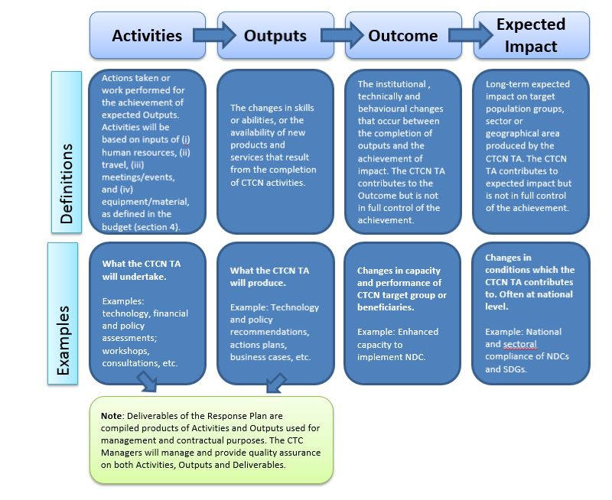

- Process for designing the Response Plan

The Response Planning process should be completed over a period of up to 60 working days (12 weeks). Indicative steps and related timelines are laid out below:
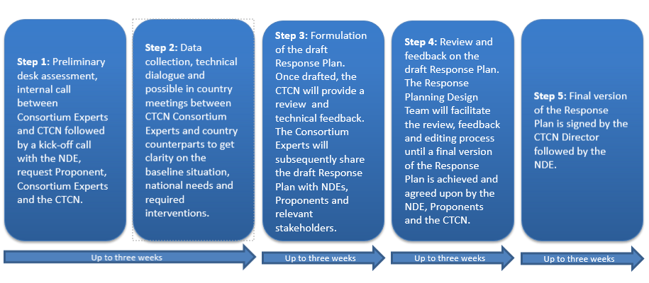

- Design Considerations

In order to maximize the impact of the technical assistance provided by the CTCN and provide an effective M&E process, the Response Plan should integrate as much as possible the considerations below:

Climate Technology focus: The Response Plan should have a clear focus on climate technologies, and identify activities that enable the identification, development, deployment or diffusion of one or several specific technologies (including equipment, techniques, knowledge and skills).

Barrier removal / Problem solving: The activities should contribute to address the specific problem statement identified in the Request. The barriers identified should be those hampering the identification, development, deployment or diffusion of one or several climate technologies or climate actions. Therefore, it may be necessary to limit the CTCN Response Plan to a set of activities for technical assistance commonly agreed with the NDE (and Proponent when needed) compared to the original request submitted. The CTCN will liaise with NDEs and Proponent in case the scope of the technical assistance deviates from the original request.

Use of the CTCN assistance by stakeholders: The Response Plan should identify clearly how the products of the CTCN assistance will be used in the short term once support is delivered, by who and when, to ensure it will lead to specific impacts in the country. The activities should engage the stakeholders that will use the concrete results of the assistance to deploy the technologies, including from the private sector, the public sector, research institutions, etc.

Within the scope of CTCN resources: The cost of the technical assistance provided by the CTCN cannot exceed USD 250,000 per Response Plan. Therefore, it may be necessary to prioritize activities and limit the CTCN Response Plan to a set of priority activities commonly agreed with the Proponent and the NDE to remain under this value. Under section 4 of the Response Plan template, an indicative activity based budget should be presented. The proposed budget is indicative and should present an estimated costing range per activity, output as well as a total costing range for the delivery of the Response Plan. Once the Response Plan is finalised and published for tendering, interested parties will provide competitive offer against the indicative budget.

CTCN activities and outputs should be linkable to monitoring and evaluation indicators: All proposed activities and outputs must be linkable to monitoring and evaluation indicators that are specific, measurable, achievable, relevant, and time-bound. The monitoring and evaluation process and corresponding indicators will be developed by the Lead Implementer as part of the work plan and will allow the CTCN technology Manager to monitor the timeliness and appropriateness of the implementation.

Synergies with existing efforts: The Response Plan should focus on activities that are not already being fully supported or that are in the process of being fully supported by another national, regional or international organization. Synergies and complementarity also require that the CTCN assistance is not duplicating past activities. It is possible in the Response Plan to indicate co-financing from the government, the Proponent or another stakeholder, that will maximize the effectiveness of the CTCN assistance.

Gender mainstreaming: The CTCN mission is to build or strengthen developing countries’ capacities to identify technology needs, to facilitate the preparation and implementation of technology projects and strategies taking into account gender considerations. The Response Plan must therefore describe how gender considerations will be included and monitored within the proposed activities, and any gender co-benefits that will be gained as a result of implementing the CTCN technical assistance. For that purpose, a Gender Assessment and Action Plan (GAAP) template has been designed to be followed by the implementation partner.

Additional information is available under Section 10 of the response plan.
All budget values related to Daily Subsistence Allowance or logistical support for local participants shall remain as indicated.
All budget values related to the organization of meetings and events shall remain as indicated.

