Closure Report for CTCN Technical Assistance

- Basic information
Title of response plan | Monitoring System of Adaptation Measures in the water sector, analysis of Barriers and Financial Sustainability for its Implementation - Peru
Technical assistance reference number | 3100005048
Country / countries | Peru
NDE organisation | Ministry of the Environment - Perú
NDE focal point | Ministry of the Environment - Perú
NDE contact information | lroque@minam.gob.pe
Proponent focal point and organisation | Patxi Greño - Metroeconomica
Designer of the response plan | Metroeconomica Ltd in association with Water, Environment and Business for Development, and Hidrika info@metroeconomica.com
Implementer(s) of technical assistance | Metroeconomica Ltd in association with Water, Environment and Business for Development, and Hidrika info@metroeconomica.com
Beneficiaries | Ministry of the Environment - Perú
Sector(s) addressed | Water
Technologies supported | Monitoring system
Implementation start date | 01/06/2022
Implementation end date | 10/11/2023
Total budget for implementation | USD 94.989
Description of delivered outputs and products as well as the activities undertaken to achieve them. In doing so, review the log frame of the original response plan and refer to it as appropriate | Outcome 1: Development of a detailed work plan and related communication documents  Activity 1.1: Detailed work plan  Activity 1.2: Monitoring and evaluation plan  Activity 1.3: Impact statement  Activity 1.4: Technical assistance closure report  Output 2: Initial analysis and diagnosis  Activity 2.1: Selection of adaptation measures  Activity 2.2: Mapping of actors  Activity 2.3: Identification and diagnosis of systems and/or platforms  Output 3: Process mapping  Activity 3.1: Elaboration of a process mapping  Output 4: Design of operational monitoring and evaluation models  Activity 4.1: Elaboration of the designs of the operational models for M&E  Output 5: Development and testing of a prototype for the M&E system  Activity 5.1: Development and testing of a prototype for the M&E system  Output 6: Analysis of barriers and financial sustainability  Activity 6.1: Review of international experiences for the maintenance of the M&E and/or MRV systems of mitigation and adaptation measures  Activity 6.2: Analysis of the current status  Activity 6.3: Recommendations for the financial sustainability of the M&E Component in the Water thematic area  Activity 6.4: Concept Note
Methodologies applied to produce outputs and products | - Stakeholder map to identify key actors.  - Multi-criteria analysis for selection key adaptation measures.  - Workshops strengthening stakeholders’ engagement.  - Platform and system diagnosis.  - Development of operational models to identify the processes to be carried out.  - Prototype development.  - Good practices analysis.
Reference to knowledge resources | NA
Deviations | As Agreed with the focal points of the Ministry of Environment and CTCN, Output 3 (Process mapping) and Output 4 (Design of operational monitoring and evaluation models) were submitted in a single deliverable.
Anticipated follow-up activities and next steps | - Harmonization of data to be collected for M&E of adaptation measures for the adaptation areas: i) Water (Water Resources); ii) Agriculture; iii) Fisheries; iv) Forestry; v) Health; vi) Transport; and vii) Tourism. Tourism  - Extension of the prototype MACC Data Management Module (Module 1) and MACC Implementation Monitoring Module (Module 2) to the components of the 7 NDC sectors.  - Pilot design of the Climate Risk Monitoring Module encompassing the adaptation sectors.  - Pilot design of the MACC Mid- and Long-term Assessment Module  - Pilot design of the Intelligent Reporting Module  - Development of the software associated with the M&E system integrated to the 5 modules in the thematic areas.  - Training and socialization of the M&E system software and implementation.

- Lessons learned
 | Lessons learned | Recommendations
Lessons learned from the CTCN TA process | Interactions with the CTCN were generally good. | No specific recommendations were identified.
Lessons learned related to climate technology transfer | Barriers to information accessibility were identified due to a lack of coordination between institutions. For example, the availability of information and the particularities of each responsible agency have influenced the speed at which data is obtained. This has hindered the construction of indicators and the development of prototypes. | Establishing protocols and  mechanisms that enable data  sharing.  Implement operational tasks to generate and improve access to the information necessary for the calculation of certain indicators.

3. Illustration of the TA and photos

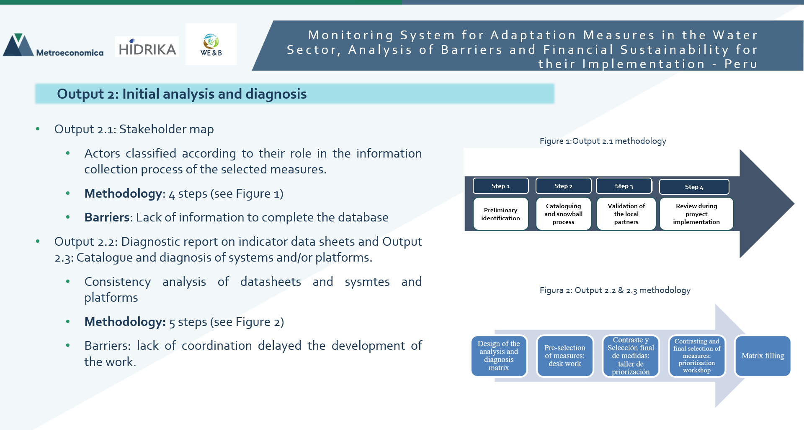
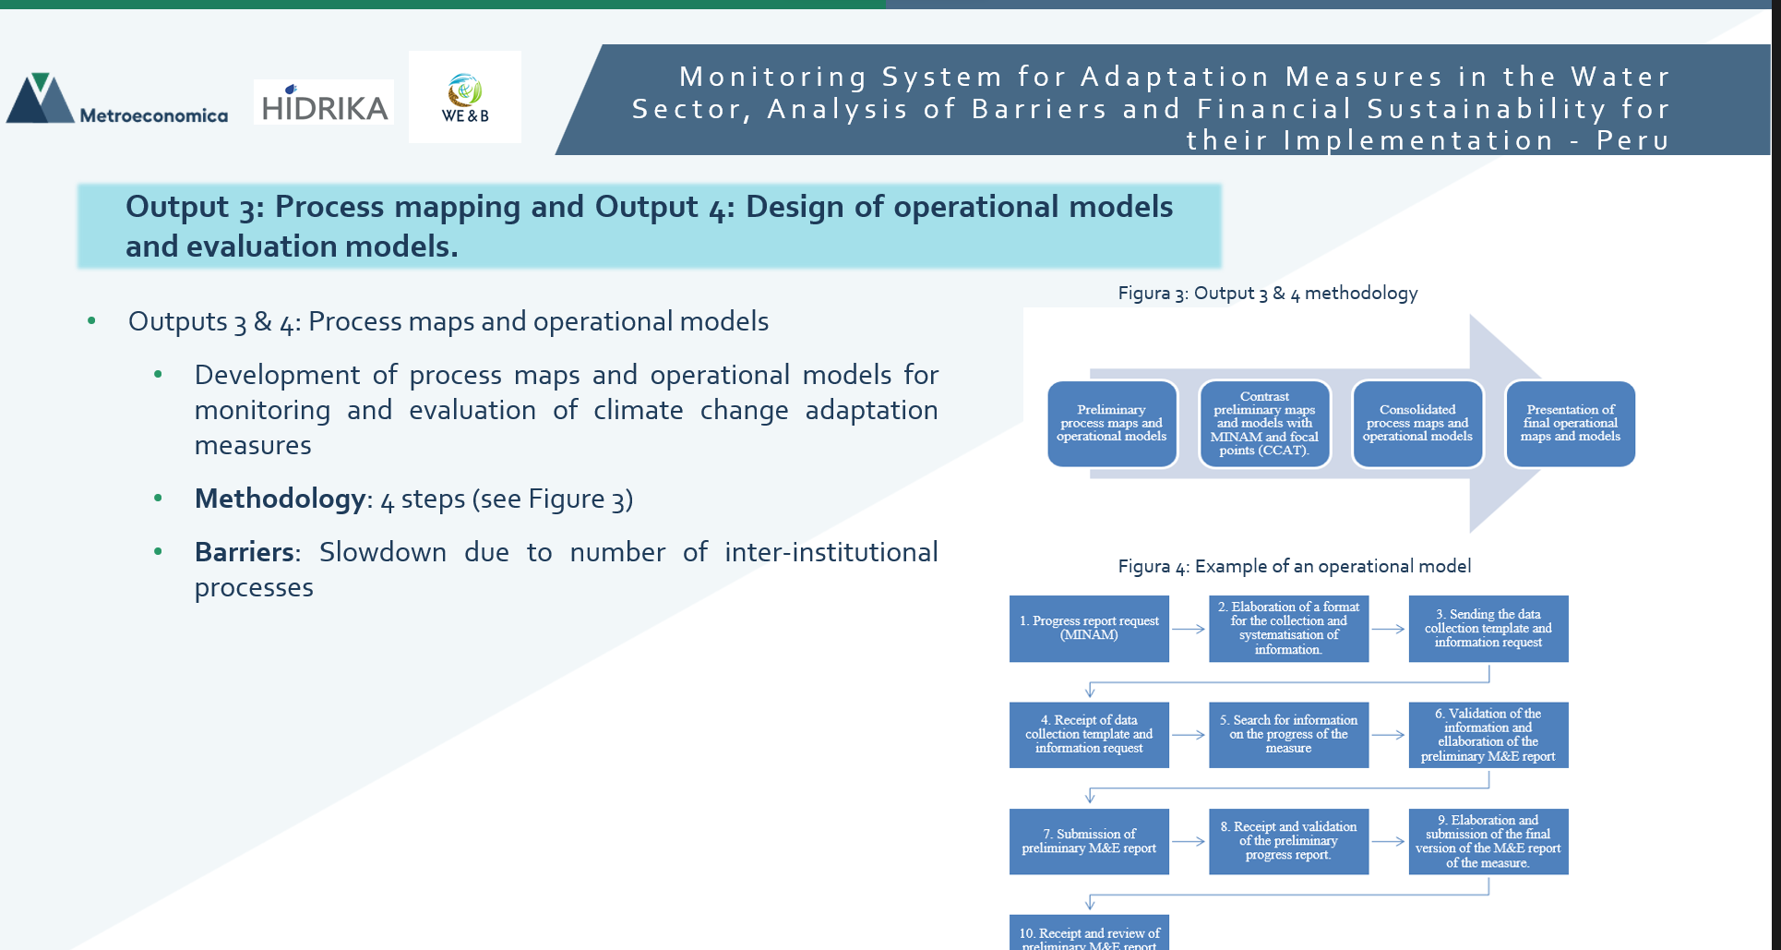

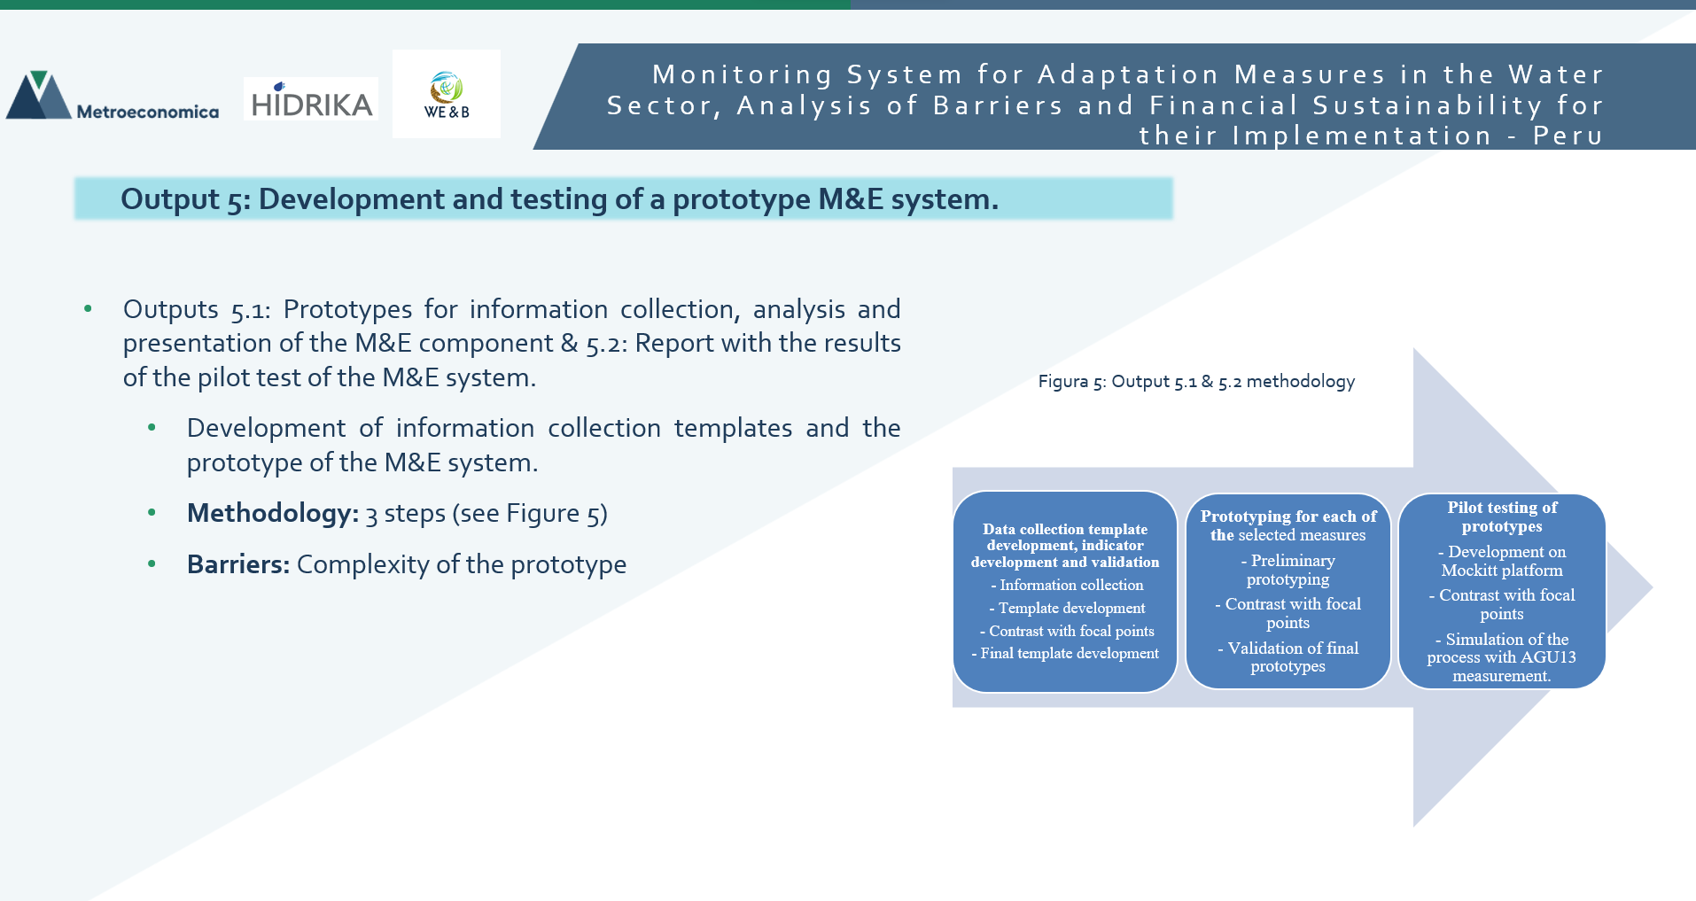

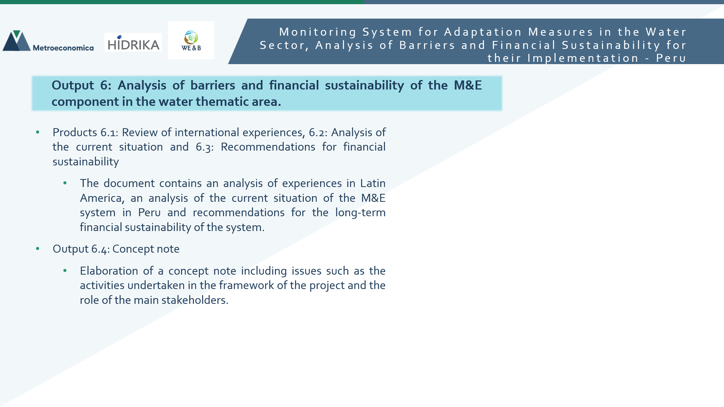
4. Impact Statement

Challenge | Peru is the 59th most water scarce country on earth. The Regulation of the Framework Law on Climate Change establishes the creation of the Monitoring of Adaptation and Mitigation Measures System. The Peruvian Ministry of the Environment developed a roadmap for the Monitoring and Evaluation of Adaptation Measures to climate change. This project contributes to the implementation of this roadmap by developing a pilot monitoring system for the implementation of adaptation measures in the water sector.
CTCN Assistance | - Development of the design phase for 15 water-related adaptation measures and analysis of the sustainability of subsequent phases  - Development of a pilot monitoring system for adaptation measures in the water sector  - The identification of barriers to the implementation of the Adaptation Monitoring System  - Development of a financial sustainability analysis
Anticipated impact | - Establishment of the 15 most important adaptation measures related to water in Peru  - Capacity to assess if measures follow the planned paths, as well as their effectiveness and how they can be improved
Co-benefits: Achieved or anticipated co-benefits from the TA | While the TA focuses on the water sector, this sector is related to multiple other areas. Therefore, the project is expected to generate multiple co-benefits in water related actors and sectors:  Agriculture: with a more resilient water sector able to provide sufficient water for irrigation  Social wellbeing: increased water security means the public has a more reliable source of water to drink and clean with.  Equality: taking gender and social standing into account the TA is able to contribute to empowerment of marginalized groups.  In addition, the pilot designed in the TA context can be extended to the other NDC sectors.
Gender aspects of the TA | Given the differing impact of water scarcity on gender, the project planned to give relevance to gender aspects and to follow a gender-integrated approach. This led to include a national expert on gender in the project. Moreover, gender was considered during stakeholder engagements.
Anticipated contribution to NDC | - Support the establishment of a monitoring and evaluation system to assess the implementation of the NDCs  - Support the coordination between institutions and sectors implementing measures highlighted in the NDC’s
The narrative story | The consolidation of a monitoring and evaluation system for adaptation measures to climate change is essential to assess the progress of adaptation interventions, how these interventions are reducing risks, improving adaptive capacity, and supporting affected populations due to climatic impacts. Moreover, such frameworks, contribute to the identification and prevention of maladaptations, which could, if not dealt with, result in the opposite outcomes of those intended.  The transversality of the adaptation measures in the water thematic area represents a challenge in the consolidation of the M&E system, since it is necessary to harmonize and homogenize the data systems at the national, regional, and sectoral levels, a task not developed before with this level of complexity. Moreover, the differing impacts faced by communities further complicates the process, with the M&E system having to incorporate these impacts and perspectives into its working.  The overarching goal of this assignment was to contribute to the implementation of the roadmap of the monitoring and evaluation component of the Monitoring System of Adaptation and Mitigation Measures of Peru.
Contribution to SDGs | As the technical assistance focuses on the monitoring and evaluation of water related adaptation measures, it contributes to SDG 6, allowing the development of a more resilient water sector able to provide communities with clean water.  Moreover, given the importance of gender perspectives within the project and the gender-water relationship, the technical assistance also contributes to SDG 5, empowering women and curbing the populations gendered relationship to water.  The establishment of the Monitoring System of Adaptation and Mitigation Measures of Peru, also, contributes to the achievement of SDG 13, providing the capacity to see if measures are following their planned paths, assessing their effectiveness and how they can be improved.

Annex 1 Technical assistance data collection

- Output and outcome indicators

Indicator  Please note indicators below highlighted as anticipated | Quantitative value  Numerals only; disaggregates must sum to the total | Qualitative description  List the various elements corresponding to the quantitative value as well as timelines and responsible institutions
Total number of events organized by proponents and implementing partners | 42
Number of participants in events organized by proponents and implementing partners | 21
- Number of men | 12
- Number of women | 9
Number of climate technology RD&D related events | NA
Number of participants in climate technology RD&D events | NA
- Number of men | NA
- Number of women | NA
Number of training organized by proponents and implementing partners | 4
Number of participants in trainings organized by proponents and implementing partners | 22
- Number of men | 13
- Number of women | 9
Total number of institutions trained | 4
- Governmental (national or subnational) | 4 | Ministry of Environment  Ministry of Energy and Mines  National Water Authority  Ministry of Housing, Construction and Sanitation
- Private sector (bank, corporation, etc.) | 0
- Nongovernmental (NGO, University, etc.) | 0
Percentage of participants reporting satisfaction with CTCN training (from CTCN training feedback form) | NA
Percentage of participants reporting increased knowledge, capacity and/or understanding as a result of CTCN training (from CTCN training feedback form) | NA
- Percentage of men | NA
- Percentage of women | NA
Total number of deliverables produced during the assistance (excluding mission, progress and internal reports) | 9
- Number of communication materials, including news releases, newsletters, articles, presentations, social media postings, etc. | 0
- Number of tools and technical documents strengthened, revised or developed | 9 | - Detailed work plan  - Impact statement  - Closure report  - Stakeholder map  - Diagnostic report of the indicator fact sheets and of the institutional systems and/or platforms.  - Process map and operational models  - Development and testing of a prototype M&E system  - Conceptual note  - analysis of barriers and financial sustainability of implementation
- Number of other information materials strengthened, revised or created (For example training and workshop reports, Power Points, exercise docs etc.) | 0
Total number of policies, strategies, plans, laws, agreements or regulations supported by the assistance | 0
- Adaptation related | 0
- Mitigation related | 0
- Both adaptation- and mitigation related | 0
Anticipated number of policies, strategies, plans, laws, agreements or regulations proposed, adopted or implemented as a result of the TA | 0
- Adaptation related | 0
- Mitigation related | 0
- Both adaptation- and mitigation related | 0
Anticipated number of technologies transferred or deployed as a result of CTCN support | 1 | M&E system
Anticipated number of collaborations facilitated or enabled as a result of technical assistance | 0
- Number of South-South collaborations | 0
- Number of RD&D collaborations | 0
- Number of private sector collaborations | 0
Number of countries with strengthened National System of Innovation as a result of CTCN support | 1 | Perú
Insert any additional indicators here | NA

- Core impact indicators
Core indicator 1 | Anticipated metric tons of CO₂ equivalent (CO₂e) emissions reduced or avoided as a result of CTCN TA  Please add your calculations in word or excel format as an Annex to this Closure Report, where applicable.
 | Anticipated metric tons of CO₂e reduced or avoided as a result of the TA on annual basis | Anticipated metric tons of CO₂e reduced or avoided as a result of the TA in total
Quantitative value  (emissions reductions) | Total number (numerals only, no rounding or abbreviations) | Total number (numerals only, no rounding or abbreviations)
Unit | tCO₂e | tCO₂e
GHG assessment boundary (project emissions)

Identify expected post-TA activities, associated effects and assess boundary for quantification of GHG emission reductions
Baseline emissions

Describe baseline scenario, baseline candidates, emission factors and emissions calculated
Methodology

Explain the method or process of verifying the indicator and how data was gathered
Assumptions
Describe assumptions made during calculation and quantification of GHG reductions

Core indicator 2 | Anticipated increased economic, health, well-being, infrastructure and built environment, and ecosystems resilience to climate change impacts as a result of technical assistance.  Please provide a qualitative description of the anticipated impacts on the categories below
Infrastructure and built environment  Anticipated increased infrastructure resilience (avoided/mitigated climate induced damages and strengthened physical assets) | The monitoring and evaluation system developed in the framework of the technical assistance allows tracking the expected and observed results of policies aimed at improving infrastructure resilience, especially housing resilience through the measures of the population use component. Future use of this system will increase the resilience of infrastructure to climatic phenomena such as drought.
Ecosystems and biodiversity  Anticipated increased ecosystem resilience (areas with increased resistance to climate-induced disturbances and with improved recovery rates) | NA
Economic  Anticipated increased economic resilience (e.g. less reliance on vulnerable economic sectors or diversification of livelihood) | The monitoring and evaluation system developed in the framework of the technical assistance allows tracking the expected and observed results of policies aimed at improving the resilience of economic sectors vulnerable to climate change, especially in the field of energy. For example, this system, which will be implemented in the future, will monitor the implementation of good practices in energy consumption in the economic sectors, thus improving the productivity of the sectors.
Health and wellbeing  Anticipated increased health and wellbeing of target group (e.g. improved basic health, water and food security) | The monitoring and evaluation system developed in the framework of the technical assistance allows tracking the expected and observed results of policies aimed at improving health resilience and well-being. For example, this system to be implemented in the future will monitor measures to ensure water provision in areas considered vulnerable.

Core indicator 3 | Anticipated number of direct and indirect beneficiaries as a result of the TA
 | Quantitative value | Means of verification
Total beneficiaries | 32.131.400 – INEI population estimate 2020 for Perú | The provision of this technical assistance has developed a monitoring and evaluation system that will support the future improvement of measurement, and therefore compliance with climate change adaptation measures, thus promoting resilience to climate impacts for the entire population of Peru.
Number of adaptation beneficiaries | 32.131.400 INEI population estimate 2020 for Perú
Number of mitigation beneficiaries
Number of adaptation-and mitigation beneficiaries

Core indicator 4 | Anticipated amount of funding/investment leveraged (USD) as a result of TA (disaggregated by public, private, national, and international sources, as well as between anticipated/confirmed funding)
 | Quantitative value confirmed in USD | Quantitative value anticipated in USD | Qualitative description  List the institutions, timelines, and description or title of the investment | Methods  Describe methods used for quantification of funds leveraged
Total funding | Total number in USD (numerals only, no rounding or abbreviations) | Total number in USD (numerals only, no rounding or abbreviations)
Anticipated amount of public funding mobilised from national/domestic sources
Anticipated amount of public funding mobilised from international/ regional sources
Anticipated amount of private funding mobilised from national/domestic sources
Anticipated amount of private funds mobilised from international/regional sources

Annex 2 (for internal use – to be filled in by the CTCN)
CTCN evaluation
This section will be completed by the relevant CTCN Technology Manager.

- Evaluation of the timeliness of the TA implementation as measured against the timeline included in the response plan;
- Evaluation of TA quality as defined in the response plan;
- Overall performance of the Implementers;
- Overall engagement of the NDE and Proponent;
- Lessons learned on the CTCN process and steps taken by the CTCN to improve.

The number of events organized considers both remote follow-up meetings with MINAM and face-to-face meetings with other ministries.

