Technical Assistance Closure Report Template
Objective of the technical assistance (TA) Closure Report:
- To communicate publicly in one document a summary of progress made and lessons learned during the TA towards the anticipated impact (sections 1-4).
- To document qualitative and quantitative data collected during TA, for use in donor and UN reporting (Annex 1).

Steps for completing the TA closure report:
- The lead TA implementer submits the closure report at the end of the technical assistance as a final deliverable. The TA closure report will capture outputs, outcomes and impacts of all activities conducted under the TA. Please copy and summarise relevant material from previous TA outputs/deliverables and the Response Plan, as relevant.
- A CTCN Manager will review and revise the closure report before final approval by the CTCN Deputy Director.

Important note on public and internal use of the closure report:
Once approved by the CTCN Deputy Director, the TA closure report will be a public document available on the CTCN website www.ctc-n.org. Selected content will be used for targeted communication activities. Annex 2 is for internal use only and will not be publicly available.

Closure Report for CTCN Technical Assistance

- Basic information
Title of response plan | Enhance the resilience of Suriname´s water supply system by modelling drought  risks and developing a roadmap of prioritized alternatives for aquifer recharge.
Technical assistance reference number | AF-2021000199/2023000037
Country / countries | Suriname
NDE organisation | Ministry of Oil, Gas and Environment of the Republic of Suriname; Min. OGM (Previously Ministry of Spatial Planning & Environment; Min. ROM)
NDE focal point | Mr. Ritesh Sardjoe
NDE contact information | Email address  ritesh.sardjoe@gov.sr
Proponent focal point and organisation | Name, organization, email  Mr. Ritesh Sardjoe, Ministry of Oil, Gas and Environment of the Republic of Suriname , ritesh.sardjoe@gov.sr  Prins Hendrikstraat 22  Paramaribo, Suriname  Nationale Milieu Autoriteit; NMA, former National Environmental Authority (NIMOS)  Mrs. Vanuessa Gefferie, Director
Designer of the response plan | Name, organization, email  Rajiv Garg, CTCN Director, Rajiv.garg@unep.org
Implementer(s) of technical assistance | Instruction: Implementers and other partner organisations are defined as the people and institutions engaged in the implementation of the TA  - ILACO Suriname N.V.  - Acacia Water  - HaskoningDHV (Royal HaskoningDHV)
Beneficiaries | Instruction: Beneficiaries are defined as people and institutions benefitting from the TA  A. Stakeholders affecting the Lack of Water Supply Influence Interest Impact  1. Water Supply Companies  2. Industrial Sectors  3. Government Agencies  4. Urban Developers  5. Agricultural Practices  B. Stakeholders impacted by the Lack of Water Supply:  1. Water Supply Companies  2. Local Communities  3. Agricultural Producers  4. Health Institutions  5. Businesses/Organizations  C. Policymakers, Data-collection/Research, Knowledge Institutes  1. Government Officials  2. Environmental NGOs  3. International Organizations
Sector(s) addressed | Instruction: Select relevant sector(s) from the CTCN taxonomy https://www.ctc-n.org/resources/ctcn-taxonomy  Water supply  Groundwater
Technologies supported | Instruction: Please indicate the type of technologies supported by this assistance. Technologies may be identified from the CTCN taxonomy of climate sectors and technologies (download in pdf format and choose from column C): https://www.ctc-n.org/resources/ctcn-taxonomy  If technologies supported are not found in the taxonomy, please suggest.  - Geo hydrology  - Water treatment  - Aquifer recharge
Implementation start date | (DD/MM/YYYY)  13th September 2024
Implementation end date | (DD/MM/YYYY)  19th December 2025
Total budget for implementation | Instruction: In addition to financial value of the technical assistance, please also include if any pro bono or in-kind support has been provided by either the implementer and/or the national counterparts.  USD 193,000
Description of delivered outputs and products as well as the activities undertaken to achieve them. In doing so, review the log frame of the original response plan and refer to it as appropriate | Mandatory Deliverables:  i) Implementation plan  ii) Monitoring and evaluation plan  iii) Impact statement (initial and final version)  iv) Adaptation Fund Result Tracker at start, midterm, and closure  v) Gender assessment  vi) Technical assistance closure report  Activities undertaken: For the key deliverables, existing information was used as the primary basis, and gaps were filled where possible using available data and analysis.  Deliverables:  1.1 Report on stakeholder mapping  1.2 Detailed description of the stakeholder working group, with name and contact details of the  members, respective institutions, gender, etc.  1.3 Minute of the inception meeting including a list of participants disaggregated by gender, the  material used for the presentation  Activities undertaken: Stakeholders were identified based on their affiliations with, interests in, and experience in the water supply sector. Subsequently, a workshop was organized during which a permanent Stakeholder Working Group was established. The selection of members was based on the consideration to make effective use of already existing structures within the water sector that have similar purposes and scopes, complemented by additional relevant stakeholders such as grassroots organizations and entrepreneurs.  Deliverables:  2.1 Suriname drought assessment, selection of the pilot area, minute of the meeting with the  stakeholder working group and representative of the selected commune.  2.2 Detailed report on the 3D mapping of aquifers in Suriname  2.3 Report on the water balance in Suriname  2.4 Report on water conservation measures and technologies recommended to save water in the  high consuming water sectors.  2.5 Minute of the SWG meeting with a list of participants disaggregated by gender, material used,  and summary of the discussions held.  Activities undertaken: The list of required data was shared with the client, after which the consultants collected the available data. Sufficient data were obtained to ensure timely project progress.  Key stakeholders were contacted to provide the required data. NH was contacted by email in the second week of December. OW, including MDS and WLA, was contacted by email in the second week of December and visited in the third week of December, resulting in the receipt of some data.  Other stakeholders did not respond or were unable to provide data due to lack of permission. In addition, extensive self-research was conducted using existing data and reports.  Deliverables:  3.1 Benchmarking of technologies for groundwater recharge, identification of the suitable  technologies in the context of Suriname, including the prioritization and selection of the suitable  technology(ies).  3.2 Report on the existing pre-treatment technologies to be used before the water is being recharged  to the groundwater, identification of the suitable technologies in the context of Suriname, including  the prioritization of the suitable technologies.  3.3 Minute of the meeting and selection of the technologies to be designed  3.4 Design of the full system for that will enable Suriname to recharge its aquifer in time of drought in  a sustainable, clean, and safe manner.  3.5 Cost analysis of the full system  3.6 Benchmark of the financial sources that could finance a pilot and scale up of the architecture of  Aquifer recharge  3.7 Minute of the full day meeting including a list of participants disaggregated by gender, materials  used for the session, photos.  Activities undertaken: The water treatment system is based on a Managed Aquifer Recharge (MAR) approach. A pilot site was selected in Hanover, utilizing riverbank infiltration. The selection was made during the second SWG Workshop, during which five pilot proposals were presented. A preliminary wellfield design was developed based on the geophysical survey. Subsequently, a conceptual design was prepared based on the wells that will serve as the intake source. For this purpose, a general cost analysis was conducted, along with benchmarking of potential financial sources.  Summary of the Deliverables submitted:  - Gender analysis  - Staekholder mapping  - Inception & Implementation  - Drought analysis & water balances  - Design of MAR technology  - Cost analysis & Benchmarking financial sources  Other Mandatory Deliverables:  - Monitoring & Evaluation (M&E) Plan and Impact Statement Form  - AFCIA Results tracker Suriname  - Technical Assistance Closure Report
Methodologies applied to produce outputs and products | Instruction: Examples of methodologies: E.g. cost-benefit analysis; surveys and structured interviews with key stakeholders etc.  Methodology:  Phase 1 – Inception  This phase focused on establishing the project foundation through stakeholder and gender analysis, an inventory of available data, and the setup of a Stakeholder Working Group (SWG). Initial consultations were conducted and the inception report was prepared and finalized.  Phase 2 – Analysis  The analysis phase assessed drought and climate conditions, water demand, aquifer characteristics, and water balances. Suitable Managed Aquifer Recharge (MAR) technologies were reviewed, leading to the preselection of five potential pilot sites. Consultations with the SWG supported the evaluation and final selection of the pilot site.  Phase 3 – Conceptual Design  This phase developed the conceptual MAR system design through consultations with local stakeholders, 3D aquifer mapping using geophysical methods and studies on wells, water quality, and pre-treatment needs. A draft MAR design was prepared and validated with the SWG. The phase concluded with benchmarking of potential financing sources and a final workshop to promote a broader understanding of groundwater management and MAR among stakeholders.
Reference to knowledge resources | Instruction: Please indicate if any UNFCCC Technology Executive Committee (TEC) knowledge products (publications, briefs, tools etc.) were used in the implementation of the TA request, and which.  Link to TEC knowledge database: https://unfccc.int/ttclear/tec/documents.html  No UNFCCC Technology Executive Committee (TEC) knowledge products (publications, briefs, tools etc.) were used in the development of the TA request.
Deviations | Instruction: Please describe any deviations from the response plan against the actual implemented activities, outputs and products  No significant deviations from the response plan have occurred
Anticipated follow-up activities and next steps | Instruction: Please describe planned follow-up activities after completion of technical assistance, including information on involved stakeholders and anticipated timelines.  The following are some examples of next steps:  - Submission of a draft law/policy developed by the CTCN to cabinet/parliament.  - Follow-up and formal submission of funding proposal drafted with support from the CTCN.  - Implementation of activities designed by the CTCN.  - Dissemination of report drafted by the CTCN.  Use of new expertise acquired during training led by CTCN.  Recommendations were made for follow-up actions and financing, but there are no concrete anticipated follow-up activities or next steps planned after the completion of this project.  During the workshops, stakeholders were connected to each other for potential collaboration and possible investments.

- Lessons learned
 | Lessons learned | Recommendations
Lessons learned from the CTCN TA process | Describe lessons learned from following the steps of the TA process and interacting with the CTCN Secretariat. What were the challenges and essential factors contributing to successful implementation  - Qualitative data and information not available on time (delay occurred)  - Stakeholders group formation takes longer than expected  - Lack of familiarity with the templates | Recommendations include  - Steps which could be taken to improve the CTCN TA process  - Considerations for increased success of similar efforts (i.e. regulatory, legal, stakeholders, communication, etc.)  - Communicate data requirements early and identify alternative sources.  - Use existing sector platforms and define a clear selection process for stakeholders.  - Provide guidance and examples to improve familiarity with templates.
Lessons learned related to climate technology transfer | Describe lessons learned, opportunities, and barriers for the use and deployment of the technology or technologies supported by the TA. The objective is to identify specific success factors for technology transfer  - Knowledge was transferred to SWG members, the pool of experts, and other relevant stakeholders from both the public and private sectors. Local personnel were involved in conducting the geophysical surveys and gained hands-on experience in groundwater studies and measurement techniques.  - Communities in the interior are actively engaged in managing groundwater sources and drinking water supply systems.  - Three water-related laws are currently under preparation and will be further developed.  - Awareness has been raised about protecting the area, emphasizing that no activities or deforestation should take place within the protected zones. | Recommendations include  - Risk mitigation measures  - Identified opportunities for over-coming barriers  - Long-term sustainability (e.g. building endogenous capacities, funding opportunities, etc.)  - Knowledge Transfer: Continue capacity building and training for SWG members, local staff, and stakeholders to strengthen technical skills and knowledge in groundwater management.  - Community Engagement: Support and expand local initiatives in the interior to sustainably manage groundwater and drinking water systems.  - Water Legislation: Accelerate the development and implementation of the three water laws, ensuring stakeholder consultation and alignment with national water management strategies.  - Awareness & Protection: Maintain and strengthen awareness campaigns on environmental protection, restricting activities and deforestation in critical groundwater recharge areas.

3. Illustration of the TA and photos
For communication purposes, please provide 2-4 Power Point slides, including illustrations or charts, describing barriers, opportunities, methodology, activities, outputs and achieved results. The illustrations must be copied into the TA Closure report but must also be delivered as power point files. Also, please provide at least five high-resolution pictures in jpg format, capturing technical assistance. The pictures should illustrate how the TA has impacted the lives of the beneficiaries in particular and the communities in general.

See the photos below for an overview of some of the activities, outputs and achieved results.
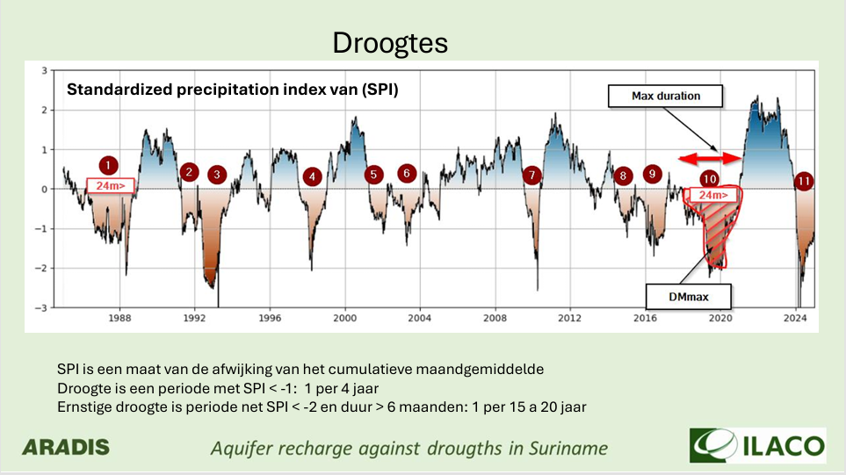
Figure 1 Overview of drought analysis
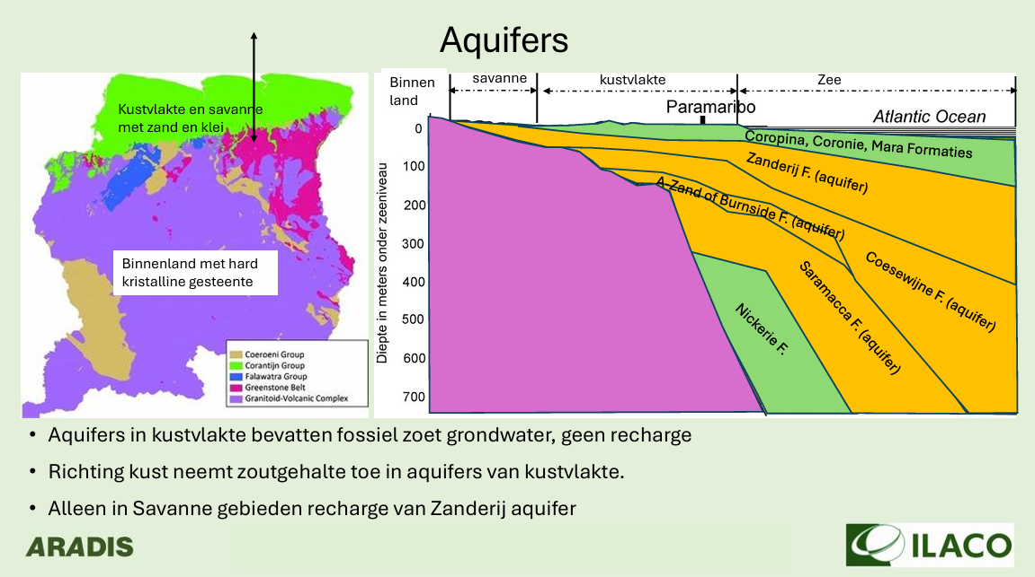
Figure 2 Overview of aquifers
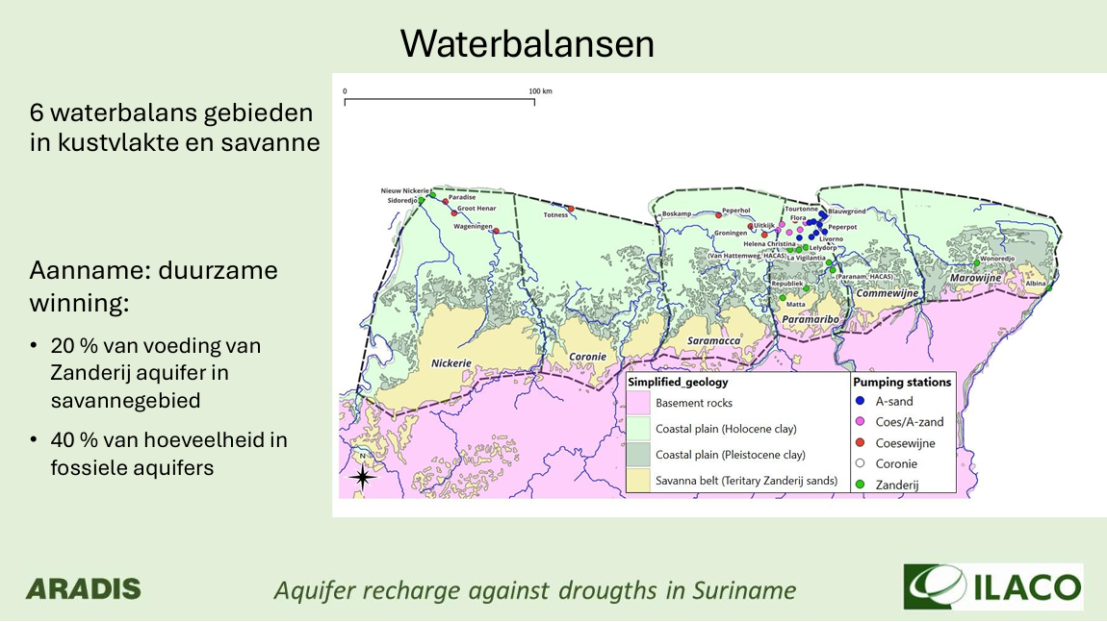
Figure 3 Overview of water balance areas
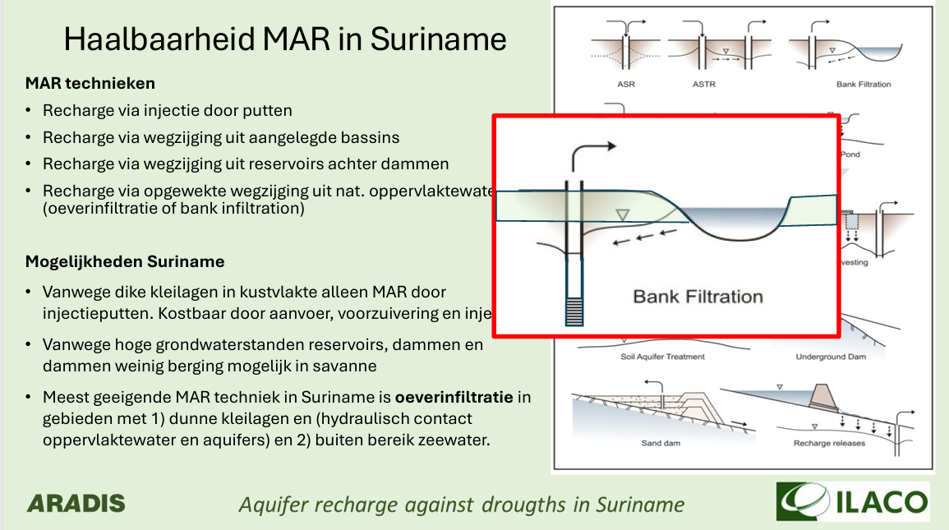Figure 4 Overview of the feasibility of MAR in Suriname

See the photos below highlighting the project’s community impact.
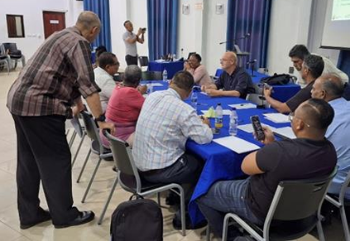
Figure 5 The Stakeholders Working Group (SWG) brainstorming with full support and guidance of ILACO

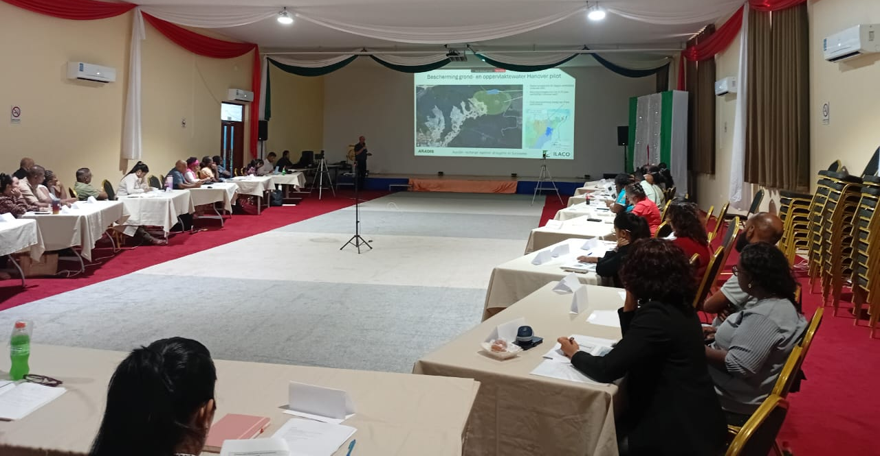
Figure 6 Overview of stakeholders who participated in the 4th Stakeholders Workshop
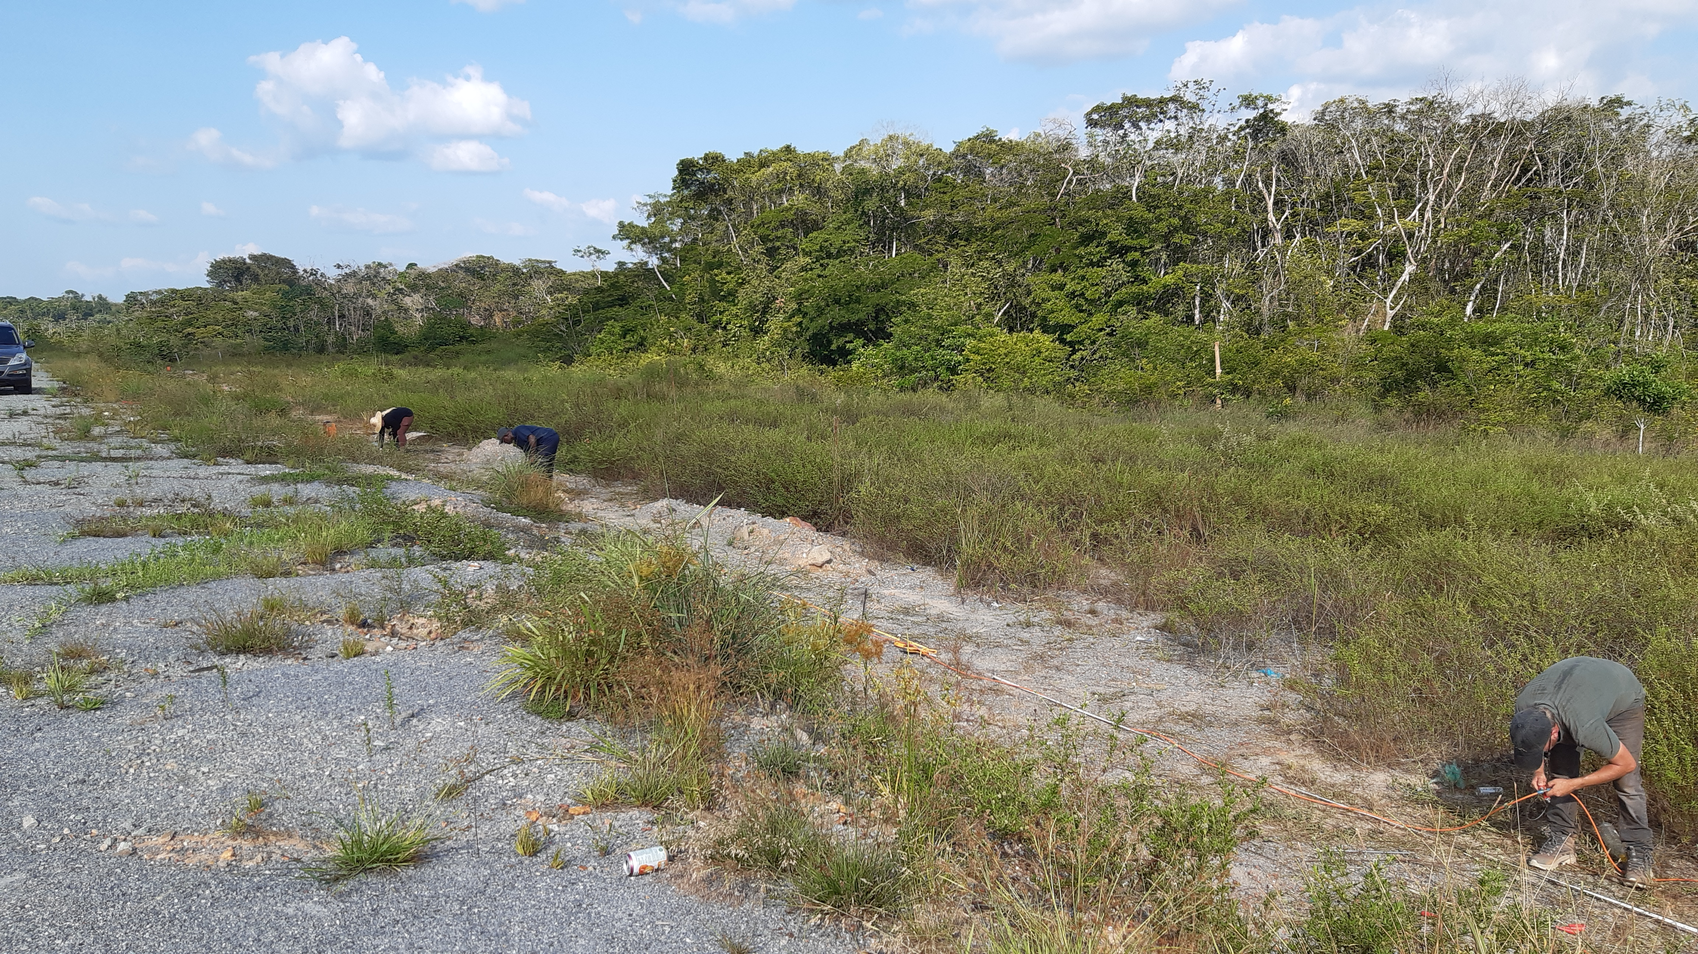
Figure 7 Geophysical surveys conducted along the Bouterse Highway #1
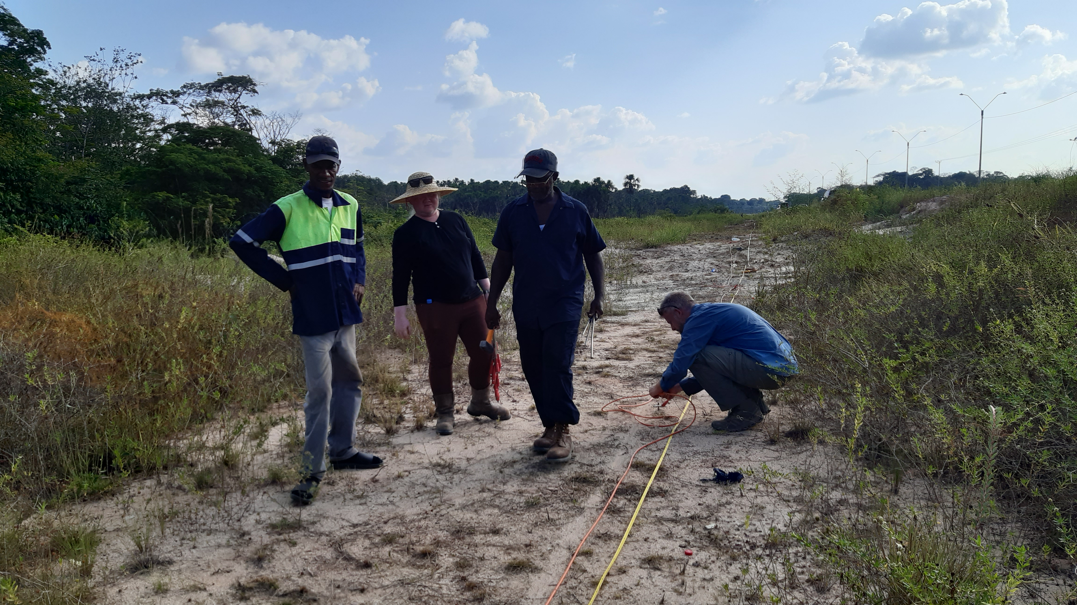
Figure 8 Geophysical surveys conducted along the Bouterse Highway #2
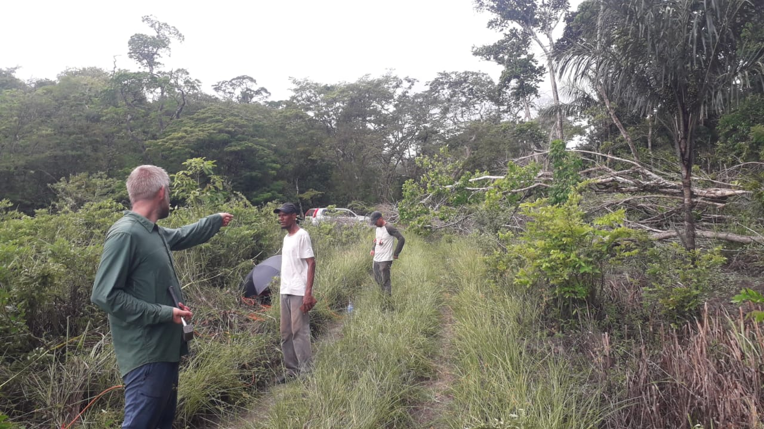
Figure 9 Geophysical surveys at the Hanover Settlement
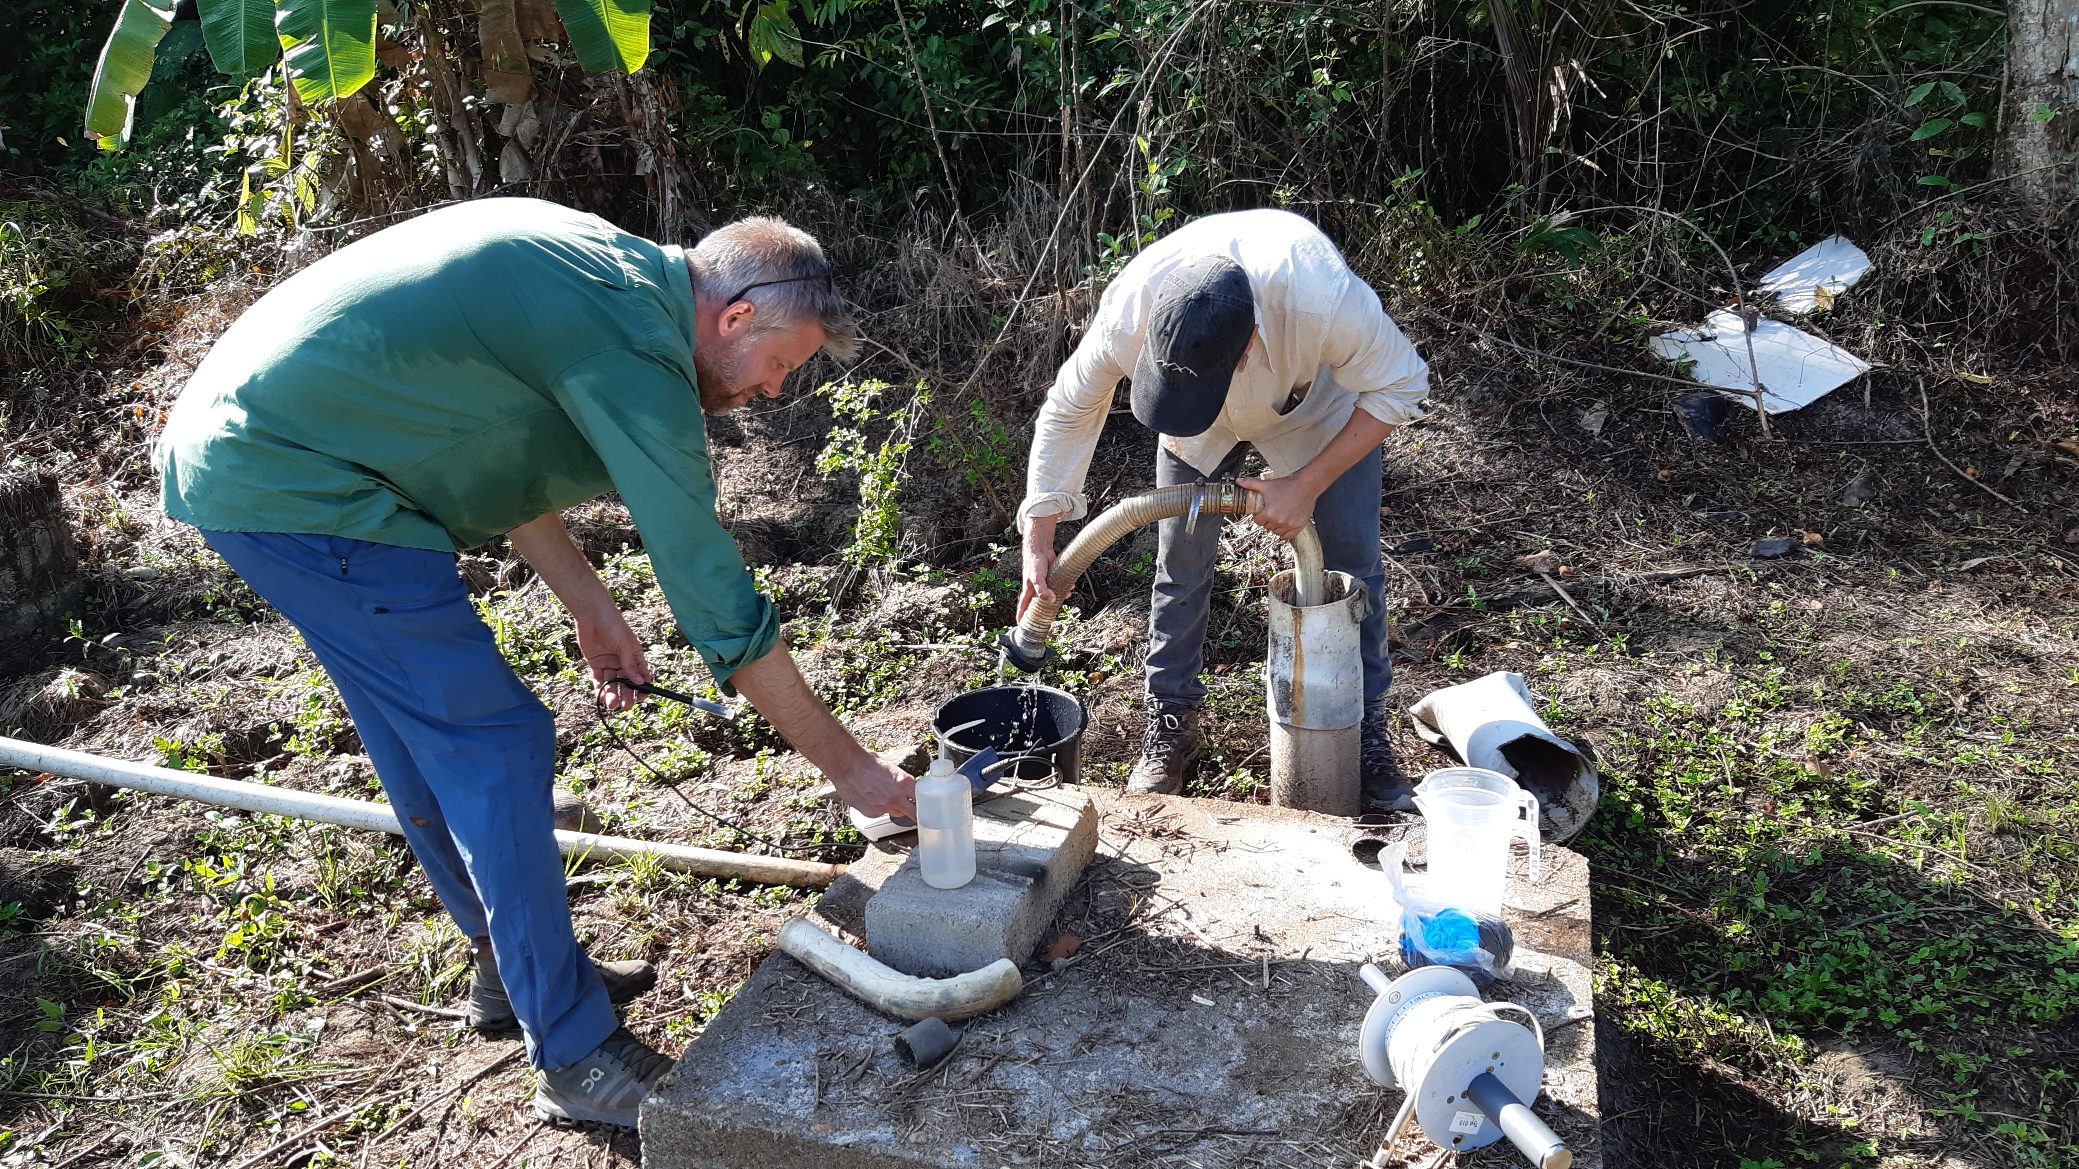
Figure 10 Abstraction of groundwater from a well at Hanover for water quality analysis
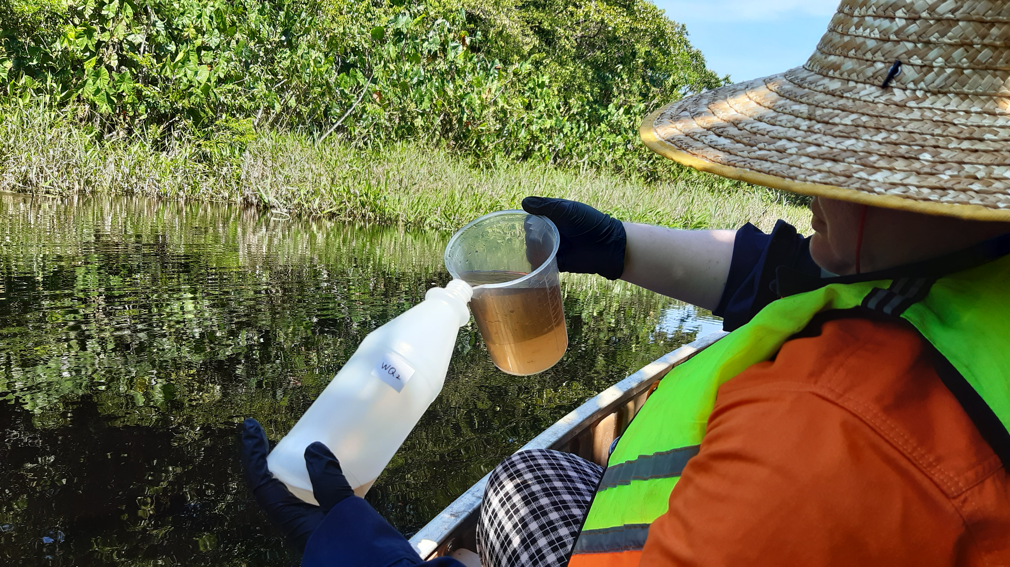
Figure 11 Collection of water sample from the Para River for water quality analysis
4. Impact Statement
The information in the table below will be used to communicate results and anticipated impacts of this technical assistance publicly. Please copy information from impact statement developed in the M&E Plan and update as relevant.

Challenge | Approx. 500 characters with spaces
CTCN Assistance | 2 to 4 bullet points. Approximately 450 characters with spaces  Ramiro Salinas is asked for guidance and assistance, which he willingly proposed and accepted. Guidance has been successfully received throughout the project..
Anticipated impact | Summarize the problem statement and desired impact. Describe how the TA is expected to lead to the desired impact. Include description of stakeholders, deliverables and timelines. As a minimum, please include at least one of the core impact indicators from the closure report Annex.  Enough data collected and qualitatively enough to support insights study and analysis, which resulted in a qualitative end-presentation and report.
Co-benefits: Achieved or anticipated co-benefits from the TA | Instruction: Please indicate expected co-benefits as described in the response plan and in the relevant deliverables  - Experience with working with CTCN  - Systematic approach according to CTCN procedures adapted  - Local knowledge & experience fieldwork gained  - Stakeholdermapping  - Drought analyses  - MAR Technologies & Possibilities implemented, discussed & shared
Gender aspects of the TA | Instruction: Please indicate if technical assistance was supported by a gender analysis. Describe gender aspects identified and additional considerations taken to mainstream gender (e.g. equal participation in trainings, gathering of gender-disaggregated data, etc.).  This project started & is based on a special gender & social analysis prior to any other components.
Anticipated contribution to NDC | 2 to 4 bullet points. Approximately 350 characters with spaces  1. Capacity building  2. Transfer of knowledge & insights  3. Transfer of experience in especially field surveying  4. Insight in potential groundwater capacity  5. Awareness of the importance of protection water resources & areas (groundwater resources)
The narrative story | Approximately 1200 characters with spaces  Please provide a brief description of the background and context for the technical assistance. Describe the main problems and barriers for climate change mitigation and/or adaptation in terms of climate technologies that the CTCN technical assistance will address.  Background and context:  The water supply in Greater Paramaribo, the most populated area in Suriname, relies almost entirely on groundwater extraction, which represents about 85% of the overall groundwater exploitation in the country. The most important and most exploited freshwater aquifers are the A Sand aquifer, the Coesewijne aquifer, and the Zanderij aquifer. Several other aquifers are deemed not to be suitable for exploitation because of their size, their depth of the water table and the potential high levels of salinity. Therefore, one of the major difficulties in providing an appropriate and sustainable supply of potable water from groundwater resources is the uncertainty with respect to the safe yield of suitable aquifers for water supply.  Considering the extent of saline intrusion in surface waters along the coast, water supply for the coastal areas will continue to be met in its majority by groundwater. To protect and guarantee a reliable and affordable provision of potable water from groundwater resources, and to support the  planning of future water supply development and improvement projects, the Government of Suriname requested to conduct a comprehensive drought assessment and a detailed analysis of aquifer recharge solutions.  Problem statement:  The water supply in Greater Paramaribo, the most populated area in Suriname, relies almost entirely on groundwater extraction, which represents about 85% of the overall groundwater exploitation in the country. The most important and most exploited freshwater aquifers are the A Sand aquifer, the Coesewijne aquifer, and the Zanderij aquifer. Several other aquifers are deemed not to be suitable for exploitation because of their size, their depth of the water table and the potential high levels of salinity. Therefore, one of the major difficulties in providing an appropriate and sustainable supply of potable water from groundwater resources is the uncertainty with respect to the safe yield of suitable aquifers for water supply.  The 2011 Suriname Water Supply Master Plan, financed through ATN/SF-11374-SU, identified clear signs of saline intrusion in the northern stations of the Grater Paramaribo area (A Sand and Coesewijne). The assessment revealed that the available groundwater yield in the Greater Paramaribo Area is conservatively estimated at 12,500m 3 /h for the next 15 years. However, after that length of time, this yield will have to be drastically reduced because of a salinity increase due to heavily exploitation of the A-Sand and Coesewijne aquifers, which are not recharged with new and fresh water as they are confined aquifers. In the long term, increases in the level of salinity intrusion will limit the yield of several fields.  Considering the extent of saline intrusion in surface waters along the coast, water supply for the coastal areas will continue to be met in its majority by groundwater. In order to protect and guarantee a reliable and affordable provision of potable water from groundwater resources, and to support the planning of future water supply development and improvement projects, the Government of Suriname requested to conduct a comprehensive dedicated hydrogeological study to evaluate the real groundwater level of the most vulnerable aquifers to evaluate their potential for supplying the total yield that would be required passed the period of 15 years.  The objective of this Technical Assistance (TA) is to contribute to the provision of sustainable water services to the population of Suriname, through: (i) the assessment of the potential and groundwater level of the Costal aquifer in Suriname; and (ii) the identification of suitable aquifer recharge solutions.  End Result:  - the assessment of the potential and groundwater level of the Costal aquifer in Suriname: this has been incorporated into the aquifer mapping and water balance analysis.  - the identification of suitable aquifer recharge solutions: out of six different MAR technologies, riverbank infiltration was selected as the most suitable option.
Contribution to SDGs  A complete list of SDGs and their targets is available here: https://sustainabledevelopment.un.org/partnership/register/ | To the extent possible, please describe contribution to approximately 3 SDGs, including SDG13, with a few sentences for each SDG concerned.  1. SDG: End poverty in all its forms everywhere  Direct contribution from CTCN TA: The Technical Assistance will map drought risks through GIS and design an aquifer mapping architecture that will therefore support food security and increase the income of rural communities.  2. SDG: End hunger, achieve food security and improved  nutrition, and promote sustainable agriculture  Direct contribution from CTCN TA: The TA will assess the vulnerability of the country define the water balance and identify the most suitable technologies to manage the water resources and recharge the groundwater in times of drought.  3. SDG: Take urgent action to combat climate change and its impacts  Direct contribution from CTCN TA: The system will consist of various aspects that will be useful for planning and conservation of water resources in a small island of the pacific.  3.1 SDG: Strengthen resilience and adaptive capacity to climate-related hazards and natural disasters in all countries  Direct contribution from CTCN TA: This climate technology will help Suriname to become more resilient to the effects of climate change  3.2 SDG: Integrate climate change measures into  national policies, strategies, and planning  3.3 SDG: Improve education, awareness-raising and human and institutional capacity on climate change mitigation, adaptation, impact reduction and early warning  Direct contribution from CTCN TA: The project includes numerous workshops, meetings and 46months of testing of the drought prediction model.  3.4 SDG: Implement the commitment undertaken by developed-country parties to the United Nations Framework Convention on Climate Change to a goal of mobilizing jointly $100 billion annually by 2020 from all sources to address the needs of developing countries in the context of meaningful mitigation actions and transparency on implementation and fully operationalize the Green Climate Fund through its capitalization as soon as possible  3.5 SDG: Promote mechanisms for raising capacity  for effective climate change-related planning  and management in least developed countries  and small island developing States, including  focusing on women, youth, and local and  marginalized communities  Direct contribution from CTCN TA: The drought prediction system is a  planning tool.

Annex 1 Technical assistance data collection

Please add quantitative and qualitative values for the indicators selected in the M&E plan and monitored throughout the technical assistance in the tables below. Indicators which have been monitored in addition to the proposed indicators below may be added at the end of table A. Non-relevant indicators should be left blank.

- Output and outcome indicators

Indicator  Please note indicators below highlighted as anticipated | Quantitative value  Numerals only; disaggregates must sum to the total | Qualitative description  List the various elements corresponding to the quantitative value as well as timelines and responsible institutions
Total number of events organized by proponents and implementing partners | 4 Stakeholder Working Group (SWG) Workshops | - 1ST SWG Workshop was held on 5 December 2024 by ILACO N.V.  - 2ND SWG Workshop was held on 15 April 2025 by ILACO N.V.  - 3rd SWG Workhsop was held 13 November 2025 by ILACO N.V.  - 4th SWG Workshop was held on 12 December 2025 by ILACO N.V.
Number of participants in events organized by proponents and implementing partners
- Number of men | List total number here  - 1st SWG Workshop: 15  - 2nd SWG Workshop: 15  - 3rd SWG Workshop: 12  - 4th SWG Workshop: 24 | Disaggregate by country  Suriname (there were also participants with other nationalities such as the Netherlands and Ukraine)
- Number of women | - 1st SWG Workshop: 12  - 2nd SWG Workshop: 7  - 3rd SWG Workshop: 16  - 4th SWG Workshop: 32 | Suriname (there were also participants with other nationalities such as the Netherlands and Ukraine)
Number of climate technology Research, Development & Demonstration (RD&D related events | NA
Number of participants in climate technology RD&D events | List total number here
- Number of men
- Number of women
Number of training organized by proponents and implementing partners | List total number here  NA.  No specific training other than the transfer of knowledge during the project and stakeholders workshops. | List the title of the training sessions and capacity strengthening activities
Number of participants in trainings organized by proponents and implementing partners | List total number here
- Number of men | NA
- Number of women | NA
Total number of institutions trained | List total number here  NA (see previous answer)
- Governmental (national or subnational) | NA | List the name of organisations trained here
- Private sector (bank, corporation, etc.) | NA | List the name of organisations trained here
- Nongovernmental (NGO, University, etc.) | NA | List the name of organisations trained here
Percentage of participants reporting satisfaction with CTCN training (from CTCN training feedback form) | NA | Satisfied= 4+ on 5-pt scale
Percentage of participants reporting increased knowledge, capacity and/or understanding as a result of CTCN training (from CTCN training feedback form) |  | Increased knowledge, capacity and/or understanding= 4+ on 5-pt scale
- Percentage of men | NA
- Percentage of women | NA
Total number of deliverables produced during the assistance (excluding mission, progress and internal reports) | List total number here
- Number of communication materials, including news releases, newsletters, articles, presentations, social media postings, etc. | NA | List the name of the documents
- Number of tools and technical documents strengthened, revised or developed | NA | List the name of the documents
- Number of other information materials strengthened, revised or created (For example training and workshop reports, Power Points, exercise docs etc.) | NA | List the name of the documents
Total number of policies, strategies, plans, laws, agreements or regulations supported by the assistance | List total number here
- Adaptation related | 5 | List the type and name of documents supported  - Groundwater Protection Law – Protects areas around groundwater sources to prevent pollution.  - Groundwater Abstraction Law – Regulates how much and where groundwater can be extracted; restricted zones are clearly defined.  - Drinking Water Quality Law – Sets standards and oversight for drinking water quality.  - Law on Spatial Planning  - Land development standards van Suriname  All are still in concept and ready to be approved by legislation
- Mitigation related | See a | List the type and name of documents supported  See a
- Both adaptation- and mitigation related | See a | List the type and name of documents supported  See a
Anticipated number of policies, strategies, plans, laws, agreements or regulations proposed, adopted or implemented as a result of the TA | List total number here
- Adaptation related | See a | List the type of documents anticipated to be proposed, adopted or implemented  See a
- Mitigation related | See a | List the type of documents anticipated to be proposed, adopted or implemented  See a
- Both adaptation- and mitigation related | See a | List the type of documents anticipated to be proposed, adopted or implemented  See a
Anticipated number of technologies transferred or deployed as a result of CTCN support | List total number here  9 | Instruction: List the type of technologies supported by this assistance. Technologies must be identified from the CTCN taxonomy of climate sectors and technologies (download in pdf format and choose from column C): https://www.ctc-n.org/resources/ctcn-taxonomy  - Drought analysis  - Stakeholder mapping  - Waterbalans  - Aquifer & grondwaterpotentieel  - Geohydrology Suriname  - MAR technologies  - Water treatment  - Financing & Benchmarking  - Drinkwater, agricultural, transport & tourism
Anticipated number of collaborations facilitated or enabled as a result of technical assistance | List total number here
- Number of South-South collaborations  (Collaborations between developing countries) | NA | List the names of the organisations (excluding the CTCN or TA implementers)  NA
- Number of Research, Development & Demonstration (RD&D) collaborations | NA | List the names of the organisations (excluding the CTCN or TA implementers)  NA
- Number of private sector collaborations | 10 | List the names of the organisations (excluding the CTCN or TA implementers)  - Ministry of Natural Resources  - Ministry of Oil & Gas and Environment  - Ministry of Land Policy and Forest Management  - Ministry of Public Works and Spatial Planning  - Ministry of Agriculture  - Ministry of Regional Develpment  - Suriname Water Supply Company (SWM)  - Bottling companies  - Community Hanover  - National Women’s Movement (NVB)
Number of countries with strengthened National System of Innovation as a result of CTCN support | NA | List names of countries  NA
Insert any additional indicators here | NA | NA

- Core impact indicators

Please fill in the tables for anticipated impacts of the CTCN assistance. Every technical assistance should contribute to at least one of the indicators below. For guidance on how to report on core indicators see the ‘M&E Guidance Document for TA Implementers’.

Core indicator 1 | Anticipated metric tons of CO₂ equivalent (CO₂e) emissions reduced or avoided as a result of CTCN TA  Please add your calculations in word or excel format as an Annex to this Closure Report, where applicable.
 | Anticipated metric tons of CO₂e reduced or avoided as a result of the TA on annual basis | Anticipated metric tons of CO₂e reduced or avoided as a result of the TA in total
Quantitative value  (emissions reductions) | Total number (numerals only, no rounding or abbreviations)  The Hanover pilot water catchment area covers approximately 45,000 ha. Groundwater must be conserved, so no activities or deforestation should take place in the area. Based on an estimated 150–200 t CO₂e per hectare, the total carbon stock for the area is calculated as:  Low estimate: 45,000 ha × 150 t CO₂e/ha = 6,750,000 t CO₂e  High estimate: 45,000 ha × 200 t CO₂e/ha = 9,000,000 t CO₂e  Reference:  IPCC (2019). Refinement to the 2006 IPCC Guidelines for National Greenhouse Gas Inventories. Volume 4: Agriculture, Forestry and Other Land Use (AFOLU). Intergovernmental Panel on Climate Change, Geneva, Switzerland. | Total number (numerals only, no rounding or abbreviations)  The Hanover pilot water catchment area covers approximately 45,000 ha. Groundwater must be conserved, so no activities or deforestation should take place in the area. Based on an estimated 150–200 t CO₂e per hectare, the total carbon stock for the area is calculated as:  Low estimate: 45,000 ha × 150 t CO₂e/ha = 6,750,000 t CO₂e  High estimate: 45,000 ha × 200 t CO₂e/ha = 9,000,000 t CO₂e  Reference:  IPCC (2019). Refinement to the 2006 IPCC Guidelines for National Greenhouse Gas Inventories. Volume 4: Agriculture, Forestry and Other Land Use (AFOLU). Intergovernmental Panel on Climate Change, Geneva, Switzerland.
Unit | tCO₂e | tCO₂e
GHG assessment boundary (project emissions)  Identify expected post-TA activities, associated effects and assess boundary for quantification of GHG emission reductions | See above | See above
Baseline emissions  Describe baseline scenario, baseline candidates, emission factors and emissions calculated | See above | See above
Methodology  Explain the method or process of verifying the indicator and how data was gathered | See above | See above
Assumptions  Describe assumptions made during calculation and quantification of GHG reductions | See above | See above

Core indicator 2 | Anticipated increased economic, health, well-being, infrastructure and built environment, and ecosystems resilience to climate change impacts as a result of technical assistance  Please provide a qualitative description of the anticipated impacts on the categories below
Infrastructure and built environment  Anticipated increased infrastructure resilience (avoided/mitigated climate induced damages and strengthened physical assets) | Strengthened water supply infrastructure and groundwater protection zones will reduce the risk of contamination and pollution of groundwater resources. It will also benefit minimizing the risk of climate-induced damages such as flooding or contamination. Physical assets, including water treatment facilities and distribution networks are better protected and maintained.
Ecosystems and biodiversity  Anticipated increased ecosystem resilience (areas with increased resistance to climate-induced disturbances and with improved recovery rates) | Protected groundwater zones and improved land and forest management will enhance ecosystem stability. Areas under conservation will have increased resistance to climate-induced disturbances and faster recovery rates, supporting biodiversity preservation.
Economic  Anticipated increased economic resilience (e.g. less reliance on vulnerable economic sectors or diversification of livelihood) | Reduced vulnerability of water-dependent economic sectors (agriculture, small-scale industries) through secure water supply and sustainable groundwater use. Diversification of livelihoods is supported by improved water management, reducing economic losses from climate shocks.
Health and wellbeing  Anticipated increased health and wellbeing of target group (e.g. improved basic health, water and food security) | Improved access to safe drinking water and better water quality monitoring will enhance public health. Reduced exposure to contaminated water lowers waterborne disease risks, while stable water supply improves food security and overall community wellbeing. Protection of groundwater potential for future generations.

Core indicator 3 | Anticipated number of direct and indirect beneficiaries as a result of the TA
 | Quantitative value | Means of verification
Total beneficiaries |  | Estimated based on the population served by SWM water supply and communities in groundwater protection zones across major districts, using General Bureau of Statistics (ABS) environmental statistics (which report approximately 120,000 connections). This figure was multiplied by the average number of people per household, which is 3.
  ≈350,000
Number of adaptation beneficiaries | ≈634,000 | Describe calculation methods and assumptions made  Communities benefiting from climate-resilient water supply infrastructure and protected groundwater areas. The whole country will benefit (ca. 634,000)
Number of mitigation beneficiaries | See above | Describe calculation methods and assumptions made  See above
Number of adaptation-and mitigation beneficiaries | ≈634,000 | Describe calculation methods and assumptions made  People who benefit from both adaptation (secure water supply) and mitigation (reduced emissions). The whole country will benefit (ca. 634,000).

Core indicator 4 | Anticipated amount of funding/investment leveraged (USD) as a result of TA (disaggregated by public, private, national, and international sources, as well as between anticipated/confirmed funding)
 | Quantitative value confirmed in USD | Quantitative value anticipated in USD | Qualitative description  List the institutions, timelines, and description or title of the investment | Methods  Describe methods used for quantification of funds leveraged
Total funding | Total number in USD (numerals only, no rounding or abbreviations)  17,500,000 | Total number in USD (numerals only, no rounding or abbreviations)  26,250,000 | Based on funding modalities | Based on funding modalities
Anticipated amount of public funding mobilised from national/domestic sources | 0 | 0 | Based on funding modalities | Based on funding modalities
Anticipated amount of public funding mobilised from international/ regional sources | 0 | 0 | Based on funding modalities | Based on funding modalities
Anticipated amount of private funding mobilised from national/domestic sources | 0 | 0 | Based on funding modalities | Based on funding modalities
Anticipated amount of private funds mobilised from international/regional sources | 0 | 0 | Based on funding modalities | Based on funding modalities

Annex 2 (for internal use – to be filled in by the CTCN)
CTCN evaluation
This section will be completed by the relevant CTCN Technology Manager.

- Evaluation of the timeliness of the TA implementation as measured against the timeline included in the response plan;
- Evaluation of TA quality as defined in the response plan;
- Overall performance of the Implementers;
- Overall engagement of the NDE and Proponent;
- Lessons learned on the CTCN process and steps taken by the CTCN to improve.

