Technical Assistance Closure Report Template
Objective of the technical assistance (TA) Closure Report:
- To communicate publicly in one document a summary of progress made and lessons learned during the TA towards the anticipated impact (sections 1-4).
- To document qualitative and quantitative data collected during TA, for use in donor and UN reporting (Annex 1).

Steps for completing the TA closure report:
- The lead TA implementer submits the closure report at the end of the technical assistance as a final deliverable. The TA closure report will capture outputs, outcomes and impacts of all activities conducted under the TA. Please copy and summarise relevant material from previous TA outputs/deliverables and the Response Plan, as relevant.
- A CTCN Manager will review and revise the closure report before final approval by the CTCN Deputy Director.

Important note on public and internal use of the closure report:
Once approved by the CTCN Deputy Director, the TA closure report will be a public document available on the CTCN website www.ctc-n.org. Selected content will be used for targeted communication activities. Annex 2 is for internal use only and will not be publicly available.

Closure Report for CTCN Technical Assistance

- Basic information

Title of response plan | Developing a National Framework for the Standardization of Stalls and Procedures for a Climate-Smart Street Side Vendor throughout The Bahamas
Technical assistance reference number | 3100004798
Country / countries | The Bahamas
NDE organisation | The Bahamas Ministry of Agriculture and Marine Resources
NDE focal point | Ramiro Salinas
NDE contact information | ramiro.salinas@un.org
Proponent focal point and organisation | Dr. Rhianna M. Neely-Murphy, Director Department of Environmental Planning and Protection, RHIANNANEELY@BAHAMAS.GOV.BS
Designer of the response plan | Dr. Rhianna M. Neely-Murphy, Director Department of Environmental Planning and Protection, RHIANNANEELY@BAHAMAS.GOV.BS
Implementer(s) of technical assistance | DEUMAN
Beneficiaries | The Bahamas Ministry of Agriculture and Marine Resources, Local vendors’ associations, government, agricultural vendors, community groups, and private sector actors in Nassau and other Bahamian islands
Sector(s) addressed | - Infrastructure and Urban planning  - Water  - Waste Management  - Renewable energy  - Energy efficiency
Technologies supported | - Solar PV/ Battery energy storage  - Lighting – Efficient LED systems  - Rainwater harvesting  - Water efficiency and demand management  - Composting  - Recycling of municipal solid waste  - Elevated buildings  - Buildings resistant to weather events
Implementation start date | 11/11/2021
Implementation end date | 31/10/2025
Total budget for implementation | US$ 166,560
Description of delivered outputs and products as well as the activities undertaken to achieve them. In doing so, review the log frame of the original response plan and refer to it as appropriate | Output 1 – Development of implementation planning and related communication documents  Established the implementation schedule, responsibilities, risk management plan, and M&E framework for the TA.  Output 2 – Analysis of key stakeholders and consultations  Mapped and engaged key public, private, and civil society actors, including local vendors, associations, and ministries. Documented institutional roles and collaboration mechanisms for the Green Market initiative.  Output 3 – Market assessment for open green market spaces  Conducted a baseline market analysis in New Providence, including benchmarking of nine international green markets. Identified demand, opportunities, and space requirements. Proposed design criteria for climate-smart and low-carbon market models.  Output 4 – Establishing baseline/site selection for two open green market spaces  Reviewed national bylaws and technical regulations (urban planning, energy, food safety, waste, and water).  Developed a matrix of selection parameters and assessed nine potential sites.  Identified two priority sites—Clifford Market and R. M. Bailey Park—for the establishment of pilot open green markets.  Output 5: Establish a framework of requirements, capacity and loads of renewable energy systems, organic waste produce and water management  Established a technical framework for sustainable design and operation of climate-smart green markets in Nassau. It analyzed local infrastructure conditions and regulatory frameworks, benchmarked regional Caribbean standards, and defined system requirements for energy, water, waste, and infrastructure.  Two pilot sites were selected (Clifford Market and R.M. Bailey Park) where preliminary spatial designs and system load estimations were developed. The framework ensures energy efficiency, reliable water supply and effective waste management.  Output 6: Feasibility assessment of applicable climate technologies on open green market spaces and their sustainability  Assessed the technical, economic, and environmental feasibility of climate-smart technologies for energy, water, waste, and risk management systems in the proposed green market model. The evaluation identified the most suitable technologies for the Bahamian context based on performance, adaptability, and sustainability.  The results were later validated with key stakeholders, introducing an additional criterion — Local Validation — to strengthen the prioritization methodology.  Output 7: Business model for open green spaces/markets to function effectively and governance  This deliverable proposed a comprehensive business model for green markets in The Bahamas. The model integrates economic, social, and environmental dimensions, focusing on inclusivity, circular economy, and community participation.
Methodologies applied to produce outputs and products | - Literature and regulatory review  - Stakeholder mapping and structured interviews  - Benchmarking  - GIS and spatial analysis for site selection, field visits, and preliminary market design.  - Multi-criteria scoring matrix for site prioritization  - Stakeholder validation workshops  - Quantitative modelling for estimating energy, water, and waste loads  - Business model canvas adapted for community-based green markets
Reference to knowledge resources | Not applicable
Deviations | Not applicable
Anticipated follow-up activities and next steps | - Dissemination of report drafted by the CTCN.  - Following up on open green markets implementation

- Lessons learned

 | Lessons learned | Recommendations
Lessons learned from the CTCN TA process | - The participation of local stakeholders was key to achieving locally validated and contextually relevant results. Integrating gender-sensitive participation and validation criteria improved inclusivity and strengthened the ownership of the outcomes.  - The validation of the proposal to implement climate-sustainable markets demonstrated the feasibility of a scalable and replicable model for other Small Island Developing States (SIDS).  - The limited availability of up-to-date local data and the weak enforcement capacity of existing regulations hindered the market design process and the estimation of actual demand. | - Maintain regular technical coordination meetings to address local challenges.  - Strengthen the early involvement of local authorities to enhance ownership and sustainability.  - Improve access to up-to-date public data on agricultural production, product supply, and number of sellers to facilitate evidence-based design and planning of climate-smart markets.
Lessons learned related to climate technology transfer | - The technical assistance demonstrated that climate-smart technologies can be effectively transferred and adapted to the Bahamian context.  - Aligning these technologies with national priorities on energy and food security, as well as water and waste management, represents an opportunity for implementation because it ensures coherence with existing policy goals, addresses urgent local vulnerabilities, and supports the country’s transition toward low-carbon and resilient development.  - Identified barriers include initial investment costs and limited local technical experience in implementing these technologies in market-related contexts. | - Opportunities to overcome barriers: Foster public-private partnerships and access to financing to offset initial costs, promote local technical training, and facilitate solid waste management.  - Long-term sustainability: Develop endogenous capacities through ongoing staff training and supplier partnerships; seek synergies with ongoing national programs on green economy, sustainable tourism, and energy efficiency.

- Illustration of the TA and photos

For communication purposes, please provide 2-4 Power Point slides, including illustrations or charts, describing barriers, opportunities, methodology, activities, outputs and achieved results. The illustrations must be copied into the TA Closure report but must also be delivered as power point files. Also, please provide at least five high-resolution pictures in jpg format, capturing technical assistance. The pictures should illustrate how the TA has impacted the lives of the beneficiaries in particular and the communities in general.

Power Point slides
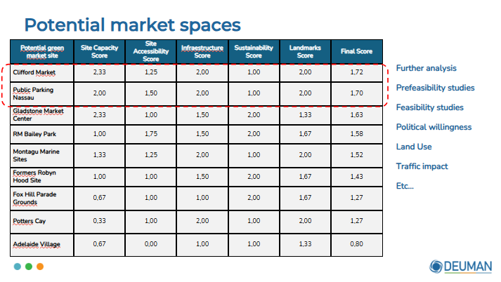 | 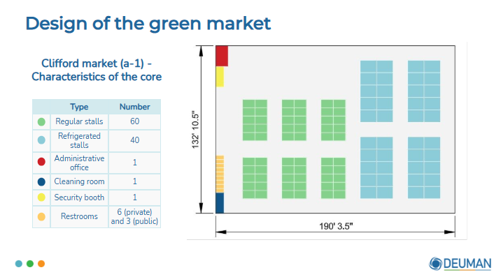
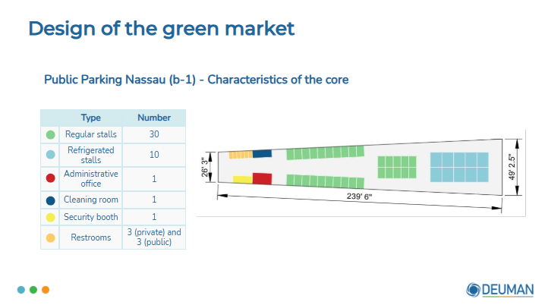 | 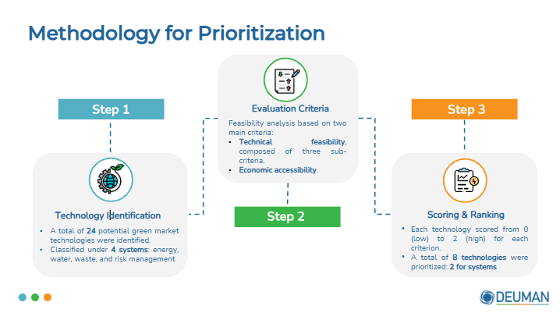
Pictures capturing technical assistance
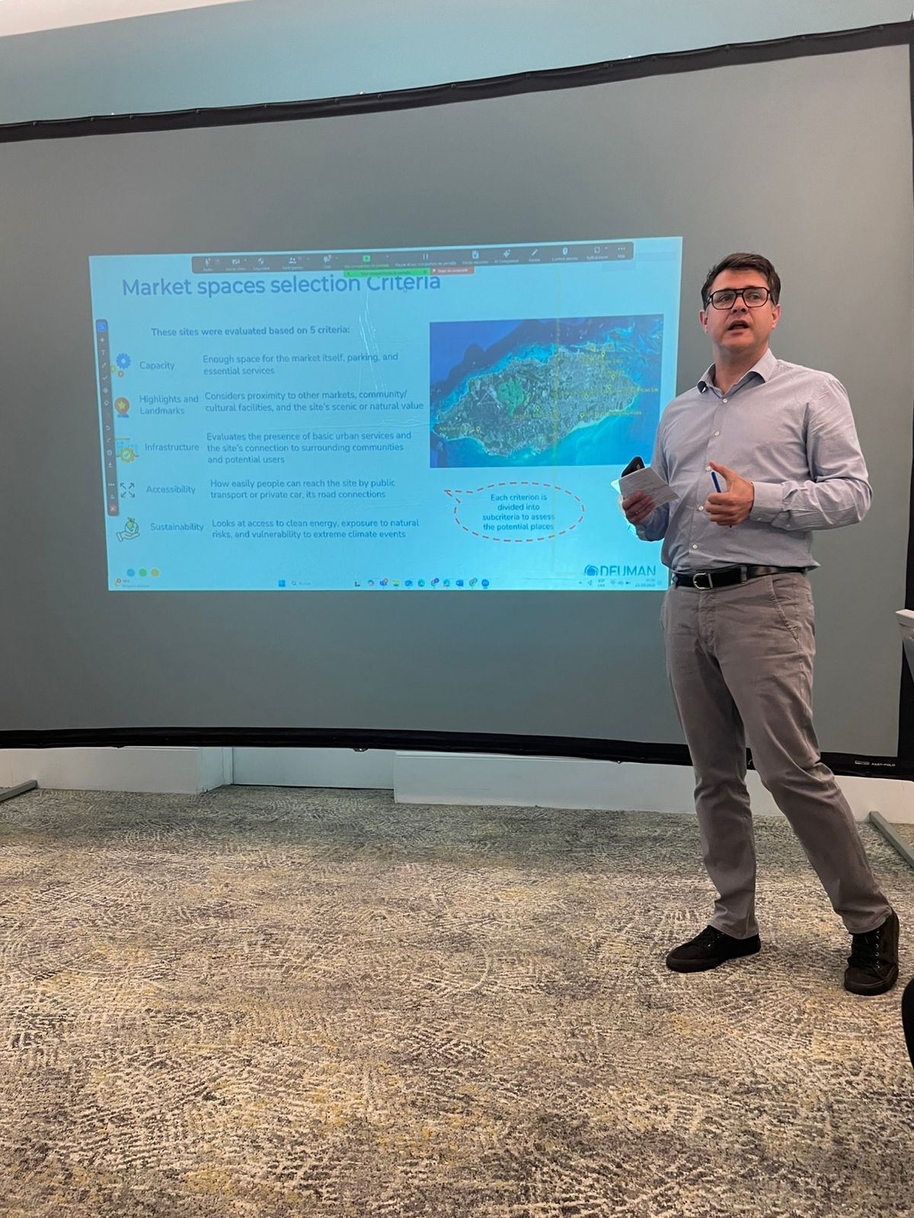 | 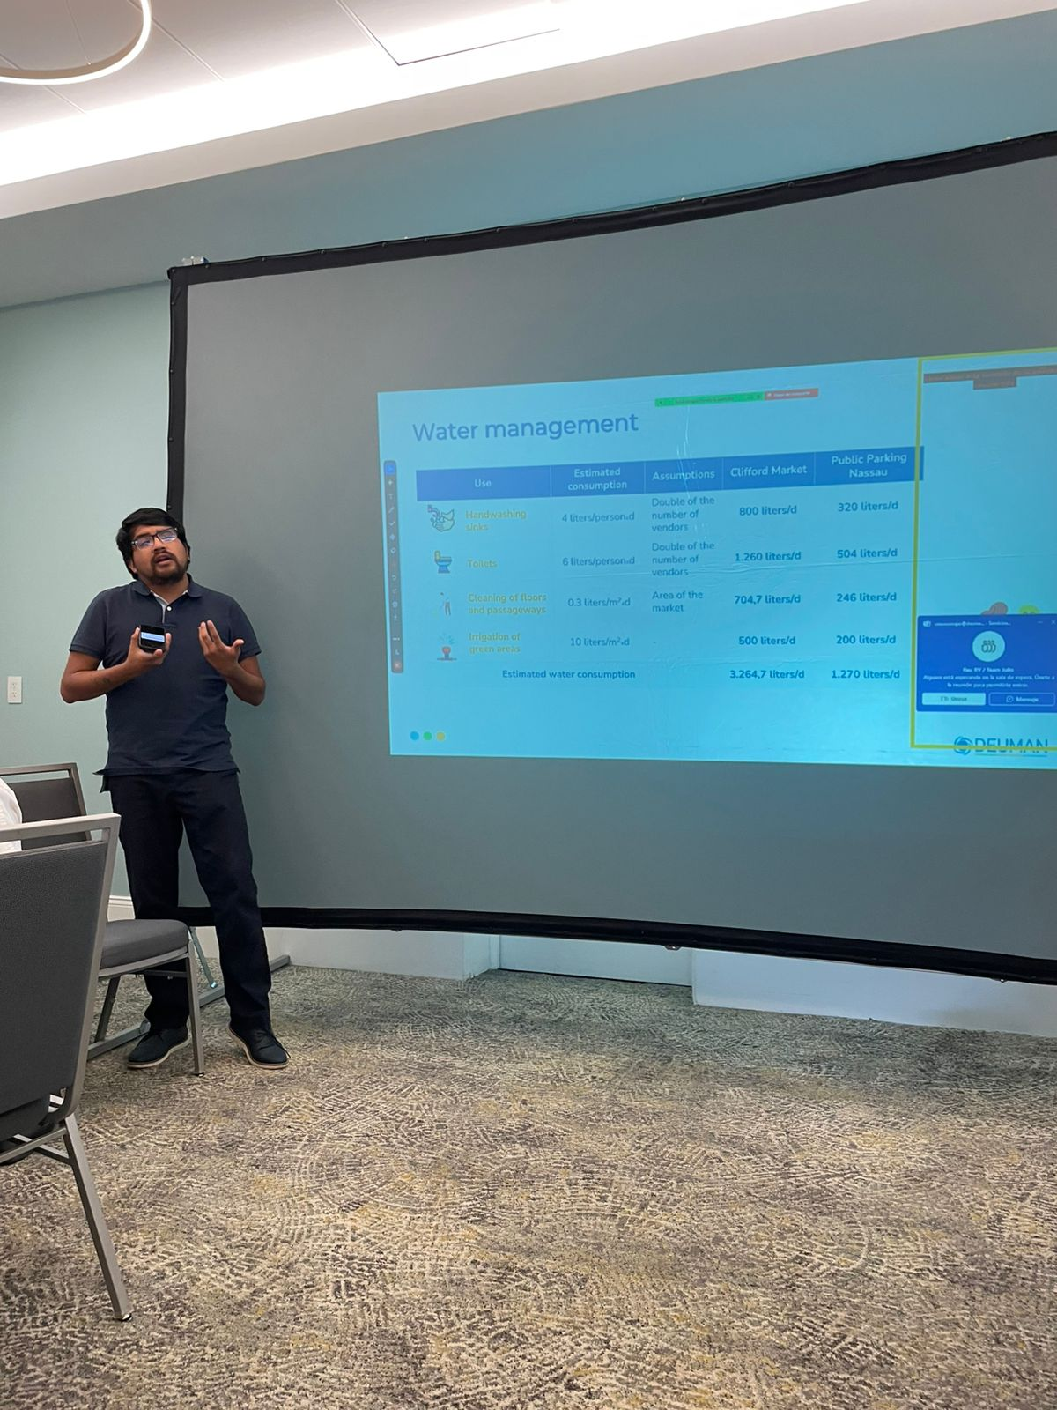

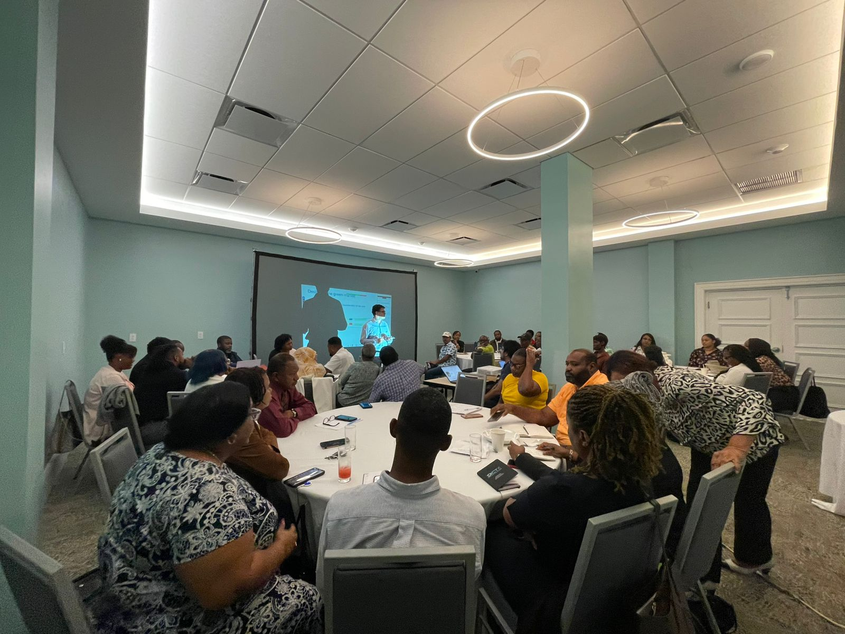

- Impact Statement

The information in the table below will be used to communicate results and anticipated impacts of this technical assistance publicly. Please copy information from impact statement developed in the M&E Plan and update as relevant.

Challenge | The project addressed The Bahamas’ high dependence on imported food and the need to integrate street vendors into the formal sector under adequate sanitary conditions. This aimed to strengthen their resilience to climate change, improve food security, and contribute to a more sustainable and safer urban food system.
CTCN Assistance | - A diagnostic of the food system and identification of regulatory and technical gaps were conducted.  - Stakeholder mapping and a market study for open green spaces were completed.  - A technical framework for energy, water, waste, and infrastructure design was developed.  - A sustainable business model and governance plan for green markets were prepared.
Anticipated impact | The technical assistance established the technical and operational foundations for developing climate-smart green markets in The Bahamas. Through seven outputs, the project assessed the food system, defined technological and regulatory requirements, validated prioritized technologies through participatory processes, and developed a replicable business model.  This strengthened institutional capacity to plan climate-resilient markets, promoted the formalization of street vendors, and improved hygiene and food safety conditions. Results were validated with public, private, and community stakeholders, ensuring local ownership. The project laid the groundwork for future pilot implementations and contributed directly to The Bahamas’ adaptation and mitigation goals.
Co-benefits: Achieved or anticipated co-benefits from the TA | - Improved organic waste management and quality of food products offered.  - Greater local participation in climate action and innovation initiatives.  - Integration of renewable energy into market systems.  - Strengthened social cohesion and organization among vendors.  - Enhanced food safety and public health in Nassau.
Gender aspects of the TA | The technical assistance ensured active inclusion of women in all phases, achieving balanced participation in interviews, validation workshops, and meetings.  Benefits: increased visibility of women’s roles in sustainable food management, strengthened economic capacity, and greater equality of opportunity — in alignment with SDG 5 on gender equality.
Anticipated contribution to NDC | - Strengthened private sector engagement in climate resilience efforts, contributing to The Bahamas’ NDC adaptation and mitigation targets.  - Enhanced urban food system resilience, supporting national adaptation objectives.  - Promoted adoption of low-carbon technologies and renewable energy use.  - Provided technical inputs for policies on food security and sustainable management.
The narrative story | The Bahamas faces high food import dependency, poor sanitation conditions, and vulnerability to natural disasters.  Throughout the technical assistance, diagnostics, institutional mapping, and market studies were carried out, forming the basis for designing two pilot sites: Clifford Market and R.M. Bailey Park.  These markets incorporate renewable energy, water and waste management systems, and climate-resilient infrastructure criteria.  The process, led by DEUMAN and the CTCN, included participatory workshops, local validation, and a gender-sensitive approach, resulting in an adaptable and sustainable green market model that improves food security, creates green jobs, and strengthens community resilience to climate change.
Contribution to SDGs  A complete list of SDGs and their targets is available here: https://sustainabledevelopment.un.org/partnership/register/ | SDG 6 – Clean Water and Sanitation: Installation of rainwater harvesting systems and improvement of sanitary conditions.  SDG 7 – Affordable and Clean Energy: Promotes decentralized renewable energy solutions (solar PV, efficient lighting).  SDG 8 – Decent Work and Economic Growth: Formalization of street vendors and creation of sustainable employment.  SDG 11 – Sustainable Cities and Communities: Develops inclusive, resilient market infrastructure and public spaces.  SDG 12 – Responsible Consumption and Production: Encourages circular waste management and local food systems.  SDG 13 – Climate Action: Enhances adaptation and mitigation capacity through technology deployment.

Annex 1. Technical assistance data collection

Please add quantitative and qualitative values for the indicators selected in the M&E plan and monitored throughout the technical assistance in the tables below. Indicators which have been monitored in addition to the proposed indicators below may be added at the end of table A. Non-relevant indicators should be left blank.

- Output and outcome indicators

Indicator  Please note indicators below highlighted as anticipated | Quantitative value  Numerals only; disaggregates must sum to the total | Qualitative description  List the various elements corresponding to the quantitative value as well as timelines and responsible institutions
Total number of events organized by proponents and implementing partners | 2 | - Inception meeting: March 22, 2024  - Technology and business model validation workshop: September 25, 2025
Number of participants in events organized by proponents and implementing partners | 54 | Participants from government, academia, the private sector, agencies, and vendor associations.
- Number of men | 23 | The Bahamas
- Number of women | 31 | The Bahamas
Number of climate technology RD&D related events | 0
Number of participants in climate technology RD&D events | Not applicable | Not applicable
- Number of men | Not applicable | Not applicable
- Number of women | Not applicable | Not applicable
Number of trainings organized by proponents and implementing partners | Not applicable | Not applicable
Number of participants in trainings organized by proponents and implementing partners | Not applicable | Not applicable
- Number of men | Not applicable | Not applicable
- Number of women | Not applicable | Not applicable
Total number of institutions trained | Not applicable | Not applicable
- Governmental (national or subnational) | Not applicable | Not applicable
- Private sector (bank, corporation, etc.) | Not applicable | Not applicable
- Nongovernmental (NGO, University, etc.) | Not applicable | Not applicable
Percentage of participants reporting satisfaction with CTCN training (from CTCN training feedback form) | Not applicable | Not applicable
Percentage of participants reporting increased knowledge, capacity and/or understanding as a result of CTCN training (from CTCN training feedback form) | Not applicable | Not applicable
- Percentage of men | Not applicable | Not applicable
- Percentage of women | Not applicable | Not applicable
Total number of deliverables produced during the assistance (excluding mission, progress and internal reports) | 7
- Number of communication materials, including news releases, newsletters, articles, presentations, social media postings, etc. | 2 | - 1 PowerPoint presentation for the validation workshop  - 1 flyer/invitation for the stakeholder validation workshop
- Number of tools and technical documents strengthened, revised or developed | 2 | - Site prioritization matrix for selection of 2 open green market locations (excel)  - Technology prioritization matrix for evaluating climate-resilient technologies applicable to market infrastructure (excel)
- Number of other information materials strengthened, revised or created (For example training and workshop reports, Power Points, exercise docs etc.) | 3 | - Questionnaire for Stakeholders interviews  - Workshop report  - Workshop Power Points
Total number of policies, strategies, plans, laws, agreements or regulations supported by the assistance | 9
- Adaptation related | 3 | - Policy – National Climate Change Policy and Implementation Strategy (2019)  - Plan – National Development Plan (vision 2040)  - Policy – National Food and Nutrition Security Policy (2017)
- Mitigation related | 2 | - Policy – National Energy Policy (2013–2033)  - Plan – National Renewable Energy Plan
- Both adaptation- and mitigation related | 4 | - Commitment / National Contribution – Bahamas Nationally Determined Contribution (NDC, 2020 update)  - Act – Environmental Protection and Management Act (2019)  - Policy Framework – Integrated Coastal Zone Management Policy Framework  - Strategy – Waste-to-Energy and Solid Waste Management Strategy
Anticipated number of policies, strategies, plans, laws, agreements or regulations proposed, adopted or implemented as a result of the TA | Not applicable
- Adaptation related | Not applicable | Not applicable
- Mitigation related | Not applicable | Not applicable
- Both adaptation- and mitigation related | Not applicable | Not applicable
Anticipated number of technologies transferred or deployed as a result of CTCN support | 8 | - Solar PV/ Battery energy storage  - Lighting – Efficient LED systems  - Rainwater harvesting  - Water efficiency and demand management  - Composting  - Recycling of municipal solid waste  - Elevated buildings  - Buildings resistant to weather events
Anticipated number of collaborations facilitated or enabled as a result of technical assistance | Not applicable
- Number of South-South collaborations | Not applicable | List the names of the organisations (excluding the CTCN or TA implementers)
- Number of RD&D collaborations | Not applicable | List the names of the organisations (excluding the CTCN or TA implementers)
- Number of private sector collaborations | Not applicable | List the names of the organisations (excluding the CTCN or TA implementers)
Number of countries with strengthened National System of Innovation as a result of CTCN support | 1 | The Bahamas
Insert any additional indicators here

- Core impact indicators

Please fill in the tables for anticipated impacts of the CTCN assistance. Every technical assistance should contribute to at least one of the indicators below. For guidance on how to report on core indicators see the ‘M&E Guidance Document for TA Implementers’.

Core indicator 1 | Anticipated metric tons of CO₂ equivalent (CO₂e) emissions reduced or avoided as a result of CTCN TA  Please add your calculations in word or excel format as an Annex to this Closure Report, where applicable.
 | Anticipated metric tons of CO₂e reduced or avoided as a result of the TA on annual basis | Anticipated metric tons of CO₂e reduced or avoided as a result of the TA in total
Quantitative value  (emissions reductions) | Not applicable | Not applicable
Unit | tCO₂e | tCO₂e
GHG assessment boundary (project emissions)  Identify expected post-TA activities, associated effects and assess boundary for quantification of GHG emission reductions | Not applicable | Not applicable
Baseline emissions  Describe baseline scenario, baseline candidates, emission factors and emissions calculated | Not applicable | Not applicable
Methodology  Explain the method or process of verifying the indicator and how data was gathered | Not applicable | Not applicable
Assumptions  Describe assumptions made during calculation and quantification of GHG reductions | Not applicable | Not applicable

Core indicator 2 | Anticipated increased economic, health, well-being, infrastructure and built environment, and ecosystems resilience to climate change impacts as a result of technical assistance  Please provide a qualitative description of the anticipated impacts on the categories below
Infrastructure and built environment  Anticipated increased infrastructure resilience (avoided/mitigated climate induced damages and strengthened physical assets) | Not applicable
Ecosystems and biodiversity  Anticipated increased ecosystem resilience (areas with increased resistance to climate-induced disturbances and with improved recovery rates) | Not applicable
Economic  Anticipated increased economic resilience (e.g. less reliance on vulnerable economic sectors or diversification of livelihood) | Not applicable
Health and wellbeing  Anticipated increased health and wellbeing of target group (e.g. improved basic health, water and food security) | Not applicable

Core indicator 3 | Anticipated number of direct and indirect beneficiaries as a result of the TA
 | Quantitative value | Means of verification
Total beneficiaries | 1620 | The total number of beneficiaries includes 140 direct beneficiaries, based on the projected number of vendors expected to participate in the two open climate-smart markets (100 vendors and 40 vendors). This estimate reflects the number of stalls in the final design and the preliminary supply–demand analysis.  Indirect beneficiaries are estimated at 1,480 potential regular customers, using a conservative assumption of approximately 10 customers per stall per day in the larger market and 12 customers per stall per day in the smaller market.
Number of adaptation beneficiaries | 1620 | Considering that both markets incorporate technologies for climate change mitigation and adaptation, the vendors (direct beneficiaries) as well as the customers (indirect beneficiaries) benefit from an infrastructure that is low-emission and climate-resilient at the same time.
Number of mitigation beneficiaries | 1620 | Considering that both markets incorporate technologies for climate change mitigation and adaptation, the vendors (direct beneficiaries) as well as the customers (indirect beneficiaries) benefit from an infrastructure that is low-emission and climate-resilient at the same time.
Number of adaptation-and mitigation beneficiaries | 1620 | Considering that both markets incorporate technologies for climate change mitigation and adaptation, the vendors (direct beneficiaries) as well as the customers (indirect beneficiaries) benefit from an infrastructure that is low-emission and climate-resilient at the same time.

Core indicator 4 | Anticipated amount of funding/investment leveraged (USD) as a result of TA (disaggregated by public, private, national, and international sources, as well as between anticipated/confirmed funding)
 | Quantitative value confirmed in USD | Quantitative value anticipated in USD | Qualitative description  List the institutions, timelines, and description or title of the investment | Methods  Describe methods used for quantification of funds leveraged
Total funding | Not applicable | Not applicable | Not applicable | Not applicable
Anticipated amount of public funding mobilised from national/domestic sources | Not applicable | Not applicable | Not applicable | Not applicable
Anticipated amount of public funding mobilised from international/ regional sources | Not applicable | Not applicable | Not applicable | Not applicable
Anticipated amount of private funding mobilised from national/domestic sources | Not applicable | Not applicable | Not applicable | Not applicable
Anticipated amount of private funds mobilised from international/regional sources | Not applicable | Not applicable | Not applicable | Not applicable

Annex 2 (for internal use – to be filled in by the CTCN)
CTCN evaluation
This section will be completed by the relevant CTCN Technology Manager.

- Evaluation of the timeliness of the TA implementation as measured against the timeline included in the response plan;
- Evaluation of TA quality as defined in the response plan;
- Overall performance of the Implementers;
- Overall engagement of the NDE and Proponent;
- Lessons learned on the CTCN process and steps taken by the CTCN to improve.

