Sustainable Cuerval
Participatory mangrove conservation, restoration and monitoring strategies of the Cuerval Community Council for adaptation and mitigation, with a focus on integrating peace in climate action, on the Colombian Pacific Coast

Impacts Statement (Final version)

October 30, 2024
Technical Assistance
Sustainable Cuerval: participatory mangrove conservation, restoration and monitoring strategies of the Cuerval Community Council for adaptation and mitigation, with a focus on integrating peace in climate action, on the Colombian Pacific Coast
Country: Colombia
Implementing entity: Tropical Agriculture Research and Higher Education Center (CATIE)
October, 2025

Impact Statement (final version)

Objective of the technical assistance (TA) Closure Report:

- To communicate publicly in one document a summary of progress made, and lessons learned during the TA towards the anticipated impact (sections 1-4).
- To document qualitative and quantitative data collected during TA, for use in donor and UN reporting (Annex 1).

Steps for completing the TA closure report:

- The lead TA implementer submits the closure report at the end of the technical assistance as a final deliverable. The TA closure report will capture outputs, outcomes and impacts of all activities conducted under the TA. Please copy and summarise relevant material from previous TA outputs/deliverables and the Response Plan, as relevant.
- A CTCN Manager will review and revise the closure report before final approval by the CTCN Deputy Director.

Important note on public and internal use of the closure report:

Once approved by the CTCN Deputy Director, the TA closure report will be a public document available on the CTCN website www.ctc-n.org. Selected content will be used for targeted communication activities. Annex 2 is for internal use only and will not be publicly available.

1. Basic information
Title of response plan | Sustainable Cuerval: Participatory mangrove conservation, restoration and monitoring strategies of the El Cuerval Community Council for adaptation and mitigation, with a focus on integrating peace in climate action, on the Colombian Pacific Coast
Technical assistance reference number | CTCN-24-008
Country / countries | Colombia
NDE organisation | Climate Change Directorate of the Ministry of Environment and Sustainable Development
NDE focal point | Allison del Río Bahamón
NDE contact information | ADelRio@minambiente.gov.co
Proponent focal point and organisation | Julio Cesar Rodríguez Peláez, Juan Carlos Amezquita Londoño, jrodriguez@crc.gov.co, jamezquita@crc.gov.co, Corporación Autónoma Regional del Cauca (CRC)
Designer of the response plan | Pablo Imbach, CATIE, pablo.imbach@catie.ac.cr
Implementer(s) of technical assistance | Tropical Agriculture Research and Higher Education Centre (CATIE)
Beneficiaries | Men, women and youth of San Miguel del Mar, Concepción and Playa Cuerval afro-descendent communities, Consejo Comunitario del Cuerval
Sector(s) addressed | Coastal zones, Integrated coastal zone management
Technologies supported (Technologies may be identified from the CTCN taxonomy of climate sectors and technologies | Ecosystem restoration and conservation plans
Implementation start date | 01/08/2024
Implementation end date | 31/07/2025
Total budget for implementation | USD 200 000
Description of delivered outputs and products as well as the activities undertaken to achieve them. In doing so, review the log frame of the original response plan and refer to it as appropriate | Development of project management tools: Development of documents that allow measuring and evaluating the progress of the project and the challenges.  Support mechanism: virtual meetings were conducted to identify key stakeholders from government and academic institutions who will support the implementation of the technical assistance. Gender balance and adequate representation of the community group were ensured to incorporate ancestral knowledge and local livelihoods.  Initial workshop with Community Council: A workshop was held to inform stakeholders about the start of the TA and ensure their participation throughout the implementation process, and to include recommendations for it.  Diagnosis of mangrove conservation: satellite imagery, existing maps, and vegetation indices were used to assess mangrove cover within the community council area. The information was validated during the workshop on the causes of mangrove degradation.  Conduct a participatory session to establish the causes of mangrove degradation: causes related to anthropogenic and natural processes, including climate change, were identified. The ecosystem services provided by mangroves to local and global livelihoods were reviewed.  Conduct a participatory vulnerability analysis workshop: Information was collected on the vulnerability of mangroves and related livelihoods to climate change and anthropogenic processes.  Conduct a diagnosis of key sites to document degradation processes and define intervention plans for restoration: Field visit to collect biophysical data to identify degraded mangrove areas and recommend the most appropriate restoration methods.  Mangrove restoration strategy and capacity building in mangrove restoration techniques: Three descriptive sheets were prepared, each containing a site description, documentation of degradation processes, proposed restoration measures, and the resources or enabling conditions needed for their implementation. Theoretical and practical training will be provided to introduce restoration techniques, their costs, and benefits. A demonstration exercise was also conducted in a previously selected area.  Methodology and design of the monitoring plan: The necessary and feasible indicators to monitor the progress of the restoration were defined; these indicators correspond to the interventions required to support the strategy. A plan with the monitoring periods and frequency was also established.  Training in the estimation of variables for field monitoring: capacity was built so that the community can establish monitoring plots, as well as apply the methods required to measure the monitoring variables, as established in activity 4.1 (monitoring protocols). Equipment and materials for monitoring were delivered to the community.  Recommendations for the implementation of the technological support system for monitoring: recommendations for the implementation of the technological support system in hardware, software, internet, and other components for community monitoring, as well as the development of an online dashboard to update the implementation of field actions (based on CATIE’s geoservices platform for managing local partners).
Methodologies applied to produce outputs and products | - Participatory mapping workshops  - Theoretical and practical workshops on mangrove restoration  - Theoretical and practical workshops on mangrove monitoring
Reference to knowledge resources | Zamora, A., Bouroncle, C., Skrinjaric, T. y Imbach, P. (2025). Bridging knowledge, strengthening territories. Participatory mapping to analyze climate change vulnerability in agricultural livelihoods. [PDF file]. https://repositorio.catie.ac.cr/handle/11554/12730  Teutli-Hernández, C.; Herrera-Silveira, J.A.; Cisneros-de la Cruz, D.J.; Arceo-Carranza, D.; Canul-Cabrera, A.; Robles-Toral, P.J.; Pérez-Martínez, O.J.; Sierra-Oramas, D.; Zenteno, K.; Us-Balam, H.G.; Pech-Poot, E.; Chiappa-Carrara, X.; Comín, F.A. (2021). Manual for the ecological restoration of mangroves in the Mesoamerican Reef System and the Greater Caribbean. [PDF file]. https://marfund.org/es/wp-content/uploads/2021/12/Manual-Restauracion-de-Manglar.pdf  Teutli-Hernández, C., Herrera-Silveira, J.A., Cisneros-de la Cruz, D.J. and Román-Cuesta, R. (2020). Mangrove ecological restoration guide: Lessons learned. [PDF file]. https://www.cifor-icraf.org/publications/pdf_files/Books/2020-Guide-SWAMP.pdf
Deviations | All planned activities under the technical assistance were carried out. However, at the beginning of the technical assistance, the date for the participatory mapping had to be postponed due to security issues in the area.
Anticipated follow-up activities and next steps | - Monitoring of restoration at selected key sites  - Use of the monitoring system for data reporting  - Monitoring the causes of mangrove degradation  - Search for funding sources for mangrove restoration  - Monitoring of adaptation measures to climate and non-climate vulnerabilities identified through participatory mapping

2. Lessons learned
 | Lessons learned | Recommendations
Lessons learned from the CTCN TA process | - Flexibility: willing to adjust activity dates due to force majeure issues (security).  - Project monitoring: periodic follow-up of CTCN on the progress of project activities and results  - Participation in an international forum: presentation of progress and results of the technical assistance  - Constant communication with local partners (CRC and Community Council) was essential for developing the TA activities | - Always coordinate field activities with the local partner and communities  - Adapt to local needs and capacities  - Request permission from communities to share information about them (photos and documents)
Lessons learned related to climate technology transfer | - Adapt highly technical concepts to local capacities  - Conduct multiple short trainings covering a few topics each  - Local authorities do not have local infrastructure to store data (e.g., an online dashboard) | - Include regional government and environmental authorities

3. Illustration of the TA and photos

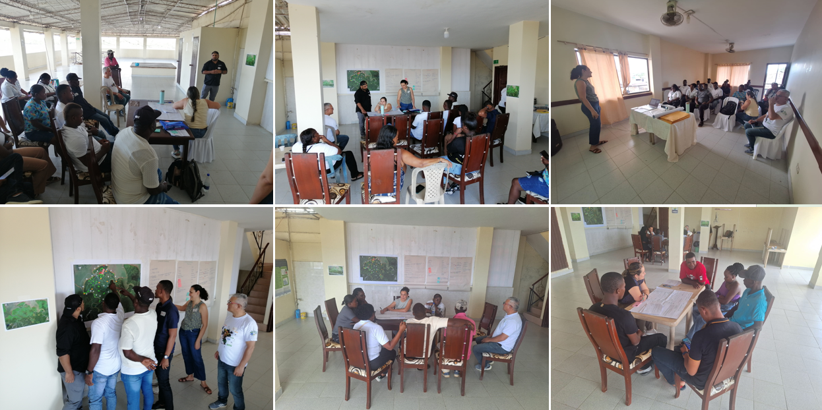
Figure 1. Development of participatory workshops for collecting information on the causes of mangrove degradation and vulnerability, as well as related livelihoods, in the Cuerval Community Council, Timbiquí, Cauca, 2025.

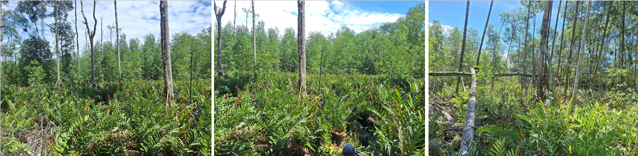

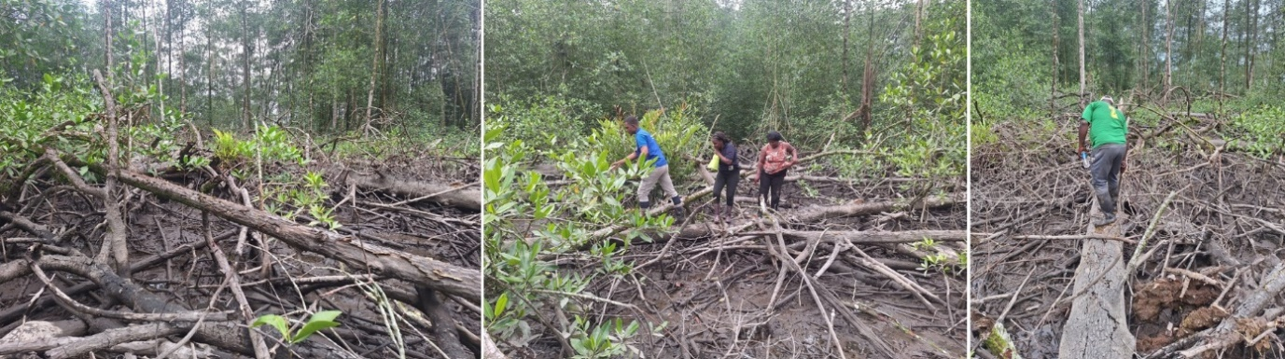
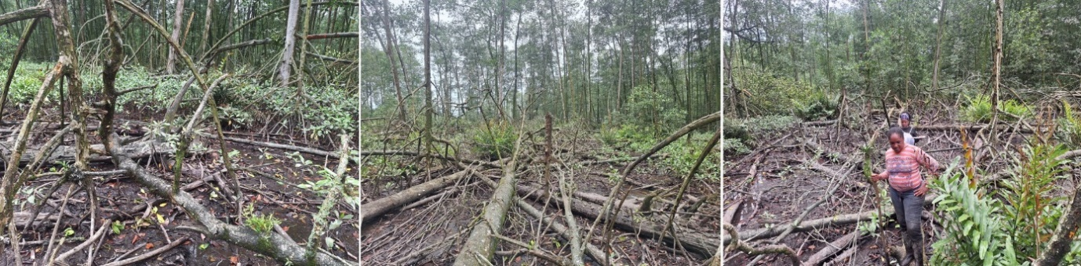
Figure 2. Status and conditions found at the key sites.
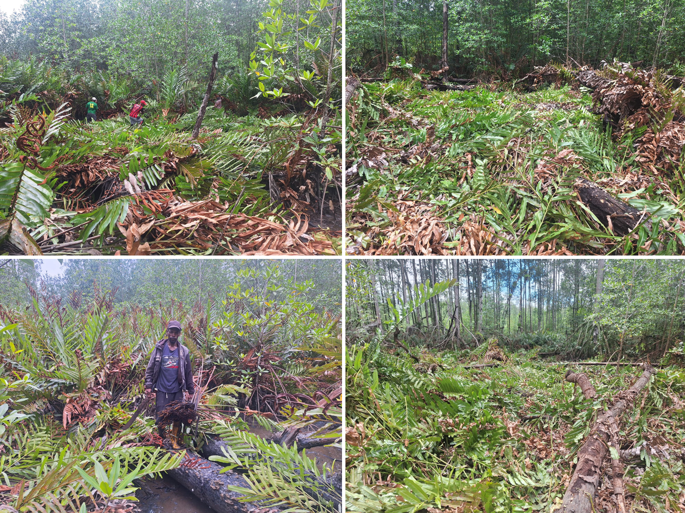
Figure 3. Demonstration activity in the field on mangrove restoration.

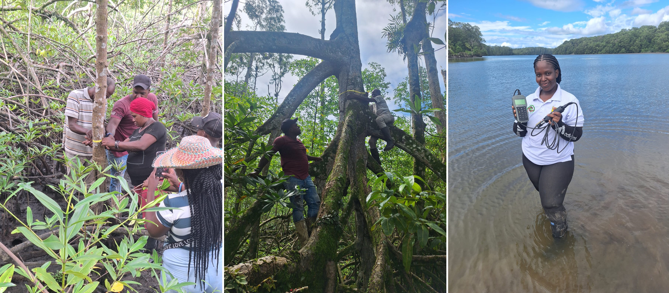
Figure 4. Field training for data collection of variables and indicators of the community monitoring system.

4. Impact Statement

The information in the table below will be used to communicate results and anticipated impacts of this technical assistance publicly. Please copy information from impact statement developed in the M&E Plan and update as relevant.

Challenge | This TA faces technological barriers, such as limited knowledge of the interactions of processes that influence mangroves and recovery practices beyond reforestation; and the formulation of a community-based monitoring process of restoration processes and their impacts on sustainable community development, adaptation to climate change and contributions to climate change mitigation.
CTCN Assistance | A mangrove restoration strategy attempts to identify the processes that influence mangrove degradation and reduction, and to define the most efficient practices for their recovery. A community-based MRV system will facilitate the measurement of the impact of future restoration activities and enable communities to share in the benefits of the carbon market in the future.
Anticipated impact | Problem summary: this TA faces technological barriers, such as limited knowledge of the interactions of processes that influence mangroves and recovery practices beyond reforestation; and the formulation of a community-based monitoring process of restoration processes and their impacts on sustainable community development, adaptation to climate change and contributions to climate change mitigation.  Desired impact: (i) identify the most vulnerable ecosystem service of mangroves in the Cuerval Community Council, (ii) Cuerval Community Council and CRC members trained in mangrove restoration techniques and monitoring, (iii) Mangrove restoration benefits local livelihoods, and (iv) number of technologies transferred or deployed.  The TA is expected to lead to the desired impact with the involvement of stakeholders in workshops and virtual meetings, and Cuerval Community Council members through their participation in participatory mapping workshops and mangrove restoration field practices.
Co-benefits: Achieved or anticipated co-benefits from the TA | - Empowerment of communities in mangrove restoration project  - Technical assistance is aligned with the country's goals expressed in its NDC and with other national, regional, and local priorities for climate change adaptation and mitigation  - Positive impact on local livelihoods (for example: the extraction of piangua).
Gender aspects of the TA | Technical assistance will consider gender factors in access to local resources, participation and decision-making spaces, distribution of tasks and other factors that affect the vulnerability to climate change of men and women in a differentiated manner. It will also consider the gender approach to defining the restoration strategy and its monitoring in terms of benefits for men and women throughout its implementation process (e.g. strengthening women's agency) and final impacts (e.g. restoration of key ecosystem services for different livelihoods). Basic considerations to mainstream gender will include equal opportunities to participation in trainings and gathering of gender-disaggregated data.
Anticipated contribution to NDC | - Adaptation targets: A participative methodology to build restoration plans of mangroves in protected areas of the National Natural Parks System and its zones of influence.  - Mitigation targets: A participative methodology to build a monitoring plan of mangrove restoration, including carbon sequestration.
The narrative story | Mangroves are a key ecosystem for the adaptation of coastal communities in the department of Cauca and carbon sequestration. The mangroves of the El Comedero Regional Natural Park (PNREC) are being degraded and deforested by common processes in the department, such as logging for illegal hunting of native and migratory species, and land use change. The CRC and communities promote mangrove restoration and good practices for mangrove use. However, the lack of knowledge to identify the most effective restoration processes and the absence of technological resources to design a community-based restoration monitoring process impede the progress of these efforts. This technical assistance will provide CRC technical staff and community agents with the conceptual and technical basis to design a mangrove restoration strategy for the PNREC and its monitoring, reporting and verification (MRV) system through courses, guidelines and pilot experiences; in a manner harmonised with national priorities and local development plans; so that it can be scaled up in other parts of Cauca.
Contribution to SDGs (A complete list of SDGs and their targets is available here: https://sustainabledevelopment.un.org/partnership/register/. To the extent possible, please describe contribution to approximately 3 SDGs, including SDG13, with a few sentences for each SDG concerned.) | Goal 5 Gender equality  The participative mapping of climate vulnerability on local livelihoods can highlight how climate impacts are affecting men, women and youth in different ways.  Goal 13, Climate Action  The definition of a mangrove restoration strategy can directly contribute to strengthening local livelihoods that depend on this ecosystem and reduce their vulnerability to risks related to gradual climate change and increased climate variability.  Goal 14, Live bellow water  Building a restoration strategy and community monitoring of mangroves in a participatory manner provides opportunities for knowledge sharing and strengthening of social and institutional capital on the role of mangroves in climate change adaptation and contribution to carbon sequestration.

