Technical Assistance Closure Report Template
Objective of the technical assistance (TA) Closure Report:
- To communicate publicly in one document a summary of progress made and lessons learned during the TA towards the anticipated impact (sections 1-4).
- To document qualitative and quantitative data collected during TA, for use in donor and UN reporting (Annex 1).

Steps for completing the TA closure report:
- The lead TA implementer submits the closure report at the end of the technical assistance as a final deliverable. The TA closure report will capture outputs, outcomes and impacts of all activities conducted under the TA. Please copy and summarise relevant material from previous TA outputs/deliverables and the Response Plan, as relevant.
- A CTCN Manager will review and revise the closure report before final approval by the CTCN Deputy Director.

Important note on public and internal use of the closure report:
Once approved by the CTCN Deputy Director, the TA closure report will be a public document available on the CTCN website www.ctc-n.org. Selected content will be used for targeted communication activities. Annex 2 is for internal use only and will not be publicly available.

Closure Report for CTCN Technical Assistance

- Basic information
Title of response plan | Enhancing multi-scalar mapping and research of food security risk, due to climate change in Jamaica
Technical assistance reference number | 2021000051
Country / countries | Jamaica
NDE organisation | Climate Change Division, Ministry of Economic Growth and Job Creation
NDE focal point | Mr Ajani Alleyne  Research and Development Officer
NDE contact information | Ajani.alleyne@megjc.gov.jm
Proponent focal point and organisation | Mr Ajani Alleyne (Ajani.alleyne@megjc.gov.jm)  Research and Development Officer, Climate Change Division, Ministry of Economic Growth and Job Creation
Designer of the response plan | Mr Ajani Alleyne (Ajani.alleyne@megjc.gov.jm)  Research and Development Officer, Climate Change Division, Ministry of Economic Growth and Job Creation
Implementer(s) of technical assistance | HR Wallingford Ltd
Beneficiaries | - Climate Change Division, Ministry of Economic Growth and Job Creation  - Ministry of Agriculture and Fisheries  - Rural Agricultural Development Authority (RADA)  - Other ministries and agencies involved in food security and climate resilience  - Farmers and agricultural producers  - Academic institutions and researchers involved in climate and agricultural studies  - Future projects and programmes, benefiting from improved data availability and tools  - Agribusiness Information System (ABIS)  - Agricultural Marketing Information System (AMIS)
Sector(s) addressed | Agriculture and Forestry
Technologies supported | Hazard mapping solutions  Improvement of Agri-food processes  Stakeholder consultations  Open source climate data and tools
Implementation start date | March 2024
Implementation end date | July 2025
Total budget for implementation | USD 240,250
Description of delivered outputs and products as well as the activities undertaken to achieve them. In doing so, review the log frame of the original response plan and refer to it as appropriate | Output 1: Development of work plan and related communication documents  l D.1.1: Detailed implementation plan  l D.1.2: Monitoring and evaluation plan.  l D.1.3: Impact Statement (initial and final version).  l D.1.4: Technical Assistance Closure and Data Collection Report  Output 2: Develop and implement a baseline survey  l D.2.1. Food security data collection, processing, and analysis  l D.2.2. Robust baseline survey  Output 3: Retrofit the various farmers databases to capture the post-harvest processes.  l D.3.1: A comprehensive report on the existing farmer databases  l D.3.2a: Recommendations as to the data needed.  l D.3.2b: A comprehensive list of recommendations on improvements.  Output 4: Determine the main limiting factors that lead to food insecurity, intervention points and adaptation measures  l D.4.1. A comprehensive report on the main limiting factors  l D.4.2. A comprehensive list of recommendations on intervention points  Output 5: An interactive map/software application to spatially visualize current and future food security risk rates.  l D.5. Database used to provide information and monitoring of food security.  Output 6: Training on sustainable land management and Crop/livestock management.  l D.6.1a: Develop a roadmap for ad hoc technology interventions.  l D.6.2c: Suggestions on technologies that help the postharvest process  Output 7: Improve the economic resilience of farming systems through increased market access and sustainable production.  l D.7.1a: Training and capacity-building materials and guidelines.  l D.7.1b: Training report.  Output 8. Capacity building to a specialized group that will provide oversight on the monitoring/maintenance of the database  l D.8.1: Training and capacity-building materials and guidelines  l D.8.2: Training report.
Methodologies applied to produce outputs and products | - Baseline surveys in rural and urban areas to assess food security conditions  - Spatial analysis and mapping using GIS tools to visualize risk distribution  - Database retrofitting to capture post-harvest processes and integrate systems  - Stakeholder consultations to identify limiting factors and intervention points  - Gender-sensitive data disaggregation to capture food insecurity nuances  - Training workshops for sustainable land, crop, and livestock management  - Capacity building for national practitioners on software use and data analysis  - Technology gap assessments to identify needs for innovation and efficiency
Reference to knowledge resources | NA
Deviations | None
Anticipated follow-up activities and next steps | - Operationalization of the food security mapping tool across ministries and agencies  - Ongoing training and capacity building for national practitioners and technical staff  - Regular updates and maintenance of consolidated databases (AMIS, RADA, ABIS)  - Replication of methodologies in other vulnerable sectors or regions

- Lessons learned
 | Lessons learned | Recommendations
Lessons learned from the CTCN TA process | - The project was well-designed, managed, and implemented through strong collaboration between CTCN and Jamaican institutions.  - Co-designing the TA with multiple national stakeholders ensured relevance and ownership.  - Early engagement with government agencies helped align the project with national development and climate adaptation strategies. | - A small allocation of funding for sustainability and regional outreach would enhance long-term impact and visibility.
Lessons learned related to climate technology transfer | - Continuous engagement with end users and beneficiaries was critical to ensure the system met local needs.  - Building strong in-country relationships throughout design and implementation strengthened trust and uptake.  - Collaborative development and inclusion of user feedback improved system relevance and usability.  - Capacity building was essential—training in data management, analysis, and interpretation must be ongoing.  - Technological innovation requires time; funders should allow sufficient duration for testing, adoption, and scaling.  - Projects of this complexity benefit from a minimum three-year timeline to build confidence in system reliability. | - Capacity building: Continue training for system users, with freely available materials and short courses.  - Multi-scale tools: Develop food security tools that operate across spatial and temporal scales to support decision-making.  - National planning: Support development of a national framework to guide responses based on food security risk data.  - Sustainability funding: Allocate resources for long-term maintenance, updates, and regional promotion of the tool.  - Stakeholder engagement: Maintain active collaboration with ministries, academia, and local communities to ensure continued relevance and impact.

3. Illustration of the TA and photos

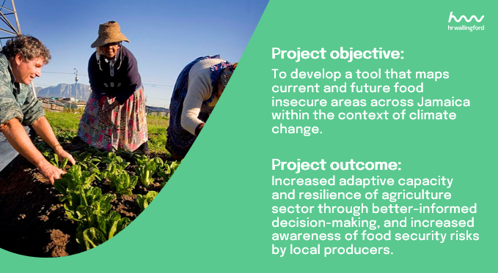

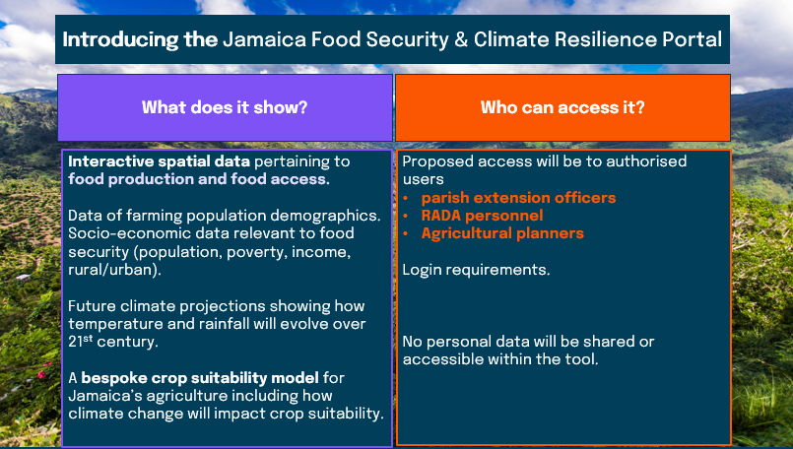

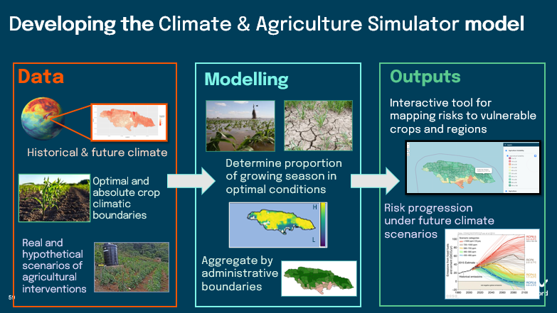

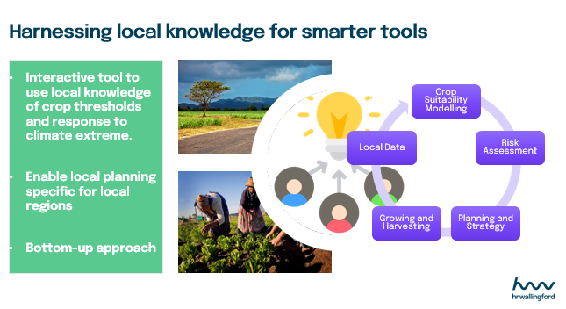

4. Impact Statement
The information in the table below will be used to communicate results and anticipated impacts of this technical assistance publicly. Please copy information from impact statement developed in the M&E Plan and update as relevant.

Challenge | Agriculture is a climate-sensitive sector, where changing climate conditions can impact production levels and the availability of food crops. Jamaica is facing low food production and a high dependency on food imports. This Technical Assistance (TA) provided knowledge on the spatial distribution of current and future food security risk across the island. In doing so, it helped increase resilience in the agriculture sector of Jamaica.
CTCN Assistance | - Implement baseline survey administered to a sample of rural and urban areas.  - Retrofit farmers databases to capture the post-harvest processes.  - Determine main limiting factors that lead to food insecurity, identify intervention points and adaptation measures for enhancing food security.  - Develop tool to spatially visualize current and future food security risk.  - Train on sustainable land management and crop/livestock management.  - Improve economic resilience of farming systems through increased market access and sustainable production.  - Capacity building on monitoring and maintenance of the database, and the ability to perform the analysis regularly.
Anticipated impact | - The project enabled Jamaica to benefit from a tool that allowed spatial visualization of current and future food security risk.  - It retrofitted farmers' databases to capture the post-harvest processes of select produce.  - The assistance provided stakeholders with information that improved their ability to intervene to enhance food security in the areas most at risk.  - In the mid-term it will assist decision-makers in assessing how and where interventions are designed and implemented.  - In the long term it will ensure resilience in terms of food security.
Co-benefits: Achieved or anticipated co-benefits from the TA | - Enhanced food and nutrition security of vulnerable groups, communities and parishes  - Development of policies and legislation that will assist decision makers in assessing how and where targeted intervention strategies are designed and implemented.  - Availability and accessibility of data (baseline and future) for adaptation projects to be implemented.  - Database used for timely decisions regarding vulnerable groups’ needs, enabling government to be more effective.  - Consolidation of available databases (AMIS, RADA, ABIS, etc.) so that information can be updated at once, with reduced maintenance costs.  - Continuous update of databases will provide a real-time snapshot of food poverty across the island, ensuring easy report production, accessibility and enabling decision making.  - Greater collaboration amongst stakeholders within the agriculture sector.  - Greater capacity within the agriculture sector to tackle food insecurity.
Gender aspects of the TA | Research has found that women and girls are not only disproportionately vulnerable to the impacts of climate change but are also vulnerable to all dimensions of food security.
Anticipated contribution to NDC | - By promoting national food security this TA is aligned with Jamaica’s development policies, plans and strategies that target a reduction of food poverty and increased adaptation to climate change.  - The TA facilitated the strengthening of partnerships among agencies and academia, while increasing their capacity to provide climate services.  - The TA strengthened existing data collection mechanisms within ministries and agencies so that quality data on food security and climate change were generated and used for programme assessment and for monitoring progress.  - Strategic NDC aims include facilitating the use of water and energy efficient agricultural methods, improved food storage systems and diversifying food production techniques. The need for new innovations is embedded in the need to be more efficient and to produce from cleaner technologies.
The narrative story | Jamaica is vulnerable to the negative impacts associated with  climate change. Recent studies have shown that in Jamaica it is expected to see more frequent and severe droughts from reduced precipitation and increased evaporative demand due to anthropogenic climate change. Along with experiencing these warming and drying trends, the island’s north and south coasts are also expected to be impacted by sea level rise. This may result in a “loss of agricultural lands due to direct erosion, temporal flooding and contamination of the agricultural soil via salination”, hence impacting livelihoods, production and economic output.  In an effort to address the impacts of climate change and climate variability in a sustainable way, access to critical information within the agriculture sector is vital. Several projects have been completed or are underway, however, there remains significant knowledge and technology gaps.  The Climate Change Division, Ministry of Economic Growth and Job Creation of the government of Jamaica requested assistance through the CTCN to implement a tool that maps/visualizes the current areas across the island that are food insecure, as well as areas which may become food insecure in the future. This will assist decision-makers in assessing how and where targeted interventions strategies are designed and implemented, as well as monitoring and evaluating the contribution of future projects/programmes to reducing food insecurity.  The CTCN assistance aimed to fill the identified gaps by strengthening the expertise of national practitioners in using the food security software.
Contribution to SDGs | The Project outcomes respond directly to SDG 2 ‘End hunger, achieve food security and improved nutrition and promote sustainable agriculture’ by providing a system that will support decision-making for sustainable food production in Jamaica. The Project will also contribute to SDG 1 (End poverty), SDG 6 (Availability and sustainable management of water), and SDG 13 (Climate action), as the tool will improve agricultural use of water resources, improve food security and increase the income of rural communities.

Annex 1 Technical assistance data collection

Please add quantitative and qualitative values for the indicators selected in the M&E plan and monitored throughout the technical assistance in the tables below. Indicators which have been monitored in addition to the proposed indicators below may be added at the end of table A. Non-relevant indicators should be left blank.

- Output and outcome indicators

Indicator  Please note indicators below highlighted as anticipated | Quantitative value  Numerals only; disaggregates must sum to the total | Qualitative description  List the various elements corresponding to the quantitative value as well as timelines and responsible institutions
Total number of events organized by proponents and implementing partners | 6 | Kick-off meeting  3 stakeholder workshops  2 training workshops
Number of participants in events organized by proponents and implementing partners | 42
- Number of men | 30 | 30 Jamaica
- Number of women | 12 | 10 Jamaica  1 UK  1 Greece
Number of climate technology RD&D related events | 6 | Kick-off meeting  3 stakeholder workshops  2 training workshops
Number of participants in climate technology RD&D events | 42
- Number of men | 30 | 30 Jamaica
- Number of women | 12 | 10 Jamaica  1 UK  1 Greece
Number of training organized by proponents and implementing partners | 2 | - Showcasing the food security tool  - Obtaining feedback on potential areas for improvement  - Discussing ownership, data requirements and operationalisation of the tool
Number of participants in trainings organized by proponents and implementing partners | 42
- Number of men | 30 | 30 Jamaica
- Number of women | 12 | 10 Jamaica  1 UK  1 Greece
Total number of institutions trained | 6
- Governmental (national or subnational) | 4 | - Climate Change Division, Ministry of Economic Growth and Job Creation  - Ministry of Agriculture and Fisheries  - Rural Agricultural Development Authority (RADA)  - Farmers and agricultural producers
- Private sector (bank, corporation, etc.) | 1 | - HR Wallingford
- Nongovernmental (NGO, University, etc.) | 1 | - Rutgers University
Percentage of participants reporting satisfaction with CTCN training (from CTCN training feedback form) | 100% | Satisfied= 4+ on 5-pt scale
Percentage of participants reporting increased knowledge, capacity and/or understanding as a result of CTCN training (from CTCN training feedback form) | 100% | Increased knowledge, capacity and/or understanding= 4+ on 5-pt scale
- Percentage of men | 100%
- Percentage of women | 100%
Total number of deliverables produced during the assistance (excluding mission, progress and internal reports) | 14
- Number of communication materials, including news releases, newsletters, articles, presentations, social media postings, etc. | 1 | - CTCN Conference presentation (Costa Rica, 2024)
- Number of tools and technical documents strengthened, revised or developed | 14 | l D.2.1. Food security data collection, processing, and analysis  l D.2.2. Robust baseline survey  l D.3.1: A comprehensive report on the existing farmer databases  l D.3.2a: Recommendations as to the data needed.  l D.3.2b: A comprehensive list of recommendations on improvements.  l D.4.1. A comprehensive report on the main limiting factors  l D.4.2. A comprehensive list of recommendations on intervention points  l D.5. Database used to provide information and monitoring of food security.  l D.6.1a: Develop a roadmap for ad hoc technology interventions.  l D.6.2c: Suggestions on technologies that help the postharvest process  l D.7.1a: Training and capacity-building materials and guidelines.  l D.7.1b: Training report.  l D.8.1: Training and capacity-building materials and guidelines  l D.8.2: Training report.
- Number of other information materials strengthened, revised or created (For example training and workshop reports, Power Points, exercise docs etc.) | 14 | l D.1.1: Detailed implementation plan  l D.1.2: Monitoring and evaluation plan.  l D.1.3: Impact Statement (initial and final version).  l D.1.4: Technical Assistance Closure and Data Collection Report  + 10 ppt presentations
Total number of policies, strategies, plans, laws, agreements or regulations supported by the assistance | NA
- Adaptation related
- Mitigation related
- Both adaptation- and mitigation related
Anticipated number of policies, strategies, plans, laws, agreements or regulations proposed, adopted or implemented as a result of the TA | NA
- Adaptation related
- Mitigation related
- Both adaptation- and mitigation related
Anticipated number of technologies transferred or deployed as a result of CTCN support | 1 | Hazard mapping solutions  Improvement of Agri-food processes  Stakeholder consultations  Open source climate data and tools
Anticipated number of collaborations facilitated or enabled as a result of technical assistance | List total number here
- Number of South-South collaborations
- Number of RD&D collaborations | 1 | Collaboration of HR Wallingford-led team with local stakeholders from Jamaica
- Number of private sector collaborations
Number of countries with strengthened National System of Innovation as a result of CTCN support | 1 | Jamaica
Insert any additional indicators here

- Core impact indicators

Please fill in the tables for anticipated impacts of the CTCN assistance. Every technical assistance should contribute to at least one of the indicators below. For guidance on how to report on core indicators see the ‘M&E Guidance Document for TA Implementers’.

Core indicator 3 | Anticipated number of direct and indirect beneficiaries as a result of the TA
 | Quantitative value | Means of verification
Total beneficiaries | Total number
Number of adaptation beneficiaries | 42 | Number of people directly trained by the project team
Number of mitigation beneficiaries | 42 | Number of people directly trained by the project team
Number of adaptation-and mitigation beneficiaries | 42 | Number of people directly trained by the project team

(A) Outputs and Activities as described in the Response Plan | (B) Indicator | (C) Results
Project-level impact | Anticipated number of direct and indirect beneficiaries as a result of the TA  Agricultural land (as a % of total agricultural area) or number of farmers (as a % of registered farmers) benefitting from the project  Population below the national poverty line (%) benefitting from the project  Tourism (% of GDP) benefitting from the project | Enhanced, multi-scalar mapping and improved decision making to manage food security risks.  Enhanced food and nutrition security of vulnerable groups, communities and parishes.  Development of policies and legislation that will assist decision makers in assessing how and where targeted intervention strategies are designed and implemented.  Availability and accessibility of data (baseline and future) for adaptation projects to be implemented.  Consolidation of available databases (AMIS, RADA, ABIS, etc.) so that information can be updated at once, with reduced maintenance costs.  Greater collaboration amongst stakeholders within the agriculture sector.  Greater capacity within the agriculture sector to tackle food insecurity.
Output 1: Development of work plan and related communication documents | Total number of institutions identified and engaged in the meetings  Number of participants co-opted to the Stakeholder Working Group | 9 institutions  8 stakeholder working group members
Output 2: Develop and implement a baseline survey | Baseline survey issued | Baseline survey issued  Data collected
Output 3: Retrofit the various farmers databases to capture the post-harvest processes. | Total number of tools, technical  documents and  material produced | 2 technical reports (activities 3.1–3.2)
Output 4: Determine the main limiting factors that lead to food insecurity, intervention points and adaptation measures | Limiting factors that lead to food insecurity are assessed  Recommandations on intervention points are made | 2 technical reports (activities 4.1–5.2)
Output 5: An interactive map/software application to spatially visualize current and future food security risk rates. | Interactive tool developed | Interactive tool is accessible
Output 6: Training on sustainable land management and Crop/livestock management. | Total number of deliverables (tools and technical documents) | Two technical reports (activities 6.1a and 6.1b), and training workshop report (activity 6.2)
Output 7: Improve the economic resilience of farming systems through increased market access and sustainable production. | Total number of deliverables (tools and technical documents) | Training manuals (activity 7.1a) and training workshop report (activity 7.1b)
Output 8. Capacity building to a specialized group that will provide oversight on the monitoring/maintenance of the database | Number of organisations engaged in the training  Number of participants taking part in the meeting  a) number of men  b) number of women  Total number of deliverables (tools and technical documents)  Anticipated number of technologies transferred or deployed as a result of CTCN support  Percentage of participants reporting satisfaction with training  Percentage of participants reporting increased knowledge, capacity and/or understanding as a result of training | -Minutes of the SWG meeting with a list of participants disaggregated by sex  Training manuals (activity 8.1) and training workshop report (activity 8.2)  Number of participants taking part in the meeting = 42  a) number of men = 30  b) number of women = 12  Percentage of participants reporting satisfaction with training = 100%  Percentage of participants reporting increased knowledge, capacity and/or understanding as a result of training = 100%

Annex 2 (for internal use – to be filled in by the CTCN)
CTCN evaluation
This section will be completed by the relevant CTCN Technology Manager.

- Evaluation of the timeliness of the TA implementation as measured against the timeline included in the response plan;
- Evaluation of TA quality as defined in the response plan;
- Overall performance of the Implementers;
- Overall engagement of the NDE and Proponent;
- Lessons learned on the CTCN process and steps taken by the CTCN to improve.

