Technical Assistance Closure Report Template
Objective of the technical assistance (TA) Closure Report:
- To communicate publicly in one document a summary of progress made and lessons learned during the TA towards the anticipated impact (sections 1-4).
- To document qualitative and quantitative data collected during TA, for use in donor and UN reporting (Annex 1).

Steps for completing the TA closure report:
- The lead TA implementer submits the closure report at the end of the technical assistance as a final deliverable. The TA closure report will capture outputs, outcomes and impacts of all activities conducted under the TA. Please copy and summarise relevant material from previous TA outputs/deliverables and the Response Plan, as relevant.
- A CTCN Manager will review and revise the closure report before final approval by the CTCN Deputy Director.

Important note on public and internal use of the closure report:
Once approved by the CTCN Deputy Director, the TA closure report will be a public document available on the CTCN website www.ctc-n.org. Selected content will be used for targeted communication activities. Annex 2 is for internal use only and will not be publicly available.

Closure Report for CTCN Technical Assistance

- Basic information
Title of response plan | Strengthening Waste Management Policymaking in Uganda in Response to Climate Change
Technical assistance reference number | 2023000001
Country / countries | The republic of Uganda
NDE organisation | Ministry of Science, Technology and Innovation
NDE focal point | Dr. Samuel Okodi, Team Leader of the Infrastructure Innovations Bureau, Research UNFCCC-CTCN-NDE Focal Point,
NDE contact information | samuel.okodi@sti.go.ug
Proponent focal point and organisation | James Kunobere, Manager Waste & Sanitation, Kampala Capital City Authority
Designer of the response plan | Shinhyun Kang, THEHAMMSolz Co., Ltd, thehammsolz@gmail.com
Implementer(s) of technical assistance | THEHAMMSolz Co., Ltd
Beneficiaries | 1. KCCA (Kampala Capital City Authority) and relevant government agencies  2. Private recycling companies  3. Kampala City residents
Sector(s) addressed | Waste Management
Technologies supported | Landfill gas power
Implementation start date | (01/11/2023)
Implementation end date | (10/12/2024)
Total budget for implementation | USD 194,860
Description of delivered outputs and products as well as the activities undertaken to achieve them. In doing so, review the log frame of the original response plan and refer to it as appropriate | 1. Integrated waste management and related policy establishment and proposal  - Support the establishment of the waste management ordinance in 2024  2. Support waste recycling and landfill operation plan  - Propose a review of landfill operation plan through LFG treatment  3. Discovery of greenhouse gas reduction projects  - Develop a reduction project (plan) using landfill gas power generation technology and calculate the greenhouse gas reduction amount  4. Support capacity building of government officials  - Conduct a total of 7 training events to transfer waste management technology and improve the capacity of government officials
Methodologies applied to produce outputs and products | 1.Development of Integrated Management System (Support for Establishing the 2024 Waste Management Ordinance)  2.Propose the closure and final covering of existing non-sanitary landfills, conduct greenhouse gas reduction projects, and install MRF (Material Recovery Facility) on available land to transfer only residual waste to the new landfill.  3.Conduct on-site investigation of landfill gas composition and estimate greenhouse gas reduction (energy production, power generation), and propose greenhouse gas reduction projects.  4.Conduct 2 workshops and 4 technical seminars, followed by a program satisfaction survey.
Reference to knowledge resources | Instruction: Please indicate if any UNFCCC Technology Executive Committee (TEC) knowledge products (publications, briefs, tools etc.) were used in the implementation of the TA request, and which.  Link to TEC knowledge database: https://unfccc.int/ttclear/tec/documents.html
Deviations | On August 9, 2024, a catastrophic landfill collapse occurred at the Kiteezi landfill, burying and killing dozens of people as it swept through nearby residential areas, resulting in a national emergency. Due to prolonged rescue operations, site maintenance around the landfill, accountability measures, and the development of countermeasures, the existing Kitezi landfill has been permanently closed and the acceptance of waste has been suspended following the collapse. Consequently, the ongoing LOI negotiations with the Ministry of Water and Environment and the Ministry of Energy and Mineral Development were discontinued.  As part of independent supplementary activities, know-how was documented through landfill gas collection and compositional analysis at the local landfill site, resulting in three additional patent applications
Anticipated follow-up activities and next steps | This TA includes the discovery of international greenhouse gas reduction projects. Therefore, it can be said that it is a foundation for promoting international greenhouse gas reduction projects in Kampala City by establishing a detailed business plan for the discovery of international greenhouse gas reduction projects, establishing a step-by-step business promotion strategy for the development of follow-up projects, and producing essential materials at each stage. In addition, the possibility of follow-up projects can be maximized through the promotion and cooperation of Korea East-West Power Co., Ltd. in the promotion of international greenhouse gas reduction projects.

- Lessons learned
 | Lessons learned | Recommendations
Lessons learned from the CTCN TA process | Inadequate field surveys and lack of reliable data can result in lower-quality policy recommendations and limited policy feasibility assessments. | In the preliminary stage, it is critical to assess the availability, accessibility, and quality of data in Uganda. If necessary, a plan to secure data through local partners and specialized agencies should be included.
Lessons learned related to climate technology transfer | The technical understanding and capacity of local governments and institutions regarding landfill management and climate change response technologies were found to be limited. To ensure successful technology transfer, ongoing capacity-building is necessary beyond simple policy proposals. | Technology transfer should be designed as a continuous process that includes long-term technical training, on-site application, monitoring, and feedback, rather than as a one-time activity.

3. Illustration of the TA and photos
For communication purposes, please provide 2-4 Power Point slides, including illustrations or charts, describing barriers, opportunities, methodology, activities, outputs and achieved results. The illustrations must be copied into the TA Closure report but must also be delivered as power point files. Also, please provide at least five high-resolution pictures in jpg format, capturing technical assistance. The pictures should illustrate how the TA has impacted the lives of the beneficiaries in particular and the communities in general.

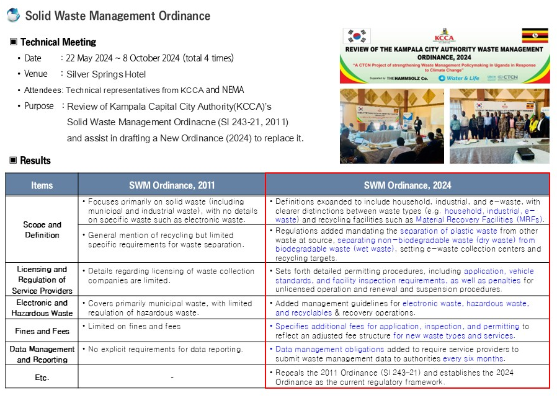
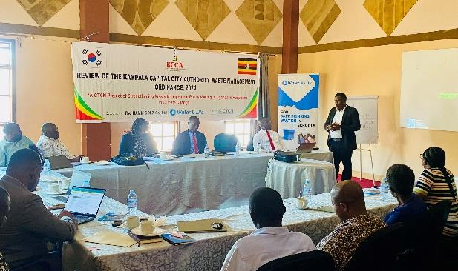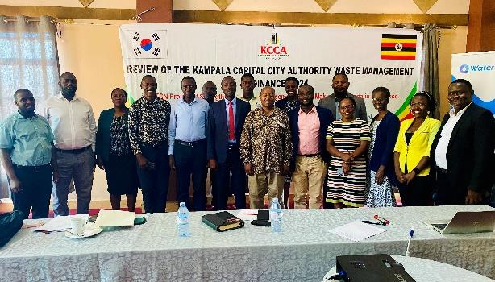

- We supported a project to review the existing solid waste policy and management ordinance (SI 243-21) enacted in 2011 by the Kampala Capital City Authority (KCCA), and to develop a new ordinance draft that reflects comprehensive waste management and resource circulation policies.
- The purpose of the revision was to establish more comprehensive and specialized regulatory standards for solid waste management, reflecting the changes in the legal status of the ordinance established under the 2000 Local Government Act (Cap. 243), such as the introduction of the National Environment Act (Act 5 of 2019).
- From May 22, 2024 to October 8, 2024, waste management decision-makers from Kampala City and external expert consultants conducted a joint review and held a total of four discussion sessions.
- The contents of the existing ordinance concerning six items were amended and submitted to the KCCA Authority CEC, and the draft is expected to go through the final review process by the Public Health Committee and Parliament.

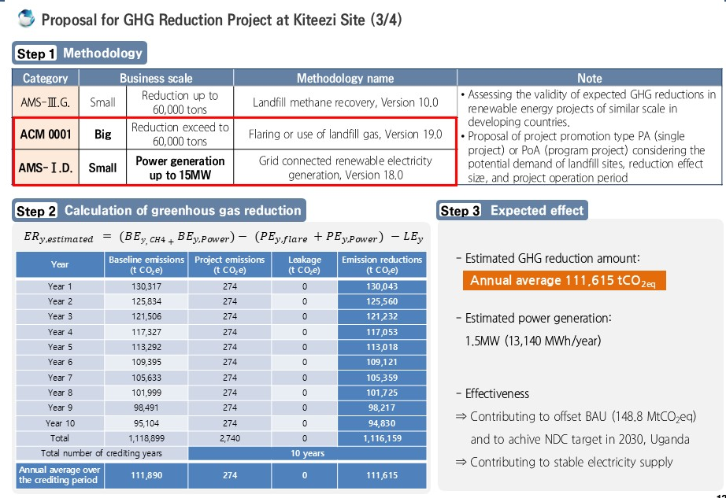

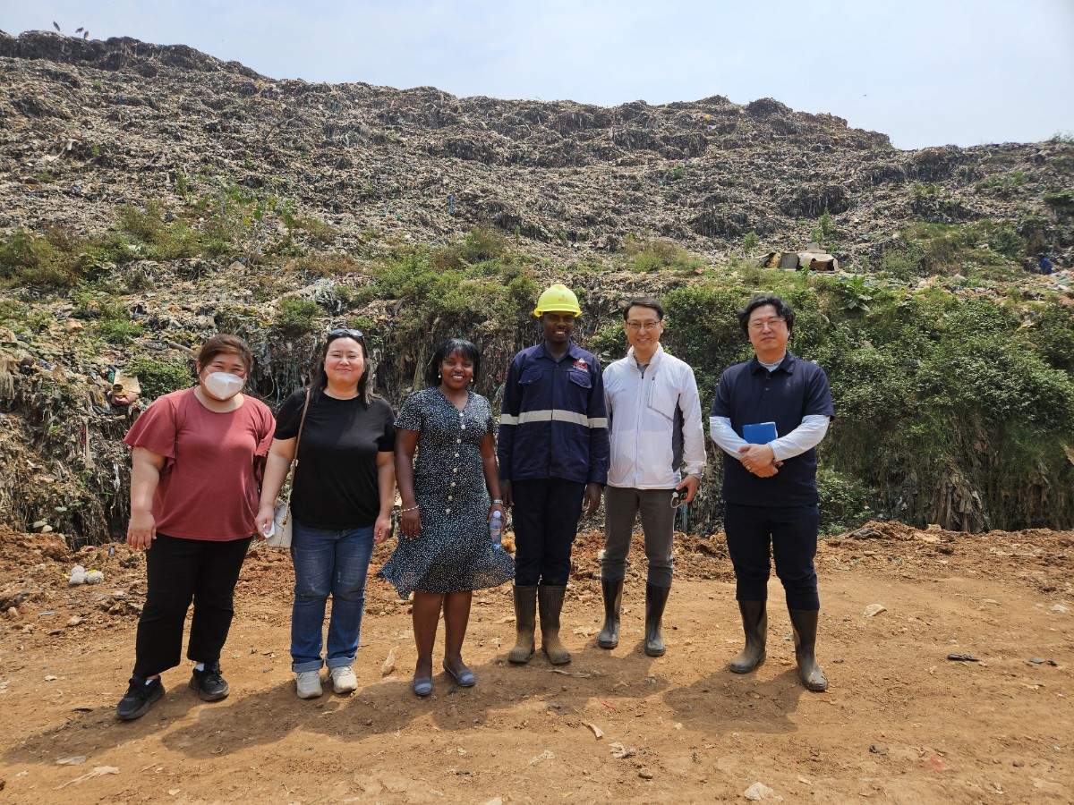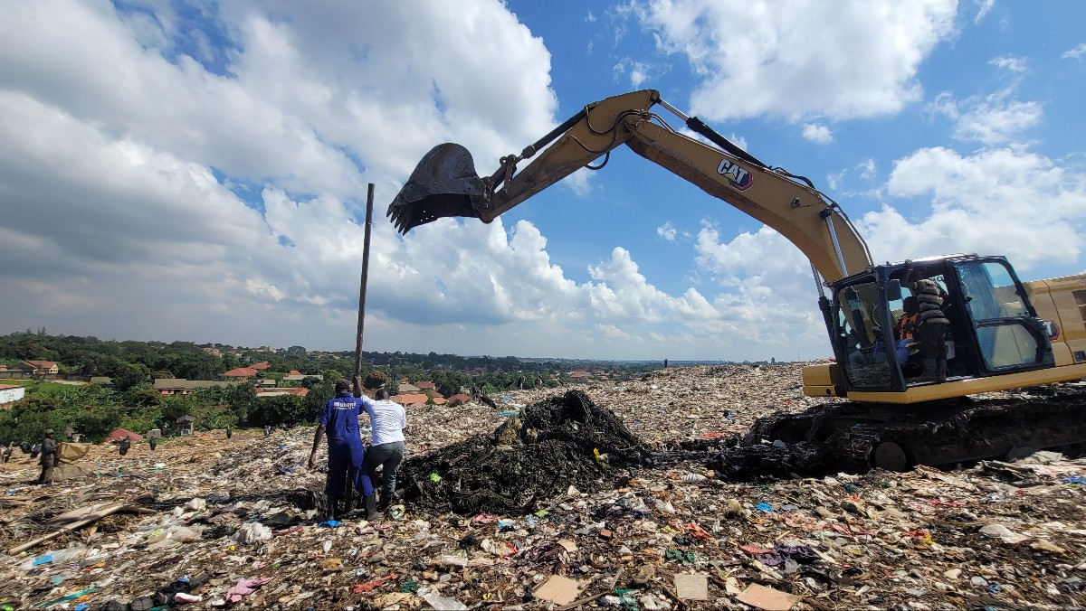

- The project aims to capture and flare the landfill gas (LFG) generated at the Kiteezi landfill site, thereby reducing the atmospheric emissions of methane (CH₄), a greenhouse gas, and contributing to climate change mitigation and the alleviation of global warming.
- According to the greenhouse gas reduction assessment, the total reduction over 10 years is estimated at 1,116,159 tCO₂e, with an average annual reduction effect of 111,615 tCO₂e.
- Additionally, if the landfill gas is utilized to operate a combined heat and power (CHP) generator, it would be capable of producing 1.5 MW of electricity.

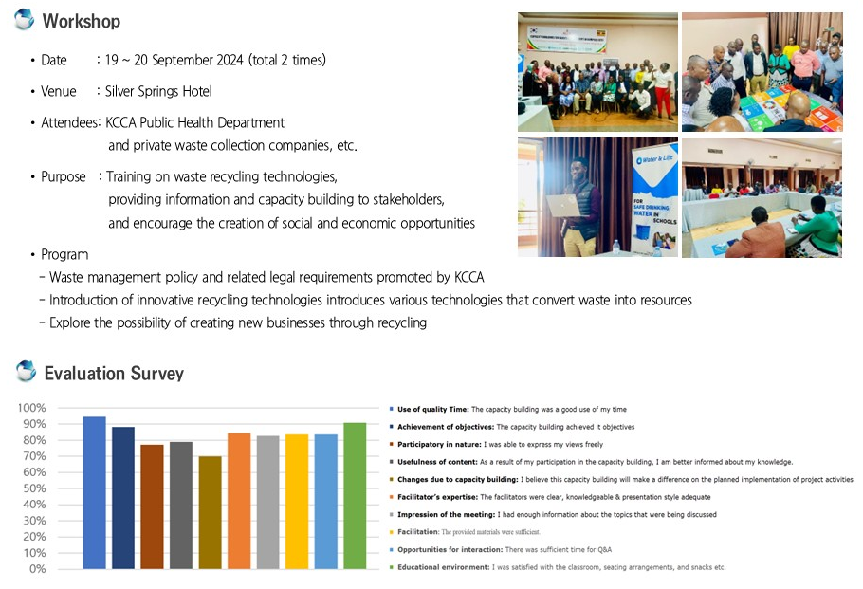
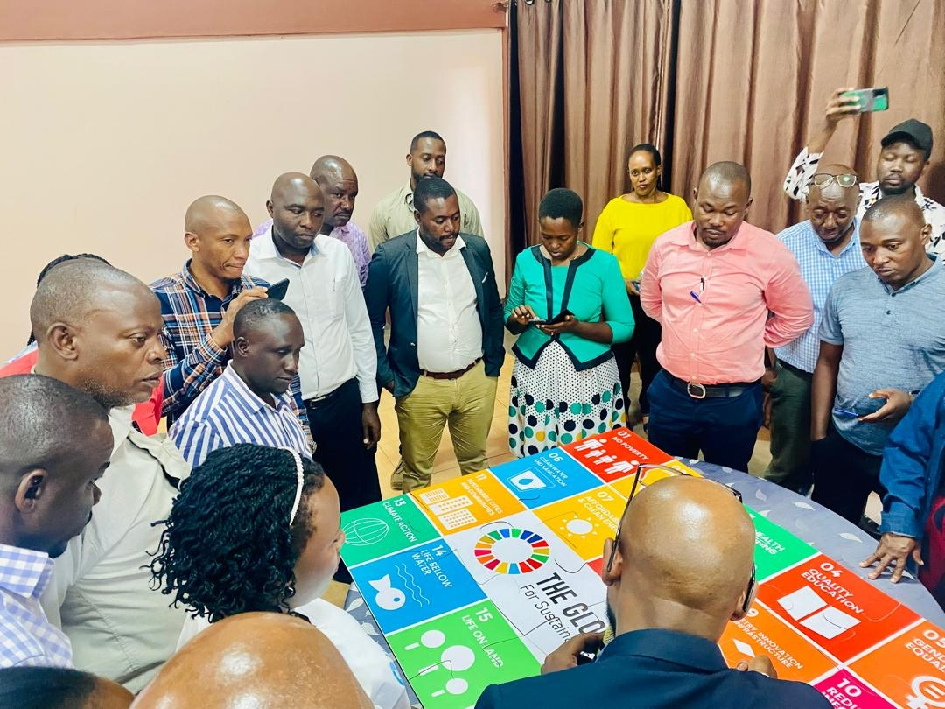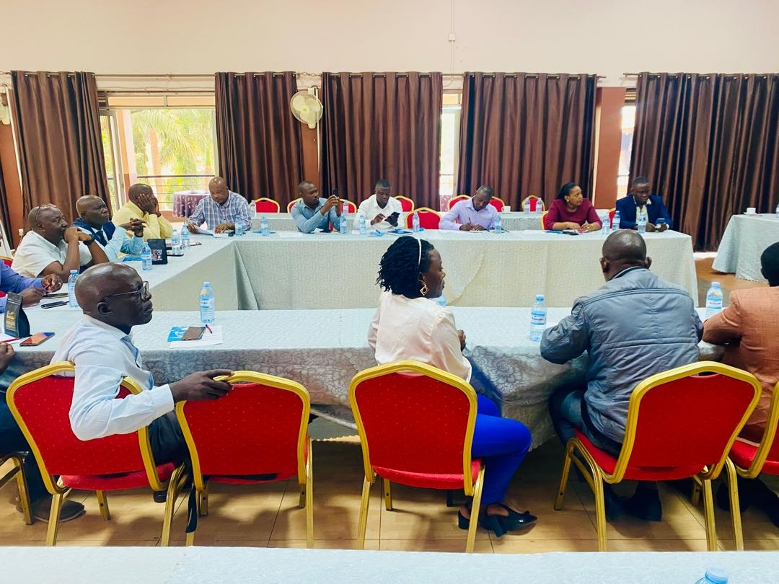

- A total of three workshops were conducted to strengthen the capacity of government officials. The program covered a variety of topics, including policy briefings, introductions to innovative recycling technologies, and the exploration of economic opportunities through recycling. In the policy sessions, KCCA’s waste management policies and related legal requirements were explained in detail, while the sessions on innovative recycling technologies introduced various methods for turning waste into resources.
- The workshops also included sessions exploring the potential to create new businesses through recycling, encouraging participants to generate social and economic opportunities through sustainable waste management.
- The average satisfaction rate for the capacity-building support was approximately 91.2%, with particularly high ratings in areas such as instructor expertise and time efficiency, indicating a positive outcome in achieving the core goals of knowledge transfer and professional development.

4. Impact Statement
The information in the table below will be used to communicate results and anticipated impacts of this technical assistance publicly. Please copy information from impact statement developed in the M&E Plan and update as relevant.

Challenge | Kampala City recognizes the need for climate change response and efficient management of landfill facilities and is planning the construction of a new landfill site. However, for successful implementation, various barriers, including the following, must be resolved.  a. Lack of waste disposal policy and system  b. Lack of waste resource infrastructure and expertise  c. Lack of greenhouse gas treatment facilities generated from landfills  d. Lack of waste management experience and technical knowledge
CTCN Assistance | Support the establishment of national policies related to waste landfill and strengthen the capacity of government officials for climate change response projects.  a.Policy establishment support  b.Waste recycling plan proposal  c.callculate greenhouse gas reduction and energy production to discover greenhouse gas reduction projects  d.workshops and support to strengthen government capacity
Anticipated impact | Lack of wasteUganda lacks overall infrastructure and experience in waste management, and thus aimed to build infrastructure and accumulate technology for waste management while simultaneously promoting greenhouse gas reduction.  a.Mitigating greenhouse gases through discovering greenhouse gas reduction projects (power generation facilities-2,74tCO2/year)  b.Support in establishing waste management policies suitable for Kampala city conditions  c.Accumulation of technology required for overall waste management  (3 workshops, 4 technical seminars)
Co-benefits: Achieved or anticipated co-benefits from the TA | a. Inclusive Economic Growth  The project will contribute indirectly to poverty reduction by generating additional employment and contribution to provision of basic amenities to the people and hence leading to improvement in quality of life of, at least, the people within the community in which the project is sited. The construction, controlling and monitoring of the LFG plant will create new positions for both skilled and unskilled labour in the communities.  b. Communities’ Health  The unsanitary dumpsites (especially huge scale sites as this target areas) in Uganda and scattered waste piles impacts adjacent communities, especially in terms of excessive odours, noise, dust, vermin and blowing litter. They can elevate health concerns relating to exposed waste, and leachate and landfill gas emissions. As these facilities are unsanitary, visually ugly, and degrade and pollute adjacent lands and water resources, they can reduce adjacent land values and restrict their future use. Communities along dumpsite access corridors also suffer from traffic, noise, dust, litter and accidents. Thus, immediate actions are needed to both improve and expand KCCA’s solid waste collection services, and to remediate existing disposal facilities to reduce environmental and public health impacts. The project will be changed the current situation and then the improved municipal solid waste system will accrue healthier benefit to households in the project areas. Modest direct short-term impacts on health levels in the project area would be expected during the project’s implementation phase. In addition, implementation of sanitation awareness and hygiene promotion activities will also assist to reduce the incidence of inflectional diseases.  C. Reducing greenhouse gases  The implementation of project activities in the target areas will contribute positively to climate change, as the emission of greenhouse gases emission will be reduced. Methane (CH4) is the main GHG generated at the landfill, and combustion of such gas yields carbon dioxide (CO2) which is less harmful (being methane 28 times as dangerous as carbon dioxide in terms of climate change)
Gender aspects of the TA | Households, and particularly women play important roles in solid waste management in Uganda, as they are mostly responsible to prepare and purchase food and other items for household consumption as well as to manage the household waste. Men, women and children transport waste to collection points and to curbside pick-up, depending on the weight of the containers. Men have primary responsibility to give money to women in the household to pay the tariff collectors.  At the institutional level women are underrepresented both in lower-level positions and at managerial or decision-making levels. Senior and mid-level management staff, most economists, engineers, and operators in the sector are males. Women mostly work at junior (and consequently low-paying) technical positions. The project also will be focused on women’s important roles in waste minimization and management to improve female consumer awareness of environmental and solid waste management issues through public awareness campaigns and training. In fact, in conducting three workshops and four technical seminars, we conducted training with decision-makers regardless of gender. This will enhance collection point operations for women operators by ensuring that overall conditions are improved.
Anticipated contribution to NDC | Through CTCN technical support,  a.Support for waste management and policy establishment,  b.discovery of greenhouse gas reduction projects,  c.and support for waste recycling and landfill operation plans  will help Uganda achieve NDC's greenhouse gas emission reduction.
The narrative story | Due to population growth and rapid urbanization, waste generated in Kampala City is expected to increase from 3,206 tons per day in 2015 to 4,739 tons in 2030.  Currently, there is only one landfill in Kampala, Kiteezi, and it is operating beyond its landfill capacity. 1,200 tons of waste is brought in per day across an area of about 14ha, and there are no facilities for waste reuse. As a result, landfill is being done using a simple open dumping method, which poses a serious risk of fire and explosion due to methane gas and contamination of the surrounding soil and nearby rivers due to leachate.  To solve these problems, KCCA is planning to build a new landfill and is stipulating measures and guidelines in accordance with the 2017 National Urban Solid Waste Management Policy.  However, it is experiencing difficulties due to lack of government policy and capacity to respond to climate change and improve waste landfill facility management efficiency.  Therefore, through CTCN technical support, we aim to support the establishment of current policies and implementation plans to achieve sustainable waste management and greenhouse gas reduction goals.
Contribution to SDGs  A complete list of SDGs and their targets is available here: https://sustainabledevelopment.un.org/partnership/register/ | SDG 6. Ensure availability and sustainable management of water and sanitation for all  - Reducing the proportion of wastewater generated from waste by half through the establishment of integrated waste management plans, and promoting the increase of recycling and safe reuse.  SDG 7.b By 2030, expand infrastructure and upgrade technology for supplying modern and sustainable energy services for all in developing countries, in particular least developed countries, small island developing States, and land-locked developing countries, in accordance with their respective programmes of support  - Expanding infrastructure for sustainable energy service provision through the development of greenhouse gas reduction projects, such as the use of landfill gas for power generation  SDG 13.2 Integrate climate change measures into national policies, strategies and planning  - Climate change measures are reflected in national policies, strategies and plans through integrated waste management and related policy establishment proposals.

Annex 1 Technical assistance data collection

Please add quantitative and qualitative values for the indicators selected in the M&E plan and monitored throughout the technical assistance in the tables below. Indicators which have been monitored in addition to the proposed indicators below may be added at the end of table A. Non-relevant indicators should be left blank.

- Output and outcome indicators

Indicator  Please note indicators below highlighted as anticipated | Quantitative value  Numerals only; disaggregates must sum to the total | Qualitative description  List the various elements corresponding to the quantitative value as well as timelines and responsible institutions
Total number of events organized by proponents and implementing partners | 7 | 3 workshops, 4 technical seminars
Number of participants in events organized by proponents and implementing partners | 24
- Number of men | 21 | All Ugandans
- Number of women | 3 | All Ugandans
Number of climate technology RD&D related events
Number of participants in climate technology RD&D events
- Number of men
- Number of women
Number of training organized by proponents and implementing partners | 7 | 3 workshops, 4 technical seminars
Number of participants in trainings organized by proponents and implementing partners | 24
- Number of men | 21 | All Ugandans
- Number of women | 3 | All Ugandans
Total number of institutions trained | 2
- Governmental (national or subnational) | 1 | KCCA,
- Private sector (bank, corporation, etc.) | 1 | Private waste collection company
- Nongovernmental (NGO, University, etc.)
Percentage of participants reporting satisfaction with CTCN training (from CTCN training feedback form) | 91.2
Percentage of participants reporting increased knowledge, capacity and/or understanding as a result of CTCN training (from CTCN training feedback form) | 85
- Percentage of men | 93.3
- Percentage of women | 6.7
Total number of deliverables produced during the assistance (excluding mission, progress and internal reports) | 8
- Number of communication materials, including news releases, newsletters, articles, presentations, social media postings, etc. |  | List the name of the documents
- Number of tools and technical documents strengthened, revised or developed | 4 | 1)Analysis of existing policies and waste facilities  2)Field investigation results report  3)Report of GHG Reduction Project at Kiteezi Landfill  4)KCCA technical meeting report for ordinance
- Number of other information materials strengthened, revised or created (For example training and workshop reports, Power Points, exercise docs etc.) | 4 | 1)Proposal for GHG reduction in dumpsite and new sanitary landfill  2)Attachment. Introduction of GHG Reduction Technology  3)Greenhouse Gas Reduction and Plastic Program  4) Capacity Building and Satisfaction Survey Results Report
Total number of policies, strategies, plans, laws, agreements or regulations supported by the assistance
- Adaptation related
- Mitigation related
- Both adaptation- and mitigation related
Anticipated number of policies, strategies, plans, laws, agreements or regulations proposed, adopted or implemented as a result of the TA
- Adaptation related
- Mitigation related
- Both adaptation- and mitigation related | 1 | The Local Governments (Kampala City Council) (Solid Waste  Management) Ordinance.
Anticipated number of technologies transferred or deployed as a result of CTCN support
Anticipated number of collaborations facilitated or enabled as a result of technical assistance
- Number of South-South collaborations
- Number of RD&D collaborations
- Number of private sector collaborations
Number of countries with strengthened National System of Innovation as a result of CTCN support | 1 | Uganda
Insert any additional indicators here

- Core impact indicators

Please fill in the tables for anticipated impacts of the CTCN assistance. Every technical assistance should contribute to at least one of the indicators below. For guidance on how to report on core indicators see the ‘M&E Guidance Document for TA Implementers’.

Core indicator 1 | Anticipated metric tons of CO₂ equivalent (CO₂e) emissions reduced or avoided as a result of CTCN TA  Please add your calculations in word or excel format as an Annex to this Closure Report, where applicable.
 | Anticipated metric tons of CO₂e reduced or avoided as a result of the TA on annual basis | Anticipated metric tons of CO₂e reduced or avoided as a result of the TA in total
Quantitative value  (emissions reductions) | Total number (numerals only, no rounding or abbreviations) | Total number (numerals only, no rounding or abbreviations)
Unit | tCO₂e | tCO₂e
GHG assessment boundary (project emissions)  Identify expected post-TA activities, associated effects and assess boundary for quantification of GHG emission reductions | 274 | 2740
Baseline emissions  Describe baseline scenario, baseline candidates, emission factors and emissions calculated | 111,890 | 1,118,899
Methodology  Explain the method or process of verifying the indicator and how data was gathered | Calculate emissions from electricity consumed according to the methodology of “Tool to calculate baseline, project and/or leakage emissions from electricity consumption” and “AMS-I.D.: Grid connected renewable electricity generation” | Calculate emissions from electricity consumed according to the methodology of “Tool to calculate baseline, project and/or leakage emissions from electricity consumption” and “AMS-I.D.: Grid connected renewable electricity generation”
Assumptions  Describe assumptions made during calculation and quantification of GHG reductions | Global Warming Potential (GWP) of methane, valid for the relevant commitment period=28 | Global Warming Potential (GWP) of methane, valid for the relevant commitment period=28

Core indicator 2 | Anticipated increased economic, health, well-being, infrastructure and built environment, and ecosystems resilience to climate change impacts as a result of technical assistance  Please provide a qualitative description of the anticipated impacts on the categories below
Infrastructure and built environment
Anticipated increased infrastructure resilience (avoided/mitigated climate induced damages and strengthened physical assets)
Ecosystems and biodiversity
Anticipated increased ecosystem resilience (areas with increased resistance to climate-induced disturbances and with improved recovery rates)
Economic
Anticipated increased economic resilience (e.g. less reliance on vulnerable economic sectors or diversification of livelihood)
Health and wellbeing  Anticipated increased health and wellbeing of target group (e.g. improved basic health, water and food security) | Environmental improvements can be made by establishing an integrated waste management system, activating separate disposal, recycling waste, and reducing fires and greenhouse gas emissions caused by landfill gas, thereby contributing to the health and well-being of Kampala residents.

Core indicator 3 | Anticipated number of direct and indirect beneficiaries as a result of the TA
 | Quantitative value | Means of verification
Total beneficiaries | 16,321,000
Number of adaptation beneficiaries | 16,320,000 | The labor force engaged in agriculture in Uganda
Number of mitigation beneficiaries | 1,000 | The number of people working at the Kiteezi landfill
Number of adaptation-and mitigation beneficiaries | 16,321,000

Core indicator 4 | Anticipated amount of funding/investment leveraged (USD) as a result of TA (disaggregated by public, private, national, and international sources, as well as between anticipated/confirmed funding)
 | Quantitative value confirmed in USD | Quantitative value anticipated in USD | Qualitative description  List the institutions, timelines, and description or title of the investment | Methods  Describe methods used for quantification of funds leveraged
Total funding |  | 3,200,000 | Total anticipated funding leveraged through TA support for waste management, methane capture, and green job training.
Anticipated amount of public funding mobilised from national/domestic sources |  | 750,000 | Commitment expected from Uganda Ministry of Water and Environment and Kampala Capital City Authority for landfill infrastructure upgrades.
Anticipated amount of public funding mobilised from international/ regional sources |  | 1,200,000 | Expected contribution from international partners (NEP, GCF readiness grants) for LFG capture technology and policy reform.
Anticipated amount of private funding mobilised from national/domestic sources |  | 400,000 | Anticipated investment from local waste management enterprises in recycling and composting pilots.
Anticipated amount of private funds mobilised from international/regional sources |  | 850,000 | nvestment interest from regional green energy firms in methane-to-electricity generation.

Annex 2 (for internal use – to be filled in by the CTCN)
CTCN evaluation
This section will be completed by the relevant CTCN Technology Manager.

- Evaluation of the timeliness of the TA implementation as measured against the timeline included in the response plan;
- Evaluation of TA quality as defined in the response plan;
- Overall performance of the Implementers;
- Overall engagement of the NDE and Proponent;
- Lessons learned on the CTCN process and steps taken by the CTCN to improve.

