Technical Assistance Closure Report Template
Objective of the technical assistance (TA) Closure Report:
- To communicate publicly in one document a summary of progress made and lessons learned during the TA towards the anticipated impact (sections 1-4).
- To document qualitative and quantitative data collected during TA, for use in donor and UN reporting (Annex 1).

Steps for completing the TA closure report:
- The lead TA implementer submits the closure report at the end of the technical assistance as a final deliverable. The TA closure report will capture outputs, outcomes and impacts of all activities conducted under the TA. Please copy and summarise relevant material from previous TA outputs/deliverables and the Response Plan, as relevant.
- A CTCN Manager will review and revise the closure report before final approval by the CTCN Deputy Director.

Important note on public and internal use of the closure report:
Once approved by the CTCN Deputy Director, the TA closure report will be a public document available on the CTCN website www.ctc-n.org. Selected content will be used for targeted communication activities. Annex 2 is for internal use only and will not be publicly available.

Closure Report for CTCN Technical Assistance

- Basic information
Title of response plan | Nohlivaranfaru Infiltration Gallery Response Plan
Technical assistance reference number | 3100004903
Country / countries | Maldives
NDE organisation | Afsal Hussain/Ahmed Waheed, Ministry of Environment, Climate Change and Technology
NDE focal point | Afsal Hussein, Ahmed Waheed
NDE contact information | afsal.hussain@environment.gov.mv afnan.ahmed@environment.gov.mv
Proponent focal point and organisation | Name, organization, email
Designer of the response plan | David Cox, NRW Specialists, dcox@nrwspecialists.com.au
Implementer(s) of technical assistance | UNTC, MECCT, NRW Specialists, Lamer, Stakeholders
Beneficiaries | Farmers and local community
Sector(s) addressed | Agricultural sector
Technologies supported | Water efficiency and water pumping
Implementation start date | (28/04/2022)
Implementation end date | (13/12/2024)
Total budget for implementation | USD 308,964
Description of delivered outputs and products as well as the activities undertaken to achieve them. In doing so, review the log frame of the original response plan and refer to it as appropriate | The technical services are to design and install an infiltration gallery system for groundwater extraction to ensure sustainable use of limited water resources with minimum impact on the aquifers in HDh.Nolhivaranfaru Island. The support will be achieved through:  - Site selection for installing the infiltration gallery system in HDh.Nolhivaranfaru Island through stakeholder consultations and preliminary investigation.  - Design of the infiltration gallery system at selected site in HDh.Nolhivaranfaru Island.  - Installation and monitoring of the infiltration gallery system at selected site in HDh.Nolhivaranfaru Island.  - Capacity building and awareness-raising to increase water use efficiency for agriculture as well as to manage the infiltration gallery system and monitor groundwater quality.
Methodologies applied to produce outputs and products | Background information review, site investigation including field survey, system analysis, environmental impact assessment, detailed design of new infiltration gallery, construction of new gallery, testing and monitoring of new gallery performance, production or water use efficiency material, management of gallery manual and agricultural guide materials.
Reference to knowledge resources | This is a new technology for the Maldives and the design was carried out based on past project experience
Deviations | The length of the infiltration gallery was increased form an estimated 250m to 300m long based on the field test data.
Anticipated follow-up activities and next steps | The following are some examples of next steps:  - Ministry to implement phase 2 of the project which is to provide water storage tank(s) and reticulation to farmers lots as well as drip irrigation systems for farmers  - Ministry of Agriculture to develop a Soils Management Plan for the Farmers  .

- Lessons learned
 | Lessons learned | Recommendations
Lessons learned from the CTCN TA process | The key issue is the responsiveness of the NDE organisation which delayed multiple deliverables | Recommendations include  - Acceptable response times to reports etc should be communicated to the NDE so that delays can be avoided in future
Lessons learned related to climate technology transfer | The adopted technology is suitable for the island and has the potential to make a long term sustainable improvement on the island and can be adopted on other islands also. | Recommendations include  - Ensuring that the receiving government is willing to implement the necessary Phase 2 activities to make full use of the constructed Phase 1 infrastructure

3. Illustration of the TA and photos

The following powerpoint slides show an overview of the project and how the constructed infiltration gallery is now available for future use.
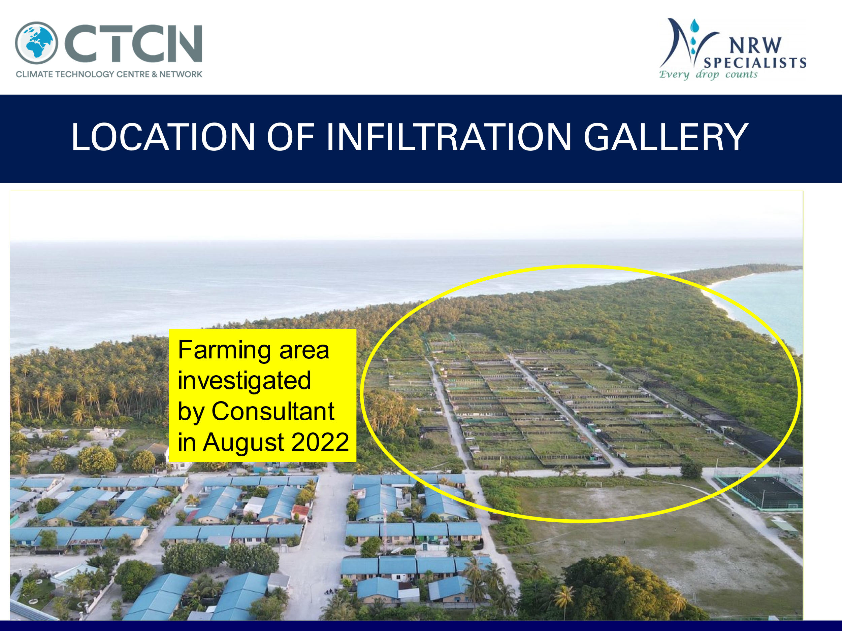

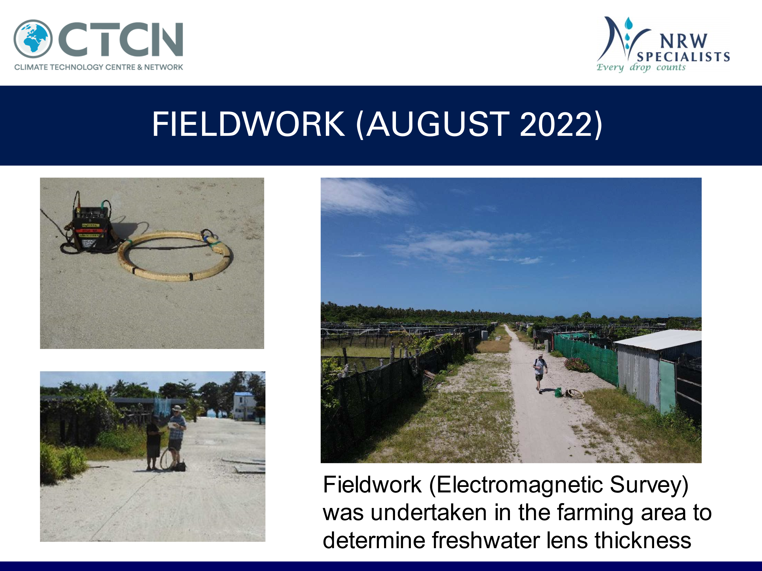

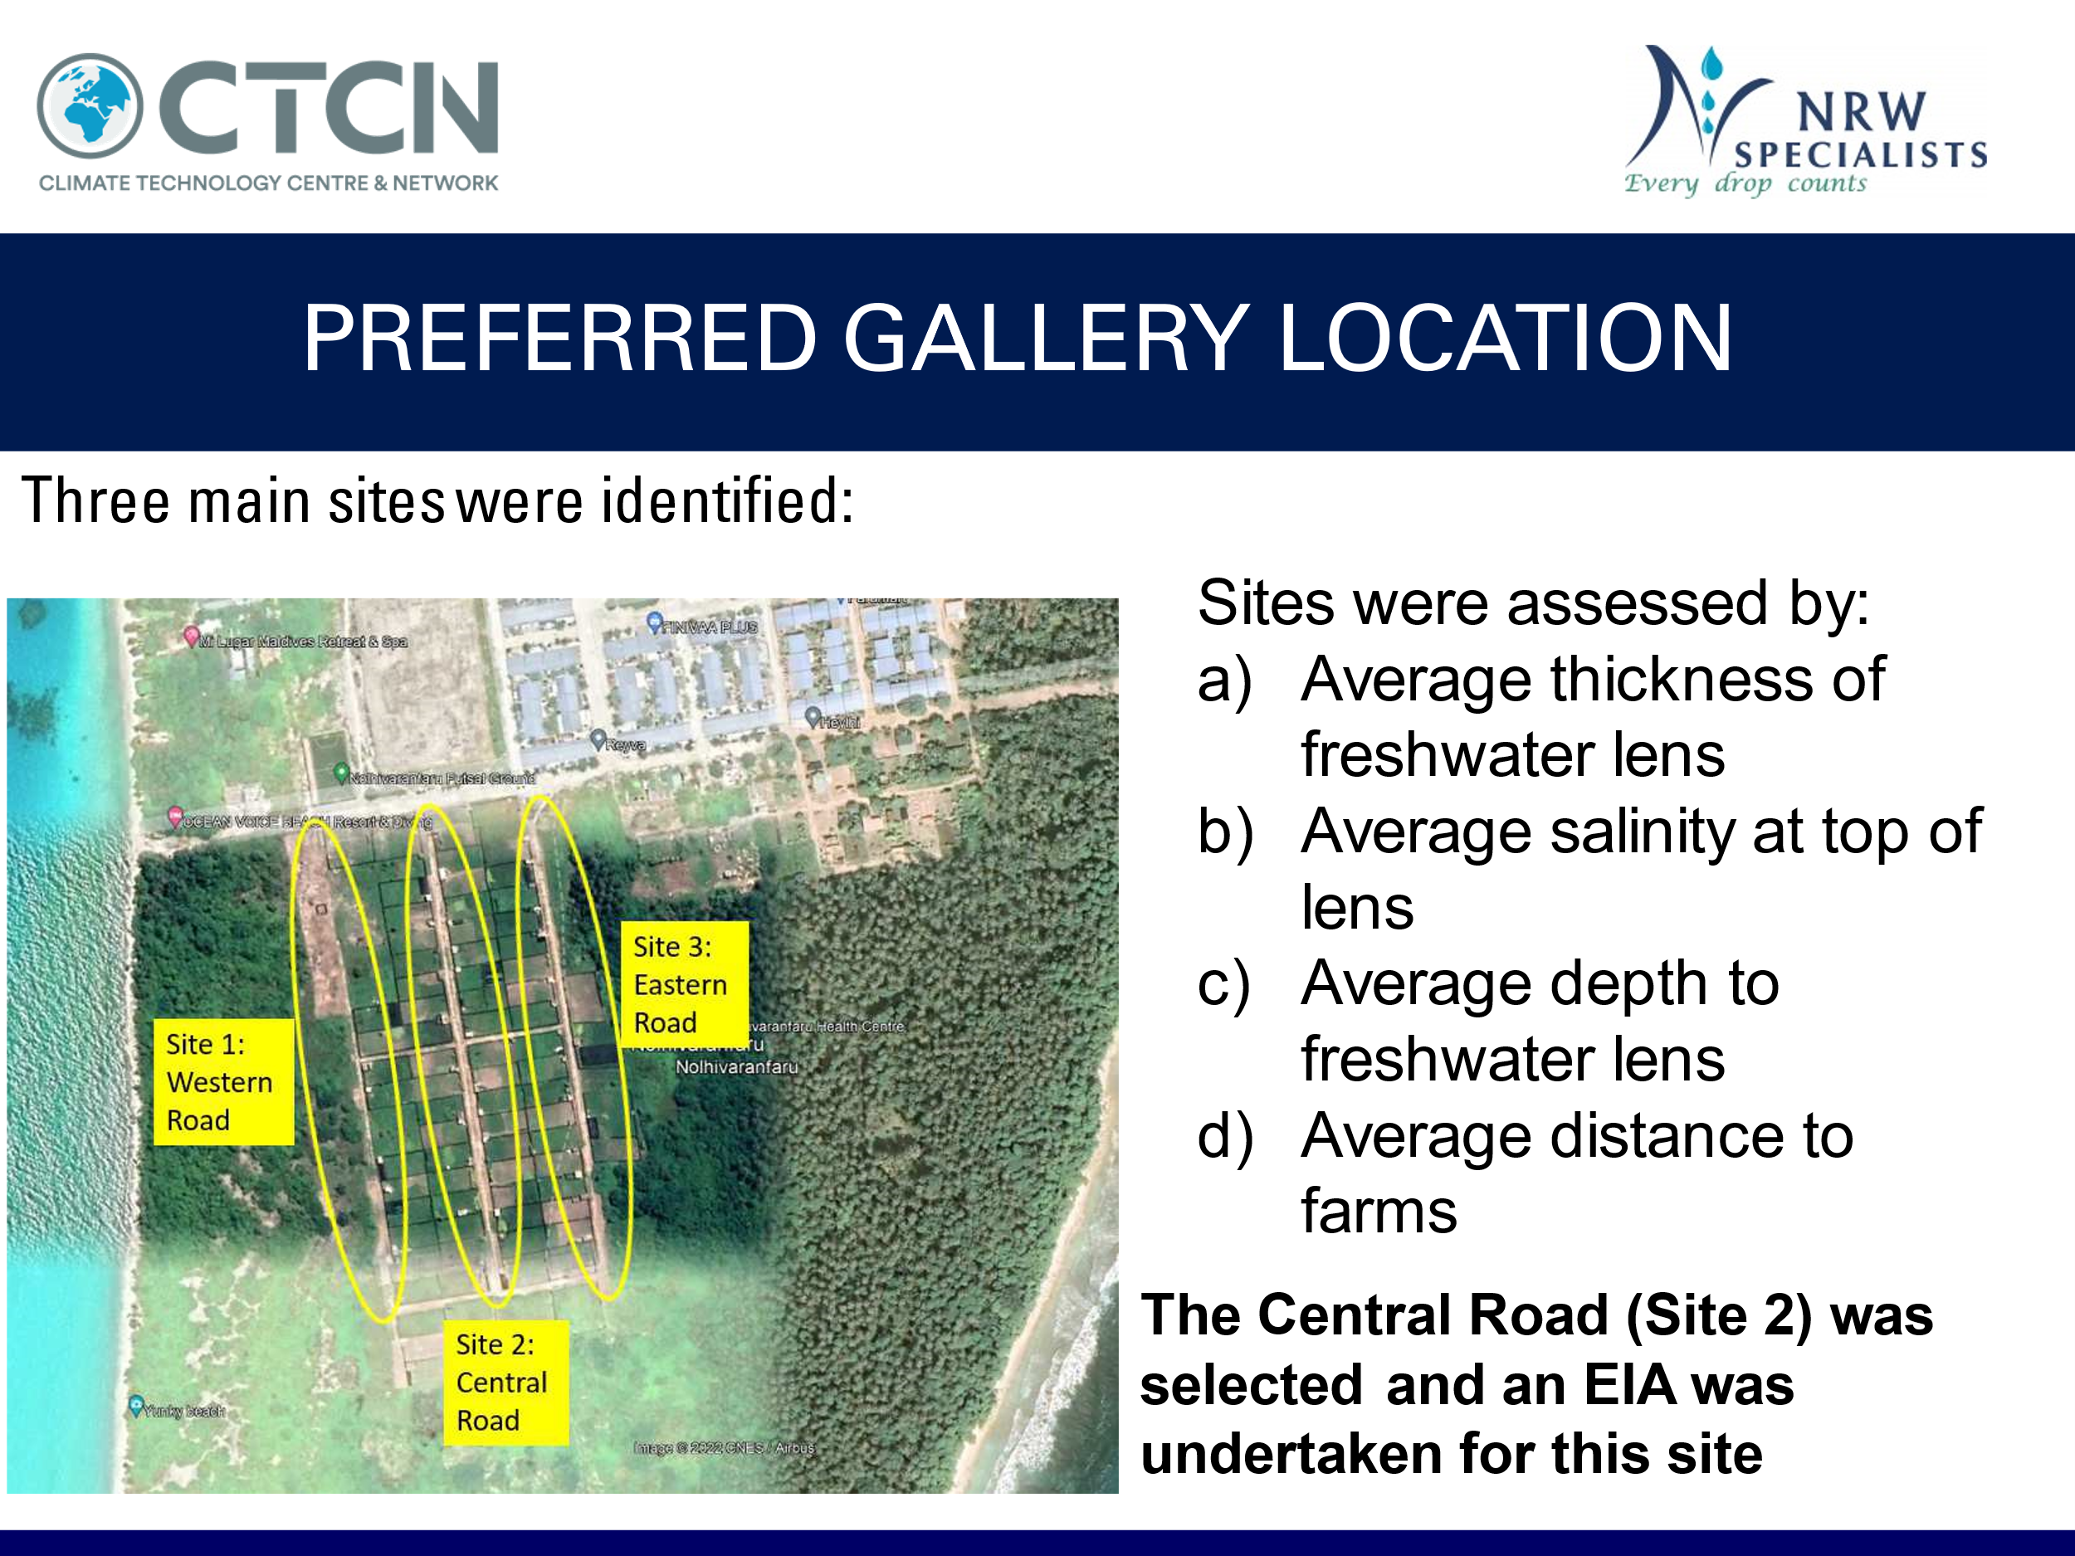

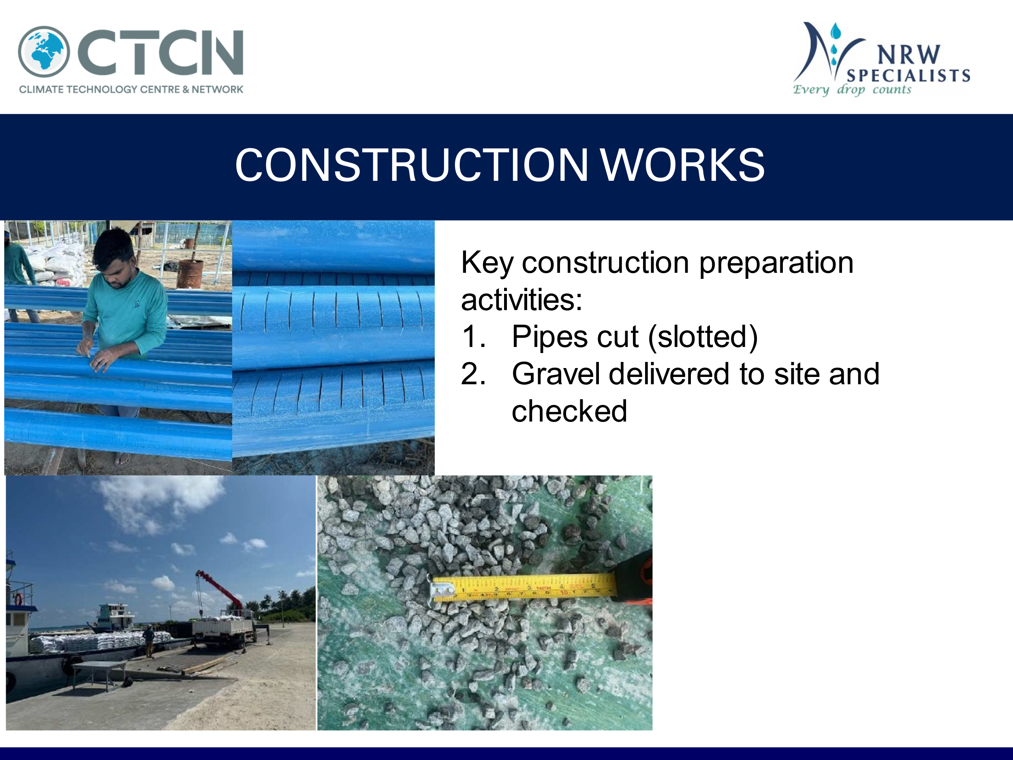

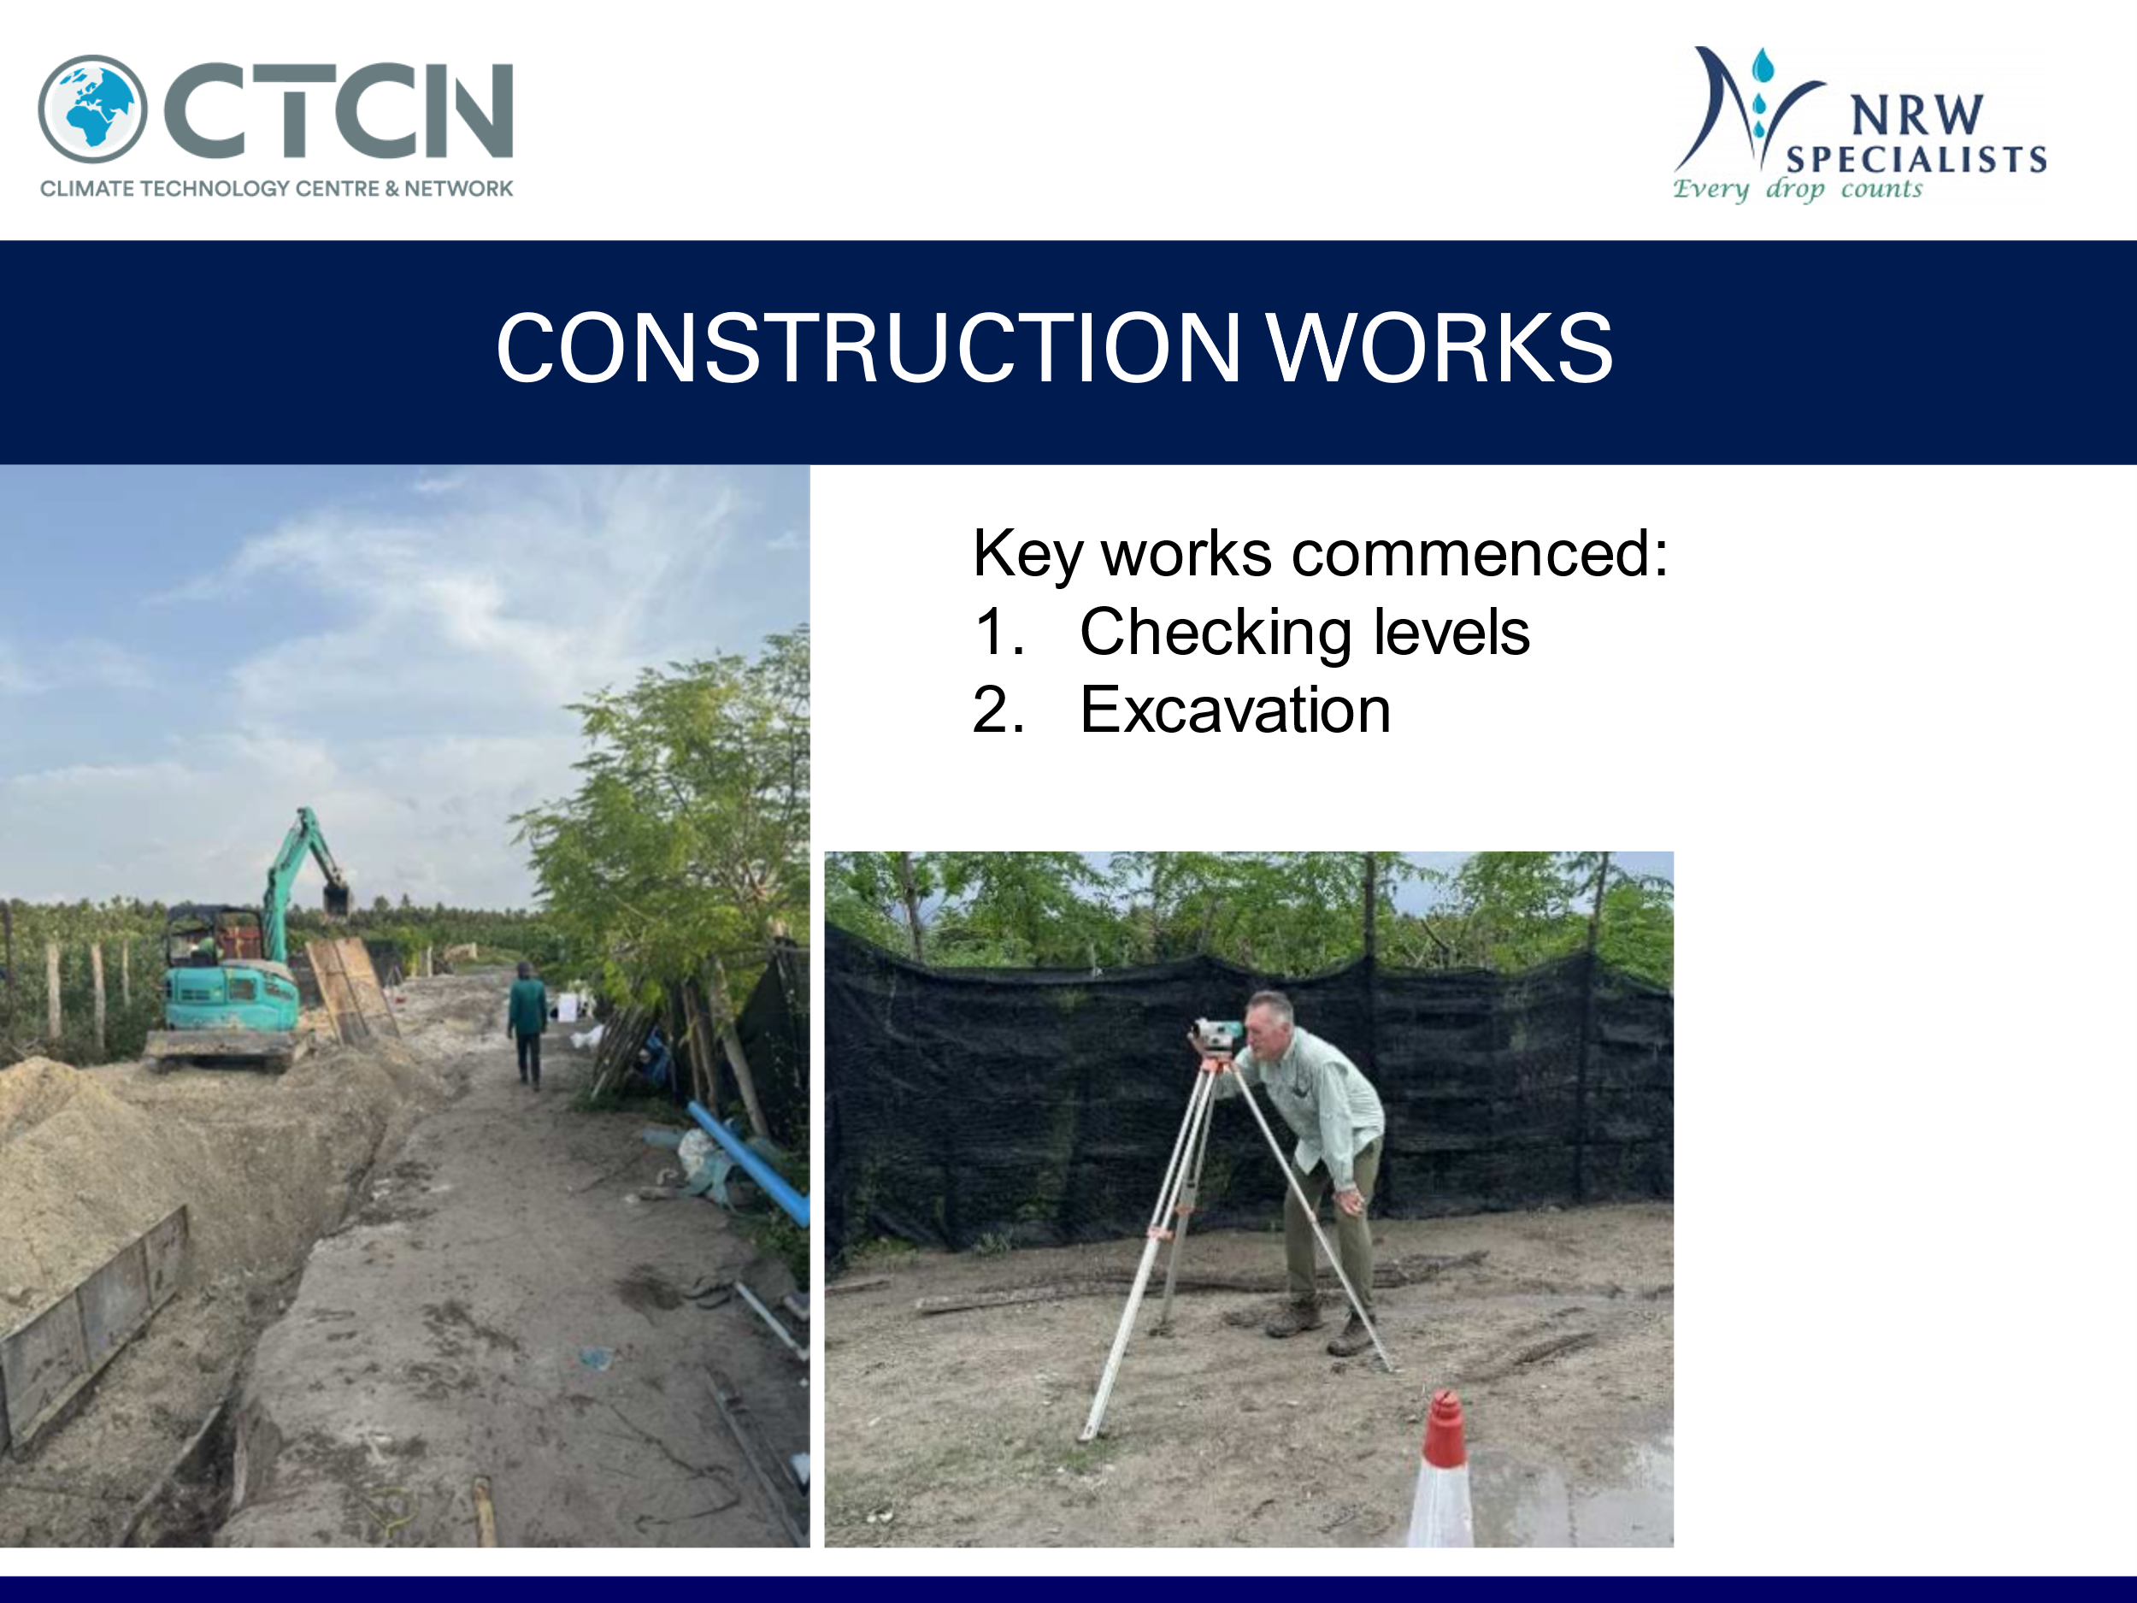

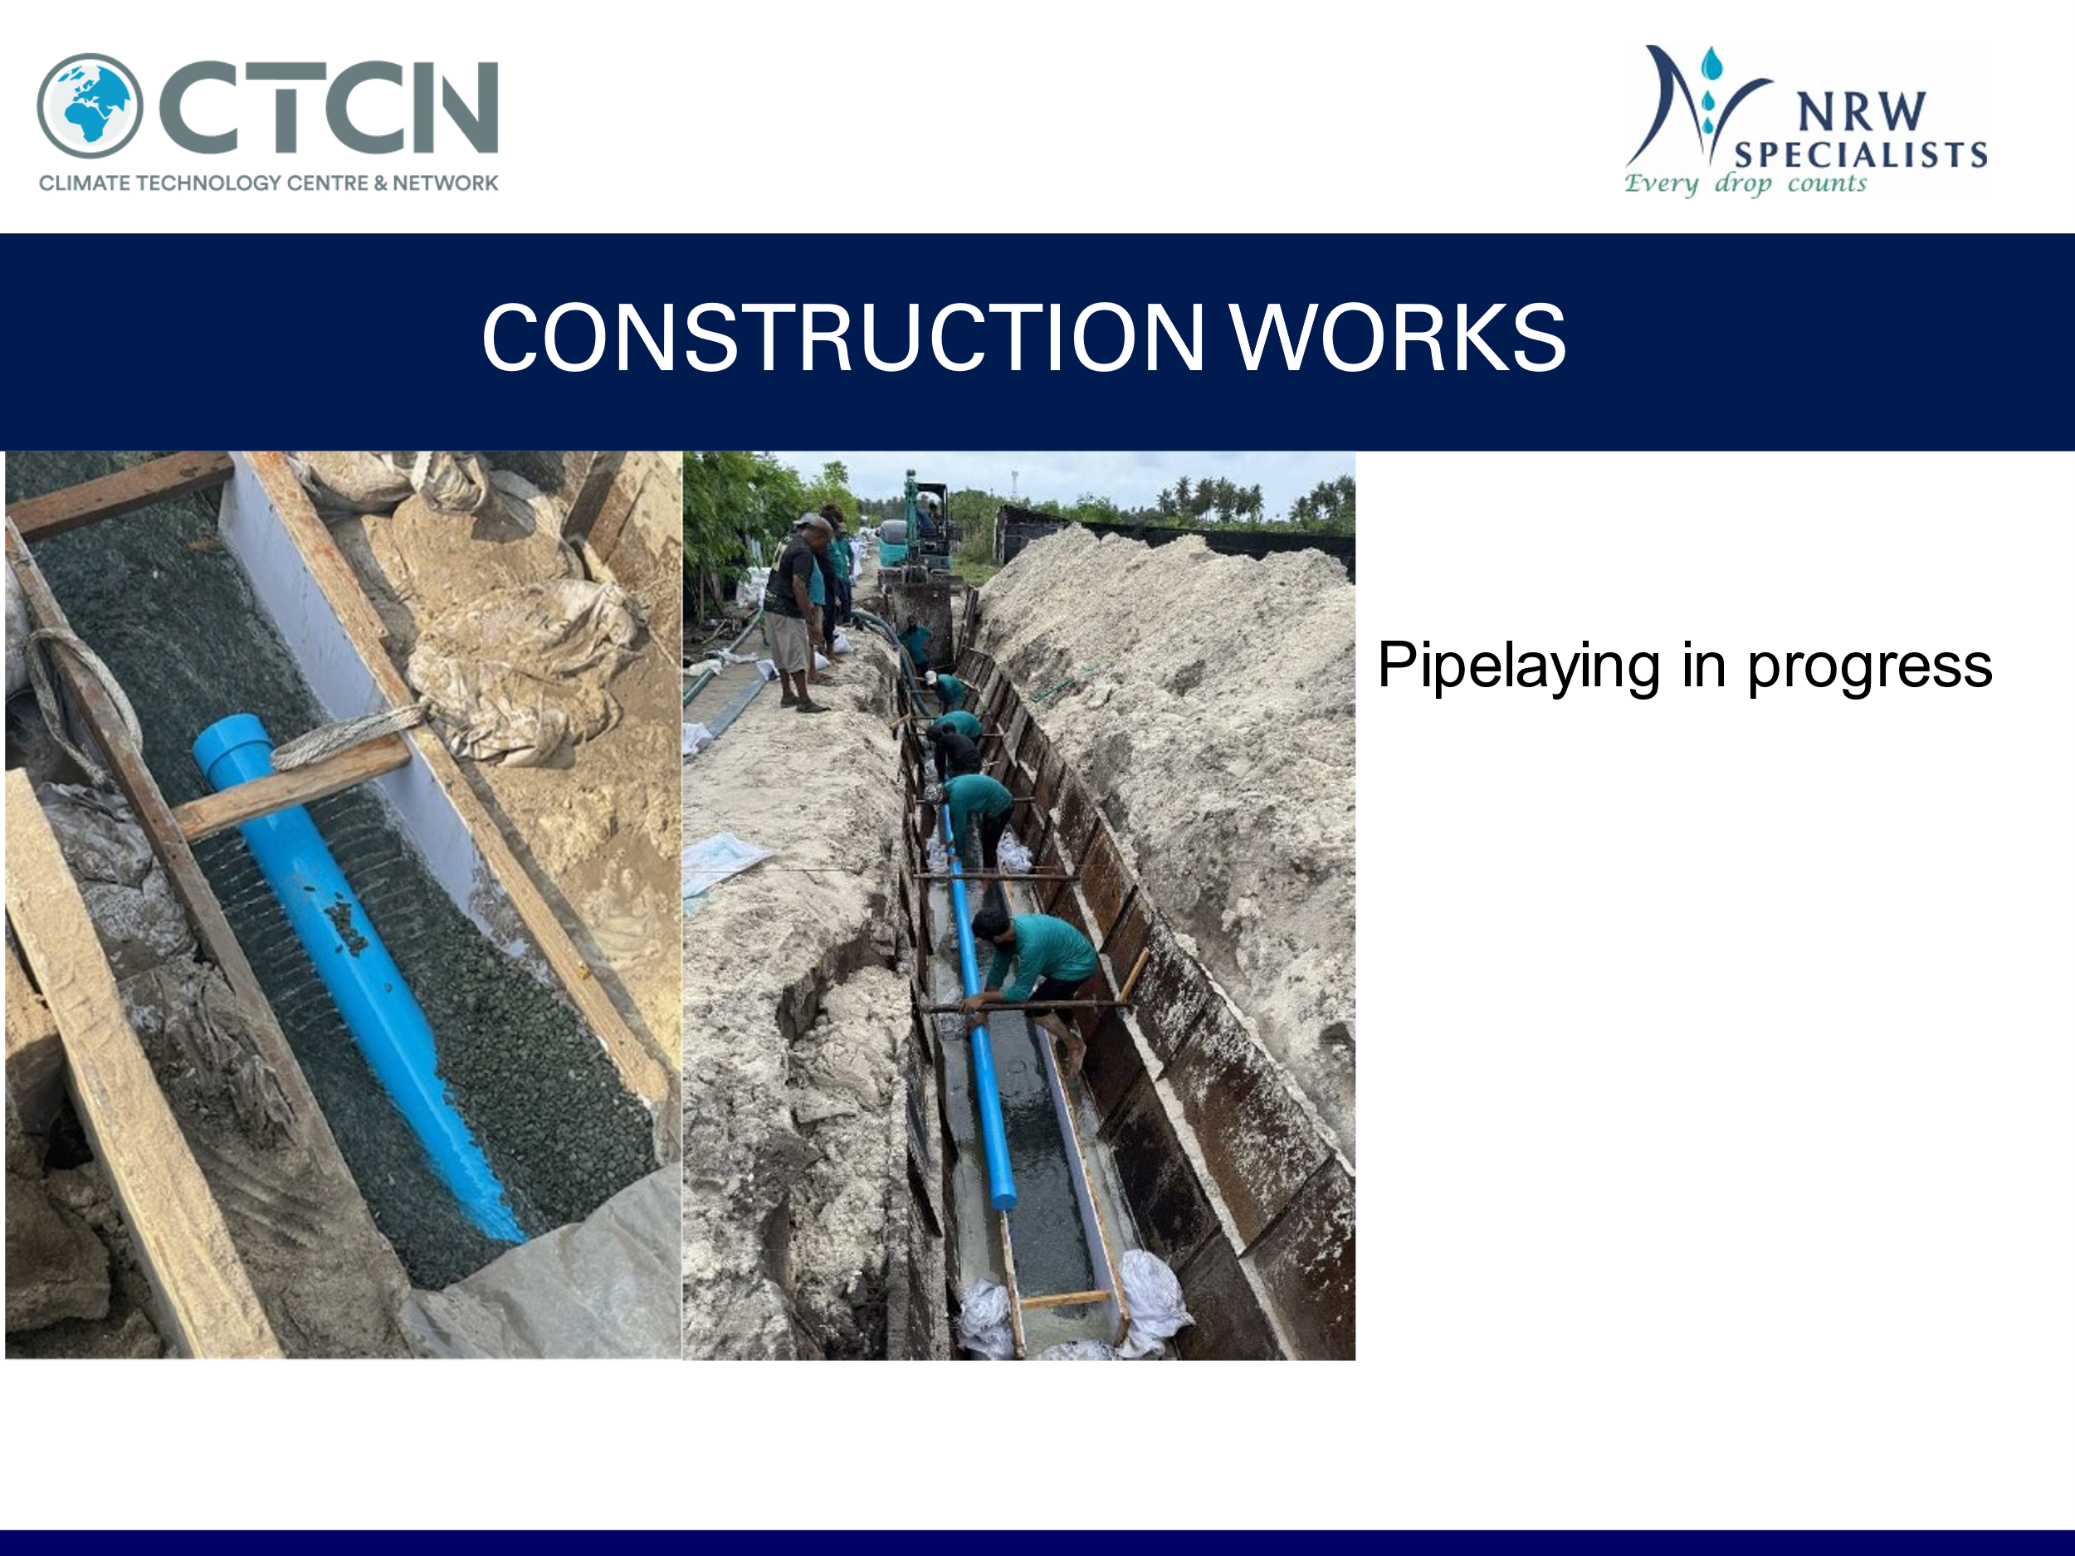

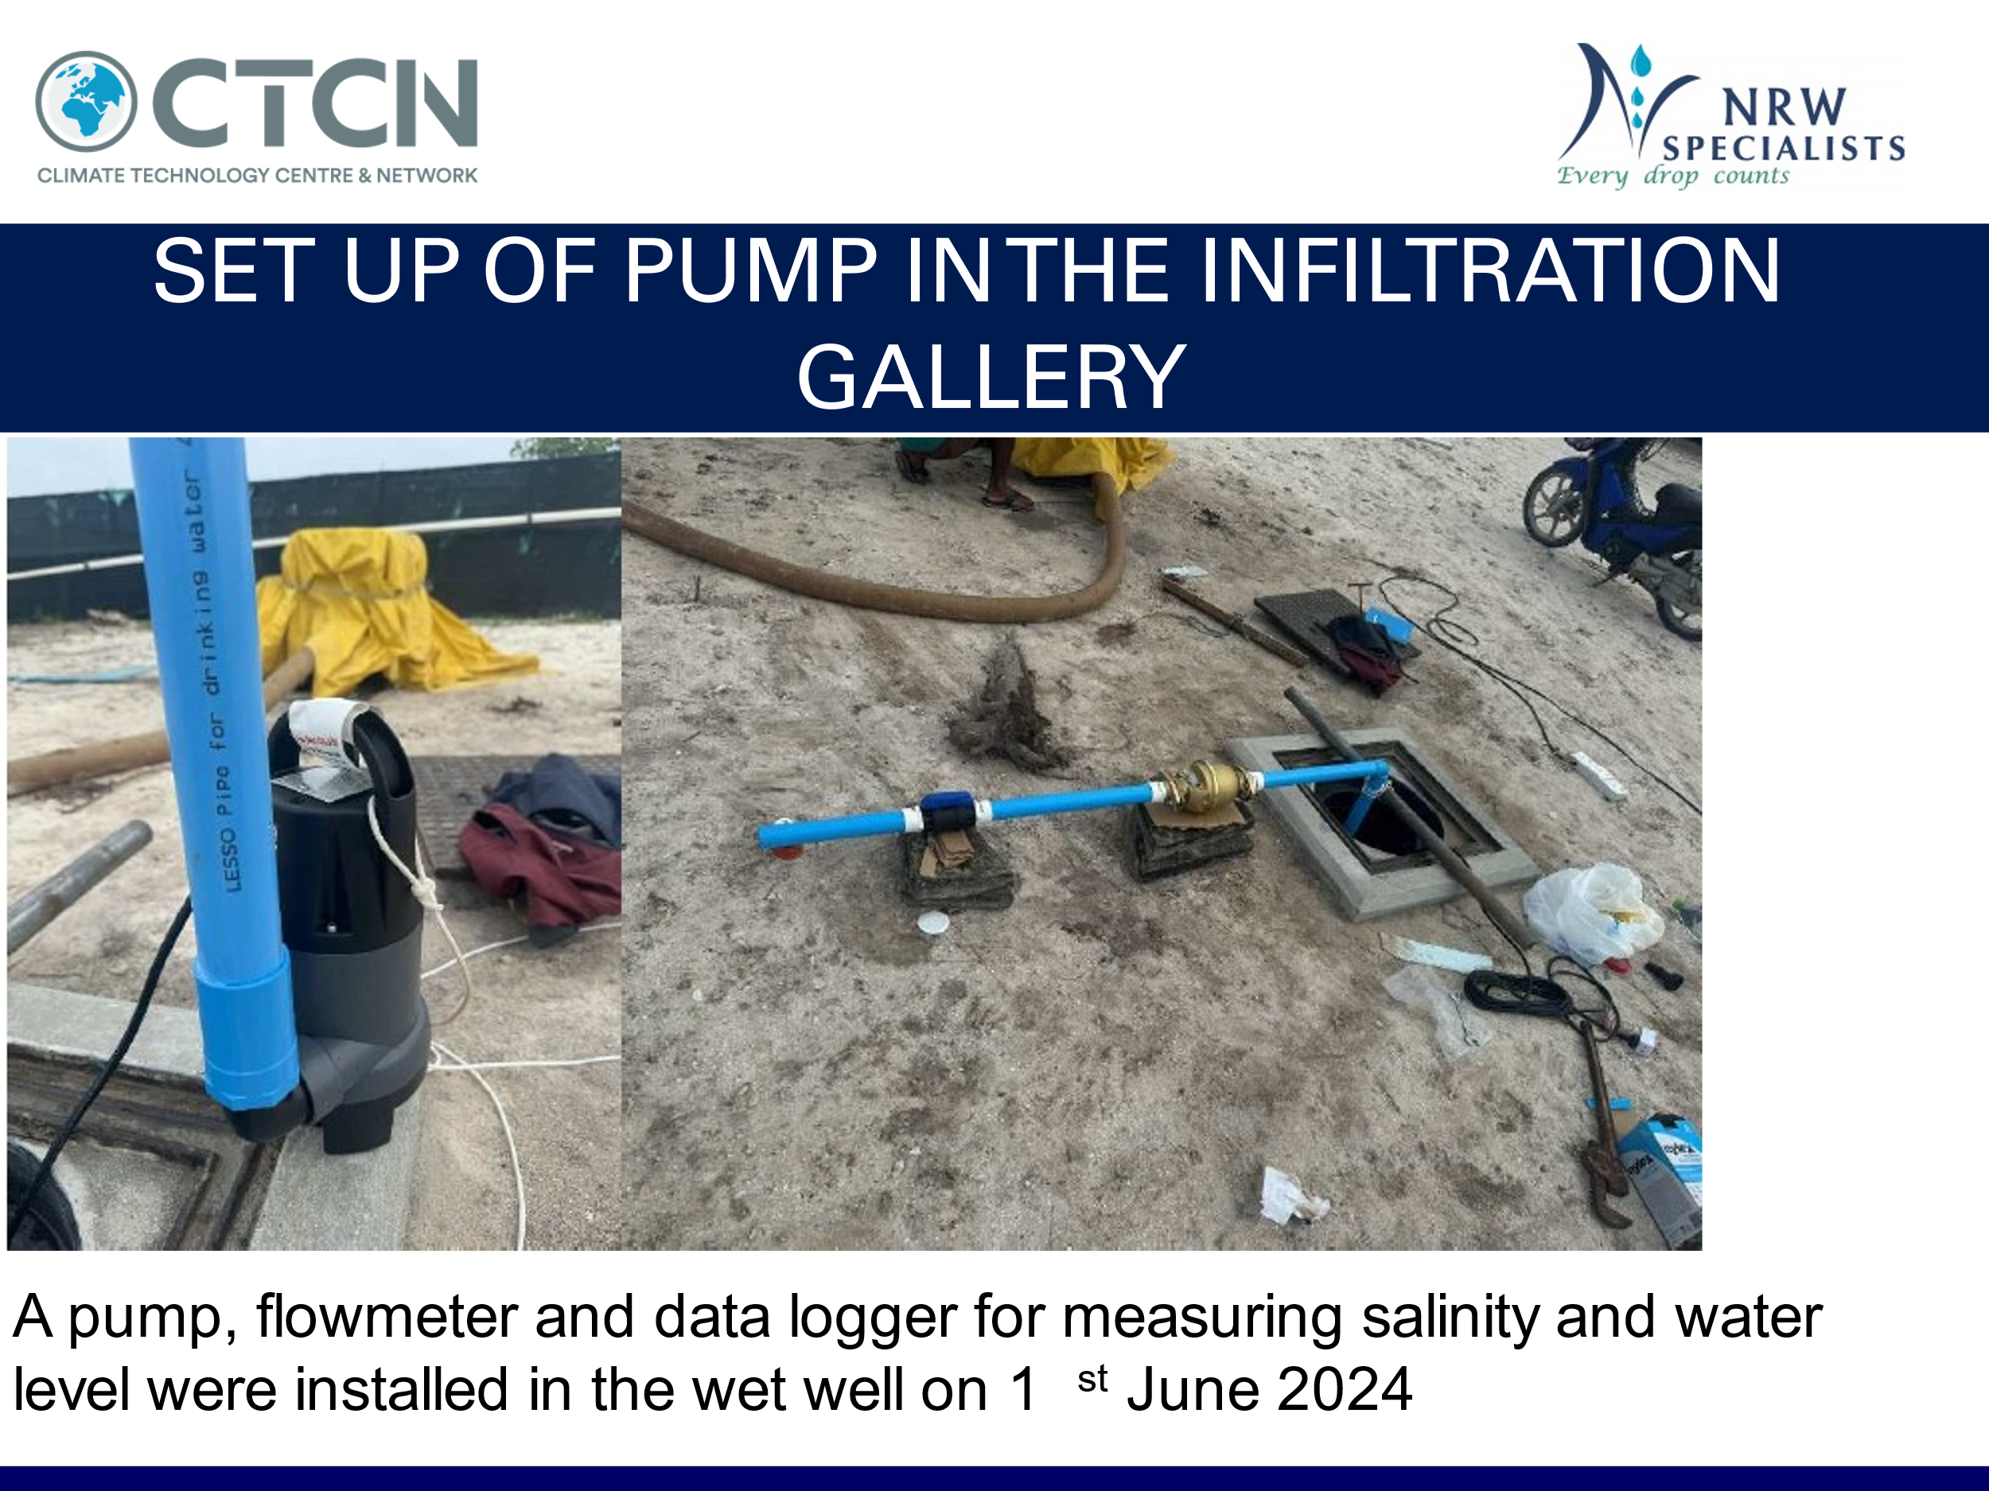

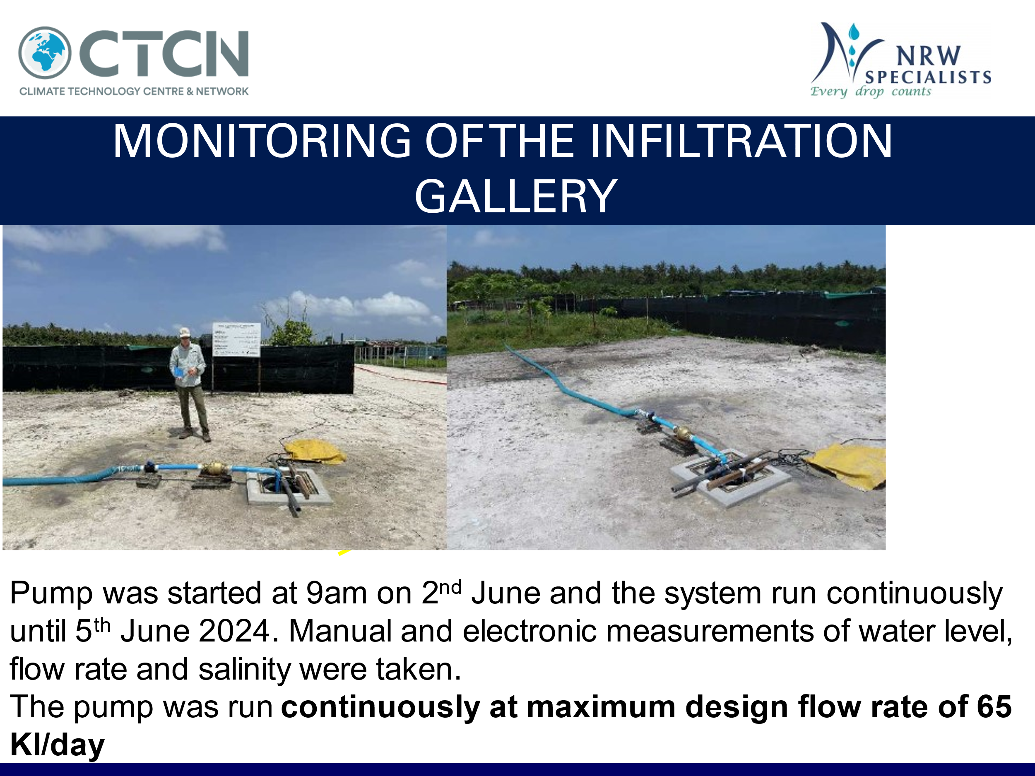

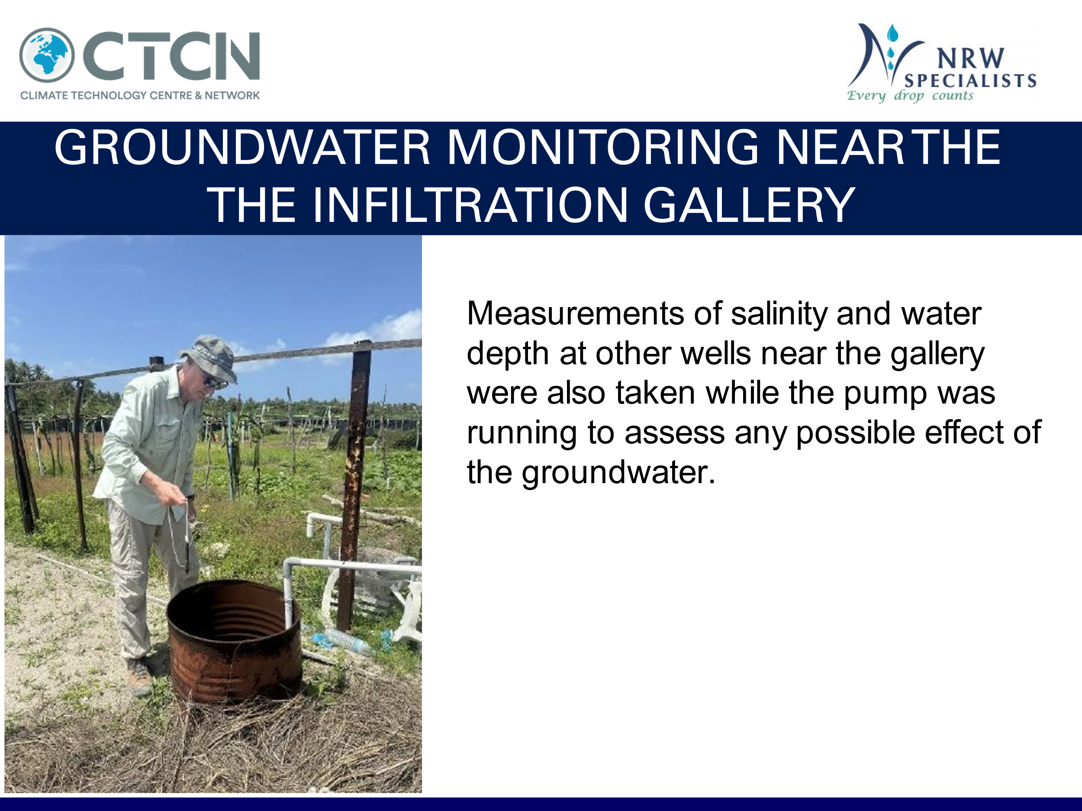

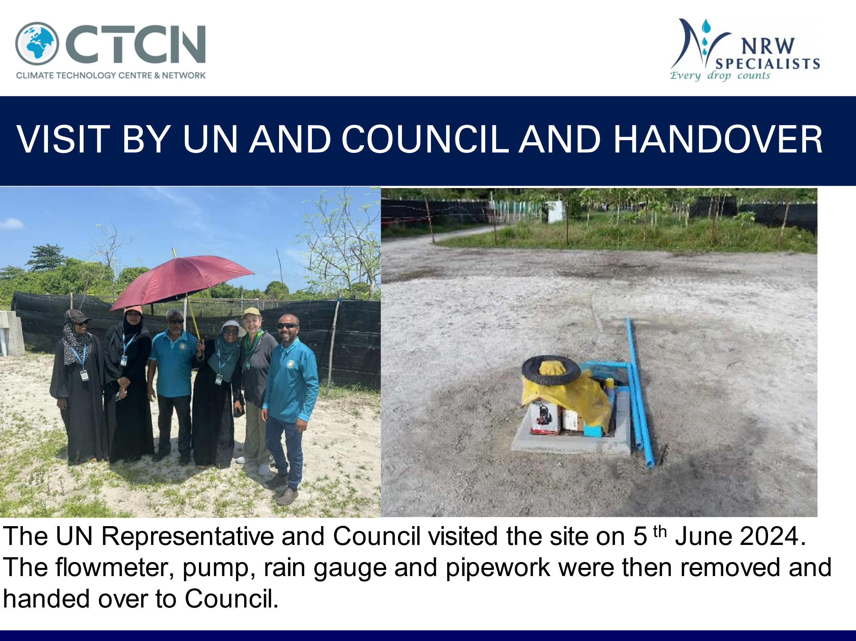

4. Impact Statement
The information in the table below will be used to communicate results and anticipated impacts of this technical assistance publicly. Please copy information from impact statement developed in the M&E Plan and update as relevant.

Impact Statement

Challenge | Water scarcity is one of the biggest challenges in Maldives arising from climate change. Freshwater is the most important water resource in the country; however, it’s quality and quantity are highly affected by climate variations and human activities such as urbanisation of the country and water use for agriculture. Moreover, intrusion of saline water deteriorates the quality of freshwater resources. Existing poor agricultural practices, such as use of dug wells as fertiliser mixing containers which causes leaching of fertilisers into freshwater resources, further intensifies this problem. Depletion of freshwater resources due to uncontrolled usage in the absence of appropriate means to regulate results in the threats to groundwater aquifers on the islands of Maldives. Excessive groundwater extraction has led to saline water intrusion and reduction of the efficiency of its natural recharge processes. In particular, during drought season, over-pumping can alter the size of the groundwater aquifer and limit recovery to its former size. Therefore, it is vital to develop and deploy an efficient method for groundwater extraction in order to ensure sustainable use of limited water resources with minimum impact on the aquifers in Maldives
CTCN assistance | The key areas of CTCN assistance are:  - Design and Construction of a new infiltration gallery for sustainable agricultural water supply  - Development of a Maintenance Manual for maintaining the new infrastructure  - Improvements to agricultural practices to achieve water efficient agricultural outcomes
Anticipated impact | - Climate resilient agricultural water supply system;  - Ability to maintain the new infrastructure effectively  - Improved agricultural yields through improved agricultural practices  - Direct benefit to community through improved local agricultural practices on Nohlivaranfaru.  - Estimated more than 1200 population to benefit by having locally produced fruits and vegetables.  - Opportunity to fully develop the farming potential using all farms and supply neighbouring islands including Hanimadhoo and Kulhudhuffushi which could benefit an additional approximately 5,000 people.
Anticipated co-benefits from the TA | - Capacity building of farmers to effectively manage the new infrastructure  - Improved agricultural knowledge by farmers to select appropriate crops for sustainable yields  - Reduced drawdown of water table and protection of groundwater quality and quantity.
Gender aspects of the TA | The technical assistance will be accompanied by a gender analysis. In particular, women have traditionally played the major role in agricultural and household production and childcare, as well as in drying and processing fish and producing a range of local fibre-based handicrafts.  These local knowledge systems and community-based practices have effectively ensured the sustainable harvesting and conservation of the natural resources.  Expected gender benefits include:  - Capacity building benefits in terms of:  - groundwater source management of the infiltration gallery  - Crop selection and water efficiency;  - Agricultural sustainability farming practice
Anticipated contribution to NDC | The project will contribute to the NDC by:  - Reduced emissions due to reduced pumping (water efficient agriculture);  - Climate proofing the agricultural water supply system on Nohlivaranfaru Island  - Contributing to food security and farmers and community members livelihoods
The narrative story | Since the current approach used in sourcing water for irrigation is unsustainable, there have been a number of interventions to promote sustainable groundwater use in small scale farming. In most cases, groundwater is extracted through jet (petrol) pumps for irrigation, and such system threatens the thin groundwater aquifer of the island which replenishes after rainfall. Moreover, although there have been some works underway to establish such system, it is not operationalised and neither practiced by farming communities. It is important to install and demonstrate an effective technology (e.g., avoiding using jet or heavyduty pumps to extract groundwater) which can facilitate sustainable groundwater extraction and management among small scale farmers of the island. With this, replication of the technology to other islands which are facing the similar issues in Maldives is to be taken into account.  The technical services are to design and install an infiltration gallery system for groundwater extraction to ensure sustainable use of limited water resources with minimum impact on the aquifers in HDh.Nolhivaranfaru Island. The support will be achieved through:  - Site selection for installing the infiltration gallery system in HDh.Nolhivaranfaru Island through stakeholder consultations and preliminary investigation.  - Design of the infiltration gallery system at selected site in HDh.Nolhivaranfaru Island.  - Installation and monitoring of the infiltration gallery system at selected site in HDh.Nolhivaranfaru Island.  - Capacity building and awareness-raising to increase water use efficiency for agriculture as well as to manage the infiltration gallery system and monitor groundwater quality.
Contribution to SDGs | SDG2 – Zero Hunger  The improvements in agricultural water supply reliability and sustainability will ensure that the island’s agricultural sector is robust for the long term and can sustain the local community. The full utilisation of the farms can provide for the a number of the food needs of the 1200 population of the island.  SDG5 – Gender Equality  The project will include the representation and participation of women to ensure knowledge transfer, capacity building and empower women and girls. There has been active participation by womend during Council meetings on the islands and women are represented on the Island Council which was the interface with the farmers.  SDG-13: Climate Action  The project will provide substantial benefits in climate change resilience including climate proofing the agricultural water supply through avoiding overextraction and pollution of the freshwater groundwater source. Prior to the project, the groundwater was at severe risk of being overpumped and damaged. The new infiltration gallery is suitable for servicing all the farms in a sustainable manner.
Reference to knowledge products | Knowledge products were accessed where considered appropriate to delivery of the project.

Annex 1 Technical assistance data collection

Please add quantitative and qualitative values for the indicators selected in the M&E plan and monitored throughout the technical assistance in the tables below. Indicators which have been monitored in addition to the proposed indicators below may be added at the end of table A. Non-relevant indicators should be left blank.

- Output and outcome indicators

Indicator  Please note indicators below highlighted as anticipated | Quantitative value  Numerals only; disaggregates must sum to the total | Qualitative description  List the various elements corresponding to the quantitative value as well as timelines and responsible institutions
Total number of events organized by proponents and implementing partners | 3 | Inception Meeting, Kickoff Meeting, Council Meeting, Steering Committee Meetings
Number of participants in events organized by proponents and implementing partners | 8
- Number of men | 6
- Number of women | 2
Number of climate technology RD&D related events | 1 | Field investigation using electro-magnetic equipment
Number of participants in climate technology RD&D events | List total number here
- Number of men | 6
- Number of women | 2
Number of training organized by proponents and implementing partners | 0 | Formal training was not possible due to project expiry
Number of participants in trainings organized by proponents and implementing partners | List total number here
- Number of men
- Number of women
Total number of institutions trained | List total number here
- Governmental (national or subnational) |  | List the name of organisations trained here
- Private sector (bank, corporation, etc.) |  | List the name of organisations trained here
- Nongovernmental (NGO, University, etc.) |  | List the name of organisations trained here
Percentage of participants reporting satisfaction with CTCN training (from CTCN training feedback form) |  | Satisfied= 4+ on 5-pt scale
Percentage of participants reporting increased knowledge, capacity and/or understanding as a result of CTCN training (from CTCN training feedback form) |  | Increased knowledge, capacity and/or understanding= 4+ on 5-pt scale
- Percentage of men
- Percentage of women
Total number of deliverables produced during the assistance (excluding mission, progress and internal reports) | 5 OUTPUTS | Refer to table below for individual documents under each Output
- Number of communication materials, including news releases, newsletters, articles, presentations, social media postings, etc. |  | List the name of the documents
- Number of tools and technical documents strengthened, revised or developed |  | List the name of the documents
- Number of other information materials strengthened, revised or created (For example training and workshop reports, Power Points, exercise docs etc.) |  | List the name of the documents
Total number of policies, strategies, plans, laws, agreements or regulations supported by the assistance | List total number here
- Adaptation related |  | List the type and name of documents supported
- Mitigation related |  | List the type and name of documents supported
- Both adaptation- and mitigation related |  | List the type and name of documents supported
Anticipated number of policies, strategies, plans, laws, agreements or regulations proposed, adopted or implemented as a result of the TA | List total number here
- Adaptation related |  | List the type of documents anticipated to be proposed, adopted or implemented
- Mitigation related |  | List the type of documents anticipated to be proposed, adopted or implemented
- Both adaptation- and mitigation related |  | List the type of documents anticipated to be proposed, adopted or implemented
Anticipated number of technologies transferred or deployed as a result of CTCN support | List total number here | Instruction: List the type of technologies supported by this assistance. Technologies must be identified from the CTCN taxonomy of climate sectors and technologies (download in pdf format and choose from column C): https://www.ctc-n.org/resources/ctcn-taxonomy
Anticipated number of collaborations facilitated or enabled as a result of technical assistance | List total number here
- Number of South-South collaborations |  | List the names of the organisations (excluding the CTCN or TA implementers)
- Number of RD&D collaborations |  | List the names of the organisations (excluding the CTCN or TA implementers)
- Number of private sector collaborations |  | List the names of the organisations (excluding the CTCN or TA implementers)
Number of countries with strengthened National System of Innovation as a result of CTCN support |  | List names of countries
Insert any additional indicators here

(A) Outputs and Activities as described in the Response Plan | (B) Indicator | (C) Expected results | (D) Method and frequency for data collection | (F) Comments
OUTPUT 1: DEVELOPMENT OF IMPLEMENTATION PLANNING AND COMMUNICATION DOCUMENTS | Core Indicator 2: Anticipated increased economic, health, well-being, infrastructure and built environment, and ecosystems resilience to climate change impacts as a result of technical assistance
Activity 1.1 Implementation Plan | Detailed Work Plan | Completed Detailed Work Plan
Activity 1.2 Monitoring and evaluation plan and Impact statement | Development of Plan | Completed M&E Plan
Activity 1.3 Technical assistance closure report | Development of Closure Report | Completed Closure Report
OUTPUT 2: INFILTRATION GALLERY SITE SELECTION | Core Indicator 2: Anticipated increased economic, health, well-being, infrastructure and built environment, and ecosystems resilience to climate change impacts as a result of technical assistance
Activity 2.1 Report on the kick-off meeting and stakeholder consultations | Consultation with Stakeholders and kick off meeting | Minutes of meeting
Activity 2.2 Detailed description of the Project Steering Committee, with name and contact details of the members, respective institutions, gender, etc. | Development of Steering Committee Structure and members | List of Steering Committee Members
Activity 2.3 Report on the preliminary investigation in HDh.Nolhivaranfaru | Site visit to Nohlivaranfaru to assess the site | Report on proposed location of gallery |  | Field measurements of salinity etc
OUTPUT 3: DESIGN OF INFILTRATION GALLERY SYSTEM AT SELECTED SITE | Core Indicator 2: Anticipated increased economic, health, well-being, infrastructure and built environment, and ecosystems resilience to climate change impacts as a result of technical assistance
Activity 3.1 Report on the environmental assessment of the infiltration gallery | Environmental Impact Assessment | Completed Environmental Impact Assessment
Activity 3.2 Detailed engineering design of the infiltration gallery system | Engineering Design | Design Drawings of proposed gallery
Activity 3.3 Minute of the Project Steering Committee meeting with a list of participants disaggregated by gender,materials used etc | Steering Committee meeting | Minutes of meeting with List of participants segregated by gender etc
OUTPUT 4: INSTALLATION AND MONITORING OF THE INFILTRATION GALLERY AT SELECTED SITE | Core Indicator 2: Anticipated increased economic, health, well-being, infrastructure and built environment, and ecosystems resilience to climate change impacts as a result of technical assistance
Activity 4.1 Installation, testing and commissioning of the infiltration gallery system at selected site | Construction of infiltration gallery | Completed infiltration gallery
Activity 4.2 Report on the monitoring of the infiltration gallery system and groundwater quality at selected site | Reporting on monitoring of gallery performance | Report on Monitoring of the Gallery
Activity 4.3 Minute of the Project Steering Committee with a list of participants disaggregated by gender, materials used, and summary of the discussions held | Steering Committee Meeting | Minutes of meeting with List of participants segregated by gender etc
OUTPUT 5: CAPACITY BUILDING AND AWARENESS-RAISING TO INCREASE WATER USE EFFICIENCY FOR AGRICULTURE, MANAGE THE INFILTRATION GALLERY AND MONITOR GROUNDWATER QUALITY | Core Indicator 2: Anticipated increased economic, health, well-being, infrastructure and built environment, and ecosystems resilience to climate change impacts as a result of technical assistance and Core Indicator 3: Anticipated number of direct and indirect beneficiaries as a result of this TA
Activity 5.1 Report on recommendations to increase water use efficiency for agriculture at selected site | Assessment of opportunities for increased water efficiency | Report on recommendations for increased water efficiency for agricultural use
Activity 5.2 Guide materials (e.g., leaflets, handouts, flyers, brochures, videos, etc.) for sustainable agricultural practices (in English and Maldivian) | Assessment of opportunities for sustainable agricultural practices | Guide materials for sustainable agricultural practices in English and Maldivian | Online workshop and printed materials
Activity 5.3 A manual for management of the infiltration gallery system and monitoring of groundwater quality at selected site (in English and Maldivian) | Development of Operations Manual | Manual for management of Infiltration Gallery in English and Maldivian | Online workshop and printed materials
Activity 5.4 Materials for training of trainer programme (e.g., presentations, satisfaction survey template, etc.) | Development of Training the Trainer programme | Development of Printed materials

- Core impact indicators

Please fill in the tables for anticipated impacts of the CTCN assistance. Every technical assistance should contribute to at least one of the indicators below. For guidance on how to report on core indicators see the ‘M&E Guidance Document for TA Implementers’.

Core indicator 1 | Anticipated metric tons of CO₂ equivalent (CO₂e) emissions reduced or avoided as a result of CTCN TA  Please add your calculations in word or excel format as an Annex to this Closure Report, where applicable.
 | Anticipated metric tons of CO₂e reduced or avoided as a result of the TA on annual basis | Anticipated metric tons of CO₂e reduced or avoided as a result of the TA in total
Quantitative value  (emissions reductions) | Total number (numerals only, no rounding or abbreviations) | Total number (numerals only, no rounding or abbreviations)
Unit | tCO₂e | tCO₂e
GHG assessment boundary (project emissions)

Identify expected post-TA activities, associated effects and assess boundary for quantification of GHG emission reductions
Baseline emissions

Describe baseline scenario, baseline candidates, emission factors and emissions calculated
Methodology

Explain the method or process of verifying the indicator and how data was gathered
Assumptions
Describe assumptions made during calculation and quantification of GHG reductions

Core indicator 2 | Anticipated increased economic, health, well-being, infrastructure and built environment, and ecosystems resilience to climate change impacts as a result of technical assistance  Please provide a qualitative description of the anticipated impacts on the categories below
Infrastructure and built environment
Anticipated increased infrastructure resilience (avoided/mitigated climate induced damages and strengthened physical assets)
Ecosystems and biodiversity
Anticipated increased ecosystem resilience (areas with increased resistance to climate-induced disturbances and with improved recovery rates)
Economic
Anticipated increased economic resilience (e.g. less reliance on vulnerable economic sectors or diversification of livelihood)
Health and wellbeing
Anticipated increased health and wellbeing of target group (e.g. improved basic health, water and food security)

Core indicator 3 | Anticipated number of direct and indirect beneficiaries as a result of the TA
 | Quantitative value | Means of verification
Total beneficiaries | 1250 | Population data for the island – all inhabitants to benefit from larger scale farming on the island
Number of adaptation beneficiaries | 1250 | Describe calculation methods and assumptions made
Number of mitigation beneficiaries | 530,000 | Population of Maldives
Number of adaptation-and mitigation beneficiaries | 531,250 | As this project was the first of its kind in the Maldives and can be replicated on other islands, the country can benefit from rolling out this technology on a larger scale.

Core indicator 4 | Anticipated amount of funding/investment leveraged (USD) as a result of TA (disaggregated by public, private, national, and international sources, as well as between anticipated/confirmed funding)
 | Quantitative value confirmed in USD | Quantitative value anticipated in USD | Qualitative description  List the institutions, timelines, and description or title of the investment | Methods  Describe methods used for quantification of funds leveraged
Total funding | Total number in USD (numerals only, no rounding or abbreviations) | Total number in USD (numerals only, no rounding or abbreviations)
Anticipated amount of public funding mobilised from national/domestic sources
Anticipated amount of public funding mobilised from international/ regional sources
Anticipated amount of private funding mobilised from national/domestic sources
Anticipated amount of private funds mobilised from international/regional sources

Annex 2 (for internal use – to be filled in by the CTCN)
CTCN evaluation
This section will be completed by the relevant CTCN Technology Manager.

- Evaluation of the timeliness of the TA implementation as measured against the timeline included in the response plan;
- Evaluation of TA quality as defined in the response plan;
- Overall performance of the Implementers;
- Overall engagement of the NDE and Proponent;
- Lessons learned on the CTCN process and steps taken by the CTCN to improve.

