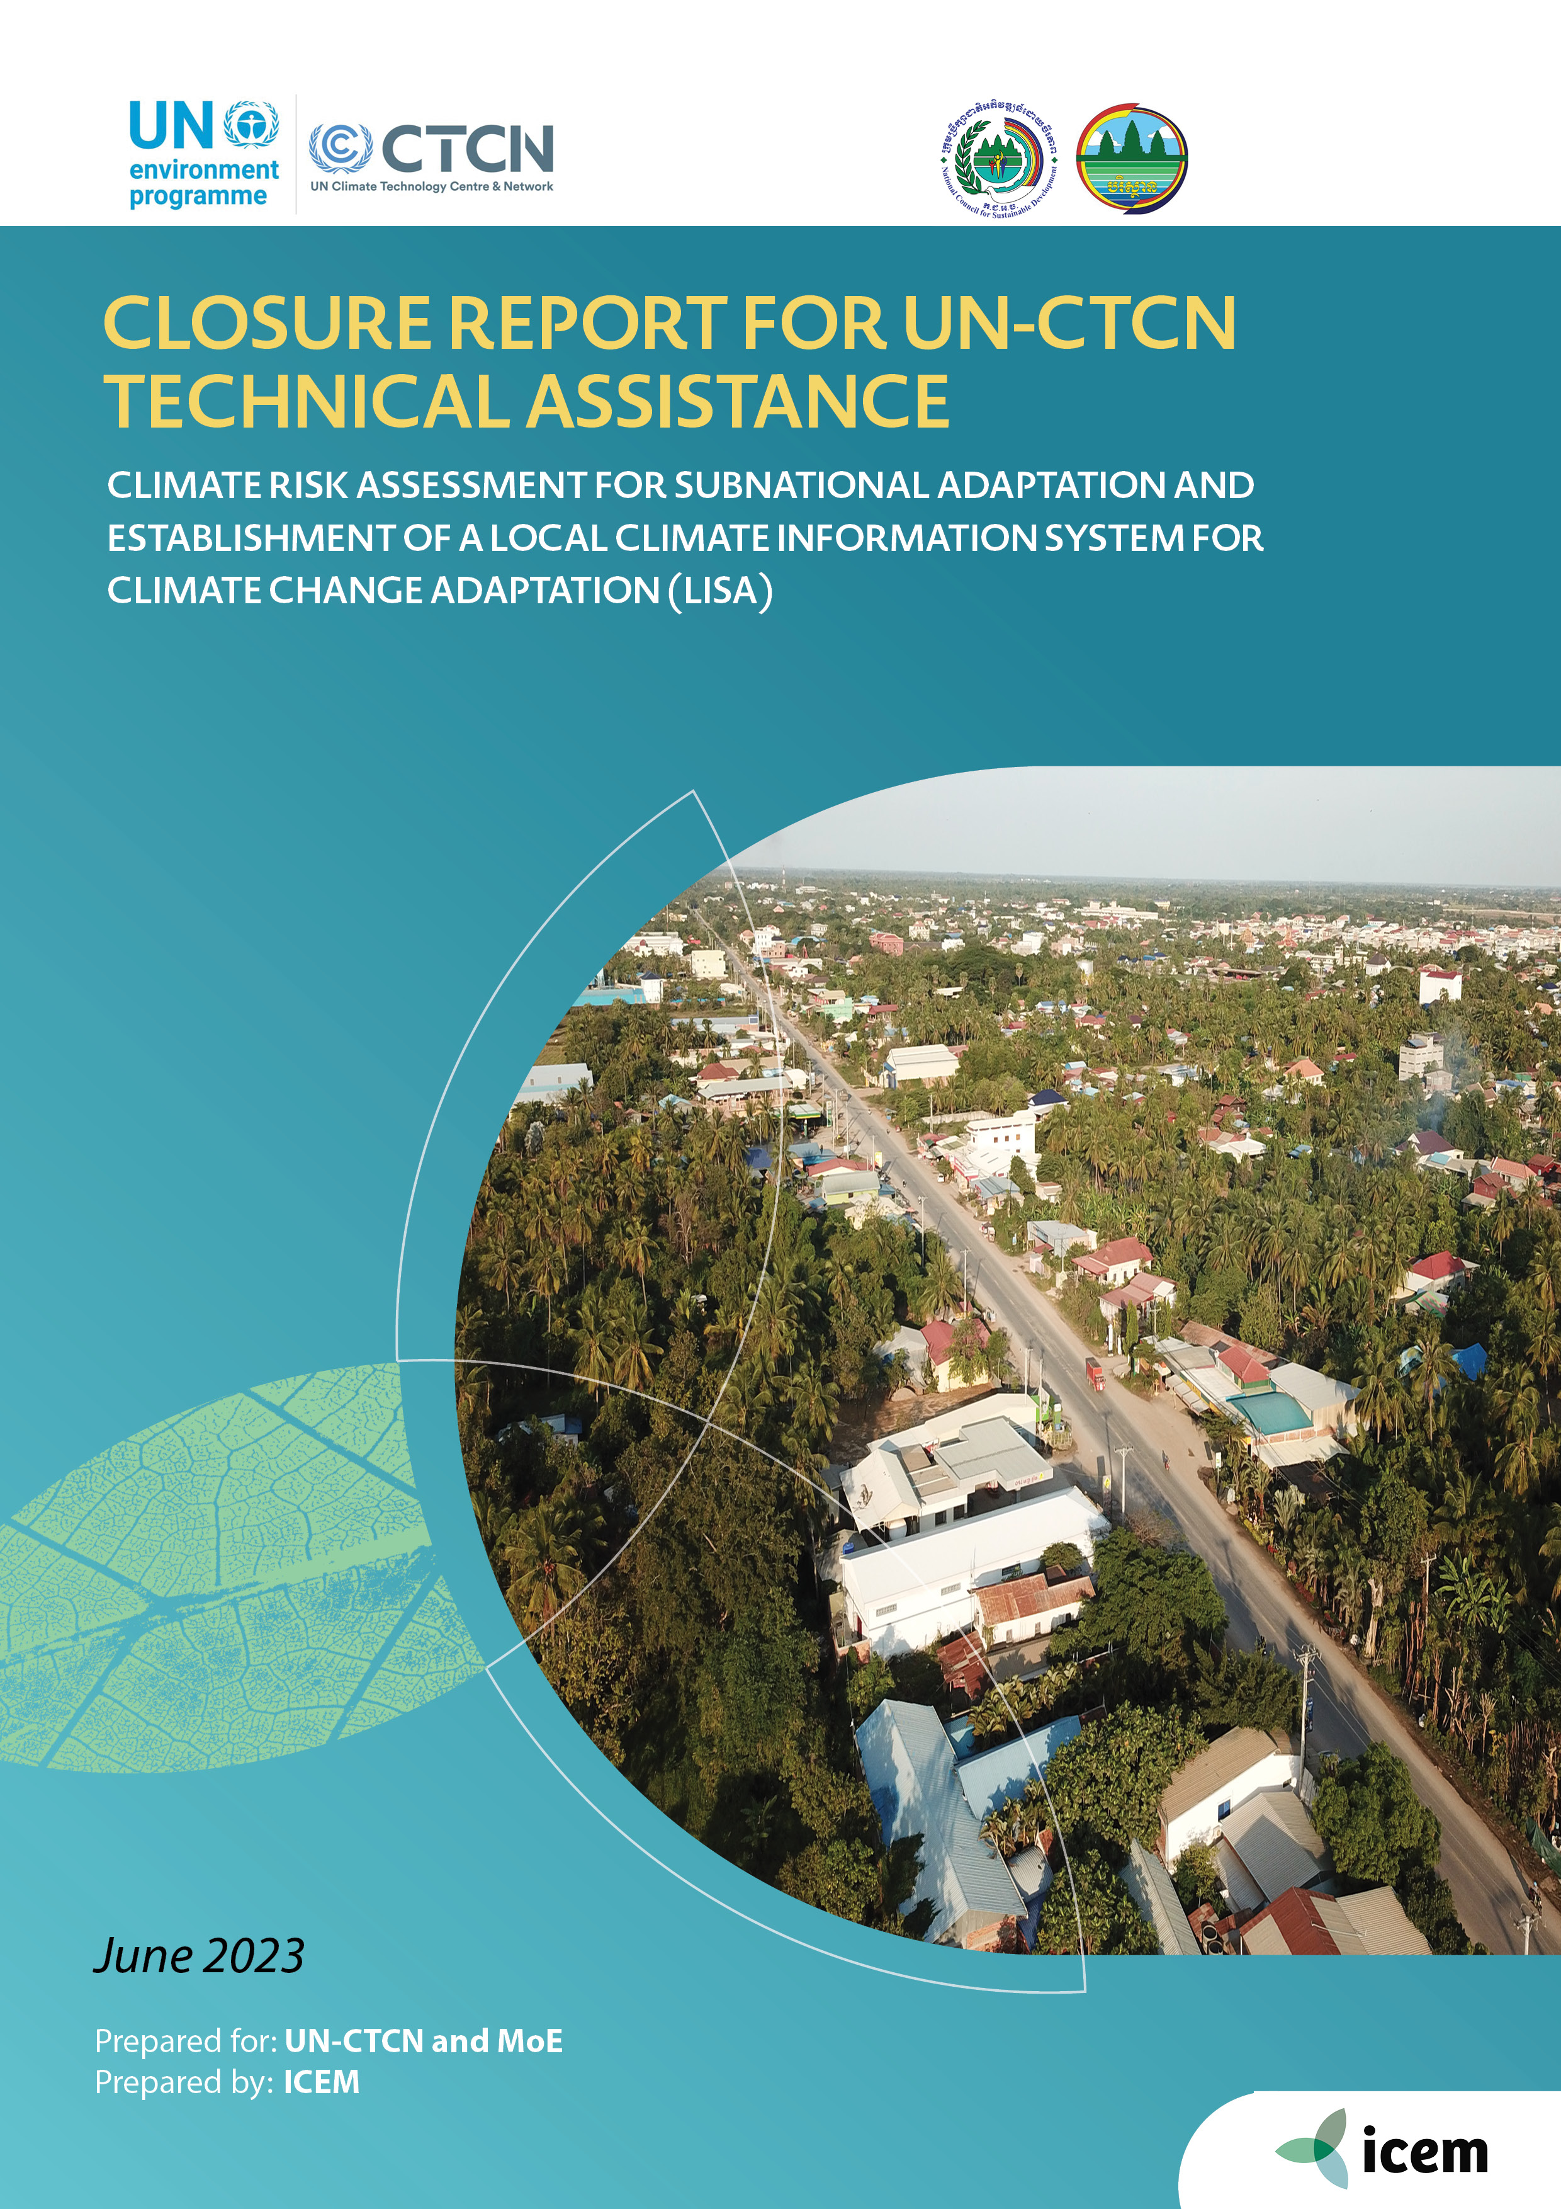
Closure Report for CTCN Technical Assistance

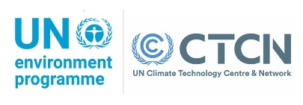




Disclaimer
This document was prepared for the United Nations Climate Technology Centre and Network (UN-CTCN) by an ICEM consultant team engaged to undertake the Technical Assistance – Climate risk assessment for subnational adaptation and establishment of a local climate information system for climate change adaptation (LISA) in Cambodia. The views, conclusions and recommendations in the document are not to be taken to represent the views of the UN-CTCN.
Prepared by | ICEM
Prepared for | UN-CTCN and MOE
Suggested citation | ICEM. 2023. Closure Report for CTCN Technical Assistance. Climate risk assessment for subnational adaptation and establishment of a local climate information system for climate change adaptation (LISA), June 2023. Prepared for UN-CTCN, and MoE.
More information | www.icem.com.au | info@icem.com.au  ICEM - International Centre for Environmental Management  26 Lane 86, To Ngoc Van,  Tay Ho, Hanoi,  Viet Nam
Cover Photo credit | Photo by ICEM
Project Team | Richard Cooper, Joe Ogden, Pham Tran Minh, Miguel Coulier, Tous Sophorn, Lay Chanthy, Truong Tung Hoa

TABLE OF Contents
1. Basic information 1
2. Lessons learned 10
3. ILLUSTRATION OF THE TA AND PHOTOS 11
4. Impact Statement 13
ANNEX 1: TECHNICAL ASSISTANCE DATA COLLECTION 16
ANNEX 2: FOR INTERNAL USE – TO BE FILLED IN BY THE CTCN 24

Basic information
Title of response plan | Climate risk assessment for subnational adaptation and establishment of a local climate information system for climate change adaptation (LISA)
Technical assistance reference number | 2021000015
Country / countries | Cambodia
NDE organisation | Director of the Department of Climate Change  General Secretariat of the National Council for Sustainable Development/  Ministry of Environment of the Kingdom of Cambodia  No. 503, Road along Bassac River, Sangkat Tonle Bassac, Chamkarmon,  Phnom Penh, Cambodia
NDE focal point | Dr. Hak Mao
NDE contact information | maohakccd.se@gmail.com
Proponent focal point and organisation | Dr. Hak Mao, Department of Climate Change, maohakccd.se@gmail.com
Designer of the response plan | Dr. Hak Mao, Department of Climate Change, maohakccd.se@gmail.com
Implementer(s) of technical assistance | ICEM – International Centre for Environmental Management
Beneficiaries | Battambang municipality in Cambodia, Department of Climate Change
Sector(s) addressed | Possibly including early warning and environmental assessment, agriculture and forestry, human health, water, infrastructure and urban planning, coastal zones
Technologies supported | Information Systems ; DSS; (Vulnerability Assessments …)
Implementation start date | 15 December 2021
Implementation end date | 15 June 2023
Total budget for implementation | 209,490 USD
Description of delivered outputs and products as well as the activities undertaken to achieve them. In doing so, review the log frame of the original response plan and refer to it as appropriate | D2.1/D3.1 Joint Report on Stakeholder Consultations  These two outputs were developed through implementation of Activity 2.1: A kick-off meeting and stakeholder consultations and  Activity 3.1: Consultations to select the most appropriate municipality to design LISA.  This Joint Report on D2.1/D3.1 Stakeholder Consultations addresses the requirements of two project deliverables: D2.1 Report on the kick-off meeting and stakeholder consultations and D3.1 Report on the consultations to select the most appropriate municipality to design LISA. These two reports have been combined into a single report as the selection of a municipality for the Local Climate Information System for Climate Change Adaptation (LISA) was a key discussion point of all stakeholder consultations.  The initial project kick-off meeting was held online on 12 January 2022 with representatives of the United Nations Climate Technology Centre and Network, project proponent (Department of Climate Change) and the International Centre for Environmental Management (ICEM). Subsequent consultations with key three key government agencies were held in June 2022 - National Committee for Disaster Management (NCDM), National Committee for Sub-national Democratic Development (NCDD), and Ministry of Women’s Affairs (MoWA). The purpose of these meetings was to help inform implementation of the project and to ensure that the concerns and needs of government are responded to in the project.  Battambang municipality was selected as the site for conducting the climate risk assessment and development of the LISA application. Battambang was recommended for selection at the three consultations with NCDD, NCDM, and MoWA. This decision was subsequently strengthened through the scientific analysis conducted by ICEM, as presented to the MoE’s General Directorate of Policy and Strategy on 20 September 2022. The recognized climate threats to Battambang, availability of information resources and commitment of the authority to address climate change, favour the selection of this municipality.  D2.2 Report on the review of climate information systems in Cambodia.  This output was developed through Activity 2.2: Review of the climate information systems in Cambodia. Eight web-based platforms have been developed for Cambodia, which function as either early warning for local communities (EWS1294, PRISM) or have potential to support the data needs for climate change adaptation planning (CAM-MeDiA, Cambodia Climate Change Toolbox, Cambodia Climate Change Data Portal, MRC-GIZ 9C9T Atlas, CamDI).  This document presents findings from a review on the status of the eight climate information systems (CISs) in Cambodia, with the aim of informing development of the LISA platform. These findings were subsequently discussed with stakeholders during the January mission to Cambodia in January 2023.  D2.3 Report on the investigation of best practices of operating local  climate information systems  This output was developed through Activity 2.3: Investigation of best practices of operating local climate information systems. The document includes a brief account of the need for climate services; developing end-to-end CISs; a review of how municipalities access climate information; and finally a series of recommendations for developing a concept for a web-based LISA. These recommendations were subsequently discussed with stakeholders during the January mission to Cambodia in January 2023.  A review of seven municipal CISs indicates that the existence of best practice municipal CIS in the Asia-Pacific region is very limited and often CIS are focused on the national-level. The review therefore has also looked at examples beyond Asia, including ‘best practice’ case studies for Amsterdam (Netherlands), London (United Kingdom), Pokhara (Nepal), Los Angeles (United States), Darwin (Australia), Toronto (Canada) and Singapore.  D3.2/D3.4: Report on stakeholder mapping and needs assessment and establishment of a LISA working group for Battambang Municipality  The mission to Cambodia from 9 to 17 January 2023 contributed to the following activities within the LISA project:  • Activity 3.2: Mapping of potential stakeholders in the selected municipality and surveying their needs  • Activity 3.3: Climate change risk assessment at the selected municipality  • Activity 3.4: Organization of the stakeholder working group  These activities contributed to the following outputs:  • D3.2: Report on the mapping of potential stakeholders at the selected municipality and a survey of their needs  • D3.3: Report on the climate change risk assessment at the selected municipality (in separate report)  • D3.4: Detailed description of the stakeholder working group, with name and contact details of the members, respective institutions, and gender.  This report addresses deliverables D3.2 and D3.4, and a separate report was drafted for D3.3.  Bilateral and multi-stakeholder meetings to assess stakeholder needs for the LISA platform were held with the following Government representatives, during the January 2023 mission:  • Department of Climate Change, Ministry of Environment;  • National government representatives from the Ministry of Environment (MoE), National Committee for Sub-National Democratic Development (NCDDS), National Committee for Disaster Management (NCDM), Ministry of Women Affairs (MoWA), and Ministry of Post and Telecommunications (MoPT);  • Subnational government representatives from the Provincial Administration, Provincial Committee for Disaster Management (PCDM), Provincial Department of Environment (PDoE), Provincial Department of Women Affairs (PDoWA), Provincial Department of Transport and Telecommunications (PDoPTC), and the Battambang Cross-Sectoral Integration Division, provincial investment and planning division.  National stakeholders for the LISA project were identified: National key institutions include the Ministry of Environment (MoE), Ministry of Womens Affair (MoWA), National Committee for Disaster Management (NCDM), National Committee for Sub-national Democratic Development Secretariat (NCDDS), Ministry of Post of Telecommunication (MoPT), and Ministry of Water Resource and Meteorology (MoWRAM).  Subnational stakeholders identified for the LISA project were identified: the Secretariat of the Provincial Committee for Disaster Management, Battambang Municipality, and relevant provincial departments.  D3.3 Report on the climate change risk assessment at the selected  Municipality  This output was developed though Activity 3.3: Climate change risk assessment at the selected municipality.  A risk assessment was carried out for various systems and assets in Battambang municipality to determine the impact and vulnerability for rainfall-induced (pluvial) floods and drought.  Risk assessment is a process that does not result in a fixed final answer, but rather is a starting point and tool which delivers results to support decision-making. A risk assessment necessitates further detailed quantitative and qualitative analysis, particularly when performed over a short time and as more data becomes available.  The risk assessment carried out for this project was based on available data and for Battambang and there was only limited data available. For example, the only hazard model available was for flood, with the model only covering the centre of the municipality (nine communes). For climate change, there was only downscaled data available to a spatial resolution of 1 km, resulting in a limited number of values for the entire city and not allowing a deeper analysis, for example per village or specific hotspots in the municipality. In terms of sensitivity and capacity, the census data was only useful for measuring sensitivity and capacity of entire villages, with no information available for transport infrastructure, houses and critical facilities. For those assets, the analysis is limited to exposure analysis.  In addition to natural hazards and climate change, other biophysical pressures such as changing land use, infrastructure development, environmental degradation and anthropogenic influences should also be considered with additional study and integrated into a comprehensive qualitative assessment.  The risk assessment is largely a desk-based analysis, with limited and therefore incomplete field verification due to insufficient time and resources. It is recommended to perform more detailed risk assessments for specific assets of importance for urban development in Battambang, using the risk assessment results as a starting point.  D3.5 Report of the first stakeholder working group meeting (virtual event on 20 March 2023)  Deliverable 3.5 (Minutes of the stakeholder working group meeting with a list of participants disaggregated by gender, materials used, and summary of the discussions held) is linked to activity 3.5 in the project’s terms of reference (Organisation of a meeting with the stakeholder working group).  The specific objectives of the meeting included the following:  (i) Present key findings from the climate change risk assessment;  (ii) Seek feedback on the prototype LISA web-based application; and (iii) Ensure gender is addressed across project activities.  D4.1 LISA Platform User Manual  D4.1 addresses preparation of the Report on the design of contents and specifications for LISA, and development of the LISA website which is available at https://icem.com.au/lisa. The LISA platform is linked to other national-level climate data portals from its home page.  The purpose of this manual is to provide guidance on how to use the LISA platform, including how to use it for performing climate change impact and vulnerability assessment. The manual describes the content and functions of each of the LISA platform pages, using a series of screenshots. This report, together with the LISA application software and data will be packaged and shared at the end of the project (Output D4.8).  The terms of reference for the establishment/deployment of LISA at the selected municipality is address in the Final Workshop Report (D4.7) as deployment was a key discussion item in the final meeting given the lack of capacity across government (national and subnational) to host and manage this type of data-driven platform.  D4.2/D4.3 LISA Platform Administrator Manual  This document, the LISA Administrator Manual, integrates two deliverables under Output 4 of the terms of reference:  D4.2: Report on the design of the process of data management for LISA, and D4.3: Report on the management protocols for LISA.  These deliverables are outputs of Activity 4.2: Design of the process of data management for LISA, and Activity 4.3: Development of the management protocols for LISA.  The first section of the report details the data integrated into the LISA platform, and the second part describes the software used to develop the open source LISA platform and its management.  Hyperlinks to LISA:  LISA application (frontend): https://icem.com.au/lisa  LISA GeoServer application (data catalogue): https://dss.icem.com.au/geolisa  Note that the current platform is hosted on an ICEM company server until it can be deployed to a government machine. A future training programme, also addressing deployment, is detailed in output D4.4, as included in the LISA project final report (D4.7).  D4.5: Report of the second stakeholder working group meeting (virtual event on 10 May 2023).  This output was delivered though implementation of Activity 4.5: Organisation of a meeting with the stakeholder working group.  The purpose of the virtual meeting was to present the near-final version of the LISA platform, and highlight the approach adopted for management of the platform and proposed future training programme. This meeting included members of the stakeholder working group including representatives from national and subnational key agencies and the project team.  There was a total of 27 participants from national government (DCC/MoE, MoWA, NCDM, MoPTC, NCDDS) and subnational agencies (PDoPWT, PDoE, PDoWRAM, DLMUPCC, Battambang Provincial Committee and Battambang Municipality), and the consultant team (ICEM).  D4.4/4.6/4.7: Report of the Final Stakeholder Workshop  Deliverables 4.4 (Report on the capacity building program for effective use of LISA), 4.6 (Materials for the workshop e.g., presentations, satisfaction survey template, etc.), and 4.7 (Report on the 1-day stakeholder workshop for government bodies and stakeholders) are combined into a single report, which is linked to  Activity 4.4 (Development of the capacity building program for effective use of LISA), and Activity 4.6 (Organisation of a 1-day stakeholder workshop for government bodies and stakeholders).  The purpose of this workshop is to present the final version of the LISA platform, the approach adopted for management of the platform and the proposed future training programme. This workshop included members of the stakeholder working group from national and subnational key agencies and the project team.  A total of 31 participants (22 in-person and 9 online) from national and subnational agencies, and the consultant team (ICEM) joined the event. National representatives included the DCC/MoE, NCDM, MoWA, MoPTC, NCDDS; and subnational representatives from Battambang included those from the PCDM, PDoPWT, PDoE, PDoWA, PDoWRAM, and Battambang DLMUPCC, Provincial Committee, and Municipality.  Deliverable 4.4 (Report on the capacity building program for effective use of LISA) which was a key discussion item in the workshop is included in Appendix 6 of Report of the Final Stakeholder Workshop. A capacity building programme (called LISA Phase II) is proposed for Battambang government officials to manage the LISA platform and to conduct and interpret the outputs of climate risk assessments. The proposed twelve-month training programme incorporates a total of four training modules to address technical management of the LISA platform and in better understanding climate risk assessments.  NOTE: currently no government agency, whether national or subnational has adequate capacity to host the LISA platform, and only Battambang provincial and municipal authorities expressed willingness to host the platform. Current IT staffing is limited (only one IT staff member in the municipality). Additional staff will need to be hired if LISA is to be hosted and maintained in-house (at least two experienced IT administrators with webGIS expertise are required).  The proposed training programme aims to (i) provide technical training to government staff in the management of the LISA platform;  (ii) provide training in conducting and interpreting climate risk assessments so that government staff can readily use the LISA platform and better integrate climate change into urban planning; and  (iii) the LISA platform will be supplemented with new findings from additional climate risk assessments conducted in Phase II of the project.  D4.8: Copy of all materials produced under this consultancy (including programming code and databases)  All project outputs have been uploaded to GoogleDrive and are accessible online here  NOTE: the LISA app software and data will be packaged and uploaded at the start of the working week commencing 12 June 2023.
Methodologies applied to produce outputs and products | - Climate change risk analysis  - Spatial data analysis and visualization  - Management of spatial decision support systems  - IT system administration  - Workshop participant surveys  - Gender analysis  - Desktop literature review
Reference to knowledge resources | Key knowledge resources developed during the project included:  D2.2 Review of climate information systems in Cambodia  D2.3: Report on the investigation of best practices of operating local  climate information systems  D3.3: Report on the climate change risk assessment at the selected  Municipality  D4.1: LISA Platform User Manual  D4.2/D4.3: LISA Platform Administrator Manual  The final LISA app: https://icem.com.au/lisa  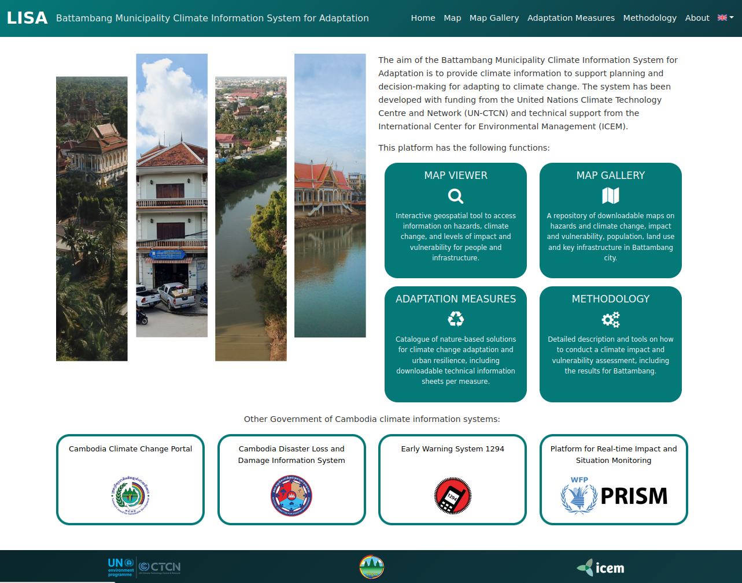  GeoServer data catalogue linked to the LISA frontend: https://dss.icem.com.au/geolisa  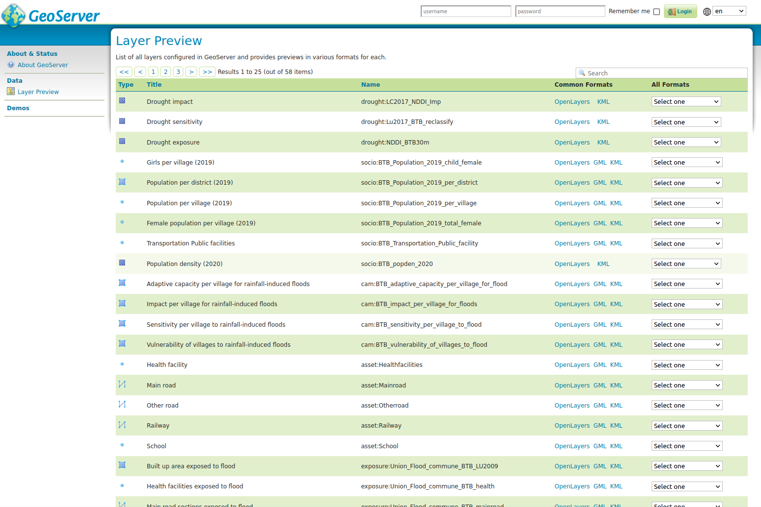
Deviations | 1. There were some long initial delays in the project which required the team to request a 6-month extension. Delays were primarily related to high-level administrative arrangements and related documentation needs to authorise meetings, and secondarily from the availability of government stakeholders for meetings.  2. The lack of IT capacity within government, at national and subnational level, made it challenging to find a department willing to host and manage the LISA application. Furthermore, the LISA platform is a data-based decision support tool and technically more complicated than the typical content management system used to build institutional websites. Battambang province/municipality expressed willingness to host the application and will need support in the future to address their current limited staff capacity.  A future needs assessment will also be required in the future when deployment/training can take place to address any changes in capacity since the implementation of this project. For instance, Battambang municipality plans to implement a SMART City project that will require additional IT capacity.  3. The risk assessment carried out for this project was based on available data and for Battambang there is only limited data available. For example, the only hazard model available was for flood, with the model only covering the center of the municipality (nine communes).  For climate change, there was no downscaled information available, resulting in a limited number of values for the entire city and not allowing a deeper analysis, for example per village or specific hotspots in the municipality. In terms of sensitivity and capacity, the census data was only useful for measuring sensitivity and capacity of entire villages, with no information available for transport infrastructure, houses and critical facilities. For those assets, the analysis is limited to exposure analysis.  In addition to natural hazards and climate change, other biophysical pressures such as changing land use, infrastructure development, environmental degradation and anthropogenic influences should also be considered with additional study and integrated into a comprehensive qualitative assessment.  The risk assessment is largely a desk-based analysis, with limited and therefore incomplete field verification due to insufficient time and resources. It is recommended to perform more detailed assessments for specific assets of importance for urban development in Battambang, using the risk assessment results as a starting point.
Anticipated follow-up activities and next steps | The ICEM team will support the government to explore further funding opportunities for a second phase of LISA project (as presented in D4.4) with the Department of Climate Change.  Possible funding sources include the UN-CTCN TA request with a maximum budget of USD 250,000 and a duration up to 12 months. The proposed LISA Phase II project has a timeline of 12 months.  However, as a more immediate and urgent follow up support to secure the institutionalization of the local climate information system designed for Battambang, assistance from the CTCN through their Fast Technical Assistance (FTA) support should be sought. CTCN FTA support could enable the local government to consolidate capacities to use the LISA platform to its full extent, and ensure that the LISA platform is hosted in an appropriate government institution (provided a decision is made by the Government on the most appropriate host for the LISA platform for Battambang (e.g. NCM, GIS Department of MoE).  The development of a proposal for scale up funding to replicate LISA to other cities in Cambodia (possibly bridging this effort with EWS platforms) would be a subsequent step.  The possibility of tapping into support from the UNFCCC Financial Mechanism (e.g. through the development of a GCF concept note) will be further discussed with DCC, and given Battambang is part of the SMART city programme, the ICEM team will support the government in exploring possible synergies with LISA Phase II.

Lessons learned
 | Lessons learned | Recommendations
Lessons learned from the CTCN TA process | This is more a lesson reinforced from experience in other projects, but governments in the region generally lack capacity, both computer hardware and especially staff expertise, in hosting and managing these types of data-driven decision support tools. Also, LISA requires a larger skill set to maintain than a simple content management system.  Some government agencies are more willing to share than others. More time should be allowed for data collection. | Consider hosting and management with a commercial hosting provider in the region (or out of region). This may or may not be acceptable to the government, but it is likely to be more sustainable. This also addresses the loss of capacity when IT staff pursue other positions outside of government. Furthermore, management of data-driven platforms require more specific skill sets, including knowledge of webGIS, which IT administrators may not be familiar with.  To facilitate improved data collection, it is recommended that more face-to-face meetings are organized.
Lessons learned related to climate technology transfer | Refer to above comment re hosting and management | Refer to above comment re hosting and management

ILLUSTRATION OF THE TA AND PHOTOS
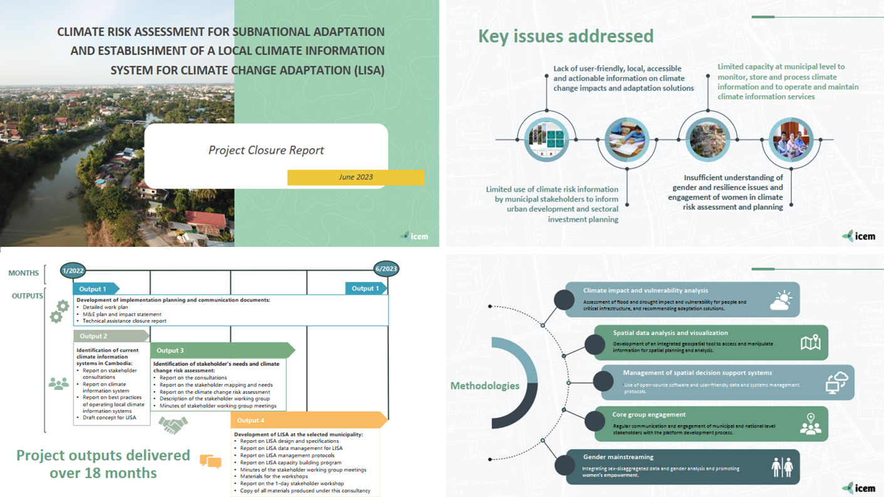

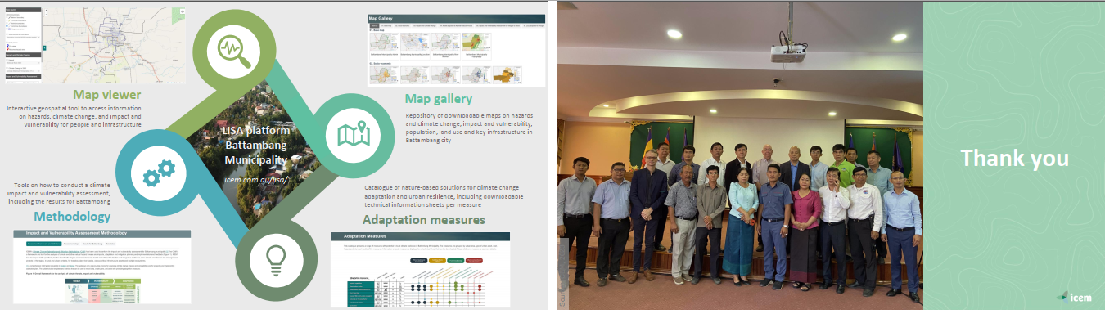

Impact Statement
The information in the table below will be used to communicate results and anticipated impacts of this technical assistance publicly. Please copy information from impact statement developed in the M&E Plan and update as relevant.
Challenge | Approx. 500 characters with spaces
CTCN Assistance | - to design a web-based local climate information system at municipality level in Cambodia  - conduct a climate risk assessment to establish a baseline that can support adaptation decision-making processes, and  - provide services for climate information delivery at the sub-national (local) level.
Anticipated impact | - climate resilience enhanced at municipality level  - improved awareness of local government stakeholders to climate change impacts and adaptation  - evidence-based decision-making at local level enhanced through improved access to climate and data information integrated into the LISA platform.
Co-benefits: Achieved or anticipated co-benefits from the TA | Engagement of stakeholders in the development of a focused sub-national climate information system can help communities better understand climate change impacts and the benefits of investing in climate resilient development.
Gender aspects of the TA | Importance of addressing gender issues: In the rural areas of Cambodia, more than half of women are dependent on local natural resources for their livelihoods.  Outcome from developing LISA Establishment of LISA will increase opportunities for women to access climate information, which will help them enhance their knowledge to address vulnerabilities and risks to climate change. Information to be included in LISA is expected to assist in addressing and measuring impacts on key climate-related gender issues.
Anticipated contribution to NDC | The TA is in line with national strategies and plans of Cambodia for climate change response.  Nationally Determined Contribution (2020)*:  Adaptation contributions:  - 3.3 Prioritised adaptation actions  - 3.3.1. Prioritised adaptation actions  Table 10 Priority adaptation actions  - 31. Prepare spatial planning (city, district, municipality) guidelines at all levels for climate change adaptation (page 36)  - 34. Vulnerability assessment towards the development of climate change strategic plans to respond to the impacts on land, housing, coastal management and building due to climate change (page 36)  - 39. Strengthening climate resilient cities (page 37)  *Ref: https://ncsd.moe.gov.kh/sites/default/files/2021-01/20201231_NDC_Update_Cambodia.pdf
The narrative story | Cambodia is recognized as a country particularly vulnerable to natural hazards, ranking 16th at most risk globally. Due to limited adaptive capacity, poor infrastructure and substantial reliance on the use of natural resources, the country is particularly vulnerable to the impacts of climate change.  This proposal addresses development of a local climate information system for climate change adaptation (LISA). LISA will involve development of an intuitive and user-friendly web-based data visualisation platform that enables users to explore future climate scenarios and to gain an appreciation of potential impacts and adaptation options for future climate resilient planning. The development of LISA will build on findings from a climate change risk assessment at a selected municipality.  Combining future climate change scenarios derived from climate models, and informed by findings from the climate change risk analyses, the LISA platform will be targeted at policy makers, planners, and other practitioners working at sectoral and sub-national levels. Effective use of LISA will strengthen risk-informed decision making and the mainstreaming of climate change into policy making and planning at the local level.
Contribution to SDGs  A complete list of SDGs and their targets is available here: https://sustainabledevelopment.un.org/partnership/register/ | SDG 11: Make cities and human settlements inclusive, safe, resilient and sustainable  This TA will contribute to enhancing climate resilience at the selected municipality.  SDG 13. Take urgent action to combat climate change and its impacts:  13.1 - Strengthen resilience and adaptive capacity to climate-related hazards and natural disasters in all countries  This TA will contribute to enhancing climate resilience at the selected municipality by providing climate change risk assessment and the baseline for establishing LISA  13.3 - Improve education, awareness-raising and human and institutional capacity on climate change mitigation, adaptation, impact reduction and early warning  This TA will provide the 1-day stakeholder workshop for government bodies and stakeholders, supporting them to increase their knowledge on the local climate information system.

ANNEX 1: TECHNICAL ASSISTANCE DATA COLLECTION
- Output and outcome indicators
Indicator  Please note indicators below highlighted as anticipated | Quantitative value  Numerals only; disaggregates must sum to the total | Qualitative description  List the various elements corresponding to the quantitative value as well as timelines and responsible institutions
Total number of events organized by proponents and implementing partners | 4+ | Activity 3.1: Consultations to select the most appropriate municipality to design LISA (1 or more consultation events)  Activity 3.5: Organisation of a meeting with the stakeholder working group  Activity 4.5: Organisation of a meeting with the stakeholder working group  Activity 4.6: Organisation of a 1-day stakeholder workshop for government bodies and stakeholders.
Number of participants in events organized by proponents and implementing partners | 129
- Number of men | 109
- Number of women | 20
Number of climate technology RD&D related events | N/A
Number of participants in climate technology RD&D events | N/A
- Number of men
- Number of women
Number of trainings organized by proponents and implementing partners |  | A proposed training programme has been developed as part of D4.4.
Number of participants in trainings organized by proponents and implementing partners
Stakeholder consultations in Phnom Penh on 10 January 2023
- Number of men | 21
- Number of women | 3 | 3 from Cambodia
Stakeholder consultations in Battambang on 11 January 2023
- Number of men | 16
- Number of women | 3 | 3 from Cambodia
Stakeholder meeting on 20 March 2023
- Number of men | 24
- Number of women | 5 | 4 from Cambodia, 1 from Vietnam
Stakeholder meeting in 10 May 2023
- Number of men | 22
- Number of women | 5 | 4 from Cambodia, 1 from Vietnam
Final Stakeholder workshop on 26 May 2023
- Number of men | 26
- Number of women | 4 | 3 from Cambodia, 1 from Vietnam
Total number of institutions trained
- Governmental (national or subnational) |  | Stakeholder participation: National representatives included the DCC/MoE, NCDM, MoWA, MoPTC, NCDDS; and subnational representatives from Battambang included those from the PCDM, PDoPWT, PDoE, PDoWA, PDoWRAM, and Battambang DLMUPCC, Provincial Committee, and Municipality.
- Private sector (bank, corporation, etc.)
- Nongovernmental (NGO, University, etc.)
Percentage of participants reporting satisfaction with CTCN training (from CTCN training feedback form) | 92% | 12 out of 13 respondents reporting satisfaction with LISA platform (Survey responses are in the Report of the Final Stakeholder Workshop).
Percentage of participants reporting increased knowledge, capacity and/or understanding as a result of CTCN training (from CTCN training feedback form) | 92% | 12 out of 13 respondents reporting satisfaction with LISA platform (Survey responses are in the Report of the Final Stakeholder Workshop).
- Percentage of men | 85
- Percentage of women | 15
Total number of deliverables produced during the assistance (excluding mission, progress and internal reports) | 20
- Number of communication materials, including news releases, newsletters, articles, presentations, social media postings, etc. | 12 | 12 presentations delivered at various workshops and meetings.
- Number of tools and technical documents strengthened, revised or developed | 9 | - LISA platform at https://icem.com.au/lisa  - LISA GeoServer application (data catalogue): https://dss.icem.com.au/geolisa  - D2.2: Report on the review of climate information systems in Cambodia  - D2.3: Report on the investigation of best practices of operating local climate information system  - D2.1/D3.1 Joint Report on Stakeholder Consultations.  This report includes the discussions and ICEM’s analysis for selection of Battambang as the location for conducting the climate risk assessment and LISA development.  - D3.3 Report on the climate change risk assessment at the selected Municipality  - D4.1 LISA Platform User Manual  This report provides guidance on how to use the LISA platform for climate change impact and vulnerability assessment.  - D4.2/D4.3 LISA Platform Administrator Manual  The first section of the report details the data integrated into the LISA platform, and the second part describes the software used to develop the open source LISA platform and its management.  - D 4.4: Report on the capacity building program for effective use of LISA.  The proposed twelve-month training programme incorporates a total of four training modules to address technical management of the LISA platform and in better understanding climate risk assessments. This output is in Appendix 6 of the output Report of the Final Stakeholder Workshop.
- Number of other information materials strengthened, revised or created (For example training and workshop reports, Power Points, exercise docs etc.) | 6 | - D3.2/D3.4: Report on stakeholder mapping and needs assessment and establishment of a LISA working group for Battambang Municipality.  This report addresses D3.2: Report on the mapping of potential stakeholders at the selected municipality and a survey of their needs, and D3.4: Detailed description of the stakeholder working group, with name and contact details of the members, respective institutions, and gender.  - D3.5 Report of the first stakeholder working group meeting (virtual event on 20 March 2023).  - D4.5: Report of the second stakeholder working group meeting (virtual event on 10 May 2023).
Total number of policies, strategies, plans, laws, agreements or regulations supported by the assistance
- Adaptation related
- Mitigation related
- Both adaptation- and mitigation related
Anticipated number of policies, strategies, plans, laws, agreements or regulations proposed, adopted or implemented as a result of the TA
- Adaptation related
- Mitigation related
- Both adaptation- and mitigation related
Anticipated number of technologies transferred or deployed as a result of CTCN support | 2* | * This represents an increased understanding of climate risk assessment and the use of local climate information systems.  During the final workshop, the climate risk assessment methodology and its outputs from its application to Battambang municipality were presented by the ICEM team.  Additionally, the LISA platform was demonstrated and practical exercises conducted by participants to explore how LISA can be used to support climate risk assessment and adaptation planning in Battambang.
Anticipated number of collaborations facilitated or enabled as a result of technical assistance
- Number of South-South collaborations
- Number of RD&D collaborations
- Number of private sector collaborations
Number of countries with strengthened National System of Innovation as a result of CTCN support |  | Cambodia
Insert any additional indicators here | N/A
- Core impact indicators
Please fill in the tables for anticipated impacts of the CTCN assistance. Every technical assistance should contribute to at least one of the indicators below. For guidance on how to report on core indicators see the ‘M&E Guidance Document for TA Implementers’.

Core indicator 1 | Anticipated metric tons of CO₂ equivalent (CO₂e) emissions reduced or avoided as a result of CTCN TA  Please add your calculations in word or excel format as an Annex to this Closure Report, where applicable.
 | Anticipated metric tons of CO₂e reduced or avoided as a result of the TA on annual basis | Anticipated metric tons of CO₂e reduced or avoided as a result of the TA in total
Quantitative value  (emissions reductions) | Total number (numerals only, no rounding or abbreviations) | Total number (numerals only, no rounding or abbreviations)
Unit | tCO₂e | tCO₂e
GHG assessment boundary (project emissions)

Identify expected post-TA activities, associated effects and assess boundary for quantification of GHG emission reductions
Baseline emissions

Describe baseline scenario, baseline candidates, emission factors and emissions calculated
Methodology

Explain the method or process of verifying the indicator and how data was gathered
Assumptions
Describe assumptions made during calculation and quantification of GHG reductions

Core indicator 2 | Anticipated increased economic, health, well-being, infrastructure and built environment, and ecosystems resilience to climate change impacts as a result of technical assistance  Please provide a qualitative description of the anticipated impacts on the categories below
Infrastructure and built environment  Anticipated increased infrastructure resilience (avoided/mitigated climate induced damages and strengthened physical assets) | The development of LISA will support urban adaptation planning in Battambang. The current system contains the outputs from a full climate risk assessment conducted for villages and flood, and exposure assessments were conducted on the other assets (road, railway, land cover, schools and hospitals). Impact and exposure of land cover to drought were also analysed.
Ecosystems and biodiversity  Anticipated increased ecosystem resilience (areas with increased resistance to climate-induced disturbances and with improved recovery rates) | The mainstreaming of climate change into urban planning will facilitate improved strategic planning and the sustainability of ecosystems and biodiversity. The implementation of nature-based solutions also have potential to protect conservation values.
Economic  Anticipated increased economic resilience (e.g. less reliance on vulnerable economic sectors or diversification of livelihood) | LISA’s identification of vulnerable areas and identification of mitigation measures will help strengthen economic resilience to future hazards. For instance, LISA can be used to indicate those areas of the city at highest risk to flooding.
Health and wellbeing  Anticipated increased health and wellbeing of target group (e.g. improved basic health, water and food security) | Adaptation measures as identified in the LISA platform can contribute to improved health and wellbeing by reducing the impacts from future hazards on local communities. Communities can learn from LISA as to the areas of the city most vulnerable to flooding and erosion.

Core indicator 3 | Anticipated number of direct and indirect beneficiaries as a result of the TA
 | Quantitative value | Means of verification
Total beneficiaries | Total number
Number of adaptation beneficiaries | Battambang municipality  Battambang province | Beneficiaries include Battambang province and municipality. It is anticipated that the LISA project will be piloted and scaled-up in the future. Discussions are ongoing with the Department of Climate Change, Ministry of Environment, to identify additional funding and to explore potential synergies with other initiatives.
Number of mitigation beneficiaries
Number of adaptation-and mitigation beneficiaries

Core indicator 4 | Anticipated amount of funding/investment leveraged (USD) as a result of TA (disaggregated by public, private, national, and international sources, as well as between anticipated/confirmed funding)
 | Quantitative value confirmed in USD | Quantitative value anticipated in USD | Qualitative description  List the institutions, timelines, and description or title of the investment | Methods  Describe methods used for quantification of funds leveraged
Total funding | Total number in USD (numerals only, no rounding or abbreviations) | Total number in USD (numerals only, no rounding or abbreviations)
Anticipated amount of public funding mobilised from national/domestic sources
Anticipated amount of public funding mobilised from international/ regional sources
Anticipated amount of private funding mobilised from national/domestic sources
Anticipated amount of private funds mobilised from international/regional sources

Acknowledgements

The study team wishes to give a special thanks to Clara Landeiro from the United Nations Climate Technology Centre and Network (UN-CTCN) for her vision in recognizing the need for this technical assistance and for providing excellent technical guidance and suggestions throughout.
The team especially acknowledges the strong support of His Excellency Mao Hak, Director, Department of Climate Change (DCC), Ministry of Environment, and His Excellency Vann Monyneath, Director, General Department of Policy and Strategy (GDPS), for their guidance, comments, contribution and advice in producing the project deliverables.
Our sincerest thanks also go to His Excellency Ou Dary, Deputy Governor, Battambang Provincial Government, and staff for their valuable advice and insights. We also acknowledge and appreciate the support and collaboration provided from all Battambang provincial and municipal staff and their contribution to this project.
Special thanks go to all contributors, particularly the government officials from the Department of Climate Change (DCC), National Committee for Disaster Management (NCDM), National Committee for Subnational Democratic Development Secretariat (NCDDS), Ministry of Women’s Affairs (MOWA), Ministry of Post and Telecommunications (MoPTC), and the Battambang provincial authorities and departments, and Battambang municipality for their collaboration and contribution in supporting the implementation processes of this project including the stakeholder consultations and meetings and sharing of important data and advice.

ANNEX 2: FOR INTERNAL USE – TO BE FILLED IN BY THE CTCN
CTCN evaluation
This section will be completed by the relevant CTCN Technology Manager.
- Evaluation of the timeliness of the TA implementation as measured against the timeline included in the response plan;
- Evaluation of TA quality as defined in the response plan;
- Overall performance of the Implementers;
- Overall engagement of the NDE and Proponent;
- Lessons learned on the CTCN process and steps taken by the CTCN to improve.

