Technical Assistance Closure Report
Closing Report for CTCN Technical Assistance

- Baseline information

Response Plan Title | Technology Needs Assessment (TNA) and Technology Action Plan (TAP) for Chile's NDC implementation
Technical Assistance Reference Number | 2021000010
Country/Countries | Chile
NDE organization | Agencia de Sustentabilidad y Cambio Climático (ASCC)
NDE focal point | Ximena Ruz  Executive Director
NDE contact Information | Ximena.ruz@ascc.cl
Focal point and organization of the proposer | Jenny Mager Santos  Head of the Climate  Change Office  Ministerio de Medio Ambiente (MMA)  jmager@mma.gob.cl  Paula González Frías  Director of the Public Policy Division  Ministerio de Ciencia, Tecnología, Conocimiento e Innovación  pgonzalez@minciencia.gob.cl  Ximena Ruz  Executive Director  Agencia de Sustentabilidad y Cambio Climático (ASCC)  Ximena.ruz@ascc.cl
Designated Response Plan | Ximena Ruz  Executive Director  Agencia de Sustentabilidad y Cambio Climático (ASCC)  Ximena.ruz@ascc.cl
Technical Assistance Implementer(s) | Deuman Ldta & Anthesis Lavola
Beneficiaries | Ministerio de Medio Ambiente (MMA)  Ministerio de Ciencia, Tecnología, Conocimiento e Innovación  Agencia de Sustentabilidad y Cambio Climático (ASCC)  Ministerio de Energía  Ministerio de Agricultura (MINAGRI)  Ministerio de Obras Públicas (MOP)
Sector(s) addressed | Energy efficiency, Transport, Water, Waste Management, Early Warning and Environmental Assessment, Agriculture, Forestry
Supported Technologies | Energy: Batteries, Bus Rapid Transit, Heavy-duty vehicles with green hydrogen  Water resources: Rainwater harvesting, Wastewater reuse, Machine learning for the detection and location of leaks in water distribution networks  Waste Management: Community Vermicomposting of municipal organic waste, biological treatment using black soldier fly larvae, Anaerobic digestion to produce biogas and electricity  Forestry and agriculture: Intelligent Irrigation System, Early Warning Systems, Machine learning to optimize the performance of agricultural and forestry activity
Implementation Start Date | 06/12/2021
Implementation End Date | 26/01/2024
Total budget for implementation | 155,912.5 USD
Description of the results and outputs delivered, as well as the activities undertaken to achieve them. As you do so, review the logical framework of the original response plan and refer to it accordingly. | Below is the summary of outputs 1 – 4, corresponding to the original response plan.  Output 1: Development of the work plan and related communication documents  Activity 1.1: Detailed Work Plan  A detailed work plan was made for all activities, deliverables, outputs, timelines, and responsible organizations, including a detailed budget to implement the Response Plan. As a result, the main activities of the work plan include internal coordination meetings, product presentations, workshops, and bilateral meetings/interviews.  Activity 1.2: A monitoring and evaluation plan  Monitoring and evaluation plan with all data collected at the beginning of the technical assistance, using CTCN model documents.  Activity 1.3: A description of the impact of the CTCN  CTCN Technical Assistance Impact Description prepared at the beginning of the technical assistance and updated at the end of the technical assistance.  Activity 1.4: Closing Report  Closure report and data collection completed at the end of technical assistance.  Output 2: Establishment of a TNA committee  Activity 2.1: Conduct stakeholder analysis.  An analysis was conducted of the stakeholders that will be part of the Technology Needs Assessment (TNA) process within the four shortlisted sectoral focus areas of (1) Water Resources, (2) Forestry and Agriculture, (3) Energy, and (4) Waste Management.  The methodology selected for the identification and prioritization of stakeholders was developed considering the Guide "Identifying and Engaging Stakeholders in the TNA Process – Guide for National Teams" and the Stakeholder Mapping (CAM) has been taken as a methodological basis, a tool that helps to have a list of different actors and know their reasons for participating in the project.  As a result, a total of 187 stakeholders were mapped, of which 19.8% correspond to the academic sector, 21.9% to the public sector, 44.9% to the private sector and 13.4% to NGOs and civil society. As for the sectors raised in the process, 17.1% correspond to the water resources sector, 16.6% to the forestry and agricultural sector, 35.3% to the energy sector, 19.3% to the waste management sector and 11.8% correspond to transversal entities. On the other hand, the total number of cross-cutting stakeholders identified is 23, of which 9.1% are from academia, 50% from the public sector, 13.6% from the private sector and 27.3% from NGOs and civil society, obtaining the participation of 6 of them. Responses were obtained from 102 stakeholders through interviews and surveys.  As a result of the prioritization of the parties mapped, identified, characterized, and prioritized at a very high or high level, 17 stakeholders will be proposed to be part of the committee and 21 participants considered in the proposal of sectoral technical groups.  Activity 2.2: Support the establishment of a TNA Committee  The formation of the TNA National Steering Committee was carried out according to the prioritization of stakeholders made in the previous product, their roles and functions were reported; as well as validating and aligning the preliminarily proposed sectors and subsectors in accordance with the country's priorities.  With the prioritized stakeholders, a validation was carried out with the focal points and members of the Interministerial Committee for the Development and Transfer of Climate Technologies and the gender focal point, through the holding of the first working table held on March 24, 2022. The TNA Committee was established with the participation of a total of 17 members, distributing 3 places for the water resources and energy sector, 1 place for the forestry and agricultural sector and waste, as well as 5 members representing transversal stakeholders and 4 focal points from the technical counterpart were incorporated.  Activity 2.3: Formation of sectoral working groups and capacity building  The member institutions were validated to be part of the Sectoral Working Groups in a Second Working Table with the TNA Coordinators. As a result, in the water resources sector, 8 institutions and 3 technical representatives of the TNA committee were validated, in the forestry and agricultural sector, 10 institutions and 1 technical representative of the TNA committee were validated, in the energy sector, 10 institutions and 3 technical representatives of the TNA committee were validated, and in the waste sector, 10 institutions and 1 technical representative of the TNA committee were validated. There was a participation of 33% of the public sector made up of ministries and their most representative directorates, 27% of academia made up of universities and research centers, 26% of the private sector made up of associations or groups of companies in the field, and finally 14% of civil society.  As part of the schedule of meetings for the sectoral working groups, the training workshop on TNA processes was held on Tuesday, August 16, 2022. A total of 25 representatives participated in this workshop, 69% of whom were men and 31% women.  Activity 2.4: Development and approval of the TNA committee's work plan for monitoring and monitoring  A work plan of the TNA process in Chile was developed with the scheduling of the meetings of the process based on the identification of the organizational structure, roles and functions of the members of the TNA Committee: TNA coordinators, TNA national steering committee, sectoral working groups, among others.  Output 3: Prioritization of relevant technologies and actions for greater access to finance  Activity 3.1: Validation of Prioritized Challenges  The challenges, previously identified by the country, were validated together with the sectoral working groups through 4 technical tables of each sector and a meeting of the national steering committee.  The workshop on prioritization of challenges by the working groups was held on Thursday, September 1, 2022, and was attended by 31 technical representatives in total, where 74% were men and 26% women.  While the national steering committee for the validation of the challenges was held on Thursday, September 22, 2022. It was attended by a total of 15 technical representatives, 60% of whom were men and 40% women.  Activity 3.2: Identification and prioritization pf technologies  The evaluation, prioritization, and validation of key technologies for compliance with Chile's TNA was carried out. For the prioritization of technologies, the Multicriteria Analysis (MCA) methodology was used, where the weighting of criteria and scoring of technologies was developed in the Third Sectoral Working Group on December 13, 2022, with the participation of 27 institutions, with representatives made up of 63% men and 37% women. Finally, 3 technologies were prioritized for each sector.  As a result, in the energy sector, sheets of the 9 pre-selected technologies were prepared and 3 of them were prioritized; In the waste sector, sheets were prepared for the 10 pre-selected technologies and 3 were prioritized; In the water resources sector, factsheets were prepared for the 12 pre-selected technologies and 3 were prioritized; and in the forestry and agricultural sector, sheets of the 6 pre-selected technologies were prepared and 3 were prioritized.  Activity 3.3: Development of a Technology Action Plan per sector and/or sub-sector  A Technology Action Plan (TAP) was developed for the energy, waste, water resources and forestry and agricultural sectors. Each of these plans details an analysis of existing barriers and the enabling framework (BAEF) related to the three priority technologies, along with recommendations to overcome those barriers. In addition, it includes the vision and objectives of the TAP, as well as specific actions and activities, a mapping of the actors involved in the implementation of the TAP and an estimate of the resources needed. Finally, a project idea is presented for each of the prioritized technologies in each mentioned sector:  - Collective energy storage with a diversity of energy consumption and demand profiles.  - Bus Rapid Transit (BRT) to electromobility in Valparaíso  - Garbage collection truck powered by H2V generated in a landfill.  - Machine Learning pilot in agricultural mixed production systems, in a basin in the Maule region  - Complete early warning system in Ñuble - Biobío  - Modernization of technological tools for water efficiency.  - Community vermicomposting at a neighborhood scale in a public and municipal administration space  - Anaerobic digestion plant of domestic and industrial origin with energy generation on the Isla Grande de Chiloé.  - Biological treatment using black soldier fly larvae in the salmon farming sector.  - Machine learning for leak detection in a drinking water distribution company  - Reuse of rural wastewater in the commune of Isla de Maipo with purifying wetlands for use in subsistence agriculture  - Rainwater harvesting systems as a complementary technology to the rural drinking water (Central-South Macrozone)  Activity 3.4: National Consultation Workshop to Ensure National Ownership and Deployment of Technology  The "Discussion for the deployment of climate technologies" workshops were held on November 7, 9 and 10, 2023, where 33 institutions and a total of 51 representatives participated. These workshops were held as part of the selection process of project ideas for sectoral Technology Action Plans, serving as a key space for the exchange of knowledge, the discussion of ideas and the identification of optimal solutions to contribute significantly to climate change mitigation and adaptation in the Chilean context through innovative climate technologies.  This product also presents a concept note proposal for the technology prioritized by the technical counterpart. The project idea chosen was the "complete early warning system in Ñuble – Biobío".  Output 4: Support for the implementation of the Technology Action Plan with communications, guidance and training  Activity 4.1: Communication and dissemination strategy  The strategy details the objectives, principles, target audience, and guidelines, outlining how it is intended to reach and capture the attention of the identified target audience. It lays the foundations for successful communication that not only shares the results, progress and fosters a deep understanding of the implementation of the TAP, but also encourages the implementation of the project ideas with the selected technologies and serves as a frame of reference for the communication of the other TNAs and TAPs that will be developed in the other sectors prioritized by the Framework Law on Climate Change.  A policy brief was developed for each sector: energy, waste, water resources and forestry. In addition, dissemination materials were prepared on the technologies prioritized by sector and on the methodology developed in the TNA process in Chile.  Activity 4.2: Capacity Building Workshop  The capacity-building workshop was held on January 24, 2024, with the participation of 79 people from different institutions in the private sector, public and academia. This workshop addressed elements for the implementation of climate change technologies, their financing, and the participation of the private sector.
Methodologies applied to produce results and outputs | Specific methodologies were developed for the identification and prioritization of stakeholders in Output 2, through the development of a database of actors, virtual interviews, surveys, evaluation sheets, selection of prioritization criteria (influence, experience, technological capacity, and interest) and categorization of actors.  In Output 3, the multi-criteria analysis methodology developed for the identification and prioritization of technologies was used. The multi-criteria analysis included the identification of technological options that responded to the prioritized challenges and the definition of prioritization criteria. In addition, a joint work was carried out with the technical working groups in a participatory session where technologies were scored and these criteria were weighted. Finally, a sensitivity analysis of these results was carried out, which concluded in the prioritization of 3 technologies per sector.
Referencing Knowledge Resources | - The Climate Technology progress report – annual reports  - Deep Decarbonization Technologies for Sustainable Road Mobility  - Emerging Climate Technologies in the Energy Supply Sector  - TEC Brief #5 – Technologies for adaptation in the water sector  - TEC Brief #4 – Technologies for adaptation in the agriculture sector
Deviations | According to the Terms of Reference, Activity 3.4 would include the presentation of the Technology Action Plan and its project ideas, however, the collection of project ideas was carried out with the sectoral key actors. The presentation of the TAP and project ideas took place in Activity 4.2.
Anticipated follow-up activities and next steps | Implementation of the 4 technological action plans, 3 project ideas per sector (12 project ideas) and search for funding for the concept note presented on the "complete early warning system in Ñuble – Biobío".

- Lessons learned
 | Lessons learned | Recommendations
Lessons Learned from the CTCN Technical Assistance Process | - Constant communication with the national institutions in charge: MMA, ASCC and Ministry of Science  - Follow-up with counterparts for the continuous development of the consultancy.  - Work with methodologies that allow for consensus, respecting the country's interests.  - Participation of the focal points was essential in the call for projects, achieving a greater scope of responses.  - Time management is crucial in the validation processes of the TNA results. An extensive process can generate fatigue in participants, affecting the quality of feedback.  - TAPs must be backed by public policies for their implementation. | - To strengthen participation in this long and virtual process, invitations by mail, telephone calls, summaries of the process, didactic materials, spaces for congregation between sectors and specific work by theme were developed.  - Use virtual tools that allow participants to schedule meetings in advance, because formal invitations through public entities may have delays due to the administrative procedures they must follow.  - Adaptation of the methodology to the Chilean reality for a more user-friendly process that responds to the challenges of the Chilean culture.  - The call of the interested parties must be made in conjunction with the focal points, which would guarantee a greater participation of these in the workshops held.  - Implement strategies to manage the duration and format of activities, thus ensuring continued commitment and meaningful feedback from stakeholders for implementation in other sectors.  - Include support for the implementation of TAPs in public policies.
Lessons learned related to climate technology transfer | - The definition of project ideas on a local scale has been a task to be defined jointly with the stakeholder’s key, according to the needs of the territory.  - The importance of the private sector (small and medium-size enterprises) in the process of technological insertion and its productive chain was of vital importance.  - The planning of the TNA process considered the validation processes of all the stakeholders involved, as it is a participatory process. | - The implementation of the TAPs and projects ideas require funds for their development to meet the established goals.  - The planning and development of the TAPs process must take into account the validation processes of all the stakeholders involved, as it is a participatory process.

- Technical Assistance Illustrations & Photos

- Sectorial working groups

First meeting: training on the TNA process in Chile (August 16, 2022) | Second meeting: with the aim of identifying the challenges previously selected for each subsector (September 1, 2022)
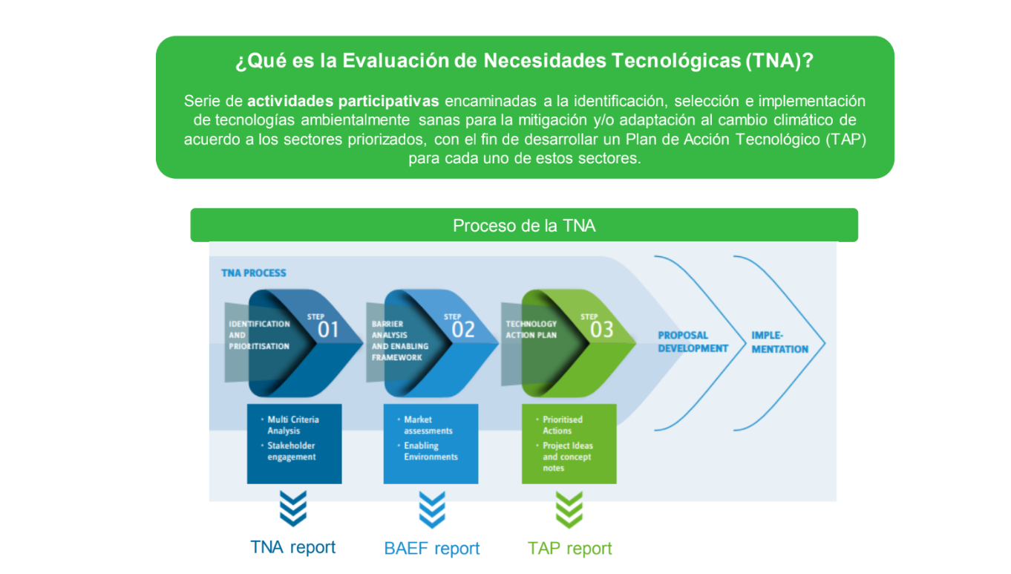 | 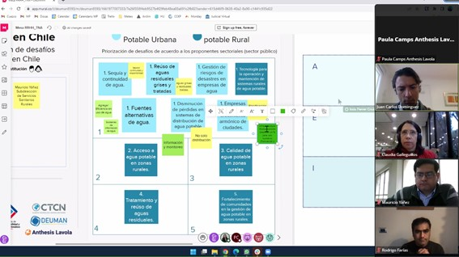
Third meeting: the weighting of criteria and scoring of technologies was held (December 13, 2022) | Fourth meeting: Analysing existing technological barriers (May 4, 2023)
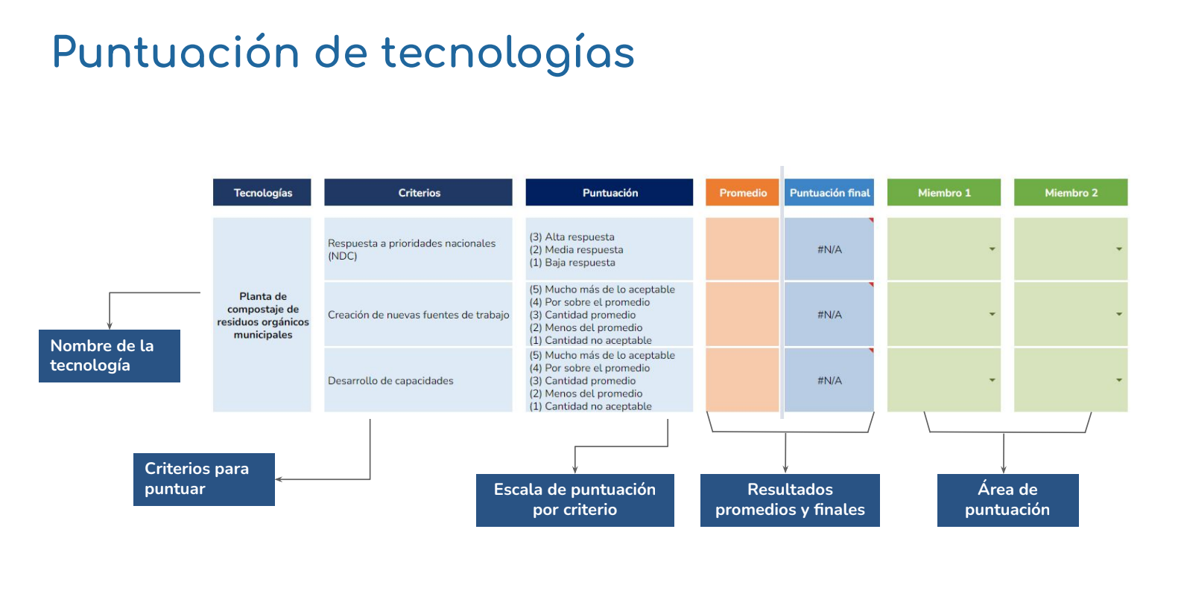 | 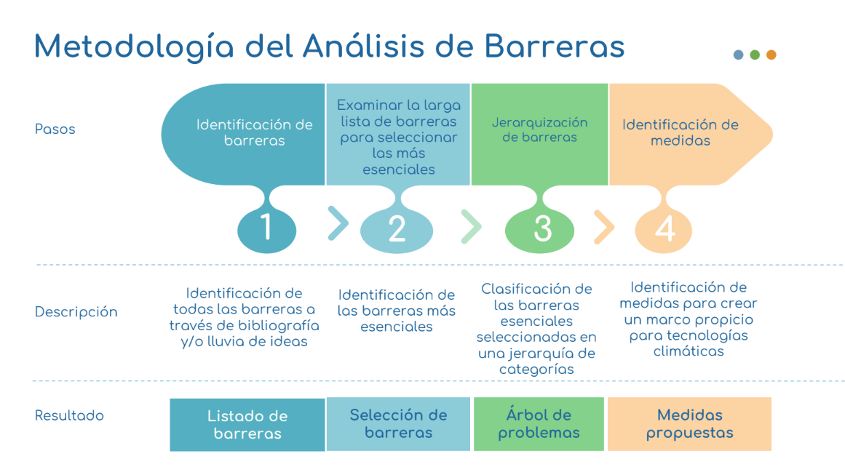

- Discussion Workshops for the deployment of climate technologies held for each sector (November 7, 9 and 10, 2023)
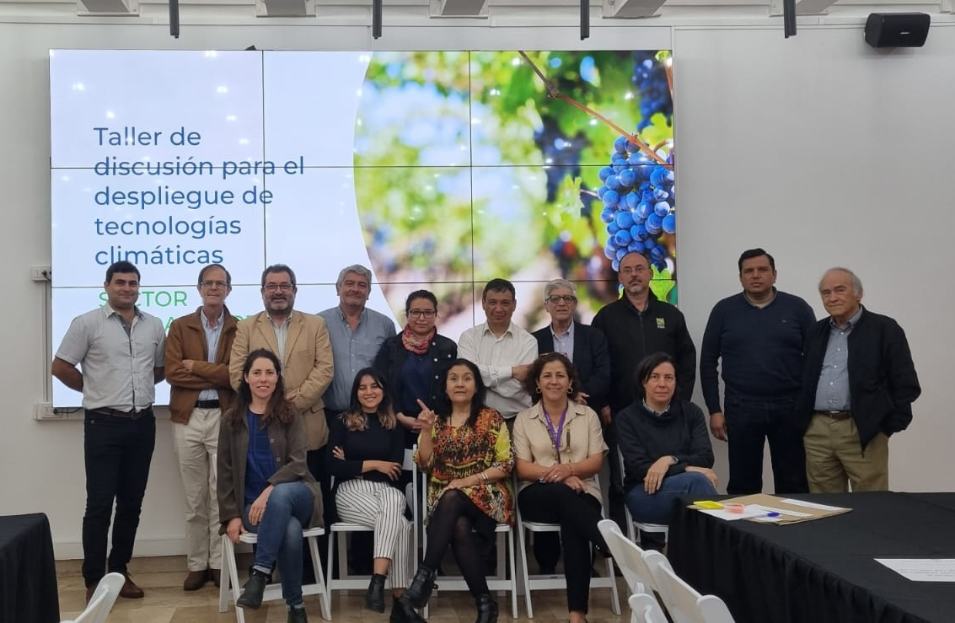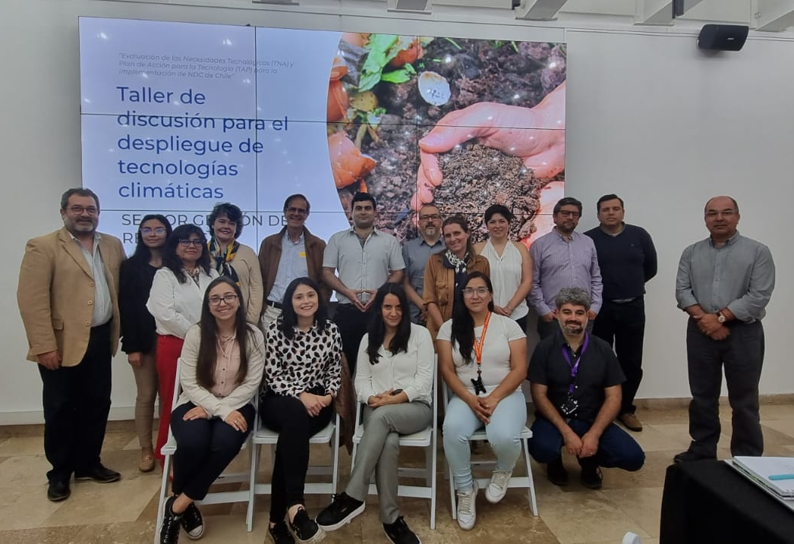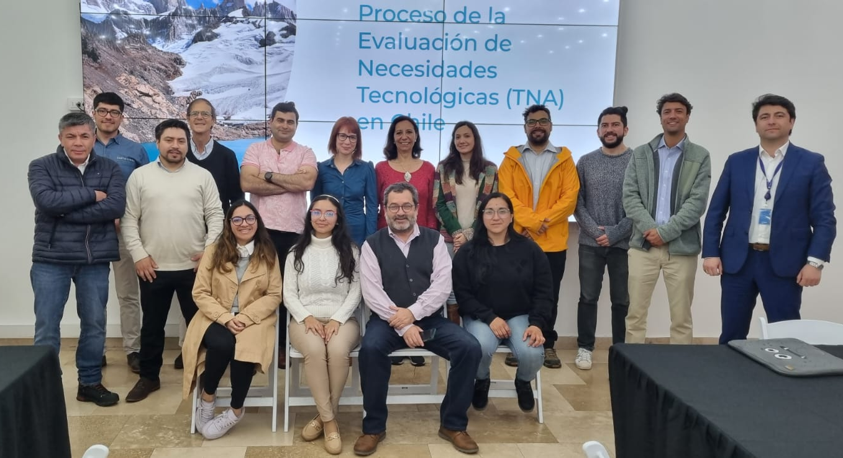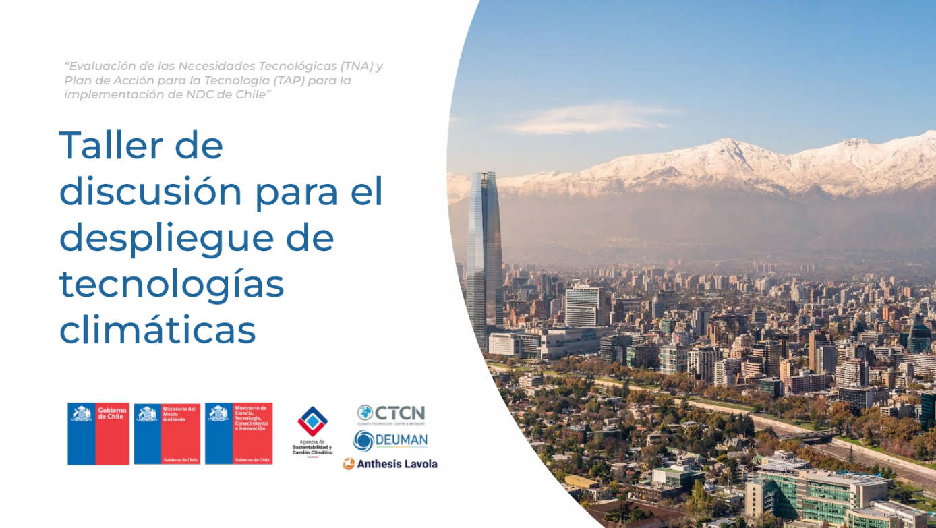

- Capacity Building Workshop (January 24, 2024)
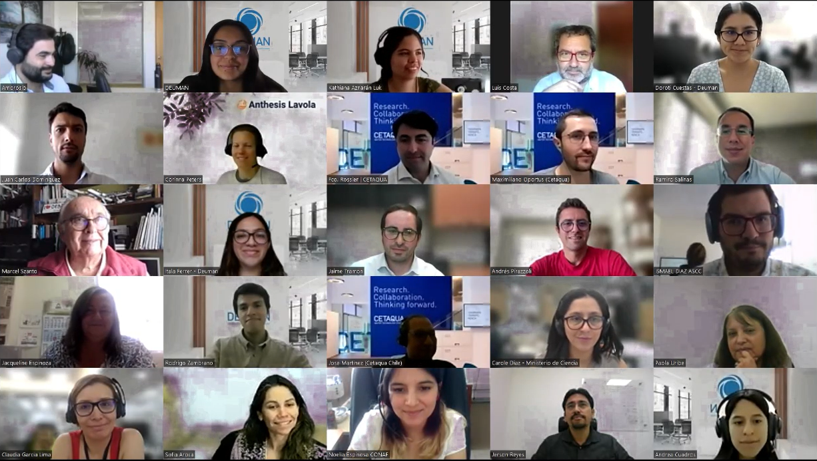

- First TNA National Steering Committee Meeting (September 22, 2022)
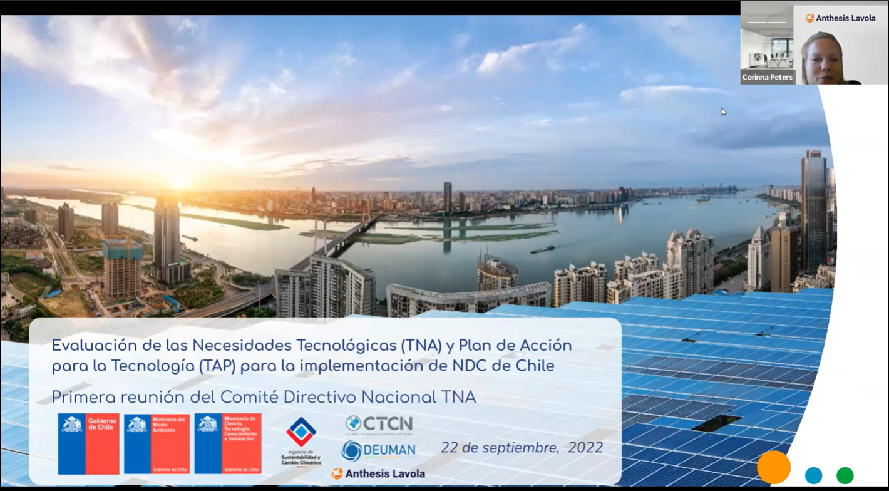

- Working Group 1 (March 24, 2022) and Working Group 2: Validation of key actors for the formation of the Sectoral Technical Groups (July 20, 2022).
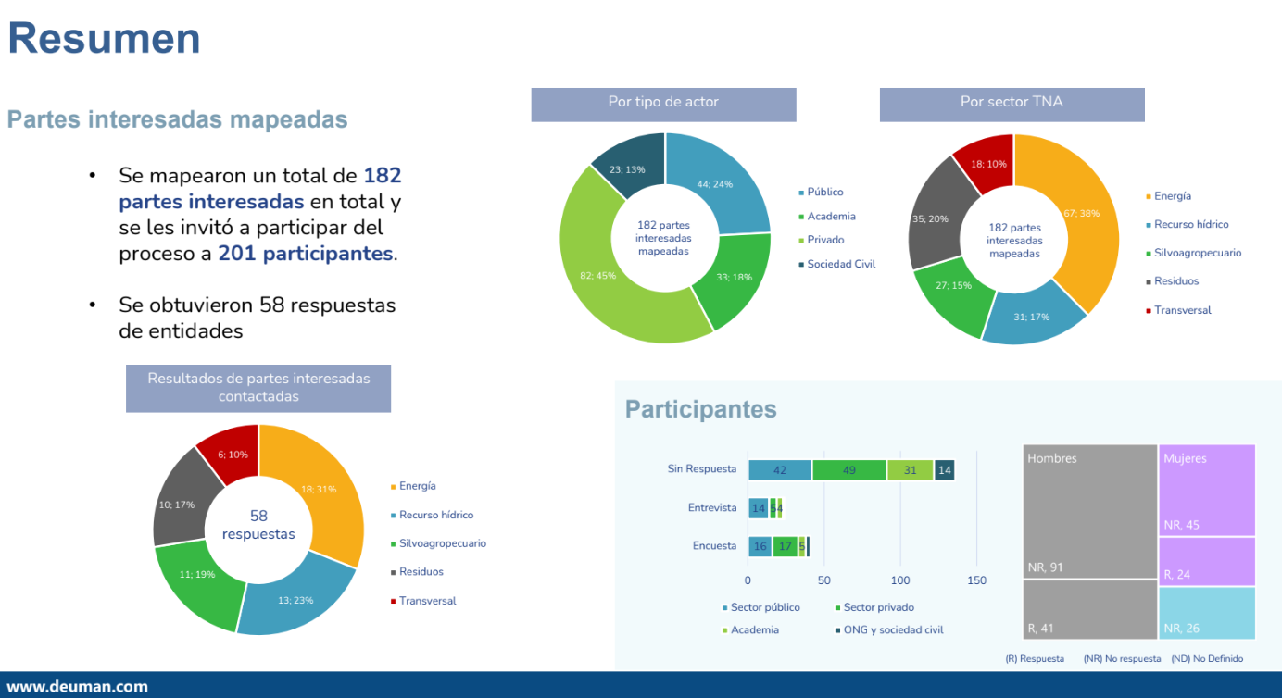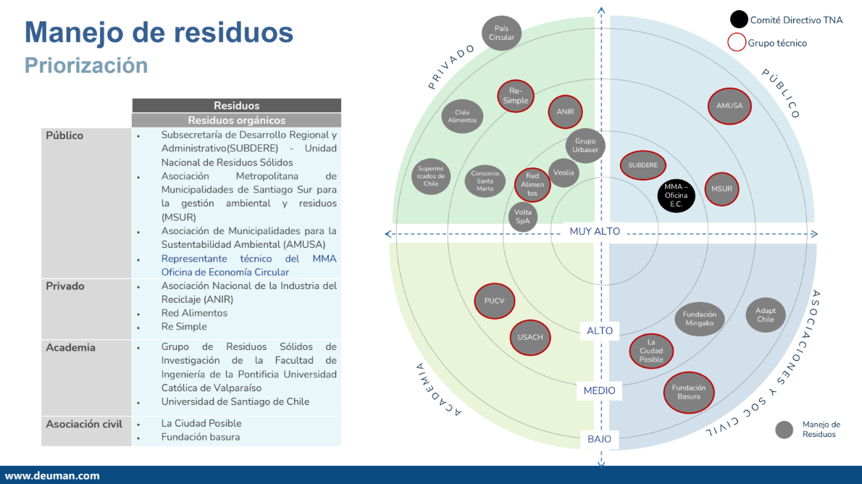

4. 4. Impact Statement

Defiance | To align Chile's development vision with its commitments under the NDC, the main barriers facing the country to advance the climate technologies needed to strengthen mitigation and adaptation measures were addressed. To this end, technologies were identified that respond to specific needs of the energy, agricultural and forestry, water resources and waste management sectors.
CTCN Support | CTCN assistance provided the following:  - Establishment of a TNA committee through consideration of key stakeholders.  - Evaluation, prioritization, and validation of key technologies to comply with Chile's TNA.  - Preparation of Technology Action Plans (TAPs) by sector.
Impact | - Increasing the country's resilience and adaptive capacity through the identification of climate change adaptation technologies in the water resources (rural and urban) and forestry and agriculture sectors.  - Improving the health of the population by ensuring access to drinking water and organic waste management.  - Increasing the response to climate change by identifying greenhouse gas mitigation technologies in the organic waste management, energy, and transport sectors.
Co-benefits: | The following co-benefits are displayed:  - Improvement of institutional processes, policies and regulations for the deployment of climate technologies.  - Development of action plans specific to the prioritized technologies and their proposed project ideas.  - The opportunity to generate successful applications for the GCF and other public and private sector institutions that respond to national technology priorities.  - Fulfilment of technological commitments in its NDC.  - Input for the development of implementation measures in sectoral and regional plans to climate change, specifically "technology development and transfer".  - Capacity building for technology development and transfer in the sectors involved in climate policy formulation in Chile.
Gender aspects of technical assistance | TA included the participation of women in every phase and has been safeguarded through the contribution of a gender expert. The role of women is addressed from the selection and participation in sectoral working groups, workshops, and technical committees, as well as in the analysis for the implementation of specific technologies and measures in the Technological Action Plans.
Contribución anticipada a la NDC | - The technical assistance will help Chile to have operational mechanisms and instruments for the analysis of needs and for the implementation of technological action plans in the targeted areas.  - It will also support the country in generating, focusing, and linking tools to support the development and transfer of technology, both for local development and for the transfer of existing technologies at the local and global level in mitigation and adaptation for the various and/or different productive sectors prioritized at the national and regional level by 2030.  - It will promote the generation of an inventory of Research Centers, R+D+i initiatives and projects related to mitigation and adaptation, and capacities to coordinate the Development and Transfer of Technology for climate change by 2022.  - It will initiate the implementation of the EDTTCCs set out in the NDC, including the establishment of their governance at the implementation level, and promote the generation of the Climate Technology Inventory System.  - It will enhance the country's capacity to adapt to climate-related risks and manage the adverse effects stemming from socio-natural disasters, particularly within the agro-forestry sector, while also providing technical assistance to promote the efficient use of fertilizers.  - It will support the disposal of urban household waste in landfills equipped with incineration or biogas utilization systems.  - It will help reduce GHG emissions associated with fossil fuel consumption by using energy storage systems, as well as increase the percentage of electric buses in urban public transportation systems.
The Narrative Story | Since 2015, a TNA has been part of Chile's NDC and in 2018 the country took the first steps in this process, resulting in the prioritization of three sectors: water resources; forestry; and energy.  A fourth sector, the waste management sector, was included in 2020 due to the growing importance in recent decades in the total national GHG emissions’ mix.  With the assistance of the CTCN, the country aims to complete the TNA process through the identification of technological solutions for the prioritized sectors, the development of a Technology Action Plan by challenge, sector and/or subsector and ensure national ownership and technological deployment.  The results of this process provided plans for long-term participatory transformative action in all identified and prioritized sectors to drive climate-resilient and low-carbon growth and strengthen compliance with country contributions detailed in the "Implementation and Operation of Mechanisms and Instruments for Needs Analysis and for the Implementation of Technology Action Plans in Specific Areas" of the country NDC.
Contribution to the SDGs | SDG 2: Improve agricultural practices through the use of technologies for adaptation and mitigation.  SDG 5: Empower women by ensuring gender balance in workshops and decision-making processes, with respect to selected technology and the implementation of plans.  SDG 6: Ensure access to safe drinking water, both subsectors of water relate to drinking water.  SDG 7: Through the TNA-TAP process, technologies will be identified for a climate-resilient electricity grid and to provide comprehensive solutions for the use of self-consumption energy.  SDG 9: Promote innovation through the use of technologies for adaptation and mitigation; build resilient infrastructure related to the energy-transport sector.  SDG 12: Ensure the use of sustainable technologies for mitigation and adaptation.  SDG 13.1: Through the TNA-TAP process, climate change adaptation technologies will be identified in various sectors and subsectors that will increase Chile's resilience and adaptive capacity.  SDG 13.a: The TNA-TAP process will result in a set of priority mitigation and adaptation technologies that include financing opportunities through the public and private sector (e.g., GCF).

Annex 1 Technical Assistance Data Collection

- Performance indicators and outputs

Indicator | Quantitative value | Qualitative description
1. Events (other than trainings) held as part of the assistance
Total number of events hosted by proponents and implementation partners | 7 | 3 sectoral working groups, 1 discussion workshop for the deployment of technologies, 1 national steering committee, 2 working tables
Number of participants in events organized by proponents and implementation partners | 171 | 91 participants in sectoral working groups  14 participants in the working groups  51 participants in the Technology Deployment Workshop  15 participants in the TNA National Steering Committee
- Number of men | 110 | 63 men participants in sectoral working groups  7 men participants in the working groups  31 men participants in the Technology Deployment Workshop  9 men participants in the TNA National Steering Committee
- Number of women | 61 | 28 women participants in sectoral working groups  7 women participants in the working groups  20 women participants in the technology deployment workshop  6 women participants in the TNA National Steering Committee
Number of climate technology RD&D related events | 1 | Discussion workshop for the deployment of technologies
Number of participants in climate technology RD&D events | 51 | 51 participants
- Number of men | 31 | 51 men participants
- Number of women | 20 | 20 women participants
2. Training and capacity building activities conducted during the assistance
Number of trainings organized by proponents and implementing partners | 2 | 1st meeting of the sectoral working group: training on the TNA process in Chile  2nd Capacity Building Workshop for Technology Needs Assessment (TNA)
Number of participants in trainings organized by proponents and implementing partners | 137 | 26 participants in the 1st meeting of the sectoral working group  111 participants in 2nd Capacity Building Workshop
- Number of men | 73 | 18 men participants in the 1st meeting of the sectoral working group  55 men participants in 2nd Capacity Building Workshop
- Number of women | 64 | 8 women participants at the 1st meeting of the sectoral working group  56 women participants in 2nd Capacity Building Workshop
Total number of institutions trained | 102 | 62 governmental organizations participants  26 private corporations participants  9 universities participants  2 NGO participants  3 independent participants
- Governmental (national or subnational) | 62 | 62 national governmental organizations
- Private sector (bank, corporation, etc.) | 26 | 26 private corporation participants
- Nongovernmental (NGO, University, etc.) | 14 | 9 universities participants  2 NGO participants  3 independent participants
Percentage of participants reporting satisfaction with CTCN training (from CTCN training feedback form) | 75% | Am I satisfied with the training provided?  Totally agree – 25%  Agree – 50%  Neutral – 16.7%  Disagree – 0%  Totally disagree – 8.3%  Note: 12 of the 111 attendees filled out the satisfaction survey
Percentage of participants reporting increased knowledge, capacity and/or understanding as a result of CTCN training (from CTCN training feedback form) | 91.7% | Indicate the level of knowledge increase on the topic covered in the training  No increase – 8.3%  Moderate increase – 41.7%  Some increase– 25%  Significant increase – 25%  Note: 12 of the 111 attendees filled out the satisfaction survey
3. Tools, technical reports and information material supported by the assistance
Total number of deliverables produced during the assistance (excluding mission, progress, and internal reports) | 12 | Output 1, 2 (2.1, 2.2, 2.3 y 2.4), 3 (3.1, 3.2, 3.3 y 3.4), 4 (4.1 y 4.2), monitoring and evaluation plan and closure report
Number of communication materials, including news releases, newsletters, articles, presentations, social media postings, etc. | 9 | 7 invitations to the National Steering Committee (Output 2)  2 invitations to the dissemination workshops (Outputs 3 and 4)
Number of tools and technical documents strengthened, revised or developed | 13 | Output 1 (Work plan)  Activity 1.1: Monitoring and Evaluation Plan  Activity 1.2: Closure report  Activity 2.1: Stakeholder Analysis  Activity 2.2: Support for the establishment of a TNA Committee  Activity 2.3: Formation of sectoral working groups and capacity building  Activity 2.4: TNA Steering Committee Work Plan  Activity 3.1: Validation of Prioritized Challenges  Activity 3.2: Identifying and prioritizing technologies  Activity 3.3: Development of a Technology Action Plan by sector  Activity 3.4: Discussion Workshop for the Deployment of Climate Technologies  Activity 4.1: Communication and dissemination strategy  Activity 4.2: Capacity Building Workshop
Number of other information materials strengthened, revised or created (For example training and workshop reports, Power Points, exercise docs etc.) | 34 | 1 Power Point of Capacity Building Workshop for Technology Needs Assessment  4 Power Points of discussion workshop for the deployment of technologies  5 minutes of the meeting of sectoral working groups  10 Power Points for presentations to sectoral working groups  8 excels for presentations to sectoral working groups  1 Power Point for presentation to first national steering committee  1 minute of the meeting of the first national steering committee  2 Power Points for the working tables meetings  2 minutes of the meeting of working tables
Number of working tables executed with Authorities of the ministry of environment and energy | 9 | 9 working tables executed
4. Diagnosis of key actors
Total, number of meetings with stakeholders | 102 | 81 surveys  21 interviews
Number of participants in interviews and surveys | 114 | 90 participants in surveys  24 participants in interviews
- Number of men | 71 | 52 men participants in surveys  19 men participants in interviews
- Number of women | 43 | 38 women participants in surveys  5 women participants in interviews
Total, number of minutes of the meetings of the interview | 1050 | 50 meeting minutes for each interview
5. Policies, laws and regulations supported by the assistance
Total number of policies, strategies, plans, laws, agreements or regulations supported by the assistance | Does not apply | -
- Adaptation related | Does not apply | -
- Mitigation related | Does not apply | -
- Both adaptation- and mitigation related | Does not apply | -
Anticipated number of policies, strategies, plans, laws, agreements or regulations proposed, adopted or implemented as a result of the TA | 8 | 4 policy briefs  4 technological action plans
- Adaptation related | 4 | 2 policy briefs  2 technological action plans
- Mitigation related | 4 | 2 policy briefs  2 technological action plans
- Both adaptation- and mitigation related | - | -
Anticipated number of technologies transferred or deployed as a result of CTCN support | 12 | Energy: Batteries, Bus Rapid Transit, Heavy-duty vehicles with green hydrogen  Water resources: Rainwater harvesting, Wastewater reuse, Machine learning for the detection and location of leaks in water distribution networks  Waste Management: Community Vermicomposting of municipal organic waste, biological treatment using black soldier fly larvae, Anaerobic digestion to produce biogas and electricity.  Forestry and agriculture: Intelligent Irrigation System, Early Warning Systems, Machine learning to optimize the performance of agricultural and forestry activity.
6. Partnerships and cooperation
Anticipated number of collaborations facilitated or enabled as a result of technical assistance | 12
- Number of South-South collaborations | 0
- Number of RD&D collaborations | 6 | CORFO, INIA, FIA, INDAP, ANID, universities
- Number of private sector collaborations | 6 | 1 project leader health company  1 transport company  1 landfill company  1 private company for anaerobic digestion plant  1 center for salmon farmers  1 industrial park
Number of countries with strengthened National System of Innovation as a result of CTCN support | 1 | Chile

- Core impact indicators
Core indicator 1 | Anticipated metric tons of CO₂ equivalent (CO₂e) emissions reduced or avoided as a result of CTCN TA
 | Anticipated metric tons of CO₂e reduced or avoided as a result of the TA on annual basis | Anticipated metric tons of CO₂e reduced or avoided as a result of the TA in total
Quantitative value  (emissions reductions) | 32,953.8 | -
Unit | tCO₂e | tCO₂e
GHG assessment boundary (project emissions)  Identify expected post-TA activities, associated effects and assess boundary for quantification of GHG emission reductions | Community Vermicomposting  The implementation of Community Vermicompost in Maipú, according to calculations, would avoid approximately 9.86 tCO₂e per year. The implementation of vermicompost would result in the management of organic waste that currently goes to landfills, dumps or microbasurals, generating a positive impact on public health and the welfare of the people. | -
Anaerobic digestion plant
The anaerobic digestion plant in the province of Chiloé, according to calculations, would avoid the emission of a total of 32,902.85 tCO₂e per year. This alternative treatment of organic waste responds to the current management given to waste as disposal in landfills or dumps.
Garbage collection truck powered by H2V
According to calculations, it is estimated that this technology can prevent the emission of a total of 35.92 t CO₂e per year. This decrease is due to the change of fossil fuel (diesel) versus green hydrogen that does not generate combustion. The implementation of this project idea promotes the transition of fuels in freight transport.
Biological treatment using black soldier fly larvae in the salmon farming sector.
It is estimated a decrease of 5.16 tCO₂e per year, this innovation not only contributes to the reduction of greenhouse gas emissions, but also promotes the circular economy and sustainability in the salmon industry. By exploiting organic waste for insect meal production using the black welded fly, the production cycle is closed and dependence on landfills and dumps is reduced.
Baseline emissions  Describe baseline scenario, baseline candidates, emission factors and emissions calculated | Community vermicomposting  An annual emission of 9.99 tCO₂ is estimated from the final disposal of organic waste in landfills for approximately 20 families. | -
Anaerobic digestion plant
Currently, in the province of Chiloé, an annual emission of about 33,356.02 tCO₂e is estimated. This emission originates from the disposal of organic waste in landfill.
Garbage collection truck powered by H2V
Diesel garbage trucks emit around 35,917 t CO₂ per year.

Biological treatment using black soldier fly larvae in the salmon farming sector.
4 salmon farms emit 20.91 t CO₂ per year when their solid waste is disposed of in landfills.
Methodology  Explain the method or process of verifying the indicator and how data was gathered | Community vermicomposting  $$E_{avoided}=E_{landfill}-E_{composting}$$  E: Emissions (t CO₂e)  $$E=AL x EF$$  AL: Activity level (tons of organic waste for the pilot)  EF: emission factor  - It was determined that the amount of organic waste generated in Maipú per year is 0.238 t per capita. This was obtained by the municipal solid waste data reported in the Pollutant Release and Transfer Register, which amounts to 229,359.28 t for 2022, a total of 559,123 inhabitants (INE, 2017) and considering that 58% are organic waste.  - The pilot to be developed will be with 20 families (houses), a total of 60 inhabitants.  - For emission factors, the values provided by DEFRA 2023 were used, which are 700.21 kg CO₂ per ton of organic waste disposed in landfill and 8.91 kg CO₂ per ton of organic waste disposed in composting.
- Anaerobic digestion plant
$$E_{avoided}=E_{landfill}-E_{anaerobic digestion}$$
E: Emissions (t CO₂e)
$$E=AL x EF$$
AL: Activity level (tons of organic waste in Chiloé)
EF: emission factor

- The data provided by the National Waste Declaration System, which reported a generation of 87,670 tons of solid household waste in the province of Chiloé in 2018, were considered. In addition, the percentage established by ENRO of 58% of organic waste within solid household waste was considered to calculate the amount of organic waste generated in the province.
- For emission factors, the values provided by DEFRA 2023 were used, which are 655.98 kg CO₂ per ton of organic waste disposed in landfill and 8.91 kg CO₂ per ton of organic waste disposed in anaerobic digestion.
-Garbage collection truck powered by H2V
$$E_{avoided}=E_{Diesel}-E_{H2V}$$
E: Emissions (t CO₂e)
$E_{H2V}$: Emission is 0, there is no combustion.
$$E_{Diesel}=fuel x Calorific value x EF$$
EF: Emission factor

- The average diesel consumption per truck is considered 13,406.25 L per year. Calculated on the base that it travels 55 km a day and consumes an average of 1.28 km/L of diesel, for approximately 6 days a week.
- In addition, the diesel emission factor according to the IPCC, set at 74,100 kg CO₂ per terajoule (TJ), and the net caloric value of diesel, which is 0.000036 TJ/L. By multiplying these values, approximately 2.68 kgCO2 /L diesel consumed by garbage trucks.
- Biological treatment using black soldier fly larvae in the salmon farming sector
$$E_{avoided}=E_{landfill}-E_{composting}$$
E: Emissions (t CO₂e)
$$E=AL x salmon centers x EF$$
AL: Activity level (residuos orgánicos de la salmonicultura por centro de cultivo)
EF: Emission factor
- The amount of farming salmoniculture organic waste generated per year was determined to be 1.86 t per salmon center. This was obtained from reported salmoniculture residue data, which, according to the Pollutant Release and Transfer Register, amount to 5,523 t per year. In addition, the salmon centers registered in the National Aquaculture Register are 1,716 according to the Servicio Nacional de Pesca y Acuicultura (SERNAPESCA).
- The pilot to be developed will be with 4 salmon centers.
- For emission factors, the values provided by DEFRA 2023 were used, which are 700.21 kg CO₂ per ton of organic waste disposed in landfill and 8.91 kg CO₂ per ton of organic waste disposed in composting.
Assumptions  Describe assumptions made during calculation and quantification of GHG reductions | -Community vermicomposting  - Currently organic waste goes to landfills.  - Municipal solid waste is considered to contain 58% organic waste, according to Chile’s National Organic Waste Strategy.  - Each family has an average of 3 inhabitants. | -
 | - Anaerobic digestion plant  - Currently organic waste goes to landfills.  - Household solid waste is considered to contain 58% organic waste, according to Chile’s National Organic Waste Strategy. | -
 | - Garbage collection truck powered by H2V  - A garbage truck in the Metropolitan region is considered to travel 55 km per day and consume an average of 1.28 km/L of diesel fuel.  - Current garbage trucks are considered to run on diesel and only emissions from combustion. | -
 | - Biological treatment using black soldier fly larvae in the salmon farming sector  - Currently organic waste goes to landfills.  - Salmonid residues are considered to contain 58% organic residues, as to information of municipal solid waste according to Chile’s National Organic Waste Strategy. Because no specific information is found for salmonid residues | -

Core indicator 2 | Anticipated increased economic, health, well-being, infrastructure and built environment, and ecosystems resilience to climate change impacts as a result of technical assistance
Infrastructure and built environment. | In the water resources sector machine learning technology would be implemented for the detection and location of leaks, this technology would reduce the risk of water leakage and the deterioration of infrastructure in distribution networks.  On the other hand, in the forestry and agriculture sector, technologies such as the early warning system, will help prevent adverse events from causing damage to the infrastructure associated with these areas or surrounding places (housing, public infrastructure, others). In addition, machine learning technologies to optimize agricultural productivity and intelligent irrigation systems will also generate infrastructure resilient to drought events and agro-climate monitoring stations for data collection.  The energy sector, with the implementation of Bus Rapid Transit technology, will increase transport infrastructure and accessibility for the beneficiary population. While energy storage technology generates resilient infrastructure in response to decarbonization policies in Chile.
Ecosystems and biodiversity  Anticipated increased ecosystem resilience (areas with increased resistance to climate-induced disturbances and with improved recovery rates) | The forestry and agricultural sector plans to implement an integrated early warning system with a focus on rural agriculture but with public use for the entire population in the regions of Ñuble and Bíobio. The implementation of this technology would mean in the early response to extreme climate events such as heat waves and floods that also affect the ecosystems and endemic biodiversity of the area.  In the water resources sector, the implementation of reuse of wastewater technology seeks to reduce the use of continental water and thus the conservation of natural water sources such as lakes and lagoons. In addition, the implementation of artificial wetlands for water treatment seeks to increase biodiversity in the implementation areas.
Economic  Anticipated increased economic resilience (e.g. less reliance on vulnerable economic sectors or diversification of livelihood) | The energy technologies evaluated in the Technological Action Plans include decarbonization technologies and reduction on fossil fuels dependency. Some of these seek to reduce energy costs in industrial zones through energy storage and green hydrogen powered heavy-duty vehicles.  While in the agricultural sector, the plans are characterized by providing technologies that help increase the resilience of rural farmers due to their condition of vulnerability to extreme events and water scarcity.  In the water resources sector, the aim is to reduce costs due to water leaks in the sanitary network for operating companies and in the waste generate sector, the technologies focus on generating businesses that boost the valorization of organic waste.
Health and wellbeing  Anticipated increased health and wellbeing of target group (e.g. improved basic health, water and food security) | The technologies of the water resources sector seek to ensure the water security of the population, both with rainwater collection systems, and with the reuse of wastewater, in sectors where its use is possible.  On the other hand, forestry and agricultural technologies such as machine learning to optimize agricultural performance and intelligent irrigation systems seek to increase the resilience of the sector and ensure the continuity of food supply, therefore, food security.  In the energy sector, the change of combustion transport technologies such as the use of garbage trucks to green hydrogen and electric buses will contribute to the reduction of local emissions as particulate material, increasing air quality and improving living conditions of the population in the areas where these vehicles circulate.

Core indicator 3 | Anticipated number of direct and indirect beneficiaries as a result of the TA
 | Quantitative value | Means of verification
Total beneficiaries | 25,291 agricultural producers  2,784,962 people  4 salmon centers  34 industries (1 industrial park)  1 landfill  1 waste collection company | Different beneficiaries were considered for each project idea in the four selected sectors.
Number of adaptation beneficiaries | Forestry and agriculture:  - 11,931 producers in Biobio region and 11,470 producers in Ñuble region  - 1,815 producers on land less than 1 hectare in Maule region  - 75 farmers in the 3 macrozones of Chile | - The implementation of the project "Early warning system in Ñuble - Biobío" aims to benefit agricultural producers registered in the Agricultural Census 2021-2022 in these regions.  - The pilot of Machine Learning in mixed production systems in a basin in the Maule region offers significant benefits for small farmers. According to the National Agricultural and Forestry Census 2021-2022, about 11.7% of the Agricultural Production Units (UPA) in the Maule region correspond to areas less than 1 hectare. For the calculation of the beneficiaries, this percentage is multiplied by the total number of producers in the region.  - In the project idea "Modernization of technological tools for water efficiency ", farmers linked to an association for each macrozone (south, center and north) are identified as direct beneficiaries. An average of 25 farmers per association is estimated.
Number of adaptation beneficiaries | Water resources:  - 1 implementing healthcare company and 527 clients on average.  - 1,773 people in Maipo Island commune  - 1,863,627 rural inhabitants in the central-southern macrozone of Chile | - The implementation of a Machine Learning system for water leak detection will directly benefit the implementing company by reducing its operational losses and communities by reducing water outages due to repairs. It was considered an average of customers by the 4 healthcare companies in the Metropolitan region.  - In the project idea Reuse of wastewater with artificial wetlands, the homes of the commune of Maipo Island, Metropolitan region were considered. 591 families (1,773 people) have a pit system.  - In the project idea "SCALL complementary to APR", the rural population in the south-central macrozone (O'Higgins, Maule, Ñuble and Biobío) is considered as beneficiaries of its implementation.
Number of mitigation beneficiaries | Waste Management:  - 168,185 people in the province of Chiloé  - 60 people in the Maipú commune  - 4 salmon centers | - The implementation of the pilot proposes the installation of an anaerobic digestion plant on the island of Chiloé for the treatment of organic waste, both domestic and industrial, seeking to benefit the inhabitants in the province of Chiloé, Los Lagos region.  - The implementation of the pilot for the "Community Vermicompost" project idea aims to reduce the amount of organic waste sent to landfills. It will benefit 20 families (60 people) in the commune of Maipú by promoting sustainable waste management practices and improving the local environmental environment.  - The implementation of the pilot for the project idea "Biological treatment using black soldier fly larvae in the salmon farming sector" seeks to transform organic waste from salmoniculture into a valuable resource. It will benefit salmon farming centers in southern Chile, including areas such as La Araucanía, Los Lagos, Aysén and Magallanes.
 | Energy:  - 32 industries approximately in an industrial and technological park  - 751,317 inhabitants of the province Valparaíso  - 1 company collecting waste and landfill | - The implementation of the project idea "Collective energy storage with a diversity of energy consumption and demand profiles " aims to generate a short-term energy storage system. Considering that in the industrial and technological park of La Araucanía there are 32 industries, this data is taken as a reference.  - The implementation of the project idea "Bus Rapid Transit (BRT) to electromobility in Valparaíso" seeks to integrate a rapid transit bus into the existing public transport system in Valparaiso, the population of the province of Valparaiso is considered as direct beneficiaries.  - The implementation of the pilot for the project idea "Garbage collection truck powered by green hydrogen" will benefit waste collection companies and the chosen landfill.
Number of adaptation-and mitigation beneficiaries

Core indicator 4 | Anticipated amount of funding/investment leveraged (USD) as a result of TA (disaggregated by public, private, national, and international sources, as well as between anticipated/confirmed funding)
 | Quantitative value confirmed in USD | Quantitative value anticipated in USD | Qualitative description  List the institutions, timelines, and description or title of the investment | Methods  Describe methods used for quantification of funds leveraged
Total funding | - | 23,863,000 USD | See the Technological Action Plan | They are an approximate cost of implementing only the project ideas for technologies proposed in the Technological Action Plan.
Anticipated amount of public funding mobilised from national/domestic sources |  | - Community Vermicomposting:  113,500 USD  - Black soldier fly larvae:  2,935,000 USD  - Rainwater harvesting:  452,000 USD | See the Technological Action Plan | They are an approximate cost of implementing only the project ideas for technologies proposed in the Technological Action Plan. For ease of reporting, the expected financing is separated by domestic or international/regional resources, however, it is possible that mixed financing exists when implementing project ideas, including from the private sector.
Anticipated amount of public funding mobilised from international/ regional sources |  | -Machine learning for agriculture:  533,000 USD  -Early Warning Systems:  720,000 USD  - Intelligent Irrigation System:  321,000 USD  - Wastewater reuse:  525,000 USD  - Bus Rapid Transit:  9,790,000 USD | See the Technological Action Plan | They are an approximate cost of implementing only the project ideas for technologies proposed in the Technological Action Plan. For ease of reporting, the expected financing is separated by domestic or international/regional resources, however, it is possible that mixed financing exists when implementing project ideas, including from the private sector.
Anticipated amount of private funding mobilised from national/domestic sources |  | - Batteries: 1,046,500 USD  -Machine learning for leaks: 1,055,000 USD  - Anaerobic digestion:  6,372,000 USD | See the Technological Action Plan | They are an approximate cost of implementing only the project ideas for technologies proposed in the Technological Action Plan. For ease of reporting, the expected financing is separated by domestic or international/regional resources, however, it is possible that mixed financing exists when implementing project ideas, including from the private sector.
Anticipated amount of private funds mobilised from international/regional sources |  | - | - | -

Annex 2 (For internal use – completed by the CTCN)
Evaluación CTCN
This section will be completed by the relevant CTCN Technology Manager

- Assessment of the timeliness of implementation of technical assistance measured against the schedule included in the response plan;
- Assessment of the quality of technical assistance as defined in the response plan;
- Overall performance of implementers;
- General commitment of the NDE and proponent;
- Lessons learned about the CTCN process and steps taken by the CTCN to improve.

Objective of the technical assistance (TA) Closure Report:
- To communicate publicly in one document a summary of progress made and lessons learned during the TA towards the anticipated impact (sections 1-4).
- To document qualitative and quantitative data collected during TA, for use in donor and UN reporting (Annex 1).

Steps for completing the TA closure report:
- The lead TA implementer submits the closure report at the end of the technical assistance as a final deliverable. The TA closure report will capture outputs, outcomes and impacts of all activities conducted under the TA. Please copy and summarise relevant material from previous TA outputs/deliverables and the Response Plan, as relevant.
- A CTCN Manager will review and revise the closure report before final approval by the CTCN Deputy Director.

Important note on public and internal use of the closure report:
Once approved by the CTCN Deputy Director, the TA closure report will be a public document available on the CTCN website www.ctc-n.org. Selected content will be used for targeted communication activities. Annex 2 is for internal use only and will not be publicly available.

The beneficiaries were estimated based on an approximation of the proposed area or territory in the implementation of the project ideas.

