Technical Assistance Closure Report Template
Objective of the technical assistance (TA) Closure Report:
- To communicate publicly in one document a summary of progress made and lessons learned during the TA towards the anticipated impact (sections 1-4).
- To document qualitative and quantitative data collected during TA, for use in donor and UN reporting (Annex 1).

Steps for completing the TA closure report:
- The lead TA implementer submits the closure report at the end of the technical assistance as a final deliverable. The TA closure report will capture outputs, outcomes and impacts of all activities conducted under the TA. Please copy and summarise relevant material from previous TA outputs/deliverables and the Response Plan, as relevant.
- A CTCN Manager will review and revise the closure report before final approval by the CTCN Deputy Director.

Important note on public and internal use of the closure report:
Once approved by the CTCN Deputy Director, the TA closure report will be a public document available on the CTCN website www.ctc-n.org. Selected content will be used for targeted communication activities. Annex 2 is for internal use only and will not be publicly available.

Closure Report for CTCN Technical Assistance

- Basic information
Title of response plan | Increasing resilience of the education system to climate change in Saint Lucia
Technical assistance reference number | 2019000059
Country / countries | Saint Lucia and Antigua and Barbuda
NDE organisation | Ministry of Education, Sustainable Development, Innovation, Science, Technology and Vocational Training;  4th Floor, Francis Compton Building, Waterfront, Castries  Samanthia Justin  Chief Technical Officer  Department of Sustainable Development  sajustin@gosl.gov.lc  Ministry of Health and Environment  doe@ab.gov.ag  Botanical Gardens, Factory Road, St. John’s, Antigua
NDE focal point | Samanthia Justin  Chief Technical Officer, Saint Lucia  Department of Sustainable Development  Diann Black-Layne  Director, Department of the Environment, A&B
NDE contact information | Samanthia Justin - sajustin@gosl.gov.lc  Diann Black-Layne - Diann.Black-Layne@ab.gov.ag; doe@ab.gov.ag
Proponent focal point and organisation | NDE
Designer of the response plan | UN Environment
Implementer(s) of technical assistance | ECMC Ltd
Beneficiaries | Management, Teachers and Students from twelve schools in Saint Lucia and Sixteen schools in Antigua and Barbuda
Sector(s) addressed | Energy efficiency, Renewable energy; Infrastructure and Urban planning;
Technologies supported | The technology sectors which were supported include:  Sector: Infrastructure and Urban planning  Technology Group: Building design and material  Urban design and spatial planning  Building construction  Water supply infrastructure  Urban planning  Building codes  Technology: Urban infrastructure development,  General planning solutions  Sector: water  Technology Group: Adaptation planning, Water augmentation, Water storage,  Technology: Disaster risk assessment tools  Hazard mapping solutions, Climate change vulnerability assessment, Rainwater harvesting, Water reservoirs  Mitigation: Climate resilient construction and Renewable energy  Sector: - Renewable energy  Technology Group: - Solar  Technology: - Building-integrated PV; Solar water pumps; Solar water heater;  Sector: - Energy efficiency  Technology Group: - Appliances and equipment  Technology: - Water efficiency; Residential water heaters; Lighting; Appliance standards; Water pumping;  Sector: - Energy efficiency  Technology Group: - Buildings  Technology: - Sustainable design; Daylight harnessing; New building design; Insulation in buildings; Building materials; Building life cycle and integrated design process; Building standards and codes; Greening the built environment; Retrofitting of existing buildings; Building Energy Management Systems; Heating - Ventilation and Air Conditioning; Design for Deconstruction; Traditional building materials and design; Sustainable spatial planning; Efficient air conditioning systems  Cross-sectoral enablers: Capacity building and training;  Cross-cutting approaches: Disaster risk reduction
Implementation start date | 27 February 2020
Implementation end date | 16 December, 2021
Total budget for implementation | USD208,856
Description of delivered outputs and products as well as the activities undertaken to achieve them. In doing so, review the log frame of the original response plan and refer to it as appropriate | Output 1: Development of implementation planning and communication documents  Output 2: Climate change vulnerability assessments  - Performing a Rapid Vulnerability Assessment and School Identification for both Islands  - Coordinating and agreeing with key stakeholders for data, criteria  - Conducting a review of OECD Guidelines and compare with criteria developed  Output 3: List, rank and select the most climate change  vulnerable areas and schools  - Preparing a shortlist and ranking potential schools to be upgraded from initial assessments  - Preparation of preliminary cost estimates for upgrading  - Coordinating and agreeing with Key Stakeholders on the proposed ranking;  - Assisting Antigua and Barbuda in replicating methodology implemented in Saint Lucia  Output 4: Develop school-by-school resilience improvement packages  - Conducting Technical Assessment of Schools and preparing a comprehensive report with work packages;  - Providing Antigua and Barbuda NDE with criteria for condition assessment and review report  - Preparing a framework to assist in Integrating Disaster Risk Reduction and Resilience Education in the School Curriculum  - Consulting Beneficiary Communities and Vulnerable Groups and using outcome in a Consultations Report  - Identifying gaps in capacities of key stakeholders to implement activities in the work packages and preparing a Capacity Gaps Report  Output 5: Identifying ways to replicate and upgrade the technique and approach in the country and in the region  - Develop a roadmap to integrating, upgrading and technologies for all schools in Saint Lucia and Antigua and Barbuda  - Reviewing of roll out plan by Client and Key Stakeholders  - Updating roll out plan to reflect changes recommended by Client and Key Stakeholders  Output 6: Conducting potential environmental & social risks screening & impact assessment of the proposed interventions for both Saint Lucia and Antigua and Barbuda  - Conducting environmental and social risks screening and impact assessments of the interventions included in the work packages  - Providing Antigua and Barbuda NDE with scope for revising ESIA to conform with standard being used by Saint Lucia  - Coordinating with key stakeholders for relevance to policies & regulations;  - Conducting consultations to identify concerns related to potential risks and impacts.  - Preparing environmental and social management plans for Saint Lucia and Antigua and Barbuda.
Methodologies applied to produce outputs and products | The following methodologies were adopted:  - Conducting a reconnaissance visit to the twelve selected schools to appreciate the conditions and to hold discussions with key stakeholders – teachers and school principals;  - Collecting data from the Water and Sewerage Company of Saint Lucia on production levels at water intakes in the communities where the Schools were located;  - Conducting a comprehensive condition assessment of the twelve schools in Saint Lucia and identifying interventions to address the vulnerabilities assessed, particularly as it related the defined list of hazards - 1) hurricanes, 2) droughts, 3) floods, 4) Sea-Level rise, 5) Landslides;  - Conducting three sets of stakeholder consultations and two sets of focus group discussions in the southern and northern regions of Saint Lucia;  - Conducting a stakeholder consultation with teachers in Antigua on the issue of DRR in the Education system;  - Developing preliminary and detailed cost estimates for the work packages evolving from the condition assessments of the twelve schools in Saint Lucia;  - Through virtual and in-person means, assisting the Antigua NDE representative;
Reference to knowledge resources | Instruction: Please indicate if any UNFCCC Technology Executive Committee (TEC) knowledge products (publications, briefs, tools etc.) were used in the implementation of the TA request, and which. Link to TEC knowledge database: https://unfccc.int/ttclear/tec/documents.html
Deviations | The following are some deviations from the response plan against the actual implemented activities, outputs and products:  - As opposed to the original plan to assist Antigua with the preparation of an updated version of their project proposal to the Adaptation Fund, Antigua was assisted in replicating the works done in Saint Lucia by ECMC  - Include preparation of a Framework for Including Disaster Risk Resilience in the School Curriculum; and a Teacher’s Handbook for Including DRR Education in Schools;  - Due the challenges posed by operating during the Pandemic, only one Consultations Report was prepared as opposed to two;  - Reviewing and making recommendations on the issues of fire safety at each of the twelve schools
Anticipated follow-up activities and next steps | The following are some anticipated activities and next steps:  - Submission of the accepted outputs to CTCN for onward transmittal to UN-Habitat for preparation of the Adaptation Fund Proposal  - Discussing the Project Roll-out with the organisations identified as the key stakeholders before said report is accepted by Saint Lucia NDE and CTCN.  - Follow-up and formal submission of funding proposal drafted with support from the CTCN.  - Undertaking detailed designs of the works identified in the work packages and the procurement contracting services for undertaking the works;  - Performing a detailed and comprehensive structural condition assessment of the Bexon Primary School in Saint Lucia, before any works intervention are taken;  - Implementation of the activities and the interventions identified in the work packages;  - Adoption and use of the DRR Framework and Teacher’s Handbook by both Saint Lucia and Antigua and Barbuda;  - Dissemination of report drafted by the CTCN.

- Lessons learned
 | Lessons learned | Recommendations
Lessons learned from the CTCN TA process | - The flow of deliverables in the TOR was not realistic – developing cost estimates should not be requested before detailed inspection;  - The Roll-out report could not benefit from key stakeholder involvement.  - Ownership of the outputs was not clear from the TOR – particularly the Roll-out Report;  - Stakeholders were not aware of the TA and saw the project as one of repair and maintenance of school plant;  - Antigua was more concerned with the non-structural as opposed to the structural interventions | Recommendations include  - More thought should be given to the logical and logistical flow of project deliverables;  - TA/Project should be widely presented to the key stakeholders prior to being implemented so that there is easy buy-in;  - The most relevant objective and output should be clearly articulated – the importance of structural and structural measures should be clearly articulated  - The role of the TA Implementer should have been precisely articulated as there was only minimal control of implementation in Antigua and Barbuda;  - Given the known paucity of information and data in SIDS, the delivery periods for the outputs should have been longer or made contingent on obtaining feedback from the NDE.
Lessons learned related to climate technology transfer | In both Saint Lucia and Antigua and Barbuda; the teams within the Ministry of Education, Ministry of the Environment, teachers; students and members of the communities have been provided with clear guidelines:  - as to how the interventions were developed for each school;  - regarding the adaptation and mitigation interventions required in the schools;  - the impact of the interventions on the environment | Recommendations include  - Measures for undertaking rapid hazard risk assessment so as to prioritise interventions  - Implementing disaster risk resilience construction measures to enhance buildings’ performance during climate related disasters;  - Adopting maintenance and sustainability strategies to reduce the impacts of climate change.

3. Illustration of the TA and photos
For communication purposes, please provide 2-4 Power Point slides, including illustrations or charts, describing barriers, opportunities, methodology, activities, outputs and achieved results. The illustrations must be copied into the TA Closure report but must also be delivered as power point files. Also, please provide at least five high-resolution pictures in jpg format, capturing technical assistance. The pictures should illustrate how the TA has impacted the lives of the beneficiaries in particular and the communities in general.
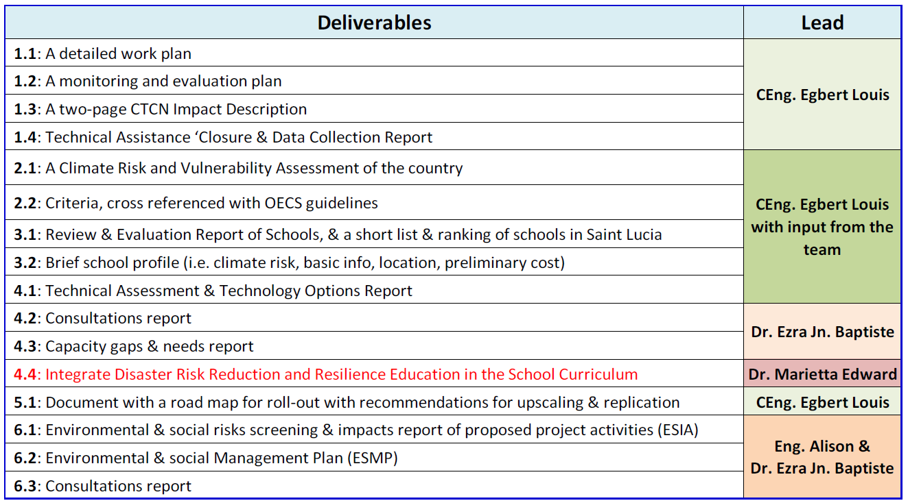
TA Deliverables and Leads

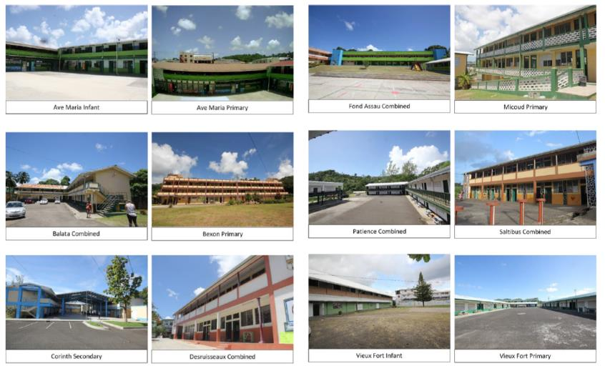
The Selected Schools in Saint Lucia

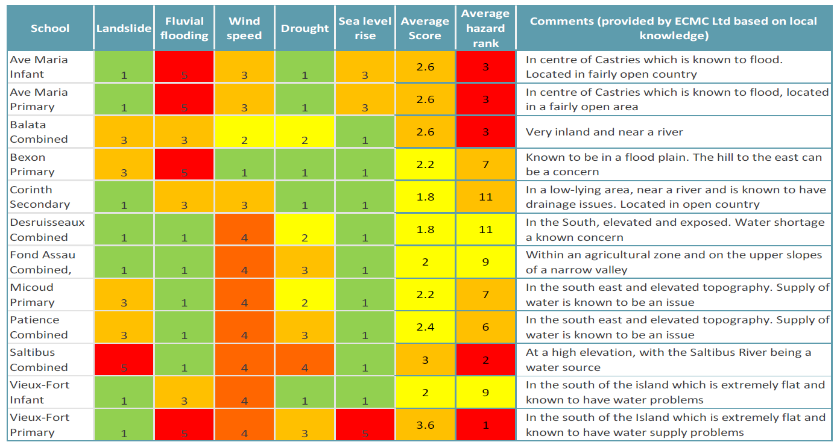
Rapid CVA – Schools’ Hazard Rating – Saint Lucia
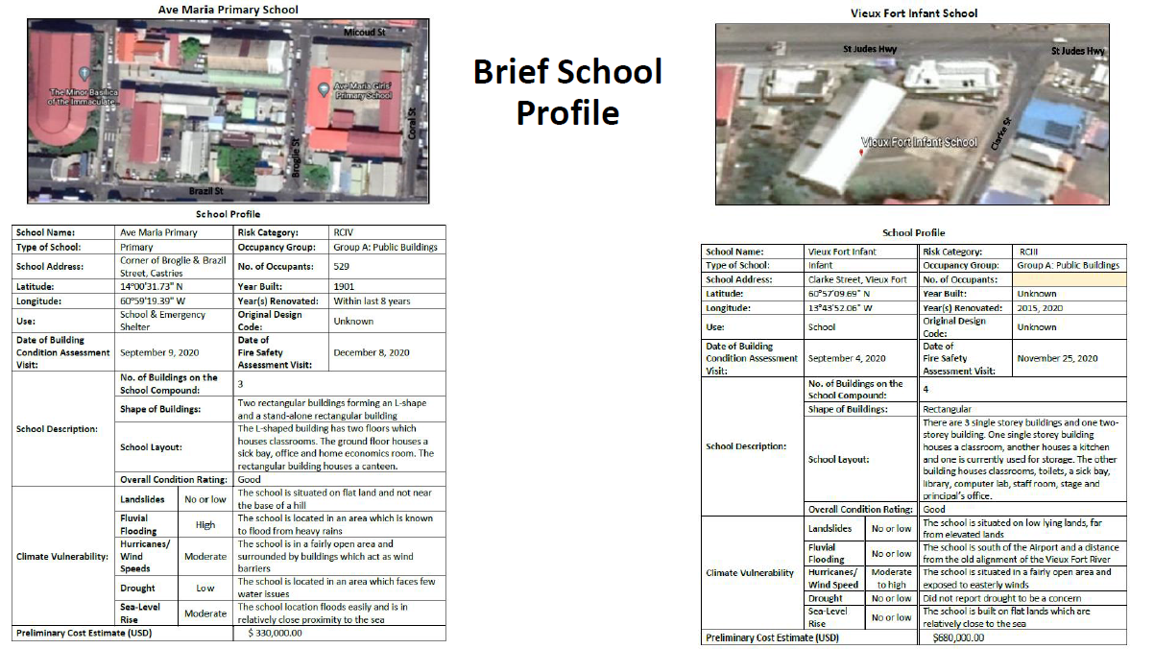
Typical Schools Profile – Saint Lucia

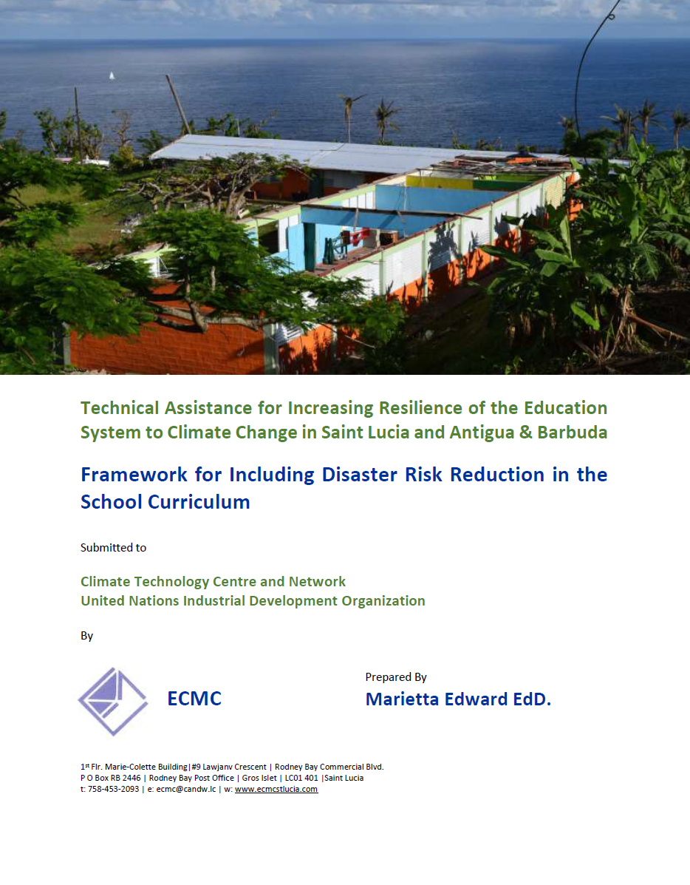
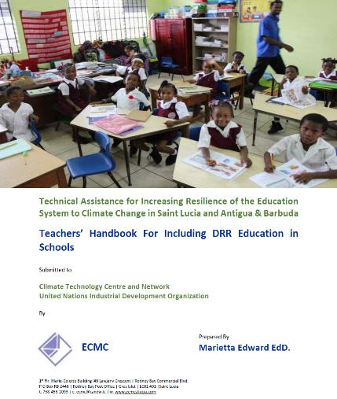
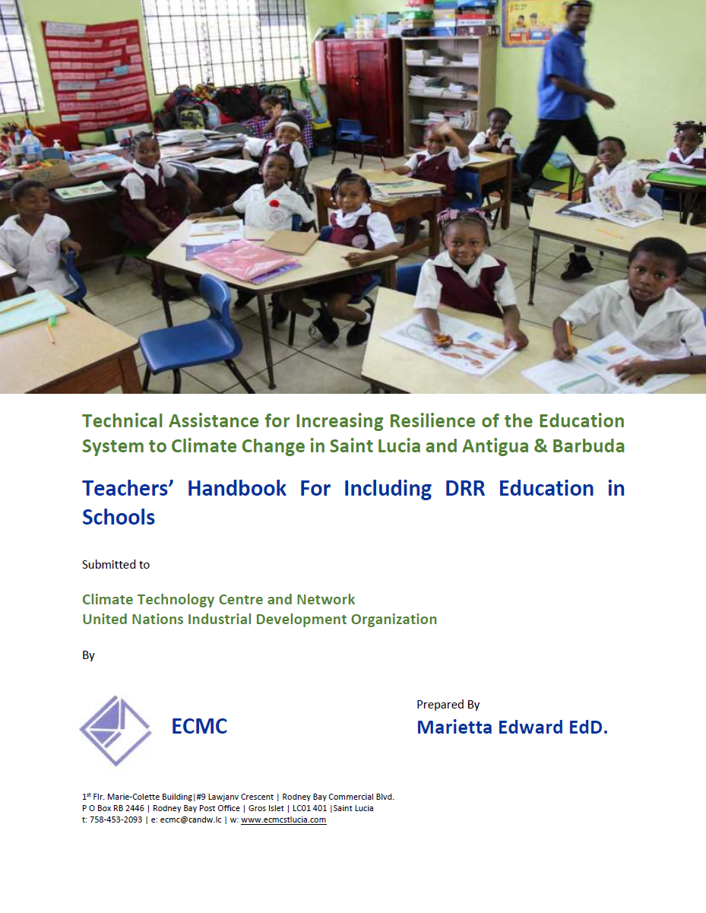
Framework and Teachers’ Handbook for DRR Education in Schools Curriculum
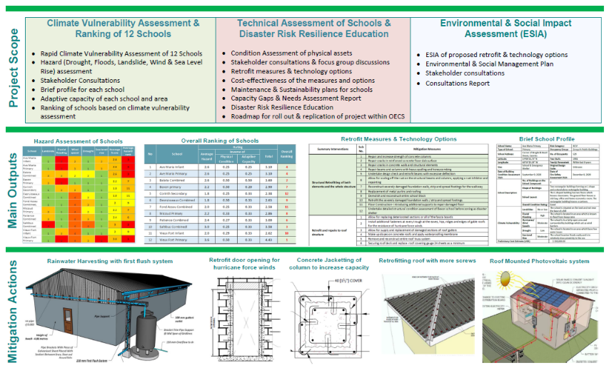
Proposed Infographic for Climate Resilience in the OECS - Part of the Road Map

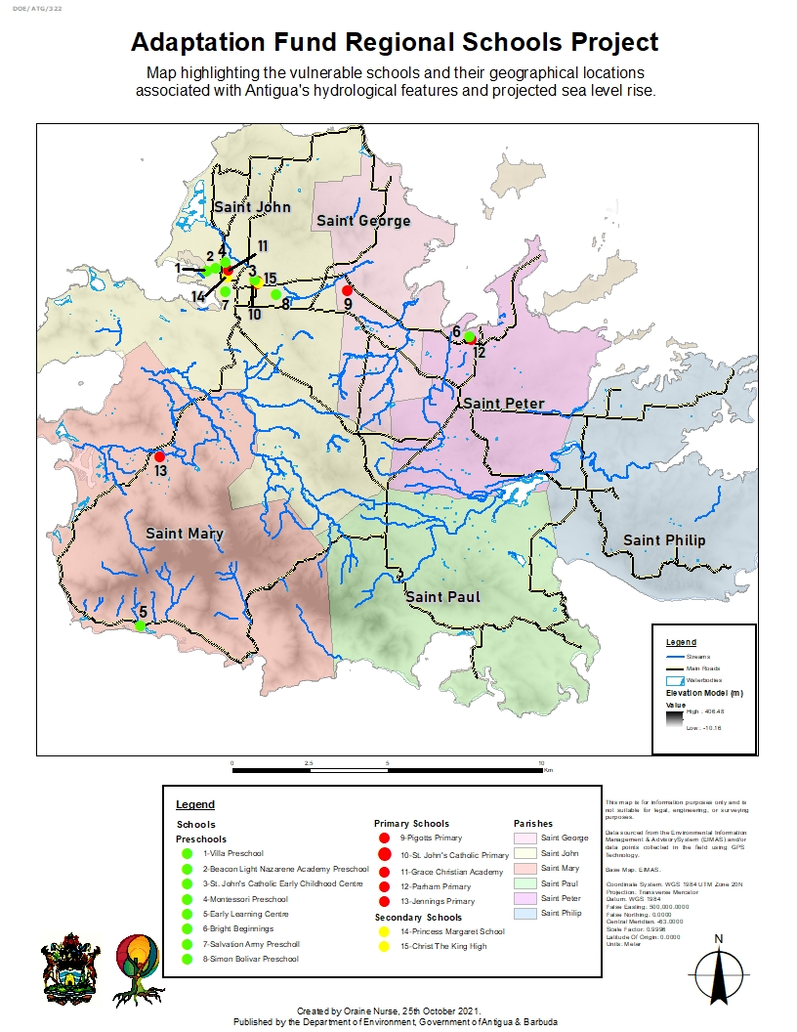

Schools’ Hazard Rating – Antigua and Barbuda

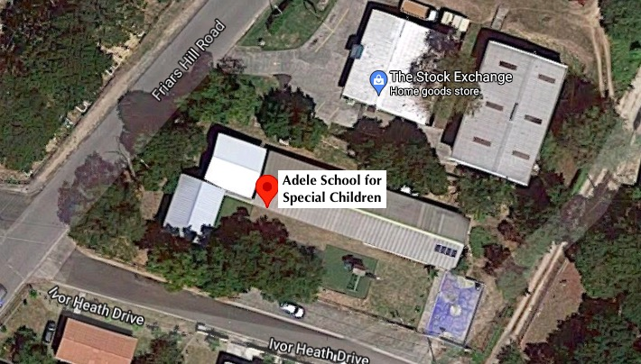
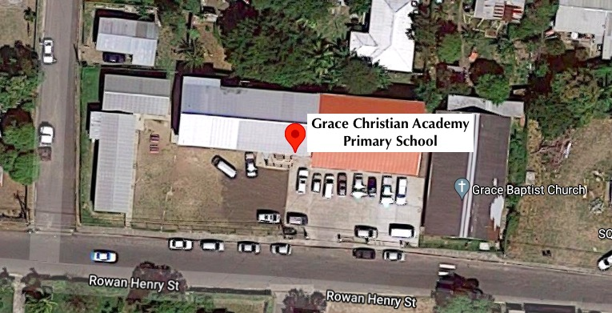
Two Selected Schools – Antigua and Barbuda

4. Impact Statement
The information in the table below will be used to communicate results and anticipated impacts of this technical assistance publicly. Please copy information from impact statement developed in the M&E Plan and update as relevant.

Impact Statement
Challenge | Saint Lucia, and Antigua and Barbuda, like all the other eastern Caribbean countries, are exposed to a variety of similar natural hazards, including hurricanes, floods, landslides, droughts, and fires. These hazards have compromised countries` poverty reduction strategies, hindered development gains, and negatively impacted various sectors, including the educational systems.  The overall objective of the Project is to improve resilience of local communities and human settlements to climate change by assessing and planning the implementation of technology and design options for the improvement of critical infrastructure within the education system.
CTCN Assistance | - Conducting a rapid climate change vulnerability assessment of 12 school buildings in Saint Lucia and an unknown number in Antigua;  - Developing school ‘resilience improvement’ packages with options for upgrading, retrofitting or replacement needs to increase the school buildings’ resilience;  - Identifying ways to replicate the solutions and approaches in the target countries and throughout the region;  - Conducting potential environmental and social risks impacts assessment of the developed interventions.
Anticipated impact | - A minimum of 12 schools in Saint Lucia retrofitted to be climate and disaster resilient structures;  - At least 16 school buildings retrofitted to be climate resilient & structurally sound;  - Enhanced capacity of the national workforce to apply the work packages to other municipal buildings;  - The curriculum of all infant and primary schools augmented to include Disaster Risk Reduction.
Co-benefits: Achieved or anticipated co-benefits from the TA | - Enhanced community resilience through better access to community shelters and their services during and immediately after extreme events would include the most vulnerable groups  - Contribute towards reduced emissions through renewable energy and energy efficient technologies and will provide social and economic co-benefits to communities accessing the emergency shelters  - Integrated awareness raising in disaster preparedness and climate change adaptation;  - Reduction in utility costs for the schools gained through the use of more efficient lighting systems  - Reduction in the cost of water bills through Rainwater Harvesting  - Longer school contact time through the extended availability of water due to rainwater harvesting
Gender aspects of the TA | The project activities will ensure that issues relating to gender inequality are addressed by ensuring full and equal access to men and women in particular relating to the capacity building and awareness raising activities.  The design of retrofitting is proposed to take gender considerations into account, particularly relating to the internal layout of emergency shelters, access to facilities such as toilets and allowing safe spaces for vulnerable groups, which would include women, youth, elderly and those with special needs.
Anticipated contribution to NDC | TA supported the Antigua and Barbuda’s Nationally Determined Contribution to:  - Improve and prepare all buildings for extreme climate events including drought, flooding; hurricanes; landslides, sea level rise and earthquakes;  - Meet regulated percentage of electricity demand of the schools through off-grid renewable sources;  - Introduce DRR in schools’ education curriculum  - Develop a roadmap for the use of the designed project throughout the national school system
The narrative story | Given the vulnerability of both Saint Lucia and Antigua and Barbuda is likely to worsen, it has become imperative that the Islands improve the capacity of their population and education sector to anticipate, prepare, adapt and become more resilient to disastrous events associated with climatic and non-climatic hazards. This has to be facilitated through the assessment of the climate risk and the related negative impacts to the educational system and appraise improvement measures.  In that regard, through the technical assistance from CTCN, the Islands will be able to develop work packages which will result in improving the climatic, non-climatic, and structural resiliency of prioritised education buildings. The capacity building component will result in the Islands being able to manage the use of the retrofit educational buildings as shelters and to transition from emergency response to rehabilitation.  Critical to the exercise is the development of a technique and approach that can be easily adapted for use throughout the region. Another important output will facilitate environmental and social risks screening and impacts assessment of the proposed solutions, and the critical development of an Environment and Social Management Plan (ESMP) which would guide the implementation of any specified works.
Contribution to SDGs. A complete list of SDGs and their targets is available here: | - SDG 13 – the Technical Assistance will enable Saint Lucia and Antigua and Barbuda to implement adaptive measures for climate resiliency of their educational buildings;  - SDG 9 – the technical assessments will consider resilience to both climatic and non-climatic hazards, with particular attention given to; hurricanes, floods, droughts; landslides, earthquakes;  - SDG 7 – the Technical Assistance will support a planned intervention under a proposal titled “Transitioning Antigua and Barbuda’s off-grid diesel generation to low-carbon wind, solar, battery, and hybrid renewable systems for critical services” by including renewable energy as one of the interventions.
Reference to knowledge products | Please indicate if any UNFCCC Technology Executive Committee (TEC) knowledge products (publications, briefs, tools etc.) were used in the development of the TA request and/or are envisaged to be used during implementation of the technical assistance.  Link to TEC knowledge database: https://unfccc.int/ttclear/tec/documents.html  Which knowledge products do you envisage to use? Please list

Annex 1 Technical assistance data collection

Please add quantitative and qualitative values for the indicators selected in the M&E plan and monitored throughout the technical assistance in the tables below. Indicators which have been monitored in addition to the proposed indicators below may be added at the end of table A. Non-relevant indicators should be left blank.

- Output and outcome indicators

Indicator  Please note indicators below highlighted as anticipated | Quantitative value  Numerals only; disaggregates must sum to the total | Qualitative description  List the various elements corresponding to the quantitative value as well as timelines and responsible institutions
Total number of events organized by proponents and implementing partners | 19 – Saint Lucia | 1 reconnaissance visit, 12 inspection visits, three stakeholder consultations, and three focus group consultations
Number of participants in events organized by proponents and implementing partners | 50– Saint Lucia
- Number of men | 15– Saint Lucia | Disaggregate by country
- Number of women | 35– Saint Lucia
Number of climate technology RD&D related events
Number of participants in climate technology RD&D events
- Number of men
- Number of women
Number of training organized by proponents and implementing partners
Number of participants in trainings organized by proponents and implementing partners
- Number of men
- Number of women
Total number of institutions trained
- Governmental (national or subnational)
- Private sector (bank, corporation, etc.)
- Nongovernmental (NGO, University, etc.)
Percentage of participants reporting satisfaction with CTCN training (from CTCN training feedback form)
Percentage of participants reporting increased knowledge, capacity and/or understanding as a result of CTCN training (from CTCN training feedback form)
- Percentage of men
- Percentage of women
Total number of deliverables produced during the assistance (excluding mission, progress and internal reports) | 16 – Saint Lucia  6 – Antigua & Barbuda | The TA required 15, however, the preparation of Framework and Teachers Handbook for including Disaster Risk Resilience in the Education Curriculum; were also prepared
- Number of communication materials, including news releases, newsletters, articles, presentations, social media postings, etc.
- Number of tools and technical documents strengthened, revised or developed | 14 – Saint Lucia  The ESMP was combined with the ESIA.  There was one Consultations Report as opposed to two  Assisting Antigua & Barbuda in the preparation of their documents | - CTCN Impact Description  - Detailed Work Plan  - Monitoring and Evaluation Plan and Impact Statement  - TA Closure Report  - Rapid Climate Vulnerability Assessment for Twelve Schools in Saint Lucia  - Review and Evaluation Report of Schools and Climate Change Ranking  - Schools Profiles Reports - Saint Lucia  - Technical and Assessment and Technology Options Report  - Environmental and Social Impact Assessment and Management Plan  - Consultations Report  - Framework for Including Disaster Risk Reduction in the School Curriculum  - Teacher’s Handbook for Including DRR Education in Schools  - Capacity Gaps and Needs Report  - Project Roll-out Report
- Number of other information materials strengthened, revised or created (For example training and workshop reports, Power Points, exercise docs etc.)
Total number of policies, strategies, plans, laws, agreements or regulations supported by the assistance
- Adaptation related
- Mitigation related
- Both adaptation- and mitigation related
Anticipated number of policies, strategies, plans, laws, agreements or regulations proposed, adopted or implemented as a result of the TA
- Adaptation related
- Mitigation related
- Both adaptation- and mitigation related
Anticipated number of technologies transferred or deployed as a result of CTCN support | List total number here | The technology sectors which were supported include:  Sector: Infrastructure and Urban planning  Technology Group: Building design and material  Urban design and spatial planning  Building construction  Water supply infrastructure  Urban planning  Building codes  Technology: Urban infrastructure development,  General planning solutions  Sector: water  Technology Group: Adaptation planning, Water augmentation, Water storage,  Technology: Disaster risk assessment tools  Hazard mapping solutions, Climate change vulnerability assessment, Rainwater harvesting, Water reservoirs  Mitigation: Climate resilient construction and Renewable energy  Sector: - Renewable energy  Technology Group: - Solar  Technology: - Building-integrated PV; Solar water pumps; Solar water heater;  Sector: - Energy efficiency  Technology Group: - Appliances and equipment  Technology: - Water efficiency; Residential water heaters; Lighting; Appliance standards; Water pumping;  Sector: - Energy efficiency  Technology Group: - Buildings  Technology: - Sustainable design; Daylight harnessing; New building design; Insulation in buildings; Building materials; Building life cycle and integrated design process; Building standards and codes; Greening the built environment; Retrofitting of existing buildings; Building Energy Management Systems; Heating - Ventilation and Air Conditioning; Design for Deconstruction; Traditional building materials and design; Sustainable spatial planning; Efficient air conditioning systems  Cross-sectoral enablers: Capacity building and training;  Cross-cutting approaches: Disaster risk reduction
Anticipated number of collaborations facilitated or enabled as a result of technical assistance
- Number of South-South collaborations
- Number of RD&D collaborations
- Number of private sector collaborations
Number of countries with strengthened National System of Innovation as a result of CTCN support
Insert any additional indicators here

- Core impact indicators

Please fill in the tables for anticipated impacts of the CTCN assistance. Every technical assistance should contribute to at least one of the indicators below. For guidance on how to report on core indicators see the ‘M&E Guidance Document for TA Implementers’.

Core indicator 1 | Anticipated metric tons of CO₂ equivalent (CO₂e) emissions reduced or avoided as a result of CTCN TA  Please add your calculations in word or excel format as an Annex to this Closure Report, where applicable.
 | Anticipated metric tons of CO₂e reduced or avoided as a result of the TA on annual basis | Anticipated metric tons of CO₂e reduced or avoided as a result of the TA in total
Quantitative value  (emissions reductions) | Total number (numerals only, no rounding or abbreviations) | Total number (numerals only, no rounding or abbreviations)
Unit | tCO₂e | tCO₂e
GHG assessment boundary (project emissions)

Identify expected post-TA activities, associated effects and assess boundary for quantification of GHG emission reductions
Baseline emissions

Describe baseline scenario, baseline candidates, emission factors and emissions calculated
Methodology

Explain the method or process of verifying the indicator and how data was gathered
Assumptions
Describe assumptions made during calculation and quantification of GHG reductions

Core indicator 2 | Anticipated increased economic, health, well-being, infrastructure and built environment, and ecosystems resilience to climate change impacts as a result of technical assistance  Please provide a qualitative description of the anticipated impacts on the categories below
Infrastructure and built environment  Anticipated increased infrastructure resilience (avoided/mitigated climate induced damages and strengthened physical assets) | Urban infrastructure development,  General planning solutions,  Disaster risk assessment tools,  Hazard mapping solutions, Climate change vulnerability assessment, Rainwater harvesting, Water reservoirs;  Building-integrated PV; Solar water pumps; Solar water heater;  Water efficiency; Residential water heaters; Lighting; Appliance standards; Water pumping;  Sustainable design; Daylight harnessing; New building design; Insulation in buildings; Building materials; Building life cycle and integrated design process; Building standards and codes; Greening the built environment; Retrofitting of existing buildings; Building Energy Management Systems; Heating - Ventilation and Air Conditioning; Design for Deconstruction; Traditional building materials and design; Sustainable spatial planning; Efficient air conditioning systems
Ecosystems and biodiversity
Anticipated increased ecosystem resilience (areas with increased resistance to climate-induced disturbances and with improved recovery rates)
Economic
Anticipated increased economic resilience (e.g. less reliance on vulnerable economic sectors or diversification of livelihood)
Health and wellbeing
Anticipated increased health and wellbeing of target group (e.g. improved basic health, water and food security)

Core indicator 3 | Anticipated number of direct and indirect beneficiaries as a result of the TA
 | Quantitative value | Means of verification
Total beneficiaries | 12,000 | Data for the size of the beneficiary groups for the twelve schools were not readily unavailable. However, given the objective of the exercise was to establish the cost-effectiveness of the retrofit measures, a method was developed to estimate the size of the beneficiary groups. The method involved factoring the population of each school by the average household size in the community in which the school is located
Number of adaptation beneficiaries | 12,000
Number of mitigation beneficiaries | 12,000
Number of adaptation-and mitigation beneficiaries | 12,000

Core indicator 4 | Anticipated amount of funding/investment leveraged (USD) as a result of TA (disaggregated by public, private, national, and international sources, as well as between anticipated/confirmed funding)
 | Quantitative value confirmed in USD | Quantitative value anticipated in USD | Qualitative description  List the institutions, timelines, and description or title of the investment | Methods  Describe methods used for quantification of funds leveraged
Total funding | 15,000,000 | USD
Anticipated amount of public funding mobilised from national/domestic sources | 15,000,000 | USD | Proposal in preparation at the GCF | 2021 - 2022
Anticipated amount of public funding mobilised from international/ regional sources | 15,000,000 | USD
Anticipated amount of private funding mobilised from national/domestic sources
Anticipated amount of private funds mobilised from international/regional sources

Annex 2 (for internal use – to be filled in by the CTCN)
CTCN evaluation
This section will be completed by the relevant CTCN Technology Manager.

- Evaluation of the timeliness of the TA implementation as measured against the timeline included in the response plan;
- Evaluation of TA quality as defined in the response plan;
- Overall performance of the Implementers;
- Overall engagement of the NDE and Proponent;
- Lessons learned on the CTCN process and steps taken by the CTCN to improve.

