Technical Assistance Closure Report

- Basic information
Title of response plan | Research, Development and Deployment of Climate Technologies for the Reduction of GHG Emissions in Dairy Farms, Through the Circularity of Flows and Materials in Uruguay
Technical assistance reference number | 2021000033
Country / countries | Uruguay
NDE organisation | Dirección Nacional de Cambio Climático (DINACC) - Ministerio de Ambiente
NDE focal point | Natalie Pareja. Directora Nacional de Cambio Climático. Punto Focal ante el CTCN: natalie.pareja@ambiente.gub.uy  Carla Zilli. Punto Focal alterno ante el CTCN: +59819502010 carla.zilli@ambiente.gub.uy
NDE contact information | carla.zilli@ambiente.gub.uy
Proponent focal point and organisation | Dirección Nacional de Cambio Climático (DINACC) - Ministerio de Ambiente.
Designer of the response plan | Dirección Nacional de Cambio Climático (DINACC) - Ministerio de Ambiente.
Implementer(s) of technical assistance | UNEP on behalf of CTCN (consortia OIKO and CONSUR)
Beneficiaries | Ministry of Environment, aro-industry key actors, particularly farmers and milk producers
Sector(s) addressed | Dairy Sector
Technologies supported | Use of different types of biodigesters, composting, manure dry cleansing, production of biochar from manure, changes in animal diet leading to emission reduction
Implementation start date | (23/12/2021)
Implementation end date | (20/03/2023)
Total budget for implementation | 92,124.00  USD
Description of delivered outputs and products as well as the activities undertaken to achieve them. In doing so, review the log frame of the original response plan and refer to it as appropriate | Output 1: Work Plan and related Communication Documents developed.  Activity 1.1: Development of detailed work plan  Activity 1.2: Development of M&E Plan  Activity 1.3: Development of Impact Statement  Activity 1.4: Development of TA Closure Report  D 1.1: Work Plan (D 1)  D. 1.2: Monitoring & Evaluation Plan (D 1.2)  D.1.3: Impact Statement (D 1.3)  D 1.4: Closure and Data Collection Report (D 1.4)  Output 2: Stakeholder Mapping and Creation of a RD&D focus group for scaling up TA results.  Output 2: Stakeholder Mapping and Creation of a RD&D focus group for scaling up TA results.  Activity 2.1: Conduct stakeholder mapping  Activity 2.2: Establish an Advisory Technical Group (Grupo Técnico Consultivo) for coordination of assistance and of RD&D component  Activity 2.3: Individual interviews with key institutions  D 2.1.: Stakeholder Mapping Report, where roles and responsibilities are specified  D 2.2.: Report on the Establishment of the Advisory Technical Group  D.2.3: Minutes of the Kick-off meeting with list of participants disaggregated by gender and inputs during and after TA  Output 3: Analysis of circularity in dairy farms and identification of the perceived value of the circular economy and its benefits in the dairy sector in Uruguay.  Activity 3.1: Analysis of perceived benefits  Activity 3.2: Identification and analysis of circularity pathways to improve circularity of materials and energy in the dairy industry  Activity 3.3: Market analysis for the adoption of circularity pathways in milk production in Uruguay  Activity 3.4: Business Models and profitability scenarios  Activity 3.5: Stakeholder meeting on circularity analysis  D3.1: Report identifying underutilized material and energy flows in dairy farms, and management alternatives.  D3.2: Report presenting technologies, concepts, policies, engagement strategies and best practices that improve circularity in the prioritized waste stream, including requirements and benefits.  D3.3: Report presenting the market analysis for the adoption of the circularity pathways.  D3.4: Report with alternative business models and profitability scenarios.  D3.5: Report of the virtual meeting with stakeholders.  Output 4: Assessment of the feasibility of climate technologies applicable to dairy farms and their sustainability.  Activity 4.1: Needs Assessment  Activity 4.2: Development of a List of technology options  Activity 4.3: Review of pilot experiences for waste treatment in dairies  Activity 4.4: Prioritization of climate technologies  Activity 4.5: Analysis of possible sources of financing for the implementation of climate technologies applicable to dairies  Activity 4.6: Impact assessment and development of an indicator matrix  Activity 4.7: Stakeholder validation workshop and RD&D focus group  D4.1: Technology Data Sheets; Set of criteria for the Multicriteria Analysis (MCA) exercise.  D4.1.1: Report on Women Opportunities in prioritized climate technologies.  D4.2: Shortlist and ranking of appropriate climate technologies for dairy farms.  D4.3: Report of existing pilots with replicability in dairy farms in Uruguay  D4.4: Report on the prioritization of climate technologies.  D 4.5: Report on the analysis of possible sources of financing and logical framework for the implementation of the most appropriate climate technology in dairy farms.  D4.6: Report on the impact of identified technology options and indicator matrix.  D4.7: Report of the virtual validation workshop with stakeholders with the selection of prioritized climate technologies to be implemented in the dairy farms.  Output 5: Monitoring and evaluation of mitigation and circularity actions and knowledge sharing  Activity 5.1: Monitoring and evaluation model  Activity 5.2: Development of educational materials  Activity 5.3: Dissemination of generated knowledge  D5.1: Proposal for the monitoring and evaluation of mitigation and circularity actions in line with the national NDC monitoring system and the sustainable development perspective.  D5.2: Manual for milk producers and for trainers of trainers. Proposed strategy to continue the Research, Development and Deployment.  D5.3: Virtual training & workshop reports:
Methodologies applied to produce outputs and products | - Multi-criteria matrix analysis  - Desk review and comparative analysis  - GHG emissions calculations methods  - Cost-benefit analysis  - Structured interviews
Reference to knowledge resources | For this TA, the technical team used as a source of information the technical fiches and GHG mitigation calculations from Biovalor project, previously implemented by ONUDI and GEF: https://biovalor.gub.uy/
Deviations | Due to time limitations for the development of Output 5, 1 workshop has been conducted instead of foreseen three, although systematic meetings- interactions with Focal Group and key actors were held
Anticipated follow-up activities and next steps | - Use of new expertise acquired by the Ministries, farmers, and milk producers.  - Follow up on the TA findings together with the Biovalor project.

- Lessons learned
 | Lessons learned | Recommendations
Lessons learned from the CTCN TA process | - Constant communication with the NDA and monitoring of the progress  - Agreed adjustment in the outputs and timeline according to the project needs made ahead | Recommendations include  - Getting support for implementing some multifactorial approaches for reducing GHGs emissions in a specific  - Considerations for increased success of similar efforts (i.e. regulatory, legal, stakeholders, communication, etc.)
Lessons learned related to climate technology transfer | No single technological approach will be sufficient for reducing GHGs emissions from Dairy farms. An integrated (multivariate) approach has to be adjusted and implemented in order to become carbon neutral or negative.  In the same direction water and carbon footprint data should be addressed. | Recommendations include  - When comparing a Climate technology (circular) or a combination of these, the use of the developed Multifactor Matrix Tool allows for a comparative analysis of multiple aspects, thus reducing the possible risks derived from the implementation and operation process.  - Initiate integrated studies including water and energy footprint analyses.  - Some promising technological approaches (biochar i.e) may need special support from the government (subsidies, soft loans).  - Achieving long term sustainability (i.e carbon neutral or negative; low water and energy footprints in benchmarking studies) will only arise from the implementation of integral and holistic strategies for the sector.  - Implementing a comprehensive strategy of applied research; validation and technology transfer for adjusting the best technological combinations for mitigating GHGs emissions including a territorially based approach.

3. Illustration of the TA and photos
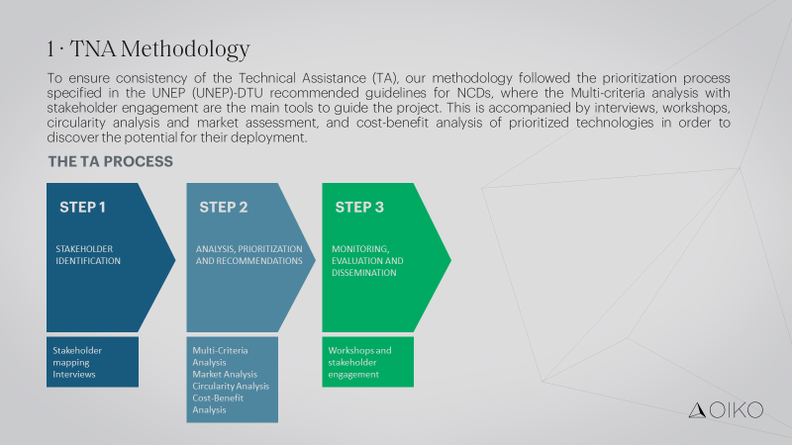

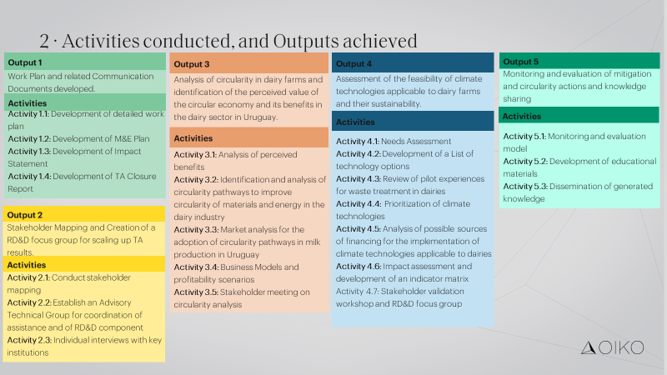

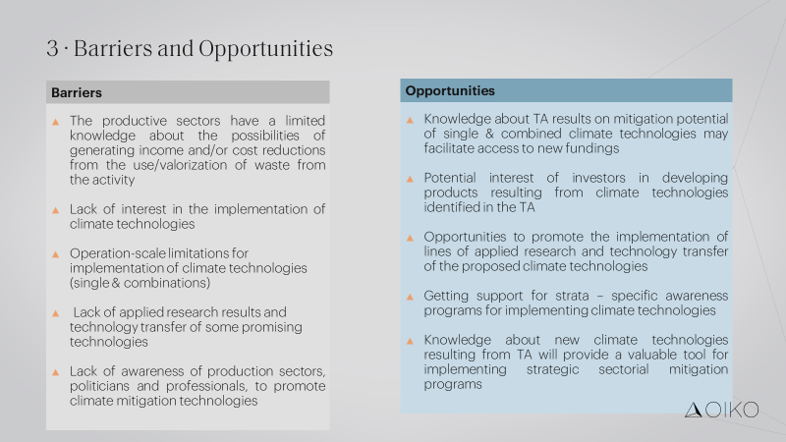

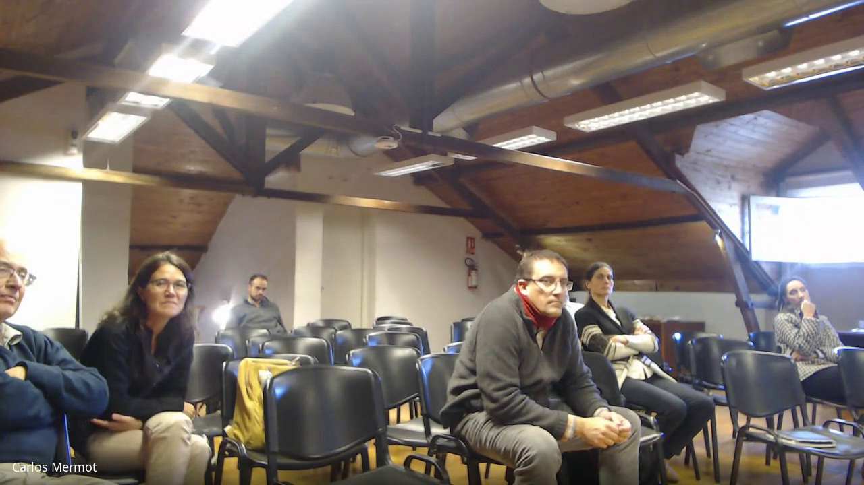



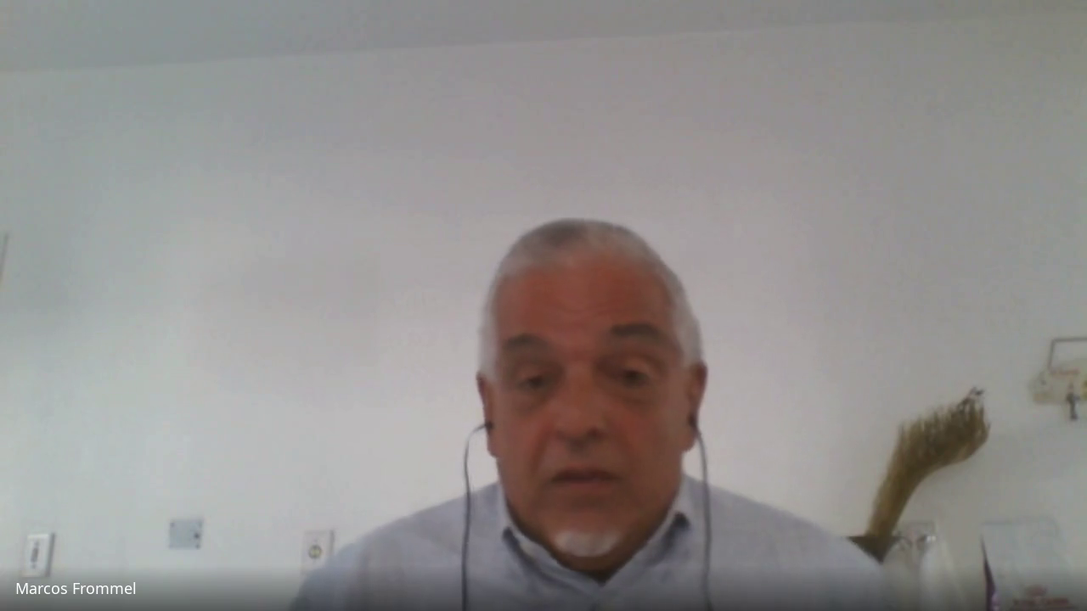

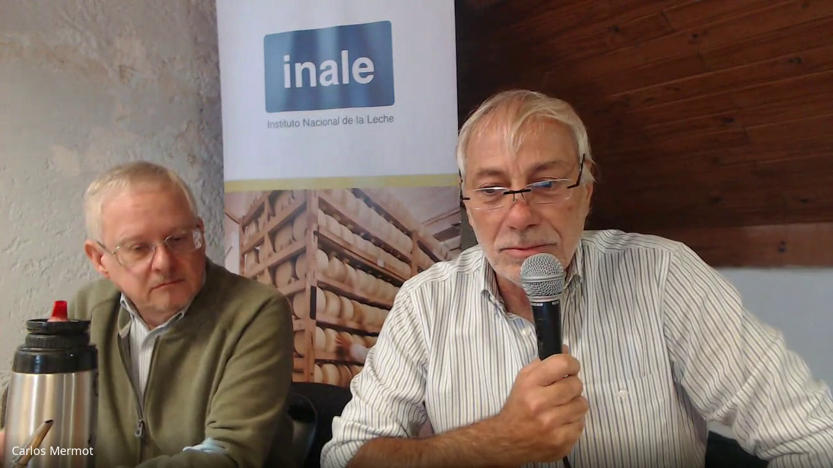

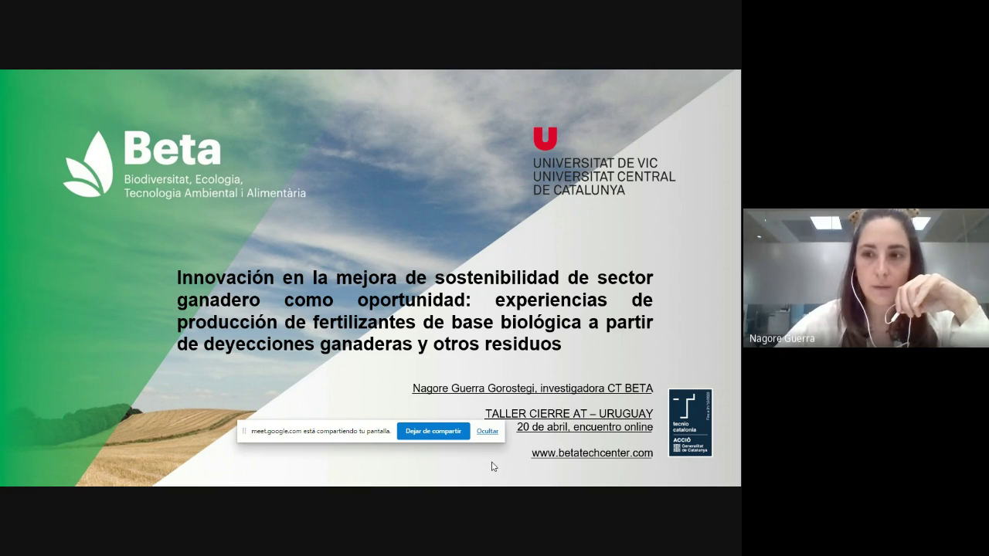

4. Impact Statement
Challenge | Uruguay's emissions profile Is strongly marked by emissions related to food production. According to the latest National GHG Inventory, in 2017, 60% of net emissions correspond to the agricultural sector. Within these, 95% are generated within establishments and 2.5% In industry. Therefore, it is a priority for the country to work on mitigation and adaptation alternatives in this sector, and to make progress in the use of waste from animal production systems, particularly from livestock. Since, in the recent decades there has been a significant increase in milk production at the national level, accompanied by a process of concentration of production systems, the challenge for Uruguay's dairy industry is to make intensification sustainable.  The purpose of the TA is to identify and study climate technologies and circularity practices for the treatment and use of flows and materials. In addition, technologies that have worked at the pilot level but have challenges for scaling up will be studied. Centralized models that include waste from other agricultural industries will be evaluated to determine management models, assessing their economic feasibility and co-benefits, and identifying the actors that should participate in order to obtain sustainable models that can be replicated at the national level.
CTCN Assistance | To provide technical assistance (TA) to Uruguay to establish a baseline and roadmap for the Research, Development and Deployment of climate technologies for the reduction of GHG emissions in dairy farms, through the circularity of flows and materials and the use of emission mitigation technologies.  The TA will entail conducting categorization and prioritization of technologies that will provide a reduction of emissions and the implementation of circularity actions.  The fundamental goal is to enable Uruguay to implement its climate targets using the most appropriate technologies.
Anticipated impact | Promote the development of an environmentally sustainable milk production value chain with fewer contributions of greenhouse gases and with new business opportunities through innovative circularity actions in the same dairy value chain and other related agricultural industries (poultry and pig farming)  Facilitate the development of new businesses specialized in the management of material flows from the milk production industry that are susceptible to valorization (new products; energy generation (cost savings); fertilizer substitution).  Reduce the disposal of wastewater and solid waste to surface water sources and soils  A set of techniques – management procedures were identified and thoroughly described. Their technical and economic feasibility were studied, and their mitigation and eutrophication reduction potentials assessed. I addition a Multivariate Criteria Matrix was designed and adjusted. This can be used as a guide for successful Climate Techniques – procedures implementation planning. These complex products were achieved through a process which required a continuous and systematic information retrieval as well as consultations with key stakeholders (National Milk Institute (INALE); Academia; National Agricultural Research Institute; Milk Cooperatives, etc.) and counterparts – focal points of the TA (Ministry of Environment & Ministry of Agriculture). GHGs emission reductions achieved by the application of single and combined recommended technologies – management under different scenarios are presented and discussed. The tools adjusted in the TA will help Government to study different technological scenarios and estimate their expected impact on GHGs emissions. Additionally, the impact of technologies promoted by the authorities can be monitored under the NDC INGEIs reporting and monitoring system.
Co-benefits: Achieved or anticipated co-benefits from the TA | Despite having good macroeconomic indicators, Uruguay continues to face the challenge of unequal income distribution and structural gender inequalities in strategic areas for development. The gaps particularly affect Afro-descendant women and rural women. Women have increased their participation in the labour force in recent decades. However, female participation rates remain below those of men.  Dairy production can be an important means of promoting gender equity in the agricultural sector and the empowerment of rural women. In addition, the results of the assistance will contribute to the reduction of the environmental impact of unused material flows from dairy production facilities in water sources and soils and will contribute to the reduction of water use.  The long-term impact of CTCN assistance is the sustainable management of milk production. In addition, the assistance will provide a unique opportunity for decision-makers to address women's vulnerability in the sector through appropriate plans and technologies that will be identified based on the technological needs of the sector. This should allow a better integration of the gender and youth dimension in the planning of policies in Uruguay with specific actions in their benefit
Gender aspects of the TA | The TA was supported by a gender analysis throughout project implementation. The TA findings indicate that the participation of women in the sector can reach 80% (more than the official surveys show). This is due to the problems of making women invisible in public surveys and the patriarchal culture of Latin America and considering women's work as family help. In this way, it is considered that there are many more women participating in the milk sector, and women must be included in access to funds and training.  The main recommendation of the TA are:  - Accompany technological innovations with adequate technical assistance and training activities especially aimed at women.  - That training be designed with appropriate formats according to the size of the establishment and that this serves not as a burden/overload for women but as support  - Creation of training spaces as a means of empowering learning manifested by women  - Promotion of awareness-raising actions on gender and sustainability issues in dairy establishments, in the communities, to promote a comprehensive perspective (awareness raising to convert the role of caring for women into caring for the environment)  - Opportunity to work on negative social perceptions in case of bad odors and etc.: opportunity to act on these
Anticipated contribution to NDC | Taking stock of existing low-carbon technologies in Uruguay for the dairy sector  Undertaking comprehensive identification of technical and technology needs of the dairy sector, as a priority of the national NDC  Identifying technical capacity-building needs for deployment of these technologies; monitoring and evaluation of mitigation and circularity actions in line with the national NDC monitoring system and the sustainable development perspective.
The narrative story | The Paris Agreement identified technology as a key area where developing countries need support, and in particular LDCs. The "use of zero discharge technologies to rivers and streams and/or application of good effluent treatment practices and/or recovery of nutrients and minimization of methane emissions in dairy farms" is one of the mitigation actions included in Uruguay's First NDC, submitted to the UNFCCC in 2017. Other actions included were the improvement in industrial wastewater treatment systems, with technologies that reduce CH4 emissions, including new methane capture and flaring systems in anaerobic treatments.  During 2019 and 2020, the Project for the Evaluation of the current situation of the Circular Economy for the development of a Roadmap for Brazil, Chile, Mexico and Uruguay was implemented through the CTCN: a project aimed at promoting actions to mitigate climate change and progress in the circular economy, for which two value chains were selected, the dairy and meat chain.
Contribution to SDGs  A complete list of SDGs and their targets is available here: https://sustainabledevelopment.un.org/partnership/register/ | SDG 6: ensure the availability and sustainable management of water and sanitation for all. The technical assistance will identify circularity alternatives and emission mitigation technologies that, as a co-benefit, will reduce surface water and soil pollution from inadequate waste management in the milk production industry.  SDG 9: build resilient infrastructure, promote inclusive and sustainable industrialization and foster innovation. The milk production industry has experienced a strong intensification of its activities with consequent environmental impacts. The assistance will identify innovative technological solutions and circularity practices for the reduction of environmental impacts, including GHG emissions.  SDG 13.2: Incorporating climate change measures into CTCN assistance will help identify national policies, strategies and plans CTCN assistance will help identify national policies, strategies and plans, circularity actions and appropriate mitigation technologies that will be integrated into local, national and regional policies, strategies and planning.  SDG 13.3: Improve education, awareness-raising and human and institutional capacity regarding climate change mitigation and adaptation, reduction of climate change impacts and early warning. Training for local and national experts will strengthen their technical capacities.

Annex 1 Technical assistance data collection
- Output and outcome indicators

Indicator  Please note indicators below highlighted as anticipated | Quantitative value  Numerals only; disaggregates must sum to the total | Qualitative description  List the various elements corresponding to the quantitative value as well as timelines and responsible institutions
Total number of events organized by proponents and implementing partners | 2 | - Internal Workshop with the Focus Group hold in December 2022  - Dissemination workshop with the NDA, Focus Group, and external invitees hold in April 2023
Number of participants in events organized by proponents and implementing partners | 51 | Uruguay, Argentina, USA, Spain
- Number of men | 34 | Uruguay, Spain, USA
- Number of women | 17 | Uruguay, Argentina, Spain
Number of climate technology RD&D related events | 2 | - Internal Workshop with the Focus Group hold in December 2022  - Dissemination workshop with the NDA, Focus Group, and external invitees hold in April 2023
Number of participants in climate technology RD&D events | 2 | - Internal Workshop with the Focus Group hold in December 2022  - Dissemination workshop with the NDA, Focus Group, and external invitees hold in April 2023
- Number of men | 34 | Uruguay, Spain, USA
- Number of women | 17 | Uruguay, Argentina, Spain
Number of trainings organized by proponents and implementing partners | N/A | N/A
Number of participants in trainings organized by proponents and implementing partners | N/A | N/A
- Number of men
- Number of women
Total number of institutions trained | N/A | N/A
- Governmental (national or subnational) |  | List the name of organisations trained here
- Private sector (bank, corporation, etc.) |  | List the name of organisations trained here
- Nongovernmental (NGO, University, etc.) |  | List the name of organisations trained here
Percentage of participants reporting satisfaction with CTCN training (from CTCN training feedback form) | N/A | N/A
Percentage of participants reporting increased knowledge, capacity and/or understanding as a result of CTCN training (from CTCN training feedback form) | N/A
- Percentage of men | N/A
- Percentage of women | N/A
Total number of deliverables produced during the assistance (excluding mission, progress and internal reports) | 19 | D 2.1.: Stakeholder Mapping Report, where roles and responsibilities are specified  D 2.2.: Report on the Establishment of the Advisory Technical Group  D.2.3: Minutes of the Kick-off meeting with list of participants disaggregated by gender and inputs during and after TA  D3.1: Report identifying underutilized material and energy flows in dairy farms, and management alternatives.  D3.2: Report presenting technologies, concepts, policies, engagement strategies and best practices that improve circularity in the prioritized waste stream, including requirements and benefits.  D3.3: Report presenting the market analysis for the adoption of the circularity pathways.  D3.4: Report with alternative business models and profitability scenarios.  D3.5: Report of the virtual meeting with stakeholders.  D4.1: Technology Data Sheets; Set of criteria for the Multicriteria Analysis (MCA) exercise.  D4.1.1: Report on Women Opportunities in prioritized climate technologies.  D4.2: Shortlist and ranking of appropriate climate technologies for dairy farms  D4.3: Report of existing pilots with replicability in dairy farms in Uruguay  D4.4: Report on the prioritization of climate technologies.  D 4.5: Report on the analysis of possible sources of financing and logical framework for the implementation of the most appropriate climate technology in dairy farms.  D4.6: Report on the impact of identified technology options and indicator matrix.  D4.7: Report of the virtual validation workshop with stakeholders with the selection of prioritized climate technologies to be implemented in the dairy farms.  D5.1: Proposal for the monitoring and evaluation of mitigation and circularity actions in line with the national NDC monitoring system and the sustainable development perspective.  D5.2: Manual for milk producers and for trainers of trainers. Proposed strategy to continue the Research, Development and Deployment.  D5.3: Virtual training & workshop reports:
- Number of communication materials, including news releases, newsletters, articles, presentations, social media postings, etc. | N/A
- Number of tools and technical documents strengthened, revised or developed | 1 | Biovalor calculations sheets and technical fiches
- Number of other information materials strengthened, revised or created (For example training and workshop reports, Power Points, exercise docs etc.) | 11 | Power point presentations from the final workshops shared with the NDA
Total number of policies, strategies, plans, laws, agreements or regulations supported by the assistance | N/A
- Adaptation related |  | List the type and name of documents supported
- Mitigation related |  | List the type and name of documents supported
- Both adaptation- and mitigation related |  | List the type and name of documents supported
Anticipated number of policies, strategies, plans, laws, agreements or regulations proposed, adopted or implemented as a result of the TA | N/A
- Adaptation related |  | List the type of documents anticipated to be proposed, adopted or implemented
- Mitigation related |  | List the type of documents anticipated to be proposed, adopted or implemented
- Both adaptation- and mitigation related |  | List the type of documents anticipated to be proposed, adopted or implemented
Anticipated number of technologies transferred or deployed as a result of CTCN support | 4 | Technologies must be identified from the CTCN taxonomy of climate sectors and technologies (download in pdf format and choose from column C): https://www.ctc-n.org/resources/ctcn-taxonomy:  - CH4 Reduction  - Biochar  - Manure management  - Methane emission mitigation of ruminants
Anticipated number of collaborations facilitated or enabled as a result of technical assistance | 10
- Number of South-South collaborations | 2 | BETA Research Centre  Arti
- Number of RD&D collaborations | 2 | BETA Research Centre  Arti
- Number of private sector collaborations | 8 | CONAPROLE  CLALDY  CALCAR  Queseros Artesanales  Asociación de Façoneros de Pollos Unidos  CUPRA  AUCIPIN  Wirapitá Tech
Number of countries with strengthened National System of Innovation as a result of CTCN support | N/A
Insert any additional indicators here | N/A

- Core impact indicators (completed indicators 1 and 3)
Please fill in the tables for anticipated impacts of the CTCN assistance. Every technical assistance should contribute to at least one of the indicators below. For guidance on how to report on core indicators see the ‘M&E Guidance Document for TA Implementers’.

Core indicator 1 | Anticipated metric tons of CO₂ equivalent (CO₂e) emissions reduced or avoided as a result of CTCN TA  Please add your calculations in word or excel format as an Annex to this Closure Report, where applicable.
 | Anticipated metric tons of CO₂e reduced or avoided as a result of the TA on annual basis | Anticipated metric tons of CO₂e reduced or avoided as a result of the TA in total per year (two Scenarios RN+BS; and RN+BS+TPP
Quantitative value  (emissions reductions) | Total number (numerals only, no rounding or abbreviations) –  2019 Base line (Inale survey 2019)  250492 tCO₂ Eq/year  Base line adjusted to set 2025  278474 tCO2 Eq/year | Total number (numerals only, no rounding or abbreviations)  RN+BS: 116832 tCO2 Eq/year (-42%)  RN+BS+TPP: 169741 tCO2 Eq/year (-61%)
Unit | tCO₂e | tCO₂e
GHG assessment boundary (project emissions)  Identify expected post-TA activities, associated effects and assess boundary for quantification of GHG emission reductions |  | The results of the TA present Climate Technologies (TCs) with impact on GHG mitigation and eutrophication reduction. These technologies can be used individually or in combination. Additionally, the use of the Multicriteria Matrix would facilitate the strategic analysis (case by case) of the limiting factors for the implementation of TCs. Pooling and processing residues from dairy and poultry, slaughterhouses appear promising, as well as techniques for processing manure by pyrolysis to produce biochar.  Another recommended activity for the future is to implement a comprehensive strategy of applied research; validation and technology transfer for adjusting the best technological combinations for mitigating GHGs emissions including a territorially based approach.  The boundary initially defined in this study is the Milk Production Farms (all strata) characterized in the INALE Surveys and the Ministry of Agriculture, Livestock and Fisheries Census.
Baseline emissions  Describe baseline scenario, baseline candidates, emission factors and emissions calculated | The starting point corresponding to the Baseline of GHG emissions for the year 2019 was updated, first, to the year 2022, adding the projects benefited by the Call for the Santa Lucía Basin, which improved their situation compared to 2019. Based on the list of projects of the CSL Call, provided by the MGAP, it was possible to determine that, of the total number of beneficiaries, there were 100 cases that executed the improvements between the years 2019 and 2022, and that therefore they were not reached or are included in the data from the 2019 INALE Dairy Survey.  Extrapolation 2025: Following the 2022 update, it was assumed that between the years 2023 – 2025, 200 new dairy farms beneficiaries of the 2022 Call of the MGAP and MA were considered ("Environmental improvement for dairy farms in the Santa Lucía River basin at risk geographic high”.)  The same methodology for calculating GHG emissions that was described in detail for the 2019 Baseline was applied to this new scenario. It was assumed that the number of establishments per VO stratum remained constant, and that the amount of VO did not change either. in establishments.
Methodology  Explain the method or process of verifying the indicator and how data was gathered |  | GHG emissions and the potential for eutrophication calculations were performed using the Excel® spreadsheet for “Calculation of GHG Emissions in SGE of dairy farms” was used, developed by V. Emmer for BIOVALOR. Adaptations were made to the form to contemplate the evaluation of new environmental management methodologies not contemplated in its original version (eg dry sweeping, effluent application with liquid manure).
Assumptions  Describe assumptions made during calculation and quantification of GHG reductions | . | It was assumed that the number of establishments per VO stratum remained constant, and that the amount of milking cows (VO) did not change either.

Core indicator 2 | Anticipated increased economic, health, well-being, infrastructure and built environment, and ecosystems resilience to climate change impacts as a result of technical assistance  Please provide a qualitative description of the anticipated impacts on the categories below
Infrastructure and built environment  Anticipated increased infrastructure resilience (avoided/mitigated climate induced damages and strengthened physical assets) | N/A
Ecosystems and biodiversity  Anticipated increased ecosystem resilience (areas with increased resistance to climate-induced disturbances and with improved recovery rates) | N/A
Economic  Anticipated increased economic resilience (e.g. less reliance on vulnerable economic sectors or diversification of livelihood) | N/A
Health and wellbeing  Anticipated increased health and wellbeing of target group (e.g. improved basic health, water and food security) | N/A

Core indicator 3 | Anticipated number of direct and indirect beneficiaries as a result of the TA
 | Quantitative value | Means of verification
Total beneficiaries | Total number
Number of adaptation beneficiaries | N/A | Describe calculation methods and assumptions made
Number of mitigation beneficiaries | 3146 – (https://edairynews.com/es/como-incide-la-leche-en-la-economia-uruguaya/ ) | The environmental benefits of extending the use of effluents as a soil improver to 100% of the national herd were evaluated. In addition, two scenarios resulting from the additional application of low GHG emission technologies recommended by this Technical Assistance were considered. These scenarios would be feasible if, in the coming years, it was possible to induce and/or support dairy farmers to fully implement the best practices recommended for dairy effluent management.  Two scenarios were evaluated in which, in addition to nutrient recycling, all dairy farms incorporate the separation of solids by cleaning by sweeping (this refers to those cases that do not yet have some type of separator, either by gravity or mechanical). In this case it is assumed that the dry sweep will be implemented in 100% of the cases. It was also assumed that sweeping can be done by machinery present in the dairy (tractor with front or tail blade). Surely this hypothesis is not fulfilled in all cases, due, for example, to the construction characteristics and/or state of maintenance of the waiting pens associated with the milking parlours. This scenario was called 2030 + RN + BS (for Nutrient Recycling and Dry Sweeping).  Subsequently, an additional scenario was assumed in which, to the previous improvements, the partial coverage of pools is incorporated, with capture and burning of biogas. It involves the placement of floating covers in the existing lagoons, which allow part of the generated biogas to be captured, but without completely covering the pools (as would be the case for a "covered lagoon" type biodigester). The objective of proposing partial coverage is based on leaving the possibility of cleaning the pools by means of machinery such as the one currently used in the country (mixed with an external "revolver" and extraction of accumulated solids by suction / pumping to a manure truck). . In order for the partial coverage of the pools or lagoons with biogas capture to effectively imply a reduction in GHG emissions, it is necessary to burn the biogas.
Number of adaptation-and mitigation beneficiaries | N/A | Describe calculation methods and assumptions made

Core indicator 4 | Anticipated amount of funding/investment leveraged (USD) as a result of TA (disaggregated by public, private, national, and international sources, as well as between anticipated/confirmed funding)
 | Quantitative value confirmed in USD | Quantitative value anticipated in USD | Qualitative description  List the institutions, timelines, and description or title of the investment | Methods  Describe methods used for quantification of funds leveraged
Total funding | Total number in USD (numerals only, no rounding or abbreviations) | Total number in USD (numerals only, no rounding or abbreviations)
Anticipated amount of public funding mobilised from national/domestic sources | N/A | N/A | N/A | N/A
Anticipated amount of public funding mobilised from international/ regional sources | N/A | N/A | N/A | N/A
Anticipated amount of private funding mobilised from national/domestic sources | N/A | N/A | N/A | N/A
Anticipated amount of private funds mobilised from international/regional sources | N/A | N/A | N/A | N/A

Annex 2 (for internal use – to be filled in by the CTCN)
CTCN evaluation
This section will be completed by the relevant CTCN Technology Manager.

- Evaluation of the timeliness of the TA implementation as measured against the timeline included in the response plan;
- Evaluation of TA quality as defined in the response plan;
- Overall performance of the Implementers;
- Overall engagement of the NDE and Proponent;
- Lessons learned on the CTCN process and steps taken by the CTCN to improve.

