Technical Assistance Closure Report Template
Objective of the technical assistance (TA) Closure Report:
- To communicate publicly in one document a summary of progress made and lessons learned during the TA towards the anticipated impact (sections 1-4).
- To document qualitative and quantitative data collected during TA, for use in donor and UN reporting (Annex 1).

Steps for completing the TA closure report:
- The lead TA implementer submits the closure report at the end of the technical assistance as a final deliverable. The TA closure report will capture outputs, outcomes and impacts of all activities conducted under the TA. Please copy and summarise relevant material from previous TA outputs/deliverables and the Response Plan, as relevant.
- A CTCN Manager will review and revise the closure report before final approval by the CTCN Deputy Director.

Important note on public and internal use of the closure report:
Once approved by the CTCN Deputy Director, the TA closure report will be a public document available on the CTCN website www.ctc-n.org. Selected content will be used for targeted communication activities. Annex 2 is for internal use only and will not be publicly available.

Closure Report for CTCN Technical Assistance

- Basic information
Title of response plan | Technical and Economic Feasibility of Solar units and water storage on public buildings in Dominica
Technical assistance reference number | 3100005102
Country / countries | Dominica
NDE organisation | Ministry of Environment Rural Modernisation and Kalinago Upliftment
NDE focal point | Mr. Edgar Hunter  Senoir Technical Advisor
NDE contact information | huntere@dominica.gov.dm
Proponent focal point and organisation | Same as NDE
Designer of the response plan | Same as NDE
Implementer(s) of technical assistance | Integrated Sustainability, CTCN  Government of Dominica
Beneficiaries | Government of Dominica
Sector(s) addressed | Instruction: Select relevant sector(s) from the CTCN taxonomy https://www.ctc-n.org/resources/ctcn-taxonomy  Renewable energy, Water
Technologies supported | Small Grid  Water Efficiency  Sustainable Design  New Building Design  Greening the Built Environment  Retrofitting of Existing Buildings  Building Energy Management Systems  Batteries  Building Integrated PV  Solar PV  Grid Integration for Renewables  Irrigation  Water Efficiency in Industry  Water Accounting  Irrigation Efficiency and Information Systems  Water Savings Requirements in Building Codes  Public Water Conservation Campaigns  Rainwater Harvesting  Water Reservoirs  Water Recycling and Reclamation  Water Reallocation
Implementation start date | 21/09/2022
Implementation end date | 21/12/2023
Total budget for implementation | US$185,980
Description of delivered outputs and products as well as the activities undertaken to achieve them. In doing so, review the log frame of the original response plan and refer to it as appropriate | Output 1: Development of implementation planning and communication documents  Activity 1.1 Development of a detailed work plan and related communication documents.  Output 2: Identify relevant stakeholders for the project  Activity 2.1:  Identify relevant stakeholders in the value chain for fostering small solar generation units and water capture and storage systems.  Output 3: Review of present solar generation units and water capture/storage units for 10 public buildings in Dominica  Activity 3.1:  Identification and analysis of stand-alone solar generation units for buildings present in Dominica.  Activity 3.2:  Identification and analysis of water capture/storage units for buildings present in Dominica.  Output 4: Analysis of current electricity and water consumption patterns in public buildings  Activity 4.1:  Create a database of public buildings and identify the potential market size.  Activity 4.2:  Identification of climate technology solutions.  Output 5: Financial feasibility analysis and modelling scenarios of electricity generation and water capture/storage, costs, and savings.  Activity 5.1:  Modelling scenarios of electricity generation and water capture/storage  Activity 5.2:  Financial analysis  Activity 5.3:  Drafting recommendations for financing options and validation with the NDE and key stakeholders  Output 6: Analysis of impacts on climate change mitigation goals in the energy sector, public buildings resilience, and other co-benefits of the project.  Activity 6.1:  Perform an impact analysis, including an analysis of the energy and water supply resilience of public buildings in case of extreme climate change events.  Output 7: Revision and analysis of the current technical, policy and regulatory, organization capacity, and financial barriers.  Activity 7.1:  Analyse the current framework for small solar generation units and water capture systems.  Output 8: Capacity building and dissemination of results in Final Report.  Activity 8.1: Organize a public event to present the project results and invite Stakeholders.
Methodologies applied to produce outputs and products | Preliminary designs, site visits, policy and regulatory review, cost-benefit analysis; and structured interviews with key stakeholders.
Reference to knowledge resources | None
Deviations | None
Anticipated follow-up activities and next steps | - Implementation of activities designed by the Consultant, Integrated Sustainability.  - Dissemination of report drafted by the Consultant, Integrated Sustainability.

- Lessons learned
 | Lessons learned | Recommendations
Lessons learned from the CTCN TA process | There appeared to be some misunderstanding at the onset of the project with a Dominican Diplomat, named Mr. Michael Savarin. He was to assist the Consultant with organizing the initial Stakeholder meeting. He repeated that we (the Consultant) reported directly to him, and we were to follow his exact instructions. This caused some friction as the Consultant reports directly to the CTCN, not any Dominican Government employee. | Recommend better communication during the onset of the project to the Stakeholders
Lessons learned related to climate technology transfer | No issues.

3. Illustration of the TA and photos
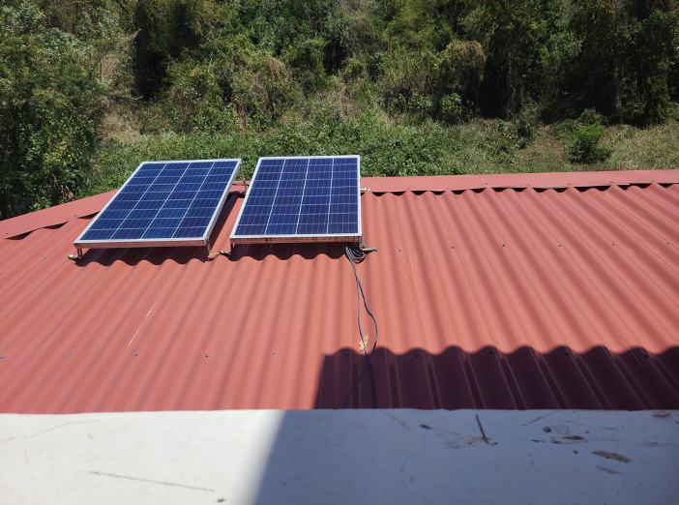
Figure 1: Newtown Health Centre, Sloped Roof of Building

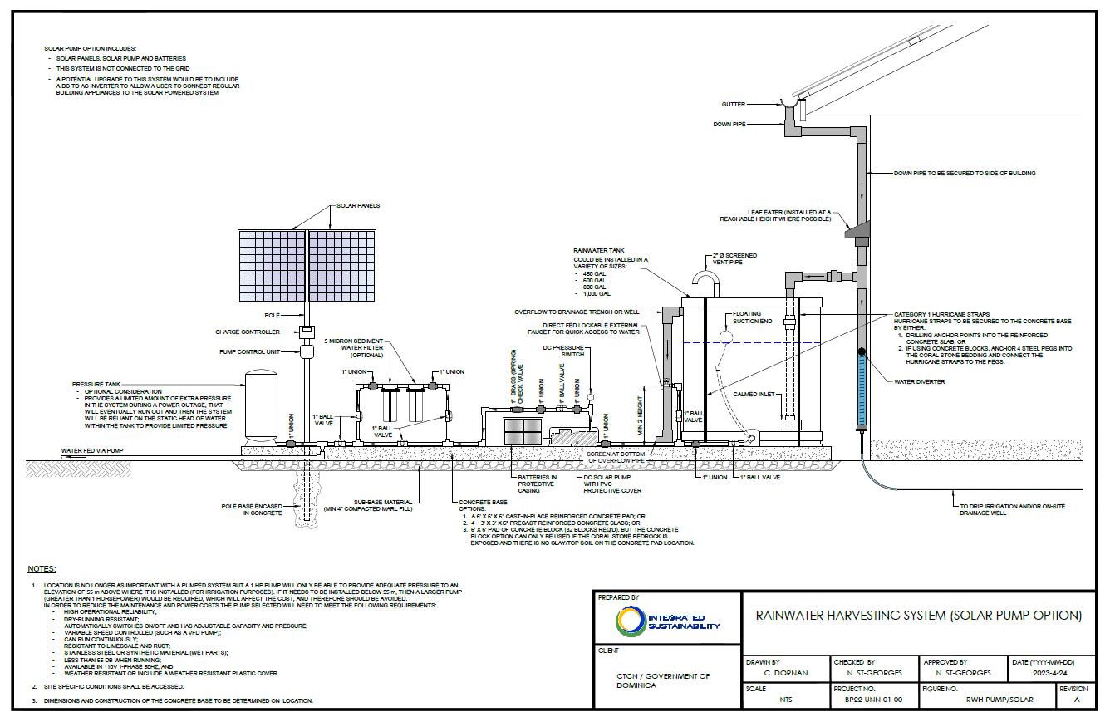
Figure 2: A Templated Rainwater Harvesting Design Consideration That Includes Solar

- Ten (10) Identified Public Buildings Analysed in the Field
Building ID | Date of Site Visit
Trafalgar Community Centre | May 5th, 2023
Dominica Community High School | April 27th, 2023
Newtown Health Centre | April 12th, 2023
Mahaut Health Centre | April 12th, 2023
Roseau Fisheries Complex | April 14th, 2023
Dominica State College | April 11th, 2023
Mahaut Primary School | May 3rd, 2023
Dominica Meteorological Office | April 13th, 2023
Vieille Case Community Centre | May 4th, 2023
Sineku Resource Centre | May 10th, 2023

- Solar / Electrical Site Assessment Summary
Building ID | Electrical  Connection Type | Standby Generator? (Y/N) | Standby Generator Capacity (kVA) | Roof Condition | Electrical Services Condition | Recommended Renewable Energy System for Building
Education
Dominica State College – Buildings A, B, C | Three-Phase | N | N/A | Very Good | Very Good | Solar PV only
Dominica State College – Carpentry Building | Three-Phase | N | N/A | Good | Good | Solar PV only
Dominica State College – Library | Three-Phase | N | N/A | Very Good | Very Good | Solar PV only
Dominica State College – Building N1 | Three-Phase | N | N/A | Very Good | Poor | Solar PV only
Dominica State College – Building N2 | Three-Phase | N | N/A | Very Good | Poor | Solar PV only
Dominica State College – Tourism Building | Single-Phase | Y | 52 kVA | Good | Good | Solar PV only
Dominica State College – Confucius Classroom | Single-Phase | Y | 52 kVA | Good | Good | Solar PV only
Dominica State College – General Studies Building | Single-Phase | Y | 52 kVA | Good | Good | Solar PV only
Dominica State College – Creative Caribbean Building | Single-Phase | N | N/A | Good | Good | Solar PV only
Dominica State College – Main Building & Office | Single-Phase | Y | 52 kVA | Poor | Good | Solar PV only
Dominica State College – Jolly’s Mini Pharmacy | Single-Phase | Y | 52 kVA | Good | Good | Solar PV only
Dominica Community High School | Single-Phase | Y | 5.5 kVA | Good | Good | Solar PV only
Mahaut Primary School | Three-Phase | N | N/A | Good | Good | Solar PV only
Community
Vieille Case Community Centre | Three-Phase | N | N/A | Concrete Roof: Good  Aluminum Roof: Very Good | Very Good | Solar PV and battery storage
Trafalgar Community Centre | Single-Phase | Y – Not yet installed | 12 kVA | Concrete Roof: Poor  Aluminum Roof: Good | Good | Solar PV only
Sineku Resource Centre | Single-Phase | N | N/A | Good | Good | Solar PV only
Health
Mahaut Health and Wellness Centre | Single-Phase | N | N/A | Very | Very good | Solar PV and battery storage
Newtown Health Centre | Three-Phase | N – Generator to be installed in coming weeks | TBD | Very good | Very good | Solar PV only
Other Sectors
Roseau Fisheries Complex | Three-Phase | Y – Generator on site, but not yet installed | 310 kVA | Very good | Very good | Solar PV only
Dominica Meteorological Office | Three-Phase | Y | N/A | Very good | Very good | Solar PV and battery storage

- Water Storage Summary
Building ID | Storage Type | Location of Storage | Is System Scalable? | How Sustainable is Building? | Can Water Capture System Operate Under Hazardous Conditions? | Any Design Recommendations?
Education
Dominica State College | Rubber tank above ground | Ground setup | Y | Many buildings form campus and most not sustainable. | Yes, certain buildings act as an emergency shelter prior, during or after a natural hazard. | The college has a storage tank with a capacity of 15,000 imp gal. Most structures have timber roofs which makes them vulnerable.
Dominica Community High School | Rubber tanks at ground (existing, Nos.-6) | Ground setup | Y | New extension has concrete roof so additional tanks can be installed at roof level | Yes, this school was newly refurbished under BNTF 9. The new refurbishments enabled the school to be resilient in case of natural hazards. | Both a rainwater storage system utilizing a gravity fed circulation system and a rainwater storage system utilizing a pump powered by a solar panel can be utilized on this site.
Mahaut Primary School | Rubber tank above ground | Roof setup | Y | Sustainable | Yes, this school is newly built with design considerations to make it less vulnerable and more resistant to natural hazards. It was constructed in 2022. | Both a rainwater storage system utilizing a gravity fed circulation system and a rainwater storage system utilizing a pump powered by a solar panel can be utilized on this site.
Community
Vieille Case Community Centre | Rubber tank at roof | Roof setup | Y | Building commissioned in 2021. Concrete roof exists so units can be placed there. No roof sealant applied and cracking observed. | Yes, this community centre was newly constructed in 2021, with design considerations to make it less vulnerable and resistant to natural hazards. | Both a rainwater storage system utilizing a gravity fed circulation system and a rainwater storage system utilizing a pump powered by a solar panel can be utilized on this site.
Trafalgar Community Centre | Rubber tank at Roof | Roof setup | Y | Building commissioned in 2021. Concrete roof exists so units can be placed there. No roof sealant applied and cracking observed | Yes, this community centre was newly constructed in 2021, with design considerations to make it less vulnerable and resistant to natural hazards. | Both a rainwater storage system utilizing a gravity fed circulation system and a rainwater storage system utilizing a pump powered by a solar panel can be utilized on this site.
Sineku Resource Centre | Rubber tanks at ground level (existing, Nos.-2) | Ground setup with cable fastening. | Y | Building renovations done in 2021. Sufficient lands available to increase tanks. Resizing of pump maybe required. | Yes, however this structure has a timber roof. | Both a rainwater storage system utilizing a gravity fed circulation system and a rainwater storage system utilizing a pump powered by a solar panel can be utilized on this site.
Health
Mahaut Health and Wellness Centre | Rubber tank above ground | Ground setup | N | Same design as Mahaut Health Center | Yes, this health centre was newly constructed in 2021, with design considerations to make it less vulnerable and resistant to natural hazards. | Both a rainwater storage system utilizing a gravity fed circulation system and a rainwater storage system utilizing a pump powered by a solar panel can be utilized on this site.
Newtown Health Centre | Rubber tank above ground | Ground setup | N | Leaks on roof existing | Yes, this health centre was newly constructed in 2021, with design considerations to make it less vulnerable and resistant to natural hazards. | Both a rainwater storage system utilizing a gravity fed circulation system and a rainwater storage system utilizing a pump powered by a solar panel can be utilized on this site.
Other Sectors
Roseau Fisheries Complex | Rubber tank above ground | Roof setup | Y | Sustainable | Yes, this building was rehabilitated and upgraded in 2022, with design considerations to make it less vulnerable and resistant to natural hazards. | Both a rainwater storage system utilizing a gravity fed circulation system and a rainwater storage system utilizing a pump powered by a solar panel can be utilized on this site.
Dominica Meteorological Office | Rubber tank above ground | Roof setup | Y | Sustainable | Yes, this building was recently built and appears to meet recent code changes with many sustainable features (eg concrete roof). | There is existing water storage on the roof, however, this can be augmented and in addition inclusion of PV system. Sufficient roof space exists to house these systems.

- Solar PV & Battery Storage System Capacities and Costs
Building ID | Average Monthly Electricity Usage (kWh) | Maximum Permitted Solar PV System Size (kWac) | Proposed Solar PV System Size (kWac/kWdc) | Solar Panels Required (420W panels) | Battery Storage System Size (kWac/kWh) | Estimated Cost (USD)
Education

Dominica State College – Buildings A, B, C | 1,044 | 10.4 | 10 / 10.9 | 26 | N/A | $19,600
Dominica State College – Carpentry Building | 2,051 | 20.5 | 20 / 21.8 | 52 | N/A | $34,950
Dominica State College – Library | 504 | 5 | 5 / 5.8 | 14 | N/A | $12,950
Dominica State College – Building N1 | 244 | 2.4 | 2 / 2.52 | 6 | N/A | $6,950
Dominica State College – Building N2 | 290 | 2.9 | 3 / 3.3 | 8 | N/A | $8,400
Dominica State College – Tourism Building | 105 | 1.1 | 1 / 1.2 | 3 | N/A | $3,500
Dominica State College – Confucius Classroom | 538 | 5.4 | 5 / 5.8 | 14 | N/A | $12,950
Dominica State College – General Studies Building | 848 | 8.5 | 8 / 9.2 | 22 | N/A | $20,350
Dominica State College – Creative Caribbean Building | 151 | 1.5 | 1.5 / 1.6 | 4 | N/A | $4,650
Dominica State College – Main Building & Office | 2,032 | 20.3 | 20 / 21.8 | 52 | N/A | $34.950
Dominica State College – Jolly’s Mini Pharmacy | 601 | 6 | 6 / 6.7 | 16 | N/A | $14,800
Dominica Community High School | 314 | 3.1 | 3 / 3.3 | 8 | N/A | $8,400
Mahaut Primary School | 1,491 | 14.9 | 15 / 16.8 |  | N/A | $30,250
Community
Vieille Case Community Centre | 132 | 1.3 | 3 / 1.6 | 4 | 6 / 11.4 | $25,650
Trafalgar Community Centre | 267 | 2.7 | 2.5 / 2.9 | 7 | N/A | $8,100
Sineku Resource Centre | 26 | 0.3 | 0.3 / 0.4 | 1 | N/A | $1,200
Health
Mahaut Health and Wellness Centre | 614 | 6.1 | 6.1 / 6.7 | 16 | 10 / 30 | $59,800
Newtown Health Centre | 3,157 | 31.6 | 6.1 / 6.7 | 16 | N/A | $14,800
Other Sectors
Roseau Fisheries Complex | 8,710 | 87.1 | 57 / 59.6 | 142 | N/A | $95,400
Dominica Meteorological Office | 1,920 | 19.2 | 10 / 10.9 | 26 | 20 / 68 | $103,700

- Estimated Rainwater Capture System Costs per Site
Building ID | Storage Type | Size of System | Estimated Costs ($ECD)
Education
Dominica State College | Rubber tank above ground | N/A | Nil
Dominica Community High School | Rubber tanks at ground level | Two (2) 1,000 Gal Rainwater tanks powered by solar panels | $ 16,977
Mahaut Primary School | Rubber tank above ground | Two (2) 1,000-Gal Rainwater tanks gravity fed | $ 11,484
Community
Vieille Case Community Centre | Rubber tank at roof | Two (2) 1,000 Gal Rainwater tanks powered by solar panels | $ 16,977
Trafalgar Community Centre | Rubber tank at Roof | Two (2) 1,000 Gal Rainwater tanks powered by solar panels | $ 16,977
Sineku Resource Centre | Rubber tanks at ground level | Two (2) 1,000 Gal Rainwater tanks powered by solar panels | $ 16,977
Health
Mahaut Health and Wellness Centre | Rubber tank above ground | Two (2) 1,000-Gal Rainwater tanks gravity fed | $ 15,765
Newtown Health Centre | Rubber tank above ground | Two (2) 1,000 Gal Rainwater tanks powered by solar panels | $ 16,977
Other Sectors
Roseau Fisheries Complex | Rubber tank above ground | Two (2) 1,000 Gal Rainwater tanks powered by solar panels | $ 16,977
Dominica Meteorological Office | Rubber tank above ground | Two (2) 1,000-Gal Rainwater tanks gravity fed | $ 11,484

Implementation Challenges
Technical Challenges: The area available for solar panel deployment on roof-tops, and shading from roof-top structures, vegetation and adjacent buildings is a key limiting factor in determining power generation potentials. Similarly, the surface area available for rainwater collection, the potential for contamination of collection surfaces, and the amount of water that can be stored are key limitations for rainwater harvesting.
Building Structure: Some older public buildings in Dominica may not be structurally adequate to attach PV panels in a manner suitable to withstand hurricane winds, or to modify for rainwater collection or bear the weight of a water storage tank. The cost of structural modifications may affect the economics or may not be practically possible, but, regardless, may require additional resources and planning to overcome.
Maintenance and Operation: Both solar PV systems and rainwater harvesting infrastructure require regular routine maintenance to ensure their optimal performance. Without proper maintenance, these systems may not achieve their intended benefits. However, the availability of skilled personnel with appropriate operations and maintenance training and may be a limiting factor in the context of public buildings.
Regulatory and Guidance: There is currently no plumbing code in place to facilitate non-potable water distribution systems within buildings, or regulatory governance enabling the distribution of non-potable water in Dominica.
The implementation of using purple pipe to signify the use of reclaimed non-potable water is practiced in many areas around the world, including the Caribbean such as Barbados. The source of the reclaimed water is often from a wastewater treatment plant and can be blended with rainwater capture for non-potable use such as irrigation, toilets and even laundry. Dual plumbing codes have been developed to provide standards and guidance for the installation of these non-potable water distribution systems. This policy framework is needed in Dominica to utilize more reclaimed water and place less of a demand on the potable water distribution system that is expensive to produce and maintain, especially with high non-revenue water (NRW) leaks in the system.
Awareness and Education: A significant barrier to the implementation and use of solar generation and rainwater water collection systems can be the lack of knowledge and guidance available to assist public officials, policymakers, and stakeholders in deploying these systems. Conducting awareness campaigns, educational programs, and workshops can help disseminate information about the benefits (e.g. climate change mitigation, adaptation and improved electrical and water network performance), feasibility, financial viability and long-term direct and indirect cost savings associated with these technologies. In carrying out awareness campaigns, educational programmes as well as workshops to disseminate information, gender-sensitive and inclusive approaches are critical. This means that the approaches to the format and content of the information as well as how it is disseminated should take gender into consideration including the differentiated needs and interests of men, women, young people, the elderly, Persons with Disabilities, and Indigenous People. Moreover, ideally content and should be developed that acknowledges these diverse groups and some of the specific needs they have in deploying these systems and as users of the buildings identified. Additionally, accessibility of content is important in terms of the imagery and language used (avoiding gender-based stereotypes and biases), as well as trying to ensure some content is accessible to the hearing and sight-impaired and uses Kalinago language where possible.

Summary of Financial Analysis Report
The Financial Analysis Report assessed the financial feasibility of the recommended solar PV and water storage solutions, including recommendations on good practices for the implementation of the systems, as well as possible financing schemes and business models.

Water
The design considerations, for rainwater harvesting (RWH) storage systems focused on three (3) main categories:
- Potential tank installation location;
- Cost options associated with each design consideration; and
- Various tank sizes that are available from local suppliers.
For all buildings, the recommended water capture system consisted of the following:
- Rainwater harvesting (RWH) storage system to include solar systems to power the pumps, which includes two (2) 1,000-Gal rainwater tanks; or
- gravity fed RWH storage system that includes two (2) 1,000-Gal rainwater tanks.
By using rainwater harvesting systems on certain Government buildings, Dominica has the potential to reduce the amount of water consumed by the network with its potential resulting cost savings. The collected rainwater can be used for many non-potable purposes including landscape irrigation, laundry, toilet and urinal flushing, vehicle and surface washing and fire suppression. The storage tanks can also be topped up with potable water during dry weather to reduce demands on the water distribution network during dry weather and serve as an additional water source wherever water is scarce including any disruption in the water distribution network or during natural disasters such as hurricanes. The non-potable purposes identified here are gendered in some ways including who is likely to play these roles in terms of the staff in the building as well as any maintenance activities which are likely to still be dominated by men as is landscape irrigation, vehicle, and surface washing suppression. Laundry as well as toilet/urinal flushing are likely to involve if not be dominated by female staff and information on the benefits as well as the use of these technologies needs to engage all of these potential users and workers.

Solar PV Systems
The estimated costs of the solar PV system and battery storage system (where applicable) have already been provided in Table H. Solar PV & Battery Storage System Capacities and Costs. Additionally, Appendix 3 of the “Analysis of Current Electricity and Water Consumption Patterns” report provides potential layouts of the solar PV arrays that could be installed on each building.

Feed-in Tariff and Economic Analysis
According to the Distributed Renewable Energy Generation Interconnection Policy, published by the Dominica Electricity Services Limited (DOMLEC), the company will encourage and promote renewable and clean generation sources including Photovoltaic, Hydro, Wind, Fuel Cells, or Microturbines (under 250kW in unit size) and renewable fuels including biogas and landfill-gas. According to The Renewable Energy Industry in CARIFORUM Countries, published by Caribbean Export, for Dominica, the Independent Power producers negotiate selling rate with Domlec and the regulator for PV systems. Net billing is utilized using the standard customer rate and the Feed-in Tariff, often referred to as ‘FiT’, to be set by the regulator. FiT is estimated to be around $ECD 0.405 per KWh.
In order to make an investment into solar photovoltaic panels worthwhile with lower paybacks it is advisable to look into the FiT. The FiT obliges the energy company (DOMLEC) to pay the owner of a solar PV system a price (per kWh) for the energy that they sell/export back to the grid.
The cost analysis of solar PV systems took into consideration eight key variables:
- Capital cost of materials;
- Labour to install panels;
- VAT on labour & materials;
- Yearly estimated maintenance fee;
- Estimated inverter replacement (once every 20-years;)
- Solar panel efficiency and changes with time;
- Feed-in Tariff rate; and
- Electricity savings based upon ECD $0.405 per kWh.
As an example, a financial analysis was carried out for two buildings – the Dominica Stage College Carpentry Building and Dominica Stage College Main Building and Office. The analysis on these buildings is scalable to other buildings.
The estimated cost for the selected system for the Dominica State College – Carpentry Building and the Dominica State College – Main Building & Office is approximately ECS $95,400; this figure includes the total estimated cost for the technology, delivery, installation, and other extras with VAT. We have modelled that funding for these two (2) systems would be through 100% equity financing. The Government of Dominica may be able to obtain grant or low interest funding to cover some or all of the costs of the installation of the solar PV systems on these buildings.
Further analysis on investment and payback is displayed in Figure A and Figure B. It can be observed that the payback period is in 9 - 10 years in which the system is operating and obtaining the FiT. The income generated from the FiT accumulates to ECD$103,700 over the 20-years. Conservative savings on electricity bills at a rate of ECD$0.10 per kWh, amounts to approximately ECS$57,900 over the 20-years on each installation, based on the net production of electricity. The FiT is assumed to be fixed during the 20-year period. These figures also take into consideration any additional cash flow payments throughout the 20-year scheme, i.e. maintenance for cleaning the panels and inverter replacement once every 20 years.
Figure A presents the yearly payback over the 20-year FiT scheme. The income generated from the PV system will be repaying the initial capital cost of the system for the first 9-years. Over the 20-year analysed timeframe, the system will have saved carbon dioxide emissions being produced from grid electricity. Figure B shows the effect of the gradual reduction in efficiency of the system over the 20-years. The first year’s total electricity generation at 31,230kWh reducing to 26,810kWh in year 20.
Further analysis for the remaining fifteen (15) sites where there is a solar PV system without battery storage, show similar pattern of cash flows, and electricity generated with payback periods between 9 – 11 years, based on the estimated FiT.
- Cash Flows Pay Back Period (20-years)
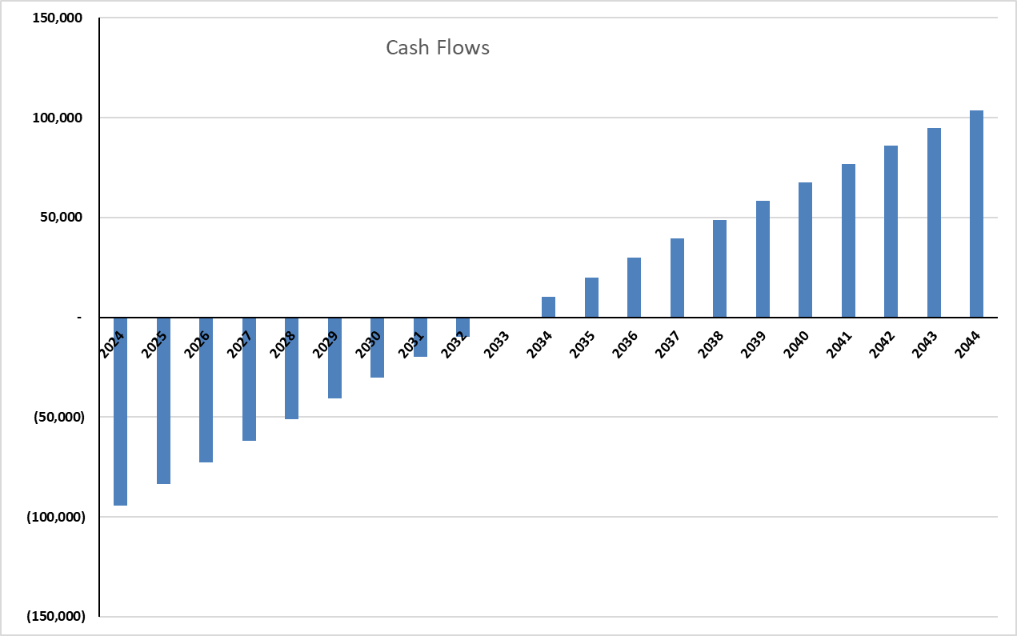
In the case of the selected sites with both a Solar PV system and Battery storage, we have determined the estimated cost for the selected system for the Mahout Health and Wellness Centre is approximately ECDS$161,500 with the proposed PV system of 6.1 kWAC/6.7kWDC with 10 kWAC/30 kWh batteries. Again, these figures include the total estimated cost for the technology, delivery, installation, batteries, and other extras with VAT. It should be noted that the proposed PV system for the Newtown Health Centre in similar in size but without the batteries and the estimated cost of that system is approximately ECD$ 40,000, roughly one quarter of the cost of the same sized system with the batteries.
Further analysis on investment and payback for this solar PV system with batteries is displayed in Figure B. In the case of the solar PV system with batteries, the payback period is in excess of 20 years, when the Fit is considered. Based on the selected system for the Mahout Health and Wellness Centre, the system is designed to generate more electricity than what is consumed therefore this site can technically operate “off-grid”, potentially saving the annual electricity costs. With average annual electricity production from this system at the Mahout Health and Wellness Centre being approximately ECD$3,900 per year, at the current electric tariff rates, the payback period for this system will still be in excess of 20 years.
- Cash Flows Pay Back Period (20-years)
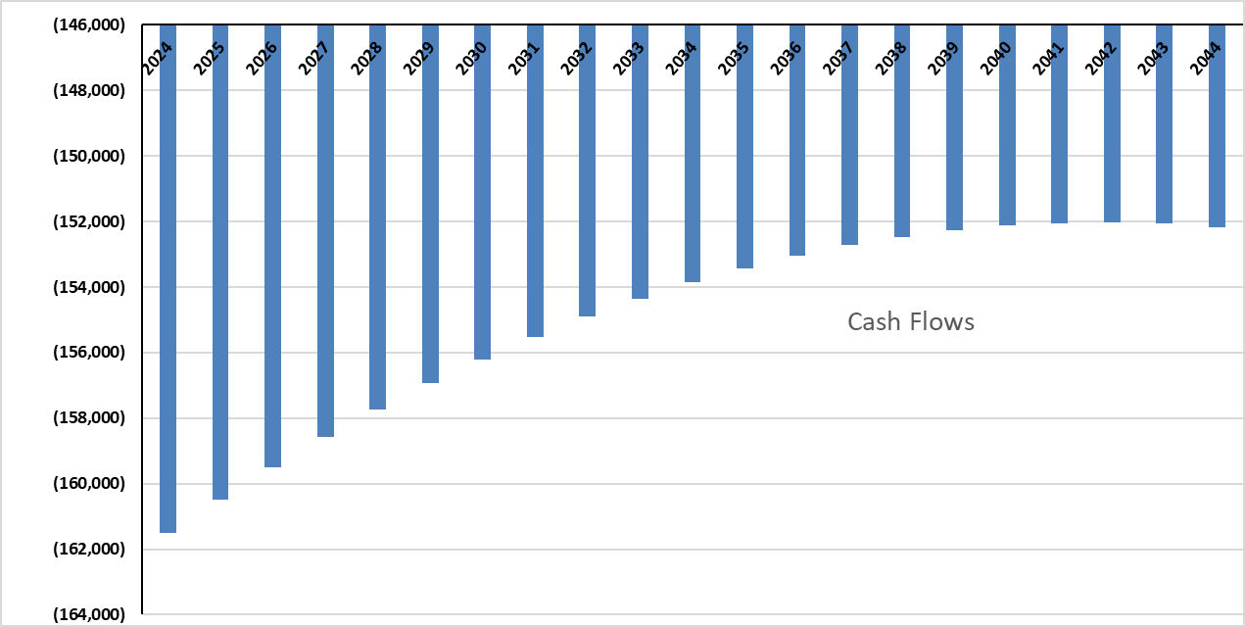
Overall, the Financial Analysis Report highlighted the technical and economic issues pertaining to the sizing and specifying of solar photovoltaic systems onto existing domestic commercial structures. Twenty (20) PV systems have been designed and discussed for ten (10) locations with the objective of providing a clear understanding of all the constraints and technical issues surrounding the installation of PV technology, before committing to a 20-year investment.
The analysis process included modelling several PV panel sizes and technologies along with inverter size options for each building or for each block within a building. The modelling mechanism takes influence from each building’s orientation, roof tilt, size of availability roof area and any shading that impacts upon the roof. Each PV and inverter option that was simulated obtains a yearly output of electricity and the number of panels required to achieve different output levels. The selection of the ‘best fit’ PV system was based upon the annual kilowatt/hour output to cost ratio. The case studies analysed in the document are subjected to individual constraints, either with roof space, appropriate orientation, roof tilt or their location.
4. Impact Statement
The information in the table below will be used to communicate results and anticipated impacts of this technical assistance publicly. Please copy information from impact statement developed in the M&E Plan and update as relevant.

Challenge | The island of Dominica does not have a detailed analysis to identify the feasibility and benefits of expanding self-sufficient renewable energy generation solutions that can reduce the dependency of fossil fuels and increase the island energy self-sufficiency with low carbon technologies. Moreover, in terms of water supply, there are no official programs to promote rainwater capture and storage systems that could help the country to minimize difficulties in the water supply during the dry seasons and extreme weather conditions (such as hurricanes), which are at risk due to climate change.
CTCN Assistance | - Impact statement report of the CTCN technical assistance prepared at the start of the CTCN technical assistance and updated at the end of the CTCN technical assistance using the CTCN template; and  - A technical assistance closure report completed at the end of the CTCN technical assistance.
Anticipated impact | - Reduce Dominica’s dependency on fossil fuels through solar units;  - Aid in Dominica’s energy Transition;  - Reduce Dominica’s GHG emissions; and  - Combat water scarcity in Dominica
Co-benefits: Achieved or anticipated co-benefits from the TA | Co-benefits from this plan will include a detailed Stakeholder mapping report, with classification by type and sector, and potential participation in a solar energy/water capture market, gap analysis and recommendations. As well as existing legal, technical, and financial framework and barriers for incorporating standalone solar units and water capture/storage systems, including the especial case of energy surplus sale to the grid.  This project will ultimately position the Dominica Government to subsequently implement the solar and water storage recommendations and template design installations in a subsequent tender to Contractors to build these storage systems.
Gender aspects of the TA | This project will involve the input from consultants, including scientists and Stakeholders that represent male and female, as well as the LGBTQ community where possible.
Anticipated contribution to NDC | This project is expected to align with Dominica’s National Determined Contribution (NDC) target to reduce 44.7% of GHG emissions by 2030.
The narrative story | The United Nations Environment Programme (UNEP) an international, inter-governmental organization established by the General Assembly of the United Nations, represented by its Division of Science and having its office at Nairobi, Kenya requires the services of a consulting firm to develop options for the future form and function of its flagship report, the Global Environment Outlook. The Climate Technology Centre and Network (CTCN) is the operational arm of the United Nations Framework Convention on Climate Change (UNFCCC) Technology Mechanism and co-hosted by the United Nations Environment (UN Environment) in collaboration with the United Nations Industrial Development Organization (UNIDO) and supported by 11 partner institutions with expertise in climate technologies. The mission of the CTCN is to promote accelerated development and transfer of climate technologies at the request of developing countries for energy-efficient, low-carbon and climate-resilient development. The purpose of this request is to identify and hire a suitable firm amongst the network members of CTCN to implement a technical assistance to support the technical and economic feasibility of solar units and water storage on public buildings in Dominica.  Dominica is reliant on imported fossil fuels, leaving it vulnerable to global oil price fluctuations that directly impact the cost of electricity. The implementation of small-scale solar generation systems can support the energy transition in Dominica. However, the island does not have a detailed analysis to identify the feasibility and benefits of expanding self-sufficient renewable energy generation solutions that can reduce the dependency of fossil fuels and increase the island energy self-sufficiency with low carbon technologies. These self-sufficient energy solutions can be off-grid or on-grid systems. The first ones are completely independent from the electricity grid and rely on batteries when there is not solar irradiation, and the second ones are still connected and use the electricity grid as an energy backup. In terms of water supply, there are no official programs to promote water capture and storage systems that could help the island to minimize difficulties in the water supply during the dry seasons.  Major Barriers to the implementation of solar generation systems and water capture/storage systems are scarce experience and studies on that can support decisions to electricity consumers on the feasibility of stand-alone solar systems and installation of water capture and storage systems. The lack of innovative business models that develop strategies to effectively develop the solar and water markets. There is also a need to address potential synergies but also conflict of interest between stakeholders in the electricity sector in the scenario of sales of electricity surplus to the grid. In addition, this request will help the government to reduce the impacts of drought during the dry season. Through the promotion harvesting and utilizing rainwater from roof catchments for individual households in cisterns or on a small scale in surface storage tanks in areas of water deficit and developing a program to support retrofitting public buildings. Despite these barriers, the expected outcome of this project is to increase climate resilience in Dominica and reduce greenhouse gas emissions from fossil fuel dependence, by assessing the viability of installing solar units and water storage units in public buildings.
Contribution to SDGs | SDG 6: Clean water and Sanitation  This project seeks to increase the availability of freshwater through decentralized rainwater harvesting on public buildings, reducing water scarcity in Dominica, aligning with targets 6.4 and 6.7.  SDG 7: Affordable and Clean Energy  Reducing Dominica’s dependency on fossil fuels through solar units installed on public buildings across Dominica, increases sustainable technologies, infrastructures, and services available on the island for this project will aligning with targets 7.2,7.5 and 7.4.  SDG 13: Climate Action  This project seeks to strength Dominica’s resilience to climate and adaptive capacity to climate related disasters through conducting research and pilot projects and results that could be added to building codes, aligning with all 5 targets under SDG 13.

Annex 1 Technical Assistance Data Collection

Please add quantitative and qualitative values for the indicators selected in the M&E plan and monitored throughout the technical assistance in the tables below. Indicators which have been monitored in addition to the proposed indicators below may be added at the end of table A. Non-relevant indicators should be left blank.

- Output and outcome indicators

Indicator  Please note indicators below highlighted as anticipated | Quantitative value  Numerals only; disaggregates must sum to the total | Qualitative description  List the various elements corresponding to the quantitative value as well as timelines and responsible institutions
Total number of events organized by proponents and implementing partners | 2 | Stakeholder Engagement Meetings
Number of participants in events organized by proponents and implementing partners | 23 | Stakeholder Engagement Meeting #1
- Number of men | 14 | 1 from Barbados  13 from Dominica
- Number of women | 9 | 9 from Dominica
Number of climate technology RD&D related events | 0
Number of participants in climate technology RD&D events | 0
- Number of men
- Number of women
Number of trainings organized by proponents and implementing partners | 0
Number of participants in trainings organized by proponents and implementing partners | 0
- Number of men
- Number of women
Total number of institutions trained | 0
- Governmental (national or subnational)
- Private sector (bank, corporation, etc.)
- Nongovernmental (NGO, University, etc.)
Percentage of participants reporting satisfaction with CTCN training (from CTCN training feedback form) | N/A
Percentage of participants reporting increased knowledge, capacity and/or understanding because of CTCN training (from CTCN training feedback form) | N/A
- Percentage of men
- Percentage of women
Total number of deliverables produced during the assistance (excluding mission, progress, and internal reports) | 5
- Number of communication materials, including news releases, newsletters, articles, presentations, social media postings, etc. | 3 | - Project kick-off presentation (Feb. 13, 2023  - Stakeholder engagement meeting/presentation (March 15, 2023)  - Final report vetting meeting/presentation with Stakeholders (Oct. 4, 2023)
- Number of tools and technical documents strengthened, revised, or developed | 5 | Prepared the following technical documents:  - Detailed Work Plan  - Identify Relevant Stakeholders  - Analysis of Current Electricity & Water Consumption Patterns  - Financial Feasibility Analysis  - Final Report
- Number of other information materials strengthened, revised, or created (For example training and workshop reports, Power Points, exercise docs etc.) | 1 | Final report summary presentation (Oct. 4, 2023)
Total number of policies, strategies, plans, laws, agreements, or regulations supported by the assistance | 0
- Adaptation related | N/A
- Mitigation related | N/A
- Both adaptation- and mitigation related | N/A
Anticipated number of policies, strategies, plans, laws, agreements or regulations proposed, adopted or implemented as a result of the TA | 0
- Adaptation related | N/A
- Mitigation related | N/A
- Both adaptation- and mitigation related | N/A
Anticipated number of technologies transferred or deployed as a result of CTCN support | 2
Anticipated number of collaborations facilitated or enabled because of technical assistance | 24 | Small Grid  Water Efficiency  Sustainable Design  New Building Design  Greening the Built Environment  Retrofitting of Existing Buildings  Building Energy Management Systems  Batteries  Building Integrated PV  Solar PV  Grid Integration for Renewables  Irrigation  Water Efficiency in Industry  Water Accounting  Irrigation Efficiency and Information Systems  Water Savings Requirements in Building Codes  Public Water Conservation Campaigns  Rainwater Harvesting  Water Reservoirs  Water Recycling and Reclamation  Water Reallocation
- Number of South-South collaborations | 0
- Number of RD&D collaborations | 0
- Number of private sector collaborations | 0
Number of countries with strengthened National System of Innovation as a result of CTCN support | 0
Insert any additional indicators here

- Core impact indicators

Please fill in the tables for anticipated impacts of the CTCN assistance. Every technical assistance should contribute to at least one of the indicators below. For guidance on how to report on core indicators see the ‘M&E Guidance Document for TA Implementers’.

Core indicator 1 | Anticipated metric tons of CO₂ equivalent (CO₂e) emissions reduced or avoided as a result of CTCN TA  Please add your calculations in word or excel format as an Annex to this Closure Report, where applicable.
 | Anticipated metric tons of CO₂e reduced or avoided as a result of the TA on annual basis | Anticipated metric tons of CO₂e reduced or avoided as a result of the TA in total
Quantitative value  (emissions reductions) | Total number (numerals only, no rounding or abbreviations) | Total number (numerals only, no rounding or abbreviations)
Unit | tCO₂e | tCO₂e
GHG assessment boundary (project emissions)  Identify expected post-TA activities, associated effects and assess boundary for quantification of GHG emission reductions | This project is expected to align with Dominica’s National Determined Contribution (NDC) target to reduce GHG emissions by 2030.
Baseline emissions  Describe baseline scenario, baseline candidates, emission factors and emissions calculated | Since 156.52 Gg of Carbon is equal to 77,104.4 tonnes. Public buildings could reduce, annually = 10% reduction.
Methodology  Explain the method or process of verifying the indicator and how data was gathered | Dominica public buildings:  - Ministries – 20 bldgs  - Schools (gov. owned only) – 59 bldgs  - Community centers – 5 bldgs  - Prison – 1 bldgs  - Hospitals – 3 bldgs  - Fire stations – 8 bldgs  - Police stations – 19 bldgs  Total = 115 public buildings  - Average solar panel Area 1.63m²  - No. of Solar panels to cover public buildings roof tops = 19227  - Average solar system is 10kW/30 panels = 2005  - One 10 KW system produce 16, 677 kWh annually in Dominica (according to PVWatt Calculations)  - Therefore 2,088.6 systems would produce 34 million kWh annually = 16,032  - 10kW systems reduce 4 tonnes of CO2 annually = 8021  - Since 156.52 Gg C is equal to 77,104.4 tonnes. Public buildings could reduce ,annually = 10%
Assumptions  Describe assumptions made during calculation and quantification of GHG reductions | Dominica's Energy Sector Key Information:  - Total Energy Consumption (MWh) = 97.45  - Total Installed Capacity (MW) = 27.4  - Total Diesel Generated Electricity (MW) = 20.1  - Total Renewable Energy Generated Electricity (MW) = 6.6  - Total Residential and commercial RE Generated Electricity (MW) = 0.7 (0.44 Solar & 0.26 Wind )  - Total GHG emissions in energy (Gg C02 equivalent) = 156.52

Annex 2 (for internal use – to be filled in by the CTCN)
CTCN evaluation
This section will be completed by the relevant CTCN Technology Manager.

- Evaluation of the timeliness of the TA implementation as measured against the timeline included in the response plan;
- Evaluation of TA quality as defined in the response plan;
- Overall performance of the Implementers;
- Overall engagement of the NDE and Proponent;
- Lessons learned on the CTCN process and steps taken by the CTCN to improve.

