Technical Assistance Closure Report

Closure Report for CTCN Technical Assistance

- Basic information
Title of response plan | Provision of Technical Guidance and Support to conduct a Technology Needs Assessment and a Technology Action Plan for Paraguay
Technical assistance reference number | 2020000032
Country / countries | Paraguay
NDE organisation | Ministry of the Environment and Sustainable Development (MADES)  His Excellency Mr. César Oviedo Verdun, Minister
NDE focal point | Ulises Lovera, Director of DNCC (Dirección Nacional de Cambio climático)
NDE contact information | ulises.lovera@mades.gov.py
Proponent focal point and organisation | Ministerio del Ambiente y Desarrollo Sostenible (MADES)
Designer of the response plan | The Climate Technology Center and Network (CTCN) –  Ministerio del Ambiente y Desarrolllo Sostenible (MADES)
Implementer(s) of technical assistance | United Nations Environment Programme (UNEP) on behalf of The Climate Technology Center and Network (CTCN) (consortia OIKO, Investigación para el Desarrollo y Fundación Moisés Bertoni)
Beneficiaries | Ministry of Environment and Sustainable Development, key stakeholders of prioritized sectors
Sector(s) addressed | Instruction: Select relevant sector(s) from the CTCN taxonomy https://www.ctc-n.org/resources/ctcn-taxonomy :  Water  Chemicals management  Waste Management  Transport  Renewable energy  Forestry
Technologies supported | Instruction: Please indicate the type of technologies supported by this assistance. Technologies may be identified from the CTCN taxonomy of climate sectors and technologies (download in pdf format and choose from column C): https://www.ctc-n.org/resources/ctcn-taxonomy If technologies supported are not found in the taxonomy, please suggest.  Water - Integrated planning: Integrated Water Resources Management  Chemicals management - SF6 reduction  Waste Management – Recycling: Glass recycling  Transport - Inland water & maritime: river waterway management  Renewable energy - Renewable energy infrastructure: Hydrogen technologies  Renewable energy – Solar: Solar PV  Forestry - Carbon stock measurement, monitoring and verification: Platform/s as a carbon market marketplace and financial management of protected areas.
Implementation start date | (02/09/2021)
Implementation end date | (20/06/2023)
Total budget for implementation | USD 201,250
Description of delivered outputs and products as well as the activities undertaken to achieve them. In doing so, review the log frame of the original response plan and refer to it as appropriate | Output 1.3.1: Effective coordination mechanism between NDA and NDE for the UNFCCC Technology Mechanism and other climate finance focal points  Activity: 1.3.1a: Develop CTCN planning and communication documents  D. 1.3.1a (i): CTCN Work plan  D. 1.3.1a (ii): CTCN Monitoring and evaluation plan  D. 1.3.1a (iii): CTCN Impact description  D. 1.3.1a (iv): CTCN Closure and Data Collection report  Activity 1.3.1b: Conduct stakeholder´s analysis  D. 1.3.1b (i): Stakeholder mapping report, where roles  and responsibilities are specified.  D. 1.3.1.b (ii): Report of the 2 -day stakeholders’  workshop  Activity 1.3.1c: Support the establishment of a TNA Committee  D. 1.3.1c (i): Official government circular establishing  the national TNA committee  D. 1.3.1c (ii): TNA Committee Constitution document  informing on the work of the TNA Committee  D. 1.3.1c (iii): Report on the 2 workshops organized,  including a full list of participants with genderdisaggregated data.  D. 1.3.1c (iv): TNA Committee Work plan  D. 1.3.1c (v): Report of quarterly TNA committee  Meetings  Output 1.3.2: Private sector (with a focus on SME) capacity is strengthened and the creation of an enabling environment for their participation in climate technology adoption through innovative new business identification training programmes is supported  Activity 1.3.2a: Enhance SME capacity and enable environment through innovative new business identification  D. 1.3.2a (i): Workshop report  Output 2.2.1 Appropriate climate technology solutions are identified and prioritized and relevant action for increased access to finance is identified  Activity 2.2.1a: Pre-select sub-sectors for the fulfilment of Paraguay’s TNA  D. 2.2.1a (i): Report on TNA-TAP alignment with  national plans/grants  D. 2.2.1a (ii): Report on analysis of sectoral priorities  expressed in national documents  D. 2.2.1a (iii): Report describing the methodology  utilized for sector and subsector selection and  prioritization.  D. 2.2.1a (iv): Stakeholders consultation workshop  report  Activity 2.2.1b: Assess, prioritize, and validate key technologies for the fulfilment of Paraguay’s TNA  2.2.1b (i): Up to 40 technology fact sheets (10 per  sector)  D. 2.2.1b (ii): Report detailing the set of criteria for the  MCA exercise  D. 2.2.1b (iii): Workshops reports  D. 2.2.1b (iv): Final reports including a mitigation TNA  report and an adaptation TNA report.  D. 2.2.1b (v): Database in the most suitable format.  Activity 2.2.1c: Develop a Technology Action Plan per sector and /or sub sector  D. 2.2.1c (i): Draft report and executive summary of 4 Technology Action Plans for each of the priority technologies in compliance with the TNA  Output 2.2.2 Effective stakeholders’ engagement and information dissemination for enhanced country ownership and technology deployment  Activity 2.2.2a: Conduct a national consultation workshop to ensure national ownership and technology  Deployment  D. 2.2.2a (i): Workshop report including a full list of  participants with gender-disaggregated data.  D. 2.2.2a (ii): Validated report and executive summary  of 4 Technology Action Plans for each of the priority  technologies in compliance with the TNA  Activity 2.2.2b: Support the implementation of the Technology Action Plan with communications, guidance, and training  D. 2.2.2b (i): Policy briefs and market-use cases for the selected technologies.  D. 2.2.2b (ii): Report on the dissemination strategy.  D. 2.2.2b (iii): Training materials for the sub-national workshops.  D. 2.2.2b (iv): Workshops reports  Output 4.1.1: Concept Notes for Technology Action Plans operationalization developed  Activity 4.1.1a: Develop concept notes for priority sectors for submission to the GCF  D. 4.1.1a: Two concept notes developed for climate  technology deployment to be submitted to the GCF.
Methodologies applied to produce outputs and products | Desk research  Multi-criteria analysis  Workshops and stakeholder engagement  Structured Survey
Reference to knowledge resources | For the purposes of the TNA and PAT, we reviewed different final country TNA and TAP reports from Honduras, Uruguay, and Argentina, and further we also reviewed Policy Briefs from a variety of countries. Available at: https://unfccc.int/ttclear/tna/reports.html Further, the TNA step by step guidebook was used throughout the process: https://tech-action.unepccc.org/wp-content/uploads/sites/2/2019/04/2019-02-tna-step-by-step-guide.pdf
Deviations | Five sectors were prioritized and analyzed in the TNA process, instead of foreseen 4.  Activity 2.2.1b (iv): Workshop to validate key technologies was divided into first session of face-to-face workshops to present and discuss key technologies and second round of online workshops to validate final results of the MCDA.
Anticipated follow-up activities and next steps | - Submission of two concept notes to GCF  - Implementation of Technology Action Plans.  - Dissemination of reports.

- Lessons learned
 | Lessons learned | Recommendations
Lessons learned from the CTCN TA process | The steps from the Response Plan were clear and easy to follow.  The process of Technology Needs Assessment took much longer time (and resources), stakeholder engagement and negotiation, than the Technology Action Plan.  The key experts finally needed had to be adjusted according to sector prioritization process. | - consider more time and LOE needed for the TNA processes  - leave flexibility to adjust the team composition according to the sectors prioritization
Lessons learned related to climate technology transfer | Lessons learned: For the deployment of climate technologies, it is essential to obtain ownership of key both governmental stakeholders, private sector, academy, and others.  Opportunities: The cooperation of different dependencies of the NDA and other Ministries, such as Water Resources department and Ministry of Energy, open the opportunity for ownership of the designed TAP.  Barriers: Constrains to engage stakeholder from the agricultural sector and their negation of existence of climate change. It was possible to conduct the TNA process, but the TAP could not be conducted.  Barriers: Lack of local capacity to absorb some of the proposed technologies and need for extensive capacity building programmes in different areas of the prioritized sectors. | - use GCF funding for implementation of two prioritized technologies, including extensive capacity building activities  - implement the Dissemination Strategy

3. Illustration of the TA and photos
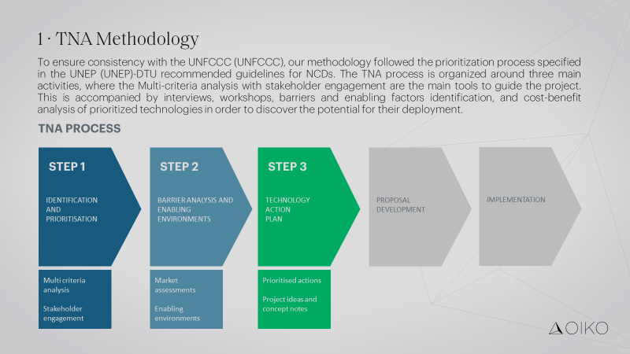

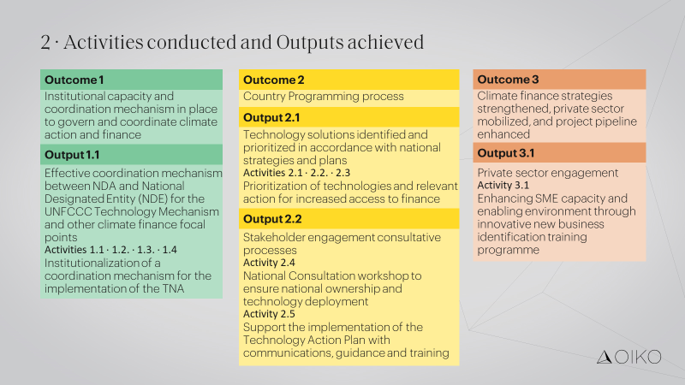

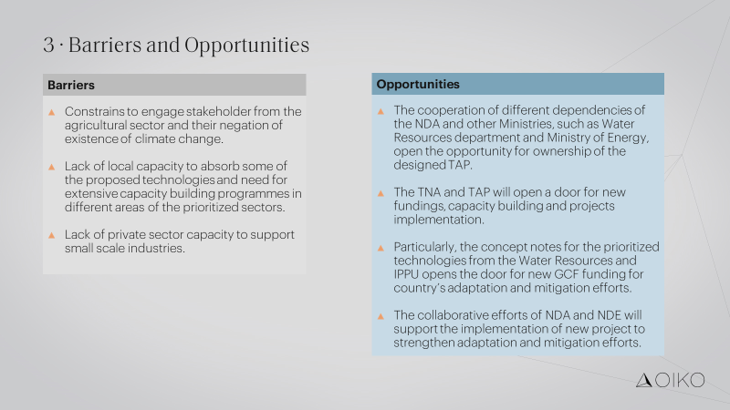

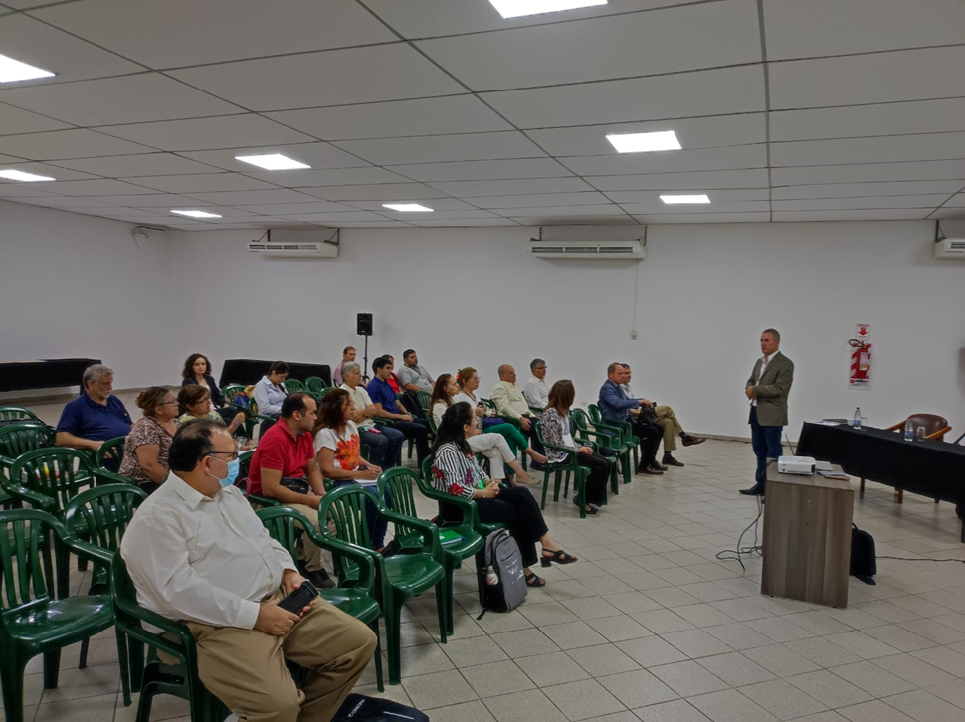

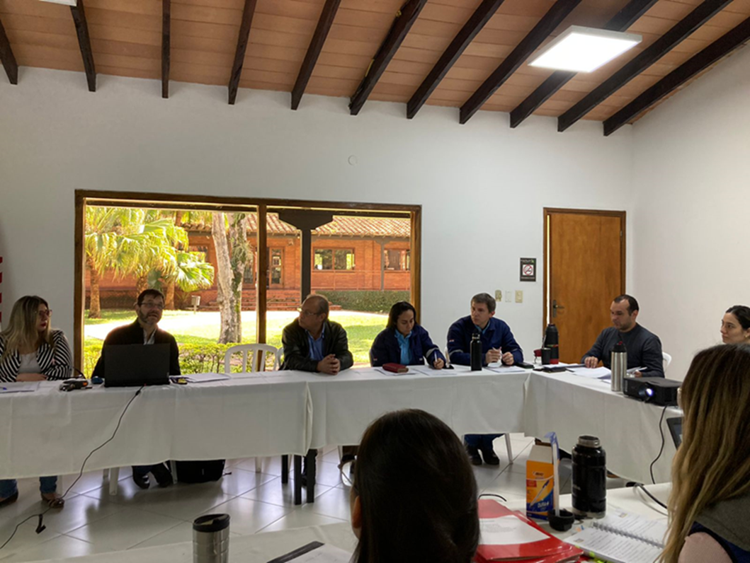

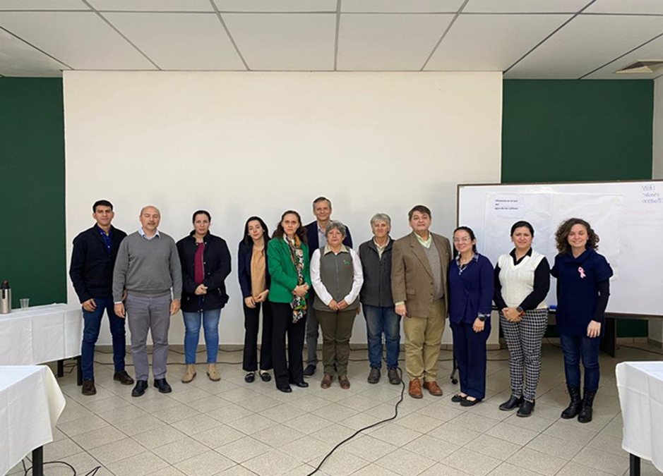

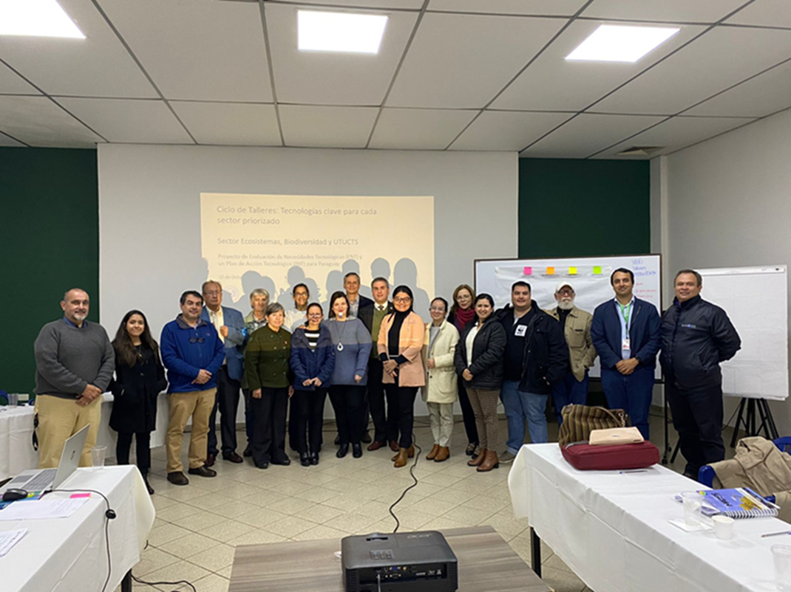

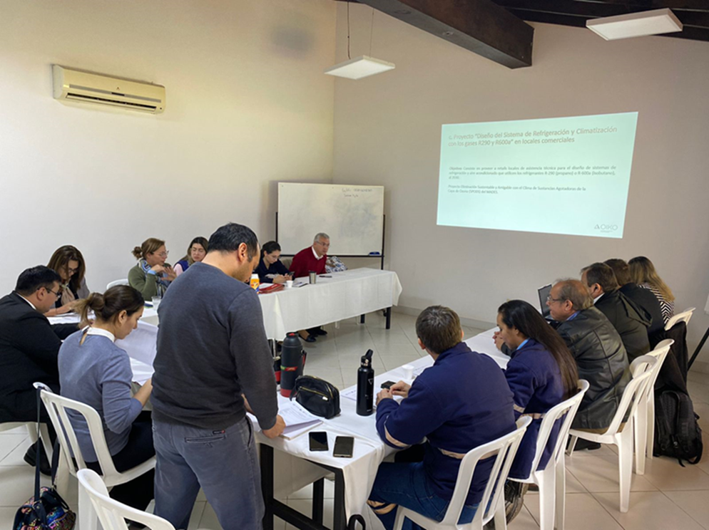

4. Impact Statement
The information in the table below will be used to communicate results and anticipated impacts of this technical assistance publicly. Please copy information from impact statement developed in the M&E Plan and update as relevant.

Challenge | Paraguay is a landlocked developing country (LLDC) with a highly dependent economy on the primary sector, which makes it highly vulnerable to the effects of climate change, such as temperature increase, pattern change in rainfall, and intensity and frequency increase of extreme  weather events. In the Nationally Determined Contributions (NDCs) Paraguay recognizes the obstacles to advance in the climate technologies adoption needed to  strengthen mitigation and adaptation measures and building resilience. The  country faces lack of specialized skills required in climate technologies,  innovations, and knowledge. Other barriers include inadequate infrastructure services to ease acquisition of appropriate technologies, lack of market awareness, lack of research and development of green  technologies, inadequate incentives and enabling environment for technology transfer. The technical assistance to Paraguay to enable the development of a  Technology Needs Assessment (TNA) and action plan, will allow the country  to implement its climate targets using the most appropriate technologies, and address the country needs in climate change adaptation and mitigation.
CTCN Assistance | To provide technical assistance (TA) to Paraguay to enable the development of a comprehensive Technology Needs Assessment (TNA) and a Technology action plan (TAP).  x The TA will entail conducting categorization and prioritization of  technologies that will comply with the Paraguay NDCs and other  strategies.  x The fundamental goal is to enable Paraguay to implement its climate  targets using the most appropriate technologies.  x In this context, the TNA report and TAP will provide the necessary  guidance to evolve the prioritized technologies and address the country  needs in climate change adaptation and mitigation
Anticipated impact | x Measures implemented across the prioritized sectors that will drive  climate resilient and low carbon growth in Paraguay  x Institutional capacity and effective coordination mechanisms between  NDA and NDE in place to coordinate climate action  x 4.987.510 (74 % of population) impacted by the Integrated Water Resources management programme
Co-benefits: Achieved or anticipated co-benefits from the TA | Potential co-benefits of climate change mitigation / Response plan and  deliverables  x Reducing air pollution from emissions of fossil fuels and the accompanying health (including premature deaths and morbidity) and environmental impacts  x Increased resource efficiency  x Increased resilience to climate change for the primary industry  x Enhancement of renewable energy use.  x Increased resilience of sectors  x Finance for identified climate technology solutions is ensured.  Potential co-benefits of climate change adaptation:  x Reduced exposure to food shortages and economic downturns derived  from climate change impacts.  x Reduced vulnerability to climate change in the country
Gender aspects of the TA | The technical assistance (TA) will promote intervention where gender equality - the shared control of resources and decision-making - and women’s empowerment are central in the process. The level of awareness and appreciation of gender inequalities has been assessed as a part of the TA.  The TA has been supported by an analysis of the relations between gender issues and climate resilience and identifying the gaps and opportunities for a TNA in Paraguay.  As a result, the TA developed a methodology and provided capacity building on Gender Mainstreaming in TNA.
Anticipated contribution to NDC | x Taking stock of existing low-carbon technologies in Paraguay;  x Undertaking comprehensive identification of technical and technology  needs by NDC sector;  x Identifying technical capacity-building needs for deployment of these  technologies; Implementing the Paraguay technology action plan (TAP)  in cooperation with all stakeholders.
The narrative story | The Paris Agreement identified technology as a key area where developing  countries need support, and in particular LDCs. In consistency with National  Priorities established in the NDC for Paraguay, the government plans to  conduct a Technology Needs Assessment (TNA) with a Technology Action  Plan (TAP). Paraguay has never initiated this process before. TNA is a  prerequisite for planning to the achievement of the objectives set in the  NDC. The goal of this project is to prepare a TNAs selecting those technologies that reduce greenhouse gas emissions, support adaptation to climate change, and are consistent with Nationally Determined  Contributions and national sustainable development objectives. As a result, the technology needs for the identified priority sectors (especially: (1) energy (2) agriculture (3) livestock (4) Waste and (5) forestry) need to be identified to promote investment in climate technologies.
Contribution to SDGs  A complete list of SDGs and their targets is available here: https://sustainabledevelopment.un.org/partnership/register/ | SDG 7 - Ensure access to affordable, reliable, sustainable and modern energy for all: the TNA and TAP will contribute to facilitating access to clean energy research and technology, including renewable energy, energy efficiency and advanced and cleaner fossil-fuel technology, and promote  investment in energy infrastructure and clean energy in Paraguay.  SDG 13 - Take urgent action to combat climate change and its impacts: The  TNA and TAP will improve education, awareness-raising and human and  institutional capacity on climate change mitigation and adaptation in  Paraguay, by identifying and selecting technologies that will address the  barriers to climate change adaptation and mitigation. Moreover, it will  promote mechanisms for raising capacity for effective climate change related planning and management, through capacity building and training  to relevant stakeholders in the priority sectors for climate adaptation and  mitigation.  SDG 15 - Protect, restore and promote sustainable use of terrestrial ecosystems, sustainably manage forests, combat desertification, and halt and reverse land degradation and halt biodiversity loss: The TA will provide advice and analysis to promote the sustainable management of Paraguay’s ecosystems as well as land use change through the selected technologies.

Annex 1 Technical assistance data collection

Please add quantitative and qualitative values for the indicators selected in the M&E plan and monitored throughout the technical assistance in the tables below. Indicators which have been monitored in addition to the proposed indicators below may be added at the end of table A. Non-relevant indicators should be left blank.

- Output and outcome indicators

Indicator  Please note indicators below highlighted as anticipated | Quantitative value  Numerals only; disaggregates must sum to the total | Qualitative description  List the various elements corresponding to the quantitative value as well as timelines and responsible institutions
Total number of events organized by proponents and implementing partners | 7 | Activity 1.3.1.b (ii): Stakeholder’s workshop (under the activity stakeholder mapping)  Activity 1.3.1c (iv): Stakeholder’s workshop – TNA capacity building  Activity 1.3.2a: Workshop to enhance SME capacity and enable environment through innovative new business identification  Activity 2.2.1.a (iv): Stakeholders consultation workshop (creation of sectorial working groups)  Activity 2.2.1b (iv): Workshop to validate key technologies  Activity 2.2.2.a: National Consultation Workshop  Activity 2.2.2.b: Capacity building/workshops to support the implementation of the TAP
Number of participants in events organized by proponents and implementing partners | 360 | Paraguay, Spain
- Number of men | 191 | Paraguay, Spain
- Number of women | 169 | Paraguay, Spain
Number of climate technology RD&D related events | N/A | N/A
Number of participants in climate technology RD&D events | N/A | N/A
- Number of men
- Number of women
Number of training organized by proponents and implementing partners | 2 | 1.3.1c (iii): Stakeholder’s workshop – TNA capacity building  Activity 1.3.2a: Workshop to enhance SME capacity and enable environment through innovative new business identification.  Activity 2.2.2.b: Capacity building/workshops to support the implementation of the TAP
Number of participants in trainings organized by proponents and implementing partners | 81 | Paraguay, Spain
- Number of men | 42 | Paraguay, Spain
- Number of women | 29 | Paraguay, Spain
Total number of institutions trained | List total number here | MADES, DMH/DINAC, FAPI, FECOPROD, UNA, UIP, VMME, UGP, MAG, MDN
- Governmental (national or subnational) |  | MADES, DMH/DINAC, FAPI, VMME, MAG, MDN
- Private sector (bank, corporation, etc.) |  | FECOPROD, UIP, UGP, Friopar, Energy Green, CERM, SPECIES, Guyra Paraguay, AEPY, SOLIDARIDAD
- Nongovernmental (NGO, University, etc.) |  | UNA, FCBT,
Percentage of participants reporting satisfaction with CTCN training (from CTCN training feedback form) | N/A | N/A
Percentage of participants reporting increased knowledge, capacity and/or understanding as a result of CTCN training (from CTCN training feedback form) | N/A | N/A
- Percentage of men | N/A | N/A
- Percentage of women | N/A | N/A
Total number of deliverables produced during the assistance (excluding mission, progress and internal reports) | 16 | D. 1.3.1b (i): Stakeholder mapping report, where roles  and responsibilities are specified.  D. 1.3.1c (i): Official government circular establishing  the national TNA committee  D. 1.3.1c (ii): TNA Committee Constitution document  informing on the work of the TNA Committee  D. 2.2.1a (i): Report on TNA-TAP alignment with national plans/grants  D. 2.2.1a (ii): Report on analysis of sectoral priorities  expressed in national documents  D. 2.2.1a (iii): Report describing the methodology  utilized for sector and subsector selection and prioritization.  D2.2.1b (i): Up to 40 technology fact sheets (10 per sector)  D. 2.2.1b (ii): Report detailing the set of criteria for the  MCA exercise  D. 2.2.1b (iv): Final reports including a mitigation TNA  report and an adaptation TNA report.  D. 2.2.1b (v): Database in the most suitable format.  D. 2.2.1c (i): Draft report and executive summary of 4 Technology Action Plans for each of the priority technologies in compliance with the TNA  D. 2.2.2a (ii): Validated report and executive summary  of 4 Technology Action Plans for each of the priority technologies in compliance with the TNA  D. 2.2.2b (i): Policy briefs and market-use cases for the selected technologies.  D. 2.2.2b (ii): Report on the dissemination strategy.  D. 2.2.2b (iii): Training materials for the sub-national workshops.  D. 4.1.1a: Two concept notes developed for climate  technology deployment to be submitted to the GCF.
- Number of communication materials, including news releases, newsletters, articles, presentations, social media postings, etc. | 17 | Paraguay registra avances en pacto para mitigar el cambio climático  https://pyinforma.com/paraguay-registra-avances-en-pacto-para-mitigar-el-cambio-climatico/  NOTICIAS  MADES realizó un taller de priorización de tecnologías para enfrentar al cambio climático  https://www.mades.gov.py/2023/03/15/mades-realizo-un-taller-de-priorizacion-de-tecnologias-para-enfrentar-al-cambio-climatico/  Priorizan tecnologías para enfrentar al cambio climático en un taller en el MADES http://economiavirtual.com.py/web/pagina-general.php?codigo=35793  Proceso de detección de tecnologías para enfrentar el cambio climático es altamente participativo  http://economiavirtual.com.py/web/pagina-general.php?codigo=35556  Paraguay registra un balance positivo en acciones para mitigar el cambio climático  Lee más aquí: https://www.popular.com.py/.../paraguay-registra-un.../  Paraguay registra un balance positivo en acciones para mitigar el cambio climático (Facebook post)  Hay un balance positivo en acciones para mitigar efectos del cambio climático http://economiavirtual.com.py/web/pagina-general.php?codigo=34453  Nos visita el Director Nacional de Cambio Climático, Ing. Ulises Lovera. Hablamos de la evaluación de necesidades tecnológicas. Proyecto llevado adelante con Oiko, ID y Fundación Moisés Bertoni. Por  @1000noticiaspy  @1000_am  instagram.com  Horacio Isaías Enciso Cardozo (@enciso.horacio) • Instagram  Ya está con nosotros en estudios la @mrrscribano directora de @idesarrollopy hablamos sobre cambio climático.  Ykua Satî, jornada sostenible, con el Dr. Aníbal Insfrán Pelozo y la Ing. Rossana Scribano. @anibal_insfran @mrrscribano  Taller de identificación de sectores para la Evaluación de Necesidades Tecnológicas - Proyecto MADES. Con Rossana Scribano de ID.  Cambio climático. Con el Director Nacional de Cambio Climático del MADES, Ing. Ulises Lovera, en el taller de Evaluación de Necesidades Tecnológicas para mitigar el cambio climático. Proyecto OIKO, ID y Fundación Moisés Bertoni.  Nos visita el Director Nacional de Cambio Climático, Ing. Ulises Lovera. Hablamos de la evaluación de necesidades tecnológicas. Proyecto llevado adelante con Oiko, Investigación para el Desarrollo ID @idesarrollopy y Fundación Moisés Bertoni @fundacionmoisesbertoni .  Radio 1000 AM (@1000_am) twitteó a las 9:58 a. m. on dom, jul 10, 2022:  Nos visita el Ing. Ulises Lovera, Director Nacional de Cambio Climático del @mambiente_py  Además se realizaron publicaciones de entrevistas en radios 970, Cáritas, y 1000 AM, con Alberto Yanosky, Daniel Jacquet, Verónika Macku y Miguel Trillo.
- Number of tools and technical documents strengthened, revised or developed | N/A | N/A
- Number of other information materials strengthened, revised or created (For example training and workshop reports, Power Points, exercise docs etc.) | 14 | D. 1.3.1.b (ii): Report of the 2 -day stakeholders’ workshop + Set of ppt presentations for the workshop  D. 1.3.1c (iii): Report on the 2 workshops organized +  Set of ppt presentations for the workshop  D. 1.3.2a (i): Workshop report + Set of ppt presentations for the workshop  D. 2.2.1a (iv): Stakeholders consultation workshop report + Set of ppt presentations for the workshop  D. 2.2.1b (iii): Workshops reports + Set of ppt presentations for the workshop  D. 2.2.2a (i): Workshop report + Set of ppt presentations for the workshop  D. 2.2.2b (iv): Workshops reports +Set of ppt presentations for the workshop
Total number of policies, strategies, plans, laws, agreements or regulations supported by the assistance | N/A | N/A
- Adaptation related | N/A | N/A
- Mitigation related | N/A | N/A
- Both adaptation- and mitigation related | N/A | N/A
Anticipated number of policies, strategies, plans, laws, agreements or regulations proposed, adopted or implemented as a result of the TA | N/A | N/A
- Adaptation related | N/A | N/A
- Mitigation related | N/A | N/A
- Both adaptation- and mitigation related | N/A | N/A
Anticipated number of technologies transferred or deployed as a result of CTCN support | 2 | Technologies selected for the concept notes:  Water - Integrated planning: Integrated Water Resources Management  Chemicals management - SF6 reduction  Waste Management – Recycling: Glass recycling
Anticipated number of collaborations facilitated or enabled as a result of technical assistance | List total number here
- Number of South-South collaborations | N/A | N/A
- Number of RD&D collaborations | N/A | N/A
- Number of private sector collaborations |  | N/A
Number of countries with strengthened National System of Innovation as a result of CTCN support | N/A | N/A
Insert any additional indicators here | N/A | N/A

- Core impact indicators

Please fill in the tables for anticipated impacts of the CTCN assistance. Every technical assistance should contribute to at least one of the indicators below. For guidance on how to report on core indicators see the ‘M&E Guidance Document for TA Implementers’.

Core indicator 1 | Anticipated metric tons of CO₂ equivalent (CO₂e) emissions reduced or avoided as a result of CTCN TA (project Substitution of HFCs with refrigerants with a more environmentally friendly global warming potential (GWP))
 | Anticipated metric tons of CO₂e reduced or avoided as a result of the TA on annual basis | Anticipated metric tons of CO₂e reduced or avoided as a result of the TA in total
Quantitative value  (emissions reductions) | Total number (numerals only, no rounding or abbreviations) | Total number (numerals only, no rounding or abbreviations)
Unit | tCO₂e | tCO₂e
GHG assessment boundary (project emissions)  Identify expected post-TA activities, associated effects and assess boundary for quantification of GHG emission reductions | -188.645,66 (baseline year 2024); 374.944,39 (baseline year 2029) (Between 2024 and 2027 there would be no reductions, because the estimated GHG emissions in the BaU scenario are lower than the Kigali Amendment limitations and, from 2028 onwards, reductions will begin to be observed due to the implementation of the Kigali Amendment reduction targets.) | 30.509.694,27 (accumulated reduction until 2045)
Baseline emissions  Describe baseline scenario, baseline candidates, emission factors and emissions calculated | 818,28
Methodology  Explain the method or process of verifying the indicator and how data was gathered | The base scenario corresponds to a situation in which no projects designed to reduce GHG emissions have been implemented and its future projection does not consider the implementation of any type of project of these characteristics.  To estimate the GHG emissions associated with this consumption, the methodology established in Volume 2, Chapter 7 of the 2006 IPCC guidelines (IPCC, 2006) is used based on a Tier 1a methodological level, applying the GWP value to each of the fluorinated gases to report the emissions in terms of CO2equivalent, as shown in the following equation.  Emissions _{HFC} [ton CO₂eq] = Consume _{HFC} [ton HFC] x PCG _{HFC} [ton CO₂eq/ton HFC]  For the development of the base scenario of the technology related to the substitution of fluorinated gases in commercial premises, the calculation of the mitigation potential is limited to the scope of the project, that is, to the number of premises on which action is expected to be taken. In addition, in order to be aligned with the implementation period of the superior measure, the implementation of this measure until 2045 is also considered. Taking into account that the measure starts to be implemented in 2023 and that it is foreseen to act on one commercial premises per year, in the period 2023-2045 a total of 23 commercial premises would be acted on.  The consumption or recharging of fluorinated gases in the equipment is carried out at the end of its useful life (15 years). It could be assumed that the consumption or recharge is carried out annually to compensate for the losses caused by these gases in order to estimate the annual consumption, which would correspond to the maximum load of the equipment over the 15 years of useful life.  The final results of the GHG emission reduction potential from the implementation of this measure are shown below. Annual reductions are reported as the difference between the emissions of both scenarios (BaU Scenario GHG Emissions - Mitigation Scenario GHG Emissions) and the cumulative reduction as the sum of the annual reductions (Accumulated reduction _{año i} = $\sum_{i-1}{Annual reduction}$).  (table 2)  (Annex of the Technology Action Fiche for IPPU)
Assumptions  Describe assumptions made during calculation and quantification of GHG reductions | For the estimation of the base scenario, it is considered that the equipment of these 23 commercial premises does not undergo any type of modification over the years, so that their annual consumption will be constant over time.

Core indicator 2 | Anticipated increased economic, health, well-being, infrastructure and built environment, and ecosystems resilience to climate change impacts as a result of technical assistance  Please provide a qualitative description of the anticipated impacts on the categories below
Infrastructure and built environment  Anticipated increased infrastructure resilience (avoided/mitigated climate induced damages and strengthened physical assets) | The project Substitution of HFCs with refrigerants with a more environmentally friendly global warming potential (GWP) will strengthen the resilience of build infrastructure due to more environmentally friendly refrigeration technology and GGH emissions would be mitigated.
Ecosystems and biodiversity  Anticipated increased ecosystem resilience (areas with increased resistance to climate-induced disturbances and with improved recovery rates) | The Integrated Water Management project will reverse ecosystem degradation in prioritized river-basins and strengthen resilience of the ecosystems to climate change, as droughts, floods and other climate risks would be anticipated, and water resources would be more equally distributed.
Economic  Anticipated increased economic resilience (e.g. less reliance on vulnerable economic sectors or diversification of livelihood) | In the Integrated Water Management project, the local livelihoods will be strengthened, as avoided droughts and floods and more equally distributed water resources will provide more steadily income of the inhabitants of the river basins, such as the fishery communities and the farmers.
Health and wellbeing  Anticipated increased health and wellbeing of target group (e.g. improved basic health, water and food security) | The access to safe water is essential for the Integrated Water Management project. The project envisions an increased access to safe and drinkable water in both urban areas and rural areas and further aims to ensure water is available with least amount of cost increase to consumers, many of whom are women, children and elderly.

Core indicator 3 | Anticipated number of direct and indirect beneficiaries as a result of the TA (referred to the CN Integrated Water resources Management)
 | Quantitative value | Means of verification
Total beneficiaries | 4.987.510 (74 % of population)
Number of adaptation beneficiaries | 4.987.510 (74 % of population) | Calculated number of inhabitants of the prioritized river basins the in the TAP and the CN according to the current census information
Number of mitigation beneficiaries | N/A | N/A
Number of adaptation-and mitigation beneficiaries | N/A | N/A

Table 1. Activity variables and GHG emissions data for the BaU Scenario (Fluorinated Substitution in commercial premises)
 | 2023 | 2025 | 2030 | 2040 | 2045
R-134a | 0,3757 | 0,3757 | 0,3757 | 0,3757 | 0,3757
R-404a | 0,0276 | 0,0276 | 0,0276 | 0,0276 | 0,0276
R-410a | 0,0828 | 0,0828 | 0,0828 | 0,0828 | 0,0828
GHG emissions Baseline (tCO₂eq) | 818,28 | 818,28 | 818,28 | 818,28 | 818,28

Table 2: Results of mitigation potential (own elaboration)
 | 2024 | 2029 | 2030 | 2035 | 2040 | 2045
Emisiones GEI Escenario Base (tCO₂eq) | 1.243.025,30 | 1.663.448,25 | 1.763.255,14 | 2.359.633,13 | 3.157.721,41 | 4.225.743,56
Emisiones GEI Escenario de Mitigación (tCO₂eq) | 1.431.670,96 | 1.288.503,86 | 1.288.503,86 | 1.002.169,67 | 715.835,48 | 286.334,19
Reducción anual (tCO₂eq) | -188.645,66 | 374.944,39 | 474.751,28 | 1.357.463,46 | 2.441.885,94 | 3.939.409,37
Reducción acumulada (tCO₂eq) |  | 561.356,30 | 1.036.107,58 | 5.415.933,62 | 14.790.979,07 | 30.509.694,27

Annex 2 (for internal use – to be filled in by the CTCN)
CTCN evaluation
This section will be completed by the relevant CTCN Technology Manager.

- Evaluation of the timeliness of the TA implementation as measured against the timeline included in the response plan;
- Evaluation of TA quality as defined in the response plan;
- Overall performance of the Implementers;
- Overall engagement of the NDE and Proponent;
- Lessons learned on the CTCN process and steps taken by the CTCN to improve.

