Technical Assistance Closure Report Template
Objective of the technical assistance (TA) Closure Report:
- To communicate publicly in one document a summary of progress made and lessons learned during the TA towards the anticipated impact (sections 1-4).
- To document qualitative and quantitative data collected during TA, for use in donor and UN reporting (Annex 1).

Steps for completing the TA closure report:
- The lead TA implementer submits the closure report at the end of the technical assistance as a final deliverable. The TA closure report will capture outputs, outcomes and impacts of all activities conducted under the TA. Please copy and summarise relevant material from previous TA outputs/deliverables and the Response Plan, as relevant.
- A CTCN Manager will review and revise the closure report before final approval by the CTCN Deputy Director.

Important note on public and internal use of the closure report:
Once approved by the CTCN Deputy Director, the TA closure report will be a public document available on the CTCN website www.ctc-n.org. Selected content will be used for targeted communication activities. Annex 2 is for internal use only and will not be publicly available.

Closure Report for CTCN Technical Assistance

- Basic information
Title of response plan | Incorporating drought risks modelling as a planning tool for climate change adaptation measures in Saint Kitts and Nevis
Technical assistance reference number | 3100004796
Country / countries | Saint Kitts and Nevis
NDE organisation | Department of Environment
NDE focal point | June Hughes (June.hughes@gov.kn)  Director
NDE contact information | June.hughes@gov.kn
Proponent focal point and organisation | Cheryl Jeffers (Cheryl.Jeffers@gov.kn; jeffers31@gmail.com)  Conservation Officer  Department of Environment
Designer of the response plan | Cheryl Jeffers (Cheryl.Jeffers@gov.kn; jeffers31@gmail.com)  Conservation Officer  Department of Environment
Implementer(s) of technical assistance | HR Wallingford Ltd
Beneficiaries | - Department of Environment, Ministry of Environment and Cooperatives  - Water Services Department, Ministry of Public Infrastructure, Utilities, Posts and Urban Development  - National Emergency Management Agency  - Department of Agriculture, Ministry of Agriculture, Fisheries and Marine Resources  - Integrated Water Resources Management Unit, Ministry of Communications  - Department of Physical Planning  - (GIS Lab), Ministry of Sustainable Development  - Nevis Water Department, Ministry of Communications  - Nevis Department of Disaster Management  - Nevis Department of Agriculture , Ministry of Agriculture  - Nevis Meteorological Services, Nevis Air and Sea Ports Authority  - St. Kitts Meteorological Services, St. Kitts Air and Sea Ports Authority
Sector(s) addressed | Water  Early Warning and Environmental Assessment
Technologies supported | Hazard mapping solutions  Early warning systems communication  Water resource assessment  Stakeholder consultations  Open source climate data and tools  Hydrological modelling
Implementation start date | December 2021
Implementation end date | January 2023
Total budget for implementation | GBP 149,553
Description of delivered outputs and products as well as the activities undertaken to achieve them. In doing so, review the log frame of the original response plan and refer to it as appropriate | Output 1: Map Stakeholders and establish a stakeholder working group (SWG)  Activity 1.1: Map Stakeholders  Activity 1.2: Establish a stakeholder working group  Activity 1.3: Conduct an inception meeting  Output 2: Assess drought risk and water resources in Saint Kitts and Nevis (SKN)  Activity 2.1: Assess drought risk in SKN and generate GIS risks maps for SKN  Activity 2.2: Map the total water resources including the groundwater in SKN.  Activity 2.3: Estimate the water balance in SKN  Activity 2.4: Identify water conservation measures and recommend technologies to save water in the high consuming  water sectors for SKN.  Activity 2.5: Organize a meeting with the SWG to summarize the results of output 2  Output 3: Benchmark, design and implement a drought prediction model in SKN  Activity 3.1: Benchmark and select the most suitable drought prediction model for SKN  Activity 3.2: Organize a meeting with the SWG, St. Kitts Water Services Department (WSD), The Nevis Water Department (NWD) and the to discuss the characteristics of the drought prediction model  Activity 3.3: Design the architecture of the drought prediction model for SKN  Activity 3.4: Organize a meeting with SWG, St. Kitts Water Services Department (WSD), The Nevis Water Department  (NWD) and the national climate agency to present the drought prediction model and implementation plan.  Activity 3.5: Implement the drought prediction model in SKN  Output 4: Train administrators and users of SKN to the drought prediction model  Activity 4.1: Develop a manual of use for the administrators of the drought prediction model  Activity 4.2: Develop a manual of use for the users of the drought prediction model  Activity 4.3: Train administrators and users to the drought prediction model and test the model
Methodologies applied to produce outputs and products | - Surveys and structured interviews with key stakeholders  - User needs assessments  - Drought risk assessment  - Research into water conservation measures  - Benchmarking, design and development of webtool  - Hydrological modeling  - Training workshops
Reference to knowledge resources | NA
Deviations | None
Anticipated follow-up activities and next steps | - Support the implementation of the drought forecasting tool in SKN  - Discussions with Department of Environment on the sustainability of the system  - Maintenance of the drought forecasting tool  - Dissemination project results in conferences  - Seek opportunities to offer drought forecasting system to other counties in the region

- Lessons learned
 | Lessons learned | Recommendations
Lessons learned from the CTCN TA process | - The project has been well designed, managed and implemented by CTCN. The importance of working together to design the TA with different organisations is appreciated. | - Would be useful to have a small amount of funding allocated to sustainability activities within the implementation country but also for outreach activities to promote the tool in the region.
Lessons learned related to climate technology transfer | - The importance of engaging with end users and beneficiaries throughout the project is another lesson. Having a strong presence in country and building strong relations with in-country stakeholders is essential throughout the design and delivery process.  - Projects should always prioritise approaches that enhance co-design through a collaborative development between a project team and in-country stakeholders / end users. Maintaining engagement with and effective inclusion of end user feedback strengthens ownership of the systems being produced and ensures it responds to end user needs.  - Taking a technologically innovative program from concept to successful and sustainable implementation takes time. Greater appreciation is required by funders of the time to test new technologies, before recipient governments trust the system enough to commit their own resources.  - Capacity building is very important for complex innovative projects. Training is needed to improve professional capacity at all levels both in data management, storage and analysis, as well as interpretation and use of the system outputs.  - The timing and length of the project is a key factor towards achieving sustainability. Projects need to have enough time (minimum of three years and ideally more for such complex and technologically innovative programs) to prove their effectiveness and engender trust in the reliability and accuracy of the system by in-country stakeholders. | - Capacity building for system users: There is a critical need to train and sustain the next generation of the SKN drought forecasting tool users, through training materials that are freely available, and the creation of short training programmes.  - Multi-scale tools: There is a need to develop drought forecasting systems across a range of spatio-temporal scales to capture climate processes at different scales and to support decision making needs across scales. There are challenges in developing higher resolution forecasts, and these challenges need to be clearly communicated to officials. Additional funding could support the development of higher resolution forecasts, but more time is needed to assess their usefulness in drought risk control.  - To ensure the system is effectively implemented, the project team could support the development of a national plan providing guidance on actions in response to the drought forecasts.

3. Illustration of the TA and photos
For communication purposes, please provide 2-4 Power Point slides, including illustrations or charts, describing barriers, opportunities, methodology, activities, outputs and achieved results. The illustrations must be copied into the TA Closure report but must also be delivered as power point files. Also, please provide at least five high-resolution pictures in jpg format, capturing technical assistance. The pictures should illustrate how the TA has impacted the lives of the beneficiaries in particular and the communities in general.
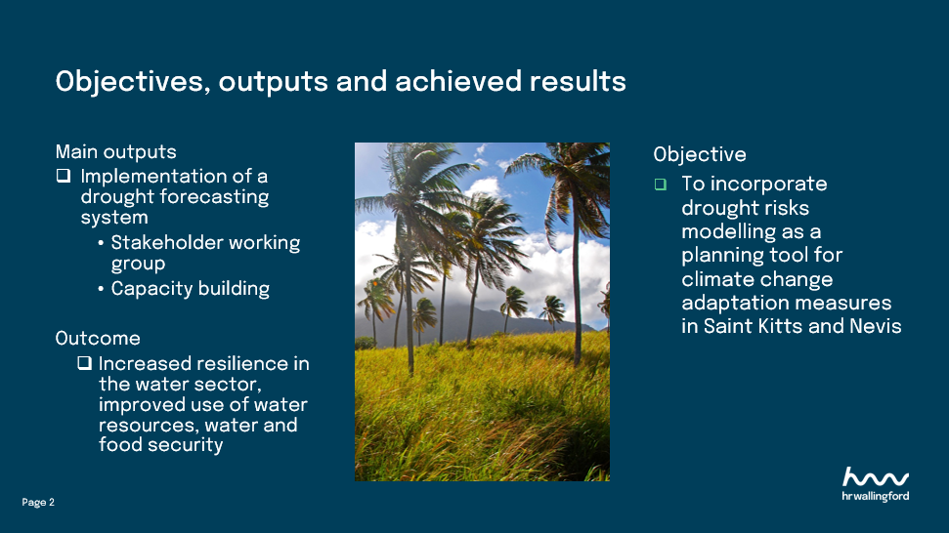
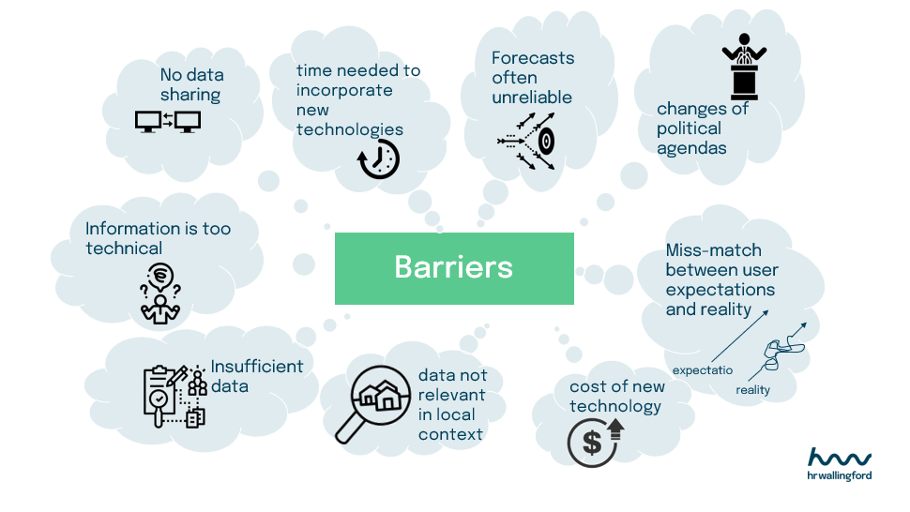
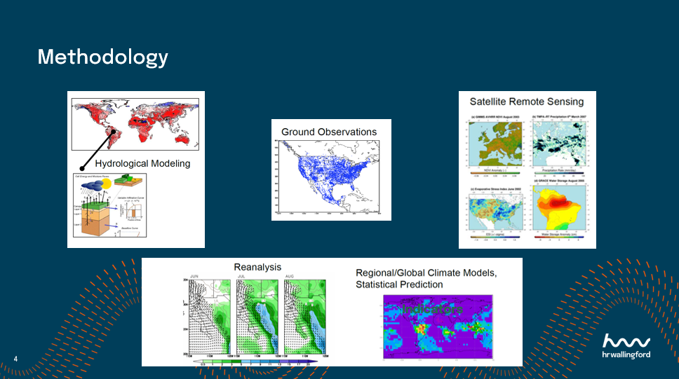
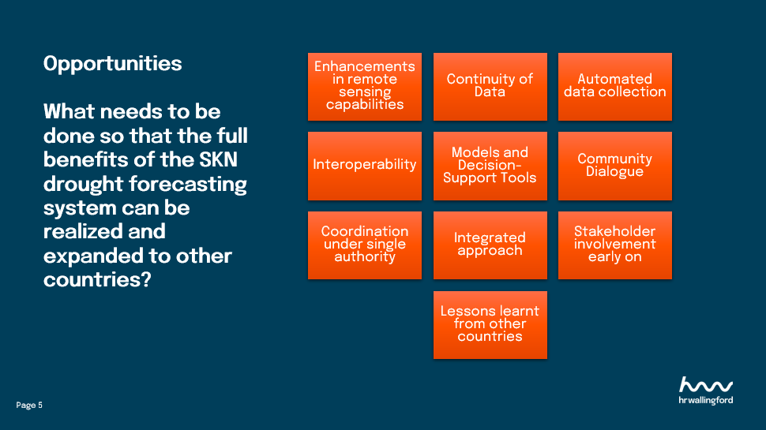

4. Impact Statement
The information in the table below will be used to communicate results and anticipated impacts of this technical assistance publicly. Please copy information from impact statement developed in the M&E Plan and update as relevant.

Challenge | Climate change and variability pose challenges to the water sector of Saint Kitts and Nevis (SKN). The recent push towards an agricultural and tourism-based economy places a greater demand on already stressed water resources. Identifying areas and vulnerable groups most susceptible to water supply shortages is crucial to facilitate early action to manage risks.  By providing timely information in advance of, or during the early onset of a drought, action can be taken to reduce potential impacts. In doing so, this will increase resilience in the water sector of SKN.
CTCN Assistance | - Map stakeholders and establish a stakeholder working group;  - Assess drought risk and water resources in SKN;  - Benchmark, design and implement a drought prediction model in SKN;  - Train administrators and users of SKN to the drought prediction model.
Anticipated impact | - This project has enabled SKN to benefit from a drought prediction system.  - The assistance has provided stakeholders with information that will improve their ability to plan in advance for managing water shortages in the areas most at risk.  - In the long term it will ensure resilience in terms of water and food security.
Co-benefits: Achieved or anticipated co-benefits from the TA | All households including vulnerable persons will benefit from improved water supply systems and planning tools for climate change adaptation through:  - Better access to water and improved water supply systems  - Sustainable water delivery to communities: with more informed planning, water rationing can be avoided and a more effective supply structure put in place.
Gender aspects of the TA | Drought management studies have shown that women are more severely affected by drought than men, as they are often the ones caring for domestic duties that are inherently ‘water intensive’. SKN has a high number of female-headed households, many of whom are poor. If there is limited or lack of water supply, the burden on such women to care for their households is significant and can affect sanitation, health and hygiene and nutrition. With more informed drought planning, the negative impacts of water cuts and restrictions can be avoided, and a better-informed water supply system put in place. Special attention to the needs of women and youth and those in vulnerable situations is essential.  Poor households benefit especially from planning tools for climate change adaptation, water saving measures and better access to water in times of drought.
Anticipated contribution to NDC | - The SKN Intended Nationally Determined Contribution (INDC) underlines the importance of protecting the water sector for socio-economic sustainability  - The SKN water resources are highly vulnerable to climate change.  - The SKN national climate change adaptation strategy and action plan highlight the impacts of climate change and variability on the water sector.  - This TA has strengthened the drought risk forecasting capabilities of SKN and the availability of information to cope with future water shortages.
The narrative story | SKN is classed as water scarce, which the UN defines as countries with less than 1000 cubic meters per capita of renewable water resources a year. Recent studies have shown that in SKN it is expected to see more frequent and severe droughts from reduced precipitation and increased evaporative demand due to anthropogenic climate change. In an effort to address the impacts of climate change and climate variability in a sustainable way, access to critical information within the water sector is vital.  The Department of Environment, Ministry of Environment and Cooperatives of the government of SKN requested assistance through the CTCN to implement a drought forecasting model as a planning tool for climate change adaptation. The drought forecasting model is now helping national officers from SKN to identify areas most susceptible to water supply variability and shortages, and therefore to take early action to manage these risks.  The CTCN assistance has helped to fill the identified gaps by strengthening expertise of national practitioners to use the drought forecasting software.
Contribution to SDGs  A complete list of SDGs and their targets is available here: https://sustainabledevelopment.un.org/partnership/register/ | The Project outcomes respond directly to SDG 13 ‘Taking early action to combat climate change and its impacts’ by providing a system that supports planning and decision-making for the sustainable management and conservation of water resources in SKN.  The Project has also contributed to SDG 1 (End poverty), SDG 2 (Food security) and SDG 6 (Availability and sustainable management of water) as the drought prediction model is improving agricultural use of water resources, which in turn contributes to improved food security and increased incomes of rural communities.

Annex 1 Technical assistance data collection

Please add quantitative and qualitative values for the indicators selected in the M&E plan and monitored throughout the technical assistance in the tables below. Indicators which have been monitored in addition to the proposed indicators below may be added at the end of table A. Non-relevant indicators should be left blank.

- Output and outcome indicators

Indicator  Please note indicators below highlighted as anticipated | Quantitative value  Numerals only; disaggregates must sum to the total | Qualitative description  List the various elements corresponding to the quantitative value as well as timelines and responsible institutions
Total number of events organized by proponents and implementing partners | 6 | Kick-off meeting  3 stakeholder workshops  2 training workshops
Number of participants in events organized by proponents and implementing partners | 33
- Number of men | 19 | 18 St Kitts and Nevis  1 UK
- Number of women | 14 | 11 St Kitts and Nevis  1 UK  1 Canada  1 Spain
Number of climate technology RD&D related events | 5 | Kick-off meeting  3 stakeholder workshops  2 training workshops
Number of participants in climate technology RD&D events | 33
- Number of men | 19 | 18 St Kitts and Nevis  1 UK
- Number of women | 14 | 11 St Kitts and Nevis  1 UK  1 Canada  1 Spain
Number of training organized by proponents and implementing partners | 2 | - Showcasing the drought forecasting tool  - Obtaining feedback from the Stakeholder Working Group and potential areas for improvement  - Discussing ownership, data requirements and operationalisation of the tool
Number of participants in trainings organized by proponents and implementing partners | 28
- Number of men | 14 | 14 St Kitts and Nevis
- Number of women | 14 | 11 St Kitts and Nevis  1 UK  1 Canada  1 Spain
Total number of institutions trained | 10
- Governmental (national or subnational) | 8 | - Nevis Disaster Management Department (NDMD)  - Department of Environment (DOE)  - Integrated Water Resources Management (IWRM), Nevis  - St Kitts Met Office / St Christopher Air & Sea Ports Authority(SCASPA)  - Department of Physical Planning, Ministry of Sustainable Development (DPP)  - Department of Physical Planning and Environment (DPPE) Nevis  - National Emergency Management Agency (NEMA)  - Water Services Department
- Private sector (bank, corporation, etc.) | 1 | - HR Wallingford
- Nongovernmental (NGO, University, etc.) | 1 | - Inter-American Institute for Cooperation on Agriculture (IICA), St Kitts office
Percentage of participants reporting satisfaction with CTCN training (from CTCN training feedback form) | 100% | Satisfied= 4+ on 5-pt scale
Percentage of participants reporting increased knowledge, capacity and/or understanding as a result of CTCN training (from CTCN training feedback form) | 100% | Increased knowledge, capacity and/or understanding= 4+ on 5-pt scale
- Percentage of men | 100%
- Percentage of women | 100%
Total number of deliverables produced during the assistance (excluding mission, progress and internal reports) | 20
- Number of communication materials, including news releases, newsletters, articles, presentations, social media postings, etc. | 3 | - CTCN Conference presentation (Santo Domingo, 2022)  - Caribbean Water and Wastewater Association (CWWA, 2022) annual conference  - GWP-C Water Symposium (2023)
- Number of tools and technical documents strengthened, revised or developed | 9 | Drought forecasting system  D 2.1: Saint Kitts and Nevis drought assessment  D 2.2: Detailed report on the 3D mapping of aquifers  D 2.3: Report on the water balance  D 2.4: Report on water conservation measures/technologies  D 3.1: Benchmarking of drought prediction models  D 3.3: Design dought prediction model, plan & framework  D 3.5: Drought prediction model deployed and functioning  D 4.1: Manual for administrators  D 4.2: Manual for users
- Number of other information materials strengthened, revised or created (For example training and workshop reports, Power Points, exercise docs etc.) | 11 | D.0.1: Detailed implementation plan  D.0.2: Monitoring and evaluation plan.  D.0.2: Impact Statement (initial and final version).  D.0.4: Technical Assistance Closure Report  D 1.1: Report on stakeholder mapping  D 1.2: Detailed description of the stakeholder working group  D 1.3: Minute of the inception meeting  D 2.5: Minute of the stakeholder working group meeting  D 3.2: Minute of the meeting and selection of the model  D 3.4: Minute of the meeting, on the design and framework  D 4.3: Minutes of the training, materials used
Total number of policies, strategies, plans, laws, agreements or regulations supported by the assistance | NA
- Adaptation related
- Mitigation related
- Both adaptation- and mitigation related
Anticipated number of policies, strategies, plans, laws, agreements or regulations proposed, adopted or implemented as a result of the TA | NA
- Adaptation related
- Mitigation related
- Both adaptation- and mitigation related
Anticipated number of technologies transferred or deployed as a result of CTCN support | 1 | Hazard mapping solutions  Seasonal to interannual weather forecast  Early Warning Systems Communication  Water resource assessment  Disaster risk assessment tools  Open source climate data and tools  Hydrological modelling  Stakeholder consultations
Anticipated number of collaborations facilitated or enabled as a result of technical assistance | List total number here
- Number of South-South collaborations
- Number of RD&D collaborations | 1 | Collaboration of HR Wallingford-led team with local stakeholders from St Kitts and Nevis
- Number of private sector collaborations
Number of countries with strengthened National System of Innovation as a result of CTCN support | 1 | St Kitts and Nevis
Insert any additional indicators here

- Core impact indicators

Please fill in the tables for anticipated impacts of the CTCN assistance. Every technical assistance should contribute to at least one of the indicators below. For guidance on how to report on core indicators see the ‘M&E Guidance Document for TA Implementers’.

Core indicator 3 | Anticipated number of direct and indirect beneficiaries as a result of the TA
 | Quantitative value | Means of verification
Total beneficiaries | Total number
Number of adaptation beneficiaries | 33 | Number of people directly trained by the project team
Number of mitigation beneficiaries | 33 | Number of people directly trained by the project team
Number of adaptation-and mitigation beneficiaries | 33 | Number of people directly trained by the project team

(A) Outputs and Activities as described in the Response Plan | (B) Indicator | (C) Results
Project-level impact | Anticipated number of direct and indirect beneficiaries as a result of the TA | -Department of Environment  -St Kitts Water Services Department  -Farmer, Youth and Gender Associations  -Nevis Water Department and Nevis IWRM Unit  -St Kitts and Nevis Meteorological Services  - National Emergency Management Agency  -Nevis Department of Disaster Management  - Departments of Agriculture St. Kitts and Nevis  -Department of Physical Planning (National GIS Lab)
Output 1: Map Stakeholders and establish a stakeholder working group (SWG) | Total number of institutions identified | 9 institutions  8 stakeholder working group members
Output 2: Assess drought risk and water resources in Saint Kitts and Nevis (SKN) | Total number of tools, technical  documents and  material produced | 4 technical reports (see activities 2.1 – 2.4) and minutes from meeting (activity 2.5)
Activity 2.1: Assess drought risk in SKN and generate GIS risks maps for SKN | Drought risks in SKN assessed | - SKN drought  assessment report
Activity 2.2: Map the total water resources including the groundwater  in SKN. | Total water resources in SKN assessed | -Detailed report on the SKN water resources
Activity 2.3: Estimate the water balance in SKN | Water balance in SKN estimated | -Report on the water balance in SKN
Activity 2.4: Identify water conservation measures and recommend technologies to save water in the high consuming  water sectors for SKN. | Water conservation measures identified and technologies to save water in the high consuming  water sectors recommended | -Report on water conservation measures and technologies recommended to save water in the high consuming water sectors for SKN
Output 3: Benchmark, design and implement a drought prediction model in SKN | Total number of deliverables (tools and technical documents) | Two technical reports (activities 3.1 and 3.3), minutes from two meetings (activities 3.2 and 3.4) and demonstration of the tool
Activity 3.1: Benchmark and select the most suitable drought prediction model for SKN | Number of drought risk models identified and benchmarked | -Report on benchmarking of drought models suitable for SKN
Activity 3.3: Design the architecture of the drought prediction model for SKN | Architecture of the drought prediction model designed | -Implementing plan and operational framework technical document
Activity 3.5: Implement the drought prediction model in SKN | Number of technologies transferred or deployed as a result of CTCN support | 1
Output 4: Train administrators and users of SKN to the drought prediction model | Total number of deliverables (tools and technical documents)  Anticipated number of technologies transferred or deployed as a result of CTCN support  Percentage of participants reporting satisfaction with training  Percentage of participants reporting increased knowledge, capacity and/or understanding as a result of training | Two manuals, drought prediction model operational, training material, minutes of training  1  100%  100%
Activity 4.1: Develop a manual of use for the administrators of the drought prediction model | Total number of deliverables (tools and technical documents) | Manual for administrators
Activity 4.2: Develop a manual of use for the users of the drought prediction model | Total number of deliverables (tools and technical documents) | Manual for users

Annex 2 (for internal use – to be filled in by the CTCN)
CTCN evaluation
This section will be completed by the relevant CTCN Technology Manager.

- Evaluation of the timeliness of the TA implementation as measured against the timeline included in the response plan;
- Evaluation of TA quality as defined in the response plan;
- Overall performance of the Implementers;
- Overall engagement of the NDE and Proponent;
- Lessons learned on the CTCN process and steps taken by the CTCN to improve.

