
3rd CTCN Advisory Board Meeting
19-21 March 2014 - Copenhagen, Denmark
Information for participants

The 3rd meeting of the CTCN Advisory Board Meeting will be
held at the UN City in Copenhagen, Denmark.

This document answers commonly asked questions and provides a range of information
to facilitate your participation and stay during the meeting.

Where do I get my conference badge?

Board members, Parties and observers can register outside the Auditorium – ground floor.

Badges are issued to participants on the basis of receipt of a registration form. Representatives of Observer Organizations must be registered in order to be issued a badge.

Registration counters opening hours:
Wednesday, 19 March 2014
13:30 to 14:30

Opening of the meeting will be at 14:30

At the entry to the UN City building in Copenhagen you will be met by the security guards and receive a guest badge. You are kindly requested to wear it visibly so that you are not approached and asked for identification during your stay. We apologize for any inconvenience this may cause, but trust that we have your understanding in view of the fact that the above rules have been implemented to protect staff and guests visiting the UN City.

Please note that access to the conference area is restricted to registered participants of the meeting.

Disclaimer: The United Nations and the Convention secretariat disclaim all responsibility for medical, accident and travel insurance, for compensation for death or disability, for loss of or damage to personal property and for any other costs or losses that may be incurred during travel time or the period of participation. In this context, it is strongly recommended that you obtain international medical insurance for the period of participation.

Where is the meeting venue?

The CTCN Advisory Board Meeting will be held at UN City, in Copenhagen, Auditorium A1: Marmorvej 51, 2100 Copenhagen Ø. A map with the location of the UN City can be found in Annex I.

How to book a hotel in Copenhagen?

For accommodation in Copenhagen, please visit the website of various hotels in Copenhagen city area here
How to get to the UN City?

From Copenhagen international airport
By taxi:
The UN City Copenhagen is located approximately 19 kilometres from the airport. The taxi ride from the airport to UN City takes about 30–40 minutes and costs between DKK 300 to 350/USD 55-65. Taxis are available just outside terminals 2 and 3.
On your departure from UN City, the receptionist will call a taxi on your request.

By train
You may choose the regional train or the metro:
Regional train:
The train station is located in terminal 3; the ticket office is located in the same terminal above the railway. Automatic ticket machines are also available at the airport. Take the train (destination: Helsingør (Elsinore) and get off at the Nørreport station. The train leaves every 20 minutes.
From Nørreport station travellers should take one of the following S-trains and get off at Nordhavn station:
* the A-line (direction: Farum),
* the B-line (direction: Holte) or
* the C-line (direction: Klampenborg).
Travel time from the airport to Nordhavn Station is approximately 40–50 minutes.

Metro:
The metro station is located at the end of terminal 3 and is covered by the roof of the terminal. From the airport the metro M2 (direction: Vanløse) is in operation throughout the day and night and departs from the airport with 2–6 minutes intervals. Travellers should get off at Nørreport station.
From Nørreport station travellers should take one of the following S-trains and get off at Nordhavn station:
* the A-line (direction: Farum),
* the B-line (direction: Holte) or
* the C-line (direction: Klampenborg).
Travel time from the airport to Nordhavn Station is approximately 30–40 minutes.

From the city centre
By taxi
The distance from the centre of Copenhagen to UN City is about 5 km. You should expect to pay around DKK 135/USD 25.

By train
The UN City building is located close to Nordhavn Station. The trains are called S-trains and are identified by a big S sign outside the station and on the platform. The following regional trains run between Copenhagen main station and Nordhavn: lines A, B, C. From the station there is a 15 min walk to the office.

By bus
The busses 80N, 3A, 18 and 40 stop at Nordhavn station. The bus 26, direction Unicef Færgehavn Nord, stops at the UN City (FN Byen in Danish) – time schedule is available at www.movia.dk. Please enquire with your hotel where to find the closest bus stop and where to change if you need to take more than one bus.

How to get from Nordhavn Station to the UN City by foot:
Once you exit Nordhavn Station, turn right down Østbanegade. At the end of Østbanegade, you turn right on Århusgade and cross under the railway lines. Continue on approx. 100 metres (after crossing Kalkbrænderihavnsgade, the road will become a path) and turn right, down Sandkaj. Hereafter you continue to the end of the street (approx. 450 metres) and turn left at Marmorvej. Here you continue down Marmorvej 400 metres, until you reach the main entrance to the FN City on your left at nr. 51 Marmorvej.

If you wish to plan your own travels in Copenhagen by public transport, it can be done via the flowing link: journey planner

Visit the Copenhagen airport web site CPH

Train services (DSB)

Copenhagen Central Station
(“Kobenhavns Hovedbanegaard”)
Tel: +45 70131415

Travel information for trains can be found on this link DSB. Tickets can be ordered electronically, find information how to here, & order here

By taxi
The fare for a taxi ride from the airport to Copenhagen city is around 38 EUR/50 USD. The central phone number for Copenhagen taxis is (+45) 4848 4848.

By car
From Sweden/Malmö
Find the route via Driving Routeplanner here
From Germany/Berlin
Find the route via TomTom Routeplanner here

Note for visitors

There is parking available at the venue. Once you turn left down Marmorvej from Gittervej, it is the first road on the right.

Other options in the centre of Copenhagen (near the Central Station) are:

City Auto & P-service
Jernbanegade 1
1608 KBH V.

Saga P-Hus
Vesterbrogade 23-27
1620 København V

The costs for whole day parking in central Copenhagen will be 35 Euro (5 Euro per hour).

DSA disbursement and travel

CTCN Board members eligible for funding should contact UNEP staff to collect their daily subsistence allowance (DSA) during the coffee break on the first day of the meeting. You will need your passport or other official identification (with photo ID), flight ticket and boarding pass stubs when claiming DSA.

Internet/computer facilities
A computer with internet connection is available on the ground floor of UN City for the use of visitors. Detailed instructions will be announced there.

Coat stands/wardrobe
Unattended coat stands are available in the Conference area. Suitcases may be stored safely in this area too. Please contact the reception staff on this issue.

Conference rooms
All rooms are placed on the ground floor of the building. Smoking is not allowed on the UN City island. All meetings are announced on screens in the conference area.

From 13:00-14:30 the cafeteria provides a buffet-style lunch with hot and cold meals, soup, cheese, salads and fruit. The cost is approximately DKK 39; it is possible to pay with credit cards.

Banking

The Danish currency is the krone (crown) which is made up of 100 øre. Denmark does not participate in the single European currency (EURO), but major shops will accept payment in EURO.
The banks usually stay open from 10:00 to 16:00 Monday to Friday. Outside opening hours, cash can be obtained from the numerous cash dispensers. Most banks have these machines outside in the street and all major credit cards are accepted (be sure to have the PIN code). The most common credit card in Denmark is the Visa card.

Notices – anything else I should know?

You can call the following emergency numbers for assistance:

Police Services - Tel: 114
Fire brigade - Tel: 112
Emergency doctor / ambulance - Tel: 112

Telephone information service: Tel: 118

Taxi service - Tel. +45 4848 4848

Lost Property Offices
For lost luggage or other possessions:
• On a plane, please contact the relevant airline or Copenhagen Air Service in the terminal area. The website also keeps a list of registered lost items during the last 30 days (www.cph.dk).
• On a bus: call MOVIA Service centre: 36 13 14 15.
• On a train: call Danish Railway (DSB): 24 68 09 60.
Lost property is kept at end stations for up to 7 days and are then handed over to the police. In the Copenhagen area, please contact the police at (+45) 38 74 88 22 or by email:
kbh-hittegods@politi.dk.

Consulates and embassies in and around

For further information, one may want to visit below mentioned link for the complete contact list of the foreign diplomatic missions represented in the country:

Where to eat in Copenhagen

For information on places to eat in Copenhagen, please visit the following link here.

Visitor information

Time zone: Central European Time (GMT +1)
Currency: 1 DKK = 0.13 Euro / 1 DKK = 0.17 USD
Telephone country code: ++45
Power voltage: 230 V, 50 Hz. 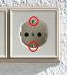 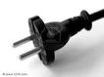
Time zone: Central European Time (CET) with European daylight savings time
Climate: Moderate climate zone
Average temperature in May: 10-12° C
Forecasts

Further information for visitors can be found on the website of the City of Copenhagen,
Visit Copenhagen or Copenhagen

Annex I

The FN City in Copenhagen, Marmorvej 51 - 2100 København Ø
Bridge under railway
Nordhavn Station
The FN City
Axelborg
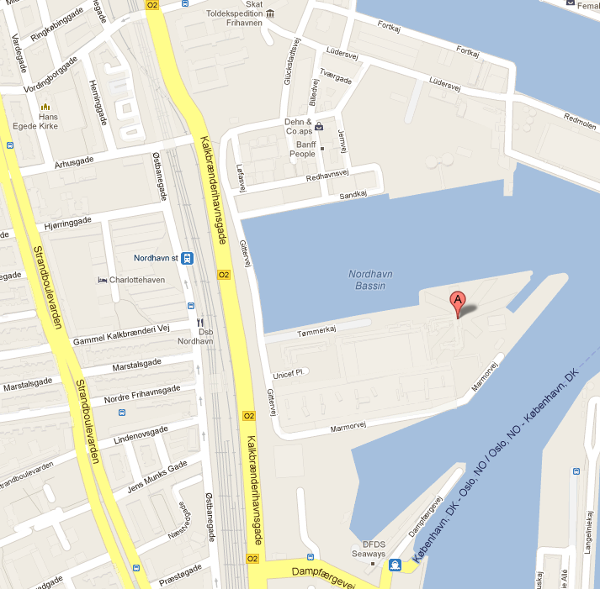
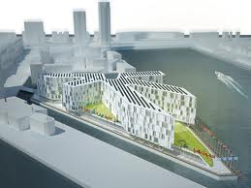
Tivoli

