Presentation of the Fast Technical Assistance The Fast Technical Assistance (FTA) is the Climate Technology Centre & Network (CTCN) short time response to requests referring to technology prioritisation, endogenous technologies assessment, policies and measures that are immediate priorities for the requesting country. FTA has duration up to 2 months and a total value typically up to USD 15,000 (it may include a scoping mission, only if strictly necessary). The FTA is implemented by means of an international expert.

Guidelines:
- This Request Submission Form should be completed by the organisation requesting technical assistance from the Climate Technology Centre & Network (CTCN) in collaboration with the National Designated Entity (NDE) of the country in question
- The Form must be signed by the NDE. Please see updated contact list of NDEs here: http://unfccc.int/ttclear/support/national-designated-entity.html
- The Form can be submitted as a Word file containing a digital signature or as a signed and scanned PDF file in combination with an un-signed Word file

Requesting country: | CAMBODIA
Fast Request title: | Capacity assessment of integrating Solar power (or renewable energy sourced power) into the local grid and development of grid codes on a pilot geographic area in Cambodia
NDE | General Secretariat of the National Council for Sustainable Development/Ministry of Environment, Cambodia  Focal Point: Dr. Hak Mao  Position: Director of the Department of Climate Change  Email: maohakccd.se@gmail.com  Address: No. 503, Road along Bassac River, Sangkat Tonle Bassac, Chamkarmon, Phnom Penh, Cambodia
Request Applicant: | General Secretariat of the National Council for Sustainable Development/Ministry of Environment, Cambodia  Contact person: Dr. Hak Mao  Position: Director of Department of Climate Change  Email: maohakccd.se@gmail.com  Address: No. 503, Road along Bassac River, Sangkat Tonle Bassac, Chamkarmon, Phnom Penh, Cambodia

Climate objective:
Adaptation to climate change
☑Mitigation of climate change
Combination of adaptation and mitigation of climate change

Geographical scope:
Community level
Sub-national
National
The proposed project located in Taphem and Chheang Torng commune, Tramkok district, Takeo province. Schools and Pagoda will be used for demonstration of installing solar power. It will be beneficial for monks and followers and students. We expect that the installation of solar power will contribute to light class room in the evening so that students can use for extract class.

Sectors:
Please indicate the main sectors related to the request:
Coastal zones | Early Warning and Environmental Assessment | Human Health | Infrastructure and Urban planning
Marine and Fisheries | Water | Agriculture | Carbon fixation
Energy Efficiency | Forestry | Industry | Renewable energy
Transport | Waste management

CONTEXT OF THE ASSIGMENT (up to half page):
This section should present the climate problem and the national context within which it takes places (i.e. efforts to tackle it, climate policies and priorities, etc). It should end with an explanation of the specific questions and issue the CTCN expert would have to address.

Please list or attach relevant documents that will help the CTCN analyse the context of this request.

Cambodia is a least and vulnerable to the impacts of climate change in the ASEAN. Although the government has tried utmost effort to install and contract electricity line rural areas still can’t access to national grid. To meet the objectives of the government to access to electricity consumption, off-grid (solar, battery, kerosene lamp) has been introduced, especially the remote areas. With the increasing population and economic growth, more electricity demand is needed and the government has committed to exploring possible energy options to supply. On this, the proposed proposal will partially contribute to meeting country’s commitment. (please read more country information on second national communication, NDC, National Strategic Development Plan, Rectangular Strategy, Energy Master Plan, Energy Efficiency Policy, Cambodia Climate Change Strategic Plan, etc. to extend this description)

Alignment with national priorities :
Please describe how the technical assistance is consistent with national climate priorities such as: Nationally Determined Contribution, national development plans, poverty reduction plans, technology needs assessments, Low Emission Development Strategies, Nationally Appropriate Mitigation Actions, Technology Action Plans, National Adaptation Plans, Sectorial Strategies and Plans, etc.
Reference document (please include date of document) | Second national communication, NDC, National Strategic Development Plan, Rectangular Strategy, Energy Master Plan, Energy Efficiency Policy, Cambodia Climate Change Strategic Plan, etc.
Nationally Determined Contribution (NDC) | Government has set a conditional commitment to reduce emissions of 27% in 2030 compared to BAU level. Energy efficiency and renewable energy are priority actions proposed to achieve the commitment. (See detail in INDC/Cambodia Climate Change Strategic Plan)
Technology Needs Assessment | Prepared in 2013 and no updated
National Adaptation Plans | Available
Nationally Appropriate Mitigation Actions | 2 reports developed (Energy Efficiency in Garment Factory and Energy Efficiency Cook-stove)
Add others here as relevant | Relevant reports listed above

OBJECTIVE OF THE FTA (up to 5,000 characters):
The objective of this study would be to Enhance capacity to transition to renewable energy and energy efficiency by:
• Providing a better understanding of the achievable levels of renewable energy integration;
• Developing capacity to conduct grid stability assessment;
• Developing a comprehensive methodology for the grid stability assessment; and
• Providing technological options for grid stability and renewable energy integration.

This section should present the overall objective of the assignment, including the result expected by the end of the Fast Technical Assistance

SCOPE AND ACTIVITIES OF THE PROPOSED FTA (up to one page):
The FTA should clearly contribute to mitigation or adaptation to climate change as described in the context of the assignment.
Within a clearly defined scope, the description of the FTA should be structured into the following:
- Expected activities
- Expected deliverables (following the structure of the activities)
- Expected use of the deliverables by the requesting organisation

Please note that the CTCN facilitates technical assistance and is not a project financing mechanism. All FTA has one mandatory activity, “Evaluation and communication”.

Activity x: Evaluation and communication
The CTCN FTA Closure report will be completed at the end of the FTA (a template will be provided).
Deliverable:
FTA Closure report

GENERAL TIME SCHEDULE OF EXPERT AND ACTIVITY/DELIVERY PLAN:
The activities under this contract must be completed within a period of X months. Please note that the maximum time for the assignment is 2 months.

Monitoring and impact of the assistance:
By signing this request, I affirm that processes are in place in the country to monitor and evaluate the technical assistance provided by the CTCN. I understand that these processes will be explicitly identified in the CTCN Response Plan and that they will be used in the country to monitor the implementation of the technical assistance following standard CTCN procedures.

Signature:
NDE name: | Dr. Hak Mao
Date: | 5 May 2020
Signature: | 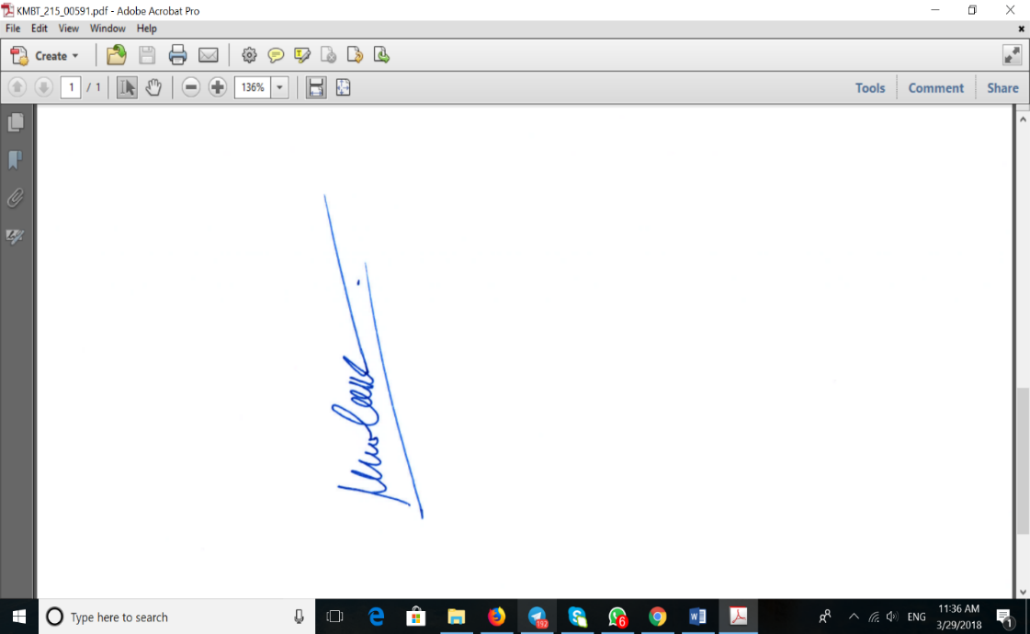

THE COMPLETED FORM SHALL BE SENT TO THE CTCN@UN.ORG

