En Lima, a 20 de noviembre de 2019

A quien corresponda:

Tengo el gusto de adjuntarles el informe de Cierre y de Datos de la Asistencia Técnica brindada por AAE a nuestro Ministerio.

Sin otro particular, reciban un cordial saludo,

Silvia Cristina Rodríguez
Directora Adaptación al Cambio Climático y Desertificación
MINAM

Closure and Data Collection Report for CTCN Technical Assistance

- Basic information
Title of response plan | Development of a methodological framework for incorporating ecosystem-based adaptation in the process of planning and management of protected areas in Peru
Country / countries | Perú
NDE focal point and organisation | Ricardo Alfredo Vergara, MINAM  Marco Arenas, SERNANP
Proponent focal point and organisation | Guido Fernández de Velasco, AAE
Sector(s) addressed | Adaptation
Technologies supported | Cross-cutting approach: Ecosystems and Biodiversity;  Cross-cutting enabler: Capacity building and learning; Governance and planning
Implementation period and total duration | 2018-2019;
Total budget for implementation | USD 185,097.70  AAE has also provided in-kind support to assist SERNANP present a proposal to COP25 to participate to the upcoming event in Chile to present the main product of the consultancy. Also, consultants assisted the Government on the elaboration of a concept note to mainstream EbA on several protected areas in the country to be presented to the GCF
Designer of the response plan | AAE
Implementer of response plan | AAE

2. Summary of all activities, outputs and products that contribute to the expected impact of the technical assistance.
Description of delivered outputs and products as well as the activities undertaken to achieve them. In doing so, review the log frame of the original response plan and refer to it as appropriate | The project’s main outputs are the following:  - Integration of the Ecosystem based adaptation approach in the Protected Natural Area’s planning process – Conceptual Framework;  - Practical Guide: Integration of the Ecosystem Based Adaptation (EbA) approach in the Protected Natural Area’s planning process of Perú.  - Working Document 14: Technical Guidelines for elaboration or updating Protected Natural Areas that incorporate the climate factor. Methodological and Guiding aspects;  - Guide to incorporate the Ecosystem Based Adaptation to SERNANP’s budgeting process;  - Cerros de Amotape National Park Action Plan to incorporate Ecosystem Based Adaptation measures;  - Socialization Workshop Report on the steps to implement EbA measures in the Tambopata National Park;  - Socialization Workshop Report on the steps to implement EbA measures in the Laquipampa National Park;  - Socialization Workshop Report on the steps to implement EbA measures in the Cerros de Amotape National Park;  - Systematization of national EbA measures identified by all National Protected Area’s Technical Staff; and  - GFC Concept Note: Incorporation of EbA measures to Perú’s Coastal and Mountainous Protected Areas.  Important to mention that outputs 1, 2 and 3 are being edited for online publication at both MINAM and SERNANP’s websites.  During the inception meeting, the client (SERNANP) requested a slight modification to the project’s logframe. More precisely, AAE was requested to update the existing Working Document 14. Thus, the consultancy produced an additional output.  To carry out all project’s outputs, AAE followed the methodology proposed and agreed with SERNANP/MINAM and CTCN. This implied desk top review of international best practices and more precisely, a three-day workshop held in Lima where all National Protected Areas Chiefs were brought to receive a specifically designed capacity building training and gather their valuable knowledge regarding the planning processes and adaptation measures. This three-day workshop was key to design both the Conceptual Framework as well as the Practical Guide. Regarding the Guide, the consulting team (composed of the international EbA and Protected Area specialist together with the national experts) conducted three socialization workshops in protected areas. The team also reviewed and systematized all EbA measures proposed by the Protected Areas Chief’s and Technical Teams which will be used by MINAM NDAs. Finally, during the first three-day workshop held in Lima, SERNANP and MINAM requested to modify the second training which was to be held to train protected area’s technical team to prepare action plans to incorporate EbA approach in their respective’ s management plans. The training was not longer deemed necessary and asked to assist them and their key teams to design concept notes to include EbA measures into their projects.
Partners organisations | MINAM; SERNANP; Instituto de la Montaña
Beneficiaries | All protected area managers within SERNANP (58); Technicians at SERNANP and MINAM; Protected Area Guards
Methodologies applied to produce outputs and products | International best practices reviews; desk top reviews; information gathering workshops and thematic trainings; individual meetings; validation workshops at specific Protected Areas.
Deviations | As indicated above, the client requested to add one output (number 3) and modify the second planned training. Also, AAE systematized all PAs EbA measures to be used by NIMAM on their NDA’s reporting.
Achieved or anticipated gender benefits from the TA | The capacity building exercise ensured to include all women working for SERNANP both at central and PA level.
Achieved or anticipated co-benefits from the TA | Perú’s NDA include activities to be conducted within Protected Areas. The TA has assisted the Government to identify all Adaptation measures that can be included in the next report to the Paris Agreement.
Anticipated follow up activities and next steps | The SINANPE (National System of Natural Protected Areas by the State), has a strategy which is constructed through a technical and participatory process, this planning instrument is the Master Plan, for a period of 10 years. The process discusses the major issues, of the management of protected areas and even more the new contexts. Climate Change and especially EbA measures will be among the most outstanding issues, more even with the information the Government now has thanks to this TA. Likewise, the Government now has the list of Protected Areas Measures, the first input to build the National Adaptation Plan. Also, they also have the planning processes at the level of the territory or of the Natural Protected Areas through the master plans are the main management documents of an NPAs; in that sense, during the planning processes of the NPAs, and with the technical support from SERNANP headquarters, in the stages and phases identified in the manual, it will be oriented to incorporate climate change and climate variability. Therefore, the manual has emphasized the methodology already used by the institution to accompany the master planning processes. Our processes use a tool called a conceptual model, "taken" from the methodology of open standards, the same as the one used by the NPAs becoming the key to the methodological incorporation of climate change and climate variability. However, SERNANP needs to continue strengthening capacities, so that climate change and climate variability are increasingly and better incorporated into the processes of ANP master plans.  Then the planning processes will support this effort. On the other hand, the improvements in the budgeting process (way of allocating resources), mainstreaming climate change and the special issue of restoration (EBA measures) are other major inputs that the TA has accompanied. The counterparts have indicated that they have a great job ahead of them and consider that a priority issue from now on is to work on the conceptual models and the results chain, accompanied by a strong training process and education at the ground level. Although the TA accompanied in a first stage they now have to continue with this process (search for resources to achieve this must be the next step), in the same way they will move forward with their own capabilities. The client considers the manuals to be a key element in this process.

- Lessons learnt
 | Lessons learnt | Recommendations
Lessons learnt for this TA.  Describe essential factors contributing to successful implementation, as well as specific challenges. Recommendations include considerations on what would need to be in place for increasing success of similar efforts (i.e. regulatory, legal, stakeholders, communication, etc.) | - It is key to test all technical methodologies with personnel on the ground.  - The review process has included over twenty people from two ministries. This has implied a really long time but also that the final products were highly shared and agreed upon. | - Include at the ToR level validation as well as testing of all guides produced;  - Suggest the client to designate a small qualified and dedicated review group to ensure the quality of the evaluation and review process.
Lessons learnt related to climate technology transfer  Describe opportunities, challenges and barriers for the use and deployment of the technology or technologies supported by the TA. The objective is to identify specific success factors for technology transfer | - Ecosystem based adaptation is a new concept but at the end of the day, it relates to tangible adaptation measures to be carried out within Natural Protected Areas (the scope of the TA). | - Ensure the TA captures local technical knowledge.
Lessons learnt related the CTCN process for TA | - A fair amount of time elapses between the elaboration of the ToR and the presentation of the Response Plan. Also, national technicians might change from one step to the other.  - The organization of national workshops brining together all NPA technical staff is a huge logistical task; | - Consider including a first activity to review and adapt the ToR accordingly at a very early stage, even before the inception workshop.  - When organizing national events is key to have national logistics technicians to assist any international firm. Important to budget for an important variation.

4. Illustration of the TA and photos
For communication purposes, please provide 2-4 Power Point slides with illustrations or charts showing the TA process, applied methodology, activities, outputs and achieved results. The illustrations must be copied into the TA Closure report but must also be delivered as power point files. Also, please provide at least five high-resolution pictures in jpg format, capturing technical assistance. The pictures should illustrate how the TA has impacted the lives of the beneficiaries in particular and the communities in general.

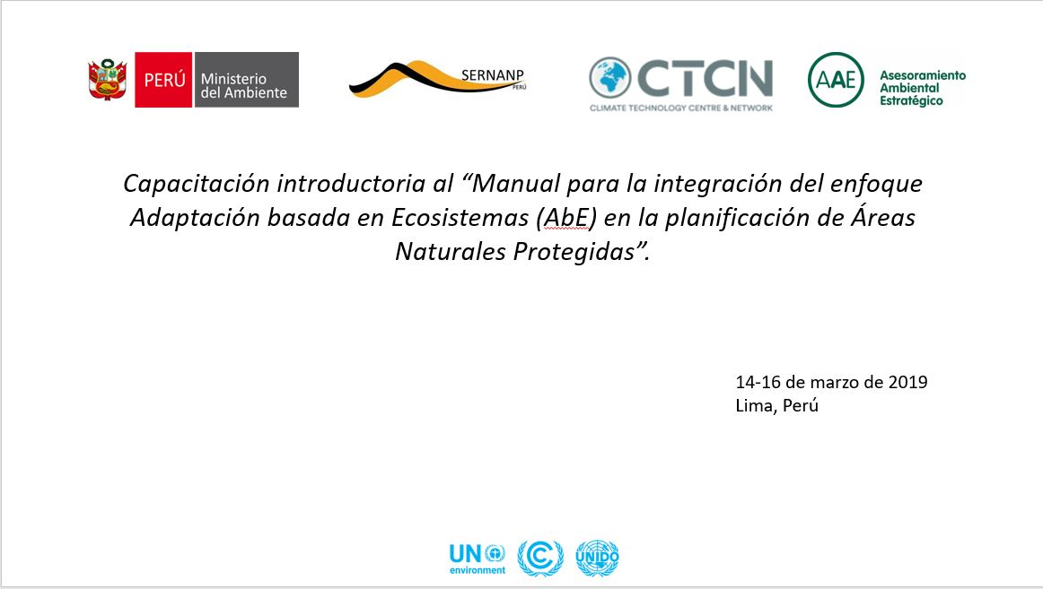

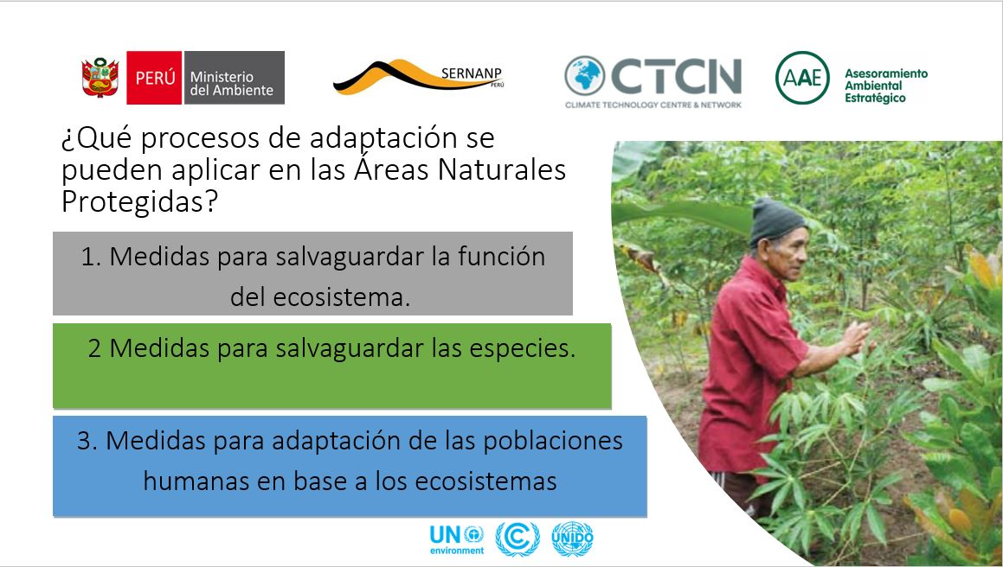

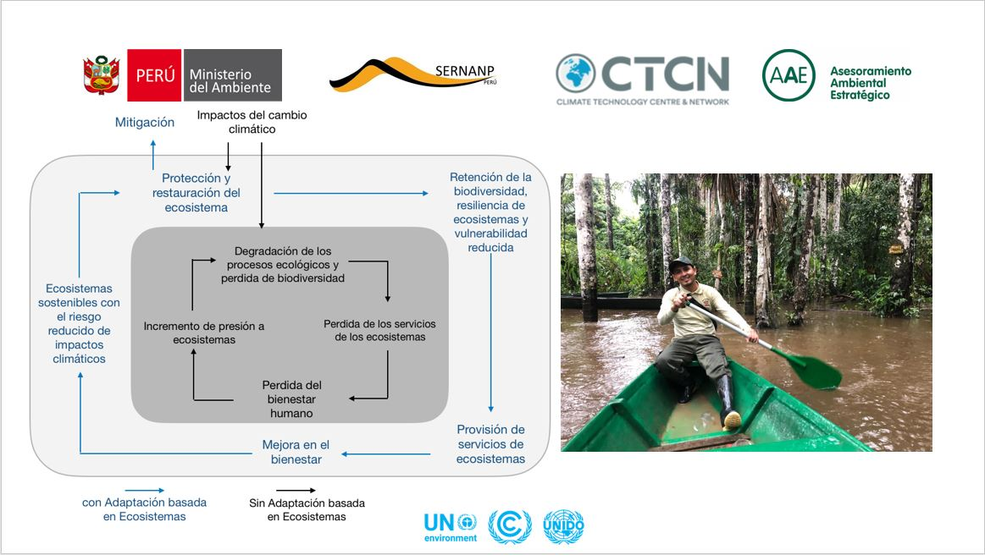

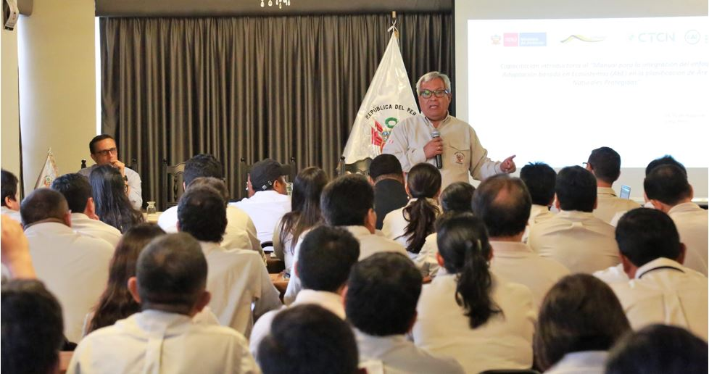

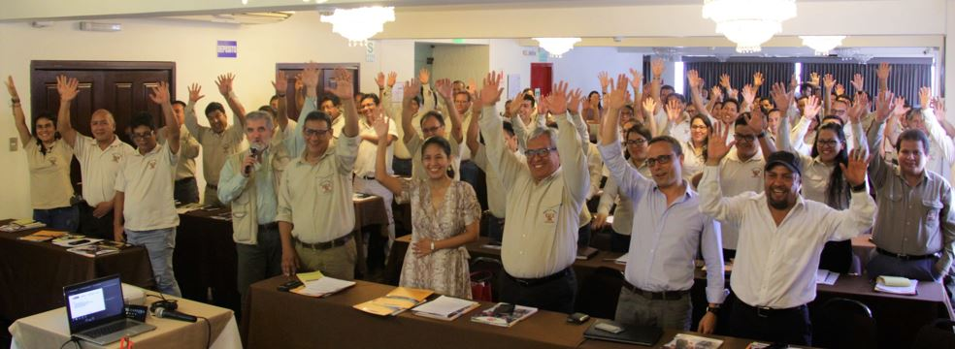

5. Information for TA impact description
The information in the table below will be used to produce the CTCN TA Impact Description. The TA Impact description is a 2-page summary document for communication purposes. Please copy information from sections above and technical delivery reports as required.
Challenge: Approx. 500 characters with spaces | Peru's geographical location, fragile ecosystems and socio-economic conditions make the country highly vulnerable to climate change and variability, while being exposed to a wide variety of extreme events such as Southern Oscillation. Most of Peru's economy and most livelihoods depend on diverse but fragile ecosystems such as the fishing industry, agriculture, the tourism and energy sector. Ecosystem services contributed to Peru's economy with USD 28.8 billion (equivalent to 22% of GDP) in 2009. NPAs are therefore essential for improving the generation of ecosystem services important for the adaptation of the population and climate-sensitive economic sectors.
CTCN Assistance: 2 to 4 bullet points. Approximately 450 characters with spaces | - To assist MINAM and SERNANP develop the necessary tools to assist them and their PA managers to effectively anticipate to climate change impacts by identifying feasible EbA measures and include them into their planning tools and processes.  - To do so, AAE’s team of international and national experts designed a fully participatory methodology to design the necessary tools and validate them on the field to make it as realistic as possible.
Anticipated impact: 2 to 4 bullet points to summarise anticipated impact. Approximately 250 characters with spaces. As a minimum, please include one of the following: i) Quantity of greenhouse gas emissions reduced, avoided or sequestered; or ii) Number of people with increased capacity to adapt to the impacts of climate variability and change. | - The TA has effectively produced two guidelines (“Practical Guide: Integration of the Ecosystem Based Adaptation (EbA) approach in the Protected Natural Area’s planning process of Perú” and “Guide to incorporate the Ecosystem Based Adaptation to SERNANP’s budgeting process” which is a first step to capacitate all relevant actors and provide them with the tools to mainstream EbA into the Pas System planning process to help them comply with their NDA.  - Also, the TA has produced additional technical documents to support the Government’s efforts to better understand how to use ecosystem’s to adapt to climate change (“Integration of the Ecosystem based adaptation approach in the Protected Natural Area’s planning process – Conceptual Framework; and “Working Document 14: Technical Guidelines for elaboration or updating Protected Natural Areas that incorporate the climate factor. Methodological and Guiding aspects”  - 160 people were trained throughout the course of the TA. 60% of the people interviewed surveyed indicated they had improved their knowledge regarding EbA and climate change.
Linkages and contribution to NDC: 2 to 4 bullet points. Approximately 350 characters with spaces | - Within the established NDC at national level 5 correspond to SERNANP to help attain and 2 as co-responsible entity. More precisely, Implementation of ancestral practices in peasant and native communities in the sustainable use of ecosystems (biological diversity, water and soils) to adapt to the effects of climate change; Restoration of ecosystems in the field of SINANPE to maintain landscape connectivity and reduce impacts to extreme weather events; Implementation of a monitoring system, biodiversity and ecosystems in the field of NPAs in face of the impacts of variability and climate change; Implementation of sustainable practices for the conservation of ecosystems in watersheds of the scope of the Protected Natural Areas vulnerable to extreme climatic events and implementation of monitoring and control measures on Natural Protected Areas to reduce the risks of the effects of climate change.  - The TA assisted all 57 PA at national level to determine their EbA measures to build the National Adaptation Plan.
The narrative story: Approximately 1200 characters with spaces | Due to Peru’s geography and socio-economic situation, it is charactized as a highly vulnerable country to the negative impacts of climate change. The country is committed to tackle the effects of climate change and as such has determined its NDC in a highly participatory manner. MINAM and SERNANP are key players and more precisely, SERNANP has 5 NDC assigned to them. SERNANP and the National Protected Area system has in place a natural resources planning process which does not necessarily take climate change nor EbA into consideration. To change this, the Government requested CTCN assistance. AAE put together a strong international and national team which worked for over a year with national counterparts to effectively develop the necessary tools to help PA managers take into consideration potential threats to climate change and identify viable ecosystem based adaptation measures. Training, capacity building and validation on the ground have been key to successfully design all the described tools produced.
Contribution to SDGs: Always include contribution to SDG 13, and to the extent possible, please include contribution to 2 other SDGs, describing the contribution with a few sentence for each SDGs concerned. A complete list of SDGs and their targets is available here: https://sustainabledevelopment.un.org/partnership/register/ | The TA has helped Peru and their responsible institutions to tackled SDG 13 “Take urgent action to combat climate change and its impacts” by building the necessary tools at Protected Area System to adapt to climate change. By identifying adaptation measures at the PA level, the TA has also assisted to SDG 15 “Protect, restore and promote sustainable use of terrestrial ecosystems, sustainably manage forests, combat desertification, and halt and reverse land degradation and halt biodiversity loss”
Note: Please see example of a TA Impact Description at the following link:
https://www.ctc-n.org/sites/www.ctc-n.org/files/benin_a_ag_forestry.final_.pdf
Annex 1 (for internal use in donor and UN reporting)

A. Standardised CTCN performance indicators for donor and UN internal reporting
Please add quantitative values for indicators relevant to the particular TA in the list below. Non-relevant indicators should be left blank. Please only fill in the table for activities and outputs conducted or produced directly by the CTCN assistance.

CTCN standardised performance indicators | Quantitative value | Qualitative description  List the various elements corresponding to the quantitative value
- Overview
Number of active person-days (not full duration) of technical assistance provided to counterparts or stakeholders by international experts and consultants | 150 int | The international team consisted of three consultants. The EbA expert spent three months straight in Perú working directly with the Ministry. Three workshops were held and four missions to Protected Areas. Also, a lot of the work was also conducted from home office.
Number of active person-days (not full duration) of technical assistance provided to counterparts or stakeholders by national experts and consultants | 125 nat | The national team consisted of two national experts plus one project assistant. They all participated in the workshops and conducted field work.
Number of for external communication and outreach activities conducted to showcase the assistance (news release, newsletters, articles on website, etc.) | 3 | Three of the TA’s assistance will be published on MINAM and SERNANPs website.
- Events (other than trainings) held as part of the assistance
Number of international and multi-country (at regional or sub-regional level) technology and knowledge sharing events | NA
Number of participants in the events above | NA
Number of national technology and knowledge sharing events | NA
Number of participants in the events above | NA
Number of public-private events related to technologies | NA
Number of participants in the events above | NA
- Training and capacity building activities conducted during the assistance
Number of training sessions and capacity strengthening activities | 6
Number of people who received the training | 160
Number of men | 90
Number of women | 70
Total number of organisations trained
Number of research organisations, laboratories and universities | 1
Number of private companies | 0
Number of cities and local government | 0
Number of communities | 0
Number of ministries | 1
Number of specialised governmental institutions | 2
Number of non-profit organisations | 1
Level of satisfaction of participants after the training (from training feedback form). Categories include: From very satisfied, satisfied, partly not satisfied, not satisfied at all | Satisfied | The average reached was 2,68 on a scale of 1 to 5
Percentage of participants that increased their capacities thanks to the training (from training feedback form). Categories include: Significantly, very, moderately, to none. | Moderately | The average reached was 2,68 on a scale of 1 to 5
Percentage of men | 60%
Percentage of women | 40%
- Tools, technical reports and information material supported by the assistance
Total number of tools, technical reports and information material supported by the assistance (excluding mission, progress and internal reports)
Number of tools strengthened, revised or developed | 3 | - Integration of the Ecosystem based adaptation approach in the Protected Natural Area’s planning process – Conceptual Framework;  - Practical Guide: Integration of the Ecosystem Based Adaptation (EbA) approach in the Protected Natural Area’s planning process of Perú  - Guide to incorporate the Ecosystem Based Adaptation to SERNANP’s budgeting process;
Number of technical reports strengthened, revised or created | 1 | Working Document 14
Number of other information materials strengthened, revised or created | 1 | GCF Concept note
- Policies, laws and regulations supported by the assistance

Number of policies, strategies, and plans drafted addressing climate change adaptation | 1 | The EbA measures systematized for the National Protected Areas System will help produce the National Adaptation Plan
Number of policies, strategies, and plans drafted addressing climate change mitigation | 0
Number of documents developed to inform other policies, strategies, and plans on climate change adaptation (sectoral strategies, national development plans, etc.) | 0
Number of documents developed to inform other policies, strategies, and plans on climate change mitigation (sectoral strategies, national development plans, etc.) | 1 | The EbA measures systematized for the National Protected Areas System will help produce the National Adaptation Plan
Number of laws, agreements, or regulations drafted addressing climate change adaptation | 0
Number of laws, agreements, or regulations drafted addressing climate change mitigation | 0
Number of documents developed to inform laws, agreements, or regulations on climate change adaptation | 0
Number of documents developed to inform laws, agreements, or regulations on climate change mitigation | 0
- Institutional strengthening supported by the assistance
Number of institutional arrangements in place to coordinate near and long-term national adaptation plans (NAPs) | -
Number of organisations with increased technical capacity to advance near and long term national adaptation plans (NAPs) which integrate EbA | 2 | SERNANP; MINAM
Number of organisations with increase awareness and knowledge among countries to better own and drive national adaptation planning processes | 2 | SERNANP; MINAM
- Partnerships and cooperation
Number of private companies directly engaged in the assistance (that partnered with the proponent, the beneficiaries or the CTCN to implement the assistance) | 0
Number of South-South collaboration enabled during or through the assistance, when stakeholders from other countries were involved in the assistance | NA
Number of North-South collaboration enabled during or through the assistance, when stakeholders from other countries were involved in the assistance | 0
Number of Triangular collaboration enabled during or through the assistance, when stakeholders from other countries were involved in the assistance | 0

B. Indicators of anticipated impacts that may occur after the TA is completed
CTCN standardised performance indicators | Quantitative value  Insert the request value and unit | Content  List the elements included in the number provided | Expected timeline  Indicate when the indicator and value are expected to be achieved | Responsible institution  Indicate the institution(s) that will play leading role in enabling the indicators and anticipated values to be achieved
16. Anticipated finance mobilised
- Anticipated amount of public/donor investment mobilised (in USD) from the beneficiary country for climate change activities as a result of the TA | NA | NA | NA | NA
- Anticipated amount of public/donor investment mobilized (in USD) from international and regional sources for climate change activities as a result of the TA | TBD | 1  Draft GCF concept note | 5 years | SERNANP
- Anticipated amount of private investment mobilised (in USD) from the beneficiary country for climate change activities as a result of the TA | NA | NA | NA | NA
- Anticipated amount of private investment mobilised (in USD) from international and regional sources for climate change activities as a result of the TA | NA | NA | NA | NA
17. Policies
- Anticipated number of policies, strategies, plans, addressing climate change mitigation officially proposed, adopted, or implemented as a result of the TA | NA | NA | NA | NA
Anticipated number of policies, strategies, plans, addressing climate change adaptation officially proposed, adopted, or implemented as a result of the TA. | 1 | The TA provided number of Adaption measures to be applied in NPAs to the future National Adaptation Plan | 2020 | MINAM
- Anticipated number of laws, agreements, or regulations addressing climate change mitigation officially proposed, adopted, or implemented as a result of the TA. | NA | NA | NA | NA
Anticipated number of laws, agreements, or regulations addressing climate change adaptation officially proposed, adopted, or implemented as a result of the TA. | NA | NA | NA | NA
- Anticipated laws, policies, regulations, strategies and plans where climate change mitigation will be mainstreamed as a result of the TA | NA | NA | NA | NA
Anticipated laws, policies, regulations, strategies and plans where climate change adaptation will be mainstreamed as a result of the TA | 1 | The TA provided number of Adaption measures to be applied in NPAs to the future National Adaptation Plan | 2020 | MINAM
18. Anticipated number of public-private partnerships created | NA | NA | NA | NA
19. Anticipated twinning arrangements created as a result of the TA | NA | NA | NA | NA
20. Anticipated number of technology projects prepared and implemented to support action on low emission and climate-resilient development | NA | NA | NA | NA
21. Anticipated number of strengthened National Systems of Innovation and technology innovation centres in recipient country | NA | NA | NA | NA
22. Anticipated Clean Energy Generation Capacity  Clean supported by the TA that has achieved financial closure | NA | NA | NA | NA
23. Anticipated and projected GHG reductions. Quantity of greenhouse gas (GHG) emissions, measured in metric tons of CO_{2-e}, anticipated to be reduced or sequestered as a result of projects supported by the TA | Not feasible to determine at this stage | Not feasible to determine at this stage | Not feasible to determine at this stage | Not feasible to determine at this stage
24. Anticipated clean energy generation capacity supported by the TA that has achieved financial closure | NA | NA | NA | NA
25. Anticipated and projected greenhouse gas emissions reduced or avoided through 2030, in metric tons of CO_{2-e}, from adopted laws, policies, regulations, or technologies related to clean energy/sustainable landscapes as a result of the TA | Not feasible to determine at this stage | Not feasible to determine at this stage | Not feasible to determine at this stage | Not feasible to determine at this stage
26. Anticipated number of people improving their livelihood as co-benefits as a result of the TA | Not feasible to determine at this stage | Not feasible to determine at this stage | Not feasible to determine at this stage | Not feasible to determine at this stage
27. Anticipated technology types effectively deployed in the country | NA | NA | NA | NA
28. Anticipated UNFCCC processes implemented as a result of the TA (NAMA, NAPA, NDC, etc.) | 1 | The National Adaptation Plan | 2020 | MINAM
29. Anticipated Technology Needs Assessments (TNA) and technology Action Plans (TAP) as a result of the TA | NA | NA | NA | NA
30. Anticipated cooperative research, development and demonstration programmes within and between developed and developing country Parties facilitated as a result of the TA | NA | NA | NA | NA
31. Anticipated improved climate change observation systems and related information management in developing country Parties. | NA | NA | NA | NA

Annex 2 (for internal use – to be filled in by the CTCN)
CTCN evaluation
This section will be completed by the relevant CTCN Technology Manager.

- Evaluation of the timeliness of the TA implementation as measured against the timeline included in the response plan;
- Evaluation of TA quality as defined in the response plan;
- Overall performance of the Implementers;
- Overall engagement of the NDE and Proponent;
- Lessons learned on the CTCN process and steps taken by the CTCN to improve.

