Request Submission Form for CTCN Technical Assistance
(Final Version - July 2014)

APPLICANT/CONTACT:

National Designated Entity: Environmental Protection Agency, Ghana
Contact person: Joseph Amankwa Baffoe
Position: Principal Programme Officer
Phone: +233 302 662465 and +233262373698
Fax: +233 302 662690
Email: jabaffoe@gmail.com and joseph.baffoe@epa.gov.gh
Postal address: P.O.Box M326 Accra

National Designated Entity: Kenya Industrial Research and Development Institute.
Contact person: Dr. M. C. Z. Moturi
Position: Director
Phone: +254 20 6003842/6003493/6009440
Fax: +254 20 6007023
Email: dir@kirdi.go.ke
Postal address: P.O. Box 30650 – 00100 G.P.O. Nairobi, Kenya

National Designated Entity: Mauritius
Contact person: Mr P.Jhugroo
Position: Permanent Secretary
Phone: 230 2127181
Fax: 230 2128324
Email: pjhugroo@mail.gov.mu
Postal address: Ministry of Environment & SD, 10th Floor, Ken Lee Tower, Barracks Street, Port Louis

National Designated Entity: Namibia
National Designated Entity: Ministry of Environment and Tourism
Contact person: Mr. Petrus Muteyauli
Position: Deputy Director- Department of Environmental Affairs
Phone: +264 61 2842701
Fax: +264 61 240 339
Email: pmuteyauli@yahoo.co.uk
Postal address: Private Bag 13306, Windhoek, Namibia
TITLE: Green Cooling Africa Initiative (GCAI)
COUNTRIES: Ghana, Kenya, Mauritius, Namibia

Regional initiative to prepare a transformational change towards sustainable cooling appliances including the establishment of key elements – appliance inventory, technology and policy benchmarking, BAU and mitigation projection, policy and NAMA recommendations, regional collaboration.

Through the initiative a network of countries in Africa and institutions will be established to pursue the objectives of the GCAI beyond a project scope. The CTCN is requested to play a catalytic role in establishing and bringing forward the network. The network initiative will identify and sustainably from a broad range of low GWP technologies for Green Cooling.

GEOGRAPHICAL FOCUS {Select the most relevant geographical level}

▢ Community-based ▢Sub-national ▢ National x Multi-country

Regional approach to Africa covering Ghana, Kenya, Mauritius and Namibia

SECTOR/THEME
{Select the most relevant sector}
Mitigation: | x Energy |  | ▢ Forestry
 | x Transport |  | ▢Water Resources
 | x Industry |  | ▢ Coastal Zones/Oceans
 | ▢ Agriculture |  | ▢ Terrestrial Ecosystems
 | ▢ Forestry |  | ▢ Human Health
 | ▢Waste |  | ▢ Infrastructure/Human Settlement
 | x Cross-sectoral |  | ▢Tourism
Adaptation: | ▢Early Warning/ Disaster Reduction |  | ▢Businesses
 |  |  | ▢Education
 | ▢ Agriculture/Fisheries |  | ▢Cross-sectoral

OTHER RELEVANT SECTORS
The project is focussing on Green Cooling Technologies, i.e. refrigeration and air conditioning appliances and systems which are used mainly in buildings (i.e. refrigerators, air conditioners), commercial and industrial purposes and transportation (i.e. transport refrigeration or mobile air conditioning). The appliances in all these sectors have the same principle functioning, consume a significant amount of energy and mostly use high GWP refrigerants and foam blowing substances.

PROBLEM STATEMENT
Refrigeration and air conditioning appliances (RAC) are rapidly spreading across Africa. According to estimates by GIZ Proklima with the growing number of people living in Africa and an increased middle income population the number of RAC appliances in Africa will more than double by 2030 (Figure1). This will be a key driver for the growing energy needs in many African countries.

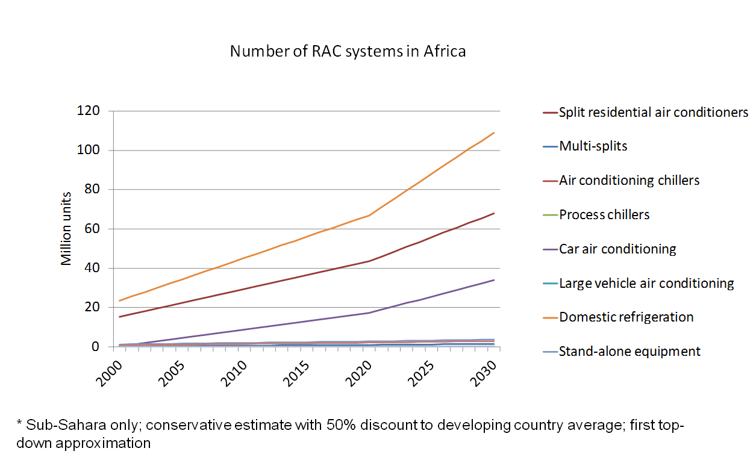
Figure1: Estimated increase of RAC systems in Africa

As the electricity in most of the African countries is still generated through the burning of fossil fuels, the demand for energy causes the GHG emissions. Additional GHG emissions are produced through the leakage of high GWP HFC-based refrigerants and foam blowing agents. As a consequence then GHG emissions will then nearly triple between 2010 and 2030.

.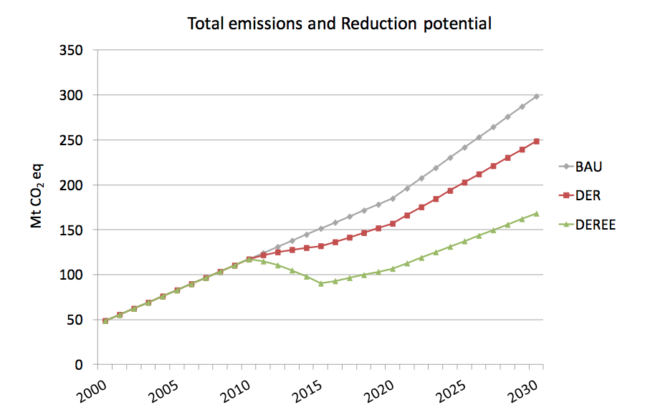
Figure2: Estimated RAC Business as Usual (BAU) emissions and mitigation potential; DER - leakage reduction of high GWP refrigerants; DEREE - additional introduction of energy efficiency measures.

Through the use of highly energy efficient refrigeration and air conditioning devices and the substitution of high GWP refrigerants with low GWP refrigerants and foam blowing substances, both GHG emissions and the energy use can be substantially reduced (see red and green lines in Figure2). Alternative technologies are internationally available but not common in Africa available.

So far, only few African countries have implemented measures such as labelling or minimum energy efficiency performance standards (MEPS) for the refrigeration and air conditioning equipment. In comparisons, countries and regions like the US, Europe, Japan, Korea, China and India have demonstrated to substantially lower their energy use through the introduction of MEPS and supporting technology programmes. Similar standards are suitable for reducing the leakage of high GWP refrigerants and the use of low GWP refrigerants instead. Leaking HFC substances are very harmful to the environment and require special treatment. Suitable facilities for the destruction of HFC substances are hardly available in Africa.

The GCAI aims at establishing a “prototype” best practice approach in four front-running African countries, Ghana, Kenya Mauritius and Namibia.

Figure 3 estimates the BAU emissions in the four countries from the RAC sector. A first top down approach shows that unabated emissions from the RAC sector could increase to 30 mt CO₂eq by 2013. With mitigation measures (MIT) the emissions could be reduced by 50%.

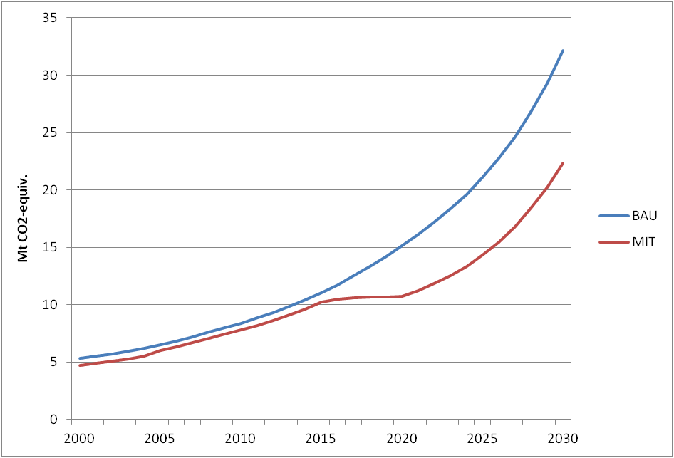

Figure 3: Total estimated BAU CO₂-equiv. GHG emissions in comparison with emission development under a DEREE mitigation scenario to 2030, for countries Ghana, Kenya, Mauritius and Namibia.

Further analysis of the country and sector specific emission scenarios are illustrated in the Annex. BAU emissions will grow the fastest in Kenya and Ghana, mainly driven by the population growth (Figure A1). Stationary air conditioning (mainly room air conditioning) and mobile air conditioning constitutes more than 50% of the estimated total BAU emission and emission mitigation potential (Figure A2). An estimated 8 Mio. t of CO₂ can be reduced through the fast transition towards low GWP refrigerants which also has significant additional co-benefits (Figure A3) .

DEVELOPMENT OF THE REQUEST
Through the UNEP Ozone network activities, the actions of African countries are co-ordinated to mitigate harmful emissions for the ozone layer. A similar coordination is not yet taking place to lower the GHG emissions from refrigeration and air conditioning equipment. A joint approach among African countries will provide significant synergies by (a) replicating the experiences made with the Montreal protocol now with climate mitigation action and (b) allowing an exchange between the countries in the region.

The respected support from the CTCN specifically addresses the need to lower energy consumption and emissions through deploying and scaling up low GWP Green Cooling Technologies.

On a national level, the action will be coordinated between the National Ozone Officers (NOU) and the National Designated Entities (NDEs) of the participating countries. NOUs and NDEs will then closely co-ordinate with the relevant government and private stakeholders and the supporting network sought through the CTCN.

Country specifically the following main stakeholders will participate:

- GHANA:
EPA, Energy Resources and Climate Change Unit, Ozone Unit, Ministry of Environment, Science, Technology and Innovation.
- KENYA:
NEMA Ozone Desk and Ministry of Environment Climate Change Secretariat GHG Inventory Team.
- MAURITIUS:
National Ozone Unit, Ministry of Environment and Sustainable Development.
- NAMIBIA:
Ministry of Environment and Tourism through the Department of Environmental Affairs, Ministry of Trade and Industry (National Ozone Unit).

ASSISTANCE REQUESTED

The request seeks critical support of the CTCN for the participating countries in the Green Cooling Africa Initiative to mitigate GHG emissions from RAC appliances both through improved energy efficiency and reduction of leakage for high GWP refrigerants.

The CTCN is requested to support the countries of the GCAI with the following actions, specifically for the refrigeration and air conditioning sectors:

- Establishment of robust GHG Inventory for selected, priority cooling sub-sectors. Inventories will be ideally established according to the UNFCCC-Tier 2 methodology allowing the participating countries to establish NAMAs in the subsectors and a unit based MRV. The inventory will allow the countries to report their emissions through their biennial National Communication on a more accurate basis.
- Projection of future RAC stock, energy use and GHG emissions based on the Tier-2 methodology. Through the projections the countries will gain a clear understanding of the sector impact on energy consumption and GHG emissions.
- For the selected sub-sectors, appliances and systems:
  - benchmarking of currently deployed refrigeration and air-conditioning technologies (Stationary air conditioning, mobile air conditioning, commercial refrigeration, transport refrigeration) and
  - comparing of local equipment types with internationally available best practice technologies; Comparing energy efficiencies, (COPs), refrigerant leakage rates etc.; Establishing test procedures to establish equipment performance standards; Ideally, appliance standards and tests will be carried out through qualifying institutions in the region;
  - Assessment and review of currently deployed policies; Recommendation of best practice policies for RAC energy efficiency and refrigerant leakage; Establishing top- runner appliance standards.
- Define regional and country specific Technology Roadmaps including R&D, Demonstration, Deployment, Scaling-Up of Green Cooling Technologies
- Capacity building and NAMA institutional setup. Development of proposals on future NAMA activities in the RAC sector. Regional exchange, training and capacity building on RAC technologies, policy and the development of RAC NAMAs.
- Funding: For the execution of the activities it is suggested that each of the country is supported with a budget of 200,000 USD.

ALIGNMENT WITH NATIONAL PRIORITIES

All four countries, Ghana, Kenya, Mauritius and Namibia, state in the National Climate Policies and National Communications their commitments to lower GHG emission, to improve energy efficiencies and to accelerate technology cooperation and technology transfer for GHG mitigation action. The suggested actions through the GCAI are fully supplementary towards these goals.

GHANA
Climate Change has been on top of national development priorities in Ghana to the extent that it is reflected in the Ghana Shared Growth and development agenda. The government of Ghana has therefore demonstrated its commitment to contribute to national and global solutions to climate change by ensuring that its policies provide strategic directions on mitigation actions while accessing low carbon pathways that are sustainable and ensuring energy efficiency for all sectors of the economy.

The following policies are to ensure that these goals are reached:

- National Climate Change Policy (2012)
- National Environment Policy (Part I) (2012)
- National Energy Policy (2010)
- Energy Sector Strategy and Development Plan (2010)
- National Transport Policy (2008)

KENYA
The government of Kenya is highly committed to foster its strategies toward tackling climate change and mitigation of GHGs in order to initiate a low carbon resilient development.

To reach this objective the government has issued a number of relevant policies, in particular:

- Vision 2030
- National Climate Change Response Strategy “NCCRS” (2010)
- Kenya National Climate Change Action Plan 2013 – 2017
- The Energy Management Regulation and Kenya National Energy Policy 2012.

To promote energy efficiency Kenya has made initiatives in carrying out labelling or MEPS in some subsectors
- Appliances’ Energy Performance and Labelling, Regulation 2014
- The UNDP/GEF project document on “Development and Implementation of a Standards and Labelling Programme in Kenya

The policies so far have not been specific to the individual RAC sectors. The GCAI would therefore deepen and support the climate action pathways Kenya has already initiated. The proposed GCAI supports specific objectives of the national policies, in particular the NCCRS:
- identification of technology needs and avenues for transferring existing, readily deployable technologies for mitigation action also from industrialised countries --> Identification and deployment of suitable Green RAC technologies with low GWP refrigerants and high energy efficiencies; comparing the existing RAC stock with international best practice technologies.
- Energy efficient electrical appliances should be promoted through tax incentives. Incentive programmes for Green RAC technologies
- For target groups and sectors climate change training materials and programmes should be developed. Capacity building and training for equipment importers, manufacturer and technicians of the RAC sector;
- Integrated MRV framework support the development of a MRV framework through promotion through a Tier 2 based RAC stock inventory.

MAURITIUS
Mauritius as a Small Island developing State is highly vulnerable to the impacts of Climate Change. Thus the Government of the Republic of Mauritius has placed the issues of climate change high into its agenda and is highly committed come up with strategies toward tackling climate change and mitigation of GHGs in order to initiate a low carbon development strategy.

To reach this objective the government has come up with:

- Disaster Risk Reduction (DRR) Strategy and Action Plan under the Africa Adaptation Programme funded by the Government of Japan. The Action Plan contains 9 specific areas of intervention and 25 actions, which are meant to significantly reduce the annual damage due to natural hazard and produce additional (ancillary) benefits in economic, social and environmental terms.

- A National Climate Change Adaptation Policy Framework, which is the first report for the Republic of Mauritius. The key objectives of this framework are to foster the development of policies, strategies, plans and processes to avoid, minimise and adapt to the negative impacts of climate change on the key sectors. Besides, the framework aims to integrate and mainstream climate change into core development policies, strategies and plans of Mauritius.

- A multi-pronged approach is also being developed to address impacts of climate change and enhance the resilience of Mauritius. Several priority sectors like disaster risk reduction and management, renewable energy, water, coastal zones, fisheries, tourism, public infrastructure, health and agriculture have been targeted and actions are being taken at different levels to reduce our vulnerability and increase our resilience.

Guidelines and a vulnerability toolkit are being developed with a view to strengthen preparedness vis-à-vis climate change risks, and to empower the Local Authorities

- A Technology Needs Assessment and Action Plan have been developed. 12 technologies have been prioritized following a thorough consultative process and assessment from an initial list of 128 technologies for enhanced climate change mitigation in the Energy sector and adaptation in the Agriculture, Water and Coastal Zone sectors.

- A Low Carbon Development Strategy and Nationally Appropriate Mitigation Actions (NAMA) with a view to mainstream climate change mitigation in the institutional framework and into core development plans, policy, and strategies for Mauritius are presently being developed.

- A Climate Change Bill is being finalised. This will be a major step forward and Mauritius would be amongst the very few countries to have such a law.

NAMIBIA

The government of Namibia, through its National Climate Change and Action Plan seeks to put measures in place to tackle climate change and to mitigate against it. The aim is to follow a low carbon resilient development path.
Supporting policies and initiatives to reach this objective include:
- Vision 2030
- National Climate Change Strategy and Action Plan (NCCSAP, 2013-2020)
- Sector- specific initiatives like the Namibia Renewable Energy Programme (NAMREP) have managed to eliminate some of the barriers to the adoption and nationwide promotion of renewable energy
- Recent launch of Renewable Energy and Energy Efficiency Institute (REEI)
- Carbon Neutral Policy

PAST AND ONGOING EFFORTS

The countries are engaged either in HCFC phase-out management programmes or have started to cooperate on climate action under the Green Cooling Africa Initiative.

Under the GCAI the countries are seeking to strengthen and intensify their engagement along the action programme outlined above.

GHANA

- Project on Domestic refrigeration sector conversion of CFCs to HCs (since 2000)
- Hydrochloroflorocarbon (HPMP) phase out management plan: Converting exiting R22 based air conditioners to run on R290. (Since 2010)
- Energy Performance Baselines and Benchmarks & the Designation of Industrial, Commercial and Institutional Energy Users in Ghana, 2013

KENYA

Kenya has issued specific policies to address the energy efficiencies of appliances. This is includes the Kenya Draft Energy Regulation 2014, UND/GEF project “Development and Implementation of a Standards and Labelling Programme in Kenya”, The ECOCARE report on Energy Performance Baselines and Benchmarks & the Designation of Industrial, Commercial and Institutional Energy Users in Kenya, 2013.

MAURITIUS

Mauritius is fully engaged in the implementation of the HCFC phase-out management programmes.

An Energy Efficiency Management Office (EEMO) has been set up under Section 4 of the Energy Efficiency Act 2011 with the objectives of, among others, promoting awareness for the efficient use of energy as a means to reduce carbon emissions and protect the environment.

Four importers/dealers of household electrical appliances have entered into an Agreement with the Energy Efficiency Management Office for participation in the “Voluntary Scheme for Energy Efficiency Labelling of Electrical Appliances”:

NAMIBIA

Recently launched the Renewable Energy and Energy Efficiency Institute (REEI) and the Carbon Neutral Policy.

EXPECTED BENEFITS

- Avoidance of GHGs: Refrigeration and Air Condition emissions (indirect emissions through the consumption of electricity and direct emission through the leakage for high GWP HFCs as refrigerants and foam blowing agents) are accounting for approximately 10% of the regional GHG emissions. Emissions are expected to more than triple by 2030 if unmitigated. Through the scaling-up of low GWP green cooling technology, emissions and energy consumption could be lowered by 30-50% of BAU emissions;
  - Indicators:
    - Establish for each of the RAC subsectors (i.e. stationary air conditioning, mobile air conditioning, etc., BAU unit stock based emissions and MIT (mitigation) unit
    - Identification of country and subsector specific MIT technology options

- Pre-2020 action with high mitigation potential: Through the avoidance of leaking high GWP HFC-based refrigerants, a significant emission reduction can be achieved pre-2020. With the pre-2020 action the region will contribute significantly on the regional basis to the internationally targeted pre-2020 commitments.
  - Indicators:
    - Develop stakeholder supported BAU and MIT emission scenarios (2030)
    - Identify subsector & country specific early action (pre-2020) mitigation options

- Avoidances of harmful substances: HFC are harmful, toxic substances which require specialised destruction. Africa so far has not established appropriate recycling and destruction facilities. The avoidance of HFCs through natural substances, therefore, would be clearly highly beneficial and environmentally sound.
  - Indicators:
    - Identify for each subsector & country technology options for the avoidance of HFCs

- Sustainable development benefits
  - Income and employment generation: New employments would be created with Green Cooling Technologies for the installation, the planning, construction, maintenance and servicing of the technologies.
  - Foreign exchange savings: With the implementation of measures, fossil fuel based energy imports would be reduced with consequential saving on imported energies.
  - Increased energy security: Through reducing the energy needs, electricity consumption will be saved and less fossil fuels will be imported;
  - Mobilisation of additional funds Nationally Appropriate Mitigation Actions (NAMAs): Ultimately the project will support the countries with capacity building for submitting NAMA proposal and supportive financing.
  - Indicators:
    - For each of the countries, a country specific proposal with co-benefits is established for further action (NAMA)

EXPECTED TIME FRAME

Phase I

Phase I will be implemented from 06/2014 to 06/2015. This includes building the inventories, benchmarking the technologies and identifying technology needs.

Phase II

Phase II includes the establishment of technology cooperation and technology transfer. For the different appliances the equipment will be performance tested with minimum performance standards. Non-Performing equipment will be banned and Green Technologies promoted. Technology specific COP targets (for each of the subsectors i.e. Stationary AC, Mobile AC, Domestic Refrigerators etc. will be developed)

Phase III

Phase III includes the national and regional scaling-up of green technologies. Eventually Green Cooling Technologies will reach significant penetration rates (>50%). The scaling-up and penetration of the technologies will be financially promoted through supporting NAMAs. The implementation will be monitored.

KEY STAKEHOLDERS

Stakeholder | Role in the response
NDE | - International co-ordination with CTCN network  - Regional co-ordination with other NDEs  - National coordination with NOUs and line ministries (Ministry of Environment, Energy and Industry)
NOU | - International coordination through UNEP Ozone network  - Country specific  - GHANA, NOU, EPA  - KENYA: NOU, Ministry of Environment  - MAURITIUS: NOU, Ministry of Environment  - NAMIBIA: NOU, Ministry of Trade and Industry
Line ministries (like Ministry of Energy, Industry Environment, etc.) | i.e. Ministry of Energy for the establishment of MEPS or refrigerant standards
Standardisation institutions | - Regional and international technical institutions for the establishment of energy efficiency standards, testing, monitoring & reporting  - Country specific  - GHANA  - Ghana Standards Authority  - Energy Commission, Ghana  - KENYA  - Kenya Bureau of Standards, Kenya Energy Regulatory Authority  - MAURITIUS  - EEMO  - NAMIBIA  - Namibia Standard Institution  - Namibia Training Authority
Universities, Institutes | - as above under “standardisation”; in addition to cooperation on R&D, deployment and scaling-up of green technologies; Training dissemination
GIZ Proklima | - Together with Ghana, Kenya, Mauritius and Namibia proponent of the Green Cooling Africa Initiative together
Private Sector | - Country specific  - GHANA  - Association of Ghana Industries  - Private Enterprise Federation  - Consumer Protection Association  - KENYA  - Kenya Association of Manufactures  - Kenya Private Sector Alliance  - Kenya Association of Hotel Keepers and Caterers  - MAURITIUS  - Mauritius importers and dealers of refrigerants  - NAMIBIA  - Namibia Institute of Refrigeration and Air Conditioning

MONITORING AND EVALUATION

▢ By signing this request, I affirm that processes are in place in the country to monitor and evaluate the assistance provided by the CTCN. I understand that these processes will be explicitly identified in the Response Plan in collaboration with the CTC, and that they will be used in the country to monitor the implementation of the CTCN assistance.
▢I understand that, after the completion of the requested assistance, I shall support CTCN efforts to measure the success and effects of the support provided, including its short, medium and long-term impacts in the country.
DATE AND SIGNATURE

NDE/ Ghana : Date:
Responsible Person:

Signature

NDE/ Kenya : Date:
Responsible Person:

Signature

NDE/Mauritius: Date:
Responsible Person:

Signature

NDE/ Namibia: Date:
Responsible Person:

Signature

**PLEASE LIST ANY RELEVANT BACKGROUND DOCUMENTS and provide their web links (IF WEB LINKS ARE NOT AVAILABLE PLEASE ATTACH THEM as PDF FILES TO THE APPLICATION)

THE COMPLETED FORM SHALL BE SENT TO THE CTCN@UNEP.ORG

Need help? The CTCN team is available to answer questions and guide you through the process of submitting a request. The CTCN team welcomes suggestions to improve this form.

>>> Contact the CTCN team at ctcn@unep.org

References

GIZ NAMA Handbook

ANNEX

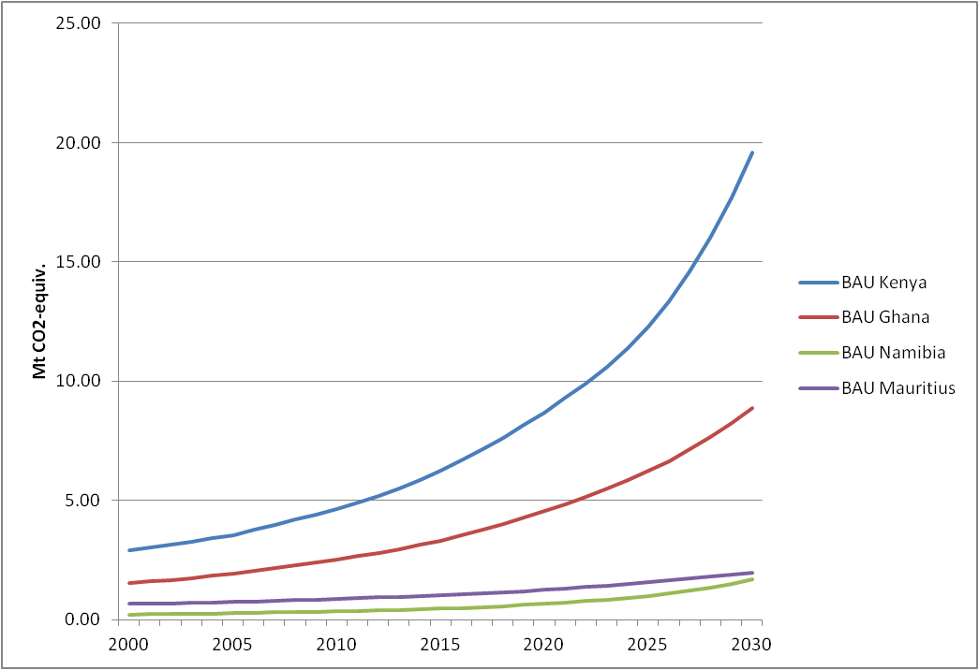
Figure A1: Estimation of total CO₂-equiv. GHG emission development until 2030 under BAU conditions, depicted for countries Kenya, Ghana, Namibia and Mauritius individually.

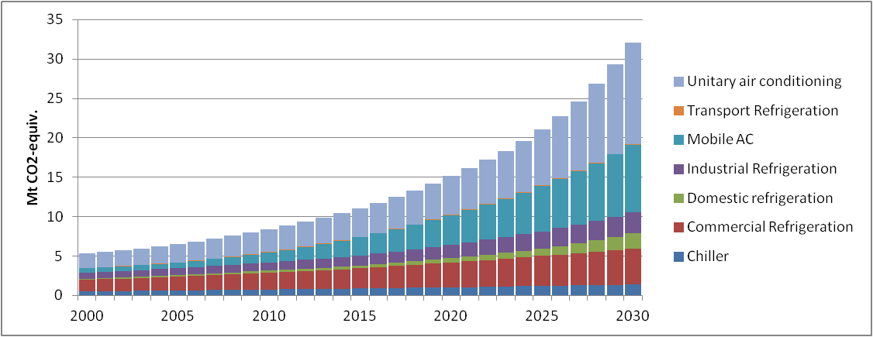
Figure A2: Sector-related mitigation potential projected to 2030 of estimated total CO₂-equiv. GHG emissions under DEREE conditions, for countries Kenya, Ghana, Namibia and Mauritius.

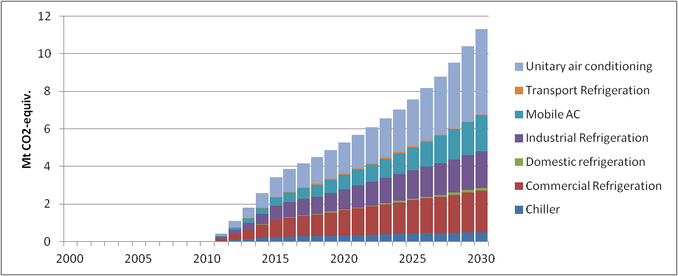
Figure A3: Sector-related mitigation potential projected to 2030 of estimated (direct) CO₂-equiv. GHG emissions under DEREE conditions, for countries Kenya, Ghana, Namibia and Mauritius. Reduction of direct GHG emissions may contribute 70% to the total mitigation potential.

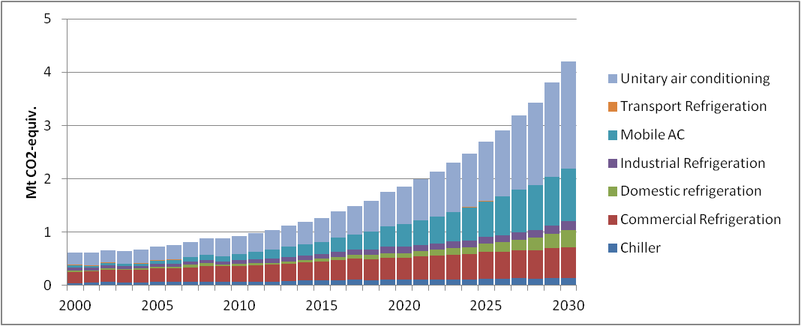
Figure A4: Sector-related mitigation potential projected to 2030 of estimated (indirect) CO₂-equiv. GHG emissions under DEREE conditions, for countries Kenya, Ghana, Namibia and Mauritius. Reduction of indirect GHG emissions may contribute 30% to the total mitigation potential.

