Strengthening salinity intrusion data sharing and forecasting for adaptation to climate change impacts in the Mekong Delta of Viet Nam

D2.3 Project Stakeholder Workshop Report

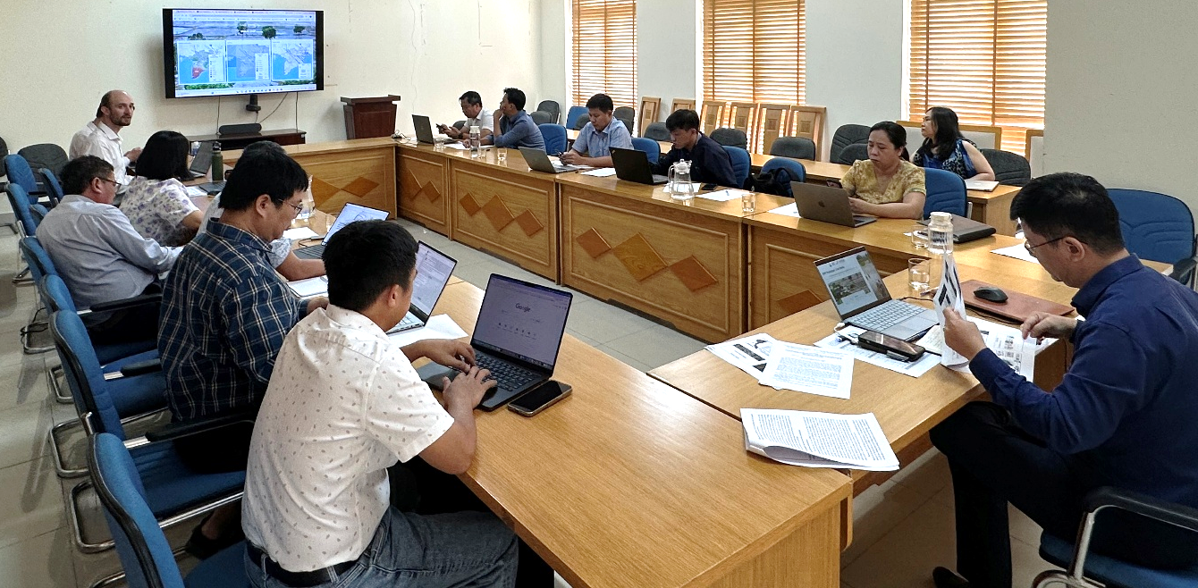

In-person stakeholder workshop, June19 2026, HCMC

Workshop location: VNMC representative office 200 Lý Chính Thắng, Ward 9, Nhiêu Lộc, Hồ Chí Minh City 70057, Viet Nam

Contents
Abbreviations 4
1. Background 5
2. Participating institutions 5
3. Stakeholder workshop agenda 6
4. Stakeholder meeting participants 7
5. Stakeholder workshop notes 8
6. Bilateral meeting with SRHMC on June 18th 14
4. Bilateral meeting with SIWRR on June 18th 18
Annex A. Presentation of the initial design framework for the salinity DSP 22
Annex B. Presentation on the salinity model to be incorporated in the DSP 26
Annex C. Gender expert presentation 31

Strengthening salinity intrusion data sharing and forecasting for adaptation to climate change impacts in the Mekong Delta of Viet Nam

Deliverable 2.3 Stakeholder Workshop Report June 2026
CTCN Ref. RFP 3100006172
Prepared for: CTCN and VNMC and VNMC

Disclaimer
This report has been prepared by DHI staff exclusively for CTCN and VNMC, based on information provided by stakeholders and published reports believed to be reliable at the time of this document’s preparation. DHI makes no warranties regarding the accuracy or completeness of the information and accepts no liability for any loss or damage arising from reliance on this report. We have not independently verified the data or otherwise examined it to determine its accuracy, completeness, sufficiency for any purpose, or feasibility for any particular outcome, including financial ones. Recommendations and conclusions drawn in this report represent professional judgment only, with no guarantee of outcomes. We accept no responsibility for any error or omission in the report that is due to an error or omission in data, information, or statements supplied to us by other parties, including the Client. Information and opinions are current only as of the date of this report, and we accept no responsibility for updating such information or opinions. It should, therefore, not be assumed that any such information or opinion continues to be accurate after the date of the report.
This report has been prepared solely for use by the party that commissioned it in connection with the captioned project. It is intended solely for the stated purpose and should not be relied upon by third parties. For the avoidance of doubt, this report does not in any way purport to include legal, insurance, or financial advice or opinion. Basin management, infrastructure operation, and business decisions remain the Client's sole responsibility.

Contact person: | Maija Bertule mabe@dhigroup.com
Project Manager: | Maija Bertule
Quality Supervisor: | Bertrand Richaud
Project No.: | 11828057
Approved by: | Oluf Zejlund Jessen ozj@dhigroup.com
Approval date:
Revision: | Final 1.0
Classification: | Restricted: This document may be shared within DHI whereas sharing it outside the DHI Group entities is subject to the client’s prior approval.

DHI A/S • Agern Allé 5 • • DK-2970 Hørsholm • Denmark
Telephone: +45 4516 9200 • dhi@dhigroup.com • www.dhigroup.com •

Abbreviations

VNMC Viet Nam National Mekong Committee
CTCN Climate Technology Centre and Network
DCC Department of Climate Change
DHI DHI A/S
DSP Data Sharing Platform
FTP File Transfer Protocol
HCMC Ho Chi Minh City
MARD Ministry of Agriculture and Rural Development
MIKE DHI modelling software suite
MRC Mekong River Commission
NAWAPI National Center for Water Resources Planning and Investigation
SRHMC Southern Regional Hydrometeorological Center
SIWRP Southern Institute of Water Resources Planning
SIWRR Southern Institute of Water Resources Research
TA Technical Assistance
VNMC Viet Nam National Mekong Committee

Background
The “Strengthening salinity intrusion data sharing and forecasting for adaptation to climate change impacts in the Mekong Delta of Viet Nam” is implemented with support from the Climate Technology Centre and Network (CTCN) at the request of the Viet Nam National Mekong Committee (VNMC) as the main Project Proponent. DHI is the main implementer of the project.
This document contains a summary of the main discussions that took place during the in-person stakeholder workshop that took place in Ho Chi Minh City on June 19, 2026 (D2.3 of the TA project).
This report also contains a summary from the bilateral institutional discussions with key salinity data providers that took place on June 18th June.

Participating institutions
The following institutions took part in the workshop (full participants list can be found in Chapter 4 of this report).
- Viet Nam National Mekong Committee (VNMC)
- Center for Water Resources Warning and Forecast, National Center for Water Resources Planning and Investigation (NAWAPI)
- Center for Climate Change Adaptation and Carbon Neutrality, Department of Climate Change (DCC)
- Southern Institute of Water Resources Planning (SIWRP)
- Center of Technical Infrastructure Development, Southern Institute of Water Resources Research (SIWRR)
- Southern Regional Hydrometeorological Center (SRHMC)
- Can Tho City Sub-Department of Water Resources and Irrigation
- DHI
- Gender expert (Independent consultant)

Stakeholder workshop agenda
The workshop was chaired by Dr. Duc, he Deputy General Director of VNMC, and the agenda was as follows:
Time (HCMC) | Agenda item | Speakers
08:00 – 08:30 | Arrival and registrations | -
08:30 – 08:45 | Official opening of the meeting (welcome and VNMC project idea summary and plan for DSP) | VNMC
08:45 – 09:00 | Roundtable: participant introductions | All
9:00 – 09:20 | Short presentation of the initial design framework for the salinity Data Sharing Platform (DSP) | DHI
09:20 – 09:40 | Brief overview of the salinity model to be incorporated in the DSP (what has been done and what forecasting functions will be available via platform) | VNMC modelling work
09:40 – 10:00 | Participant QA on both presentations | All
10:00 – 10:15 | Coffee/tea break
10:15 – 10:45 | Interactive session I: focus on the salinity data collection, sharing and use practices and needs by participating institutions (focus on what decisions need to be informed and how the salinity data is used by institutions and expectations from DSP, decision-making flow) | Facilitated by DHI
10:45 – 11:25 | Interactive session II: focus on capacity development - stakeholder salinity data and information capacities, including staff and technical capacity gaps and needs of the participating institutions for future better salinity monitoring and decision-making in the Delta | Facilitated by DHI
11:25 – 11:40 | Gender expert presentation | Gender expert
11:40 – 11:50 | Wrap up (including findings from bilateral meetings) and next steps on CTCN project | DHI ad VNMC
11:50 – 12:00 | Official meeting closure | VNMC
12:00 – 13:00 | Lunch for meeting participants | Provided at VNMC
13:00 – 14:30 | Bilateral meeting between VNMC and DHI at VNMC office to discuss the main outcomes of the workshop and agree on next steps

Stakeholder meeting participants
Final list of CTCN TA in-person stakeholder workshop participants.
No. | Name | Surname | Institution | Title | M/F
 | Dr. Duc | Nguyen Anh | Viet Nam National Mekong Committee (VNMC) (HAN) | Deputy General Director | M
 | Mr. Dong | Tran Tien | Viet Nam National Mekong Committee (VNMC) (HAN) | Officer | M
 | Mr. Dat | Nguyen Dinh | Viet Nam National Mekong Committee (VNMC) (HCMC) | Modelling expert | M
 | Mr. Thien | Vu Minh | Viet Nam National Mekong Committee (VNMC) (HCMC) | Modelling expert | M
 | Ms. Hue | Tran Thi Kim | Viet Nam National Mekong Committee (VNMC) (HCMC) | Officer | F
 | Dr. Phuong | Tran Anh | Center for Water Resources Warning and Forecast, National Center for Water Resources Planning and Investigation (NAWAPI) | Deputy Director | M
 | Ms. Nguyen | Thi Hoang Anh | Center for Climate Change Adaptation and Carbon Neutrality, Department of Climate Change (DCC) | Deputy Director | F
 | Mr. Tho | Tran Quang | Southern Institute Water Resources Planning | Head of Mekong Delta Division | M
 | Mr. Thuan | Pham Khac | Center of Technical Infrastructure Development, Southern Institute of Water Resources Research (SIWRR) | Deputy Director | M
 | Mr. Tuan | Pham Ho Quoc | Southern Regional Hydrometeorological Center (SRHMC) | Deputy Director | M
 | Mr. Tam | Mai Hoang | Can Tho City Sub-Department of Water Resources and Irrigation | Deputy Director | M
 | Mr. Vi | Hoang | Can Tho City Sub-Department of Water Resources and Irrigation | Officer | M
 | Ms. Maija | Bertule | DHI | CTCN TA project manager | F
 | Mr. Jakob | Luchner | DHI | CTCN TA technical lead | M
 | Ms. Huyen | Nguyen Thi | Independent consultant | Gender expert | F

Stakeholder workshop notes
08:30 – 08:45 Official opening of the meeting
Dr. Duc, Deputy General Director of the VNMC, officially opened the meeting and welcomed all participants. Dr. Duc also summarized the purpose of the meeting as well as the CTCN technical assistance project and invited all participating institutions to actively engage in the workshop discussions and share their feedback and experiences regarding salinity monitoring in the Delta.
08:45 – 09:00 Roundtable: participant introductions
The introductory remarks were followed by a roundtable session of participant introductions. The list of participants, including their institutional affiliations, is included in chapter 4 of this report.
9:00 – 09:20 Short presentation of the initial design framework for the salinity Data Sharing Platform (DSP)
Project Technical Lead, Jakob Luchner (DHI), presented the proposed design of the Salinity Data Sharing Platform to the meeting participants. The presentation included a live demo of the platform draft, including presentation of example salinity data received from VNMC.
The DSP design presentation slides are included in Annex A of this report.

09:20 – 09:40 Brief overview of the salinity model to be incorporated in the DSP
Dr. Dat, a modelling expert from VNMC, presented the hydraulic model to be included in the VNMC Salinity Data Sharing Platform, which will serve as the basis for salinity modelling. The presentation summarized the model, initial validation results at selected stations, as well as planned work steps to further refine the MIKE model so that it is suitable for salinity forecasting and modelling.

09:40 – 12:25 Participant QA on both presentations and interactive discussion sessions (merged)
Following the presentations, meeting chair Dr. Duc invited participants to ask questions or make immediate comments to both presentations. This plenary interactive session also covered key questions posed to the meeting participants, requesting stakeholder input on:
- The initial platform design that was presented
- Salinity data presentation in the platform (including identification of the most useful salinity intrusion thresholds for different users to inform advisory services)
- What decisions need to be informed and how salinity data is used by institutions and expectations from the DSP decision-making flow
- Questions on capacity gaps and needs relating to salinity intrusion monitoring and management
- A request by VNMC to all participating institutions to give a short brief of their situation with salinity intrusion monitoring, challenges and needs.

Following feedback, questions and suggestions were received from the participating institutional stakeholders:

VNMC (Dr. Duc) noted that:
- The data disclosure with stakeholders and data access will be a key differentiating factor of the VNMC salinity DSP.
- The Delta region is extremely important for the country, with many significant economic activities relying on water.

Discussion inputs from SRHMC (Mr. Tuan):
- SRHMC has interest in many issues in the region, including saltwater intrusion. For saltwater intrusion, 2019 and 2020 were particularly challenging years.
- Salinity intrusion has become a higher priority than flood management in recent years, reflecting the increasing need for reliable salinity forecasting to support climate adaptation in the Mekong Delta. The official salinity monitoring network currently consists of 47 stations operating mainly along the main river channels in accordance with Ministry Circular No. 47. Although routine observations officially end in May, monitoring activities are frequently extended into June due to persistent salinity intrusion.
- The TA project is thus very needed and necessary, particularly to support provinces with saltwater intrusion data and forecasting.
- It is important that salinity monitoring data are collected according to the national standards and procedures (referring also to the environmental regulations of 2024, which took effect in February 2025). This is to ensure that data are properly measured and calibrated. This is currently a challenge with data collected from other institutions and companies, as for some stations the data are not inspected properly or are not shared or regulated according to existing standards.
- The publicly available salinity monitoring data from SRHMC will be shared with the project. The sharing of historical and other non-public datasets will be subject to a formal and transparent data-sharing mechanism, endorsed by the relevant authorities, that clearly defines the types of data to be shared, their intended use, and the roles and responsibilities of participating organizations. In addition, SRHMC emphasized that datasets from other organizations should be subject to appropriate quality assurance and quality control (QA/QC) procedures before being integrated into the DSP.
- There is also a need for the provinces to coordinate better on data collection and improve the monitoring station network. SRHMC also emphasized that the river cross-section data is updated given the significant development of salinity control infrastructure throughout the Mekong Delta, updated cross-section surveys are considered essential for improving salinity modelling accuracy.
- There is also a need for updating the cross-sections, which are currently from 2000 and have not been updated for several decades.
- Suggestion to improve coordination and information sharing between the provinces, and to include other Delta provinces in communications around salinity data collection and sharing.
- SRHMC asked for clarification on the methods for salinity intrusion estimation, and VNMC clarified that it is based on a combination of a model and monitoring stations along the mainstream. They also use some stations in the mainland for validation and interpolation.
- The existing salinity bulletin was also presented by SRHMC, demonstrating how the 1 g/L and 4 g/L salinity boundaries are generated using observed data from the main river monitoring network, hydrodynamic modelling, model validation, and spatial interpolation. SRHMC emphasized the importance of displaying affected communes to better support local decision-making. SRHMC may come with some suggestions for the bulletin when there is more clarity on data available from the DSP.

VNMC (Dr. Duc) noted that:
- It is important that bulletins produced from the DSP should be simple and easy to understand – not too complicated for the users in local communities.
- The maps should also be simple and have easily understandable information on salinity.

Discussion inputs from Can Tho Province representatives (Mr. Tam and Mr. Vi):
- The Can Tho Sub-Department of Irrigation explained that salinity observations at sluice gates are currently conducted manually for operational purposes. The observations are intended primarily to support gate operation decisions rather than regional monitoring.
- The project was recognized as timely and highly relevant to current regional needs.
- Participants recommended that the DSP should provide a user-friendly interface with simple access procedures and intuitive navigation.
- It was also suggested that future development of the platform could consider incorporating information related to riverbank erosion, which is becoming an increasingly important concern for local authorities.
- They would like a clarification on how the salinity intrusion lines are extrapolated in areas without observation stations.
- In the province there are challenges in the monitoring network (e.g. concern about the issue of landslides) and they are currently in the process of setting up additional monitoring stations.
- Province representatives also highlighted that it is a challenge to ensure timely prevention of saltwater intrusion currently, and there is a real need for recommendations on when to act and what measures to take for best impact of salinity management measures.
- They would welcome recommendations around monitoring and salinity data collection in the province.
- At the province level, there is a need to receive timely forecast information as soon as possible so that actions can be taken in advance to manage intrusion.
- The processes for data upload and download from the DSP should be simple and easy so that they can be easily undertaken by the staff.
- The issue of outdated river cross-section information is also pertinent in the province and the cross-sections need updating.

Discussion inputs from DCC (Ms. Nguyen):
- The Department of Climate Change emphasized that the DSP database should be designed to ensure compatibility with the Ministry's future information management systems, facilitating future integration where appropriate.
- Participants also recommended that datasets and forecasting bulletins should be updated regularly and that clear mechanisms should be established for sharing salinity information among organizations operating monitoring stations. VNMC acknowledged these recommendations and they will be taken into consideration during project implementation.
- DCC expressed a concern about whether the relevant institutions will accept the DSP and will be willing to proactively upload their monitoring data to the platform.
- DCC also emphasized that any bulletins produced from the DSP should be easily understandable for the public.
- The DSP should also ensure that the public has access not only to the bulletin but also to the data on salinity intrusion, so that all data and information are accessible.

Discussion inputs from SIWRP (Mr. Tho):
- SIWRP noted that salinity-related information is currently dispersed across multiple organizations, requiring considerable effort to collect publicly available datasets. A centralized data-sharing platform integrating information from different agencies would therefore significantly improve data accessibility.
- For sharing the information on salinity intrusion and the thresholds via the DSP, it is important that there is clarity about what the thresholds mean and what significance they have for the different activities (e.g. different thresholds relevant for drinking water, fruit cultivation, rice) – as in some instances concentration of 0,5 can already be significant for some activities.
- Specifically, participants recommended expanding future salinity products beyond the current 1 g/L and 4 g/L thresholds to include additional thresholds such as 0.5 g/L for domestic water supply and 2 g/L for fruit cultivation and agricultural production.
- Clarification is needed the access level to the data on the platform – e.g. would the province representatives or institutions be able to adjust the data or the model directly into the platform.
- It was also requested that clarity should be ensured on which data presented in the DSP are derived from observations and which data are modelled/forecasted data, so that it is clear for the platform users.
- It was further recommended that additional monitoring stations across the Mekong Delta be incorporated into the platform where possible, together with upstream hydrological information from Tonle Sap Lake and Kratie to improve forecasting capability.
- Participants highlighted the importance of considering tidal dynamics in salinity forecasting and identified four principal factors affecting salinity intrusion: tidal conditions, upstream inflow, rainfall, and hydraulic structure operations.
- Questions were also raised regarding the long-term sustainability of the DSP, including responsibility for maintaining forecasting models after project completion, future system upgrades, forecast issuance frequency, publication schedules. Clarity needs to be established on who will maintain and manage the platform in the long term. VNMC confirmed that long-term model maintenance will be undertaken by VNMC. Additional upstream datasets will be incorporated where feasible while remaining within the scope of the project.
- There is a need to define and agree on the frequency of issuance of the bulletins to be produced by the platform (e.g. 7 days, one month).
- It would be useful to clarify how the data update will take place – will it be manual or automatic, and ultimately who will be in the position to approve the data submitted to the platform (and who will undertake the final QA before approval).

Discussion inputs from SIWRR (Mr. Thuan):
- The Institute currently provides salinity forecasts for more than 70 inland locations to support agricultural production and water management throughout the Mekong Delta.
- SIWRR expressed its willingness to share publicly available information, including forecasting bulletins, published reports, and annual salinity monitoring information. Similar to previous comments, the Institute emphasized the importance of ensuring sustainable operation and maintenance of the DSP after project completion.

Discussion inputs from NAWAPI (Dr. Phuong):
- NAWAPI emphasized the importance of establishing robust forecast verification procedures to evaluate forecasting performance after operational implementation.
- It was recommended that the DSP should provide information at commune level wherever possible to better support local decision-making.
- Questions were also raised regarding compliance with national database standards
- NAWAPI further recommended maintaining consistency in MIKE software versions throughout model development, implementation, and future technology transfer to ensure long-term operational stability.
- Clarification will be needed on where the new salinity DSP will be installed and hosted. VNMC confirmed that the DSP will continue to be maintained after project completion through close collaboration among participating organizations.
- Results of the modelled indicators in the DSP will need validation to ensure that forecasts are corrected, if needed.
- NAWAPI also operate with MIKE software, but different version - MIKE 11.

DCC (Ms. Nguyen) added that:
- DCC have an ongoing project with the Environment Agency, which may be useful to connect with.
- There are many projects targeting climate change issues, and many have taken place previously, but there is an issue of sustainability and continuity. Meaning, that often the information is lost after project closure, or there is no funding to sustain project activities after project closure.

VNMC (Dr. Duc) noted that:
- The salinity DSP in question will be hosted and maintained by VNMC.
- One of the most important tasks for sustainability will be to develop salinity data sharing agreements with the relevant institutions.
- For the general salinity monitoring capacity in the future, more data will be needed (e.g. data on topography, updated river cross-sections, more station data from the tributaries, as well as updated methodologies for interpolation of the salinity intrusion lines).

11:25 – 11:40 Gender expert presentation by Ms. Ms. Huyen Nguyen Thi
The group discussion was wrapped up and followed by gender focused session. The national gender expert made a presentation focusing on relevance of integrating gender considerations in project design and implementation, as well as suggestions for concrete activities of how to do this. Gender expert presentation can be found in Annex C of this report.

11:40 – 12:00 Wrap-up and next steps on CTCN project and official closure of the meeting
Dr. Duc, the meeting chair, adjourned the discussions and thanked all participants for their contributions and participation. He also noted that the project will take on board all stakeholder inputs and keep in touch with the institutions to ensure that the DSP is most useful not just for VNMC, but for all stakeholders in the Delta.

The meeting was officially adjourned and followed by a lunch for all participants.

13:00 – 14:30 Bilateral meeting between VNMC and DHI at VNMC office
Following the workshop, VNMC and DHI further discussed several technical recommendations raised by participants and agreed on following:
- Continue investigating the influence of tidal dynamics, particularly the interaction between diurnal and semi-diurnal tides, together with more flexible upstream boundary conditions at Kratie to improve salinity forecasting.
- During the initial implementation phase, the DSP will continue providing salinity products based on the 1 g/L and 4 g/L thresholds while evaluating the feasibility of introducing additional thresholds such as 0.5 g/L and 2 g/L for different water-use purposes.
- DHI also acknowledged the recommendation to improve the spatial resolution of rainfall products and will explore opportunities to provide more detailed information, where feasible and applicable, to better support local decision-making.
- VNMC will continue providing DHI with information on additional monitoring stations, including mobile stations, publicly available datasets, and information products from relevant organizations for consideration in future integration into the DSP.
- In parallel, VNMC will continue engaging with relevant agencies to facilitate discussions on establishing a transparent and mutually agreed data-sharing mechanism, building on the discussions and consensus reached during the two bilateral meetings. The mechanism will define clear arrangements for data access, data types, intended use, and the roles and responsibilities of participating organizations.
- VNMC also highlighted several issues requiring early attention during the prototype development stage. These include ensuring that the prototype uses an appropriate basemap that accurately reflects the territorial and administrative representation of Viet Nam.

Bilateral meeting with SRHMC on June 18th
Meeting date and time: June 18, 2026, 08:00 Hrs, Ho Chi Minh City, SRHMC offices
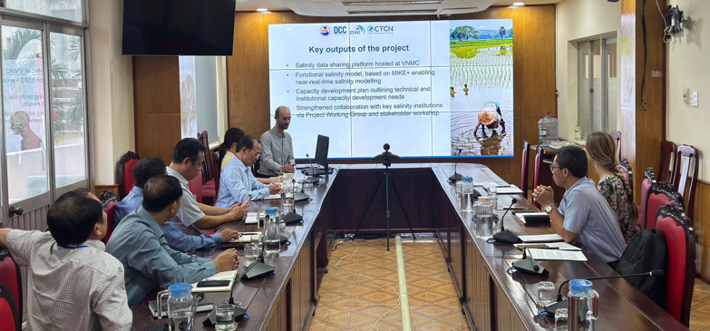
Image 1 Photo from bilateral meeting with SRHMC
Meeting participants:
No. | Name | Institution | Title | M/F
 | Pham Ho Quoc Tuan | Southern Institure Water Resources Research | Deputy Director | M
 | Nguyen Tien Cong | Hydrometeorological Information and Data Division | Deputy Head of Division | M
 | Doan Thi Truc Man | Southern and Central Highlands Environmental Analysis Laboratory Division | Head of Division | F
 | Nguyen Manh Hong | Hydrometeorological Station Network Division | Head of Division | M
 | Nguyen Van Huan | Hydrometeorological Forecasting Division | Deputy Head of Division | M
 | Nguyen Dang Hiep | Hydrometeorological Forecasting Division | Deputy Head of Division | M
 | Maija Bertule | DHI | CTCN TA PM | F
 | Jakob Luchner | DHI | CTCN TA Technical Lead | M
 | Thien Vu Minh | VNMC | Modelling expert | M

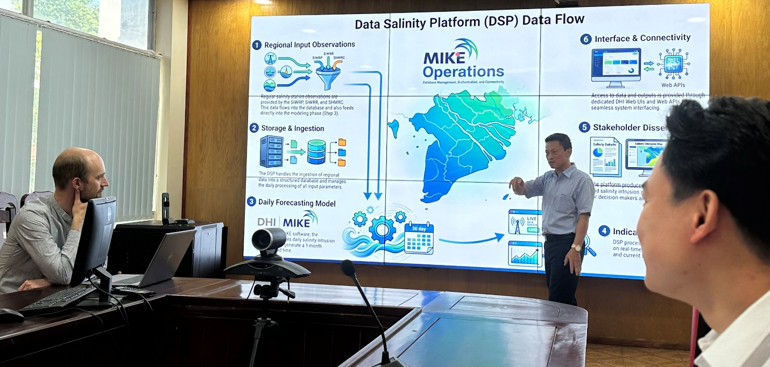
Main discussion points from bilateral meeting with SRHMC.
Image 2 Photo from bilateral meeting with SRHMC, presentation of the DSP

The bilateral meeting with SRHMC focused on three main topics:
- Current salinity monitoring practices in the Mekong Delta
- Existing data-sharing mechanisms
- Development of the DSP to support salinity monitoring, forecasting, infrastructure operation, and water management
VNMC and DHI started with a presentation of the proposed DSP and explained that the platform will integrate observed data with model simulations to provide salinity outlooks and decision-support information. The target is to launch the platform by December 2026.
Salinity data collection and sharing by SRHMC:
- The proposed salinity DSP and the general question of salinity intrusion is highly relevant for the Delta, and highly timely since a dry year is expected.
- SRHMC expressed support for the project, recognizing the platform as a valuable initiative for improving salinity information sharing.
- SRHMC is the official institution collecting salinity data in the Delta Region and is following the standards for measurement and data collection set nationally.
Current salinity monitoring network:
- Currently, SRHMC has 47 stations for salinity measurements in the Southern region, extending from Ho Chi Minh City to Ca Mau Province.
- About 38-39 of these stations are located in the Mekong Delta.
- All stations currently perform manual observations; no automatic salinity monitoring stations are in operation (although some testing is being done).
- Approximately 12 observation days are selected each month based on tidal conditions due to high and/or low tides and also depend on the location/stations.
- During each observation day, salinity is measured 12 times at designated hourly intervals.
- Historic data availability varies from station to station.
- SRHMC only undertakes salinity measurements in the dry season (December to May), when the issue of salinity intrusion is the most problematic.
SRHMC data collection and processing workflow:
- The current workflow consists of:
  - Field observers manually observed and record measurements.
  - Observation sheets are photographed/texted and submitted to the Provincial Hydro-Meteorological Center.
  - Provincial staff validate the observations values/data before entering them into the internal database which can ben use by both Regional/Provincial staffs.
  - The validated data are then transmitted to SRHMC.
- When data are collected from provinces, the province offices do the initial data QA and enter measurement data into the system (usually Excel/Csv) and the data are then sent to SRHMC.
- Sometimes the station observation data from the provinces (depending on the station) are sent to SRHMC by text message, image or conveyed by phone.
- Because the monitoring process is entirely manual, observation data are typically available with a delay of one to two days (not-near/real-time monitoring).
- SRHMC confirmed that both the monitoring equipment and observation procedures comply with the national standards specified in Ministry Circular No. 47, so monitoring follows standardized national protocols.
- SRHMC also noted that its existing operational datasets are primarily stored in excel/CSV 2003 format.
- The data are routinely reported to the Vietnam Meteorological and Hydrological Administration.
SRHMC feedback on the project and DSP design:
- A question was raised regarding the input of salinity data to the system - particularly how, in the long term, salinity data could be entered into the system by other users, including both institutions and field personnel collecting measurements.
- The DSP information and forecasts could be useful for SRHMC and other stakeholders, including as an input to SRHMC's bulletin.
- Currently, there are no formal data-sharing agreements between SRHMC and VNMC. Such agreements would need to be established to enable more systematic and automated uploading of monitoring data to the salinity DSP. In practice, monitoring data from the South are often acquired by VNMC through the National Forecasting Centre.
- If institutional agreements are put in place, it would be possible to activate the SRHMC servers, enabling automated access to and download of the relevant data.
Other SRHMC remarks regarding the gaps and needs for better salinity monitoring:
- SRHMC is collecting data from provinces, but capacity levels are uneven.
- Support is needed to improve field equipment.
- Automated data collection, in particular, is not functioning well at the moment, and support is needed in some locations to improve the automation of measurements. SRHMC is currently undertaking pilot testing of automated data collection.
- SRHMC also noted that other institutions/agencies (e.g. SIWRR) do not always follow the nationally established data collection protocols. As a result, there can be differences in measurements and data collection methods used (e.g. irrigation departments may undertake observations differently to better suit their needs, but this can result in values that are not directly compatible with those from the station network). These salinity measurements are often collected from sluice gates primarily for operational purposes. However, these datasets are produced using different methodologies and are not standardized to the same national quality requirements.
- Therefore, if multiple salinity datasets are integrated into a common platform, proper quality control and data standardization will be essential before public dissemination.
- When collecting data from their stations or receiving data from provinces, SRHMC undertakes quality assurance activities, such as checking for abnormalities in observations.
Comments on data sharing mechanisms:
- Regarding possibilities for data download and general access to the salinity data collected by SRHMC, there may be several ways for access (institutional agreement for data exchange and sharing will be needed first):
  - The DSP could be connected via FTP
  - The SRHMC could send data by email
  - VNMC could be made a technical user in their system.
- A formal data-sharing mechanism should clearly define responsibilities, access rights, and permitted data usage.
- Regarding historical observations, SRHMC indicated that data records extend approximately 10 - 20 years depending on the installation date of individual stations. However, historical datasets cannot currently be shared because they are subject to national regulations governing hydrometeorological data management and utilization. A formal legal framework would therefore be required before such data could be released.
- SRHMC further stated that, once an official mechanism is established, data could be provided to VNMC using procedures similar to those already applied for reporting to the Vietnam Meteorological and Hydrological Administration.
Final SRHMC expectations and recommendations:
- SRHMC expressed interest in:
  - Receiving technology transfer.
  - Gradually acquiring the capability to operate the DSP independently.
  - Eventually modifying model boundary conditions to support their operational forecasting activities.
- VNMC acknowledged these requests and indicated that they could be considered in future project expansion phases if additional funding becomes available after successful implementation of the current project.

Bilateral meeting with SIWRR on June 18th
Meeting date and time: June 18, 2026, 10:00 Hrs, Ho Chi Minh City, SIWRR office
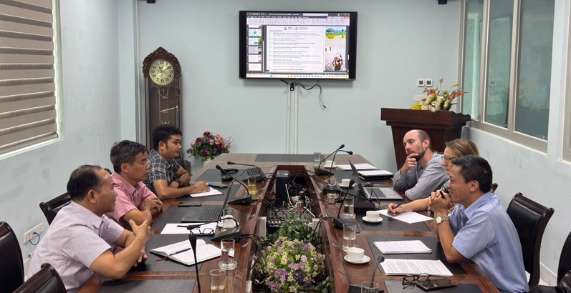

Meeting participants:
No. | Name | Institution | Title | M/F
 | To Quan Toan | Training and International Cooperation Division | Head of Division | M
 | Tran Thai Hung | Research Center for Irrigation and Water Supply | Deputy Director | M
 | Pham Huu Phat | Training and International Cooperation Division | Officer | M
4. | Maija Bertule | DHI | CTCN TA PM | F
5. | Jakob Luchner | DHI | CTCN TA Technical Lead | M
6. | Thien Vu Minh | VNMC | Modelling expert | M

The main discussion topics of the bilateral meeting with SIWRR included following:
- SIWRR's current salinity monitoring network and observation practices.
- Existing mechanisms for salinity data sharing.
- SIWRR's experience in salinity forecasting and operational support.
Main discussion points from bilateral meeting with SIWRR
Salinity data collection and sharing by SIWRR:
- SIWRR welcomed the initiative and recognized the DSP as a valuable platform for improving information sharing across the Mekong Delta.
- Unlike SRHMC, SIWRR does not operate a permanent salinity monitoring network. Salinity information is obtained from multiple sources depending on operational requirements, including:
  - Publicly available datasets, including information shared through the Mekong App.
  - Salinity observations provided by SRHMC.
  - Measurements were collected by provincial Sub-departments of irrigation from sluice gates and salinity control structures.
  - During unusual events, SIWRR organizes rapid field surveys to collect additional observations.
- SIWRR also does not have the national or regional mandate to collect salinity data in the Delta, and it undertakes salinity intrusion forecasting in the Delta primarily with data from irrigation departments to help inform agricultural planning activities.
- SIWRR does not have its own gauges, and no real-time data collection is undertaken by SIWRR.
- SIWRR reconfirmed that SRHCM is the main institution with a mandate for systematic salinity data collection in the Southern Region, while SIWRR primarily caters to farmers and provides agricultural advice.
- During the dry season, they receive data from the irrigation departments, usually every 2 days or once a week.
- The SIWRR then generates the forecasts and distributes them to the Ministry of Agriculture and Environment and agricultural departments in the Mekong Delta. This salinity information is primarily used to inform agricultural activities, including e.g. when to get water from the river, or when to open or close the sluice gates.
- SIWRR explained that observed salinity data are first quality-controlled before being used for forecasting. Forecast results are subsequently provided to provincial irrigation authorities to support decisions on opening and closing salinity control sluice gates.
- SIWRR prepares weekly, monthly, and seasonal salinity forecasts, which are particularly important for supporting irrigation management during the Winter–Spring rice season in the Mekong Delta.
- SIWRR noted that forecasting salinity intrusion remains technically challenging because boundary conditions are strongly influenced by wind patterns, tidal dynamics, and the interaction between diurnal and semi-diurnal tides.
- For monitoring along the Mekong mainstream, SIWRR primarily relies on SRHMC observations, while data from tributaries and salinity control structures are provided by provincial irrigation authorities. Sometimes they make arrangements for data purchase from SRHMC.
- When they share forecast reports (only during the dry season), they produce weekly, monthly, and seasonal forecasts.
- The seasonal forecast is made 6 months in advance, using their own model (also a MIKE model), and they forecast the flow at Kratie.
- Sometimes SIWRR, when able to get some information on hydropower data from upstream (China), either from VNMC or MRC, produces extraordinary forecasts for the Ministry of Agriculture and Environment (previously Ministry of Agriculture and Rural Development, MARD).
- Their primary interest is salinity monitoring in the transition zone between saltwater and brackish water – this is the most relevant area for farmers.
- Historical salinity records dating back to approximately 1980 are available; however, access to these datasets will require an appropriate data-sharing mechanism and formal agreement defining data ownership, station coverage, permitted use, and responsibilities.
SIWRR feedback on the project and DSP design:
- The proposed DSP could be extremely useful for their work, but especially so for the farmers
- For farmers, timely salinity intrusion data access is critical, and the sooner they get the information the better.
- Forecasting for critical times (e.g. to inform the start of season) are particularly important.
- For SIWRR data, as they don’t have set station network, sometimes they send staff to undertake field measurements with mobile stations, especially during extreme conditions. This means that the measurements are not taken in the exact same locations over time, but they do have historic data going back to 1980
- As the MRC data sometimes have delay in publishing, and the MRC data, especially the long-term, is not always available, they often have to rely on their own data. Therefore some benefit to SIWRR and other institutions could be if the DSP could share some of the MRC data relevant for salinity.

Other remarks regarding gaps and needs for better salinity monitoring:
- SIWRR does tidal forecasting, but salinity boundary determination is particularly challenging, as factors such as wind have a very high effect on the intrusion.
- SIWRR also has an app (Mekong Forecast) that is active during the dry season. In the app, data can be viewed but not downloaded. The bulletins produced by SIWRR are also shared via the app.
- They are expecting to have the next updates for the season in June.
- Also interested to get data from VNMC, as SIWRR currently does not have the desired access to MRC data – e.g. boundary conditions are of particular interest.

Discussion on the data sharing agreement and mechanisms:
- SIWRR emphasized that data and information sharing is one of the key challenges in the Mekong Delta.
- It was also noted that, even though MRC has a lot of data, the institutions and stakeholders do not always have access to it.
- The Institute expressed its willingness to share publicly available salinity information with VNMC through its existing Mekong App, including station location information where appropriate.
- Near real-time forecast products can also be shared through SIWRR's public application. However, historical datasets will require a formal agreement and clear regulations before they can be exchanged.
- SIWRR expressed particular interest in allowing authorized users to access the platform directly and upload additional datasets to support different operational purposes. Both parties discussed the possibility of addressing this requirement through a user authorization and access control system within the DSP.
- In principle, SIWRR would be willing to share data with VNMC – but some kind of data sharing agreements will be necessary. VNMC and SIWRR will therefore continue discussions on appropriate data-sharing mechanisms and explore opportunities for integrating SIWRR's observations, forecasts, and publicly available information into the DSP while ensuring compliance with applicable regulations and institutional responsibilities.
- SIWRR is willing to share their data, including historic data, and could create access for VNMC to get access to the data from the app. In the exchange agreement, they could be interested in information/data on the salinity boundary conditions.
- SIWRR would be interested in uploading their salinity data to the DSP and would also be interested in adding their monitoring locations (not the same as for SRHCM).
- SIWRR agreed to share some data samples and the locations of the monitoring points (e.g. mobile stations).

Annex A. Presentation of the initial design framework for the salinity DSP
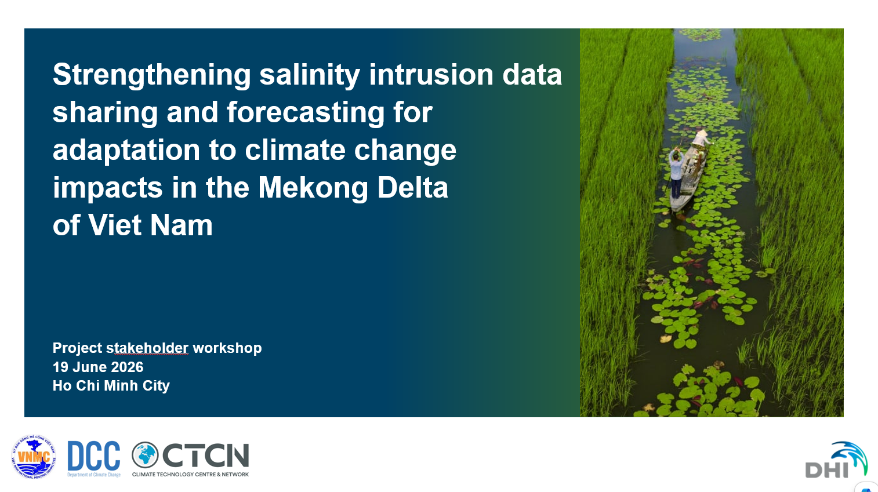
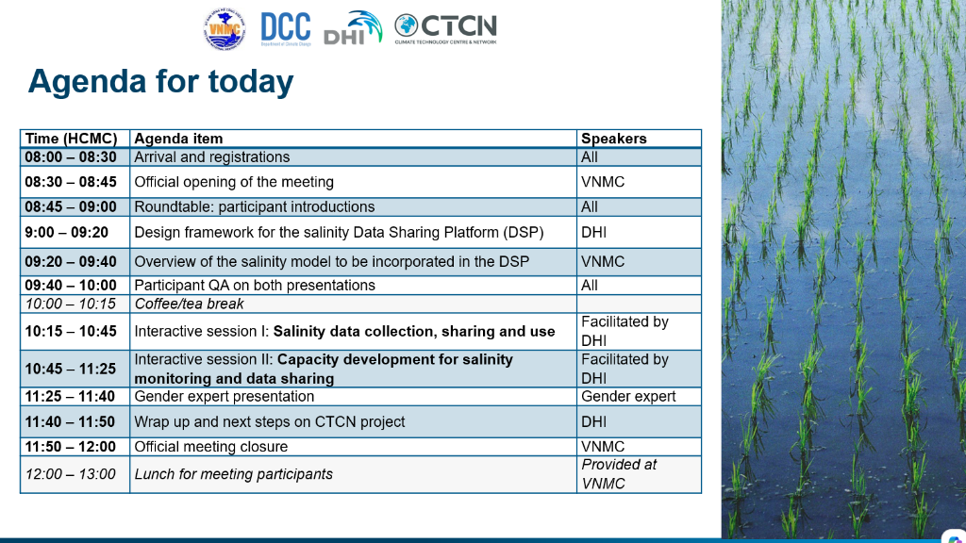
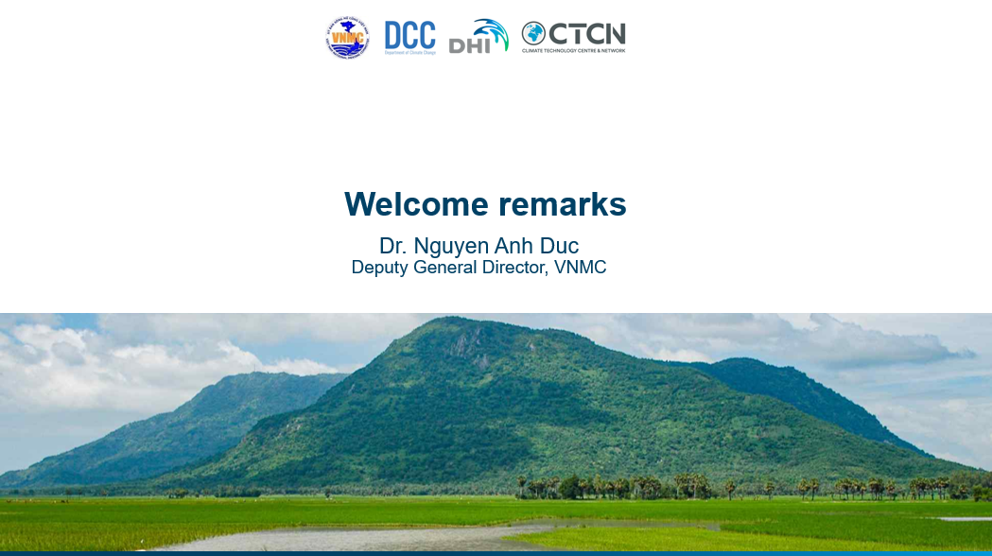

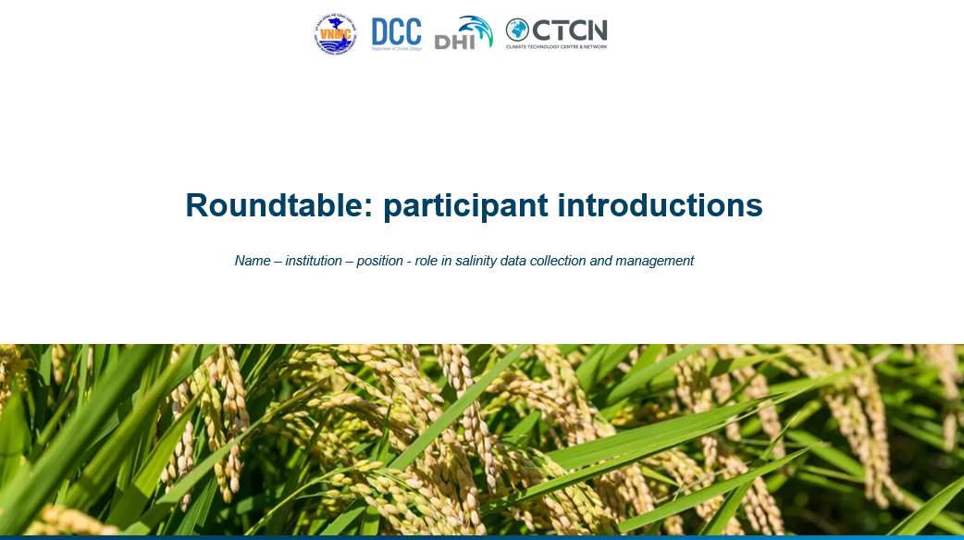
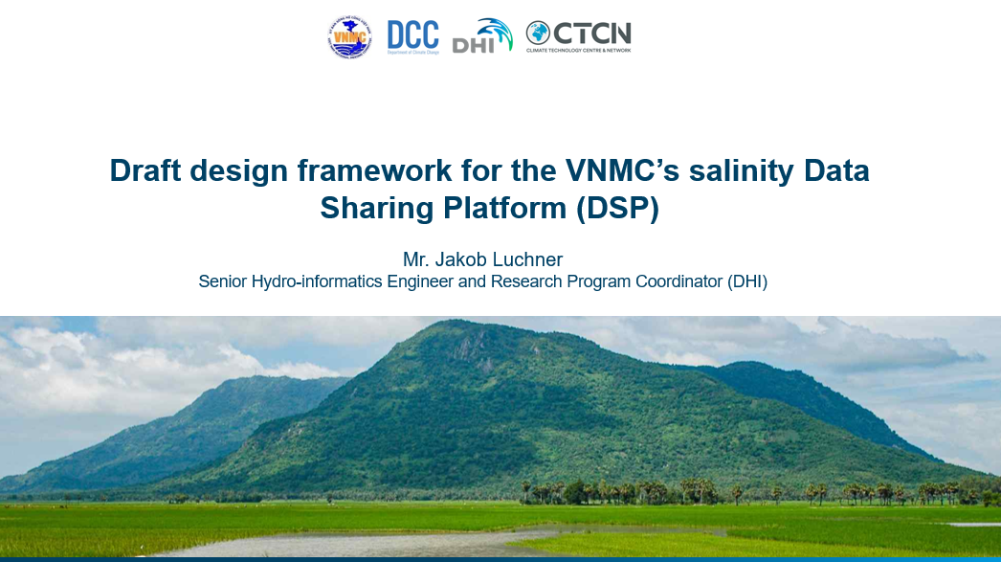
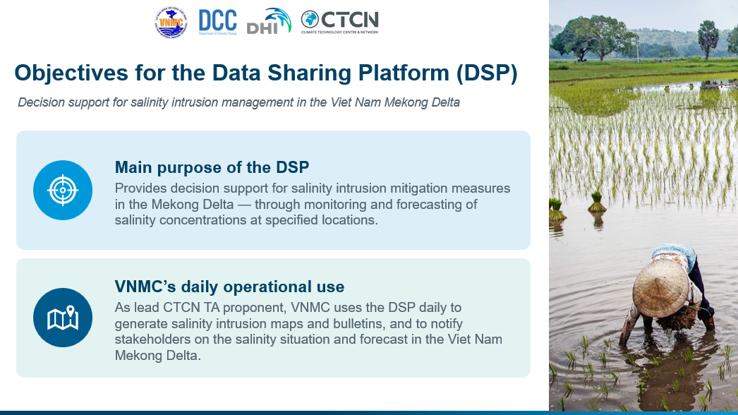
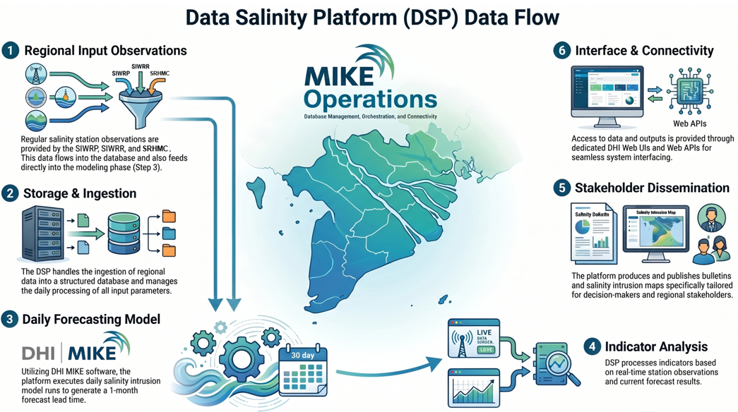
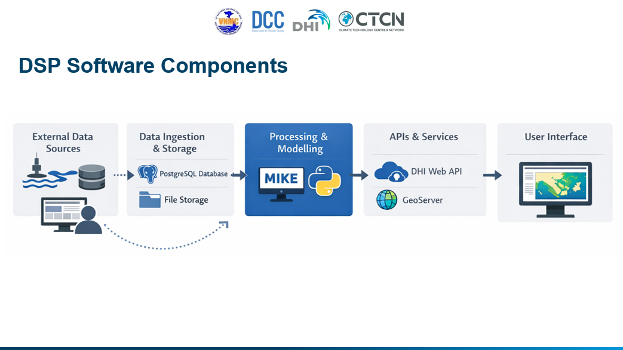
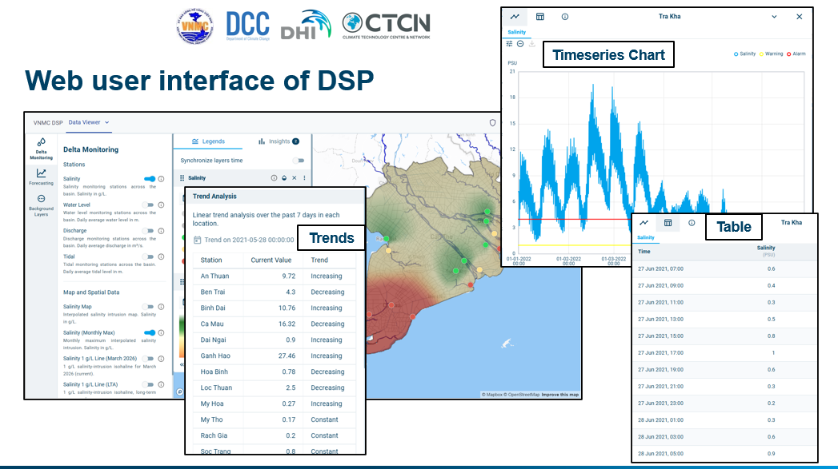

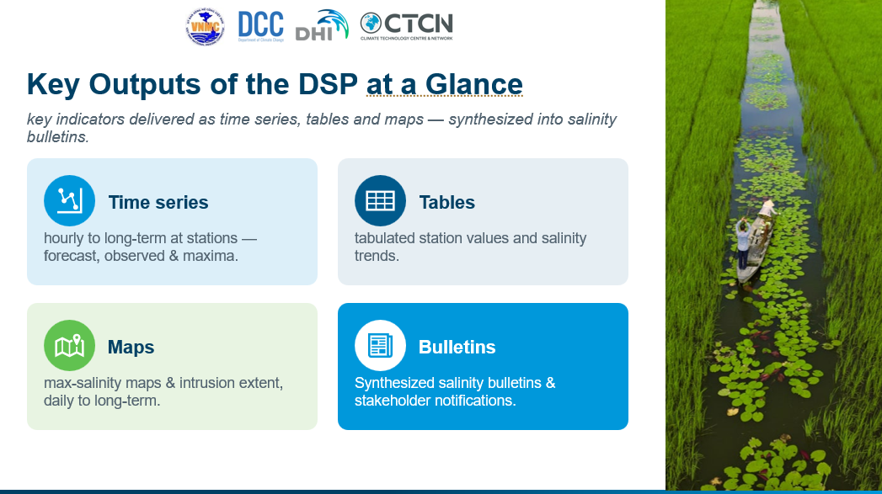
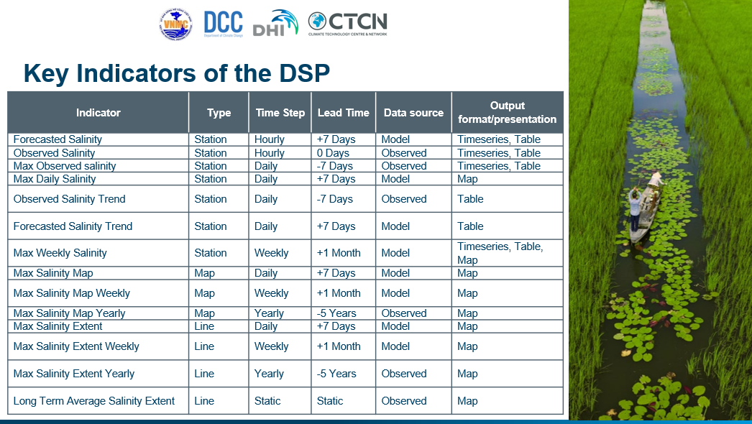
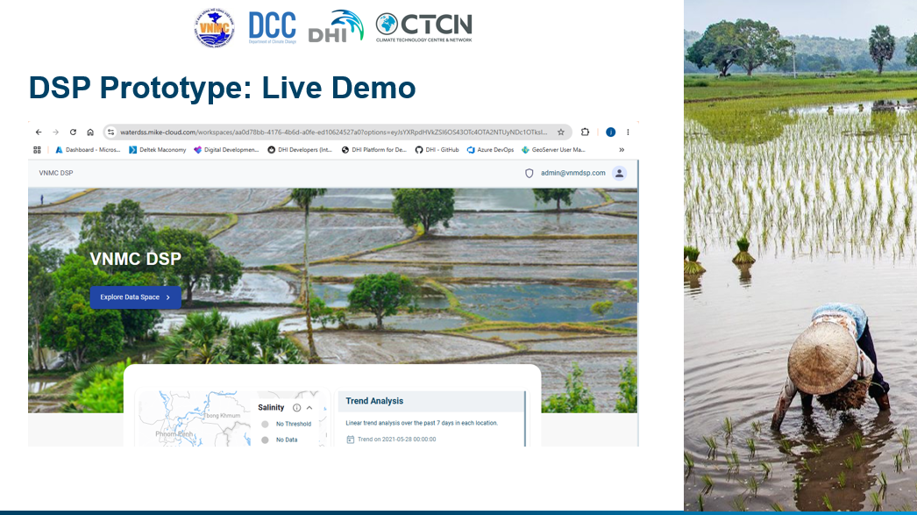

Annex B. Presentation on the salinity model to be incorporated in the DSP
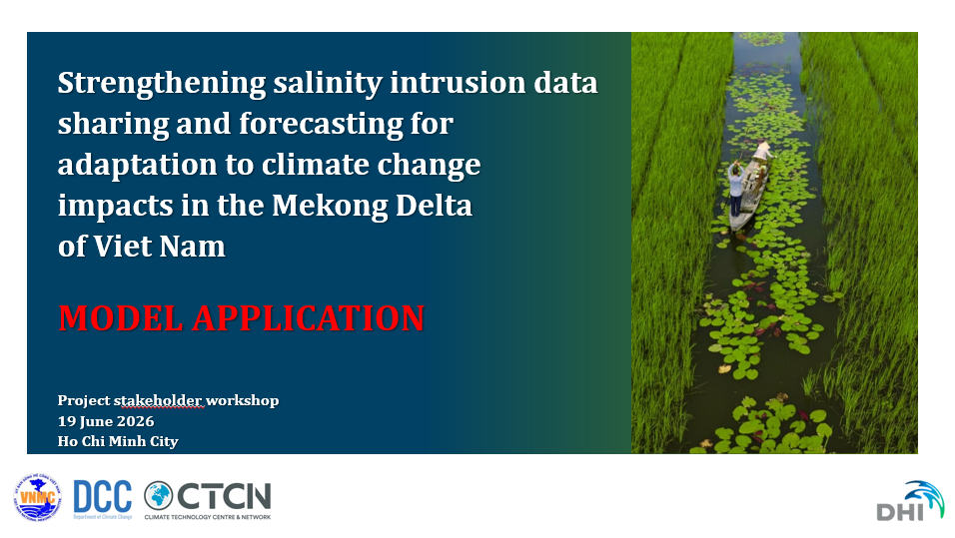
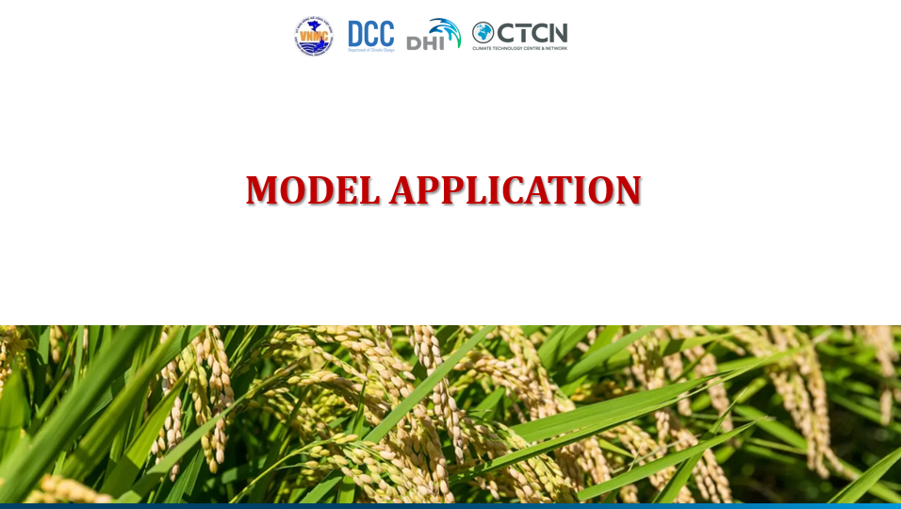
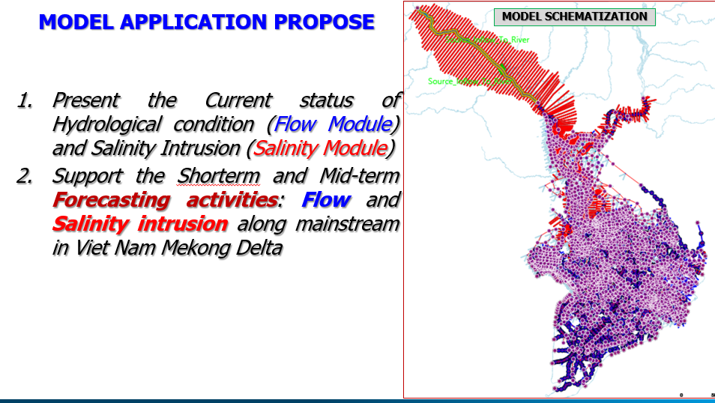

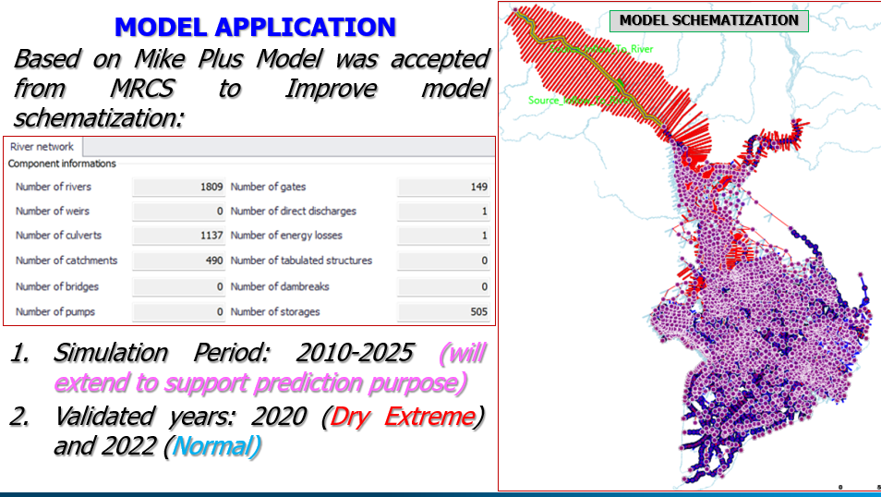
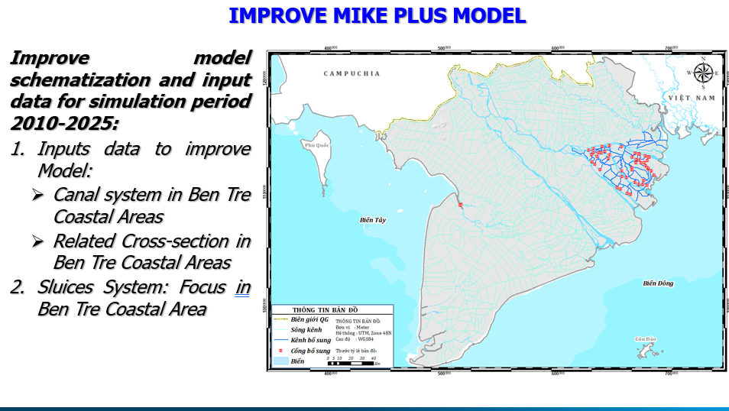
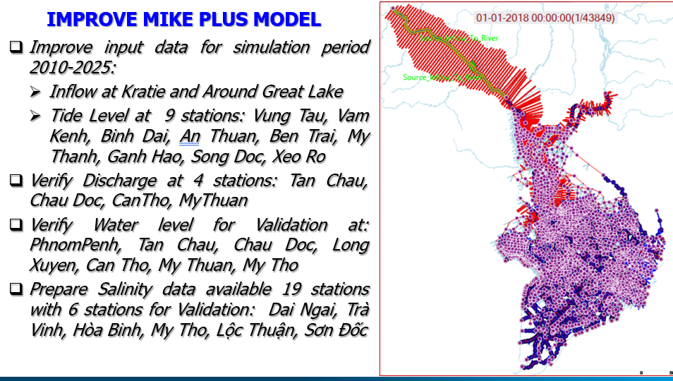

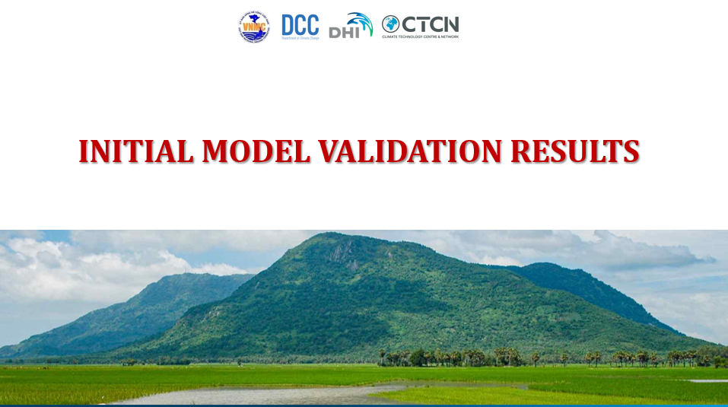
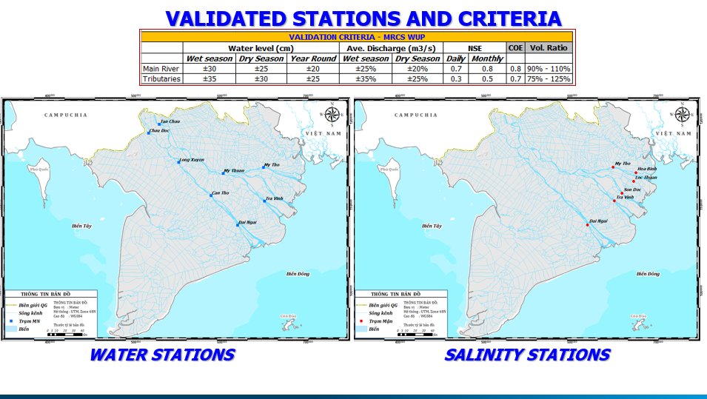
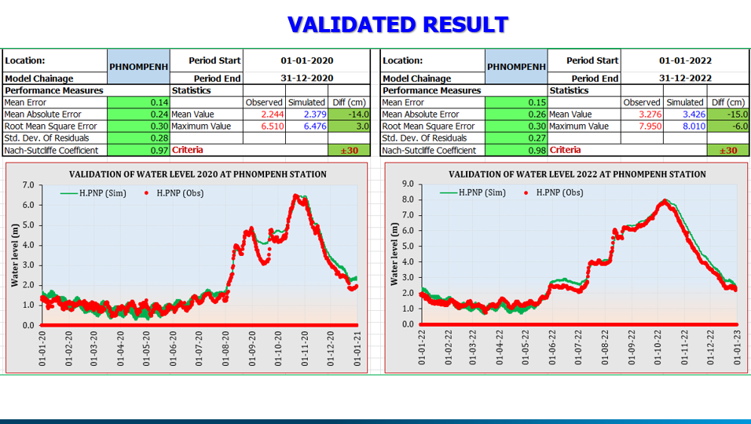

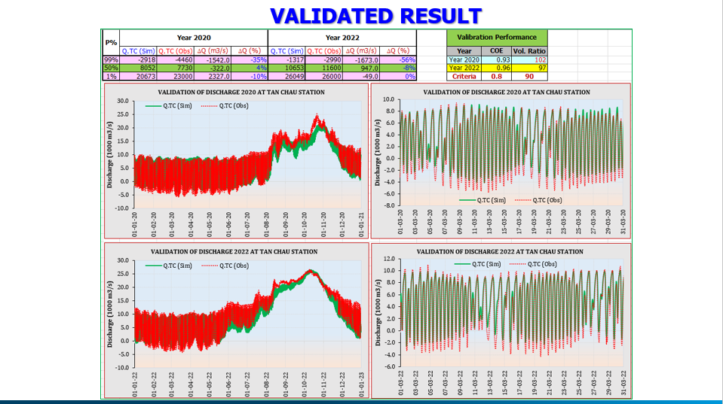
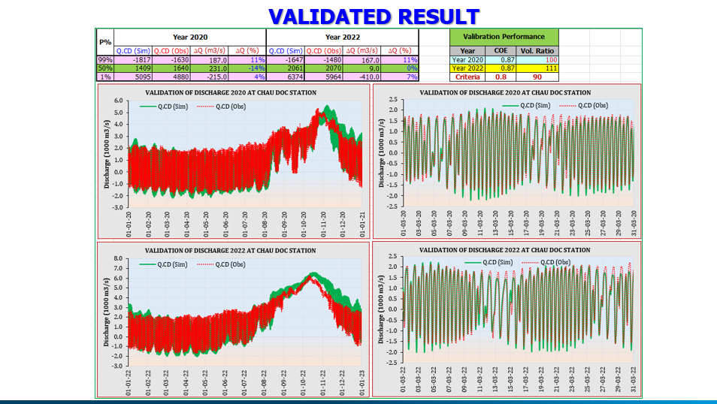
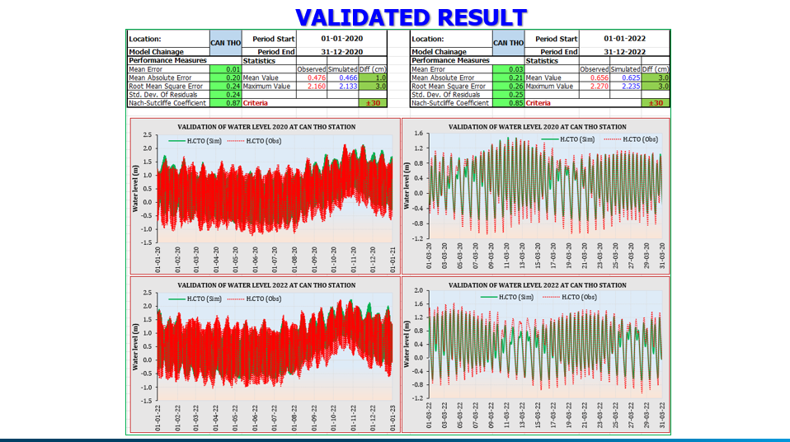

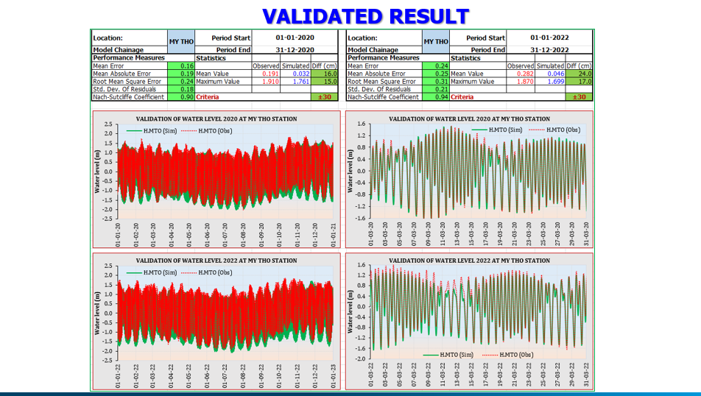
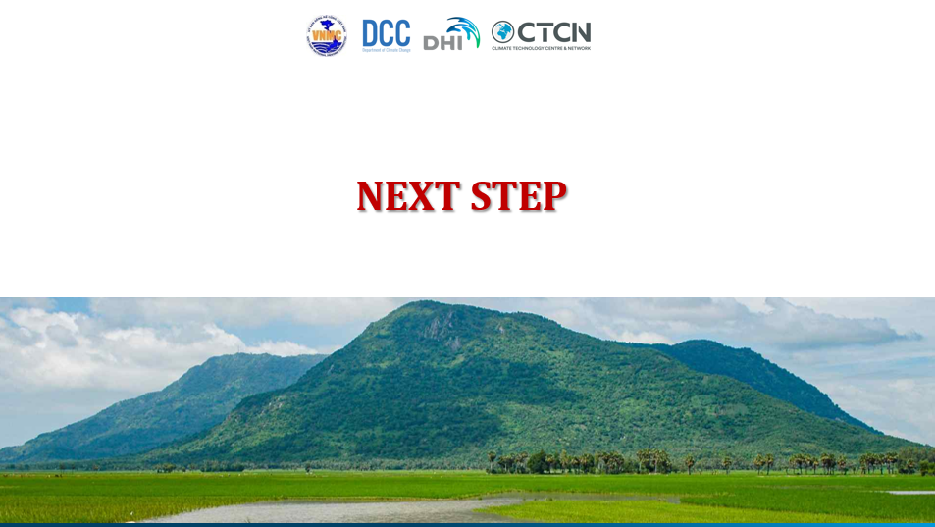
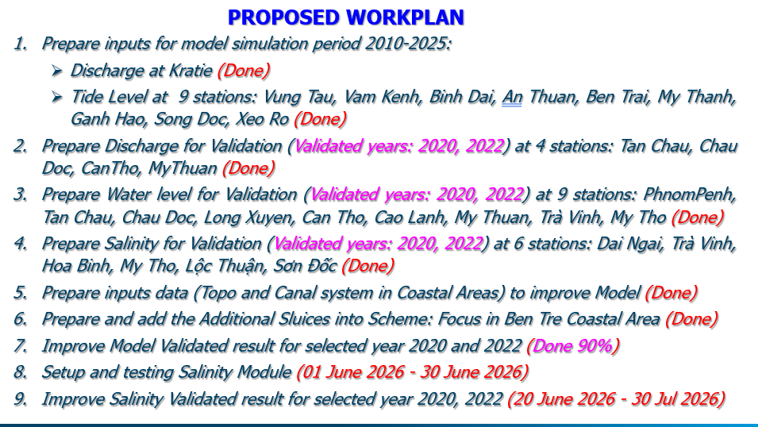

Annex C. Gender expert presentation
