CTCN TECHNICAL ASSISTANCE FEEDBACK FORM

This form is to be completed by National Designated Entity (NDE) and the request applicant of the country which has received the technical assistance (TA).
This form will enable the CTCN to:
- Receive feedback on timeliness and appropriateness of the assistance provided;
- Collect lessons learnt, and improve the design and implementation of technical assistance based on successes and challenges encountered;
- Track the results and effective use of its assistance in the country;
- Identify possible impacts that the assistance will contribute to.

Country: | Bangladesh | TA Request reference number: | 2023000003 | Date of TA completion: | 08/2024
Title of TA: | Development of Medium- to Long-Range Hydrologic Forecasting System for Ganges-Brahmaputra-Meghna River Basins
NDE | NDE organization : Department of Environment (DoE)  NDE focal point : (Director General, DoE)
Project proponent(s) | Proponent organization : Bangladesh Water Development Board (BWDB)  Proponent focal point : (Superintending Engineer)

Continue on next page

PART I: FEEDBACK ON TECHNICAL ASSISTANCE DELIVERY AND ACHIEVEMENTS

Please share how satisfied you were with CTCN Technical Assistance service by ticking the boxes below. Provide any comments you may have:

Timeliness of Assistance
- The response plan was designed in a timely manner | Strongly agree | 5 ☐ | Comment: The response plan was well-structured to meet national needs, although initial administrative setup required additional time for focal point identification.
- The response plan was designed in a timely manner | Agree | 4 ☒
- The response plan was designed in a timely manner | Neither agree nor disagree | 3 ☐
- The response plan was designed in a timely manner | Disagree | 2 ☐
- The response plan was designed in a timely manner | Strongly disagree | 1 ☐
- The final products have been implemented and delivered in a timely manner | Strongly agree | 5 ☐ | Comment: All final deliverables have been developed and submitted. While project schedules experienced minor adjustments due to local political curfews and unstable internet connectivity, the implementation phase in Bangladesh is actively ongoing. Specifically, the model will be installed and officially handed over to the BWDB in the next step.  Capacity development such as training need to be carried out on the model that has been developed.
 | Agree | 4 ☒
 | Neither agree nor disagree | 3 ☐
 | Disagree | 2 ☐
 | Strongly disagree | 1 ☐

Appropriateness of Assistance
- The technical assistance activities have been well suited to the expressed needs and requirements of the request for CTCN assistance | Strongly agree | 5 ☒ | Comment: The activities directly addressed Bangladesh's critical need for medium- to long-range flood forecasting by implementing the VIC-River Routing model integrated with ECMWF S2S forecast data.
 | Agree | 4 ☐
 | Neither agree nor disagree | 3 ☐
 | Disagree | 2 ☐
 | Strongly disagree | 1 ☐
- The final assistance products effectively address the expressed needs and requirement of the request for CTCN assistance | Strongly agree | 5 ☒ | Comment: The final outputs successfully generated high-resolution (9-km grid) hydrological forecast data with a lead time of over 10 days, overcoming spatial and temporal limitations of existing deterministic systems
 | Agree | 4 ☐
 | Neither agree nor disagree | 3 ☐
 | Disagree | 2 ☐
 | Strongly disagree | 1 ☐

Appropriateness (continued)
- Extent to which the assistance provided involved the private sector | Significant |  |  |  | 5 ☐ | Comment: The technical assistance involved the private sector through the direct engagement of Weatherpia Co., Ltd. of Republic of Korea as one of the TA implementers, working alongside POSTECH. This partnership enabled effective delivery of technical outputs and practical support for implementation, combining research capacity with private-sector delivery and operational know-how.
 | High |  | 4 ☒
 | Marginal |  |  | 3 ☐
 | Low | 2 ☐
 | Very Low |  |  |  | 1 ☐
- Extent to which gender considerations have been mainstreamed in the assistance activities and products | Significant |  |  |  | 5 ☐ | Comment: Gender considerations were integrated in the TA’s expected impacts, emphasizing that early warning system knowledge and disaster response benefits should reach both women and men, and that improved awareness and preparedness can strengthen women’s participation in disaster-related decision-making and benefit vulnerable groups (including women responsible for children and the elderly).
 | High |  |  |  | 4 ☐
 | Marginal |  |  |  | 3 ☒
 | Low |  |  |  | 2 ☐
 | Very Low |  |  |  | 1 ☐

PART II: FEEDBACK ON SUCCESSES AND CHALLENGES
In order to help the CTCN better design and implement future assistance activities, please complete this section on any positive aspects and on any difficulties/challenges that were encountered during the planning and implementation of the assistance.

- 1. What aspects of the CTCN support contributed to the success of activities after completion of the technical assistance? (e.g. a specific aspect of the assistance design and /or implementation helped to provide a particularly timely and/or appropriate response)
- The clear deliverables design and stepwise implementation (Work plan–M&E–Impact/Closure linkage) ensured that key documents and outputs could be readily used for follow-up activities, reporting, and external communication after TA completion.
- The establishment of a structured inception and consultation arrangement with key stakeholders (kick-off/coordination, stakeholder engagement) enabled continued uptake of outputs and follow-up discussions led by the beneficiary institutions (e.g., BWDB/FFWC).
- The provision of core technical outputs (medium- to long-range hydrologic forecasting data and verification based on ECMWF S2S and the VIC–River Routing model) strengthened tools and capacity to address limitations of existing deterministic short-range forecasting.
- The technology transfer and capacity-building package (workshops, tutorial/manuals) strengthened the practical ability of local staff to understand, interpret, and apply the forecast information.
- The inclusion of scale-up and institutionalization enablers—such as an integrated dissemination improvement plan and a follow-up financing pathway (GCF concept note)—helped clarify concrete post-TA continuation routes.
- 2. Why this was the case? (e.g. the assistance product was able to be defined/developed/disseminated/ in a particularly effective manner due to the quality of assistance design and/or implementation)
- The TA explicitly targeted Bangladesh’s key bottlenecks—limited medium- to long-range flood forecasting capacity and gaps in dissemination and interpretation at community level—and combined a technical solution (forecasting system) with capacity building (workshops/manuals), increasing the likelihood of post-TA use.
- Outputs were delivered not as standalone reports but as a coherent package (data production–verification–practical use through training/tutorials–dissemination system planning–follow-up concept note), making it easier for institutions to transition to next steps (project planning, resource mobilization, internal coordination).
- From a follow-up perspective, the beneficiary institution (BWDB) expressed interest in proceeding with follow-up projects, and a GCF-oriented concept note was prepared, helping secure momentum for scaling beyond the TA period.
- The TA also articulated expected benefits—such as the importance of securing 10+ days of proactive response time and anticipated improvements in resilience (health, well-being, infrastructure, economic resilience)—supporting stronger communication and justification of results.

Please list difficulties/challenges that were encountered during the assistance’s implementation (if any). If so, please also include recommendations on how this could have been avoided and how it could be improved in the future.
1. Describe difficulty/challenge encountered and any mitigating measures:
- Difficulty/Challenge : Attendance at online meetings and workshops has been suspended or postponed due to national political issues or curfew measures.

- Mitigation Measures/Recommendations : It is hoped that measures will be developed to flexibly apply project operational guidelines to ensure smooth technology transfer between technical support implementers and beneficiaries (proposers) in accordance with the national emergency.
2. Describe difficulty/challenge encountered and any mitigating measures:

PART III: NEXT STEPS
Please complete this section by briefly describing the next steps that will be undertaken building on the technical assistance results and the progress to date. We encourage you to share details, as CTCN can help raise visibility, promote these great stories, and showcase your achievements.
The following are some examples of next steps:
- Submission of a draft law/policy developed by the CTCN to cabinet/parliament.
- Follow-up and formal submission of funding proposal drafted with support from the CTCN.
- Implementation of activities designed by the CTCN.
- Approval of business plan developed by the CTCN.
- Dissemination of report drafted by the CTCN.
- Use of new expertise acquired during training led by CTCN.
1. Describe next steps (including timeline). Please be as specific as possible (i.e. who will use the products of the assistance, when, and for what):

0–6 months (immediately after TA completion): Operational uptake by BWDB/FFWC
BWDB/FFWC will begin operational use and internal testing of the delivered medium- to long-range hydrologic forecasting data/products (ECMWF S2S + VIC–River Routing outputs) to support flood preparedness planning and risk assessment. TA deliverables (tutorial/manuals and technical documents) will be shared internally within BWDB/FFWC to standardize understanding of forecast interpretation and application.
0–12 months: Dissemination and institutional coordination
BWDB/FFWC, together with relevant disaster management stakeholders, will disseminate key TA outputs (e.g., technical reports, dissemination improvement plan) and convene follow-up coordination meetings to agree on roles, workflows, and priority actions for strengthening dissemination to downstream users/communities. Knowledge and skills acquired through the CTCN-supported trainings will be applied in routine workflows, including interpreting forecast products and translating them into actionable preparedness measures.
3–9 months: Follow-up project development and resource mobilization
Building on the TA results, BWDB (Project Proponent) will revise and further develop the GCF Concept Note prepared under the TA, incorporating stakeholder requests/comments and aligning the concept with national priorities. The concept and proposed scale-up approach will be shared with the National Designated Authority (NDA) to seek guidance and advance the process for obtaining the Non-Objection Letter (NOL) as required for GCF submission.
6–12 months: Formalization and next-phase implementation
Subject to national approvals and partner alignment, BWDB/FFWC will proceed with formal submission of a follow-up funding proposal (e.g., under GCF SAP) and initiate preparatory steps for implementation (work planning, partnership arrangements, detailed technical design and data requirements).
A roadmap will be used to prioritize further technical enhancements identified during the TA (e.g., data improvements, additional model inputs/ensembles, and integration with dissemination systems) as part of the scale-up phase.

ANNEX 1: ADDITIONAL INFORMATION

If needed, please reference any additional information here such as videos, photos, publications, or documents, which CTCN can use for promotion purposes on its communication channels (e.g. website, social media, presentations) with your consent.

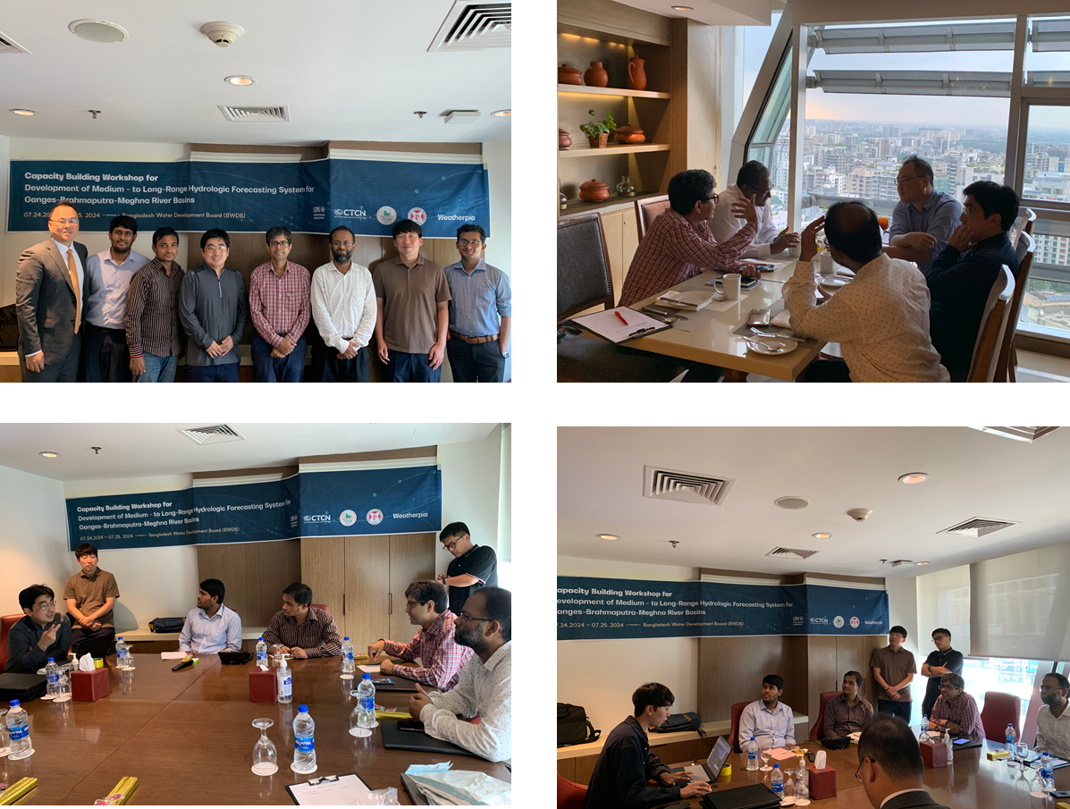
Figure 1. Pictures for technology transfer & capacity building workshop (July 24-25, 2024 in Bangladesh)

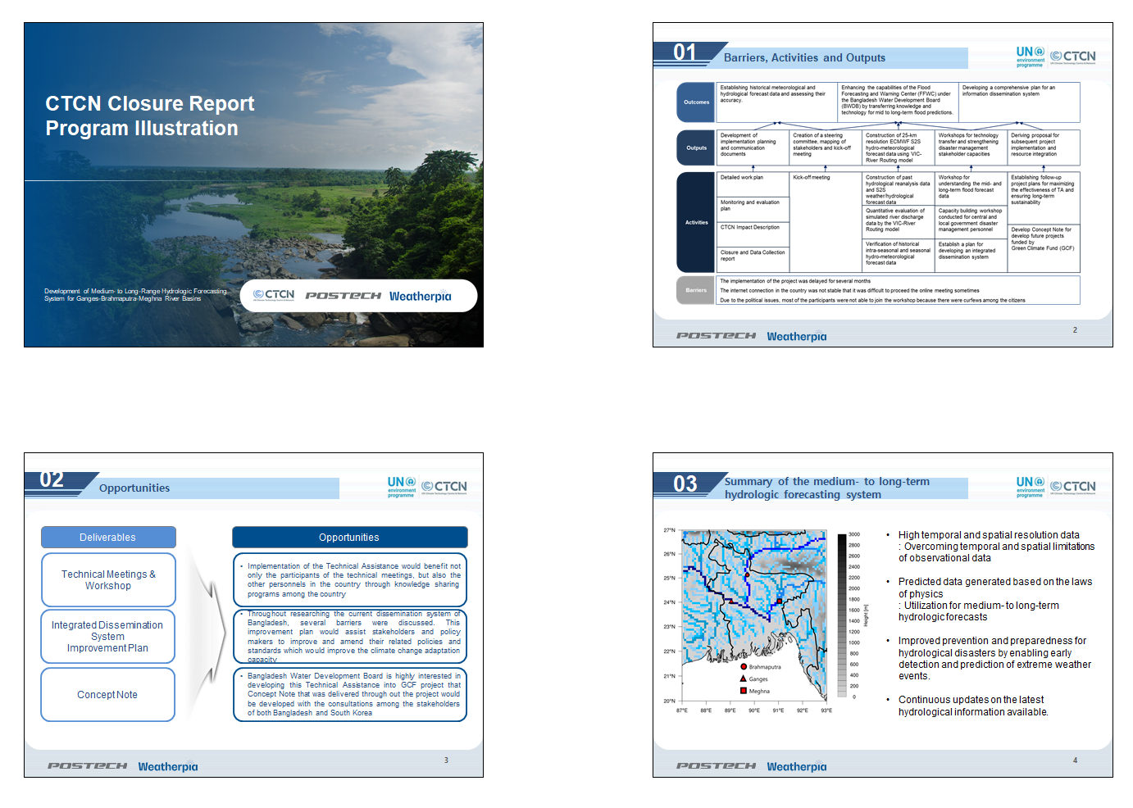
Figure 2. Workshop presentations for technology transfer & capacity building workshop in Bangladesh

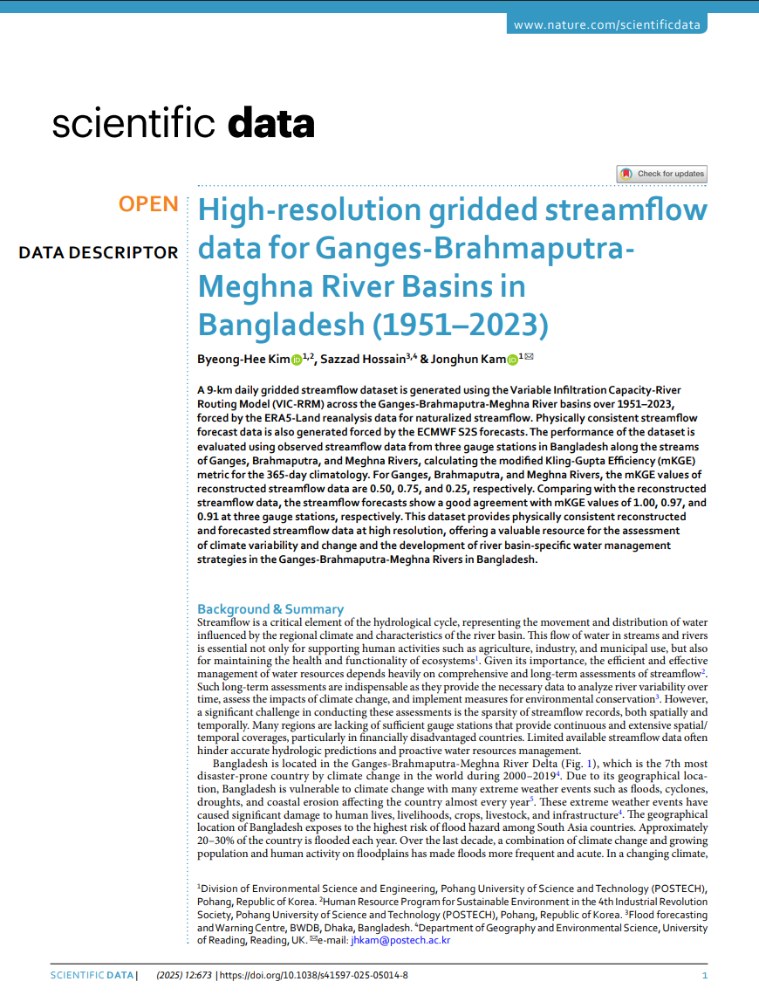
Figure 3. Scientific publication (Scientific Data) resulting from the TA project for the Development of Medium- to Long-Range Hydrologic Forecasting System for Ganges-Brahmaputra-Meghna River Basins.

ANNEX 2: SUPPORTING DOCUMENTS/ MATERIAL

Please attach any documents/material which may be relevant and support the information contained within this form.

[Supporting Documents]
Output 1. TA_M&E_plan_and_impact_statemen_final.docx
Output 2. TA_Closure_report_final.docx
Output 3. TA_workshop_Bangladesh.pdf
Output 4. CTCN Bangladesh_GCF_Concept Note_final.pdf
Output 5. Scientific_data_paper (Kim et al. 2025).pdf
- Kim, B. H., Hossain, S., & Kam, J. (2025). High-resolution gridded streamflow data for ganges-brahmaputra-meghna river basins in Bangladesh (1951–2023). Scientific Data, 12(1), 673. https://doi.org/10.1038/s41597-025-05014-8

[Dataset from the Medium- to Long-Range Hydrologic Forecasting System]
Kim, B. H., & Kam, J. (2024). High-resolution gridded streamflow for Ganges-Brahmaputra-Meghna River Basins. Harvard Dataverse dataset, 673. https://doi.org/10.7910/DVN/V2C6G2

** END **

