Reducing Smallholder Farmers vulnerability to climate change impacts including water scarcity in Mongolia through ecosystem-based adaptation (EbA) and digitalized risk mitigation insurance solutions


D.1.4 Technology menu with practical guidelines for farmers

Climate Technology Center Network (CTCN)

8/07/2026

Mongolia

 |  | 

Table of Contents
Executive Summary 4
1 Introduction 5
1.1 How to use this menu 5
2 Advisory and Extension Materials 6
2.1 Priority technical topics for extension materials 6
3 Farmer typologies and suitability conditions 7
3.1 Province-specific orientation 7
4 Summary Technology Menu 8
5 Technology Fact Sheets 9
5.1 Solar-Powered Water Pumps 9
5.1.1 How it works 9
5.1.2 Cost and CBA information 9
5.1.3 Technical specifications to confirm before installation 9
5.1.4 Main benefits 10
5.1.5 Risks and safeguards 10
5.1.6 Operation and maintenance checklist 10
5.1.7 Optional solar configuration — tilted panels and vertical bifacial solar fences 10
5.2 Drip Irrigation Systems 13
5.2.1 How it works 13
5.2.2 Cost and CBA information 13
5.2.3 Technical specifications to confirm before installation 13
5.2.4 Main benefits 14
5.2.5 Risks and safeguards 15
5.2.6 Operation and maintenance checklist 15
5.2.7 Advisory material to be developed for drip irrigation 15
5.3 Passive Solar Greenhouses 16
5.3.1 How it works 16
5.3.2 Cost and CBA information 18
5.3.3 Technical specifications to confirm before installation 18
5.3.4 Main benefits 19
5.3.5 Risks and safeguards 19
5.3.6 Operation and maintenance checklist 19
5.4 Simple Greenhouse Heating and Thermal Protection 20
5.4.1 How it works 20
5.4.2 Cost and CBA information 21
5.4.3 Technical specifications to confirm before installation 21
5.4.4 Main benefits 21
5.4.5 Risks and safeguards 21
5.4.6 Operation and maintenance checklist 21
5.5 Agroforestry, Shelterbelts and Wind Protection 22
5.5.1 How it works 22
5.5.2 Cost and CBA information 23
5.5.3 Technical specifications to confirm before installation 23
5.5.4 Main benefits 24
5.5.5 Risks and safeguards 24
5.5.6 Operation and maintenance checklist 24
6 Combining Technologies in Practice 25
6.1 Province-specific recommended combinations 25
7 Finance, Insurance and Producer Organization 26
7.1 Producer organization and WUA requirements 26
7.2 Minimum requirements for greenhouse loan readiness 26
8 Conclusions and next steps 27
Annex 1. Draft species table template 28
Annex 2. Farmer Technology readiness checklists 29
General farmer self-assessment checklist 29
Solar-powered pump checklist 29
Drip irrigation checklist 29
Greenhouse management checklist 29
Agroforestry establishment checklist 29
Finance and insurance readiness checklist 30
Annex 3. Outline for the Greenhouse Management Manual 31
Annex 4. Outline for the Agroforestry Management Manual 32
Annex 5. Renewable Energy Applications in Smallholder Agriculture 32
Annex 6. Example farmer-facing extension material — Solar-Powered Water Pumps 33
Annex 7. References and source materials 35

Executive Summary
This Technology Menu and Farmer Guidelines document translates the final technology feasibility assessment and cost-benefit analysis into a practical catalogue for smallholder vegetable farmers, cooperatives, water-users’ associations, agroparks, extension officers, local authorities, technology suppliers, financial institutions and insurance actors in Dundgovi and Uvurkhangai.

The menu is organized around four farmer-facing technology families: solar-powered water pumping, drip irrigation, passive solar greenhouses, and ecosystem-based agroforestry services. Simple greenhouse heating and thermal protection are treated as supporting measures, not stand-alone investment packages. The final feasibility assessment confirms that these technologies perform best when combined: shelterbelts protect crops and infrastructure from wind, solar pumping secures water, drip irrigation reduces water losses, and passive solar greenhouses generate the main productive value.

The CBA confirms the main design message. Greenhouse-bearing scenarios are the only options that generate positive financial returns to representative households in both provinces. In Uvurkhangai, the full integrated model has a financial NPV of USD 15,552, IRR of 43.1%, BCR of 2.22 and a payback of about three years. In Dundgovi, the same integrated model is financially viable only when based on the low-cost earth-sheltered passive solar greenhouse: NPV USD 3,253, IRR 17.8%, BCR 1.21 and payback of about five years. The higher-cost wind-resistant polycarbonate greenhouse is retained only as a co-financed variant for the most exposed sites, because at full household cost it is not financially viable.

The menu therefore prioritizes greenhouse-anchored practical combinations rather than stand-alone technologies. Solar drip irrigation and agroforestry do not recover their own costs when appraised alone, but they are essential enabling and protective investments within the integrated model. Insurance is presented as a residual risk-transfer layer, not as a profit centre. Public co-financing is justified because the economic returns are higher than the private financial returns, especially where domestic vegetable production substitutes imports and shelterbelts and solar energy generate wider environmental benefits.

The final farmer-facing materials should be prepared in English and Mongolian and converted into leaflets, fact sheets, checklists, videos and manuals for use under Output 4 training and Output 5 scale-up planning. This document provides the technical structure for those products.

Introduction
The purpose of this deliverable is to provide a user-friendly Technology Menu and practical farmer guidelines for climate-resilient vegetable production in Dundgovi and Uvurkhangai. It consolidates the practical conclusions of the final feasibility assessment and the CBA into a decision-support tool. It helps users understand which technologies are suitable, under which conditions they work, what benefits and risks they present, what costs and returns are expected, and what safeguards must be respected before investment.

The Technology Menu deliberately avoids repeating the methodology, evidence base and analytical calculations already presented in D.1.2 and D.1.3. Instead, it presents the technologies as a farmer- and extension-facing catalogue, with practical fact sheets, suitability notes, safeguards, cost/CBA summaries and links to future training materials.

The intended users are:
- Smallholder vegetable farmers who need simple, affordable, and manageable adaptation options.
- Women-led farms and cooperatives that require accessible technologies, training, and finance pathways.
- Medium-sized farms and producer groups that may be able to invest in integrated technology combinations.
- Extension officers, agropark managers, and local agricultural departments that will advise farmers.
- Technology suppliers, banks, insurers, and public programmes assessing which options are technically and financially realistic.
Table 1 Summary of technology families

Technology family | Main purpose | Examples included in this menu | Alignment with feasibility/CBA
Solar-powered water pumping | Provide reliable irrigation energy without diesel or grid dependence. | Solar pump, controller, storage tank, water meter, pump-hour records, shared borehole model. | Core enabling infrastructure in S1/S2/S3/S4; preferably shared through WUA/cluster.
Drip irrigation | Reduce water losses and deliver water directly to the root zone. | Open-field drip, greenhouse drip, filtration, flushing, irrigation scheduling. | Default delivery mode; stand-alone returns limited but essential to productive packages.
Passive solar greenhouses | Extend the season, stabilize production and generate the main household income gain. | Earth-sheltered passive solar greenhouse; wind-resistant variant only where required. | Financial value driver of S2/S4; default design especially important for Dundgovi.
Eco-based agroforestry services | Reduce wind, erosion, dust and microclimate stress while supporting longer-term EbA benefits. | Shelterbelts, shrub layers, living fences, tree protection, fencing, establishment irrigation. | Protective layer in S3/S4; not stand-alone financially viable but essential in integrated design.

How to use this menu
- Identify the farm type and investment tier: household garden, smallholder plot, greenhouse-assisted farm, cooperative, water-users’ association or agropark-based producer.
- Check the water source and water availability before considering irrigation investment, especially in Dundgovi.
- Define the main production objective: water saving, season extension, wind protection, yield improvement, market-oriented production, or climate-risk reduction.
- Review the relevant fact sheet and compare the minimum conditions, expected costs, benefits, risks and maintenance requirements.
- Select a stand-alone entry technology only where appropriate, or combine technologies in practice according to the recommended package logic.
- Confirm finance, insurance relevance and technical support needs before investment.
- Use the checklists in Annex 2 to guide readiness, installation, operation, maintenance and monitoring.

Advisory and Extension Materials
Different extension materials serve different educational purposes. The Technology Menu should therefore be converted into a package of practical products under Output 4 training. The fact sheets provide the technical backbone; short leaflets, videos and manuals should translate them into field-ready material for the farmer (the extension material will be produced in Mongolian). The Annex 6 contain a leaflet as an example of how the Technology Menu can be translated into farmer-facing advisory material. The final version should be technically validated, translated into Mongolian, adapted to local visual context and disseminated through training activities.

Table 2. Summary of Advisory and extension material to be developed
Material type | Role | Recommended content for this project
Leaflets | Quick, portable, low-cost reminders for field use. | One-page summaries on drip maintenance, greenhouse ventilation, solar pump safeguards, tree planting and wind protection.
Fact sheets | Short technical guidance with numbers, costs, specifications and decision criteria. | The technology fact sheets included in this menu, translated into Mongolian and simplified for field use.
Videos | Visual demonstration of practical steps and farmer-to-farmer learning. | How to clean drip filters; how to build/maintain a simple greenhouse; how to plant and protect shelterbelts; how to check solar pump components.
Manuals | Comprehensive guidance for extension officers and progressive farmers. | Greenhouse management handbook; irrigation and water management manual; agroforestry establishment manual; farm business and record-keeping guide.

Priority technical topics for extension materials

Table 3. Priority topics for advisory materials
Theme | Topics to develop
Solar-powered irrigation | Introduction to solar pumping; pump components; storage tanks; water meters; pump-hour records; sustainable withdrawal; year-round irrigation planning.
Drip irrigation | Greenhouse and open-field layout; filtration; flushing; emitter spacing; crop water requirements; maintenance and repair.
Greenhouse management | Passive solar greenhouse principles; construction steps; film layers; ventilation; temperature and humidity; pest and disease management; crop calendar; record-keeping.
Agroforestry | Nursery management; site selection; soil preparation; species selection; seed/seedling treatment; planting; watering; protection; fencing; replacement planting.
Finance and business | Basic bookkeeping; crop budgeting; maintenance fund; producer group management; loan readiness; insurance literacy.

Farmer typologies and suitability conditions
Technology choice should begin with farmer type, investment capacity, water access and maintenance capacity. The final feasibility assessment differentiates target households into investment-capacity tiers so that technologies are matched to realistic adoption pathways rather than promoted uniformly.

Table 4. Farmer investment tiers and suitable technology approaches
Tier | Profile | Indicative finance access | Affordable investment envelope
Tier 1 — Subsistence / non-investing | Family labour; <0.2 ha; production mainly for self-consumption; little cash; not registered. | Self-finance, grants, shared assets, micro-amounts. | < ~5 million MNT.
Tier 2 — Emerging commercial (core target) | Family-operated with seasonal labour; ~0.2–2 ha; market-oriented; can register as legal entity. | Subsidised SME loans, credit guarantee, blended finance, index insurance. | ~20–100 million MNT.
Tier 3 — Established / scaling | Registered enterprise or cooperative; >1–2 ha or multiple structures; stronger market links. | Commercial and subsidised loans, own savings, collateral. | ~100–350+ million MNT.

Province-specific orientation

Table 5. Province-specific orientation for the Technology Menu
Province | Priority orientation | Key safeguards
Dundgovi | Prioritize water-saving technologies, careful solar-pump sizing, storage, drip irrigation, wind protection, shelterbelts and low-regret options. High-cost infrastructure should be linked to water users associations, agroparks or public support. | Do not promote solar pumping without water source assessment, withdrawal limits, water metering and efficient irrigation. Avoid technologies requiring high water consumption or continuous skilled maintenance unless support is guaranteed.
Uvurkhangai | Stronger potential for greenhouse-assisted production, drip irrigation, improved protected cultivation, cooperative technology combinations and diversified vegetable production, depending on market access and site conditions. | Ensure greenhouse profitability through crop planning, ventilation, maintenance, market channels and technical training. Avoid expanding production without realistic sales/storage capacity.

Summary Technology Menu
The table below translates the final feasibility shortlist and CBA results into a concise menu of options. The figures are indicative 2026 USD values from the CBA and should be refreshed at procurement stage using supplier quotations and the final exchange rate.

Table 6. Summary Technology Menu aligned with D.1.2 and D.1.3
Technology option | Function | Best suited for | Indicative cost/CBA information | Main risk / safeguard
Solar-powered water pump + storage | Pumps water independently from grid/diesel and fills storage for drip irrigation. | Clusters, WUAs, cooperatives, agroparks and farmers with confirmed water source. | Shared solar system per cluster: ~USD 2,250 in Uvurkhangai; ~USD 8,750 in Dundgovi. S1 alone is not financially viable (NPV −365 / −979), but is enabling. | Over-pumping. Require hydrogeological assessment, abstraction cap, meter and pump-hour records.
Drip irrigation system | Delivers water directly to plant roots through low-pressure lines and emitters. | Open-field plots, greenhouses, solar-pump users and cooperative irrigation systems. | Household drip: about USD 225 open-field only or USD 360 open-field + greenhouse. Improves yields but works best with greenhouse package. | Emitter clogging. Require filtration, flushing and maintenance.
Water storage tank | Stores pumped water for gravity-fed irrigation and scheduling. | Solar-pump users, drip systems and greenhouses. | Part of solar-drip package; size based on household demand ~3.5–4 m³/day and cluster demand ~60–70 m³/day. | Poor sizing/contamination. Cover tanks and match storage to sustainable supply.
Passive solar greenhouse | Extends season and creates the main productive income gain. | Core target Tier 2 farmers, cooperatives, AgroParks, demonstration farms. | Default cost model: USD 20/m², 300 m² reference. S2 NPV: USD 15,060 in Uvurkhangai; USD 3,211 in Dundgovi. | Poor ventilation, market access or maintenance. Require crop calendar, film upkeep, drip irrigation and records.
Wind-resistant polycarbonate greenhouse variant | Higher-specification structure for the most exposed Dundgovi micro-sites. | Only exposed sites where wind/sand/hail risk justifies public co-financing. | Variant model: USD 45/m²; Dundgovi S2 NPV −USD 4,289 at full household cost. | Not viable as default. Use only with co-financing and clear site justification.
Simple greenhouse thermal protection | Reduces frost/cold stress using passive or low-cost measures. | Greenhouse farmers seeking early planting or limited season extension. | Not appraised as stand-alone CBA scenario; include only if safety and business case are clear. | Fire, smoke, humidity and operating-cost risks. Prioritise passive protection before active heating.
Shelterbelts / agroforestry | Reduces wind, erosion, dust and microclimate stress; supports ecosystem resilience. | Exposed plots, greenhouse sites, agroparks, cooperative clusters. | Establishment cost model: USD 320/household for 250 m² strip. S3 stand-alone NPV negative, but protective layer essential to S4. | Low survival, grazing, water competition. Require species selection, fencing, aftercare and survival monitoring.
Index-based crop insurance | Transfers residual climate risk that physical measures cannot fully remove. | Farmers in S4/full integrated model and future scale-up packages. | Insurance-only S5 is analytical reference; with 50% premium subsidy it is mildly positive but not a profit centre. | Basis risk and low uptake. Pair with physical risk reduction and premium support.
.

Technology Fact Sheets

Solar-Powered Water Pumps
Farmer message: Solar-powered water pumps can reduce energy costs and improve irrigation reliability, but they must be sized to the sustainable water resource and combined with drip irrigation. In Dundgovi especially, solar pumping without an abstraction cap can become maladaptation.

How it works
A standard agricultural solar pumping system uses a photovoltaic array, a controller, a submersible or surface pump, a storage tank and a drip distribution system. The pump fills the tank during solar hours and the tank supplies water to drip lines by gravity or low pressure. The CBA assumes shared solar pumping infrastructure serving an 18-household water-users’ association or cluster.

Table 7. Province-specific solar pumping configuration
Element | Uvurkhangai | Dundgovi
Groundwater depth | Typically 5–25 m. | Typically 50–150 m.
Recommended pump configuration | Direct DC surface pump; no battery required in many sites; gravity-fed drip where elevation allows. | Submersible DC pump with higher head capacity and LiFePO₄ battery storage of 10–15 kWh.
Water management priority | Local borehole yield and siting; moderate recharge in many locations but still site-specific. | Sustainable abstraction is binding; deep confined aquifers and low recharge require strict caps.
Shared system cost used in CBA | ~USD 2,250 per 18-household cluster. | ~USD 8,750 per 18-household cluster.

Cost and CBA information
- Indicative cost. The shared solar water system is costed at about USD 2,250 per 18-household cluster in Uvurkhangai and about USD 8,750 in Dundgovi. The Dundgovi value is higher because deep boreholes require a submersible pump, higher head capacity and battery storage. The household share of this shared asset is included in the integrated package cost; the household drip network is treated separately in the drip irrigation fact sheet.
- Financial result. When shared solar pumping and storage are assessed with household drip irrigation on open-field plots only, the stand-alone result is negative: NPV about -USD 365 in Uvurkhangai and -USD 979 in Dundgovi. The additional income from low-value open-field vegetables is not sufficient by itself to recover the shared infrastructure cost within the appraisal horizon.
- Practical interpretation. Solar pumping should be treated as enabling infrastructure rather than as an isolated profit centre. Its value is realized when it supplies drip irrigation, greenhouse production and establishment watering for shelterbelts within an integrated farm or cluster system.
- Financing note. The preferred model is shared ownership through a water-users’ association, cooperative or AgroPark, with clear rules for abstraction, pump scheduling, fee collection, maintenance and asset replacement. Systems must be sized to sustainable water withdrawal rather than to maximum pump capacity or maximum well yield.

Technical specifications to confirm before installation
- Water source: deep well, shallow well, pond, reservoir or surface source; confirm depth, yield and water quality.
- Pump type: direct DC surface pump for shallow wells; submersible DC pump for deep boreholes.
- PV array: sized according to pump power, pumping head, daily water demand and effective solar hours.
- Storage: tank capacity sized for daily irrigation scheduling and short cloudy periods.
- Monitoring: water meter, pump-hour records and seasonal groundwater-level checks.
- Distribution: drip irrigation should be the default water-application method.

Main benefits
- No ongoing energy costs: Since the pump runs on sunlight, there are no electricity or fuel costs after the initial purchase.
- Environmentally friendly and sustainable: No greenhouse gases are emitted during operation, which protects the environment and preserves water quality.
- Independence from the power grid: No power outlets or long cables are required, making the system extremely versatile - whether in your own garden or in remote, off-grid areas.
- Reliability: Solar pumps perform exceptionally well in regions with plenty of sunshine (or during the summer months)—precisely when the demand for water for plants or fields is at its peak.
- Low maintenance: Solar water systems are generally very robust and require little maintenance.

Risks and safeguards
- Over-abstraction risk: cheaper pumping can increase water use; apply withdrawal limits and metering.
- Oversizing risk: pump capacity should match crop water demand, water availability and irrigation area.
- Theft or damage risk: panels and controllers need secure installation.
- Maintenance risk: local spare parts and repair services should be confirmed.
- Financial risk: high upfront cost may exceed individual smallholder capacity.
Water sustainability is the central safeguard for this technology menu. Solar-powered pumps can make irrigation cheaper and more reliable, but they can also create maladaptation if they lead to uncontrolled groundwater abstraction or expansion of irrigated area beyond safe limits. All irrigation recommendations should therefore be linked to water appraisal, efficient application and monitoring.

Minimum safeguards before installing solar-powered irrigation:
- Confirm the water source and legal/administrative permission for use.
- Estimate the sustainable daily and seasonal withdrawal limit before pump sizing.
- Size the pump according to actual crop water demand, not only maximum well yield.
- Use water storage and drip irrigation to avoid waste and improve scheduling.
- Install or promote water meters where feasible.
- Record pump hours and irrigated area.
- Do not expand irrigated area without reassessing water availability.
- Coordinate with local water authorities, water users associations and aimag/soum agricultural offices.

Operation and maintenance checklist
- Keep panels clean and check for damage after storms or dust events.
- Inspect cables, controller and pump performance regularly.
- Record pumping hours and water use where possible.
- Check tank, valves and pipes for leaks.
- Stop pumping if the well level declines abnormally or the pump runs dry.
- Maintain drip lines and filters to avoid wasting pumped water.

Optional solar configuration — tilted panels and vertical bifacial solar fences
There are two types of solar modules of interest for the project:

- Tilted solar modules are typically oriented towards the south at an angle of approximately 30 to 45 degrees; they are optimal for maximizing yield around midday.
- Vertical bifacial (double-sided) solar modules are installed facing east and west. They do not produce an extreme power peak during the midday sun; instead, they generate significantly more electricity during the morning and evening hours. Snow and dirt hardly accumulate on the vertical surface, and the modules can serve as a windbreak to a certain extent.

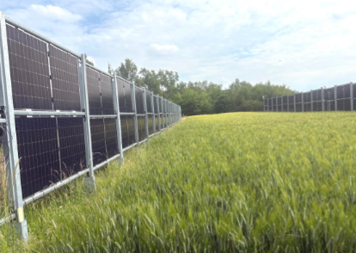  Figure 1. Vertical bifacial (on both sides) solar panel | 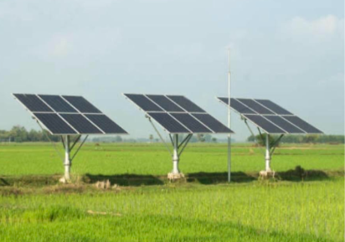  Figure 2. Tilted solar panel
A solar fence, i.e. a vertical bifacial solar panel row, offers a smart, vertical solution for the off-grid power supply of deep well pumps. Ideally, the modules are oriented east west to provide a steady supply of electricity throughout the day perfect for irrigation or livestock operations. Vertical bifacial solar panels used as fencing offer an innovative dual-use solution for Mongolia. They provide robust boundary security and shade for agriculture or livestock, while generating localized power with minimal land usage. This maximizes existing infrastructure and bypasses competition for arable land.

Key Advantages in Project Regions
- Dual Land Use: By serving as a physical barrier and a power plant simultaneously, these fences protect crops from livestock or trespassing while eliminating the need to clear extra land for solar farms.
- Peak Demand Alignment: Oriented East-West, vertical bifacial panels produce energy peaks in the early morning and late afternoon. This perfectly matches rural household and agricultural processing needs (e.g., water pumping or milking).
- Higher Yields: Bifacial panels harvest direct light on one side and reflected albedo light from the ground on the other. Because they sit vertically, they avoid dust accumulation and are much less prone to heavy soiling compared to flat roof panels.
Crucial Challenges
- High Initial Costs: While they act as both a fence and a generator, the upfront capital expenditure for bifacial modules and sturdy, weather-resistant mounting hardware is higher than traditional wood, wire, or brick fences.
- Security & Vandalism: Leaving fragile solar cells exposed to the elements or populated public areas introduces a high risk of theft or localized damage, requiring durable tempered glass and security monitoring.
- Grid Infrastructure: In many rural regions, there are no local mini-grids or transmission lines to absorb surplus power, meaning these systems are most effective only when paired with localized energy storage.

The vertical solar fences create a new income source for farmers, as well as potentially supporting the growth of certain crops by protecting plants from wind and extreme heat.

Vertical solar fences create a new revenue stream for farmers and can also boost the growth of certain crops by protecting plants from wind and extreme heat. Both systems merit consideration. Technical details will primarily need to be discussed with a water users' association, as the cost of solar-powered water pumps is too high for individual smallholder investments. The water association could also operate in conjunction with the Aimag administration or the agricultural park. Solar fences, on the other hand, could be utilized by individual smallholders.

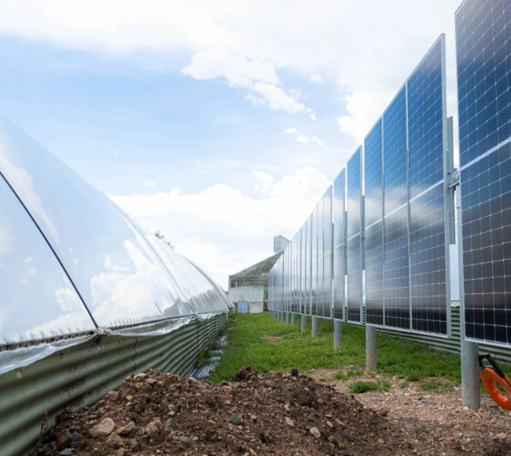  Figure 3. Examples of Vertical solar fences | 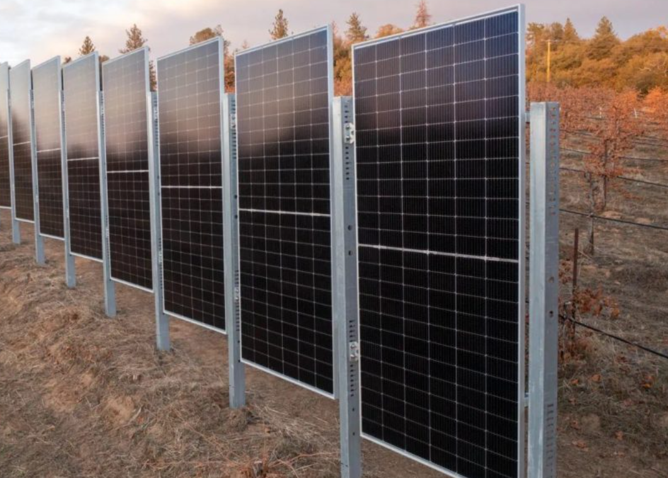  Figure 4. Examples of Vertical solar fences
This is just the beginning to understand the interaction between vertical solar power, crop yield, land utilization and financial benefits for farmers. Installing these modules in an east-west configuration can produce the same amount of electricity as a south-facing solar panel, according to recent studies.

Box 1. Other solar applications in agriculture
Solar energy can support several agricultural functions beyond water pumping, including greenhouse ventilation and heating, humidity monitoring, wireless sensors, crop drying and small-scale refrigeration. In this Technology Menu, solar-powered water pumping and greenhouse-related solar applications are prioritized because they are most directly linked to the project objective. Other applications are presented in Annex 4 as possible future options for advisory, training or scale-up activities.

Drip Irrigation Systems
Farmer message: Drip irrigation is the priority water-saving technology for both open-field and greenhouse vegetables. It is affordable at small scale, but it only performs well when filtration, flushing and maintenance are routine.

How it works
Drip irrigation is a low-pressure water system that keeps roots moist but doesn’t soak the soil. Rather than a steady stream of water spraying over an extended area, a drip irrigation system provides constant drips to specific areas. It uses less water than other irrigation systems, which saves energy and money.

Drip irrigation is also called trickle irrigation. It’s a watering system where water runs through a system of hoses and drip tape and comes out next to each plant through tiny holes called emitters. Since the moisture is applied directly to the roots of each plant, the plant is kept at an optimal moisture level, improving its productivity.

Table 8. Drip irrigation effect in open-field enterprise budgets
Indicator | Uvurkhangai | Dundgovi
Open-field baseline effective yield | 0.81 kg/m² | 0.49 kg/m²
Open-field with drip effective yield | 1.24 kg/m² | 0.92 kg/m²
Open-field baseline net margin | USD 49 / household | −USD 13 / household
Open-field with drip net margin | USD 73 / household | USD 10 / household
Interpretation | Drip improves yield and water control but open-field margins remain modest. | Drip is essential for water efficiency but cannot by itself make open-field vegetable production attractive.

Cost and CBA information
- Indicative cost. The household drip network is costed at about USD 225 where it serves the open-field plot only, and about USD 360 where it serves both the open-field plot and the greenhouse. These values cover the drip network and fittings and should be refreshed with local supplier quotations before procurement.
- Financial result. As part of the stand-alone improved-irrigation option, drip irrigation raises open-field effective yields from 0.81 to 1.24 kg/m² in Uvurkhangai and from 0.49 to 0.92 kg/m² in Dundgovi. However, when combined only with open-field production and the shared solar system, the overall stand-alone irrigation result remains negative: NPV about -USD 365 in Uvurkhangai and -USD 979 in Dundgovi.
- Practical interpretation. Drip irrigation should still be promoted as a low-regret enabling and safeguarding measure. It saves water, reduces leaf wetness and disease risk, supports greenhouse productivity, and limits the maladaptation risk associated with solar pumping by reducing unnecessary abstraction.
- Financing note. Small drip kits can be supported through microcredit, farmer grants or extension programmes. Larger systems should be linked to greenhouse packages, shared solar pumping systems or producer-group investment, and should always include filtration, flushing points and farmer training.

Technical specifications to confirm before installation
- Layout: mainline from tank or pump, sub-main line, lateral drip lines along crop rows.
- Filtration: screen or disc filter should be installed to prevent clogging.
- Pressure: low-pressure operation is preferred; pressure should match emitters and drip tape.
- Emitter spacing: should be selected according to crop spacing and soil type.
- Flushing points: line ends should allow flushing of sediment.
- Fertigation: optional, but requires training and careful nutrient management.
- Water monitoring: irrigation time and frequency should be adjusted by crop stage and weather conditions.

Main benefits
Drip Irrigation is a highly efficient way to deliver water to the crops. The water moves from a water source through a supply line and finally into the drip tape. Watering in this way has many advantages.

- Decrease Labor – With a drip irrigation system, there’s no need to drag around hoses or watering cans to keep your garden watered.
- Conserves Water – A drip irrigation system delivers water to the plant’s roots so each plant gets the water it needs to grow correctly. Drip irrigation uses smaller amounts of water and has far less evaporation.
- Targeted Watering – Drip irrigation permits to lay the water drip lines down exactly where it should be, preventing a lot of overspray from traditional sprinkler systems. A drip system won’t require leveling the garden space.
- Prevents Soil Erosion – Because the water is applied directly to the soil at the root level, there is no soil erosion that overhead watering devices like sprinkler heads can cause.
- Energy Saver – Because drip irrigation uses lower pressure levels than other types of irrigation, energy costs will be considerably lower.
- Prevents Disease – Drip irrigation systems minimize the water contact with the plant’s leaves, stems and fruit, which helps to control plant diseases.

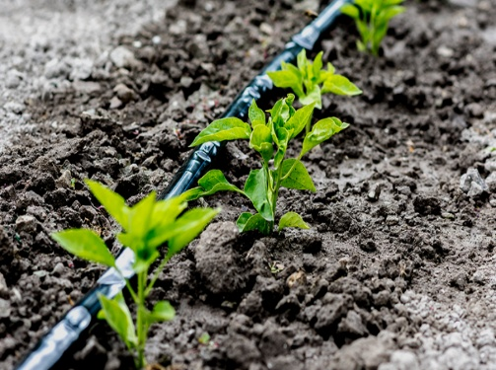  Figure 5. Example of Drip irrigation | 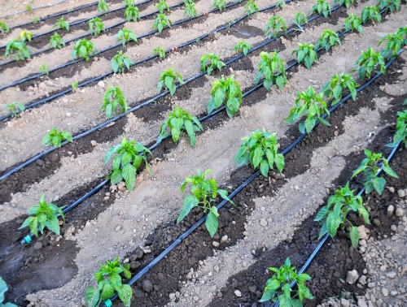  Figure 6. Example of Drip irrigation

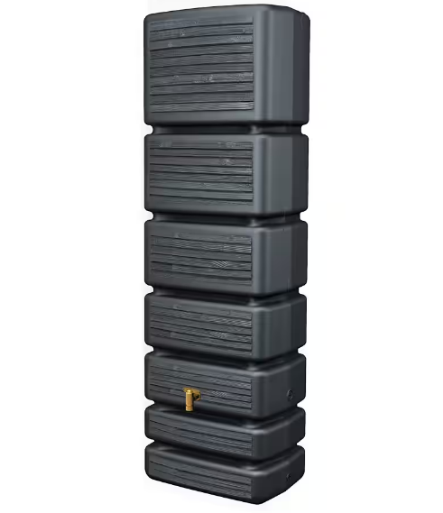  Figure 7. Water tanks - 0,60 x 0.40 x 2,00 m - almost 500 ltrs | 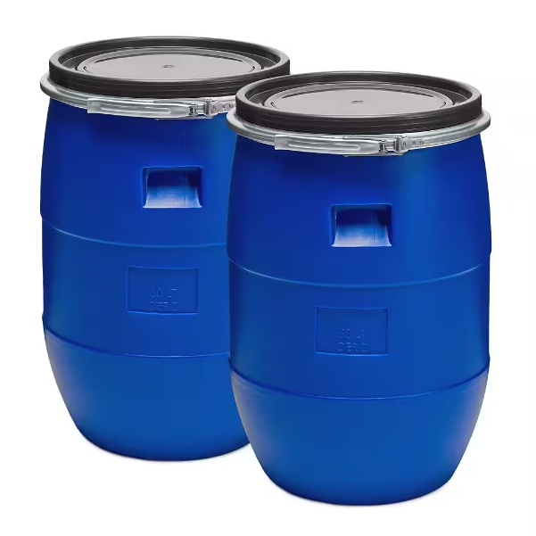  Figure 8. Example of water tanks

Risks and safeguards
- Emitter clogging if water is not filtered or lines are not flushed.
- Damage from animals, tools, frost or poor storage after the season.
- Uneven watering if pressure is not balanced or layout is poor.
- Over-irrigation if farmers do not adjust frequency to crop needs.

Operation and maintenance checklist
- Clean filters regularly.
- Flush lateral lines at least periodically and after dirty water events.
- Check for leaks, blocked emitters and damaged lines.
- Store removable drip tape properly after the season where applicable.
- Adjust irrigation according to crop stage, weather and soil moisture.
- Avoid walking or driving over lines.

Advisory material to be developed for drip irrigation
- Leaflet/checklist: filter cleaning, line flushing, leak detection and seasonal storage of drip tape.
- Fact sheet: open-field and greenhouse layout, filtration, emitter spacing, irrigation frequency, cost placeholders and maintenance requirements.
- Video: simple installation and maintenance demonstration, with validated links to be inserted before final dissemination.

Passive Solar Greenhouses
Farmer message: The passive solar greenhouse is the productive core of the recommended package. It extends the season and creates the main household income gain. In Dundgovi, the low-cost earth-sheltered design is financially decisive; the higher-cost polycarbonate variant should not be the default unless co-financed for very exposed sites.

How it works
The passive solar greenhouse (often referred to as a Chinese greenhouse) represents the best alternative for small-scale farms facing harsh, cold winters characterized by severe wind and sandstorms. Its unique structure uses a transparent south-facing roof or wall and a thick, heat-retaining north wall to store solar energy during the day and release it at night. This minimizes the need for supplemental heating, making it ideal for cooler climates. Ventilation is needed to prevent overheating and humidity build-up.

Compared to standard tunnel greenhouses, they require less plastic sheeting due to their three-sided masonry walls. Their unique design enables superior solar heat absorption and allows that heat to be released at night.
It is not only the multi-layered nature of the films that matters; a keen interest and attention to detail are also prerequisites for profitable greenhouse vegetable cultivation.

Simple tunnel greenhouses covered by only one or two layers of plastic film are highly vulnerable to wind—especially if they are not adequately protected and maintained. Due to human error—specifically, a lack of proper care for the materials—the covering deteriorates quickly.

Table 9. Passive solar greenhouse design and CBA information
Indicator / design point | Uvurkhangai | Dundgovi
Primary greenhouse recommendation | Earth-sheltered passive solar greenhouse / GERES-type; third-generation designs for two harvests per season. | Low-cost earth-sheltered passive solar greenhouse protected by shelterbelts as the default financially viable design.
Reference area in CBA | 300 m² | 300 m²
Cost used in CBA | USD 20/m² passive solar greenhouse. | USD 20/m² passive solar base case; USD 45/m² polycarbonate co-financed variant.
Greenhouse yield used in CBA | 17.7 kg/m²/year effective yield. | 14.6 kg/m²/year effective yield.
Greenhouse net margin | USD 3,384/year per representative household. | USD 2,216/year per representative household.
S2 financial result | NPV USD 15,060; IRR 44.6%; BCR 2.39; payback 3 years. | Passive solar base: NPV USD 3,211; IRR 18.3%; BCR 1.23; payback 5 years. Polycarbonate variant: NPV −USD 4,289; IRR 3.9%; BCR 0.80; payback 11 years.

Table 10. Pictures with examples of passive solar greenhouse
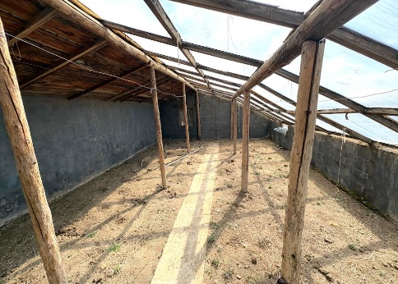 | 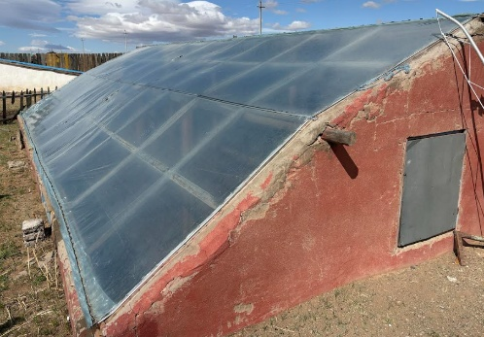
Thanks to the sturdy walls and robust wooden framework, the passive greenhouses—originally built 7 to 15 years ago—remain fully functional, with the exception of the plastic sheeting, which has been replaced every 3–5 years. Additionally, the size of the greenhouses has increased to at least 60 m², up from the original approximately 30 m².
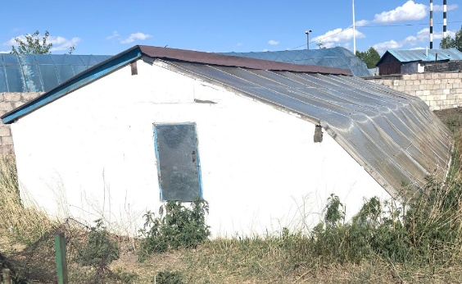 | 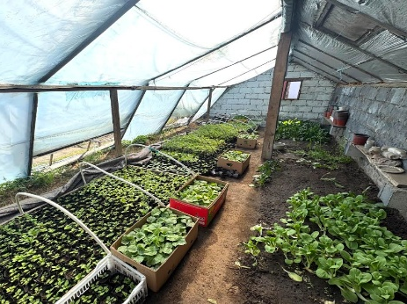

In recent years, there has been an increase in the use of greenhouse tunnels, primarily sourced from South Korea. These so-called "summer greenhouses" have had varying impacts; - for some, they have served as an entry point into more intensive vegetable cultivation. This approach has often been combined with small passive solar greenhouses - measuring approximately 30 m²that are heavily promoted by various NGOs. Additionally, some aimag centers feature "agroparks," where various institutions (such as police stations and hospitals) have the opportunity to grow their own vegetables.

Improved 2nd and 3rd generation of passive solar greenhouse - this type of greenhouse appears better suited to withstand strong winds and the risk of frost, due to its three walls and its unique shape alone. 29 degree measured inside – plastic film protection allows for even earlier use of the greenhouse

Figure 9. Pictures of Improved 2nd and 3rd generation of passive solar greenhouse
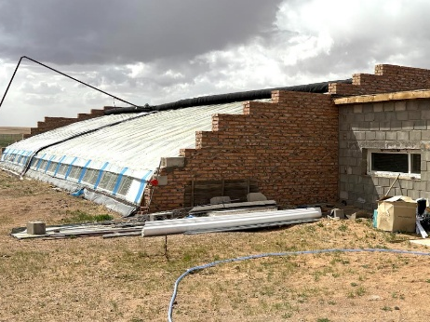 | 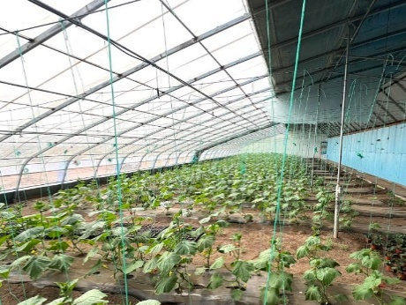
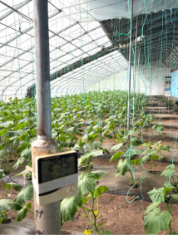 | 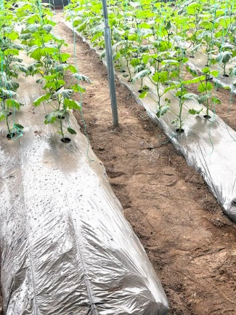

Target beneficiaries - Targeting Criteria and Selection Approach
A set of practical criteria will guide Beneficiary selection to ensure transparency and effectiveness. These include:

- farm size within the defined smallholder threshold
- engagement in or potential for vegetable production
- access to water and irrigation infrastructure
- willingness to adopt new technologies
- inclusion of women and vulnerable groups

This targeted approach ensures alignment between the needs of the beneficiaries, farming systems, and the proposed technological and financial solutions. For smallholder farms, the proposed greenhouse size should be limited to 50–100 m². If the family farm operates successfully, it can expand its greenhouse on its own; this should be taken into account during the foundation planning stage.

Cost and CBA information
- Indicative cost. The default passive-solar greenhouse cost used for planning is USD 20/m², within the low-cost earth-sheltered range of approximately USD 15–25/m². For the 300 m² reference greenhouse, this corresponds to about USD 6,000 for the structure before associated irrigation, maintenance and replacement items. The higher-specification polycarbonate variant tested for exposed Dundgovi micro-sites is USD 45/m², or about USD 13,500 for the same reference area.
- Financial result. The passive-solar greenhouse is the main value driver of the Technology Menu. In Uvurkhangai, the irrigation-plus-greenhouse combination has NPV about USD 15,060, IRR 44.6%, BCR 2.39 and payback of around 3 years. In Dundgovi, the low-cost passive-solar base case remains viable, with NPV about USD 3,211, IRR 18.3%, BCR 1.23 and payback of around 5 years. If the full-cost polycarbonate variant is used in Dundgovi, the result becomes negative at household level, with NPV about -USD 4,289 and BCR 0.80.
- Practical interpretation. The greenhouse should be treated as the productive core of the package. Profitability depends on achieving reliable yields and prices through good crop planning, ventilation, irrigation, pest management, maintenance and market access. In Dundgovi, the low-cost earth-sheltered design should be the default; the polycarbonate option should be reserved for sites where wind exposure genuinely requires it and where co-financing is available.
- Financing note. Greenhouse investment is suitable for concessional loans, cooperative investment, public support or blended finance, but only where the farmer or group can demonstrate a water source, crop calendar, maintenance plan, market outlet and basic production records. Drip irrigation and wind protection should be treated as part of the greenhouse investment, not as optional extras.

Technical specifications to confirm before installation
- North wall: main thermal mass; material and thickness should be selected for heat storage and insulation.
- South roof/transparent cover: plastic film, polycarbonate or glass; must maximize winter light transmission.
- Film layers: two or three layers may improve thermal performance and wind resilience compared with a single layer.
- Ventilation: roof or side vents should be included to control heat and humidity.
- Insulation: north/east/west walls and night cover should reduce heat loss.
- Irrigation: drip irrigation is recommended to control water and reduce humidity.
- Wind protection: siting, anchoring, side netting and shelterbelts should be considered.
- Records: crop calendar, costs, labour, yields, sales and maintenance.

Table 11. Key Components and Their Functions
Component | Function Material | Example Key | Considerations
North Wall | The core of the greenhouse’s heat storage. Absorbs solar radiation (heat) during the day and releases it slowly at night. Maintains a stable internal temperature. | Brick, Concrete, Earth (rammed earth), Composite | Thickness: Crucial for heat storage capacity. Insulation: Minimizes heat loss to the outside. Material Density: Affects heat absorption rate.
South Roof | Transparent south-facing roof allows sunlight to enter. Provides light for photosyn-thesis and contributes to warming the air inside. | Plastic Film (polyethylene), Polycarbonate, Glass | Light Transmission: Maximizes sunlight entering. UV Resistance: Protects the covering from degradation. Angle: Optimized for winter sun.
Insulation | Essential on the north, east, and west walls, and often used as a movable cover over the south roof at night. Reduces heat loss to the environment. | Straw, Foam (polystyrene), Reflective Materials | R-Value: Higher R-value = better insulation. Moisture Resistance: Prevents insulation from becoming damp and ineffective.
Ventilation | Usually vents on the roof or south side. Regulates tempera-ture by releasing excess heat and allows for air exchange (CO2/O2). | Manual Vents, Automated Vents (thermostatcontrolled) | Placement: Strategic location for effective airflow. Size: Adequate to prevent overheating.
Irrigation system | Provides water efficiently and reduces humidity problems. |  | Drip irrigation connected to storage tank or pressurized source.
Wind protection | Reduces structural damage and heat loss. |  | Shelterbelts, windbreak nets, secure anchoring and protected siting.

Main benefits
- Extends the growing season and can enable earlier planting.
- Improves protection from frost, wind and sandstorms compared with simple tunnel greenhouses.
- Reduces plastic film requirement compared with some tunnel designs because of solid walls.
- Can reduce heating needs by storing solar heat.
- Can improve crop quality and production reliability when well managed.

Risks and safeguards
- Poor ventilation can cause overheating, humidity and disease.
- Poor construction or anchoring can lead to wind damage.
- Film must be protected and replaced periodically.
- Profitability depends on crop management, timing, yields and market access.
- A greenhouse left unused or poorly maintained will deteriorate; insurance cannot compensate for lack of maintenance.

Operation and maintenance checklist
- Inspect plastic film and repair tears immediately.
- Ventilate during hot periods and close/insulate during cold nights.
- Monitor humidity and disease pressure.
- Use drip irrigation and avoid unnecessary leaf wetting.
- Plan crops, planting dates and harvest cycles before the season.
- Keep simple records of costs, labour, yields and sales.

Figure 10 Pictures of not maintained greenhouses
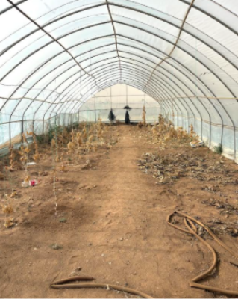 | 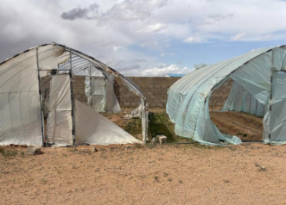
If a greenhouse is not maintained—meaning nothing is planted or the plastic sheeting is not protected—nothing happens, or rather, the greenhouse is left to its own and falls into disrepair. Even the best insurance cannot help here

Simple Greenhouse Heating and Thermal Protection
Farmer message: Simple greenhouse heating and thermal protection should support the passive solar greenhouse, not compensate for poor design. Passive heat-retention measures should be prioritized before active heating because active heating can introduce fire, smoke, electricity and operating-cost risks.

How it works
Simple heating options either add heat directly to the greenhouse air or protect the root zone and plants from cold periods. Passive methods such as micro-tunnels, thermal mass, water-filled black tubes and night covers reduce heat loss without complex equipment. Mechanical or fuel-based options may provide more heat but require safety checks, fuel or electricity, and careful monitoring.

Figure 11. Example of simple heating options
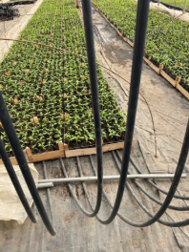 | 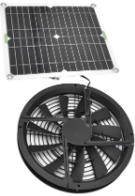  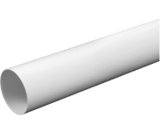
- Radiant tube heater | - PC pipe – heater - 5 w, blows higher temperature air through PC pipe underground
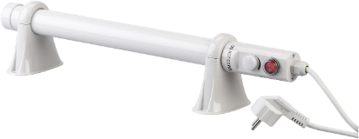 | 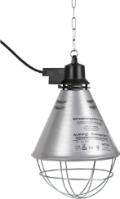
- Heating lamp | - Rod heater
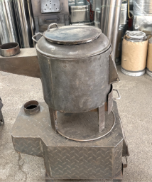  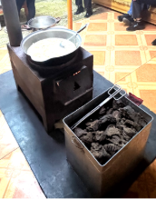 | 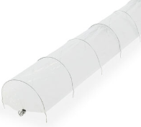  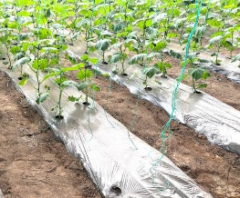
- Yurt-style oven | - Micro tunnel or plastic film

Cost and CBA information
- Indicative cost. No stand-alone cost range is assigned to simple heating and thermal protection in the main appraisal because the options vary widely, from low-cost passive measures such as inner micro-tunnels and night covers to active electric or combustion systems. Supplier quotations and safety requirements should be checked before any active heating option is promoted.
- Financial result. Simple heating is not assessed as a separate investment scenario. It should be considered an optional greenhouse management or design measure, and only where the additional value of earlier or later harvests is likely to exceed the extra equipment, energy and maintenance costs.
- Practical interpretation. Passive heat-retention measures should come first: good orientation, insulation, sealing, double or triple film where appropriate, thermal mass, night covers and careful ventilation. Active heating should not be used to compensate for poor greenhouse design or poor crop management.
- Financing note. Active heating should not normally be financed as a stand-alone smallholder investment. It may be considered in demonstration sites, AgroParks or better-capitalized greenhouses if safety, energy source, operating cost and market timing are clearly justified.

Technical specifications to confirm before installation
- Passive thermal protection: inner micro-tunnels, plastic covers, water barrels/tubes, insulation and night covers.
- Electric options: heating lamps, rod heaters or low-power pipe heaters should be assessed for energy source, safety and cost.
- Fuel/oven options: yurt-style ovens or other combustion systems require strict ventilation and fire safety.
- Root-zone heating: may be more efficient than heating the entire greenhouse air volume, but needs technical design.
- Controls: thermometer and simple monitoring should be mandatory for any heating option.

Main benefits
- Can reduce frost damage and improve early-season crop survival.
- Can extend the production period where market prices justify the investment.
- Passive and root-zone options may be affordable and efficient for small greenhouses.

Risks and safeguards
- Fire, smoke or carbon monoxide risk from combustion systems.
- High operating costs may make active heating unprofitable.
- Poorly controlled heating can create humidity and disease problems.
- Electrical systems require safe wiring and protection from moisture.
- Heating should not compensate for poor greenhouse design or lack of insulation.

Operation and maintenance checklist
- Use thermometers and record minimum/maximum temperatures.
- Check all heaters before cold periods.
- Keep flammable materials away from heaters and ovens.
- Ventilate safely when combustion is used.
- Prioritize insulation and passive heat retention before active heating.
- Compare extra harvest value with additional heating cost.

Agroforestry, Shelterbelts and Wind Protection
Farmer message: Agroforestry and shelterbelts are not quick-return investments. Their value is protection: they reduce wind, dust, erosion and microclimatic stress, protect greenhouses and crops, and support longer-term ecosystem resilience. They require species selection, establishment watering, fencing and multi-year care.

How it works
Shelterbelts, living fences, orchards, shrub rows, tree shelters, hail nets and windbreak netting reduce exposure to wind, dust, hail, snow load and animal damage. Vegetation-based measures also provide ecosystem services such as carbon sequestration, biodiversity habitat, soil conservation, hydrological regulation, water retention and local climate regulation.

Forestry Fencing Solutions
- Tree Shelters: Rather than fencing an entire forest, individual tree shelters or "tubes" protect young saplings from browsing animals during critical early growth stages.
- Animal Corridors: To avoid blocking animal migration routes, forestry fences can utilize drop-net sections or specialized "frame" designs that allow smaller animals to pass through without harming the broader barrier.
- Rot-Resistant Posts: Utilizing naturally durable woods like black locust or recycled steel minimizes chemical treatments and lowers long-term maintenance costs.

Innovative fencing solutions for orchards, forests and greenhouses balance high-performance wildlife protection with sustainability and ease of maintenance. Whether you need to deter deer, protect young timber, or manage boundaries, modern systems use advanced materials and eco-friendly designs.
- High-Tensile Woven Wire: The industry standard for long-term tree protection. It is highly resistant to impact from wildlife and eliminates sagging.
- Tall Exclusion Fencing: For robust livestock management, fences should be 2,10 - 2,40 m tall. Taller systems deter animals from jumping into vulnerable fruit trees.
- Electric Reinforcement: Adding one or two offset strands of high-voltage electric wire to a standard fence provides a psychological barrier against any animals.
- Living Fences: Planting dense, rapid-growing native shrubs or trees along boundaries establishes a natural, wind-blocking perimeter.

Figure 12. Hail net examples

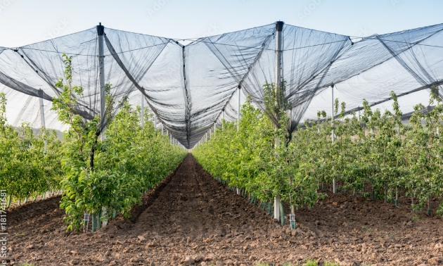 | 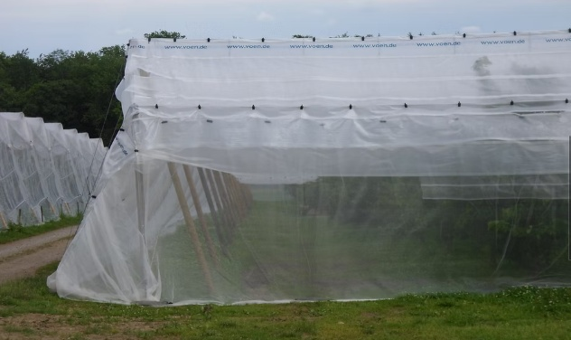
Hail nets can serve as simple protection against, wind, hail, and snow loads. This is standard in commercial market oriented economies, and should more be used in Mongolia.
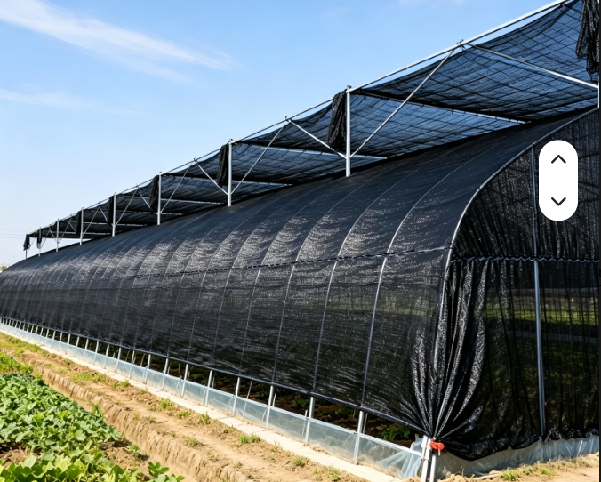 | 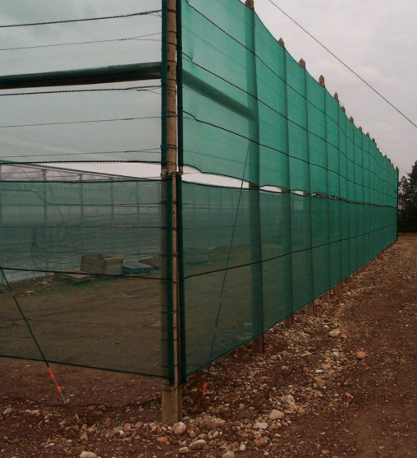
Netting – not just overhead but also as windbreak along the sides – is absolutely essential
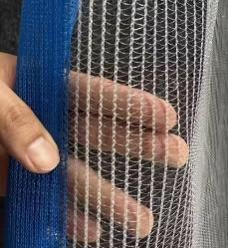 | Simple network already have a major impact

Table 12. Agroforestry models carried into the Technology Menu
Agroforestry model | Best suited for | Key design elements
Model A — Three-row multifunctional productive shelterbelt | Medium and larger vegetable farms; especially Dundgovi reference design. | Row 1 windward shrub layer dominated by Caragana with sea buckthorn/hawthorn; Row 2 structural trees dominated by Ulmus with Tamarix in saline areas; Row 3 long-term reinforcement and biodiversity/berry layer; width about 4.5–5 m.
Model B — Two-row compact shelterbelt | Smaller farms or sites with limited land and lower establishment budget. | One drip line midway between shrub/tree rows during establishment; lower cost while still providing wind protection.
Agro-silvo orchard + horticulture system | Uvurkhangai demonstration farms and farmers with water and capacity for diversification. | Vegetables remain core; fruit trees and berries are established behind shelterbelts with drip irrigation and spacing adapted to greenhouse/plot layout.

Cost and CBA information
- Indicative cost. The appraisal uses a 250 m² agroforestry or shelterbelt strip per representative household. Establishment cost is modelled at about USD 320 per household, including seedlings, planting, fencing and establishment irrigation. Costs should be updated with local nursery, fencing and labour prices before implementation.
- Financial result. Marketable output from the shelterbelt is modest at household scale: mature annual net margin is estimated at about USD 72/year in Uvurkhangai and USD 11/year in Dundgovi. As a stand-alone household investment, the irrigation-plus-agroforestry option is not financially viable, with NPV about -USD 665 in Uvurkhangai and -USD 1,589 in Dundgovi.
- Practical interpretation. Agroforestry should be promoted as a protective and ecosystem-based adaptation measure, not as a quick-return crop enterprise. Its main value is wind reduction, dust control, soil protection, microclimate regulation, protection of greenhouses and long-term resilience. These benefits are strongest when agroforestry is combined with greenhouse and irrigation investments.
- Financing note. Because benefits are long-term and partly public, shelterbelts are well suited to grants, public adaptation finance, EbA programmes, community labour schemes and cooperative implementation. Financing should include not only planting, but also fencing, establishment watering, survival monitoring and replacement planting.

Technical specifications to confirm before installation
- Shelterbelt orientation: should be planned according to prevailing winds and site layout.
- Species: locally adapted trees and shrubs with drought, wind and frost tolerance should be selected.
- Spacing: row spacing and within-row spacing to be defined by species and purpose.
- Establishment irrigation: supplemental irrigation may be required during the first years.
- Protection: fencing, tree shelters or guards may be needed against livestock and wildlife.
- Netting: side netting and hail nets can provide immediate protection while trees establish.
- Maintenance: weeding, replacement planting, pruning and survival monitoring are required.

Main benefits
- Reduces wind speed and physical damage to crops and greenhouse films.
- Reduces soil erosion and dust movement.
- Improves microclimate and may reduce evapotranspiration.
- Supports biodiversity and landscape restoration.
- Can provide long-term carbon, soil and water regulation benefits.
- Can protect orchards, greenhouse sites and young plantations from animals when combined with fencing.

Table 13. Agroforestry services and benefits
Service | Practical relevance for farmers
Carbon sequestration | Trees and shrubs store carbon in biomass and soils, supporting broader climate benefits.
Soil conservation | Roots and vegetation cover reduce wind and water erosion and help maintain fertility.
Biodiversity support | Shelterbelts and living fences create habitats and corridors for beneficial species.
Hydrological regulation | Vegetation can improve infiltration, reduce runoff and support soil moisture retention.
Microclimate regulation | Windbreaks stabilize local wind and temperature conditions around plots and greenhouses.
Air quality improvement | Vegetation can reduce dust and airborne particles in exposed areas.
Cultural and aesthetic value | Trees and green areas can improve farm landscapes and community well-being.

Risks and safeguards
- Low seedling survival if species are poorly selected or watering is insufficient.
- Grazing damage if protection is not installed.
- Competition for water if trees are planted too close to vegetable beds.
- Delayed benefits: trees take time to establish and protect crops.
- Maintenance responsibilities may be unclear in communal or cooperative sites.

Operation and maintenance checklist
- Water seedlings during establishment according to species needs and rainfall.
- Protect young trees from livestock and wildlife.
- Replace dead seedlings promptly.
- Control weeds around seedlings.
- Inspect fences, nets and tree shelters after wind and snow events.
- Prune and manage shelterbelts to maintain windbreak function.

Combining Technologies in Practice
The feasibility and CBA reports confirm that technologies should be combined in practical sequences rather than promoted as isolated equipment. The Technology Menu therefore presents five farmer-facing entry combinations. The insurance-only scenario used in the CBA is not a farmer package; it is an analytical reference case.

Table 14. Technology Menu combinations mapped to CBA scenarios
Menu combination | Components | Main benefits | Closest CBA scenario | Practical use
Combination A — Basic water-saving | Small drip kit, simple storage, mulching, irrigation scheduling, basic crop records. | Low-cost water saving; easier entry point; practical training value. | Entry step toward S1 | For Tier 1 and low-capital farmers; below the full shared-solar system appraised as S1.
Combination B — Protected production | Passive solar greenhouse or improved protected cultivation structure, drip irrigation, ventilation, crop calendar, pest monitoring. | Season extension; improved crop quality; reduced climate exposure. | S2 | Priority first investment where full package is not possible.
Combination C — Solar irrigation + drip | Solar pump, controller, storage tank, water meter, drip system, pump-hour records. | Reduced energy cost; improved irrigation reliability; water-use efficiency if managed. | S1 | Shared infrastructure; subject to water appraisal safeguard before installation.
Combination D — Cooperative resilience | Shared solar pump, shared storage, drip network, greenhouse cluster, producer group management, maintenance fund. | Economies of scale; stronger financeability; shared training and maintenance. | S4 cluster level | Preferred full model for WUA/cooperative/AgroPark implementation.
Combination E — EbA landscape | Shelterbelts, living fences, windbreak nets, soil moisture practices, establishment irrigation. | Long-term microclimate and soil protection; reduced wind damage. | S3 | Protective ecosystem layer; strongest when linked to greenhouse and drip systems.

Province-specific recommended combinations

Table 15. Province-specific recommended combinations
Province | Recommended combination | CBA result | Implementation note
Uvurkhangai | Full Integrated Model (S4): solar drip + passive solar greenhouse + agroforestry shelterbelt + index-based insurance. Where finance is limited, begin with S2 greenhouse package. | S4 financial NPV USD 15,552; IRR 43.1%; BCR 2.22; payback 3 years. Economic NPV USD 20,900. | Strongly viable. Use as standard package, with producer organization and market planning.
Dundgovi | Full Integrated Model (S4) built around low-cost earth-sheltered passive solar greenhouse, deep-borehole solar pumping with LiFePO₄ storage, drip irrigation and shelterbelts. | S4 passive-solar financial NPV USD 3,253; IRR 17.8%; BCR 1.21; payback 5 years. Economic NPV USD 6,965. | Viable but thinner margin. Requires public co-financing, water safeguards and low-cost greenhouse design.
Dundgovi exposed micro-sites | Same as above but with wind-resistant polycarbonate greenhouse only where genuinely required. | S4 polycarbonate variant has negative financial NPV at full household cost (−USD 4,247). | Use only with targeted public co-financing and site justification.

Finance, Insurance and Producer Organization
The recommended technologies are capital-intensive relative to smallholder cash resources. The CBA estimates per-household year-0 CAPEX for the full integrated model at about USD 6,855 in Uvurkhangai and USD 7,244 in Dundgovi. At cluster level, an 18-household water-users’ association requires about USD 123,390 in year-0 CAPEX in Uvurkhangai and USD 130,390 in Dundgovi. This makes producer organization, public co-financing and clear maintenance responsibility essential.

Table 16. Finance and insurance relevance by technology
Technology / combination | Likely finance approach | Insurance / risk relevance
Basic drip and agronomic practices | Small grant, microcredit, household investment or extension programme. | Reduces water stress and supports basic resilience, but not enough alone for profitability.
Passive solar greenhouse | Concessional loan, cooperative investment, public support and blended finance. | Main insurable productive asset if crop plan, water source, maintenance and records are documented.
Solar pump + storage + drip | WUA/cooperative finance, public-private model, AgroPark investment. | Requires water safeguards; reduces energy risk but can increase water risk if unmanaged.
Shelterbelts and agroforestry | Public adaptation finance, grants, community labour and EbA programmes. | Long-term risk reduction; public/environmental benefits justify subsidy.
Index-based insurance | Premium support, bundled with physical package and farmer records. | Residual risk-transfer layer; not a profit centre; improves recovery after adverse events.

Producer organization and WUA requirements
- Define ownership of shared boreholes, pumps, tanks and mainlines before installation.
- Agree abstraction shares, operating schedule, fee collection and maintenance responsibility.
- Create an asset-replacement fund for pumps, batteries, drip components and greenhouse film/glazing.
- Keep simple records of water use, pump hours, crop area, yields, maintenance and weather losses.
- Use local producer associations, AgroParks and vocational schools as platforms for training, technician development and market planning.

Minimum requirements for greenhouse loan readiness
- Simple greenhouse design and bill of quantities.
- Crop calendar and expected harvest windows.
- Water source and irrigation plan.
- Ventilation, pest management and maintenance plan.
- Basic record-keeping template for costs, labour, yields and sales.
- Market outlet or buyer assumptions.
- Training or technical support arrangements.
- Insurance or risk management option where available.
Training should not focus only on construction. Farmers also need practical support on vegetable cultivation, crop care, integrated pest management, storage, processing, marketing, bookkeeping and food safety records. Agroparks and vocational schools can provide useful platforms for continuing education and practical technical training, including for welders, greenhouse technicians, irrigation installers and renewable energy technicians.

Conclusions and next steps
This Technology Menu consolidates practical guidance on solar-powered irrigation, drip irrigation, passive solar greenhouses, simple greenhouse heating, agroforestry, wind protection and extension materials. To become a fully submission-ready deliverable, it must now be completed with validated technical specifications, cost ranges, CBA results, province-specific recommendations, water safeguards, species tables and Mongolian translation.

The final version should remain concise and visual. Detailed calculations, full CBA tables and engineering assumptions should be moved to annexes. The main body should serve as a practical catalogue and decision-support guide for farmers and extension officers.

Annex 1. Draft species table template
The table below consolidates species and species groups mentioned in the feasibility assessment.

Table 17. Summary of species for technology implementation
Species / group | Common role | Province suitability | Water need | Recommended use / note
Ulmus pumila | Structural tree / windbreak | Both; especially Dundgovi and steppe sites | Low to medium | Dominant structural species for shelterbelts under dry conditions.
Tamarix spp. | Structural tree/shrub | Dundgovi, saline or arid sites | Low to medium | Valuable where salinity or poor soils occur.
Caragana arborescens | Shrub layer / nitrogen fixation | Both; especially Dundgovi | Low | Dominant windward shrub layer; reliable in dry conditions.
Hippophae rhamnoides | Berry shrub / productive shelterbelt | Both; stronger in Uvurkhangai and irrigated sites | Medium | Economic berry function; market saturation risk should be considered.
Hawthorn | Shrub diversity / pollinator habitat | Both, to validate locally | Medium | Adds structural diversity and biodiversity.
Populus spp. | Fast-growing structural tree | Uvurkhangai and irrigated Dundgovi sites only | Medium to high | Useful where reliable irrigation exists; should not dominate Dundgovi designs.
Haloxylon ammodendron | Dryland shrub/tree | Dundgovi / Gobi sites | Low | Useful in desert-steppe restoration where suitable planting material exists.
Malus domestica / Malus baccata | Fruit / pollination / resilience | Uvurkhangai favourable sites | Medium | For orchard-horticulture demonstration behind shelterbelts.
Pyrus communis / Pyrus ussuriensis | Fruit / hardiness | Uvurkhangai favourable sites | Medium | For orchard models where frost and water risks are manageable.
Prunus spp. | Fruit diversification | Uvurkhangai demonstration sites | Medium | Plum, cherry and Siberian apricot to be piloted only in suitable sites.
Honeyberry, blackcurrant, raspberry | Berry diversification | Uvurkhangai; some irrigated sites in Dundgovi to test | Medium | Alternative berry options to reduce reliance on sea buckthorn.

Annex 2. Farmer Technology readiness checklists
The farmer checklists are practical self-assessment tools for farmers, cooperatives and extension officers. They help users check whether minimum conditions for adopting, operating and maintaining each technology are in place. They also support future finance and insurance readiness by encouraging basic records. They are not formal eligibility criteria for credit or insurance.

General farmer self-assessment checklist
- Farm size and plot location known
- Secure land tenure or use agreement confirmed
- Main crops and planting calendar identified
- Water source known and legally usable
- Basic market outlet or buyer assumption identified
- Labour and maintenance capacity available
- Basic cost/yield/sales records started

Solar-powered pump checklist
- Water depth, yield and quality assessed
- Sustainable abstraction estimated
- Pump sized to crop demand and safe withdrawal
- Storage tank and drip system included
- Water meter or pump-hour records planned
- Maintenance and spare parts identified
- Ownership/WUA rules agreed

Drip irrigation checklist
- Filter installed and cleaned
- Lines flushed regularly
- Emitters checked for clogging
- Leaks repaired
- Irrigation adjusted by crop stage/weather
- Lines protected from animals and damage

Greenhouse management checklist
- Orientation and wind protection confirmed
- Ventilation functioning
- Film/glazing inspected and repaired
- Drip irrigation installed
- Crop calendar prepared
- Pest and disease monitoring routine established
- Cost/yield/sales records maintained

Agroforestry establishment checklist
- Main wind direction identified
- Species validated for site
- Spacing and row design confirmed
- Watering plan for establishment phase prepared
- Fencing/tree protection installed
- Survival checked annually
- Replacement planting budgeted

Finance and insurance readiness checklist
- Farm/cooperative name and location recorded
- Technology cost and maintenance estimate available
- Crop calendar and expected output documented
- Water source and irrigation method described
- Production and sales records kept
- Past climate losses recorded if available
- Photos and installation records available

Annex 3. Outline for the Greenhouse Management Manual
This annex provides the proposed structure and content areas for a practical Greenhouse Management Manual to be adapted to Mongolian conditions. The manual is intended to complement the greenhouse technology fact sheets included in the Technology Menu. While the fact sheets provide short, farmer-facing guidance on specific greenhouse options and practices, the manual should provide more detailed technical and operational guidance for farmers, cooperatives, AgroParks, extension officers, vocational training centres and local technicians.

The manual will be finalized under Phase 4 of the TA. It should be practical, visual and adapted to the climatic and production conditions of Dundgovi and Uvurkhangai, including short growing seasons, strong winds, frost risk, high temperature variation, water scarcity, limited access to spare parts, and the need for low-cost but durable solutions.
Manual topics include:
- Environmental control: temperature management, cold-weather protection, ventilation, cooling, humidity control, CO₂/air exchange and light management.
- Growing media and containers: soil improvement, soil sanitation, field soil use, soilless or improved media, seedling trays and containers.
- Plant propagation: seed selection, germination conditions, sowing depth, seedling care, transplanting and post-transplant monitoring.
- Irrigation inside greenhouses: drip irrigation, irrigation frequency, filtration, flushing, water-quality checks and water-use records.
- Fertilizer and soil fertility management: fertilizer planning, organic amendments, commercial fertilizer labels, fertigation and avoiding over-fertilization.
- Plant health: pest and disease monitoring, integrated pest management, cultural controls, physical controls and pesticide safety.
- Greenhouse structure maintenance: film/glazing inspection, anchoring, wind protection, frame inspection, snow/load management and seasonal maintenance calendar.
- Crop planning and production management: crop selection, growing schedule, crop rotation, plant spacing, pruning, harvesting and post-harvest handling.
- Greenhouse business management: production costs, income records, marketing plan, post-season evaluation and loan-readiness information.

Annex 4. Outline for the Agroforestry Management Manual

This manual will also be finalized under Output 4. It should provide operational guidance for establishing and maintaining shelterbelts, living fences, nursery systems and agro-silvo demonstration plots.
- Nursery management and local seedling supply.
- Site selection and wind-direction assessment.
- Soil preparation and moisture conservation.
- Seed and seedling selection and treatment.
- Planting in pots and making low-cost pots locally.
- Water management during establishment.
- Nutrition management and soil amendment.
- Weed control.
- Pest and disease management.
- Plantation of trees, orchards and shelterbelts.
- Fencing, tree shelters and protection from livestock.
- Survival monitoring and replacement planting.

Annex 5. Renewable Energy Applications in Smallholder Agriculture
Solar-powered water pumping and greenhouse-related solar applications are the priorities in this Technology Menu. Other renewable-energy applications are included as future options for advisory, training or scale-up activities only.

Table 18. Renewable energy applications and relevance
Application area | Renewable energy option | Possible use | Relevance for this Technology Menu
Irrigation | Solar PV panels | Water pumping for field or greenhouse irrigation | Core
Water pumping | Solar PV water pumping system | Pump operation using DC motors, centrifugal or displacement pumps | Core
Greenhouse management | PV panels / solar thermal | Ventilation, simple heating, greenhouse energy support | Relevant
Monitoring and regulation | Solar-powered sensors | Humidity sensors, wireless monitoring, precision agriculture | Relevant but optional
Drying | Solar drying systems | Drying vegetables or other products | Future option
Desalination | Solar collector / solar still | Treatment of saline or poor-quality water | Future option, only if water quality requires it
Refrigeration | PV or solar thermal systems | Cold storage or post-harvest cooling | Future option for market development
Distillation | Solar-driven systems | Essential oil or niche product processing | Not a priority for this project

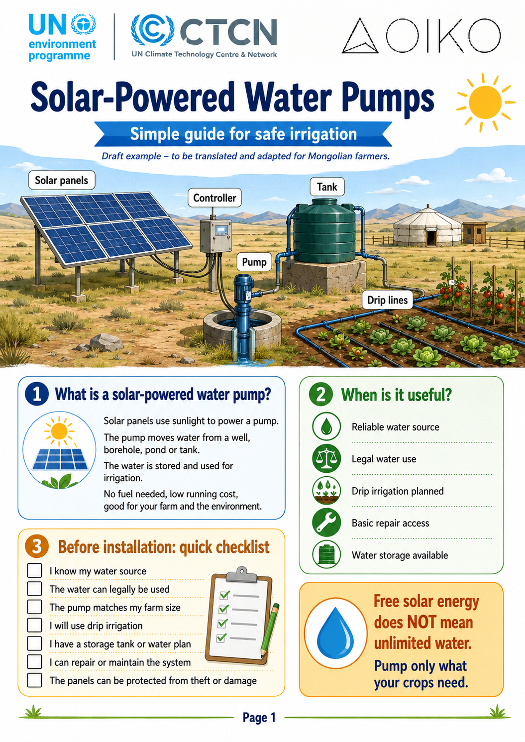
Annex 6. Example farmer-facing extension material — Solar-Powered Water Pumps

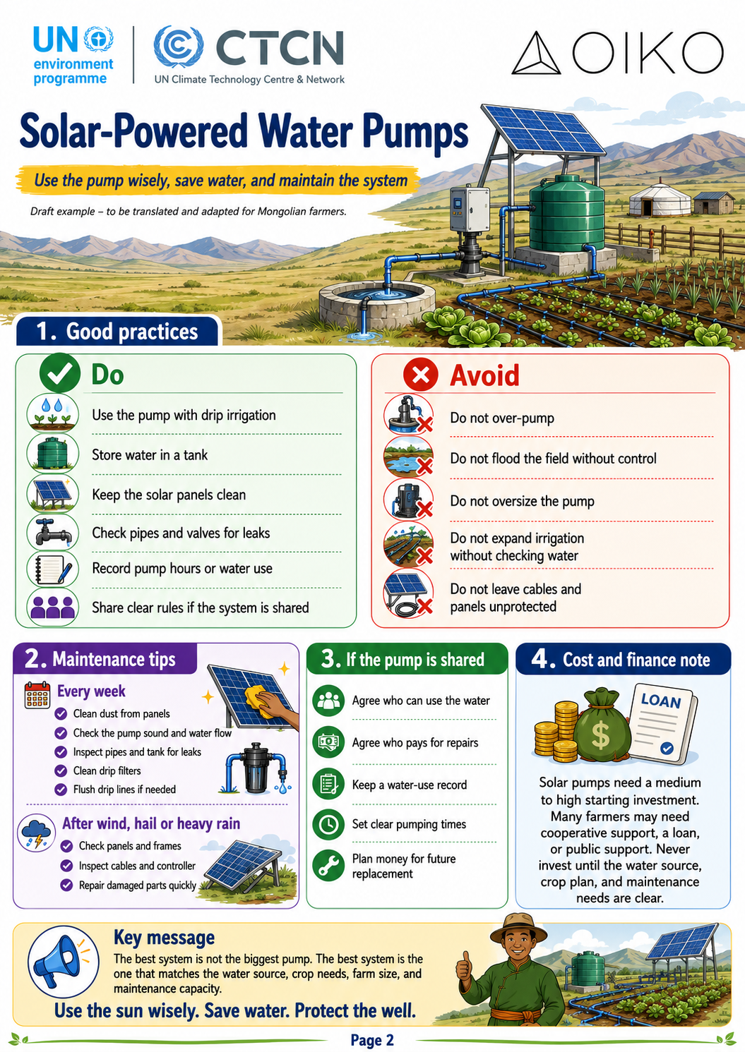

Annex 7. References and source materials
- UNEP CTCN Technical Assistance Response Plan / Terms of Reference for Mongolia.
- D.1.2 Technology Feasibility Report.
- D.1.3 Cost-Benefit Analysis Report, including water resource assessment and maladaptation risk management.
- Policy Mapping and Gap Analysis under Output 2.
- Team Leader technical note: Technical Menu & Farmer Guidelines.
- National standards and guidance for greenhouse infrastructure, irrigation, water use and agroforestry, as applicable.
- Supplier quotations and local market information for pumps, panels, drip equipment, greenhouse materials and seedlings.

The financial appraisal uses a 300 m² greenhouse as a representative analytical unit to test the economics of greenhouse-based production under a commercially oriented smallholder or cooperative model. For farmer-facing implementation, however, the recommended entry size for individual smallholders is 50–100 m². This smaller size reduces upfront investment, labour requirements, water demand and market risk, and can serve as a stepping stone toward larger production where farmers have sufficient experience, finance and market access.
The financial appraisal uses a 300 m² greenhouse as a representative analytical unit to test the economics of greenhouse-based production under a commercially oriented smallholder or cooperative model. For farmer-facing implementation, however, the recommended entry size for individual smallholders is 50–100 m². This smaller size reduces upfront investment, labour requirements, water demand and market risk, and can serve as a stepping stone toward larger production where farmers have sufficient experience, finance and market access.
R-value measures a material’s ability to resist heat flow (thermal resistance)

