Technical Assistance Closure Report
Objective of the technical assistance (TA) Closure Report:
- To communicate publicly in one document a summary of progress made and lessons learned during the TA towards the anticipated impact (sections 1-4).
- To document qualitative and quantitative data collected during TA, for use in donor and UN reporting (Annex 1).

Steps for completing the TA closure report:
- The lead TA implementer submits the closure report at the end of the technical assistance as a final deliverable. The TA closure report will capture outputs, outcomes and impacts of all activities conducted under the TA. Please copy and summarise relevant material from previous TA outputs/deliverables and the Response Plan, as relevant.
- A CTCN Manager will review and revise the closure report before final approval by the CTCN Deputy Director.

Important note on public and internal use of the closure report:
Once approved by the CTCN Deputy Director, the TA closure report will be a public document available on the CTCN website www.ctc-n.org. Selected content will be used for targeted communication activities. Annex 2 is for internal use only and will not be publicly available.

Closure Report for CTCN Technical Assistance

- Basic information
Title of response plan | EC CTCN - Climate Change and Security Programme - promoting synecoculture in the northern region of Cameroon, in the communes of Garoua 2 and Figuil (Mayo-Louti)
Technical assistance reference number | CTCN - 24-016
Country / countries | Cameroon
NDE organisation | Government of Cameroon
NDE focal point | Timothée KAGOMBE
NDE contact information | kagonbetim@gmail.com
Proponent focal point and organisation | Albert Albala, Terre des jeunes
Designer of the response plan | Ruth LANGSI, Terre des jeunes Cameroun, nruth2000@yahoo.fr
Implementer(s) of technical assistance | CASE (Care Society and Environment-Cameroun)  Terre des jeunes transnational  Terre des jeunes Cameroun  Central government of Cameroun, represented by Témothée KAGOMBE, UNEP focal point  Local municipal Governments represented by the mayors of Figuil and Garoua
Beneficiaries | - Community groups in Garoua:  - Mbilga community farmers’ association  - L’apes-wantoumi community farmers’ association  - Nyakira community farmers’ association  - Participating schools in Garoua:  - Ngourore public school  - Tongo public school  - Nyakira public school  - Community groups in Figuil  - Kereng community farmers’ association  - Bawaka community farmers’ association  - Wafango community farmers’ association  - Participating schools in Figuil  - Dahal public school  - Indjode public school  - Delele public school
Sector(s) addressed | Increasing crop resilience and productivity
Technologies supported | Sustainable fertilizers  Integrated nutrient management  Soil moisture monitoring  Organic agriculture  Fungal symbioses  Pest and insect control  Tillage-free agriculture  Improved cultivation techniques
Implementation start date | 24/06/2024
Implementation end date | 30/10/2025
Total budget for implementation | USD 166,935 from CTCN, in addition to approximately USD 20,000 in community-financed in-kind and cash contribution including land being made available to the project, approximate value of all volunteer work, and an additional equivalent USD 22,000 pledged by the stakeholders and planned for the period following the end of the project with the aim of perpetuating the project.
Description of delivered outputs and products as well as the activities undertaken to achieve them. In doing so, review the log frame of the original response plan and refer to it as appropriate | Output 1: kick-off report  Activity 1: kick-off  Output 2: identification of stakeholders & steering committee  Activity 2.1.1: identify stakeholders in Government, among schools and agriculturers.  Activity 2.1.2: put in place a decision-making process  Output 3: identification of needs  Activity 3.1.1: survey on current situation and needs  Output 4: analysis of how synecoculture can respond to identified needs  Activity 4.1.1: steering committee identifies plan of action based on needs assessment  Activity 4.1.2: selection of schools  Output 5: pilot project and training based on analysis  Activity 5.1.1: recruit and train school and community agriculture groups  Activity 5.1.2: implement priorities based on 4.1.1.  Activity 5.1.3: harvests  Output 6: ensure replicability  Activity 6.1.1: video documentary  Activity 6.1.2: maintain a social media presence through a Facebook group  Activity 6.1.3: guide on synecoculture farming practices for schoolchildren  Activity 6.1.4: open data  Activity 6.2.1: selection of international interns  Activity 6.2.2: internship
Methodologies applied to produce outputs and products | Pre-implementation surveys with stakeholders;  Implementation plan developed in concert with stakeholders;  Production of weekly reports;  Maintenance of a website related to the project including open metrics and links to media at https://www.terredesjeunes.org/synecoculture/;  Setting up twelve (12) conventional plots and twelve (12) synecoculture plots to compare productivity by the collection of regular metrics;  Regular training events including “training the trainers” events;  Internship with international participants;
Reference to knowledge resources | The document “TEC Brief #4: Technologies for Adaptation in the Agriculture Sector” (https://unfccc.int/ttclear/misc_/StaticFiles/gnwoerk_static/TEC_column_L/544babb207e344b88bdd9fec11e6337f/bcc4dc66c35340a08fce34f057e0a1ed.pdf) by UNFCC helped us:  - Understand how “Ecosystem-based agriculture” works: putting the ecosystem at the center of agricultural practices. This has helped us define how to communicate the benefits of synecoculture to stakeholders.  - Define Community-Based training approaches where stakeholders led the approach, and not the opposite.  - Define the importance of information, specifically openly available metrics which are collected, collated and shared in a transparent manner.
Deviations | Initially within Activity 4.1.2, we had planned to select 6 pilot plots in schools (three conventional to compare to three synecoculture). However community interest was such that, in addition to six schools, six community groups expressed interest in providing land and participating in the pilot project. In addition, each participating school and community group expressed a willingness to try synecoculture, so in order to be able to compare synecoculture with conventional farming, each plot was separated into two sections. This meant that in the end, there were 12 plots, each separated into two sections (synecoculture and conventional).
Anticipated follow-up activities and next steps | The stakeholders have committed about 13M Central African Francs, or about 22,000 USD in cash and in-kind contribution, for the period following the technical assistance, including setting up transformation and sales infrastructure for the produce; making permanent the cooperatives set up during the technical assistance phase; the plan being to ensure long-term regular income for the farmers. In terms of expanding the practice of synecoculture, being able to demonstrate that it provides more (and more regular) income than conventional farming is the best way to do that.  In parallel to that, the local team is planning to pursue opportunities with international climate finance and development funds for a new phase of the project.

- Lessons learned
 | Lessons learned | Recommendations
Lessons learned from the CTCN TA process | The logical process of defining a request, response plan, and collecting and collating indicators during the technical assistance has been interesting especially for the local team, some of whom had not dealt with large funders before. The importance of implicating the NDE early and regularly, as well as community stakeholders and the local government (municipal) representatives, is essential in ensuring the long-term viability of the project. | The process was thorough and ensured strong accountability, which we appreciate. At the same time, some administrative steps were sometimes resource-intensive, particularly the volume of documentation required at each stage. Streamlining or digitizing certain reporting and approval procedures could maintain the same level of rigor while reducing the administrative burden, allowing more time and energy to focus on technical implementation and stakeholder engagement.
Lessons learned related to climate technology transfer | As with any project with financing over a limited period of time, it is difficult to ensure long-term use of the technology, the incentive to use the technology tends to increase over a longer period than the technical assistance itself, and the abrupt end of financing often causes a crisis among the stakeholders where many abandon the project and move on to something else. Our approach has been to clearly communicate that funding will stop at a given date, and encourage stakeholders to invest in long-term income generation in preparation of the end of financing. | Provide entrepreneurship mentorship by pairing local entrepreneurs who have credibility in the community (for example, small businesspeople) with the stakeholders, perhaps even giving entrepreneurs a place on the steering committee and compensating them for their time. During numerous projects in poor communities, we often feel that an entrepreneurial spirit is present, but entrepreneurial reflexes are missing and should be encouraged.

3. Illustration of the TA and photos

Please refer to the slideshow at https://docs.google.com/presentation/d/1wzl11qDV38BgAlh62cVLBxtZQXWzmD8Akj_mCwsmR8s/edit?slide=id.g364640a611c_0_83#slide=id.g364640a611c_0_83 which was presented by project ambassador Ruth Langsi at TICAD9 in Japan on August 22nd, 2025.

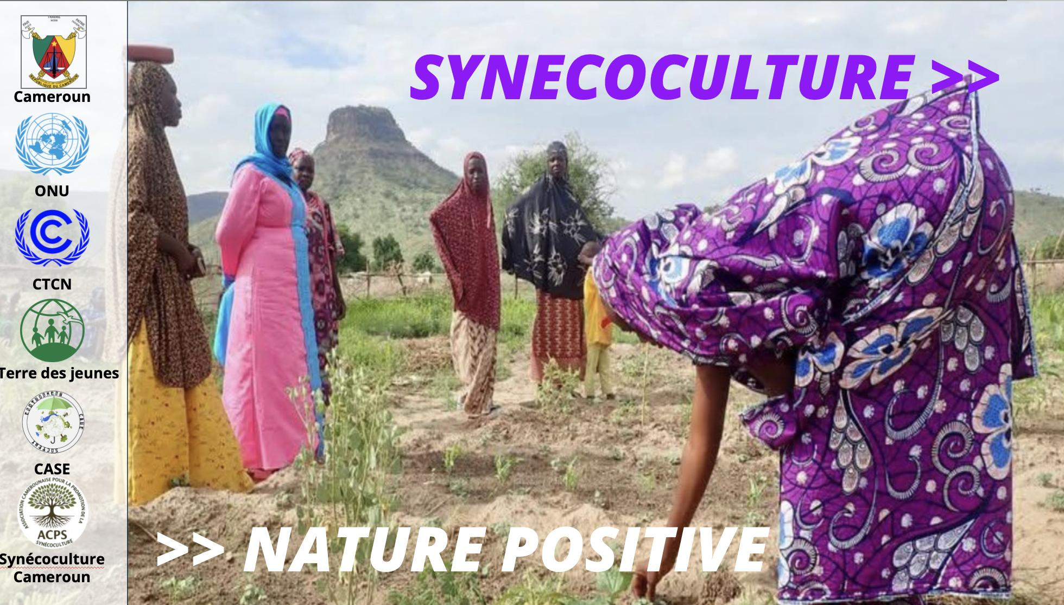 | 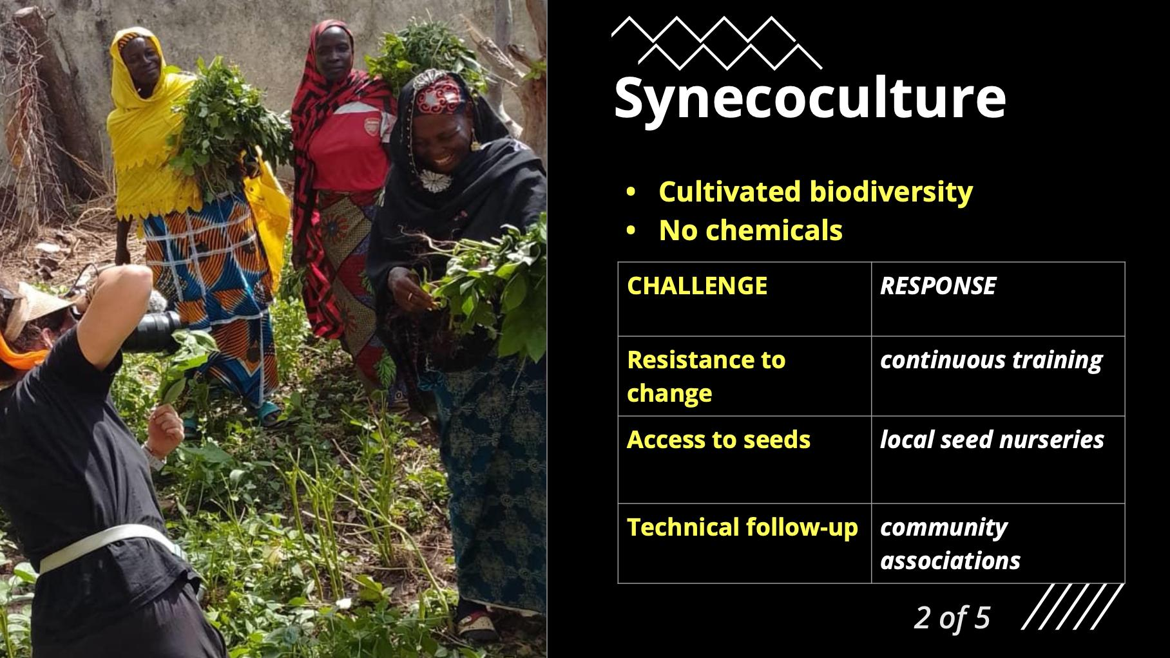 | 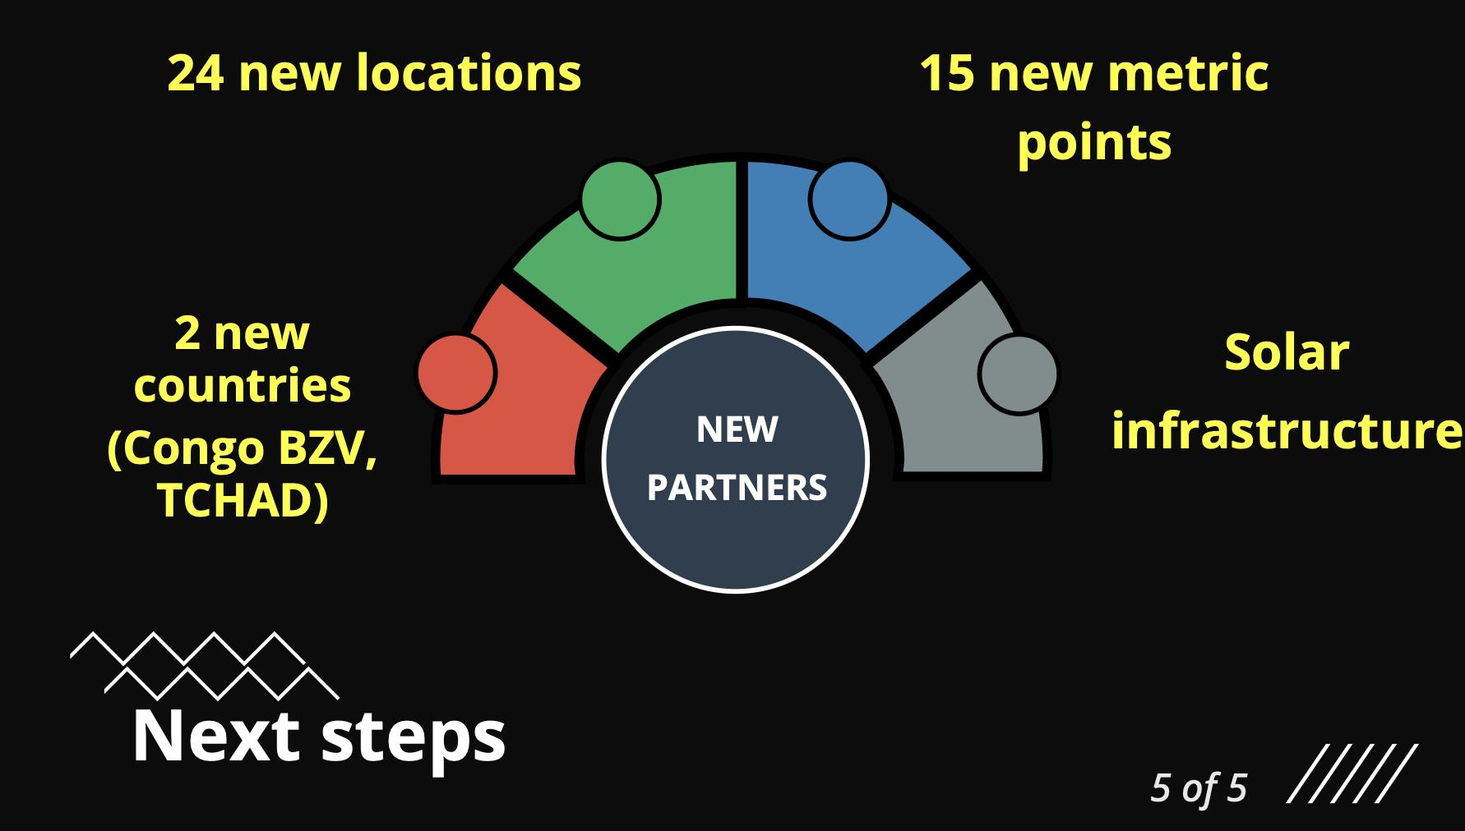

Please refer to the https://www.terredesjeunes.org/synecoculture/ which has metrics, photos and documents related to the project.

4. Impact Statement
The information in the table below will be used to communicate results and anticipated impacts of this technical assistance publicly. Please copy information from the impact statement developed in the M&E Plan and update as relevant.

Challenge | In its National Development Strategy 2020-2030 (SND30), Cameroon aims to improve the performance of its rural sector. This strategy stipulates that efforts must be made to promote sustainable agriculture and allocate more budgetary resources to the rural sector. It is within this framework that the present project is situated, its main objective being to ensure and maintain the resilience of beneficiary populations in the face of food security challenges and the impact of climate change.
CTCN Assistance | The government is committed to accompany farmers on the adoption of environmentally friendly methods, such as agroforestry, crop rotation, and the implementation of efficient irrigation systems, and is allocating subsidies and financial incentives to farmers who adopt ecological practices. The CTCN assistance will provide specific technical assistance on experimenting with synecoculture, a low-input, high-yield resilient form of agriculture.
Anticipated impact | * In terms of research and development, this organic farming project aligns with the government's policy of investing in research on sustainable agriculture and improving crop varieties resistant to diseases, pests, and climatic conditions, while offering increasing opportunities not only for health and well-being but also for food security and exports, and higher income for small-scale farmers.  * By incorporating technologies such as organic soil restoration, degraded land rehabilitation, and high-yield, low-input agriculture, the project will have a significant impact on food security through agricultural techniques adapted to climate change and mindful of environmental protection.
Co-benefits: Achieved or anticipated co-benefits from the TA | Thanks to this technical assistance, the project could be replicated in other areas of Cameroon (through collaboration with Government entities) and beyond (though an internship program with international experts) affected by food insecurity and the impacts of climate change on agricultural activities.  Furthermore, a guide on synecoculture farming practices for schoolchildren, including a survey of best practices, will be produced, providing young farmers with new skills in synecoculture.  Similarly, the open and accessible online data on the project's productivity metrics will lead to a domino effect of changing attitudes and behaviours among many stakeholders in the rural sector, who will undoubtedly embrace the innovative techniques of synecoculture, which are far more advantageous than conventional farming methods.
Gender aspects of the TA | Technical assistance has been supported by a gender analysis. Thanks to this initiative, the percentage of involvement of women, youth, and vulnerable populations in agricultural activities in the two localities (Garoua 2 and Figuil) targeted by the project has been about 70%.
Anticipated contribution to NDC | The 2020-2030 National Development Strategy (2) aims (page 122, section 7.1.1.1, item 472, sub-item (i)) to strengthen production and productivity, with an emphasis on increasing yields and cultivated areas, particularly at the family farm level.  Cameroon's Nationally Determined Contribution (NDC), updated in 2021 (1), identifies agriculture (page 1) as a priority sector. Slash-and-burn agriculture (page 3) is defined as problematic, and among the country's agricultural priorities is the promotion of climate-smart agriculture to strengthen resilience (page 34).  Cameroon's National Climate Change Adaptation Plan (3) proposes, in measure 1.2, the implementation of agro-climatological research projects and the dissemination of climate-adapted agricultural practices.
The narrative story | The Northern region, targeted by this project, is grappling with sociological and climatic crises that are having a detrimental impact on the approximately 70% of the population who depend on subsistence farming. In Cameroon, the average annual temperature has increased while average annual rainfall has decreased over the past few decades.  In light of this situation, Cameroon, in its updated Nationally Determined Contribution (NDC), targets agriculture among its adaptation and resilience priorities, specifically: “Promoting climate-smart agriculture to strengthen resilience.”  Furthermore, the Rural Sector Development Strategy (RSDS) 2020-2030 aims to make Cameroon the breadbasket of Central Africa (1) within a framework of sustainable development.  It is in this context that the National Project for Monitoring and Strengthening Food Security (PNVRSA) (2) aims to increase the nutritional status and food security of the Cameroonian population, particularly through increased agricultural yields and adaptation to climate change. Indeed, the Rural Sector Development Strategy (SDSR) proposes productivity gains in several ways, notably through a "genuine strategy for the sustainable management of soil fertility" and the implementation of "climate change adaptation measures."  Across the country, the FAO, WWF, IDB, and other humanitarian and environmental organizations have initiated several projects to support agriculture and peri-urban market gardening, in particular, with the aim of bolstering the food resilience of populations affected by the independence conflict, including internally displaced persons.  However, the initiatives implemented remain limited due to the conflict and a lack of local and international funding.  This project, which targets subsistence farmers who make up 70% of the population, particularly in northern Cameroon, is part of this broader context.  Furthermore, population growth is driving the degradation of arable land. Synecoculture, by introducing farming methods more resilient to climate change, will increase the diversity of cultivated species and their yields, thereby boosting overall agricultural productivity.  (1) National Climate and Development Report, World Bank, 2022, p. 10.  (2) Nationally Determined Contribution, p. 4.
Contribution to SDGs  A complete list of SDGs and their targets is available here: https://sustainabledevelopment.un.org/partnership/register/ | SDG 1: NO POVERTY  Through this project, poverty will be reduced because the farmers, its primary beneficiaries, will increase their productivity and experience economic growth thanks to sustainable agricultural jobs. Furthermore, the target communities and surrounding areas will be protected from hunger, which will have a positive impact on our economies, health, education, equality, and social development.  This is a key element in building a better future for all.  SDG 2: ZERO HUNGER  The project will ensure food security through high-yield synecocultural techniques on small plots of land; all of which will eradicate hunger and poverty, because hunger and malnutrition prevent individuals from being productive; they are more exposed to disease and therefore often unable to earn more and improve their livelihoods.  SDG 12: RESPONSIBLE CONSUMPTION AND PRODUCTION  The project will use organic fertilizers and preserve biodiversity, including post-harvest losses.  SDG 13: CLIMATE ACTION  The project will improve the education, awareness, and individual capacities of farmers and institutional capacities of partner technical ministries regarding climate change adaptation and mitigation through the diversification of agricultural production methods.

Annex 1 Technical assistance data collection

Please add quantitative and qualitative values for the indicators selected in the M&E plan and monitored throughout the technical assistance in the tables below. Indicators which have been monitored in addition to the proposed indicators below may be added at the end of table A. Non-relevant indicators should be left blank.

- Output and outcome indicators

Indicator  Please note indicators below highlighted as anticipated | Quantitative value  Numerals only; disaggregates must sum to the total | Qualitative description  List the various elements corresponding to the quantitative value as well as timelines and responsible institutions
Total number of events organized by proponents and implementing partners | 17
Number of participants in events organized by proponents and implementing partners | 1118 | 500 community members + 618 students
- Number of men | 459
- Number of women | 659 | 70% of community members are women, and 50% of students
Number of climate technology RD&D related events
Number of participants in climate technology RD&D events
- Number of men
- Number of women
Number of training organized by proponents and implementing partners | 12 | Community groups in Garoua:  - Mbilga community farmers’ association  - L’apes-wantoumi community farmers’ association  - Nyakira community farmers’ association  Participating schools in Garoua:  - Ngourore public school  - Tongo public school  - Nyakira public school  Community groups in Figuil  - Kereng community farmers’ association  - Bawaka community farmers’ association  - Wafango community farmers’ association  Participating schools in Figuil  - Dahal public school  - Indjode public school  - Delele public school
Number of participants in trainings organized by proponents and implementing partners | 548
- Number of men | 142
- Number of women | 406
Total number of institutions trained | 5
- Governmental (national or subnational) | 5 | Municipality of Garoua  Municipality of Figuil  Ministry of the Environment  Ministry of Agriculture and Rural Development  Ministry of Basic Education
- Private sector (bank, corporation, etc.)
- Nongovernmental (NGO, University, etc.)
Percentage of participants reporting satisfaction with CTCN training (from CTCN training feedback form) | 100% based on spot checks | Satisfied= 4+ on 5-pt scale
Percentage of participants reporting increased knowledge, capacity and/or understanding as a result of CTCN training (from CTCN training feedback form) | 100% based on spot checks | Increased knowledge, capacity and/or understanding= 4+ on 5-pt scale
- Percentage of men | 100% based on spot checks
- Percentage of women | 100% based on spot checks
Total number of deliverables produced during the assistance (excluding mission, progress and internal reports) | List total number here
- Number of communication materials, including news releases, newsletters, articles, presentations, social media postings, etc. | 44 | 1 guide for students  1 power-point presented in Japan at TICAD9, 22 Aug. 2025  1 website section (https://www.terredesjeunes.org/synecoculture/)  40 facebook posts (https://www.facebook.com/profile.php?id=61566495247549)
- Number of tools and technical documents strengthened, revised or developed | 2 | 1 training guide  1 training video
- Number of other information materials strengthened, revised or created (For example training and workshop reports, Power Points, exercise docs etc.) | 3 | Report of training-trainers workshop  Good practices on synecoculture  Weekly reports
Total number of policies, strategies, plans, laws, agreements or regulations supported by the assistance | List total number here
- Adaptation related |  | List the type and name of documents supported
- Mitigation related |  | List the type and name of documents supported
- Both adaptation- and mitigation related |  | List the type and name of documents supported
Anticipated number of policies, strategies, plans, laws, agreements or regulations proposed, adopted or implemented as a result of the TA | List total number here
- Adaptation related |  | List the type of documents anticipated to be proposed, adopted or implemented
- Mitigation related |  | List the type of documents anticipated to be proposed, adopted or implemented
- Both adaptation- and mitigation related |  | List the type of documents anticipated to be proposed, adopted or implemented
Anticipated number of technologies transferred or deployed as a result of CTCN support | List total number here | Sustainable fertilizers  Integrated nutrient management  Soil moisture monitoring  Organic agriculture  Fungal symbioses  Pest and insect control  Tillage-free agriculture  Improved cultivation techniques
Anticipated number of collaborations facilitated or enabled as a result of technical assistance | List total number here
- Number of South-South collaborations | 5 | Direct collaboration with the Terre des jeunes network including Togo, Haiti, Ivory Coast. And interns from Congo Brazzaville and Tchad were present on the field.
- Number of RD&D collaborations | 1 | An in-person presentation of the project was done at TICAD9 in Japan
- Number of private sector collaborations |  | List the names of the organisations (excluding the CTCN or TA implementers)
Number of countries with strengthened National System of Innovation as a result of CTCN support |  | List names of countries
Insert any additional indicators here

- Core impact indicators

Please fill in the tables for anticipated impacts of the CTCN assistance. Every technical assistance should contribute to at least one of the indicators below. For guidance on how to report on core indicators see the ‘M&E Guidance Document for TA Implementers’.

Core indicator 1 | Anticipated metric tons of CO₂ equivalent (CO₂e) emissions reduced or avoided as a result of CTCN TA  Please add your calculations in word or excel format as an Annex to this Closure Report, where applicable.
 | Anticipated metric tons of CO₂e reduced or avoided as a result of the TA on annual basis | Anticipated metric tons of CO₂e reduced or avoided as a result of the TA in total
Quantitative value  (emissions reductions) | Total number (numerals only, no rounding or abbreviations) | Total number (numerals only, no rounding or abbreviations)
Unit | tCO₂e | tCO₂e
GHG assessment boundary (project emissions)

Identify expected post-TA activities, associated effects and assess boundary for quantification of GHG emission reductions
Baseline emissions

Describe baseline scenario, baseline candidates, emission factors and emissions calculated
Methodology

Explain the method or process of verifying the indicator and how data was gathered
Assumptions
Describe assumptions made during calculation and quantification of GHG reductions

Core indicator 2 | Anticipated increased economic, health, well-being, infrastructure and built environment, and ecosystems resilience to climate change impacts as a result of technical assistance  Please provide a qualitative description of the anticipated impacts on the categories below
Infrastructure and built environment  Anticipated increased infrastructure resilience (avoided/mitigated climate induced damages and strengthened physical assets) | The technical assistance strengthens agricultural infrastructure and built environments in participating communities by promoting synecoculture systems that require minimal mechanization and reduce pressure on degraded land.  Synecoculture, by its nature, also regenerates land by combining crops which have a positive systemic impact.  Establishing school and community demonstration gardens strengthens local capacity to maintain productive land even during periods of heat and drought. These practices collectively reduce the risk of land degradation, soil erosion, and crop failure, helping stabilize livelihoods and preserve local infrastructure dependent on healthy ecosystems.
Ecosystems and biodiversity  Anticipated increased ecosystem resilience (areas with increased resistance to climate-induced disturbances and with improved recovery rates) | The introduction of synecoculture enhances ecosystem resilience by promoting high levels of plant diversity, soil organic matter, and natural symbiotic interactions. By minimizing soil disturbance and eliminating chemical inputs, the approach restores soil structure, microbial life, and water retention capacity, increasing resistance to heat stress and drought. Mixed-species plantings reduce pest outbreaks and support pollinators and beneficial fauna. As soils regenerate, vegetation cover stabilizes and local microclimates improve, enabling faster ecosystem recovery after climate-related shocks. Over time, these restored ecological functions help reverse land degradation, strengthen biodiversity, and maintain productive landscapes that are better adapted to climate variability.
Economic  Anticipated increased economic resilience (e.g. less reliance on vulnerable economic sectors or diversification of livelihood) | The project strengthens economic resilience by diversifying agricultural production and reducing dependency on single-crop systems that are highly vulnerable to climate shocks. Synécoculture enables continuous, year-round harvesting of multiple species, increasing food availability and creating varied revenue streams for households. Because the method does not rely on chemical fertilizers, pesticides, or mechanized irrigation, production costs decrease significantly, reducing exposure to volatile input prices. These factors collectively improve income reliability, reduce financial risk for smallholder farmers, and enhance the capacity of communities to adapt to climate-induced economic disruptions.
Health and wellbeing  Anticipated increased health and wellbeing of target group (e.g. improved basic health, water and food security) | The project improves health and wellbeing by increasing access to diverse, nutritious foods through year-round synecoculture harvests, reducing risks of malnutrition, particularly among women and children. Eliminating chemical fertilizers and pesticides decreases farmers’ exposure to harmful substances and promotes safer working conditions.  Strengthened local food production lessens reliance on imported or expensive market foods, improving household food security. In schools, garden-based learning encourages healthier diets and environmental awareness among youth, supporting long-term community wellbeing and climate-resilient livelihoods.

Core indicator 3 | Anticipated number of direct and indirect beneficiaries as a result of the TA
 | Quantitative value | Means of verification
Total beneficiaries | Total number
Number of adaptation beneficiaries | 3354 | Of the approximately 1118 direct beneficiaries of the project, we have calculated about 3 family members, neighbours, colleagues each who were indirectly exposed to the project. This is based on observations by the team regarding interest in the project.
Number of mitigation beneficiaries
Number of adaptation-and mitigation beneficiaries

Core indicator 4 | Anticipated amount of funding/investment leveraged (USD) as a result of TA (disaggregated by public, private, national, and international sources, as well as between anticipated/confirmed funding)
 | Quantitative value confirmed in USD | Quantitative value anticipated in USD | Qualitative description  List the institutions, timelines, and description or title of the investment | Methods  Describe methods used for quantification of funds leveraged
Total funding | Total number in USD (numerals only, no rounding or abbreviations) | Total number in USD (numerals only, no rounding or abbreviations)
Anticipated amount of public funding mobilised from national/domestic sources |  | 150,000 | Japan International Cooperation Agency  Within 3 years following the end of the technical assistance  A natural alignment with the technical assistance is due to the fact that synecoculture has been developed in Japan. | During the technical assistance, project ambassadors have engaged with international funders including the Japan International Cooperation Agency during an in-person panel in Japan. Based on such engagement, we anticipate being in a good position to cooperate with them.
Anticipated amount of public funding mobilised from international/ regional sources
Anticipated amount of private funding mobilised from national/domestic sources | 42,000 |  | 20,000 USD in-kind: value of volunteer work and land made available for the project;  A further 22,000 USD (or 13M Central African Francs) has been confirmed as an investment directly by stakeholders with the goal of ensuring the long-term viability of synecoculture including infrastructure (solar water pumps), transformation, sales and organizational capacity. | We calculated the market-value of services provided by the community to the project; and cash amounts pledged by stakeholders.
Anticipated amount of private funds mobilised from international/regional sources

Annex 2 (for internal use – to be filled in by the CTCN)
CTCN evaluation
This section will be completed by the relevant CTCN Technology Manager.

- Evaluation of the timeliness of the TA implementation as measured against the timeline included in the response plan;
- Evaluation of TA quality as defined in the response plan;
- Overall performance of the Implementers;
- Overall engagement of the NDE and Proponent;
- Lessons learned on the CTCN process and steps taken by the CTCN to improve.

