Technical Assistance Closure Report Template
Objective of the technical assistance (TA) Closure Report:
- To communicate publicly in one document a summary of progress made and lessons learned during the TA towards the anticipated impact (sections 1-4).
- To document qualitative and quantitative data collected during TA, for use in donor and UN reporting (Annex 1).

Steps for completing the TA closure report:
- The lead TA implementer submits the closure report at the end of the technical assistance as a final deliverable. The TA closure report will capture outputs, outcomes and impacts of all activities conducted under the TA. Please copy and summarise relevant material from previous TA outputs/deliverables and the Response Plan, as relevant.
- A CTCN Manager will review and revise the closure report before final approval by the CTCN Deputy Director.

Important note on public and internal use of the closure report:
Once approved by the CTCN Deputy Director, the TA closure report will be a public document available on the CTCN website www.ctc-n.org. Selected content will be used for targeted communication activities. Annex 2 is for internal use only and will not be publicly available.

Closure Report for CTCN Technical Assistance

- Basic information
Title of response plan | Production of affordable solar ovens in the deforestation-threatened Bangui region of the Central African Republic
Technical assistance reference number | 2023000030
Country / countries | République Centrafricaine (Central African Republic)
NDE organisation | Ministre de l’Environnement, de l’Ecologie et du Développement Durable
NDE focal point | Charlemagne Polycarpe MANDAYEN
NDE contact information | polycarpemandayen@gmail.com
Proponent focal point and organisation | Dr. Vinci de Dieu BOKOYO BARANDJA, La Faculté des Sciences de l'Université de Bangui, ngaya_12@yahoo.fr
Designer of the response plan | Keith Wingeard, Solar Cookers International (SCI), partnerships@solarcookers.org
Implementer(s) of technical assistance | Solar Cookers International; Carnot Energy Laboratory, Faculty of Sciences, University of Bangui;
Beneficiaries | Community members from four pilot communities (Landja Mboko, Danzi, PK22, Kpalongo), students from the University of Bangui trained as project enumerators: 1,744 total direct beneficiaries
Sector(s) addressed | Renewable energy
Technologies supported | Solar – solar cooking
Implementation start date | 21/05/2024
Implementation end date | 15/10/2025
Total budget for implementation | CTCN technical assistance budget: $ 180,300 USD  SCI pro bono/in-kind expenses (additional/unbudgeted staff time required to complete project deliverables): $ 15,000 USD  Local partners in-kind expenses (additional materials like black pots and training materials): $ 700  Total budget: $ 196,000 USD
Description of delivered outputs and products as well as the activities undertaken to achieve them. In doing so, review the log frame of the original response plan and refer to it as appropriate | Key outputs and deliverables included:  - Quick Needs Assessment of four pilot communities.  - 180 locally manufactured solar cooker appliances  - Enumerator and Training-of-trainer sessions for capacity building.  - Baseline and post-distribution surveys conducted by local NGOs and university students, with data review and analysis led by SCI.  - Youth Committee established to contribute to planning and coordination of implementation.  - Feasibility study, market assessment, and roadmap for scaling documents completed to guide opportunities for expanding on initial technical assistance phase.
Methodologies applied to produce outputs and products | 1) Technology assessment to review open-source design plans of various solar cooking models  2) Quick Needs Assessment survey to assess pre-intervention cooking practices and needs  3) Structured baseline and post-distribution survey to assess technology adoption and community impact  4) Training-of-trainer model for community engagement  5) Market assessment and Feasibility Study  6) Guided community feedback/focus group sessions in pilot communities
Reference to knowledge resources | The Climate Technology Progress Report 2024 (used to inform best practices for structuring technical assistance and guide relevant updates to the NDC 3.0 document)
Deviations | All intended activities, outputs, and deliverables were completed; deviations included a delayed implementation timeline (bank transfers delayed the start of solar cookstove manufacturing), with the pilot phase reduced from the intended 6 months to approximately 3 months.
Anticipated follow-up activities and next steps | The CAR Ministry of Environment and Sustainable Development has committed to signing an MOU extension with Solar Cookers International to explore opportunities for scaling the pilot technical assistance to a country-wide program. The University of Bangui has expressed interest in a solar cooking master’s program within the Faculty of Sciences. The “Roadmap for Scaling Solar Cooking in Central African Republic” has been reviewed and will form the basis for next steps, including potential grant and investment pathways.  Funding proposals are expected to focus on the Green Climate Fund (GCF), Green Environment Facility (GEF), and Adaptation Fund (AF).

- Lessons learned
 | Lessons learned | Recommendations
Lessons learned from the CTCN TA process | 1. Strategic Planning and Multi-Stakeholder Coordination  2. Community Engagement and Ownership Are Central to Success  3. Adaptation of Technology to Local Context Is Essential  4. Capacity Building Strengthens Sustainability  5. Institutional Collaboration Enhances Impact  6. Strengthening Monitoring and Evaluation Builds Local Capacity and Ensures Reliable Data  7. Integrating Gender Expertise Enhances Participation and Adoption | - Ensure regular coordination during early stages to ensure alignment on implementation planning.  - Include local community leaders while finalizing response plan and specify role of community in the technical assistance.  - If possible, assign a monitoring and evaluation lead or point person from the NDE office or other national position to ensure local data management capacity remains consistent.  - Continue to include gender requirements throughout planning and implementation components of technical assistance.
Lessons learned related to climate technology transfer | 1. Effective Supply Chain Planning Reduces Delays and Strengthens Implementation  2. Establishing Local Enterprises Ensures Continuity Beyond Project Funding  3. Socioeconomic Benefits Drive Adoption  4. Weather Variability Remains a Limiting Factor  5. Affordability and Financing Mechanisms Must Be Addressed  6. Awareness Campaigns Are Key to Scale-Up  7. Behavioural Change and Continuous Support Are Essential for Technology Adoption  8. Community feedback enhances learning  9. Financial Transfers Require Adaptation to Local Banking Contexts | - Accelerate turn-around time for approving response plan documentation and interim reporting to enable quicker disbursement of funds (a 3-month delay becomes significant if implementation is intended to be completed within 12 months).  - Prioritize clear communication of socioeconomic benefits related to technical assistance.  - Coordinate timing of implementation (especially for solar technologies that are dependent on reliable access to sunlight).  - Highlight behaviour change and awareness campaign elements as critical to success.  - Contributions from CTCN to support NDE and national stakeholders in review of financial opportunities for expanding technical assistance.

3. Illustration of the TA and photos
For communication purposes, please provide 2-4 Power Point slides, including illustrations or charts, describing barriers, opportunities, methodology, activities, outputs and achieved results. The illustrations must be copied into the TA Closure report but must also be delivered as power point files. Also, please provide at least five high-resolution pictures in jpg format, capturing technical assistance. The pictures should illustrate how the TA has impacted the lives of the beneficiaries in particular and the communities in general.

Illustrations from slide deck (PPT file attached to email):
Slide 1:
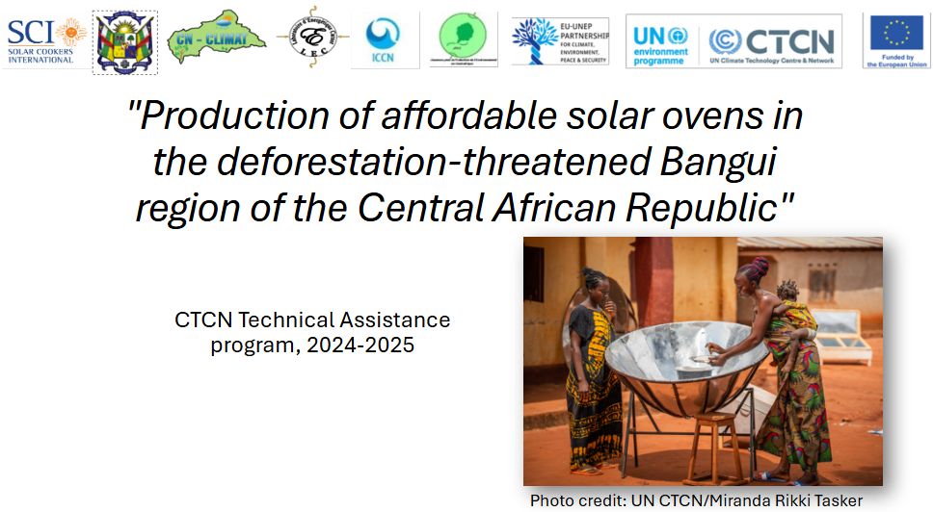
Slide 2:
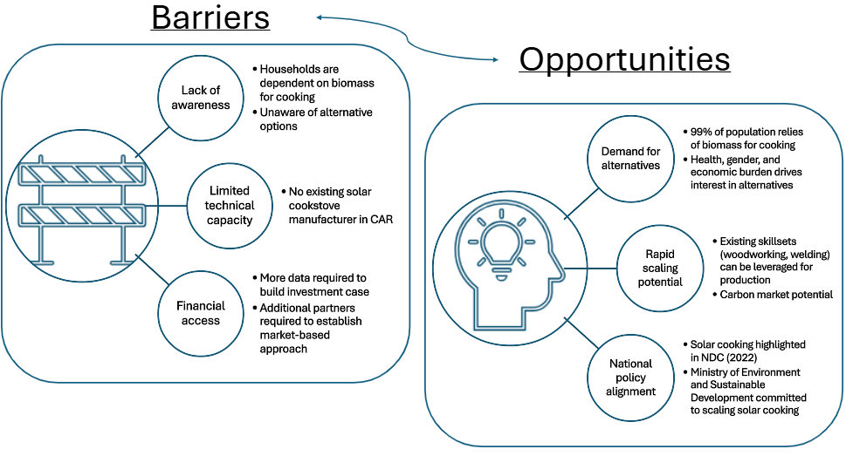

Slide 3:
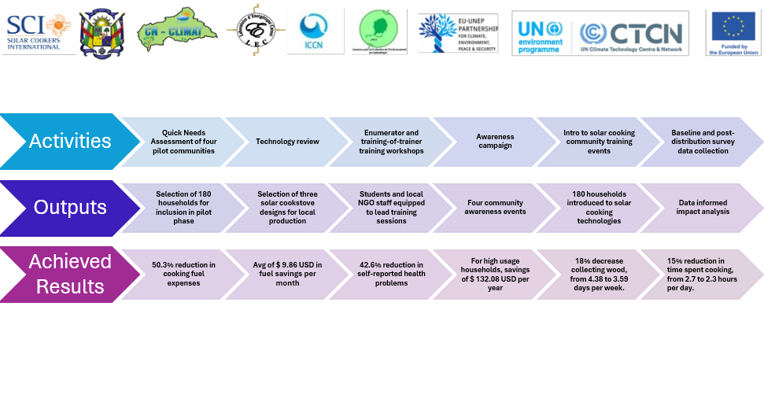

4. Impact Statement
The information in the table below will be used to communicate results and anticipated impacts of this technical assistance publicly. Please copy information from impact statement developed in the M&E Plan and update as relevant.

Challenge | Limited access to clean cooking means the population of the Central African Republic depends on burning wood, charcoal, agricultural waste, or dung to cook their meals. This leads to significant indoor air pollution, accelerated deforestation to meet fuel demand, and increased emissions of CO₂ and short-lived climate pollutants such as black carbon. Indoor air pollution from food preparation is a problem that disproportionately affects women and the young children they must care for while meals are being prepared.
CTCN Assistance | - 1) initial assessment and planning (included Quick Needs Assessment and technology review);  - 2) production of solar cookers and piloting of the use of solar stoves (180 units locally manufactured and distributed across 4 pilot communities);  - 3) data collection, feasibility study, market assessment, and scaling roadmap based on pilot project and recommendations on financial viability.
Anticipated impact | - Initial assessment included a Quick Needs Assessment of the four pilot communities to identify households prioritized for inclusion in the pilot phase, along with a review of specific solar cookstove designs.  - Three designs were selected as prototypes and built locally, according to available design plans with modifications for locally available materials. After trials, each of the designs were then included in the pilot phase, with 60 of each type included for deployment. Awareness campaign targeted households with an introduction to solar cooking technologies before distribution phase.  - SCI led training-of-trainer and enumerator training events to prepare local implementing partners to conduct baseline survey, introductory training, complementary technology training, and post-distribution survey data collection.  - Analysis of data resulted in feasibility study, market assessment, and roadmap for scaling document.
Co-benefits: Achieved or anticipated co-benefits from the TA | Co-benefits include gender indicators related to a reduction in time spent collecting fuel (18% reduction in average days per week spent collecting fuel, from 4.38 to 3.59) and time spent on cooking activities (15% reduction, from 2.7 hours per day to 2.29 hours per day) and health indicators (42.6% reduction in self-reported respiratory or ocular health problems, from 14.8% to 8.5%; health impact was higher for households that used the solar cooker more often, with households that used the solar cooker at least 3 times per week seeing a larger 54.7% reduction in self-reported health problems, from 14.8% to 6.7%).
Gender aspects of the TA | Gender Analysis was integrated within every aspect of implementing the technical assistance, with a national gender expert participating in project planning meetings and contributing to training and community engagement events. Without a template for the gender assessment, SCI and the gender expert co-developed a gender action plan across each step of the response plan. Enumerators were selected to have equal gender balance, and female community leaders were encouraged to play key roles in community events. Survey analysis included review of gender disaggregated data.
Anticipated contribution to NDC | - Established local production capacity for solar cookstoves, which are identified as a priority for improving access to clean cooking in the 2022 NDC.  - Provides an initial estimate for potential emission reductions resulting from deployment of solar cookstoves.  - Initial Feasibility Study and Scaling Roadmap offer assessment of pathways to achieve NDC solar cooking goals in CAR.
The narrative story | The Central African Republic requests technical assistance from the CTCN and relevant network members to help it assess the potential for using solar cooking technologies in the CAR; establish domestic manufacturing capacity within the CAR; pilot an initial distribution of solar cookers to vulnerable populations; collect relevant data to inform future production and establish the impact of related benefits on health, the economy, gender equality, and the environment; and identify investment opportunities to ensure the long-term sustainability and expansion of solar cooker manufacturing beyond the technical assistance period. The CAR government has clearly indicated solar cooking as a national priority to address access to clean cooking in its NDC targets: 10% of the population by 2030. This target equates to 546,000 people positively impacted by 2030, given a total population of the Central African Republic of 5,457,154 in 2021 (World Bank). With climate change leading to greater volatility in weather conditions and an increased likelihood of extreme weather events such as fires or floods, the nationwide availability and access to solar cookers will increase the resilience of users, enabling them to operate their solar cookers in sunny weather after a disruptive weather event. This improves energy security and independence for solar cooker users in a country where access to electricity is currently limited.
Contribution to SDGs  A complete list of SDGs and their targets is available here: https://sustainabledevelopment.un.org/partnership/register/ | SDG5 – Gender equality: the technical assistance specifically targeted reductions in time spent collecting wood as a cooking fuel by women and girls, and data indicated a reduction in days spent collecting wood, a reduction in the total time spent on cooking activities, and improved respiratory health of (primarily women) household cooks.  SDG7 – Affordable and clean energy: distribution of solar cookers provided pilot households with a device that transforms freely available sunlight into energy for cooking meals. Survey data indicated households spent an average of 50.3 % less on cooking fuel (wood and charcoal) compared to the pre-intervention baseline. Households averaged 1.86 uses of the solar cooker per week, with households indicating an intention to use the cookers 4.17 times per week going forward.  SDG13 – Climate action: high usage households that reported using the solar cookstove at least three times per week reported a reduction of 48.4 kg of biomass consumed per month, translating to an estimated reduction of 155.8 tCO2e per year among the 180 pilot households. The CAR government plans to continue working with Solar Cookers International to explore carbon market pathways for scaling.

Annex 1 Technical assistance data collection

Please add quantitative and qualitative values for the indicators selected in the M&E plan and monitored throughout the technical assistance in the tables below. Indicators which have been monitored in addition to the proposed indicators below may be added at the end of table A. Non-relevant indicators should be left blank.

- Output and outcome indicators

Indicator  Please note indicators below highlighted as anticipated | Quantitative value  Numerals only; disaggregates must sum to the total | Qualitative description  List the various elements corresponding to the quantitative value as well as timelines and responsible institutions
Total number of events organized by proponents and implementing partners | 8 | - Awareness campaign events (4 total, 1 per pilot community), 27-30 May 2025  - Solar cookstove demonstration events (4 total, 1 per pilot community) 4-7 June 2025
Number of participants in events organized by proponents and implementing partners | 208 | Mostly the same participants in both events, so only reporting the totals to avoid double counting
- Number of men | 36 | Primarily women participating as the lead cook and target household event participant, although men also joined
- Number of women | 172 | Primarily women participating as the lead cook and target household event participant, although men also joined
Number of climate technology RD&D related events | 5 | - SCI + University of Bangui solar cooking technology review workshop, December 2024  - Awareness Campaign events (4 total, 1 per pilot community: included explanation of the links between climate change and deforestation)
Number of participants in climate technology RD&D events | 208 | Overlaps with “events” participants indicated above.
- Number of men | 36
- Number of women | 172
Number of training organized by proponents and implementing partners | 11 | - Enumerator Training, 10-Sep-2024 (led virtually by SCI, with in-person participation at the University of Bangui)  - Enumerator Adoption and Impact and Training-of-Trainers Training, 30-Apr-2025 + 2-May-2025  - Community Solar Cooking training (4 total, 1 per pilot community), 4-7 June 2025  - Complementary technology training (use and fabrication of heat retention baskets, 4 total, 1 per pilot community), 19-20 September 2025  - Data collection training for post-distribution survey, 9-Sep-2025
Number of participants in trainings organized by proponents and implementing partners | 256
- Number of men | 60
- Number of women | 196
Total number of institutions trained | 4
- Governmental (national or subnational) | 1 | - Staff from the Ministry of Environment and Sustainable Development (4 representatives)
- Private sector (bank, corporation, etc.) | 0 | N/A
- Nongovernmental (NGO, University, etc.) | 3 | - Staff and students from the Faculty of Sciences at the University of Bangui  Staff from two partner NGOs:  - L’Association ici c’est Chez Nous (AICCN)  - Jeunesse pour la Protection de L’Environnement en Centrafrique (JPEC)
Percentage of participants reporting satisfaction with CTCN training (from CTCN training feedback form) | 100 % | Satisfied= 4+ on 5-pt scale  72% responded “5/very satisfied”  28% responded “4/satisfied”  *Note: not all participants completed the training survey
Percentage of participants reporting increased knowledge, capacity and/or understanding as a result of CTCN training (from CTCN training feedback form) | 95 % | Increased knowledge, capacity and/or understanding= 4+ on 5-pt scale  68% responded “5/very satisfied”  27% responded “4/satisfied”  5% responded “3/neither satisfied nor unsatisfied”  *Note: not all participants completed the training survey
- Percentage of men | 90 %
- Percentage of women | 100 %
Total number of deliverables produced during the assistance (excluding mission, progress and internal reports) | 14 | - 2.ii Quick Needs Assessment Report  - 2.iii CAR Cookstove Design Recommendations  - 2.iv/2.v Prototype Trials Report  - 3.ii Awareness Campaign Strategy document  - 3.iii Demonstration events report  - 3.iv Recommendation of pilot households  - 4.i/4.ii Production budget and timeline  - 4.iii Complementary Technology Report  - 5.1/5.ii Distribution + Adoption and Impact Report  - 5.iii/5.iv Community Feedback Report  - 6.i Lessons Learned report  - 6.ii Market Assessment  - 6.iii Feasibility Study  - 6.iv Roadmap for Scaling Solar Cooking in CAR
- Number of communication materials, including news releases, newsletters, articles, presentations, social media postings, etc. | 3 | - 6.ii Market Assessment  - 6.iii Feasibility Study  - 6.iv Roadmap for Scaling Solar Cooking in CAR
- Number of tools and technical documents strengthened, revised or developed | 5 | - 2.iii CAR Cookstove Design Recommendations  - 2.iv/2.v Prototype Trials Report  - 3.ii Awareness Campaign Strategy document  - 3.iv Recommendation of pilot households  - 4.i/4.ii Production budget and timeline
- Number of other information materials strengthened, revised or created (For example training and workshop reports, Power Points, exercise docs etc.) | 6 | - 2.ii Quick Needs Assessment Report  - 3.iii Demonstration events report  - 4.iii Complementary Technology Report  - 5.1/5.ii Distribution + Adoption and Impact Report  - 5.iii/5.iv Community Feedback Report  - 6.i Lessons Learned report
Total number of policies, strategies, plans, laws, agreements or regulations supported by the assistance | 3 | - 3.ii Awareness Campaign Strategy document  - 6.iii Feasibility Study  - 6.iv Roadmap for Scaling Solar Cooking in CAR
- Adaptation related | -
- Mitigation related | -
- Both adaptation- and mitigation related | 3 | - 3.ii Awareness Campaign Strategy document  - 6.iii Feasibility Study  - 6.iv Roadmap for Scaling Solar Cooking in CAR
Anticipated number of policies, strategies, plans, laws, agreements or regulations proposed, adopted or implemented as a result of the TA | 5 | - Revised “Roadmap for Scaling Solar Cooking in CAR” (after review in December 2025)  - Memorandum of Understanding (MOU) agreement between SCI and CAR Ministry of Environment and Sustainable Development to extend collaboration on scaling solar cooking beyond technical assistance (expected in Dec 2025)  - MOU agreement between SCI and University of Bangui detailing continued collaboration  - MOU agreement between SCI and local NGO AICCN  - MOU agreement between SCI and local NGO JPEC
- Adaptation related | -
- Mitigation related | -
- Both adaptation- and mitigation related | 5 | - Revised “Roadmap for Scaling Solar Cooking in CAR” (after review in December 2025)  - Memorandum of Understanding (MOU) agreement between SCI and CAR Ministry of Environment and Sustainable Development to extend collaboration on scaling solar cooking beyond technical assistance (expected in Dec 2025)  - MOU agreement between SCI and University of Bangui detailing continued collaboration  - MOU agreement between SCI and local NGO AICCN  - MOU agreement between SCI and local NGO JPEC
Anticipated number of technologies transferred or deployed as a result of CTCN support | 3 | Solar cooking:  3 designs were selected, locally manufactured, and deployed (reflective panel “CooKit”, parabolic cooker, and solar box oven)
Anticipated number of collaborations facilitated or enabled as a result of technical assistance | 0
- Number of South-South collaborations | 0
- Number of RD&D collaborations | 0
- Number of private sector collaborations | 0
Number of countries with strengthened National System of Innovation as a result of CTCN support | 1 | Central African Republic
Estimated weekly/monthly household cooking fuel expenses, compared to baseline data (economic well-being/health) |  | - Baseline (monthly) = $ 19.59 USD  - Post-distribution (monthly) = $ 9.73 USD  - Difference = $ 9.86 USD reduction in cooking fuel expenses per month (50.3 % reduction)
Estimated number of days per month that the solar cookstove was used (economic well-being/climate) |  | All households: 8.1 days of usage per month  - “high usage” households: 17.2 days of usage/month  - “moderate usage” households: 8.9 days of usage/month  - “low/no usage” households: 1.8 days of usage/month
Estimated time spent collecting wood, compared to baseline data (gender/climate) |  | - Baseline: 4.38 days per week  - Post-distribution: 3.59 days per week  - Difference: Reduction of 0.79 days spent collecting wood per week (18% reduction)
Estimated time spent on cooking activities, compared to baseline data (gender) |  | - Baseline: 2.70 hours per day  - Post-distribution: 2.29 hours per day  - Difference: Reduction of 0.41 hours (about 25 minutes) spent on cooking activities per day (15% reduction)
Self-reported respiratory health problems in the family, compared to baseline data (health) |  | - Baseline: 14.8 % of households reporting health problems  - Post-distribution: 8.5 % of households reporting health problems  - Difference: 42.6% reduction in reported respiratory or eye problems
Estimated reduction in biomass fuel used for cooking, per month, compared to baseline (economic well-being/climate) |  | - Baseline: 140.34 kg  - Post-distribution, high usage households (at least 3 uses per week): 91.93 kg  - Difference: 34.5% reduction in reported household consumption of wood among high usage households

- Core impact indicators

Please fill in the tables for anticipated impacts of the CTCN assistance. Every technical assistance should contribute to at least one of the indicators below. For guidance on how to report on core indicators see the ‘M&E Guidance Document for TA Implementers’.

Core indicator 1 | Anticipated metric tons of CO₂ equivalent (CO₂e) emissions reduced or avoided as a result of CTCN TA  Please add your calculations in word or excel format as an Annex to this Closure Report, where applicable.
 | Anticipated metric tons of CO₂e reduced or avoided as a result of the TA on annual basis | Anticipated metric tons of CO₂e reduced or avoided as a result of the TA in total
Quantitative value  (emissions reductions) | Total number (numerals only, no rounding or abbreviations) | Total number (numerals only, no rounding or abbreviations)
Unit | tCO₂e | tCO₂e
GHG assessment boundary (project emissions)  Identify expected post-TA activities, associated effects and assess boundary for quantification of GHG emission reductions | 155.8 tCO₂e per year  Includes emission reductions per year from all 180 solar cookstoves, based on average reduction in biomass consumption for cooking activities. | 1,402.2 tCO₂e in total  Includes cumulative emission reductions from all 180 solar cookstoves over the full expected lifespan of each device, based on average reduction in biomass consumption for cooking activities.
Baseline emissions  Describe baseline scenario, baseline candidates, emission factors and emissions calculated | 271.51 tCO₂e per year  Calculated based on average of 140.34 kg of biomass consumed per pilot household per month at baseline. | N/A
Methodology  Explain the method or process of verifying the indicator and how data was gathered | Methodology explained in the Annex attached.
Assumptions  Describe assumptions made during calculation and quantification of GHG reductions | Assumptions include households with training will regularly use the solar cookstove in a consistent manner over the full lifetime of the cookstove, with the average reduction in biomass (wood and charcoal) consumed when comparing the baseline with the post-distribution survey used to estimate the CO2 emission reductions. At this stage, each cooker is assumed to have an equivalent reduction, but SCI plans to differentiate by type of cooker as the project looks to scale.

Core indicator 2 | Anticipated increased economic, health, well-being, infrastructure and built environment, and ecosystems resilience to climate change impacts as a result of technical assistance  Please provide a qualitative description of the anticipated impacts on the categories below
Infrastructure and built environment  Anticipated increased infrastructure resilience (avoided/mitigated climate induced damages and strengthened physical assets) | 180 solar cookstove appliances distributed to 180 households in four pilot communities as a result of the technical assistance. These households are expected to demonstrate improved resilience to climate shocks through a reduced reliance on scarce biomass fuel for cooking and improved health and economic well-being due to the capacity to solar cook a portion of meals.
Ecosystems and biodiversity  Anticipated increased ecosystem resilience (areas with increased resistance to climate-induced disturbances and with improved recovery rates) | Forest areas surrounding four pilot communities anticipated to have increased resilience as a result of the reduced demand for wood to cook food. With the pilot only including 180 households (45 per pilot community), the overall impact is expected to be modest; however, with scaling, the anticipated deployment of 35,000 + solar cookstove units is expected to have a significant impact on the overall ecosystem resilience of CAR’s forested areas.
Economic  Anticipated increased economic resilience (e.g. less reliance on vulnerable economic sectors or diversification of livelihood) | - Across all households, spending on biomass as a source of cooking fuel decreased by 50.3%. This reduction represents a significant boost in household economic resilience.  - A subset of households participated in the “Complementary Technology” training/workshop to learn how to fabricate heat retention baskets, which can be used to keep solar cooked meals warm for several hours. This represents a new economic opportunity.
Health and wellbeing  Anticipated increased health and wellbeing of target group (e.g. improved basic health, water and food security) | - Health improvements for participants resulted from improved air quality due to a reduction in household air pollution caused by burning biomass like wood or charcoal for cooking activities. Survey results indicated:  - Baseline: 14.8 % of households reporting health problems  - Post-distribution: 8.5 % of households reporting health problems  - Difference: 42.6% reduction in reported respiratory or eye problems

Core indicator 3 | Anticipated number of direct and indirect beneficiaries as a result of the TA
 | Quantitative value | Means of verification
Total beneficiaries | Direct – 1,780  Indirect – 10,000 | Direct beneficiaries calculated by sum of self-reported size of all pilot project households that received a solar cookstove (1,744 total) + trained NGO and University staff and students (36 total)  Indirect beneficiaries calculated based on assumption that each household would likely talk about solar cooking or other aspects of training sessions with an average of 5 non-participants, rounded up to account for other community members that will benefit from potential air quality improvements from a reduction in biomass cooking among pilot households.
Number of adaptation beneficiaries | 10,036 | Calculated by estimating the number of people that become aware of solar cooking and will breathe improved air in pilot communities because of the total reduction in biomass consumed for cooking activities.
Number of mitigation beneficiaries | 0 | All households include either adaptation or adaptation + mitigation.
Number of adaptation-and mitigation beneficiaries | 1,744 | Calculated by summing the total household sizes of all 180 project households.

Core indicator 4 | Anticipated amount of funding/investment leveraged (USD) as a result of TA (disaggregated by public, private, national, and international sources, as well as between anticipated/confirmed funding)
 | Quantitative value confirmed in USD | Quantitative value anticipated in USD | Qualitative description  List the institutions, timelines, and description or title of the investment | Methods  Describe methods used for quantification of funds leveraged
Total funding | Total number in USD (numerals only, no rounding or abbreviations) | Total number in USD (numerals only, no rounding or abbreviations)
Anticipated amount of public funding mobilised from national/domestic sources | 0 | TBD
Anticipated amount of public funding mobilised from international/ regional sources | 0 | $ 400,000 | To be confirmed - Roadmap for Scaling document proposes strategy to secure $ 400,000 USD in grant funding over 5 years (through 2030) | Estimated funding required to proceed with scaling strategy to reach 35,000 solar cookstove units by 2030
Anticipated amount of private funding mobilised from national/domestic sources | 0 | TBD
Anticipated amount of private funds mobilised from international/regional sources | 0 | $ 4,000,000 | To be confirmed - Roadmap for Scaling document proposes strategy to secure $ 4,000,000 USD in investment funding over 5 years (through 2030), which would be repaid via carbon credit revenue generated as a result of large-scale solar cooking in CAR. | Estimated funding required to proceed with scaling strategy to reach 35,000 solar cookstove units by 2030

Annex 2 (for internal use – to be filled in by the CTCN)
CTCN evaluation
This section will be completed by the relevant CTCN Technology Manager.

- Evaluation of the timeliness of the TA implementation as measured against the timeline included in the response plan;
- Evaluation of TA quality as defined in the response plan;
- Overall performance of the Implementers;
- Overall engagement of the NDE and Proponent;
- Lessons learned on the CTCN process and steps taken by the CTCN to improve.

