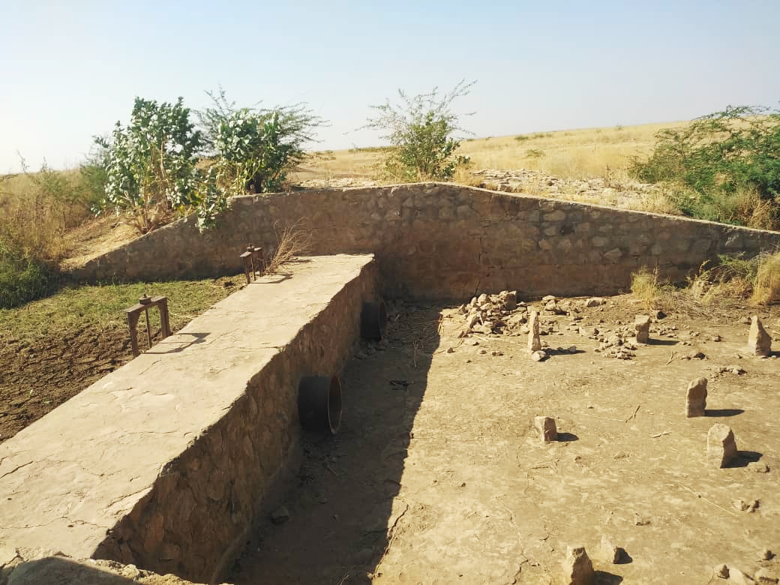
Improving the efficiency and sustainability of water harvesting technologies in Sudan
Prospects of improving existing design manuals, operation guidelines and common practices
September 2025

Executive summary
This report reviews the current state of technical manuals and guidelines for water harvesting technologies in Sudan and assesses opportunities to improve their effectiveness, usability, and relevance under changing climatic and socio-political conditions.
The analysis shows that while government-endorsed manuals (e.g. for hafirs, small dams, and hand-dug wells) provide a solid technical foundation, they lack adaptation to local contexts, climate variability, and conflict-related challenges. Many promising technologies, such as sand dams, water spreading weirs, infiltration trenches, and half-moon terraces, remain undocumented or poorly covered in Sudan, despite their proven success in other dryland countries.
International manuals offer valuable models, but they are not sufficiently localized for Sudanese conditions. This gap undermines replication, reduces the impact of investments, and limits the resilience of water harvesting systems.
Three priority improvement pathways are identified:
- Develop manuals for high-potential, undocumented technologies (sand dams, spreading weirs, terraces, recharge basins).
- Update existing manuals (hafirs, small dams) with climate adaptation, sediment and evaporation management, and conflict-sensitive design.
- Promote uptake through simplification and localization, including visual field guides, integration into training curricula, and translation into local languages.
Improved manuals will only achieve impact if paired with capacity-building and institutional embedding. The report highlights the need for a central knowledge platform, integration into government procurement and donor funding frameworks, and strong feedback loops from field experience.
In conclusion, manuals should evolve from static technical references into dynamic, user-friendly tools that support climate-resilient, inclusive, and adaptive water management across Sudan.

Table of Contents
1. Introduction 3
2. Inventory of existing manuals and guidelines 4
2.1 Government-endorsed technical manuals (MWRI/MIWR & UNICEF) 4
2.2 NGO and donor manuals 4
2.3 Strategic planning and IWRM documents 4
3. Assessment of manual coverage by technology 5
3.1. Locally developed manuals: 5
3.2. International guidelines and good practice manuals 6
4. Interpretation of existing Sudanese manuals 7
4.1. Technologies with adequate manual coverage 7
4.2. Technologies with limited or no manual coverage 8
4.3. Key Opportunities for Improvement 8
A. Develop manuals for high-potential, undocumented technologies 8
B. Update existing manuals with climate and socio-institutional adaptations 8
C. Promote manual uptake through simplification and localization 9
4.4. Prioritization of Efforts 9
4.5. Sharing, Capacity Support, and Institutional Embedding 9
5. Conclusion 11

Introduction
This deliverable builds directly on the findings of Deliverable 1.1, which assessed the performance, environmental suitability, and design parameters of twelve representative water harvesting technologies currently in use in Sudan. While Deliverable 1.1 identified and evaluated technologies at field level, Deliverable 3.1 turns attention to the enabling environment that guides their implementation: technical manuals and guidelines.
Technical manuals serve as a critical bridge between theoretical knowledge and on-the-ground application. They enable engineers, local governments, and implementing partners to design, construct, and maintain water harvesting structures in a consistent and context-appropriate manner. In the case of Sudan, such documents take on added importance due to the country's diverse climates, seasonal variability, and increasing need for climate resilience.
However, current manuals vary significantly in technical depth, coverage, and accessibility. While some technologies such as hafirs are relatively well supported by formal guidelines, others, such as sand dams, water spreading weirs, and infiltration trenches, lack structured documentation or standardized design principles. This limits replication, reduces effectiveness, and undermines sustainability.
This deliverable aims to systematically map the existing technical guidance related to water harvesting in Sudan, assess the quality, technical depth, and practical relevance of each manual, and identify significant gaps in structure coverage or usability. By comparing available manuals to the real-world challenges and needs documented in Deliverable 1.1, this review highlights opportunities for both improvement and expansion of guidance materials. The end goal is to contribute to the development of a coherent, comprehensive, and climate-smart suite of manuals tailored to Sudanese conditions, capable of supporting better project design, more effective implementation, and long-term resilience. Where shortcomings are identified, recommendations are made to improve or develop manuals that better reflect Sudan's environmental, socio-economic, and climate-resilient needs.

Inventory of existing manuals and guidelines
Only two of the manuals were identified by interviewees. Those are the only manuals about which we can say they are for sure used in practice. These manuals are denoted by *.

2.1 Government-endorsed technical manuals (MWRI/MIWR & UNICEF)
- Technical Guidelines for the Construction and Management of Improved Hafirs*
- Technical Guidelines for the Construction and Management of Hand Dug Well Hand Pumps
- Technical Guidelines for the Construction and Management of Hand Dug Well Water Yards
- Technical Guidelines for the Construction and Management of Improved Small Dams
- Technical Guidelines for the Construction and Management of Slow Sand Filters
- Technical Guidelines for the Construction and Management of Borehole Hand Pumps
- Technical Guidelines for the Construction and Management of Mini Water Yards

2.2 NGO and donor manuals
- Practical Action (2005). Water Harvesting in Sudan
- SECS/COOPI (2019). Training Manual on Surface Water Harvesting Techniques*
- UNICEF (2017). WASH Sector Emergency Technical Guidelines for Sudan

2.3 Strategic planning and IWRM documents
- JICA (2014). Project for Enhancement of Integrated Water Resources Management in Sudan (Full Report and Summary)
- UNEP (2021). ADAPT! – IWRM Good Practices in Sudan
- Bashar, K.E. (2008). Assessment of the Implementation of IWRM in Sudan

Assessment of manual coverage by technology
This section evaluates the coverage of technical manuals for the twelve representative water harvesting technologies identified and assessed in Deliverable 1.1. That deliverable provided a technical baseline on the functionality, climate suitability, and observed implementation practices of these interventions. The technologies were selected based on their relevance to Sudan’s arid and semi-arid regions and their demonstrated potential to enhance water security and resilience. Here, we compare each of these technologies with the availability and adequacy of accompanying design and management manuals to identify gaps and opportunities for improvement.

Locally developed manuals:
Table 1, Overview of the existence of manuals for the water harvesting techniques presented in deliverable 1.1
Technology | Manual Exists? | Manual Quality/Content Gaps
Hafir | Yes | Good structural info; lacks sedimentation and climate context
Hand Dug Wells | Yes | Well covered, but O&M context-specific adaptation missing
Sand Dams | No | No national manual; local NGO experience unformalized
Subsurface Dams | No | No Sudan-specific manual; design varies, needs standardization
Water Spreading Weirs | No | Only covered in NGO documents; lacks formal technical guide
Recharge Basins | No | No standalone manual; references in planning docs only
Check Dams | Partial | Mentioned in general erosion manuals, but no Sudan-specific design
Road Water Harvesting | No | Re-purposed use only; no formal guidance available
Rock Catchments | No | Not documented in manuals; potential remains untapped
Half-Moon Terraces | No | NGO/field-based knowledge only; no engineering manual
Crescent Terraces | No | No Sudan-specific document; regional comparators exist

International guidelines and good practice manuals
The table below presents a curated selection of international guidelines considered relevant to Sudan’s water harvesting context. These were evaluated through close manual review for their relevance, design applicability, and direct inclusion of the twelve structure types featured in Deliverable 1.1. a curated selection of international guidelines considered relevant to Sudan’s water harvesting context.
Table 2, Overview of identified international guidelines and manuals of good practice. For each manual the table presents what techniques from deliverable 1.1 they cover 1:Hafir 2:Sand Dams 3:Subsurface Dams 4:Check Dams 5:Recharge Basins 6:Water Spreading Weirs 7:Rock Catchments 8:Half-Moon Terraces 9:Crescent Terraces 10:Small Dams 11:Road Water Harvesting 12:Infiltration Trenches
Manual Title | Year | Publisher / Authors | Technique deliverable 1.1 | Other Relevant Structures | Technical Detail | Relevance to Sudan
Water Harvesting: Guidelines to Good Practice | 2013 | IFAD, CDE, MetaMeta, RAIN | 1, 2, 3, 4, 5, 6, 7, 8, 10, 11 | Rooftop harvesting, planting pits, contour bunds | Descriptive | High-quality typology, adaptable to Sudanese context
Smart Water Harvesting Solutions | 2007 | NWP, Aqua for All, Agromisa | 2, 3, 4, 5, 6, 7, 8, 10, 11 | Fog harvesting, Tyrolean weirs, monkey cheeks | Descriptive | Highlights scalable, affordable interventions
Profit from Storage | 2012 | MetaMeta, BGR, Aqua for All | 2, 3, 4, 5, 6, 8, 10, 11, 12 | Groundwater weirs, Tajamares | Precise | Demonstrates storage options and investment logic
Transforming Landscapes, Transforming Lives | 2011 | MetaMeta, IFAD | 2, 4, 5, 6, 8, 10 | Agroforestry buffers, grazing management | Descriptive | Strong landscape management component with 3R framing
Rainwater Harvesting Handbook (AfDB) | 2006 | African Development Bank | 2, 8, 10 | Cisterns, rooftop reuse, contour bunds | Precise | Practical guidance for semi-arid agro-pastoral contexts
Water Harvesting Guidance Manual (Tucson, USA) | 2005 | City of Tucson | — | Microbasins, swales, French drains, xeriscaping | Precise | Urban-focused; useful for institutional/school adaptation in Sudan
WUMP + 3R Facilitator Manual (Nepal) | 2015 | HELVETAS, MetaMeta, Aidenvironment |  | Participatory planning, water budgeting tools | Descriptive | Excellent for integration of recharge and community-driven planning
  5, 8, 11, 12
Rainwater Harvesting in Micro-Catchments. Planning, design and implementation (Arabic) | 2020 | UNESCWA | 1,4,5,7,8,9,11 | Micro-basins, soil bunds | Mix | Regionally adapted; directly applicable to Sudanese dryland agriculture

Interpretation of existing Sudanese manuals
The review of Sudanese manuals reveals a fragmented but informative landscape of technical guidance. While several technologies benefit from detailed, government-endorsed manuals (particularly those historically prioritized by public agencies), most others, especially more recent or climatically adaptive interventions, are poorly documented or most often entirely omitted. This imbalance directly limits the effectiveness and scalability of Sudan’s water harvesting sector.

Technologies with adequate manual coverage
Technologies such as hafirs, hand-dug wells with hand pumps, mini water yards, small dams, and slow sand filters are relatively well-represented in the suite of MWRI/UNICEF manuals. These documents provide:
- Clear construction procedures descriptive narrative for construction steps.
- Engineering drawings and dimensions: clear sketches are available naming different structure parts.
- Materials specifications: although limited, manuals specify favorable high-quality construction materials
- General maintenance guidelines: short instructions for structure operation.
However, even these manuals are typically static, with limited incorporation of three critical factors:
- Localization: standard designs, although they provide a quick reference, fall short to address site specific needs. The most obvious examples are Hafir standard designs which narrow the design parameters, length, width and depth, to limited options. Factors like temperature, construction method, construction material price, soil profile, hydraulic characteristics of surface flow, sediment load, etc. all influence the selection of Hafir dimensions and locations.
- Climate adaptation (e.g. design for variable rainfall or sediment management):
  - There is need to unify the peak discharge design probability/return period for different types of infrastructures and locations.
  - Updating operation methods for water harvesting structures constructed in regions with high sediment load e.g. Recession agriculture schemes
- Conflict resilience (e.g. functionality during periods of instability): available guidance and manuals suggest resorting to community consultation before design. However, when operating in most rural Sudan, conflict aware design requires a robust analysis for the environmental, economic, social and political potential impacts of developing new infrastructure and the surrounding power dynamics. who profit/benefit and who lose from the new technologies implemented. Such analysis is crucial for the functional, operation, maintenance and sustainability of the water harvesting structure from day one.
- Socio-economic variability (e.g. locally available materials or workforce capacity)
Thus, while they offer, foundational technical value, they do not yet reflect the climate-smart, flexible, and scalable characteristics promoted in international good practice manuals.

Technologies with limited or no manual coverage
This lack of documentation is particularly critical for sand dams, spreading weirs, and infiltration-based structures, which are:
- Among the most climate-resilient and evaporation-efficient techniques
- Already piloted or informally implemented in Sudan
- Widely featured in international manuals (see Table 2.4)

Key Opportunities for Improvement
Based on this analysis, three main improvement pathways emerge:

A. Develop manuals for high-potential, undocumented technologies
International manuals such as Water Harvesting: Guidelines to Good Practice and Profit from Storage include detailed case studies, cost-benefit analyses, and site selection criteria for technologies not yet formalized in Sudanese guidance. Sudan should prioritize manual development for:
- Sand dams and subsurface dams (as documented in Kenya and India)
- Water spreading weirs (as used in Chad and Niger)
- Recharge basins and gully plugs (India, Ethiopia)
- Half-moon and crescent terraces (Sahelian countries)
These manuals can serve as models for structure, design ranges, and planning frameworks.

B. Update existing manuals with climate and socio-institutional adaptations
Even well-established manuals such as those for hafirs and small dams require updates to include:
- Sedimentation control features
- Evaporation mitigation (e.g. floating covers, vegetation buffers)
- Scenarios for dry and wet years (based on e.g. CMIP6/CRU precipitation trends)
- Guidance for decentralized operation during conflict or institutional breakdown
For example, Profit from Storage provides modular guidance for upgrading basic structures into multifunctional, resilient water buffers.

C. Promote manual uptake through simplification and localization
Manuals must be reformatted for:
- Field-level users, using visual guides, local measurement units, and decision trees
- Training institutions and universities, integrated into civil and agricultural engineering curricula
- Decentralized governance systems, so local authorities can procure, monitor, and maintain structures
The WUMP + 3R Manual provides a model for process-oriented manuals that support community-level planning and can be adapted for Sudanese localities.

Prioritization of Efforts
Given resource constraints, the most urgent opportunities lie in:
- Developing a standard manual for sand dams and water spreading weirs using regional examples and Sudanese pilots like Girgir.
- Creating visual field guides for bunds, terraces, and trenches to support dryland restoration at scale.
- Updating or create the hafir and small dam manuals with climate and socio-political adaptations.
- Improve sharing of knowledge, capacity support and institutional embedding (see below)

Sharing, Capacity Support, and Institutional Embedding
Improved manuals can only contribute to better implementation if they are actively shared and supported by a system of learning, feedback, and coordination. To this end:
- A central knowledge platform should be developed or revitalized (as suggested in deliverable 2.1) to serve as a repository for manuals, case studies, and pilot results. This platform can support peer exchange and crowdsource feedback on manual usability and performance.
- Manuals must be embedded in training programs, both formal (universities, vocational institutions) and informal (community workshops, technician courses).
- Manuals and supporting materials should be translated into local languages and formats suitable for low-literacy settings (e.g. illustrated flipbooks, radio scripts).
- Monitoring and evaluation systems should include feedback loops to revise manuals based on field experience.
- Local government units and decentralized water management committees should be supported to procure and apply manuals when planning and supervising infrastructure development.
- Manuals should be tied to procurement and funding guidelines, ensuring that funding agencies and implementers align designs and budgets with good practice documentation.
By combining improved content with strategic dissemination, training, and institutional uptake, manuals can shift from being passive documents to active tools for inclusive, climate-resilient water management.

Conclusion
Improving the manuals and guidance ecosystem in Sudan is not just a technical task, it is about enabling better decision-making, increasing sustainability, and making water harvesting a participatory, adaptive practice. Manuals must be living tools that evolve alongside knowledge and experience on the ground. However, manuals alone are not enough. As repeatedly emphasized by interviewees, it is not realistic to rely on static documents in such a diverse, dynamic, and conflict-prone environment. Manuals should serve as supportive frameworks, not prescriptive blueprints, embedded within broader systems of local learning, field-based adaptation, and continuous feedback. Paired with stronger capacity support and institutional knowledge-sharing, they can contribute meaningfully to resilient, inclusive water infrastructure in Sudan. In summary:
- Available manuals from government agencies and international organizations active in Sudan found strong basics for technologies like Hafirs and small dams, but it shows significant gaps for others such as sand dams and water spreading weirs.
- Manuals should be designed as adaptable tools rather than strict rules, updating them with input from active projects and local users.
- Sudan's changing rains, seasons, and conflicts mean fixed guides often fall short. Manuals should allow for site-specific tailoring to match local environments and needs.
- It is important to link manuals to wider efforts or central agencies, platforms. This would allow for wider dissemination through practical training for engineers, locals, and officials, while benefiting from feedback loop via ongoing case studies.

الدليل التدريبي لحصاد مياه الأمطار في الأحواض الصغيرة: التخطيط، التصميم، والتنفيذ

