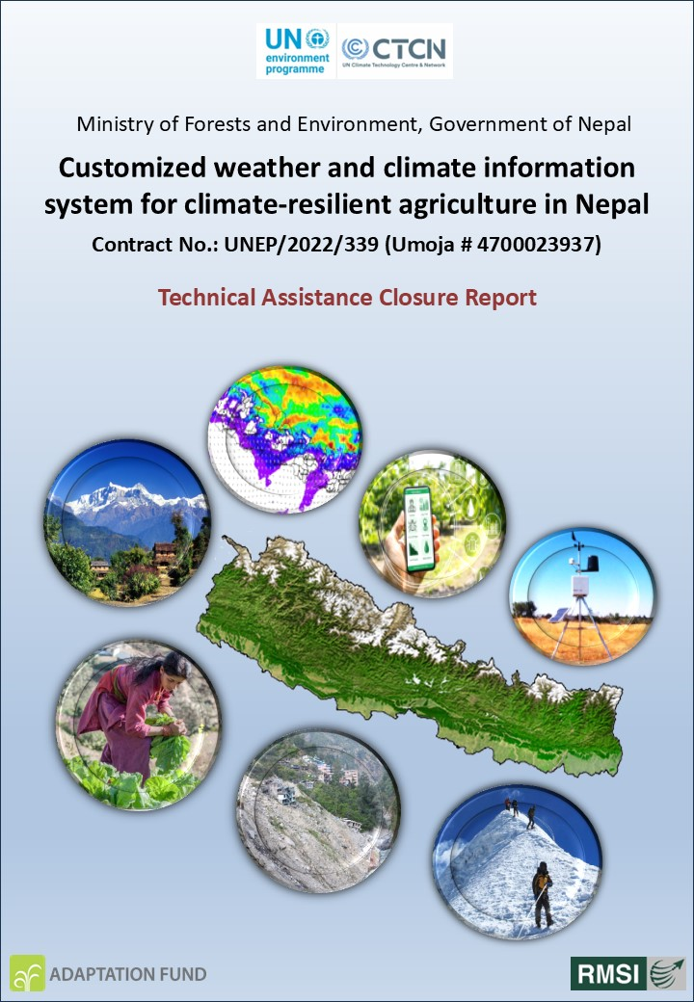

November 2025
24th August 2023
24th August 2023

Acknowledgements
This Technical Assistance (TA), awarded by the UN-CTCN to RMSI—a New Delhi–based firm— is sincerely acknowledged with deep appreciation. The study team recognizes the significance of this opportunity and the trust placed in us to support Nepal’s climate resilience initiatives.
We would like to express our heartfelt gratitude to Dr. Clara Landeiro (Regional Manager, Asia-Pacific, UN-CTCN) and Ms. Nadege Trocellier (Climate Technology Specialist - Africa, CIS, and West Asia, UN-CTCN). Their continuous encouragement, strategic guidance, and valuable technical inputs have been instrumental in steering the project in the right direction. Their leadership ensured that the TA remained aligned with regional priorities and international best practices.
Our sincere appreciation also goes to Mr. Sharad Babu Pageni (Under Secretary, CCMD, Ministry of Forests and Environment, Government of Nepal) and Dr. Buddi Sagar Poudel (Joint Secretary and Chief, Ministry of Forests and Environment, Government of Nepal). Their thoughtful insights, timely facilitation, and active engagement greatly strengthened the quality and relevance of the study. Their support helped the team navigate institutional requirements and maintain seamless coordination with national counterparts.
We are also deeply grateful to Mr. Dhiraj Pradhananga, Project Proponent from The Small Earth Nepal (SEN), for his unwavering support from the very beginning of the TA. His proactive collaboration, timely communication, and commitment to the project’s objectives significantly enhanced the overall workflow and stakeholder outreach.
Finally, we would like to extend our special thanks to all other stakeholders, government agencies, technical experts, local organizations, and community representatives, who generously contributed data, shared valuable information, and provided essential cooperation throughout the project. Their collective participation ensured that the TA was grounded in practical realities and informed by diverse regional perspectives.
.

Table of content
Acknowledgements 2
Table of content 3
List of Tables 4
List of Acronyms 5
1 Closure Report for CTCN Technical Assistance 7
1.1 Basic information 7
1.2 Lessons learned 10
1.3 Illustration of the TA and photos 12
1.3.1 Objective of the TA 12
1.4 Impact Statement 33
1.5 Annex 1 Technical assistance data collection 38
1.6 Annex 2 (for internal use – to be filled in by the CTCN) 40

List of Tables
Table 1: Basic Information of the Technical Assistance (TA) 7
Table 2: Lessons learned from the Technical Assistance (TA) 10
Table 3: Impact Description for the TA 33

List of Acronyms
Acronym | Full Form
AAS | Agro-meteorological Advisory Services
ACID | Atomicity, Consistency, Isolation, Durability
AITC | Agricultural Information and Training Center
AKC | Agricultural Knowledge Centre
API | Application Programming Interface
ASP.NET | Active Server Pages .NET
CCMD | Climate Change Management Division
CSR | Corporate Social Responsibility
CTCN | Climate Technology Centre and Network
DHM | Department of Hydrology and Meteorology
DoIT | Department of Information Technology
ECMWF | European Centre for Medium-Range Weather Forecasts
ERMC | Engineering Research and Management Consultants (P) Ltd.
FAO | Food and Agriculture Organization of the United Nations
ICT | Information and Communication Technology
ICON | Icosahedral Nonhydrostatic Weather Prediction Model
IFAD | International Fund for Agricultural Development
IMD | India Meteorological Department
IVRS | Interactive Voice Response System
MFD | Meteorological Forecasting Division
MoALD | Ministry of Agriculture and Livestock Development
MoFE | Ministry of Forests and Environment
MoU | Memorandum of Understanding
NARC | Nepal Agricultural Research Council
NDE | National Designated Entity
NDRI | Nepal Development Research Institute
NGO | Non-Governmental Organization
NOAA | National Oceanic and Atmospheric Administration
NWP | Numerical Weather Prediction
ORDBMS | Object Relational Database Management System
PP | Project Proponent
RMSI | Risk Management Solutions India
SDGs | Sustainable Development Goals
SEN | Small Earth Nepal
SMS | Short Message Service
SWG | Stakeholder Working Group
TA | Technical Assistance
TEC | Technology Executive Committee
UN-CTCN | United Nations Climate Technology Centre and Network
UNEP-CCC | United Nations Environment Programme – Copenhagen Climate Centre
UNFCCC | United Nations Framework Convention on Climate Change
WMO | World Meteorological Organization
WRF | Weather Research and Forecasting Model

Closure Report for CTCN Technical Assistance

Basic information
Table 1: Basic Information of the Technical Assistance (TA)
Basic Information of the Technical Assistance (TA)
Title of response plan | Customized weather and climate information system for climate-resilient agriculture in Nepal
Technical assistance reference number | Ref: LTR/2022/659/CTR
Country / countries | Nepal
NDE organization | Ministry of Forests and Environment (MOFE)/ Climate Change Management Division (CCMD), Government of Nepal
NDE focal point | Dr. Buddi Sagar Poudel, Joint-Secretary and Chief, MOFE, CCMD
NDE contact information | buddi.poudel@gmail.com
Proponent focal point and organisation | Dr. Dhiraj Pradhananga, The Small Earth Nepal, Gwarko, Lalitpur, Nepal.  Email: dhiraj@smallearth.org.np
Designer of the response plan | Dr. Dhiraj Pradhananga, The Small Earth Nepal, Gwarko, Lalitpur, Nepal.  Email: dhiraj@smallearth.org.np
Implementer(s) of technical assistance | RMSI Pvt. Ltd., India (lead firm)  Nepal Development Research Institute (NDRI), Nepal, (Sub-consultant)  ERMC (P.) Ltd., Nepal (Sub-consultant)  Email: uttam.singh@rmsi.com / murari.lal@rmsi.com
Beneficiaries | Ministry of Agriculture and Livestock Development (MoALD) and farmers of Nepal
Sector(s) addressed | Agricultural
Technologies supported | ICT based Agro-meteorological information system to strengthen climate resilient agricultural system in Nepal
Implementation start date | 9th September 2022
Implementation end date | 29th October 2025
Total budget for implementation | USD 142,750.00
Description of delivered outputs and products as well as the activities undertaken to achieve them. In doing so, review the log frame of the original response plan and refer to it as appropriate | - Mapping of the key stakeholders.  - Establishment of a stakeholder working group (SWG) comprised of 10 persons from the relevant organizations.  - Conducting a physical inception meeting with the SWG in Nepal just after formation of SWG.  - Minute of the inception meeting including a list of participants disaggregated by gender.  - Diagnosis of the existing climatological & meteorological information system of Nepal.  - Assessment of the users’ needs for the weather forecast and advisories.  - Conducting meeting with the SWG on the user need assessment and existing climatological & meteorological information system of DHM.  - Verification of NWP 3-day weather forecasts products of DHM for the use of farming communities.  - Improving the accuracy of DHM-generated weather forecast data through the application of appropriate bias correction techniques.  - Understanding the process of how weekly agrometeorological advisory bulletins are prepared by NARC and DHM at the regional level, and how this information is disseminated to the public.  - Validation of architecture of existing system with SWG.  - Designing of an application programming interface (API) for the automatic dissemination of location specific customized 3-days weather forecast.  - Report on technological options (technology fact sheets) and respective business models.  - Conducting meeting with the SWG on the designed API for the automatic dissemination of location specific customized 3-days weather forecast.  - Designing of the interface to disseminate location-specific customized 3-days weather forecast to farmers using identified communication mechanisms including mobile and Internet-based SMS.  - Report on the design of the communication channels that will ensure that the location-specific customized 3-days weather forecast is shared with the farmers by the communication system.  - Conducting meeting with the SWG on the conditions of use of the identified communication mechanisms e.g., mobile and Internet-based SMS.  - To test through piloting the developed (API) for the automatic dissemination of location-specific customized 3-days weather forecast to farmers in selected one community of Nepal.  - On-site demonstration workshop to present the system to the selected local government, local farmers, and civil society.  - Training and Capacity building.  - Final closer report of the TA.
Methodologies applied to produce outputs and products | - Identification of relevant stakeholders in consultation with the NDE and PP.  - Establishment of Stakeholder Working Group (SWG) comprised of 10 persons from the relevant organizations.  - Development of structured questionnaire to collect the information from the concerned department and persons for the agro-meteorological products (in this case it is customized 3-days weather forecast) user need assessment and agro-meteorological service provider capacity assessment.  - Designing and development of an application programming interface (API) for the automatic dissemination of location specific customized 3-days weather forecast.  - Interaction with the Nepal telecom service provider to get on board for the digital dissemination of agro-meteorological products to the users automatically.  - Demonstration of the developed API to the identified stakeholders, and to get their feedback.  - Identification of 3 pilot sites [in this case these are Rainas Municipality (Lamjung district), Ramprasad Rai Rural Municipality (Bhojpur district), and Malangwa Municipality (Sarlahi district)].  - Demonstration of the API to the farming community at the 3 identified pilot sites.  - Installation of API at the identifies department i.e., Agricultural Information and Training Center (AITC), Ministry of Agriculture, Nepal.  - Piloting of the API at the three identified pilot sites, with 50 beneficiaries selected from each site.  - Imparting training to AITC experts who will manage the API following the completion of the piloting phase.
Reference to knowledge resources | United Nations Environment Programme Copenhagen Climate Centre (UNEP-CCC) and United Nations Framework Convention on Climate Change (UNFCCC) Technology Executive Committee (TEC). (2022). Climate Technology Progress Report 2022. Copenhagen, Denmark.  https://unfccc.int/ttclear/misc_/StaticFiles/gnwoerk_static/TEC_documents/f6cb095702554785b53f09b73db063b7/e17ce3e0ef0e4c6ab0c1d78633503a1a.pdf  United Nations Environment Programme Copenhagen Climate Centre (UNEP-CCC) and United Nations Framework Convention on Climate Change (UNFCCC) Technology Executive Committee (TEC). (2021). Technology and nationally determined contributions. Stimulating the Uptake of Technologies in Support of Nationally Determined Contribution Implementation.  https://unfccc.int/ttclear/misc_/StaticFiles/gnwoerk_static/techandndc/c93353c94cfc4a1daa013f27ea92df2f/bdc9d4fab72f44c283a0f35fb72ecc8e.pdf
Deviations | - It took almost 7 months to finalize and establish the SWG members by the different departments due to which RMSI could only hold the first meeting with the SWG members on 3rd April 2023 (i.e., almost after 7 months) in Kathmandu, Nepal.  - It took long time to get the necessary data and information from the various departments required to develop the API.  - It took nearly six months to obtain access to the DHM weather forecast data to be integrated with the API.  - It took more than 8 months to get the clearance from the Department of Information Technology (DoIT) and Ministry of Agriculture and Livestock Development (MoALD) for the installation of API at the AITC server, which is department under the MoALD.  - Due to abovementioned reason project got delayed by for about 2 years.
Anticipated follow-up activities and next steps | - None.

Lessons learned
Table 2: Lessons learned from the Technical Assistance (TA)
 | Lessons learned | Recommendations
Lessons learned from the CTCN TA process | - The CTCN TA process extensively relies on coordination with multiple agencies attached to the different ministries and departments. Some of the key agencies are Department of Hydrology and Meteorology (DHM), DoIT, MoFE, and MoALD. This led to delays in the TA execution. | - It is recommended that the department concerned (e.g., NDE focal point, MoFE) establish a simple agreement (i.e., an MoU between the NDE and the relevant ministries or departments) to ensure smooth coordination during the project implementation phase. This will help strengthen collaboration among stakeholders and facilitate timely execution of technical assistance.
Lessons learned related to climate technology transfer | - Nepal’s weak IT infrastructure hinders the widespread implementation and expansion of ICT-based solutions across the country.  - The API host agency (i.e., AITC, MoALD) does not have a permanent IT expert within the department that hosts the API.  - Since smartphone penetration in rural areas remains relatively low, the dissemination of three-day weather forecast–based agro-met advisories primarily rely on SMS.  - There is a need to improve the 3-day weather forecasting mechanism at DHM, as the current accuracy level is relatively low. Due to this, DHM remains cautious about issuing forecasts to the public. To address this challenge, RMSI has developed a mechanism to apply bias correction to DHM’s forecast data before using it for generating agro-met advisories.  - There is lack of competent weather forecaster in the DHM. | - It is recommended for the Nepal Government to improve IT infrastructure in Nepal. Allocate more budget for ICT infrastructure under national development plans. Encourage private telecom and tech companies through tax incentives and subsidies for rural connectivity projects. Invest in ICT education, training, and digital literacy programs.  - It is important for AITC, MoALD to onboard a few permanent IT experts to ensure the smooth functioning of APIs and similar systems for the digital dissemination of weather-based agrometeorological advisories.  - It is important to promote Digital Inclusion such as subsidized smartphone schemes for farmers through government or Corporate Social Responsibility (CSR) programs.  - It is important to improve the weather forecasting system at DHM through Model Improvement and Customization such as upgrade to higher-resolution NWP models (e.g., WRF, ICON, or ECMWF regional reanalysis) customized for Nepal’s complex topography. In this process DHM can collaborate with international agencies such as European Centre for Medium-Range Weather Forecasts (ECMWF), UK.  - DHM needs to conduct intensive meteorological and forecasting training through collaboration with international agencies (e.g., WMO, IMD, ECMWF, NOAA). Pair junior staff with experienced forecasters for practical, real-time forecast exercises. Support staff to pursue advanced degrees (Ph.D./Post Ph.D.) in meteorology, climatology, and hydrology. Hire graduates with a strong foundation in meteorology, atmospheric sciences, or related fields

Illustration of the TA and photos
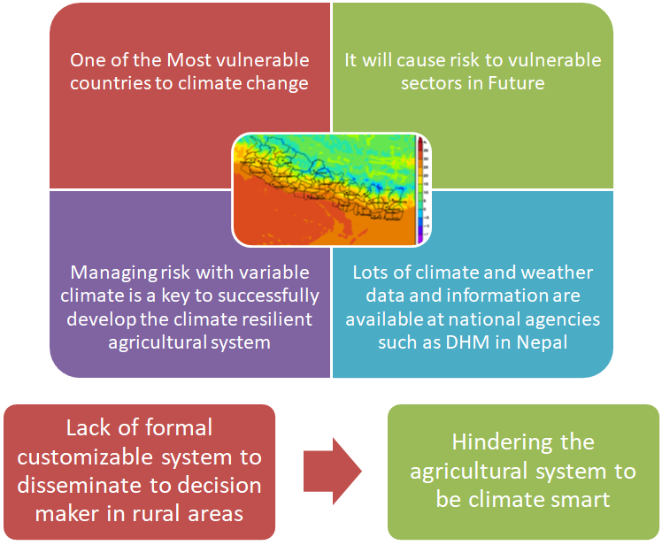

Objective of the TA
The primary objective of this technical assistance is to design and develop a robust Application Programming Interface (API) that enables the automatic dissemination of location-specific, customized 3-day weather forecasts to farmers. The API integrates with relevant meteorological data sources to generate forecasts tailored to the specific geographic location of each farmer, reflecting local weather conditions that influence agricultural activities.
The system translates technical meteorological information into simple, farmer-friendly language, making it easy for users to understand and apply in day-to-day farm decisions such as irrigation scheduling, input application, harvesting, and protection against extreme weather events. The API connects to appropriate dissemination mechanisms, including SMS, WhatsApp, and other digital platforms, to ensure that the customized 3-day forecasts reach registered users automatically, promptly, and reliably without manual intervention.
Overall, this objective creates an automated, scalable, and user-centric digital service that enhances farmers’ access to actionable weather information, reduces climate-related risks, and supports more informed, climate-resilient agricultural planning.
.
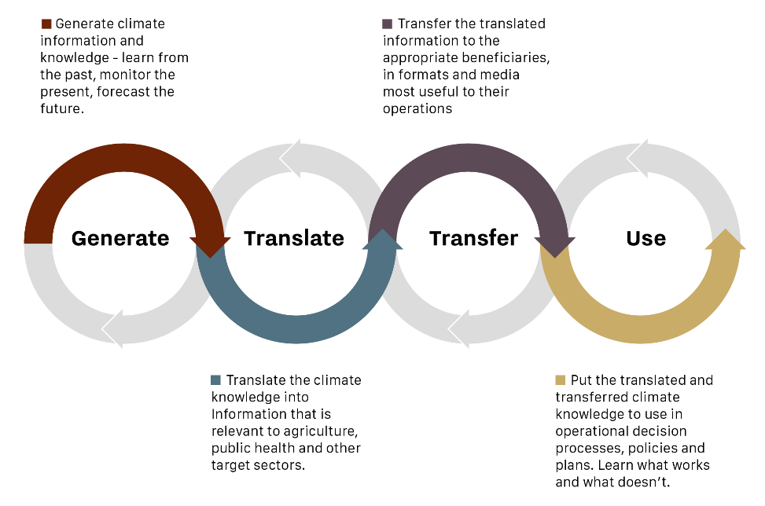
The overall scope of technical assistance is to:
- Mapping of key stakeholders and establishing a stakeholder working group (SWG) for this project.
- Diagnosing the existing system and needs on climatological and meteorological information system in Nepal.
- Designing an application programming interface (API) for the automatic dissemination of location-specific customized 3-days weather forecast.
- Designing the interface to disseminate location-specific customized 3-days weather forecast to farmers using identified communication mechanisms, including mobile- and Internet-based SMS.
- Testing the designed API and identified communication mechanisms including mobile- and Internet-based SMS technologies in the selected communities.
- Deploying the system in the selected communities, building capacity of local government, farmers and civil society, and developing strategy for upscaling the system.
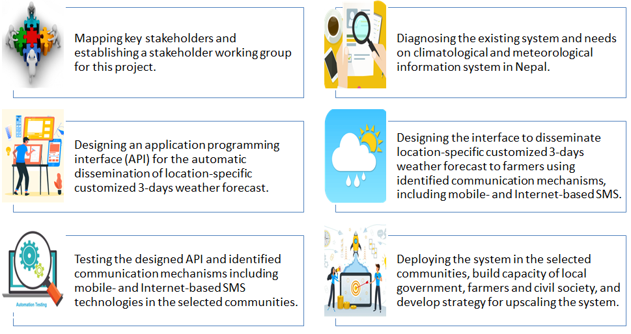
- Mapping of key stakeholders and establishing a stakeholder working group (SWG)
Initially, the project team identified the relevant stakeholders and, in consultation with the National Designated Entity (NDE) and the Project Proponent (PP), established a Stakeholder Working Group (SWG) comprising 10 members. Following the formation of the SWG, a physical meeting was held in Kathmandu, Nepal.
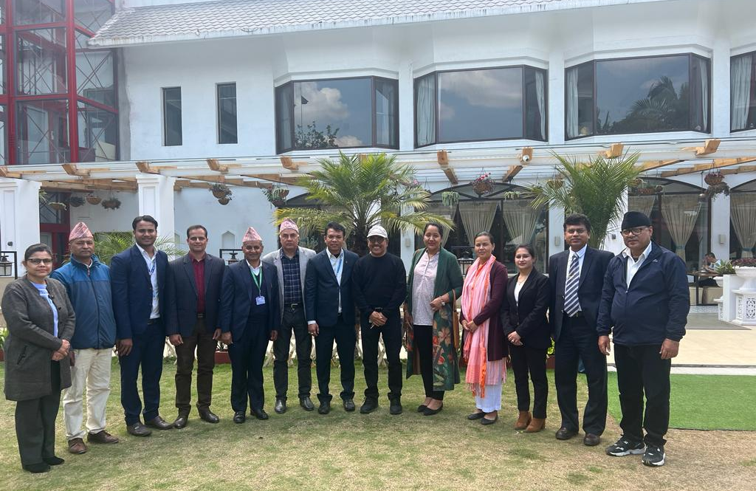
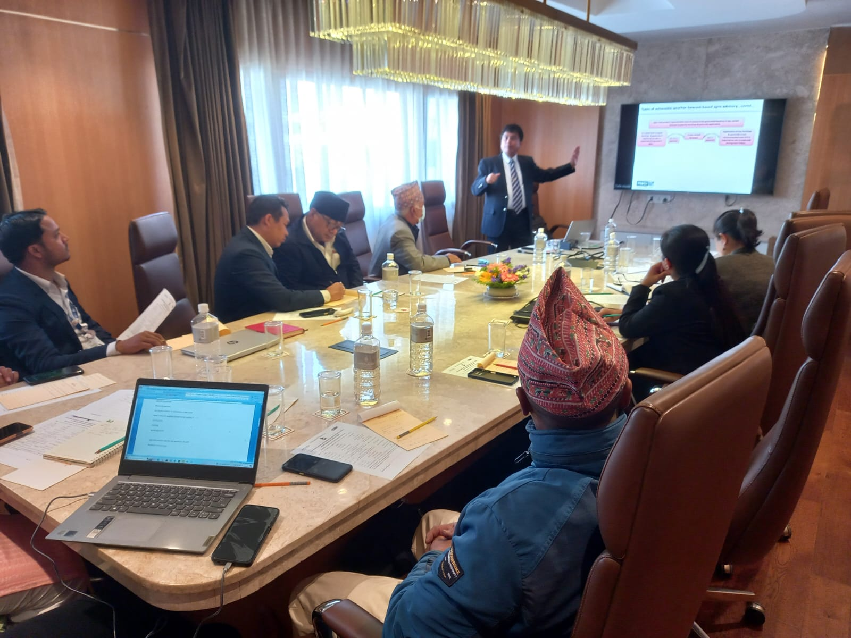
- Diagnosing the existing system and needs on climatological and meteorological information system
- Key results on diagnosis of DHM existing system
One of the key objectives of this study was to assess the existing systems of the Department of Hydrology and Meteorology (DHM) and the Nepal Agricultural Research Council (NARC) for preparing agro-meteorological bulletins and disseminating related information to the public. In addition, the study aimed to evaluate users’ requirements for weather forecasts and advisories. Accordingly, the current climatological and meteorological information systems of Nepal were thoroughly analyzed. At present, all weather forecasts and meteorological information are disseminated through the official website of the DHM and the website of its Meteorological Forecasting Division (MFD). The MFD, located at Tribhuvan International Airport in Kathmandu, provides weather forecasts, warnings, and climate information to the public.
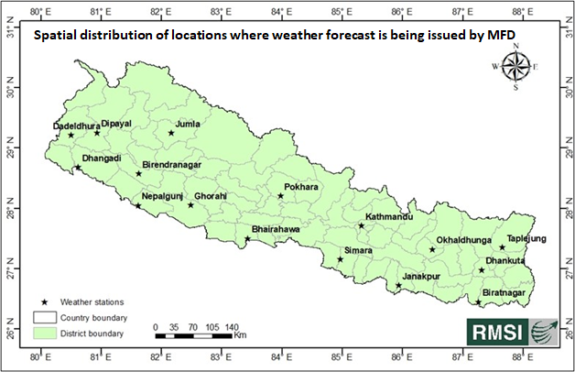
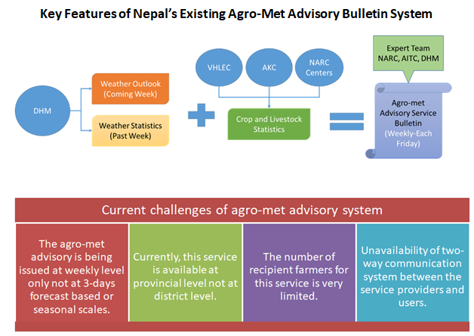
- Key results of user need assessment for the agro-met services
The assessment of users’ needs for agro-meteorological information and products is a critical step in formulating targeted recommendations to strengthen the capacity and effectiveness of Agro-meteorological Advisory Services (AAS) in Nepal. Recognizing this, the implementation team undertook a comprehensive user needs assessment to gain deeper insights into farmers’ requirements for weather forecasts, climate information, and agro-met advisory products. The assessment sought to understand not only the types of information farmers require but also how they currently access these services, their level of awareness, and the gaps that limit effective use.
To capture these insights, the team employed a structured questionnaire and conducted an interactive, field-based survey across the pilot locations. The approach enabled the team to engage directly with farmers and other stakeholders, understand local practices, and document user experiences with existing advisory mechanisms. In addition to identifying priority information needs, the assessment also examined the accessibility, frequency of use, preferred communication channels, and barriers to receiving timely advisories.
The findings from this comprehensive exercise provide a clear picture of the expectations, challenges, and opportunities related to agro-met advisory services in Nepal. The key outcomes of the user needs assessment are summarized below.
- Agro-met users expressed the need for regular and real-time information on precipitation, temperature, wind, and relative humidity.
- SMS is the most preferred delivery channel, followed by WhatsApp, email, mobile applications, web portals, print, and electronic media.
- Users emphasized the need for district-specific agro-met advisories issued on a bi-weekly, weekly, monthly, and seasonal basis.
- They highlighted that inaccurate or delayed services could lead to several negative consequences and hinder the timely completion of many agricultural activities.
- Early warning services for droughts and floods were identified as among the most important needs.
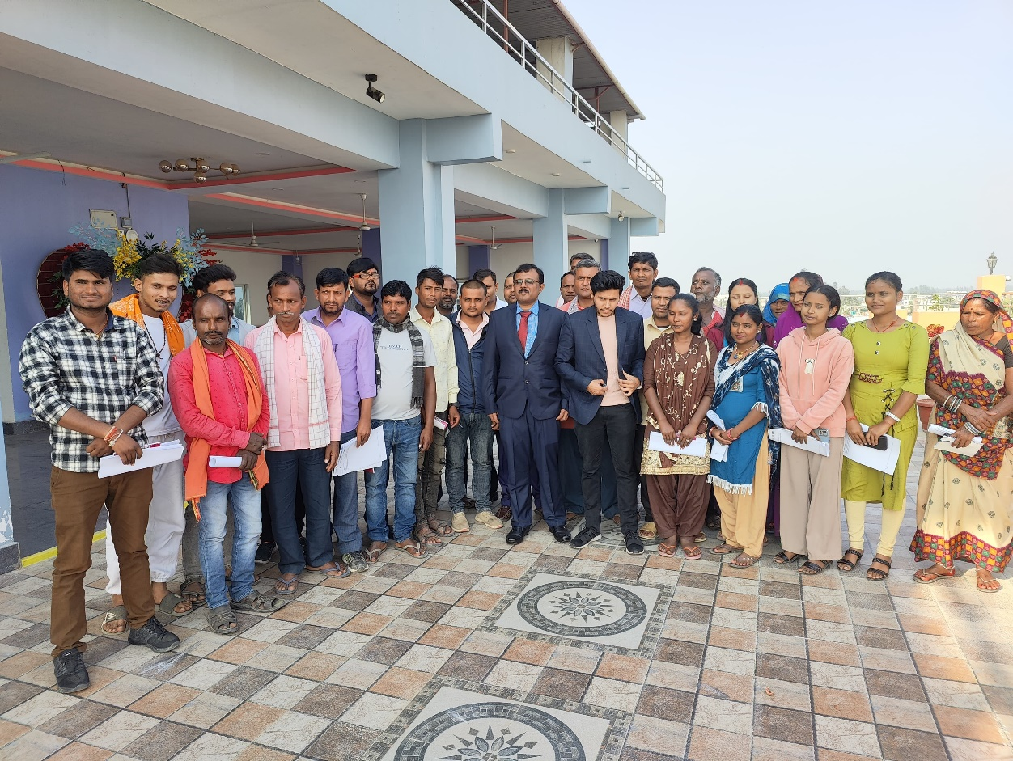
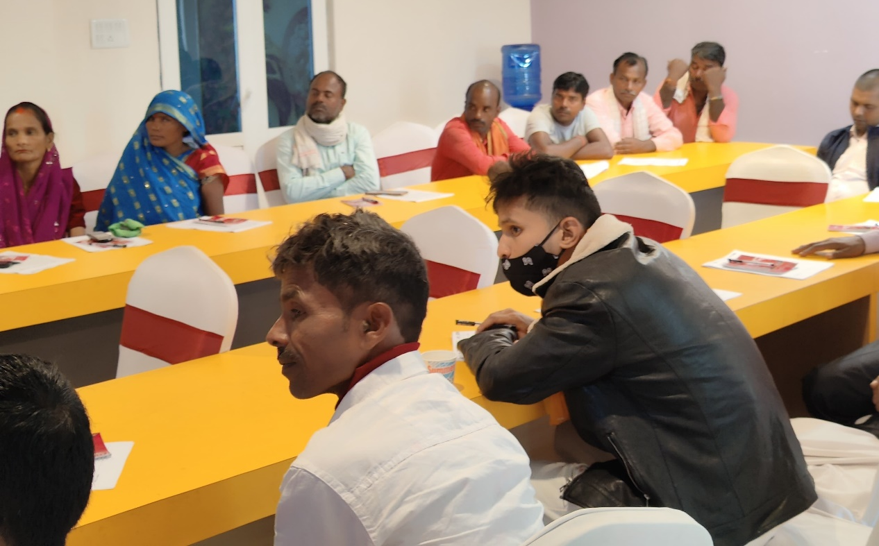
- Key results of evaluation of daily WRF forecast produced by DHM for Nepal
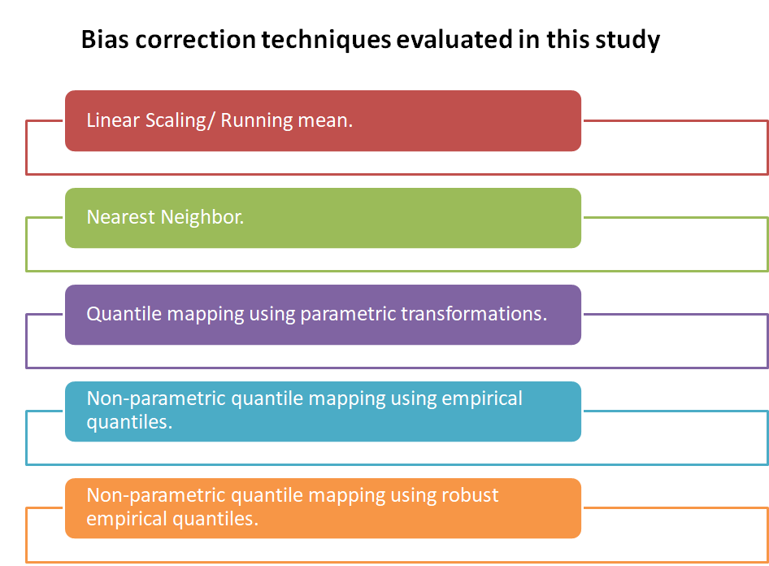
- The study identified notable biases in forecasted precipitation and maximum and minimum temperature data across Nepal’s varied physiographic regions. These biases were most prominent in the High Mountain region and comparatively lower in the Siwalik and Tarai zones. The application of multiple bias-correction techniques substantially reduced these discrepancies.
- Among the evaluated techniques, the Nearest Neighbor (NN) method proved most effective, producing the closest alignment between forecasted and observed values. The Linear Scaling (Least Squares) method performed nearly as well, underscoring its usefulness in mitigating forecast biases. Together, these results reinforce the importance of selecting appropriate bias-correction methods to improve the accuracy and reliability of temperature forecasts, especially in Nepal’s highly complex terrain.
- For precipitation forecasts, biases were greater in the Middle Mountain and Siwalik regions during the monsoon season. In the post-monsoon period, the Middle Mountain region showed the highest bias, whereas the Siwalik region recorded the lowest. During the pre-monsoon season, biases again peaked in the Middle Mountain and Siwalik regions and were lowest in the Tarai.
- In winter, the Middle Mountain region exhibited the highest bias. Importantly, bias correction techniques led to marked improvements in forecast accuracy across all physiographic regions.
- Across the High Mountain and Middle Mountain regions, non-parametric quantile mapping using empirical quantiles provided the most accurate bias-corrected forecasts for all seasons. In contrast, for the Siwalik and Tarai plains, quantile mapping with parametric transformations delivered superior accuracy.
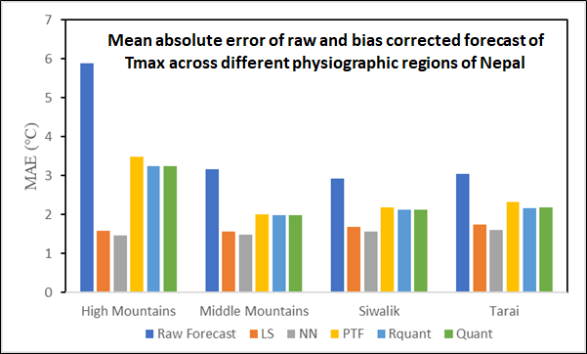
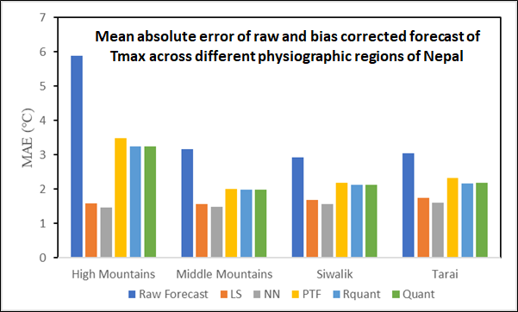
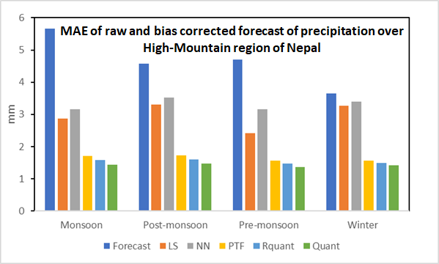
- Designing an application programming interface (API) for the automatic dissemination of location-specific customized 3-days weather forecast
Short-range weather forecasts (typically up to three days ahead) provide farmers with timely, actionable, and localized climate information that supports “crop- and cost-saving” decisions throughout the agricultural cycle. By anticipating short-term variations in temperature, rainfall, humidity, and wind speed, farmers can plan their farm operations more efficiently and avoid losses associated with sudden or unfavorable weather conditions.
These forecasts help reduce the risks posed by aberrant weather events, which are becoming more frequent due to climate variability. As a result, farmers are better equipped to protect their crops, maintain input efficiency, and enhance both productivity and profitability.
Short-range forecasts play a crucial role across multiple agricultural activities, such as:
- Planting and Sowing Operations
- Farmers can choose the optimal window for sowing to ensure proper germination and early crop establishment.
- They can avoid sowing before heavy rains or dry spells, thereby preventing seed loss and poor crop stand.
- Irrigation Scheduling
- Forecasts allow farmers to adjust irrigation plans based on predicted rainfall, reducing unnecessary water use and energy costs.
- Avoiding irrigation before expected rainfall helps prevent waterlogging and crop stress.
- Fertilizer Application
- Weather-based guidance ensures fertilizers are applied during dry weather, minimizing nutrient runoff and improving fertilizer-use efficiency.
- Farmers can avoid financial losses caused by fertilizers being washed away due to unexpected rains.
- Pesticide and Disease Management
- Farmers can apply pesticides during favorable weather conditions by avoiding rain that could reduce effectiveness.
- Harvest Planning
- Short-range forecasts guide farmers to harvest before rainfall or storms to prevent grain sprouting, lodging, or deterioration of produce.
- This ensures better product quality and reduces post-harvest losses.
- Post-Harvest Operations
- Farmers can safely plan drying, threshing, and storage activities to protect produce from moisture damage.
- It prevents fungal growth, spoilage, and quality degradation.
- Protection Against Extreme Weather (Hot Waves/Cold Waves)
- Forecasts help farmers take preventive steps such as mulching, irrigation to moderate temperature, or protective covers.
- Safeguards sensitive crops and increases resilience to extreme temperature events.
In this context, an Application Programming Interface (API) has been developed to enable the automatic dissemination of location-specific, customized three-day weather forecasts to farmers through multiple channels, including SMS, WhatsApp, email, and a web portal. The API can be accessed at http://115.124.116.200/ICWFDS_nepal/ using the admin credentials (Login ID: Admin_RMSI, Password: admin@rmsi1234). Examples of the customized three-day weather forecast outputs are illustrated in the figure below.
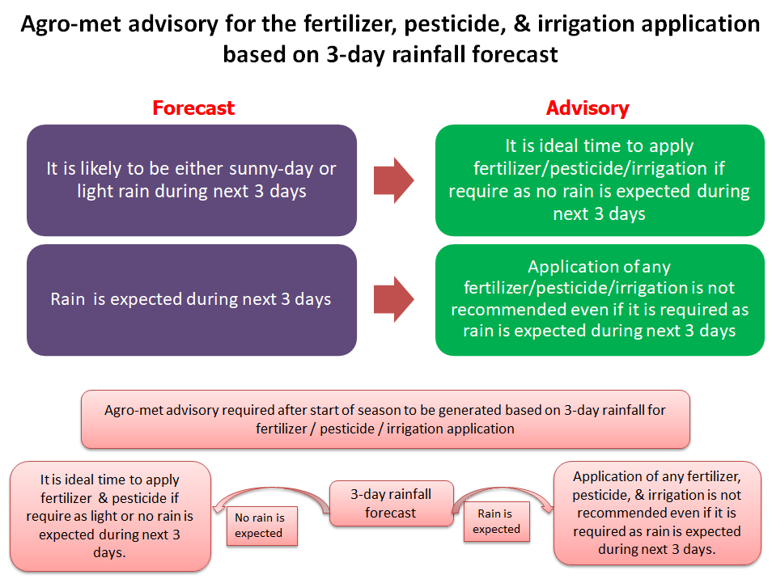
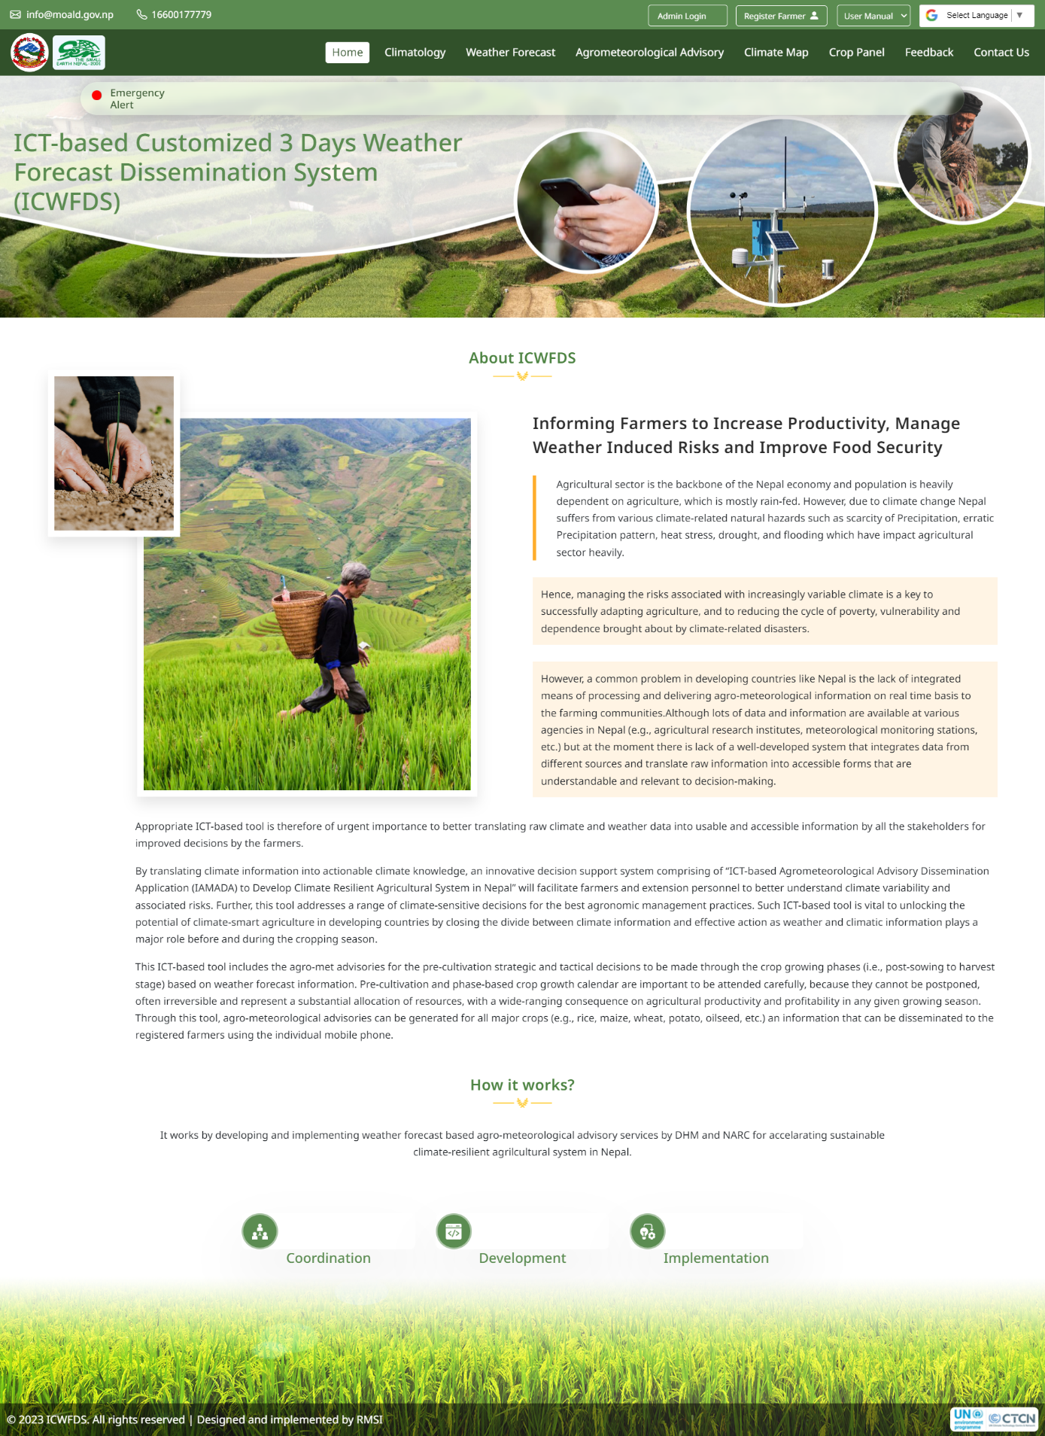
This API has been developed using modern technologies such as ASP.NET Core, PostgreSQL, and other open-source tools including jQuery, Bootstrap CSS, and JavaScript. The ASP.NET Core framework offers a high-performance, cross-platform, open-source environment with advanced capabilities for building scalable, cloud-based web applications. The following points highlight the key advantages that make ASP.NET Core an ideal framework for developing robust and high-quality web solutions:
- Open-Source Framework.
- Cross-Platform Support.
- Sophisticated Programming Features.
- High Performance.
- Razor Pages.
- Outstanding Developer Tools to Work With.
- Highly Versatile in Nature.
- Flexible App Deployment.
- Secure.
The database used is PostgreSQL, an object-relational database management system (ORDBMS) that is ACID-compliant and highly fault-tolerant. ACID stands for atomicity, consistency, isolation, and durability, the four key properties that ensure reliable database transactions. PostgreSQL offers a wide range of features designed to help developers build robust applications, enable administrators to maintain data integrity and create fault-tolerant environments, and efficiently manage datasets of any size.
- Selected communication mechanisms to disseminate customized 3-days weather forecast to the users
Several communication mechanisms can be employed to disseminate customized three-day weather forecasts electronically to end users. These may include a wide range of digital platforms and messaging services. However, based on the existing technological infrastructure, accessibility, and user preferences in Nepal, particularly in rural and semi-urban areas, the project has prioritized three primary dissemination channels (i.e., SMS, WhatsApp, and email).
- SMS remains the most reliable and widely accessible option, especially for farmers in remote locations where smartphone penetration and internet connectivity may be limited. It ensures that essential weather information reaches users quickly, even on basic mobile phones.
- WhatsApp offers an interactive and user-friendly medium for those with smartphones, enabling the delivery of richer content, such as advisories and location-specific updates, in an instant messaging format that is already familiar to many users.
- Email serves as an effective channel for institutional users, government agencies, and NGOs who require more detailed forecasts or wish to archive and share information for planning and coordination purposes.
By adopting these three channels, the dissemination system ensures broad coverage, reliability, and user convenience, maximizing the reach and impact of the customized weather forecasts across diverse user groups in Nepal.
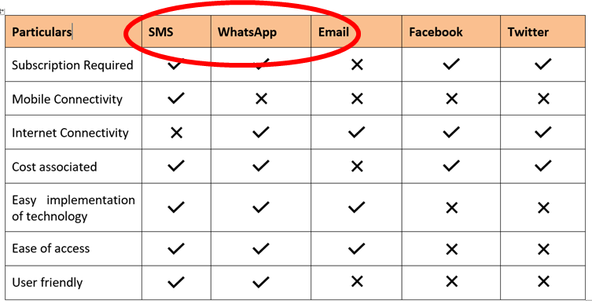
- Testing the designed API and identified communication mechanisms including mobile- and Internet-based SMS technologies in the selected communities
The developed API was tested over a five-month period (29 May 2025 to 29 October 2025) across three pilot sites in Nepal [Rainas Municipality (Lamjung District), Ramprasad Rai Rural Municipality (Bhojpur District), and Malangwa Municipality (Sarlahi District)]. Throughout the testing phase, the system performed consistently well in all locations, delivering accurate and timely three-day weather forecasts based agro-met advisories tailored to local conditions.
Farmers and community members expressed strong appreciation for the service, noting its usefulness in making day-to-day agricultural decisions. Many reported that the localized forecasts helped them better plan irrigation, fertilizer application, and crop protection measures. The introduction of this technology generated high levels of interest, with communities requesting its expansion to other wards and neighboring municipalities.
Some of the farmers shared the following feedback:
- Earlier, we depended on guesswork, but now the forecast comes directly to our phone in simple language. It has really helped us decide when to irrigate. Farmer, Rainas Municipality
- This system warned us about unexpected rainfall, and we delayed fertilizer application. It saved us both time and money. Farmer, Ramprasad Rai Rural Municipality
- If this service continues, many farmers in our area will benefit. We want this application to be implemented across the whole municipality. — Farmer, Malangwa Municipality
Overall, the pilot testing demonstrated the API’s effectiveness and highlighted the strong demand from communities for wider implementation of such climate-smart information services.

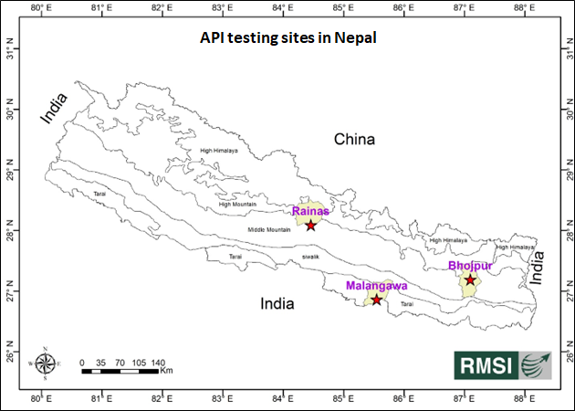
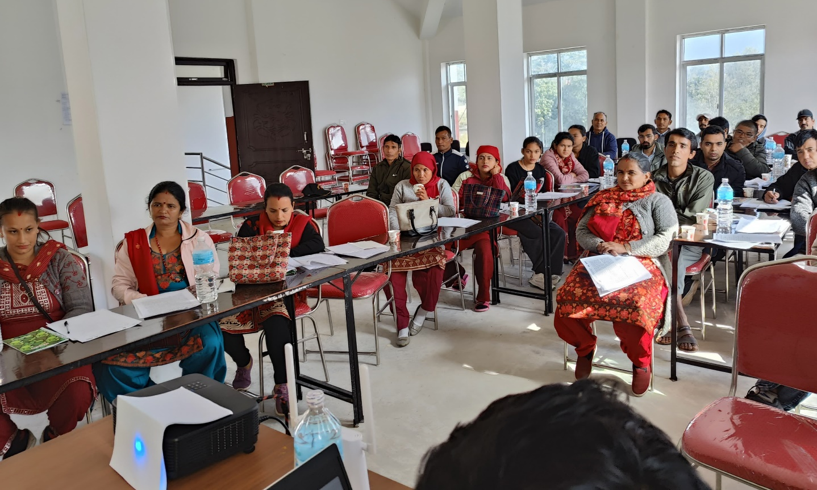
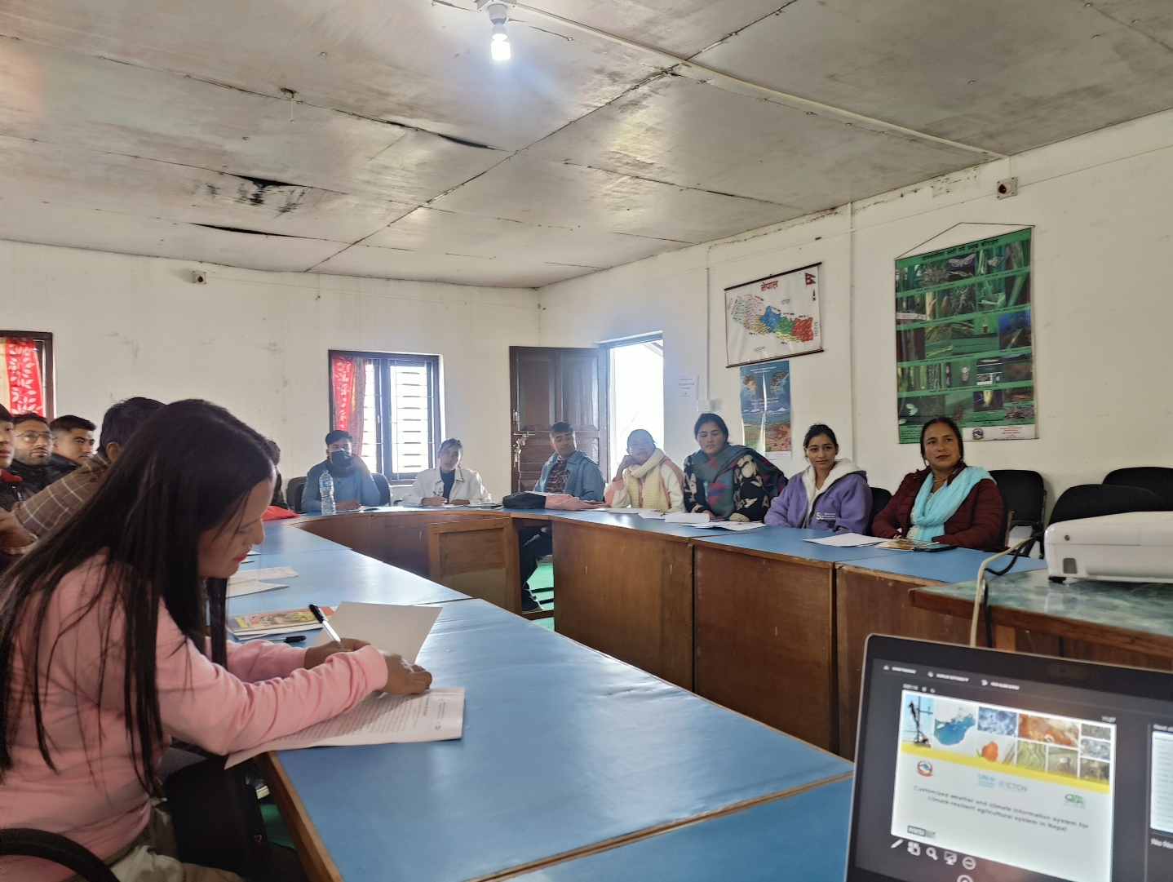

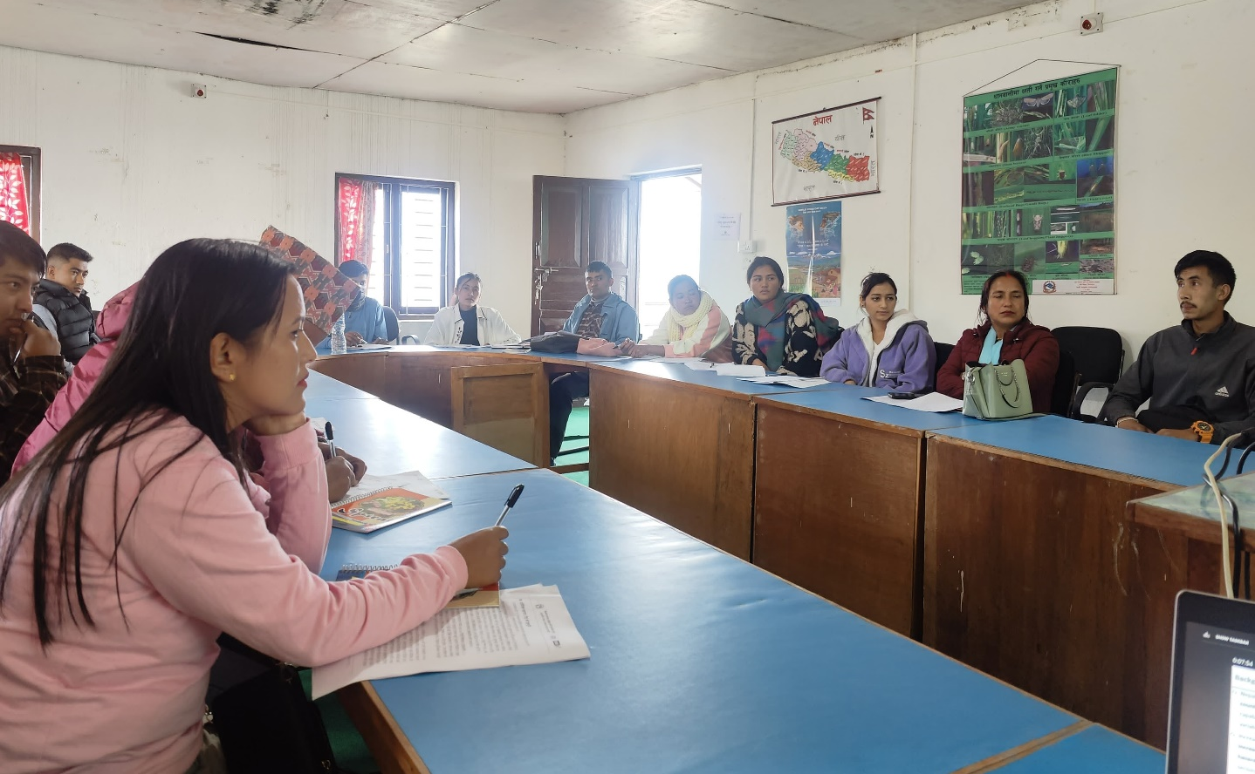
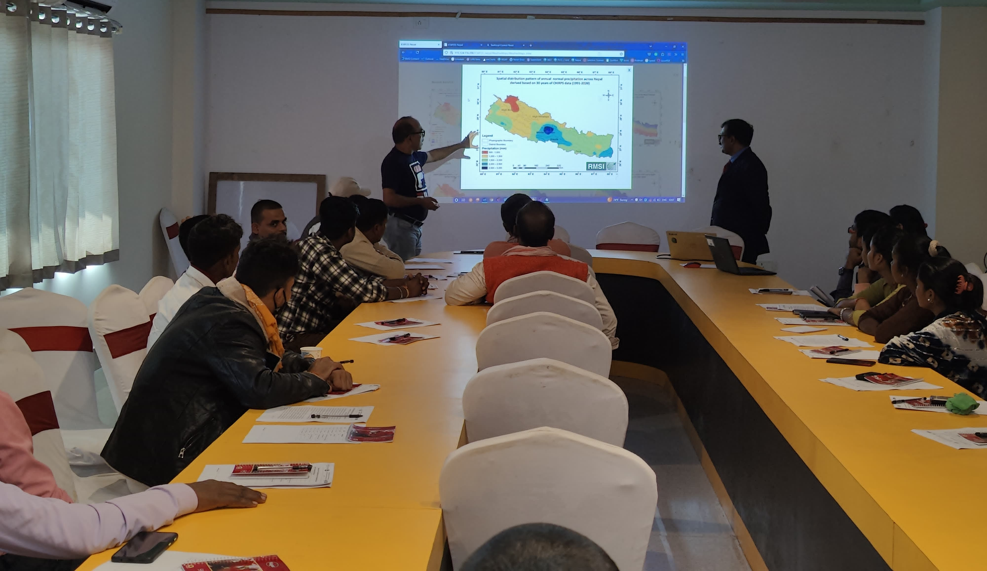
- Deploying the system in the selected communities, building capacity of local government, farmers and civil society, and developing strategy for upscaling the system
The Application Programming Interface (API) has been successfully installed and hosted on the designated server of the Agricultural Information and Training Center (AITC) under the Ministry of Agriculture, Nepal. Once the hosting process was completed and the system became fully operational, the project team organized a series of comprehensive training sessions for AITC technical experts. These sessions covered end-to-end API functionality, system configuration, operational workflows, troubleshooting procedures, and guidance on future scalability or customization.
In addition to the technical capacity-building activities, the project team formally handed over the complete API package to AITC, including the full source code, technical documentation, user manuals, and maintenance guidelines. This handover ensures that AITC has full ownership, administrative control, and the technical capability to operate, manage, and further develop the API independently in the future. The process marks a key milestone in institutionalizing climate and weather information services within the national agricultural system of Nepal.
Furthermore, drawing on the strong engagement with key Nepali institutions such as DHM and MOALD, and the lessons from the successful API piloting in Rainas (Lamjung), Ramprasad Rai (Bhojpur), and Malangwa (Sarlahi), where farmers consistently valued the usefulness of the agro-meteorological advisories and the reliability of their automated, regular delivery, a set of strategic actions has been proposed to scale the system nationwide.
- The national rollout places strong emphasis on establishing robust institutional coordination among DHM, MOALD, provincial governments, and local agricultural extension units. This coordination ensures that each institution understands its roles in data sharing, advisory development, validation, and dissemination. By aligning technical capacities, operational procedures, and communication channels, the system fosters sustainable institutional ownership and minimizes duplication of effort. A harmonized framework for standardized advisory generation, supported by clear protocols, joint review mechanisms, and regular inter-agency consultations, helps maintain the consistency, reliability, and quality of agro-meteorological information delivered to farmers across all provinces.
- It would be advisable to strengthen the technical infrastructure so the system can efficiently handle increased data volumes, support higher forecast accuracy from DHM, and integrate smoothly with existing agricultural information systems across Nepal. This could include upgrading server capacity, improving data-processing pipelines, and ensuring interoperability with both government and private digital platforms. Expanding dissemination channels (such as Mobile apps/IVRS system) in addition to existing dissemination channels (i.e., SMS, WhatsApp, and email) would also help ensure that farmers receive timely and accessible agro-meteorological advisories.
- It may also be useful to implement comprehensive capacity-building programmes for key stakeholders. Extension officers, DHM staff, and local service providers could benefit from targeted training on API system management, troubleshooting, interpreting agro-met advisories, and supporting farmers in understanding and applying the information. Such capacity strengthening would help institutions at national, provincial, and local levels maintain system quality, ensure operational reliability, and provide consistent farmer-level support as the service scales nationwide.
- A nationwide feedback and monitoring mechanism would be introduced to continuously track advisory relevance, delivery efficiency, and farmer engagement, enabling iterative improvement. The upscaling strategy also emphasizes inclusive access by tailoring advisories to local languages and literacy levels and expanding content to cover diverse crops and climate risks. Finally, the national expansion would be supported through a clear sustainability roadmap, including government budget allocation, partnerships (such as opportunities for donor collaboration, leveraging climate resilience and digital agriculture funding streams from UNEP, FAO, World Bank, and IFAD), and long-term operational planning, ensuring the API system becomes an integral component of Nepal’s climate-resilient agricultural service delivery framework.

- Conducting of final SWG workshop in Kathmandu, Nepal
The objective of the SWG workshop was to present the outcomes of the Technical Assistance and to discuss the way forward for strengthening climate information dissemination in Nepal. The session brought together key stakeholders to review the progress made, validate the results, and collectively shape future actions.
Dr. Buddi Sagar Paudel (NDE, MoFE) formally opened the SWG workshop and extended a warm welcome to all participants. In his opening remarks, he expressed his sincere appreciation to the stakeholders for their active participation. He highlighted the rapidly increasing need for accurate, real-time weather information in the face of accelerating climate change. He noted, as climate variability intensifies, the demand for timely and precise weather forecasts has become more critical than ever especially for those whose livelihoods depend on the land.
Dr. Paudel further emphasized the central role of advanced digital tools, such as the API being developed through this initiative, in supporting Nepal’s farming communities. He remarked, this type of API is not just a technological advancement, it is a lifeline for our farmers. By providing reliable, location-specific forecasts, it empowers them to make informed and climate-smart decisions that can safeguard their crops and livelihoods. He concluded by reiterating the government’s commitment to strengthening climate information services and fostering collaboration among all relevant institutions, adding, together, we can ensure that farmers in even the most remote areas have access to the information they need to thrive in an uncertain climate future.
Dr. Clara Landeiro (Regional Manager, Asia Pacific, CTCN) delivered opening remarks for this Technical Assistance (TA) and provided a comprehensive briefing on the role and mandate of the CTCN.
In her address, Dr. Landeiro emphasized the importance of strengthening climate information services and the value of innovation-driven support for developing countries.
She highlighted the significance of this TA by stating, this Technical Assistance reflects CTCN’s commitment to supporting countries in building resilient, climate-smart systems that directly benefit vulnerable communities. She further stressed the collaborative nature of the initiative - this TA is an excellent example of how national institutions, technical experts, and international partners can work hand in hand to deliver practical solutions on the ground. In addition, Dr. Landeiro acknowledged the relevance of the activity to local needs i.e., strengthening localized weather forecasting and advisory delivery is not just a technological upgrade but it is an investment in the livelihoods of farmers and communities who rely on timely, actionable climate information. In her concluding remark, she expressed confidence that the outputs of this TA would support long-term resilience.
At the conclusion of the workshop, Mr. Saroj Kant Adhikari, Chairman of the Stakeholder Working Group, highlighted the importance of the developed API in supporting climate-smart agriculture. He remarked, this API is a significant milestone for Nepal. It provides a practical, technology-driven solution that will directly support our farming communities. He further added, by delivering advisories based on three-day weather forecasts in a simple and user-friendly format, the system will help farmers make timely decisions and enhance their resilience to climate variability.
He emphasized that such innovations are essential for improving agricultural productivity and ensuring that farmers especially those in remote and climate-vulnerable areas—receive reliable and actionable information when they need it most.
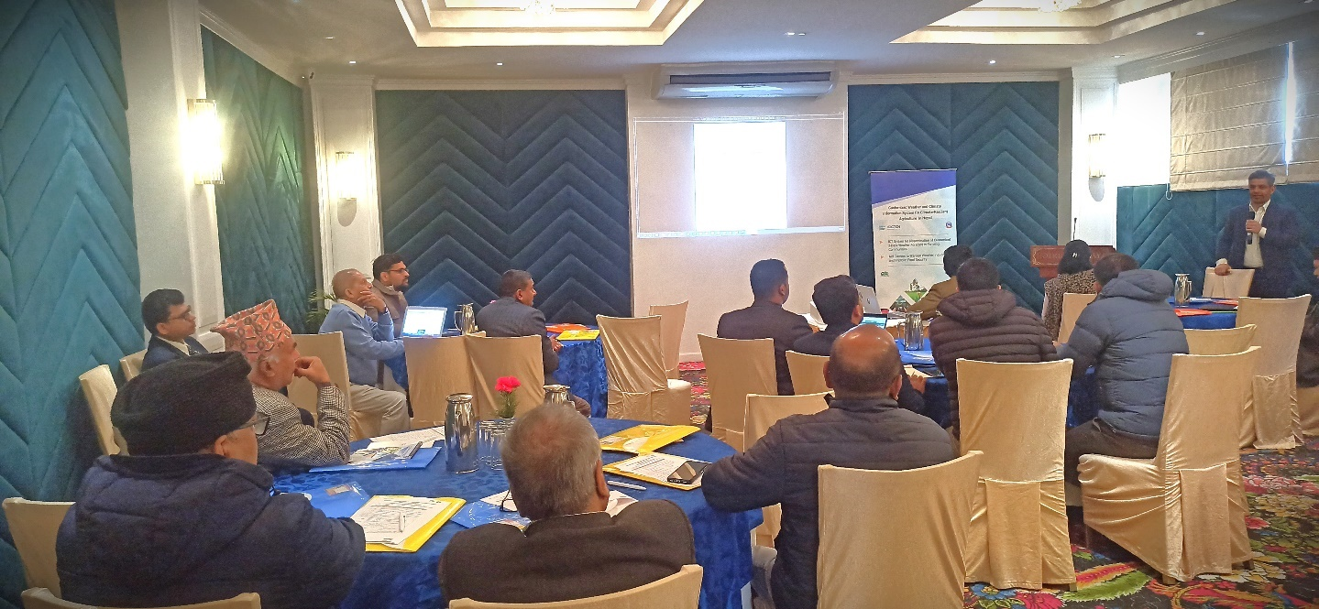

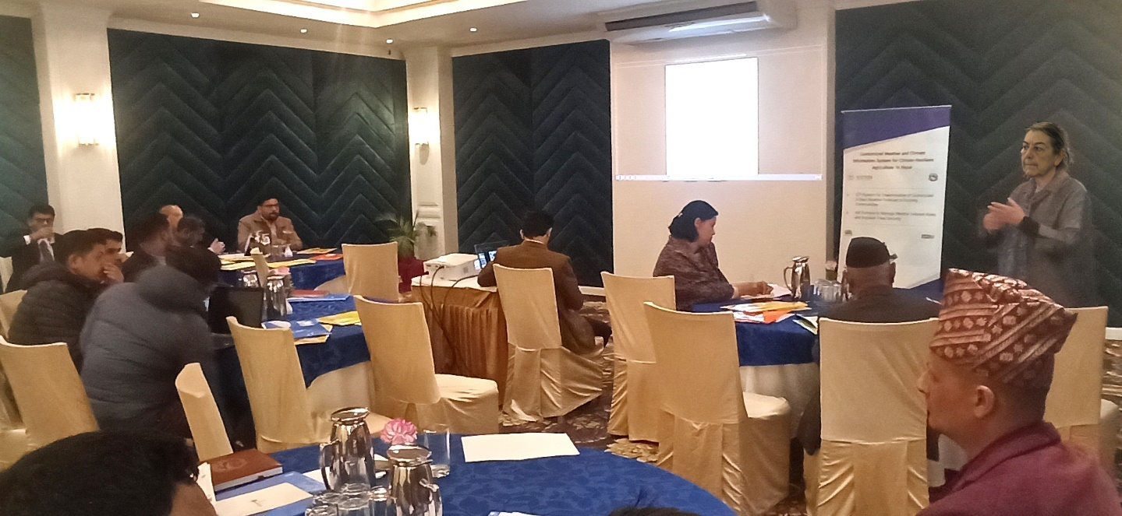
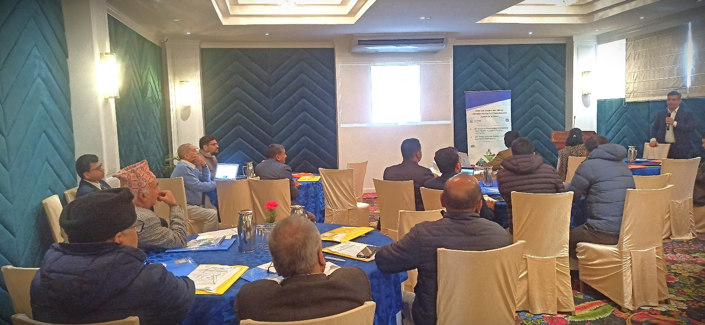
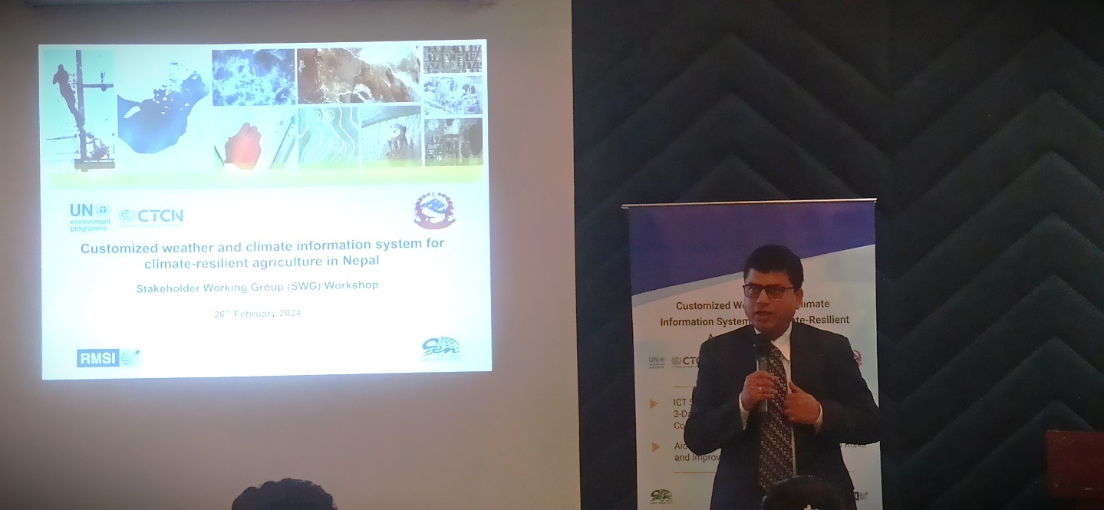

Impact Statement
Table 3: Impact Description for the TA
Impact Description
Challenge | Nepal’s economy is heavily dependent on agriculture, which contributes nearly 26.5% to the national GDP and provides employment to about 65% of the population. More than 80% of farmers rely on subsistence, rainfed agriculture, typically cultivating less than one hectare of land and owning only 2 - 3 livestock units. However, the increasing frequency and severity of climatic hazards such as droughts and floods are adversely affecting agricultural production. Farmers’ limited access to basic weather and climate information further constrains their ability to plan and adapt their farming practices effectively.
CTCN assistance | The technical assistance was provided to support the development of a Customized Weather and Climate Information System aimed at strengthening climate-resilient agriculture in Nepal. As part of this initiative, the assistance focused on creating a robust Application Programming Interface (API) capable of automatically generating and disseminating localized, user-friendly three-day weather forecasts. These forecasts were tailored to the specific needs of farmers and delivered in simple, easy-to-understand language to enhance their ability to make informed agricultural decisions. The API was integrated with appropriate dissemination channels (such as SMS, WhatsApp, Web portal, and email) to ensure effective last-mile delivery. The system was tested and validated across three selected pilot sites representing diverse agro-climatic conditions (Rainas Municipality in Lamjung District, Ramprasad Rai Rural Municipality in Bhojpur District, and Malangwa Municipality in Sarlahi District).
Anticipated impact | By establishing an API that is a robust ICT-based system for collecting, processing, and disseminating weather data and customized products (i.e., agro-meteorological advisories) the technical assistance aims to create a seamless digital pathway for delivering critical information to farmers and agricultural institutions. This system enables timely access to localized forecasts, early warnings, and crop-specific recommendations, ensuring that stakeholders can make informed decisions on crop planning, resource management, and risk preparedness.  Ultimately, the API contributes to building climate-resilient agriculture in Nepal by empowering farmers with timely and reliable information, reducing vulnerability to climate-related risks, and enhancing the efficiency of resource use. In the long term, this digital transformation supports increased agricultural productivity, improved livelihoods, and strengthened national food security.
Anticipated co-benefits from the TA | One of the most significant co-benefits of the project is the enhanced willingness, motivation, and capacity of farmers to remain engaged in agriculture over the long term. By improving access to climate-smart technologies (such as reliable weather forecasts, real-time climate information, and personalized agro-advisory services) the project empowers farmers to make informed decisions about planting, irrigation, input use, and risk management. This greater predictability and improved decision-making capacity help reduce the uncertainties traditionally associated with farming, especially in the face of climate variability and extreme weather events.  As agricultural production becomes more efficient, resilient, and profitable, farmers gain renewed confidence in the viability of agriculture as a stable livelihood option. This improved confidence plays a critical role in discouraging the abandonment of farmland and reducing distress-driven migration to urban areas or foreign labor markets. Instead, farmers are more likely to invest in their land, adopt better practices, and remain committed to farming as a long-term occupation.  The positive implications extend beyond individual households. When farmers continue farming and productivity strengthens, local food systems become more reliable, helping communities achieve better food security. Stable production volumes also support local markets by ensuring a consistent supply of agricultural products, which in turn stimulates small businesses, input suppliers, traders, and transport services. This multiplier effect contributes to broader rural economic development.  Over time, the combination of stronger farm-level productivity, higher household incomes, and a more dynamic local economy creates more resilient and self-sustaining rural communities. Increased farmer retention prevents social and economic disruptions often associated with migration, helping preserve community structures, cultural heritage, and agricultural knowledge systems.  Ultimately, the project not only enhances agricultural resilience but also contributes to sustained rural development, improved national food security, and more inclusive economic growth. The long-term benefits—from strengthened local economies to reduced migration pressures—position agriculture as a more attractive, secure, and sustainable livelihood choice for current and future generations.
Gender aspects of the TA | The project supported stronger gender mainstreaming in climate change related agricultural activities by ensuring that both women’s and men’s needs, roles, and constraints were fully considered. By improving women farmers’ access to climate information, farm inputs, and training, the initiative enabled more inclusive adoption of climate-smart agricultural practices. This ultimately enhanced agricultural productivity and contributed to building a more climate-resilient farming system.
Anticipated contribution to NDC | - To strengthen weather risk forecasting and early warning for food security in Nepal particularly in vulnerable agro-ecological zones of Nepal: This initiative aims to enhance Nepal’s ability to anticipate and respond to weather-related risks that threaten food security, especially in climate-sensitive and high-risk agro-ecological zones such as the mountains, mid-hills, and flood-prone plains. By improving the accuracy, timeliness, and spatial detail of weather risk forecasts, local governments, farmers, and agricultural stakeholders will be better equipped to take preventive and adaptive actions. Stronger early warning mechanisms will support timely decision-making on crop planning, resource allocation, disaster preparedness, and community-level resilience building, ultimately reducing losses from extreme weather events and contributing to stable food systems.
The narrative story | The Government of Nepal had requested assistance through the CTCN to strengthen climate information services and weather forecasting systems produced by national agencies, particularly for rural and remote communities where limited access to such information had hindered climate-smart and productive agricultural practices. In response, the CTCN was requested to provide Technical Assistance for developing an Application Programming Interface (API) that would automatically disseminate location-specific, customized 3-day weather forecasts to farmers in user-friendly language through appropriate dissemination channels, and pilot it in selected communities across Nepal.  The project aimed to tailor the weather and climate information products issued by the Department of Hydrology and Meteorology (DHM) to the specific needs of local farmers. By adopting a participatory approach, the project sought to bridge the long-standing gap between weather/climate science and its end users.  Overall, this Technical Assistance enhanced Nepal’s climate information delivery system by integrating advanced digital tools with community-centered dissemination mechanisms - ultimately contributing to more resilient, productive, and climate-smart agriculture across the country.
Contribution to SDGs | - NO POVERTY: End poverty in rural areas through development of climate resilient agricultural system.  - Building climate-resilient agricultural systems helps rural communities break the cycle of poverty by reducing their vulnerability to climate shocks such as droughts, floods, pest outbreaks, and unpredictable weather. By adopting improved agronomic practices, climate-smart technologies, diversified cropping systems, and better access to climate information, farmers can maintain stable yields and income even under changing climatic conditions. Enhanced productivity, reduced crop losses, and better market opportunities collectively improve household earnings, create rural employment, and contribute to sustainable poverty reduction in vulnerable regions.  - ZERO HUNGER: End hunger, achieve food security and improved nutrition and promote sustainable agriculture through introduction of climate resilient agricultural system.  - Climate-resilient agriculture ensures consistent food production despite climatic uncertainties, directly supporting food availability and accessibility. Practices such as drought-tolerant crop varieties, efficient water management, integrated pest management, and climate-informed advisory services help increase crop reliability and quality. These approaches enhance household nutrition by enabling farmers to produce a diverse basket of nutritious crops throughout the year.  - CLIMATE ACTION: Take urgent action to combat climate change and its impacts on agricultural sector.  - Climate-resilient agricultural system is a proactive response to the increasing risks posed by climate change. By adopting climate-smart practices, reducing greenhouse gas emissions from farming operations, and promoting carbon-sequestering methods such as agroforestry and conservation agriculture, the agricultural sector can contribute significantly to climate mitigation. At the same time, early warning systems, weather-based advisories, and adaptive farming techniques strengthen resilience, enabling farmers to anticipate, prepare for, and respond to climate-related hazards. These actions safeguard livelihoods, protect ecosystems, and support national commitments to climate adaptation and mitigation.

Annex 1 Technical assistance data collection
- A. Output and outcome indicators
Indicator | Quantitative value | Qualitative description
Total number of beneficiaries out of this TA  - Direct beneficiaries  - Indirect beneficiaries | 162  150  12 | In this case, direct beneficiaries include 150 farmers from the pilot locations who received hands-on guidance on how to effectively use the API-generated weather information in their day-to-day agricultural activities. Through targeted training sessions and field demonstrations, these farmers learned how to interpret location-specific forecasts and apply them to make timely decisions related to irrigation, fertilizer application, pest and disease management, and overall farm planning. As a result, the API has strengthened their ability to adopt climate-smart practices, reduce weather-related risks, and improve productivity.  Whereas indirect beneficiaries consist of 12 officials representing the Government of Nepal and partner NGOs. These officials were directly engaged throughout the API development, installation, and training processes, enabling them to build the technical capacity needed to operate, manage, and scale the system within their respective institutions.
Number of female beneficiaries  Number of male beneficiaries | 44  118 | A total of 162 beneficiaries has participated in the API development and piloting of the agro-meteorological advisory tool in Nepal, including 44 female and 118 male beneficiaries. Their involvement ensures that the system is grounded in real user needs and reflects the diverse perspectives of farming communities. Through regular engagement, feedback sessions, and field-level interactions, both women and men farmers have contributed to testing the functionality, usability, and relevance of the automated weather forecast-based agro-met advisories application. This gender-inclusive participation strengthens the API’s reliability and enhances its potential for wider adoption across different agro-ecological regions.
Number of youth beneficiaries | 40 | A total of 162 beneficiary members has participated in the API development and piloting of the agro-met advisory tool in Nepal. Notably, 40 of them are youth, reflecting strong engagement from younger community members. Their involvement has been especially valuable, as they have actively supported field testing, contributed user feedback, and assisted in operationalizing the advisory delivery system. This level of youth participation highlights both their interest and capacity to adopt digital agro-advisory services and positions them as key drivers for scaling the system in the future.
- B. Core impact indicators
Core Indicator - 1 | Capacity of staff to respond to, and mitigate impacts of, climate-related events from targeted institutions increased
 | Total number = 12 | A total of 12 officials representing key government agencies and NGOs in Nepal have participated in the training and capacity-building program on the use of the agro-met API system. The group includes 2 officials from the Department of Hydrology and Meteorology (DHM), 3 from the Agriculture Information and Training Centre (AITC), 2 from the Nepal Agricultural Research Council (NARC), 2 from Small Earth Nepal (SEN), and 3 from the Agricultural Knowledge Centre (AKC).  The training equips these officials with practical knowledge on how to use the API to integrate weather and climate information into farming decisions. They have learned how to interpret agro-met advisories and guide farmers in adjusting their agricultural practices (such as planting, irrigation, fertilizer & pesticide application, and harvesting) based on 3-days weather forecast.  These trained officials now serve as multipliers. They will further train farming communities across different regions to effectively use the agro-met advisories delivered through SMS, WhatsApp, email, and the web portal. By expanding this knowledge at the community level, the initiative builds farmers’ capacity to make informed, climate-responsive decisions. Ultimately, this process strengthens Nepal’s transition toward a more climate-resilient agricultural system, reducing risks and improving productivity in the face of increasing climate variability.
Core Indicator - 2 | Strengthen the capacity of the farming communities in the
 | Total number = 150 | A total of 150 farmers are registered in the API system during the piloting phase to receive customized three-day weather-based agro-met advisories through SMS, WhatsApp, and email. The timely delivery of these automated advisories, issued every three days, enables them to plan and carry out their farming operations in alignment with the short-range weather forecasts. Farmers report that this guidance helps them make more informed decisions related to sowing, irrigation, fertilizer application, pest and disease management, and harvesting.  Importantly, the benefits of the system extend beyond the registered users. Many of these 150 farmers actively share the advisories with other farmers in their communities who are not yet enrolled in the API system. By explaining the forthcoming weather conditions and suggesting suitable farm operations, they serve as informal extension agents within their villages. This peer-to-peer dissemination is creating wider awareness, increasing trust in the advisories, and encouraging more farmers to participate. As this cycle continues, the system is expected to expand organically, bringing a growing number of farmers into the network and strengthening climate-informed decision-making at the community level.

Annex 2 (for internal use – to be filled in by the CTCN)
CTCN evaluation
This section will be completed by the relevant CTCN Technology Manager.
- Evaluation of the timeliness of the TA implementation as measured against the timeline included in the response plan;
- Evaluation of TA quality as defined in the response plan;
- Overall performance of the Implementers;
- Overall engagement of the NDE and Proponent;
- Lessons learned on the CTCN process and steps taken by the CTCN to improve.

