Technical Assistance Closure Report Template
Objective of the technical assistance (TA) Closure Report:
- To communicate publicly in one document a summary of progress made and lessons learned during the TA towards the anticipated impact (sections 1-4).
- To document qualitative and quantitative data collected during TA, for use in donor and UN reporting (Annex 1).

Steps for completing the TA closure report:
- The lead TA implementer submits the closure report at the end of the technical assistance as a final deliverable. The TA closure report will capture outputs, outcomes and impacts of all activities conducted under the TA. Please copy and summarise relevant material from previous TA outputs/deliverables and the Response Plan, as relevant.
- A CTCN Manager will review and revise the closure report before final approval by the CTCN Deputy Director.

Important note on public and internal use of the closure report:
Once approved by the CTCN Deputy Director, the TA closure report will be a public document available on the CTCN website www.ctc-n.org. Selected content will be used for targeted communication activities. Annex 2 is for internal use only and will not be publicly available.

Closure Report for CTCN Technical Assistance

- Basic information
Title of response plan | Groundwater monitoring for mapping aquifers in Belize as a tool for climate change  adaptation planning
Technical assistance reference number | 2021000045
Country / countries | Belize
NDE organisation | - National Climate Change Office (Ministry of Sustainable Development, Climate Change and Disaster Risk Management)
NDE focal point | Ms. Gina Young - NDC Update and Implementation Facilitator (National Climate Change Office)
NDE contact information | coord.cc@environment.gov.bz
Proponent focal point and organisation | Mrs Tennielle Hendy, National Hydrological Service Belize (principal.hydrologist@naturalresources.gov.bz;)
Designer of the response plan | CTCN, Mrs Tennielle Hendy (principal.hydrologist@naturalresources.gov.bz; National Hydrological Service) and Ms Gina Young (ndc.coord@environment.gov.bz; National Climate Change Office)
Implementer(s) of technical assistance | HR Wallingford Ltd
Beneficiaries | - National Hydrological Service (NHS)-Chair  - National Climate Change Office (NCCO)  - Department of the Environment (DOE)  - Ministry of Agriculture, Food Security, and Enterprise- Extension service (MAFS&E)  - Department of Rural Transformation (DRT)  - Forest Department (FD)  - Belize Water Services Limited (BWSL)  - Ministry of Economic Development (MED)  - Private sector-Belize Sugarcane Industry-ASR Group  - Women Group-MAMAS Group (Orange Walk)
Sector(s) addressed | Water  Early Warning and Environmental Assessment
Technologies supported | Water efficiency and demand management  Adaptation planning  Water pollution  Integrated planning  Water allocation  Monitoring systems  Climate scenario development
Implementation start date | October 2022
Implementation end date | November 2023
Total budget for implementation | GBP 184,176.91
Description of delivered outputs and products as well as the activities undertaken to achieve them. In doing so, review the log frame of the original response plan and refer to it as appropriate | Output 1: Development of work plan and related communication documents  Activity 1.1: Develop detailed Implementation Plan  Activity 1.2: Develop a monitoring and evaluation plan  Activity 1.3: Impact Statement of the CTCN technical assistance prepared at the start and updated at the end of the CTCN technical assistance  Activity 1.4: A Technical Assistance Closure report  Output 2: Map Stakeholders and establish a Stakeholder Working Group  Activity 2.1: Conduct stakeholder’s mapping  Activity 2.2: Establish a Stakeholder Working Group (SWG)  Activity 2.3: Conduct an inception meeting  Output 3: Assess groundwater availability and demand based on the available technical information  Activity 3.1: Information compilation  Activity 3.2: Baseline analysis  Activity 3.3: Analysis of the current and projected economic activities and the water demand on groundwater sources  Activity 3.4: Map the groundwater resources of Belize in the prioritized area of the New River watershed  Output 4: Design a fully integrated groundwater monitoring system that will enable Belize to manage groundwater resources in the two priority areas  Activity 4.1: Defining the area to be monitored  Activity 4.2: Defining information needs  Activity 4.3: Defining monitoring objectives considering different users and data needs including topics such as uses of the land and nature conservation  Activity 4.4: Benchmark and select the most suitable groundwater monitoring technologies  Activity 4.5: Virtual workshop to share similar experiences in the region and a meeting with the SWG to discuss the characteristics of the groundwater monitoring system  Activity 4.6: Design a groundwater monitoring system  Activity 4.7: Organize a virtual meeting with the SWG and the NDE to present the groundwater monitoring system and the implementation plan  Output 5: Enabling factors for implementation: financing, institutional settings, and capacity building  Activity 5.1: Specification of required budgets for each monitoring objective  Activity 5.2: Finance strategy  Activity 5.3: Institutional assessment  Activity 5.4: Feasibility analysis  Activity 5.5: Training with relevant entities in the sector
Methodologies applied to produce outputs and products | Mapping of potential stakeholders  Workshops and structured interviews with key stakeholders  Benchmarking of existing methodologies  Design of groundwater monitoring system  Upscaling to a national level  Finance strategy  Concept note design  Stakeholder and technicians training sessions  Manuals to the monitoring system
Reference to knowledge resources | N/A
Deviations | Contract extension
Anticipated follow-up activities and next steps | - Follow-up and formal submission of concept note drafted with support from the CTCN.  - Implementation of activities designed by the CTCN.  - Dissemination of project deliverables by CTCN.

- Lessons learned
 | Lessons learned | Recommendations
Lessons learned from the CTCN TA process | The project has been well designed, managed and implemented by CTCN.  The importance of working together to design the TA with different organisations is appreciated.  The NCCO and NHS have been proactive in engaging with the project and with wider water sector stakeholders | Recommendations include  - Availability of a small amount of funding allocated to sustainability activities within the implementation country  - Outreach activities to promote the monitoring system in the region.
Lessons learned related to climate technology transfer | - The importance of engaging with end users and beneficiaries throughout the project is another lesson. Having a strong presence in country and building strong relations with in-country stakeholders is essential throughout the design and delivery process.  - It is important to improve engagement with stakeholders from a range of backgrounds; differences between SWG backgrounds and interests which limited engagement from some less technical members of the group.  - Projects should always prioritise approaches that enhance co-design through a collaborative development between a project team and in-country stakeholders / end users / population.  - Maintaining engagement with and effective inclusion of end user and population feedback strengthens ownership of the systems being produced and ensures it responds to the country needs.  - Taking a technologically innovative program from concept to successful and sustainable implementation takes time. Greater appreciation is required by funders of the time to test new technologies, before recipient governments trust the system enough to commit their own resources.  - Capacity building is very important for complex innovative projects. Training is needed to improve professional capacity at all levels both in data management, storage, and analysis, as well as interpretation and use of the system outputs.  - The timing and length of the project is a key factor towards achieving sustainability. Projects need to have enough time to prove their effectiveness and engender trust in the reliability and accuracy of the system by in-country stakeholders.  - The concept of groundwater monitoring and management is at an early stage in the national dialogue / consciousness within Belize and more groundwork is required to raise awareness of the value of groundwater resources.  - Long term and sustainable funding for groundwater monitoring is a perennial challenge, and wider institutional reforms are required to create the environment for revenue generation for monitoring, for example through abstraction licence fees and the polluter pays principle (According to the current IWRM legistation). | Recommendations include  - Risk mitigation measures  - Identified opportunities for over-coming barriers  - Long-term sustainability (e.g. building endogenous capacities, funding opportunities, etc.)  - Community outreach and engagement to raise awareness of the importance and value of groundwater would help build wide support for monitoring and IWRM in general.  - Institutional reforms are required to create the environment for IWRM and for sustainable funding of monitoring programmes.

3. Illustration of the TA and photos
For communication purposes, please provide 2-4 Power Point slides, including illustrations or charts, describing barriers, opportunities, methodology, activities, outputs and achieved results. The illustrations must be copied into the TA Closure report but must also be delivered as power point files. Also, please provide at least five high-resolution pictures in jpg format, capturing technical assistance. The pictures should illustrate how the TA has impacted the lives of the beneficiaries in particular and the communities in general.

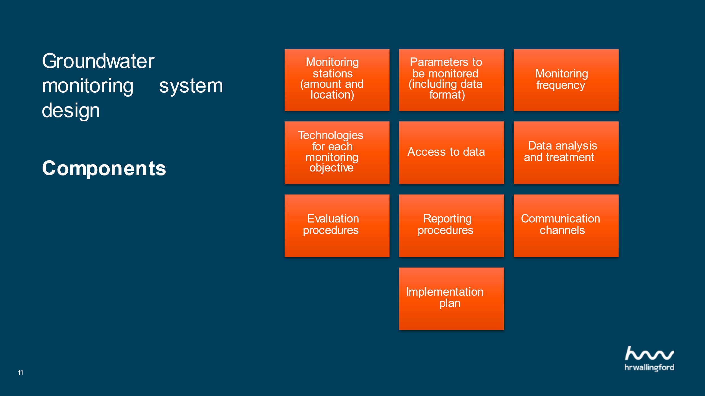

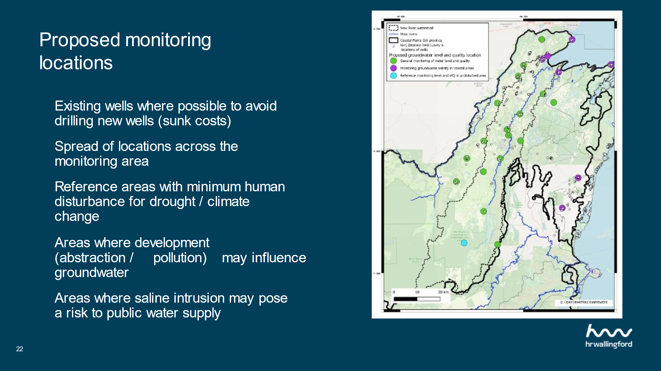

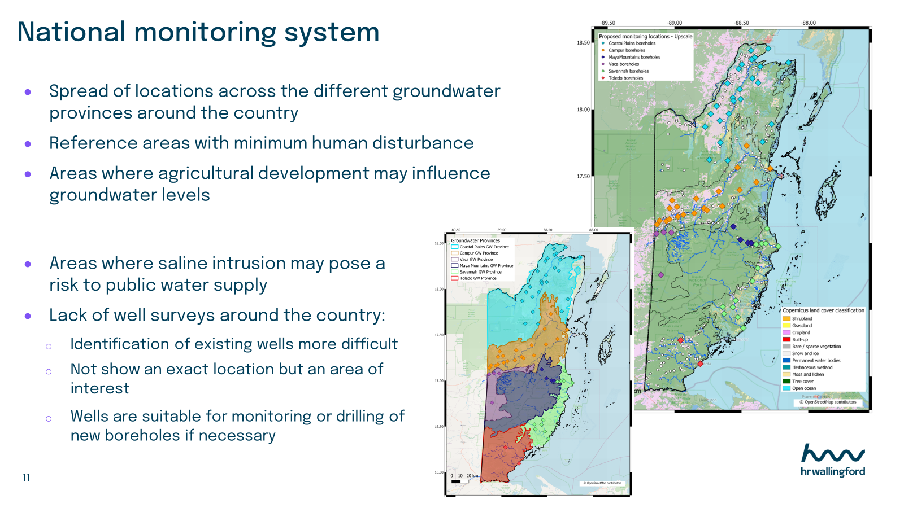

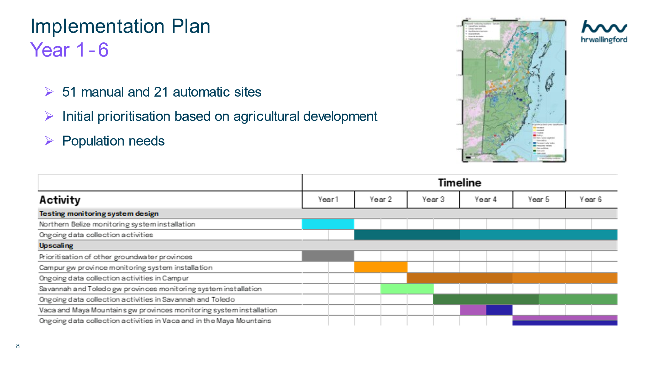

4. Impact Statement
The information in the table below will be used to communicate results and anticipated impacts of this technical assistance publicly. Please copy information from impact statement developed in the M&E Plan and update as relevant.

Challenge | Groundwater is a vital source of water supply in northern Belize for municipal, domestic, agricultural, and industrial purposes, sustaining health, livelihoods, and economic activities. However, its monitoring and management are limited, and the resource is facing several challenges.  These issues have been highlighted in recent drought events and the eutrophication of the New River in 2019. Groundwater and surface water resources are likely to be closely linked in some areas, and both geology and the transboundary nature of the aquifer systems extending into southern Mexico and Guatemala adds further dimensions of complexity to the system.  Climate change is likely to result in a warmer and drier climate, putting further stress on water resources.
CTCN Assistance | - Development of work plan. Map stakeholders and establish a stakeholder working group;  - Assess groundwater availability and demand;  - Design a groundwater monitoring system;  - Planning for implementation: financing, institutional settings, and capacity building.
Anticipated impact | - This project has enabled Belize to have a groundwater monitoring design in place for Northern Belize and a plan for scaling up to national level.  - It also has the basis for implementation with development of a concept note for seeking funding.  - The assistance can provide stakeholders with information that will improve their ability to plan in advance for managing water resources in the areas most at risk.  - In the long term it will ensure resilience of Belize’s water resources and of water and food security for the population.
Co-benefits: Achieved or anticipated co-benefits from the TA | All government departments, research institutions, and households including vulnerable persons will benefit from improved knowledge and management of groundwater resources in the area and planning tools for climate change adaptation through:  - Sustainable management of groundwater resources;  - Long-term data collection, leading to data-driven decision making;  - Protection of ecosystems;  - Early warning systems;  - Regulatory compliance and cost saving policies.
Gender aspects of the TA | Water scarcity disproportionately affects poor communities and the most marginalised individuals in society, including women. Access to water affects women’s access to education and health (in relation to pregnancy, childbirth, and water-borne diseases), as well as their income and safety (gender-based violence).  There has been limited integration of planning and institutional processes that mainstream gender within the water sector in Belize. Traditionally, these sectors were viewed as distinct with limited documented work demonstrating the water and gender nexus. Water supply policies do not encapsulate linkages between gender and water. The National Integrated Water Resources Management Policy for Belize 2008 does not include an integrated gender policy position.  Men often dominate water management roles and technical roles within the sector. The water sector, like in many Sciences, Technology, Engineering and Math (STEM) disciplines in Belize, is traditionally male dominated. Often decisions related to the sector and hazard proofing water resources are made without women’s participation (CANARI, 2021). Moreover, even when women hold technical leadership positions, they are constrained by patriarchal challenges to their decision-making styles. The Caribbean Development Bank (CDB) Country Gender Assessment for Belize (2016) identified that in electricity and water supply economic activity area, female employment was 0.172 per 1000 population and that male employment was 0.870 per 1000 population.
Anticipated contribution to NDC | - Among small states, Belize ranks very high for susceptibility to natural disasters at risk for climate change;  - Extreme temperatures affecting crops and livestock;  - Climate change will threaten the health of Belize’s coral reefs and will affect water supplies;  - National Land Use policy (2019) speak to the need for securing the protection, rehabilitation, and restoration of critical water catchment areas.
The narrative story | The United Nations Framework Convention on Climate Change (UNFCCC) has identified Belize as one of the countries most vulnerable to climate change due to the long, low-lying coastline, the 2nd longest barrier reef in the world, and many small islands that are prone to natural disasters. Belize is likely to be impacted by sea level rise, increased sea surface temperatures, changes in weather patterns and increased storm activity. There is predicted to be an increase in rainfall variability, seasonal evapotranspiration rates, and intense rainfall events and this will become more pronounced with climate. Impacts could include fluctuations in surface water levels and quality which could lead to a decrease in the level and quality of groundwater and saline intrusions in coastal aquifers, where most of the population live.  The National Hydrological Service (NHS) is leading a process for building an inventory of existing data on groundwater. The objective is to identify and homogenize information that is currently available but spread among different agencies and institutions, and their various  Departments.  The CTCN assistance has helped to fill the identified gaps by strengthening expertise of national practitioners to better understanding and management of Belize’ groundwater resources by designing a groundwater monitoring system in Northern Belize, with the aim of upscaling this system to a national scale.
Contribution to SDGs  A complete list of SDGs and their targets is available here: https://sustainabledevelopment.un.org/partnership/register/ | The Project outcomes respond directly to SDG 13 ‘Taking early action to combat climate change and its impacts’ by providing a groundwater monitoring design with the potential to support planning and decision-making for the sustainable management and conservation of water resources in Belize.  The project also contributes to SDG3 (Good health and well-being) as water quality monitoring can prevent illnesses and promote healthy lives and land; SDG6 (Clean water and sanitation) through the design of a monitoring system for groundwater and the identification of risks to the supply of water for diverse groundwater users, particularly those in rural areas where 56% of the population in Belize lives; and SDG15 (Life on land)

Annex 1 Technical assistance data collection

Please add quantitative and qualitative values for the indicators selected in the M&E plan and monitored throughout the technical assistance in the tables below. Indicators which have been monitored in addition to the proposed indicators below may be added at the end of table A. Non-relevant indicators should be left blank.

- Output and outcome indicators

Indicator  Please note indicators below highlighted as anticipated | Quantitative value  Numerals only; disaggregates must sum to the total | Qualitative description  List the various elements corresponding to the quantitative value as well as timelines and responsible institutions
Total number of events organized by proponents and implementing partners | 8 | Kick-off meeting  4 SWG workshops  1 regional workshop  2 training workshops
Number of participants in events organized by proponents and implementing partners | 15-20
- Number of men | 55%-60%
- Number of women | 40%-45%
Number of climate technology RD&D related events | 7 | 4 SWG workshops  1 regional workshop  2 training workshops
Number of participants in climate technology RD&D events | 15-20
- Number of men | 55%-60%
- Number of women | 40%-45%
Number of trainings organized by proponents and implementing partners | 2 | - NHS technicians groundwater monitoring training  - Showcasing the groundwater monitoring system design to the SWG  - Discussion on upscaling the system to a national scale  - Discussion on financing options
Number of participants in trainings organized by proponents and implementing partners | 12
- Number of men | 7
- Number of women | 5
Total number of institutions trained | List total number here
- Governmental (national or subnational) |  | National Hydrological Services (NHS)  National Climate Change Office  Ministry of Agriculture, Food Security and Enterprise (MAFSE)  Ministry of Economic Development (MED)  Department of Environment (DOE)  Department of Rural Development, Ministry of Labour, Local Government and Rural Transformation (MRT)
- Private sector (bank, corporation, etc.) |  | Belize Water Services Limited
- Nongovernmental (NGO, University, etc.) |  | None
Percentage of participants reporting satisfaction with CTCN training (from CTCN training feedback form) | to fill out | Satisfied= 4+ on 5-pt scale
Percentage of participants reporting increased knowledge, capacity and/or understanding as a result of CTCN training (from CTCN training feedback form) | to fill out | Increased knowledge, capacity and/or understanding= 4+ on 5-pt scale
- Percentage of men
- Percentage of women
Total number of deliverables produced during the assistance (excluding mission, progress, and internal reports) | 21
- Number of communication materials, including news releases, newsletters, articles, presentations, social media postings, etc. | 8 | - Groundwater monitoring in the Caribbean region virtual workshop  - CTCN Latin America and Caribbean NDE forum
- Number of tools and technical documents strengthened, revised, or developed |  | - D 3.1: Status and trends in the groundwater resources of Belize  - D 3.2: Assessment of water resources of the New River – Belize  - D 4.4: Benchmarking of methodologies for groundwater monitoring  - D 4.6: New River groundwater monitoring system design report  - D 5.1: Upscaling groundwater monitoring system to national level  - D 5.3: Gradual approach to monitoring implementation and institutional assessment
- Number of other information materials strengthened, revised, or created (For example training and workshop reports, Power Points, exercise docs etc.) |  | - D 4.1-4.3: Stakeholder Working Group meeting report  - D 4.5: Regional Groundwater Monitoring Meeting Report  - D 5.4: Groundwater monitoring system consultation report  - D 5.5: Training manuals
Total number of policies, strategies, plans, laws, agreements, or regulations supported by the assistance | N/A
- Adaptation related |  | List the type and name of documents supported
- Mitigation related |  | List the type and name of documents supported
- Both adaptation- and mitigation related |  | List the type and name of documents supported
Anticipated number of policies, strategies, plans, laws, agreements, or regulations proposed, adopted or implemented as a result of the TA | N/A
- Adaptation related |  | List the type of documents anticipated to be proposed, adopted, or implemented
- Mitigation related |  | List the type of documents anticipated to be proposed, adopted, or implemented
- Both adaptation- and mitigation related |  | List the type of documents anticipated to be proposed, adopted, or implemented
Anticipated number of technologies transferred or deployed as a result of CTCN support | List total number here | - Hazard mapping  - Early warning systems  - Monitoring systems  - Increasing crop resilience and productivity  - Water efficiency and demand management  - Adaptation planning  - Water pollution  - Use of alternative water sources  - Integrated planning  - Public health services  - Integrated coastal zone management
Anticipated number of collaborations facilitated or enabled as a result of technical assistance | List total number here
- Number of South-South collaborations |  | List the names of the organisations (excluding the CTCN or TA implementers)
- Number of RD&D collaborations |  | List the names of the organisations (excluding the CTCN or TA implementers)
- Number of private sector collaborations |  | List the names of the organisations (excluding the CTCN or TA implementers)
Number of countries with strengthened National System of Innovation as a result of CTCN support |  | Belize
Insert any additional indicators here

- Core impact indicators

Please fill in the tables for anticipated impacts of the CTCN assistance. Every technical assistance should contribute to at least one of the indicators below. For guidance on how to report on core indicators see the ‘M&E Guidance Document for TA Implementers’.

Core indicator 3 | Anticipated number of direct and indirect beneficiaries as a result of the TA
 | Quantitative value | Means of verification
Total beneficiaries | Total number
Number of adaptation beneficiaries | 12 | Number of people directly trained by the project team
Number of mitigation beneficiaries | 12 | Number of people directly trained by the project team
Number of adaptation-and mitigation beneficiaries | 12 | Number of people directly trained by the project team

Annex 2 (for internal use – to be filled in by the CTCN)
CTCN evaluation
This section will be completed by the relevant CTCN Technology Manager.

- Evaluation of the timeliness of the TA implementation as measured against the timeline included in the response plan;
- Evaluation of TA quality as defined in the response plan;
- Overall performance of the Implementers;
- Overall engagement of the NDE and Proponent;
- Lessons learned on the CTCN process and steps taken by the CTCN to improve.

