Technical Assistance Closure Report Template
Objective of the technical assistance (TA) Closure Report:
- To communicate publicly in one document a summary of progress made and lessons learned during the TA towards the anticipated impact (sections 1-4).
- To document qualitative and quantitative data collected during TA, for use in donor and UN reporting (Annex 1).

Steps for completing the TA closure report:
- The lead TA implementer submits the closure report at the end of the technical assistance as a final deliverable. The TA closure report will capture outputs, outcomes and impacts of all activities conducted under the TA. Please copy and summarise relevant material from previous TA outputs/deliverables and the Response Plan, as relevant.
- A CTCN Manager will review and revise the closure report before final approval by the CTCN Deputy Director.

Important note on public and internal use of the closure report:
Once approved by the CTCN Deputy Director, the TA closure report will be a public document available on the CTCN website www.ctc-n.org. Selected content will be used for targeted communication activities. Annex 2 is for internal use only and will not be publicly available.

Closure Report for CTCN Technical Assistance

- Basic information
Title of response plan | Monitoring & Assessment of Climate Change Impact on Geomorphology in the Coastal Areas of Bangladesh
Technical assistance reference number | 2016000088
Country / countries | Bangladesh
NDE organisation | Department of Environment, Government of Bangladesh.
NDE focal point | Mr. Sultan Ahmed, Director General
NDE contact information | dg@doe.gov.bd; sulbul2002@yahoo.com
Proponent focal point and organisation | Md Saiful Hossain, Superintending Engineer, Processing Flood Forecasting Circle, Bangladesh Water Development Board.  se.pffc@bwdb.gov.bd
Designer of the response plan | Kim Wium Olesen, Chief Engineer, DHI (kwo@dhigroup.com), in close consultation with NDE, BWD (PP) and the CTCN
Implementer(s) of technical assistance | DHI A/S  Agern Alle 5  DK-2970 Hørsholm  Denmark  kwo@dhigroup.com
Beneficiaries | Processing and Flood Forecasting Circle  Bangladesh Water Development Board
Sector(s) addressed | Instruction: Select relevant sector(s) from the CTCN taxonomy https://www.ctc-n.org/resources/ctcn-taxonomy  Coastal Zone
Technologies supported | Instruction: Please indicate the type of technologies supported by this assistance. Technologies may be identified from the CTCN taxonomy of climate sectors and technologies (download in pdf format and choose from column C): https://www.ctc-n.org/resources/ctcn-taxonomy  If technologies supported are not found in the taxonomy, please suggest.  Remote Sensing  Coastal monitoring
Implementation start date | 08/11/2022
Implementation end date | 30/10/2023
Total budget for implementation | Instruction: In addition to financial value of the technical assistance, please also include if any pro bono or in-kind support has been provided by either the implementer and/or the national counterparts.  133,698 USD
Description of delivered outputs and products as well as the activities undertaken to achieve them. In doing so, review the log frame of the original response plan and refer to it as appropriate | Following deliverables were successfully completed:  Deliverable 1.1: Updated Manual: Training manual and step-by-step guide with methodological guidelines (Under the previous technical assistance, manuals were produced on methodological guidelines and step-by-step  workflows for EO assessments of coastal zone dynamics in Bangladesh. Under current TA, the previous draft manuals were updated and finalized, incorporating stakeholder feedback.  Deliverable 2.2: Workshop Summary Report (incl. raining material package, Workshop participant list, and Workshop outcome and evaluation). Training workshop took place in Bangladesh on the information system, tools and analysis for monitoring and assessment of climate change  impact on geomorphology of coastal areas in the country, transferring the technology guidance to stakeholders in  national institutions, including the Institute of Water Modelling representatives. The training included mid- and junior-level staff from different national institutions trained, including participants from the Institute of Water Modelling.  Deliverable 3.3: Deliv-3-Study Tour Outcome Report  A successful South-south knowledge exchange trip for Bangladesh policy makers took place visiting the HAII in Thailand. The objective was to learn about best practices in region in operationalizing similar monitoring and assessment systems and utilization of the information services to inform key decision-making processes.
Methodologies applied to produce outputs and products | Instruction: Examples of methodologies: E.g. cost-benefit analysis; surveys and structured interviews with key stakeholders etc.  Training course and workshops.
Reference to knowledge resources | N/A  Link to TEC knowledge database: https://unfccc.int/ttclear/tec/documents.html
Deviations | The (original) TA commenced Q3 2019 but was terminated because of travel restriction imposed due to COVID pandemic. The TA was restarted 08/11/2022 without an updated Response Plan but with a Revised Implementation Plan. All outputs according to the Revised Implementation Plan have been delivered. Only deviation is that the implementation period had to be extended because 1) new national focal point had to be appointed in Bangladesh (original proponent had retired), 2) it took longer time than anticipated to appoint trainees, and 3) it took longer time than anticipated to appoint and get approval for participants in South-South Knowledge Exchange Trip.
Anticipated follow-up activities and next steps | Use of new Remote Sensing expertise acquired during the TA in Bangladesh is anticipated.  Seeking funds for implementation of forecast technologies seen during visit to HII in Thailand is also a potential follow up activity for the national proponents if appropriate funding sources can be identified.

- Lessons learned
 | Lessons learned | Recommendations
Lessons learned from the CTCN TA process | Describe lessons learned from following the steps of the TA process and interacting with the CTCN Secretariat. What were the challenges and essential factors contributing to successful implementation | - The support of CTCN Regional Manager was instrumental for acceleration coordination between the recipient and the NDE organization in Bangladesh.
Lessons learned related to climate technology transfer | Describe lessons learned, opportunities, and barriers for the use and deployment of the technology or technologies supported by the TA. The objective is to identify specific success factors for technology transfer | - The national focal point must have a strong ownership and time and resources to support implementation of the TA. The focal point was not the original proponent and had many other pressing tasks to attend to.  - A TA with out-of-town training course and overseas study tour requires high level approval of the participants from the respective home institutions. The time required for this should not be underestimated.

3. Illustration of the TA and photos
For communication purposes, please provide 2-4 Power Point slides, including illustrations or charts, describing barriers, opportunities, methodology, activities, outputs and achieved results. The illustrations must be copied into the TA Closure report but must also be delivered as power point files. Also, please provide at least five high-resolution pictures in jpg format, capturing technical assistance. The pictures should illustrate how the TA has impacted the lives of the beneficiaries in particular and the communities in general.
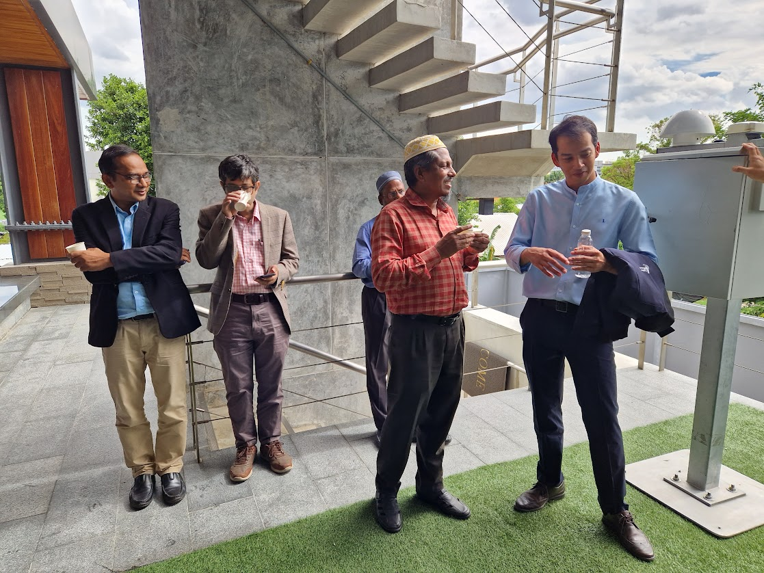
Bangladeshi and Thai water professionals exchange views on real-time monitoring of water levels and precipitation.
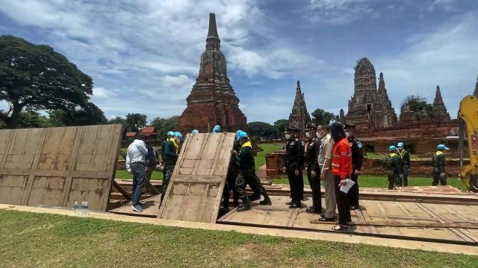 | 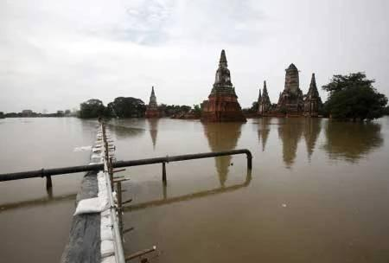
Movable flood gates being erected during pre-flood conditions and during flood situation.

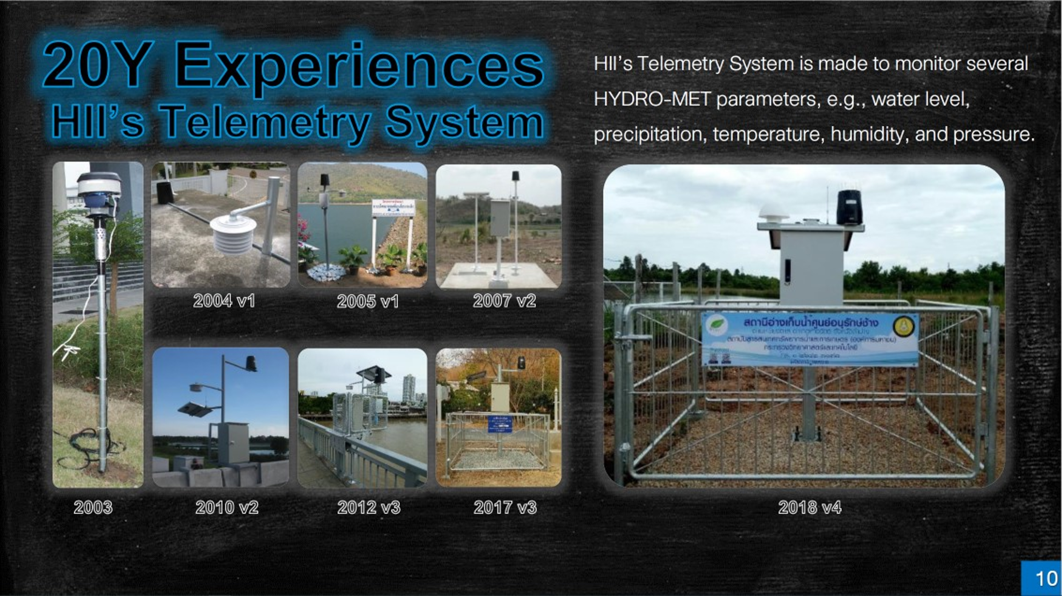
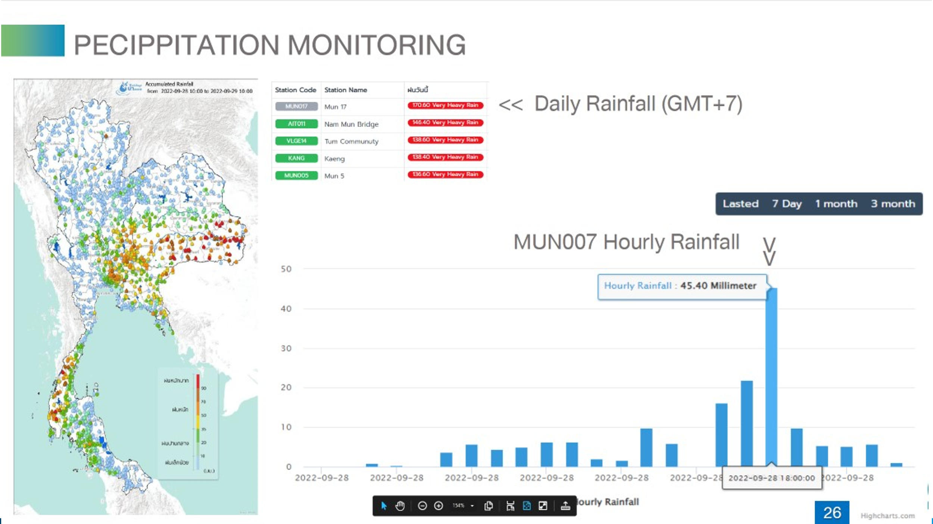

Power point Slides describing key topics of the South-south knowledge exchange workshop: Top: Importance of using reliable and accurate measuring equipment and robust data link (GSM or satellite). Bottom: The value of a dense observation network and a modern data platform for viewing and processing observed data.

4. Impact Statement
The information in the table below will be used to communicate results and anticipated impacts of this technical assistance publicly. Please copy information from impact statement developed in the M&E Plan and update as relevant.

Challenge | The vulnerability of the coastal population in Bangladesh is on the rise due to climate change. Climate variability and change will accentuate the intrinsic risks: (i) cyclones and storm surges (ii) erosion of river banks, islands and chars, (iii) sea level rise, (iv) salinity intrusion, (v) floods, (vi) droughts, (vii) drainage congestions and (viii) coastal erosion.
CTCN Assistance | Technical support and training to apply state-of-the-art Earth Observation (EO) techniques to address the risk facing the Coastal Zone of Bangladesh and in particular the erosion of riverbanks.
Anticipated impact | Capacity built to use earth observation to provide early warning of bank erosion in the coastal zone. When operationalised this will protect the livelihood of the inhabitants of the coastal zone of Bangladesh.
Co-benefits: Achieved or anticipated co-benefits from the TA | Capacity of local institutions to support further technology transfer raised (the IWM able to provide better technical advice on core matters in addition to the ministry representatives).  New lines of communication established with the regional counterparts in Thailand working on similar issues (South-South knowledge exchange and technology transfer).
Gender aspects of the TA | Women are today well-represented amongst water professionals in the government sector and private consultancy organizations (e.g. IWM). It was the intention that this TA should encourage well-balanced (with respect to gender) nomination of professionals for the training activities, but this was not achieved as nominations were generally decided and selected by the respective nominating organisations in the country. Women are amongst the most vulnerable to climate change enhanced risks and will as such benefit significantly from the risk mitigation provide by this TA.
Anticipated contribution to NDC | Increased resilience to disaster and climate change are central in the pathway towards achieving the NDC and the SDGs in Bangladesh. Early warning of bank erosion contributes to this.
The narrative story | The coastline of Bangladesh is on the frontline of climate change, and the coastal communities are becoming increasingly more vulnerable to a number of threats, including: cyclones and storm surges; river bank erosion and vulnerability of islands and chars; sea level rise; salinity intrusion; floods; droughts; drainage congestions and; coastal erosion.  The CTCN technical assistance has underpinned and strengthened earlier efforts to increase the resilience of the coastal population by enhancing the capacity of stakeholders (Bangladesh Water Development Board) in Bangladesh to apply Earth Observation (EO) based approaches for synoptic monitoring of changes and dynamics within the coastal zone.  The assistance provided included:  - Assessment of endogenous capacity in geospatial processing applications and satellite image analysis  - Demonstration, methodological guidelines and technical training in using Earth Observation technologies for impact analysis and early warning of inland bank erosion.  - Demonstration, methodological guidelines and technical training in using Earth Observation technologies for monitoring the dynamics of coastlines and assessing the impact of climate change and storm surges on the coastal zone
Contribution to SDGs  A complete list of SDGs and their targets is available here: https://sustainabledevelopment.un.org/partnership/register/ | SDG 6: Reduced flooding and pollution of surface water sources  SDG: 13: Increased resilience to climate change induced erosion and flooding  SDG 1: Flooding and erosion creates landless farmers, hence increased resilience is instrumental in reducing poverty in the coastal zone of Bangladesh

Annex 1 Technical assistance data collection

Please add quantitative and qualitative values for the indicators selected in the M&E plan and monitored throughout the technical assistance in the tables below. Indicators which have been monitored in addition to the proposed indicators below may be added at the end of table A. Non-relevant indicators should be left blank.

- Output and outcome indicators

Indicator  Please note indicators below highlighted as anticipated | Quantitative value  Numerals only; disaggregates must sum to the total | Qualitative description  List the various elements corresponding to the quantitative value as well as timelines and responsible institutions
Total number of events organized by proponents and implementing partners | 2
Number of participants in events organized by proponents and implementing partners | 36 | 23 Bangladesh  13 Thailand
- Number of men | 28
- Number of women | 8
Number of climate technology RD&D related events | 1 | 1 South-south knowledge exchange trip – Workshop at HII
Number of participants in climate technology RD&D events | Approx 20 | 7 Bangladesh  13 Thailand
- Number of men | 13
- Number of women | 7
Number of training organized by proponents and implementing partners | 1 | Training Course in EO Tools for morphological analyses.
Number of participants in trainings organized by proponents and implementing partners | 16 | 16 Bangladesh
- Number of men | 15
- Number of women | 1
Total number of institutions trained | 2
- Governmental (national or subnational) | 1 | Bangladesh Water Development Board
- Private sector (bank, corporation, etc.) | 1 (semi-private) | Institute for Water Modelling (IWM), Bangladesh
- Nongovernmental (NGO, University, etc.) | N/A
Percentage of participants reporting satisfaction with CTCN training (from CTCN training feedback form) | 100% (with 14 respondents of 16) | CTCN training feedback form not used (see Workshop Summary Report).
Percentage of participants reporting increased knowledge, capacity and/or understanding as a result of CTCN training (from CTCN training feedback form) | 100% | Increased knowledge, capacity and/or understanding= 4+ on 5-pt scale
- Percentage of men | 100%
- Percentage of women | 100%
Total number of deliverables produced during the assistance (excluding mission, progress and internal reports) | List total number here
- Number of communication materials, including news releases, newsletters, articles, presentations, social media postings, etc. | N/A
- Number of tools and technical documents strengthened, revised or developed | 1 | (Deliv-1) Manual on EO-based approaches to detect coastal accretion and erosion
- Number of other information materials strengthened, revised or created (For example training and workshop reports, Power Points, exercise docs etc.) | 2 | (Deliv-2) Workshop-Summary-Report  (Deliv-3) Study Tour Outcome Report
Total number of policies, strategies, plans, laws, agreements or regulations supported by the assistance | N/A
- Adaptation related
- Mitigation related
- Both adaptation- and mitigation related
Anticipated number of policies, strategies, plans, laws, agreements or regulations proposed, adopted or implemented as a result of the TA | N/A
- Adaptation related
- Mitigation related
- Both adaptation- and mitigation related
Anticipated number of technologies transferred or deployed as a result of CTCN support | 1 | (Bank Erosion) Early Warning System
Anticipated number of collaborations facilitated or enabled as a result of technical assistance | 2
- Number of South-South collaborations | 2 | Flood Forecasting and Warning Centre, Bangladesh Water Development Board, Bangladesh  Hydro-Informatics Institute (HII), Bangkok, Thailand
- Number of RD&D collaborations | 1 | Institute for Water Modelling (IWM)
- Number of private sector collaborations | N/A | List the names of the organisations (excluding the CTCN or TA implementers)
Number of countries with strengthened National System of Innovation as a result of CTCN support | 1 | Bangladesh
Insert any additional indicators here

- Core impact indicators

Please fill in the tables for anticipated impacts of the CTCN assistance. Every technical assistance should contribute to at least one of the indicators below. For guidance on how to report on core indicators see the ‘M&E Guidance Document for TA Implementers’.

Core indicator 1 | Anticipated metric tons of CO₂ equivalent (CO₂e) emissions reduced or avoided as a result of CTCN TA  Please add your calculations in word or excel format as an Annex to this Closure Report, where applicable.  N/A: This project deals with climate change adaptation.
 | Anticipated metric tons of CO₂e reduced or avoided as a result of the TA on annual basis | Anticipated metric tons of CO₂e reduced or avoided as a result of the TA in total
Quantitative value  (emissions reductions) | Total number (numerals only, no rounding or abbreviations) | Total number (numerals only, no rounding or abbreviations)
Unit | tCO₂e | tCO₂e
GHG assessment boundary (project emissions)

Identify expected post-TA activities, associated effects and assess boundary for quantification of GHG emission reductions
Baseline emissions

Describe baseline scenario, baseline candidates, emission factors and emissions calculated
Methodology

Explain the method or process of verifying the indicator and how data was gathered
Assumptions
Describe assumptions made during calculation and quantification of GHG reductions

Core indicator 2 | Anticipated increased economic, health, well-being, infrastructure and built environment, and ecosystems resilience to climate change impacts as a result of technical assistance  Please provide a qualitative description of the anticipated impacts on the categories below
Infrastructure and built environment  Anticipated increased infrastructure resilience (avoided/mitigated climate induced damages and strengthened physical assets) | The TA provided technical support and training to apply state-of-the-art EO techniques to address erosion risks facing the Coastal Zone of Bangladesh. When fully implemented, it has the potential of avoidance of embankment failures which is a recurrent problem in the coastal zone of Bangladesh.
Ecosystems and biodiversity  Anticipated increased ecosystem resilience (areas with increased resistance to climate-induced disturbances and with improved recovery rates) | Not significant.
Economic  Anticipated increased economic resilience (e.g. less reliance on vulnerable economic sectors or diversification of livelihood) | Not quantifiable.
Health and wellbeing  Anticipated increased health and wellbeing of target group (e.g. improved basic health, water and food security) | 25,000 beneficiaries/year, see Core indicator 3 below.

Core indicator 3 | Anticipated number of direct and indirect beneficiaries as a result of the TA
 | Quantitative value | Means of verification
Total beneficiaries | Total number
Number of adaptation beneficiaries | 25,000 beneficiaries/year | The population of the coastal zone in Bangladesh is approx. 40 million of which a large part lives in the 130+ polders. Population of the polders range from say 10,000 to 500,000 – for this calculation we assume 100,000. With early warning of bank erosion and associated embankment breach fully implemented we can assume that one embankment breach annually can be prevented. Again, if a typical embankment breach affects the livelihood of say 25% of the population of a polder we obtain 25,000 beneficiaries/year.
Number of mitigation beneficiaries | N/A
Number of adaptation-and mitigation beneficiaries | N/A

Core indicator 4 | Anticipated amount of funding/investment leveraged (USD) as a result of TA (disaggregated by public, private, national, and international sources, as well as between anticipated/confirmed funding)
 | Quantitative value confirmed in USD | Quantitative value anticipated in USD | Qualitative description  List the institutions, timelines, and description or title of the investment | Methods  Describe methods used for quantification of funds leveraged
Total funding | N/A | Total number in USD (numerals only, no rounding or abbreviations)
Anticipated amount of public funding mobilised from national/domestic sources | N/A
Anticipated amount of public funding mobilised from international/ regional sources | N/A
Anticipated amount of private funding mobilised from national/domestic sources | N/A
Anticipated amount of private funds mobilised from international/regional sources | N/A

Annex 2 (for internal use – to be filled in by the CTCN)
CTCN evaluation
This section will be completed by the relevant CTCN Technology Manager.

- Evaluation of the timeliness of the TA implementation as measured against the timeline included in the response plan;
- Evaluation of TA quality as defined in the response plan;
- Overall performance of the Implementers;
- Overall engagement of the NDE and Proponent;
- Lessons learned on the CTCN process and steps taken by the CTCN to improve.

