St Kitts and Nevis drought forecasting system
Manual for Administrators
FWR6614-009 R00-00 | 25 February 2023

Document information
Document permissions | Unrestricted
Project number | FWR6614
Project name | St Kitts and Nevis drought forecasting system
Report title | Manual for Administrators
Report number | 009
Release number | 00-00
Report date | 25 February 2023
Client | CTCN
Client representative | Ramiro Salinas Revollo
Project manager | Gina Tsarouchi
Project director | Nigel Walmsley

Document history
Date | Release | Prepared | Approved | Authorised | Notes
25 Feb 2023 | 00-00 | GMT | NW | NW

Contents
1 Background 4
2 Overview of the Drought Forecasting Tool 4
2.1 How, when and why the Drought Forecasting Tool is used 4
2.2 Intended users 5
2.3 Functions and functionalities of the system 6
2.4 Parameters of interest 7
2.5 Definitions 9
3 Getting Started / Login Page 9
4 Home Page / Exploring the Graphic User Interface (GUI) 9
4.1 Home Page Elements / Components 9
5 Layers / Exploring the Layer Categories and Layers 12
5.1 Static Contextual Layers 12
5.1.1 Land cover classification 12
5.1.2 Population density 14
5.2 Drought indicators 14
5.2.1 SPI (Standardised Precipitation Index) 14
5.2.2 Interpretation of SPI at different time scales 15
5.2.3 SPEI (Standardised Precipitation – Evapotranspiration Index) 16
5.3 Climate observations and forecasts 16
5.3.1 Precipitation 16
5.3.2 Temperature 17
5.4 Modelled hydrology and groundwater 19
5.4.1 Model overview 19
5.4.2 Model outputs 21
5.5 Long term climate change 21
6 Administration the System 23
6.1 Terms and Conditions 23
6.2 Who to contact 24
7 Closing remarks 24

Background
In an effort to address the impacts of climate change and climate variability in a sustainable way, access to critical information within the water sector is vital. Drought forecasting tools can identify areas most susceptible to water supply variability and shortages, and therefore facilitate early action to manage risks. In doing so, this increase resilience in the water sector, improves the use of scarce water resources and supports adaptation planning and decision making.
In November 2021, CTCN commissioned HR Wallingford to implement a project on Incorporating drought risks modelling as a planning tool for climate change adaptation measures in Saint Kitts and Nevis. The outcomes of the project aimed to increase resilience in the water sector and to improve agricultural and use of water resources and therefore enhance water and food security in Saint Kitts and Nevis. Specific outputs included to: (i) assess drought risk and water resources in Saint Kitts and Nevis; (ii) benchmark, design and implement a drought forecasting tool in Saint Kitts and Nevis; and (iii) train national stakeholders in the use of the drought forecasting tool.
This report relates specifically the drought forecasting tool and is a guide written for users and administrators of the system with a view to:
- Explain how, when and why the drought forecasting tool can be used
- Describe the functions and functionalities of the system
- Catalogue the data sources used and generated by the system
- How to access specific types of information from the system
- Explain how to download reports and system outputs
- Procedures for administering the system (including maintenance, updates, etc.)
A draft version of this guide was discussed at a training workshop in November 2022 and subsequently updated to ensure the final version incorporated the requirements and recommendations of users and administrators.

Overview of the Drought Forecasting Tool

How, when and why the Drought Forecasting Tool is used
The Drought forecasting tool uses models fed by climatic and atmospheric data (historical/seasonal weather patterns, real-time meteorological monitoring, and weather forecasts) to predict the probability of a drought occurring in the future for areas of interest across both Saint Kitts and Nevis. The Drought forecasting tools is an important part of early warning systems, as it provides lead-time to planners for threat responses, which helps minimise drought impact risk. Application and use of the Drought forecasting tool can help to inform early action on agricultural activity and/or water availability and is therefore particularly important for ensuring food and water security.
There are many other economic, environmental and social benefits associated with the implementation and use of a Drought forecasting tools including:
- Providing timely, early information to help identify measures to minimise impacts
- Anticipating potential drought characteristics and providing lead-time for response measures
- Maximising advance opportunities to ensure efficient and effective water use
- Managing risks and ensuring economic activity continues to the extent possible during droughts.
The Drought Forecasting Tool for Saint Kitts and Nevis incorporates forecasts with a lead time of up to 6 months. Effective use of the forecasting systems can therefore give enough lead time to adequately plan for water storage, identify alternative sources of freshwater, implement new (water-saving) agricultural practices, and other risk management measures as necessary.
Technological advances and new research are continually improving the accuracy of forecasting systems and, as an example, innovative use of earth observation (EO) data have been embedded in the Drought forecasting tool for Saint Kitts and Nevis. Co-design and development of the system has also promoted a shared vision and collaborative approach among multiple stakeholders, ensuring a wide range of user requirements and sectoral interests are met. In doing so, the system also serves as an integral component of a wider integrated approach to drought early warning and management, which will improve drought preparedness and increase resilience to drought impacts.
Users of the system do however need to be mindful that longer range drought forecasts have a high degree of uncertainty and the effects of climate change result in increasingly unpredictable weather patterns, making forecasts less precise. Forecasting models may produce a wide range of probabilities, with a healthy level of uncertainty, and a risk management ethos is central to making sound decisions. As importantly, it is only ‘timely action’ that will ultimately have an impact on the ground.
“Early warning systems are now good at warning about an impending shock, but decision-makers are reluctant to spend dollars until they see the crisis unfolding … the problem is, by the time you see what's actually happening, it's far too late.”
Some components of the system, such as model simulations, also require a high level of technical expertise to install and operate and these factors have been taken into consideration for the initial hosting and implementation of the Drought forecasting tool in Saint Kitts and Nevis to ensure that early and effective implementation of the system is not hampered by lack of technical capacity, see Section 7 on the Administration of the System.

Intended users
Information and outputs from the Drought forecasting tool are specifically targeted toward stakeholders that implement communication and emergency drought response plans. In Saint Kitts and Nevis, this includes meteorological organisations, decision-makers, disaster planners and others as follows:
Lead Agency / Responsible for administering the system
- Department of Environment, Ministry of Environment and Cooperatives (federal level for St. Kitts and Nevis)
Primary Users / Saint Kitts
- Department of Economic Affairs and Public Sector Investment Planning (PSIP), Ministry of Sustainable Development
- Water Services Department, Ministry of Public Infrastructure, Utilities, Posts and Urban Development
- Public Works Department, Ministry of Public Infrastructure, Utilities, Posts and Urban Development
- Department of Physical Planning, Ministry of Sustainable Development
- Department of Agriculture, Ministry of Agriculture, Fisheries and Marine Resources
- Environmental Health Unit, Ministry of Health
- National Emergency Management Agency
- St. Kitts Meteorological Services
- St. Christopher Air and Sea Ports Authority (SCASPA)
- Farmers’ cooperatives (several groups in SKN)
Primary Users / Nevis
- Department of Economic Planning, Ministry of Finance
- Nevis Water Department, Ministry of Communications
- Integrated Water Resources Management Unit, Ministry of Communications
- Projects Unit, Ministry of Communications
- Department of Public Works, Ministry of Communications
- Department of Physical Planning and Environment, Ministry of Communications
- Department of Agriculture, Ministry of Agriculture
- Environmental Health Unit, Ministry of Health
- Nevis Department of Disaster Management, Ministry of Agriculture
- Nevis Meteorological Services
- Nevis Air and Sea Ports Authority

Functions and functionalities of the system
The typical components of the drought forecasting tool are shown schematically in Figure 2.1 alongside the work flows to generate and deliver drought forecasts.
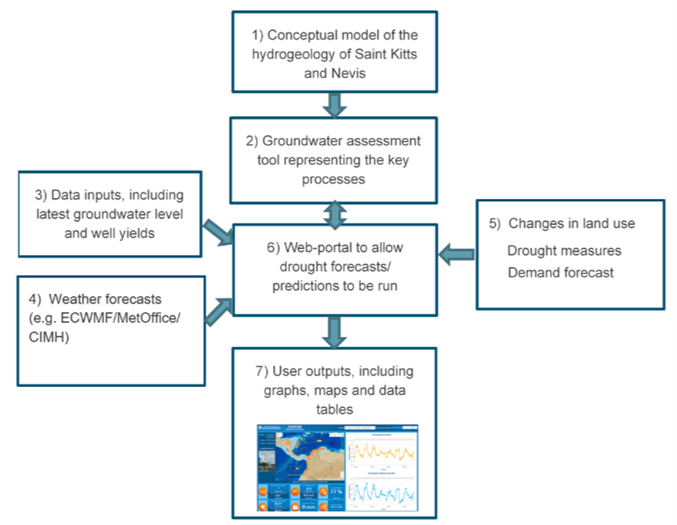
Figure 2.1: Typical components of the forecasting system
Source: HR Wallingford, 2022
The Drought forecasting tool for Saint Kitts and Nevis comprises a set of independent systems and datasets which are connected together via data flows and formatting functions. A Data Management System harvests data from multiple Earth Observation and in-situ observation sources as well as data from forecasting models. It post-processes this data, formatting, scaling and standardising it and stores it in various data stores. The data management system transforms and delivers these complex climate datasets to the web application for visualisation and display. A Water Availability Modelling System incorporating a hydrological modelling suite produces forecasts for a set of parameters which, together, describe water availability and is driven by a seasonal meteorological forecast. Finally, the web-based Data Visualisation System displays the drought indicators and information from static layers (e.g. landcover, population density) and drought forecast information.
Full technical details of the of each of these systems is provided in a separate report on the Design of the drought prediction tool.

Parameters of interest
Table 2.1 below summarises the variables generated by the Drought forecasting tool together with their spatial resolution, temporal resolution and whether they are available as historical, current state or forecast variables. Further details of accessing and viewing these variables is given in Section 5.

Table 2.1: Variables generated by the Drought forecasting tool
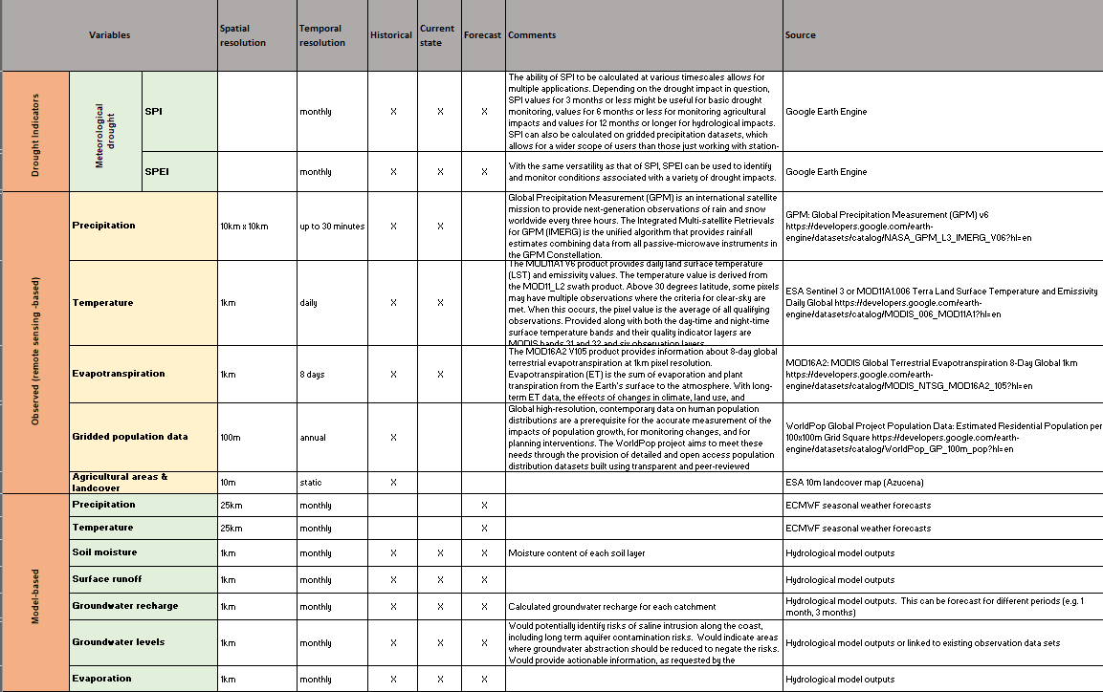

Definitions
- Population density: People per square km of land area
- SPI: Standardized Precipitation Index (SPI-n), is a statistical indicator comparing the total precipitation received at a particular location during a period of n months with the long-term rainfall distribution for the same period of time at that location. SPI is calculated on a monthly basis for a moving window of n months, where n indicates the rainfall accumulation period, which is typically 3, 6, 12, or 24 months.
- SPEI: Standardized Precipitation Evapotranspiration Index (SPEI), is an extension of the SPI. The SPEI is designed to take into account both precipitation and potential evapotranspiration (PET) in determining drought. SPEI uses the difference between precipitation and PET. Thus, unlike the SPI, the SPEI captures the main impact of increased temperatures on water demand. Like the SPI, the SPEI can be calculated on a range of timescales.
- 90th percentile: the point at which 90 percent of a given population falls below it. This value is exceeded only 10 percent of the time.
- 10th percentile: the point at which 10 percent of a given population falls below it. This value is exceeded 90 percent of the time.
- Potential evapotranspiration(PET): the maximum amount of water that can be removed from a land surface through evapotranspiration (ET) as sum of both evaporation and transpiration given abundant supply of soil moisture.
- Runoff: water that runs over the land surface during precipitation events
- Baseflow: water added to streams from the subsurface
- Recharge: water added to the aquifer through the unsaturated zone after infiltration and percolation following a precipitation event
- Soil moisture content: amount of water present in the soil

Getting Started / Login Page
https://fwr6614.hrwallingford.com/main/
Username: demouser
Password: stK1tt5

Home Page / Exploring the Graphic User Interface (GUI)

Home Page Elements / Components
Once you have logged in to the system, you may navigate around the rest of the website freely. Tabs and links on the right hand side allow you to navigate and select the different layers of information you can explore. You will be offered a variety of options for viewing the information presented, but it is not possible to change any of the information that you see.
The navigation and information bar on the right hand side of the page allows you to click on different layers of information. Once you click on a layer, the information is presented on a map of the two islands.
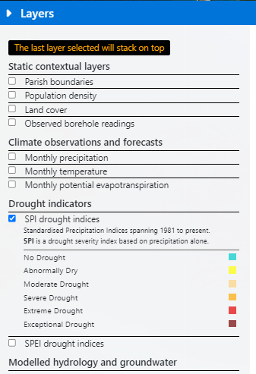
Figure 4.1: Click on a layer of interest (in this case SPI drought indices), to load the SPI data on the map.
The data is now loaded on the map, and shown like this:
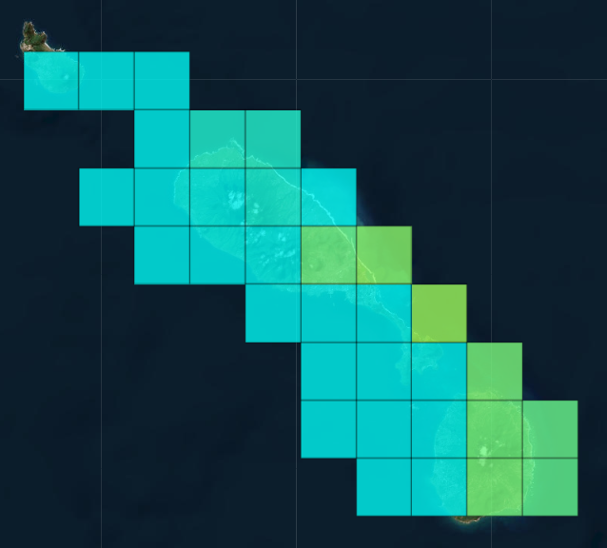

- Click on any location of interest, to see detailed information on your selected layer.

The graph controls are as follows:
- Use the zoom and autoscale buttons in the top right hand corner to zoom in and zoom out. You can also zoom in by double clicking on the map. To zoom in on a portion of a graph, place the cursor at the top left of the area you wish to view, press and hold the left mouse key then move cursor to bottom right of area and release left key.
- Pan around the map by selecting the pan button in the top right hand corner and then holding down the left mouse button and dragging the mouse.
- Hover over the graph to reveal the variable value for a given month.
- The autoscale button will return the graph to its original position and scale.
- The “Data as CSV” button allows you to download the data in a CSV format.

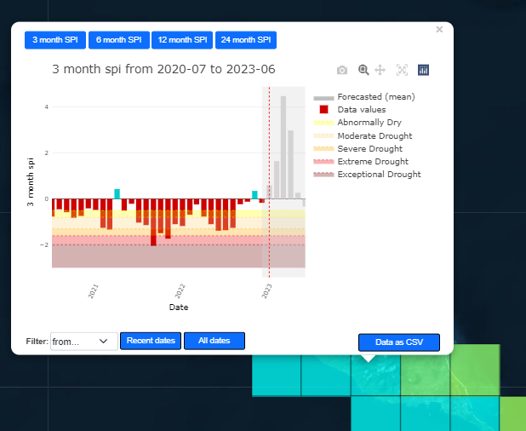

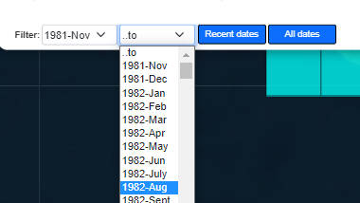
Date filtering is provided on some graphs. Select a start month, and an end month, to redraw the graph between these date ranges.
On some graphs, at the top of the graph, blue buttons give the option to visualise selected layers at different time scales. For example for SPI and SPEI, results can be visualised for 3-month, 6-month, 12-month and 24-month timescales.
The grey shaded part of the graph (right side) shows the six month forecast values for the selected variable.
The legend at the bottom of the page, enables selection of a given year, a given timescale and exporting the current selection as a geotiff file:
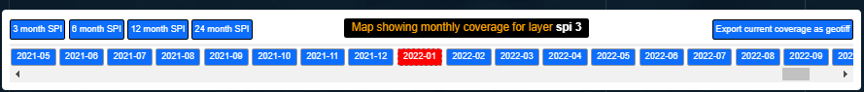

Layers / Exploring the Layer Categories and Layers

Static Contextual Layers

Land cover classification
The map is the ESRI landcover map derived from ESA Sentinel-2 imagery at 10m resolution. It is a composite of LULC (land use land cover) predictions for 10 classes throughout the year in order to generate a representative snapshot of 2020.
This map was produced by a deep learning model trained using over 5 billion hand-labelled Sentinel-2 pixels, sampled from over 20,000 sites distributed across all major biomes of the world.
The underlying deep learning model uses 6 bands of Sentinel-2 surface reflectance data: visible blue, green, red, near infrared, and two shortwave infrared bands. To create the final map, the model is run on multiple dates of imagery throughout the year, and the outputs are composited into a final representative map of 2020. For more information see: https://www.arcgis.com/home/item.html?id=d6642f8a4f6d4685a24ae2dc0c73d4ac
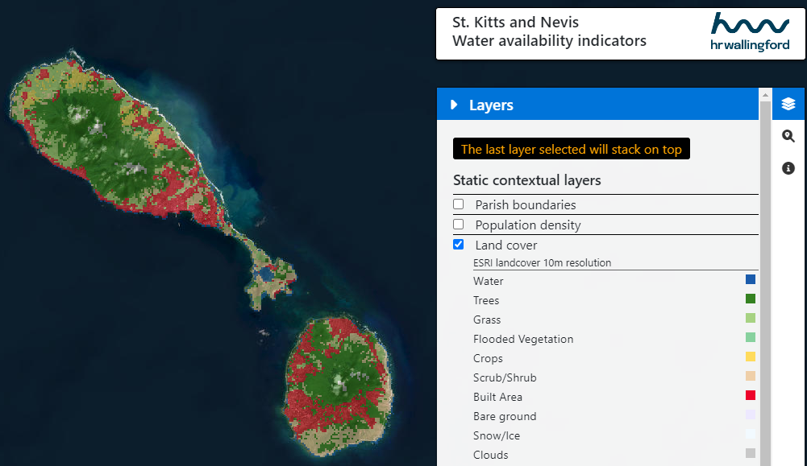

Class definitions
- Water: Areas where water was predominantly present throughout the year; may not cover areas with sporadic or ephemeral water; contains little to no sparse vegetation, no rock outcrop nor built up features like docks; examples: rivers, ponds, lakes, oceans, flooded salt plains.
- Trees: Any significant clustering of tall (~15 feet or higher) dense vegetation, typically with a closed or dense canopy; examples: wooded vegetation, clusters of dense tall vegetation within savannas, plantations, swamp or mangroves (dense/tall vegetation with ephemeral water or canopy too thick to detect water underneath).
- Grass: Open areas covered in homogenous grasses with little to no taller vegetation; wild cereals and grasses with no obvious human plotting (i.e., not a plotted field); examples: natural meadows and fields with sparse to no tree cover, open savanna with few to no trees, parks/golf courses/lawns, pastures.
- Flooded vegetation: Areas of any type of vegetation with obvious intermixing of water throughout a majority of the year; seasonally flooded area that is a mix of grass/shrub/trees/bare ground; examples: flooded mangroves, emergent vegetation, rice paddies and other heavily irrigated and inundated agriculture.
- Crops: Human planted/plotted cereals, grasses, and crops not at tree height; examples: corn, wheat, soy, fallow plots of structured land.
- Scrub/shrub: Mix of small clusters of plants or single plants dispersed on a landscape that shows exposed soil or rock; scrub-filled clearings within dense forests that are clearly not taller than trees; examples: moderate to sparse cover of bushes, shrubs and tufts of grass, savannas with very sparse grasses, trees or other plants
- Built Area: Human made structures; major road and rail networks; large homogenous impervious surfaces including parking structures, office buildings and residential housing; examples: houses, dense villages / towns / cities, paved roads, asphalt.
- Bare ground: Areas of rock or soil with very sparse to no vegetation for the entire year; large areas of sand and deserts with no to little vegetation; examples: exposed rock or soil, desert and sand dunes, dry salt flats/pans, dried lake beds, mines.
- Snow/Ice: Large homogenous areas of permanent snow or ice, typically only in mountain areas or highest latitudes; examples: glaciers, permanent snowpack, snow fields.
- Clouds: No land cover information due to persistent cloud cover.

Population density
This dataset depicts estimated number of people residing in each grid cell in 2020. It is provided by the WorldPop research project, which focuses on providing high quality solutions for low-and middle-income countries. More information is available here: https://hub.worldpop.org/project/categories?id=18
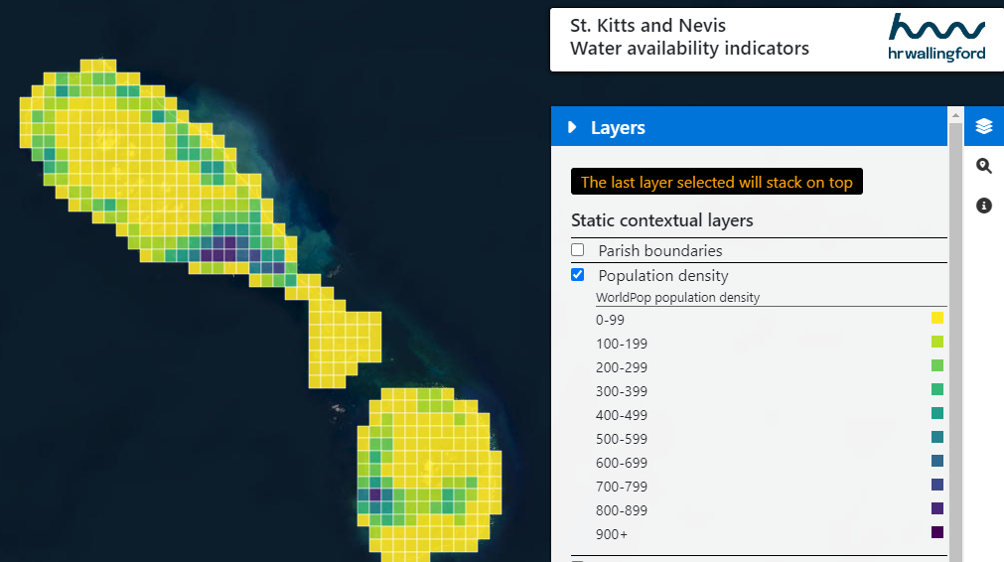

Drought indicators

SPI (Standardised Precipitation Index)
Standardized Precipitation Index – The SPI is the number of standard deviations that the observed value would deviate from the long-term mean, for a normally distributed random variable. Since precipitation is not normally distributed, a transformation is first applied so that the transformed precipitation values follow a normal distribution.
The SPI was designed to explicitly express the fact that it is possible to simultaneously experience wet conditions on one or more time scales, and dry conditions at other time scales, often a difficult concept to convey in simple terms to decision makers. Consequently, a separate SPI value is calculated for a selection of time scales, covering the last 3, 6, 12, 24 months, and ending on the last day of the latest month.

Interpretation of SPI at different time scales
The 3-month SPI provides a comparison of the precipitation over a specific 3-month period with the precipitation totals from the same 3-month period for all the years included in the historical record. In other words, a 3-month SPI at the end of February compares the December-January-February precipitation total in that particular year with the December-February precipitation totals of all the years. A 3-month SPI reflects short- and medium-term moisture conditions and provides a seasonal estimation of precipitation.
It is important to compare the 3-month SPI with longer time scales. A relatively normal 3-month period could occur in the middle of a longer-term drought that would only be visible at longer time scales. Looking at longer time scales would prevent a misinterpretation that any "drought" might be over.
The 6-month SPI compares the precipitation for that period with the same 6-month period over the historical record. The 6-month SPI indicates medium-term trends in precipitation and is still considered to be more sensitive to conditions at this scale than the Palmer Index. A 6-month SPI can be very effective showing the precipitation over distinct seasons. Information from a 6-month SPI may also begin to be associated with anomalous streamflows and reservoir levels.
A 12-month SPI is a comparison of the precipitation for 12 consecutive months with the same 12 consecutive months during all the previous years of available data. Likewise, a 24-month SPI is a comparison of the precipitation for 24 consecutive months with the same 24 consecutive months during all the previous years of available data. The SPI at these time scales reflect long-term precipitation patterns. Because these time scales are the cumulative result of shorter periods that may be above or below normal, the longer SPIs tend toward zero unless a specific trend is taking place. SPIs of these time scales are probably tied to streamflows, reservoir levels, and even groundwater levels at the longer time scales.

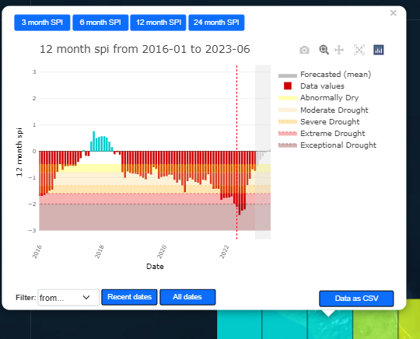

SPEI (Standardised Precipitation – Evapotranspiration Index)
The Standardised Precipitation-Evapotranspiration Index (SPEI) fulfils the requirements of a drought index since its multi-scalar character enables it to be used by different scientific disciplines to detect, monitor and analyse droughts. Like the SPI, the SPEI can measure drought severity according to its intensity and duration, and can identify the onset and end of drought episodes. The SPEI allows comparison of drought severity through time and space, since it can be calculated over a wide range of climates, as can the SPI. A crucial advantage of the SPEI over other widely used drought indices that it considers the effect of Potential Evapotranspiration (PET) on drought severity is that its multi-scalar characteristics enable identification of different drought types and impacts in the context of global warming.
The SPEI is really simple to calculate, and is based on the original SPI calculation procedure. The SPI is calculated using monthly precipitation as the input data. The SPEI uses the monthly difference between precipitation and PET. This represents a simple climatic water balance which is calculated at different time scales to obtain the SPEI.

Climate observations and forecasts

Precipitation

Historical record
For the historical precipitation data, the webtool visualises data from the Climate Hazards Group InfraRed Precipitation with Station dataset (CHIRPS), which is a 35+ year quasi-global product, spanning 50°S-50°N (and all longitudes) and ranging from 1981 to near-present. CHIRPS incorporates 0.05° resolution satellite imagery, and in-situ station data to create gridded rainfall time series for trend analysis and seasonal drought monitoring.
Read more about CHIRPS here: https://www.nature.com/articles/sdata201566
To find answers to basic questions related to CHIRPS, please visit the CHIRPS FAQs: https://wiki.chc.ucsb.edu/CHIRPS_FAQ

Forecasts
For the forecasted precipitation data, the webtool visualises data from the European Centre for Medium-Range Weather Forecasts (ECMWF). Seasonal forecasts provide a long-range outlook of changes in the Earth system over periods of a few weeks or months, as a result of predictable changes in some of the slow-varying components of the system. For example, ocean temperatures typically vary slowly, on timescales of weeks or months; as the ocean has an impact on the overlaying atmosphere, the variability of its properties (e.g. temperature) can modify both local and remote atmospheric conditions. Such modifications of the 'usual' atmospheric conditions are the essence of all long-range (e.g. seasonal) forecasts. This is different from a weather forecast, which gives a lot more precise detail - both in time and space - of the evolution of the state of the atmosphere over a few days into the future. Beyond a few days, the chaotic nature of the atmosphere limits the possibility to predict precise changes at local scales. This is one of the reasons long-range forecasts of atmospheric conditions have large uncertainties. To quantify such uncertainties, long-range forecasts use ensembles, and meaningful forecast products reflect a distributions of outcomes.
Given the complex, non-linear interactions between the individual components of the Earth system, the best tools for long-range forecasting are climate models which include as many of the key components of the system and possible; typically, such models include representations of the atmosphere, ocean and land surface. These models are initialised with data describing the state of the system at the starting point of the forecast, and used to predict the evolution of this state in time. While uncertainties coming from imperfect knowledge of the initial conditions of the components of the Earth system can be described with the use of ensembles, uncertainty arising from approximations made in the models are very much dependent on the choice of model. A convenient way to quantify the effect of these approximations is to combine outputs from several models, independently developed, initialised and operated.
To this effect, the Copernicus Climate Change Service (C3S) provides a multi-system seasonal forecast service, where data produced by state-of-the-art seasonal forecast systems developed, implemented and operated at forecast centres in several European countries is collected, processed and combined to enable user-relevant applications. The composition of the C3S seasonal multi-system and the full content of the database underpinning the service are described in the documentation available here: https://cds.climate.copernicus.eu/cdsapp#!/dataset/seasonal-original-single-levels?tab=doc.
The data includes precipitation forecasts created in real-time (since 2017).

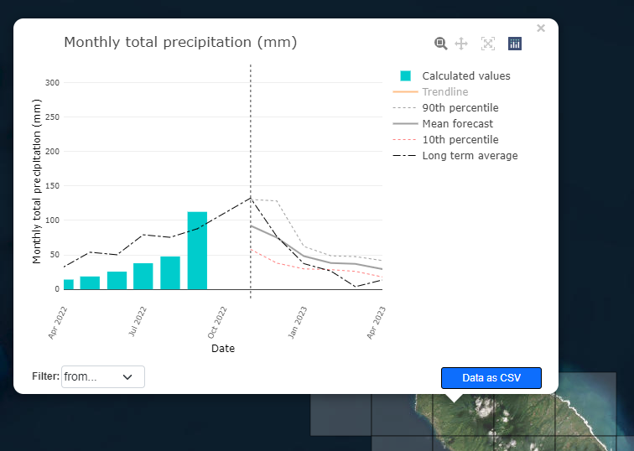

Temperature

Historical record
For the historical temperature data, the tool visualises ERA5 data spanning 1981 to present. ERA5 is the fifth generation ECMWF reanalysis for the global climate and weather for the past decades. Currently data on the tool is available from 1981.
Reanalysis combines model data with observations from across the world into a globally complete and consistent dataset using the laws of physics. This principle, called data assimilation, is based on the method used by numerical weather prediction centres, where every so many hours (12 hours at ECMWF) a previous forecast is combined with newly available observations in an optimal way to produce a new best estimate of the state of the atmosphere, called analysis, from which an updated, improved forecast is issued. Reanalysis works in the same way, but at reduced resolution to allow for the provision of a dataset spanning back several decades. Reanalysis does not have the constraint of issuing timely forecasts, so there is more time to collect observations, and when going further back in time, to allow for the ingestion of improved versions of the original observations, which all benefit the quality of the reanalysis product.
ERA5 is updated daily with a latency of about 5 days. In case that serious flaws are detected in this early release (called ERA5T), this data could be different from the final release 2 to 3 months later. In case that this occurs users are notified.
Data has been regridded to a regular lat-lon grid of 0.25 degrees for the reanalysis. The tool visualises the monthly product.

Forecasts
For the forecasted temperature data, the webtool visualises data from the European Centre for Medium-Range Weather Forecasts (ECMWF), as is done for the precipitation forecast data.
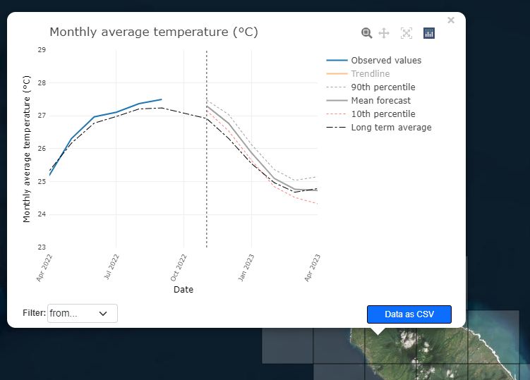

Modelled hydrology and groundwater

Model overview
The hydrological model that underpins the drought forecasting tool is the Variable Infiltration Capacity (VIC) model, coupled the 2D groundwater model AMBHAS. The VIC model is a large-scale, semi-distributed hydrologic model. The 2D groundwater flow model AMBHAS was incorporated into the VIC code to address its lack of a lateral groundwater flow component.
VIC is a macro-scale hydrological model and has been widely applied from basin to global scale for water and energy balance studies in the US, the Arctic and globally. The model describes vertical water transport in large and thin cells. Sub-grid heterogeneity of land cover and elevation is handled with statistical distributions of the different land cover types and elevation bands, dividing a cell into a number of tiles. For each of these tiles, evapotranspiration, infiltration, runoff, soil moisture and baseflow are calculated separately and weighted by area to give a cell-average value for each variable. The water and energy balance for each grid cell is solved independently and there is no lateral connectivity between the cells. The runoff function within VIC calculates surface runoff, infiltration, soil water transport and baseflow as follows: when precipitation reaches the land surface, it is partitioned into runoff and infiltration, according to the variable infiltration curve. It assumes that surface runoff from the upper two soil layers is generated by those areas for which precipitation and the soil moisture exceeds the storage capacity of the soil. Water is calculated to flow between the soil layers using a 1D Richards equation, assuming free drainage and using the Brooks–Corey relationship for hydraulic conductivity. Baseflow, which leaves the soil column, is calculated as a function of relative moisture of the bottom soil layer according to the Arno model formulation. Routing of runoff and baseflow is performed a posteriori by post-processing model output.
A two-dimensional model of groundwater flow has been incorporated into the VIC code. This has been based on the AMBHAS code. The VIC algorithm which calculates baseflow as a function of the soil moisture of the lowest soil layer, is replaced by a calculation of the downward recharge, or upward discharge, of water across the base of the VIC soil column at each time-step. This vertical flux is a function of the VIC soil moisture content and the current level of the water table simulated by the groundwater model. This vertical flux is then applied to the groundwater model, which solves for groundwater flow, baseflow to rivers, and the elevation of the water table across the domain for the time-step. Henceforth, we use the term discharge to mean an upward flux of water across the base of the soil column, i.e., a negative recharge.
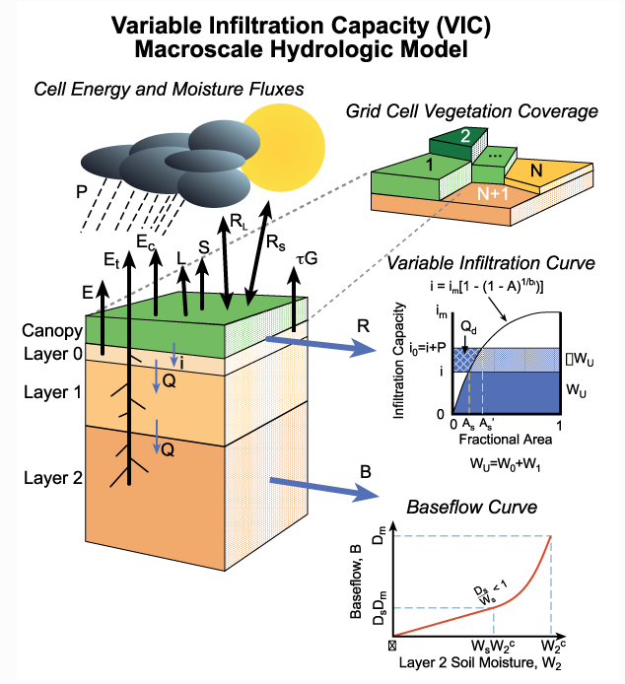
Figure 5.1: VIC land cover tiles and soil column, with major water and energy fluxes.
Source: https://vic.readthedocs.io/en/master/Overview/ModelOverview/

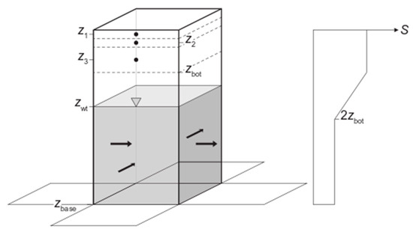
Figure 5.2: Layering in coupled soil-aquifer column and vertical variation in storage coefficient S. Z1, Z2, Z3 are the node depths of the variable infiltration capacity (VIC) soil column, Zbot is the elevation of the bottom layer in VIC, Zwt the water table depth, and Zbase the elevation of the base of the aquifer.
Source:https://www.mdpi.com/2073-4441/13/5/663/htm#B44-water-13-00663

Model outputs

Historical record
For the historical period, the model is driven by historical data from the ERA5 fifth generation ECMWF reanalysis product. Model outputs include: runoff, baseflow, recharge, PET, soil moisture.

Forecasts
For the forecasts, the model is driven by data from the European Centre for Medium-Range Weather Forecasts (ECMWF). Model outputs include: runoff, baseflow, recharge, PET, soil moisture, for the next six months.

Long term climate change
Climate change projections were developed for both Saint Kitts and Nevis. Climate change impacts on precipitation (rainfall) and temperature will directly influence the availability and demand for water resources in the future. These datasets provide precipitation and temperature projections based on an ensemble of Coupled Model Intercomparison Project Phase 6 (CMIP6) climate model projections.
For the climate change projections, the webtool visualises precipitation and temperature changes, as shown in Figure 5.3.

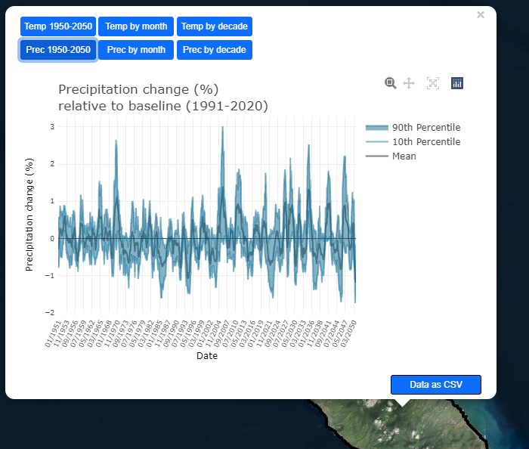 | 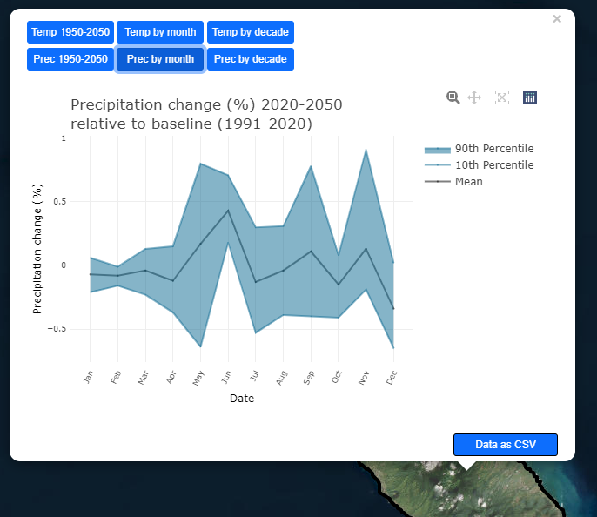
(a) | (b)
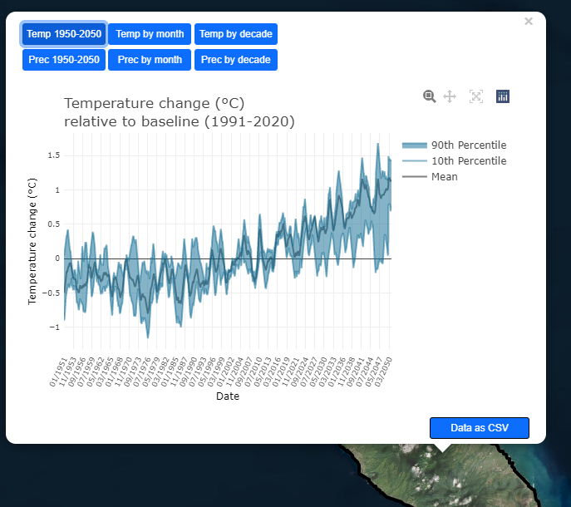 | 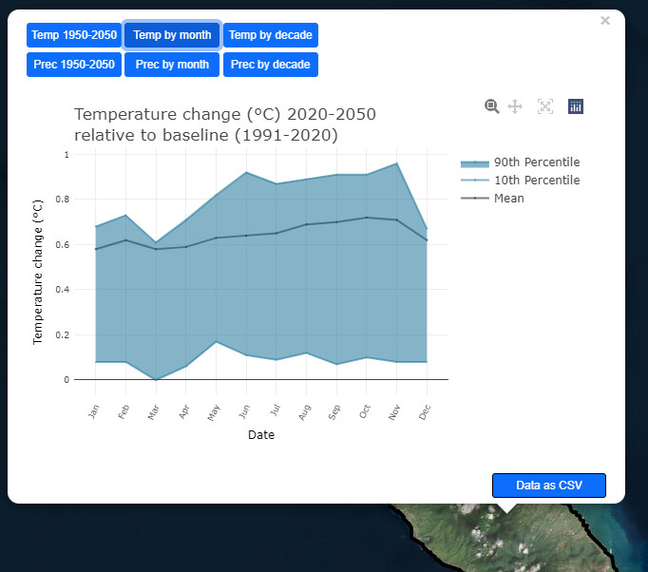
(c) | (d)
Figure 5.3: (a) Projected precipitation change (%) using a multi-model ensemble mean, showing % change from a 30-year baseline period (1991-2020). Shaded areas represent the 10-90th percentile range. (b) Annual cycle of projected precipitation % change based on the 1991-2020 baseline. The % of change for each month represents the difference between the monthly average rainfall during the baseline period and the monthly average rainfall during the long-term projected period. Shaded areas represent the 10-90th percentile range. (c,d) Same calculations for temperature, but results are shown in absolute values instead of % change.

The webtool also visualises the monthly average change of rainfall and temperature, for each decade, relative to the baseline period (1991-2020), as shown in Figure 5.4.

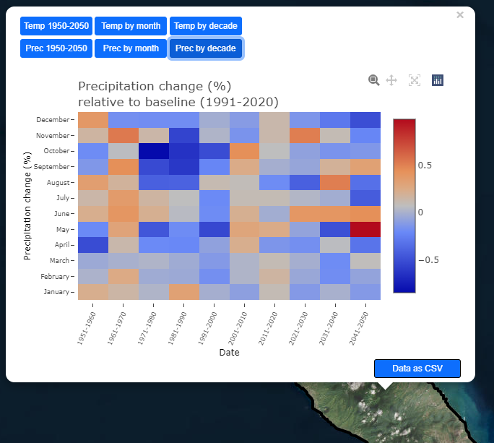 | 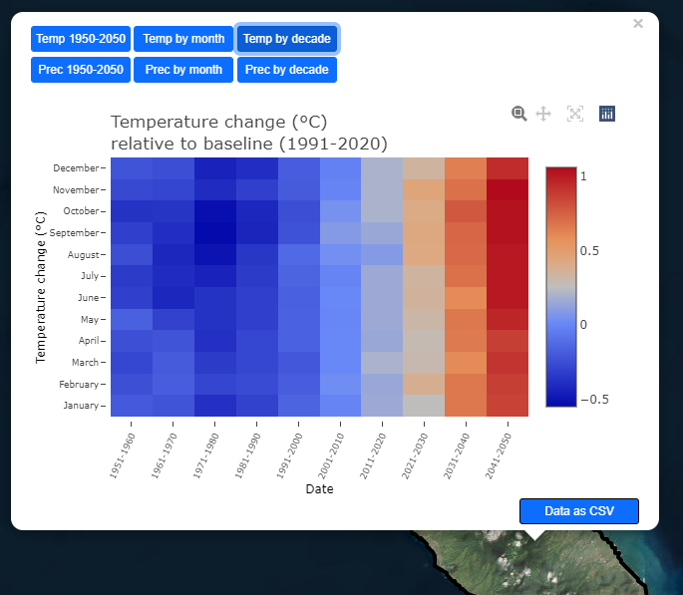
(a) | (b)
Figure 5.4: (a) Monthly rainfall % change for each decade, relative to the baseline period (1991-2020) ; (b) Monthly average temperature change (C) for each decade, relative to the baseline period (1991-2020).

Administration the System

Terms and Conditions
HR Wallingford make no representations, warranties or undertakings about any of the information provided on this website including, without limitation, its accuracy, completeness or quality or fitness for any particular purpose. All data available on this website are provided on a best efforts basis – HR Wallingford will endeavour to maintain data availability, but do not guarantee continuity of services. It is the responsibility of the user to ensure that the data, if used, are accurate and fit for purpose. To the fullest extent permitted by applicable law, HR Wallingford will not be liable for any loss or damage howsoever arising from the use or interpretation of the data.
The webtool uses cookies. Cookies are small text files that are placed on the user’s device (computer or mobile phone) by websites that they visit. We use Google Analytics cookies to collect information about how visitors use our site. We use the information to compile reports and to help us improve the site. The cookies collect information in an anonymous form, including the number of visitors to the site, where visitors have come to the site from and the pages they visited.
This Licence is created on the date that the tool, provided for you to use on this website and described below, is used by you and will endure for the time (session) that you use the tool, terminating immediately after each use. If you use the tool again, you will be asked to accept this licence again for the new session. The tool Owners (as they are defined below) may update the tool at any time or remove the use of the tool. The tool is in development at the present time and your attention is drawn to the disclaimers in this licence regarding its functionality and any reliance you may be considering placing on the results of the use of the tool.
In this licence the word “tool” refers to the functionality presented by the St Kitts and Nevis drought forecasting tool.
The Owners means the people who own the intellectual property rights in the tool who are HR Wallingford. In addition some people have provided data which is used in the tool. These data owners are space, meteorological and other government agencies in Europe, the USA and St Kitts and Nevis and they are also licencing your use of the data when you use the tool. These data owners are also included within the definition of the word “Owners” but if they are using the tool on the website they will also be subject to these licence terms for each use of the tool.
You agree with the Owners that:
- You are licenced to use the tool for free for the period described above.
- You may use the tool for the purpose of predicting dengue fever and / or water availability at your discretion but only subject to the exclusions of liability in this licence and the disclaimer on the website. The tool is under development and the Owners have no control over your use of it. Therefore the Owners have no responsibility for your use of the tool or its results.
- You may not assign, transfer, delegate or sell in any way the rights under this licence and they are personal to you only.
- The tool is the property of the Owners. All rights of ownership, copyright, trademarks and knowhow in the tool or the data within it (as appropriate) remain with the Owners.
- The Owners do not guarantee or warrant that the tool is free from errors or will meet your requirements or that the results will be correct. You use the tool at your risk. To the full extent permitted by law you agree that the Owners will not be liable to you or to any third party to whom you supply the results of the tool for any direct or indirect damage howsoever this arises even where the Owners are aware of the possibility of such damage. The Owners will also not be liable to you if the tool is not capable of being used for any reason.

Who to contact
For any queries about the St Kitts and Nevis drought forecasting tool, please contact:

Dr Gina Tsarouchi
Principal Engineer, Flood and Water Management
G.Tsarouchi@hrwallingford.com
T +44 1491 822412

Closing remarks
Climate change and variability pose challenges to the water sector of Saint Kitts and Nevis (SKN). The recent push towards an agricultural and tourism-based economy places a greater demand on already stressed water resources. Identifying areas and vulnerable groups most susceptible to water supply shortages is crucial to facilitate early action to manage risks.
By providing timely information in advance of, or during the early onset of a drought, action can be taken to reduce potential impacts. In doing so, the SKN drought forecasting tool will help to increase resilience in the water sector of SKN.
The tool can provide stakeholders with information that will improve their ability to plan in advance for managing water shortages in the areas most at risk.
In the long term, all households including vulnerable persons will benefit from improved water supply systems and planning tools for climate change adaptation through:
- Better access to water and improved water supply systems
- Sustainable water delivery to communities: with more informed planning, water rationing can be avoided and a more effective supply structure put in place.
In the future, the system could be enhanced by incorporating additional water-sector data from SKN, additional freely available satellite data and guidance on actions to be taken, depending on different levels of drought warning.

  © HR Wallingford Ltd | We design smarter, more  resilient solutions across  both the natural and built  environment to help  everyone live and work more  sustainably with water.
HR Wallingford Ltd, Howbery Park, Wallingford, Oxfordshire OX10 8BA, United Kingdom
tel +44 (0)1491 835381, email info@hrwallingford.com
www.hrwallingford.com

Source: https://www.bbc.com/future/article/20220525-how-scientists-predict-famine-before-it-hits#:~:text=act%20on%20time.-,Early%20warning%20systems%20are%20now%20good%20at%20warning%20about%20an,%2C%20it%27s%20far%20too%20late.%22
McKee, T.B., N.J. Doesken, and J. Kleist, 1993. The Relationship of Drought Frequency and Duration to Time Scales. Eighth Conference on Applied Climatology, American Meteorological Society, Jan 17-23, 1993, Anaheim CA, pp. 179-186
Liang, X., D. P. Lettenmaier, E. F. Wood, and S. J. Burges (1994), A simple hydrologically based model of land surface water and energy fluxes for general circulation models, J. Geophys. Res., 99(D7), 14415–14428, doi:10.1029/94JD00483.
Hamman, J. J., Nijssen, B., Bohn, T. J., Gergel, D. R., and Mao, Y.: The Variable Infiltration Capacity model version 5 (VIC-5): infrastructure improvements for new applications and reproducibility, Geosci. Model Dev., 11, 3481-3496, https://doi.org/10.5194/gmd-11-3481-2018, 2018.
Scheidegger, J.M.; Jackson, C.R.; Muddu, S.; Tomer, S.K.; Filgueira, R. Integration of 2D Lateral Groundwater Flow into the Variable Infiltration Capacity (VIC) Model and Effects on Simulated Fluxes for Different Grid Resolutions and Aquifer Diffusivities. Water 2021, 13, 663. https://doi.org/10.3390/w13050663
Hamman, J.J.; Nijssen, B.; Bohn, T.J.; Gergel, D.R.; Mao, Y.X. The Variable Infiltration Capacity model version 5 (VIC-5): Infrastructure improvements for new applications and reproducibility. Geosci. Model. Dev. 2018, 11, 3481–3496.
Wood, E.F.; Lettenmaier, D.P.; Zartarian, V.G. A land-surface hydrology parameterization with subgrid variability for general circulation models. J. Geophys. Res. 1992, 97, 2717–2728.
Gao, H.; Tang, Q.; Shi, X.; Zhu, C.; Bohn, T.J.; Su, F.; Sheffield, J.; Pan, M.; Lettenmaier, D.P.; Wood, E.F. Water Budget Record from Variable Infiltration Capacity (VIC) Model. Algorithm Theor. Basis Doc. Terr. Water Cycle Data Rec. 2010.
Franchini, M.; Pacciani, M. Comparative analysis of several conceptual rainfall-runoff models. J. Hydrol. 1991, 122, 161–219.
Lohmann, D.; Nolte-Holube, R.; Raschke, E. A large-scale horizontal routing model to be coupled to land surface parametrization schemes. Tellusseries A: Dyn. Meteorol. Oceanogr. 1996, 48, 708–721.
Tomer, S.; Muddu, S.S.; Mehta, V.K.; Yegina, S.; Thiyaku, S. Package ‘ambhasGW’. Available online: https://cran.r-project.org/web/packages/ambhasGW/index.html
CMIP6 - Coupled Model Intercomparison Project Phase 6. World Climate Research Program, Working Group on Coupled Modelling (WGCM) see https://www.wcrp-climate.org/wgcm-cmip and https://pcmdi.llnl.gov/CMIP6/.

