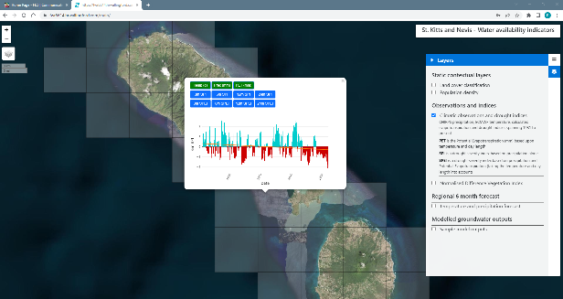
St. Kitts and Nevis - Water availability indicators: Drought indices and groundwater modelling
Using a web browser, preferably google chrome, please go to the following web address and login with the details below:

https://fwr6614.hrwallingford.com/main/ u: demouser p: stK1tt5

User evaluation and feedback document
This document is for users who are testing the application to provide feedback on their experience and make suggestions on ways the system might be improved to meet their needs.

Your name:

Your job description:

Your employer:

Please answer these questions as completely as possible
Date of testing and feedback:
(When is the testing taking place?)

Location of testing:
(Where is the testing being carried out, what is the address?)

Type of device used for testing:
(Are you using a tablet, phone or laptop to access the application? What is the make and model of the device if known?)

Type of internet connection used:
(are you using a mobile connection or a wifi hotspot? Who is the network provider?)

Specific feedback on datasets and their display

Please underline or highlight the number that best reflects your experience, and add your suggestions in the box provided.

Feedback on: Static contextual layers

Parish boundaries:
How fast did this dataset load? fast ☐ ☐ ☐ ☐ ☐ slow
How easy was this dataset to use? easy ☐ ☐ ☐ ☐ ☐ difficult
How easy was this dataset to understand? easy ☐ ☐ ☐ ☐ ☐ difficult
How useful is this dataset to your needs? very useful ☐ ☐ ☐ ☐ ☐ not useful

Do you have any specific suggestions for improvements to the display/delivery of this dataset:

Population density:
How fast did this dataset load? fast ☐ ☐ ☐ ☐ ☐ slow
How easy was this dataset to use? easy ☐ ☐ ☐ ☐ ☐ difficult
How easy was this dataset to understand? easy ☐ ☐ ☐ ☐ ☐ difficult
How useful is this dataset to your needs? very useful ☐ ☐ ☐ ☐ ☐ not useful

Do you have any specific suggestions for improvements to the display/delivery of this dataset:

Land cover:
How fast did this dataset load? fast ☐ ☐ ☐ ☐ ☐ slow
How easy was this dataset to use? easy ☐ ☐ ☐ ☐ ☐ difficult
How easy was this dataset to understand? easy ☐ ☐ ☐ ☐ ☐ difficult
How useful is this dataset to your needs? very useful ☐ ☐ ☐ ☐ ☐ not useful

Do you have any specific suggestions for improvements to the display/delivery of this dataset:

Feedback on: Climatic observations

Observations (Temperature, Precipitation, Potential Evapotranspiration):
How fast did these datasets load? fast ☐ ☐ ☐ ☐ ☐ slow
How easy were they to use? easy ☐ ☐ ☐ ☐ ☐ difficult
How easy were they to understand? easy ☐ ☐ ☐ ☐ ☐ difficult
How useful are they to your needs? very useful ☐ ☐ ☐ ☐ ☐ not useful

Do you have any specific suggestions for improvements to the display/delivery of these datasets:

Feedback on: Drought severity indicators

Drought indices (SPI, SPEI):
How fast did these datasets load? fast ☐ ☐ ☐ ☐ ☐ slow
How easy were they to use? easy ☐ ☐ ☐ ☐ ☐ difficult
How easy were they to understand? easy ☐ ☐ ☐ ☐ ☐ difficult
How useful are they to your needs? very useful ☐ ☐ ☐ ☐ ☐ not useful

Do you have any specific suggestions for improvements to the display/delivery of these datasets:

Vegetation stress indices:
How fast did this dataset load? fast ☐ ☐ ☐ ☐ ☐ slow
How easy was this dataset to use? easy ☐ ☐ ☐ ☐ ☐ difficult
How easy was this dataset to understand? easy ☐ ☐ ☐ ☐ ☐ difficult
How useful is this dataset to your needs? very useful ☐ ☐ ☐ ☐ ☐ not useful

Do you have any specific suggestions for improvements to the display/delivery of this dataset:

Feedback on: Regional 6 month forecast:

Forecasted (Temperature, Precipitation):
How fast did these datasets load? fast ☐ ☐ ☐ ☐ ☐ slow
How easy were they to use? easy ☐ ☐ ☐ ☐ ☐ difficult
How easy were they to understand? easy ☐ ☐ ☐ ☐ ☐ difficult
How useful are they to your needs? very useful ☐ ☐ ☐ ☐ ☐ not useful

Do you have any specific suggestions for improvements to the display/delivery of these datasets:

Feedback on: Modelled groundwater outputs:

Modelled (Baseflow, Evaporation, Surface runoff, Soil moisture):
How fast did these datasets load? fast ☐ ☐ ☐ ☐ ☐ slow
How easy were they to use? easy ☐ ☐ ☐ ☐ ☐ difficult
How easy were they to understand? easy ☐ ☐ ☐ ☐ ☐ difficult
How useful are they to your needs? very useful ☐ ☐ ☐ ☐ ☐ not useful

Do you have any specific suggestions for improvements to the display/delivery of these datasets:

Feedback on: Visualisation of current data compared to historical data:
Below are two ways that we can visualise how the latest data compares to historical data.
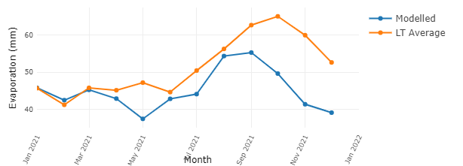

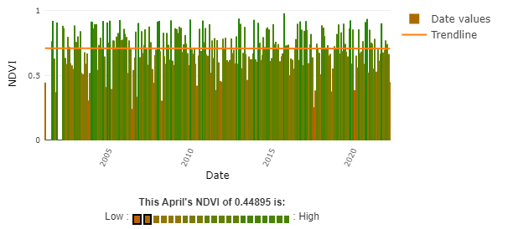

Which of these graphs do you feel is more useful in determining how recent data compares to historical data?

Feedback on: Grouping of data that shares the same grid and timespan:
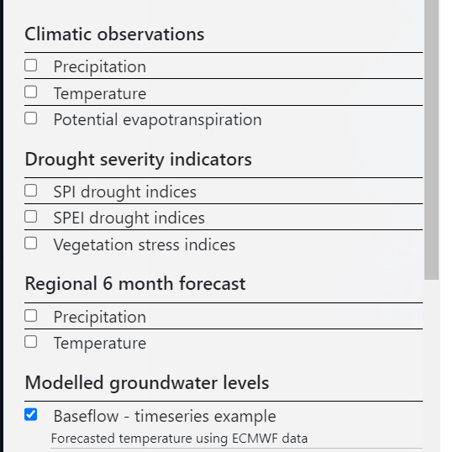
Datasets are grouped in the right hand navigation pane (Static contextual layers, Climatic observations, Drought severity indicators, Regional forecast, modelled groundwater results).

In most cases these grouped results share the same grid layout that is displayed on the map when that layer is selected.

Once you have clicked on a grid at a specific location, it is possible to be able to skip between other related graphs and charts related to this location, as shown in the blue buttons below:

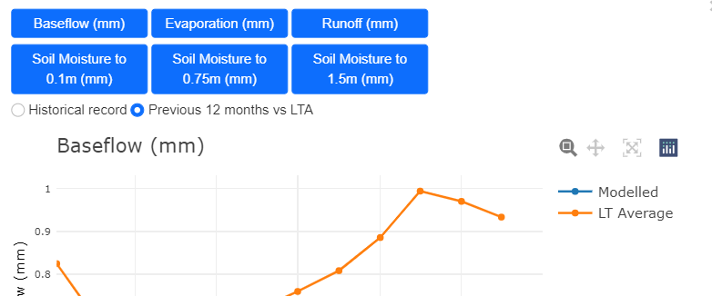

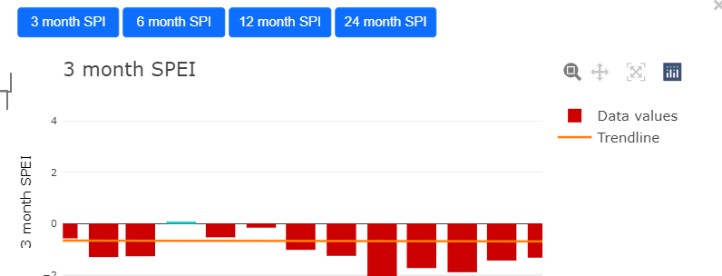

How useful is being able to skip between these related graphs for the same location using the blue buttons?

very useful ☐ ☐ ☐ ☐ ☐ not useful

Would you prefer to list all these variables separately in the right hand menu?

Feedback on: Visualisation of time series coverages:
Below is a screengrab of the timeseries of coverages aimed at informing users of Modelled Groundwater Levels. Please visit this section of the web app and answer the questions below.

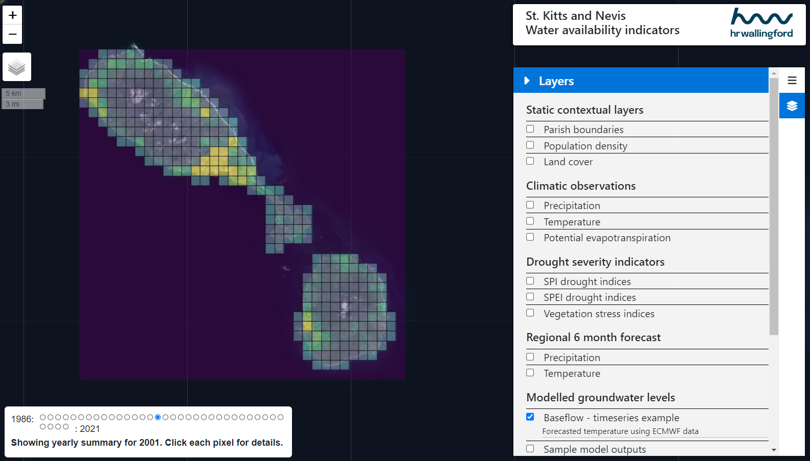
Are these separate yearly gridded coverages useful on their own?

Would a different colour scheme be preferable? Which colours?

On the graphs that popup onclick in a grid cell, which of the below would be your preferred initial view?

The full historical record of data: The last 12 months vs the Long term average:

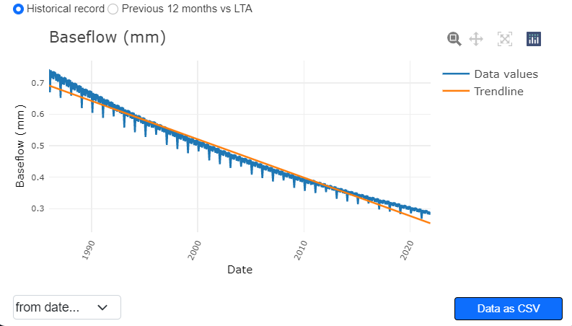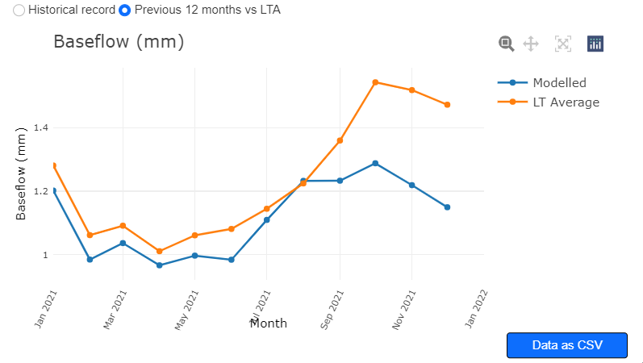

General feedback on the application design and function

Connectivity and load time:
(How long did the application take to load? What about the individual datasets and graphs? Do you consider this a useable and acceptable load time?)

Serious problems encountered:
(Did you encounter any serious problems that stopped you from using the application? Please describe these.)

General feedback or suggestions:
(Do you have any general feedback or suggestions on how to improve the application, its design or delivery?)

