TNO report

TNO 2022 P10363
Development of a waste stream-specific roadmap for the circular economy of Zambia

Sub report Output 4
Circularity analysis of the prioritized waste stream
Date | 21 April 2022
Author(s) | Naomi Montenegro Navarro  Chandi Mutubuki-Makuyana  Milou Derks  Andrew Chinyepe  Paul van den Oosterkamp  Raymond Obare Ombega  Ebenezer Alenga Amadi  Dennis Kiplagat

Number of pages | 39 (incl. appendices)
Number of appendices
Sponsor
Project name | CTCN Technical Assistance
Project number

All rights reserved.
No part of this publication may be reproduced and/or published by print, photoprint, microfilm or any other means without the previous written consent of TNO.

In case this report was drafted on instructions, the rights and obligations of contracting parties are subject to either the General Terms and Conditions for commissions to TNO, or the relevant agreement concluded between the contracting parties. Submitting the report for inspection to parties who have a direct interest is permitted.

© 2022 TNO

Contents
Executive Summary 1
1 Introduction 3
2 Technology pathways (activity 4.1) 4
2.1 Introduction 4
2.2 Plastics and end-of-life plastic management basics 6
2.3 The basics of plastic 8
2.4 Recycling pathways 10
2.5 Current application of end-of-life plastic management in Zambia 13
2.6 Economics of end-of-life plastic management 16
2.7 Impacts of end-of-life plastic management 17
3 Policy landscape (activity 4.1) 20
3.1 Introduction 20
3.2 The global perspective on policy framework and circular economy in the waste sector 21
3.3 Structure of the legal and policy landscape for waste management in Zambia 22
3.4 Policies and laws that enable circularity of plastic waste in Zambia 23
3.5 Findings from policy waste management documents 25
3.6 Summary of the gaps identified by interviewed companies in the waste sector 27
3.7 Synthesis 30
4 Market and value chain analysis (activity 4.2) 32
4.1 Organization of the current value chain 32
4.2 Current market status 35
5 Summary of gaps identified 38
5.1 Gaps within the technology landscape in Zambia 38
5.2 Key conclusions and gaps in the current policy landscape 38
5.3 Key gaps within the current markets and value chains 39
5.4 Conclusion on the relevance of the different pathways for Zambia 39

Executive Summary
In this activity technical, policy and market options and potential for circular handling of the prioritized waste stream, plastic waste, are analyzed.

Technological pathways
The circular economy aims to design out and eliminate waste and pollution, circulate resources at their highest possible value and to regenerate nature. Especially low income households often reuse their plastic products till the point it is not usable anymore and thus becomes waste. Therefore, a crucial area for development is recycling. Different techniques ranging from manually to completely mechanical are available for this. An important first step is the separation of the plastics, on polymer type and colour, which can take place at different locations, e.g. household level, landfills or waste transfer stations. It is an option to export these separated plastics (e.g. to South Africa), however, to generate more value for the Zambia itself it is preferred to further treat the plastics in the country. The next steps for this are cleaning and sizing, through shredding/flaking. After this the plastics can be converted in four different ways: (1) open loop recycling (into other product, downcycling), (2) closed loop recycling (plastics are recycled into the same product), (3) feedstock and (4) plastic to energy.

All these pathways come with some pros and con. The exact costs of plastic waste recycling depend on the activities that are executed. Yet it is important to note that for any waste management system, collection and transportation costs are a key component to the total operational costs. Besides financial aspects, environmental and social impacts are important to consider. Currently, mainly open loop recycling takes place in Zambia. However, the key technological gaps do not come from a lack of existing technology, but from the fact that there is little domestic development of recycling technologies, nor little domestic availability of spare parts. This means that recyclers are dependent on expensive imports of (parts of) equipment.

Policy landscape
Several policies and regulations are in place that directly or indirectly address waste management and circular economy in Zambia. On paper, Zambia’s policies are adequate and in line with circular economy principles for the waste sector. The problem is that stakeholder consultation showed that there exists serious gaps in practical implementation. Additionally, most instruments to stimulate domestic recycling are hardly in place. There are no financial incentives nor support for the waste valorization sector. There is an EPR policy in place, which is considered an important step in plastic waste valorization. However, there is no operationalization plan of the EPR policy as of yet.

Market and value chain analysis
Plastic household valorisation is just emerging in Zambia and therefore, although there are some players, this group is still relatively limited. The value chain currently consists roughly of five roles: (1) sources from where households by their plastic or plastic packaged products, (2) households themselves, who use, reuse, and discarded the product, (3) collection mechanisms, done by public or provide organizations and either separated or mixed, (4) the disposal mechanisms; littering, illegal dumping, controlled dumpsites and (5) waste valorisation; (in)formal waste pickers, aggregators, waste transfer stations, buy back centers, recyclers, processers or export industry. Currently, there is hardly any separation at source, which makes it very difficult to get sufficient volumes for waste valorisation, since separation at a later stage is difficult due to contamination. Thus, better separation, collection and transport logistics are essential to scale the market for plastic processing within Zambia. Various pathways for separating and collecting waste are implemented in Zambia or emerging in Africa.
The main challenges identified based on this assessment are: (1) getting sufficient volumes in an economic manner, and (2) low margins on recycled plastic products.This leads to the gap which is a vicious circle where collection infrastructure (e.g. separation, waste pickers, collection) does not scale due to low prices and difficulty in economy of scale, and recycling industry not getting sufficient volumes in an economic manner meaning they cannot pay collection infrastructure more for delivering plastics.

Introduction
This document is the deliverable of Activity 4 of the CTCN Technical Assistance study on circular economy in waste management in Zambia. During this study, a baseline assessment for the current waste system was conducted, looking at plastics, paper, metal, glass, household organic waste and (small scale) agricultural waste. This was followed by a comparative analysis per waste stream on the potential to move towards higher levels of circularity. After a physical stakeholder consultation in Lusaka, October 2021 the choice was made to focus on plastic waste for the remainder of the project. Following this specification, a more detailed analysis was conducted on the current status of the plastic waste management system in Zambia, looking at technology use, the policy and regulatory landscape and current markets and value chains on plastic (waste) management. The results of this assessment are presented in the following chapters.

Technology pathways (activity 4.1)

Introduction
The main purpose of this project is the development of a specific roadmap for circularity within household plastic waste management. An important aspect is to generate knowledge on what the potential technological pathways are for the valorisation of plastic waste. This will be elaborated on in section 2.2 and 2.4. Before we discuss the pathways, it is important to briefly discuss the options for circularity of plastics before it has become waste, as the project explicitly defines circularity as a focus point – and circularity involves much more than waste management only.

The circular economy is based on a set of key principles:

- To design out and eliminate waste and pollution
- To keep resources, products and materials at their highest value possible by circulating them
- To regenerate nature

The key principles of the circular economy confirm that it is much broader than waste management only, and that it provides a systemic view to economic redesign. Hence, also in this publication, it is important to not only look at how to manage plastic waste, but also to pay attention to how to avoid waste in the first place, as well as how to retain the value of products and materials that have been put on the market, extending the lifespan to its maximum duration before it becomes waste.

To achieve circularity, various activities are defined as key strategies to give shape to the circular economy. These strategies range from often 3 to 10 so-called R-activities. The following figure gives a synthesis of 7 of the most important R-activities, based on the EllenMacArthur Foundation, among others:

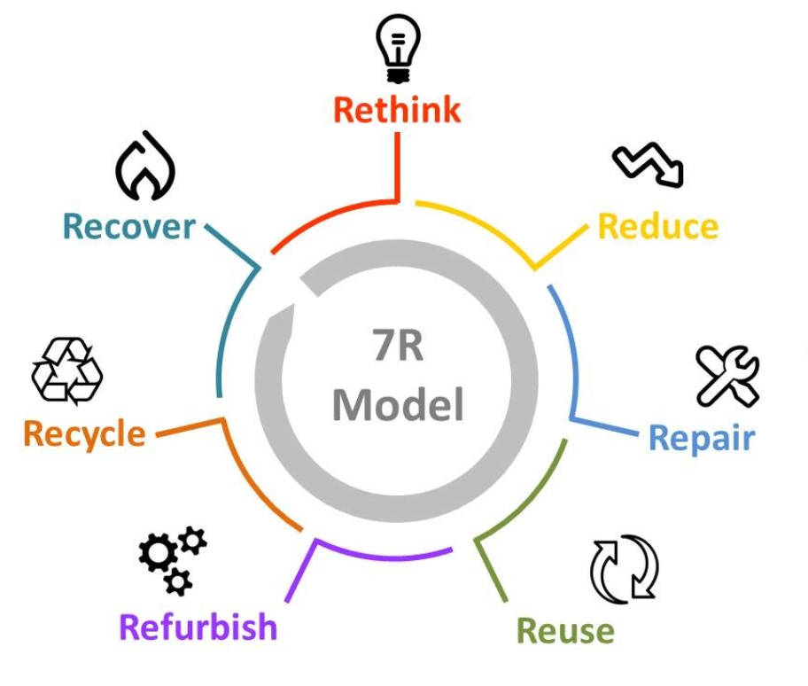
Figure 1. The 7 R's of circularity

When linking this figure to plastics, several strategies from the circularity model come to the fore. It starts with regarding the upstream phases of plastics, rethinking and reducing the total amount of plastics that come into the value chain in the first place - reducing the total amount of waste that is being generated. Examples are the rethinking how products are designed – allowing for improved recycling, or reducing the amount of plastics that come into the market place by limiting the amount of single use plastics. The strategies of repair (fixing a fault) as well as refurbishment (repairing and upgrading a product until (close to) new) are a bit less applicable to household plastics, as these are generally not very well repairable (this applies more to electronics for example, or textiles). Yet one could imagine that in the case of industrial application of plastics (e.g. in aircrafts) timely repair becomes critical to expand the lifespan of products. Reusing plastics is something that can already be seen in Zambia, particularly in the lower income households. Buckets, bottles, and other usable products are reused frequently, both in their same function or with a different function. Reuse of plastic household products however is seen to decrease with rising income levels (see the baseline study to this project).

The least preferable strategy for plastic waste management is recovery, which involves the recovery of the energy content for plastics by converting it into e.g. new hydrocarbons, monomers or fuel, or, scoring lower in terms of circularity, recovery of energy by incineration. This latter is least preferred as this means the plastics is burned with treatment, so there is no circularity achieved (which is aimed at maintaining products or resources in use at the highest value possible.

Thus, instead of recovery the key strategy for plastic once it has become waste is recycling. This strategy will be elaborated on the remainder of this Chapter.

Plastics and end-of-life plastic management basics
There are multiple pathways towards the valorisation of plastic waste. These variations are summarized in Figure 2 below. The figure discusses the flows from input, to processing activities and the variations to outputs.

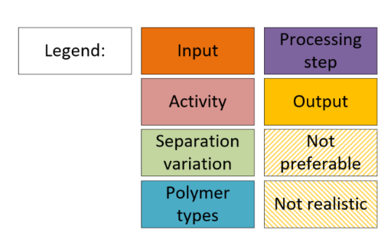
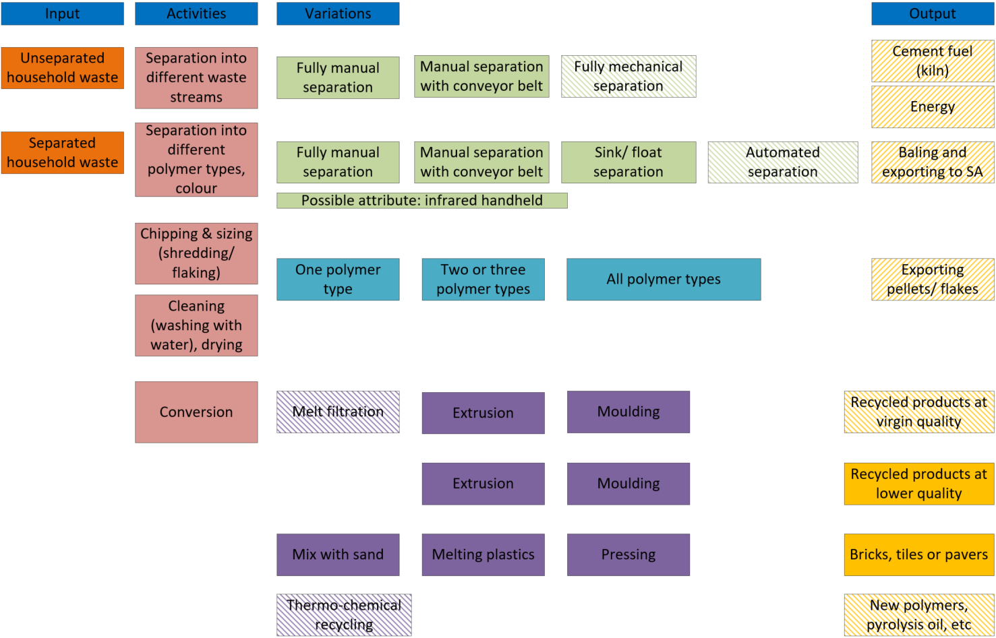

Figure 2. Schematic overview of the pathways and variations to plastic waste valorisation (own scheme)

Waste can be provided in two ways: either the plastics are mixed in the residual waste, or it has already been separated at source by households themselves.
If it is unseparated, the first activity is to separate the plastics from the mixed waste. This can be done in various ways as well: fully manually, as is happening at some waste transfer stations for example, or as currently informal waste pickers are doing at the dumps. Another option is to include one mechanical step, by using a conveyor belt. This allows for easier picking and improved labour conditions. Of course, fully mechanical separation is technically an option as well, however as these kinds of installations would require major investments, this is not included within the scope of this study as this is not deemed realistic for Zambia in the foreseeable future.

Of course, the plastics could also be provided to a processer already separated at source, or separated by a Waste Transfer Station. In that case, the next step in the treatment process is to separate the plastics into various polymer types, and into different colours. This is because it is generally not possible to recycle plastics in a sufficient quality when different polymers are mixed together. Although some types can be combined, it is safe to assume it is required to include this separation step. This can be done fully manually, or by using a conveyor belt. For manual separation, infrared handhelds can be used to support with the selection of plastics that are difficult to determine, but generally, working with trained staff is faster than supplying everybody with a handheld. Another mechanical separation option that is used frequently in e.g. Europe are sink/float installations, which separates plastics based on the differences in density. PET will sink, while the PE/ PP plastics types float. Full scale and professional sink float systems these are generally quite large installations (4-6 meters at least) which require substantial investment costs, so this is not very realistic in the near future in Zambia. However, it is possible to use more rudimentary sink float separation using salt water basins. Yet, just making use of manual separation is very effective as well, and allows for job creation too.

After this step, it is possible to market the first output, which entails the recovery of energy through the incineration of plastics. This can be done by conventional incineration, after which the energy is converted to electricity, or by using the plastic waste as a feedstock for cement kilns. This reduces the amount of fossil fuels that the cement kilns would need to use, thus positively impacting emission reductions in Zambia (although cement production is limited). However, using the plastics as energy source or kiln fuel would once again mean the product is burned and no life is extended – so in essence this is not circular and should not be pursued as a primary strategy. It could however be an option for those plastics for which no market exists yet.

In addition, after separation into different types of plastics it is also possible to compress and bale the separated polymer types and export this to e.g. South Africa, where a broader range of recycling industries exist. However, this would mean that no value adding activities are done within the country of Zambia itself and (economic and material) value are exported out of the country, so this is not a preferred direction for this project.

After separation into different polymer types, the usual next activity entails the sizing of the polymers by shredding/ flaking the plastics and cleaning them. These steps could also be reversed. After cleaning and sizing the plastics are dried and ready for conversion, in other words the actual recycling. Roughly, plastics can be converted in four different ways: through closed loop recycling (plastic products are recycled into the same product or applications with requiring materials with similar qualities), open loop recycling (plastic are downcycled into a different product, often tick walled products of lower quality), feedstock or thermo-chemical recycling (which breaks down the plastics into monomers or other hydrocarbon products). There are multiple routes clustered under the umbrella of chemical recycling, for example depolymerisation, hydrolysis and pyrolysis.
The last conversion strategy is plastic to energy, often through incineration (described above). The mechanical recycling steps (open and closed loop) usually use an extruder (melting and converting the plastics into pellets or granules) and a mould (blow or injection moulds), to make the desired end product. Another open loop method of plastic recycling is the mixing with sand into bricks or pavers. This can be done with mixed plastics, or those plastics that are not suitable for mechanical recycling. Closed loop recycling usually asks for high quality cleansing and melt filtration (this depends a bit on the product), thereby increasing the process complexity and costs and reducing the applicability for Zambia (depending on the products, there is some closed loop recycling of woven sacks in Zambia). Thermo-chemical recycling asks for industrial-sized, high energy consuming facilities and are therefore beyond relevance for Zambia in the foreseeable future (these are still in pilot scales in Europe as well).
The above provided insights provide a brief summary of the key pathways for plastic waste valorisation. The different elements as have been discussed here will be elaborated on in the following sections.

The basics of plastic
Types of polymers
Plastics are defined by their polymer type. There are seven main types of polymers, as can be seen in Figure 3.

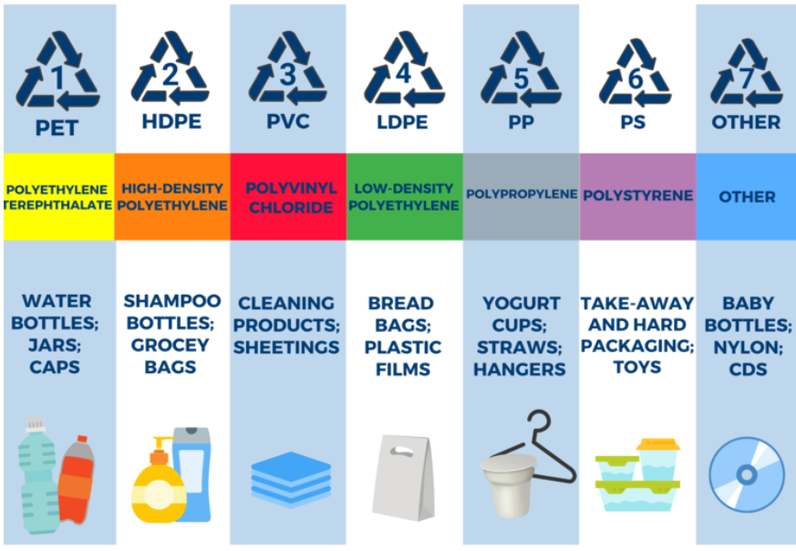
Figure 3. The seven main plastic types (Plastics for Change)

Besides clustering the plastics based on their polymer types it is possible to cluster the types of plastics by their physical characteristics, providing a clustering of three categories: rigid mono-materials, flexible mono-materials and multi-material multi-layers. Rigid mono-materials involve items like buckets, flexibles are thin bags for example, and a common example of multi-layers are crisp bags. The occurrence globally is 33%, 45% and 22% of plastics consumed, respectively (see Figure 4).
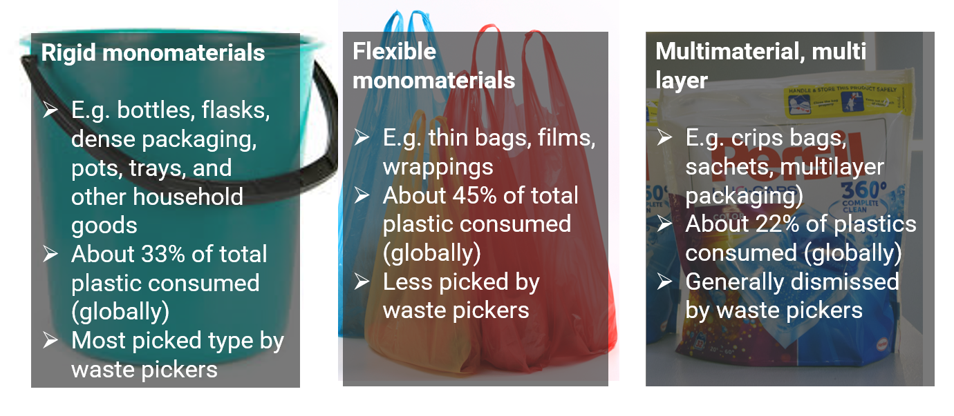
Figure 4. Plastic categories and their occurrence
The attractiveness of the three categories of plastics for waste pickers says something about their recyclability – the easier the recycling, the more recyclers there generally are and the more this category is picked by waste pickers (as it is easier for them to find a taker for the plastics). Rigids (which are very often but not limited to PET, PP, HDPE) are generally easiest to recycle and thus most popular amongst waste pickers, while flexibles (very often but not limited to LDPE) are more difficult to recycle, and multilayers (often combinations of different polymers types, or combinations of polymers with other materials such as paper or aluminium) are currently barely recyclable and thus neglected by waste pickers (this division was also confirmed by waste pickers themselves during the field work). Figure 5 shows the recyclability of plastics per polymer type.
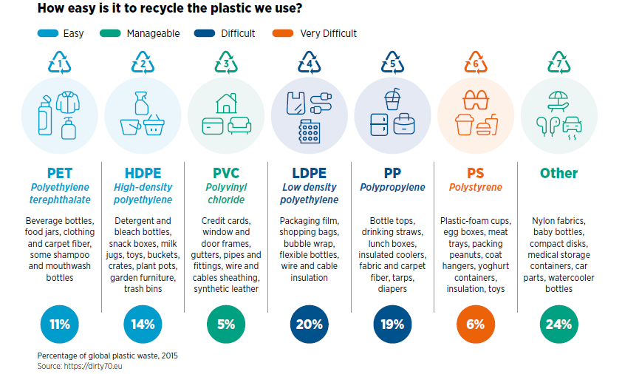

Figure 5. Overview of plastic recycling difficulty, from the 2021 Digital Dividends report (GSMA)

Recycling pathways
As discussed in above, there are four main pathways for the end-of-life treatment of plastics:
(1) closed loop mechanical recycling (primary recycling)
(2) open loop mechanical recycling (secondary recycling)
(3) feedstock or thermo-chemical recycling (tertiary recycling)
(4) plastics to energy or fuel conversion (quaternary recycling)

Figure 6 provides a visual overview of the four pathways and its hierarchy in terms of value retention:
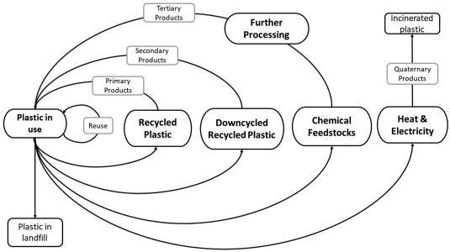
Figure 6. Overview of the four end-of-life plastic pathways (Davidson et. al 2021)

A brief overview of the pros and cons of each pathway is presented in Table 1.
Table 1. Pros and cons per end-of-life pathway
Pathway | Pros | Cons
Closed loop | Highest level of circularity as it keeps polymers intact and the quality at the same level as the original product;  Moderate overall costs;  Larger range or possible applications;  Well-known technologies;  Applicable to a large range of the most used plastic types (LDPE, HDPE, PP, PET, etc) | Requires (compared to open loop recycling) more extensive pre-treatment (= more costly and energy intensive);  Waste must be pure and from a single source;  Recyclate can typically not be used for food grade packaging or performance textiles;  Cannot remove dyes or flame retardants or other contaminants
Open loop | Moderate circularity as it keeps polymers intact but reduces the quality;  Relatively low overall costs;  Useful pathway when higher levels of circularity cannot be achieved;  Could mix certain types of plastics (PE and PP), or plastics and sand to e.g. pavers;  Well-known technologies;  Applicable to a large range of the most used plastic types (LDPE, HDPE, PP, PET, etc) | Reduces the quality of the recyclate (degrades the polymer);  Over-degradation can negatively influence the number of recycling cycles;  Decreases the range of possible applications and potential markets;  Recyclate can typically not be used for food grade packaging or performance textiles;  Cannot remove dyes or flame retardants or other contaminants;
Feedstock | Can be used for recycling of those polymers that are very difficult to recycle mechanically (e.g. PS);  Although the polymers are not kept intact the valuable components can be recovered;  Could provide a solution to multi-layered plastics;  Contaminants can be removed | Only operational (yet not widespread) for PET, rest still in pilot phases;  Economically not viable yet, processes are energy intensive and expensive, with high investment costs;  Requires large and continuous influx of feedstock
Plastic to energy | Suitable for those types of plastics that are not recyclable mechanically or chemically (e.g. containing harmful substances);  Can substitute fossil fuel use by generation of considerable amounts of energy from the plastics;  No costly separation and pre-treatment steps | Environmentally less acceptable due to emission of gases and CO2 through incineration;  Not circular at all as there is no opportunity for further use of the polymer or monomers;  Removes all future potential for reuse or recycling – should not be pursued as primary strategy

Global application of pathways
Figure 7 provides an overview of the status of global plastic waste management in 2013 (open loop recycling is defined as ‘cascading recycling’). It shows that worldwide, the majority of plastics is still not being recycled, but ends up at dumpsites, as litter or is incinerated. Of the percentage that is collected for recycling, the large majority is recycled open loop. Only a minor part is recycled closed loop (mainly applicable to PET, some HDPE). The level of thermo-chemical recycling is neglectable on a global level. Even though almost a decade has passed, not much has improved in terms of the total amount of recycling achieved: in 2022 the OECD indicated that currently still only about 9% of all plastics are recycled properly. The figure is different per region – in Europe for example current recycling levels are at 32,5% of the total collected plastics, with 42,6% going to incineration and almost 25% being landfilled. The recycling percentage mainly indicates mechanical recycling, as only two countries currently employ operational chemical recycling plants (Germany and Italy), and only at minimum levels (<0,3%).

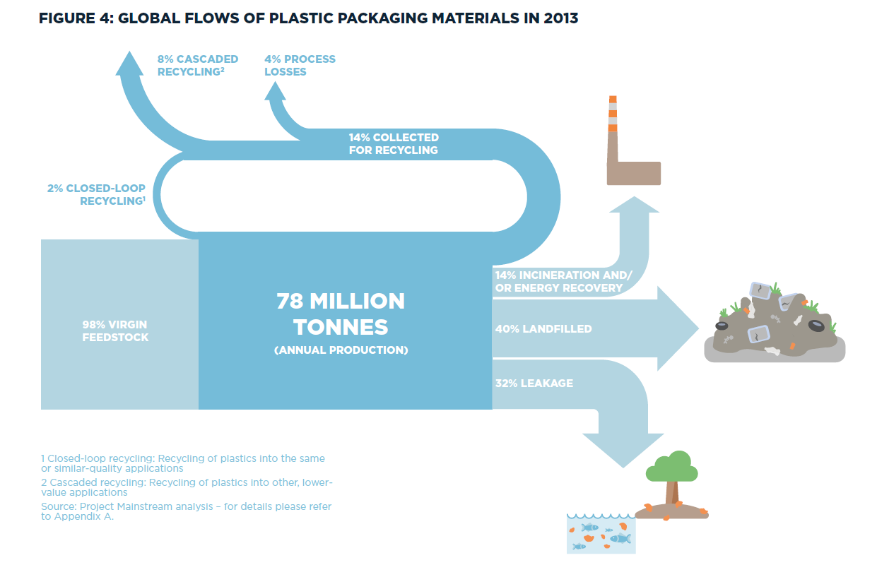
Figure 7. Global flows of plastic packaging materials in 2013 (Ellen MacArthur Foundation, 2016)

Current application of end-of-life plastic management in Zambia
Overall, it can be concluded that the plastic recycling ecosystem in Zambia is currently still in its infancy. Based on estimates by recyclers themselves, not even 5% of the total plastic brought into the Zambian market is currently recycled. This is also due to the fact that there is close to no existing infrastructure for the collection and separation of plastic wastes, so the large majority goes to waste. Given the global status of plastic recycling it is not surprising that the recycling activities that do take place are mechanical recycling; no chemical recycling exists. Based on inquiries with local stakeholders it shows that most recycling activities currently are based on open loop recycling, either into consumer products or by mixing end-of-life plastics with sand into bricks and tiles. There are several larger manufacturers of plastic products who mix virgin materials with recycled content in their production processes. There are also a few parties that work with recycled materials only. The most common plastic category used for recycling is rigid plastics, often HDPE’s (this is similar in neighbouring countries, see Figure 8), LDPE, PP or PET. There is some recycling of flexible plastics as well, but only in Lusaka. In terms of closed loop recycling, there are examples of entrepreneurs creating new woven sacks from old woven sacks. For other products, closed loop recycling is not yet developed. Visits to both formal and illegal dumps show that rigid plastics are scavenged by informal waste pickers, and only thin films and especially multi-layers remain – as there is a much smaller recycling market (see Figure 9). Also PET, which globally has the highest recycled material price, is often disregarded as the Zambian market prices are very low (see Figure 10). There is currently no incineration of plastics, as there are no incinerators for waste at all. As there are also no engineered landfills, the non-recycled plastics are either brought to the formal dumpsites or littered and dumped illegally.
In terms of technology development, there is little production of recycling equipment in Zambia, nor is there little availability of spare parts. This means that for recyclers, when machines break down, this leads to high costs for replacements, as everything has to be imported. Chapter 4 provides a more detailed overview of the current market for plastic recycling in Zambia.

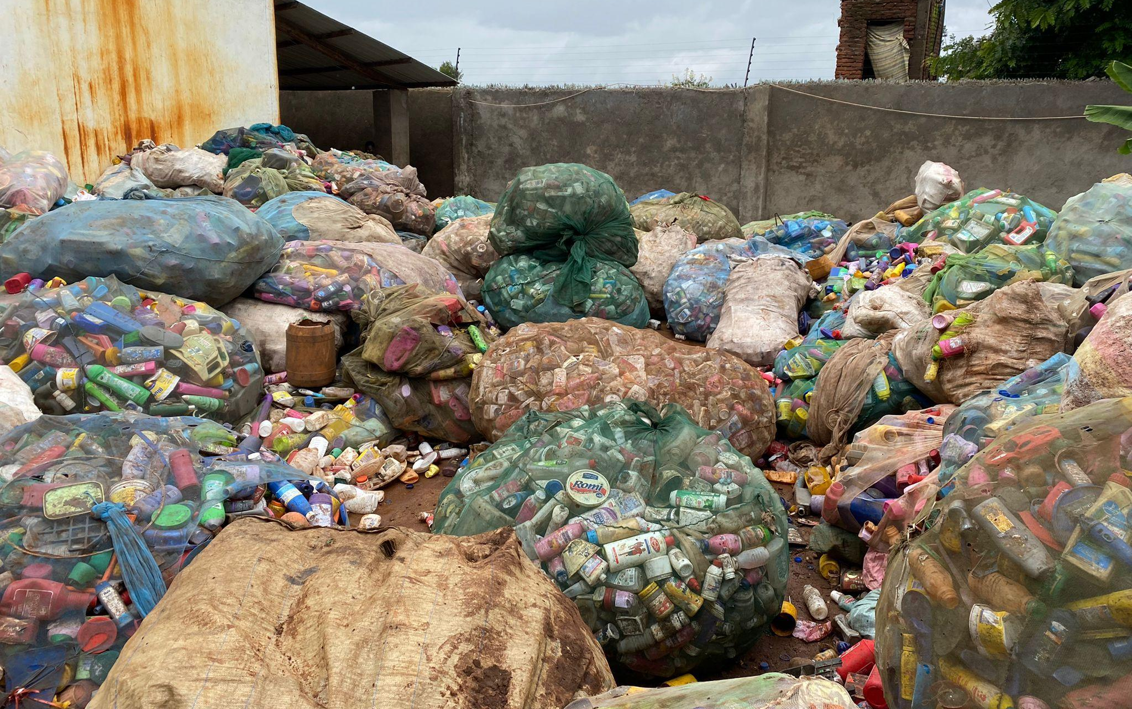
Figure 8. Rigid plastics (mainly HDPE) in 30kg bags at a local plastic manufacturer and recycler in Lusaka, Zambia (own picture)

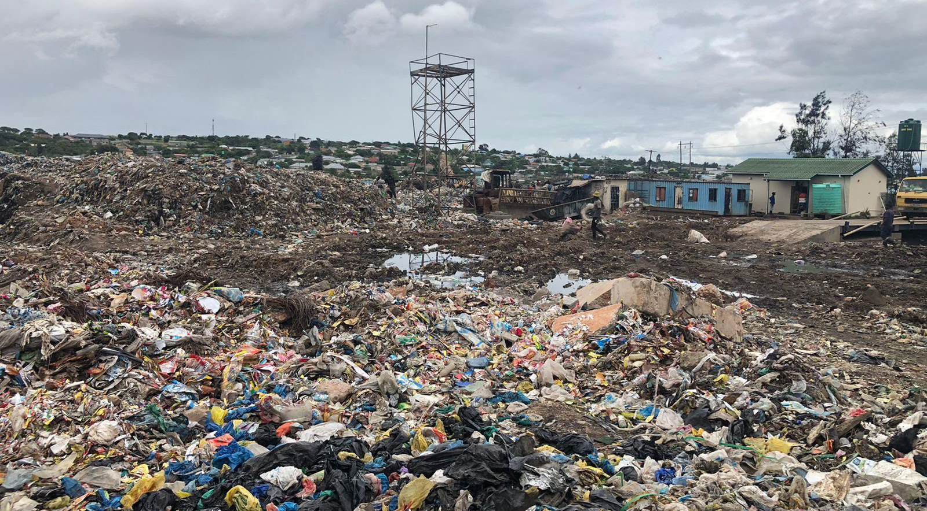
Figure 9. Thin film plastics remaining on Chunga Landfill (own picture)
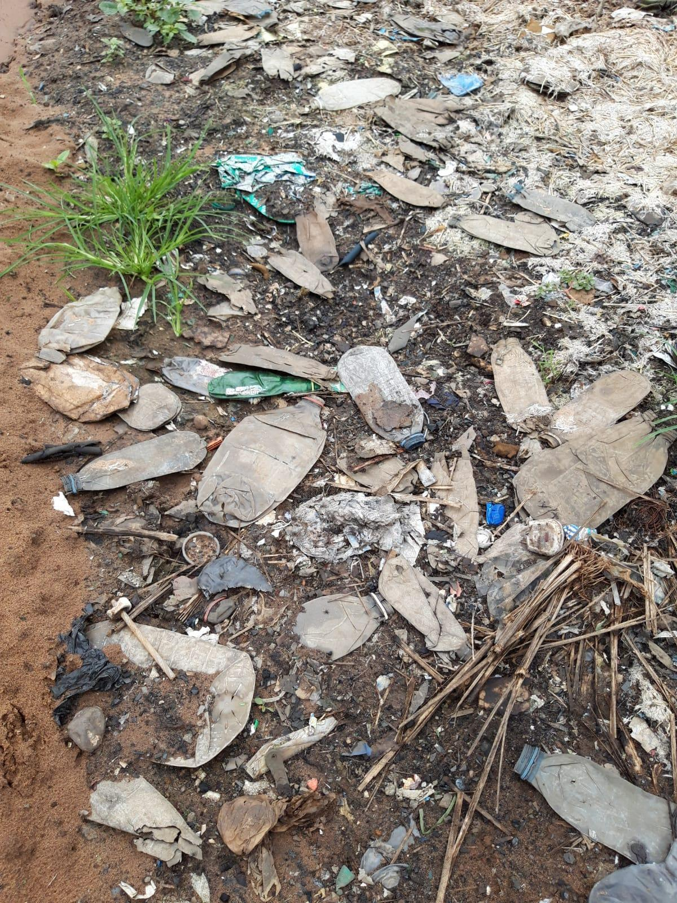
Figure 10. PET bottles left by waste pickers at the formal Livingstone dumpsite (own picture)

Economics of end-of-life plastic management
The exact costs of plastic waste recycling depend on the activities that are executed. Yet it is important to note that for any waste management system, collection and transportation costs are a key component to the total operational costs. According to the What a Waste 2.0 World Bank study of 2018, this typically accounts for 60-70% of total costs for municipal waste management.

Figure 11 gives rough estimates of the typical waste management costs per disposal type. The costs for collection and transportation provide an argument to only opt for separation of dry and wet fractions instead of the separation of multiple fractions – this reduces the overall transport movements needed but increases the recycling potential of household waste (due to less cross contamination of organic waste by dry fractions and vice versa).
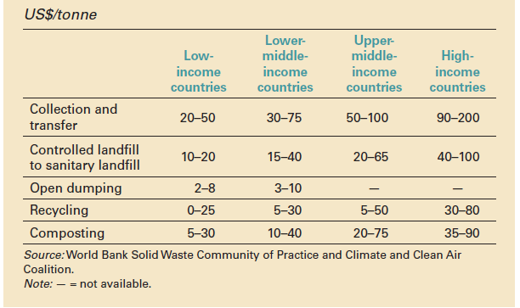
Figure 11. Typical waste management costs by disposal type(US$/tonne) (World Bank, 2018)

When comparing recycling technologies itself, it is safe to assume that closed loop recycling is more expensive in both Capex and Opex than open loop recycling. Overall, in low income countries, closed loop recycling is expected to be about 35% more capital intensive compared to open loop recycling. In terms of revenues however, closed loop recycling is expected to provide best recyclate sales prices (about a factor 0,35 higher) compared to open loop. Chemical recycling is not taken into account, as this is highly capital intensive and not even operational in developed countries either, so not applicable to Zambia.

Impacts of end-of-life plastic management
The economics of recycling are one side of the coin. It is also important to consider the impacts of the potential pathways when comparing alternative end-of-life options. Every activity always has a certain pressure on resources and energy and thus creates impact. Yet, there are differences between the various pathways in terms of their impact scores.

Environmental impact
Overall, mechanical recycling scores much better in environmental impact compared to landfilling and waste to energy. Major contributions to the better environmental impact scores of mechanical recycling comes from the avoidance of virgin materials. Compared to incineration, the impact score improves due to reduction of GHG emissions as well. Also chemical recycling has much better environmental impact scores compared to landfilling, regardless of the energy requirements.

However, the potential impact reduction for mechanical recycling depends on the polymer type and the state-of-the-art in recycling. Figure 12 provides a comparative overview of mechanical recycling versus landfilling and incineration on kg CO2-eq.
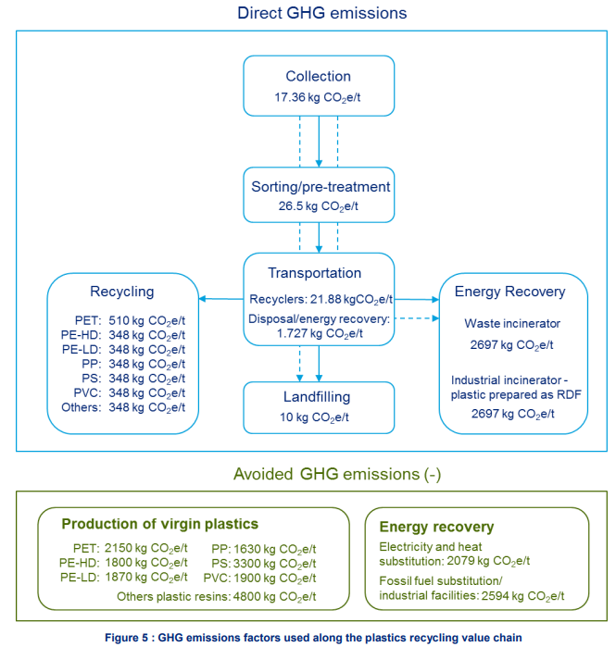
It shows that although mechanical recycling as a process leads to environmental impact, this is easily compensated by the reduction in impacts by avoided virgin production.
Figure SEQ Figure \* ARABIC 12. GHG emissions factors along the plastic recycling value chain (Deloitte, 2021)

Social impact

Although not many studies are available on plastic recycling and social impact, it is possible to estimate the difference per pathway on three social parameters: labour potential, gender equality and working conditions. Labour potential is based on the amount of manual activity involved in the pathway. For chemical recycling, this is assumed to be zero, as this pathway is not realistic in the near future for Zambia. For mechanical recycling, the potential for job creation is mainly based on the level of manual versus automated activities. If all sorting and cleaning steps are done in more rudimentary, manual fashion, the labour potential increases compared to fully automate operations. The gender equality potential is based on the likeliness in the current context of woman participating in the activities. As was found during the study, there are some female entrepreneurs active in the low-tech recycling of plastics in Zambia at this point in time, but the large majority of the recyclers are men. Waste pickers and aggregators are more often women than men. However, the limitations of women to the recycling domain are concluded to be more due to lower education levels and gender bias than any existing physical limitation: thus, there is ample potential to shift this balance. The working conditions are based on human toxicity involved with the activities.
For mechanical recycling, this is mainly based on the amount and type of additives and chemicals that are included in the plastics that are processed. This can differ per type. Risk occurs when it is unknown that certain chemicals are included in the plastics that are processed, leading to ignorance on required safety measures as well as the reintroduction of these chemicals into the value chain by mechanical recycling. Currently, recyclers have very limited ways of knowing what chemicals are contained in the plastics, because there is no transparency nor regulations on communication on this figures. As a result, recycling plants have limited ability to filter out plastics containing harmful compounds. This increases toxicity risks compared to incineration and chemical recycling, which burn or break down the plastics entirely. Nevertheless, for incineration there are additional health risks due to the potential release of toxic substances.

Table 2. Overview of the social impact assessment per pathway (from low (X) to high/ positive (XXXX)
Pathway | Labour potential | Potential for gender equality | Working conditions
Closed loop recycling | XXX | XXX | XX-XXX
Open loop recycling | XXX | XXX | XX-XXX
Feedstock recycling | - | - | XXX
Plastic to energy | X | XX | X-XX

Policy landscape (activity 4.1)

Introduction
From the circular economy (CE) perspective, this chapter analyses Zambia's policies, laws, and regulations on the priority waste stream (plastics). As a result, the study investigates how policies aim to stimulate the valorisation of plastic waste and goods produced from it in the economy to decrease or eliminate waste. It critically examines policy gaps that hinder circularity and, in particular, emphasises opportunities for promoting circularity.

The methodology used in analysing the policy framework was as follows:
- In the baseline report under Activity 2, an analysis of samples of policies that were relevant to waste management in Zambia was done by making a list of present and past policies developed in the country that were available online. The policies were then tabulated and a matrix created on whether each of the policies addressed circular economy concepts of reduce, recycle, reuse, recover, rethink, refurbish and repair. This was an inventory checklist of policies and a summary of what they focus on.
- In Activity 4 report, policies that were relevant to plastic waste and circular economy concepts were extracted using desk research and analysed on the extent to which they supported the country to transition to circularity. The intention was to assess if Zambia required a new policy or whether the ones in place were adequate. A parallel process was done to verify aspects that were being practised and this was done by conducting stakeholder interviews, mostly with private sector companies in the different levels of the value chain - collectors, aggregators, recyclers, remanufacturers.

Since an analysis of all policies was not possible, for the purposes of Activity 4 of this study, two were focused on in detail and these are the Environmental Management Act, 2011 [No. 12 of 2011] and the Solid Waste Regulation and Management Act, 2018 [No. 20 of 2018]. The rationale for selecting these two were:
- According to section 3 of the Environmental Management Act, 2011, the Environmental Management Act, 2011 supersedes all other written law relating to environmental protection and management, except for the Constitution of the country; and has a division (Division 4) which is dedicated to waste management; and
- The Solid Waste Regulation and Management Act, 2018 details the management and regulation of waste service provision in the country.
It was therefore concluded that these two Acts provided enough information to assess whether the country needed additional policies to transition to circularity or whether they provided an adequate framework for the transition. It is important to note that the analysis was not an assessment of the institutions that developed the said regulations but merely of the regulations itself.

It was found that, on paper, both policies are intentionally aligned to the principles of circular economy since they both recognise solid waste as a resource, and promote a solid waste hierarchy for prevention, reduction, re-use, recycling and composting as primary considerations, followed by recovery, with disposal as a last resort.

However, consultations with private companies pointed to possible gaps in practice and enforcement in some aspects of the policies. Most of the policy gaps that interviewed stakeholders identified were already covered in the two Acts analysed, but stakeholders did not seem to be aware of this.
Two examples that stakeholders requested policymakers to attend to were the need for separation at source and the need for collectors to report on waste collected according to type of waste. On referencing the Acts, these two issues were found to be covered in both Acts.

Interviews with authorities from ZEMA and the Ministry of Local Government and Rural Development confirmed that the gap is in the lack of guidelines. They advised that stakeholders would see the regulations more if the Acts were followed up by guidelines, and in recognition of this, the Ministry of Local Government and Rural Development, in October 2021, developed guidelines and have started on consultative meetings and creation of awareness and sensitisation of the Acts with Councils. They intend to expand these sensitisations with other stakeholders in future.

The global perspective on policy framework and circular economy in the waste sector
This study sought key learnings from examples of global experiences that other countries have taken in policy development to assist them with transitioning to a circular economy in the waste sector. The key points are noted and compared with Zambia in order to make an appropriate analysis of where Zambian policies are.

Different countries have taken different approaches to developing circular economy policies in the waste sector, but perhaps the easiest approach has been the one that was adopted by the European Union (EU). The EU opted for developing a Circular Economy Action Plan for its member states, as well as revising and improving on waste management policy sections that needed strengthening and alignment with circular economy principles.

Some countries, like Norway, take on a voluntary approach to circularity in the plastic waste sector while others take a more mandatory approach. Countries like Germany took on a combination of both voluntary and mandatory policies approach.

Most policies on a global level promote the use of recycled plastic as a resource. Re-designing plastic products to promote longevity is not yet relevant in the Zambian context since much of the plastic is imported and not locally manufactured.

Internationally, the policy position on plastics is to encourage plastic producers to take on more financial responsibilities in the plastic waste recycling value chain activities. For example, the EU notes that collection and sorting systems are often financed in part by extended producer responsibility schemes, in which manufacturers contribute to product collection and treatment costs.

It is also noted globally that to achieve high-quality recycling, it is necessary to improve waste collection and sorting processes.
Therefore, policies that encourage value chain wide development of the waste sector is essential. This includes investments in separate collection and recycling infrastructure as well as developing incentives across all stakeholders to ensure everyone is on board. Business models and economic instruments that promote higher levels of material recovery and discourage disposal of recyclable waste at landfills are important for reducing costs of transportation of recyclable waste.

Structure of the legal and policy landscape for waste management in Zambia
Zambia is a democratic country, and democratic procedures and values impact the creation of policy and legislation. The Constitution, Acts of Parliament, and Statutory Instruments are the three types of national legislation. The Constitution is the supreme law of the Republic of Zambia. According to the constitution, the National Assembly must evaluate legislation approved by parliament before being submitted to the President for approval. A bill does not become law unless it has the President's assent. Bylaws control the jurisdiction of local governments or municipalities.

Concerning waste management, two critical Acts are in place in Zambia and these are the Environmental Management Act, 2011 [No. 12 of 2011], and the Solid Waste Regulation and Management Act [No. 20 of 2018].

The Environmental Management Act, 2011 is the overall act that establishes structures and procedures and gives the power to develop initiatives to conserve the environment and negate pollution (section 3 on Superiority of Act). The Act establishes the Zambia Environmental Management Agency (ZEMA) to ensure integrated environmental management, the protection and conservation of the environment, and sustainable management and natural resources. The Act repealed and replaced the Environmental Protection and Pollution Control Act, 1990. Division 4 of the Environmental Management Act, 2011 is dedicated to waste management and includes issues concerning the role of local authorities in waste management, regulations relating to waste management, waste licences, designation of waste control areas, extended producer responsibility, and responsibilities of ZEMA, among other issues.

The Solid Waste Regulation and Management Act [No. 20 of 2018] is an Act to provide for the sustainable regulation and management of solid waste. It provides for general and self-service solid waste services; the incorporation of solid waste management companies and defines their statutory functions. It also covers the licensing and functions of solid waste service providers, operators and self-service solid waste providers and their functions; as well as the regulation, operation, maintenance and construction of landfills and other disposal facilities. The Solid Waste Regulation and Management Act, 2018 does not apply to hazardous waste, e-waste and healthcare waste or waste regulated under the Environmental Management Act, 2011.

Policies provide a framework for the priority areas set by the relevant ministries. Statutory instruments support the implementation of policies with the aspect of enforcement. Therefore, it is critical to have these documents be in tandem with each other. The Local Government has the mandate to manage waste in its areas of jurisdiction and therefore has the ability to create by-laws to support enforcement and enhance compliance. In Zambia, the Solid Waste Regulation and Management Act, 2018 forms a basis for city councils to provide solid waste services.

Table 3 provides an overview of the additional policies and regulations analyzed in this chapter. The results of this assessment are discussed in section 3.3.
Table 3: Analysed Policies, Legislations, Strategies, and Plans
POLICIES AND STRATEGIES
- National Determined Contributions (NDCs),
- National Solid Waste Management Strategy of Zambia, 2004
- National Climate Change Response Strategy (NCCRS) (2010)
LEGISLATIONS
- Constitution - Zambia’s Constitution of 1991 (rev. 2016)
- Acts of parliament
- The Environmental Management Act, 2011 [No. 12 of 2011]
- The Solid Waste Regulation and Management Act, 2018 [No. 20 of 2018]
- Zambia Development Agency Act (No. 11 of 2006)
- The Water Resources Management Act, 2011 (No. 21 of 2011)
- Public Health Act
- Statutory Instruments
- Statutory Instrument No 65 of 2009, The Extended Producer Responsibility Regulations, 2009
- Zambia Development Agency (Priority Sectors) (Declaration) Order, 2012 (S.I. No. 50 of 2012)

Policies and laws that enable circularity of plastic waste in Zambia
This section delves into the aspects of the laws and policies that address and enable the transition from a linear to a circular economy, emphasising plastic waste in Zambia. The results are presented in Table 4 (policies, laws, and regulations), giving a description and an analysis of the relation between circularity and plastic waste management.
Table 4: Analysis of policies, laws, and regulations concerning circularity in managing plastic waste
Policy/  Legislation and Regulations | Description | Analysis of the laws, policies concerning circularity in managing plastic waste
Zambia’s Constitution of 1991 (rev. 2016) | The supreme law on land provides every person living in Zambia the right to a clean, safe and healthy environment. The right to a clean, safe and healthy environment  shall include the right of access to the various elements of the environment for recreational, education, health, spiritual, cultural, and economic purposes  . | The constitution recognizes the right to a clean and healthy environment and environmental rights. The constitution promotes long-term economic and social development. It envisioned the constitution creating the opportunity for businesses aligned to supporting the establishment of a clean and healthy environment in supporting the citizens to enjoy their rights.
Environmental Management Act, 2011 (No. 12 of 2011) | This is the overall act that establishes structures and procedures and gives the power to develop initiatives to conserve the environment and negate pollution. | The Environmental Management Act supports separation at source. It states that a local authority shall take all practical measures to promote and support the minimization of waste and the recovery of waste, particularly at the point at which it is produced. In this context, the adoption of innovation in plastics is supported, giving way for implementing the proposed pilot on low-tech recycling.
The Water Resources Management Act, 2011 (No. 21 of 2011) | The Act establishes the Water Resources Management Authority (WRMA) as the overall agency that manages water resources, including developing and deploying strategies to enforce water resource management. It provides the domestication and implementation of international law's basic principles and rules relating to the environment and shared water resources as specified in treaties, conventions, and agreements to which Zambia is a party. | The Act presents an opportunity to highlight the importance of enforcing the extended producer responsibility scheme in reducing the disposal of plastic packaging in the water bodies. Separation of waste at the source can enhance the collection efficiency for plastic packaging.
Public Health Act, art IX, Sanitation and Housing, Section 65 | The Public Health Act makes provisions concerning matters affecting public health in Zambia, including sanitation, food protection, water supply, and pollution in general. | Huge amounts of plastic waste are dumped in the environment in Zambia, making microplastics easily consumable via food and water. The act provides opportunities to conduct studies and link them to how plastic waste affects public health. Conducting studies would then provide recommendations on actions taken by concerned authorities, including establishing circular economy strategies that curb plastic waste pollution by ensuring it does not end up in the environment.
National Climate Change Response Strategy (NCCRS) (2010) | NCCRS provides a comprehensive national institutional and implementation framework through which climate change adaptation, mitigation, technology, financing, public education, and awareness-related activities in Zambia can be coordinated and harmonized. | The strategy envisions capacitating local authorities to deliver proper, effective, and efficient waste management services to reduce GHG emissions from waste management. It also seeks to create an enabling policy environment that encourages investment into alternative energy production using waste products. These aspects support the transition towards circularity for plastic waste.  Lastly, it seeks to develop an enabling framework to promote waste minimization through education and behavioural change in waste generators.
National Solid Waste Management Strategy of Zambia, 2004 | The National Solid Waste Management Strategy (NSWMS) is a vital document that proposes integrated approaches to addressing the problem of poor solid waste management, which has had far-reaching effects on both human health and the environment over the years. | The strategy considers the circular economy principle and encourages waste minimization, reuse, recycling, treatment, and disposal. It establishes a waste database and classification system and promotes public awareness. There is an opportunity to leverage the strategy to highlight the relevance of data to support decision-making and calculate the viability of projects keen on recycling plastic waste.
Statutory Instrument No 65 of 2009 on Extended Producer Responsibility Regulations | The Extended Producer Responsibility Regulations is one of the tools that the Government relies on to manage, in an environmentally sound manner,  packaging materials such as plastics and their resultant waste. The EPR Regulations also regulates non-returnable glass and plastic bottles,  cartons, beverage cans, waste oils, pesticides or chemical containers, used tyres, electrical and electronic equipment, and their resultant waste. | The statutory instrument provides a framework for the sector to implement the extended producer responsibility scheme. The schedule identifies plastic as one of the priority waste streams of focus. The SI presents a framework to leverage the voluntary schemes in bringing on board lessons learned while transitioning to the enforcement of the mandatory phase. The EPR scheme will integrate informal waste pickers, increasing plastic collection for recycling.
Zambia Development Agency (Priority Sectors) (Declaration) Order, 2012 (S.I. No. 50 of 2012); | This Order, made under section 82 of the Zambia Development Agency Act, 2006, amends the Act by defining re-manufacturing. The Second Schedule, made under sections 3, 56, and 57 of the Act, specifies priority sectors for incentives. | This statutory instrument gives impetus to remanufacturing as an aspect of the circular economy and can be leveraged to spur the same in the plastics waste stream.
Local Government (Solid Waste Management) Regulations, 2011 (G.N. No. 100 of 2011 | These Regulations, made under the Local Government Act, apply to the management of solid waste generated in, imported into, or transferred through an area and other waste which is managed together with, or in, the same facility as the solid waste | Provide a basis for the city council to establish effective solid waste management, including accelerating a circular economy for plastics. This includes accelerating partnerships for valorising plastic waste and creating infrastructures that enable waste separation at the source.
National Determined Contributions (NDCs) | Zambia pledges to reduce its GHG emissions by 25% (20,000 Gg CO2 eq.) by 2030 (at Business as Usual (BAU) level of international support) and towards 47% (38,000 Gg CO2 eq) with substantial international support, compared to 2010 levels (Zambia NDC, 2020). | The NDCs incentivize emission reductions. Adoption of plastic recycling will help to cut emissions. Recycled plastic is more energy-efficient than virgin plastic. Plastic recycling, as it is now conducted, requires less energy than the process of manufacturing plastic resins from basic chemicals. This is an opportunity to support the adoption of circularity for plastics.

Findings from policy waste management documents
The Environmental Management Act 2011 is the broader policy position on waste management in Zambia. This policy speaks to circular economy concepts. While the policies do not explicitly mention circular economy, the Environmental Management Act 2011 emphasises and prioritises aspects of circular economy which provides an adequate policy framework for circularity in the waste sector to be achieved.

However, it was interesting to note that while the policy seemed to cover most aspects required, interviews with stakeholders painted a different picture, suggesting that policy and practice may not be aligned. Some key examples are given below, and a comparison of what is in the policy document and what stakeholders said about the same issue are discussed.

In this section, the study looked at key circularity issues that were flagged in global literature review as important and whether these frameworks were present in the two key policy documents in Zambia waste sector. The objective was to determine broadly whether the policies are aligned to circular economy principles in relation to the global thinking outlined in section 3.2 above. Therefore, this was a checklist process of going through the two policies (mostly) and identifying if they contained key issues which included:
- prioritisation of waste as a resource
- prioritisation of hierarchy of waste management principles of the 7 Rs
- enablers such as separation at source, availability of waste data by type; and the
- the role of the producers of plastics in waste minimisation.

(i) Prioritisation of waste as a resource - Both the Environmental Management Act, 2011, and the Solid Waste Regulation and Management Act, 2018 identify waste as a resource. In particular, section 5 (a) of the Solid Waste Regulation and Management Act, 2018 states that solid waste is a resource.

(ii) Hierarchy of waste management principles - Both policies also prioritise prevention of waste, reduction, re-use, recycling and composting as of primary consideration followed by other means of recovery such as energy recovery and lastly disposal. Sections 56 1(c) of the Environmental Management Act, 2011 and section 5 (b) of the Solid Waste Regulation and Management Act, 2018, refers. Repair, refurbish are not specified; and redesigning is not at present relevant to Zambia because the country does not yet have a significant plastic manufacturing industry.
In Part I, section 6 (h) of the Environmental Management Act, 2011, the Act states that
“the generation of waste should be minimised, wherever practicable, and waste should, in order of priority, be re-used, re-cycled, recovered and disposed of safely in a manner that avoids creating adverse effects;”

Section 55. (1) of the Environmental Management Act, recognises waste as a business and states that:
“The Agency may, upon application, issue a waste management licence to a person to allow the person to— (a) reclaim, re-use, recover or recycle waste; (b) collect and dispose of waste from industrial, commercial, domestic or community activities; (c) transport waste to a disposal site; (d) own, construct or operate a waste disposal site or other facility for the permanent disposal or storage of waste; or (e) transit, trade in or export waste.” However, remanufacturing seems to be classified under recycle which the Solid Waste Regulation and Management Act, 2018 defines as:
“ recycle ” means to separate and process material from solid waste for further use as a new product or resource;
(iii) Separation at source - The Environmental Management Act, 2011 specifically mandates separation at source; while the Solid Waste Regulation and Management Act, 2018 section 28 refers to sorting of solid waste into organic, plastic, metal, paper, and glass. The Environmental Management Act, 2011 supports separation at source: section 56 1. (d) states that
“A local authority shall take all practical measures to promote and support the minimisation of waste and the recovery of waste, particularly at the point at which it is produced;”. The Act further mandates in section 63 2.(g) states that regulations may
“require the separation of types of waste at the point of generation, management and disposal;”

The Solid Waste Regulation and Management Act, 2018 section 26. (1) mandates a local authority or a licenced solid waste provider to provide appropriate solid waste containers, for the disposal of different types of solid waste, “...of a size and pattern, and clearly colour coded or marked, for different categories or sub-divisions of solid waste, as may be prescribed by the Minister.” Section 23 covers solid waste categorisation and handling.

(iv) Availability of waste data by type - Both Acts mandate reporting on waste collected by type of waste and require local authorities to ensure that waste quantification and recording is done. The Environmental Management Act, 2011 Section 56 (2) states that:
“A local authority shall report annually to the Agency on the types of waste and the quantity of each type of waste generated and disposed of within its area of jurisdiction and on the implementation of its integrated waste management plan.”
However, the Solid Waste Regulation and Management Act, 2018 section 17 requires that these reports be submitted to the Ministers responsible for health, environment or water, which clearly means that the information currently collected, is not suitable for a private company, but to flag a possible disaster. There may, therefore, be a gap in terms of information on quantification of waste generation which is relevant and useful for private companies.

(v) The role of Producers of plastics in waste minimisation - The country has a Statutory Instrument 65 of 2009, The Extended Producer Responsibility Regulation, 2009 which outlines the role of producers of plastics as well as other types of waste. The Environmental Management Act, 2011 defines, in section 2, extended producer responsibility, and further elaborates it in section 58.

(vi) Other enablers - The Environmental Management Act further allows for local authorities to designate waste collection areas in section 57. (1) (b)
“designate one or more waste disposal sites or waste collection sites within the waste control area;”

The Act also allows for ZEMA to develop an institutional structure for circularity in section 58 (3) a, b and c states that ZEMA can establish institutional arrangements for the administration of the waste value chain, as well as financial arrangements required.

According to the analysis of the two policies above, Zambia has adequate policies that are intentionally aligned to global circular economy principles and there are provisions in the two acts for further statutory instruments to be developed to address any gaps that the country may identify in future. There may be no need to develop new policies specifically to assist the country to transition to circularity in the waste sector. However, responses from interviews with private sector companies, enterprises and CBOs in the value chain of the waste sector indicate gaps either in knowledge of the policies, or misalignment between written policy and practice. These identified gaps are detailed in section 3.6 below.

Summary of the gaps identified by interviewed companies in the waste sector
- Incentives to use recyclable waste - The government is urged to provide incentives to companies that use recycled waste to produce products like electrical conduit pipes, brooms, dust bins/pans and others. Companies advised that while the industry shows significant prospects for growth, currently much of the activities are at pilot stage so trying to attain maximum returns from a product with already high demand but from cheaper resources is challenging. For successful use of recycled materials in the remanufacturing process, the whole waste value chain, starting from households separating at source, collection of waste as separated waste by franchise companies and local authorities is essential for keeping cleaning and waste preparation costs low. This is usually out of the control of the manufacturing companies who normally just concern themselves with manufacturing, hence making it more costly than to just import virgin material. Therefore, if the government could assist with developing the value chains to ensure competitively high-quality recycled plastics from the waste value chain, manufacturing companies will be motivated to prefer recycled plastics in their manufacturing processes.
- Enforce separation at source - Most private companies called for the government to put in place regulations that promoted separation at source of waste.
However, an analysis of policies showed that regulations that promote separation of waste at source and at collection points are already in place in Zambia. Section 63 of the Environmental Management Act, 2011 clearly states that the Minister can
“require the physical separation of waste types by persons involved in the generation, management or disposal of waste”. The Solid Waste Regulation and Management Act, 2018 [No. 20 of 2018] section 28 also mandates a waste generator to sort waste into organic, plastic, paper, glass, metal and others. What this study found, however, was that this is currently not enforced.
- Establish more waste collection centres than landfills. Stakeholders also urged the government to shift its mindset from solely construction of landfills to construction of other infrastructure that promotes effective collection and reuse of recyclable waste. While landfills are okay and policies to ensure these are in place are useful, for circularity it is important to think about policies that reduce waste to landfills, like establishment of collection points for recyclable waste in major towns with appropriate equipment. Through the EPR Statutory Instrument, larger plastic producers could be mandated to establish plastic collection centres which buy back their waste. The EU has adopted the same strategy so that manufacturers contribute to product collection and treatment costs.
Regulations in Zambia already provide for the prioritisation of waste recovery, rather than disposal of waste. For example, Section 5 of the Solid Waste Regulation and Management Act, 2018, gives the key concepts and principles that apply to the management and regulation of solid waste in Zambia as:
(i) solid waste is a resource; and provides for the
(ii) promotion of a solid waste hierarchy for recovery of solid waste, that prioritises prevention, reduction, re-use, recycling and composting as of primary consideration followed by other means of recovery such as energy recovery and lastly disposal;
The policy position therefore, is to establish waste recovery centres as a priority to waste disposal centres. This may, however, not be the practice as this study could not find any waste collection centres established by local authorities.

On Extended Producer Responsibility, Zambia has a Statutory Instrument 65 of 2009, cited as the Extended Producer Responsibility Regulations, 2009 which provides for ZEMA to determine the financial arrangements of a waste minimisation programme. Further, the SI defines “Producer responsibility measures” as actions that include financial contributions to any fund that has been established to promote the minimisation, recovery, re-use or recycling of waste. Therefore, the country has regulations that the government can, if so desired, mandate plastic companies to contribute to product collection and treatment centres.

- Mandate Local Authorities to produce Reports on waste collected and generated by type - According to private companies in the waste sector, a key factor that will promote use of recyclable plastic in the manufacturing sector is quantification of plastic waste generation in the country, by type of plastic (LDPE, HDPE, PET). Private manufacturing companies need to assure themselves of reliable availability of specific types of plastic waste, so if policy can ensure that stakeholders in the waste value chain collect and report on these figures, companies can make good projections of future trends in waste management. Lack of data about the availability of materials makes companies question long term viability from using recyclable plastic. While investments cost vary, some ranges of equipment costs were shared and these showed investment costs from 250,000 USD for a simple granule producing plant to 2,000,000 USD for an integrated manufacturing facility. Therefore, a decision to invest or not to invest in such equipment depends a lot on whether there will be enough waste plastics to make a business case. Stakeholders also advised that decisions to make investments in equipment for producing quality flakes, pellets or granules from recyclable plastic depend on availability of such waste quantification information. An example was given of a machine that requires 2 tons of PET waste plastics per day, which produces 1 ton of cleaned plastic flakes; and another one which requires 2 tons of HDPE of waste plastics per day to produce 0.5 tons of plastic granules. For a company to determine the capacity of the machinery they require, they need to have information on current and future trends of plastic waste that is available. Therefore, policy on reporting of waste generation by waste stream and type needs to be mandated for all stakeholders in the waste value chain. Regulations that enforce reporting of waste collected by type is essential to give companies this vital information for their planning and assurance of, and levels of, waste they can plan to use in their production.
This study found that regulations do require Local Authorities and other stakeholders who collect waste to report on waste collected by type, as explained in section 3.4 of this document. However, The Environmental Management Act requires local authorities to ensure that waste quantification and recording is done. Section 56 (2) states that:
“A local authority shall report annually to the Agency on the types of waste and the quantity of each type of waste generated and disposed of within its area of jurisdiction and on the implementation of its integrated waste management plan.”
However, the Solid Waste Regulation and Management Act, 2018 [No. 20 of 2018] section 17 requires that these reports be submitted to the Ministers responsible for health, environment or water, which may mean that the information currently collected, is not available or suitable for a private company, but suitable to flag a possible disaster. There may therefore be a gap in the type of reports currently produced and a need for this information to be shared with a wider audience which includes the private sector.
- Simplify the process of obtaining licences - Licences were viewed by many as costly, the process to get them lengthy and cited as frustrating. There were some suggestions on how these processes could be made easier and how fees could be structured to make them more affordable. On simplifying the process and procedures, stakeholders suggested unifying legislation and creating a “one stop shop” office where companies can get all their paperwork approved.
- Regulations should include remanufacturing companies - Some private companies noted that regulations excluded some parts of the value chain, especially those involved in waste remanufacturing. Small scale enterprises pointed out that some Statutory Instruments that banned burning of plastics, in practice, were used to fine SMEs that “melted plastics” to remanufacture other products. It was pointed out that these SIs have more negative impacts on small scale enterprises that do not have suitable equipment, so SMEs encouraged ZEMA to take on a more capacity building for compliance role than a penalising role so as to encourage more cleaner remanufacturing practices.
This study found out that regulations were rather silent on the remanufacturing aspects, though globally, they encouraged waste to be treated as a resource. For example, Section 47 of the Solid Waste Regulation and Management Act, 2018 [No. 20 of 2018] defines solid waste management services as including, cleaning, handling, collection and disposal of solid waste, the section did not mention companies that remanufacture products using recyclable waste.
- Ensure incentives for equipment importation apply to all companies in the waste value chain - On importation of equipment, companies noted that some value chains (waste manufacturers, and waste collectors) had incentives to import equipment, while other value chains (waste aggregators) advised that they were not aware of incentives for equipment importation. ZEMA could engage with companies on licence fees, and possibly come up with a workable middle ground. They could schedule regular engagements with stakeholders in the value chain, from waste collectors to aggregators, manufacturers and exporters. The request was therefore, for more engagement with the private sector in policy formulation so that all value chains could be included. Government could also consider revising policies on equipment procurement that would assist companies in all the waste value chains to invest in appropriate equipment, such as no duty on waste related equipment.
- Designate land for waste related businesses in the value chain - There were some entry barriers for starting a pilot/ enterprise on plastic waste that were identified by stakeholders. These included opposition from community members to access land for waste management businesses since they are viewed as a nuisance, securing equipment needed for recycling, and stigma associated with being engaged in waste collection. Local bylaws that can allocate land for waste related businesses would promote more and a variety of enterprises to move out of home industries, especially women owned, and zoning such land would reduce costs of transportation since they will be located in one area.
- Promote opportunities for more PPPs - Companies also urged the government to look more positively towards PPPs which they felt promoted mutual financial benefits, so they welcomed policies where PPPs were promoted.
- Promote gender mainstreaming and inclusion in all value chains - Establishing circular economy incubators, and business hubs for small scale and upcoming waste manufacturing enterprises and innovations, to benefit particularly youths and women, is key, and were currently not experienced as being available sufficiently.
- Enforcement and awareness raising for the need of separation of waste at source, and at collection are essential. There is an urgent need for this transition to kick off.
- The synergy of policies is observed as a weak link that may cause frustration of stakeholders in interpreting the law.
- More active engagement of stakeholders, especially the private sector, in policy awareness, and redrafting or improvements, is critical to ensure that all value chains are included. For example, when policies around incentives to support small enterprises in the adoption of circularity for plastics are being done, it will be important to include representatives from all value chains in the consultation process. Consultations and engagements on fees may also be a good strategy to avoid licences for waste management being viewed as a barrier to entry for small businesses.
- The EPR Regulation specifies the priority waste stream but does not operationalize and enforce the scheme. Hence, there is currently no real impact or effect achieved and even the large plastic manufacturing companies do not (have to) comply yet.
- Reporting on waste by type is being done but the type of information and dissemination of the same information needs to be wider to include private sector players who need it for production planning.

Synthesis
On paper, Zambia has adequate policies and does not really require drafting new policies in line with circular economy principles for the waste sector. However, the responses from private companies, enterprises and CBOs point to gaps in practice that need to be addressed.

As pointed out by ZEMA and Ministry of Local Government and Rural Development authorities, guidelines to operationalise the two Acts are urgently required. This process, we are advised, has already commenced. Sensitisation and awareness raising of the guidelines and the Acts is also critical and again, we are advised that this has already commenced with Local Authorities and will soon be scaled up to other stakeholders including private companies.

The country may also want to consider developing a Circular Economy Action Plan, which can pull out the circularity aspects contained in the waste management policies, Acts and regulations, and set targets for the country. A Circular Economy Action Plan will be able to go into detailed aspects that the policies prioritise, and this Action Plan will have time frames by which specific commitments would have to be achieved.

Market and value chain analysis (activity 4.2)
The goal of the market and value chain analysis is to derive a detailed overview of the current situation for plastic household waste. In addition to the data gathered during activity 2 and 3, 12 interviews with market parties, a focal group discussion with public and private parties and a consultative stakeholder meeting were conducted. Additionally, the team visited the Chunga landfill, the Livingstone open dumpsite, two companies active in plastic recycling and two waste transfer stations. This has led to a thorough analysis of the current situation of the value chain and market for plastic household waste which will be described in this section.

Plastic household waste valorization is just emerging in Zambia. As of this moment there are not many players involved in it yet. In urban areas, most plastic household waste is mixed with other waste and ends up at open dumpsites and illegal dumpsites. Plastic household waste also regularly ends up in the environment, contaminating soil, or blocking rivers. Plastic reuse is rather high among low income communities out of economic necessity. However, since plastic cannot be reused indefinitely, most plastic still ends up as waste eventually. In rural areas most plastic household waste is reused, burned or buried.

There is huge potential in valorization of plastic household waste, since the volumes are expected to increase with urbanization as well as economic and population growth. The value of plastic products is also relatively high when compared to other waste streams. There are already some plastic manufacturers within the country that might be willing to increase plastic recycling. However, there are some barriers that should be overcome in order to implement the full potential of plastic household waste valorization in Zambia. This section will provide a detailed overview the current situation, and its implications for a roadmap and pilot.

Organization of the current value chain
The value chain for plastic household waste valorization consists roughly of five roles, as visualized in Figure 13. The first role represents the sources from where households buy plastic, or plastic packaged, products, such as the market, retail or import (green). The second role represents the household itself which uses the plastic products, reuses them and eventually the plastics end up as waste (grey). The third role represents the collection mechanisms, which can either by public or private (including community based collectors) and the waste that is collected can either by mixed or separated (yellow). The fourth role represents the disposal mechanisms used for plastic household waste, which are either littering, illegal dumping or local authority controlled dumpsites (blue). The fifth and final role represents actors involved in waste valorization, starting with informal and formal waste pickers, aggregators, waste transfer stations or buy back centers, ending with recyclers, processors or the export industry (orange).

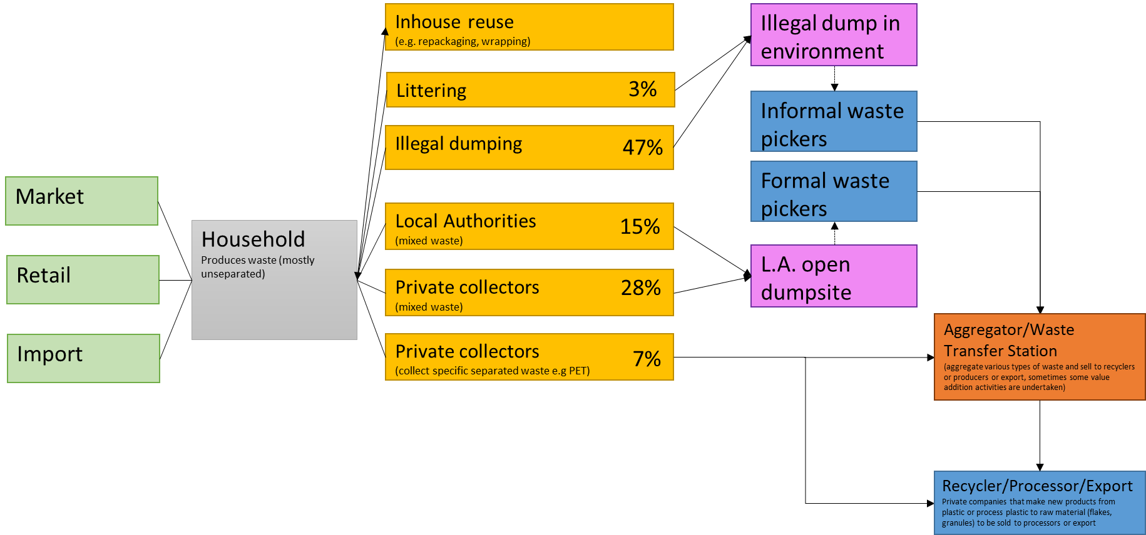

The flow of materials and money within the plastic household waste value chain is as follows:
Figure SEQ Figure \* ARABIC 13: visualization of the plastic household waste value chain in urban areas in Zambia.
- Households buy products that are wrapped or contained in plastics from either markets, super markets, street vendors, retail such as shops or restaurants or from import.
- In the household plastic is often reused out of economic necessity but cannot be reused indefinitely and still ends up as waste. The waste is largely mixed with other types of waste such as paper, organics or glass and stored in bins or bags inside the house.
- These bags/bins are then either collected by public or private collectors (50%) or end up at illegal dumpsites or littered (50%). In the case of formal collection households usually pay a small monthly fee for mixed waste collection.
- In about 7% of the cases households do separate their plastics and the plastics are collected separately by a private collector who sells it to aggregators or the processing industry.
- The waste that is collected by public authorities is disposed in controlled dumpsites or the Chunga landfill.
- The waste that is collected by private authorities is either disposed in dumpsites (both legal and illegal) or sold to aggregators or the processing industry if the waste is already separated
- At the local authorities controlled dumpsites or the illegal dumpsites, formal and informal waste pickers collect certain plastic polymer types and sell this to aggregators or waste transfer stations, who then bulk this and sell to recyclers, processors or export it. Sometimes the aggregator does some value addition such as shredding or melting. Note that most of the waste is not collected and stays at the dumpsites.

This system implies that currently the only option for plastic household waste valorization is either via separated collection which only happens in about 7% of the cases, or via collection by (in)formal waste pickers. This results in very little of the total amount of plastic waste finding its way to the processing industry, for a variety of reasons: (i) plastic often gets contaminated by organics at the household, during transport or at the dumpsite, reducing the opportunity for valorization and thus waste pickers will not collect. This implies that separating organics form other waste, can not only greatly increase plastic waste valorization but any type of waste valorization, since organics are the main source of contamination of other waste types, (ii) plastic waste has a short collection window before it gets buried by other waste, and (iii) only the plastic polymer types with the highest value are collected.

These reasons together lead to an insufficient system where only very little of the total amount of plastics get collected, resulting in difficulties for the processing industry to get plastic materials in an economic matter in order to recycle. Without sufficient volumes a profitable business case or scaling the current operation, becomes challenging.

Thus, better separation, collection and transport logistics are essential to scale the market for plastic processing within Zambia.

Various pathways for separating and collecting waste are implemented in Zambia or emerging in Africa. Table 5 and Table 6 summarize the existing and emerging pathways for separation and collection and the pros and cons of each pathway.

Table 5: Current practice (with asterisk) and emerging pathways for separation of household waste including pros and cons.
Proposed method | Requirements | Pros | Cons
Full household separation and separated collection | Frequent collection of various waste streams | Limited separation infrastructure needed after collection, easy to get sufficient volumes | Requires a big behavior change, various bins and thus space at households as well as a lot more trucks and frequent collection that might not be economically interesting due to low volumes
Only organic waste separation and separated collection | Frequent collection of two different waste streams | No cross contamination of organics to other waste types, easier to separate waste | Requires a behavior change, one more bin at households and more trucks to do frequent collection
Waste picking at disposal sites* | (informal) waste workers | Situation as is now, no changes needed | Only small percentage of waste gets recycled
Manual separation at disposal sites | (informal) waste workers and a lot of space | No behaviour changes at households needed | Labour intensive, waste gets easily contaminated or buried
Manual separation at waste transfer stations* | (informal) waste workers, and a lot space | Transfer facility that links collection to processing industry, only true waste ends up at disposal site | Labour intensive
Combination of manual and mechanical at disposal site or waste transfer station | (informal) waste workers, conveyor belt | More efficient that via solely waste workers | More expensive
Full mechanical separation | Specialized machinery and equipment | Efficient, not dependent on waste pickers | Does not create jobs for vulnerable groups, requires expert knowledge, high investment and O&M

Table 6: Current practice (with asterisk) and emerging pathways for collection of household waste including pros and cons.
Proposed method | Requirements | Pros | Cons
Kerbside system – trucks with open top* | Trucks, and high level of infrastructure, frequent collection to prevent illegal dumping | Limited behavior change needed from households. IT solutions can improve collection routes | Not possible in areas with narrow or bad roads, regular maintenance of trucks necessary,
Bring system – communal/block collection* | Trucks, and high willingness of communities, proper design to prevent smell | Less requirements on infrastructure and frequent collection | Large behavioural change necessary, regular maintenance of trucks necessary,
Informal sector IT-based collection | (informal) waste workers, IT infrastructure to connect households with waste to collection services | No high level of infrastructure needed, opportunities for job creation | Separation at households needed to earn profit, willingness from both waste collectors and households to go use app

Current market status

Actor overview
Even though valorization of plastic household waste is in its early stages, there are some organizations pioneering in this field. These organizations are mainly based in Lusaka. Their reach is still small, but it shows that early commercialization of valorization pathways is possible. Table 7 provides a non-exhaustive overview, to give an idea on the actors currently operating in plastic waste valorization, their role and a description of their activities.
Table 7: Overview of actors working in plastic valorization in Zambia, a non-exhaustive list
Organization | Description | City & Focus Area | Pathways
Charemore Glass and Plastic Recycling Company | Recycle Glass and plastic into bricks and Pavers | Lusaka | Rubber Processor
Zorbit Waste Management | Collecting and aggregating plastic waste from the Chunga Landfill in Lusaka. The company is looking to start initiatives that separate plastic waste at source from different parts of Lusaka. | Lusaka | Waste Management Facilitators and waste aggregator
Noor plastic Industries (Polycor Plastic Ltd) | Manufacture plastic products such as Buckets, brooms, plastic Kitchen utensils, Duct pans and refuse bins from Recycled Plastic. | Lusaka | Plastic Processor
Trash for Cash (Thorntree Safaris) | Had a project on Trash for Cash and promoted especially working with women. | Livingstone | Waste Management Facilitators and waste aggregator
Mulenga Oil | Pyrolysis of rubber waste to produce oil products. The company prefers utilizing HDPE plastics but they are not yet doing that because they cannot find enough HDPE waste. | Lusaka | Waste tyres processor / Potential plastic processor
Green tech Innovation | Develops alternative s solutions to deal with waste by designing simple machinery, recycling plastic into bricks, pavers and drainage Linings. Have halted production due to some challenges. | Lusaka | Plastic Processor
Shunya investment ltd. | Aggregate Different plastic Materials and prepare them for recycling. | Lusaka | Waste Aggregator
Plastpave | Manufacturing of tiles, fencing poles, flower pots from plastic waste | Lusaka | Plastic Processor
Xing Huo Company | Recycling of PET/HDP Plastics into plastic flakes and plastic granules | Chilanga | Plastic Recycler and exporter
M and F packaging industries ltd | Plastic waste recycling and manufacturing of finished good from recycled materials. Recycled plastic granules are converted to household and hardware plastic items. | Lusaka | Plastic Recycler, processor and exporter
CitiMop Waste Management | Collects mixed waste from households and commercial customers, for a fee and dumps at Chunga Landfill | Lusaka | Waste Collector
Manja Pamodzi (Zambia Breweries) | Had a project that facilitated creation of waste collection centres and linkages with waste processors | Lusaka | Waste Management Facilitator
Keli clean-up | Waste aggregation paper, metal and plastic polymer types that are baled and exported, | Livingstone | Waste Aggregator and export

The actor analysis shows that actor are present in each position of the value chain: there are actor present in plastic waste collection, aggregation, material processing (granules and flakes), recycling of products (both open and closed loop), and export of granules and flakes (mainly to South Africa). The types of products made within Zambia of recycled plastics also greatly differs, e.g. electrical conduit pipes, brooms, dus bins/pans, flower pots, pavers, hardware plastic household items and so on.

Price overview
The prices for waste material greatly depends on the polymer type, quality and cleanliness, the geographic area and the business, however in general prices collectors receive from aggregators (such as buy back centers or waste transfer stations) are:
- HDPE – K4-8/kg
- PP – K4-10/kg
- LDPE – K1-2/kg
- PET – K1/kg

Processors buy these per ton from aggregators at K2-3/kg above the price the aggregator bought if for.

Plastic granules generally range from K14-22/kg depending on the polymer type, grade and quality while the virgin materials range from K26-38/kg.

The prices of the products made from recycled plastics depend heavily on the process required to make the products. Some processes require a lot of steps, from washing, to shredding, melting and moulding, which all require large amounts of electricity, while other processes are more low tech and do not require expensive and energy intensive equipment.

Challenges experienced by the processing sector
The interviews and learning visits to the processing sector highlighted some key challenges they experience that limits them from scaling their business and which they believe limits scaling of the plastic processing industry in general.

The first challenge is getting sufficient volumes in an economic manner, the lack of separation at source, collection infrastructure, and post collection separation, results in large difficulties in getting sufficient volumes in an economic manner. The plastic material market is quite competitive and diffuse with the processing industry competing with each other to get enough materials. The unsatisfied demand has not led to more plastic volumes collected. Smaller issues regarding volumes are that processors cannot rely on a steady stream of plastics. Aggregators come when they have enough plastics and if they can get a higher price somewhere else they will take that opportunity.

The second challenge has to do with low margins on recycled plastic products. The costs of machinery to extrude and molt plastics is quite high, from 250.000$ for a simple granule producing plant to $2.000.000 for an integrated manufacturing facility. There are no incentives such as subsidies, tax holidays or reduced import duty on equipment used for recycling and circular activities. Additionally there is no equipment manufacturer in the country so everything needs to be imported. If equipment breaks down replacement parts are difficult to come by and expensive to import. Loans or other forms of financing for plastic waste processing industry is difficult to come by since the interest rate is very high and there is no data available on plastic quantities and types making business projections difficult. Additionally most professional plastic recycling equipment requires extensive electricity to function, which is quite expensive and unreliable, especially in dry season when availability of hydro energy is low. Recyclers experience regular blackouts and after each blackout it takes about 3 hours before the business is in operation again. Another reason for the low margins is that recycled plastic is now mainly open-loop recycled into low quality products, which leads to relatively low margins on products.

Summary of gaps identified
This section provides an overview of the key conclusions and gaps in the current landscape for plastics management, as well as the concluding advice on the relevance of the different pathways for Zambia.

Gaps within the technology landscape in Zambia
The assessment of the current implementation of plastic waste management technologies shows that the key gaps in the technology landscape are not due to lack of existing technology – recycling technology is in place globally, and there are already several companies implementing these in Zambia as well. However, there is little domestic development of recycling technologies, nor little domestic availability of spare parts. This means that recyclers are dependent on expensive imports of (parts of) equipment. Moreover, most deployed recycling technologies are only open loop, with very limited activity on closed loop recycling of polymers (with currently only woven sacks are being recycled closed loop).

Key conclusions and gaps in the current policy landscape
- Zambia’s policy framework for waste is covered predominantly in the Environmental Management Act, 2011 [No. 12 of 2011] and the Solid Waste Regulation and Management Act, 2018 [No. 20 of 2018]. Zambia policies are intentionally aligned to circular economy principles and there are provisions in the two acts for further statutory instruments to be developed to address any gaps that the country may identify in future. There may be no need to develop new policies specifically to assist the country to transition to circularity in the waste sector.
- However, there is currently a lack in guidelines to operationalise the two Acts.
- The synergy of the policies is observed as a weak and creates confusion amongst stakeholders interpreting the law.
- There is a lack of financial instruments to support value chain partners to implement higher levels of material recovery and lower disposal of recyclable waste at landfills, even though this is addressed in the two Acts.
- Insufficient enforcement on the regulations that promoted separation at source of waste.
- Insufficient incentives to use recyclable waste.
- A disbalance between waste dumps and landfills versus collection centres. Private sector urges for more waste collection centres than landfills.
- Local Authorities should be mandated to produce reports on waste collected and generated by type.
- The process of obtaining licences for waste entrepreneurs is experienced as too complex and unclear.
- Remanufacturing are currently not included in and supported by the waste regulations.
- Insufficient balance between of capacity building and compliance, with ZEMA now focussing mainly on performing a penalising role.
- Incentives for equipment importation do currently not apply to all companies in the waste value chain.
- Waste related businesses experience insufficient land to be available and difficult to get a license for.
- Insufficient opportunities for Public Private Partnerships exist.
- Private sector currently feels insufficiently involved in policy making processes.
- The current EPR regulation is anchored in law but not yet operationalized.
- Dissemination of data on waste collected is currently low.
- Current value chain players experience difficulties in acquiring the necessary volumes for valorisation, leading to low margins, which results in a vicious circle where collection infrastructure (e.g. separation, waste pickers, collection) does not scale due to low prices, and recycling industry not getting sufficient volumes in an economic manner meaning they cannot pay collection infrastructure more for delivering plastics.
- Insufficient clarity on and dissemination of the key waste policies. Most of the policy gaps that interviewed stakeholders identified were already covered in the two Acts analysed, but private players did not seem to be aware of this.

5.3 Key gaps within the current markets and value chains
The market and value chain assessment of plastic household waste valorisation shows that the key gaps is getting sufficient volumes in an economic manner. Together with high costs for energy, frequent blackouts, problems with equipment and spare parts, this leads to low margins made from recycled plastic products. Which results in a vicious circle where collection infrastructure (e.g. separation, waste pickers, collection) does not scale due to low prices, and recycling industry not getting sufficient volumes in an economic manner meaning they cannot pay collection infrastructure more for delivering plastics.

Conclusion on the relevance of the different pathways for Zambia
Based on the assessment of the pathways, the study of the current policy framework and the development of current markets and value chains it can be concluded that within the next ten years, the most important pathway for Zambia will be open loop and closed loop recycling recycling. These pathways are most accessible and can provide a solution for many of the currently abundant plastics within the country (rigid and some thin film plastics). Open loop recycling already happens in Zambia, although at centralised locations (not widespread over the country). It will become key to spread the implementation of open loop recycling geographically. Moreover, expansion of rudimentary efforts of open loop recycling to bricks for example could potentially provide a (temporary) solution for the more difficult to recycle multi-layered or multi-material plastics. Closed loop recycling could play a key role in the Zambia system for plastic recycling as well, even though there are much less initiatives currently in place. As closed loop recycling generally asks for higher investment costs, while the current budgets nor policy support is not sufficiently in place to facilitate that, it is expected that this will take somewhat longer to expand. In terms of thermo-chemical recycling, this is not deemed realistic within the near future, as this is still in pilot scale for most plastics, not commercially viable yet and requires huge amounts of energy. Plastics-to-energy is not advised as a primary pathway due to the environmental impacts and it not being a circular pathway (no value retention possible).

What is a circular economy? | Ellen MacArthur Foundation
Vermeulen, W. J., Reike, D., & Witjes, S. (2019). Circular Economy 3.0; Solving confusion around new conceptions of circularity by synthesising and re-organising the 3R’s concept into a 10R hierarchy. Renewable Matter, 27, 12-15.
EMF is one of the leading institutes in the field of the circular economy. The 7R Model for a Circular Economy |LinkedIn (For a more thorough explanation to the R strategies see Vermeulen, W. J., Reike, D., & Witjes, S. (2019). Circular Economy 3.0; Solving confusion around new conceptions of circularity by synthesising and re-organising the 3R’s concept into a 10R hierarchy. Renewable Matter, 27, 12-15 or the original framework by Ellen Mac Arthur Foundation The butterfly diagram (ellenmacarthurfoundation.org)
Summary based on technical expertise of TNO; Grigore, M. E. (2017). Methods of recycling, properties and applications of recycled thermoplastic polymers. Recycling, 2(4), 24; Lau, W. W., Shiran, Y., Bailey, R. M., Cook, E., Stuchtey, M. R., Koskella, J., ... & Palardy, J. E. (2020). Evaluating scenarios toward zero plastic pollution. Science, 369(6510), 1455-1461; Parameswaranpillai, J., Rangappa, S. M., Rajkumar, A. G., & Siengchin, S. (Eds.). (2021). Recent Developments in Plastic Recycling. Springer Singapore; Schwarz, A. E., Ligthart, T. N., Bizarro, D. G., De Wild, P., Vreugdenhil, B., & Van Harmelen, T. (2021). Plastic recycling in a circular economy; determining environmental performance through an LCA matrix model approach. Waste Management, 121, 331-342 (TNO Study); World Economic Forum, the Ellen MacArthur Foundation, & McKinsey Company (2016) - The new plastics economy, rethinking the future of plastics | Shared by New Plastics Economy (thirdlight.com)
The 7 Different Types of Plastic<br/> | Plastics For Change
Lau, W. W., Shiran, Y., Bailey, R. M., Cook, E., Stuchtey, M. R., Koskella, J., ... & Palardy, J. E. (2020). Evaluating scenarios toward zero plastic pollution. Science, 369(6510), 1455-1461; World Economic Forum, the Ellen MacArthur Foundation, & McKinsey Company (2016) - The new plastics economy, rethinking the future of plastics | Shared by New Plastics Economy (thirdlight.com)
Lau, W. W., Shiran, Y., Bailey, R. M., Cook, E., Stuchtey, M. R., Koskella, J., ... & Palardy, J. E. (2020). Evaluating scenarios toward zero plastic pollution. Science, 369(6510), 1455-1461.
Digital dividends in plastics recycling, GSMA 2021
Davidson, M. G., Furlong, R. A., & McManus, M. C. (2021). Developments in the life cycle assessment of chemical recycling of plastic waste–A review. Journal of Cleaner Production, 293, 126163.
Grigore, M. E. (2017). Methods of recycling, properties and applications of recycled thermoplastic polymers. Recycling, 2(4), 24; Lau, W. W., Shiran, Y., Bailey, R. M., Cook, E., Stuchtey, M. R., Koskella, J., ... & Palardy, J. E. (2020). Evaluating scenarios toward zero plastic pollution. Science, 369(6510), 1455-1461; Parameswaranpillai, J., Rangappa, S. M., Rajkumar, A. G., & Siengchin, S. (Eds.). (2021). Recent Developments in Plastic Recycling. Springer Singapore;. Schwarz, A. E., Ligthart, T. N., Bizarro, D. G., De Wild, P., Vreugdenhil, B., & Van Harmelen, T. (2021). Plastic recycling in a circular economy; determining environmental performance through an LCA matrix model approach. Waste Management, 121, 331-342 (TNO Study); World Economic Forum, the Ellen MacArthur Foundation, & McKinsey Company (2016) - The new plastics economy, rethinking the future of plastics | Shared by New Plastics Economy (thirdlight.com)
World Economic Forum, the Ellen MacArthur Foundation, & McKinsey Company (2016) - The new plastics economy, rethinking the future of plastics | Shared by New Plastics Economy (thirdlight.com)
OECD 2022, Global Plastics Outlook, OECD iLibrary (oecd-ilibrary.org)
Plastics Europe 2020, Plastics - the Facts 2020 • Plastics Europe
Kaza, S., Yao, L., Bhada-Tata, P., & Van Woerden, F. (2018). What a waste 2.0: a global snapshot of solid waste management to 2050. World Bank Publications.
; Lau, W. W., Shiran, Y., Bailey, R. M., Cook, E., Stuchtey, M. R., Koskella, J., ... & Palardy, J. E. (2020). Evaluating scenarios toward zero plastic pollution. Science, 369(6510), 1455-1461 (Supplementing material)
Arena, U., Mastellone, M. L., & Perugini, F. (2003). Life cycle assessment of a plastic packaging recycling system. The international journal of life cycle assessment, 8(2), 92-98.
Antelava, A., Damilos, S., Hafeez, S., Manos, G., Al-Salem, S. M., Sharma, B. K., ... & Constantinou, A. (2019). Plastic solid waste (PSW) in the context of life cycle assessment (LCA) and sustainable management. Environmental Management, 64(2), 230-244.
Hestin, M., Faninger, T., & Milios, L. (2015). Increased EU plastics recycling targets: environmental, economic and social impact assessment. Retrieved, 17, 2018, Deloitte.
Parsai, T., & Kumar, A. (2016, November). Human risk assessment: Toxicity issues and challenges associated with mixture of chemicals released during plastic reuse and recycling. In The 1st International Electronic Conference on Water Sciences; Brosché, S., Strakova, J., Bell, L., & Karlsson, T. (2021). WIDESPREAD CHEMICAL CONTAMINATION OF RECYCLED PLASTIC PELLETS GLOBALLY, IPEN.
Brosché, S., Strakova, J., Bell, L., & Karlsson, T. (2021). WIDESPREAD CHEMICAL CONTAMINATION OF RECYCLED PLASTIC PELLETS GLOBALLY, IPEN
Ágnes, N., & Rajmund, K. U. T. I. (2016). The environmental impact of plastic waste incineration. AARMS–Academic and Applied Research in Military and Public Management Science, 15(3), 231-237.
European Union, 2014, Document 52015DC0614 COMMUNICATION FROM THE COMMISSION TO THE EUROPEAN PARLIAMENT, THE COUNCIL, THE EUROPEAN ECONOMIC AND SOCIAL COMMITTEE AND THE COMMITTEE OF THE REGIONS Closing the loop - An EU action plan for the Circular Economy COM/2015/0614 final, https://eur-lex.europa.eu/legal-content/EN/TXT/?uri=CELEX:52015DC0614
International Association of Young Lawyers, 2020, CIRCULAR ECONOMY DAY | 18 NOVEMBER 2020 A report by the AIJA Environmental & Energy Law Commission, https://www.aija.org/images/uploads/E_E_FINAL_.pdf
European Union, 2014, Document 52015DC0614 COMMUNICATION FROM THE COMMISSION TO THE EUROPEAN PARLIAMENT, THE COUNCIL, THE EUROPEAN ECONOMIC AND SOCIAL COMMITTEE AND THE COMMITTEE OF THE REGIONS Closing the loop - An EU action plan for the Circular Economy COM/2015/0614 final, https://eur-lex.europa.eu/legal-content/EN/TXT/?uri=CELEX:52015DC0614
https://eur-lex.europa.eu/legal-content/EN/TXT/?uri=CELEX:52015DC0614

