PROGRESS REPORT 2
October 2020
Report on wave models
- Support at 21st – 22nd August 2019 project Inception meeting
The Pacific Community (SPC) project team provided support into the delivery of the project inception meeting. SPC led a couple of sessions around the wave modelling component of the project and its integration with bathymetry data.
The meeting helped to map country needs in terms of wave modelling training. Participants expressed a range of wave modelling training needs such as island and lagoon scale wind wave modelling, high resolution inundation modelling from tropical cyclone and swell as well as tsunami inundation modelling.
Unfortunately, it was deemed unrealistic to provide participants with introductory capability in such a wide range of highly scientific concepts and tools over a 5-day period. High-resolution inundation modelling requires high resolution and accurate baseline data (e.g. bathymetry and topography) to ensure the model output provides sound and actionable information. Such dataset is not available for most of the participating countries such as Kiribati, Palau and Solomon Islands.
Based on the above, the 5-day wave training will focus on national to lagoon scale wind wave modelling. The development of such wave models do not require high resolution nearshore and topography data and would be a useful capability for all participating countries to better understand and monitor coastal processes such as sediment transport (erosion/accretion), support the strengthening of coastal inundation risk knowledge, etc.

- Preparation of the data acquisition and data catalogue
After receiving authorization from its member countries, SPC provided the project with the bathymetry data stored on behalf of its member countries.
- Review of wave models and preparation of case studies
SPC developed national scale, island group scale and island scale wave model for the purpose of the up-coming training. The table1 below showcases the work done to date under the CTCN technical assistance.
The higher resolution models are designed to be run in 2 ways:
- By user-defined inputs on wave and wind conditions
- By the wave forcing generated from the national and sub-regional scale wave model. These coarser models are setup to generate wave boundary condition for the high- resolution model (i.e. nesting modelling technique to be covered during the training).

Table1: Overview of the various wave model products developed under the CTCN technical assistance as training material
Location | Data Source | Resolution | Grid Size | Status / comments
RMI
National | GEBCO_2020 | 450m | 2km | Completed
Majuro | GEBCO_2020 | 450m | 450m | Completed
Majuro | SPC grid | 100m | 100m | In progress - SPC’s wave model of Majuro was deemed too complex for training purposes (based on Flexible mesh). A new model of Majuro is being developed for training purposes using the recently procured bathy/topo lidar data.
Palau
National | GEBCO_2020 | 450m | 2km | Completed
Area A | GEBCO_2020 | 450m | 505m | Completed
Area B | GEBCO_2020 | 450m | 505m | Completed
Area C | GEBCO_2020 | 450m | 505m | Completed
High resolution  model |  |  |  | Not started - No high resolution bathymetry grid data is available for Palau to date.
Kiribati
Sub Reg. Tarawa | GEBCO_2020 | 450m | 2km | Completed
Sub Reg. Kirimati | GEBCO_2020 | 450m | 2km | Completed
Tarawa | SPC | 100m | 100m | Completed
Kirimati | GEBCO_2020 | 450m | 500m | Completed
Solomon
National | GEBCO_2020 | 450m | 2km | Completed
Honiara | SPC | 250m | 250m | Completed
Gizo | SPC | 250m | 250m | Completed

- Preparation of training materials including design course curriculum for the 2.5 day-training courses
SPC is currently working on training materials to support the 2.5-day wave modelling training course.
Issues and corrective actions
Issues | Risk | Corrective actions
No high-resolution bathymetry data available for Palau to support high resolution wave modelling | Palau could feel left out resulting in participant disengagement during the training | Proposed solution:  - GRID-ARENA might be able to create a high resolution (100s of meter) bathymetry grid for a location in Palau based on satellite derived bathymetry and digitized marine charts.  - SPC created a high-resolution wave model of key area in Palau based on global bathymetry data (500m res.).
COVID-19 | Travel ban to persist throughout 2021 | Two potential solutions:  - Organise online training  Such technical, hands on training is not propitious to an online setting. While possible, there would be significant impact to pivot this training.  - Donor agrees to postpone the training until travel restrictions are lifted.

Annex1: Snapshot of model outputs
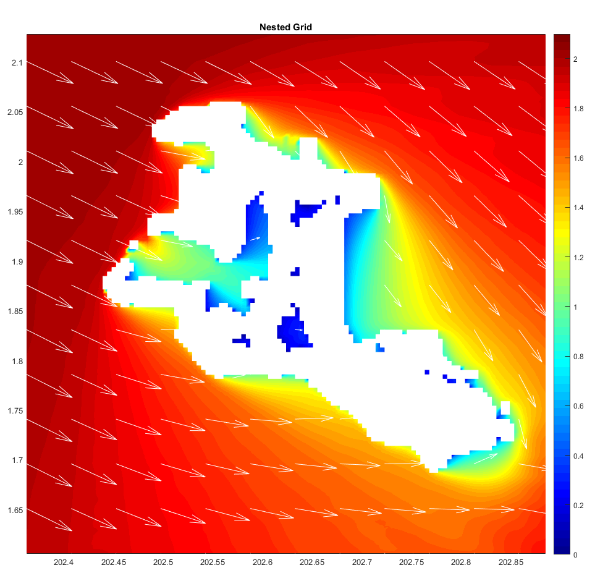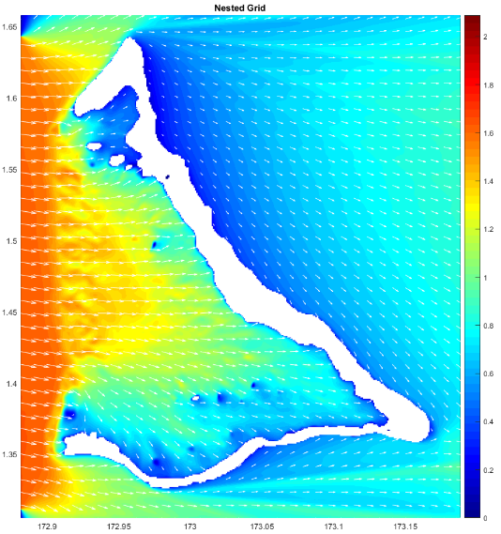
Figure 1: Snapshot of Kiritimati (left) and Tarawa (right) wave models

