PRELIMINARY DRAFT

Project/Programme Title: | Adaptive measures to increase Port Louis’ harbour resilience to climate change
Country(ies): | Mauritius
National Designated Authority(ies) (NDA): | Ministry of Finance and Economic Development
Accredited Entity(ies) (AE): | African Development Bank (AfDB)
Date of first submission/ version number: | [2020-12-31] [V.0]
Date of current submission/ version number | [YYYY-MM-DD] [V.0]

Notes
- The maximum number of pages should not exceed 12 pages, excluding annexes. Proposals exceeding the prescribed length will not be assessed within the indicative service standard time of 30 days.
- As per the Information Disclosure Policy, the concept note, and additional documents provided to the Secretariat can be disclosed unless marked by the Accredited Entity(ies) (or NDAs) as confidential.
- The relevant National Designated Authority(ies) will be informed by the Secretariat of the concept note upon receipt.
- NDA can also submit the concept note directly with or without an identified accredited entity at this stage. In this case, they can leave blank the section related to the accredited entity. The Secretariat will inform the accredited entity(ies) nominated by the NDA, if any.
- Accredited Entities and/or NDAs are encouraged to submit a Concept Note before making a request for project preparation support from the Project Preparation Facility (PPF).
- Further information on GCF concept note preparation can be found on GCF website Funding Projects Fine Print.

- Project/Programme Summary (max. 1 page)
A.1. Project or programme | ☒ Project  ☐ Programme | A.2. Public or private sector | ☒ Public sector  ☐ Private sector
A.3. Is the CN submitted in  response to an RFP? | Yes ☒ No ☐  If yes, specify the RFP: ______________ | A.4. Confidentiality | ☐ Confidential  ☒ Not confidential
A.5. Indicate the result areas for the project/programme | Mitigation: Reduced emissions from:  ☐ Energy access and power generation  ☐ Low emission transport  ☐ Buildings, cities and industries and appliances  ☐ Forestry and land use  Adaptation: Increased resilience of:  ☐ Most vulnerable people and communities  ☒ Health and well-being, and food and water security  ☒ Infrastructure and built environment  ☐ Ecosystem and ecosystem services
A.6. Estimated mitigation impact (tCO2eq over lifespan) | Not applicable | A.7. Estimated adaptation impact (number of direct beneficiaries and % of population) |  | 25 000 persons (2%) directly impacted; more people indirectly impacted
A.8. Indicative total project cost (GCF + co-finance) | Amount: USD 318 793 500 | A.9. Indicative GCF funding requested |  | Amount: USD 159 396 750
A.10. Mark the type of financial instrument requested for the GCF funding | ☒ Grant ☐ Reimbursable grant ☐ Guarantees ☐ Equity  ☐ Subordinated loan ☐ Senior Loan ☐ Other: specify___________________
A.11. Estimated duration of project/ programme: | 10 years | A.12. Estimated project/ Programme lifespan |  | 100 years
A.13. Is funding from the Project Preparation Facility requested? | Yes ☐ No ☒  Other support received ☒ If so, by who: UNIDO project study | A.14. ESS category |  | ☐ A or I-1  ☒ B or I-2  ☐ C or I-3
A.15. Is the CN aligned with your accreditation standard? | Yes ☒ No ☐ | A.16. Has the CN been shared with the NDA? |  | Yes ☒ No ☐
A.17. AMA signed (if submitted by AE) | Yes ☒ No ☐  If no, specify the status of AMA negotiations and expected date of signing: | A.18. Is the CN included in the Entity Work Programme? |  | Yes ☐ No ☐
A.19. Project/Programme rationale, objectives and approach of programme/project (max 100 words) | As a major asset in Mauritius, the port of Port Louis is exposed to a number of combined climatic risks including storm surge, flooding and powerful and frequent winds, magnified by climate change. These risks challenge the resilience of port infrastructure whilst at the same time disrupt the supply chain and the overall economy of the country. The requested GCF grant aims to co-fund an adaptation project that will increase the resilience of the port while protecting the port physical assets and increasing the beneficiaries’ awareness on climate change (capacity building programme).

- Project/Programme Information (max. 8 pages)
B.1. Context and baseline (max. 2 pages)
Mauritius experiences on average over USD110 million / year in combined direct losses from floods and tropical cyclones (South West Indian Ocean Risk Assessment and Financing Initiative, 2016). A 100-year return period tropical cyclone event could produce direct losses of USD 1.9 billion, equivalent to 13 percent of the 2018 GDP, and require approximately USD 430 million in emergency costs.

In the past decade (2010-2019), the Mauritius Container Terminal had to stop operations an average of 16.5 days per year due to excessive rain, wind, waves and flooding by overtopping of the container platform. In January 2018 for instance, cyclone Berguitta forced the main port in Port Louis to shut down, with both direct economic cost to the harbour and indirect cost to the sugar cane and textile export industries operating on short schedules. Climate change is foreseen to increase the frequency of such stops of operations.

Port Louis harbour is exposed to risks due to impact from weather and climate change effects such as sea level rise, storm surges, wave and wind impact, precipitation and flooding. With climate change follows the risk of more frequent stops of operations, just as it carries the risk of increased wear on structures resulting in increased maintenance efforts and costs. In addition to this, there is a risk of increase in siltation rates and hence potentially an increased requirement for maintenance dredging or other mitigating measures around Port Louis harbour.

The physical assets as well the services and activities centred around the port’s operation include:
- Navigation and Berthing
- Material handling (loading / unloading)
- Goods transportation within the port
- Goods storage
- Transport & Supply chain from/to port (import / export)
- Other services / Auxiliary.

A complete shutdown of the port because of climatic hazards can beget important economic losses both from the direct, indirect and induced activities around the port’s operation as well as climate change induced costs for infrastructure, various downtimes, additional insurance, goods spoilage and economic activity more generally. As a matter of fact, a downtime will have an impact on the port operations and, as a consequence, affect port revenues and climate change is likely to affect physical infrastructure and land assets, including potential revenues from lost land use (operation, rent, concession…). The total annual cost of climate change has been estimated by a study (Artelia 2020) in three scenarios to be approximately USD 218 million, USD 458 million or USD 859 million corresponding to the additional cost of climate change discounted over the period 2020-2100.

The country’s national priorities

Mauritius has been ranked 16th country with the highest disaster risk and 10th as the most exposed to natural hazards as per the 2018 World Risk Index. The threatening impacts of climate change in Mauritius are already being felt with an accelerated sea level rise, accentuated beach erosion, increase in frequency and intensity of extreme weather events such as flash floods, cyclones and water scarcity. National, sectoral strategies and plans have been elaborated to implement the recommendations of the international conventions. Key legislative and policy measures have been set in place to strengthen the environmental management and sustainable development frameworks of the country.

The existing national plans and strategies relevant to the Mauritian Port Sector in general and Port Louis in the context of projected impact for Climate change are presented below, including relevant extracts.

 Third national communication report for the Republic of Mauritius, Report to the United Nations Framework Convention on Climate Change :

The Third National Communication (2016) has proposed several adaptation options for the coastal zone, including ‘Adaptation of public infrastructure on the coastal zone and the Ports Area’. The adaptation measures include wave breakers at sea and a flood wall on the coastline to protect vulnerable terrestrial infrastructure, raising existing wharfs to lessen inundation by stom surges and building elevated roads or relocating coastal roads more inland.

 The Master Plan of Port Louis Harbour:

The MPA has commissioned a new Port Master Plan which caters to the requirements of the port for the next 25 years, taking into consideration new opportunities such as transhipment, bunkering, seafood, cruise and ocean related businesses. It was required to prepare a traffic forecast and make recommendations for port infrastructure required to handle the future traffic and propose a land use plan. The reference to climate change includes the construction of a flood wall: “A flood defence barrier set back from the quay does consume otherwise valuable stacking and operational space but is crucial to protecting against flood waters during cyclones.”

 The National Disaster Scheme (NDS) from the National Risk Reduction and Management Centre:

The NDS is intended to be a functional document to support agencies and stakeholders in understanding and undertaking their roles, responsibilities and actions in emergencies. This document is organized per risk: cyclone, Heavy Rain/ Torrential Rain/ Flooding, tsunami, high waves, water crisis, earthquake, landslide, Port-Louis Flood Response Plan. (quote) “Recommendations to Mauritius Ports Authority (MPA) are included in the document, regarding cyclone, tsunami, high waves and within the Port Louis flooding response plan.”

 The National Disaster Risk Reduction Strategic Framework and Action Plan, 2013:

It was developed to identify risks and assess the exposure of people, property, critical facilities, infrastructure, and economic activities as well as the potential losses (human, economic and financial) related to flooding, coastal inundation and landslide prone areas. According to established scenarios, high coastal risk due to storm surges near Port Louis occurs in an area from Baie du Tombeau to Baie de la Grande Rivière, East of the port.

 The Nationally Determined Contribution (NDC)

Protecting infrastructure is one of the priority adaptation actions presented in Mauritius NDC (2015). Specifically, the NDC states that the ‘protection of infrastructure will be enhanced against climate change calamities’.

As the principal gateway of the country, Port Louis Harbour plays a vital role in the national economy by handling about 99% of the total volume of the external trade. All strategic imports such as food and petroleum products, raw materials for the textile industry, and major exports such as sugar and textile, transit through the harbour. The port sector contributes more than 2% to Mauritius GDP. A major asset in Mauritius, the port of Port Louis is exposed to a number of combined climatic risks including storm surge, flooding and more powerful and frequent winds, thereby challenging the resilience of port infrastructure whilst at the same time disrupting the supply chain.

B.2. Project/Programme description (max. 3 pages)
Through the GCF’s Readiness and Preparatory Support a pre-feasibility study of the selected adaptive measures to address the vulnerabilities listed above were identified, the selected measures were prioritized based on a MCA approach. The 15 selected adaptation measures include preventive, protective and mitigation solutions. The measures will be implemented over a 10 year period and will address the following four key components:

Component A - Increase knowledge on climate change (immediate):

- Appoint an expert in charge of the overall coordination of climate adaptation: Appointing a Climate Change Officer is the earliest step in the action plan. The expert would be in charge of all climate and climate change related issues and would be involved in strategic committees.
- Implement a climate adaptation capacity building program: Implementing a capacity building program will instil participants with a climate change state of mind. Direct port users and some indirect port users must be included in the process
- Monitor climatic and environmental parameters: the MPA shall gather climatic and environmental data from its own devices and complement them with national meteorological services already in place.
- Real time monitoring of waves and tides, Early Warning System: MPA shall gather climatic and environmental data from its own devices and complement them from national meteorological services already in place.
- Identify the exact cause of overtopping during South-West swell events and its recent increase (capital dredging works, strong local wind waves etc): Understand the exact cause of overtopping based on monitoring and data analysis. This is a key step to properly design the protection measure identified (breakwater)
- Keep track of all climate-related incidents and events affecting the port, and lessons learnt: Keeping track of incidents and climatic events allows: - to identify climatic trends and projections; - to measure the efficiency of the solution implemented; - to forecast upcoming climatic event and get prepared.

Component B - Limit the increase of maintenance and repair costs due to climate change (medium term):

- Focus on infrastructure assets subject to the climate hazards identified, such as the MCT quay walls as well as the oil terminal equipment and jetty. For these infrastructure, increase prevention measures.
- Strengthen functional requirements of future infrastructure: Design infrastructure based on climate projection data and identified impacts. Use climate projection data and associated hazards to design future infrastructure. Refer to adaptation measures such as wet/dry proofing or protection measures (dikes, barriers) if necessary.

Component C - Allow continuous and safe berthing and quay operation at the MCT terminal (medium term):

- Build a breakwater to reduce wave action at the MCT and oil jetties: Overtopping and MCT / Oil jetty operation downtime is the first cause of operation downtime and the most critical hazard identified over the 2020 - 2100 period. A breakwater will prevent wave overtopping and the associated flooding hazard.
- Automate logistics procedures: Port automation consists of five components which can be implemented individually : 1 – Automated equipment ; 2 – Equipment control system ; 3 – Terminal control tower ; 4 – Human machine interaction ; 5 – Interaction with the port community. The implementing authority depends on the components, but the systems shall be centralized around a common system to connect them all.
- Install cranes that can safely operate under strong winds: Crane operation under strong wind shall not be implemented as a priority, as it is difficult to find a financial equilibrium based on climate change only. Instead, when crane have to be renewed, take into account climate change projections when specifying the cranes to be purchased.

Component D - Maintain continuous & safe operation within the port (immediate):

- Include climate adaptation in key policy and operational documents of the port, and periodically review and update the climate component of these documents (continuous improvement process): Climate change and adaptation must be at the heart of port policy and drive strategic, financial and operational decisions. Including climate adaptation in key policy and operational document is the earliest step for maintaining continuous and safe operation within the port.
- Adapt operational procedures (minimize disruption of supply chain, maximize operational wind and wave thresholds): Adapting operational procedures is a response to climate hazards to maximize port productivity and performance while keeping the same level of security. It is best addressed by identifying operations which may continue despite certain climate hazards.
- Promote the use of IAPH sustainability standards (IAPH Lease Agreement Template, ESI clean ship incentive scheme, Toolbox for Port Clean Air Program etc): The IAPH set up in 2017 the World Port Sustainability Program (WPSP). The goals are to enhance the sustainability of the ports and encourage the participation of supply chain members. The Program is based on the 17 UN Sustainable Development Goals and addresses five main topics: Climate and Energy, Community outreach and port-city dialogue, Governance and Ethics, Resilient Infrastructure, Safety and Security.
- Conduct regular emergency drills for climate events to minimize disruption: Once operational procedures are adapted, emergency drill may be an efficient method to 1) audit the procedures, 2) train the team in charge 3) inform and train the people affected and 4) adapt the procedure in view of the drill outcomes.

The construction of the breakwater (Measure 9 of component C), a central measure to protect the port’s physical assets

Breakwaters are the standard engineering solution to protect a port against wave action, for navigation, mooring and wave overtopping on the quay. Component C of the project includes the construction of a breakwater to protect the port’s physical infrastructure. The breakwater will be positioned approximately 1150 m off the MCT, protecting it from North and North-West waves. The breakwater will have limited effect on the existing port basin (Caudan waterfont, fishing port). Simulations have been carried out for two different hydro-meteorological scenarios (See Annexes A and B). The results of the simulations have shown that:
- The wave height at the toe of the MCT during a storm is considerably reduced ;
- The MCT quay should therefore no longer be flooded ;
- The maximum wave heights are observed at the reclaimed area west of the port and at the Indian Oil terminal. Only these two terminals are expected to be flooded during the passage of the reference cyclone and the flood depth is reduced compared to the current situation ;
- The breakwater would however not prevent localised flooding on the Caudan waterfront and the fishing port due to their low altimetry.

The theory of change: Increasing the climate resilience of the port of Port Louis

To increase the climate resilience of the port of Port Louis, selected soft and hard adaptive measures will be implemented. These measures will increase the port’s resilience to climate change, protect the port’s physical assets to allow the continuous operation of the port and protect the livelihoods and economies centred on the port’s operation. If no appropriate adaptive measures are implemented:
- The port’s physical assets and freight goods can be damaged;
- The port shutdown will have serious negative impacts on the Mauritius economy;
- The port will likely experience increased maintenance and damage costs due to climate hazards.

The ToC diagram in Annex C illustrates how each project component will address Port Louis’ harbour vulnerability to climate change as well as the barriers and challenges listed above.

National regulatory and legal framework

Component C of the project includes the construction of a breakwater to reduce wave action at the MCT and oil jetties. Under the Environment Protection Act 2002 of the Mauritius Republic, the construction of breakwaters require an Environmental Impact Assessment (EIA). The MPA will conduct an EIA to make sure that appropriate environmental protection measures including mitigation measures to reduce adverse effects and measures for environmental enhancement will be implemented.

The African Development Bank (AfDB), as the GCF-AE, will oversee appropriate implementation of the programme in line with the AfDB’s procedures and standards, and specific requirements in the AMA agreed with the GCF. The AfDB is well placed as an Accredited Entity of the GCF to undertake the planned activities since the bank has been managing climate projects and programmes in Africa for decades. The AfDB has mobilised approximately $12billion of climate finance in the region to support climate resilience and low carbon development in Africa. In its 2013 – 2022 strategy, the AfDB puts a clear emphasis on the importance of building resilience and sustainable infrastructure to ensure the green growth of African economies. Furthermore, the Bank's Action Plan on Climate Change emphasizes the need to increase support for capacity building to tackle climate risks. In its Country Strategy Paper, the bank sees Mauritius vulnerability to climate variability and change as an inhibiting factor in the development of PPPs and transformation of Mauritius into a High Income Country (HIC). It is therefore crucial for the Mauritius economy to protect the existing infrastructure from climate hazards. The project will directly and indirectly help achieve some of the strategic objectives listed in the AfDB Country Strategic Paper. Finally, AfDB sees the financing of port infrastructure as a priority for the bank as it is a necessary entry point to the development of African countries. It states that “Investing in port infrastructure is a lever to accelerate regional integration and industrialization in Africa, it fits in two of the top five priorities of the bank”. The AfDB has always played an important role in preparing projects, identifying partners with the right technical capabilities to provide solutions to development challenges and the right donors to complement its own investments.

The implementation map below summarizes the different interactions between the different parties involved in this technical assistance:

Delivery Partner
AfDB
National Designated Authority
NDA

National Designated Entity
NDE
Service provider
International consultant + local expert

Technical assistance
National stakeholders
Beneficiaries
MPA – Port operators – Direct and indirect port users -
Ministry of Environment, Solid Waste Management and Climate Change
- Ministry of Blue Economy,
Marine Resources, Fisheries and
Shipping
Project
proponent:
The MPA
Reporting

Guidance and feedback

Figure 1: Implementation arrangements between the different actors

The UNFCCC country focal points for technology (NDE) and finance (NDA) will provide active support to the delivering partner in the execution of this technical assistance. Their roles as country focal points will include, but not be limited to: Ensuring the activities associated with the implementation of this technical assistance are aligned with national climate priorities; promote and engage with key stakeholders as identified by the implementing partner; promote and present this technical assistance in climate change-related events; and participate in events and in national workshops affiliated with this technical assistance, if required. They will also be expected to provide guidance and review any relevant documents produced, and will be kept apprised of the progress of the technical assistance.

Technical risks of such infrastructure relate to the layout, hydraulic and geotechnical design of the structure, its impact on currents and sediment transport, and the proper construction methods when placing artificial concrete blocks. They will be addressed by proper design studies and works supervision. The risk level is medium.

Financial risks should be low in view of the strength of the funding partners identified. Maintenance costs shall be borne by MPA from its continued growth. It is expected that the breakwater will provide additional economic opportunities through further expansion of the port.

B.3. Expected project results aligned with the GCF investment criteria (max. 3 pages)
Impact potential

Port Louis harbour is exposed to a number of combined risks from sea level rise including storm surge, flooding and more powerful and frequent winds, which challenge the resilience of the port infrastructure whilst disrupting the supply chain at the same time. These are foreseen to deteriorate considerably with climate change. The proposed construction of a breakwater (Component C) has the potential to deliver important climate adaptation and resilience benefits to the industries, companies and beneficiaries whose activities rely on the port operation and the wider country’s economy. The project will protect the port infrastructure and the livelihoods (direct and indirect) that derive from it (Figure 2).
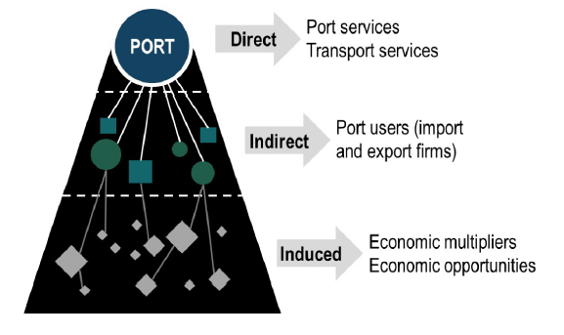

Figure 2: Activities around the port of Port Louis

- The direct activities include companies directly linked to the port "core business", i.e. those essential to the daily and proper running of the port site. These companies are involved in the provision of services to ships and goods and are centred on three categories of activity: public port authorities, ship auxiliaries and cargo auxiliaries.
- The indirect activities regroup companies which use the services offered by the port or participate in the port activity in a partial or indirect way. These companies include transport and logistics companies, industries or services located near the port or in the port area.
- The induced activities include activities related to the consumption expenditure of employees in direct and indirect activities. These expenditures are reflected in various sectors of activity such as trade, transport or housing.

The economic impact of the port in terms of Gross Value Added (GVA) and number of beneficiaries has been estimated to be nearly 575 million USD annually and approximately 25,000 people. If no appropriate adaptation measures are implemented (including the construction of the breakwater), climate change impacts resulting in increased port shutdown will have serious negative impacts on the Mauritius economy.

Paradigm shift potential
As the principal gateway of the country, Port Louis Harbour plays a vital role in the national economy by handling about 99% of the total volume of the external trade. All strategic imports such as food and petroleum products, raw materials for the textile industry, and major exports such as sugar and textile, transit through the harbour. Over the past decades, the port has been transformed into an economic nerve centre, with modern port equipment, a dynamic Freeport, extensive port-based facilities together with an impressive waterfront and dedicated cruise facility. The MPA wants to stimulate the Mauritius economic growth by transforming the port of Port Louis into a dynamic logistics hub. The construction of a breakwater to protect the physical assets of the port is not only necessary to preserve the Mauritius economy and livelihoods deriving from the port’s activities, but will also help open the door to new opportunities should MPA want to position itself as a regional hub port. As a matter of fact, the breakwater is crucial to the success of this ambitious vision as it will give private operators the visibility needed to invest in future developments. Mauritius is one of the most vulnerable countries in the world to climate change, the economic development of the island state would provide financial means to further adapt to climate change.

Sustainable development potential
Increasing the port’s resilience and protecting the port’s physical assets to transform the port of Port Louis into a dynamic logistics hub will create new opportunities for development, employment, and poverty reduction. Furthermore, the improved resilience of the port will enable economic diversification and make all economic investments in Mauritius more attractive.

Needs of recipient

- Urgent need for capacity building and climate monitoring (Component A): At present, awareness of the effects of climate change in Mauritius is limited and the approach to tackle it at national level needs to be better coordinated among public and private stakeholders. Climate data availability is low with direct consequences for the management of climatic events, illustrated by the fact that the exact conditions under which the port is forced to close, are not known. The recipient has hence a strong need for climate data collection efforts and targeted capacity building.

- In the baseline scenario, the additional cost caused by climate change: The annual cost of climate for the port in the present situation amounts to approximately 12.9 million USD (situation representative of the period 2010-2019). The cost estimate includes the port’s operation downtime, assets damage and other costs such as increased insurance or maintenance needs. If no adaptation measures are implemented (mainly the construction of the breakwater), the net present value of costs for the period 2020-2100 for the business as usual scenario, without climate change, would amount to a total cost of 1.4 billion USD. With climate change these costs would rise by 218, 458 or 859 million USD for the optimistic, mean and pessimistic climate change scenario respectively (cost of climate change). Climate change would hence represent an increase of respectively 16%, 33% or 61% of the cost of climate depending on the scenario.

- Lack of alternative funding: The lack of direct investment return on the breakwater infrastructure makes it difficult to finance by the private sector or to contract a loan for a substantial share of the overall budget. Therefore, a combination of subsidy from the government of Mauritius and a development loan, completed by a grant appears as the winning structure.

Country ownership

- Coherence and alignment with the country’s national climate strategy and priorities as well as other existing policies: The Third National Communication (2016) has proposed several adaptation options for the coastal zone, including ‘Adaptation of public infrastructure on the coastal zone and the Ports Area’. The proposed project includes several adaptive measures such as wave breakers at sea and a flood wall on the coastline to protect vulnerable terrestrial infrastructure, raising existing wharfs to lessen inundation by storm surges and building elevated roads or relocating coastal roads more inland. Moreover, infrastructure is one the priority adaptation actions presented in Mauritius NDC (2015). Specifically, the NDC states that the ‘protection of infrastructure will be enhanced against climate change calamities’. Through this project, the main entry point of the country, i.e. the port of Port Louis should be protected against climate hazards and the capacity building programme will enhance endogenous capacities to effectively respond to climate change hazards.

- The AfDB as an accredited entity has a long track record of financing the construction, the modification and retrofit of ports in a number of countries throughout Africa (e.g in Togo, Mozambique, Namibia, Nigeria, Morocco, etc. ). As an illustration, the AfDB received in 2017 the award of African ports by the Pan-African Association for Port Cooperation.

Efficiency and effectiveness

- Studies have been conducted on the implementation of two possible breakwater configurations as adaptation measures. In both cases, the significant wave height during a storm at the toe of the container terminal would be considerably reduced and the quay would no longer be flooded. The breakwater, which location is restricted by the local water depth and navigation channel, would however not prevent localised flooding on the Caudan waterfront and the fishing port due to their low altimetry.
- The effectiveness is further enhanced on the finance side by an efficient co-financing proposed for the project which combines direct investments by the state of Mauritius and the port authority (MPA), a loan portion from the AfDB and a grant portion to make the overall project financially viable.
- The Ministry of Finance and Economic Development of Mauritius has been closely involved in the past developments linked to the protection and expansion of the port of Port Louis. Their involvement seems particularly appropriate, as the Ministry is the National Designated Authority for the GCF in Mauritius.
- Also, the AfDB as a foreseen financing entity for the project, alongside the GCF, is closely informed of the project and its expertise in financing port infrastructures and operations throughout Africa is highly relevant here. The AfDB is the Accredited Entity for this project. Finally, as a central infrastructure and landmark of the island state, stakeholders consultations have been conducted and will be conducted to properly involve the population.

B.4. Engagement among the NDA, AE, and/or other relevant stakeholders in the country (max ½ page)
The Ministry of Finance and Economic Development of Mauritius has been closely involved in the past developments linked to the protection and expansion of the port of Port Louis. Their involvement seems particularly appropriate, as the Ministry is the National Designated Authority for the GCF in Mauritius.

Also, the AfDB as a foreseen financing entity for the project, alongside the GCF, is closely informed of the project and its expertise in financing port infrastructures and operations throughout Africa is highly relevant here. The AfDB is the Accredited Entity for this project. Finally, as a central infrastructure and landmark of the island state, stakeholders consultations have been conducted and will be conducted to properly involve the population.

- Indicative Financing/Cost Information (max. 3 pages)
C.1. Financing by components (max ½ page)
Component/Output | Indicative cost  (USD) | GCF financing |  | Co-financing
Component/Output | Indicative cost  (USD) | Amount  (USD) | Financial Instrument | Amount  (USD) |  | Financial Instrument | Name of Institutions
Increase knowledge on climate change (immediate) | 550,000 | 275,000 | Grant | 192,500 |  | Loan | AfDB
 |  |  |  | 82,500 |  | Subsidy | Mauritius government & MPA
Allow continuous and safe berthing and quay operation at the MCT terminal (medium term) | 301,000,000 | 150,500,000 | Grant | 105,350,000 |  | Loan | AfDB
 |  |  |  | 45,150,000 |  | Subsidy | Mauritius government & MPA
Indicative total cost (USD) | 301,550,000 | 150,775,000 | Grant | 105,542,500 | Loan |  | AfDB
 |  |  |  | 45,232,500 | Subsidy |  | Mauritius government & MPA

The split of financing by sources shown above was suggested following initial discussions with MPA. It has not been fully agreed on at the time of writing this document, however, this represents fairly well how the project is expected to be financed.

C.2. Justification of GCF funding request (max. 1 page)
A Financial Assessment has been conducted by MPA, which shows that the breakwater construction being very capital intensive (over USD 300 millions) with no direct return on investment cannot be financed solely with borrowed funding, and cannot be of interest to the private sector who would benefit from a more reliable and safer harbour. Hence, the Government of Mauritius and MPA would be responsible for funding the breakwater with the assistance of an accredited entity.
However, the government of Mauritius already has a large number of adaptation infrastructure projects to finance to adequately safeguard its coastline and territory to the increasing adverse effects of climate change. Mauritius has already financed adaptation projects including land drainage programs, coastal zone rehabilitation, Disaster Risk Reduction Operations for a total amount of USD 50 million (equivalent to Rs 2 billion) for the period 2018 to 2020. A second amount of USD 50 million has been committed in 2020 for the period July 2020 to July 2022. This may be compared to a Total Government Expenditure (TGE) of Rs 147.2 billion (USD 3.68 billion) for 2017-2018. As a result, to make this necessary additional infrastructure possible, some contribution funding in the form of a grant is unavoidable. At this stage a financial analysis of the investment has concluded that there is no alternative to having a grant covering a substantial part of the investment to make it viable.

C.3. Sustainability and replicability of the project (exit strategy) (max. 1 page)
Exit strategy: The long-term benefit of building a breakwater at the entrance of Mauritius Island is demonstrated by a number of elements:
- It safeguards the port infrastructure, upon which depends 99% of the trade of Mauritius with the outside world, against existing and increasingly virulent climatic events;
- It is built to have a life expectancy of 100 years (with maintenance);
- MPA will be responsible for the proper maintenance of the new infrastructure. MPA has a long-term experience of looking after the existing port infrastructure;
- The commitment of the government of Mauritius is illustrated by its direct investment in the project for 15% of the overall cost;
- Finally, the medium term strategic plan of Mauritius to develop the port into a logistic hub for Africa, with the aim to double the capacity of the container port, shows the commitment of Mauritius to capitalise on economic opportunities which would arise from building the breakwater.

Operational stability: The MPA has been operating the port of Mauritius successfully for decades and has the structure and organisation to allow for a significant increase of the port capacity. Part of the additional income which is expected from the increase in capacity will allow to maintain adequately the new breakwater structure which will be protecting the port from adverse climatic conditions.

For the portion financed by a loan by the AfDB (35% of total financing), such loan will be repaid from the foreseen additional revenue from the port expansion. However, a financial analysis has shown that the additional revenue from the port expansion will not be able to cover instalments if the new breakwater were financed only from borrowing funds, since large amounts are already foreseen to be borrowed to build the new terminal and other infrastructures within the port. Also, the Mauritius government has financed from its own national budget an important effort of adaptation to climate change along its coastline as mentioned in C2.
- Supporting documents submitted (OPTIONAL)
☒ Map indicating the location of the project/programme
☒ Diagram of the theory of change
☐ Economic and financial model with key assumptions and potential stressed scenarios
☒ Pre-feasibility study (Deliverable 3: ADAPTATION ACTIONS REPORT)
☐ Evaluation report of previous project
☐ Results of environmental and social risk screening

Self-awareness check boxes
Are you aware that the full Funding Proposal and Annexes will require these documents? Yes ☒ No ☐

- Feasibility Study
- Environmental and social impact assessment or environmental and social management framework
- Stakeholder consultations at national and project level implementation including with indigenous people if relevant
- Gender assessment and action plan
- Operations and maintenance plan if relevant
- Loan or grant operation manual as appropriate
- Co-financing commitment letters

Are you aware that a funding proposal from an accredited entity without a signed AMA will be reviewed but not sent to the Board for consideration? Yes ☒ No ☐

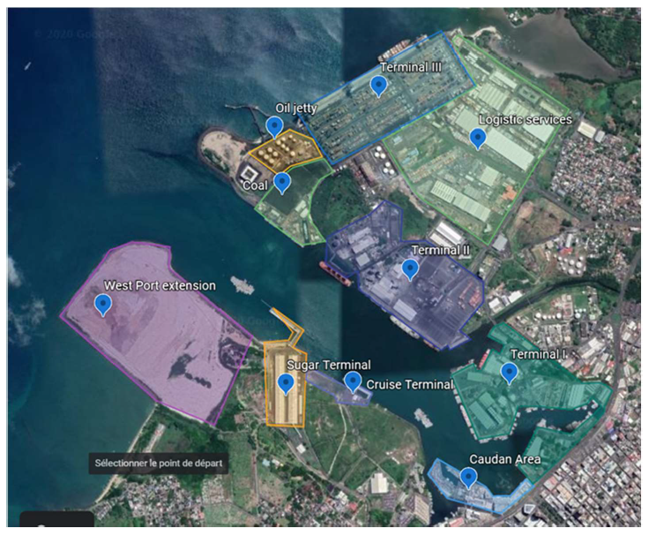
Annex A: Location of the project
Figure 1 : Map indicating the location of the project/programme
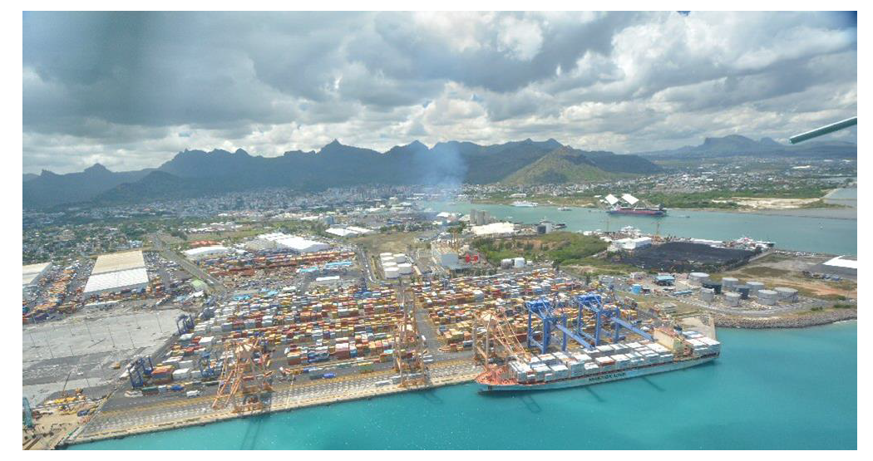
Figure 2 : The port of Port-Louis in Mauritius

Annex B: Results of the breakwater simulations for the two selected scenarios

Scenario 1: T 100 actual
The T100 reference hazard is based on the track of cyclone Chantelle-Daniella, shifted to the northeast so that the eye of the cyclone passes over Port Louis. The wind and pressure values are those of cyclone Cilida, with values at Port Louis corresponding to a 100 years return period.

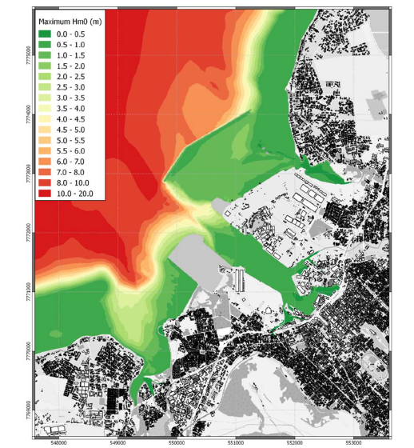

Figure 3: Maximum significant wave height – T100 actual – Long breakwater

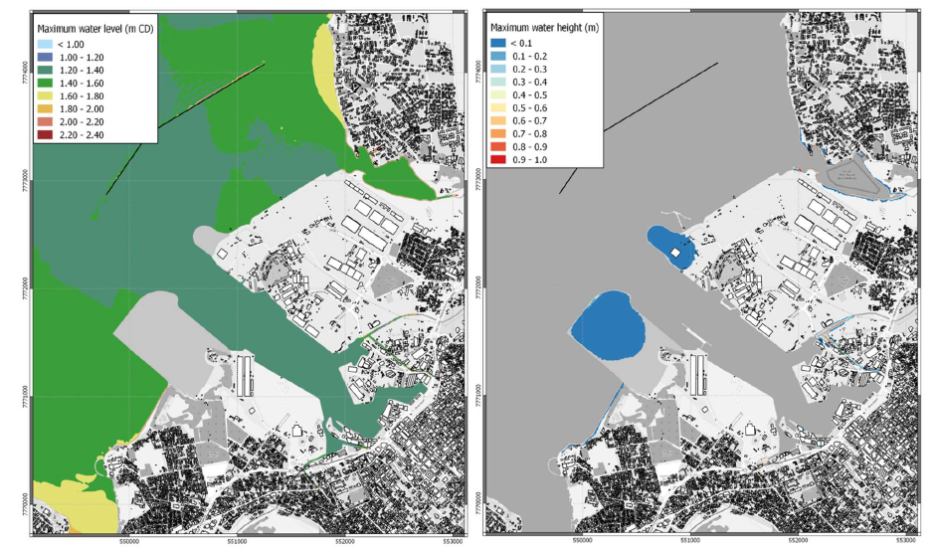

Figure 4 : Maximum water level (left) and maximum water height (right) – T100 actual - Long breakwater

Scenario 2: T 100 mean future
The T100 mean scenario is based on the track of cyclone Chantelle-Daniella, shifted to the northeast so that the eye of the cyclone passes over Port Louis. The wind and pressure values are those of cyclone Cilida, with values at Port Louis corresponding to a 100 years return period. In addition to a +3.3% on extreme wind speed, a -3.3% on minimum cyclone pressure and a sea level rise of +0.47 m.
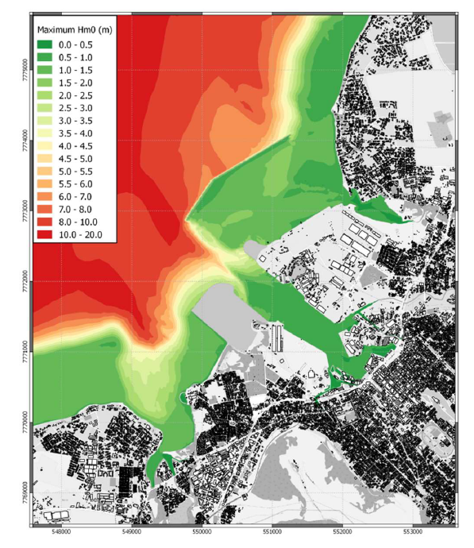
Figure 5 : Maximum swell significant height – T100 mean future – Long breakwater

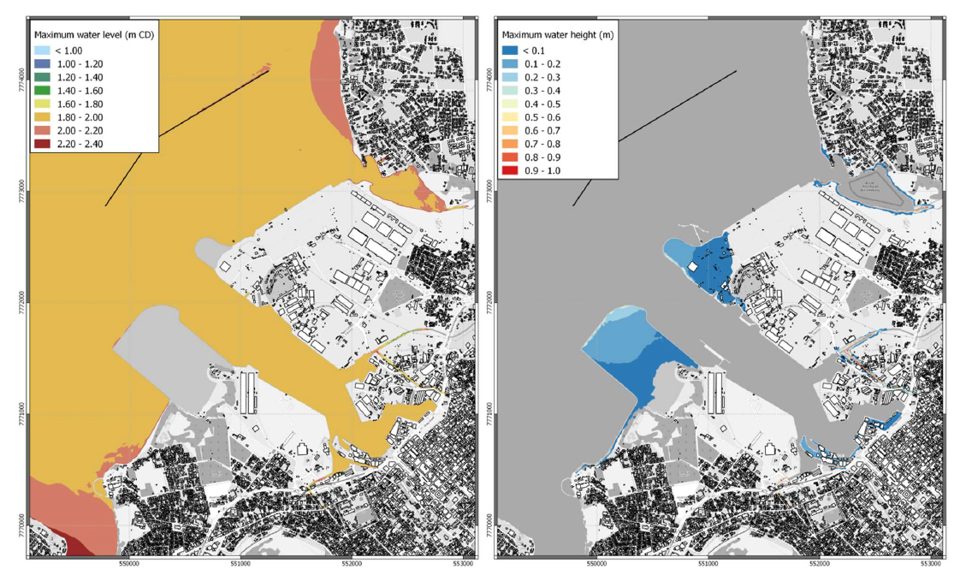
Figure 6 : Maximum water level (left) and maximum water height (right) – T100 mean future - Long breakwater

Annex C: ToC diagram

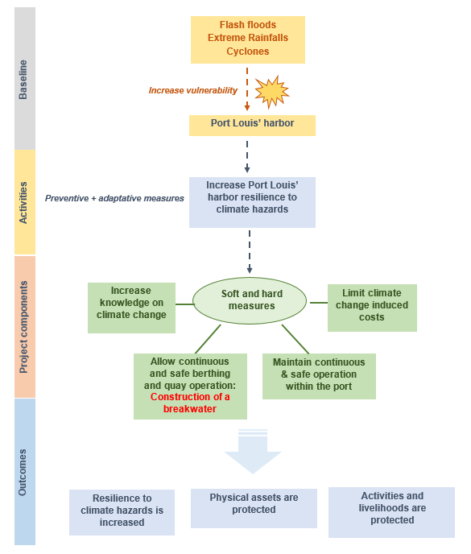

Figure 7 : ToC diagram for the adaptation project in Port Louis' harbour

Concept notes (or sections of) not marked as confidential may be published in accordance with the Information Disclosure Policy (Decision B.12/35) and the Review of the Initial Proposal Approval Process (Decision B.17/18).
See here for access to project preparation support request template and guidelines
Refer to the Fund’s environmental and social safeguards (Decision B.07/02)
https://unfccc.int/non-annex-I-NCs

