Preliminary project outline

Resiliency of productive landscapes and ecosystems in the Caribbean Corridor of Dominican Republic

CATIE

- Draft project baseline, justification and alignment with policies, plans and programs that are active in the country, highlighting opportunities for synergies and coordination

Dominican Republic presents high exposure and sensitivity to climate change and extreme weather events, that impacts livelihoods

Dominican Republic is a Small Island Developing State. It is also a middle-income country with a high population density of 220 people/km² and the tenth country in the world most affected by climatic catastrophes during the last 20 years, when it suffered 49 extreme weather events. In 1998, Hurricane Georges caused damages and losses equivalent to 14% of GDP and the tropical storms of 2007 forced a reorientation of the economy and governmental priorities. In 2016, the country was strongly impacted by Hurricane Matthew, which caused material destruction estimated at US $243 million and loss of human lives. In addition to these catastrophes, since 2014, the Dominican Republic has experienced intensified droughts due to the El Niño, with significant impacts on crop production (e.g. reductions in agricultural production up 15% due to severe drought conditions in 2010, and of 95-100% of second rice harvest for 75% of rice producers in the Monte Cristi province as a result of 2015 drought), the availability of water for human consumption and the generation of hydroelectric power. At the national level, 48.4% of the country’s territory is considered critically sensitive to desertification, and 16.4% of it highly critically sensitive. Sensitivity to desertification is mainly due to intense and inadequate land use practices. In addition, frequent fires are a serious driver of degradation in these areas and their control is a national priority.

The current situation is expected to worsen in the next decades

For the period 2030-2050 a substantial increase in the frequency of extreme droughts and heat waves is expected, which will affect the capital Santo Domingo, where 35% of the country's population lives. Climate prBojections reveal increases of temperature up to 2.5 ºC by 2050. In addition, the intensity of tropical storms and associated precipitation is expected to increase, exacerbating the damage caused by these phenomena, including that caused by more frequent and intense floods. Finally, the Dominican Republic is a critically important component of the Caribbean Biodiversity Hotspot. More than 70% of the plant species and almost 100% of the herpetofauna of this hotspot are endemic. The country's forest cover recovered from 28% in 1996 to 39% in 2012, mainly due to natural succession. However, the variation and change of climate and the associated drivers of degradation are a serious threat to this unique biodiversity and the key contribution it makes to the resilience of the country's agricultural and forestry production, as well as tourism.

The proposed project area is key for the national economy, sanitation and food security, but is highly threatened by climate change

The Central Cordillera-Los Haitises Corridor (Figure 1) is one of the most important areas of the country in terms of demographic and productive perspective, agricultural and forestry productivity and the regulation of water resources. It is therefore critically important to ensure adaptation to climate change in the corridor, as well as the maintenance of its mitigation functions. A recent analysis of vulnerability to climate change in the corridor predicts changes in the rainfall seasonality and increases of temperature up to 2.5 ºC by 2050. Temperature increases, the impact of droughts and floods, together with the dangerous high sensitivity to desertification will impact agricultural and forestry systems and groundwater in the watersheds that comprise the corridor (Yaque del Norte Integrated Watershed, Yuna, the middle and upper Ozama-Isabela, and those of the rivers Nizao, Duey, Haina and Ocoa). The latter two watersheds are crucially important for the provision of water for more than 4 million people in the city of Santo Domingo and its surroundings.

A field visit and consultation with local actors (Annex 2) characterized the environmental conditions in the area, which faces issues related to the degradation of natural resources (including soils and forests), over exploitation of certain resources, mismanagement of agriculture and livestock systems, vulnerability to climate change and climate variability, lack of adequate land and water planning, among others. Therefore, the key livelihoods and productive sectors along the Corridor are threatened by extreme droughts, periods of torrential rains, climatic variation and climate-driven outbreaks of pests and diseases.

In summary, the status of crops and tree cover in the area is as follows:

  - Coffee: Devastated by coffee leaf rust (Hemileia vastatrix) between 2005 and 2015, it registered an 84% drop in production at the national level, but it is slowly recovering with resistant and high production varieties.
  - Cocoa: Dominican cocoa is known for its finesse and the country is a world leader in organic cocoa. Production at the national level grew by 322% in the last decade. However, the sector is threatened by the expansion of moniliasis (Moniliophthora roreri) in the Caribbean region. The varieties of cocoa currently cultivated in the country are susceptible to that disease, which could cause the loss of up to 50% of the cultivated area and a reduction of 40-70% of the yield per hectare in plantations under production.
  - Both coffee and cocoa are highly sensitive to climate change, are currently managed in low densities, and both require adaptation actions that will have synergies with mitigation.
  - Livestock: This sector is currently under being strengthened to combat the drivers of degradation and to promote an economically efficient management adapted to new climate conditions and low in emissions.

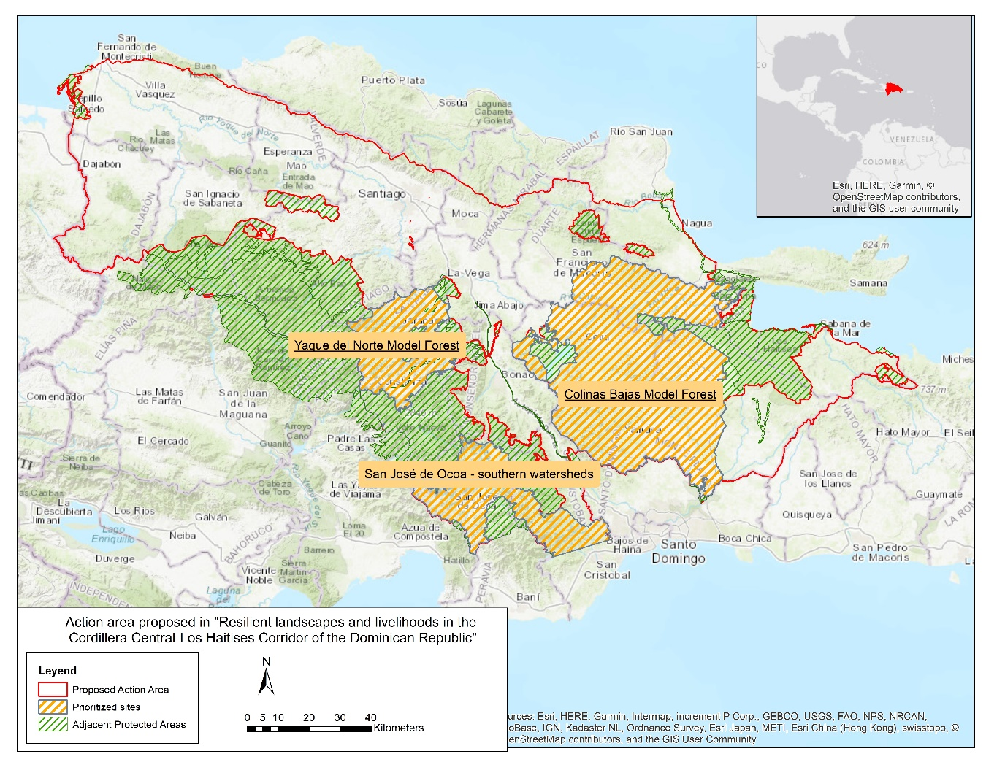
Figure 1. Area of influence (red outline) and priority landscapes (black circles) of the “Resiliency of productive landscapes and ecosystems in the Dominican Caribbean Corridor” Project.

  - Forestry: Forests and forest plantations show a high potential for sustainable production, promoted by the Dominican Chamber of Forestry and based on the relatively extensive forest cover, the abundance of species with excellent behavior in plantations and agroforestry systems, and by natural regeneration of valuable species. The presence of private companies innovating in the clonal production of high value tree species is a key factor, which is common to coffee and cocoa.
  - Intensive crops: The Dominican Republic is self-sufficient in rice production, which is concentrated in the northern productive agricultural regions of the country, including the flat areas of the Corridor. However, 98% of the production is achieved under irrigation and is therefore vulnerable to both droughts and floods. In addition, management of those crops compromises water quality (agrochemicals, sediments, etc.) and availability downstream.

On the other hand, the socio-economic and institutional situation increases the pressure over those environmental resources. As an example, the reduction of agricultural productivity due to droughts and extreme weather events causes food insecurity and promotes deforestation and further degradation. In addition, the country faces social issues such as a generalized lack of opportunities in the rural area (employment, market access, economic alternatives such as rural tourism, etc.), illegal immigration, lack of generational integration, governance weaknesses and disconnection among governance platforms and actors, lack of appropriate policy frameworks to face climatic threats and scarce coordination among national authorities (e.g. isolated work of ministries of environment and agriculture).

Climate change, climate variability and extreme hazards will compromise the livelihoods of millions if restoration, conservation and sustainable management of ecosystems and agroecosystems isn’t implemented soon

The severe climatic hazards and climate variations that affect the project area, in conjunction with the environmental and socioeconomic conditions described previously, are exacerbating the degradation of landscapes and ecosystems, including the crops with the highest potential, as well as the hydrological network. Human well-being is seriously threatened by these trends in both rural and urban areas, in a context of inequality, rural poverty and challenges to food, nutritional and, above all, water security. Thus, adaptation to climate change is a national priority in the Dominican Republic (see the country’s INDCs).

The project draft is consistent with national regulatory and legal framework

Based on the current situation identified, a potential project for the area will have three main components. The first one will focus on climate resilience of landscapes and ecosystem services. The second one will promote diversified livelihoods to improve business capacities and develop local economies. To enhance promote enabling conditions for the sustainability of the project’s proposed actions, the project will also need to focus on strengthening institutional, policy and governance frameworks and participatory intersectoral platforms. These components form a cohesive package of interventions that are aligned with national frameworks, as described below.

Proposed interventions are aligned with the vision, strategic axes and expected results described in the National Development Strategy (2010-2030 - NDS), while the fifth responds to the requirement to develop specific in-country capacities (e.g. institutional capacities for implementing adaptation strategies), highlighted in the NDS. Proposed activities will address both adaptation and mitigation needs, contributing to NDC commitments, the guidelines included in the National Action Plan for Climate Change Adaptation (2008), the Strategic Plan for Climate Change 2011-2030, and instruments such as the Disaster Risk Management Plan, among others supporting specific adaptation measures in productive sectors. Climate change mitigation activities promoted by the project are complementary to efforts conducted by the government, such as NAMAs and the ongoing Strategy for Sustainable Livestock. The project will implement CATIE’s unique approach for promoting synergies between adaptation and mitigation through transversal regulations, specific frameworks for natural resources use, primary sector, rural tourism, etc.

- Description of proposed activities and interventions needed to address identified problems and barriers

Problem statement

The territory under consideration has low resilience to the effects of climate change and adverse climate events. The severe climatic hazards and climate variations affecting the prioritized intervention area also exacerbate the on-going degradation of productive landscapes and ecosystems and the hydrological network. A lack of comprehensive policy frameworks and failure of laws and regulations to effectively increase the adaptive capacity of the population and mitigate the causes of climate change, in combination with poverty, weak governance platforms, and lack of technical knowledge, also make the Dominican rural sector socially, economically and environmentally vulnerable.

Furthermore, the Dominican government lacks specific knowledge and technologies for managing landscapes, ecosystems and hydrological networks, strengthening local markets and creating opportunities for rural communities. Finally, work of public and private institutions is uncoordinated to incorporate climate action in national and local land planning and implement innovative solutions for long-term resilience. Thus, human resilience and well-being are seriously threatened in both rural and urban areas.

Barriers to solving the problem

a) Inadequate knowledge, information and technologies for the management of landscapes, ecosystems and hydrological networks and scarce incorporation of climate action in national and local land planning. Proposed interventions are designed to overcome weaknesses and mismanagement in production systems and the use of natural resources such as water.

b) People currently involved in agriculture, agroforestry, livestock and forestry value chains do not have the skills, market information or other competencies necessary to maximize the potential of their products in a context of climate resilience. This project will provide the needed tools, knowledge and opportunities to small and medium local enterprises for overcoming new challenges imposed by climate change.

c) Capacities and resources of existing territorial governance platforms need to be consolidated to move towards integrated, climate-change resilient governance of ecosystems and hydrological networks. Project actions will strengthen the existing platforms, their capacities and communication networks while promoting the implementation of strategic planning.

d) Neither public nor private Dominican institutions have enough technical capacity to implement existing mitigation and adaptation policies, nor to implement the innovative solutions that will be built by the project. Proposed capacity building efforts are aligned with these needs and are geared towards enhancing local and national capacities to face climate, productivity, and land degradation challenges.

Proposed components of a project that will overcome the identified problem

Overarching project objective

The project will strengthen the climate resilience of rural communities in the Dominican Republic through the implementation of landscape and local-scale ecosystem-based adaptation (EbA) focused on the agroforestry and forestry production systems of highest potential for future sustainability, developing capacities and stimulating the growth of an enabling environment of appropriate policies, laws, economic incentives and participatory landscape governance.

Project area

The three intervention areas are in the Central Cordillera-Los Haitises Corridor (Fig. 1) and comprise the watersheds of Yuna, the middle and upper Ozama-Isabela, and those of the rivers Nizao, Duey, Haina and Ocoa). The latter two watersheds are crucially important for the provision of water for more than 4 million people in the city of Santo Domingo and its surroundings. Selection criteria included vulnerability to climate change and climate extremes, the existence of an active territorial governance platform, allowing scaling of the enabling conditions they provide, current desertification risk (Izzo et al 2013), future water demand and availability (INAPA) for human health and well-being, as well as crop irrigation, and potential for implementing key project interventions (presence of coffee, cacao or other prioritized crops, degraded pastures or degraded forest cover)

Components/outputs and subcomponents/activities that will lead to the expected outcomes

To achieve the overarching project objective, the project approach sets forth a paradigm shift towards participatory integrated approaches to ecosystem and water management at the landscape scale, rather than sectoral development models. Thinking at the landscape level places the emphasis on multi-functionality and socioecological interactions among people, ecosystems and natural resources, and opens a dimension in which synergies between mitigation and adaptation can be achieved through careful planning of interventions that balance and potentiate carbon and other cobenefits together. This paradigm shift combines EbA at the farm level and at the landscape level, through a high diversity of sustainable land uses. It emphasizes the interactions between natural capital and the ecosystem services it produces.

In line with the Millennium Ecosystem Assessment, the approach i), conceptualizes agricultural and forestry production as an ecosystem service, and ii), considers human livelihoods and food and water insecurity as both affecting and depending on ecosystems, and therefore on climate variability and change. A paradigm shift of this magnitude critically requires an enabling environment and capacity building. The full theory of change for this project is included in section 4 of this document.

Based on the previous reasoning, the project will implement EbA actions in three priority landscapes in the Corridor, and their farms and main production systems (component 1), by identifying the most vulnerable value-chains and the implementation of adaptation actions to support the sustainable improvement of the livelihoods of people and communities (component 2) in an enabling environment orientated around a changed paradigm prioritizing climate change adaptation (component 3). Capacity development and communication will be cross-cutting. A description of these components follows.

Component 1: Resilient landscapes, ecosystems and ecosystem services

Output 1: More resilient landscapes and ecosystems, with adaptation and mitigation measures implemented.
This component will introduce EbA measures for the restoration of the socio-ecological functions of the priority landscapes, their agricultural, agroforestry and forestry production systems, and progress towards sustainable water supply from the associated watersheds. A direct contribution will be made to increasing the resilience to climate variability and change of farms and yields of the main production systems (coffee, cocoa, livestock, homegardens), enhancing progress towards country adaptation and mitigation goals, improving rural people’s wellbeing and addressing the indicators of development and sustainability (SDGs). A multiple-scale ecosystem-based adaptation (EbA) approach will be introduced to achieve production-adaptation-mitigation-well-being synergies and at the landscape scale, harness the contribution to resilience of a variety of natural systems in the landscape such as wetlands that store water during floods, and natural vegetation on slopes that can protect against landslides during heavy rains.

Component 1 activities:

Analysis and planning. The project will identify, prioritize and communicate EbA practices for the management of each of the three landscapes, their natural and agro-ecosystems and water resources. These practices will be identified based on fully participatory analyses of vulnerability to climate change, diagnoses and action plans. Adaptive landscape restoration will be both progressive and transformational. In each landscape, current and future areas with aptitude for the major production systems, as well as groundwater recharge and runoff, will be modelled for the year 2050. Dynamic land use planning for adaptation will be carried out and communicated.

Implementation. At the farm and production system levels, ongoing adaptation strategies will be identified; the potential contributions of new pest-resistant and highly productive coffee and cacao clonal varieties will be determined; improved shade-management technologies will be introduced to facilitate adaptation to temperature increase and drought. Home gardens will be improved or introduced. Other adaptation practices likely to be introduced – all of which will also diversify livelihoods and contribute to mitigation - include improved tillage (to increase the organic carbon in soils while reducing erosion during extreme weather events); crop residue management (to increase the soil organic matter, while supporting biological process and nutrient cycling), integrated nutrient management (e.g., through the use of green manures and planting nitrogen-fixing crops to improve soil quality, while increasing the amount of carbon and nitrogen retained in the soil, and decreasing the need for agrochemicals), crop diversification (to reduce risks for farmers when faced with unexpected weather conditions), rotational grazing of livestock (to enable the regeneration of vegetation and prevent degradation. Water-related practices to be potentially implemented based on their relevance and potential benefits include improved water management (water harvesting, irrigation, terrace systems and other strategies to improve water-use efficiency)

Component 2: Livelihoods of people and communities

Output 2: Diversified livelihoods, local economy improved, and business capacities strengthened.

This component is based on the well-accepted notion that diverse production systems at the farm and landscape levels are more resilient to impacts of climate change. By diversifying crops farmers can have a variety of crops and other products available for commercialization or in-farm use. Also, by promoting more diverse production systems complementary ecological niches can be established and taken advantage of by different plant crops and livestock. In addition, several income streams can be built into farming systems to strengthen or even increase farm incomes. Having multiple crops, products and income streams requires that farmers enhance their management capacities, and their commercial awareness and entrepreneurship so that they can earn better access to value chains and markets.

Component 2: activities

Climate-resilient value chains. Agricultural and forestry value chains will be selected based on their vulnerability to climate change, their impact on the sustainable use of natural resources and the livelihoods of communities in the prioritized landscapes. They will include cocoa, coffee, meat and milk, timber and macadamia. The determination of climate-induced vulnerabilities in the respective value chains, and the corresponding action, will be carried out under component 1. New business opportunities will be established, networks and businesses strengthened or created through innovation and development processes (including compliance with quality and safety criteria, integration of processing technologies, among others). Key commercial alliances will also be promoted, and negotiations monitored. Commercial events (such as business roundtables) will be organized with all chain actors (processors to international buyer companies). Associative rural enterprises will be strengthened by providing technical assistance and facilitation, and establishing a capacity building plan which will include administrative, financial, commercial and organizational management.

Home gardens. Family needs and strategies will be assessed, and home gardens improved or implemented in about 6000 family units through annual field schools, implementing technical assistance, and implementing additional support (e.g. seeds, access to funding opportunities, etc.) in the three intervention areas. Field schools will observe EbA principles, emphasize the roles of women and youth, and consider cross-cutting issues such as sanitation, nutrition and safety management of agricultural products.

Component 3: Strengthening of institutional, policy and governance frameworks

Output 3: Strengthened institutional and policy frameworks and participatory platforms for landscape governance and sector development

This component will support and accompany government, private sector and community institutions in creating enabling conditions to harness EbA at landscape and local scales to fulfill sustainable development needs. The creation of laws, legal instruments and economic incentives that respond to the goal of EbA-based sustainable development in the three landscapes will be stimulated, while existing platforms for participatory landscape governance will be strengthened and the governance approach scaled out.

For this, the project will design and promote economic incentives to encourage the sustainable management of production systems and landscapes. This will include developing plans of action towards a profitable agriculture made sustainable through EbA, integrated at the landscape scale through planning and adaptive management focused on the effective conservation, restoration and watershed management.

Component 3 activities:

Development and promotion of laws, legal instruments and economic incentives for landscape-scale EbA. To support large-scale transformative action that encourages diversified production, opens access to sustainable value chains and markets, and takes advantage of financial incentives proper legislation must be in place. The project will work with the legislature and decision-makers to strengthen existing regulation or promote new laws that promote economic dynamics and market access. The project will also link rural and market dynamics between farms and urban areas by promoting economic incentives so that production can be enhanced.

Strengthened and scaled participatory local governance platforms. Dialogues for the participatory governance of landscapes in the project area and sectorial platforms (coffee, cacao, livestock, forestry) will be strengthened and focused on resilience to climate change. The primary focus will be on networks of key actors in the landscape, including their mechanisms and instruments of dialogue, consensus building and decision making, and communication within and outside the networks, to increase capacities to plan, manage and evaluate in a resilience framework. The project will carry out diagnoses of governance and agricultural commodity production groups, their context and current challenges. For each existing platform, participatory design and implementation of strategies to strengthen territorial and sub-sectoral governance will be carried out. Leadership and institutionality for climate-resilient co-management of landscapes, watersheds and value chains through local bodies or committees and related regulations will be promoted.

Capacity development. This component cross-cuts and complements the previous ones by providing technical, managerial, marketing and other specific capacities towards climate resilience to different stakeholders involved in the proposal. To achieve long-term changes that ensure the sustainability and permanence of our interventions in terms of sustainable climate-resilient management of landscapes, natural and agro-ecosystems and the improvement of livelihoods depending on those, local capacities must be strengthened, and specific knowledge must be systematized and transferred. This component will provide capacity building through workshops, courses, training of trainers, multi-subject and multi-sector farmer field schools, multi-stakeholder dialogues and exchanges of successful experiences, among other methods, to reinforce public and private extension services, farming communities, producers’ organizations and rural enterprises and government institutions.

Underrepresented social groups (ie. youth, women) directly targeted among the many actors identified. For example, female presence will be included in the socialization workshops, consultation events and working sessions for preparing the proposal. In addition, these workshops will address gender issues to assess the situation in the study area and guide the technical recommendations in a more appropriate way. Among the technical recommendations for the adaptation of productive systems and the improvement of value chains, gender aspects will be considered to include women in decision-making at the farm and business level and in training programs for women, so that they are linked to long-term production systems. Enabling conditions for enhancing the participation of women, such as gender sensitization across technical assistance actions will be promoted. Also, affirmative gender actions will be used to promote the inclusion of women; for example, appropriate meeting times, adequate gender mediation, and targeted actions to guarantee full and effective participation during meetings and workshops.

- Complementary ongoing projects and programs in Dominican Republic

Currently, there is a significant number of projects and initiatives in Dominican Republic that partially address the identified problem (Annex 1). Projects managed by the Ministry of Agriculture are small, with a duration of two or three years and actions in one or several provinces. Cooperation projects funded and/or led by international institutions, on the other hand, tend to be larger, implemented over larger areas and in coordination with several Dominican institutions. Nevertheless, none encompass the proposed components of this project (access to markets, local governance, enabling conditions for climate change adaptation and capacity building).

There are several initiatives improving the management of natural resources and productivity (Component 1). However, these mainly focus on a specific crop (coffee, cocoa, or rice) or water resources management, instead of offering a holistic approach to addressing management and production challenges, as is being proposed here. Current experiences related to access to markets, development of products, etc. (Component 2) are carried out at a small scale. Progress so far and key lessons learned will be potentiated and extrapolated to a broader area with the implementation of this proposal. Improving governance (Component 3) is not relevant among current projects, so this is a key component that this proposal addresses directly because previous experiences demonstrate that local buy-in and appropriation are mandatory conditions for sustaining project impacts and conserving natural resources. Some efforts have been made aimed at providing information to decision makers and at generating spaces for dialogue, however, due to the scale and scarce intersectoral character of previous initiatives, these efforts must be reinforced so that strong political enabling conditions for improved resilience exist (Component 3). Finally, capacity building (Component 3) and aspects of management, marketing and governance are included in several initiatives. However, the scope of previous projects is limited, and none are addressed in the cross-scale and multi-actor approach proposed here.

Finally, a World Bank proposal currently in its public consultation phase has a similar orientation, area of action and schedule to the one being proposed (Annex 3). There are, however, large differences in focus (e.g. they are addressing infrastructure) and target populations. In any case, it is recommended to look for synergies and collaborations with said project once begun.

One particularity of all the projects underway is the scant information available online. To integrate progress and lessons learned from initiatives already underway, as well as to coordinate actions with them and other, yet to be identified interventions, on-site work and contacts with key personnel will be required during the preparatory phase of the full proposal.

- Preliminary theory of change for the “Resiliency of productive landscapes and ecosystems in the Dominican Caribbean Corridor” Project

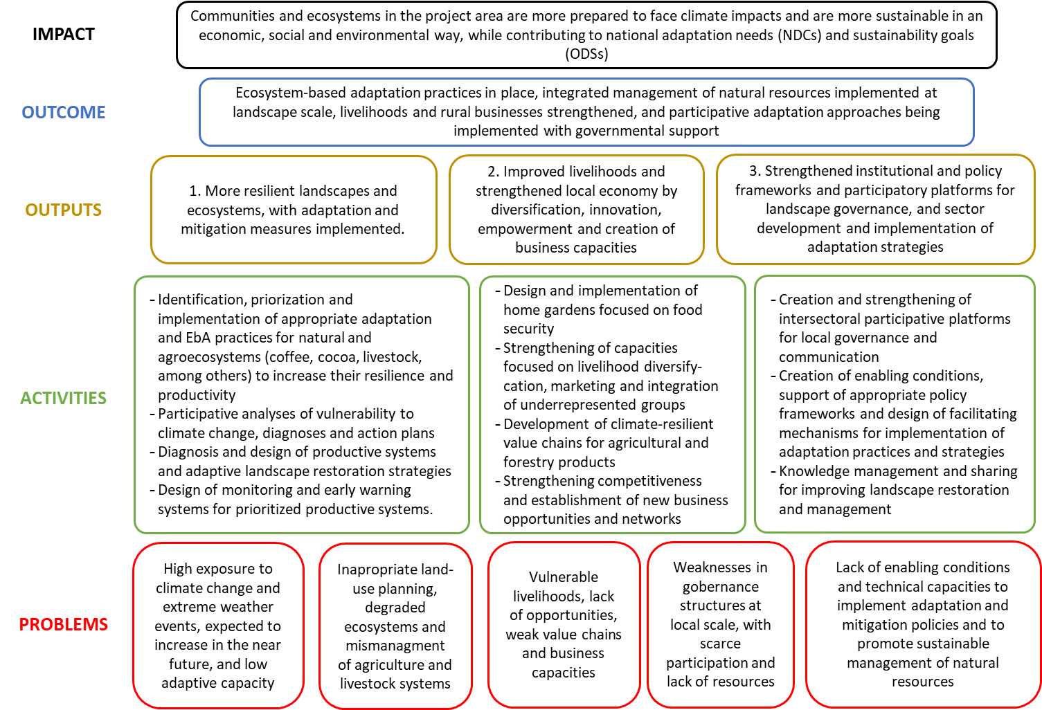

Annex 1. List of complementary ongoing projects and programs active (or in public consultation) in Dominican Republic, indicating objective(s), impact area and potential interactions with the components of this preliminary project outline.

 |  |  |  |  |  |  |  |  |  |  |  |  |  |  | Component interactions
Type | Status | Name | Profile | Objectives |  |  | Scale |  |  | GCF topics |  | Total amount | Funding Agency | Implementer | 1 | 2 | 3 | 4 | 5
Project | Ongoing | Technological and financial alternatives for renovating, rehabilitating and promoting coffee plantations in Dominican Republic | Coffee farming | Calibrate a model to renovate and rehabilitate coffee plantations that will provide robust quantitative information to guide the government’s national coffee renovation plan and private and state bank financing for producers. |  |  | National |  |  | Partial |  |  | Fondo de ciencia y tecnología de República Dominicana (FONDOCYT) | CATIE & CODOCAFE | *** |  |  | *
Project | Ongoing | Programa Centroamericano de Gestión Integral de la Roya del Café (PROCAGICA) | Coffee farming | Contribute to address climate change and its effects through adoption and application of adaptation, mitigation, and environmental and climate disasters risk reduction measures in coffee growing areas of Dominican Republic |  |  | Sierra de Bahoruco |  |  | No |  |  | European Union | CATIE, IICA, CODOCAFE and coffee institutes in other countries | *** |  |  | **
Project | Ongoing | Good governance practices in Dominican Republic | Gover-nance |  |  |  |  |  |  |  |  |  | Dominican Republic government | Intermon Oxfam |  |  | **
Program | Ongoing | San Juan Province Production and Competitivity Development Program (IDB No. 3107/OC-DR) | Productivity and Markets development | Contribute to agriculture production development and export capacity of the San Juan province, improving access to credit by agriculture producers and small and medium-sized enterprises, market access, reducing terrestrial transport costs and use of available water resources. |  |  | Local (San Juan de la Maguana Province) |  |  | No |  | US$ 38.3 million | IDB | MA | * | * |  | * | **
Project | Ongoing | Building production systems for the agriculture reconversion in  San Juan de la Maguana | Productivity and competitivity | Enhance income and livelihoods of farmers in the San Juan province, improving their agriculture production competitivity. |  |  | Local (San Juan de la Maguana) |  |  | No |  |  |  | MA | * | * |  | *
Project | Ongoing | Support to improve innovation of agriculture technologies in Dominican Republic (PATCA II) | Technological innovation | Invest in technology development to increase agriculture income and productivity of farmers adopting new technologies. |  |  | National |  |  | Partial |  |  |  | MA | * |  |  | *
Project | Ongoing | Improving agro-food sanitation and innocuity in Dominican Republic (PATCA III) | Strengthening sanitation and innocuity services | Contribute to enhancing productivity of the agriculture sector and improving access of national products to national and international markets by strengthening the government’s capacity to provide and integrate access of animal and plant health, and agriculture produce innocuity. |  |  | National |  |  | Partial |  |  |  | MA | * | * |  | **
Project | Ongoing | MERCADOM | Markets | Building, complementing and running the Santo Domingo City Network of Markets and expanding the network to the Cibao region and the San Juan de la Maguana province. |  |  | Regional (Santo Domingo, Cibao, San Juan de la Maguana) |  |  | Yes |  |  |  | MA |  | **
Project | Ongoing | Improving rural economic development in central and east provinces of the country (PRORURAL Center & East) | Value chains | Promote and strengthen capacities of men, women and youth and their beneficiary organizations (community, territorial, economic and social) to ensure active participation in executing project activities and ultimately enhance the sustainability of income and quality of life. |  |  | Regional (20 central and east provinces) |  |  | TBD |  |  |  | MA |  | ** | *
Project | Ongoing | Improving the development of economic organizations of rural poor along the border (PRORURAL Oeste) | Organization and markets | Increase income and assets of poor men, women, and youth members of economic organizations through an equitative, environmentally sound participatory process on the 11 provinces along the border |  |  | Regional (11 border provinces) |  |  | Partial |  |  |  | MA | * | ** |  |  | *
Project | Ongoing | Integrated Snail Control Project | Annual crops | Reduce the population of Ampularia glauca (snail) under levels that cause economic harm in rice fields |  |  | Regional (Cibao, Sureste y suroeste) |  |  | Yes |  | USD 285.587 |  | MA | *
Project | Ongoing | Corn improvement (Achaparramiento de Maíz) | Genetic improvement / annual crops | Obtain and validate improved varieties of corn, enhance crop productivity, and improve agronomic management |  |  | Regional (San Cristóbal and Puerto Plata Province) |  |  | No |  | USD 33.860 |  | MA | **
Project | Ongoing | Institutional strengthening for the rural territory development of Barahona (PRODESUR) | Institutional strengthening, Technical assistance, improved production and capacity building | Strengthen capacities of agriculture producers and of their organizations and territory organizations in Barahona, as part of a cohesive rural territory development with END and ECADERT |  |  | Local (Barahona) |  |  | No |  |  |  | MA, INDRHI, IDIAF, Banco Agrícola, CODOCAFE, IAD, AECID and NGOs. |  |  |  |  | ***
Project | Ongoing | Reforestation and social development in the Sierra, San José de las Matas | Ecological and social planning | Consolidate and expand Ecological and social reorganization of the Sierra by supporting Plan Sierra actions by the French Development Agency |  |  | Local (San José de las Matas) |  |  | Yes |  |  |  | MA | ** |  |  |  | **
Project | Ongoing | Food security special management in the Montecristi province (PESA) | Food security | Improve life quality and food security of families within the PESA intervention area, facilitating frequent access to good quality diet, ensuring good quality crop inputs are innocuous so nutrients consumed promote a healthy, active and productive life |  |  | Local (Montecristi) |  |  | Yes |  | USD 907.200 |  | MA, FAO | *** |  |  |  | ***
Project |  | Strengtheing response capacity of PROSOLI and the Dominican Republic Food Bank | Food security |  |  |  |  |  |  |  |  |  |  | FAO |  |  |  | *
Project |  | Resilience and ensuring timely SAN response to drought in Dominican Republic | Food security | Strengthening technical capacities and functioning of the national emergency commission. The project focuses on improving the generation and systematization of information related to agroclimate risks and provide municipal and national plans with relevant data. |  |  |  |  |  |  |  |  |  | FAO |  |  |  | ** | **
Project |  | Regional CELAC | Food security | Facilitate opportunities for dialogue and generate regional and national capacities to face malnutrition through food and nutrition education as part of the CELAC plan. |  |  |  |  |  |  |  |  |  | FAO, State Secretariat |  |  | * | * | *
Project |  | Building a thematic platform for promoting competitiveness of milk and its derivatives | Sustainable livestock | Improve the competitivity of the national milk sector, emphasizing producers facing greater hardship from the entrance of these products into the national market due to the reduction of trade tariffs that now control their access |  |  | National |  |  | No |  |  | FAO | FAO, MA, CONALECHE and the General Livestock Directorate |  | **
Project | In formula-tion | Resilient Agriculture and Integrated Water Resources Management | Water resources management, agroecosystems management, strengthening capacities and governance | To contribute to improved sustainable landscape management and access to water supply and sanitation services in targeted river basins |  |  | Regional (Yaque Norte, Ozama-Isabela watersheds) |  |  |  |  | $103 Million | WB / French Agency for Development (23Million) / International Bank for Reconstruction and Development (80 Million) | MEPyD, INDRHI, MA, INAPA, MARN | *** |  | ** |  | ***
Project | In formula-tion | Rehabilitating integrated rural service centers (CENSERI) and agroindustries of small farmers’ associations. | Value chains | Institutional development program to enhance quality of life and farmer income. Making available operations capital to associated groups so they can implement sub-projects |  |  | National |  |  |  |  |  |  |  |  | ** |  | * | *
Agree-ment | Ongoing | Coffee cluster of Jarabacoa collaboration agrement | Coffee farming | Direct support to projects of coffee development in Jarabacoa. Providing supplies: seeds, bags, feritlizers, pesticides, netting, and technical assistance |  |  |  |  |  | Yes |  |  | INDOCAFE | INDOCAFE | **
Initiativa | Ongoing | Rural and Environmental Finances (FRA) | Sustainable production | Promote resilience and strengthen productivity of small farmers |  |  |  |  |  |  |  |  | BBVA Microfinance Foundation (FMBBVA) | BBVA Microfinance Foundation (FMBBVA) | ** | *
Program |  | Planning for adaptation | Adaptation/planning |  |  |  |  |  |  |  |  |  | USAID | USAID
Program |  | Improved Climate Information | Adaptation/planning |  |  |  |  |  |  |  |  |  | USAID | USAID
Program |  | Climate and Agriculture | Adaptation/planning |  |  |  |  |  |  |  |  |  | USAID | USAID
Program |  | Climate Adaptation Measures | Adaptation/planning |  |  |  |  |  |  |  |  |  | USAID | USAID
Program |  | Sustainable Cocoa Production | Cacao |  |  |  |  |  |  |  |  |  | USAID | USAID
Program |  | Climate Resilience and Insurance Indices | Adaptation/planning |  |  |  |  |  |  |  |  |  | USAID | USAID
Programa |  | Technical Assistance in Adaptation to Climate Change | Adaptation/planning |  |  |  |  |  |  |  |  |  | USAID | USAID
MA: Ministry of Agriculture; MARN: Ministry of the Environment and Natural Resources; * Potential Interaction; ** Partial Interaction; *** Thematic Interaction and complementarity with the proposal

Annex 2. List of local actors interviewed to characterized the environmental conditions in the project area.

Local partner | Institution type | Potential role | Intervention area | Expertise areas | Website
Enda Dominicana | ONG (International) | Implementing partner | Duarte, Monte Plata, Samaná, Hato Mayor, Sanchez Ramirez, Maria T. Sanchez, La Vega, Monseñor Nouel and San Cristobal provinces | Forest restoration  Conservation of protected areas  Forest management and biodiversity  Sustainable agriculture  Small business development  Land management  Other: urban and rural sanitation | link
Fondo Pro Natura, Inc. (Pronatura) | ONG | Implementing partner | Valle Nuevo, Montaña La Humeadora National Park, Bayaguana, Ozama Watershed, Macasías river, Haina river, Masacre river, Monte Cristi National Park, Cabral Lagoon, Los Dajaos, Constanza, Jarabacoa and San José de Ocoa | Conservation of protected areas and biodiversity  Sustainable management of rural areas and climate change adaptation  Watershed conservation and restoration  DRM and forest fires management | link
Instituto Dominicano de Desarrollo Integral, Inc. (IDDI) | ONG | Implementing partner | Samaná, La Vega, Monseñor Nouel, San Juan de la Maguana, Elias Piña, San Cristobal, Santiago, Monte Plata and Monte Cristi provinces | Climate change adaptation  Renewable energy  Micro-credits  Promotion of public-private alliances  Others: sanitation, infrastructure, wealth education, etc. | link
Asociación para el Desarrollo de San José de Ocoa Inc. (ADESJO) | Civil association | Implementing partner | San José de Ocoa province | Natural resources management  Agriculture and livestock management  Implementation of adaptation practices and technologies: irrigation, soil conservation, etc.  Early Warning Systems (EWS) | link
Asociación para el Desarrollo, Inc. (APEDI) | Non-profit society | Advisor / Subcontractor | Cibao region, mainly Santiago and surroundings | Promotion of public-private alliances  Development of initiatives: infrastructure, economy, water management, Agroforestry diversification and rehabilitation | link
Plan Yaque | ONG | Subcontractor | Rio Yaque del Norte watershed | Management of forest and soil  Other: water, sanitation and waste | link
Servicio Social de Iglesias, Inc. (SSID) | Religious organization | Subcontractor | San Pedro de Macorís, Hato Mayor and Monte Plata provinces, Yaque del Norte low basin and North East Region. | Environmental protection  Agriculture  General development: wealth, education, drinking water, economic development, among others | link
Universidad Agroforestal Fernando Arturo de Meriño (UAFAM) | Academia | Subcontractor | La Vega province and surrounding provinces | Graduate education in forestry, agroforestry, economics, touristic management, etc. | link
Universidad Nacional Pedro Henriquez Ureña (UNPHU) | Academia | Subcontractor | Santo Domingo and La Vega provinces | Graduate education aiming sustainable development and society improvement. | link
Plan Sierra | Non-profit organization | Subcontractor | La Vega and Santiago provinces | Reforestation and carbon | link
Fundación H+D | Non-profit organization | Subcontractor | Elias Piña, Azua and San Juan de la Maguana provinces | Fight against poverty  Promotes development: education, sanitation, housing, drinking water, etc. | link
Fundación Naturaleza / Centro para la educación y acción ecológica Naturaleza (CEDAE) | Educational | Subcontractor | Dajabón, Santiago Rodriguez and Santiago provinces | Human development  Environmental protection and education | link
Corporación Ciudadana Santiago Solidaria | Civil organization | Subcontractor | Santiago, La Vega, Puerto Plata, Valverde and Espaillat provinces. | Promotion of strategies, programs and projects for prevent and mitigate risks  Response to natural disasters, rehabilitation and reconstruction | link

Annex 3. Summary of World Bank proposal on Resilient Agriculture and Integrated Water Resources Management, and brief analysis of similarities and differences with this preliminary project outline (PPO).

 | Basic WB proposal data | Similarities/differences with this PPO
Name | Dominican Republic - Resilient Agriculture and Integrated Water Resources Management | Resilient landscapes, ecosystems and livelihoods in three priority watersheds of the Dominican Republic Project
Type | Development | Development
Dates | Not defined yet | NA
Budget | USD 103 million | USD 25 to 50 million
Proposed area | Yaque del Norte and Ozama-Isabela Watersheds | Partial overlap in Yaque del Norte Highlands and Southern Watersheds, inclusion of Yuna watershed.
Proposed objective | Contribute to improved sustainable landscape management and access to water supply and sanitation services in targeted river basins. | WB proposal is more focused in water resources from a sanitation and disaster risk reduction perspective. Main differences are the use of grey infrastructure and work in sanitation improvement.  In contrast, our PPO outline resilience in an environmental, social and economic perspective, work on multiple productive systems, address DRR as part of EbA and restoration strategies, contemplate to strengthen local governance, institutions and technical capacities to promote resilience at landscape level and pursues a paradigm change.
Approach | Watershed | Landscape
Compo-nents | 1. Sustainable Productive Management of Agroecosystems | Our PPO adds climate change adaptation and mitigation needs.
Compo-nents | 2. Enhancement of Resilience and Management of Hydraulic Infrastructures | NA
Compo-nents | 3. Reducing contamination through Improvement of Water Supply and Sanitation Services in Prioritized Areas | NA
Compo-nents | 4. Capacity Building for Natural Resources Management and Governance, and Project Management | In addition to capacity building, this PPO will strengthen institutional, policy and governance frameworks beyond water management.
Compo-nents |  | No overlap in our component #2 - Livelihoods of people and communities
Beneficia-ries | Direct: 105.000 families (agriculture and sanitation users)  Indirect: 250.000 families by the improvement of dam safety  Others: governmental and non-governmental institutions | Direct: 160.000 men, women and children, in 20 municipalities and 16 provinces representing 1.7% of the national population.  Indirect: More than 500.000 people by water provision and DRM.  Others: Small enterprises, governmental and non-governmental institutions.

German Watch. 2018. Global Climate Risk Index 2018. https://germanwatch.org/en/14638
World Bank. 2013. Estudio de factibilidad de seguro agrícola por índices informe de avance: seguro de índices a nivel macro. 100 pp. República Dominicana.
OXFAM, 2016. Con la seca al cuello. Evaluación del impacto de la sequía. 70 pp. https://www.oxfam.org/sites/www.oxfam.org/files/file_attachments/informe-hea-oxfam-5.pdf
Izzo, M., Araujo, N., Aucelli, P.P.C., Maratea, A., Sánchez, A. 2013. Land sensitivity to desertification in the Dominican Republic: an adaptation of the ESA methodology. Land Degradation and Development 24, 486-498.
Ministerio de Medio Ambiente y Recursos Naturales. 2015. Estrategia Nacional de Manejo del Fuego para República Dominicana. Santo Domingo, Dominican Republic.
Instituto Tecnológico de Santo Domingo, 2017. Científicos pronostican sequía extrema en Santo Domingo a partir de 2020. https://www.intec.edu.do/prensa/notas-de-prensa/item/cientificos-pronostican-sequia-extrema-en-santo-domingo-a-partir-de-2020
United States Agency for International Development. 2013. Dominican Republic Climate Change Vulnerability Assessment Report. USAID, Washington, D.C. 132 p.
Critical Ecosystem Partnership Fund. n.d. Islas del Caribe Hotspot de Biodiversidad. Resumen de Perfil de Ecosistema.
https://www.diariolibre.com/economia/produccion-de-cafe-en-la-republica-dominicana-crece-16-actualmente-IH8382846
http://www.iica.int/es/prensa/noticias/el-cacao-un-cultivo-clave-que-mantiene-la-república-dominicana-como-uno-de-los
https://www.catie.ac.cr/catie-noticias/3402-republica-dominicana-se-prepara-para-el-diseno-de-la-nama-de-ganaderia-bovina.html
Ministerio de Economía, Planificación y Desarrollo. s.f. Documento base de la propuesta de Estrategia Nacional de Desarrollo 2010-2030. Un viaje de transformación hacia un país mejor.
República Dominicana, 2015. Contribución Prevista y determinada a Nivel Nacional INDC-RD. Santo Domingo, Dominican Republic. 4 p.
Millennium Ecosystem Assessment, 2005. Ecosystems and Human Well-being: Synthesis. Island Press, Washington, DC.
Trier, R.C.A. 2018. Dominican Republic - Resilient Agriculture and Integrated Water Resources Management Project (English). Washington, D.C: World Bank Group.

