Instructions to lead Implementers for drafting the

Technical Assistance Closure and Data Collection Report

Objective of the technical assistance (TA) Closure Report and Data Collection Report:
- To communicate publicly in one synthesis document a summary of progress made and lessons learned under the technical assistance (TA) towards the anticipated impact (main template).
- Compile TA-specific information required for internal use in donor and UN reporting (annex 1).

Steps for completing the TA Closure report:
- The lead TA implementer drafts the report at the end of the assignment as a final deliverable /product. The TA Closure report will capture all activities conducted under the TA hence it is expected that duplication of information will occur from earlier documents. Please copy and summarise relevant material from previous TA outputs/deliverables and the Response Plan, as relevant.
- A CTCN Manager will review and revise the report before final approval by the CTCN Director.

Important note on public and internal use of the closure report:
Once approved by the CTCN Director, the TA Closure and Data Collection Report will be a public document available on the CTCN website. Annex 1 is for internal use only and will not be publicly available.

Closure and Data Collection Report for CTCN Technical Assistance

- Basic information
Title of response plan | Strengthening technology transfer platform for Tropical Forest Management and Ecosystem Services to address climate change: "The Costa Rica Green Hub”
Technical assistance reference number | 2016000008
Country / countries | Costa Rica
NDE focal point and organisation | Andreas Meza, Direcion de Cambio Climatico (MINAE), ameza@minae.go.cr / Andreas.mezamurillo@gmail.com
Proponent focal point and organisation | Bernal Herrera, FUNDECOR
Sector(s) addressed | Agriculture and Forestry, Early warning and Environmental assessment
Technologies supported | Disaster risk assessment tools  Hazard mapping solutions  Climate change vulnerability assessment  Open source climate data and tools
Implementation period and total duration | 15 Dec 2017 – 1 Aug 2019
Total budget for implementation | USD 46,875
Designer of the response plan | DNV GL
Implementer of response plan | DNV GL

2. Summary of all activities, outputs and products that contribute to the expected impact of the technical assistance.
Description of delivered outputs and products as well as the activities undertaken to achieve them. In doing so, review the log frame of the original response plan and refer to it as appropriate | Provision of:  • Knowledge management masterclass delivered as a train-the-trainer concept, to allow broad dissemination of the acquired competences  • On-line knowledge management instructional materials, for re-use locally and as part of the Green Hub infrastructure  • On-line coaching to Costa Rican knowledge management trainees to help advance the development of the Green Hub.
Partners organisations
Beneficiaries | Instruction: FUNDECOR, Government of Costa Rica, National Direction of Climate Change, Centro Nacional de Información Geoambiental (CENIGA) Beneficiaries are defined as people and institutions benefitting from the TA
Methodologies applied to produce outputs and products | To produce the outputs, the implementer applied the following tools:  - Google Venture Sprint Methodology  - DNV GL Knowledge Management Methodology  - Mediawiki wiki development environment  - PowerBI dashboard  The methodologies were an on-the-job training taking the shape of the hosting of a training event (Training of Trainers) and remote assistance, and methodologies and methods for the gap analysis.
Deviations | The delivery of the response took longer than originally planned due to external circumstances: the plan to involve stakeholders/future users of the Green Hub was dependent on availability of local stakeholder groups. This proved to be more limited than expected. Equally, data availability for the Green Hub GIS components was hindered due to issues with release of data to the project by the data provider. See official communication from FUNDECOR approved by NDE of 25th of February 2019.
Achieved or anticipated gender benefits from the TA | The Technical Assistance and tools are gender neutral and not specifically targeted to focus on the specific gender needs. Nevertheless, the Knowledge Management Masterclass saw participation of one senior female representative of the Costa Rican government.
Achieved or anticipated co-benefits from the TA | n/a
Anticipated follow up activities and next steps | FUNDECOR will use the guidance and training offered to further detail the prototype of the Green Hub, particularly to expand its decision support capabilities.

- Lessons learnt
 | Lessons learnt | Recommendations
Lessons learnt for this TA.  Describe essential factors contributing to successful implementation, as well as specific challenges. Recommendations include considerations on what would need to be in place for increasing success of similar efforts (i.e. regulatory, legal, stakeholders, communication, etc.) | - It is key to have early stakeholder feedback on prototypes to steer further development.  - Working face-to-face, in the field to socialise KMS vision, associated functionalities and get an early on, full understanding of user needs is essential.  - There are simple, easy to use tools to support stakeholder needs capture, which are centred around the Google Design Sprint model (https://www.gv.com/sprint/)  - To offer decision support to stakeholders in the region, it is essential to provide high quality data from a variety of sources and combine these with textual content (reports, stories from the field). It has proven difficult to source such data from government sources  - The Microsoft PowerBI suite offers relatively affordable easy to implement components to visualise data and provide interactive dashboards for users.  - Development of a KMS needs to be adequately resourced and should not be seen as a purely technical project, although technical issues should not be underestimated, especially issues around data availability and accessibility, data definitions, making data from various sources comparable and combining data with textual information.  - The approach that FUNDECOR is taking using a GIS perspective as a key window to increasing understanding of the climate risk that stakeholder groups in Sarapiqui are exposed to is innovative. Yet, making GIS data truly accessible for non-professional users requires building a dashboard layer between the GIS system and the end users. | Recommend, when the ambition is to create a portal, to use a Google Venture Sprint approach to develop minimum viable products (MVP) quickly, so that they can be discarded quickly as well, in a cost-effective manner. The advantage of this method is that MVPs trigger more reliable feedback than e.g. functional specifications and thus provide the project with a better steer what to do in the next iteration.
Lessons learnt related to climate technology transfer  Describe opportunities, challenges and barriers for the use and deployment of the technology or technologies supported by the TA. The objective is to identify specific success factors for technology transfer | The delivery of a knowledge management wiki (https://www.kmfieldbook.org/) is useful, but can only come to live as a tool if the users add additional information that makes it more contextual for their situation. | If you use a wiki, then provide instructions to prospective authors to add additional information.
Lessons learnt related the CTCN process for TA | n/a

4. Illustration of the TA and photos
For communication purposes, please provide 2-4 Power Point slides with illustrations or charts showing the TA process, applied methodology, activities, outputs and achieved results. The illustrations must be copied into the TA Closure report but must also be delivered as power point files. Also, please provide at least five high-resolution pictures in jpg format, capturing technical assistance. The pictures should illustrate how the TA has impacted the lives of the beneficiaries and the communities in general.

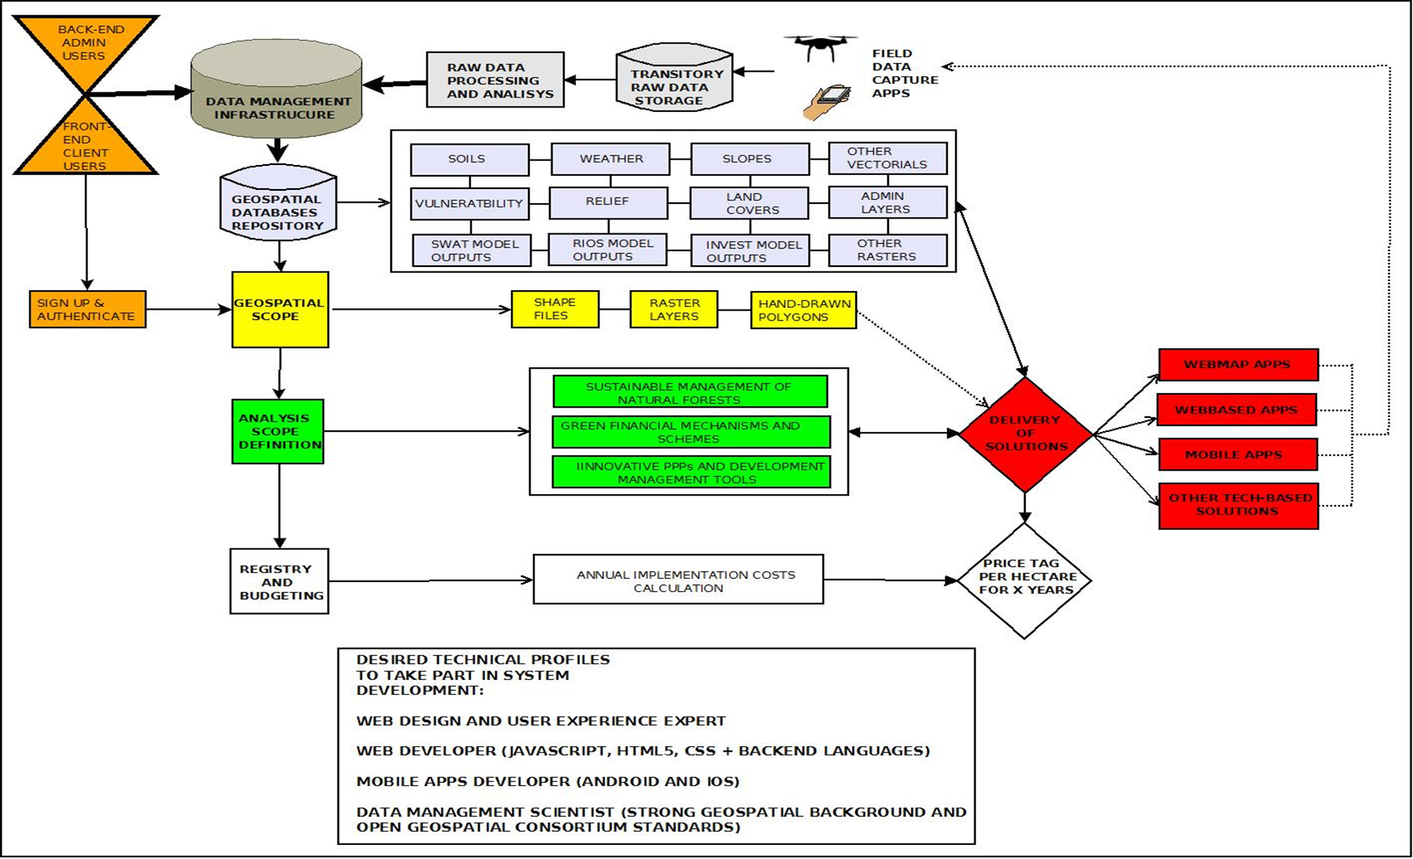

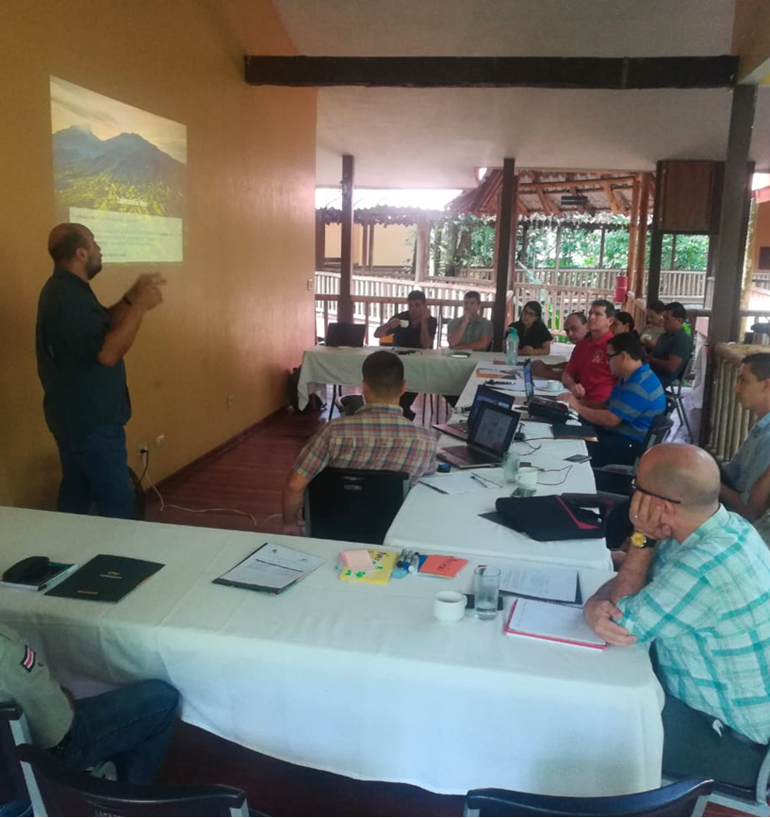 | 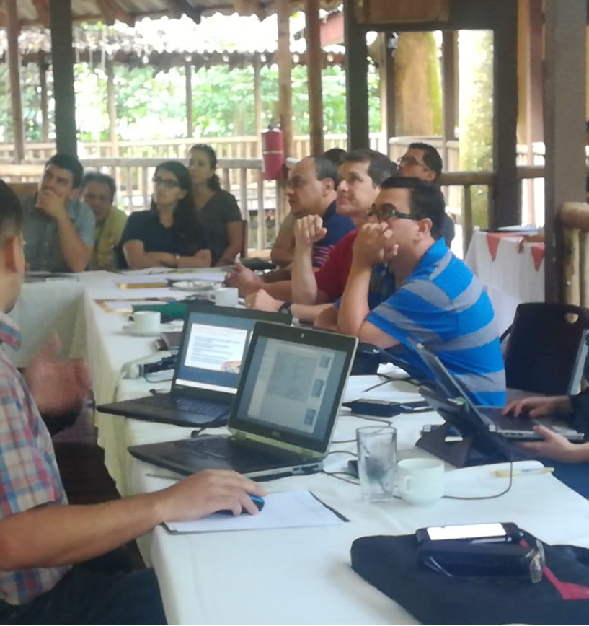

End-user KMS consultation in Sarapiquí, Costa Rica.

5. Information for TA Impact Description
The information in the table below will be used to produce the CTCN TA Impact Description. The TA Impact description is a 2-page summary document for communication purposes.

Challenge: Approx. 500 characters with spaces | The Government of Costa Rica supports the Green Hub, a national, on-line knowledge management system to share information and knowledge on tropical forest resources. At the onset, it appeared that there is a gap in local capacities to manage knowledge using specific components of the GH, such as an on-line platform. Therefore, there is a need to acquire training in the capture, organisation, validation and dissemination of knowledge in the area of mitigation and adaptation to climate change.
CTCN Assistance: 2 to 4 bullet points. Approximately 450 characters with spaces | To address the challenge, CTCN has engaged DNV GL, a leading knowledge management services provider to provide:  - Knowledge management masterclass delivered as a train-the-trainer concept, to allow broad dissemination of the acquired competences  - On-line knowledge management instructional materials, for re-use locally and as part of the Green Hub infrastructure  - On-line coaching to Costa Rican knowledge management trainees
Anticipated impact: 2 to 4 bullet points to summarise anticipated impact. Approximately 250 characters with spaces. As a minimum, please include one of the following: i) Quantity of greenhouse gas emissions reduced, avoided or sequestered; or ii) Number of people with increased capacity to adapt to the impacts of climate variability and change. | Using the intensive train-the-trainer activities during the Knowledge Management Masterclass, Costa Rican nationals will subsequently obtain required training necessary to run effective knowledge capturing events as well as Knowledge Management Master Classes in Costa Rica that will enable assimilation of and access to of key Forest Management knowledge of the resources managers responsible for the management of forest resources within Costa Rica.  Based on training results, the acquired knowledge will be replicated to Costa Rica technical staff involved in the GH design and management. At least 50 technical staff from national institutions will be trained. In the first stage, the information system will be at least used by over 100 natural resource practitioners.
Linkages and contribution to NDC: 2 to 4 bullet points. Approximately 350 characters with spaces | This work is in line with the National Development Plan 2015 – 2018 and contributes to the further development of the National Strategy for Climate Change Adaptation and National Adaptation Plan  The training and its outcomes will also contribute with national NDCs, as follows:  - Contribution to the Costa Rican goal of carbon neutrality for 2021.  - Provide capacities and information for the design of ecosystem-based adaptation strategies  - Enhance the lessons learned of the payments for environmental services.  - Contributes with the land use managing plans and landscape management.
The narrative story: Approximately 1200 characters with spaces | Poor capacity to access, absorb technological options and a lack of knowledge to operation and management of new technology are barriers to achieving the spread of essential national and international knowledge in tropical forestry and resource management. This domain is key in battling climate change effects in Costa Rica.  Costa Rica is aiming to address this challenge by supporting the creation of an on-line platform (the Green Hub) that brings together key stakeholders around a repository of good practices and lessons learned in the domain of tropical forestry and resource management in particular. To successfully launch and sustain such a platform, Costa Rica is seeking expert inputs to ensure that the platform is indeed a key resource in managing crucial knowledge in its journey to a safe and sustainable future.  The request for technical assistance relates to the generation of capacities to manage and administer knowledge, encompassing its capture and its final transfer to targeted audience. In accordance with the INDC and the National Climate Change Strategy, the request for Technical Assistance falls under both the CTCN Adaptation sectors: biodiversity, agriculture, agriculture and drinking water supply as well as CTCN Mitigation sectors: change of land-use, forestry, agriculture and water.
Contribution to SDGs: Always include contribution to SDG 13, and to the extent possible, please include contribution to 2 other SDGs, describing the contribution with a few sentence for each SDGs concerned. A complete list of SDGs and their targets is available here: https://sustainabledevelopment.un.org/partnership/register/ | 13.2 - Integrate climate change measures into national policies, strategies and planning | The Technical Assistance directly supplements current national policies, strategies and planning in relation to Forestry and Resource management in Costa Rica.
 | 13.3 - Improve education, awareness-raising and human and institutional capacity on climate change mitigation, adaptation, impact reduction and early warning | The Technical Assistance directly focusses on the training of staff in Costa Rica and through the Train the Trainer programme enhances their ability to replicate the training to domestic experts.
 | 13.b - Promote mechanisms for raising capacity for effective climate change-related planning and management in least developed countries and small island developing States, including focusing on women, youth and local and marginalized communities | The Technical Assistance directly focusses on enhancing the distribution and knowledge and enhance the Green Hub’s value as a repository of essential Forestry management expertise and experience.
 | 15. Protect, restore and promote sustainable use of terrestrial ecosystems, sustainably manage forests, combat desertification, and halt and reverse land degradation and halt biodiversity loss | Through the Technical Assistance, the Green Hub platform will be established as an effective Knowledge Management Platform that shares key information around the management of Costa Rica’s Forest resources.
 | 17. Strengthen the means of implementation and revitalize the global partnership for sustainable development | The Technical Assistance contributes to creating a world-wide accessible dissemination platform delivering Costa Rican insights in the domain of sustainable development.

Note: Please see examples of TA Impact Description in adaptation and mitigation at the following link:
https://www.ctc-n.org/sites/www.ctc-n.org/files/learning-reports/18106-ctcnimpactdescriptionv02.pdf
https://www.ctc-n.org/sites/www.ctc-n.org/files/learning-reports/ta_impact_description_2014000002_gcai.doc

Annex 1 - Standardised CTCN performance indicators for donor and UN reporting

Please add quantitative values and qualitative descriptions for indicators relevant to the particular TA in the tables below. Non-relevant indicators should be left blank.

- Activities and outputs supported by CTCN technical assistance
Please only fill in the table for activities and outputs conducted or produced directly by the CTCN assistance.

CTCN standardised performance indicators | Quantitative value | Qualitative description  List the various elements corresponding to the quantitative value
Overview
- Number of work days of the international expert team spent on the implementation of the technical assistance | 20 days
- Number of work days of the locally-contracted expert team spent on the implementation of the technical assistance | n/a
- Number of external communication and outreach activities conducted to showcase the assistance (news release, newsletters, articles on website, events presenting the results of the technical assistance, social media postings, and presentations at events outside the technical assistance etc.) | 3 | DNV GL Web site, training in the Netherlands  https://www.ctc-n.org/news/international-forest-day-costa-rica-creating-it-system-forest-management  Presentation at regional forum
Events (other than trainings) held as part of the assistance
- Total number of events other than trainings (Aggregation of numbers in categories below) | Aggregation of numbers in categories below | 1
- Number of international and multi-country (at regional or sub-regional level) technology and knowledge sharing events | NA | List title of events
- Number of participants in the events above | NA
- Number of national technology and knowledge sharing events (national events held including national consultations) | NA | List title of events
- Number of participants in the events above | NA
- Number of public-private events related to technologies | NA | List title of events
- Number of participants in the events above | NA
Training and capacity building activities conducted during the assistance
- Number of training sessions and capacity strengthening activities | 1 | List the title of the training sessions and capacity strengthening activities
- Number of people who received the training | 3
- Number of men | 2
- Number of women | 1
- Total number of organisations trained | List total number here
- Number of research organisations, laboratories and universities |  | List the name of organisations trained here
- Number of private companies |  | List the name of organisations trained here
- Number of cities and local government |  | List the name of organisations trained here
- Number of communities |  | List the name of organisations trained here
- Number of ministries | 1 | List the name of organisations trained here
- Number of specialised governmental institutions |  | List the name of organisations trained here
- Number of non-profit organisations | 1 | List the name of organisations trained here
- Number of participants that were significantly or moderately satisfied after the training (from CTCN training feedback form). | 3 | Breakdown the categories here based on the results of the CTCN training feedback forms
- Number of participants that significantly or moderately increased their capacities thanks to the training (from CTCN training feedback form). | 3 | Breakdown the categories here based on the results of the CTCN training feedback forms
- Number of men | 2
- Number of women | 1
Tools, technical documents and information material supported by the assistance
- Total number of tools, technical documents s and information material supported by the assistance (excluding mission, progress and internal reports) | 3
- Number of tools strengthened, revised or developed (including tools, methodology, software, calculation systems, etc.) | 3 | Green Hub portal prototype  Knowledge Management Tools  Google Venture Sprint/Portal Development Method
- Number of technical documents strengthened, revised or created | n/a | List the name of the documents
- Number of other information materials strengthened, revised or created (For example training and workshop reports, Power Points, exercise docs etc.) | n/a | List the name of the documents
Policies, laws and regulations supported by the assistance

- Total number of policies, strategies, plans, laws, agreements or regulations supported by the assistance |  | List the policies, strategies, plans, laws, agreements or regulations
- Number of policies, strategies, and plans drafted addressing climate change adaptation |  | List the policies, strategies, plans, laws, agreements or regulations
- Number of policies, strategies, and plans drafted addressing climate change mitigation |  | List the policies, strategies, plans, laws, agreements or regulations
- Number of documents developed to inform other policies, strategies, and plans on climate change adaptation (sectoral strategies, national development plans, etc.) |  | List the documents
- Number of documents developed to inform other policies, strategies, and plans on climate change mitigation (sectoral strategies, national development plans, etc.) |  | List the documents
- Number of laws, agreements, or regulations drafted addressing climate change adaptation |  | List the laws, agreements and regulations
- Number of laws, agreements, or regulations drafted addressing climate change mitigation |  | List the laws, agreements and regulations
- Number of documents developed to inform laws, agreements, or regulations on climate change adaptation |  | List the documents
- Number of documents developed to inform laws, agreements, or regulations on climate change mitigation |  | List the documents
Institutional strengthening supported by the assistance
- Total number of institutional arrangements supported to support climate change planning | NA | List the institutional arrangements
- Number of organisations with increased awareness and knowledge among countries to better own and drive national adaptation planning processes |  | List the organizations
- Number of organisations with increased awareness and knowledge among countries to better own and drive national mitigation planning processes |  | List the organizations
Partnerships and cooperation
- Number of private companies directly engaged in the assistance (that partnered with the proponent, the beneficiaries or the CTCN to implement the assistance) (Excluding the role of the CTCN and TA implementers) | NA | Please list here the names of the organisations cooperating
- Number of South-South collaborations enabled during or through the assistance, when stakeholders from other countries were involved in the assistance (Excluding the role of the CTCN and TA implementers) |  | Please list here the names of the organisations cooperating
- Number of North-South collaborations enabled during or through the assistance, when stakeholders from other countries were involved in the assistance (Excluding the role of the CTCN and TA implementers) |  | Please list here the names of the organisations cooperating
- Number of Triangular collaborations enabled during or through the assistance, when stakeholders from other countries were involved in the assistance (Excluding the role of the CTCN and TA implementers) |  | Please list here the names of the organisations cooperating
UNFCCC planning/support processes
- Number of National Adaptation Plans (NAPs) developed as part of the technical assistance |  | List as appropriate
- Number of Nationally Appropriate Mitigation Actions (NAMA) developed as part of the technical assistance |  | List as appropriate
- Number of Technology Needs Assessment s(TNAs) developed as part of the technical assistance |  | List as appropriate

B. Impacts anticipated after completion of CTCN technical assistance: core indicators

Every technical assistance should contribute to at least one indicator below.

CTCN core indicators | Quantitative value | Unit | Methodology  Explain the method or process of verifying the indicator and how data was gathered | Assumptions  Indicate assumptions made during quantification | Expected timeline  Indicate when the indicator and value are expected to be achieved
- Total anticipated amount of funding/investment mobilised (in USD) as a result of the TA | 30 000 | US$ | Project funding allocated to develop the pilot KMS |  | At the end of the project (2020)
- Anticipated amount of public funding mobilised (in USD) from national sources as a result of the TA
- Anticipated amount of public funding mobilized (in USD) from international and regional sources as a result of the TA
- Anticipated amount of private investment mobilised (in USD) from national sources as a result of the TA
- Anticipated amount of private investment mobilised (in USD) from international and regional sources as a result of the TA
- Anticipated number of beneficiaries as a result of a mitigation TA |  |  | (please describe the calculation process, original unit etc)
- Anticipated number of people with increased resilience as co-benefits as a result of the TA |  |  | (please describe the calculation process, original unit etc)
- Anticipated average the total GHG reductions in metric tons of CO_{2-e}, as a result of the TA |  |  | (please describe the calculation process, original unit etc) | (please also indicate the baseline year and when the indicated value is expected to be achieved)
- Anticipated average annual GHG reductions in metric tons of CO_{2-e}, as a result of the TA |  |  |  | (please also indicate the baseline year and when the indicated value is expected to be achieved)
- Anticipated and projected greenhouse gas emissions reduced or avoided through 2030, in metric tons of CO_{2-e}, from adopted laws, policies, regulations, or technologies related to clean energy/sustainable landscapes as a result of the TA |  |  |  | (please also indicate the baseline year and when the indicated value is expected to be achieved)

C. Outputs and impacts anticipated after completion of CTCN technical assistance: standardised performance indicators

CTCN standardised performance indicators | Quantitative value  Insert the request value and unit | Content  List the elements included in the number provided | Expected timeline  Indicate when the indicator and value are expected to be achieved | Responsible institution  Indicate the institution(s) that will play leading role(s) in enabling the indicators and anticipated values to be achieved
- Anticipated number of policies, strategies, plans, addressing climate change mitigation officially proposed, adopted, or implemented as a result of the TA
- Anticipated number of policies, strategies, plans, addressing climate change adaptation officially proposed, adopted, or implemented as a result of the TA.
- Anticipated number of policies, strategies, plans, addressing climate change on both adaptation and mitigation officially proposed, adopted, or implemented as a result of the TA
- Anticipated number of laws or regulations addressing climate change mitigation officially proposed, adopted, or implemented as a result of the TA.
- Anticipated number of laws or regulations addressing climate change adaptation officially proposed, adopted, or implemented as a result of the TA.
- Anticipated number of laws or regulations addressing climate change both adaptation and mitigation officially proposed, adopted, or implemented as a result of the TA
- Anticipated number of public-private partnerships and collaboration created (Excluding the role of the CTCN and TA implementers)
- Anticipated twinning arrangements created as a result of the TA
- Anticipated number of technology projects to support action on low emission and climate-resilient development | 1 | The GIS platform/Green Hub | 2020 | FUNDECOR/Government of Costa Rica
- Anticipated number of strengthened National Systems of Innovation and technology innovation centres in recipient country
- Anticipated Clean Energy Generation Capacity in kWh
supported by the TA
- Anticipated technology types effectively deployed in the country | 4 | Disaster risk assessment tools  Hazard mapping solutions  Climate change vulnerability assessment  Open source climate data and tools | 2020 | FUNDECOR/Government of Costa Rica
- Anticipated UNFCCC processes implemented as a result of the TA (NAMA, NAPA, NDC, etc.)
- Anticipated Technology Needs Assessments (TNA) and technology Action Plans (TAP) as a result of the TA
- Anticipated cooperative research, development and demonstration programmes within and between developed and developing country Parties facilitated as a result of the TA | 1 | DNV GL/FUNDECOR
- Anticipated improved climate change observation systems and related information management in developing country Parties. | 1 | The GIS platform/Green Hub

Annex 2 (for internal use – to be filled in by the CTCN)
CTCN evaluation
This section will be completed by the relevant CTCN Technology Manager.

- Evaluation of the timeliness of the TA implementation as measured against the timeline included in the response plan;
- Evaluation of TA quality as defined in the response plan;
- Overall performance of the Implementers;
- Overall engagement of the NDE and Proponent;
- Lessons learned on the CTCN process and steps taken by the CTCN to improve.

