Technical Assistance Closure Report

Assessment of the current status of the Circular Economy for developing a Roadmap in Brazil, Chile, Mexico and Uruguay.

Implemented by:

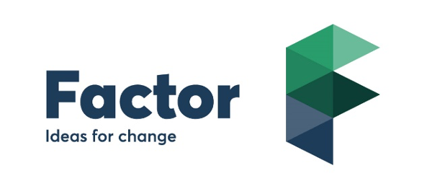 | 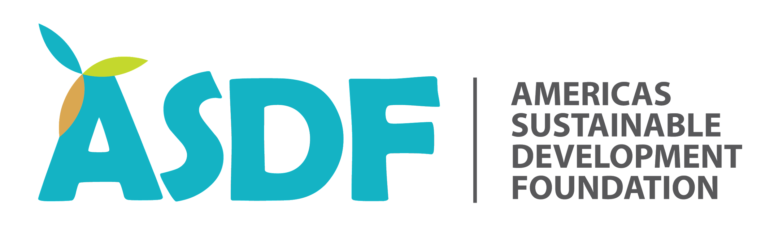

RFP/UNIDO/7000003530
August 2021

This technical assistance advances the following Sustainable Development Goals:

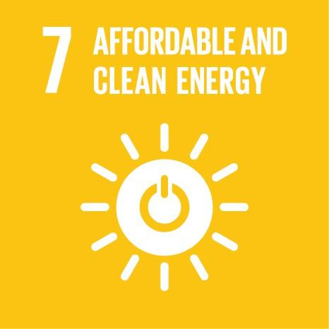 | 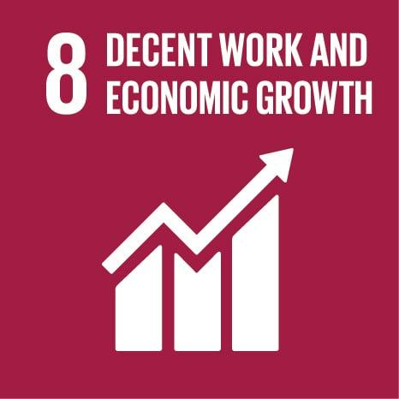 | 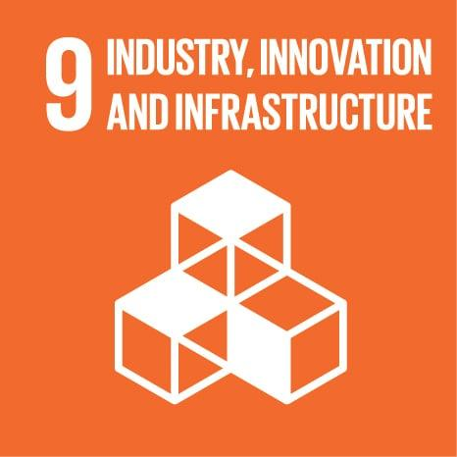 | 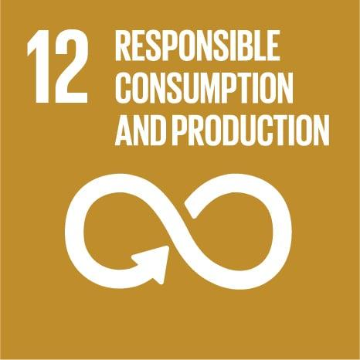 | 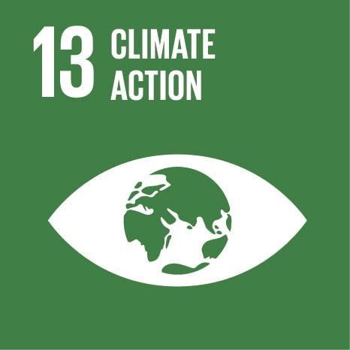

Closure Report for CTCN Technical Assistance

- Basic information
Title of response plan | Assessment of the current status of the Circular Economy for developing a Roadmap
Technical assistance reference number | 2018000028
Country / countries | Brazil, Chile, Mexico and Uruguay
NDE organization | Brazil:  - General Coordination of Climate, Ministry of Science, Technology and Innovation (MCTI) of Brazil (NDE for Brazil).  Chile:  - Executive Directive, Agency for Sustainability and Climate Change of Chile (NDE for Chile).  Mexico:  - Director General, National Institute of Ecology and Climate Change of Mexico (NDE for Mexico).  Uruguay:  - Climate Change Division at the Ministry of Environment of Uruguay (NDE for Uruguay).
NDE focal point | Brazil:  - Márcio Rojas da Cruz, General Coordinator of Climate Change, Ministry of Science, Technology and Innovation (MCTI) of Brazil (NDE Focal Point for Brazil).  Chile:  - Augusto Hermo, Executive Director, Agency for Sustainability and Climate Change of Chile (NDE Focal Point for Chile).  Mexico:  - María Amparo Martínez Arroyo, Director General, National Institute of Ecology and Climate Change of Mexico (NDE Focal Point for Mexico).  Uruguay:  - Natalie Pareja, Director of Climate Change, Climate Change Division at the Ministry of Environment of Uruguay (NDE Focal Point for Uruguay).
NDE contact information | Brazil:  - Daniel Lage Chang, Bioeconomy Programs and Projects Coordinator, Ministry of Science, Technology, and Innovations (MCTI) of Brazil (NDE Operational Focal Point) – E: Daniel.chang@mcti.gov.br  Chile:  - Ximena Ruz Espejo, Sub-Director of Operations, the Sustainability and Climate Change Agency of Chile (NDE Operational Focal Point) – E: Ximena.ruz@ascc.cl  Mexico:  - Juana Itzchel Nieto Ruiz, Director of Investigation for Low Carbon Development Strategies, National Institute of Ecology and Climate Change of Mexico (NDE Operational Focal Point) – itzchel.nieto@inecc.gob.mx  Uruguay:  - Jorge Castro, Consultant, Climate Change Division, Ministry of Environment in Uruguay (NDE Operational Focal Point) – Jorge.castro@mvotma.gub.uy
Proponent focal point and organisation | - Guillermo Gonzáles Caballero, Head of the Circular Economy Office in the Ministry of Environment of Chile – E: ggonzalez@mma.gob.cl  - Giovanni O. Calderón Bassi, former Executive Director, Agency for Sustainability and Climate Change of Chile.  - Sebastian Carvallo Albornoz, National Coordinator Agreements and Instrument Design, Agency for Sustainability and Climate Change of Chile.
Designer of the response plan | Petar Blas OSTOJIC SALINAS, Centre for Innovation and Circular Economy, Chile – E: petar@ostojic.cl
Implementer(s) of technical assistance | International Consortium composed of Factor Ideas Integral Services L.S. (Factor) and the Americas Sustainable Development Foundation (ASDF).  Project Team:  Iker Larrea, Project Director (Factor/ASDF Project Team) – E: ilarrea@iamfactor.com  Kevin de Cuba, Team Leader (Factor/ASDF Project Team) – E: kdecuba@sustainableamericas.com  Alexandre Gobbo Fernandes, National Consultant – Brazil (Factor/ASDF Project Team)  Irina Reyes Donoso, National Consultant – Chile (Factor/ASDF Project Team)  Mauricio Zenteno, National Consultant – Mexico (Factor/ASDF Project Team)  Hernan Carlino, National Consultant – Uruguay (Factor/ASDF Project Team)  Maria de los Angeles Franco, Project Officer (Factor/ASDF Project Team)  Kenneth Alston, Senior Circular Economy Advisor (Factor/ASDF Project Team)  Carmelo Angulo, Senior Circular Economy Advisor (Factor/ASDF Project Team)  Thanks to:  Claudia Lorena Garcia, former Project Officer (Factor/ASDF Project Team)  Christina Garcia, former Senior Consultant (Factor/ASDF Project Team)  Elena Aguirre Martin, former Senior Consultant (Factor/ASDF Project Team)  In Memory of:  Sandra Cesilini, Senior Gender Specialist (Factor/ASDF Project Team) (r.i.p.)
Beneficiaries | Brazil: Ministry of Science, Technology, and Innovations (MCTI).  Chile: Agency for Sustainability and Climate Change (ASCC).  Mexico: National Institute of Ecology and Climate Change (INECC).  Uruguay: Ministry of Environment of Uruguay (MA).
Sector(s) addressed | Cross Sectoral (Transport, Energy Efficiency, Renewable Energy, Waste Management, Forestry, Agriculture, Industry, Water, Human Health, Infrastructure and Urban Planning, and Marine and Fisheries); Productive Sectors with potential for technology deployment for Sustainable Circular Economy and Climate Compatible solutions.
Technologies supported | Technologies applicable under CTCN Climate Mitigation and Adaptation Sectors. Sectors: Transport, Energy Efficiency, Renewable Energy, Waste Management, Forestry, Agriculture, Industry, Water, Human Health, Infrastructure and Urban Planning, and Marine and Fisheries.
Implementation start date | 01/07/2019
Implementation end date | Original: 30/06/2020; Actual: 06/08/2021
Total budget for implementation | Total Budget: US$180,540.00
Description of delivered outputs and products as well as the activities undertaken to achieve them. In doing so, review the log frame of the original response plan and refer to it as appropriate | The general objective of this regional technical assistance was to perform an assessment of the circular economy, revealing the key actors/interested parties and characterizing gaps and deficits to serve as input for the collaborative construction of a roadmap on this issue and as a management tool for the future implementation phase.  In many ways this Regional Technical Assistance (RTA) (implemented from July 2019 to August 2021) is a unique, challenging, and ground-breaking regional project. It is the first CTCN regional or multi-country level program to be deployed in Latin America and the Caribbean region since the establishment of CTCN. This RTA responds to a new and upcoming global paradigm shifting concept known as the Circular Economy (CE), where in addition to assessing the level of comprehension and status of implementation of circular economy in each participating country, namely Brazil, Chile, Mexico and Uruguay, focus is also placed on understanding and confirming the inter-relationship and inter-dependence of Circular Economy vis-à-vis Climate Change Mitigation and Adaptation (in other words, how does CE contribute to addressing climate change). Moreover, the RTA also was aimed at recommending how CE solutions and interventions could be integrated and contribute to the implementation of the Nationally Determined Contributions (NDCs) in response to the Paris Agreement (COP-21) and the 17 UN Sustainable Development Goals, as part of the UN 2030 Agenda.  Besides these very ambitious goals and objectives, this regional project required a robust and flexible methodological approach to tailor the assistance to each respective participating country’s needs, priorities, circumstances and level of understanding and advancement in adopting and/or deploying Circular Economy solutions and initiatives as well as their national Climate Change mitigation and adaptation efforts. To make things more challenging, the RTA had to withstand and proceed throughout several social and political unrest occurring across the participating nations during the implementation period and was heavily hampered by the global COVID-19 pandemic (from March 2020 until present). With a strict and demanding review and approval process enforced by CTCN in making sure all deliverables were reviewed and approved by the National Designated Entities (NDEs), within this global pandemic context, this also led to delays as all parties involved (NDEs, CTCN and Project Team) suffered institutional or personnel challenges, reducing everyone’s capacity to remain responsive and to comply with the original implementation schedule.  Therefore, it is to be appreciated that this RTA has reached its closure phase achieving all set objectives and targets and leaving many concrete leads, insights and follow up added-value actions and recommendations within and beyond the original scope of work, with an unplanned delay of 14 months.  The RTA was designed to generate six (6) key outputs.  Output 1. Development of implementation planning and communication documents.  This first phase of the RTA resulted in the approval by each respective NDE and CTCN of Four (4) planning and communication documents: (1) Detailed Work Plan; (2) Monitoring and Evaluation Plan; (3) CTCN Impact Description; and (4) the first draft of the Data and Collection Report by July 2019. The Work Plan, which contains the methodological implementation approach, was considered the key document to engage with the participating countries and achieve the originally set outcomes and products.  Output 2. Diagnosis of key stakeholders and current initiatives related to circular economy in each country.  The first and critical activity implemented entailed the organization of Kick-Off Meetings (KOMs) in each respective project country to confirm the conditions, needs, and priorities by key national actors, and thereby also, if needed, adapting the “General” Work Plan (including the implementation methodology) approved by the NDEs, to feedback and recommendations received during each respective Kick-Off Meeting.  Kick-Off Meetings and Reporting (D2.1/2.2)  The missions and Kick-Off Meetings (KOMs) were organized based on the availability of the NDEs and national counterparts, which resulted in various dates for the 4 KOMs (namely: Uruguay on August 14, 2019; Mexico on August 27, 2019; Brazil on August 29, 2019; and Chile on September 03, 2019).  This led to delays relating to the Project Team’s ability to draft Mission Reports (incl. Meeting Minutes), accompanied by delays in responsiveness by each respective NDE and CTCN during revision and approval processes to secure final approvals.  ** Upon request by NDEs (MEX, CHI, and UY) and with consent by CTCN, it was agreed that all future reports were to be submitted in Spanish (deviating from the original TORs where all deliverables were to be submitted in English). Agreement with NDE BRA was to submit all future reports in English. This detail, also contributed to delays, as the original draft KOM reports were produced in English.  Therefore, all 4 KOM reports (Mission Reports) were approved at the end of September 2019, leading to 1 month of delay (original schedule: August 2019).  National Work Plans (D2.3)  A significant deviation from the original method and approved General Work Plan (July 2019) was experienced as result of the Kick-Off Meetings. More specifically, the NDEs of CL and UY requested significant modifications to the original scope and implementation method of the project. This also resulted in the addition of a new deliverable, resulting in having to secure the approval of four (4) national work plans.  Specific modifications:  (1) NDE UY requested with consent of CTCN the Project Team to focus on 2 (two) value-added chains of priority interest to the country (namely the Beef and Diary value chains). NDE UY indicated that the country already has a draft National Circular Economy Plan that was to be launched in December 2019. This resulted in a longer process of defining and securing national consensus on the adapted national work plan and the agreement on the selected value chains which was finalized with a formal approval by NDE UY in mid November 2019.  (2) NDE CL requested with consent of CTCN the Project Team to bring about complementary activities in the four (4) main sub-regions of the country in addition to the ongoing road mapping process led by the Ministry of Environment (MMA) (mainly centralized in Santiago de Chile). Agreeing on replicating most of the original implementation method in 4 (four) subregions in the country and changing particularly the scope of Outputs 2 and 3. The formal approval by NDE CHI of the adapted national work plan was provided in first week of October 2019.  (3) NDE MX and NDE BR requested changes in sequence and timing of certain activities and deliverables but these did not result in significant deviations from the originally proposed and agreed upon methodological approach included in the General Work Plan approved in July 2019 by NDEs and CTCN. Both National Work Plans for MX and BR were approved in September 2019.  Evaluation Reports (D2.4)  After having secured the approvals of each respective adapted National Work Plans, the process of performing stakeholders’ analyses (interviews, surveys, etc.), identification of ongoing circular economy projects and initiatives, the mapping of key actors, and the assessment of the general conditions, including the policy regime (relevant policies, NDCs, SDGs, and Climate policies) of each country was brought about for drafting the National Evaluation Reports. The four (4) National Evaluation Reports were approved by the end of May 2020 by each respective NDE and CTCN.  Due to changes in the scope of the work plan for CL and UY, and NDE BR’s demand for an extensive stakeholders mapping exercise, all these led to overall delays in the timing of approvals of the respective Evaluation Reports.  Specific results:  (1) NDE CHI requested the Project Team to bring about missions in 4 subregions of Chile namely:  - Los Lagos (07 OCT 2019)  - Valparaíso (18 NOV 2019)  - Antofagasta (28 NOV 2019)  - Biobío (05 DEC 2019)  For each mission to a sub-region, mission reports were drafted, summarizing key feedback and recommendations for needs, priorities and opportunities for deployment of circular economy solutions and pre-identification of key actors and stakeholders to involve in the ongoing national circular economy road mapping process led by MMA. The review-update-review-approval process between CTCN and NDE led to securing final approval by NDE CHI and CTCN by February 2020.  (2) In the case of NDE UY, an extensive series of individual interviews were deployed within the two prioritized Diary and Meat value chains resulting in a two-prong process and a more detailed depiction of the needs, priorities, conditions, and opportunities for the deployment of circular economy solutions as well as a mapping of key relevant actors and initiatives for each subsector.. Nevertheless, NDE UY requested a more extensive group of interviewees and gave a preliminary approval of D2.4 (Evaluation Report) in December 2019 with agreement and consent by CTCN that the Project Team would need to interview more actors/stakeholders throughout the further implementation process. This was requested taking into account that two different sectors/value chains would have to be examined with each having its own characteristics, attributes and level of development. The Project Team complied with the minimum requirement of 15 interviewees, as outlined in the original TORs and expanded the number of interviews beyond the original terms.  (3) NDE MX requested direct (in-person) presence of National Project Consultant in Mexico City to help identifying, selecting, and performing interviews. In close cooperation with the NDE MX 17 key stakeholders of 20 pre-selected were interviewed during Nov 05 – 19, 2019. The review-update-review-approval process between CTCN and NDE led to securing final approval by NDE MX and CTCN in the end of February 2020 (with agreement and consent by CTCN that more actors/stakeholders will be interviewed during planned mid-term event (Apr/May 2020), while already complying with the minimum requirement of 15 interviewees, as outlined in the original TORs.  (4) NDE BRA requested and with consent by CTCN the Project Team to perform a more in-depth and extensive stakeholder’s analysis process using an online survey tool where more than 140 stakeholders were engaged (resulting in more than 100 organizations represented of which 19 key stakeholders with consent from NDE BRA were selected and interviewed). Processing all the findings and including the review-update-review-approval process between CTCN and NDE led to securing final approval of D2.4 (ENG) by NDE BR and CTCN in May 2020.  **Please note that the requirement was that in all countries at least 15 or more key (institutional) stakeholders were identified, selected, and interviewed with consent from each NDE and CTCN.  Specific number of interviewed key actors:  UY: 35 interviewees (strategically selected with consent of NDE UY).  MX: 17 interviewees (strategically selected with consent of NDE MX).  BR: 19 interviewees (out of pool of 140 actors participating in 1st level online survey, and strategically selected with consent of NDE BR).  CL: 15 interviewees (Antofagasta); 13 interviewees (Valparaiso); 13 interviewees (Biobío); and 20 interviewees (Los Lagos). As result of replicating the method in 4 sub-regions of the country.  COP-25 (D2.5)  In anticipation of the 25th Conference of Parties under the United Nations Framework Convention on Climate Change (UNFCCC/COP-25), to take place in early December 2019 in Santiago, Chile, the Project Team was requested by CTCN to prepare a mid-term update presentation to be shared during a CTCN Side Event. Due to the social unrest in Chile in the months prior to COP-25, this was moved to Madrid, Spain for 02-13 of December 2019. Kevin de Cuba (Team Leader, Factor/ASDF), Iker Larrea (Project Director, Factor/ASDF), and Hernan Carlino (National Consultant for Uruguay, Factor/ASDF) attended COP-25 upon their own costs and contributed to CTCN’s side events by participating in the side event programs to present the mid-term outcomes of this regional TA to the wider audience present at the events.  The first of two CTCN Side Events took place on 09 December 2019, and where the mid-term results of this regional project were presented by Kevin de Cuba (Team Leader, Factor/ASDF):  https://www.ctc-n.org/calendar/events/cop25-building-countries-capacity-circular-economy-medium-tackle-climate-change  The second CTCN Side Event took place on 12 December 2019 where Iker Larrea (Project Director, Factor/ASDF) provided mid-term outcomes of this regional project:  https://www.ctc-n.org/calendar/events/cop25-eu-climate-technologies-day-accelerating-global-climate-technology  **A mission report was drafted as output of this activity which was not contemplated in the original terms of reference.  Modifications to the original activities and products:  ORIGINAL TOR AND PRODUCTS:  ADAPTED TOR AND SUBMITTED PRODUCTS:  **The purpose of highlighting the difference between the original terms and the actual activities and products delivered contributes to shed light to an important aspect and recurring reality throughout the project implementation process that reflects the willingness of the Project Team to accommodate to CTCN and NDEs requests, and also explains the challenges the Project Team was confronted with while still managing to respond to requests by NDEs and CTCN without modifications in personnel, budget, and managing timing in the implementation schedule.  ** please note that from Oct 2019 – Mar 2020, there were civil unrest in Chile (stagnating / stopping national government operations) with curfew and other measures.  ** please note that since Jan 2020, the Program Manager at CTCN (Federico Villantico Campbell) left his position, where Program Officer (Judit Manotas Rodriguez) took over the role of principle CTCN counterpart carrying forward this and other projects by herself.  ** please note that the global COVID-19 effects started early in March 2020 across Latin America impacting responsiveness of NDEs, CTCN and Project Team, and which are still ongoing as per March 2021. There were immediate impacts on project implementation, in particular those related with interactions with stakeholders; those impacts created the need to revise and modify methodological approaches in order to reflect the shift to online interactions and home based work in a number of national public and private institutions.  All the above + external factors impacting the responsiveness of NDEs, CTCN and Project Team, led to accumulated delays of 5 months beyond original planning.  Output 3. Identification of the circular economy value and definition of benefits, weaknesses, opportunities and challenges in each country.  In the next phase of the Project, focus was placed on performing an extensive Strengths, Weaknesses, Opportunities and Threats (SWOT) analyses per country and assess the perceived benefits of deploying Circular Economy solutions and approaches in each respective country. This was complemented with the development of a circular economy indicator matrix for all four participating countries to consider as a means to evaluate, select and prioritize interventions and projects that are in line with the circular economy principles.  Diagnosis of Perceived Benefits (D3.1)  Four reports entitled “Diagnosis of Perceived Benefits” covering the circular economy benefits as recognized or perceived by the key actors were analyzed and processed. Based on request by CTCN, these reports required a more detailed analysis and description of the main economic activities in each project country. Four (4) Reports of the main economic activities and perceived benefits were after the application of the review-update-review-approval process between CTCN and NDEs overall approved by September 2020.  Specific Activities undertaken:  (1) Submitted draft D3.1 BRA (ENG) in March 2020, and only after a 2nd round of update-review-approval round by CTCN-NDE-Project Team-CTCN-NDE (taking into account delays in responsiveness by all parties due to COVID-19 pandemic + changes in implementation method and scope of work), secured final approval in July 2020.  (2) Submitted draft D3.1 CHI (ESP) in May 2020, and after a 2nd round of update-review-approval round by CTCN-NDE-Project Team-CTCN-NDE (taking into account delays in responsiveness by all parties due to COVID-19 pandemic + changes in implementation method and scope of work), only secured a final approval in September 2020.  (3) Submitted draft D3.1 UY (ESP) in January 2020, and only after a 2nd round of update-review-approval round by CTCN-NDE-Project Team-CTCN-NDE (taking into account delays in responsiveness by all parties due to establishment of new government + COVID-19 pandemic + changes in implementation method and scope of work), secured final approval in May 2020.  ** please note that National Elections took place in October 2019 in Uruguay resulting in a new administration starting in March 2020 impacting/limiting the responsiveness of NDE UY in the first quarter of 2020.  (4) Submitted draft D3.1 MEX (ESP) in January 2020, and only after a 2nd round of update-review-approval round by CTCN-NDE-Project Team-CTCN-NDE (taking into account delays in responsiveness by all parties due to COVID-19 pandemic + changes in implementation method and scope of work), secured final approval in May 2020.  All the above + external factors impacting the responsiveness of NDEs, CTCN and Project Team, led to accumulated delays of 9 months beyond original planning.  ** the delays between first moment of hand-in of draft deliverable until its final approval represents the time consumption for the time-consuming review-update-review-approval process brought about, as demanded by CTCN, where both NDE and CTCN needed to consent and approve for each respective deliverable/activity.  ** please keep in mind ongoing external factors (incl. COVID-19 pandemic) impacting all actors’ abilities and responsiveness.  ** Passing of Project Team member, Sandra Cesilini (Gender Specialist) in May 2020.  ** please keep in mind Ms. Judit Rodriguez operating as the only individual of the CTCN team performing the technical review of all draft deliverables of the Project, while in charge of overall management of the Project, which automatically leads to reduced responsiveness.  SWOT Analyses (D3.2/3.3.)  In agreement with CTCN, results of Activities 3.2 and 3.3 as outlined in the original terms, were merged into a single deliverable, resulting in Four (4) Reports of Strengths, Opportunities, Weaknesses and Barriers approved by each respective NDE and CTCN in October 2020.  Specific Activities undertaken:  (1) Submitted draft D3.2/3.3 BRA (ENG) in May 2020, and only after a 2nd round of update-review-approval round by CTCN-NDE-Project Team-CTCN-NDE secured final approval in August 2020 (ENG). But in September 2020, upon NDE BRA request and CTCN’s consent, the Project Team had to include a DISCLAIMER in each deliverable, resulting in formal final approval in September 2020 (ENG).  (2) Submitted draft D3.2/3.3 CHI (ESP) in May 2020, and after a 2nd round of update-review-approval round by CTCN-NDE-Project Team-CTCN-NDE, secured a final approval in September 2020 (ESP).  (3) Submitted draft D3.2/3.3 UY (ESP) in January 2020, and only after a 2nd round of update-review-approval round by CTCN-NDE-Project Team-CTCN-NDE, secured final approval in October 2020 (ESP). In the case of Uruguay two SWOT Analysis were performed, one each for the selected value chains (Dairy and Beef).  ** please note that National Elections took place in Oct 2019 in Uruguay resulting in a new administration starting in Mar 2020, impacting/limiting the responsiveness of NDE UY in the first quarter of 2020.  (4) Submitted draft D3.2/3.3 MEX (ESP) in February 2020, and only after a 2nd round of update-review-approval round by CTCN-NDE-Project Team-CTCN-NDE, secured final approval in October 2020 (ESP).  **All the above + external factors impacting the responsiveness of NDEs, CTCN and Project Team, led to accumulated delays of 10 months beyond original planning.  ** the delays between first moment of hand-in of draft deliverable until its final approval represents the time consumption for the time-consuming review-update-review-approval process brought about, as demanded by CTCN, where both NDE and CTCN needed to consent and approve for each respective deliverable/activity.  ** please keep in mind ongoing external factors (incl. COVID-19 pandemic) impacting all actors’ abilities and responsiveness.  ** please keep in mind Ms. Judit Rodriguez operating as the only individual of the CTCN team performing the technical review of all draft deliverables of the Project, while in charge of overall management of the Project, which automatically leads to reduced responsiveness.  Circular Economy Indicators Matrix (D3.4)  Upon agreement with CTCN, D3.4 would become a single document (deliverable) to be reviewed and approved by all 4 respective NDEs and CTCN, resulting in D.3.4 “Circular Economy Indicator Matrix” (ENG and ESP) approved by all NDEs and CTCN in February 2021.  Specific Activities undertaken:  (1) Submitted draft D3.4 (ENG) in January 2020, and during the first round of review by all NDEs, in February 2020 NDE CL and MX demanded D3.4 in (ESP) for review, resulting in two living draft documents D3.4 (ENG) under review by NDE BR and D3.4 (ESP) under review by NDE CL, MX and UY. In addition, Uruguay requested specific indicators at the value chain level to be included in the general matrix.  (2) A decision was made to wait for the D3.4 (ESP) version to be updated based on feedback from NDE CL, MX and UY, to translate back into ENG to share with NDE BR the latest version. This took place in July 2020.  (3) In parallel NDE UY and MX requested changes in D3.4 (ESP), and NDE BR requested changes in D3.4 (ENG) final draft versions. Finally, it was decided to only use the ESP version as main document, which resulted in presenting a final draft NDE (ESP) in October 2020, upon which NDE BR demanded an ENG version of the same.  (4) Only after a 2nd round of update-review-approval round by CTCN-NDE-Project Team-CTCN-NDE of both D3.4 (ESP and ENG), secured an overall final approval in February 2021 (ENG and ESP) by all NDEs and CTCN.  **All the above + external factors impacting the responsiveness of NDEs, CTCN and Project Team, leading to an accumulated delay of 14 months beyond original planning.  **Upon request by NDE BR, CTCN agrees and instructs Project Team that all final and approved deliverables of the Project need to be translated into Portuguese (from ENG to PT, deviating from the original TORs where all deliverables were to be submitted in English). This decision was made by NDE BR and CTCN to enable NDE BR to communicate outcomes and recommendations of the Project with key actors and stakeholders in Brazil. Although CTCN has agreed to take charge of translation of all deliverables from ENG to PT, this caused unplanned delays in the Project Team’s ability to organize the national closing workshop for Brazil (D6.3), executed on the 25th of June 2021.  ** please keep in mind Ms. Judit Rodriguez operating as the only individual of the CTCN team performing the technical review of all draft deliverables of the Project, while in charge of overall management of the Project, which automatically leads to reduced responsiveness.  Modifications to the original activities and products:  ORIGINAL TOR AND PRODUCTS:  ADAPTED TOR AND SUBMITTED PRODUCTS:  **The purpose of highlighting the difference between the original terms and the actual activities and products delivered is an important aspect and recurring reality throughout the project implementation process that reflects the willingness of the Project Team to accommodate to CTCN and NDEs requests, and also explains the challenges the Project Team was confronted with while still managing to respond to requests by NDEs and CTCN without modifications in personnel, budget, and managing timing in the implementation schedule.  ** please note that the global COVID-19 effects started in March 2020 across Latin America impacting responsiveness of NDEs, CTCN and Project Team, and which are still ongoing as per August 2021.  All the above + external factors impacting the responsiveness of NDEs, CTCN and Project Team, led to the overall accumulated delays of 14 months beyond original planning.  Output 4. Review of international experiences.  In the 4th phase of the project implementation process, an extensive research was performed to (1) review and assess international circular economy case studies and best practices as means of benchmarking projects and initiatives identified in the four project countries, (2) identify the specific aspects and conditions that allowed the case studies to be successful, and (3) finally gain an understanding of the specific characteristics and conditions that promote the success of circular economy programs as well as identifying potential individuals and organizations that could participate in knowledge exchanges.  **Upon agreement with CTCN, D4.1, D4.2 and D4.3 would be merged into a single document (D4) to be reviewed and approved by all 4 respective NDEs and CTCN, resulting in D.4. “Review of International Experiences” (ENG and ESP) approved by all NDEs and CTCN in November 2020.  Specific Activities undertaken:  This deliverable passed through a different process compared to other deliverables. The scope of work/expected content was not clear which led to many iterations, first submitted draft D4 (ENG) in February 2020, received 1st feedback from CTCN in April 2020; 2nd feedback from CTCN in July 2020; 3rd feedback by CTCN in September 2020, resulting in sharing CTCN pre-approved version of D.4. (ENG) in October 2020 with NDEs (requesting NDEs cooperation to review the ENG version) which resulted in request for modifications by NDE MX and NDE BR, and after making pertinent changes, securing the final overall approval in November 2020 of D4 (ENG) by all NDEs and CTCN.  **CTCN confirmed they would take charge of translating the approved D4 (ENG) into ESP and PT to submit to the respective NDEs. As this was not contemplated in the original terms.  **All the above + external factors impacting the responsiveness of NDEs, CTCN and Project Team, led to accumulated delays of 10 months beyond original planning.  ** please keep in mind Ms. Judit Rodriguez operating as the only individual of the CTCN team performing the technical review of all draft deliverables of the Project, while in charge of overall management of the Project, which automatically leads to reduced responsiveness.  ** please note that since November 2020, a new LAC Program Manager at CTCN (Diana Ramos Perez) was appointed, where Program Officer (Judit Rodriguez) returned to her previous role as Climate Change Mitigation Expert to focus on technical review. And where from this point forward Ms. Ramos took over the role of principle CTCN counterpart and project manager.  Modifications to the original activities and products:  ORIGINAL TOR AND PRODUCTS:  ADAPTED TOR AND SUBMITTED PRODUCTS:  **The purpose of highlighting the difference between the original terms and the actual activities and products delivered is an important aspect and recurring reality throughout the project implementation process that reflects the willingness of the Project Team to accommodate to CTCN and NDEs requests, and also explains the challenges the Project Team was confronted with while still managing to respond to requests by NDEs and CTCN without modifications in personnel, budget, and managing timing in the implementation schedule.  ** please note that the global COVID-19 effects started in March 2020 across Latin America impacting responsiveness of NDEs, CTCN and Project Team, and which are still ongoing as per August 2021.  All the above + external factors impacting the responsiveness of NDEs, CTCN and Project Team, led to the overall accumulated delays of 9 months beyond original planning.  Output 5. Mapping of successful cases of application of industry 4.0 which benefit circular economy at international level and adoption of practices at local level taking into account technological development in these countries.  Phase 5 included the review and assessment of technological solutions categorized under Industry 4.0 which can enable key actors in the project countries to adopt disruptive circular business models using these advance technological solutions. Part of this process was the assessment of the level of adoption and readiness of the project countries to deploy industry 4.0 technologies as means to accelerate the transition to circular economies.  Specific Activities undertaken:  (1) Submitted draft D5.1 (ESP) in February 2020, and only after a 2nd round of update-review-approval round by CTCN-NDE-Project Team-CTCN-NDE secured final approval in November 2020 (ENG and ESP).  **NDE CL was originally not convinced or in agreement with the Project Team regarding the understanding and interpretation of “Industry 4.0”, this led to several weeks of back-and-forth which was finally resolved during a technical meeting.  **Upon agreement with CTCN, D5.1 would become a single document (deliverable) in ENG and ESP to be reviewed and approved by all 4 respective NDEs and CTCN.  (2) Submitted draft D5.2 (ESP) in March 2020, and only after a 2nd round of update-review-approval round by CTCN-NDE-Project Team-CTCN-NDE secured final approval in November 2020 (ESP and ENG).  **Upon agreement with CTCN, D5.2 would become a single document (deliverable) in ENG and ESP to be reviewed and approved by all 4 respective NDEs and CTCN.  **All the above + external factors impacting the responsiveness of NDEs, CTCN and Project Team, led to accumulated delays of 9 months beyond original planning.  ** please keep in mind Ms. Judit Rodriguez operating as the only individual of the CTCN team performing the technical review of all draft deliverables of the Project, while in charge of overall management of the Project, which automatically leads to reduced responsiveness.  Modifications to the original activities and products:  ORIGINAL TOR AND PRODUCTS:  ADAPTED TOR AND SUBMITTED PRODUCTS:  **The purpose of highlighting the difference between the original terms and the actual activities and products delivered is an important aspect and recurring reality throughout the project implementation process that reflects the willingness of the Project Team to accommodate to CTCN and NDEs requests, and also explains the challenges the Project Team was confronted with while still managing to respond to requests by NDEs and CTCN without modifications in personnel, budget, and managing timing in the implementation schedule.  ** please note that the global COVID-19 effects started in March 2020 across Latin America impacting responsiveness of NDEs, CTCN and Project Team, and which are still ongoing as per August 2021.  **All the above + external factors impacting the responsiveness of NDEs, CTCN and Project Team, led to accumulated delays of 9 months beyond original planning.  Output 6. Identification of potential projects in circular economy.  In the 6th and final phase of this regional technical assistance, potential pilot projects that contribute to the transition toward circular economy addressing climate change were identified and described based on close cooperation with the NDEs and/or third parties interested/engaged in the potential pilot project. The objective behind these identified pilot projects opportunities was to enable the NDEs and involved parties to proceed with drafting detailed project proposals to request international financing, with particular focus on the Green Climate Fund (GCF), to launch demonstrative pilot projects compatible with circular economy principles and that contribute to the mitigation of or adaptation to Climate Change.  In this final phase the outcomes and recommendations of previous deliverables (Phase 1 to 5) were communicated and shared with the NDEs, critical stakeholders, and any interested parties. In some cases this included the sharing of an executive summary of the main results and recommendations, accompanied by specific recommendations for jump-starting and bring about the National Circular Economy Road mapping process. Finally, a regional closing workshop was organized to share all results among the NDEs, CTCN and other interested international participants to exchange learnings and identify potential north-south and south-south cooperation opportunities as follow up to this regional TA.  Pilot Projects (D6.1)  Six (6) reports describing identified potential pilot projects for which two (2) for NDE UY and two (2) for NDE CL in addition to one (1) for NDE BR and NDE MX respectively, were approved by February 2021. Due to the structural changes in the objectives and scope that occurred during the initial stages of the implementation process this original deliverable was adapted to specific country context and needs.  (1) Mexico: Submitted draft Report D6.1 (ESP) “Pilot Project scoping and general description” for NDE MX to be approved by NDE MX and CTCN. NDE MX and CTCN approved final report in April 2021.  (2) Chile: Submitted two (2) draft Report D6.1 (ESP) “Pilot Project scoping and general description” for NDE CL in January 2021. Multiple rounds for the review of the documents accounted. NDE CL and CTCN approved final report in May 2021.  (3) Uruguay: Submitted two (2) draft Report D6.1 (ESP) “Pilot Project scoping and general description” for NDE UY in December 2020. For the case of Uruguay, the National report included two pilot projects that were presented in separate documents (6.1a and 6.1b). NDE UY and CTCN approved final reports in May 2021.  (4) Brazil: Submitted draft Report D6.1 (ENG) “Pilot Project scoping and general description” for NDE BR to be approved by NDE BR and CTCN. NDE BR and CTCN approved final report in April 2021.  Summary Outcomes or Draft National Circular Economy Roadmaps (D6.2)  Specific Activities undertaken:  (1) Brazil: A draft Report “Executive Summary of the Main Project Results” and a Draft “Guidelines for the formulation of a National Roadmap towards the Circular Economy in Brazil” outlined as D6.2 (ENG) for NDE BR was submitted in December 2020, and after review by NDE BR and CTCN was pre-approved in January 2021. NDE BRA and CTCN approved final report in April 2021.  (2) Chile: A second Report “Pilot Project scoping and general description” for NDE CL (acknowledging MMA has advanced with the National Circular Economy Roadmap, and prefers a second pilot project to consider), was submitted instead of a Summary Report. Please see D6.1 Chile. NDE CL and CTCN approved final report in May 2021.  (3) Mexico: Submitted draft “Executive Summary of general findings” and a Draft “National Circular Economy Roadmap” outline D6.2 (ESP) for NDE MX in January 2021. NDE MX and CTCN approved final report in April 2021.  (4) Uruguay: A draft Report “Executive Summary of General Findings” (D6.2 ESP) was submitted in December 2020. NDE UY and CTCN approved final report in May 2021.  National Closing Workshops (D6.3)  Specific Activities undertaken:  MX: National Closing Workshop held on Jun 15, 2020  UY: National Closing Workshop held on Nov 04, 2020  CL: National Closing Workshop held on Nov 11, 2020  BR: National Closing Workshop held on Jun 25, 2021  In all countries at least 50 or more stakeholders participated in each respective national closing workshop.  (1) MX: 296 participants for which 300 participants pre-registered for the national closing (5hr-online) workshop, held on June 15, 2020, including among other key/senior representatives of the Government of Mexico, Private Sector Associations, SMEs, Academia, UNIDO, NDE MX and CTCN. The timing of this event was at the commencement of the implementation process a requested modification by NDE MX which was part of the approved national work plan for Mexico.  The national closing workshop report (D6.3) for Mexico was submitted in a first draft version in September 2020, as other deliverables had to be prioritized, and after a 1st round of review-update-approval round by CTCN-NDE-Project Team-CTCN-NDE it was approved in January 2021 (D6.3 ESP).  (2) UY: 51 participants attended the national (2hr-online) closing workshop held on November 04, 2020, including senior representatives of the Government of Uruguay, UNIDO, Private Sector, Civil Society groups, Academia, NDE UY and CTCN.  (3) CL: 646 participants attended the Day 1 Program: “Economia Circular: una nueva oportunidad de negocio” as part of the Online Forum “Mercados para Economias Circulares” held on November 11, 2020 and organized by the Chilean Agency for Sustainability and Climate Change (ASCC), where with consent of NDE CL (ASCC) and CTCN, the intervention provided by Kevin de Cuba (Team Leader) was acknowledged as the means for sharing the overall outcomes and recommendations of this regional TA as compliance to the delivery of the national closing (online) workshop for Chile (D6.3).  (4) BR: as requested by NDE BR and with consent by CTCN, all deliverables, including the most recently approved D3.4 (ENG) in February 2021 had to be send for translation from ENG to PT (representing +500 pages to be translated) to be accepted as FINAL products for Brazil. As agreed, once all products are received in PT, NDE BR was in charge of the selection of a date and the organization of the national closing workshop for Brazil that was held on June 25, 2021 and 214 participants attended.  **Deviating from the original TORs, during the course of the Project, CTCN upon requests by NDEs, instructs Project Team to organize national closing workshops (4 in total) and to consider these as part of D6.3. This resulting in additional planning, logistics, re-assignment of workload, and undergoing review and approval processes by each respective NDEs and CTCN.  **CTCN authorizes modifications in budget expenditures, moving savings obtained in the travel budget, due to non-travel by experts (due to COVID-19 pandemic) to consultancy services (additional workdays) to cover the unplanned workload for the national closing workshops.  **The original target “One (1) Meeting Report and one (1) MoU draft for the establishment of a regional circular economy platform and south-south cooperation alternatives.” Was based on instructions by CTCN eliminated from the deliverables list under this Activity. Rationale is that CTCN had started a new and parallel project focused on the launch of the “Circular Economy Regional Coalition for Latin America and the Caribbean” with other partner organizations.  **Upon request by NDE Brazil, CTCN agrees and instructs Project Team that all final and approved deliverables of the Project need to be translated into Portuguese (from ENG to PT, deviating from the original TORs where all deliverables were to be submitted in English) to enable NDE BRA to communicate outcomes and recommendations of the Project with key actors and stakeholders in Brazil. Although CTCN confirmed their role in translating all products from ENG to PT, this still caused unplanned delays in the Project Team’s ability to organize the national closing workshop for Brazil (tentatively planned for April 2021, resulting ultimately in execution of the closing event on June 25, 2021).  Regional Closing Event (D6.4)  Specific Activities undertaken:  (1) The Regional Closing Event for this regional RTA was organized on December 09, 2020 as a side-event to the 4th edition of the Circular Economy Forum of the Americas (CEFA2020) which was a hybrid-in-person/digital forum. Some Project Team members participated in CEFA2020 and therefore connected through an Online/Zoom Webinar from the Aruba TV Studios in Oranjestad, Aruba (Dutch Caribbean) where the main event (Program of CEFA2020) was being transmitted and recorded in roundtable discussion podcasts formats.  (2) A total of 87 participants attended the online Regional Closing Event.  **Upon request by CTCN the MoU draft to be submitted for revision and approval by the end of month 11 was eliminated from the list of deliverables.  Modifications to the original activities and products:  ORIGINAL TOR AND PRODUCTS:  ADAPTED TOR AND SUBMITTED PRODUCTS:  **The purpose of highlighting the difference between the original terms and the actual activities and products delivered is an important aspect and recurring reality throughout the project implementation process that reflects the willingness of the Project Team to accommodate to CTCN and NDEs requests, and also explains the challenges the Project Team was confronted with while still managing to respond to requests by NDEs and CTCN without modifications in personnel, budget, and managing timing in the implementation schedule.  ** please note that the global COVID-19 effects started in March 2020 across Latin America impacting responsiveness of NDEs, CTCN and Project Team, and which are still ongoing as per August 2021.  **All the above + external factors impacting the responsiveness of NDEs, CTCN and Project Team, led to accumulated delay of 14 months beyond original planning.
  ORIGINAL TORs | ORIGINAL PRODUCTS
  Act. 2.1. Kick Off Meeting | D2.1 Meeting minutes by month 3 (Sept 2019).
  Act. 2.2. Exploration and Diagnosis of Actors and Initiatives | D2.2 Evaluation Report by month 6 (Dec 2019).
  ADAPTED TORs | SUBMITTED PRODUCTS
  Act. 2.1. Kick-Off Meeting in each respective country. | -
  Act. 2.2. Submit a Mission Report describing outcomes of Kick-Off Meetings in each respective project country. | D2.1/2.2 Mission Report per country, including Meeting Minutes (ESP for CL, MX, and UY; ENG for BR) to be approved by each NDE and CTCN.
  Act. 2.3. Adjustment of general work plan to tailor to each country (based on state of development) and secure approval from NDE. | D2.3 Approved National Work Plan (per country) (ESP for CL, MX, and UY; ENG for BR) to be approved by each NDE and CTCN.
  Act. 2.4. National Evaluation Reports – Exploration and diagnosis of actors and initiatives, prioritization of sectors, and general current conditions (circular readiness) in each country. | D2.4 Evaluation Report per country (ESP for CL, MX, and UY; ENG for BR) to be approved by each NDE and CTCN.
  Act. 2.5. Mid-term update to be presented at the CTCN Side Event at COP-25. | D2.5 Mission Report – CTCN Side Event during COP-25 in Madrid, Spain.
  ORIGINAL TORs | ORIGINAL PRODUCTS
  Act. 3.1 Diagnosis of perceived benefits the circular economy benefits as recognized by the key actors will be analyzed | D3.1 Diagnosis of perceived benefits reports will be submitted for approval to CTCN/UNIDO by the end of month 6 (Dec 2019).
  Activity 3.2. Diagnosis of strengths and opportunities | D3.2 Reports on strengths and opportunities to be submitted for approval to CTCN/UNIDO by the end of month 6 (Dec 2019).
  Activity 3.3. Diagnosis of weaknesses and barriers | D3.3 Reports on weaknesses and barriers to be submitted for approval to CTCN/UNIDO by the end of month 6 (Dec 2019).
  Activity 3.4. Development of an indicator matrix | D3.4 Four (4) reports on indicators matrix will be submitted for approval to CTCN/UNIDO by the end of month 6 (Dec 2019).
  ADAPTED TORs | SUBMITTED PRODUCTS
  Act. 3.1 Submit Report “Diagnosis of Perceived Benefits” covering the circular economy benefits as recognized or perceived by the key actors, including a more detailed analysis and description of the main economic activities in each project country. | D3.1 Four (4) Reports of the main economic activities and perceived benefits are approved by each respective NDE and CTCN.
  Act. 3.2/3.3. Submit Report “Strengths, Opportunities, Weaknesses and Barriers” that include the analysis of strengths, opportunities, weaknesses and barriers of each participating country, including the analysis of regulatory, market, cultural, entrepreneurship support, financing, capital, industrial and technological and recovery capacity of products and materials of each participating project country. | D3.2/3.3 Four (4) Reports of Strengths, Opportunities, Weaknesses and Barriers approved by each respective NDE and CTCN.
  Act. 3.4 Submit One (1) Report regarding “Circular Economy Indicator Matrix”: to enable all four participating countries to consider as a means to evaluate, select and prioritize interventions and projects that are in line with the circular economy principles including a national monitoring dashboard to allow for comparison between each country. | D3.4 A Report “Circular Economy Indicator Matrix” (ENG and ESP), including an excel-based national “Circular Economy Monitoring Dashboard”, approved by all NDEs and CTCN.
  ORIGINAL TORs | ORIGINAL PRODUCTS
  Act. 4.1. Benchmarking of international success stories, presenting an overview of the main cases of countries that have been successful in implementing a general, sectoral or specific circular economy model. | D4.1 Report that presents cases of countries that have been successful by the end of month 7.
  Act. 4.2. Diagnosis of the conditions and opportunities and international cases presenting the lessons learned such as what the main barriers, challenges and opportunities were, and what policies, incentives or conditions were developed for a successful implementation of the circular model. | D4.2. Report that presents lessons learned by the end of month 7.
  Activity 4.3. Design of a comparative matrix of experiences that analyses regional and international exchanges and initiatives of south-south cooperation for use in Output 6. | D4.3. Report including the comparative experience matrix by the end of month 7.
  ADAPTED TORs | SUBMITTED PRODUCTS
  Act. 4 Submit Report “Review of International Experiences”, which includes the original three activities D4.1 (Benchmarking of international success stories), D4.2 (Diagnosis of the conditions and opportunities of international cases) and D4.3. (Design of a comparative matrix of experiences). | D4. One (1) Report “Review of International Experiences” (ENG) to be approved by all NDEs and CTCN.
  ORIGINAL TORs | ORIGINAL PRODUCTS
  Act. 5.1. Analysis of technologies, benefits and opportunities of the fourth industrial revolution. | D5.1. Report that presents a general diagnosis of the level of development of industries 4.0 in each participating country and an analysis of the main technologies of the fourth industrial revolution by the end of month 8.
  Act. 5.2. Diagnosis of the potential benefit of applying industry 4.0 to circular economy models. | D.5.2. Report that presents the benefits that the actors and initiatives identified in Output 2 would bring with new disruptive circular business models in each participating country by the end of month 8.
  ADAPTED TORs | SUBMITTED PRODUCTS
  Act. 5.1 Analysis of technologies, benefits and opportunities of the fourth industrial revolution. | D5.1 One (1) Report of general diagnosis that explains the level of development of industries 4.0 in each participating country and an analysis of the main technologies of the fourth industrial revolution to be approved by each NDE and CTCN.
  Act. 5.2. Diagnosis of the potential benefit of applying industry 4.0 to circular economy models. | D5.2 One (1) Report of benefits of identified actors and initiatives: How these identified groups would bring disruptive circular business models with the technologies previously identified, to be approved by each NDE and CTCN.
  ORIGINAL TORs | ORIGINAL PRODUCTS
  Activity 6.1 Definition of pilot projects. | D6.1. Evaluation report to identify and define potential projects by month 10.
  Activity 6.2. Presentation of the results to the participant countries. | D6.2. Roadmap draft for the implementation of the circular economy for each country by month 11.
  Activity 6.3. Organization of a final workshop to present the results of the technical assistance in the participating countries. | D6.3. Material for the final workshop to present the results to the NDEs and the requesting organizations, as well as (1) a Report of the Meeting and (2) a MoU draft for the establishment of a Regional Circular Economy Platform and (3) south-south cooperation alternatives by month 12.
  ADAPTED TORs | SUBMITTED PRODUCTS
  Activity 6.1 Definition of pilot projects. | D6.1. Report “Pilot Project scoping and general description” per project country to be approved by each respective NDE and CTCN.
  Activity 6.2. Draft National Circular Economy Roadmaps / Summary of outcomes. | D6.2.a. An “Executive Summary of general findings” and a Draft “National Circular Economy Roadmap” Outline for NDE MX; and an “Executive Summary of the Main Project Results” and “Guidelines for Formulation of a National Roadmap towards the Circular Economy in Brazil” for NDE BR to be approved by each respective NDE and CTCN.  D6.2.b. A second Report “Pilot Project scoping and general description” for NDE UY (acknowledging two sub-sectors of interest to Uruguay, thus a Pilot Project per sub-sector) to be approved by NDE UY and CTCN.  D6.2.c. A second Report “Pilot Project scoping and general description” for NDE CL (acknowledging MMA has advanced with the National Circular Economy Roadmap, and prefers a second pilot project to consider), to be approved by NDE CL and CTCN.
  Activity 6.3. Presentation of the results to the participant countries through national workshops. | D6.3 Organize a national workshop and draft a National Report per country describing the overall country specific outcomes and key conclusions and recommendations, to be approved by each respective NDE and CTCN.
  Activity 6.4. Organization of a final regional event to present the results of the technical assistance in the participating countries. | D6.4 Organize a Regional Closing Event and draft an Event Report to present the overall project results and outcomes, facilitating exchange of learnings and identification of cooperation opportunities between participating project countries, to be attended and facilitated by all NDEs, CTCN and Project Team.
Methodologies applied to produce outputs and products | - Extensive multi-stakeholder analyses  - Mapping of key actors and beneficiaries  - Inventory of projects, programs and initiatives  - Online mass-distributed surveys  - Structured 1-on-1 and group-based interviews with key stakeholders and actors  - SWOT analyses  - Extensive literature/desk research  - Pre-feasibility analyses (pilot project identification and descriptions)  - Extensive review and approval processes (involving key partners and beneficiaries to guarantee appropriation of outcomes)  - Facilitation of national and regional dialogue and exchange of learnings
Reference to knowledge resources | Technology Needs Assessment (TNA) and Climate Technology Financing (CTF) with specific focus on the Green Climate Fund.
Deviations | Significant delays have been experienced throughout the implementation of the project, partly due to external factors (in particular the global COVID-19 pandemic) and partly due to the delays in responses/feedback during the revision processes by the NDEs and CTCN, and intermediate revision steps (deemed excessive) leading to accumulations of delays over time.  This issue was flagged on multiple occasions by the Project Team and where upon multiple attempts requesting CTCN for the pertinent modifications in the management structure and flow to streamline the revision and approval process, remained futile. Thus, resulting in the accumulation of delays summing to almost 14 months of additional unplanned and non-compensated extension of implementation activities not directly linked to the Project Team's lack of responsiveness nor performance.
Anticipated follow-up activities and next steps | (1) Circular Economy Roadmaps  This regional technical assistance has laid the fundamental elements in several participating project countries, and enables the development of a general, sectoral and/or process-specific circular economy road maps partly in response to climate change, that could serve as a management tool for a future implementation phase in order to create new businesses, innovation and technological transfer, generate quality employment, gender equality, and combat climate change in one or more of the participating project countries, while complying with their nationally determined contributions (NDC) and sustainable development goals (SDGs), enabling project countries to become leaders in the field of circular economy.  (2) Circular Economy Pilot Projects  Next to laying the foundation for the development of critical policy instruments such as a National Circular Economy Roadmap, this regional TA also recommends a series of pilot projects co-identified working closely together with key national stakeholders to enable the Project Countries to proceed with drafting detailed project proposals to request international financing, with particular focus on the Green Climate Fund (GCF), to launch pilot projects compatible with circular economy principles and that contribute to the mitigation or adaptation to Climate Change.  (3) Launch of Regional Platform on Circular Economy  This regional technical assistance also laid the foundation and justified the launch of the Regional Coalition on Circular Economy for Latin America and the Caribbean.  **First Technical Preparatory Meeting for the establishment of the Circular Economy Regional Coalition for Latin America and the Caribbean  Lima, Peru – 03 March 2020.  CTCN’s Contribution to the Circular Economy Coalition for Latin America and the Caribbean (based on work performed under this regional TA):  https://www.ctc-n.org/sites/www.ctc-n.org/files/CTCN_LAC_CE_Coalition_0.pdf  **Launch of the Circular Economy Regional Coalition for Latin America and the Caribbean during a virtual side event at the XXII Meeting of the Forum of Ministers of Environment of the region, hosted by Barbados and the United Nations Environmental Program (UNEP).  Bridgetown, Barbados – 01 February 2021.  CTCN as one of the co-founding partners to the Regional Coalition (as a concrete output of this regional TA):  https://www.ctc-n.org/news/latin-america-and-caribbean-launch-circular-economy-coalition  (4) Strengthening of CTCN’s institutional capacity in Circular Economy  This regional technical assistance served as a useful instrument for CTCN to justify intensive dialogue, capacity building, and long-term engagement with NDEs in Latin America and the Caribbean for furthering CTCN’s Circular Economy agenda as an effective means to simultaneously address Climate Change and Environmental Degradation. This is observed through the CTCN Regional Forum held in August 2019 in Brazil, the intended agenda for the CTCN Regional Forum to be held in July 2020 in the Dominican Republic (postponed to 2021), and the CTCN Virtual Regional Forums held during the summer of 2020. Where on all occasions particular focus is set on presenting the latest developments on Circular Economy and sharing national and regional experiences and best practices in the region.  **CTCN Regional Forum for Latin America and the Caribbean  Salvador de Bahia, Brazil – 19 & 20 August 2019.  CTCN mid-term update (CTCN Regional Forum for Latin America and the Caribbean):  https://www.ctc-n.org/sites/www.ctc-n.org/files/s.6.4_multi-country_request_on_circular_economy_ms._judit_rodriguez.pdf  Chile mid-term update by Ximena Ruz Espejo (Operational Focal Point - Chile) (CTCN Regional Forum for Latin America and the Caribbean):  https://www.ctc-n.org/sites/www.ctc-n.org/files/s.6.5_brief_from_chile_on_ce_ms._ximena_ruz.pdf  Mexico mid-term update by Claudia Octaviano (Principal Focal Point - Mexico) (CTCN Regional Forum for Latin America and the Caribbean):  https://www.ctc-n.org/sites/www.ctc-n.org/files/s.6.6_brief_from_mexico_on_ce_ms._claudia_octaviano.pdf  Uruguay mid-term update by Jorge Castro (Operational Focal Point) (CTCN Regional Forum for Latin America and the Caribbean):  https://www.ctc-n.org/sites/www.ctc-n.org/files/s.6.7_brief_from_uruguay_on_ce_mr._jorge_castro.pdf  Brazil mid-term update by Sonia Bittencourt (Alternate to General Coordinator of Climate – Brazil) (CTCN Regional Forum for Latin America and the Caribbean):  https://www.ctc-n.org/sites/www.ctc-n.org/files/s.6.8_brief_from_brazil_on_ce_ms._sonia_bittencourt.pdf  **CTCN Virtual Regional Forums for NDEs (2020)  Virtual, 02-05 June 2020  The Climate Technology Centre and Network (CTCN) regularly conducts a series of Regional Forums to provide opportunities for the National Designated Entities (NDEs), Network Members and climate technology stakeholders to meet and discuss some of the key issues of the CTCN and share experiences. Due to COVID-19, the meetings in 2020 were online:  https://www.ctc-n.org/calendar/events/ctcn-virtual-regional-forums-national-designated-entities

- Lessons learned

 | Lessons learned | Recommendations
Lessons learned from the CTCN TA process | It is important to understand that since the last quarter of 2019 up until present time, the project was confronted with significant external factors impacting the responsiveness of NDEs, CTCN, and the Project Team's internal coordination due to among others, the Social Crisis in Chile (last quarter of 2019), changes in government caused by the elections in Uruguay in first quarter of 2020, the global Corona Virus pandemic (2nd quarter of 2020 until present), and a complex dynamic with the administration of President Bolsonaro (Brazil) throughout the implementation.  In addition, since January 2020 a sudden change in CTCN team composition with the departure of program manager (Federico Villantico) resulting in all project management and product review process falling in hands of one specialist (Judit Rodriguez Manotas) resulting in reduced human capacity to remain responsive. | Recommendations include: (1) use the lessons learned from this first CTCN regional project, and address the highlighted challenges with a new management approach, anticipating and building in time requirements for revision and feedback processes in the work or implementation plan to a more realistic outline of the expected project duration; (2) revise the intervention logic and reassess the budget allocation to particular deliverables (expressed in man-hours required for the delivery of each product).
Lessons learned related to climate technology transfer | The content addressed through this RTA is ground-breaking and very relevant to the project countries. This regional project has enabled assessing the baseline conditions and circular readiness of participating project countries while exploring the interlinkages and interdependencies between Circular Economy (CE) and Climate Change (CC) mitigation and adaptation. It’s the first of its kind to look in-depth in the CE-CC nexus in the Latin American region, assessing the potential to integrate circular solutions and strategies with existing NDCs and commitments to the UN-SDGs, resulting in very relevant findings and recommendations for the project countries, CTCN, and third parties to expand on the work done through this TA. A key conclusion is that CE solutions and strategies contribute to a critical degree to reducing GHG emissions and effectively aid in addressing climate change targets. | A key recommendation is to continue to build upon this baseline assessment and the performed stakeholders’ analyses to facilitate the further dialogue, engagement, drafting and completion of the respective National Circular Economy Roadmaps, while aiding the project countries to identify and source necessary (co)-funding to invest in the pre-identified circular economy compatible pilot projects in each project country and look into their regional replication and scale up throughout the region.  Given the varying level of progress between countries towards circular economy planning and implementation, regional projects need to very carefully plan the objectives, terms of reference, timelines and review processes for each of the participating countries.

- Illustration of the TA and photos

[For communication purposes, please provide 2-4 Power Point slides, including illustrations or charts, describing barriers, opportunities, methodology, activities, outputs and achieved results. The illustrations must be copied into the TA Closure report but must also be delivered as power point files. Also, please provide at least five high-resolution pictures in jpg format, capturing technical assistance. The pictures should illustrate how the TA has impacted the lives of the beneficiaries in particular and the communities in general.]

Power Point Slides:

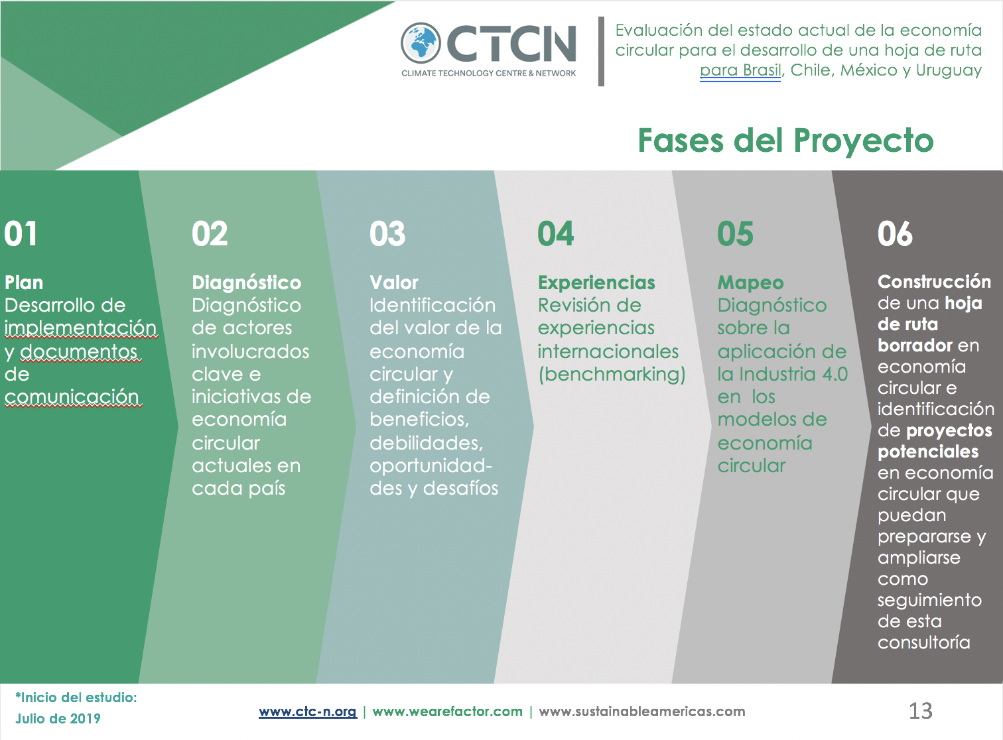 | 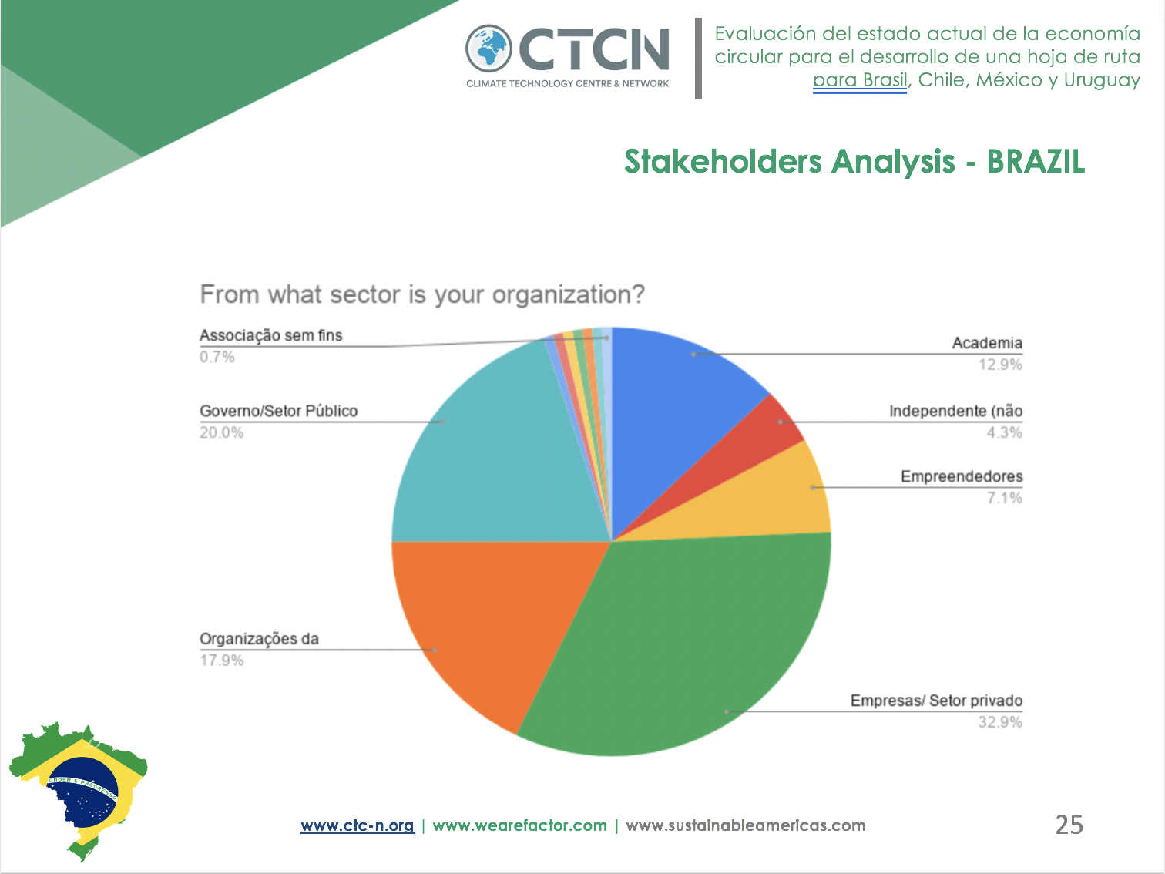
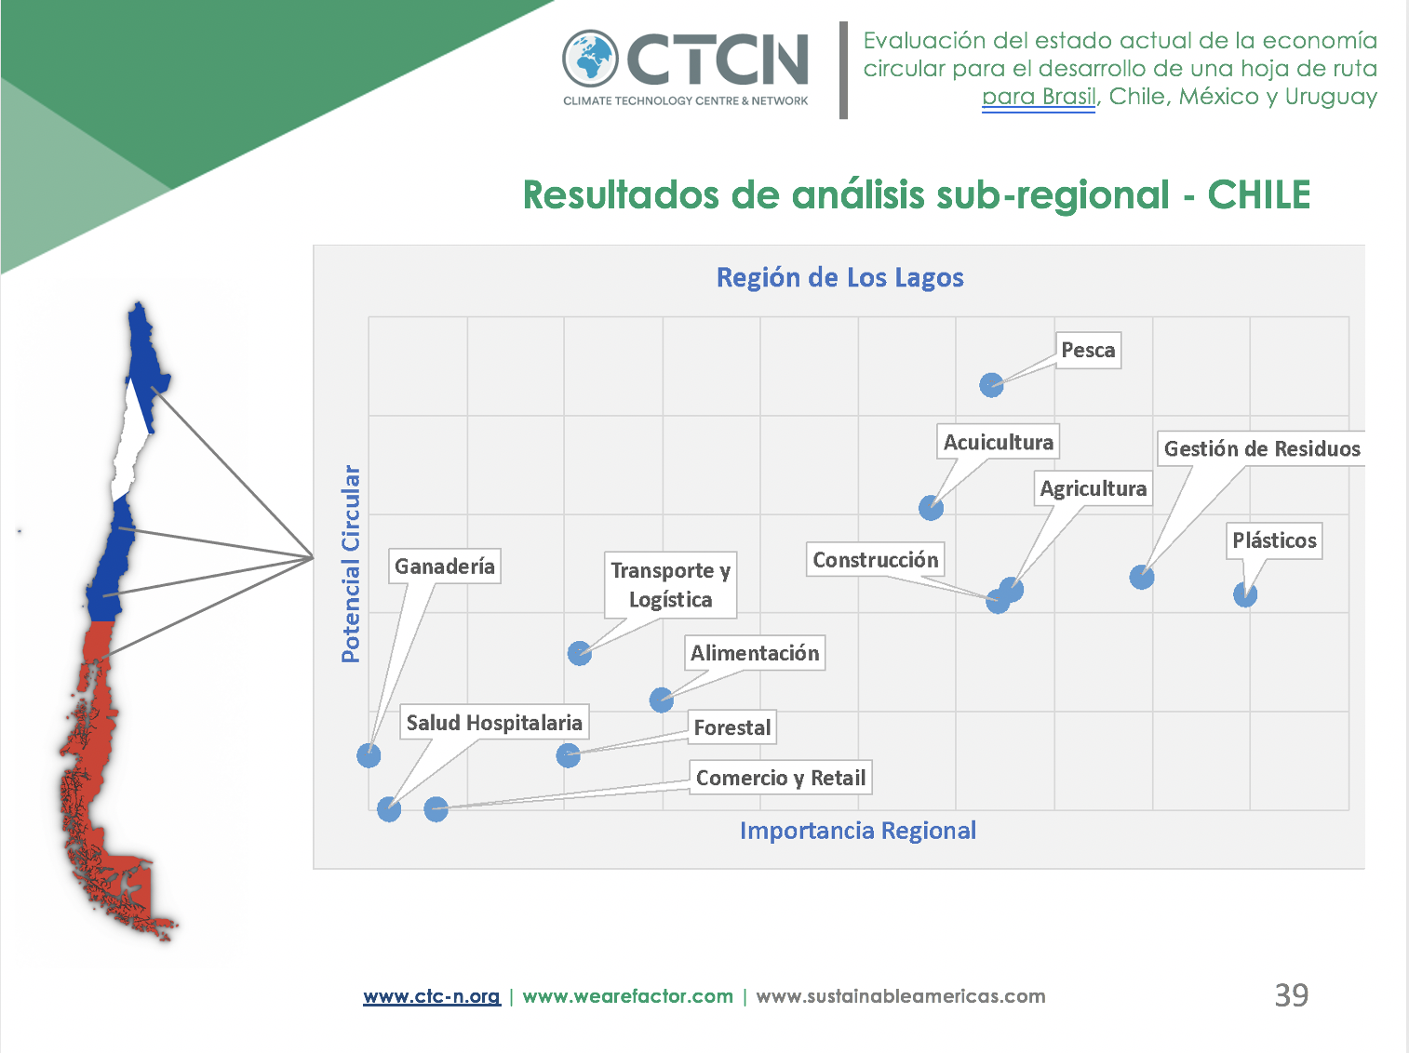 | 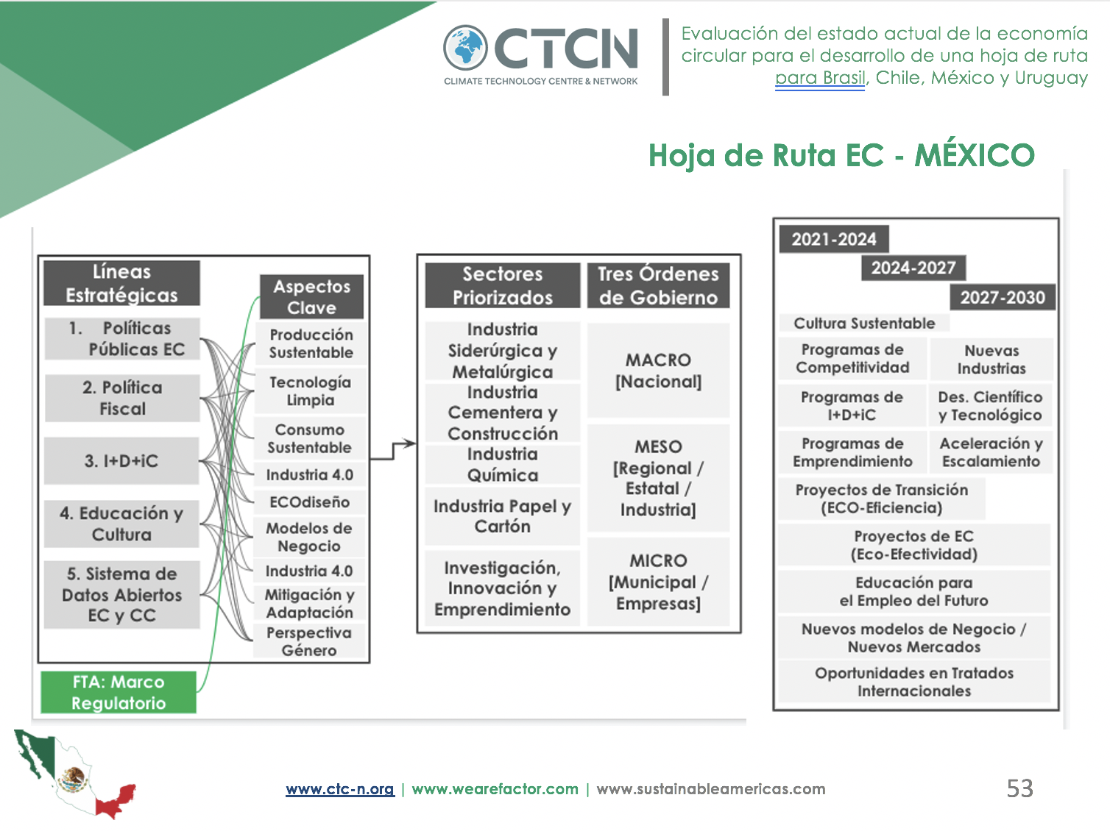
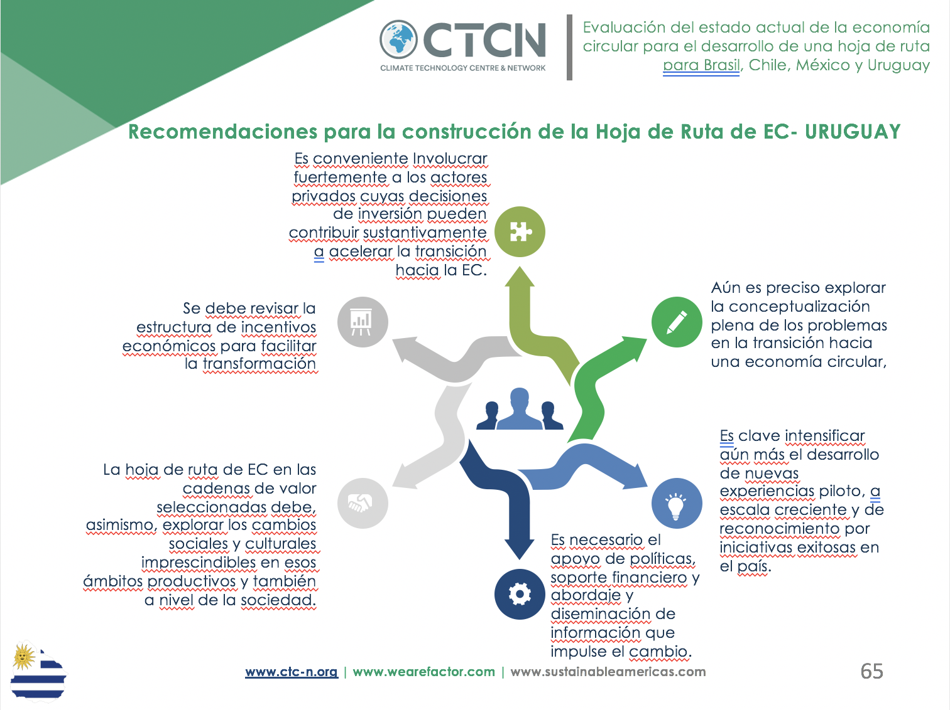 | 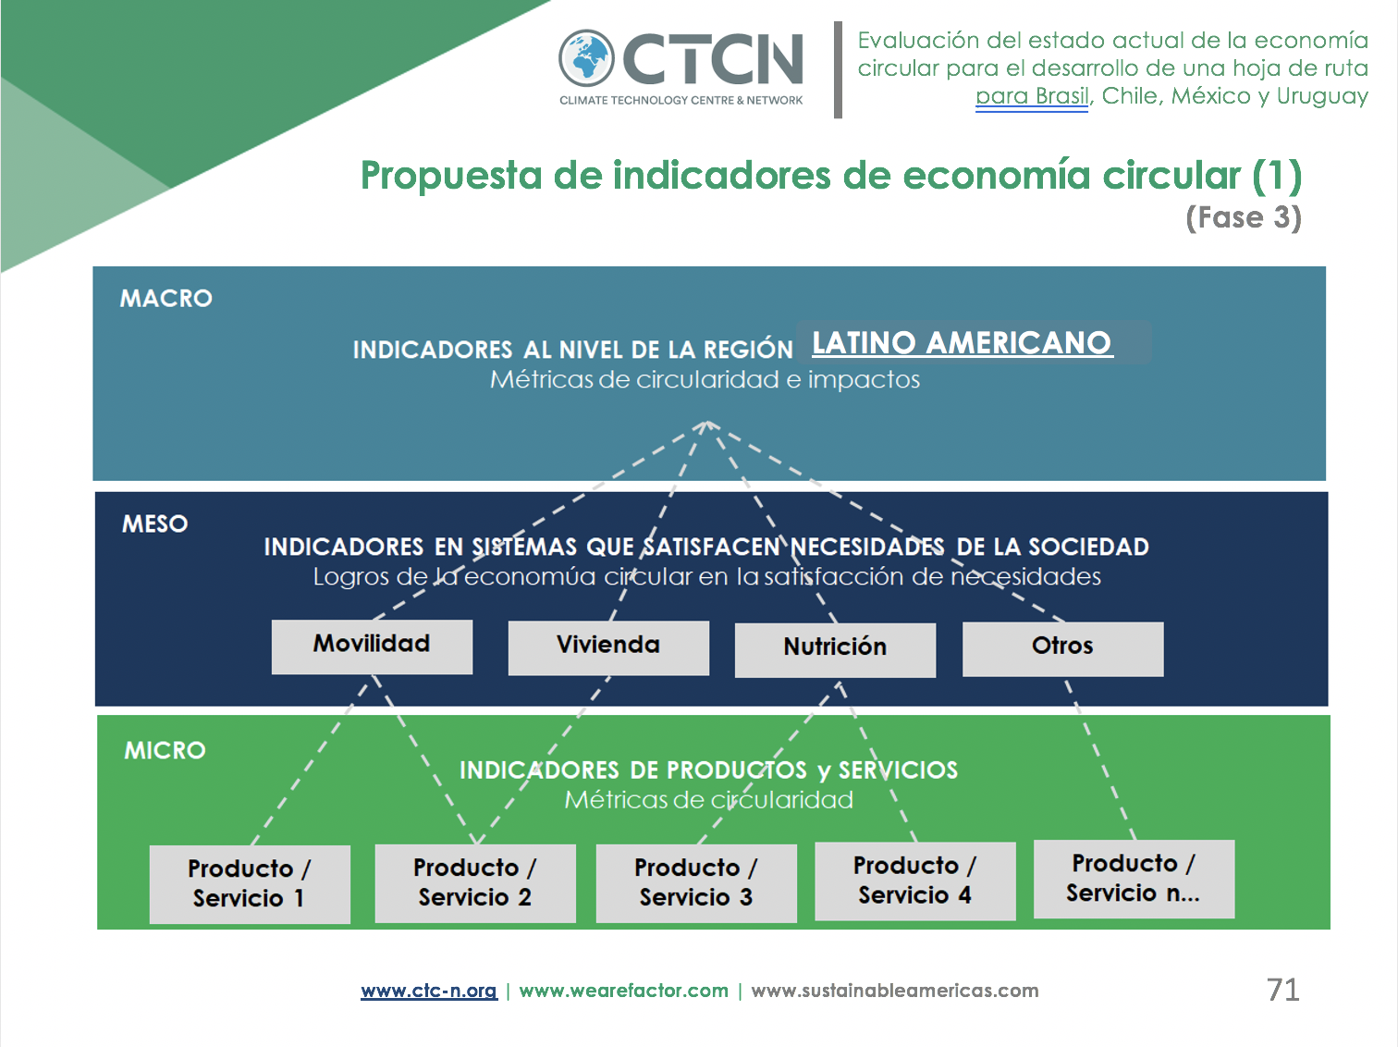
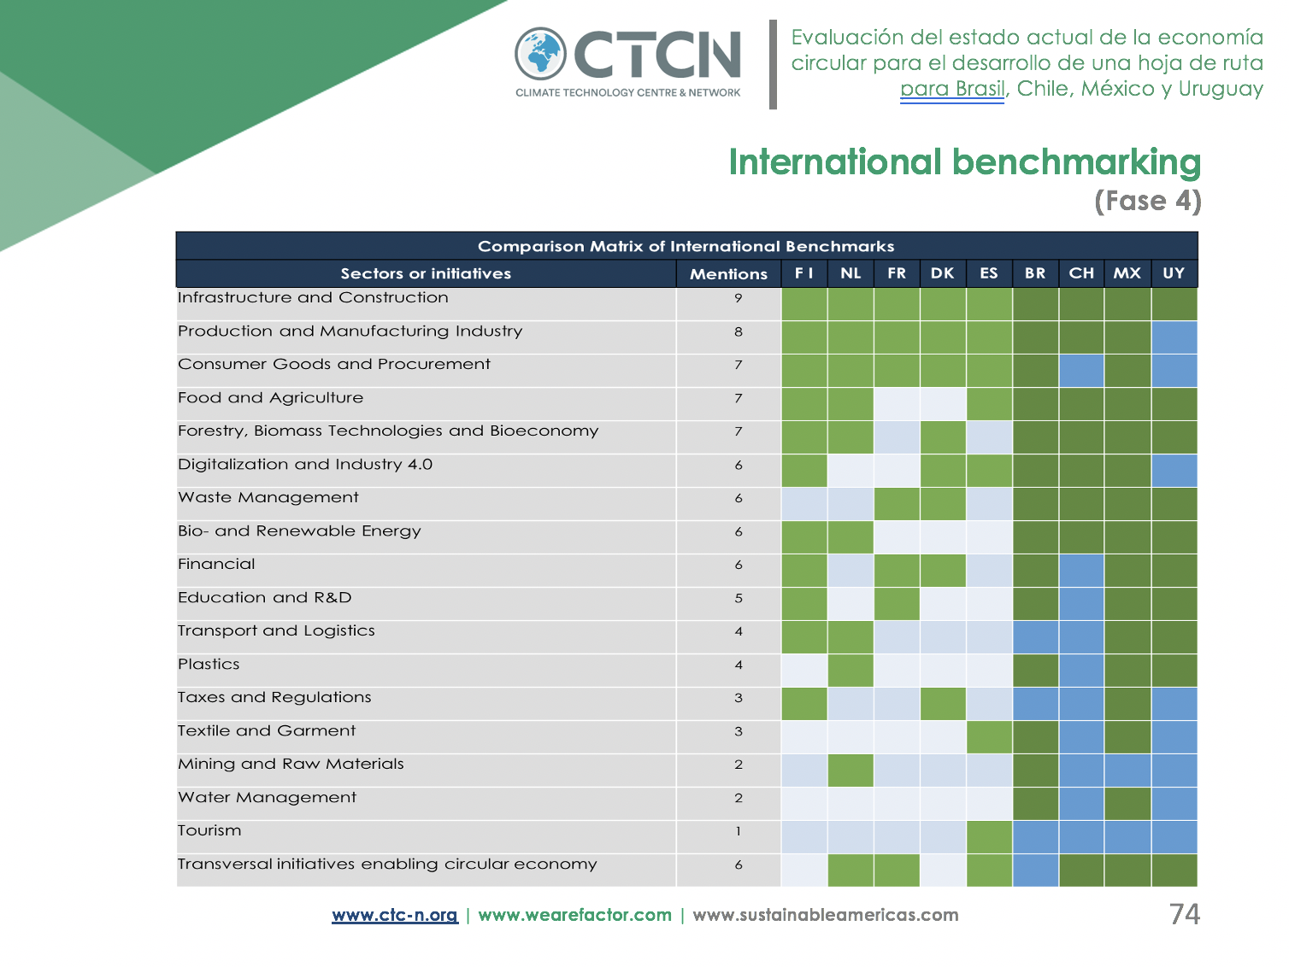 | 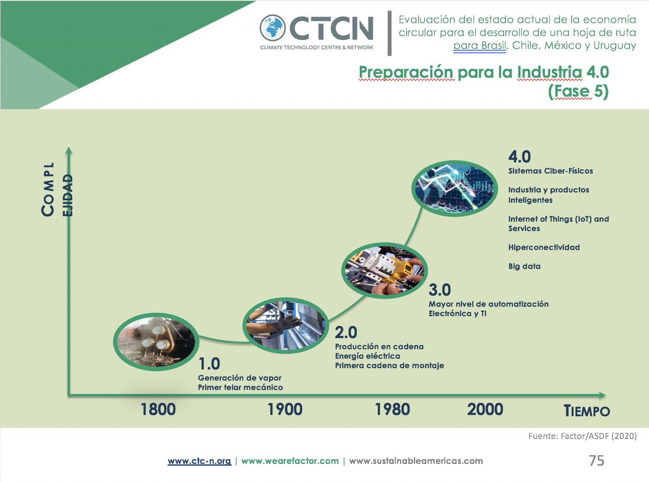

High-resolution pictures:

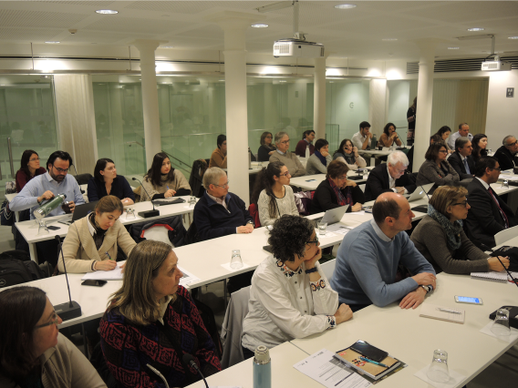 | 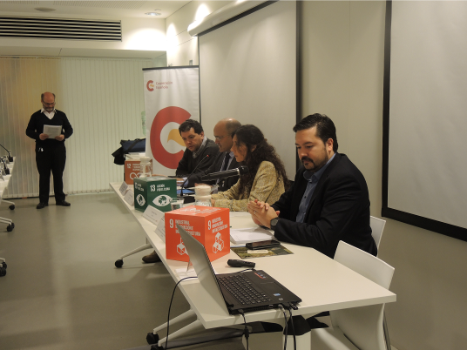
Image 1 and 2: August 14, 2019. Kick of meeting in Uruguay. Panels included participation of the Education Center of the Spanish Cooperation Agency in Uruguay (host of event), United Nations Development Organization (UNIDO), Renewable Energies Section of the Ministry of Energy and Mines, Climate Change Division of the Ministry of Environment, and other 50+ participants representing public, private, civil society, and academic sectors.

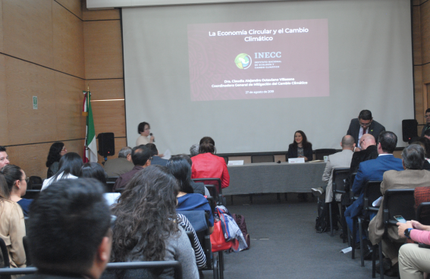 | 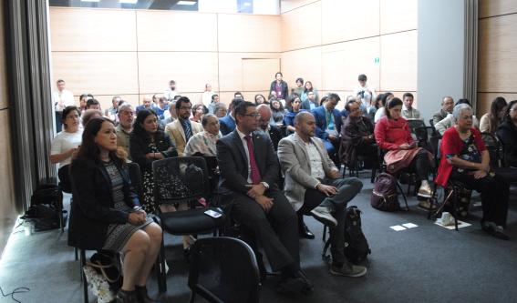
Image 3 and 4: August 27th, 2019. Kick off meeting in México. Panels included participation of the National Institute of Ecology and Climate Change (INECC) serving also as host of the event, Secretariat of Environment and Natural Resources (SEMARNAT), the Mexican Green Ecological Party (PVEM), Americas Sustainable Development Foundation (ASDF), and other 75+ participants from government, academy, companies and civil society.

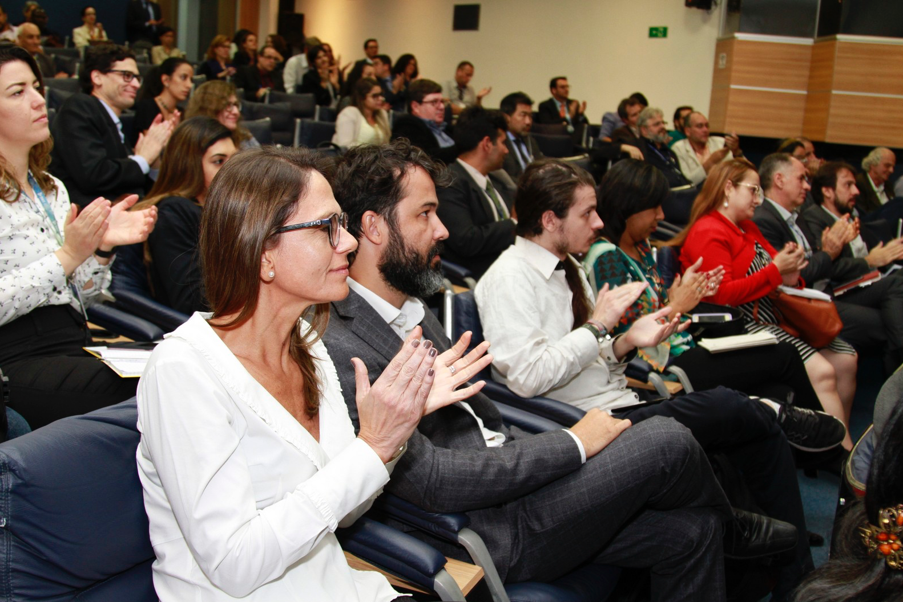 | 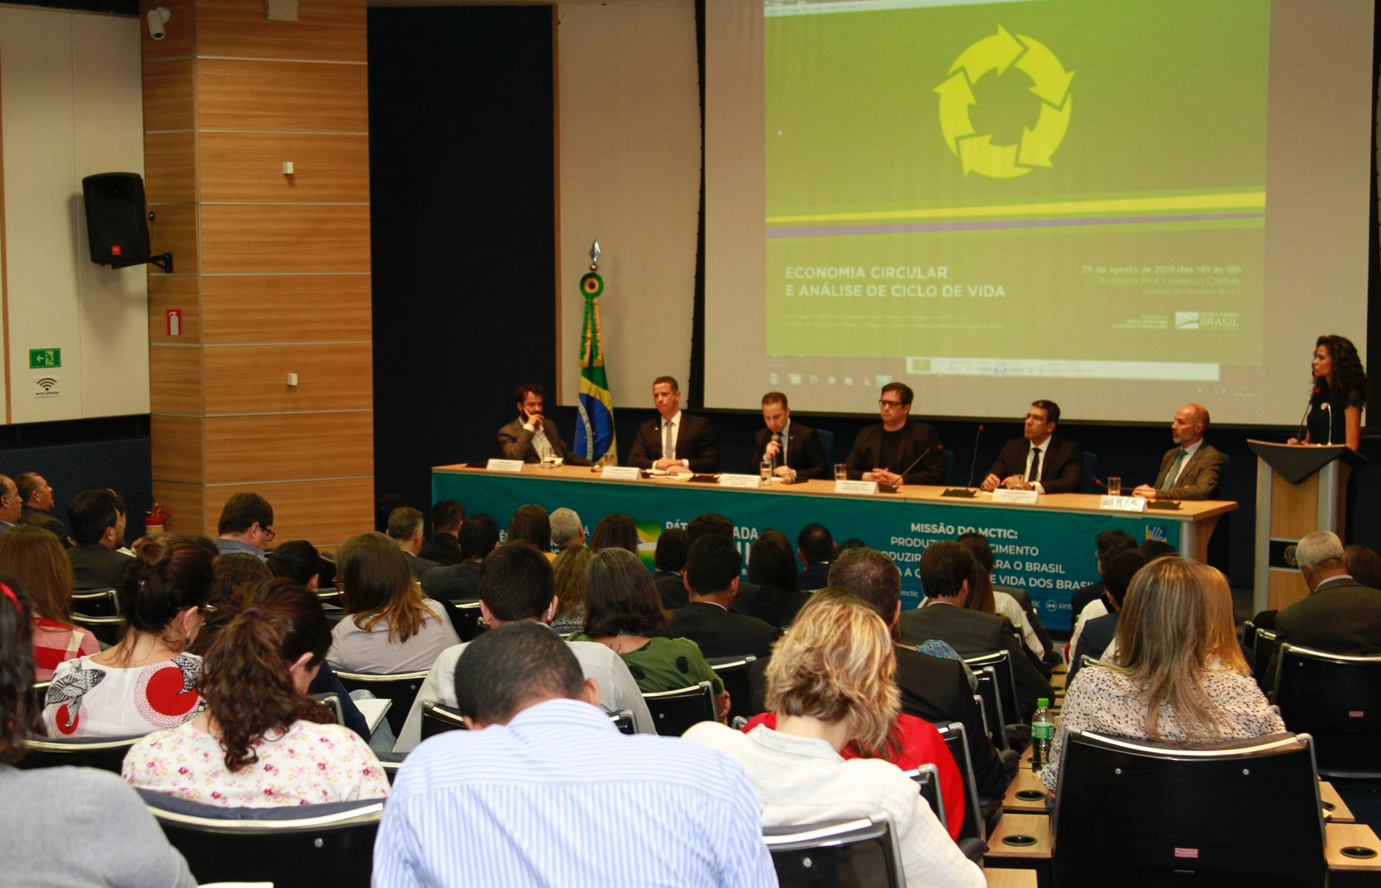
Image 5 and 6: August 29th, 2019. Kick of meeting in Brazil. Panels included participation of the Ministry of Science, Technology and Innovations (MCTI) serving also as host of the event; Ministry of Mines and Energy (MME); Ministry of Regional Development (MDR); Brazilian Institute of Information on Science and Technology (IBICT); National Industry Confederation (CNI); United Nations Industrial Development Organization in Brazil (UNIDO) and 100+ participants from government, academy, companies and civil society.

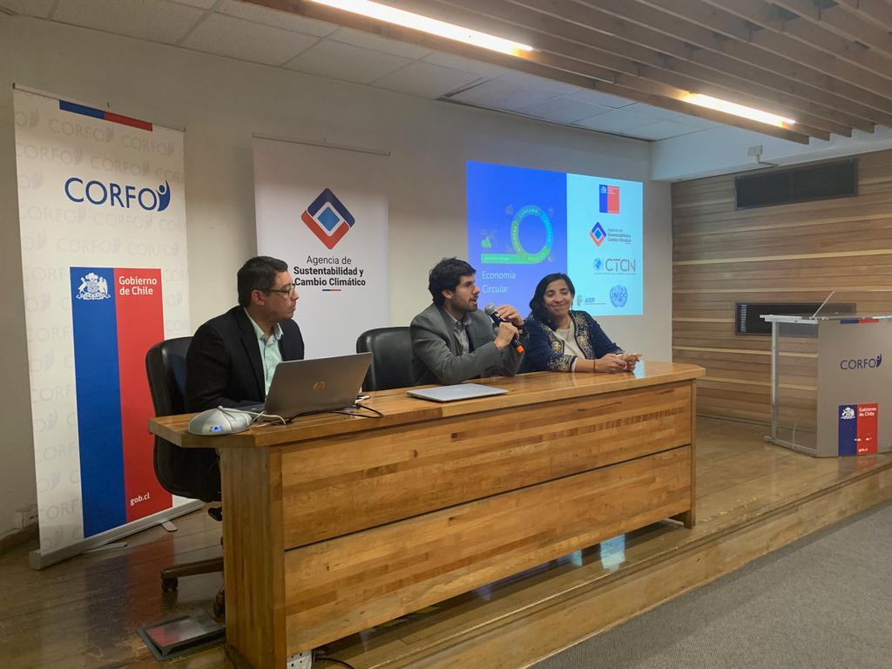 | 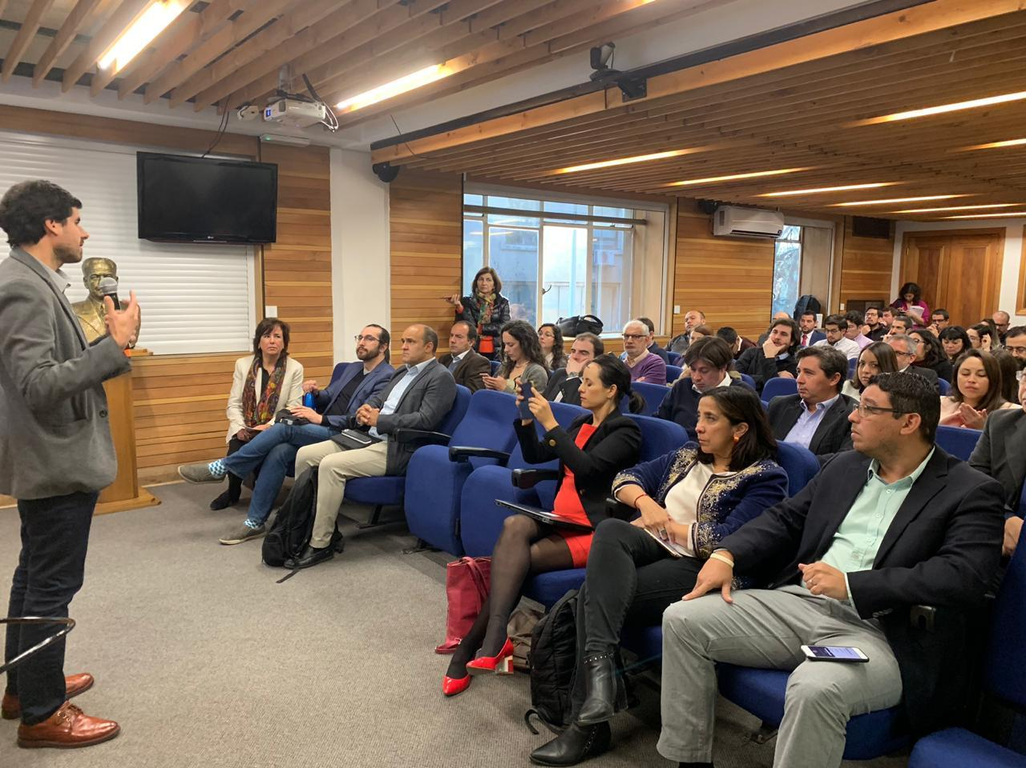
Image 7 and 8: September 2nd, 2019. Kick of meeting in Chile. Panels included participation of Chilean Economic Development Agency (CORFO), serving as host of the event, the Chilean Agency for Sustainability and Climate Change (ASCC), the Ministry of Environment (MMA), Americas Sustainable Development Foundation (ASDF), and other 60+ participants representing public, private, civil society, and academic sectors.

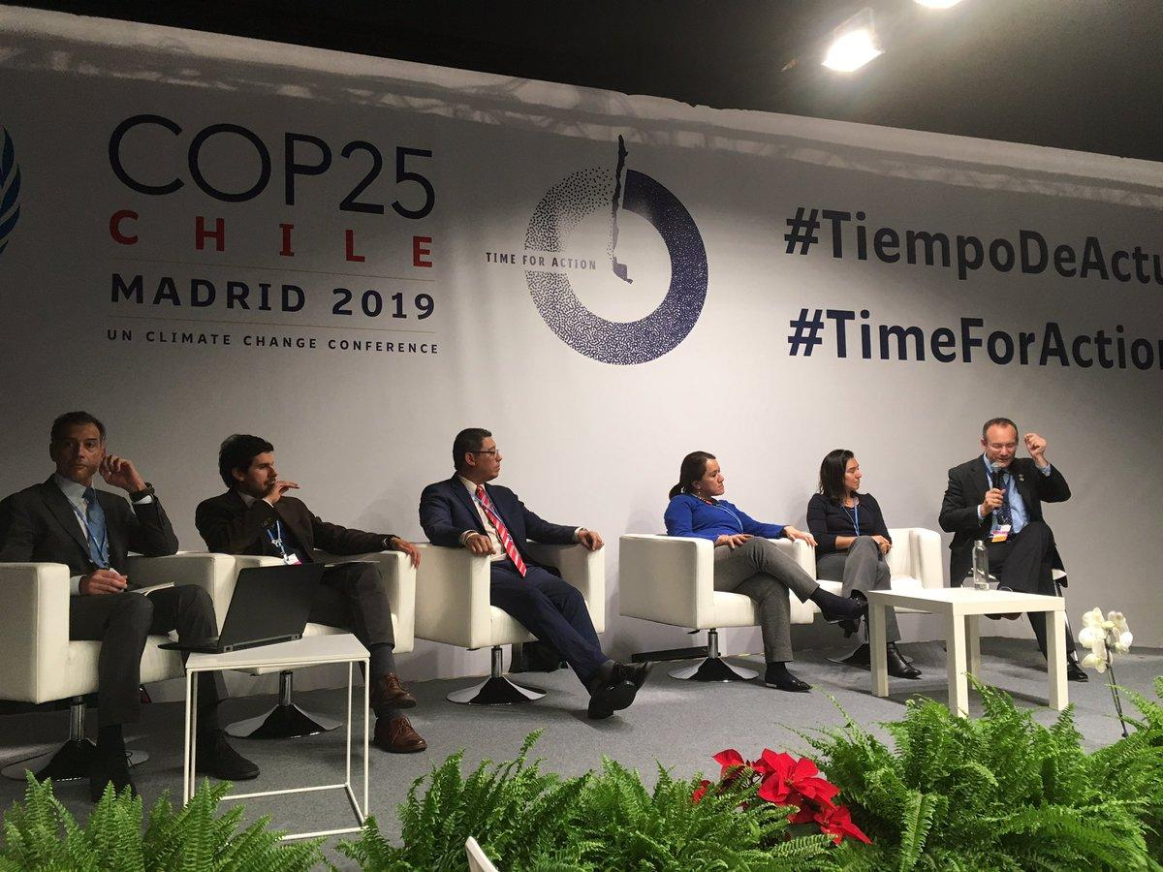 | 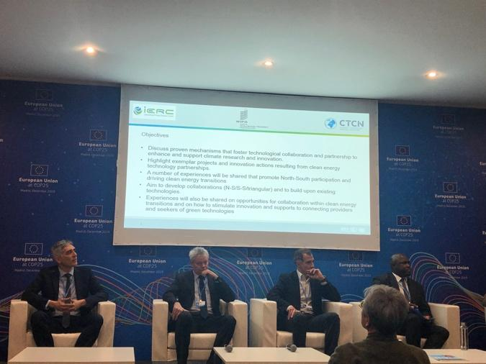
Image 10: From left to right: Federico Villatico (Regional Manager - LAC, West and Central Africa at CTCN); Guillermo Gonzáles (Head of the Circular Economy Office at the Ministry of Environment in Chile); Kevin de Cuba (Team Leader, CTCN CE LAC Project & Director, Americas Sustainable Development Foundation); Claudia Octaviano (General Coordinator of Climate Change Mitigation and Low Carbon Development of Mexico and NDE Mexico); Paola Visca (Climate Change Division of the Ministry of Housing, Planning and Environment of Uruguay and NDE Uruguay); and Gonzalo Muñoz (High Level Champion COP25). And Image 11: Iker Larrea, Partner and Head of Markets at FACTOR, and Project Director (Factor/ASDF), presented mid-term outcomes of the CTCN CE LAC Project on December 12, 2019, EU Pavilion, Blue Zone, COP25 Venue, Madrid, Spain.

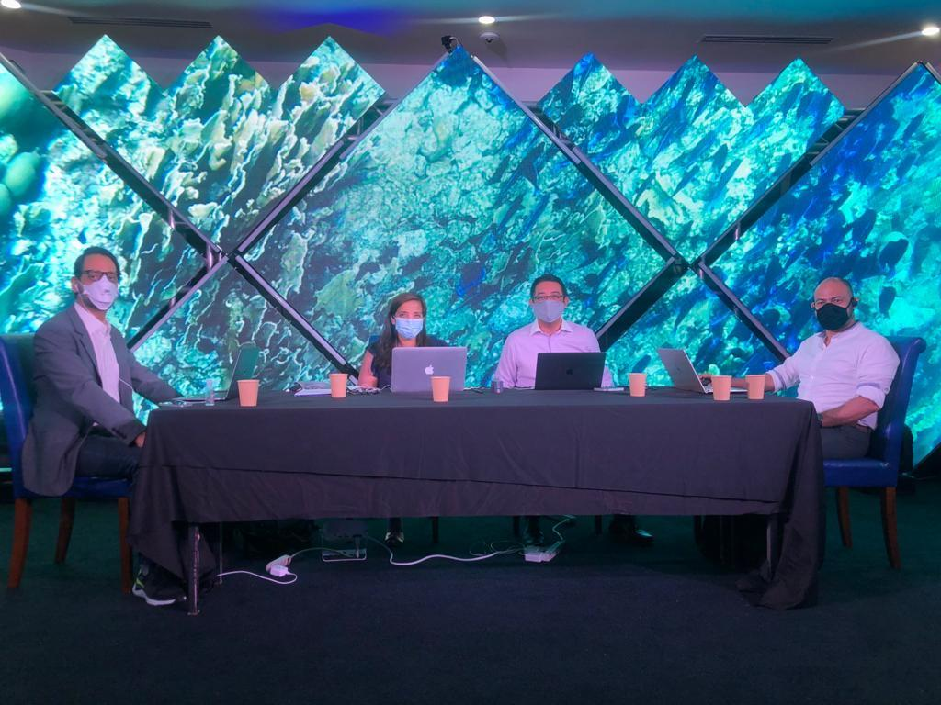
Image 12: December 9th, 2020. TA Regional Closing Event at Aruba TV Studios in Oranjestad, Aruba (Dutch Caribbean). In the picture from left to right: Alexandre Fernandes (Brazil), Irina Reyes (Chile), Kevin de Cuba (Team Leader) and Mauricio Zenteno (México), members of the Factor/ASDF Project Team.

- Impact Statement

Challenge | Latin America is particularly vulnerable to natural resource exploitation as a means of creating large export and resource flows at the expense of the increasing degradation and depletion of those natural resources. A new economic and industrial model must be implemented as a way to increase economic prosperity, develop innovative technologies, become more competitive in the global market, protect and regenerate natural resources by deploying climate compatible solutions and products.  Circular Economy has been identified as a potential solution to these issues. The problem is the lack and asymmetry of information, as well as the coordination failures that exist in the participating countries with regard to the state and level of development of the circular economy, as well as the lack of knowledge of the players and the circular initiatives that are being developed in their respective territories, their potential benefits and existing barriers.  The requesting countries have implemented public policies and private initiatives to advance in the circular economy or for the integral management of waste, characterized mainly by regulations and programs that have established a framework for waste management, extended responsibility to the producer and promoted recycling to reduce the generation of waste and promote its recovery and reuse in order to protect the health of their citizens and the environment.  However, these initiatives have not been framed within a national strategy for a circular economy that systematizes these experiences, defines and establishes clear goals and objectives, and provides information on the dimension of the existing benefits and barriers, thus enabling the creation of a road map to begin the transition towards a circular economic model aligned to the national strategy for climate change and create performance indicators that facilitate monitoring compliance with the NDC, the SDGs (9, 12 and 13) and the commitments of each requesting country under the Paris Agreement adopted by the Conference of the Parties (COP) to the Framework Convention on Climate Change.  This consultancy aimed to deliver country-specific baseline assessments for jump-starting the circular economy roadmapping in Brazil, Chile, Mexico and Uruguay through the development of the following objectives:  - Gather information on key stakeholders and current initiatives.  - Gather data on circular economy value and definition of benefits, weaknesses, opportunities and challenges.  - Review international experiences in successful applications of industry 4.0 in circular economy processes.  - Identify potential projects that can be prepared and scaled-up as a follow-up of this consultancy.  This process included the analysis of the “current” situation of the circular economy in the requesting countries, identifying and developing an updated map of key players/stakeholders, public/private initiatives, definition of territories, and description of gaps and barriers, to serve as input for the development of a general, sectoral and/or process-specific circular economy road map. The developed circular economy roadmap related and contributed to climate change mitigation and adaptation that could serve as a management tool for a future implementation phase in order to create new businesses, innovation and technological transfer, generate quality employment and combat climate change in Latin America, while complying with their nationally determined contributions (NDC) and sustainable development goals (SDGs), which enable to become leaders in the field of circular economy.
CTCN Assistance | - Four (4) National Circular Economy Roadmaps formally adopted by the Governments of Brazil, Chile, Mexico and Uruguay as a follow up to this Technical Assistance.  - Definition of at least one high-potential demonstrative pilot project per country to be implemented as a follow-up to this Technical Assistance.  - The definition and launch of a Regional Platform on Circular Economy for sharing the results of the Technical Assistance and facilitate follow up work through south-south partnerships in the region.
Anticipated impact | The assessment of the current status of the circular economy understanding and deployment in each project country enables the proper development of roadmaps to be either general, sectorial or process-focused based on the needs of each country. It is a result of an inclusive and participative process that gathers information and actions to contribute to the:  - Reduction of the use of resources needed per unit produced.  - Reduction of the quantity of waste produced.  - Reduction in the quantity of energy consumed (the reuse of raw materials reduces the amount of energy required to obtain the same or another product).  - Development of new businesses and generation of new job opportunities (Latin America presently has a low rate of recycling and increasing the present rate will create the need to hire more personnel for the various tasks required in the different parts of the value chain of each product manufactured).  - Promotion of innovation, because it is necessary to change and update the production model as well as update the production infrastructure, equipment and technologies, to process waste (future raw material).  - Contribute to mitigating and adaptation to climate change.
Co-benefits: Achieved or anticipated co-benefits from the TA | Significant co-benefits are generated through this regional TA. This in particular for the Project Countries, where in some this TA is deemed as the principle or launching program to specifically coordinate a government-level intervention in the field of Circular Economy, and in addition exploring, investigating and learning about the interlinkages and interdependencies between Circular Economy solutions and Climate Change mitigation and adaptation.  Overall, this TA is ground-breaking, as it’s the first regional program in the Americas with such focus and which has generated and/or confirms relevant conclusions and recommendations for the wider region to continue to engage in Circular Economy strategies as a means to address Climate Change and contribute to the SDGs.
Gender aspects of the TA | This regional TA benefitted from a particular focus on gender aspects led by a Senior Gender Specialist to guarantee that the gender relevant information is incorporated transversally, and making sure gender is evaluated within the diagnoses, associated with a baseline in circular economy issues, looking into economic, social and environmental implications, disaggregated by gender.  During the stakeholder’s identification and mapping exercises and consequent interviews, key national experts and leading organizations were approached and asked for their insights and advancements in the field of circular economy. Among these actors and stakeholders several leading female professionals were identified and/or women-led organizations, showcasing the high participative level of women within this emerging field of Circular Economy.
Anticipated contribution to NDC | All requesting countries have commitments to nationally determined contributions (NDC):  - Brazil, a reduction of 37 per cent by 2025 compared to 2005 levels and an indicative contribution of 43 per cent by 2030 (also compared to 2005 levels);  - Chile, a 30 per cent reduction of emissions per unit of GDP by 2030, and varying between 35 and 45 per cent if international contributions are received;  - Mexico, an unconditional reduction of 22 percent in its GHG emissions by 2030 and a conditional reduction of 36 per cent by 2030, compared to a BAU (business as usual) scenario; and  - Uruguay’s emission reduction targets for 2030 by sector comparable to 1990 levels.  Furthermore, all participating countries agreed that productive/industrial processes, energy, and waste are priority sectors for mitigation, and are sectors where the circular economy has the greatest impact.  This is of great importance, since this regional TA seeks to lay the foundations for the development of road maps to create general, sectoral or specific circular economy strategies that generate an economic, social, institutional and environmental impact through the identification of players and territories that have favorable conditions for the development of a circular economic model, improving the competitiveness and efficiency of local businesses, enterprises and organizations that operate in these sectors, particularly small and medium-sized enterprises (SMEs) that require sustainable and inclusive development due to the high impact that these type of enterprises have for the project countries as a main source of employment.  The intersection between circular economy and industry 4.0 represents a great opportunity for companies, organizations and academia to develop new circular business models through the incorporation of technologies and continuing competitivity to reduce the environmental impact of their productive activities.  Finally, all the participating countries have nationally appropriate mitigation actions (NAMAs), that can serve to better link this regional TA with the different NDCs as part of the voluntary commitment to reduce greenhouse gas emissions.
The narrative story | Since the Industrial Revolution, in the nineteenth century, most countries have based their growth and development on a linear model of production and consumption which can be summed up as “take, make and discard” and an energy matrix that is based on the use of fossil fuels.  Some 250 years later, our Earth has become home to 7 billion people, who use resources equivalent to 1.7 planets. Not only is the linear economy inefficient, because out of the 92.8 billion tons of resources mined each year, only 9 per cent is reused, but it also contributes to climate change, as the management of materials accounts for approximately 67 per cent of greenhouse gas (GHG) emissions.  Human activity is estimated to have caused the global temperature to increase by about 1°C above pre-industrial levels and, if no rapid and far-reaching action is taken, the temperature is expected to rise by 1.5°C between 2030 and 2053.  Latin America, owing to its wealth in natural resources and the limited industrialization of its economy, has played a fundamental role in the current linear model, accounting for 44 per cent of the world's copper, 49 per cent of silver, 65 per cent of lithium, 20 per cent of petroleum reserves, 33 per cent of freshwater reserves and 20 per cent of native forests. This has led the region to specialize in economic activities based on the extraction of these resources, generating little economic benefit and significant environmental impacts, neglecting industrial activities that generate added value, and hindering industrial development based on technology and innovation.  On the other hand, Latin America generates 160 million tons of solid waste per year, at an average per capita of 1.1 kg per day, of which less than 3 per cent is reused or recycled, and it is expected that by 2030 the region's population will grow by 17 per cent, reaching 705 million, increasing its per capita waste generation by 45 per cent, to reach 1.6 kg per day.  While Latin America only produces 11 per cent of GHG emissions, it is one of the regions that is most vulnerable to climate change, which could come to represent a cost of up to US $100,000 million per year by 2050, mainly owing to natural disasters, and leading up to 17 million people to migrate internally in the region.  The circular economy seeks to replace the current linear economic model with a circular model, to enable the harnessing and eco-effective and efficient use of resources, promoting the use of non-conventional renewable energies (NCRE).  Instead of extracting natural resources, the circular economy involves recovering and reusing materials that have already been processed, thus keeping them in circulation for as long as possible, reducing pressure by up to 28%and GHG emissions by up to 72% globally.  A circular economic system allows the decoupling of economic growth from the use of natural resources, promoting the creation of new companies, as well as changes in the production processes of existing companies, with an economic potential of up to US $4.5 trillion, and generating up to 6 million new jobs by 2030 worldwide, thus complying in particular with Sustainable Development Goals (SDGs) 9, 12 and 13, as well as the nationally determined contributions (NDC) agreed by each participating country, representing a great opportunity for sustainable development in Latin America.
Contribution to SDGs | SDG 7 – Ensure access to affordable, reliable, sustainable and modern energy  This regional TA promoted the development of concept notes for pilot projects about technologies related with eco-efficiency and re-use of biomass on energy generation and co-processing of industrial waste as part of cement production process for the case of Mexico; as well as a sustainable cattle raising value chain for the case of Uruguay.  SDG 8 – Promote sustained, inclusive and sustainable economic growth, full and productive employment and decent work.  This regional TA promotes the generation of decent work opportunities but also a more robust, inclusive, and poverty-reducing growth through the pilot projects proposed related with eco-efficiency, re-use of biomass and sustainable farming.  SDG 9 – Build resilient infrastructure, promote inclusive and sustainable industrialization and foster innovation  This regional TA attempts to promote sustainable industrialization that puts at the forefront innovative technologies, renewable energy development, industries and infrastructure that could potentially incorporate circular economy approaches. This SDG aims to help countries become economically competitive through this approach.  SDG 12 - Ensure sustainable consumption and production patterns  The regional TA aims at gauging a country’s ability to coordinate business practice, global value chains and sustainable consumption and production. This indicator directly reflects circular economy values. When analyzing responsible consumption and production, e-waste, wastewater, SO₂ and nitrogen emissions (imported and produced), municipal solid waste and non-recycled municipal solid waste are all considered.  SDG 13 - Take urgent action to combat climate change and its impacts  The implementation of this regional TA reflects the participating countries’ approach to addressing climate change and its impacts in their commitments to the Paris Agreement. It also represents other in-country approaches aimed at limiting the global temperature increase. Data on CO₂ emissions, climate change vulnerability and effective carbon rate are all relevant to understanding SDG 13.

Annex 1 Technical assistance data collection

[Please add quantitative and qualitative values for the indicators selected in the M&E plan and monitored throughout the technical assistance in the tables below. Indicators which have been monitored in addition to the proposed indicators below may be added at the end of table A. Non-relevant indicators should be left blank.]
- Output and outcome indicators

Indicator  Please note indicators below highlighted as anticipated | Quantitative value  Numerals only; disaggregates must sum to the total | Qualitative description  List the various elements corresponding to the quantitative value as well as timelines and responsible institutions
Total number of events organized by proponents and implementing partners | 17 | BRA: Three (3). 1 Kick Off presential Meeting open to actors available online, 1 meeting with Key actors, and 1 National online Meeting for presenting final results with actors.  MX: Two (2). 1 Kick Off presential Meeting and 1 National online Meeting for presenting final results.  URU: Four (4). 1 Kick Off presential, 2 meetings with Key actors, and 1 National online Meeting for presenting final results with actors.  CH: Seven (7). 1 Kick Off presential Meeting open to actors available online, 1 meeting with Key actors, 4 Regional Meetings, and 1 Local Event (online).  Regional: One (1). 1 International / Regional online meeting with NDE representatives of Brazil, Chile, Mexico, Uruguay, and CTCN.
Number of participants in events organized by proponents and implementing partners | 659+ | The number provided is estimated based on the number of events organized (online and in-person) and the average level of participation throughout the project implementation phase.
- Number of men | 60%
- Number of women | 40%
Number of climate technology RD&D related events | N/A
Number of participants in climate technology RD&D events | N/A
- Number of men | N/A
- Number of women | N/A
Number of training organized by proponents and implementing partners | 5 | MX: at least fiev (5) working sessions organized that resulted in transferring of knowledge on Circular Economy, Business Models & Industry 4.0.
Number of participants in trainings organized by proponents and implementing partners | 4
- Number of men | 0
- Number of women | 4
Total number of institutions trained | 1 | MX: NDE
- Governmental (national or subnational) | 1 | INECC
- Private sector (bank, corporation, etc.) | N/A | N/A
- Nongovernmental (NGO, University, etc.) | N/A | N/A
Percentage of participants reporting satisfaction with CTCN training (from CTCN training feedback form) | N/A | N/A
Percentage of participants reporting increased knowledge, capacity and/or understanding as a result of CTCN training (from CTCN training feedback form) | N/A | N/A
- Percentage of men | N/A
- Percentage of women | N/A
Total number of deliverables produced during the assistance (excluding mission, progress and internal reports) | Total: 39 | See: https://www.ctc-n.org/technical-assistance/projects/assessment-current-status-circular-economy-developing-roadmap
- Number of communication materials, including news releases, newsletters, articles, presentations, social media postings, etc. | Total: 33 | BR:  https://www.youtube.com/watch?v=hjCaJpjQjbw https://www.youtube.com/watch?v=whe96FQB570 ,  https://economiacircular.mctic.gov.br  https://www.ctc-n.org/news/evento-evaluaci-n-del-estado-actual-de-la-econom-circular-para-el-desarrollo-de-una-hoja-de  https://www.gov.br/mcti/pt-br/acompanhe-o-mcti/noticias/2021/06/mcti-publica-roadmap-de-economia-circular-em-parceria-com-ctcn-das-nacoes-unidas  https://www.investe.sp.gov.br/noticia/estudo-do-mcti-em-parceria-com-ctcn-das-nacoes-unidas-identifica-oportunidades-do-pais-para-economia-circular/  https://ccbj.jp/oportunidades-do-brasil-para-economia-circular/  https://circular-economy-platform.tribe.so/topic/ctcn  https://mapa.sa.com/evento-vai-apresentar-resultados-de-roadmap-nacional-de-economia-circular/  CH:  https://paginav.cl/2020/11/06/congreso-internacional-virtual-abordara-la-economia-circular-como-puente-para-crear-nuevas-oportunidades-y-empleos/  https://www.paiscircular.cl/consumo-y-produccion/congreso-internacional-abordara-la-economia-circular-como-puente-para-crear-nuevas-oportunidades-y-empleos/  https://www.diariosostenible.cl/noticia/actualidad/2020/11/congreso-virtual-promueve-los-modelos-de-negocios-circulares  https://www.paiscircular.cl/consumo-y-produccion/kevin-de-cuba-el-sector-privado-tiene-la-habilidad-y-el-deber-de-innovar-de-buscar-la-forma-de-reconfigurar-su-modelo-de-negocio/  https://codexverde.cl/realizaran-diagnostico-para-la-construccion-de-la-ruta-de-la-economia-circular-en-chile/  https://paginav.cl/2019/09/06/realizaran-diagnostico-para-la-construccion-de-la-ruta-de-la-economia-circular-en-chile/  http://www.diarioestrategia.cl/texto-diario/mostrar/1519117/realizaran-diagnostico-construccion-ruta-economia-circular-chile  https://www.paiscircular.cl/industria/manuel-albaladejo-la-economia-circular-es-el-punto-de-encuentro-entre-la-agenda-productiva-y-la-ambiental-hoy-es-imposible-entender-una-sin-la-otra/  MX:  https://alcanzandoelconocimiento.com/inecc-onudi-y-pnuma-disenan-hoja-de-ruta-para-la-economia-circular-en-mexico/  https://www.ctc-n.org/news/webinar-evaluaci-n-del-estado-actual-de-la-econom-circular-para-desarrollar-una-hoja-de-ruta  https://www.vertigopolitico.com/bienestar/notas/economia-circular-como-vamos-en-mexico  https://vimeo.com/429638479  http://www.teorema.com.mx/sostenibilidad/inecc-analiza-el-estado-actual-de-la-economia-circular-en-mexico/  https://www.gob.mx/inecc/prensa/realiza-inecc-sobre-el-estado-actual-de-la-economia-circular-en-mexico-en-el-marco-de-las-ndcs  https://www.virtualpro.co/noticias/hoja-de-ruta-para-la-economia-circular-en-mexico  UY:  https://intercoonecta.aecid.es/economia-circular-hoja-ruta  https://www.eltelegrafo.com/2021/02/economia-circular-brinda-oportunidades-para-la-generacion-de-fuentes-laborales/  Regional: Regional Closing Event (as side-event to the Circular Economy Forum of the Americas – CEFA2020):  https://www.ctc-n.org/news/evento-evaluaci-n-del-estado-actual-de-la-econom-circular-para-el-desarrollo-de-una-hoja-de  https://www.cefa2020.com/  https://www.youtube.com/watch?v=whe96FQB570  General:  https://www.wearefactor.com/es/factor-proporciona-asistencia-tecnica-de-economia-circular-a-ctcn-en-brasil-chile-mexico-y-uruguay/noticia/4126  https://es-la.facebook.com/pg/PECAmericas/posts/  https://www.pec-americas.com/190906-ec-regional  https://www.responsabilidadsocial.net/america-latina-y-el-caribe-lanza-la-coalicion-de-economia-circular/  https://industriaspesqueras.com/noticia-64483-sec-Pol
- Number of tools and technical documents strengthened, revised or developed | 35 | - MX: 4 Additional reports based on Project's deliverables. These documents were prepared in collaboration with NDE MX team, to attend specific needs by the NDE & its stakeholders (these documents were not included in the Project's budget). See for instance: https://www.gob.mx/cms/uploads/attachment/file/641380/VF_version_ejecutiva_Economia_Circular_2.pdf  - 4 Evaluation Reports (technical documents to explain Current Situation of Circular Economy (Diagnosis), FODA+Barriers & Pilot projects identified and to present the most relevant results of this Project/Roadmap to other Public Entities representatives within project's timeline (Aug 2019 - Jan 2021)  - 4 Reports presenting a map of the main economic activities.  - 4 Reports of the strengths and opportunities identified, and the weaknesses and barriers identified.  - 4 Reports with the indicator matrix  - 1 Report that presents cases of countries that have been successful in Circular Economy development  - 1 Report that presents lessons learned.  - 1 Report including the comparative experience matrix.  - 4 Reports that presents a general diagnosis of the level of development of industries 4.0 in each participating country and an analysis of the main technologies of the fourth industrial revolution.  - 4 Reports that presents the benefits that the actors and initiatives identified in Output 2 would bring with new disruptive circular business models.  - 4 Evaluation report to identify and define potential projects.
- Number of other information materials strengthened, revised or created (For example training and workshop reports, Power Points, exercise docs etc.) | 2 | - External Reports benefitting from inputs/results from the TA:  https://www.chathamhouse.org/sites/default/files/2020-04-01-inclusive-circular-economy-schroder.pdf  https://repositorio.cepal.org/bitstream/handle/11362/46618/1/S2000783_es.pdf
Total number of policies, strategies, plans, laws, agreements or regulations supported by the assistance | List total number here
- Adaptation related | N/A | N/A
- Mitigation related | N/A | N/A
- Both adaptation- and mitigation related | 2 | MX: D.6.2. Roadmap & Regulatory Framework Roadmap as part of an additional scope of work beyond original TORs (FTA)
Anticipated number of policies, strategies, plans, laws, agreements or regulations proposed, adopted or implemented as a result of the TA | 4 | National Circular Economy Roadmaps, one per participating project country (Brazil, Chile, Mexico and Uruguay)
- Adaptation related | N/A | N/A
- Mitigation related | N/A | N/A
- Both adaptation- and mitigation related | 4 | National Circular Economy Roadmaps, one per participating project country (Brazil, Chile, Mexico and Uruguay)
Anticipated number of technologies transferred or deployed as a result of CTCN support | N/A | N/A
Anticipated number of collaborations facilitated or enabled as a result of technical assistance | N/A
- Number of South-South collaborations | 1 | Launch of Regional Platform on Circular Economy  This regional technical assistance also laid the foundation and justified the launch of the Regional Coalition on Circular Economy for Latin America and the Caribbean.  **First Technical Preparatory Meeting for the establishment of the Circular Economy Regional Coalition for Latin America and the Caribbean  Lima, Peru – 03 March 2020.  CTCN’s Contribution to the Circular Economy Coalition for Latin America and the Caribbean (based on work performed under this regional TA):  https://www.ctc-n.org/sites/www.ctc-n.org/files/CTCN_LAC_CE_Coalition_0.pdf  **Launch of the Circular Economy Regional Coalition for Latin America and the Caribbean during a virtual side event at the XXII Meeting of the Forum of Ministers of Environment of the region, hosted by Barbados and the United Nations Environmental Program (UNEP).  Bridgetown, Barbados – 01 February 2021.  CTCN as one of the co-founding partners to the Regional Coalition (as a concrete output of this regional TA):  https://www.ctc-n.org/news/latin-america-and-caribbean-launch-circular-economy-coalition
- Number of RD&D collaborations | N/A | N/A
- Number of private sector collaborations | N/A | N/A
Number of countries with strengthened National System of Innovation as a result of CTCN support | 4 | Brazil, Chile, Mexico and Uruguay
Number of entities benefitting from institutional capacity building in a relevant field (e.g. Circular Economy). | 1 | Strengthening of CTCN’s institutional capacity in Circular Economy  This regional technical assistance served as a useful instrument for CTCN to justify intensive dialogue, capacity building, and long-term engagement with NDEs in Latin America and the Caribbean for furthering CTCN’s Circular Economy agenda as an effective means to simultaneously address Climate Change and Environmental Degradation. This is observed through the CTCN Regional Forum held in August 2019 in Brazil, the intended agenda for the CTCN Regional Forum to be held in July 2020 in the Dominican Republic (postponed to 2021), and the CTCN Virtual Regional Forums held during the summer of 2020. Where on all occasions particular focus is set on presenting the latest developments on Circular Economy and sharing national and regional experiences and best practices in the region.  **CTCN Regional Forum for Latin America and the Caribbean  Salvador de Bahia, Brazil – 19 & 20 August 2019.  CTCN mid-term update (CTCN Regional Forum for Latin America and the Caribbean):  https://www.ctc-n.org/sites/www.ctc-n.org/files/s.6.4_multi-country_request_on_circular_economy_ms._judit_rodriguez.pdf  Chile mid-term update by Ximena Ruz Espejo (Operational Focal Point - Chile) (CTCN Regional Forum for Latin America and the Caribbean):  https://www.ctc-n.org/sites/www.ctc-n.org/files/s.6.5_brief_from_chile_on_ce_ms._ximena_ruz.pdf  Mexico mid-term update by Claudia Octaviano (Principal Focal Point - Mexico) (CTCN Regional Forum for Latin America and the Caribbean):  https://www.ctc-n.org/sites/www.ctc-n.org/files/s.6.6_brief_from_mexico_on_ce_ms._claudia_octaviano.pdf  Uruguay mid-term update by Jorge Castro (Operational Focal Point) (CTCN Regional Forum for Latin America and the Caribbean):  https://www.ctc-n.org/sites/www.ctc-n.org/files/s.6.7_brief_from_uruguay_on_ce_mr._jorge_castro.pdf  Brazil mid-term update by Sonia Bittencourt (Alternate to General Coordinator of Climate – Brazil) (CTCN Regional Forum for Latin America and the Caribbean):  https://www.ctc-n.org/sites/www.ctc-n.org/files/s.6.8_brief_from_brazil_on_ce_ms._sonia_bittencourt.pdf  **CTCN Virtual Regional Forums for NDEs (2020)  Virtual, 02-05 June 2020  The Climate Technology Centre and Network (CTCN) regularly conducts a series of Regional Forums to provide opportunities for the National Designated Entities (NDEs), Network Members and climate technology stakeholders to meet and discuss some of the key issues of the CTCN and share experiences. Due to COVID-19, the meetings in 2020 were online:  https://www.ctc-n.org/calendar/events/ctcn-virtual-regional-forums-national-designated-entities

- Core impact indicators

[Please fill in the tables for anticipated impacts of the CTCN assistance. Every technical assistance should contribute to at least one of the indicators below. For guidance on how to report on core indicators see the ‘M&E Guidance Document for TA Implementers’.]

Core indicator 1 | Anticipated metric tons of CO₂ equivalent (CO₂e) emissions reduced or avoided as a result of CTCN TA  Please add your calculations in word or excel format as an Annex to this Closure Report, where applicable.
 | Anticipated metric tons of CO₂e reduced or avoided as a result of the TA on annual basis | Anticipated metric tons of CO₂e reduced or avoided as a result of the TA in total
Quantitative value  (emissions reductions) | Total number (numerals only, no rounding or abbreviations) | Total number (numerals only, no rounding or abbreviations)
Unit | tCO₂e | tCO₂e
GHG assessment boundary (project emissions)  Identify expected post-TA activities, associated effects and assess boundary for quantification of GHG emission reductions | N/A | N/A
Baseline emissions  Describe baseline scenario, baseline candidates, emission factors and emissions calculated | N/A | N/A
Methodology  Explain the method or process of verifying the indicator and how data was gathered | N/A | N/A
Assumptions  Describe assumptions made during calculation and quantification of GHG reductions | N/A | N/A

**Since this TA is not a straightforward technology deployment project, it is considered a cross cutting regional TA of a high degree of conceptual nature with a particular focus on assessing the level of awareness and understanding of the concept of Circular Economy. The TA assesses the understanding of the Circular Economy and Climate Change (CE-CC) nexus in the countries, and in addition evaluates the level of adoption and readiness of Circular Economy in each country as input for the development of general, sectoral and/or process-specific circular economy road maps relating and contributing to climate change mitigation and adaptation. Therefore, the specific measurement or quantification of CO₂e was not contemplated for this TA.

The baseline assessment and inputs generated through this regional TA serve as strategic and generic policy means to create the enabling conditions for new “circular” businesses, innovation and technological transfer, generate quality employment, combat climate change and stimulate south-south cooperation in Latin America, while enabling each country to comply with their respective Nationally Determined Contributions (NDCs) and Sustainable Development Goals (SDGs), and help positioning the project countries to become leaders in the field of circular economy.

Core indicator 2 | Anticipated increased economic, health, well-being, infrastructure and built environment, and ecosystems resilience to climate change impacts as a result of technical assistance  Please provide a qualitative description of the anticipated impacts on the categories below
Infrastructure and built environment  Anticipated increased infrastructure resilience (avoided/mitigated climate induced damages and strengthened physical assets) | In case the Circular Economy principles are properly understood and adopted by the Project Countries, and linked in their respective national circular economy roadmaps to the built environment (in particular cities), there is a significant potential for the redesign and re-organization of physical spaces with inclusion of more “circular” designed buildings and public infrastructure that make these not only more resilient to climate induced damages, but also serve as effective means to use energy, water, materials and other resources more rational and efficiently thereby helping mitigate climate change.
Ecosystems and biodiversity  Anticipated increased ecosystem resilience (areas with increased resistance to climate-induced disturbances and with improved recovery rates) | In case the Circular Economy principles are properly understood and adopted by the Project Countries, and linked in their respective national circular economy roadmaps to nature or biodiversity conservation efforts, there is a significant potential for increased level of preservation of ecosystem services, as a new circular economic model is regenerative and restaurative by intent and design. Thus circular economic activities, including productive and industrial activities, are to be developed using healthy and clean feedstock (raw material, energy or water) extracted in a sustainable manner (without impacting the regenerative capacity of the ecosystem services such as an acquifer’s ability to replenish fresh water).
Economic  Anticipated increased economic resilience (e.g. less reliance on vulnerable economic sectors or diversification of livelihood) | In case the Circular Economy principles are properly understood and adopted by the Project Countries, and linked in their respective national circular economy roadmaps to their national economic development strategies, significant socio-economic benefits are to be accrued through the stimulation of ecodesign, innovation, new business models, and conversion of the complete national economic system, which will require new jobs and skills set (new education and training), and there is the potential for a more inclusive and better distribution of the nation’s wealth and improved livelihood among all its citizens.
Health and wellbeing  Anticipated increased health and wellbeing of target group (e.g. improved basic health, water and food security) | In case the Circular Economy principles are properly understood and adopted by the Project Countries, and linked in their respective national circular economy roadmaps as means to improve health and overall wellbeing, there is significant potential for increased water, energy and food security as the circular economy stimulates nations to build resilience to external shocks by developing and deploying “glocalized” circular solutions in critical sectors of the economy and stimulate the development of domestic production capacity to offer for instance healthy organic food and nature-based products that are compatible with a circular economic system (closed loop cycle system) where resources continuous are transformed, used, re-used, and reintegrated in nature or economy.

Core indicator 3 | Anticipated number of direct and indirect beneficiaries as a result of the TA
 | Quantitative value | Means of verification
Total beneficiaries | Total number
Number of adaptation beneficiaries | N/A | N/A
Number of mitigation beneficiaries | N/A | N/A
Number of adaptation-and mitigation beneficiaries | 100+ (at least 25 per project country) | The estimated accumulative number of organizations/institutions across the four (4) project countries (BR, CH, UY, and MX) that have benefitted directly and indirectly in gaining an understanding of the concept of the Circular Economy, its inter-relationship and inter-dependence with Climate Change mitigation and adaptation from their involvement and engagement in meetings, workshops, and publically accessible online events organized throughout the project implementation phase.  See meeting reports available at: https://www.ctc-n.org/technical-assistance/projects/assessment-current-status-circular-economy-developing-roadmap

Core indicator 4 | Anticipated amount of funding/investment leveraged (USD) as a result of TA (disaggregated by public, private, national, and international sources, as well as between anticipated/confirmed funding)
 | Quantitative value confirmed in USD | Quantitative value anticipated in USD | Qualitative description  List the institutions, timelines, and description or title of the investment | Methods  Describe methods used for quantification of funds leveraged
Total funding | Total number in USD (numerals only, no rounding or abbreviations) | Total number in USD (numerals only, no rounding or abbreviations)
Anticipated amount of public funding mobilized from national/domestic sources | N/A | N/A | N/A | N/A
Anticipated amount of public funding mobilized from international/ regional sources | N/A | N/A | N/A | N/A
Anticipated amount of private funding mobilized from national/domestic sources | N/A | N/A | N/A | N/A
Anticipated amount of private funds mobilized from international/regional sources | N/A | N/A | N/A | N/A
Annex 2 (for internal use – to be filled in by the CTCN)
CTCN evaluation
This section will be completed by the relevant CTCN Technology Manager.

- Evaluation of the timeliness of the TA implementation as measured against the timeline included in the response plan;
- Evaluation of TA quality as defined in the response plan;
- Overall performance of the Implementers;
- Overall engagement of the NDE and Proponent;
- Lessons learned on the CTCN process and steps taken by the CTCN to improve.

A complete list of SDGs and their targets is available here: https://sustainabledevelopment.un.org/partnership/register/

