Technical Assistance Closure Report Template
Objective of the technical assistance (TA) Closure Report:
- To communicate publicly in one document a summary of progress made and lessons learned during the TA towards the anticipated impact (sections 1-4).
- To document qualitative and quantitative data collected during TA, for use in donor and UN reporting (Annex 1).

Steps for completing the TA closure report:
- The lead TA implementer submits the closure report at the end of the technical assistance as a final deliverable. The TA closure report will capture outputs, outcomes and impacts of all activities conducted under the TA. Please copy and summarise relevant material from previous TA outputs/deliverables and the Response Plan, as relevant.
- A CTCN Manager will review and revise the closure report before final approval by the CTCN Deputy Director.

Important note on public and internal use of the closure report:
Once approved by the CTCN Deputy Director, the TA closure report will be a public document available on the CTCN website www.ctc-n.org. Selected content will be used for targeted communication activities. Annex 2 is for internal use only and will not be publicly available.

Closure Report for CTCN Technical Assistance

- Basic information
Title of response plan | Assessment of Applicable Climate Technologies for Establishing Baseline GHG Emissions from Cattle Farming in Cuba
Technical assistance reference number | 3000073279
Country / countries | Cuba
NDE organisation | Estación Experimental de Pastas y Forrajes Indio Hatuey
NDE focal point | Beef Sector
NDE contact information | Dra.C. Tania Sánchez Santana  Investigador Titular  Dra.C. Ciencias Veterinarias  MSc. Pastos y Forrajes  Estación Experimental de Pastos y Forrajes Indio Hatuey, Matanzas, Cuba
Proponent focal point and organisation | Dra.C. Tania Sánchez Santana  Investigador Titular  Dra.C. Ciencias Veterinarias  MSc. Pastos y Forrajes  Estación Experimental de Pastos y Forrajes Indio Hatuey, Matanzas, Cuba
Designer of the response plan | Tanya Maynes  Viresco Solutions  tanya@virescosolutions.com
Implementer(s) of technical assistance | Viresco Solutions  Anthesis  Lavola  The Cuban Project Team was made up of experts and leaders from the Estación Experimental de Pastos y Forrajes “Indio Hatuey”. The Team, with solicited input of other Cuban experts in cattle production, developed a list of potential practices to reduce greenhouse gas emissions
Beneficiaries | Cuba
Sector(s) addressed | Agriculture – Livestock Management
Technologies supported | - Manure management  - Selective breeding via controlled mating  - Methane emission mitigation of ruminants  - Straw ammoniation and silage  - Temperature regulation for livestock  - Enteric fermentation  - Livestock disease management  - Grazing land management  - Fodder banks  - Climate tolerant livestock  - Domestic manure  - Pasture management  - Livestock feed optimisation
Implementation start date | 09/18/2019
Implementation end date | 30/06/2021
Total budget for implementation | $86,932.00
Description of delivered outputs and products as well as the activities undertaken to achieve them. In doing so, review the log frame of the original response plan and refer to it as appropriate | The project was initially developed in 2019 and completed in 2021. The following outcomes were derived in the project:  1. Development of an initial estimate of a baseline of its livestock emissions;  2. Estimation the greenhouse gas reduction potential of implementing best practices;  3. Identification of the potential adaptation co-benefits of adopting climate-smart livestock management practices;  4. Development of materials to disseminate to local stakeholders (e.g. researchers, specialists, local leaders) on the learnings of the project;  5. Development of related communication documents to further implementation of climate-smart management;  6. Development of an outline of a concept note for support from the Green Climate Fund to implement a project to achieve improved climate-smart production for Cuba with lower greenhouse gas emissions.
Methodologies applied to produce outputs and products | - Gathering and analyzing the secondary information available on the application of good practices including:  - Review of secondary information (both qualitative and quantitative) on climate smart livestock management practices that are applicable to Cuba.  - Review leadership from other countries that could be feasibly replicated in Cuba and draw on regional knowledge of the livestock sector and beef production systems.  - The greenhouse gas emissions for cattle production were estimated by Viresco Solutions using the Agriculture and Land Use National Greenhouse Gas Inventory Software, based on Methodologies in the 2006 IPCC Guidelines (https://www.nrel.colostate.edu/projects/alusoftware/home/), henceforth referred to as ALU2006. The ALU2006 software was developed by Colorado State University and is freely available (https://www.nrel.colostate.edu/projects/alusoftware/download-software.php ). ALU2006 was specifically developed to assist non-Annex 1 countries, such as those in Latin America and the Caribbean, to produce national inventories. This software provides rigorous internal checking for data consistency. Inputs are collated and organized into an Access database. Output results from ALU2006 are provided in Excel worksheets. Unfortunately, the current version of ALU2006 is only available in English (note, some earlier ALU versions that are not currently supported or operational were in Spanish).  - ALU2006 was specifically used to implement Tier 2 methodologies for enteric emissions from cattle available in the IPCC 2006 Guidelines. The Tier 2 methodology enables calculation of the effects on greenhouse gas emissions from changes to cattle diet quality and herd performance characteristics including rates of pregnancy, lactation, live weights, and daily weight gains. This was important because changes to both diet quality and herd performance characteristics were important to the improved management scenarios. The alternative was to use Tier 1 methodologies which use fixed emissions for each type of animal with no regard to diet quality or livestock performance characteristics. Where 2019 Refinement to 2006 IPCC Guidelines had significant updates to factors and values, these updates were used. Updated values that were used include emission factors from biodigesters for producing methane, required for one of the scenarios of improved management, and soil carbon stock estimates that affected all the scenarios of improved management.  - Although the changes in biomass and soil carbon stocks could be done using ALU2006, these changes were calculated in separate spreadsheet for simplicity (ALU2006 would require a full matrix of land uses to be included and that complexity was not needed for this analysis). These calculations were based on the 2006 IPCC Guidelines.  - The amount of change in soil organic carbon stocks was estimated using default values from the 2019 Refinements to IPCC Greenhouse Gas Inventory Guidelines and factors from the 2006. We assume that the 47 ha of land that was improved pasture in base scenario was converted to forage in scenarios A, B, and C. We assume that the pasture area was moderately degraded pasture («pastizal moderadamente degradado») due to high grazing intensity relative to the pasture production in the base scenario. For scenarios of improved rotations, rotational and rational grazing caused the pasture to move to a non degraded state.  - Prepare Technical Report on Good Practices and Climate Technologies.  Estimating the mitigation potential of the good practices chosen and documenting all assumptions, data sources and quantification steps presented in an open-access database (excel format)  Participatory meeting for the selection of the most appropriate climate technologies.  - The team sought validation and by-in with the scenarios developed through a consultative process with the on the ground Cuba team. This work took place in November 2020. The development of baseline and scenarios involved back and forth with technical experts and the Cuba team in addition to an in-person meeting in Cuba with local stakeholders. This consultation led to a high-quality report that will form the basis of handbooks and subsequent work.  - Handbooks were built to disseminate information.
Reference to knowledge resources | FAO. 2019. Global Livestock Environmental Assessment Model (GLEAM). [Online]. Available: http://www.fao.org/gleam/en/.  García Trujillo, R. 1991. Milk production systems based on pastures in the tropics. FAO, Rome.  Gobierno Cubano. 2020. Primera contribución nacionalmente determinada (actualizada) República de Cuba. Gobierno cubano, Havana.  IPCC. 2007. Fourth Assessment Report. Climate Change 2007: Synthesis Report IPCC.  Ministerio de Ciencia Tecnología y Medio Ambiente. 2020. Tercera Comunicación Nacional a la Convención Marco de las Naciones Unidas sobre Cambio Climático. Ministerio de Ciencia, Tecnología y Medio Ambiente, República de Cuba, havana.  Opio, C., Gerber, P., Mottet, A., Falcucci, A., Tempio, G., MacLeod, M., Vellinga, T., Henderson, B., and Steinfeld, H. 2013. Environmental performance of large ruminant supply chains - A global life cycle assessment. Food and Agriculture Organization of the United Nations (FAO), Rome, Italy.  Russell, J.R., Bisinger, J.J., 2015. FORAGES AND PASTURES SYMPOSIUM: Improving soil health and productivity on grasslands using managed grazing of livestock. Journal of animal science 93, 2626-2640.
Deviations | The project ran into delays due to COVID 19. Work from home requirements and lack of reliable internet services delayed some progress. Furthermore, travel restrictions prevented the meeting schedule initially proposed. Meetings were combined where appropriate and held via the web to all extent possible.  Originally, the discussions were to be conducted over two sets of workshops, the first to narrow the practice options and the second to discuss the adoptability and greenhouse gas benefits of the practice combinations. However, Covid-19 produced important restrictions on meetings and only allowed one set of workshops. Therefore, the initial reduction to a set of practices into several combinations, termed scenarios, was done through more limited consultation, led by the Cuban Project Team, within Cuba via email. Using those initial scenarios, preliminary estimates were calculated of how the greenhouse gas emissions changed and how the greenhouse gas emission intensities were affected. The practices, scenarios, and preliminary greenhouse gas results were shared with a broader set of stakeholders in Cuban cattle production at a workshop in late November 2020. As a result of this workshop, the scenarios were modified slightly including both modifications to expected practice adoption and to expected cattle performance with that expected adoption.
Anticipated follow-up activities and next steps | The final stage of the workshop included the preparation of a Concept Note. The Concept Note outlines an on the ground project to implement many of the activities identified in this project.

- Lessons learned
 | Lessons learned | Recommendations
Lessons learned from the CTCN TA process | Describe lessons learned from following the steps of the TA process and interacting with the CTCN Secretariat. What were the challenges and essential factors contributing to successful implementation | Recommendations include  The limits of the amount and level of technical training that could be provided to Cubans on cattle management practices should have been more carefully specified in the project documentation. The lack of clarity led to some misunderstandings that this aspect would be larger and cover a wider audience than what actually possible under the limits of the project. This misunderstanding complicated exchange of necessary information and the timely project delivery, especially under the uncertainty of Covid-19 pandemic.
Lessons learned related to climate technology transfer | Describe lessons learned, opportunities, and barriers for the use and deployment of the technology or technologies supported by the TA. The objective is to identify specific success factors for technology transfer | Recommendations include  There needed to be a better risk mitigation plan. Once Covid-19 caused major disruptions, there was no plan to follow. Lacking a plan, the assumption that only relatively minor adjustments to the project would be required as Covid-19 pandemic would end. Also, there was assumption of leveraging resources from Global Research Alliance and the European Commission to aid in the project within Cuba but this became impossible with Covid-19. In retrospect, for this relatively short-term, narrowly focused project, as soon as there was a major disruption to the project schedule, the plan should have specified a major adjustment to that work schedules and products consistent with the new circumstances.

3. Illustration of the TA and photos
For communication purposes, please provide 2-4 Power Point slides, including illustrations or charts, describing barriers, opportunities, methodology, activities, outputs and achieved results. The illustrations must be copied into the TA Closure report but must also be delivered as power point files. Also, please provide at least five high-resolution pictures in jpg format, capturing technical assistance. The pictures should illustrate how the TA has impacted the lives of the beneficiaries in particular and the communities in general.

Due to COVID 19 and travel restrictions, it was not possible to attend the workshops in person.
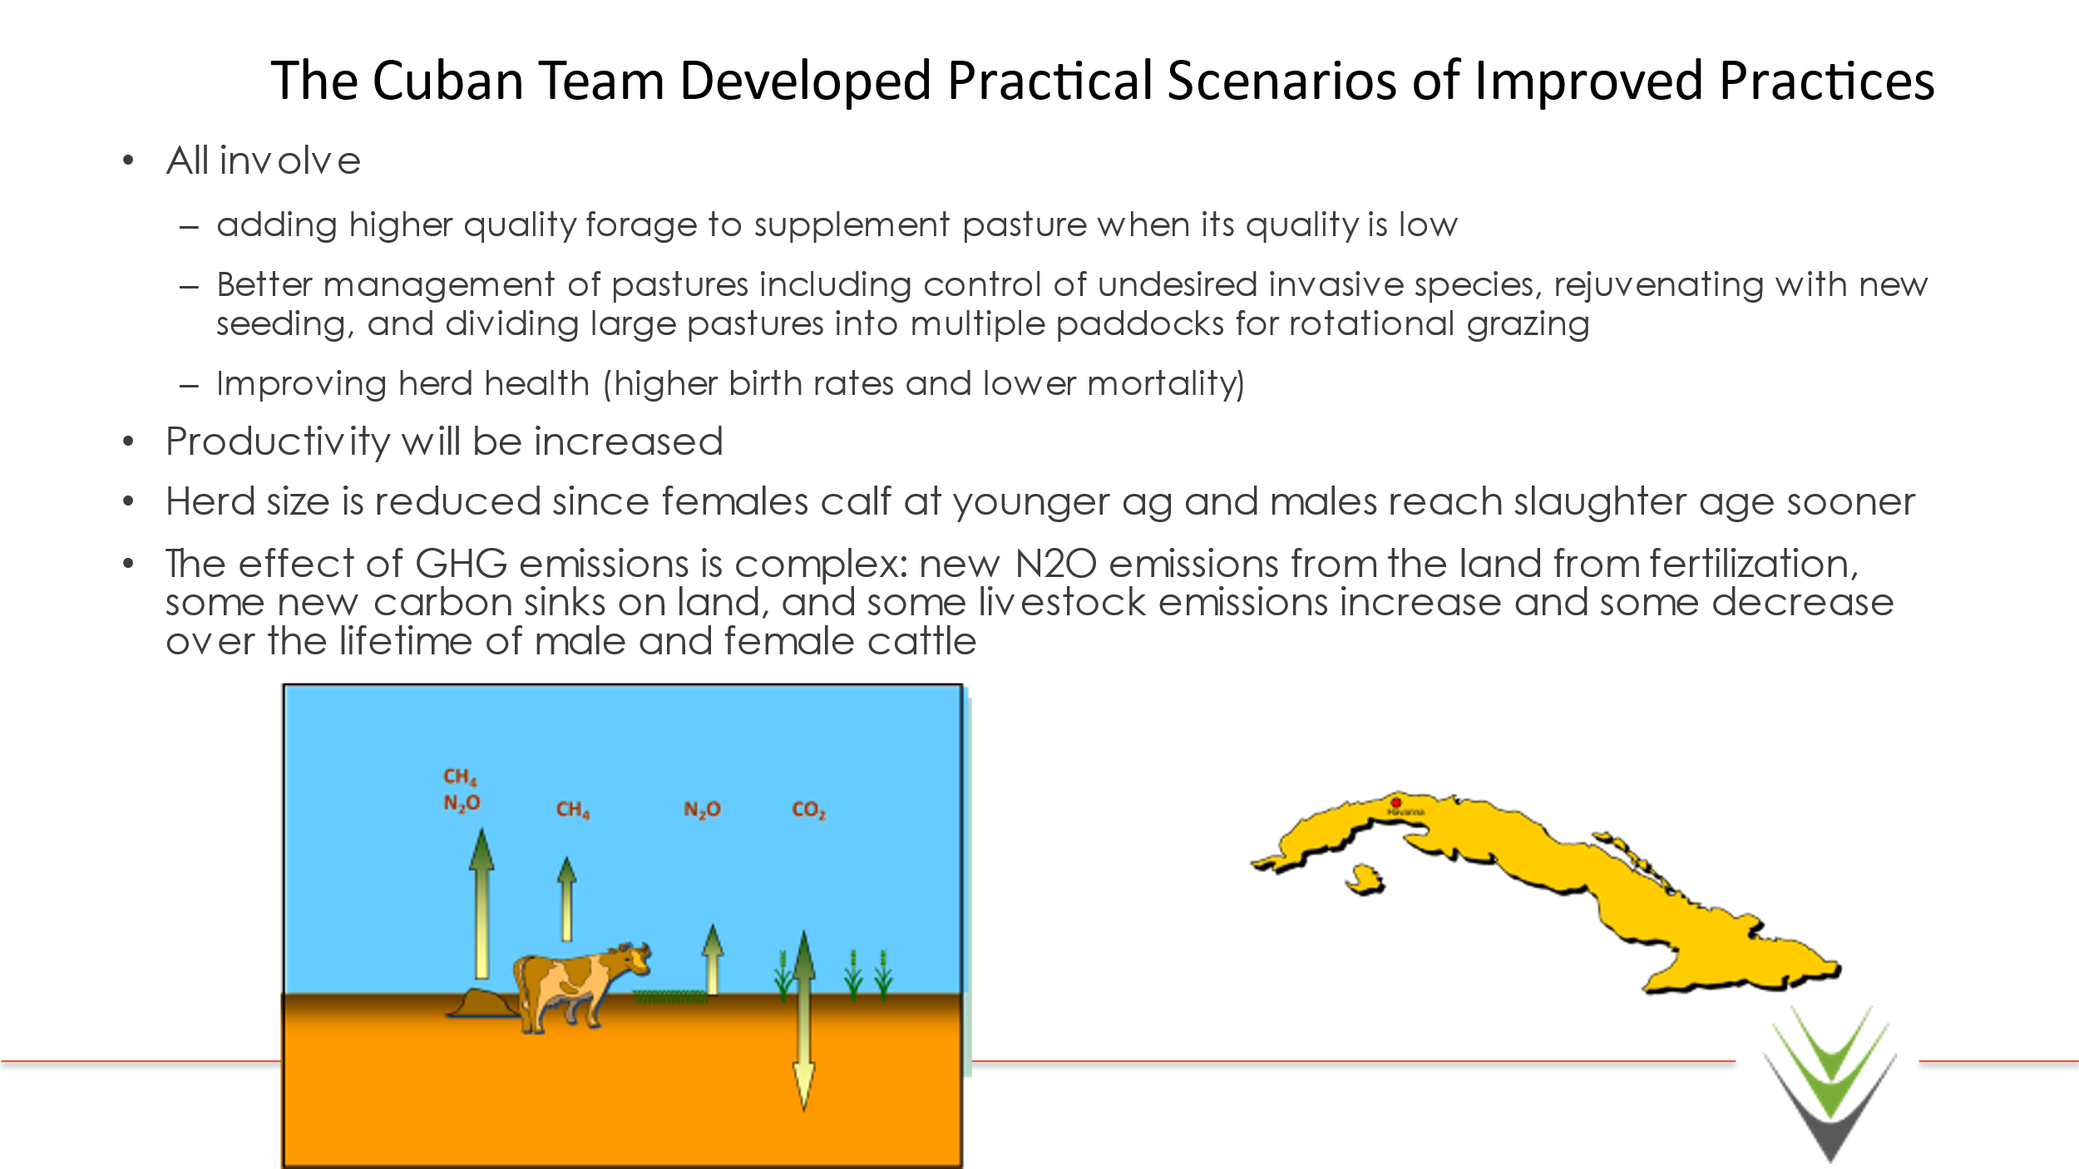

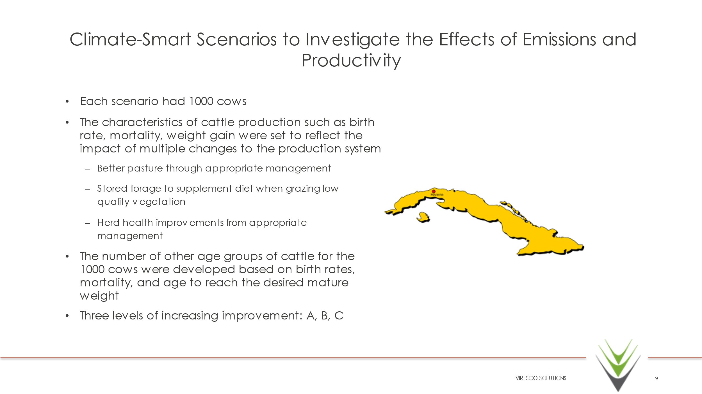
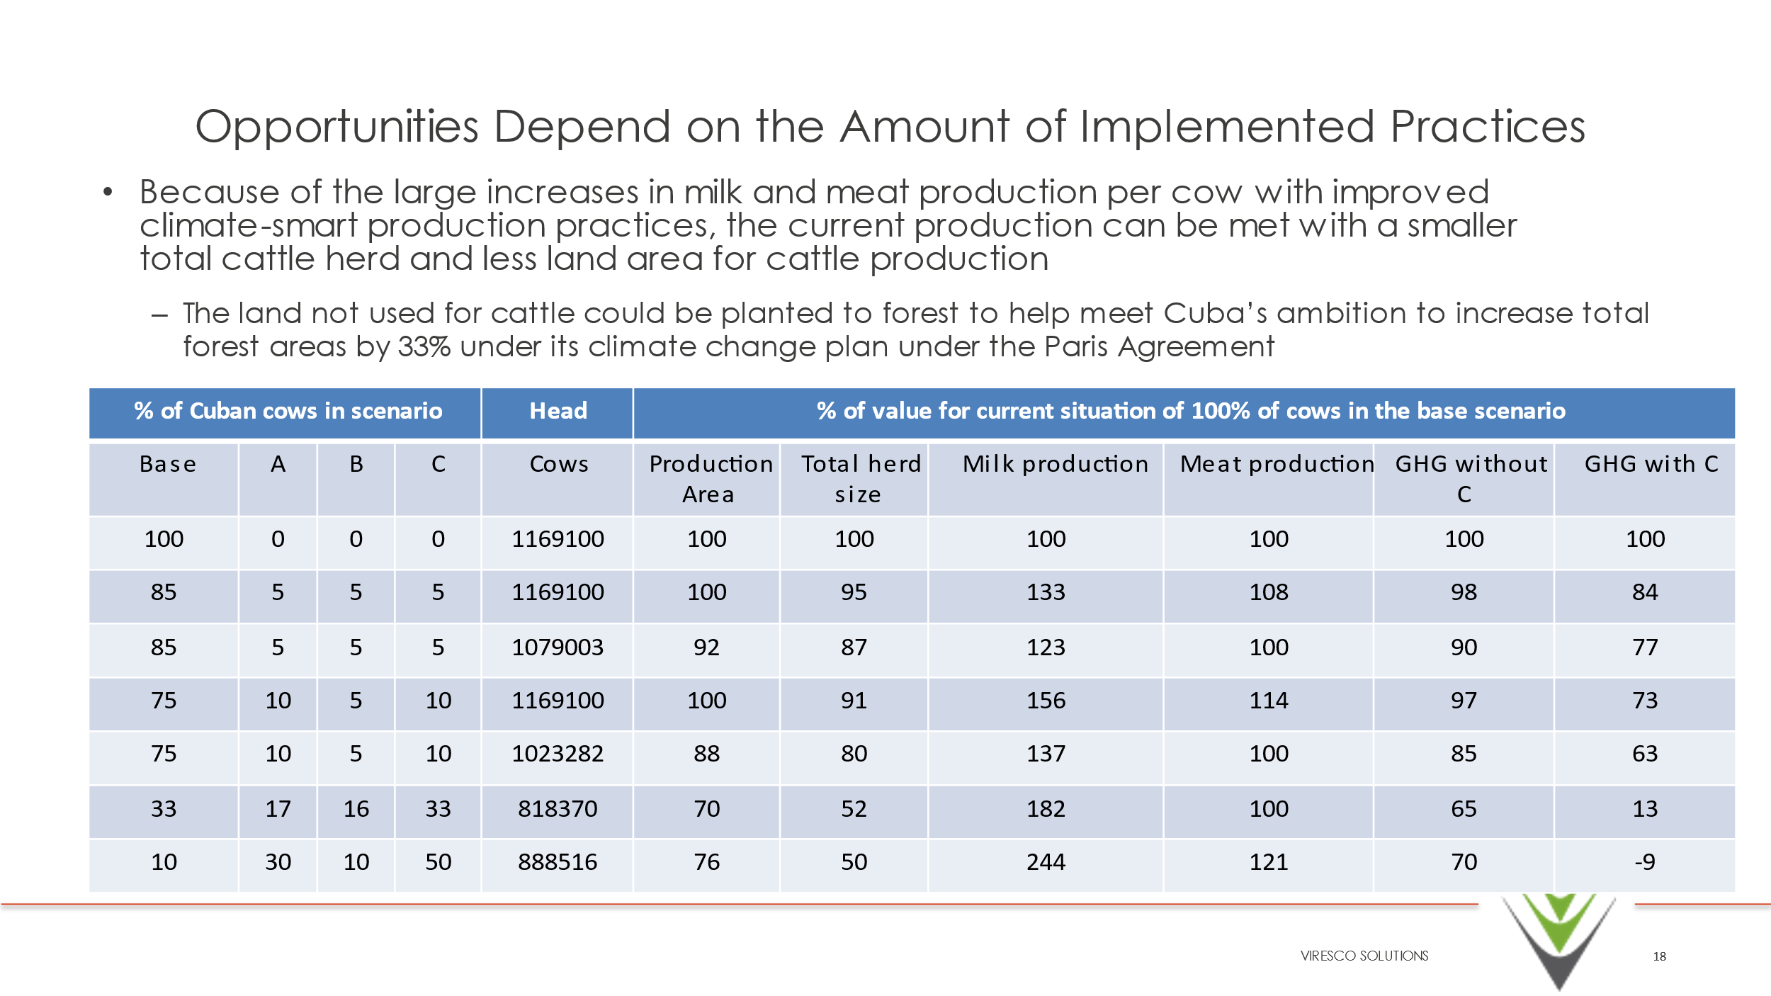

4. Impact Statement
The information in the table below will be used to communicate results and anticipated impacts of this technical assistance publicly. Please copy information from impact statement developed in the M&E Plan and update as relevant.

Challenge | Cuban livestock farming is characterized by low productivity and economic efficiency which stems from a variety of causes including, but not limited to grass monocultures, poor management of grasslands, poor herd management, inappropriate use of water, poor management of woody vegetation (silvopastoral systems) and lack of knowledge of sustainable farming practices (Preparation of GHG Emissions Baseline for the Beef Cattle Sector, 2018). Given this, it is likely there are opportunities for improving productivity, while simultaneously reducing greenhouse gas (GHG) emissions. However, at present, Cuba has not quantified national GHG emissions from its livestock sector, nor its potential for emissions reductions. Furthermore, there are no known resident personnel trained in quantification of these emission sources. In Cuba, livestock farming covers over two million hectares of land, of which approximately 16-20 percent is cultivated pasture, 38 percent is partially or completely covered by invasive plants, and the remainder is natural pasture with low productivity (Preparation of GHG Emissions Baseline for the Beef Cattle Sector, 2018). It is within this context that the Government of Cuba approached the Climate Technology and Centre Network (CTCN) for technical assistance in quantifying its baseline GHG emissions from cattle farming and the potential reductions that could be achieved from the implementation of a range of practice changes.
CTCN Assistance | - Estimate of a baseline of its livestock emissions;  - Estimate of the greenhouse gas reduction potential of implementing best practices;  - Identification of potential adaptation co-benefits of adopting climate-smart livestock management practices;  - Capacity building in local stakeholders (e.g., researchers, specialists, local leaders) on the learnings of the project;  - Communication documents to further implementation of climate-smart management  Outline of a concept note for support from the Green Climate Fund to implement a project to achieve improved climate-smart production for Cuba with lower greenhouse gas emissions
Anticipated impact | This project was key to determining a baseline assessment of the Beef Industry in Cuba. This baseline assessment is vital to the identification of future projects which will have a meaningful impact on the Beef Sector.
Co-benefits: Achieved or anticipated co-benefits from the TA | Instruction: Please indicate expected co-benefits as described in the response plan and in the relevant deliverables  NA
Gender aspects of the TA | Instruction: Please indicate if technical assistance was supported by a gender analysis. Describe gender aspects identified and additional considerations taken to mainstream gender (e.g. equal participation in trainings, gathering of gender-disaggregated data, etc.).  NA
Anticipated contribution to NDC | - Clear Understanding of Baseline emissions from the Beef Sector in Cuba  - Clear and concise messaging for Politicians, Agrologists and Farmers on the benefits and opportunities  - Draft concept note outlining a potential pathway forward to action
The narrative story | Cattle production is important to Cuba. For 2016, the Tercera Comunicación Nacional of Cuba (Ministerio de Ciencia Tecnología y Medio Ambiente 2020) reports that 2617 million hectares (Mha, 24% of the surface of Cuba) is natural pastures, primarily used for cattle production. In addition, there are about 0.5 Mha of improved (cultivated) pasture. Total emissions from agriculture are 10000 kt CO2e -about one-fifth of total national greenhouse gas emissions. The Tercera Comunicación Nacional does not separate out greenhouse gas emissions for cattle production. However, by estimating enteric fermentation, some methane emissions from manure and some nitrous oxide emissions from manure applied to soil, about one-half of greenhouse emissions from agriculture can be attributed to cattle production. That means about 10% of total national emissions can be attributed to cattle production.  The Cuban cattle production system has many challenges including:  • Feeding systems with low quality natural grasses  • Low soil fertility (acidity, erosion, low organic matter, salinity, compaction, and drainage)  • Insufficient food production areas  • Requirements for dry matter, energy, protein, and minerals are not covered throughout the year  • Inadequate management in pasture and forage areas that affect persistence, availability, and quality, as well as the invasion of herbaceous and shrubby weeds  • Deficit of protein plants and quality food  • Little presence of trees in the pastures  • Water deficit for animal consumption and sanitation of facilities  • Low productive and reproductive indicators  • Livestock waste is not recycled in most production units (lack of culture or equipment)  • Due to the above factors, production of milk and meat from cattle has low efficiency and provides low incomes.  Implementing practices that overcome some of these challenges will improve efficiency and increase productivity of cattle production while reducing the intensity of greenhouse gas emission per unit of milk and meat produced. The effect on absolute emissions depends on how the management interventions affect the balance between GHG efficiency, total national production of meat and milk, and the size of the national cattle herd. Large increases in national milk and meat production from cattle are possible with reduction in total national GHG emissions, particularly if the total increase in national production is reduced by reducing the national cattle herd.  In its Primera Contribución Nacionalmente Determinada (Actualizada) (Gobierno Cubano 2020), the Government of Cuba did not identify specific goals for cattle production. However, there was a general goal for agriculture to further build resilience and less carbon-intensive development. This goal is obviously relevant for cattle production. Another goal across the economy was to increase the use of renewable energy sources. This goal is relevant where, for example, there are opportunities to collect cattle manure and use the manure in biodigesters to produce methane for energy.
Contribution to SDGs  A complete list of SDGs and their targets is available here: https://sustainabledevelopment.un.org/partnership/register/ | To the extent possible, please describe contribution to approximately 3 SDGs, including SDG13, with a few sentences for each SDG concerned.  Goal 1 - End poverty in all its forms everywhere  The baseline assessment is key to identifying opportunities to improve Beef Production including improving efficiency which may increase the bottom line of farmers and thus reduce poverty.  Goal 2 - End hunger, achieve food security and improved nutrition and promote sustainable agriculture  Improved Beef Production Efficiency will improve the availability of valuable proteins and nutrients and may reduce costs thus resulting in increased food security.  Goal 6 - Ensure availability and sustainable management of water and sanitation for all  Improved Beef Production will reduce the demand and negative impact on water and thus may increase availability.  Goal 12 - Ensure sustainable consumption and production patterns  Knowledge of the baseline Beef Sector in combination with information sharing associated with potential opportunities for improvement will support sustainable consumption.  Goal 15 - Protect, restore and promote sustainable use of terrestrial ecosystems, sustainably manage forests, combat desertification, and halt and reverse land degradation and halt biodiversity loss  Improved beef production will reduce demands on other resources.

Annex 1 Technical assistance data collection

Please add quantitative and qualitative values for the indicators selected in the M&E plan and monitored throughout the technical assistance in the tables below. Indicators which have been monitored in addition to the proposed indicators below may be added at the end of table A. Non-relevant indicators should be left blank.

- Output and outcome indicators

Indicator  Please note indicators below highlighted as anticipated | Quantitative value  Numerals only; disaggregates must sum to the total | Qualitative description  List the various elements corresponding to the quantitative value as well as timelines and responsible institutions
Total number of events organized by proponents and implementing partners | 1 | Face to Face Workshop
Number of participants in events organized by proponents and implementing partners
- Number of men | List total number here | Disaggregate by country
- Number of women
Number of climate technology RD&D related events | 1 | Face to Face Workshop
Number of participants in climate technology RD&D events | List total number here
- Number of men
- Number of women
Number of training organized by proponents and implementing partners | List total number here | List the title of the training sessions and capacity strengthening activities
Number of participants in trainings organized by proponents and implementing partners | List total number here
- Number of men
- Number of women
Total number of institutions trained | List total number here
- Governmental (national or subnational) |  | List the name of organisations trained here
- Private sector (bank, corporation, etc.) |  | List the name of organisations trained here
- Nongovernmental (NGO, University, etc.) |  | List the name of organisations trained here
Percentage of participants reporting satisfaction with CTCN training (from CTCN training feedback form) |  | Satisfied= 4+ on 5-pt scale
Percentage of participants reporting increased knowledge, capacity and/or understanding as a result of CTCN training (from CTCN training feedback form) |  | Increased knowledge, capacity and/or understanding= 4+ on 5-pt scale
- Percentage of men
- Percentage of women
Total number of deliverables produced during the assistance (excluding mission, progress and internal reports) | List total number here
- Number of communication materials, including news releases, newsletters, articles, presentations, social media postings, etc. | 3 | A set of three concise handbooks on good practices and climate technologies was created to complement the open access database created. The handbooks were developed for three audiences: specialists, politicians and farmers which varied in content and how it was presented. The specific content of each handbook was discussed with the Cuban team prior to their completion.  *The handbook for specialists focused on the details of the livestock management practice, how it reduces GHG emissions and how to quantify the emission changes from the implementation of the practice.  *The handbook for politicians focused on the bigger picture, including how policy can encourage implementation of the priority practices and how these practices and the associated emission reductions play a role in the larger global dialogue on climate change.  *The handbook for farmers was more practical in nature, explaining the practices, how they can improve productivity and how they are beneficial for the environment. All of the above handbooks will need to be written in Spanish. Lavola utilized a team of experts specialized in design and communication.
- Number of tools and technical documents strengthened, revised or developed | 3 | - Guia para mejores Practicas Agroecologicas: Para Decisores  - Guia para mejores Practicas Agroecologicas: Para Agronomas/os  - Guia para mejores Practicas Agroecologicas: Para Agricultores
- Number of other information materials strengthened, revised or created (For example training and workshop reports, Power Points, exercise docs etc.) | 3 | - Guia para mejores Practicas Agroecologicas: Para Decisores  - Guia para mejores Practicas Agroecologicas: Para Agronomas/os  - Guia para mejores Practicas Agroecologicas: Para Agricultores
Total number of policies, strategies, plans, laws, agreements or regulations supported by the assistance | List total number here
- Adaptation related | NA | List the type and name of documents supported
- Mitigation related | NA | List the type and name of documents supported
- Both adaptation- and mitigation related | NA | List the type and name of documents supported
Anticipated number of policies, strategies, plans, laws, agreements or regulations proposed, adopted or implemented as a result of the TA | List total number here
- Adaptation related | NA | List the type of documents anticipated to be proposed, adopted or implemented
- Mitigation related | NA | List the type of documents anticipated to be proposed, adopted or implemented
- Both adaptation- and mitigation related | NA | List the type of documents anticipated to be proposed, adopted or implemented
Anticipated number of technologies transferred or deployed as a result of CTCN support | List total number here | Instruction: List the type of technologies supported by this assistance. Technologies must be identified from the CTCN taxonomy of climate sectors and technologies (download in pdf format and choose from column C): https://www.ctc-n.org/resources/ctcn-taxonomy
Anticipated number of collaborations facilitated or enabled as a result of technical assistance | List total number here
- Number of South-South collaborations | NA | List the names of the organisations (excluding the CTCN or TA implementers)
- Number of RD&D collaborations | NA | List the names of the organisations (excluding the CTCN or TA implementers)
- Number of private sector collaborations | NA | List the names of the organisations (excluding the CTCN or TA implementers)
Number of countries with strengthened National System of Innovation as a result of CTCN support |  | List names of countries
Insert any additional indicators here

- Core impact indicators

Please fill in the tables for anticipated impacts of the CTCN assistance. Every technical assistance should contribute to at least one of the indicators below. For guidance on how to report on core indicators see the ‘M&E Guidance Document for TA Implementers’.

Core indicator 1 | Anticipated metric tons of CO₂ equivalent (CO₂e) emissions reduced or avoided as a result of CTCN TA  Please add your calculations in word or excel format as an Annex to this Closure Report, where applicable.
 | Anticipated metric tons of CO₂e reduced or avoided as a result of the TA on annual basis | Anticipated metric tons of CO₂e reduced or avoided as a result of the TA in total
Quantitative value  (emissions reductions) | Total number (numerals only, no rounding or abbreviations) | Total number (numerals only, no rounding or abbreviations)
Unit | tCO₂e | tCO₂e
GHG assessment boundary (project emissions)  Identify expected post-TA activities, associated effects and assess boundary for quantification of GHG emission reductions | NA | NA
Baseline emissions  Describe baseline scenario, baseline candidates, emission factors and emissions calculated | This project consisted of estimation of baseline emissions and the development of scenarios | NA
Methodology  Explain the method or process of verifying the indicator and how data was gathered | Outlined in Final Report
Assumptions  Describe assumptions made during calculation and quantification of GHG reductions | Outlined in Final Report

Core indicator 2 | Anticipated increased economic, health, well-being, infrastructure and built environment, and ecosystems resilience to climate change impacts as a result of technical assistance  Please provide a qualitative description of the anticipated impacts on the categories below
Infrastructure and built environment  Anticipated increased infrastructure resilience (avoided/mitigated climate induced damages and strengthened physical assets) | NA
Ecosystems and biodiversity  Anticipated increased ecosystem resilience (areas with increased resistance to climate-induced disturbances and with improved recovery rates) | NA
Economic  Anticipated increased economic resilience (e.g. less reliance on vulnerable economic sectors or diversification of livelihood) | NA
Health and wellbeing  Anticipated increased health and wellbeing of target group (e.g. improved basic health, water and food security) | NA

Core indicator 3 | Anticipated number of direct and indirect beneficiaries as a result of the TA
 | Quantitative value | Means of verification
Total beneficiaries | Total number
Number of adaptation beneficiaries | NA | Describe calculation methods and assumptions made
Number of mitigation beneficiaries | NA | Describe calculation methods and assumptions made
Number of adaptation-and mitigation beneficiaries | NA | Describe calculation methods and assumptions made

Core indicator 4 | Anticipated amount of funding/investment leveraged (USD) as a result of TA (disaggregated by public, private, national, and international sources, as well as between anticipated/confirmed funding)
 | Quantitative value confirmed in USD | Quantitative value anticipated in USD | Qualitative description  List the institutions, timelines, and description or title of the investment | Methods  Describe methods used for quantification of funds leveraged
Total funding | Total number in USD (numerals only, no rounding or abbreviations) | Total number in USD (numerals only, no rounding or abbreviations)
Anticipated amount of public funding mobilised from national/domestic sources | NA
Anticipated amount of public funding mobilised from international/ regional sources | NA
Anticipated amount of private funding mobilised from national/domestic sources | NA
Anticipated amount of private funds mobilised from international/regional sources | NA

Annex 2 (for internal use – to be filled in by the CTCN)
CTCN evaluation
This section will be completed by the relevant CTCN Technology Manager.

- Evaluation of the timeliness of the TA implementation as measured against the timeline included in the response plan;
- Evaluation of TA quality as defined in the response plan;
- Overall performance of the Implementers;
- Overall engagement of the NDE and Proponent;
- Lessons learned on the CTCN process and steps taken by the CTCN to improve.

