Technical Assistance Closure Report Template
Objective of the technical assistance (TA) Closure Report:
- To communicate publicly in one document a summary of progress made and lessons learned during the TA towards the anticipated impact (sections 1-4).
- To document qualitative and quantitative data collected during TA, for use in donor and UN reporting (Annex 1).

Steps for completing the TA closure report:
- The lead TA implementer submits the closure report at the end of the technical assistance as a final deliverable. The TA closure report will capture outputs, outcomes and impacts of all activities conducted under the TA. Please copy and summarise relevant material from previous TA outputs/deliverables and the Response Plan, as relevant.
- A CTCN Manager will review and revise the closure report before final approval by the CTCN Deputy Director.

Important note on public and internal use of the closure report:
Once approved by the CTCN Deputy Director, the TA closure report will be a public document available on the CTCN website www.ctc-n.org. Selected content will be used for targeted communication activities. Annex 2 is for internal use only and will not be publicly available.

Closure Report for CTCN Technical Assistance

- Basic information
Title of response plan | Improvement of water supply management through a GIS-based monitoring and control system for water loss reduction in Grenada
Technical assistance reference number | 2017000007
Country / countries | Grenada
NDE organisation | National Water and Sewerage Authority (NAWASA) Grenada
NDE focal point | Damani Bruno, Hydraulic Engineer
NDE contact information | dbruno@nawasa.gd
Proponent focal point and organisation | Neil Thurston – Wood Environment & Infrastructure Solutions UK
Designer of the response plan | Wood Environment & Infrastructure Solutions UK and GISCAD Limited
Implementer(s) of technical assistance | Wood Environment & Infrastructure Solutions UK and GISCAD Limited
Beneficiaries | NAWASA - National Water and Sewerage Authority, Grenada
Sector(s) addressed | Water – Water efficiency and demand management
Technologies supported | Leakage management in piped systems  Water accounting  Geographical Information Systems (GIS) management
Implementation start date | 01/04/2019
Implementation end date | 16/07/2020
Total budget for implementation | $168,790
Description of delivered outputs and products as well as the activities undertaken to achieve them. In doing so, review the log frame of the original response plan and refer to it as appropriate | Wood working in partnership with GISCAD Limited delivered a 14-month project to assist the National Water and Sewerage Authority (NAWASA) of Grenada improve the future management of water resources across the island. This work focused on the development of GIS systems, workflows and provision of GIS training to NAWASA staff, alongside the development of enhanced systems for monitoring and metering water systems. Key project activities included:  - Review of the existing digital and Geographical Information Systems (GIS) used by NAWASA to monitor and manage clean water resources. This included a focused user needs assessment;  - Development of an implementation plan to enhance the structure and connectivity of open source GIS (QGIS) and digital monitoring systems used by NAWASA;  - Building the capacity of NAWASA staff to create and update an enhanced internal GIS system, including training in field data capture. .  - Piloting the updated structure in selected District Metered Areas (DMA) for identifying Non-Revenue Water;  - Development of a pilot web mapping application using QGIS Server/Client and QWC2 viewer  - Undertaking a two-day learning visit to a water agency in another Caribbean island during summer / autumn of 2019; and;  - Delivered a final virtual regional exchange event attended by representatives of Caribbean water agencies and the wider CTCN network.  The outputs of the project were delivered within the originally planned timeframe of the study - allowing for certain adjustments to account for the impact of the Coronavirus pandemic.
Methodologies applied to produce outputs and products | The key methodologies used to deliver the TA were:  - Delivery of structure GIS data review/gap analysis through structured interviews with key stakeholders across Grenada  - Development of structured GIS systems using established GIS design principles  - Delivery of structured class and field training in the use of mobile data capture equipment  - Delivery of south-south engagement event through structured interviews with key stakeholders in Trinidad
Reference to knowledge resources
Deviations | The delivery of the TA followed the agreed project plan, adapting timelines to meet NAWASA operational objectives and at the end of the study accommodating the impacts of the Coronavirus pandemic.
Anticipated follow-up activities and next steps | The work undertaken in the TA provides a basis for NAWASA to continue to develop its GIS capability and undertaken more non-revenue water assessments in the future. The TA also provides a basis for a continuation of work through the GCF FP059 projects (G-CREWS) which will support the future delivery of enhanced water infrastructure across the island over the next 5 years (2021-2024).

- Lessons learned
 | Lessons learned | Recommendations
Lessons learned from the CTCN TA process | This study was the first CTCN project undertaken by the Wood / GISCAD staff involved. We therefore had to rapidly familiarise ourselves with the CTCN TA process, the requirements of which were both clear and logical. This process was assisted by the support of CTCN staff (Ramiro Salinas and Sandra Bry) throughout the project initiation phase and throughout the study. | No specific recommendations regarding the TA process were identified.
Lessons learned related to climate technology transfer | The successful delivery of the TA resulted from the development of a good working relationship between the delivery team and key NAWASA staff. This developed through weekly virtual MS Teams meetings during the early stages of the study and supported through good levels of support during in-country trips.  Some aspects of the delivery were affected by the impacts of extreme weather events during the winter season and the availability of staff. We also to consider alternative delivery approaches (notably for Output 5) due to the impact of the covid pandemic. | Actions and delivery risks were recorded and reviewed during the regular meeting calls and enabled the early planning of mitigation actions and/or alternative delivery approaches.  This approach was very successful and helped the delivery of all the project outputs/deliverables within the planned timeframe for the study.

3. Illustration of the TA and photos
For communication purposes, please provide Power Point slides, including illustrations or charts, describing barriers, opportunities, methodology, activities, outputs and achieved results. The illustrations must be copied into the TA Closure report but must also be delivered as power point files. Also, please provide at least five high-resolution pictures in jpg format, capturing technical assistance. The pictures should illustrate how the TA has impacted the lives of the beneficiaries in particular and the communities in general.

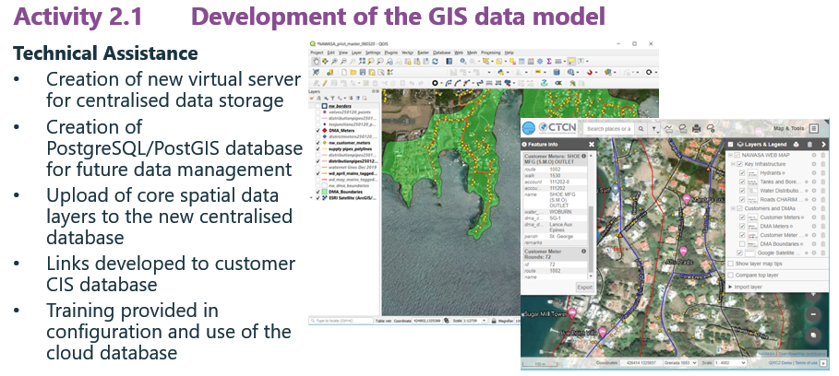

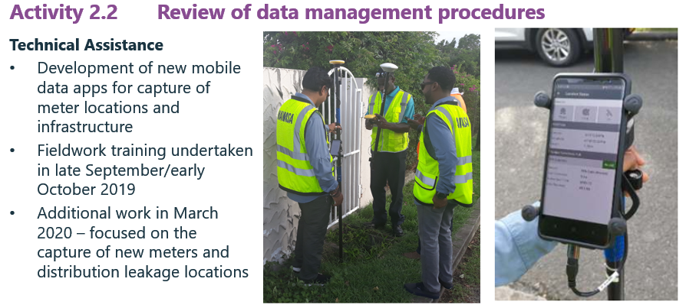

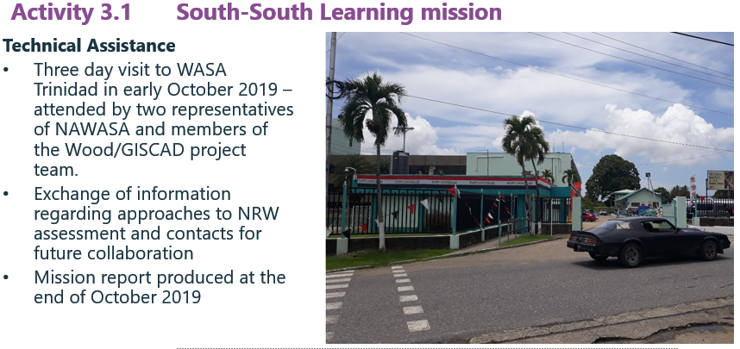
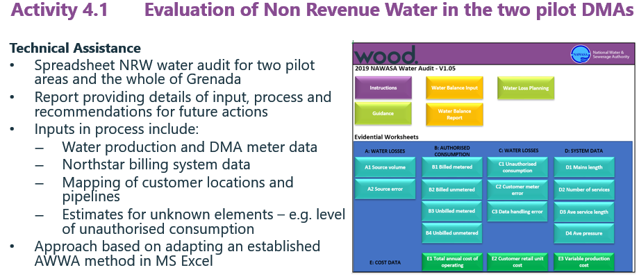

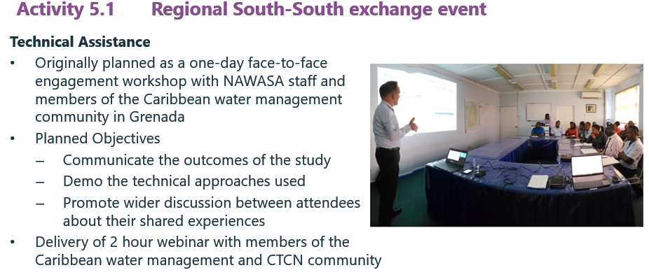

4. Impact Statement
The information in the table below will be used to communicate results and anticipated impacts of this technical assistance publicly. Please copy information from impact statement developed in the M&E Plan and update as relevant.

Challenge | It is predicted that rainfall in Grenada will continue to reduce, lowering to between 25-30 percent of current values by the end of the century. At the same time, it is expected that water demands will continue to rise and increase the pressure upon available future water supplies across the island. This TA has helped address these pressures by helping reduce levels of Non-Revenue Water (NRW) by strengthening the capability of NAWASA staff to monitor and address water losses and leakage.
CTCN Assistance | The key features of the assistance were:  - Establishment of GIS structures and procedures; and providing technical and training advise to NAWASA regarding GIS data management and system integration.  - Undertaking a South-South learning event with WASA in Trinidad, who has developed a more comprehensive GIS monitoring and assessment system.  - Development of District Metered Areas (DMA) pilots and training of NAWASA staff in their use.  - Undertaking a final Regional South-South exchange event involving the Caribbean water management community.
Anticipated impact | The key impacts of this TA were:  - Creation of a server-based Geographical Information System (GIS) for NAWASA - including detailed level training for internal staff;  - Creation of enhanced GIS infrastructure layers which can be used to undertake an effective assessment of Non-Revenue Water (NRW) in selected pilot areas;  - Provision of a basic internet-based mapping viewer, which will enable a majority of NAWASA staff to visualise datasets held by the organisation;  - Implementation to a structured assessment method to better quantify the level of Non-Revenue Water (NRW) in Grenada to enable future targeted management to reduce NRW to below the current 22-29% position, and  - Development of a south-south knowledge sharing network between different Caribbean water management agencies – including participation from a minimum of 10 organisations.
Co-benefits: Achieved or anticipated co-benefits from the TA | - Contribution of the TA to the future provision of enhanced water infrastructure/supply across the whole of Grenada.  - Contribute of the TA to the future equitable charging and use of water across Grenada.  - Development of a new digital GIS system which aligns with wider efforts to develop GIS capabilities within the Government of Grenada.
Gender aspects of the TA | Our project plan was designed to ensure that all project activities (including training presentations and final CTCN webinar) were inclusive and enabled engagement from all relevant NAWASA staff regardless of gender, age or sexuality.
Anticipated contribution to NDC | Grenada’s published Nationally Determined Contribution document (available at https://www4.unfccc.int) includes a clear commitment to improving the island’s water resource management as part of its wider adaptation programme. This includes :  - promoting and maintaining equitable and sustainable use of the water sources and their watersheds.  - improved capture, storage, distribution and conservation of water  - increases the adaptive capacity of individuals and communities.  Grenada has also completed a vulnerability assessment of the water sector and developed a national adaptation plan and action plan for the water sector, mapping and water quality testing of informal water sources. Rain water harvesting activities are currently underway in some remote communities to improve water collection and storage  This TA was aligned to the wider objectives of the Government of Grenada to increase the future management and monitoring of water resources and help deliver these important NDC adaptation objectives.
The narrative story | As a small island developing state (SIDS), Grenada is one of the world’s most at-risk countries for climate change. The island’s freshwater supply is mainly depending on rainfed surface waters (approx. 90%).  The island experienced two major drought events in 2010 and 2012 which significantly affected the water supply sector. Projections are that rainfall will be reduced by the end of the century between 25 and 30 percent of current climatologically mean values.  The National Water and Sewerage Authority (NAWASA), proponent of this technical assistance, is responsible for the provision of potable water and sanitation services for the whole of Grenada.  To be effective, NAWASA’s overall NRW management needs a structured and systematic approach. Good industrial standard is to establish a detailed monitoring system on water balances of District Metered Areas (DMAs), which allows quick and focused actions to reduce NRW. NAWASA’s current structure of the data model, as well as of the linked management processes, requires a complete review and redesign.  On this basis, the National Designated Entity submitted a request to the CTCN to assist NAWASA in this endeavour.  The objective of this TA was to efficiently reduce the currently high Non-Revenue Water (NRW) in Grenada by strengthening the capacity of NAWASA’s staff in the management of a GIS-based monitoring and control system for water loss reduction and leakage detection.
Contribution to SDGs  A complete list of SDGs and their targets is available here: https://sustainabledevelopment.un.org/partnership/register/ | SDG 3 – the Technical Assistance has also contributed to the continued provision of safe and available drinking water to the entire population of Grenada. This is a vital element of SDG3 and its aim to ensure healthy lives and promote well-being for all ages.  SDG 6 - the Technical Assistance has also supported the enhanced availability and sustainable management of water resources within Grenada. This will be achieved through the delivery of enhanced data systems, water monitoring and the MDA pilot/training within the project.  SDG 13 – the Technical Assistance will also contribute to enabling Grenada to integrate climate change considerations and adaptation measures into their NAP process – especially in respect to the sustainable management of the island’s finite water resources.

Annex 1 Technical assistance data collection

Please add quantitative and qualitative values for the indicators selected in the M&E plan and monitored throughout the technical assistance in the tables below. Indicators which have been monitored in addition to the proposed indicators below may be added at the end of table A. Non-relevant indicators should be left blank.

- Output and outcome indicators

Indicator  Please note indicators below highlighted as anticipated | Quantitative value  Numerals only; disaggregates must sum to the total | Qualitative description  List the various elements corresponding to the quantitative value as well as timelines and responsible institutions
Total number of events organized by proponents and implementing partners | 16
Number of participants in events organized by proponents and implementing partners
- Number of men
- Number of women
Number of climate technology RD&D related events
Number of participants in climate technology RD&D events
- Number of men
- Number of women
Number of training organized by proponents and implementing partners | 16 | - 12 days training of NAWASA staff in open source GIS, database and mobile data capture.  - 3 x briefing presentations for around 20 NAWASA staff  - 1 x Online webinar hosted at the end of the study attending by 42 representatives of the Caribbean water management community and wider CTCN network
Number of participants in trainings organized by proponents and implementing partners | 60
- Number of men | 42
- Number of women | 18
Total number of institutions trained | 20
- Governmental (national or subnational) | 9 | - Belize – National Water Services Limited  - Grenada - National Water and Sewerage Authority  - Jamaica - National Water Commission  - St Kitts & Nevis - National Water Department  - Trinidad & Tobago - Water & Sewerage Authority (WASA)  - Deutsche Gesellschaft für Internationale Zusammenarbeit (GIZ) GmbH  - Economic Commission for Latin America and the Caribbean (ECLAC)  - Ministry of Natural Resources & Energy, Antigua and Barbuda  - Department of Ocean Fisheries,Morocco
- Private sector (bank, corporation, etc.) | 6 | - Alpha Engineering & Design, Trinidad  - Capta Hydro, Chile  - HR Wallingford, UK  - IBM, Canada  - Public Services International (PSI), Barbados  - R.E.D Pro Consultants, Greece
- Nongovernmental (NGO, University, etc.) | 5 | - Universidad de La Plata in Argentina  - National University of Sciences and Technology – Pakistan  - Chongqing Energy Research Society, China  - Green Climate Fund (GCF)  - World Water Forum / North Star NGO
Percentage of participants reporting satisfaction with CTCN training (from CTCN training feedback form)
Percentage of participants reporting increased knowledge, capacity and/or understanding as a result of CTCN training (from CTCN training feedback form)
- Percentage of men
- Percentage of women
Total number of deliverables produced during the assistance (excluding mission, progress and internal reports) | 17
- Number of communication materials, including news releases, newsletters, articles, presentations, social media postings, etc. | 2 | Output 5 – final project closure south-south/triangular engagement webinar  - Powerpoint slide deck – 80 slides  - Project webinar recording – 16th July 2020
- Number of tools and technical documents strengthened, revised or developed | 15 | The TA resulted in the development of the following tools for NAWASA:  - Design and implementation of structured GIS/database system for NAWASA on centralised server  - Creation and population of a centralised GIS database  - Creation and population of centralised GIS data register  - Development of mobile data capture forms using Qfield – including field based training  - Development of structured database for calculation of key values for use in the non-revenue water (NRW) assessments  - Deliver and training in the use NAWASA non-revenue water (NRW) calculation methods – tested in two pilots in Grenada  - Development of out of scope online web mapping portal for use across NAWASA operational teams  The following reports were developed and issue during delivery of the TA:  - Output 2A – Spatial data review  - Output 2B – GIS system review  - Output 2C – GIS/database model design  - Output 2D – GIS/database data interface exchange  - Output 2E – Best practices and lessons learned report  - Output 2F – GIS job descriptions  - Output 3 – South-South report of WASA GIS capability in Trinidad  - Output 4 report - Presentation of the findings relating to the DMA design process with regards to the quantification and management of Non-Revenue Water
- Number of other information materials strengthened, revised or created (For example training and workshop reports, Power Points, exercise docs etc.) | 8 | Output 5 – final project closure south-south/triangular engagement webinar  - Powerpoint slide deck – 80 slides  - Project webinar recording – 16th July 2020
Total number of policies, strategies, plans, laws, agreements or regulations supported by the assistance | 1 | The TA has developed a variety of tools supporting the enhancement management and supply of clean water resources across Grenada by the national water agency (NAWASA). The outputs of the project will contribute to th1 development of future planning and investment strategies of NAWASA.
- Adaptation related | 1 | See above
- Mitigation related | 1 | See above
- Both adaptation- and mitigation related | 1 | See above
Anticipated number of policies, strategies, plans, laws, agreements or regulations proposed, adopted or implemented as a result of the TA | 0
- Adaptation related | 0
- Mitigation related | 0
- Both adaptation- and mitigation related | 0
Anticipated number of technologies transferred or deployed as a result of CTCN support | 3 | Leakage management in piped systems  Water accounting  Geographical Information Systems (GIS) management
Anticipated number of collaborations facilitated or enabled as a result of technical assistance | 1
- Number of South-South collaborations | 1 | National Water & Sewerage Authority (NAWASA) - Grenada and the Trinidad & Tobago - Water & Sewerage Authority (WASA)
- Number of RD&D collaborations | 0
- Number of private sector collaborations | 0
Number of countries with strengthened National System of Innovation as a result of CTCN support | 1 | Grenada

- Core impact indicators

Please fill in the tables for anticipated impacts of the CTCN assistance. Every technical assistance should contribute to at least one of the indicators below. For guidance on how to report on core indicators see the ‘M&E Guidance Document for TA Implementers’.

Core indicator 1 | Anticipated metric tons of CO₂ equivalent (CO₂e) emissions reduced or avoided as a result of CTCN TA  Please add your calculations in word or excel format as an Annex to this Closure Report, where applicable.
 | Anticipated metric tons of CO₂e reduced or avoided as a result of the TA on annual basis | Anticipated metric tons of CO₂e reduced or avoided as a result of the TA in total
Quantitative value  (emissions reductions) | Total number (numerals only, no rounding or abbreviations) | Total number (numerals only, no rounding or abbreviations)
Unit | tCO₂e | tCO₂e
GHG assessment boundary (project emissions)  Identify expected post-TA activities, associated effects and assess boundary for quantification of GHG emission reductions | Not Applicable | Not Applicable
Baseline emissions  Describe baseline scenario, baseline candidates, emission factors and emissions calculated | Not Applicable | Not Applicable
Methodology  Explain the method or process of verifying the indicator and how data was gathered | Not Applicable | Not Applicable
Assumptions  Describe assumptions made during calculation and quantification of GHG reductions | Not Applicable | Not Applicable

Core indicator 2 | Anticipated increased economic, health, well-being, infrastructure and built environment, and ecosystems resilience to climate change impacts as a result of technical assistance  Please provide a qualitative description of the anticipated impacts on the categories below
Infrastructure and built environment  Anticipated increased infrastructure resilience (avoided/mitigated climate induced damages and strengthened physical assets) | -
Ecosystems and biodiversity  Anticipated increased ecosystem resilience (areas with increased resistance to climate-induced disturbances and with improved recovery rates) | -
Economic  Anticipated increased economic resilience (e.g. less reliance on vulnerable economic sectors or diversification of livelihood) | -
Health and wellbeing  Anticipated increased health and wellbeing of target group (e.g. improved basic health, water and food security) | The delivery of this TA has developed a variety of tools which will support the future enhanced management and supply of clean water resources across Grenada by the national water agency (NAWASA). The future use of these tools and targeted investment in the water infrastructure on the island will ultimately benefit the health and wellbeing of the entire population of Grenada.

Core indicator 3 | Anticipated number of direct and indirect beneficiaries as a result of the TA
 | Quantitative value | Means of verification
Total beneficiaries | 112,523 - UN mid-year population estimate 2020 for Grenada | The delivery of this TA has developed a variety of tools which will support the future enhanced management and supply of clean water resources across Grenada by the national water agency (NAWASA). The future use of these tools and targeted investment in the water infrastructure on the island will ultimately benefit the health and wellbeing of the entire population of Grenada.
Number of adaptation beneficiaries | See above | See above
Number of mitigation beneficiaries | See above | See above
Number of adaptation-and mitigation beneficiaries | See above | See above

Core indicator 4 | Anticipated amount of funding/investment leveraged (USD) as a result of TA (disaggregated by public, private, national, and international sources, as well as between anticipated/confirmed funding)
 | Quantitative value confirmed in USD | Quantitative value anticipated in USD | Qualitative description  List the institutions, timelines, and description or title of the investment | Methods  Describe methods used for quantification of funds leveraged
Total funding | - | - | - | -
Anticipated amount of public funding mobilised from national/domestic sources | - | - | - | -
Anticipated amount of public funding mobilised from international/ regional sources | - | - | - | -
Anticipated amount of private funding mobilised from national/domestic sources | - | - | - | -
Anticipated amount of private funds mobilised from international/regional sources | - | - | - | -

Annex 2 (for internal use – to be filled in by the CTCN)
CTCN evaluation
This section will be completed by the relevant CTCN Technology Manager.

- Evaluation of the timeliness of the TA implementation as measured against the timeline included in the response plan;
- Evaluation of TA quality as defined in the response plan;
- Overall performance of the Implementers;
- Overall engagement of the NDE and Proponent;
- Lessons learned on the CTCN process and steps taken by the CTCN to improve.

