Technical Assistance Closure Report Template
Objective of the technical assistance (TA) Closure Report:
- To communicate publicly in one document a summary of progress made and lessons learned during the TA towards the anticipated impact (sections 1-4).
- To document qualitative and quantitative data collected during TA, for use in donor and UN reporting (Annex 1).

Steps for completing the TA closure report:
- The lead TA implementer submits the closure report at the end of the technical assistance as a final deliverable. The TA closure report will capture outputs, outcomes and impacts of all activities conducted under the TA. Please copy and summarise relevant material from previous TA outputs/deliverables and the Response Plan, as relevant.
- A CTCN Manager will review and revise the closure report before final approval by the CTCN Deputy Director.

Important note on public and internal use of the closure report:
Once approved by the CTCN Deputy Director, the TA closure report will be a public document available on the CTCN website www.ctc-n.org. Selected content will be used for targeted communication activities. Annex 2 is for internal use only and will not be publicly available.

Closure Report for CTCN Technical Assistance

- Basic information
Title of response plan | Conducting a diagnosis of vulnerability to climate change and the development of an energy and climate action plan in the municipalities of Méri, Mbé and Petté in the far-north region of Cameroon
Technical assistance reference number | CTCN Reference No.: 2018000023  UNIDO RFP No.: 7000003982
Country / countries | Cameroon
NDE organisation | L’ONACC (l’Observatoire National des Changements Climatiques)  BP 35414, Bâtiment N°1220, Rue N°1793, Bastos, Yaoundé, Cameroun
NDE focal point | Mr. Forghab Patrick Mbomba, Deputy Managing Director
NDE contact information | Email: forghabp@yahoo.fr
Proponent focal point and organisation | Help Community  Mr. Jean Raphael Djob  Email: helpacommunity@gmail.com
Designer of the response plan | Lavola 1981, SAU and I2D
Implementer(s) of technical assistance | Lavola 1981, SAU and I2D
Beneficiaries | NGO Help Community
Sector(s) addressed | Transversal (mainly agriculture, forestry and water)
Technologies supported | Identification and prioritization of technologies in the above-mentioned sectors
Implementation start date | 01/03/2020
Implementation end date | 31/05/2021
Total budget for implementation | 118,261.88 USD
Description of delivered outputs and products as well as the activities undertaken to achieve them. In doing so, review the log frame of the original response plan and refer to it as appropriate | Output #1: Development of Implementation Planning and Communication Documents  - Activity 1.1: Kick off meeting  - Activity 1.2: Monitoring and evaluation Plan  - Activity 1.3: CTCN Impact Description  - Activity 1.4: Data Collection Report  Output #2: Vulnerability matrix for the diagnostic of climate change impacts for each of the 3 selected municipalities  - Activity 2.1: Develop vulnerability matrices for the 3 selected municipalities  - Activity 2.2: Identification of pilot projects  - Activity 2.3: Organization of First National Meeting  Output #3: Capacity building on climate change mitigation and adaptation for municipal officers and the population of the three selected municipalities  - Activity 3.1: Organization of trainings of municipal officers in the 3 municipalities  - Activity 3.2: Conduction of a workshop in each selected municipality  - Activity 3.3: Conduction of public awareness campaigns  - Activity 3.4: Conduct a study to identify appropriate mechanisms and tools to integrate women and youth into decision-making on energy and climate issues  Output #4: Local action plan on climate and energy including climate change adaptation and mitigation projects is developed for each of the three selected municipalities  - 4.1: Formulating and developing three draft action plans  - 4.2: Organization of a Final National Meeting  - 4.3: Developing three final action plans  - 4.4: Development of a concept note for 1 action
Methodologies applied to produce outputs and products | Vulnerability matrices and bibliography consulted.  Participatory process: interviews, surveys and workshops with local key stakeholders
Reference to knowledge resources | External literature report was used.
Deviations | Minor deviation includes:  - At project inception, the municipality of Datcheka, which had already made an own action plan, was replaced by the municipality of Mbé in the Adamawa Region.  - The process of the data collection was initially planned during April 2020 but had to be postponed to June 2020 due to COVID-19.  - Activity 4.2 The national meeting which was planned to take place in January 2021 took place earlier in November to cope with the difficulties related to COVID-91.  The initially planned outputs and products have not been impacted by these deviations.
Anticipated follow-up activities and next steps | While there are no specific activities planned at this stage the following next steps are suggested:  - Concept note to be submitted to the NDE and discussed with Help Community  - Follow-up and formal submission of funding proposal drafted with support from the CTCN, after discussion with Help Community and the NDE focal point.

- Lessons learned
 | Lessons learned | Recommendations
Lessons learned from the CTCN TA process | Transparent and continuous communications with the CTCN was essential to ensure a mutual understanding of CTCN expectations and the challenges the TA faced in delivering the assignment. | It is useful for the TA to have the CTCN Ensure the CTCN support to engage actively with the NDE.
Lessons learned related to climate technology transfer | Successful workshops, trainings and sensitizing activities were carried out, which improved the knowledge and understanding of municipal officials on climate change and made communities aware of the challenges of climate change. Relevant and effective adaptation actions were identified according to several climate change risks.  These activities were key to identify the most appropriate type of project and technology to be implemented. | To ensure the knowledge and know-how transfer necessary for successful technology transfer and implementation, it is important to promote local climate change councils, climate adaptation project implementation units, and similar structures that can accelerate planning process if strongly supported by government officials.  Promote the emerging of national or regional structures that can implement large scale adaptation project involving technology.

3. Illustration of the TA and photos
For communication purposes, please provide 2-4 Power Point slides, including illustrations or charts, describing barriers, opportunities, methodology, activities, outputs and achieved results. The illustrations must be copied into the TA Closure report but must also be delivered as power point files. Also, please provide at least five high-resolution pictures in jpg format, capturing technical assistance. The pictures should illustrate how the TA has impacted the lives of the beneficiaries in particular and the communities in general.

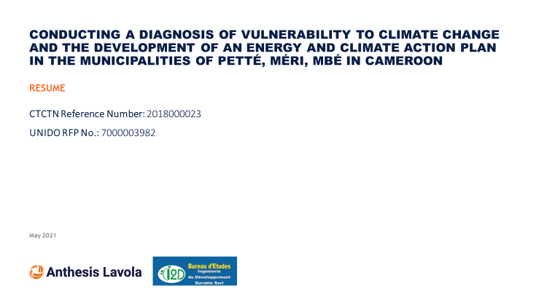
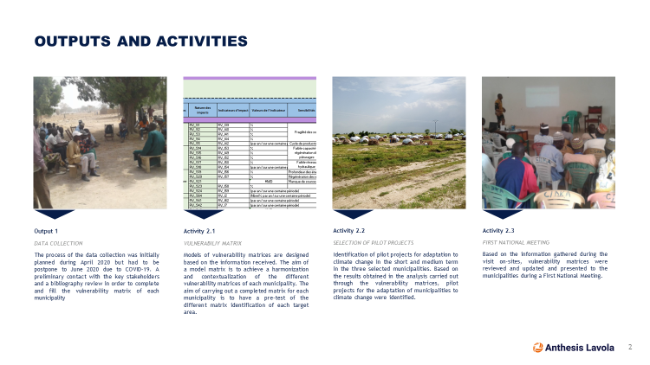

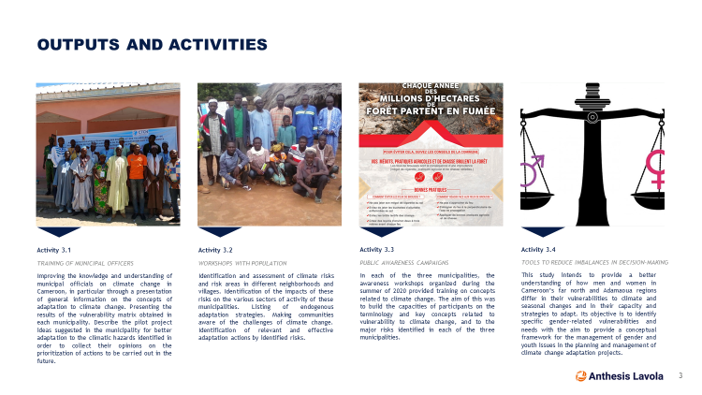
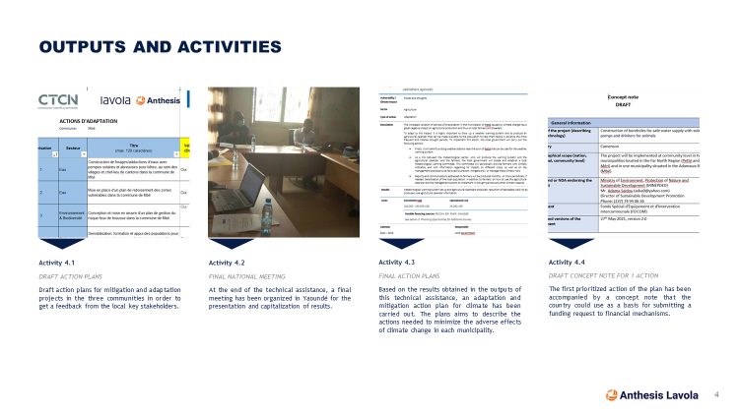

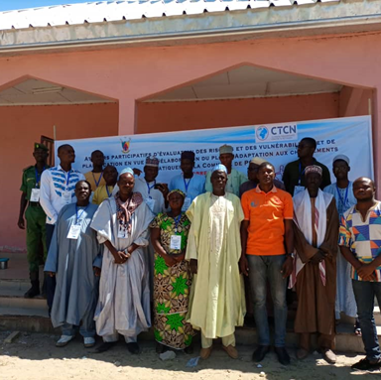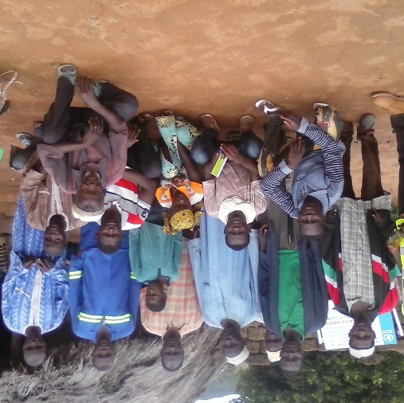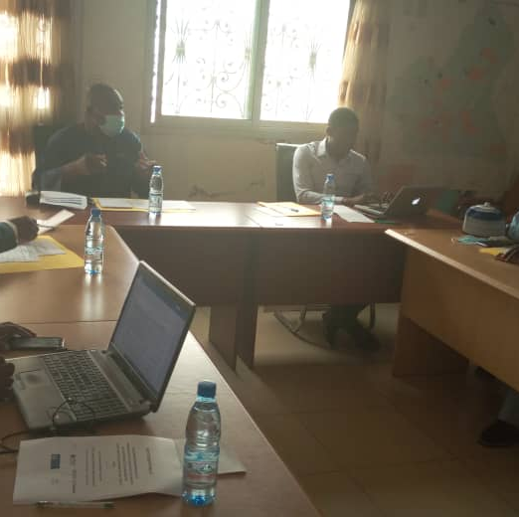

4. Impact Statement
The information in the table below will be used to communicate results and anticipated impacts of this technical assistance publicly. Please copy information from impact statement developed in the M&E Plan and update as relevant.

Challenge | The agricultural sector is the driving force of Cameroon’s economy. Nonetheless, other sectors as well, such as water, sanitation and health are already affected by disasters related to climate change, such as droughts, more frequent and severe storms and floods. These events endanger the economic and social well-being of the population in Cameroon. The far north of Cameroon is particularly affected. The low level of knowledge of practical adaptation and mitigation methods makes these sectors and communities - particularly women and youth - very vulnerable to climate change impacts.
CTCN Assistance | CTCN assistance’s outputs/outcomes include:  - The development vulnerability matrix for the diagnostic of climate change impacts for the municipalities of Petté, Méri, and Mbé.  - Identification of pilot projects by municipality to ensure that affected sectors and vulnerable populations can adapt efficiently to the effects of climate change.  - Provision of trainings and awareness campaigns on climate change mitigation and adaptation to municipal officers and the population of each municipality.  - Development of a local action plans of actions on adaptation and mitigation to climate change for each municipality.  - Development of a draft concept note for a priority set of activities.
Anticipated impact | CTCN assistance’s anticipated impacts include:  - Increase resilience of ecosystem services.  - Better understanding of climate change impacts at local level.  - Diversified livelihoods and adaptative agricultural, fishing and forestry practices and water management  - Safeguarding food security and ensuring that benefits include market and technology promotion while encouraging participatory processes
Co-benefits: achieved or anticipated co-benefits from the TA | Part of the co-benefits are directly related to the main sectors identified and pilot projects selected. Achieved and anticipated co-benefits are:  - Increased water quality and access  - Job creation  - Improving working conditions for women  - Improving the living conditions of populations  - Reforestation  - Reduction of greenhouse gases emissions  - Rebuilding plant and animal biodiversity  - Better economic profitability
Gender aspects of the TA | Women are critical in responding to climate change. Women, with their local knowledge, lead their community in the management of natural resources, food production and water governance. Their participation in decision-making, representation and leadership in community and political levels, results in greater adaptive capability and responsiveness to threat.  The TA’s gender benefits include:  - Empowerment of vulnerable populations though their active participation in the design of the vulnerability matrices, selection of pilot projects and definition of Climate Change action plans.  - Increased knowledge on climate change impacts, gender-related vulnerabilities and needs through trainings, and awareness campaigns.
Anticipated contribution to NDC | The CTCN assistance supports the NDC of the Republic of Cameroon as it contributes to the main measures and programs contemplated by the NDC.  Section 2: Mitigation:  - Self-sufficiency research, food security, agribusiness development  - Improving productivity and competitiveness of the municipalities  - Improve the access of populations and industries to electricity  - Increase the use of renewable energies in electricity production, especially in areas that are difficult to connect to electrical network  - Make energy efficiency a national priority  Section 3: Adaptation:  - Improve knowledge on climate change.  - Inform, educate and mobilize the Cameroonian population to adapt to climate change.  - Reducing vulnerability to climate change in main agro-ecological sectors and areas of the country.  - Integrate adaptation to climate change into national sectoral strategies and policies.  - Adaptation of the national gender policy and reduction of their vulnerability to climate change.
The narrative story | The Government of Cameroon requested assistance through the CTCN to address climate change impacts in the north of Cameroon and the low level of knowledge of practical adaptation and mitigation methods, which threatens the economic and social well-being of the most vulnerable sectors (agricultural, water, sanitation and health) and communities (women and youth). Municipal officers and population of the three municipalities selected (Petté, Méri and Mbé) were trained on climate change vulnerability and receive technical support to detect best adaptation practices in order to increase their resilience to climate change and protect most vulnerable sectors and populations. Two pilot projects per municipality were prioritised through a participative process in which vulnerable groups such as women and youth were involved with the aim to access practical solutions to fight climate change effects. At the end, three mitigation and adaptation plans were developed (one per municipality) all with a special focus on the most vulnerable groups, women and youth. The CTCN assistance supports the adaptation strategy identified in its Intended Nationally Determined Contributions (INDC) as well as its National Adaptation Plan to Climate Change (PNACC) and aims to increase the knowledge and capacity of its population, to anticipate impacts and increase resilience to climate change.
Contribution to SDGs  A complete list of SDGs and their targets is available here: https://sustainabledevelopment.un.org/partnership/register/ | SDG 13 – this technical assistance has improved education, awareness-raising and human and institutional capacity on climate change in Petté, Méri, and Mbé and enable their population to strengthen their resilience and adaptive capacity to climate-related hazards, specially of the most vulnerable sectors and communities.  SDG 16 – this technical assistance has increased the knowledge regarding mechanisms and tools to reduce imbalances in decision-making on energy and climate issues to help ensure women’s equal opportunities for leadership.  SDG 2 – this technical assistance supports Petté, Méri, and Mbé in implementing resilient agricultural practices that increase productivity and productions while helping maintain ecosystems that strengthen capacity for adaptation to climate change and improve land and soil quality.

Annex 1 Technical assistance data collection

Please add quantitative and qualitative values for the indicators selected in the M&E plan and monitored throughout the technical assistance in the tables below. Indicators which have been monitored in addition to the proposed indicators below may be added at the end of table A. Non-relevant indicators should be left blank.

- Output and outcome indicators

Indicator  Please note indicators below highlighted as anticipated | Quantitative value  Numerals only; disaggregates must sum to the total | Qualitative description  List the various elements corresponding to the quantitative value as well as timelines and responsible institutions
Total number of events organized by proponents and implementing partners | 15 | -5 workshops and awareness campaign in Méri (59 men, 6 women)  -5 workshops and awareness campaign in Mbé (57 men, 9 women)  -3 workshops and awareness campaign in Petté (24 men, 0 women)  -Organization of Final National Meeting (10 men, 2 women)
Number of participants in events organized by proponents and implementing partners | 167 | -5 workshops and awareness campaign in Méri (59 men, 6 women)  -5 workshops and awareness campaign in Mbé (57 men, 9 women)  -3 workshops and awareness campaign in Petté (24 men, 0 women)  -Organization of Final National Meeting (10 men, 2 women)
- Number of men | 150 | N/A
- Number of women | 17 | N/A
Number of climate technology RD&D related events | N/A | N/A
Number of participants in climate technology RD&D events | N/A | N/A
- Number of men | N/A | N/A
- Number of women | N/A | N/A
Number of training organized by proponents and implementing partners | 3 | 1 Training held for municipal officers in Méri (11 men, 1 woman)  1 Training held for municipal officers in Mbé (11 men, 6 women)  1 Training held for municipal officers in Petté (18 men, 2 women)
Number of participants in trainings organized by proponents and implementing partners | 39 | 39 officers trained in total within 3 municipalities.
- Number of men | 30 | -
- Number of women | 9 | -
Total number of institutions trained | 3
- Governmental (national or subnational) | 3 | 3 local councils of Méri, Petté and Mbé
- Private sector (bank, corporation, etc.) | - | -
- Nongovernmental (NGO, University, etc.) | - | -
Percentage of participants reporting satisfaction with CTCN training (from CTCN training feedback form) | 75% | Satisfied= 4+ on 5-pt scale
Percentage of participants reporting increased knowledge, capacity and/or understanding as a result of CTCN training (from CTCN training feedback form) | 75% | Increased knowledge, capacity and/or understanding= 4+ on 5-pt scale
- Percentage of men | 90%
- Percentage of women | 10%
Total number of deliverables produced during the assistance (excluding mission, progress and internal reports) | 20
- Number of communication materials, including news releases, newsletters, articles, presentations, social media postings, etc. | 5 | 3 infographics per municipality  2 spots in local radio
- Number of tools and technical documents strengthened, revised or developed | 6 | - Monitoring and evaluation Plan  - Vulnerability matrices for the 3 selected municipalities  - Identification of pilot projects  - Study to identify appropriate mechanisms and tools to integrate women and youth into decision-making on energy and climate issues  - 3 climate action plans  - A concept note for a common set of activities in the 3 municipalities
- Number of other information materials strengthened, revised or created (For example training and workshop reports, Power Points, exercise docs etc.) | 9 | - Trainings of municipal officers in the 3 municipalities.  - 3 reports on the trainings held for municipal officers (one for each municipality).  - 1 workshop in each selected municipality.  - 3 reports on the workshops held for the population (one for each municipality).  - Conduction of public awareness campaigns.  - 3 reports on the community awareness campaigns (one for each municipality).
Total number of policies, strategies, plans, laws, agreements or regulations supported by the assistance | 5
- Adaptation related | 3 | Plan National d’Adaptation aux Changements Climatiques du Cameroun – 2015  National Gender Policy - 2010  National Action Plan for Youth Employment – 2015
- Mitigation related | 1 | Nationally Determined Contribution of Cameroon (NDC) – 2016
- Both adaptation- and mitigation related | 1 | Cameroun Vision 2035 – 2009
Anticipated number of policies, strategies, plans, laws, agreements or regulations proposed, adopted or implemented as a result of the TA | N/A | N/A
- Adaptation related | -
- Mitigation related | -
- Both adaptation- and mitigation related | 3 | 1 Climate Action Plan per each municipality
Anticipated number of technologies transferred or deployed as a result of CTCN support | N/A | N/A
Anticipated number of collaborations facilitated or enabled as a result of technical assistance | N/A | N/A
- Number of South-South collaborations | N/A | N/A
- Number of RD&D collaborations | N/A | N/A
- Number of private sector collaborations | N/A | N/A
Number of countries with strengthened National System of Innovation as a result of CTCN support | N/A | N/A
Insert any additional indicators here | -

- Core impact indicators

Please fill in the tables for anticipated impacts of the CTCN assistance. Every technical assistance should contribute to at least one of the indicators below. For guidance on how to report on core indicators see the ‘M&E Guidance Document for TA Implementers’.

Core indicator 1 | Anticipated metric tons of CO₂ equivalent (CO₂e) emissions reduced or avoided as a result of CTCN TA  Please add your calculations in word or excel format as an Annex to this Closure Report, where applicable.
 | Anticipated metric tons of CO₂e reduced or avoided as a result of the TA on annual basis | Anticipated metric tons of CO₂e reduced or avoided as a result of the TA in total
Quantitative value  (emissions reductions) | Total number (numerals only, no rounding or abbreviations) | Total number (numerals only, no rounding or abbreviations)
Unit | tCO₂e | tCO₂e
GHG assessment boundary (project emissions)  Identify expected post-TA activities, associated effects and assess boundary for quantification of GHG emission reductions | Not calculated | Not calculated
Baseline emissions  Describe baseline scenario, baseline candidates, emission factors and emissions calculated | Not calculated | Not calculated
Methodology  Explain the method or process of verifying the indicator and how data was gathered | N/A | N/A
Assumptions  Describe assumptions made during calculation and quantification of GHG reductions | N/A | N/A

Core indicator 2 | Anticipated increased economic, health, well-being, infrastructure and built environment, and ecosystems resilience to climate change impacts as a result of technical assistance  Please provide a qualitative description of the anticipated impacts on the categories below
Infrastructure and built environment  Anticipated increased infrastructure resilience (avoided/mitigated climate induced damages and strengthened physical assets) | N/A
Ecosystems and biodiversity  Anticipated increased ecosystem resilience (areas with increased resistance to climate-induced disturbances and with improved recovery rates) | N/A
Economic  Anticipated increased economic resilience (e.g. less reliance on vulnerable economic sectors or diversification of livelihood) | N/A
Health and wellbeing  Anticipated increased health and wellbeing of target group (e.g., improved basic health, water and food security) | N/A

Core indicator 3 | Anticipated number of direct and indirect beneficiaries as a result of the TA
 | Quantitative value | Means of verification
Total beneficiaries | 582
Number of adaptation beneficiaries | -
Number of mitigation beneficiaries | -
Number of adaptation-and mitigation beneficiaries | 194 direct beneficiaries  388 indirect beneficiaries | Direct beneficiaries: 100% of participants in the trainings, workshops and awareness campaigns organised by the TA.  Indirect beneficiaries: each participant (direct beneficiary) is assumed to train or transfer its knowledge at least to 2 other people (indirect beneficiaries) on the lessons and topics learned in the municipal training, workshops and awareness campaign regarding mitigation and adaptation.

Core indicator 4 | Anticipated amount of funding/investment leveraged (USD) as a result of TA (disaggregated by public, private, national, and international sources, as well as between anticipated/confirmed funding)
 | Quantitative value confirmed in USD | Quantitative value anticipated in USD | Qualitative description  List the institutions, timelines, and description or title of the investment | Methods  Describe methods used for quantification of funds leveraged
Total funding | - | - | - | -
Anticipated amount of public funding mobilised from national/domestic sources | - | - | - | -
Anticipated amount of public funding mobilised from international/ regional sources | - | - | - | -
Anticipated amount of private funding mobilised from national/domestic sources | - | - | - | -
Anticipated amount of private funds mobilised from international/regional sources | - | - | - | -
Annex 2 (for internal use – to be filled in by the CTCN)
CTCN evaluation
This section will be completed by the relevant CTCN Technology Manager.

- Evaluation of the timeliness of the TA implementation as measured against the timeline included in the response plan;
- Evaluation of TA quality as defined in the response plan;
- Overall performance of the Implementers;
- Overall engagement of the NDE and Proponent;
- Lessons learned on the CTCN process and steps taken by the CTCN to improve.

