Instructions to lead Implementers for drafting the

Technical Assistance Closure and Data Collection Report

Objective of the technical assistance (TA) Closure Report and Data Collection Report:
- To communicate publicly in one synthesis document a summary of progress made and lessons learned under the technical assistance (TA) towards the anticipated impact (main template).
- Compile TA-specific information required for internal use in donor and UN reporting (annex 1).

Steps for completing the TA Closure report:
- The lead TA implementer drafts the report at the end of the assignment as a final deliverable /product. The TA Closure report will capture all activities conducted under the TA hence it is expected that duplication of information will occur from earlier documents. Please copy and summarise relevant material from previous TA outputs/deliverables and the Response Plan, as relevant.
- A CTCN Manager will review and revise the report before final approval by the CTCN Director.

Important note on public and internal use of the closure report:
Once approved by the CTCN Director, the TA Closure and Data Collection Report will be a public document available on the CTCN website. Annex 1 is for internal use only and will not be publicly available.

Closure and Data Collection Report for CTCN Technical Assistance

- Basic information
Title of response plan | Incorporating innovative renewables and waste heat technologies in Belgrade’s district heating (DH) system
Technical assistance reference number
Country / countries | Republic of Serbia
NDE focal point and organisation | Vladica Bozic  Head of Section for Project Management and National Designated Entity  Ministry of Environmental Protection  1, Omladinskih brigade street, 11000 Belgrade, Serbia  vladica.bozic@ekologija.gov.rs
Proponent focal point and organisation
Sector(s) addressed
Technologies supported | Solar Heating
Implementation period and total duration | Nov.2018 ~ Oct.2019 (12month)
Total budget for implementation | USD 100,000
Designer of the response plan | Vladica Bozic
Implementer of response plan | Vladica Bozic

2. Summary of all activities, outputs and products that contribute to the expected impact of the technical assistance.
Description of delivered outputs and products as well as the activities undertaken to achieve them. In doing so, review the log frame of the original response plan and refer to it as appropriate | In one comprehensive report, the contents of the response plan were prepared, and there was much communication with the NDE and the local district heating company. Received technical data from a local district heating company and a local consultant to help with regulatory and legislation in beneficiary countries.  The initial response plan was much more detailed and demanding than time and budget, but the steps were reduced and simplified in consultation with the beneficiary NDE.
Partners organisations | Benjamin W. Yoon  Principal Officer Head, Global Cooperation, Korea District Heating Corp.  Joong Yong Yi  Chief Executive Officer, Yujin Energy Consulting Co.
Beneficiaries | Beogradske Elektrane
Methodologies applied to produce outputs and products | ASHRAE handbook: for calculation of unit calories produced by solar thermal in the target area.  THERMOFLEX v28.2: for heat balance of solar thermal system  Financial analysis of IRR, NPV and Pay-back period  Survey and interviews with district heating company and stakeholders
Deviations | The original response plan was to select two technologies from five potential renewable technologies, perform pre-feasibility on the two technologies, and then perform full-scale feasibility on one selected technology.  In practice, full-scale feasibility was achieved by directly selecting one of five potential renewable technologies as a matter of study duration.
Achieved or anticipated gender benefits from the TA
Achieved or anticipated co-benefits from the TA | KDHC's district heating system, which operates a number of heat plants in conjunction with each other, was introduced to BE to suggest future development directions for Belgrade's district heating, and laid the foundation for future cooperation.
Anticipated follow up activities and next steps | BE is interested large-scale waste heat recovery project of TENT-A, and it can expect cooperation with KDHC in the future.

- Lessons learnt
 | Lessons learnt | Recommendations
Lessons learnt for this TA.  Describe essential factors contributing to successful implementation, as well as specific challenges. Recommendations include considerations on what would need to be in place for increasing success of similar efforts (i.e. regulatory, legal, stakeholders, communication, etc.) | Communication with local stakeholders in the target country (NDE, local government, local district heating company, local agent, etc.) was important.  It would able to quickly identify the needs of local stakeholders and received sufficient local data from them, it would be made the project could be conducted smoothly. | From the kick off meeting, the needs of local stakeholders should be identified quickly and the response plan should be sufficiently discussed.  An experienced and competent local agent should be appointed early in the project to ensure that local stakeholders' requirements and required local data and conditions are quickly obtained.
Lessons learnt related to climate technology transfer  Describe opportunities, challenges and barriers for the use and deployment of the technology or technologies supported by the TA. The objective is to identify specific success factors for technology transfer | It is important to understand the local conditions, the possibility of technology transfer and local acceptance. In this project, Serbia had a regulatory barrier to the use of cogeneration for district heating, and the lack of interconnection between heat plants was a barrier to the introduction of various technologies. | At the early of the project, a competent local agent should be appointed to obtain data on local regulatory and legal.
Lessons learnt related the CTCN process for TA | Advice from a group of experts on mid-project outcomes helped to keep the direction right. | Communication with NDE of beneficiary country and CTCN officials is important.

4. Illustration of the TA and photos
For communication purposes, please provide 2-4 Power Point slides with illustrations or charts showing the TA process, applied methodology, activities, outputs and achieved results. The illustrations must be copied into the TA Closure report but must also be delivered as power point files. Also, please provide at least five high-resolution pictures in jpg format, capturing technical assistance. The pictures should illustrate how the TA has impacted the lives of the beneficiaries in particular and the communities in general.

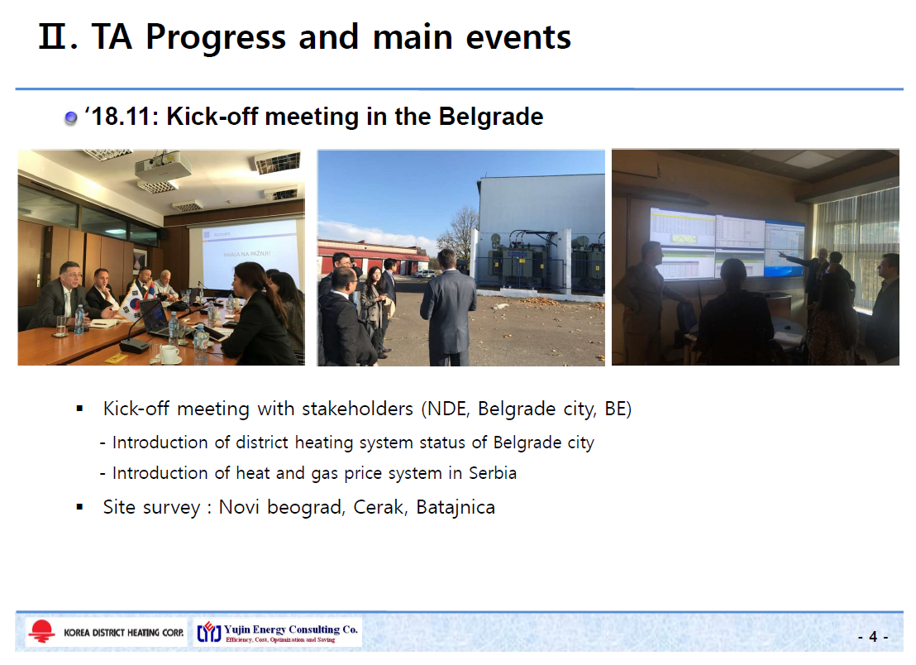
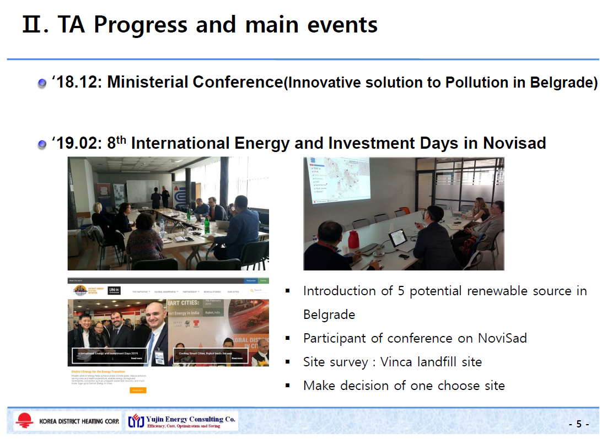
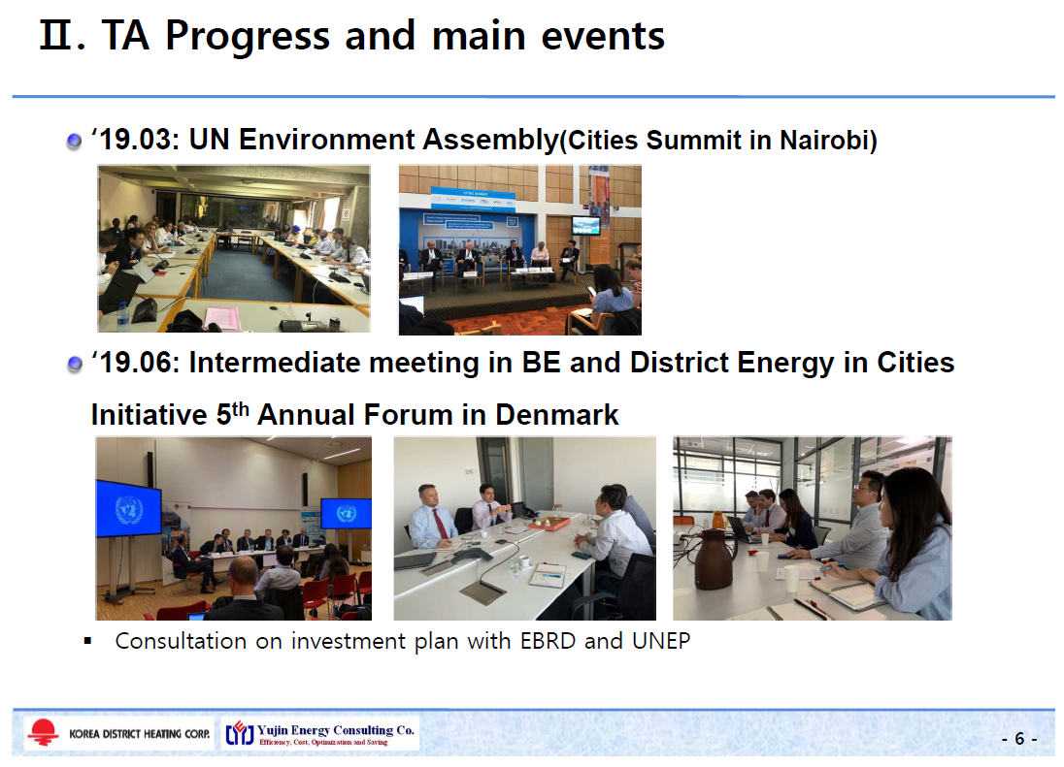
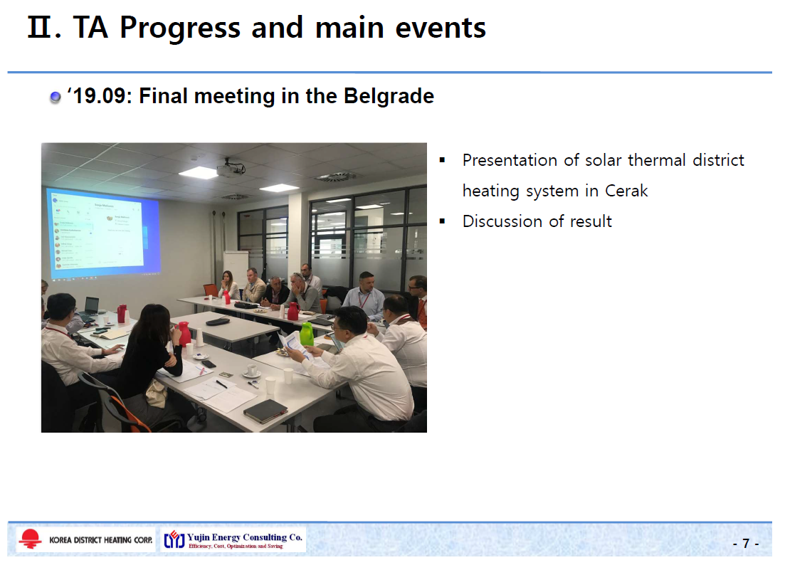

5. Information for TA Impact Description
The information in the table below will be used to produce the CTCN TA Impact Description. The TA Impact description is a 2-page summary document for communication purposes.
Challenge: Approx. 500 characters with spaces | Enhancing renewable energy and waste heat to the DH system is a priority for the city of Belgrade, and must be developed as part of a holistic action plan for DH in the city. The integration of renewable and waste heat sources in a DH network requires of innovative technologies that have already been proofed in northern European countries but that have not been demonstrated yet in the Serbian district heating market
CTCN Assistance: 2 to 4 bullet points. Approximately 450 characters with spaces | - Potential study of renewable technologies and make priority of 5 technologies which possible to connect with DH system in Belgrade city.  - Consult with local stakeholders and selecting of one site for feasibility study.  - Investment-grade feasibility study for demonstration project.
Anticipated impact: 2 to 4 bullet points to summarise anticipated impact. Approximately 250 characters with spaces. As a minimum, please include the impacts described in annex 1B as well as other relevant qualitative and quantitative impacts anticipated after completion of CTCN technical assistance. | - Secure action plan for renewable and waste heat source connect with district heating system in Belgrade city.  - Implement recommendations of the demonstration feasibility study with its investment plans, while enabling environment for private investors in country  - Ensure the increased reliability of district heating economy in whole district heating chain from the heat production to the final consumption.
Linkages and contribution to NDC: 2 to 4 bullet points. Approximately 350 characters with spaces | This Assistance supports Serbia’s Nationally Determined Contribution to  - Technical lesson from CTCN’s work in Belgrade will be applied elsewhere in the country and region and policy and regulatory recommendations developed through the project to ensure replication potential in Serbia.  - Begin process of attraction private sector investment in the City, which has been identified as crucial to the longevity of the DH system.  - Transfer lessons learned from this to other cities in the country and region that require private sector investment and expertise.
The narrative story: Approximately 1200 characters with spaces | Belgrade’s DH system is the largest in Serbia and one of the largest in Europe with total length of 1,420km and a capacity of over 2,800MW, almost half the total DH capacity in the country. “Beogradske elektran” (BE) manages the DH system which supplies heat to approximately 50% of household, business and public buildings in Belgrade. The system’s priority is to switch heat sources from almost exclusively imported natural gas to a more diverse mix of fuels, including renewables and waste heat.  In Belgrade, significant investment of €310 mil is needed for the next 25 years to modernize and expand the DH networks, diversify fuel sources whilst reducing tariffs to remain competitive. The City has significant potential for DH connect renewable and waste heat sources, have not been developed beyond the pre-feasibility stage due to a lack of finance for project feasibility, local technical expertise on renewables and long-term action plan for DH identifying specific technologies.  A full, independent feasibility study and procurement plan for DH connected low-carbon heat source would transfer technical expertise, attract 3rd-party finance, demonstrate cost and viability for future projects and accelerate the technology in Belgrade and nationally.  The Green Technology Center , Korea District Heating Corporation and Yujin Energy Consulting, together BE and other local stakeholder will review potential renewable technologies connect to DH system, and pre-feasibility study of 2 site and development of a stand-alone investment-grade feasibility study of selected demonstration one project.  By providing feasibility study of demonstration project, this CTCN assistance will contribute to secure action plan for renewable and waste heat source connect with DH system in Belgrade city. Implement of the investment-grade feasibility study for demonstration project, will ensure the attraction of private sector investment and replication potential in Serbia.
Contribution to SDGs: Always include contribution to SDG 13, and to the extent possible, please include contribution to 2 other SDGs, describing the contribution with a few sentences for each SDG concerned. A complete list of SDGs and their targets is available here: https://sustainabledevelopment.un.org/partnership/register/ | SDG 7: With this TA, improve renewable and clean energy access and increasing the share of renewable in total power generated. Also increase energy efficiency of DH system and building stock.  SDG 11: This TA will improving resource efficiency and cost-effective of the city’s DH system.  SDG 13.1: The TA wills strength climate-resilient by using more environmentally friendly energy sources for heating.
Note: Please see examples of TA Impact Description in adaptation and mitigation at the following link:
https://www.ctc-n.org/sites/www.ctc-n.org/files/learning-reports/18106-ctcnimpactdescriptionv02.pdf
https://www.ctc-n.org/sites/www.ctc-n.org/files/learning-reports/ta_impact_description_2014000002_gcai.doc
Annex 1 - Standardised CTCN performance indicators for donor and UN reporting

Please add quantitative values and qualitative descriptions for indicators relevant to the particular TA in the tables below. Non-relevant indicators should be left blank.

- Activities and outputs supported by CTCN technical assistance
Please only fill in the table for activities and outputs conducted or produced directly by the CTCN assistance.

CTCN standardised performance indicators | Quantitative value | Qualitative description  List the various elements corresponding to the quantitative value
Overview
- Number of work days of the international expert team spent on the implementation of the technical assistance | 30 | Consultation meeting in Belgrade  Communication with Stakeholders  Make presentation materials and report
- Number of work days of the locally-contracted expert team spent on the implementation of the technical assistance | 50 | Analysis of technical data  Research and review of related technical information  Write the report and ppt
- Number of external communication and outreach activities conducted to showcase the assistance (news release, newsletters, articles on website, events presenting the results of the technical assistance, social media postings, and presentations at events outside the technical assistance etc.) | 9 | - Kick-off meeting and site survey in Belgrade  - Participate of Ministerial Conference in Belgrade  - Stakeholder consultation  - Participate of international Energy and Investment days in NoviSad  - UN Environment Assembly  - District energy forum  - Final consultation  - News release (2 cases)  A. Discuss how to invigorate and make an effect for district energy in UNEP Assembly_Cities summit in Nairobi (지역난방공사, UN 환경총회에서 지역난방 효율화,활성화 방안 논의) http://www.ekn.kr/news/article.html?no=420334)  B. Panel discuss of expand District Energy to the cities in annual forum of DE initiatives(지역난방공사, 덴마크에서 ‘집단에너지 보급확대’ 주제 발표)  http://www.dt.co.kr/contents.html?article_  no=2019061702109958027005&ref=naver)
Events (other than trainings) held as part of the assistance
- Total number of events other than trainings (Aggregation of numbers in categories below) | Aggregation of numbers in categories below
- Number of international and multi-country (at regional or sub-regional level) technology and knowledge sharing events | 4 | - Kick-off meeting  - Stakeholder consultation  - Investment plan consultation meeting  - Final consultation
- Number of participants in the events above | 44
- Number of national technology and knowledge sharing events (national events held including national consultations) |  | List title of events
- Number of participants in the events above
- Number of public-private events related to technologies |  | List title of events
- Number of participants in the events above
Training and capacity building activities conducted during the assistance
- Number of training sessions and capacity strengthening activities |  | List the title of the training sessions and capacity strengthening activities
- Number of people who received the training
- Number of men
- Number of women
- Total number of organisations trained | List total number here
- Number of research organisations, laboratories and universities |  | List the name of organisations trained here
- Number of private companies |  | List the name of organisations trained here
- Number of cities and local government |  | List the name of organisations trained here
- Number of communities |  | List the name of organisations trained here
- Number of ministries |  | List the name of organisations trained here
- Number of specialised governmental institutions |  | List the name of organisations trained here
- Number of non-profit organisations |  | List the name of organisations trained here
- Number of participants that were significantly or moderately satisfied after the training (from CTCN training feedback form). |  | Breakdown the categories here based on the results of the CTCN training feedback forms
- Number of participants that significantly or moderately increased their capacities thanks to the training (from CTCN training feedback form). |  | Breakdown the categories here based on the results of the CTCN training feedback forms
- Number of men
- Number of women
Tools, technical documents and information material supported by the assistance
- Total number of tools, technical documents s and information material supported by the assistance (excluding mission, progress and internal reports)
- Number of tools strengthened, revised or developed (including tools, methodology, software, calculation systems, etc.) |  | List the name of the documents
- Number of technical documents strengthened, revised or created |  | List the name of the documents
- Number of other information materials strengthened, revised or created (For example training and workshop reports, Power Points, exercise docs etc.) | 2 | Final report include results of technical assistance  Power point of final consultation
Policies, laws and regulations supported by the assistance

- Total number of policies, strategies, plans, laws, agreements or regulations supported by the assistance |  | List the policies, strategies, plans, laws, agreements or regulations
- Number of policies, strategies, and plans drafted addressing climate change adaptation |  | List the policies, strategies, plans, laws, agreements or regulations
- Number of policies, strategies, and plans drafted addressing climate change mitigation |  | List the policies, strategies, plans, laws, agreements or regulations
- Number of documents developed to inform other policies, strategies, and plans on climate change adaptation (sectoral strategies, national development plans, etc.) |  | List the documents
- Number of documents developed to inform other policies, strategies, and plans on climate change mitigation (sectoral strategies, national development plans, etc.) |  | List the documents
- Number of laws, agreements, or regulations drafted addressing climate change adaptation |  | List the laws, agreements and regulations
- Number of laws, agreements, or regulations drafted addressing climate change mitigation |  | List the laws, agreements and regulations
- Number of documents developed to inform laws, agreements, or regulations on climate change adaptation |  | List the documents
- Number of documents developed to inform laws, agreements, or regulations on climate change mitigation |  | List the documents
Institutional strengthening supported by the assistance
- Total number of institutional arrangements supported to support climate change planning |  | List the institutional arrangements
- Number of organisations with increased awareness and knowledge among countries to better own and drive national adaptation planning processes |  | List the organizations
- Number of organisations with increased awareness and knowledge among countries to better own and drive national mitigation planning processes |  | List the organizations
Partnerships and cooperation
- Number of private companies directly engaged in the assistance (that partnered with the proponent, the beneficiaries or the CTCN to implement the assistance) (Excluding the role of the CTCN and TA implementers) |  | Please list here the names of the organisations cooperating
- Number of South-South collaborations enabled during or through the assistance, when stakeholders from other countries were involved in the assistance (Excluding the role of the CTCN and TA implementers) |  | Please list here the names of the organisations cooperating
- Number of North-South collaborations enabled during or through the assistance, when stakeholders from other countries were involved in the assistance (Excluding the role of the CTCN and TA implementers) |  | Please list here the names of the organisations cooperating
- Number of Triangular collaborations enabled during or through the assistance, when stakeholders from other countries were involved in the assistance (Excluding the role of the CTCN and TA implementers) |  | Please list here the names of the organisations cooperating
UNFCCC planning/support processes
- Number of National Adaptation Plans (NAPs) developed as part of the technical assistance |  | List as appropriate
- Number of Nationally Appropriate Mitigation Actions (NAMA) developed as part of the technical assistance |  | List as appropriate
- Number of Technology Needs Assessment s(TNAs) developed as part of the technical assistance |  | List as appropriate

B. Impacts anticipated after completion of CTCN technical assistance: core indicators

Every technical assistance should contribute to at least one indicator below.

CTCN core indicators | Quantitative value | Unit | Methodology  Explain the method or process of verifying the indicator and how data was gathered | Assumptions  Indicate assumptions made during quantification | Expected timeline  Indicate when the indicator and value are expected to be achieved
- Total anticipated amount of funding/investment mobilised (in USD) as a result of the TA
- Anticipated amount of public funding mobilised (in USD) from national sources as a result of the TA
- Anticipated amount of public funding mobilized (in USD) from international and regional sources as a result of the TA
- Anticipated amount of private investment mobilised (in USD) from national sources as a result of the TA
- Anticipated amount of private investment mobilised (in USD) from international and regional sources as a result of the TA
- Anticipated number of beneficiaries as a result of a mitigation TA |  |  | (please describe the calculation process, original unit etc)
- Anticipated number of people with increased resilience as co-benefits as a result of the TA |  |  | (please describe the calculation process, original unit etc)
- Anticipated average the total GHG reductions in metric tons of CO_{2-e}, as a result of the TA |  |  | (please describe the calculation process, original unit etc) | (please also indicate the baseline year and when the indicated value is expected to be achieved)
- Anticipated average annual GHG reductions in metric tons of CO_{2-e}, as a result of the TA | 1189 | tCO₂/yr | (A)Fuel Saving: 614341.64m³/yr  (B)Caloric value: 34.5MJ/m3  (C)Carbon emission factor of LNG: 15.3tC/TJ  A*B*C*44/22 | Carbon emission factor of LNG : 2006 IPCC
- Anticipated and projected greenhouse gas emissions reduced or avoided through 2030, in metric tons of CO_{2-e}, from adopted laws, policies, regulations, or technologies related to clean energy/sustainable landscapes as a result of the TA |  |  |  | (please also indicate the baseline year and when the indicated value is expected to be achieved)

C. Outputs and impacts anticipated after completion of CTCN technical assistance: standardised performance indicators

CTCN standardised performance indicators | Quantitative value  Insert the request value and unit | Content  List the elements included in the number provided | Expected timeline  Indicate when the indicator and value are expected to be achieved | Responsible institution  Indicate the institution(s) that will play leading role(s) in enabling the indicators and anticipated values to be achieved
- Anticipated number of policies, strategies, plans, addressing climate change mitigation officially proposed, adopted, or implemented as a result of the TA
- Anticipated number of policies, strategies, plans, addressing climate change adaptation officially proposed, adopted, or implemented as a result of the TA.
- Anticipated number of policies, strategies, plans, addressing climate change on both adaptation and mitigation officially proposed, adopted, or implemented as a result of the TA
- Anticipated number of laws or regulations addressing climate change mitigation officially proposed, adopted, or implemented as a result of the TA.
- Anticipated number of laws or regulations addressing climate change adaptation officially proposed, adopted, or implemented as a result of the TA.
- Anticipated number of laws or regulations addressing climate change both adaptation and mitigation officially proposed, adopted, or implemented as a result of the TA
- Anticipated number of public-private partnerships and collaboration created (Excluding the role of the CTCN and TA implementers)
- Anticipated twinning arrangements created as a result of the TA
- Anticipated number of technology projects to support action on low emission and climate-resilient development
- Anticipated number of strengthened National Systems of Innovation and technology innovation centres in recipient country
- Anticipated Clean Energy Generation Capacity in kWh
supported by the TA
- Anticipated technology types effectively deployed in the country | 1 | Solar thermal district heating | 2020 | PUC Beogradske Elektrane
- Anticipated UNFCCC processes implemented as a result of the TA (NAMA, NAPA, NDC, etc.)
- Anticipated Technology Needs Assessments (TNA) and technology Action Plans (TAP) as a result of the TA
- Anticipated cooperative research, development and demonstration programmes within and between developed and developing country Parties facilitated as a result of the TA
- Anticipated improved climate change observation systems and related information management in developing country Parties.

Annex 2 (for internal use – to be filled in by the CTCN)
CTCN evaluation
This section will be completed by the relevant CTCN Technology Manager.

- Evaluation of the timeliness of the TA implementation as measured against the timeline included in the response plan;
- Evaluation of TA quality as defined in the response plan;
- Overall performance of the Implementers;
- Overall engagement of the NDE and Proponent;
- Lessons learned on the CTCN process and steps taken by the CTCN to improve.

