Closure and Data Collection Report for CTCN Technical Assistance

- Basic information
Title of response plan | Technical Assistance for resilience to climate variability in the building sector of Antigua and Barbuda
Country / countries | Antigua and Barbuda
NDE focal point and organisation | Diann Black-Layne  Director, Department of the Environment  Ministry of Health and Environment  doe@ab.gov.ag  Botanical Gardens, Factory Road, St. John’s, Antigua
Proponent focal point and organisation | NDE
Sector(s) addressed | Infrastructure and Urban planning
Technologies supported | The technology sectors which were supported include:  Sector: Infrastructure and Urban planning  Technology Group: Building design and material  Urban design and spatial planning  Building construction  Water supply infrastructure  Urban planning  Building codes  Technology: Urban infrastructure development,  General planning solutions  Sector: water  Technology Group: Adaptation planning, Water augmentation, Water storage,  Technology: Disaster risk assessment tools  Hazard mapping solutions, Climate change vulnerability assessment, Rainwater harvesting, Water reservoirs  Mitigation: Climate resilient construction and Renewable energy  Sector: - Renewable energy  Technology Group: - Solar  Technology: - Building-integrated PV; Solar water pumps; Solar water heater;  Sector: - Energy efficiency  Technology Group: - Appliances and equipment  Technology: - Water efficiency; Residential water heaters; Lighting; Appliance standards; Water pumping;  Sector: - Energy efficiency  Technology Group: - Buildings  Technology: - Sustainable design; Daylight harnessing; New building design; Insulation in buildings; Building materials; Building life cycle and integrated design process; Building standards and codes; Greening the built environment; Retrofitting of existing buildings; Building Energy Management Systems; Heating - Ventilation and Air Conditioning; Design for Deconstruction; Traditional building materials and design; Sustainable spatial planning; Efficient air conditioning systems  Cross-sectoral enablers: Capacity building and training;  Cross-cutting approaches: Disaster risk reduction
Implementation period and total duration | 1 June 2018 – 1 February 2019: 9 months
Total budget for implementation | $95,740
Designer of the response plan | UN Environment
Implementer of response plan | ECMC and UN Environment

2. Summary of all activities, outputs and products that contribute to the expected impact of the technical assistance.
Description of delivered outputs and products as well as the activities undertaken to achieve them. In doing so, review the log frame of the original response plan and refer to it as appropriate | - Preliminary/introductory meeting  - Producing building inspection forms and guidance notes  - ½ day workshop with inspectors training them on the use of the building inspection forms and guidance notes for selection of the interventions  - 2 rounds of building inspections by the CTCN appointed team in partnership with the GovAB team  - Development of a GovAB public building adaptation strategy and basis of design.  - Preparation of detailed work packages for 34 buildings  - Development of an in-depth feasibility study final report
Partners organisations | - Department of the Environment, Ministry of Health and Environment
Beneficiaries | Over 9 officers trained in the conduct of building inspections and the use of guidance notes to establish interventions for the deficiencies identified
Methodologies applied to produce outputs and products | Comprehensive inspections to undertake detailed condition assessment of the 34 buildings to produce responsive work packages.  Four sets of inspections were performed  - Initial pilot inspection to obtain appreciation of the building conditions and to advise the preparation of the building inspection forms and guidance notes.  - Inspections by the Country technical team of 34 buildings  - Validation inspection of a sample group of buildings by the Team Leader and Counterpart Local Engineer  - Verification inspections by members of the Country team to provide additional information for the completion of the work packages and to obtain missing data.
Deviations | The one training workshop which was conducted earlier than planned took place after a set of building inspections had already been undertaken.  Additionally, preparing basic drawings for the parts of the buildings that will be worked on was not possible as detailed inspections would be required. However, a set of detailed generic structural retrofit details were developed to be used in a compendium of plans/drawings.  Furthermore, the intrinsic deficiency in the information contained in the inspection forms, meant that a detailed review of the photographs provided accompanied by additional site visits, had to be undertaken to develop detailed work packages.  Finally, much more analysis than forecast was required in order to develop and prioritize the upgrade scope and then determine what percentage would qualify for adaptation financing.
Achieved or anticipated gender benefits from the TA | The local team involved in the project appear to be equally divided among males and females. However, there were seven males and one female involved in the field inspections.  Based on information obtained from the Health Centres, there are much more female clients than male. Thus given the number of health clinics which were included in the inspection, it is anticipated that the list of beneficiaries would be skewed towards the female gender.
Achieved or anticipated co-benefits from the TA | - Gender is actively imbedded in GOAB’s Climate Change and planning activities, but with greater involvement at the executive and supervisory level.  - Greater application of Climate Change mitigation and adaptation solutions and retrofit measures to reduce climate change impacts, improve resiliency of building infrastructure in key economic sectors, like the health sector and GOAB institutions.
Anticipated follow up activities and next steps | Detailed recommendations for follow up are contained in the feasibility study report. The anticipated next steps are:  - Development and second round consultation for a GCF proposal  - Determination of the GovAB capacity for co-financing  - GCF proposal submission.  If the event of GCF funding being secured, then the work undertaken through the CTCN assignment will be re-used. In particular, the existing tables and reports will be drawn on for the preparation of multiple procurement-ready work packages.

- Lessons learnt
 | Lessons learnt | Recommendations
Lessons learnt for this TA.  Describe essential factors contributing to successful implementation, as well as specific challenges. Recommendations include considerations on what would need to be in place for increasing success of similar efforts (i.e. regulatory, legal, stakeholders, communication, etc.) | The Country team needs to be better prepared and probably apprised of the project and its requirements in advance of the Technical Assistance consultants’ visit.  Additionally, there did not appear to be sufficient buy-in of the project from the local team as the information provided was significantly deficient.  Observations suggest that the local team may have reacted inappropriately to the concerns raised during the first visit. This may have led to the poor quality and highly deficient inspection process as the forms may have been produced in haste. | - The developers of the project must ensure that there is complete buy-in by the local team so as to ensure dedicated and unencumbered participation by all the participants.  - Inspections should only be performed by technically competent people in the field of architecture, construction and engineering. Inspectors must be equipped with the appropriate tools for measurements and recording of defects.  - Prior to the preparation of the final (construction-ready) work packages, comprehensive and detailed condition assessments must be performed by competent and qualified professional engineers trained in the field of structural condition assessments of existing buildings.
Lessons learnt related to climate technology transfer  Describe opportunities, challenges and barriers for the use and deployment of the technology or technologies supported by the TA. The objective is to identify specific success factors for technology transfer | A core part of the TA evolved into supporting the government in the early stages of major project development. The TA was delivered at a stage where many strategic decisions had been made -without a sufficient technical and cost engineering foundation. As a result the strategy needed to be reworked.  Whereas the technical teams had their own assessment forms, it was not as comprehensive as the one specifically prepared for the project. There were standard interventions and these would essentially depend on the assessment of each individual inspector. | TA should be called in as early as possible to add the most value in the strategic planning stage.  The inspection form provided should be expanded to include as many interventions as possible.  Additionally, a database of unit construction cost should be developed and included as part of the inspection forms. In so doing, unit cost will be consistent in addition to expediting the estimating process.
Lessons learnt related the CTCN process for TA | - TA was required at two very different levels:  - Strategic planning, costing, proposal development and team training.  - Detailed inspection and building surveyor cost table development.  It proved difficult to adequately contain these two very different assignments in one package in a parallel timeframe.  - The competitive bidding process for the TA precludes the opportunity of the experts to guide development of the TOR to best fit the needs and budget of the assignment.  - The exact role of some of the participants in the TA was not well articulated. Thus it was difficult to appreciate the clear and distinct roles of all persons involved in the TA.  - The TOR was too ambitious in its outputs as a lack of detail and client side in-depth participation limited to the potential to generate detailed engineering solutions.  - There was a confusion on the client side on the inspection targets until a very advanced stage – this resulted in inefficiencies in the inspection process. | Many of the issues noted cannot be resolved by a single-shot small scale TA process scoped from outside of the target country.  One potential solution is for the CTCN solution to invest more of the overall TA programme budget into more in-depth scoping and TOR development work, conducted by the CTCN core and roster staff themselves. This would result in better informed and therefore more realistic and impactful assignments.  Wherever possible the TA assignments should be assigned to a single individual, company or existing team. This reduces the risk and transaction cost of new team development.  This recommendation in turn indicates that the CTCN mechanism is well suited to specific thematic issues but not so suitable for the more complex and multi-thematic assignments/issues.

4. Illustration of the TA and photos
For communication purposes, please provide 2-4 Power Point slides with illustrations or charts showing the TA process, applied methodology, activities, outputs and achieved results. The illustrations must be copied into the TA Closure report but must also be delivered as power point files. Also, please provide at least five high-resolution pictures in jpg format, capturing technical assistance. The pictures should illustrate how the TA has impacted the lives of the beneficiaries in particular and the communities in general.

Verification Site Visits
In order to place some of the conditions identified into proper perspective, the Team Leader, the Counterpart Local Engineer and DOE Engineer Dwight Laviscount visited some of the buildings, as part of a verification site inspection. During those visits, the Team Leader, took the opportunity to undertake some basic training, indicating the types of defects being observed and the reasons for their occurrences.
The Photographs below depict some of the major defects observed during the inspections, which were performed over a two-day period, October 4 and 5 2018
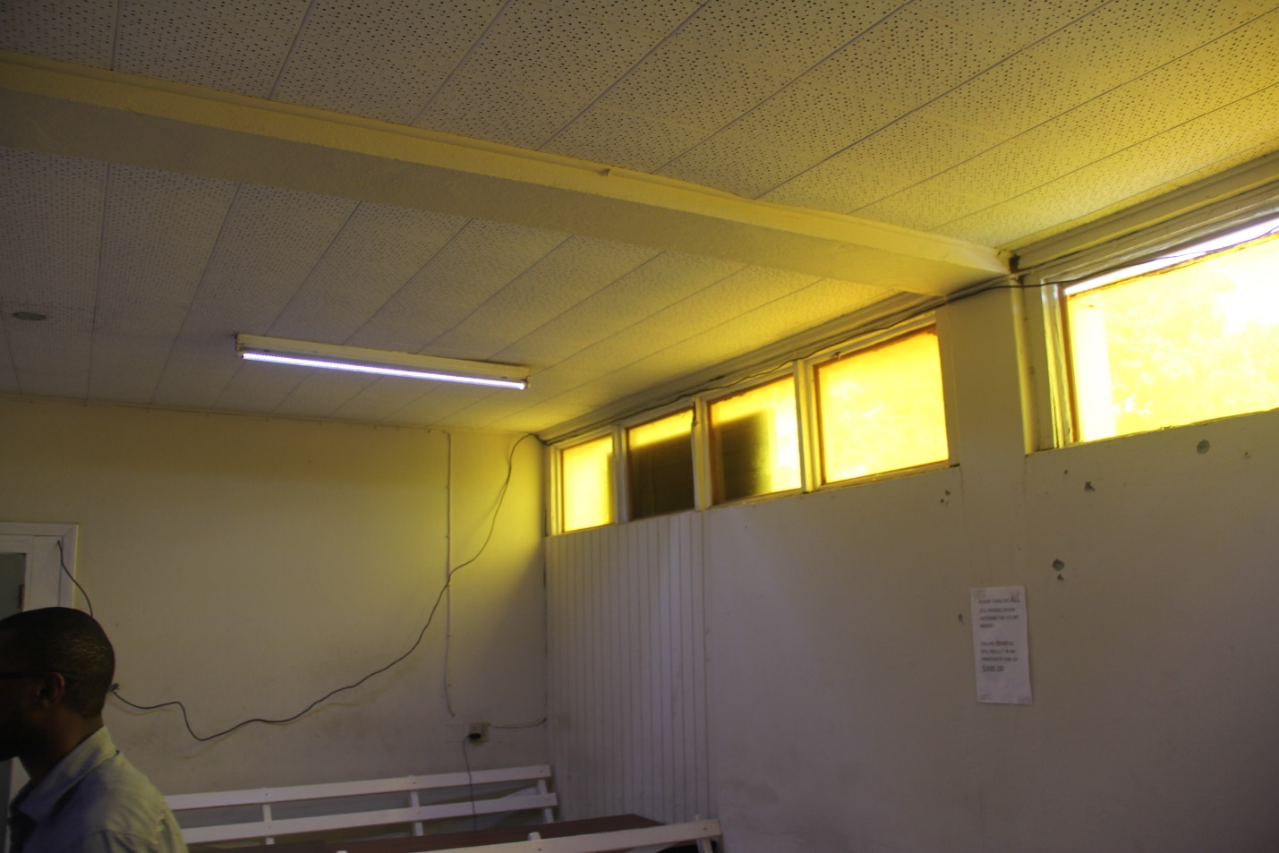
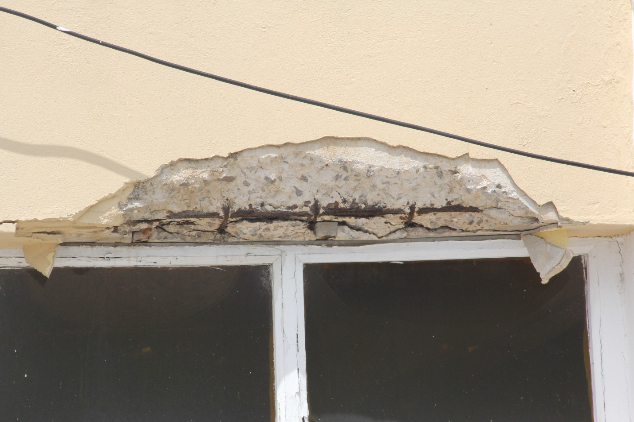
Photograph 1 – Discussing the interpretation of the defects during a training session and verification visit (October 5, 2018) at the All Saints Police Station.
Photograph 2 – Major concrete spalling and deterioration at All Saints being the focus of a discussion during a verification visit on October 5, 2018
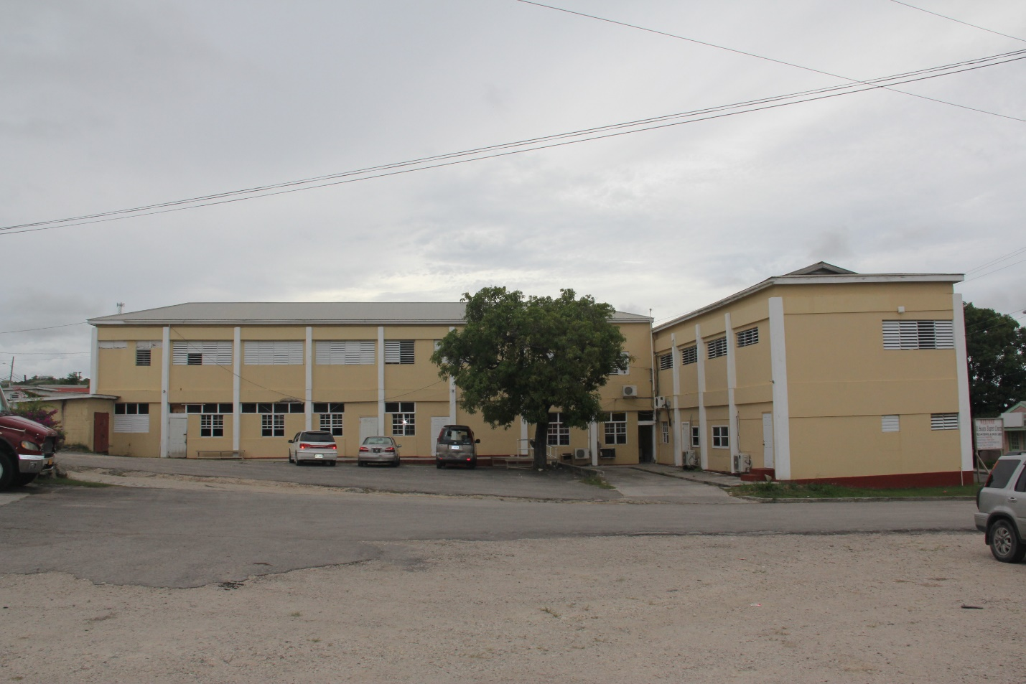

Photograph 3 – Southeast elevation of the All Saints Police Station – Subject of verification due to the extent of repairs required.
Photograph 4 – Another teaching moment at Potters Health Centre – explaining the need to use pressure treated timber
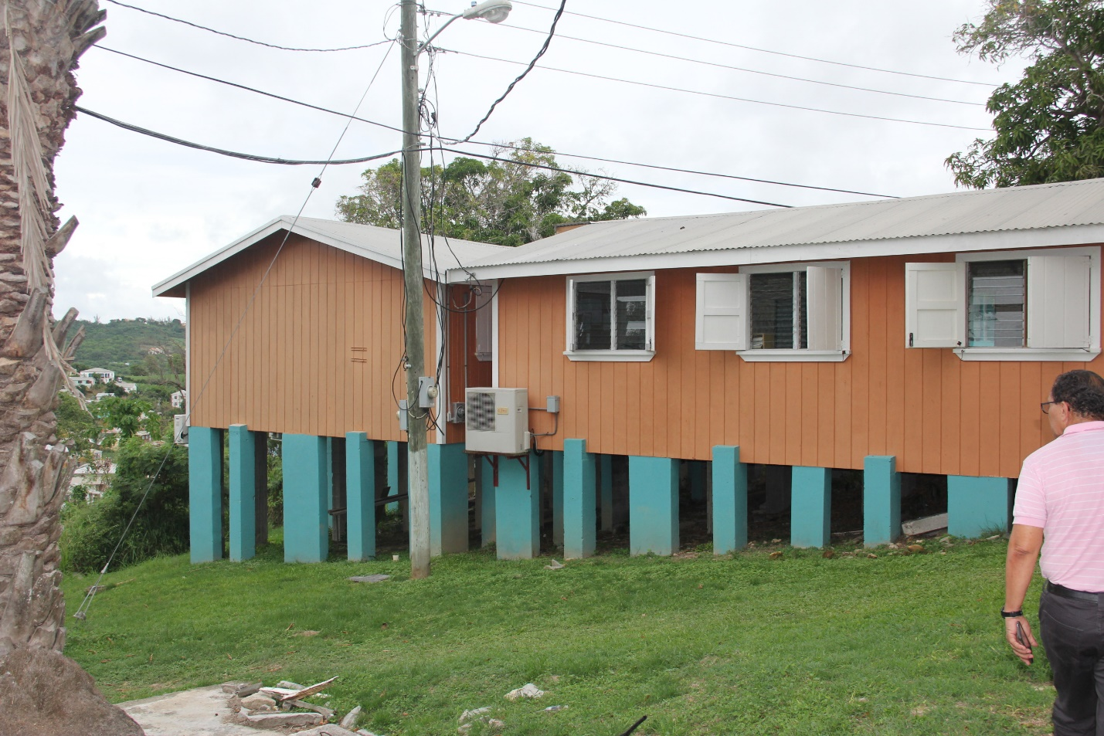
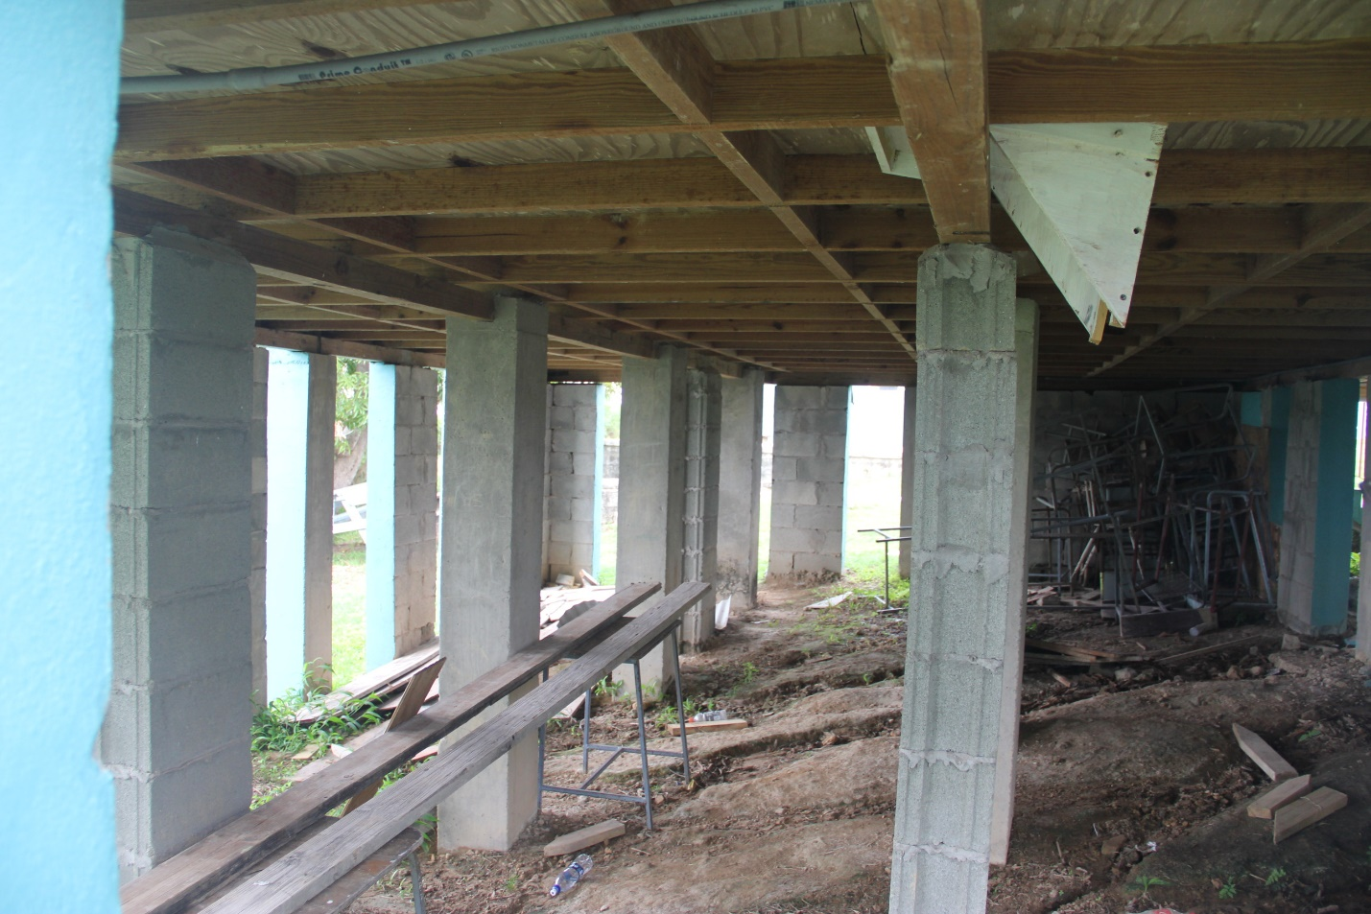
Photograph 5 – Discussions with the ECMC local counterpart Engineer – concerns about the supporting structure being expressed
Photograph 6 – Closer view of block work supports to an institutional building – reconstruction as opposed to retrofit was recommended

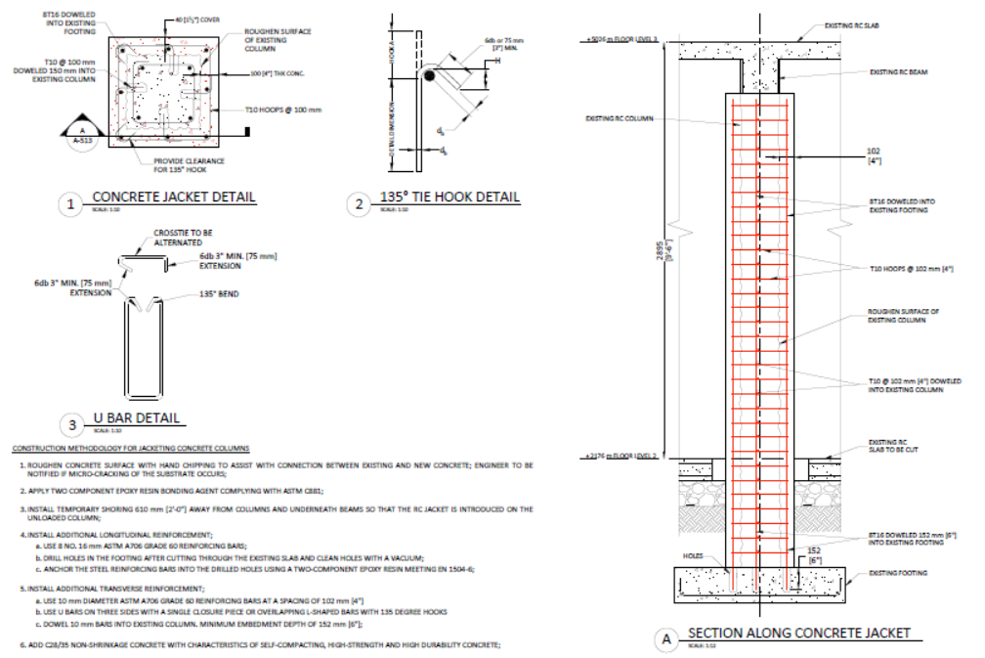
Figure 1 – Structural Retrofit works to columns
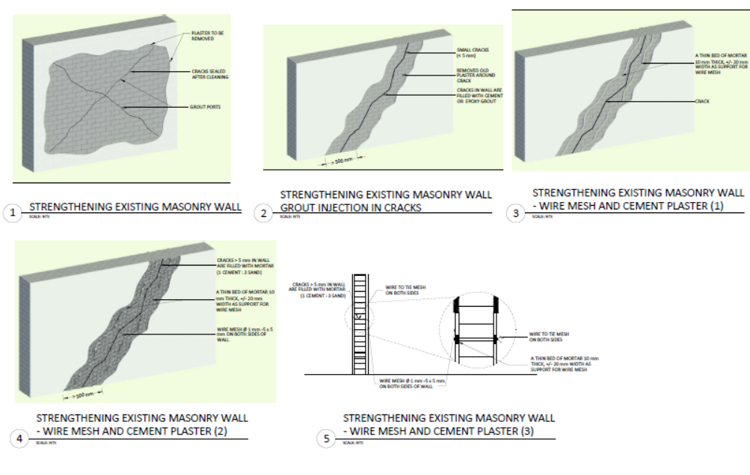
Figure 2 – Structural Repairs to wall cracks

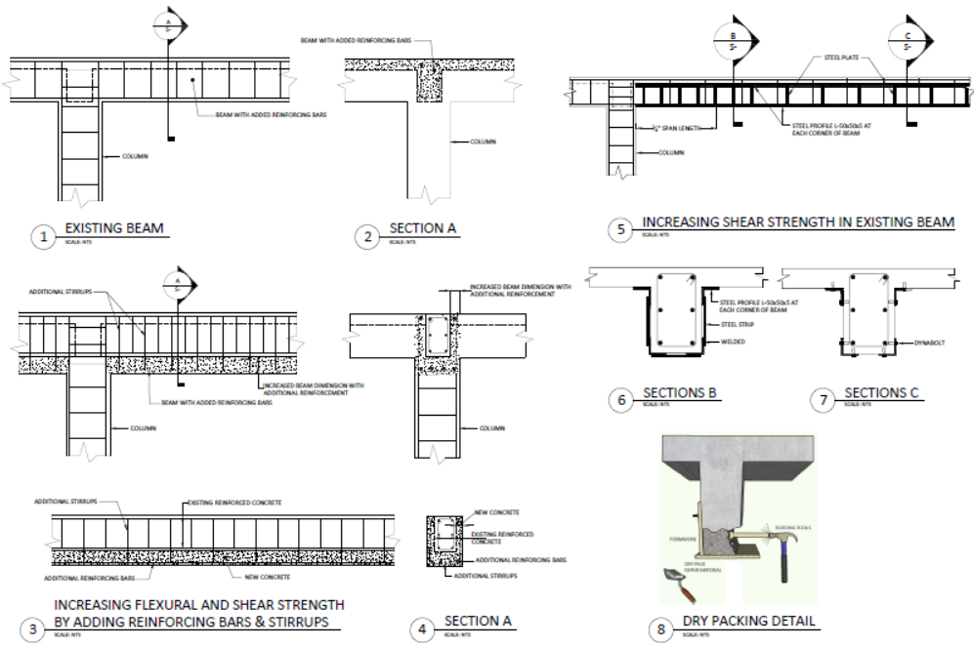
Figure 3 – Structural Retrofit works to Beams
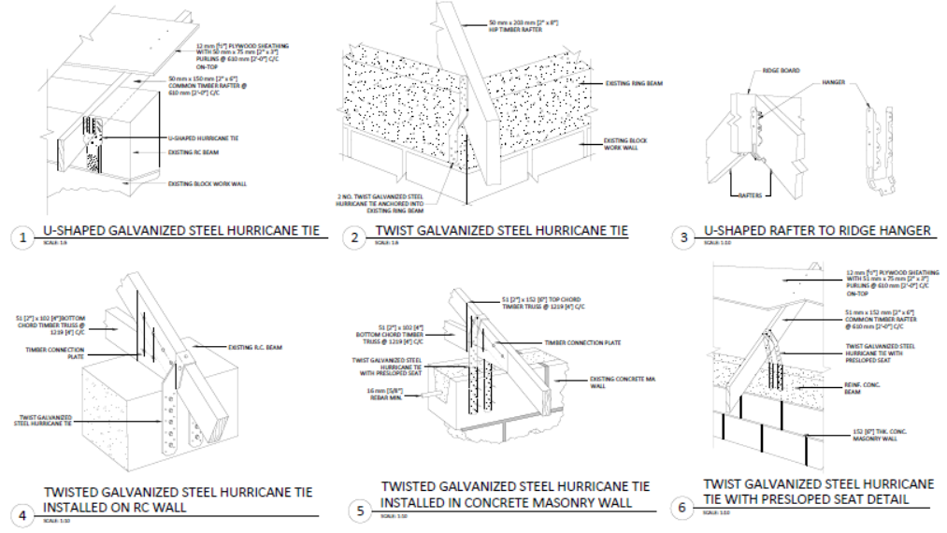
Figure 4 – Structural Retrofit to Roof Connections

5. Information for TA impact description
The information in the table below will be used to produce the CTCN TA Impact Description. The TA Impact description is a 2-page summary document for communication purposes. Please copy information from sections above and technical delivery reports as required.
Challenge: Approx. 500 characters with spaces | Hurricanes, floods and droughts are becoming increasingly destructive in Antigua and Barbuda. In September 2017, Hurricane Irma left behind three casualties, 1,800 evacuated inhabitants and 95 per cent of Barbuda's buildings and infrastructure damaged or destroyed. It is crucial that the country manages the reconstruction of key public buildings by “building back better”, ensuring that critical public service buildings and emergency services can withstand major local disasters.
CTCN Assistance: 2 to 4 bullet points. Approximately 450 characters with spaces | - Technical and strategic input into ongoing Antigua and Barbuda Government led adaptation policy and planning processes and funding proposals  - Technical assessment of 34 public buildings  - Development of 30 detailed work packages for insertion into bid documents  - Building the capacity of the national workforce through practical experience under expert guidance
Anticipated impact: 2 to 4 bullet points to summarise anticipated impact. Approximately 250 characters with spaces. As a minimum, please include one of the following: i) Quantity of greenhouse gas emissions reduced, avoided or sequestered; or ii) Number of people with increased capacity to adapt to the impacts of climate variability and change. | - 34-70 public buildings rehabilitated/retrofit  - $11 million USD investment from Global Climate Fund leveraged through technical assistance  - Enhanced capacity of national workforce to apply the work packages to other municipal buildings  - Increased resilience of infrastructure in Antigua and Barbuda to extreme climate events  - Based on the number of occupants of each building and the anticipated number of users, the likely number of beneficiaries would be roughly 6,000; the majority of whom would be females
Linkages and contribution to NDC: 2 to 4 bullet points. Approximately 350 characters with spaces | The Assistance Supports Antigua and Barbuda’s Nationally Determined Contribution to:  - Improve and prepare all buildings for extreme climate events including drought, flooding and hurricanes by 2030
The narrative story: Approximately 1200 characters with spaces | It is crucial that Antigua and Barbuda manages the reconstruction of key public buildings by "building back better". Antigua and Barbuda is seeking to avoid major destruction during potential future climate induced disasters. In order to lead a sustainable reconstruction process that reflects projected climate change impacts, Antigua and Barbuda needs support with assessments and recommendations related to adaptation of infrastructure, disaster resilience of building structures, and availability of key services during and post-emergency situations.  The CTCN Technical Assistance will enable the counterparts from Antigua and Barbuda to identify the most relevant adaptive measures for the climate resiliency of public buildings. The outputs will be used by the authorities in Antigua and Barbuda for insertion into bid documents; as guidance for further funding proposals, investment plans, and for future design and structural specifications of public buildings; for policy and strategic development; implementation of reconstruction of public buildings in Antigua and Barbuda; and for monitoring and operations.
Contribution to SDGs: Always include contribution to SDG 13, and to the extent possible, please include contribution to 2 other SDGs, describing the contribution with a few sentence for each SDGs concerned. A complete list of SDGs and their targets is available here: https://sustainabledevelopment.un.org/partnership/register/ | - SDG 13 – the Technical Assistance will enable Antigua and Barbuda to implement adaptive measures for climate resiliency of public buildings  - SDG 9 – the technical assessments will consider resilience to several hazards including hurricanes, flooding and earthquakes  - SDG 7 – the Technical Assistance will support a planned intervention under a proposal titled “Transitioning Antigua and Barbuda’s off-grid diesel generation to low-carbon wind, solar, battery and hybrid renewable systems for critical services” by helping prepare the targeted buildings for energy investment

Note: Please see example of a TA Impact Description at the following link:
https://www.ctc-n.org/sites/www.ctc-n.org/files/benin_a_ag_forestry.final_.pdf
Annex 1 - Standardised CTCN performance indicators for donor and UN reporting

Please add quantitative values and qualitative descriptions for indicators relevant to the particular TA in the tables below. Non-relevant indicators should be left blank.

- Activities and outputs supported by CTCN technical assistance
Please only fill in the table for activities and outputs conducted or produced directly by the CTCN assistance.

CTCN standardised performance indicators | Quantitative value | Qualitative description  List the various elements corresponding to the quantitative value
Overview
- Number of work days of the international expert team spent on the implementation of the technical assistance | 150 | Much more time than originally planned. Time had to be spent on both strategic and foundational issues and developing interventions from the inspection forms and photographs
- Number of work days of the locally-contracted expert team spent on the implementation of the technical assistance | 20
- Number of external communication and outreach activities conducted to showcase the assistance (news release, newsletters, articles on website, events presenting the results of the technical assistance, social media postings, and presentations at events outside the technical assistance etc.) | 5 | 2 presentations at global events (Adaptation Futures, Green Cities)  1 news page on the CTCN website  1 video of the technical assistance by the CTCN  1 Presentation of the TA project and its objectives by ECMC staff
Events (other than trainings) held as part of the assistance
- Total number of events other than trainings (Aggregation of numbers in categories below)
- Number of international and multi-country (at regional or sub-regional level) technology and knowledge sharing events
- Number of participants in the events above
- Number of national technology and knowledge sharing events (national events held including national consultations)
- Number of participants in the events above
- Number of public-private events related to technologies
- Number of participants in the events above
Training and capacity building activities conducted during the assistance
- Number of training sessions and capacity strengthening activities | 2 | 1-day workshop  ½-day site visit and workshop
- Number of people who received the training | 9
- Number of men | 7
- Number of women | 2
- Total number of organisations trained | 2
- Number of research organisations, laboratories and universities
- Number of private companies
- Number of cities and local government
- Number of communities
- Number of ministries | 2 | Ministry/Department of the Environment  Ministry of Works and Housing
- Number of specialised governmental institutions
- Number of non-profit organisations
- Number of participants that were significantly or moderately satisfied after the training (from CTCN training feedback form).
- Number of participants that significantly or moderately increased their capacities thanks to the training (from CTCN training feedback form). | 9 | Verbal communication from participants indicting their satisfaction with the inspection forms.
- Number of men | 7
- Number of women | 2
Tools, technical documents and information material supported by the assistance
- Total number of tools, technical documents s and information material supported by the assistance (excluding mission, progress and internal reports) | 67 | - 1 set of inspection forms  - 1 set of interventions/solutions to identified defects  - Guidance Notes  - 34 work packages  - 1 set of Technical Advisory Notes  - 36 sheets of construction details
- Number of tools strengthened, revised or developed (including tools, methodology, software, calculation systems, etc.)
- Number of technical documents strengthened, revised or created | 67
- Number of other information materials strengthened, revised or created (For example training and workshop reports, Power Points, exercise docs etc.)
Policies, laws and regulations supported by the assistance

- Total number of policies, strategies, plans, laws, agreements or regulations supported by the assistance
- Number of policies, strategies, and plans drafted addressing climate change adaptation
- Number of policies, strategies, and plans drafted addressing climate change mitigation
- Number of documents developed to inform other policies, strategies, and plans on climate change adaptation (sectoral strategies, national development plans, etc.)
- Number of documents developed to inform other policies, strategies, and plans on climate change mitigation (sectoral strategies, national development plans, etc.)
- Number of laws, agreements, or regulations drafted addressing climate change adaptation
- Number of laws, agreements, or regulations drafted addressing climate change mitigation
- Number of documents developed to inform laws, agreements, or regulations on climate change adaptation
- Number of documents developed to inform laws, agreements, or regulations on climate change mitigation
Institutional strengthening supported by the assistance
- Total number of institutional arrangements supported to support climate change planning
- Number of organisations with increased awareness and knowledge among countries to better own and drive national adaptation planning processes
- Number of organisations with increased awareness and knowledge among countries to better own and drive national mitigation planning processes
Partnerships and cooperation
Number of private companies directly engaged in the assistance (that partnered with the proponent, the beneficiaries or the CTCN to implement the assistance) (Excluding the role of the CTCN and TA implementers)
- Number of South-South collaborations enabled during or through the assistance, when stakeholders from other countries were involved in the assistance (Excluding the role of the CTCN and TA implementers)
- Number of North-South collaborations enabled during or through the assistance, when stakeholders from other countries were involved in the assistance (Excluding the role of the CTCN and TA implementers)
- Number of Triangular collaborations enabled during or through the assistance, when stakeholders from other countries were involved in the assistance (Excluding the role of the CTCN and TA implementers)
UNFCCC planning/support processes
- Number of National Adaptation Plans (NAPs) developed as part of the technical assistance
- Number of Nationally Appropriate Mitigation Actions (NAMA) developed as part of the technical assistance
- Number of Technology Needs Assessment s(TNAs) developed as part of the technical assistance

B. Impacts anticipated after completion of CTCN technical assistance: core indicators

Every technical assistance should contribute to at least one indicator below.

CTCN core indicators | Quantitative value | Unit | Methodology  Explain the method or process of verifying the indicator and how data was gathered | Assumptions  Indicate assumptions made during quantification | Expected timeline  Indicate when the indicator and value are expected to be achieved
- Total anticipated amount of funding/investment mobilised (in USD) as a result of the TA | 11000000
- Anticipated amount of public funding mobilised (in USD) from national sources as a result of the TA
- Anticipated amount of public funding mobilized (in USD) from international and regional sources as a result of the TA | 11000000 | USD |  | Proposal in preparation at the GCF | 2019
- Anticipated amount of private investment mobilised (in USD) from national sources as a result of the TA
- Anticipated amount of private investment mobilised (in USD) from international and regional sources as a result of the TA
- Anticipated number of beneficiaries as a result of a mitigation TA
- Anticipated number of people with increased resilience as co-benefits as a result of the TA | 6000 |  | Based on twice the number of occupants of the buildings and average daily users of the health centres
- Anticipated average the total GHG reductions in metric tons of CO_{2-e}, as a result of the TA
- Anticipated average annual GHG reductions in metric tons of CO_{2-e}, as a result of the TA
- Anticipated and projected greenhouse gas emissions reduced or avoided through 2030, in metric tons of CO_{2-e}, from adopted laws, policies, regulations, or technologies related to clean energy/sustainable landscapes as a result of the TA

C. Outputs and impacts anticipated after completion of CTCN technical assistance: standardised performance indicators

CTCN standardised performance indicators | Quantitative value  Insert the request value and unit | Content  List the elements included in the number provided | Expected timeline  Indicate when the indicator and value are expected to be achieved | Responsible institution  Indicate the institution(s) that will play leading role(s) in enabling the indicators and anticipated values to be achieved
- Anticipated number of policies, strategies, plans, addressing climate change mitigation officially proposed, adopted, or implemented as a result of the TA
- Anticipated number of policies, strategies, plans, addressing climate change adaptation officially proposed, adopted, or implemented as a result of the TA.
- Anticipated number of policies, strategies, plans, addressing climate change on both adaptation and mitigation officially proposed, adopted, or implemented as a result of the TA
- Anticipated number of laws or regulations addressing climate change mitigation officially proposed, adopted, or implemented as a result of the TA.
- Anticipated number of laws or regulations addressing climate change adaptation officially proposed, adopted, or implemented as a result of the TA.
- Anticipated number of laws or regulations addressing climate change both adaptation and mitigation officially proposed, adopted, or implemented as a result of the TA
- Anticipated number of public-private partnerships and collaboration created (Excluding the role of the CTCN and TA implementers)
- Anticipated twinning arrangements created as a result of the TA
- Anticipated number of technology projects to support action on low emission and climate-resilient development | 1 | GCF proposal | 2019 | Ministry of Agriculture, Housing, Lands and the Environment
- Anticipated number of strengthened National Systems of Innovation and technology innovation centres in recipient country
- Anticipated Clean Energy Generation Capacity in kWh
supported by the TA
- Anticipated technology types effectively deployed in the country | 30 | Urban infrastructure development,  General planning solutions,  Disaster risk assessment tools,  Hazard mapping solutions, Climate change vulnerability assessment, Rainwater harvesting, Water reservoirs;  Building-integrated PV; Solar water pumps; Solar water heater;  Water efficiency; Residential water heaters; Lighting; Appliance standards; Water pumping;  Sustainable design; Daylight harnessing; New building design; Insulation in buildings; Building materials; Building life cycle and integrated design process; Building standards and codes; Greening the built environment; Retrofitting of existing buildings; Building Energy Management Systems; Heating - Ventilation and Air Conditioning; Design for Deconstruction; Traditional building materials and design; Sustainable spatial planning; Efficient air conditioning systems
- Anticipated UNFCCC processes implemented as a result of the TA (NAMA, NAPA, NDC, etc.)
- Anticipated Technology Needs Assessments (TNA) and technology Action Plans (TAP) as a result of the TA
- Anticipated cooperative research, development and demonstration programmes within and between developed and developing country Parties facilitated as a result of the TA
- Anticipated improved climate change observation systems and related information management in developing country Parties.

