Instructions to lead Implementers for drafting the

Technical Assistance Closure and Data Collection Report

Objective of the technical assistance (TA) Closure Report and Data Collection Report:
- To communicate publicly in one synthesis document a summary of progress made and lessons learned under the technical assistance (TA) towards the anticipated impact (main template).
- Compile TA-specific information required for internal use in donor and UN reporting (annex 1).

Steps for completing the TA Closure report:
- The lead TA implementer drafts the report at the end of the assignment as a final deliverable /product. The TA Closure report will capture all activities conducted under the TA hence it is expected that duplication of information will occur from earlier documents. Please copy and summarise relevant material from previous TA outputs/deliverables and the Response Plan, as relevant.
- A CTCN Manager will review and revise the report before final approval by the CTCN Director.

Important note on public and internal use of the closure report:
Once approved by the CTCN Director, the TA Closure and Data Collection Report will be a public document available on the CTCN website. Annex 1 is for internal use only and will not be publicly available.

Closure and Data Collection Report for CTCN Technical Assistance

- Basic information
Title of response plan | Application of environmental flows and river basin management framework for the Tebicuary river priority basin as inputs for the implementation of the national strategy for adaptation to climate change – Paraguay
Technical assistance reference number | 20170000001
Country / countries | Paraguay
NDE focal point and organisation | Secretaría del Ambiente (SEAM)/ Ministerio de Ambiente y Desarrollo Sostenible (MADES)  David Fariña. Director General de Protección y Conservación de Recursos Hídricos.  Avenida Madame Lynch N° 3500, Asunción, Paraguay. defarina@gmail.com
Proponent focal point and organisation | NDE
Sector(s) addressed | Water management, basin level planning, hydrology, environmental flows, climate change, flood hazard assessment
Technologies supported | The technology sectors which were supported include:  Early Warning and Environmental Assessment: Hazard mapping  - Flood hazard mapping  Water: Adaptation planning  - National Plan  - National adaptation programmes of action  - Stakeholders consultation  - Open source climate data and tools  - Climate change vulnerability assessment  - Downscaling of climate model projections  Water: Riverine flood projection  - Floodplain zoning  Water: Integrated planning  - Basin level planning  - Integrated Water Resource Management  - Hydrological modelling  Water: Water allocation  - Seasonal water restrictions  - Basin level modeling for water allocation  - Water reallocation
Implementation period and total duration | 1 January 2018 - 15 February 2019: 13 months
Total budget for implementation | TA Initial Budget: $ 124,837.50  Amendment no. 1 Budget: $ 10.500
Designer of the response plan | IHCantabria
Implementer of response plan | IHCantabria

2. Summary of all activities, outputs and products that contribute to the expected impact of the technical assistance.
Description of delivered outputs and products as well as the activities undertaken to achieve them. In doing so, review the log frame of the original response plan and refer to it as appropriate | Activities:  1. Knowledge development of integrated water resource management (IWRM) at river basin levels  Deliverables:  - Knowledge development of environmental flows  - Knowledge development of integrated water resource management (IWRM) in Latin America and the Caribbean  2. Application of a tool for defining EF at river basin levels  Deliverables:  - Analysis of data availability  - Determination of a river basin-scaled tool to define EF in Paraguay  - Field campaigns of level and flow measurements in the Tebicuary River Basin  - Application of the tool to define EF in the Tebicuary River Basin  3. Development of a framework for an IWRM plan  Deliverables:  - Proposal of a general framework for the IWRM and Adaptation to Climate Change in Paraguay  - Guidelines for the development of an IWRM Plan for the Tebicuary river basin (Paraguay)  4. Training activity of local technicians in the use of the hydraulic model HEC-RAS and its application to flood management  Missions:  - Mission 1: In-country planning mission  - Mission 2: Selection of a tool to define EF in Paraguay  - Mission 3: Presentation of the TA results
Partners organisations
Beneficiaries | Secretaría del Ambiente (SEAM)/ Ministerio de Ambiente y Desarrollo Sostenible (MADES)
Methodologies applied to produce outputs and products | - Review and analysis of all existing documentation to summarize the state of the art in EF and IWRM.  - Methodology used for the calibration of the precipitation data, combining the information of the rain gauges with the data of the TRMM project (Tropical Rainfall Measurement Mission) financed by NASA (EEUU) y JAXA (Japan). The procedure to calibrate the TRMM data consist of the following steps:  - Selection of the closest TRMM points to each of the 7 existing rain gauges.  - Advance of 1 day of the TRMM signal at all points (not only control).  - Obtention of the average monthly value of the TRMM precipitation and the instrumental data at each control point. Monthly correction factors of the TRMM are obtained, so that the means coincide.  - Once the 12 monthly correction factors for each control point have been obtained, all the factors have been averaged to obtain a single monthly correction factor for all the TRMM points in the basin.  - These factors have been applied to the daily data of the 140 TRMM points.  - Methodology used for the analysis of the climate change effect in the Tebicuary basin, where the Earth Exchange Global Daily Database Downscaled Projections (NEX-GDDP), developed by NASA, has been used to generate precipitation series for the 2041-2070 period and different climate change scenarios (RCPs 4.5 and 8.5.  The NEX-GDDP database contains the statistical downscaling of the climate projections for 21 global CMIP5 models with a daily and spatial temporal resolution of 25X25 km.  The quantile mapping method of bias correction (Piani, C., 2010) has been used to regionalize the NEX-GDPP database to the study area, correcting also the number of rainy days. The REA ensemble method (Reliability Ensemble Averaging, Tebaldi, C. and Knutti, R., 2007) has been used to penalize those models statistically furthest from the series observed.  On the other hand, the distribution functions of the precipitation series simulated for the future have been corrected by applying the difference between the observed series and those simulated in the reference period. This is done for each of the 12 months of years. Therefore, although the information of many models is used, different weights will be granted based on their capacity to reproduce the actual conditions of this basin, and their results have been modified so that they reflect local conditions as much as possible.  In addition to the intensity of precipitation, the number of rainy days is also corrected by random processes.  - Methodology used for obtaining the flows series for the current situation and for the climate change scenarios. To do this an ad hoc model of the Tebicuary river basin has been built, combining an aggregate hydrological model, the so-called Logistic Equilibrium Model (LEM), with a propagation model based on the diffusive wave equation (Hayami equation). The proposed model, which will be called LEM-DW (Logistic Equilibrium Model with Diffusive Wave), is a conceptual aggregate model based on the discretization of the entire basin in a set of hydrological elements or sub-basins arranged in the form of a tree, according to the topology of the network.  - Methodology proposed and used to obtain the environmental flows in the Tebicuary basin. It has been decided to apply hydrological and hydrobiological methods and among the hydrological methods, the Palau method has been selected, which defines the "Basic flow" as the flow that must be left in a river downstream of each regulation or derivation use to maintain a permissible level for the development of the aquatic life. In addition, alternative hydrological methods have been applied (average values ​​of annual minimums of the 21 and 25 day moving average, percentiles of 5 and 15% of the cumulative flow curve and flow rate equivalent to 10% of the average annual flow rate) and, finally, an average environmental flow has been proposed, assigning different weights to each method. Regarding the hydrobiological method, the IFIM methodology (Instream Flow Incremental Methodology) has been selected. This methodolgy analyzes the different hydraulic conditions that occur in a channel by varying the circulating flows, also relating the preferences of the selected species through the use of curves, and finally obtaining a relationship between the circulating flow and the habitat available for the species.  - Development of a water resources management model for the Tebicuary river basin, which will be especially useful for the elaboration of a future IWRM Plan, allowing to establish the sensitivity of the water balance of the system to the most relevant water uses in the basin.  - Methodology used to develop a hydraulic study for the characterization of the flood threat in a significant section of the Tebicuary river basin. The study of the flood threat has been addressed by calculating the water depth and velocities maps associated with flood events with different presentation probabilities. Specifically, the effect of the flood events corresponding to 10, 20 and 50 years of return period has been analyzed. For this purpose, a two-dimensional hydraulic study in permanent regime has been carried out using the hydraulic model HEC-RAS (Hydrologic Engineering Center- River Analysis System) developed by the Hydrological Engineering Center of the Engineers Corps.  The steps followed for the implementation of the model are:  - Geometric characterization and definition of the calculation mesh  - Input flows characterization to the calculation mesh for the selected return periods  - Manning roughness coefficient determination from the land use data  - Boundary conditions characterization
Deviations | Deliverable 2 named “Knowledge development of integrated water resource management (IWRM) and recommendations for Paraguay” in the approved response plan, has been divided into two different deliverables: 2.1. Knowledge development of environmental flows and 2.2. Knowledge development of integrated water resource management (IWRM) in Latin America and the Caribbean. This division has been made for a better understanding of the documents and to facilitate their correction and the development of this TA because although they are related, they are different topics. Furthermore, the recommendations for the IWRM for Paraguay have been moved to the deliverable 4.1 because at this stage of the TA there was not enough information.  Deliverable 4 has been divided into two different deliverables: 4.1 Proposal of a general framework for the IWRM and Adaptation to Climate Change in Paraguay and 4.2 Guidelines for the development of an IWRM Plan for the Tebicuary river basin (Paraguay). As in the previous deliverable tis division has been made for a better understanding of the documents and also to facilitate their correction.  Furthermore, in the second document two new relevant analyzes which are not considered in the response plan have been additionally realized: a water resources management model for the Tebicuary river basin and a hydraulic study for the characterization of the flood threat in a significant section of the river basin. A specific model has been developed in these two aspects because they are considered fundamentals within a management plan. In this sense, they have been able to give concrete recommendations in the Tebicuary river basin. These two analyses have allowed to give concrete recommendations in the Tebicuary river basin as pilot watershed as request in this TA. The first one is especially useful for the elaboration of a future IWRM Plan, allowing to establish the sensitivity of the water balance of the system to the most relevant water uses in the basin.  The training of SEAM/MADES technicians included as an addendum to this TA finally has been carried out in the use of the hydraulic model HEC-RAS and its application to flood management at a SEAM/MADES request.
Achieved or anticipated gender benefits from the TA | The priorities and needs of women and men in the management and use of water, as we had shown in the assistance, are different and they must be reflected in the plans and policies which will be developed guided by this assistance. Society must take into account the multiple benefits of including women in the sustainable development of the economy and in the management of the environment, much more since climate change is a reality which involves a new approach. Some of the direct benefits promoted by the assistance are:  - The responsible Institutions for comprehensive water management with technical capacity and organizational commitment include the gender approach in making policies and plans and in their teams in order to empower and make visible women from the lowest levels of organization.  - Access, participation, use, management and control of water resources include women, and are designed to improving their initial situation and resilience. Specific gender disaggregated data will be retrieved in the aftermath of the assistance.
Achieved or anticipated co-benefits from the TA | Among the main co-benefits between the gender approach and the actions to mitigate the effects of climate change that will be derived from the results of this assistance can be cited:  - Rights to land tenure and other resources include women.  - Visibility of the contribution to development and to the local and national economy of the productive role of women.  - Improvement of food sovereignty.
Anticipated follow up activities and next steps | Regarding the general framework of IWRM the proposed next steps are:  - Opening of a reflection and decision-making process for the application of the proposals related to the creation of an IWRM organization at the country level.  - Carry out a basin prioritization for planning and replication of the methodology proposed throughout the country.  Based on the information and results presented in this study for the Tebicuary River Basin, the main lines of action proposed in the watershed can be grouped into three main sections:  - Development and implementation of measures for the harmonization of water uses in the basin.  - Reinforcement of the basin measurement and control network.  - Governance and management measures

- Lessons learnt
 | Lessons learnt | Recommendations
Lessons learnt for this TA.  Describe essential factors contributing to successful implementation, as well as specific challenges. Recommendations include considerations on what would need to be in place for increasing success of similar efforts (i.e. regulatory, legal, stakeholders, communication, etc.) | The requirements of ecological flows and existing demands make the basins to be at the limit of their capacity.  IWRM in Paraguay does not depend only on the implementation of new legislative norms or institutions. | Increase efforts for knowledge and calibration of the functioning of ecosystems.  Develop technical capabilities that support decision making.
Lessons learnt related to climate technology transfer.  Describe opportunities, challenges and barriers for the use and deployment of the technology or technologies supported by the TA. The objective is to identify specific success factors for technology transfer | The effects of climate change and environmental conditions will cause an increase in conflicts between the resource users.  The hydro meteorological data available are insufficient for the correct implementation of IWRM methodologies. By not having historical data series, it makes it difficult to assess the effects of the CC.  The water administration in Paraguay does not currently have sufficient material or personnel resources to address a modern IWRM. | Promote processes of public participation within the IWRM (creation of water tables, user groups, etc.).  Promote initiatives to get instrumentalization of the basins and use of new measurement technologies.  Promote the incorporation of human resources with sufficient training for the management of hydroclimatic data and the use of mathematical models  as have been proposed as part of this TA in the deliverable “Proposal of a general framework for the IWRM and Adaptation to Climate Change in Paraguay”.
Lessons learnt related the CTCN process for TA | The situation of the water administration in Paraguay, immersed in a restructuring process (creation of a new ministry - MADES), makes it very beneficial to find synergies with other programs or projects at national or international level. | It is recommended that CTCN follow up the processes in the restructuring of the IWRM administration in Paraguay, and that it may continue as a facilitator to implement the future actions foreseen in the TA, as a formal step in CTCN procedures.

4. Illustration of the TA and photos
For communication purposes, please provide 2-4 Power Point slides with illustrations or charts showing the TA process, applied methodology, activities, outputs and achieved results. The illustrations must be copied into the TA Closure report but must also be delivered as power point files. Also, please provide at least five high-resolution pictures in jpg format, capturing technical assistance. The pictures should illustrate how the TA has impacted the lives of the beneficiaries in particular and the communities in general.

PHOTOGRAPHS

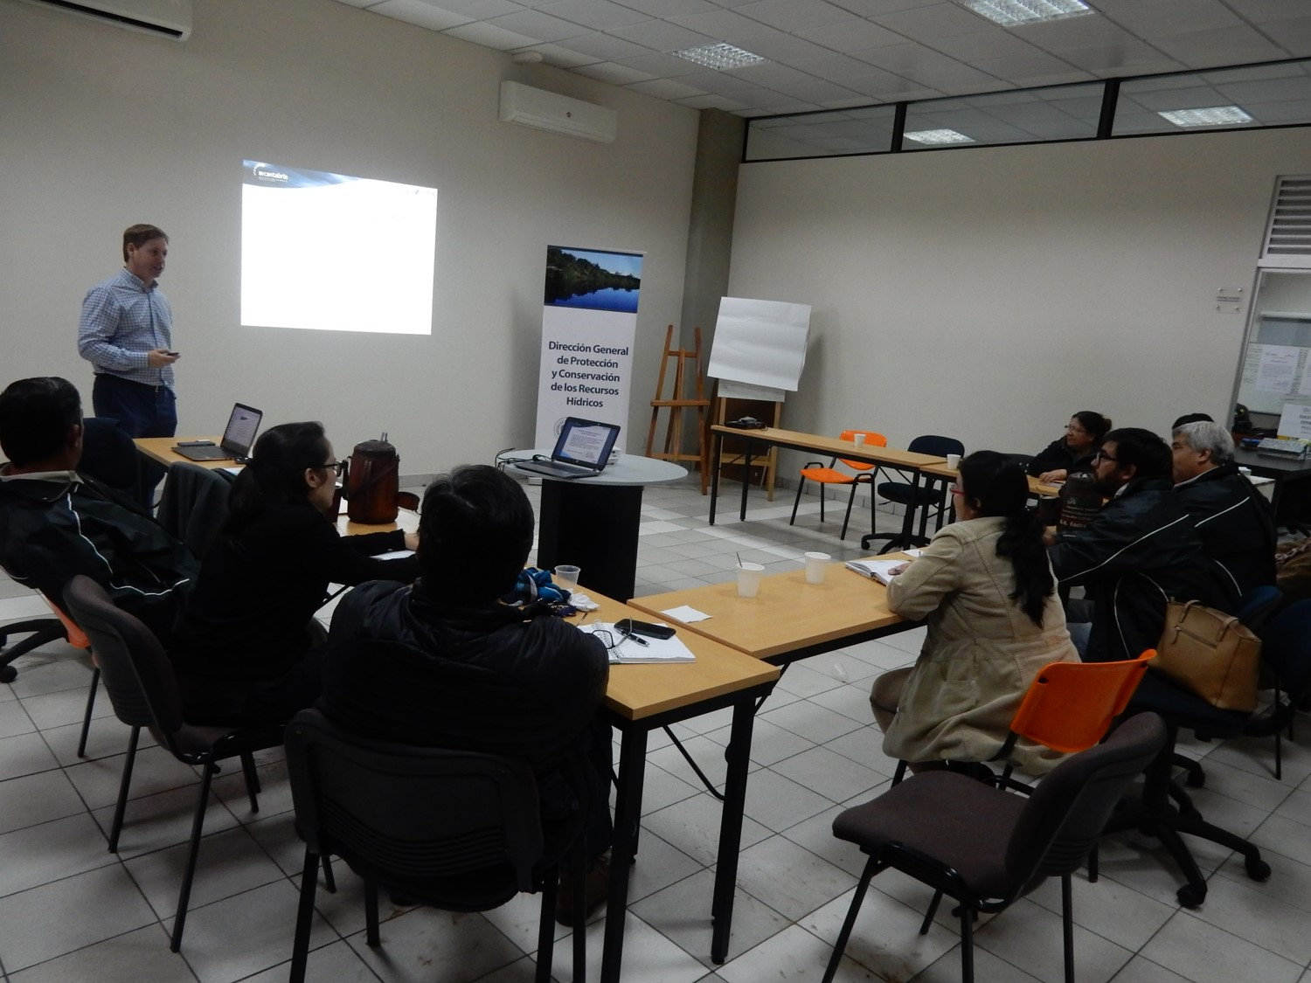
Photograph 1. Workshop mission 2 at SEAM/MADES, Asunción, Paraguay.
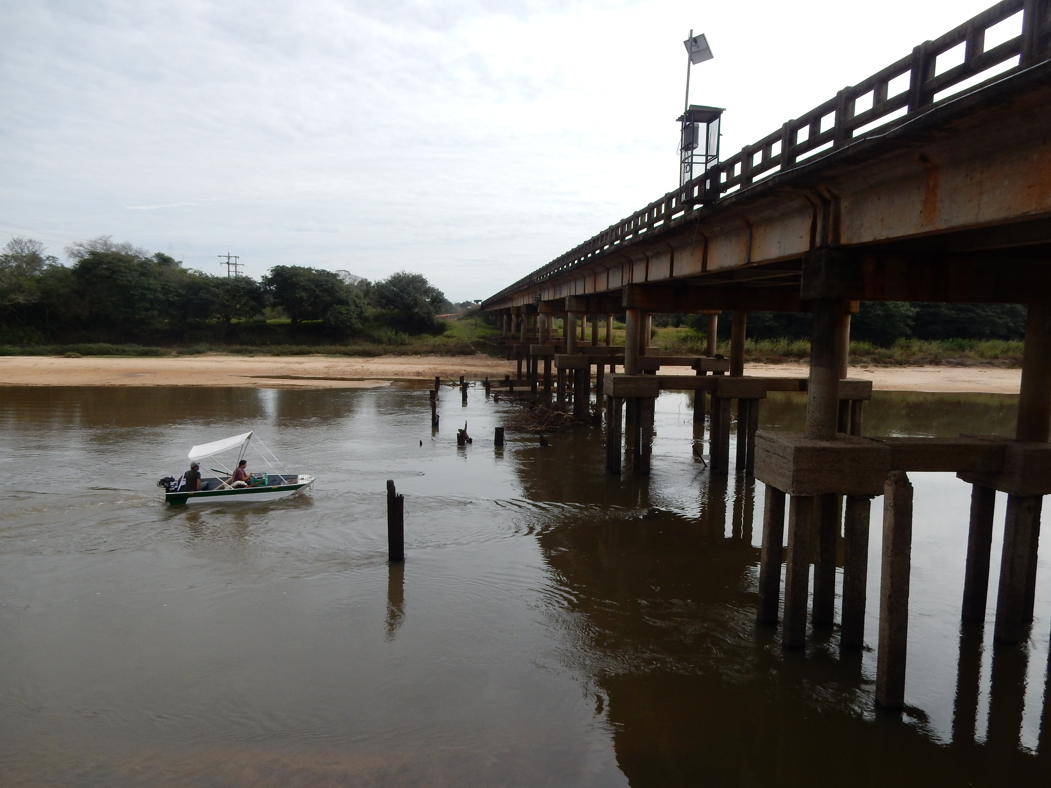
Photograph 2. Field campaign in the Tebicuary River Basin.

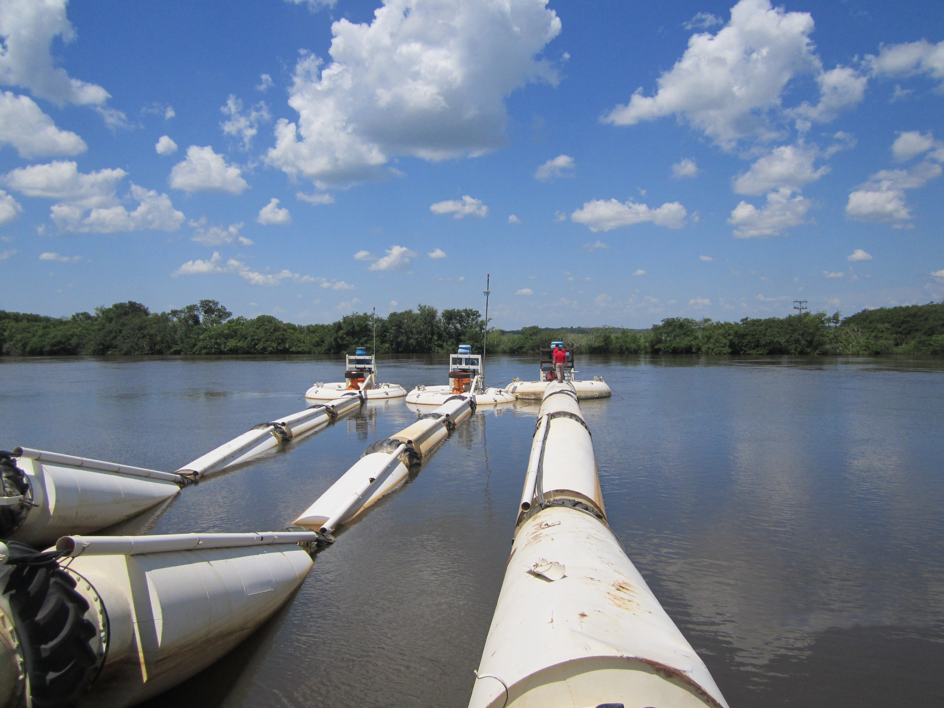
Photograph 3. Water catchment in the Tebicaury river.

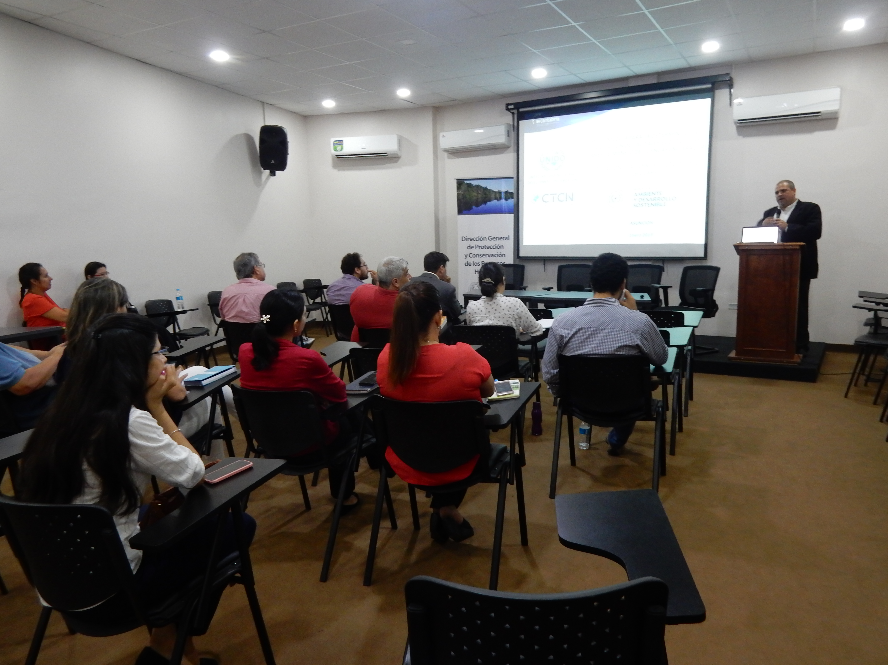
Photograph 4. Presentation of the TA final results by IHCantabria at SEAM/MADES, Asunción, Paraguay. Opening ceremony conducted by David Fariña (MADES).

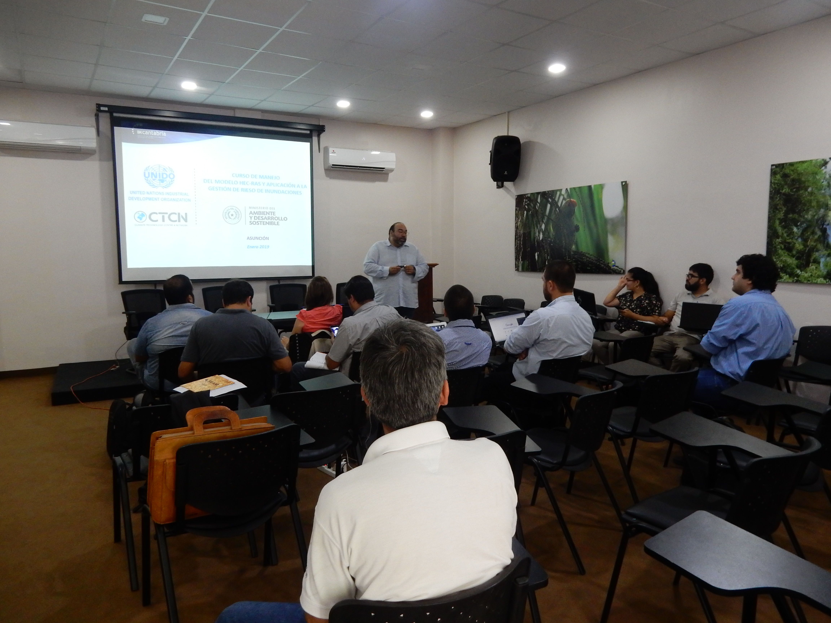
Photograph 5. Training activity of local technicians in the use of the hydraulic model HEC-RAS and its application to flood management.
5. Information for TA Impact Description
The information in the table below will be used to produce the CTCN TA Impact Description. The TA Impact description is a 2-page summary document for communication purposes.
Challenge: Approx. 500 characters with spaces | Paraguay has expressed its interest in reducing the adverse effects of climate change. Paraguay has a high dependence on agricultural activities, which often require abundant water resources. The consumptive water uses (agricultural, urban and industrial) compete with each other at the river basin scale, and with other non-consumptive uses, such as fishing, navigation and energy production.  As a result, the Paraguay river basins are increasingly exposed to problems of water scarcity and water quality. In this context, SEAM/MADES requested assistance from the CTCN to tackle the challenge of enhancing IWRM at river basin levels and defining environmental flows in response to climate change.
CTCN Assistance: 2 to 4 bullet points. Approximately 450 characters with spaces | - Establish an adequate methodology for defining environmental flows in Paraguay at river basin levels.  - Application to the Tebicuary River Basin.  - Establish a methodology to design integrated water resources management plans (IWRM) at river basin levels and its application to the Tebicuary River Basin.  - Carry out training and technology transfer activities in relation to the two previous activities.
Anticipated impact: 2 to 4 bullet points to summarise anticipated impact. Approximately 250 characters with spaces. As a minimum, please include the impacts described in annex 1B as well as other relevant qualitative and quantitative impacts anticipated after completion of CTCN technical assistance. | - Control of flows, water intakes and discharges, which will result in a conserved and resilient environment.  - The sustainability of the water resource, the regulation of water exploitation, and the guarantee of access, use, management, control and enjoyment of resource to the entire population.  - The study of flooding in the Tebicuary river basin will reduce the vulnerability to floods by a 20% (around 112,000 inhabitants).  - In this assistance, these contributions will have a direct impact on the Tebicuary River Basin population (around 560,000 inhabitants), but afterwards the replicability of the tools in other basins will extend these benefits for all the country.
Linkages and contribution to NDC: 2 to 4 bullet points. Approximately 350 characters with spaces | Paraguay has identified water resources, agriculture and territorial planning as one of the nine priority sectors in its NDC. The TA contributes to these sectors in two ways:  - The improvement of decision-making on the use and management of water resources as a result of two key methodological tools: i) methodology for determining environmental flows; and ii) methodology for formulating plans for the use and management of water resources via drainage basins.  - Greater potential for the implementation of the National Policy for Adaptation to Climate Change based on the information that is generated and the territorial prioritization of adaptation measures, starting with the Tebicuary River Basin.
The narrative story: Approximately 1200 characters with spaces | Paraguay has expressed its interest in reducing the adverse effects of climate change. As a landlocked country whose economy is predominantly based on agriculture, Paraguay is highly vulnerable to climate change impacts. Adaptation is an essential part of reducing these negative impacts. However, due to the lack of information and strategies to enhance resilience against climate risk, this country has faced environmental, social, health and economic problems.  This technical assistance focuses on advancing in the field of technical studies, providing methodologies and practical tools to improve the management of watersheds and water resources in Paraguay, in a context of climate change and regional and global socioeconomic transformation.  The application of an EF tool which is designed in consideration with data availability in river basins of Paraguay represents the first phase of this assistance. This tool will assist the authorities to develop IWRM plans with identification of relevant adaptive measures. The Tebicuary River Basin is proposed as an on-the-job training where associated data are used to train stakeholders to understand the EF tool. This river basin is one of the country’s largest basins and faces water management problems caused by all economic sectors and both rural and urban settlements.  The second phase of this assistance is to develop a framework for the formulation of an IWRM plan at river basin levels. The framework will underpin the development of IWRM plan providing the identification and implementation of control measures to adapt to climate change in river basins of Paraguay.
Contribution to SDGs: Always include contribution to SDG 13, and to the extent possible, please include contribution to 2 other SDGs, describing the contribution with a few sentences for each SDG concerned. A complete list of SDGs and their targets is available here: https://sustainabledevelopment.un.org/partnership/register/ | - (SDG 13) The water resource management plans (IWRM) developed based on the ecological flow regimes necessarily incorporate the prognosis and measures to adapt the climate change expected effects on the resource.  - (SDG 6) The establishment of an environmental flows regimen allows to control the river flows, assuring the availability for the priority uses and the efficiency in the resource management.  - (SDG 12) The knowledge of the needs and availability of flows in river basins allows to establish more efficient management policies that ensure productivity and energy savings, decreasing dependence on the resource.
Annex 1 - Standardised CTCN performance indicators for donor and UN reporting

Please add quantitative values and qualitative descriptions for indicators relevant to the particular TA in the tables below. Non-relevant indicators should be left blank.

- Activities and outputs supported by CTCN technical assistance
Please only fill in the table for activities and outputs conducted or produced directly by the CTCN assistance.

CTCN standardised performance indicators | Quantitative value | Qualitative description  List the various elements corresponding to the quantitative value
Overview
- Number of work days of the international expert team spent on the implementation of the technical assistance | 378 | More time than originally planned has been spent on the implementation of this TA due to some additional works that were not contemplated in the response plan.  This works are the development of water management model in the Tebicuary river basin and the flooding hazard study as well in the Tebicuary river basin  Project days were provided by the following people from IHCantabria:  Cesar Álvarez, Team Leader/ Hydrologist/ Hydraulic Engineer  José Barquín, Environmental Flow Expert  Manuel del Jesús, Climate Change Expert  Jorge Rojo, Environmental Engineer  Eduardo Garcia, expert in Advanced Hydrological Modeling  Beatriz Tejerina, Hydrological Engineer  Elsa Cacho, Gender expert
- Number of work days of the locally-contracted expert team spent on the implementation of the technical assistance | 15 | Dr. Ing. Andrés Wehrle, Facultad de Ingeniería de la Universidad Nacional de Asunción (FIUNA)
- Number of external communication and outreach activities conducted to showcase the assistance (news release, newsletters, articles on website, events presenting the results of the technical assistance, social media postings, and presentations at events outside the technical assistance etc.) | 9 | Please list the type of external communications here  1 news page on CTCN website  2 post on Twitter from de IHCantabria  2 news page on the IHCantabria website  1 presentation of the TA results by IHCantabria at SEAM/MADES, Asunción, Paraguay  3 news page on de SEAM/MADES website
Events (other than trainings) held as part of the assistance
- Total number of events other than trainings (Aggregation of numbers in categories below)
- Number of international and multi-country (at regional or sub-regional level) technology and knowledge sharing events
- Number of participants in the events above
- Number of national technology and knowledge sharing events (national events held including national consultations)
- Number of participants in the events above
- Number of public-private events related to technologies
- Number of participants in the events above
Training and capacity building activities conducted during the assistance
- Number of training sessions and capacity strengthening activities | 1 | 4 days training activity of local technicians in the use of the hydraulic model HEC-RAS and its application to flood management
- Number of people who received the training | 16
- Number of men | 12
- Number of women | 4
- Total number of organisations trained | 5
- Number of research organisations, laboratories and universities | 2 | UCA - Universidad Católica e Asunción  FIUNA – Facultad de Ingeniería de la Universidad Nacional de Asunción
- Number of private companies
- Number of cities and local government
- Number of communities
- Number of ministries | 2 | DGPCRH - MADES – Dirección General de Protección y Conservación de los Recursos Hídricos del Ministerio de Ambiente y Desarrollo Sostenible  DAPSAN – MOPC – Dirección de Agua Potable y Saneamiento del Ministerio de Obras Públicas y Comunicación
- Number of specialised governmental institutions
- Number of non-profit organisations | 1 | APRH – Asociación Paraguaya de Recursos Hídricos
- Number of participants that were significantly or moderately satisfied after the training (from CTCN training feedback form). |  | feedback form was prepared after the training in Paraguay. Thus this numbers cannot be reported at this stage. CTCN will try to get an input from NDE in an ex-post evaluation of the TA.
- Number of participants that significantly or moderately increased their capacities thanks to the training (from CTCN training feedback form).
- Number of men
- Number of women
Tools, technical documents and information material supported by the assistance
- Total number of tools, technical documents s and information material supported by the assistance (excluding mission, progress and internal reports) | 17
- Number of tools strengthened, revised or developed (including tools, methodology, software, calculation systems, etc.) | 3 | - An ad hoc model of the Tebicuary river called LEM-DW (Logistic Equilibrium Model with Diffusive Wave) has been built combining aggregate hydrological model (LEM, Prieto et al. 203) with a propagation model based on the diffusive wave equation (Hayami equation, Moussa1996).  - Development of a tool to define the environmental flows in the Tebicuary River. To obtain the environmental flows, a methodology that consists of the application of hydrological methods has been applied. Specifically, the EF in the basin have been obtained as an average of the application of different methods assigning different weights to each method. The selected methods are: the Palau method, average values ​​of annual minimums of the 21 and 25 day moving average, percentiles of 5 and 15% of the cumulative flow curve and flow rate equivalent to 10% of the average annual flow rate.  - Development of a water resources management model for the Tebicuary river basin.
- Number of technical documents strengthened, revised or created | 8 | - Deliverable 2.1: Knowledge development of environmental flows  - Deliverable 2.2: Knowledge development of integrated water resource management (IWRM) in Latin America and the Caribbean  - Deliverable 3.1: Analysis of data availability  - Deliverable 3.2: Determination of a river basin-scaled tool to define EF in Paraguay  - Deliverable 3.3: Field campaigns report  - Deliverable 3.4: Application of the tool to define EF in the Tebicuary River Basin  - Deliverable 4.1: Proposal of a general framework for the IWRM and Adaptation to Climate Change in Paraguay.  - Deliverable 4.2: Guidelines for the development of an IWRM Plan for the Tebicuary river basin (Paraguay).
- Number of other information materials strengthened, revised or created (For example training and workshop reports, Power Points, exercise docs etc.) | 6 | - Report of the training of local technicians in the use of the hydraulic model HEC-RAS and its application to flood management.  - Power points or the training activity (5)  - Model example files for the training activities (3)  - Mission 1 report  - Mission 2 report  - Mission 3 report
Policies, laws and regulations supported by the assistance

- Total number of policies, strategies, plans, laws, agreements or regulations supported by the assistance
- Number of policies, strategies, and plans drafted addressing climate change adaptation
- Number of policies, strategies, and plans drafted addressing climate change mitigation
- Number of documents developed to inform other policies, strategies, and plans on climate change adaptation (sectoral strategies, national development plans, etc.)
- Number of documents developed to inform other policies, strategies, and plans on climate change mitigation (sectoral strategies, national development plans, etc.)
- Number of laws, agreements, or regulations drafted addressing climate change adaptation
- Number of laws, agreements, or regulations drafted addressing climate change mitigation
- Number of documents developed to inform laws, agreements, or regulations on climate change adaptation
- Number of documents developed to inform laws, agreements, or regulations on climate change mitigation
Institutional strengthening supported by the assistance
- Total number of institutional arrangements supported to support climate change planning | 2 | Secretaría del Ambiente (SEAM)/ Ministerio de Ambiente y Desarrollo Sostenible (MADES)  MOPC –Ministerio de Obras Públicas y Comunicación
- Number of organisations with increased awareness and knowledge among countries to better own and drive national adaptation planning processes
- Number of organisations with increased awareness and knowledge among countries to better own and drive national mitigation planning processes
Partnerships and cooperation
- Number of private companies directly engaged in the assistance (that partnered with the proponent, the beneficiaries or the CTCN to implement the assistance) (Excluding the role of the CTCN and TA implementers)
- Number of South-South collaborations enabled during or through the assistance, when stakeholders from other countries were involved in the assistance (Excluding the role of the CTCN and TA implementers)
- Number of North-South collaborations enabled during or through the assistance, when stakeholders from other countries were involved in the assistance (Excluding the role of the CTCN and TA implementers)
- Number of Triangular collaborations enabled during or through the assistance, when stakeholders from other countries were involved in the assistance (Excluding the role of the CTCN and TA implementers)
UNFCCC planning/support processes
- Number of National Adaptation Plans (NAPs) developed as part of the technical assistance
- Number of Nationally Appropriate Mitigation Actions (NAMA) developed as part of the technical assistance
- Number of Technology Needs Assessment s(TNAs) developed as part of the technical assistance

B. Impacts anticipated after completion of CTCN technical assistance: core indicators

Every technical assistance should contribute to at least one indicator below.

CTCN core indicators | Quantitative value | Unit | Methodology  Explain the method or process of verifying the indicator and how data was gathered | Assumptions  Indicate assumptions made during quantification | Expected timeline  Indicate when the indicator and value are expected to be achieved
- Total anticipated amount of funding/investment mobilised (in USD) as a result of the TA
- Anticipated amount of public funding mobilised (in USD) from national sources as a result of the TA
- Anticipated amount of public funding mobilized (in USD) from international and regional sources as a result of the TA
- Anticipated amount of private investment mobilised (in USD) from national sources as a result of the TA
- Anticipated amount of private investment mobilised (in USD) from international and regional sources as a result of the TA
- Anticipated number of beneficiaries as a result of a mitigation TA
- Anticipated number of people with increased resilience as co-benefits as a result of the TA | 560,000 | persons | Methodological framework  Recommendations for the management plan | This estimation assumes that the total population in the Tebicuary river basin obtain benefits from a better IWRM promoted in this TA. | Ministerio de Ambiente y Desarrollo Sostenible (MADES)
- Anticipated average the total GHG reductions in metric tons of CO_{2-e}, as a result of the TA
- Anticipated average annual GHG reductions in metric tons of CO_{2-e}, as a result of the TA
- Anticipated and projected greenhouse gas emissions reduced or avoided through 2030, in metric tons of CO_{2-e}, from adopted laws, policies, regulations, or technologies related to clean energy/sustainable landscapes as a result of the TA

C. Outputs and impacts anticipated after completion of CTCN technical assistance: standardised performance indicators

CTCN standardised performance indicators | Quantitative value  Insert the request value and unit | Content  List the elements included in the number provided | Expected timeline  Indicate when the indicator and value are expected to be achieved | Responsible institution  Indicate the institution(s) that will play leading role(s) in enabling the indicators and anticipated values to be achieved
- Anticipated number of policies, strategies, plans, addressing climate change mitigation officially proposed, adopted, or implemented as a result of the TA
- Anticipated number of policies, strategies, plans, addressing climate change adaptation officially proposed, adopted, or implemented as a result of the TA. | 9 | This TA will contribute to the updating and improvement of the following documents:  Ley N° 3239/2007 de los Recursos Hídricos del Paraguay.  Política Nacional de Cambio Climático (2012)  Informes técnicos de relativos a la suspensión de detracciones de agua en el río Tebicuary en 2012 (resolución SEAM nº1785/12)  Plan Nacional de Desarrollo de Paraguay 2014-2030  Plan Nacional de Cambio Climático (2014)  Estrategia Nacional de Adaptación al Cambio Climático (2015)  Evaluación de la vulnerabilidad ante el cambio climático del sector recursos hídricos. SEAM (2016).  Ley Nº 5875 Nacional de Cambio Climático (2017)  Diseño del Plan Nacional de Adaptación al Cambio Climático.  Informe Final. SEAM (2017).  Guía para la elaboración de planes sectoriales de adaptación para el cambio climático. Documento orientador. SEAM (2017). | Technical reports and regulations Short-term <1 year  Modifications of laws, policies and national plans Medium term  < 3 years | Ministerio de Ambiente y Desarrollo Sostenible (MADES)
- Anticipated number of policies, strategies, plans, addressing climate change on both adaptation and mitigation officially proposed, adopted, or implemented as a result of the TA
- Anticipated number of laws or regulations addressing climate change mitigation officially proposed, adopted, or implemented as a result of the TA.
- Anticipated number of laws or regulations addressing climate change adaptation officially proposed, adopted, or implemented as a result of the TA.
- Anticipated number of laws or regulations addressing climate change both adaptation and mitigation officially proposed, adopted, or implemented as a result of the TA
- Anticipated number of public-private partnerships and collaboration created (Excluding the role of the CTCN and TA implementers)
- Anticipated twinning arrangements created as a result of the TA
- Anticipated number of technology projects to support action on low emission and climate-resilient development
- Anticipated number of strengthened National Systems of Innovation and technology innovation centres in recipient country
- Anticipated Clean Energy Generation Capacity in kWh
supported by the TA
- Anticipated technology types effectively deployed in the country | 14 | Early Warning and Environmental Assessment: Hazard mapping  - Flood hazard mapping  Water: Adaptation planning  - National Plan  - National adaptation programmes of action  - Stakeholders consultation  - Open source climate data and tools  - Climate change vulnerability assessment  - Downscaling of climate model projections  Water: Riverine flood projection  - Floodplain zoning  Water: Integrated planning  - Basin level planning  - Integrated Water Resource Management  - Hydrological modelling  Water: Water allocation  - Seasonal water restrictions  - Basin level modeling for water allocation  - Water reallocation | Medium term within 3-5 years | Ministerio de Ambiente y Desarrollo Sostenible (MADES)
- Anticipated UNFCCC processes implemented as a result of the TA (NAMA, NAPA, NDC, etc.)
- Anticipated Technology Needs Assessments (TNA) and technology Action Plans (TAP) as a result of the TA
- Anticipated cooperative research, development and demonstration programmes within and between developed and developing country Parties facilitated as a result of the TA
- Anticipated improved climate change observation systems and related information management in developing country Parties.

