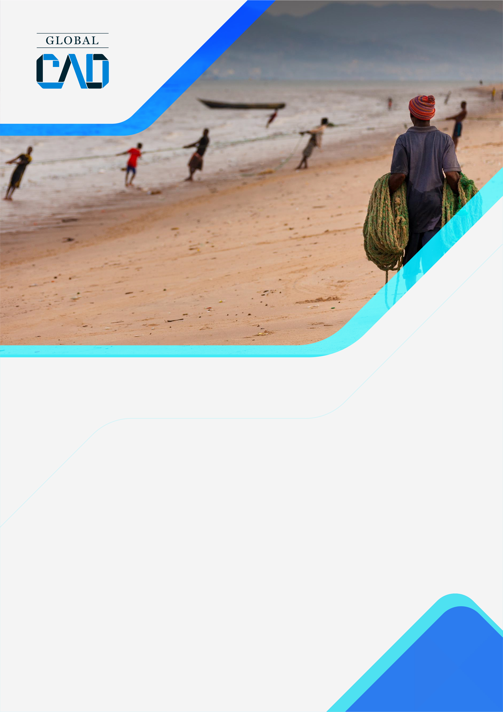
  - 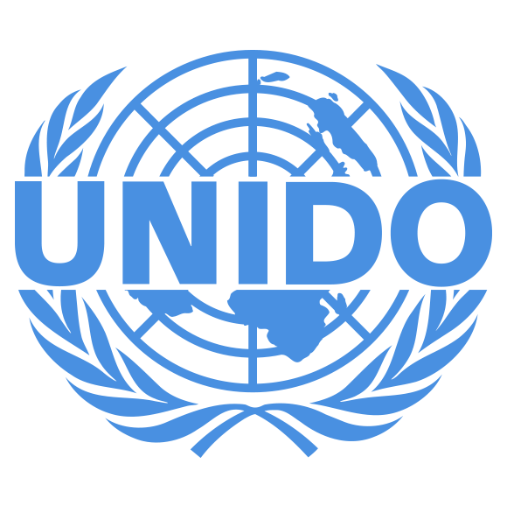
  - United Nations Industrial Development Organization

27/02/2019

CONTACT:
  - Fernando Casado Cañeque
Director
Fcasado@globalcad.org

Deliverable 1.3.
  - Assessment of Coastal Hazards and Climate Change Adaptation Technologies for the Coastal Region of West Africa and Cameroon Using the Coastal Hazard Wheel (CHW)
globalcad.org

Activity 1.3. CTCN impact description (intern) (Deliverable D 1.3.)

Challenge | The West African littoral, as well as Cameroon are among the most vulnerable regions of the world to the effects of climate change, coastal erosion and sea level rise, especially in a context of growing coastal urban concentrations and associated issues.  Identifying climate-related risks on the West African and Cameroonian littorals is therefore crucial to manage potential risks. However, there is no harmonized method at the West African and Cameroonian littoral level to identify, characterize and manage coastal risks and plan the implementation of adaptation technologies.  In this context WACOM and the National Designated Entities (NDEs) of the 9 countries request the assistance of the CTCN to strengthen their regional and national capacities to establish a robust diagnosis of multiple coastal risks and to identify technological adaptation options. The Coastal Hazard Wheel (CHW) was identified as the most relevant tool in the context of the West African and Cameroonian littoral.
CTCN Assistance | - Conduct a comprehensive assessment and analysis of data available at national and regional level and of their integration into the CHW system;  - Train the experts of the national antennas and the regional coordination unit of WACOM and other relevant researchers on the data management available in the CHW system for the mapping of risks and adaptation options;  - Identify, evaluate and formulate a series of recommendations for appropriate technological options to be implemented for the sustainable management of the main coastal risks.
Anticipated impact | - Through the Coastal Hazard Wheel (CHW) tool, the capacities and skills of the national branches of WACOM and its regional coordination unit as well as those of the Cameroon technical team are reinforced for better typology and assessment of coastal risks and appropriate technological options and their systematic integration into the national and regional planning policies of the West African and Cameroonian littoral  - Number of people with increased capacity to adapt to the impacts of climate variability and change:  - 11 experts 7 national branches of WACOM and its regional coordination unit and Cameroon Technical team  - 135 experts from National offices and Regional Office and Cameroon Technical team
Linkages and contribution to NDC | The technical assistance contributes to the needs in adaptation efforts in the following key aspects:  - Technology Development and Transfer  - Institutional strengthening through capacity building  Therefore contributing to:  - Early warning and disaster prevention  - Resilience for gender and the vulnerable
The narrative story | Climate change is producing major challenges in coastal areas of the West African and Cameroonian regions. In fact, different coastal hazards are undermining economic dynamics on the region coastal areas, and the adaptation attempts are creating social and economic tensions. In order to face these numerous challenges, West African countries had established a coastal coordination mechanism known as “West African Coastal Observation Mission” (WACOM), which aims to coordinate and implement regional coastal hazard management activities.  In order to complete and improve this mission, the CTCN Technical assistance is expecting to create a consistent system for managing key coastal hazards, improve regional coastal coordination and decision-base for national and regional adaptation activities, and continuously improve the data and facilitation data system.
Contribution to SDGs | - SDG13 - The Technical Assistance will enable West Africa and Cameroon to integrate climate change considerations and adaptation measures and to improve the resilience of ecosystems reducing coastal hazards and their impacts.  - SDG14 – The Technical assistance will provide corresponding data in order to improve resilience in coastal zones in order to address vulnerabilities to coastal hazards.  - SDG17 – The Technical assistance will enhance cooperation between countries of the region, as well as, improving data sharing and management through multiple trainings.

