Closure and Data Collection Report for CTCN Fast Technical Assistance

- Basic information
Title | Support to project proposal drafting on resiliency of productive landscapes and ecosystems in the Dominican Caribbean Corridor
Country / countries | Dominican Republic
NDE focal point and organization | Pedro García, Climate Change Director, MARN  pedro.garcia@ambiente.gob.do
Proponent focal point and organization | Mamerto Valerio, ENDA-Dominicana  direccion@endadom.org.do
Sector(s) addressed | Agriculture, Forestry, Livestock, Rural Development, Agroturism, Governance and Policy interaction.
Technologies supported | Adaptation planning, climate change vulnerability assessment, ecosystem restoration and conservation plans, water resource assessment, integrated water resources management, stakeholder consultation.
Implementation period and total duration | May to September 2018 (5 months)
Total budget for implementation | The total budget financed through CTCN was US$ 10.000, in technical assistance, including US$3.000 for travel expenditures for a mission to Dominican Republic and US$ 1,000 for the preparation of this closure report.  All the institutions involved (CATIE as implementor of technical assistance and local counterparts as proponents) invested additional resources, both in kind and in funds, for the fulfilment of this technical assistance.  CATIE invested an additional amount of approximately US$ 36000 corresponding to its international staff and local representative. The consultant and additional CATIE staff ensured the active participation of the NDE and other key stakeholders, organized the appraisal mission, and kept in touch with and integrated inputs and feedback from local counterparts throughout the technical assistance period.  Dominican counterparts (mainly ENDA-Dominicana, IDDI and ProNatura) also contributed with staff time during the technical mission, coordination meetings, and supporting the technical assistance progress (e.g. providing specific information of project areas), to an approximate amount of US$ 9400.
Implementer of response plan | CATIE

2. Summary of all activities, outputs and products that contribute to the expected impact of the technical assistance.
Description of delivered outputs and products as well as the activities undertaken to achieve them. In doing so, review the log frame of the original Response Plan and refer to it as appropriate. | As part of the TA, we developed a preliminary project outline (product 1) and a response plan (product 2) to answer the technical assistance request submitted to the CTCN. The preliminary project outline comprises i) a justification of the project (Activity 1.1) based on current challenges and future threats; ii) a draft project baseline including information on policies, plans and programmes that are active in the country, highlighting opportunities for synergies and coordination (Activity 1.2); iii) and initial version of the draft logical framework to summarize the project outcomes, outputs and activities (Activity 1.3); and iv) a description of proposed activities and interventions needed to address identified problems, including the barriers to their implementation (Activity 1.4).  The response plan is meant to identify feasibility studies and baseline analysis necessary to develop the substantive conceptual design of the project concept. It is comprised of background information, logical framework, description of resources and budget required to achieve the proposed outputs and links to country development (contribution to NDCs, sustainable goals, ongoing efforts, gender inclusion and co-benefits) (Activity 2.1).  Consultations with local partners, field visits, focal groups, and data gathering and synthesis were additional activities conducted to achieve the activities and products indicated above.
Partners organizations | Enda-Dominicana, IDDI, Pro Natura
Beneficiaries | DR Government, Ministry of Environment and Natural Resource, Partner organizations.
Methodologies applied to produce outputs and products | Coordination meetings with government representatives and partner organizations.  Field visits, unstructured interviews, and focal groups with local actors.  Participatory assessments and consultations with key stakeholders, including representatives from academia, civil organizations, NGOs, etc.  Mapping of actors, ongoing projects and initiatives, plus policies related to project theme.  Review, analysis and evaluation of existing information regarding the status and challenges in the project’s potential implementation areas, land use planning, natural resources management and climate projections.  Processing of secondary information (literature, databases, shapefiles, etc.).  Estimation of beneficiaries, selection of priority areas and productive systems relevant for strengthening resilient livelihoods in the project area.  Brainstorming of potential adaptation strategies to be included in a project proposal, discussion of methodologies and expected outputs to achieve.
Deviations | The implementation period was extended from the initial plan by 3 months because of challenges in obtaining, processing, and synthesizing primary and secondary information from the Dominican Government, local partners and international experts. There are not any additional deviations.
Achieved or anticipated gender benefits from the TA | Gender aspects have been included in the preliminary project outline and response plan, aiming to include women in the participatory design of the GCF final proposal and integrate them as direct beneficiaries to ensure their active participation in adaptation and mitigation actions.  Some of the actions considered were inclusion of women in local governance and decision making, strengthening of technical capacities and access to markets and business opportunities.  It is expected that greater inclusion, gender sensitization, and affirmative actions will result from this technical assistance to empower women into taking greater leadership roles in their communities.
Achieved or anticipated co-benefits from the TA | TA inputs can be included into national planning baselines and used to support additional government proposals and the implementation of climate resilient policies.  Potentially, the TA will raise awareness about the contribution of  sustainable landscape practices and resilient restoration to mitigation of greenhouse gases, improvement of water balance, livelihoods and growth opportunities for rural communities is expected from the implementation of proposed adaptation practices such as agroforestry systems, land planning and sustainable management of watersheds.
Anticipated follow up activities and next steps | TA inputs will be used to prepare and submit the Resiliency of productive landscapes and ecosystems in the Dominican Caribbean Corridor concept note to the GCF.  In addition, it will enable proponents to engage public and private institutions, and participatory design of project actions, outcomes and overall impact, and to align those actions with national priorities and current actions to enhance the involvement of relevant actors and synergies in promoting climate resilience across a vulnerable area of the country.  Work on ensure the participation of key stakeholders and subject the project concept to public consultation, favouring its acceptance and the enrichment of the future full proposal.

- Lessons learnt
 | Lessons learnt | Recommendations
Lessons learnt in the area of the TA | Inputs requested from local partners tend to take longer than expected despite the stated interest of local stakeholders in the process. | It is necessary that all parties are familiar with the process, schedule and requirements to streamline the TA. To this end, both the entity requesting the TA and the NDE must be actively involved to provide the inputs required by the technical team in the shortest time possible. TA implementers should make an effort to collect local information during field missions and not rely on commitments made to share such information via e-mail or other electronic means later on.
Lessons learnt related to climate technology transfer | We found that some actors do not perceive climate change as a concern, which constitutes a barrier to the implementation of participatory approaches. There are also cultural barriers, and little understanding between the private sector and the government.  The involvement of government actors is hampered by changes in government and changes in the direction of environmental and productive policies. | Actions to tackle climate change should not be separated from efforts for sustainable development. It is important that national and local stakeholders understand that both aspects are addressed together. In addition, it is necessary to raise awareness among stakeholders (from local platforms to ministry officials) about the expected consequences of climate change in the coming decades. A solid reading of government policies and dynamics can aid in ensuring country buy-in of the TA process and follow-up activities.
Lessons learnt related the CTCN process for TA | It is very useful to work on both the preliminary project outline and response plan in parallel since the response plan format keeps you focused on the relevance and contribution of the proposed actions for the country. | Gender and other co-benefits could be separated in the form because gender issues monopolize most of this section, and there are other co-benefits as relevant as gender that may be glazed over because of this.  Resources required, and itemized budget form can be improved.

4. Illustration of the TA and photos

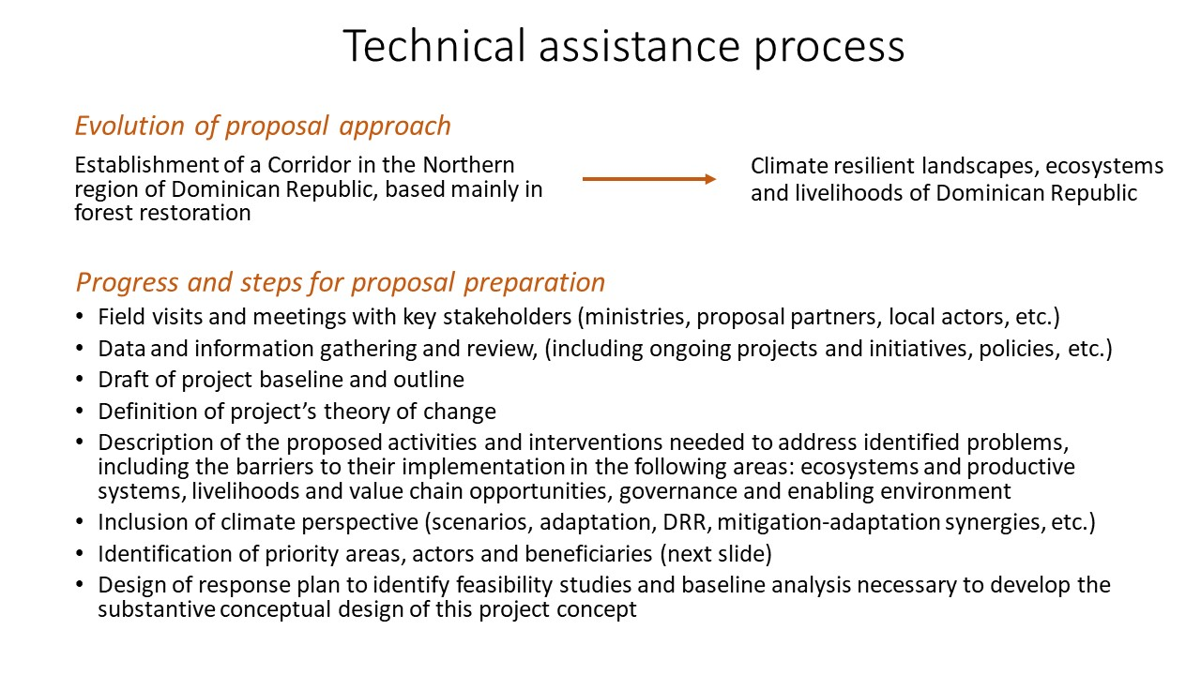
Figure 1. Summary of the technical assistance process supporting the drafting of a project proposal on resiliency of productive landscapes and ecosystems in the Dominican Caribbean Corridor

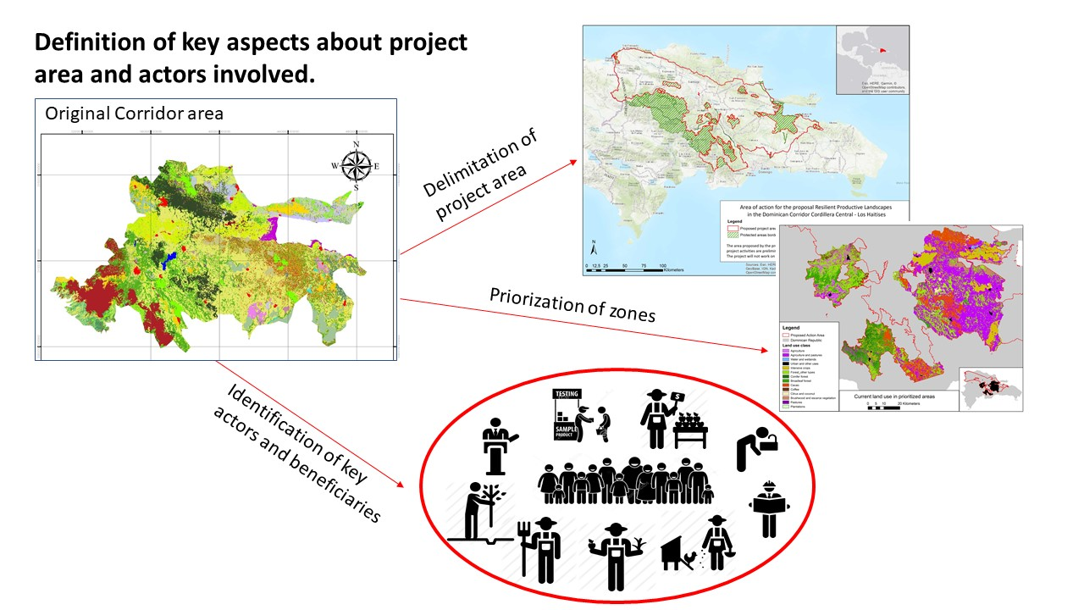
Figure 2. Detailed delimitation of project area, priority zones, local actors and beneficiaries resulting from this CTCN technical assistance.

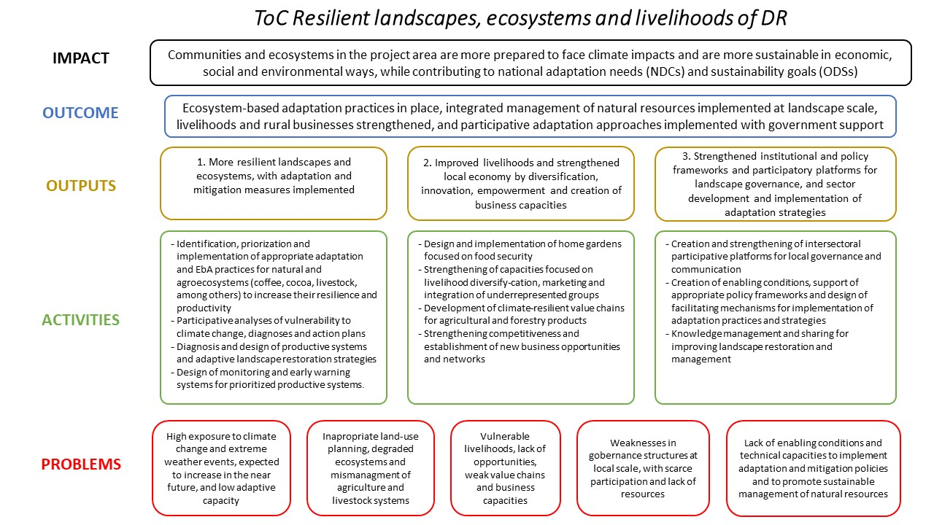
Figure 3. Proposed theory of change (ToC) for a Green Climate Fund project proposal on resiliency of productive landscapes and ecosystems in the Dominican Caribbean Corridor.

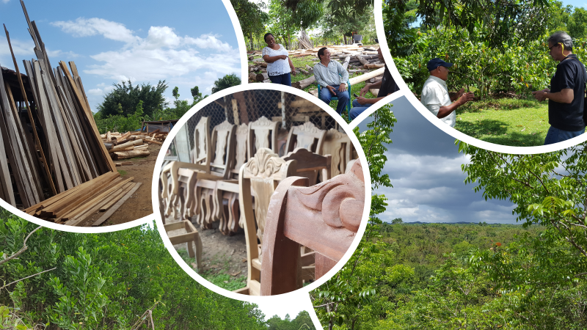
Figure 4. Pictures of field visits in Dominican Republic, including view of Los Haitises National Park, sustainable use of forest resources, natural sprouting of Acacia mangium and consultations with local actors about management of forest and agroforest systems.

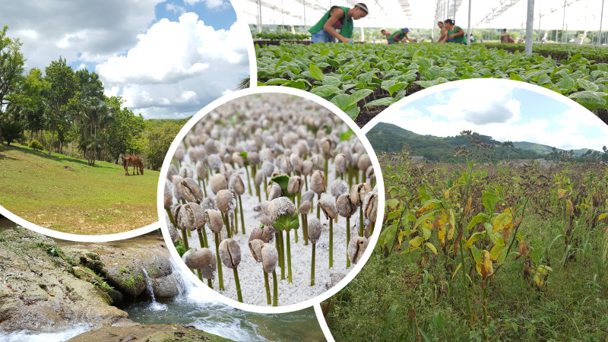
Figure 5. Pictures of field visits in Dominican Republic showing water resources, degradation of pastures, traditional annual crops (tobacco) and use of technology for recuperation of forest cover and coffee production.

5. Information for TA impact description (for public use)

Challenge | DR has low resilience to the effects of climate change and adverse climate events. Climate hazards and climatic variations exacerbate the on-going degradation of productive landscapes, ecosystems and the hydrological network. The DR government needs specific knowledge and technologies for managing landscapes, ecosystems and hydrological networks, strengthening local markets, creating opportunities for rural communities and comprehensive policy frameworks, regulations and strong governance platforms.
CTCN Assistance | - Provided technical inputs regarding status, environmental, productive and socio-economic aspects and promissory practices and adaptation strategies for designing climate resilient production models and landscape management practices.  - Built a response plan that includes technical information, consultation and validation processes required for preparing a full project proposal for the Green Climate Fund.
Anticipated impact | - Build resilience to climate change and increase carbon abatement in DR.  - Provide inputs to local government and enable the preparation of a concept note based on GCF criteria.  - Leverage financing of up to USD 50 million with the submission of Resiliency of productive landscapes and ecosystems in the Dominican Caribbean Corridor concept note to the GCF  - Directly impact >47,800 families in the project area, 20,000 ha of agronomic systems and secondary forests and indirectly improve livelihoods of nearly 4.5 million.
Linkages and contribution to NDC | - TA advances NDC goals and other country priorities and commitments ,,,.  - Product 1 will help the government define the appropriate actions to promote, guidelines and mechanisms needed, and contribute to achieve adaptation and mitigation goals.  - TA is expected to contribute to the four strategic axes defined in the National Development Strategy (2010-2030).
The narrative story | Dominican Republic’s Ministry of Environment and Natural Resources requested CTCN assistance to address the country’s climatic, economic and degradation challenges that compromises the resilience and well-being of population and landscapes. The resulting CTCN assistance contributes to building resilience to climate change and increasing carbon abatement in the project area by providing inputs to develop a project idea to request GCF funding.  This technical assistance transformed the initial idea of a conservation corridor into a preliminary project proposal to achieve sustainable and resilient landscapes development, while improving management of eco and agroecosystems, water resources and rural livelihoods, strengthening local capacities and governance and ensuring the engagement of public and private institutions. Inputs are available to be included into national planning baselines to support the implementation of climate resilient projects and policies.  The CTCN assistance supports the achievement of adaptation and mitigation goals identified in DR’s NDC as well as SDGs and other country priorities and commitments.
Contribution to SDGs | SDG 6: TA contributes by promoting a landscape approach for land and water management and proposing alternatives for their improvement.  SDG 13: TA facilitates urgent action against climate change in Dominican Republic, by suggesting actions and methodologies to improve the resilience of ecosystems, including adaptation needs in the decision-making processes and strengthening capacities of different groups. In particular, TA identifies the best strategies to strengthen resilience and adaptive capacity across vulnerable landscapes and populations.  SDG 15: TA provides a baseline of ecosystems use and needs, and suggested a series of strategies focused on protecting, restoring and sustainably managing these natural resources while contributing to local communities’ well-being and improved resilience.
Annex 1 (for internal use in donor and UN reporting)

A. Standardised CTCN performance indicators for donor and UN internal reporting

CTCN standardised performance indicators | Quantitative value | Qualitative description  List the various elements corresponding to the quantitative value
- Overview
Number of active person-days (not full duration) of assistance provided to counterparts or stakeholders by international experts and consultants | 88 | This estimate includes 60 days for in-kind contribution of CATIE’s international staff for TA preparation, communication with partners and government representatives, plus local stakeholders and consultants; plus 28 days of a consultant paid by CTCN.
Number of active person-days (not full duration) of assistance provided to counterparts or stakeholders by national experts and consultants | 24 | This includes 10 days of CATIE’s representative in Dominican Republic helping coordinate and participating in meetings with local partners and government and following up the progress of TA; plus 14 days by consortium members dedicated to the field mission, information, data, and map preparation.
Number of external communication and outreach activities conducted to showcase the assistance (news release, newsletters, articles on website, etc.) | 0
- Events (other than trainings) held as part of the assistance
Number of international and multi-country (at regional or sub-regional level) technology and knowledge sharing events | 0
Number of participants in the events above | NA
Number of national technology and knowledge sharing events | 0
Number of participants in the events above | NA
Number of public-private events related to technologies | NA
Number of participants in the events above | NA
- Training and capacity building activities conducted during the assistance
Number of training sessions and capacity strengthening activities | 0
Number of people who received the training | NA
Number of men | NA
Number of women | NA
Total number of organizations trained | NA
Number of research organizations, laboratories and universities | NA
Number of private companies | NA
Number of cities and local government | NA
Number of communities | NA
Number of ministries | NA
Number of specialized governmental institutions | NA
Number of non-profit organizations | NA
Level of satisfaction of participants after the training (from training feedback form).  From very satisfied, satisfied, not really satisfied, not satisfied at all | NA
Percentage of participants that increased their capacities thanks to the training (from training feedback form)  From significantly, very, moderately, to none | NA
Percentage of men | NA
Percentage of women | NA
- Tools, technical reports and information material supported by the assistance
Total number of tools, technical reports and information material supported by the assistance (excluding mission, progress and internal reports) | 7
Number of tools strengthened, revised or developed
Number of technical reports strengthened, revised or created | 1 | Preliminary project outline
Number of other information materials strengthened, revised or created | 6 | Maps and other spatially explicit information gathered and synthesized (but not officially published or shared outside the TA process).
- Policies, laws and regulations supported by the assistance
Number of policies, strategies, and plans drafted addressing climate change adaptation
Number of policies, strategies, and plans drafted addressing climate change mitigation
Number of documents developed to inform other policies, strategies, and plans on climate change adaptation (sectoral strategies, national development plans, etc.)
Number of documents developed to inform other policies, strategies, and plans on climate change mitigation (sectoral strategies, national development plans, etc.)
Number of laws, agreements, or regulations drafted addressing climate change adaptation
Number of laws, agreements, or regulations drafted addressing climate change mitigation
Number of documents developed to inform laws, agreements, or regulations on climate change adaptation
Number of documents developed to inform laws, agreements, or regulations on climate change mitigation
- Institutional strengthening supported by the assistance
Number of institutional arrangements in place to coordinate near and long-term national adaptation plans (NAPs)
Number of organizations with increased technical capacity to advance near and long term national adaptation plans (NAPs) which integrate EbA
Number of organizations with increase awareness and knowledge among countries to better own and drive national adaptation planning processes
- Partnerships and cooperation
Number of private companies directly engaged in the assistance (that partnered with the proponent, the beneficiaries or the CTCN to implement the assistance)
Number of South-South collaboration enabled during or through the assistance, when stakeholders from other countries were involved in the assistance
Number of North-South collaboration enabled during or through the assistance, when stakeholders from other countries were involved in the assistance
Number of Triangular collaboration enabled during or through the assistance, when stakeholders from other countries were involved in the assistance

B. Indicators of anticipated impacts that may occur after the TA is completed
CTCN standardised performance indicators | Quantitative value | Content | Expected timeline | Responsible institution
16. Anticipated finance mobilised
- Anticipated amount of public/donor investment mobilized (in USD) from the beneficiary country for climate change activities as a result of the TA | USD 25 million | Matching funds (50% of a USD 50 million initiative). Could be partially covered with private funds. El GoDR y los socios (ONGs locales ENDA-Dominicana (solicitante de la asistencia técnica), IDDI y ProNatura) tienen presente y están comprometidos con el monto de contrapartida total de los $25M | 2020 | Climate Change Directorate, Ministry of the Environment and Natural Resources
- Anticipated amount of public/donor investment mobilized (in USD) from international and regional sources for climate change activities as a result of the TA | USD 25 million  (First step of a GCF proposal) | GCF  (50% of a USD 50 million initiative) | 2020 | Climate Change Directorate, Ministry of the Environment and Natural Resources
- Anticipated amount of private investment mobilized (in USD) from the beneficiary country for climate change activities as a result of the TA. | See 16.a. | See 16.a.
- Anticipated amount of private investment mobilized (in USD) from international and regional sources for climate change activities as a result of the TA.
17. Policies
- Anticipated number of policies, strategies, plans, addressing climate change mitigation officially proposed, adopted, or implemented as a result of the TA.
Anticipated number of policies, strategies, plans, addressing climate change adaptation officially proposed, adopted, or implemented as a result of the TA. | 4 | Adaptation strategies for productive systems considering climate challenges will be proposed.
- Anticipated number of laws, agreements, or regulations addressing climate change mitigation officially proposed, adopted, or implemented as a result of the TA.
Anticipated number of laws, agreements, or regulations addressing climate change adaptation officially proposed, adopted, or implemented as a result of the TA. | 4 | Actions will include prioritized productive activities as well as water management and value chains, including water regulation and the design of incentives and PES schemes.
- Anticipated laws, policies, regulations, strategies and plans where climate change mitigation will be mainstreamed as a result of the TA
Anticipated laws, policies, regulations, strategies and plans where climate change adaptation will be mainstreamed as a result of the TA | 5 | Specific mainstreaming regarding prioritized systems and landscape approach, that will include mitigation as co-benefit. The TA will contribute to NAMA initiatives in the livestock and cocoa sectors, and sectorial adaptation plans.
18. Anticipated number of public-private partnerships created | 8 | Public and private stakeholders will be involved in the preparation of the full proposal; partnerships are expected as a result of the GCF project implementation. We expect public private partnerships between municipalities and the forestry chamber, INDRHI and forest owners, nurseries and government or other public institutions, farmers associations and academia and rural business and public institutions, among others. | 2026
19. Anticipated twinning arrangements created as a result of the TA
20. Anticipated number of technology projects prepared and implemented to support action on low emission and climate-resilient development | 1 | GCF project | 2026
21. Anticipated strengthened National Systems of Innovation and technology innovation centres in CTCN recipient country. | 3 | Early Warning Systems for two prioritized productive systems, and Flood Risk Management System | 2026
22. Anticipated Clean Energy Generation Capacity
Clean supported by the TA that has achieved financial closure
23. Anticipated and projected GHG reductions
Quantity of greenhouse gas (GHG) emissions, measured in metric tons of CO2e, anticipated to be reduced or sequestered as a result of projects supported by the TA.
10. Clean Energy Generation Capacity
Clean energy generation capacity supported by the TA that has achieved financial closure.
24. Anticipated and projected GHG reductions to 2030
Projected greenhouse gas emissions reduced or avoided through 2030, in metric tons of CO2e, from adopted laws, policies, regulations, or technologies related to clean energy/sustainable landscapes as a result of the TA.
25. Anticipated co-benefits  Number of people receiving livelihood co-benefits as a result of the TA. | 160000 | The project will directly impact 160,000 people in the project area, by the implementation of activities on 20 prioritized municipalities where we found 44,500 farmers, farmers associations and small companies registered, and their families.  Indirectly, the project will improve livelihoods of nearly 4.5 million in the GCF proposal, considering water users in the watersheds where project will have an impact. | 2026
26. Anticipated technology types effectively deployed in the country | 8 | Coordination meetings, field visits, unstructured interviews, and focal groups.  Participatory assessments with key stakeholders.  Mapping of actors, ongoing projects and policies.  Review, analysis and evaluation of existing information  Estimation of beneficiaries, selection of priority areas and productive systems.  According to CTCN Taxonomy, the types of technologies supported: Adaptation planning, climate change vulnerability assessment, ecosystem restoration and conservation plans, water resource assessment, integrated water resources management, stakeholder consultation
27. Anticipated UNFCCC processes implemented as a result of the TA (NAMA, NAPA, NDC, etc.)
28. Anticipated Technology Needs Assessments (TNA) and technology Action Plans (TAP) as a result of the TA
29. Anticipated cooperative research, development and demonstration programmes within and between developed and developing country Parties facilitated as a result of the TA
30. Anticipated improved climate change observation systems and related information management in developing country Parties.

Intended Nationally Determined Contribution of the Dominican Republic (INDC-DR). http://www4.unfccc.int/submissions/INDC/Published%20Documents/Dominican%20Republic/1/INDC-DR%20August%202015%20(unofficial%20translation).pdf#page=3
https://cambioclimatico.gob.do/download/tercera-comunicacion-nacional-pdf/
http://blogs.worldwatch.org/revolt/wp-content/uploads/2011/09/DR-ClimateCompatibleDevPlan-Sep-2011.pdf
http://www.fundacionplenitud.org/files/PNACC.pdf.
https://www.unicef.org/republicadominicana/Documento_base_propuesta_END_2010_2030.pdf

