Instructions to lead Implementers for drafting the

Technical Assistance Closure and Data Collection Report

Objective of the technical assistance (TA) Closure Report and Data Collection Report:
- To communicate publicly in one synthesis document a summary of progress made and lessons learned under the technical assistance (TA) towards the anticipated impact (main template).
- Compile TA-specific information required for internal use in donor and UN reporting (annex 1).

Steps for completing the TA Closure report:
- The lead TA implementer drafts the report at the end of the assignment as a final deliverable /product. The TA Closure report will capture all activities conducted under the TA hence it is expected that duplication of information will occur from earlier documents. Please copy and summarise relevant material from previous TA outputs/deliverables and the Response Plan, as relevant.
- A CTCN Manager will review and revise the report before final approval by the CTCN Director.

Important note on public and internal use of the closure report:
Once approved by the CTCN Director, the TA Closure and Data Collection Report will be a public document available on the CTCN website. Annex 1 is for internal use only and will not be publicly available.

Closure and Data Collection Report for CTCN Technical Assistance

- Basic information
Title of response plan | An Early Warning Service in every Pocket of Santo Domingo
Country / countries | Dominican Republic
NDE focal point and organisation | Pedro Garcia,  Ministerio de Medio Ambiente y Recursos Naturales
Proponent focal point and organisation | Eva Perez,  Instituto Dominicano del Desarrollo Integral
Sector(s) addressed | Adaptation: Early warning and Environmental assessment
Technologies supported | The technical assistance supported the technology sector “Community-Run Early Warning Systems, although it specifically integrated the community level (with the specific pilot communities in Santo Domingo) and the national level early warning institutions. To support this integration, the TA supported the development and demonstration for a possible communication platform and recommendations for an application (APP) to disseminate alerts in the Dominican Republic. and environmental assessment. The TA was further working on the cross cutting issue of Disaster risk reduction, with a wide range of methodologies, at the core working on topics of risk governance (cross-cutting: governance and planning) with the national institutions involved in early warning.  CTCN taxonomy: Early Warning Systems Communication
Implementation period and total duration | 01/2017-11/2017 11 months
Total budget for implementation | The total budget financed through CTCN was 250.000 USD. All the institutions involved, however, invested additional resources, both in kind and in funds.  55.000 Euros (approx.) contributions came from the German government´s Global Initiative on Disaster Risk Management (appraisal mission, development of demonstrator of technology, financing journeys of counterparts to final conference), and an in-kind contribution was made by the Fraunhofer FOKUS (13 Person days: approximately 7.800 Euros).  In the Dominican Republic, the NGO IDDI invested approx. 3 person months in the run-up of the project, in order to support the request application with the NDE, organize the appraisal mission, and keep in touch with the counterparts during the contract preparation. During the project, in addition to the staff calculated in the contract, IDDI staff accompanied all the processes and ensured the smooth implementation of the activities (approx. 12.000 Euros).  Finally, counterparts at the national and local levels contributed time to participate in the workshops and interviews, and to support the progress of the project.
Designer of the response plan | GIZ and DHI
Implementer of response plan | GIZ, Fraunhofer FOKUS

2. Summary of all activities, outputs and products that contribute to the expected impact of the technical assistance.
Description of delivered outputs and products as well as the activities undertaken to achieve them. In doing so, review the log frame of the original response plan and refer to it as appropriate | Departing from the original idea of introducing a new smartphone-based dissemination technology for early warning, an appraisal mission for developing the response plan widened the scope of the TA, identifying the need to analyse the existing early warning system (EWS) in order to develop recommendations for a possible technology, as well as for improving concepts, processes, and communication products.  The technical assistance hence aimed to develop an action plan with specific project proposals for improving the Dominican EWS, especially regarding hydrometeorological hazards. In the face of increased numbers and intensity of climate-related events in the context of the onset of climate change and especially in the Caribbean, effective early warning has the potential to strengthen the adaptation capacities of the entire Dominican Republic by allowing institutions (e.g. civil defense) and exposed populations to take adequate preparatory and response measures before and during these events.  To this end, 5 analytical steps were taken:  1) An analysis of the utility, the scope and the shortcomings of the existing risk analysis, as exemplified on the project zone with the perspective of early warning,  2) An analysis of roles and responsibilities as well as the performance of the actors and institutions involved in the early warning system for hydrometeorological events in the DR,  3) An analysis of existing processes in the EWS for hydrometeorological events , including the definition of gaps and needs,  4) An analysis of the framework conditions for communication and dissemination technology for use in early warning.  On the basis of these analyses, recommendations were developed  1) for a possible technology that could aid with some of the challenges previously identified, and  2) for sequenced project proposals in an action plan, to improve the Dominican early warning system, building on its strengths, and addressing key challenges of the system.  The project proposals were shared and discussed with the designated political partner, CNE-PMR, and then validated at a national conference with 30 participants from the national and the local levels.  Finally, the action plan, along with its key potential contributions to EWS in the region, was presented and discussed with representatives from the DR, from the region, from regional organizations and donors at a final conference “Taller regional de Innovación en la Alerta Temprana”. In this context, a possible technology solution was also presented to the participants, and discussed intensely with them.  The TA resulted in 8 technical reports and one documentation of the final conference days. It also resulted in a demonstration for a communication platform to be developed by Fraunhofer FOKUS, as a contribution by the German Federal Ministry of Economic Cooperation and Development (BMZ) as part of its Global Initiative on Disaster Risk Management.  Deliverables:  - Working document 1: Existing Risk Analyses  - Working Document 2: Actors and Institutions of the EWS  - Working Document 3: Existing Experiences and Potentials of  Mobile Phone Applications for Use in Early Warning Dissemination  - Working Document 4: Framework conditions for the use of smartphone apps to disseminate warnings in the Dominican Republic  - Working Document 5: Analysis of the processes of the EWS in the Dominican Republic  - Working Document 6: Challenges and Options for Action in the Dominican EWS (summary 1-4)  - Working Document 7: Conception of a comprehensive platform for sharing and exchanging information in EW (originally: specifications for apps)  - Working Document 8: Project ideas  - Conference  - Working Document 9: Documentation of the national and regional conference  - Learning Report  Impacts:  The TA has generated an intense backing for working on improving the Dominican EWS, across institutions and levels of government. The conceptual discussions in the workshops have also generated a consensus as to the need to direct warnings clearly at the population, and at harmonizing the messages emitted by different institutions. This has continued beyond the project´s workshops, and has already lead to small adaptations that increase the coherence within the system.  Beyond that, the interest to continue working on the identified projects is evident not only from the documents firmed by all members of the CT-PRM, but also from the Letters of Intent for cooperating further received by two key partner institutions: COE and ONAMET.  On another note, an app for early warning, which had been the original point of departure for this TA, was taken up by another donor (USAID), together with a local technology institute (INTEC), and implemented within the system. While the current app has its shortcomings, the fact that it was developed, shows the interest and the relevance of the topics identified as part of this project.  To maintain the momentum generated by the TA, and make use of the backing of the Dominican partners, it is crucial to promote the suggested projects for financing so as to swiftly enter into a more profound implementation with the Dominican partners.
Partners organisations | Partner and ally in the TA was the Dominican NDE, the Ministry of the Environment and Natural Resources. In the implementation, the project worked with the key stakeholders in the Dominican EWS. At the national level, these were the National Commission for Emergencies (CNE), the Center of Emergency Operations (COE), Civil Defense (DC), the monitoring institutions National Meteorological Office (ONAMET) and Dominican Institute for Hydrology (INDRHI), as well as the National Institute for Telecommunications (INDOTEL). The  Comité Técnico - Prevención, Mitigación y Respuesta (CT-PMR) was consulted and involved in the analyses. At the local level, the assistance worked with City Administration (Ayuntamiento) of Santo Domingo D.N., with representatives of the pilot zone, municipal and provincial Committees, and subnational Civil Defense. Further institutions of relevance for early warning, such as the Woman Ministry, and civil society and local outreach organizations were integrated in the discussions, where fit.  The Instituto Dominicano de Desarrollo Integral (IDDI) is a Dominican-based non-profit organization and with its Risk Management Unit coordinated and supported the smooth implementation of the TA.
Beneficiaries | Direct beneficiaries of the technical assistance are the institutions of the early warning system named as partner organizations. In working interactively with the different actors, beneficiaries not only include the national level institutions pertaining to the National Committee of Prevention, Mitigation and Response (CT-PMR), but also the local early warning systems, which, by integrating them at the national level, can be strengthened. The final beneficiaries of the TA, however, are the Dominican residents in areas affected by hydrometeorological hazards, as recipients of warnings emitted by the Dominican EWS.
Methodologies applied to produce outputs and products | The German International Cooperation (GIZ) implementation is guided by the management system and toolbox Capacity WORKS, which defines five success factors for international cooperation projects (strategy, cooperation, steering structure, processes and learning/innovation). Of particular importance for analysing complex systems, such as EWS, is the success factor cooperation. In the TA, it was applied to map stakeholders, conduct a joint learning process, and build trust. In selecting and refining the project proposals, strategy and steering structure tools were also applied.  The analysis was conducted interactively in workshops, semi-structured interviews, and field visits. Each of the missions was prepared with desktop studies and followed by a debriefing.  At the technical level, experiences from EWS projects in Indonesia (Tsunami Early Warning: GITEWS) and Philippines and Peru (Local Flood Early Warning Systems) were used as an analytical basis.
Deviations | Three deviations to the original Response Plan were agreed upon with CTCN:  1) Instead of developing specifications for a dissemination App, the TA refocused this output on a recommending a technology “Platform”, which allows for structuring the communications within the EWS as well emitting warnings automatically via different channels (including App). This was done, because an app had already been developed and launched in spring 2017. The now proposed Platform technology was discussed with the stakeholders, and a demonstrator version (developed as a contribution of the Global Initiative on Disaster Risk Management by the German Federal Government) shown during the regional conference 28th -29th of November, 2017. The feedback by the Dominican partners was very positive.  2) The second change to the plan was that the TA, instead of only analysing merely the pilot districts, considered a wider scope and made recommendations at the level of the entire system.  3) The delivery times were changed, and the TA extended by a month to end on 30/11/2017:  Firstly, this was due to the change in the delivery of the technology recommendation output (see above: 1.), which meant that this recommendation had to be developed at a later stage, after concluding the prior system analyses. Secondly, one of the missions was interrupted by the event Hurricane Irma, the preparation for which bound the resources of the counterparts and made an additional mission necessary to confirm and further elaborate the proposed projects with the counterparts.
Achieved or anticipated gender benefits from the TA | The role of women in early warning in the region is critical, due to women´s dominant role in assuring the safety of children and other vulnerable family members. The TA hence made a point in integrating women and family representatives, both at the local and national levels.  As the Dominican EWS already involves local housewives’ and neighbourhood organizations in the warning and response chains, the TA strengthened this aspect by integrating them explicitly in the analyses as well. At the national level, the Women´s Ministry was a very active participant throughout the TA. When implementing the proposed project, it is important to maintain this integrative stance, as it is these structures that allow for a wide part of the population to be reached with the warnings.
Achieved or anticipated co-benefits from the TA | The main co-benefit mentioned in general terms in the response plan for early warning is to save lives and reduce damage caused by hydrometeorological events, which becomes feasible only when the system is working as a whole, and the resulting warnings are clear and understandable to the affected population. By shifting the focus from the pilot region to the entire Dominican Republic, and recommending not just projects, but an action plan to improve the system as a whole, this becomes a feasible benefit.  A co-benefit the TA already achieved is the momentum created with the counterparts to take action and improve the system with a perspective of warning the populations at risk.
Anticipated follow up activities and next steps | Having already received letters of intent from both COE and ONAMET for implementing projects, the anticipated follow-up activities encompass all those measures that aid in identifying and securing the necessary funding to implement the proposed projects.  To this end, the consortium (IDDI, GIZ, Fraunhofer) has agreed upon responsibilities for following up on different funding options.  These include possible trilateral cooperation projects within the region, as well as bilateral and regional funding options.

- Lessons learnt
 | Lessons learnt | Recommendations
Lessons learnt for this TA.  Describe essential factors contributing to successful implementation, as well as specific challenges. Recommendations include considerations on what would need to be in place for increasing success of similar efforts (i.e. regulatory, legal, stakeholders, communication, etc.) | Integrating international experience and technological expertise (GIZ/Fraunhofer) and local knowledge (IDDI) in the implementation, was an enabling factor for generating results agreed upon with the myriad stakeholders in the system. It also generated capacities. | Having a complex cooperation system with local, national and international organizations involved, it is recommended to work with a coordinated steering structure to navigate and adapt the implementa-tion based on learning processes during the TA. Allowing a prominent role for local partner serves the longer-term ownership in the country.
Lessons learnt related to climate technology transfer  Describe opportunities, challenges and barriers for the use and deployment of the technology or technologies supported by the TA. The objective is to identify specific success factors for technology transfer | The initially proposed technology solution would not have led to the intended improvement of the warning services as it didn´t address underlying problems related to warning processes and products. Nevertheless, it served as a point of departure for discussing more systemic issues of early warning.  Technology must be adequate to the context in order to be sustainable. The presence of Fraunhofer was critical to recommending such an adequate technology. | Innovative technologies generated by research institutes can be used as a stepping stone for working with CC adaptation systems.  However, it is recommended to include these institutions in the missions in order to generate recommendations with a sustainable outlook in the system.
Lessons learnt related the CTCN process for TA | The CTCN TA mechanism is confirmed to be an apt tool for an in-depth analysis of early warning systems in LAC; it supplies time and resources for interactively identifying bottlenecks in the system and agreeing upon projects.  In this phase, funding options were identified, but more time will be needed to secure it, during which, if no missions to Santo Domingo occur, the momentum and trust of the stakeholders may decline.  The preparatory steps for the TA can be difficult to understand and lengthy from the perspective of the counterparts. In the process, momentum can be lost, and work may have to be repeated. | It is recommended to use the CTCN mechanism to analyse further systems in the region, possibly to implement a regional initiative.  It is recommended to allow for a second CTCN phase in contexts where, as in this case, momentum for reform and trust in cooperation have been generated, to secure larger-scale funding.  If steps in the process could be reduced, this could increase the popularity of the mechanism: for instance, the technology partners conducting the RP mission on behalf of CTCN could implement the plan without a second call, under the condition that the NDE agree to this shortcut procedure.

4. Illustration of the TA and photos
For communication purposes, please provide 2-4 Power Point slides with illustrations or charts showing the TA process, applied methodology, activities, outputs and achieved results. The illustrations must be copied into the TA Closure report but must also be delivered as power point files. Also, please provide at least five high-resolution pictures in jpg format, capturing technical assistance. The pictures should illustrate how the TA has impacted the lives of the beneficiaries in particular and the communities in general.
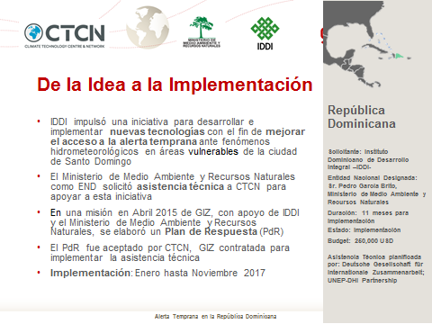
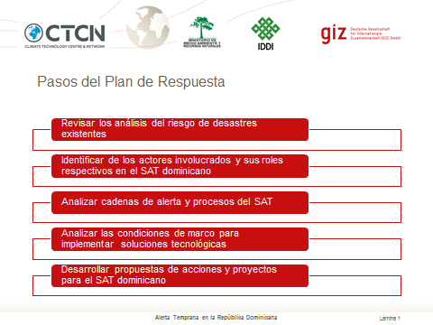
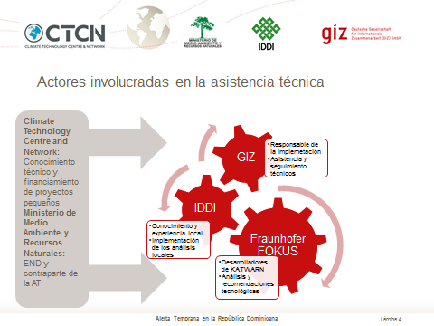
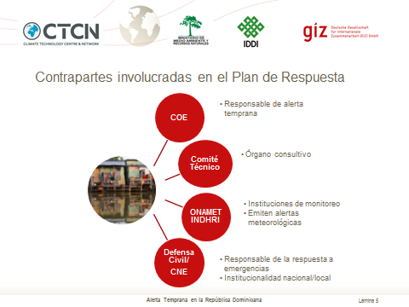
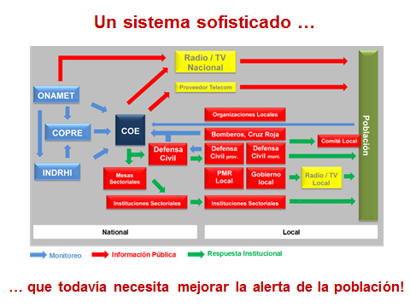
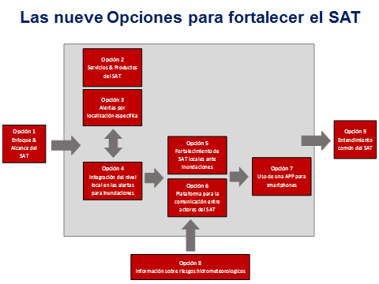
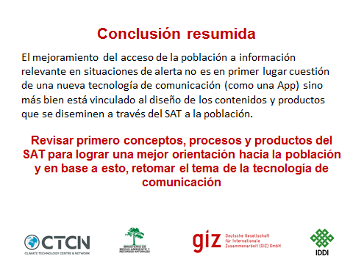

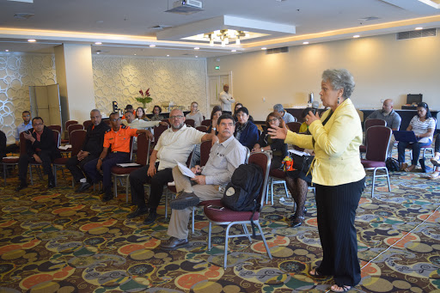
Ministerio de la Mujer giving an intervention at the final event
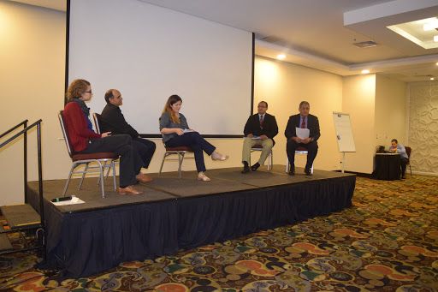
Panel on communication technology

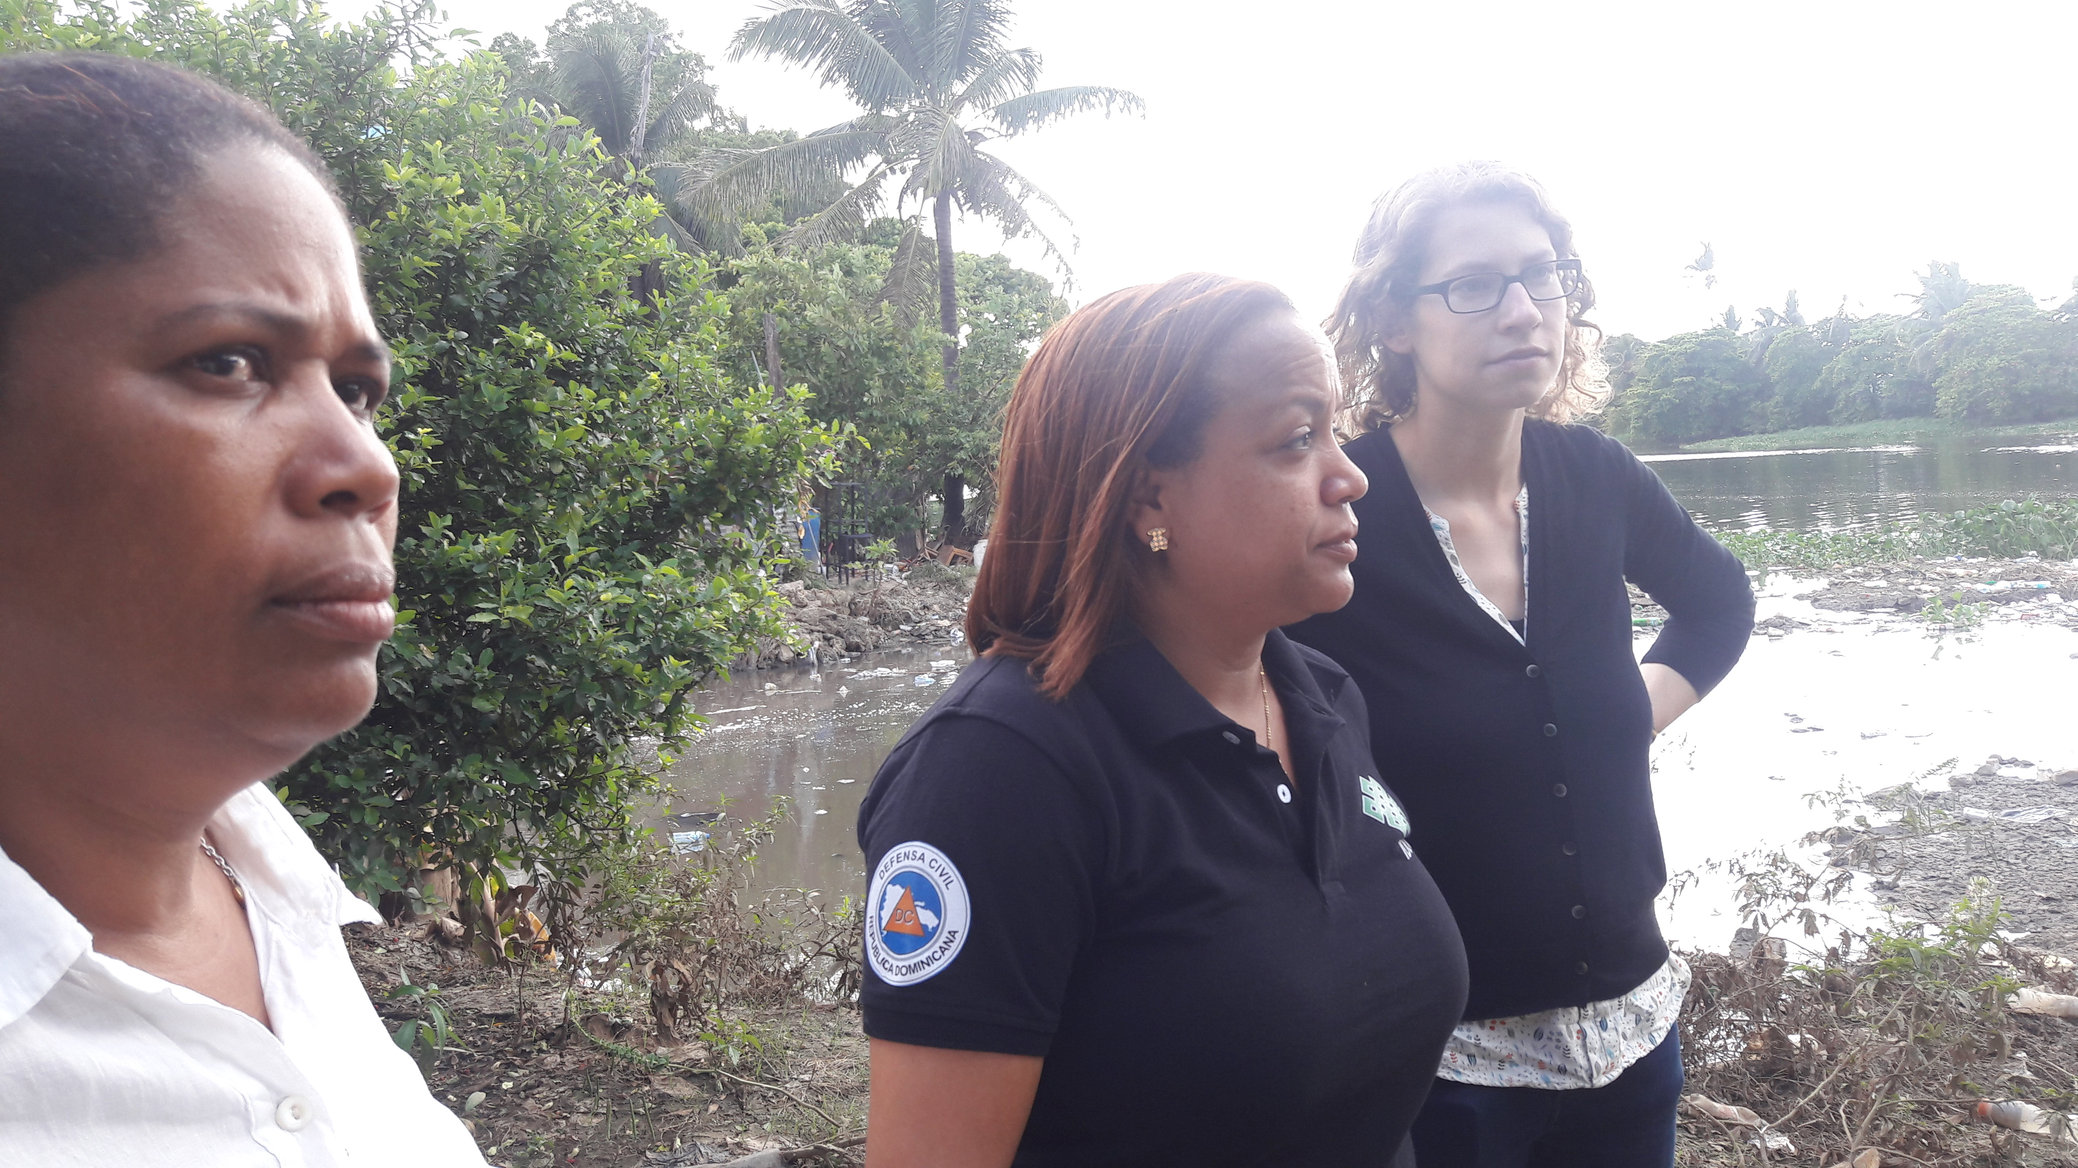
IDDI and Fraunhofer in the pilot zone

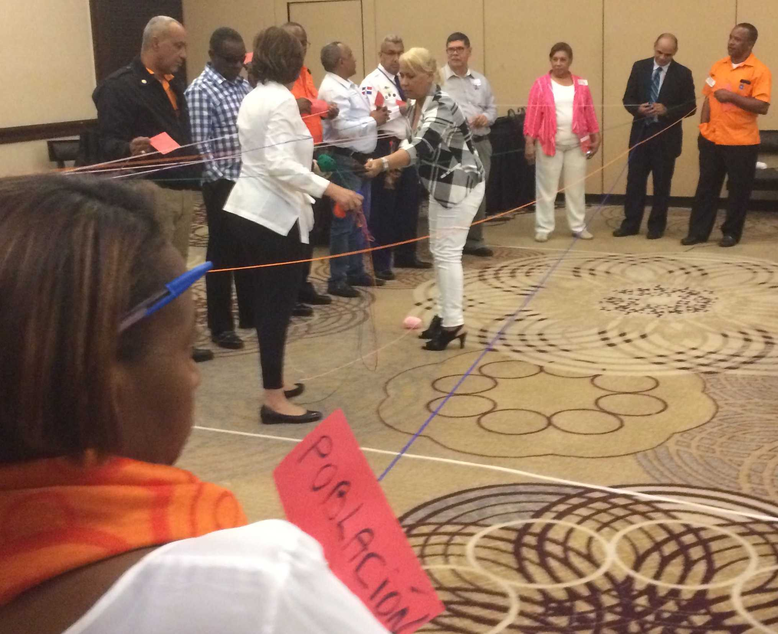
Workshop on interactions of EWS stakeholders

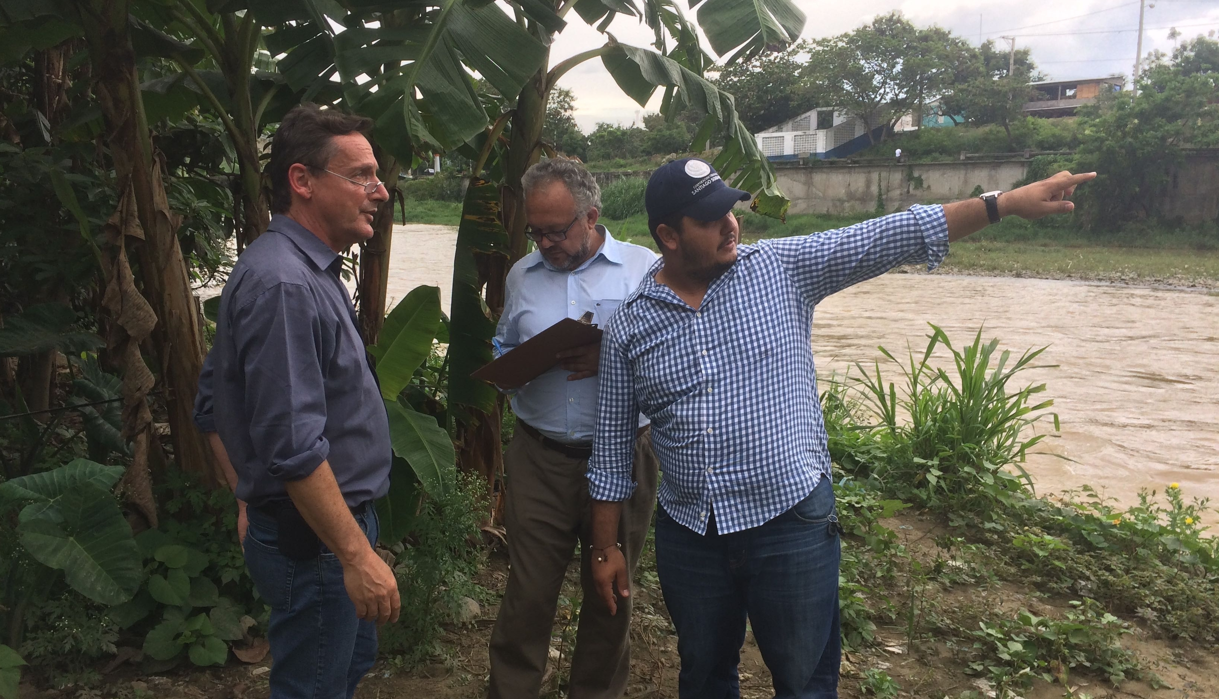
IDDI and GIZ in the pilot zone

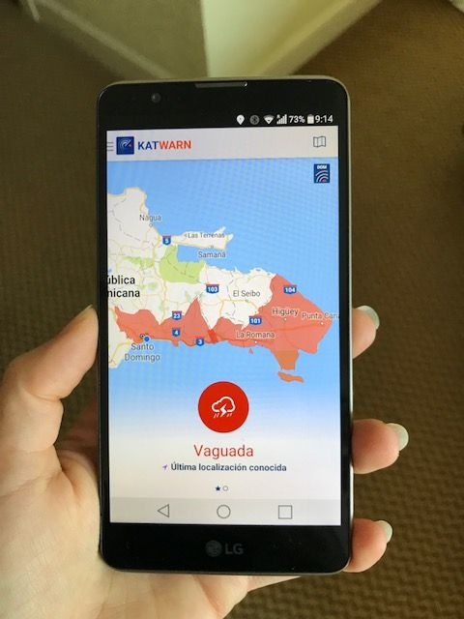
Demonstrator technology as presented by Fraunhofer

5. Information for TA impact description
The information in the table below will be used to produce the CTCN TA Impact Description. The TA Impact description is a 2-page summary document for communication purposes. Please copy information from sections above and technical delivery reports as required.
Challenge: Approx. 500 characters with spaces | While the DR has a national early warning system, alerts and messages emitted to the population do not always achieve an adequate reaction by the affected population. Consequently, the loss and damage incurred by extreme weather events is high, and forced and sudden evacuations by the Dominican civil defence are often necessary.
CTCN Assistance: 2 to 4 bullet points. Approximately 450 characters with spaces | - The technical assistance developed an action plan with specific project proposals for improving the Dominican Early Warning System (EWS) from hydrometeorological hazards.  - The in-depth analysis of the EWS included analyzing: the existing risk information for early warning (EW); key actors and institutions involved; existing EW processes; and the framework conditions for an EW dissemination technology.  - The action plan recommends: a) a technology to aid internal communication and dissemination of EW, and b) project proposals to improve the EWS.
Anticipated impact: 2 to 4 bullet points to summarise anticipated impact. Approximately 250 characters with spaces. As a minimum, please include one of the following: i) Quantity of greenhouse gas emissions reduced, avoided or sequestered; or ii) Number of people with increased capacity to adapt to the impacts of climate variability and change. | According to the Centre of Emergency Operations (COE), 68% of the territory of the Dominican Republic is vulnerable to landslides and flooding and more than 2 million people live in these vulnerable areas (Defensa Civil, 2016).  The anticipated impacts include improved population access to Early Warning and to relevant information on disaster risks and a more effective and more population-oriented early warning system for hydrometeorological hazards that builds on the strengths of the existing system, while cooperating to reduce challenges in the face of rising climate-related risks.  Estimated total amount of the 9 project ideas (profiles): $ 5.3 million (approximately)
Linkages and contribution to NDC: 2 to 4 bullet points. Approximately 350 characters with spaces | Contributes to adaptation in the Dominican NDC:  - Risk Management and Early Warning Systems mentioned in the strategic planning approach.  - Relevance for 3 NDC priority sectors: Tourism (effective dissemination of warnings via app also to tourists); water (TA focused on hydrometeorological hazards) and Human Settlements (working in among the poorest districts of Santo Domingo).
The narrative story: Approximately 1200 characters with spaces | The Dominican Republic is facing increasing disaster risks, especially from hydrometeorological phenomena, due to the effects of climate change in combination with demographic developments. While the DR has a national early warning system, alerts and messages emitted to the population do not always achieve an adequate reaction by the affected population. As a consequence, the loss and damage incurred by extreme weather events is high, and forced and sudden evacuations by the Dominican civil defence are often necessary.  In an effort to mitigate the social and economic impacts caused by such events and as part of its overall CCA-related activities, the Dominican Ministry of the Environment and Natural Resources requested technical assistance from CTCN for measures to improve the effectiveness of early warning, focusing in particular on densely-populated urban riverine districts in the capital of Santo Domingo. The ministry also proposed to assess the potentials of utilizing state-of-the-art mobile technology (e.g. warning app). A subsequent mission conducted by the Global Initiative on Disaster Risk Management (www.gidrm.net), which is implemented by the Gesellschaft für Internationale Zusammenarbeit (GIZ) on behalf of the German Federal Ministry of Economic Cooperation and Development (BMZ), and backstopped by the Danish Institute DHI, found that especially inhabitants of the hazard-prone riverine areas of Santo Domingo have indeed little access to general information on disaster risks, and remain unaware of imminent natural events that could inflict harm or damage to their districts. Building on the already established structures, such as a 24/7 operating national monitoring system for natural events, broad access to mobile technology and stable mobile network along with the political will of relevant stakeholders, the technical assistance aimed to identify, test and validate possible improvements to the existing early warning system in order to provide general information on natural hazards and effectively warn the population in the city of Santo Domingo using innovative technology.
Contribution to SDGs: Always include contribution to SDG 13, and to the extent possible, please include contribution to 2 other SDGs, describing the contribution with a few sentence for each SDGs concerned. A complete list of SDGs and their targets is available here: https://sustainabledevelopment.un.org/partnership/register/ | 11: Reduce the amount of human and material losses caused by disasters, focusing on the protection of poor and vulnerable people.  13.1 Strengthen resilience and adapt to disasters through increased awareness.  16: Increase effectiveness of preparedness and response actions by the Dominican disaster risk management institutions through an improved early warning system.  17: Promote North-South cooperation for knowledge sharing; Promote the development and transfer of climate technologies to developing countries.
Note: Please see example of a TA Impact Description at the following link:
https://www.ctc-n.org/sites/www.ctc-n.org/files/benin_a_ag_forestry.final_.pdf
Annex 1 (for internal use in donor and UN reporting)

A. Standardised CTCN performance indicators for donor and UN internal reporting
Please add quantitative values for indicators relevant to the particular TA in the list below. Non-relevant indicators should be left blank. Please only fill in the table for activities and outputs conducted or produced directly by the CTCN assistance.

CTCN standardised performance indicators | Quantitative value | Qualitative description  List the various elements corresponding to the quantitative value
- Overview
Number of active person-days (not full duration) of technical assistance provided to counterparts or stakeholders by international experts and consultants | 127 | Management, technical advice, technology recommendations.  Administration, preparation of Response Plan and GIDRM contributions not considered.
Number of active person-days (not full duration) of technical assistance provided to counterparts or stakeholders by national experts and consultants | 108 | Piloting, contact to counterparts, organizing of workshops and missions.  Preparatory and other in-kind contributions not considered.
Number of for external communication and outreach activities conducted to showcase the assistance (news release, newsletters, articles on website, etc.) | 7 | 3 CTCN website  2 GIZ-GIDRM website  1 GIZ Newsletter Mexico  1 WMO homepage
- Events (other than trainings) held as part of the assistance
Number of international and multi-country (at regional or sub-regional level) technology and knowledge sharing events | 3 | Cancun: Multi Hazard Early Warning Conference, Cancun  Taller Regional de Innovación en la Alerta Temprana, Santo Domingo  1 presentation DRM Science Network, Bonn, Germany
Number of participants in the events above | 170 | Not entire conferences, only relevant sessions.
Number of national technology and knowledge sharing events | 5 | 2 local analysis workshops  1 national analysis workshop  1 validation workshop with CT–PMR on projects  1 final validation and sharing workshop on projects
Number of participants in the events above | 113 | Each person only counted once, even if they had participated various times
Number of public-private events related to technologies
Number of participants in the events above
- Training and capacity building activities conducted during the assistance
Number of training sessions and capacity strengthening activities
Number of people who received the training
Number of men
Number of women
Total number of organisations trained
Number of research organisations, laboratories and universities
Number of private companies
Number of cities and local government
Number of communities
Number of ministries
Number of specialised governmental institutions
Number of non-profit organisations
Level of satisfaction of participants after the training (from training feedback form). Categories include: From very satisfied, satisfied, partly not satisfied, not satisfied at all
Percentage of participants that increased their capacities thanks to the training (from training feedback form). Categories include: Significantly, very, moderately, to none.
Percentage of men
Percentage of women
- Tools, technical reports and information material supported by the assistance
Total number of tools, technical reports and information material supported by the assistance (excluding mission, progress and internal reports) | 9
Number of tools strengthened, revised or developed | 2 | Technology demonstrator developed  Warning levels revised with key actors
Number of technical reports strengthened, revised or created | 7 | 7 technical reports on the Dominican system and app technology
Number of other information materials strengthened, revised or created
- Policies, laws and regulations supported by the assistance

Number of policies, strategies, and plans drafted addressing climate change adaptation
Number of policies, strategies, and plans drafted addressing climate change mitigation
Number of documents developed to inform other policies, strategies, and plans on climate change adaptation (sectoral strategies, national development plans, etc.)
Number of documents developed to inform other policies, strategies, and plans on climate change mitigation (sectoral strategies, national development plans, etc.)
Number of laws, agreements, or regulations drafted addressing climate change adaptation
Number of laws, agreements, or regulations drafted addressing climate change mitigation
Number of documents developed to inform laws, agreements, or regulations on climate change adaptation | 1 | Challenges and Options for Action in the Dominican EWS
Number of documents developed to inform laws, agreements, or regulations on climate change mitigation
- Institutional strengthening supported by the assistance
Number of institutional arrangements in place to coordinate near and long-term national adaptation plans (NAPs)
Number of organisations with increased technical capacity to advance near and long term national adaptation plans (NAPs) which integrate EbA
Number of organisations with increase awareness and knowledge among countries to better own and drive national adaptation planning processes | 5 | The five key actors at the national COE, ONAMET, INDRHI, CN-PMR and Civil Defense strongly back the process to strengthen the EWS on the basis of the projects proposed
- Partnerships and cooperation
Number of private companies directly engaged in the assistance (that partnered with the proponent, the beneficiaries or the CTCN to implement the assistance)
Number of South-South collaboration enabled during or through the assistance, when stakeholders from other countries were involved in the assistance | 3 | Exchange and networking with representatives from Colombia, Brasil, Central America (CEPREDENAC)
Number of North-South collaboration enabled during or through the assistance, when stakeholders from other countries were involved in the assistance | 2 | Fraunhofer FOKUS-Dominican Republic  UNECLAC-Dominican Republic
Number of Triangular collaboration enabled during or through the assistance, when stakeholders from other countries were involved in the assistance

B. Indicators of anticipated impacts that may occur after the TA is completed
CTCN standardised performance indicators | Quantitative value  Insert the request value and unit | Content  List the elements included in the number provided |  | Expected timeline  Indicate when the indicator and value are expected to be achieved | Responsible institution  Indicate the institution(s) that will play leading role in enabling the indicators and anticipated values to be achieved
16. Anticipated finance mobilised
- Anticipated amount of public/donor investment mobilised (in USD) from the beneficiary country for climate change activities as a result of the TA
- Anticipated amount of public/donor investment mobilized (in USD) from international and regional sources for climate change activities as a result of the TA | 3,5 m USD (proposed total project volume) | - Revise concepts of the EWS  - Strengthen information on hydro-met. risks  - Integrate local Flood EWS in the national system  - Introduce communica-tion platform for EW  - Improve dissemination technology | 4-5 years |  | n/a
- Anticipated amount of private investment mobilised (in USD) from the beneficiary country for climate change activities as a result of the TA
- Anticipated amount of private investment mobilised (in USD) from international and regional sources for climate change activities as a result of the TA
17. Policies
- Anticipated number of policies, strategies, plans, addressing climate change mitigation officially proposed, adopted, or implemented as a result of the TA
Anticipated number of policies, strategies, plans, addressing climate change adaptation officially proposed, adopted, or implemented as a result of the TA.
- Anticipated number of laws, agreements, or regulations addressing climate change mitigation officially proposed, adopted, or implemented as a result of the TA.
Anticipated number of laws, agreements, or regulations addressing climate change adaptation officially proposed, adopted, or implemented as a result of the TA.
- Anticipated laws, policies, regulations, strategies and plans where climate change mitigation will be mainstreamed as a result of the TA
Anticipated laws, policies, regulations, strategies and plans where climate change adaptation will be mainstreamed as a result of the TA
18. Anticipated number of public-private partnerships created
19. Anticipated twinning arrangements created as a result of the TA
20. Anticipated number of technology projects prepared and implemented to support action on low emission and climate-resilient development | 9 project ideas (profiles) and 2 information and communica-tion technologies (Platform and APP) | Project to develop specifications of platform and app in order to ensure sustainability of technology in the Dominican system |  | Within a year | n/a
21. Anticipated number of strengthened National Systems of Innovation and technology innovation centres in recipient country
22. Anticipated Clean Energy Generation Capacity
Clean supported by the TA that has achieved financial closure
23. Anticipated and projected GHG reductions. Quantity of greenhouse gas (GHG) emissions, measured in metric tons of CO_{2-e}, anticipated to be reduced or sequestered as a result of projects supported by the TA
24. Anticipated clean energy generation capacity supported by the TA that has achieved financial closure
25. Anticipated and projected greenhouse gas emissions reduced or avoided through 2030, in metric tons of CO_{2-e}, from adopted laws, policies, regulations, or technologies related to clean energy/sustainable landscapes as a result of the TA
26. Anticipated number of people improving their livelihood as co-benefits as a result of the TA | 2 m | Approx. 2 m people vulnerable to said events
27. Anticipated technology types effectively deployed in the country | 2 | App for disseminating warnings  Platform for early warning |  | 1 year  1.5 years | n/a
28. Anticipated UNFCCC processes implemented as a result of the TA (NAMA, NAPA, NDC, etc.)
29. Anticipated Technology Needs Assessments (TNA) and technology Action Plans (TAP) as a result of the TA | 1 | Technical specifications for platform and APP |  | 07/2018 | COE
30. Anticipated cooperative research, development and demonstration programmes within and between developed and developing country Parties facilitated as a result of the TA
31. Anticipated improved climate change observation systems and related information management in developing country Parties. | 1 | Improved information basis on hydrometeo-rological risks |  | 2 years | n/a

Annex 2 (for internal use – to be filled in by the CTCN)
CTCN evaluation
This section will be completed by the relevant CTCN Technology Manager.

- Evaluation of the timeliness of the TA implementation as measured against the timeline included in the response plan;
- Evaluation of TA quality as defined in the response plan;
- Overall performance of the Implementers;
- Overall engagement of the NDE and Proponent;
- Lessons learned on the CTCN process and steps taken by the CTCN to improve.

