Please complete the form and fill out grey spaces following the instructions in italics.
Requesting country: |  | Chile
Request title: |  | "Design of an ecological fire response and restoration platform for the forestry, agriculture and livestock sector in Chile as a mechanism for adapting to climate change"
Contact information:
{Please fill in the table below with the requested information. The request proponent is the organization that the request originates from, if different from the National Designated Entity (NDE).}
 | National Designated Entity |  |  |  | Request Applicant
Contact person: | Agency for Sustainability and Climate Change (formerly the National Council for Clean Production) |  |  |  | Daniel Álvarez Latorre
Title: |  |  |  |  | Head of Restoration Unit
Organization: |  |  |  |  | Ministry of Environment
Phone: |  |  |  |  | +56 225 73 56 35 / +56 2 25 73 5605
Fax:
E-mail: |  |  |  |  | Dalvarezl@mma.gob.cl
Postal address: |  |  |  |  | San Martín 73, Santiago de Chile
Technology Needs Assessment (TNA):
{Select one of the three boxes below:}
☐ The requesting country has conducted a TNA in... (please insert date of TNA completion)
☐ The requesting country is currently conducting a TNA
☐ The requesting country has never conducted a TNA
{If the requesting country has completed a TNA, please indicate what climate technology priority this request directly relates to. Please indicate reference in TNA/TAP/Project Ideas.} Chile has the National Plan for Adaptation to Climate Change, the Adaptation to Climate Change in Biodiversity Plan, and the Forestry, Agriculture and Livestock Sector Adaptation to Climate Change Plan.
Geographical focus:
{Select below the most relevant geographical level for this request:}
☒ Community
X☐ Sub-national (regions in Central Chile)
☐ National
☐ Multi-country
{If the request is related to the sub-national or multi-country level, please indicate here the areas concerned (provinces, states, countries, regions, etc.)}
Theme:
{Select below the most relevant theme(s) for this request:}
☒ Climate change adaptation
☐ Climate change mitigation
☐ Combination climate change adaptation and mitigation
Sectors:
{Please indicate here the main sectors related to the request. e.g. energy, industry, transport, waste, agriculture/fisheries, forestry, water, ecosystem/biodiversity, coastal zones, health, education, infrastructure/human settlement, tourism, businesses, early warning/disaster reduction, institutional design and mandates, cross-sectoral}

Industry (wine), water, coastal areas, ecosystem/biodiversity, tourism, disaster reduction, institutional design and mandates, planning and governance.

Problem statement (up to one page): {Please describe here the difficulties and specific gaps of the country in relation to climate change, for which the country is seeking support from the CTCN. Please only provide information directly relevant to this request, and that justifies the need for CTCN technical assistance.}
Difficulties:

Emergency caused by recent fires (2017) in the agricultural production sector and need for a comprehensive response: Chile has had to face an emergency caused by enormous fires that affected its Mediterranean landscapes, their biodiversity, and forestry, agriculture and livestock production activities, which a significant part of the population depends on. The magnitude of the emergency has highlighted the difficulties of dealing with this type of event. It has also highlighted the need to work with stakeholders in the agricultural production sector to begin restoration of the Mediterranean landscapes and their socio-ecological fabric, while building a culture of prevention and improving the capacity to react and respond to similar events. In a context of climate change, such events cannot be ruled out.

Megadrought: According to the report to the National Center for Climate Science and Resilience, the area between the regions of Coquimbo and Araucanía has experienced a rainfall shortage of nearly 30 per cent since 2010. This lack of rain has been uninterrupted since then and has taken place in the warmest decade in the last 100 years, which has exacerbated the water shortage through evaporation from lakes, reservoirs and crops. The length and geographical extent of the current drought are unprecedented in historical records. This event, which we are calling a “megadrought", has not been matched in the last millennium, according to climate reconstructions based on tree-ring growth. This megadrought is also affecting ecosystems, their resilience, and their capacity to provide ecosystem services.

According to the Biodiversity Climate Change Adaptation Plan (2014), which was ratified by the Council of Ministers for Sustainability, and studies conducted within this framework, aridification will continue to worsen. In fact, the joint study by the Ministry of Environment, the University of Chile and the Center for Agriculture and Environment (2013), shows how aridity will evolve in projected climate scenarios to 2030 and 2050 (Figure 1). This change will have a significant impact on bioclimatic suitability for the different ecosystems. Figure 2 shows the effect on sclerophyll forests.

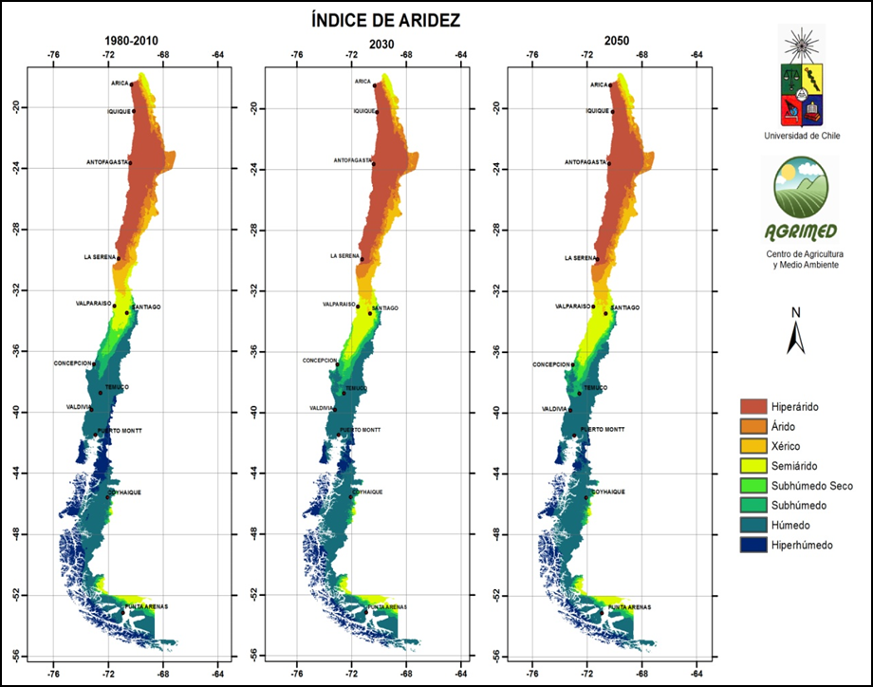
ARIDITY INDEX
University of Chile
AGRIMED
Center for Agriculture and Environment

Hyper-arid – Arid – Xeric - Semi-arid - Dry sub-humid - Sub-humid - Hyper-humid
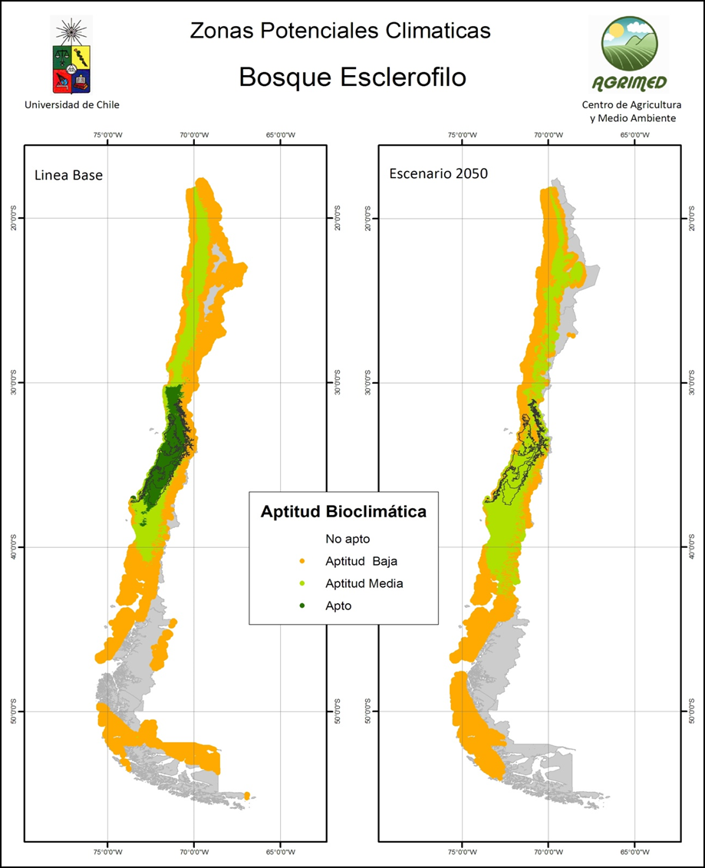

POTENTIAL CLIMATE ZONES
Sclerophyll Forest
University of Chile - AGRIMED (Center for Agriculture and Environment)
[left] Baseline - [right] 2050 scenario
[key] Bioclimatic suitability: Not suitable - Low suitability - Medium suitability - Suitable

Change in land use: The change in land use (between 1975 and 2008) without regulation or monitoring has resulted in the progressive fragmentation of natural ecosystems as the land was transformed for agricultural use, urban development, mass planting of exotic species (primarily Pinus radiata and Eucalyptus globulus), the conversion of scrubland into land for growing crops and logging. This has led to dramatic changes in the structure and composition of the semi-arid and temperate forests of central southern Chile, which is a hotspot for Chilean biodiversity. The natural vegetation in this area has been confined to gorges, slopes and isolated hills that are not connected to each other. In these circumstances, passive revegetation processes are insufficient to recover lost or damaged ecosystems. In addition, socioeconomic activities in the area, such as clearing forests to create pastures and croplands, and for firewood, have contributed to the degradation of ecosystems and the loss of biodiversity.
For example, a clear example of native forests being reduced and replaced with scrubland and plantations of exotic species can be found in the foothills of the Andes, in the Maule region, where native forest was reduced by 44 per cent between 1989 and 2003: an annual deforestation rate of 4.1 per cent. In the central area of the country, agricultural development along with the transformation of land primarily for avocado and vine cultivation on hillsides and steep slopes has affected the native forest as a result of burn-offs and fires. This has contributed to lands becoming eroded and losing their structure.

Fires: The megadrought mentioned earlier resulted in a mass of combustible material which, combined with the dryness of the atmosphere and human activity, can trigger more intense fires that spread faster. In the 2016-2017 season, the country was affected by a series of large fires that consumed an extensive latitudinal area of nearly 600,000 hectares from the Coquimpo region to the Araucanía region: a large, modified area made up of fragmented ecosystems. These anthropogenic fires have affected human settlements, forest plantations, native forests, pastures, scrublands, crops and other areas, leaving social and environmental degradation in their wake. In fact, the fires in this area have not only destroyed sensitive ecosystems, but also protected areas and priority locations that have an essential role as providers of ecosystem services and biological resources, and as key elements in the provision of climate change adaptation services. The decline in ecosystem services is widespread in the region and its effects are felt at considerable distances. An example of this is the lack of water regulation for headwater basins and the resulting erosion, which results in sedimentation far from the origin of the problem. This fact alone can mean there is a decrease in the availability of surface and groundwater for hundreds of kilometres.

Figure 3. Synoptic view of fires in the 2016-2017 season (from the southern part of the Coquimbo region to the Araucanía region)

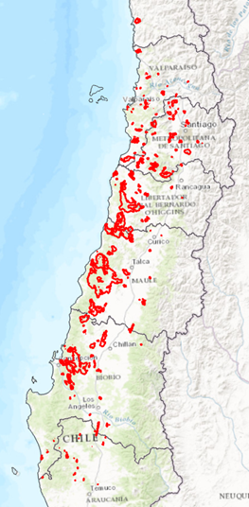

Gaps: The persistence of the drought, intensified land use, and higher frequency, intensity and extent of the fires weaken Chile's Mediterranean ecosystems and landscapes, and lead to their degradation in Chile’s Mediterranean area, which is a globally and nationally important biodiversity hotspot. This, in turn, affects ecosystem services, which impacts on the well-being of the population and productive activities. There is therefore an urgent need to implement and transfer past experiences of restoring biodiversity and the ecosystem services that it provides to support the population’s environmental, social and economic well-being. This will help to meet requirements for sustainable and inclusive development. It is also imperative to combine forestry, agriculture and livestock production with innovative and efficient practices and systems to show that the productive sectors can perform well financially while also preserving and recovering native biodiversity. For this to be feasible, ecological restoration technologies that can be replicated in the context of productive landscapes and their environments must be designed, implemented and transferred. These should contribute, for example, to the connectivity and resilience of ecological corridors, core biodiversity areas and the provision of ecosystem services. Activities and markets that add to or provide alternatives to the extraction of firewood as the only available resource must also be incorporated. These actions require management models that actively involve stakeholders who are private landowners, and stakeholders in the areas to be restored or with potential to be replicated. Government agencies, such as CORFO (Chilean Economic Development Agency), that finance innovative processes must also be included. To achieve these objectives, demonstrative and scalable models must be generated that promote the adherence and participation of stakeholders from the beginning, to the midterm and beyond the project cycle. The business model must be developed, along with the model for implementation of the economic instruments of biodiversity, and particularly the mechanisms for biodiversity offsetting and certification of best practices in biodiversity.

Past and ongoing efforts (up to half a page):
{Please describe here past and ongoing processes, projects and initiatives implemented in the country to tackle the difficulties and gaps explained above. Explain why CTCN technical assistance is needed to complement these efforts, and how the assistance can link or build on this previous work.}

PUBLIC POLICIES AND THEIR SCOPE:
The National Climate Change Action Plan 2017-2022 (PANCC-II): The aim of this plan is the effective implementation of measures identified as priorities for adapting to the specific effects of climate change, thereby reducing the country’s vulnerability.

Biodiversity Climate Change Adaptation Plan: This plan aims to generate coordinated actions for biodiversity adaptation, conservation and restoration, and to promote the provision of ecosystem services for the well-being of the general population. It was approved in July of 2014 by the Council of Ministers for Sustainability. The plan provides a fundamental priority framework for including stakeholders in the productive sectors in climate change adaptation, while also considering the role of biodiversity.

Adaptation Plan for the Forestry, Agriculture and Livestock Sector. This document lays the foundations for the national climate change adaptation policy in the forestry, agriculture and livestock sector. The initiative will help this sector adapt to climate change, with a focus on biodiversity restoration and conservation.

National Rural Development Policy: The objectives of this policy, which has already been drafted and is awaiting approval, include climate change adaptation, and protecting and restoring biodiversity.

2016-2030 National Biodiversity Strategy: This is a public policy document which includes restoration and climate change as cross-cutting themes. It also promotes cross-cutting biodiversity objectives in public and private environmental management policies and instruments.

2017-2025 National Plant Resource and Climate Change Strategy (approved in 2016): This strategy, led by the National Forestry Corporation (CONAF), is the operational framework for implementing the National Forestry Policy (adopted in 2016), the National Plan to Combat Desertification (adopted in 2016), and other policies. Its objective is to reduce social, environmental and economic vulnerability created by climate change, desertification, land degradation and drought affecting plant resources and the human communities that depend on them. The aim is to increase the resilience of ecosystems and help to mitigate climate change by promoting the reduction and capture of greenhouse gas emissions in Chile. A number of initiatives and projects are being implemented under this strategy in relation to this request for assistance, such as the GEF/CONAF/World Bank Sustainable Land Management Project. This initiative has three-pronged approach that addresses best practices in sustainability as well as biodiversity conservation and climate change mitigation.

Climate Change and Sustainability Agency: This agency was created recently, in 2017, and is responsible for facilitating the implementation of adaptation policies approved by the Council of Ministers for Sustainability, which is a linchpin for coordination of the Government of Chile’s climate actions. Its objectives include: i) Promoting cooperation between the state and the private sector to make progress in preparing for extreme environmental scenarios; and ii) encouraging businesses to adopt sustainability and climate management measures, while also promoting better energy efficiency; and iii) initiating change processes that generate far-reaching transformations throughout Chile, in which the experiences of the National Council for Clean Production (CPL) can be applied. Among the recent initiatives aligned with the rationale of this application, particularly because of the involvement of regional stakeholders and sustainability objectives, are the Territorial Agreements. These agreements provide a forum to coordinate the actions of enterprises, communities and local stakeholders, helping them to work together to find solutions to problems of risk and vulnerability, to promote territorial sustainability, and to face the challenges of climate change. These include the Voluntary Basin Management Agreements (AVGC), which are working in six of the country’s river basins to address issues such as water quality, water scarcity, ecosystem services, environmental information and education, and other areas.

In 2017, the Agency also launched the Fire Management and Prevention Agreements (AGPI), which aim to promote coordinated territorial management in relation to risk factors, especially fires. Its specific objectives include the following:
- Promoting a shared perspective among the multiple stakeholders on the territory’s threats, vulnerabilities and opportunities on the basis of fire risks.
- Offering forums for dialogue and coordination to promote the achievement of collective objectives among the different public, private and community entities.
- Providing local stakeholders with prevention tools that help minimize risks.
- Promoting territorial agreements that help manage and prevent fire risks.
In fact, work is under way in four towns in the Maule region (Hualañe, Empedrado, Colbún and San Clemente), with the support of the municipalities, to draw up local fire prevention plans for more than 30 localities. These involve construction and infrastructure work, education and ongoing coordination, and this work is being undertaken in coordination with public services and forestry companies.

Constitution of the National Ecological Restoration Committee (February 2017): This committee is responsible for advising the Ministry of Environment on the creation and implementation of ecological restoration plans. Among the different lines of work are a register of the effect of fires and local support actions (on ecosystems, activities, climate change programme, biodiversity and the wine industry).

Species recovery, conservation and management plans (RECOGE): These are tools used to implement conservation actions for species classified by the Regulation for the Classification of Wild Species. Plans are in the final stages of drafting for three species, one of which is distributed throughout the zone affected the fires, which is a protected area.

PROCESSES:
Ecological infrastructure: This is a tool that identifies priority areas of high ecological value and provides the structural and functional connectivity needed to ensure the flow of genes, species, matter and energy within and between ecosystems, which is how biodiversity is maintained. A pilot project has been designed in the Biobío region, but it has not been implemented.

INSTITUTIONAL MEASURES:
Draft Law create the Biodiversity and Protected Areas Service: This is a set of new institutional measures (currently in parliamentary proceedings) that include the function of drawing up restoration plans, a certification system for biodiversity conservation actions, training and verification of best practice.

INITIATIVES:
Wine, Climate Change and Biodiversity Programme (http://www.vccb.cl/): This is a scientific initiative of the Institute of Ecology and Biodiversity (IEB) of the Austral University of Chile, which aims to show that biodiversity conservation and the development of the Chilean wine industry are compatible.

This programme began in 2008 with the specific goal of promoting the protection of biodiversity in the Chilean Mediterranean ecosystem, which is under-represented in the National System of Protected Areas. In addition, these central Chilean ecosystems contain over 50 per cent of Chile’s vertebrate and plant species, and have been severely affected by human activity.

The programme focuses on understanding how natural landscapes can continue to provide environmental services to this industry as well as to local communities, in a scenario of increasing human impact and future climate change.

This initiative has great potential for sharing knowledge with other stakeholders, which is one of the project’s objectives.

Restoration project on private estates and priority locations. Cerro Cayumanque: This is a programme for the restoration of Cerro Cayumanque that is being developed by the Biobío Regional Secretariat of Environment with resources from the National Regional Development Fund. It is an area in which public and private stakeholders, as well as small and large landowners and local communities, are participating.

Summary: Urgent action is needed to make a greater impact in the region through simultaneous actions and more diverse measures. This includes the restoration of ecological integrity and the resulting recovery of ecosystem services, improving resilience to climate change, and the introduction of innovative measures to develop alternative and diverse markets that make sustainable use of biodiversity. The action should include different levels of training, and combine the experience of private parties and experts.
Promote the collaborative application of economic biodiversity instruments with stakeholders from the private sector for the benefit of people’s well-being.
Resources and technical assistance are needed to implement operations immediately.
Assistance requested (up to one page):
{Please describe here the scope and nature of the technical assistance requested from the CTCN and how this could help address the problem stated above and add value vis-à-vis the past and ongoing efforts. Please note that the CTCN facilitates technical assistance and is not a project financing mechanism.}
The technical assistance requested will be aimed at:
- Developing and launching a knowledge communication platform with the potential to be replicated in areas at risk of fire in agricultural production zones that need to improve their response capacity to reduce impacts and restore degraded agro-ecosystems.
- Identifying proactive stakeholders to be involved as example-setters or possible supporters of actions for ecological restoration and native biodiversity conservation in forestry, agriculture and livestock systems (winegrowing and others) in central Chile.
- Designing, based on the profile of the stakeholders mentioned above, a demonstrative, replicable and scalable knowledge-transfer model (socio-ecological technology). This is to promote involvement and consolidate existing initiatives and/or support for new actions for ecological restoration and native biodiversity conservation in forestry, agriculture and livestock systems in central Chile.
- Implementing and adjusting the knowledge-transfer model (socio-ecological technology) previously developed. This would involve transferal, training and diffusion to stakeholders in the productive sectors of the benefits of biodiversity restoration and conservation in the forestry, agriculture and livestock productive sectors and local communities, taking ecological, social and economic dimensions into account.
- Including real-life examples in a training on the benefits of certain financial instruments and their potential for biodiversity restoration and conservation, including biodiversity offsetting and certification, payment for environmental services, and identifying participants interested in the pilot application. Ideally the project would begin with a pilot.
Expected benefits (up to half a page):
{Please outline here the medium and long-term impacts that will result from the CTCN technical assistance, including how the assistance will contribute to mitigate and/or adapt to climate change.}
- The project aims to foster and create, based on demonstrative and successful experiences in biodiversity restoration and conservation (whether pre-existing or developed through the project), proactivity among companies in the forestry, agriculture and livestock sectors in the implementation of practices and processes to restore species, ecosystems and the services they provide. This proactivity will ideally take the form of explicit commitments.
- A model (strategic workplan) is envisioned that will allow technological, knowledge, information, and administrative barriers to be overcome, as well as other obstacles that hinder the implementation of successful biodiversity restoration and conservation experiences in practices common to the productive sectors that impede and alter the capacity of ecosystems to provide services sustainably.
- It is expected that a robust socio-eco-technological tool will be developed that will encourage new stakeholders to take part in the implementation of restoration and conservation actions in their productive activities.
- Specifically, it is envisaged that a training, extension, capacity-building, environmental education and awareness programme will be implemented based on experience in the grape and wine production sector, which could be replicated in other productive sectors, and possibly scaled up to a regional context.
Post-technical assistance plans (up to half a page):
{Please describe here how the results of the CTCN technical assistance will be concretely used by the applicant and national stakeholders, to pursue their efforts of resolving the problems stated above after the completion of the CTCN intervention (list specific follow-up actions that will be undertaken).}

The continuity of this initiative will be based on the following actions:

- The availability and informative capacity of the platform and protocols for the reduction of fire threats and risks and restoration on the Ministry of Environment’s website.

- The dissemination of the project’s accomplishments to different stakeholders to encourage the possible incorporation of actions for biodiversity restoration and conservation into their operations in the context climate change adaptation.

- The multiplication of initiatives for biodiversity restoration and conservation in the context of climate change adaptation in the productive sector, based on improved understanding of the potential benefits to their business operations.

- Commitments from stakeholders in the productive sector to implement biodiversity restoration and conservation actions generated during the technical assistance.

- The future Biodiversity and Protected Area Service, and therefore the Ministry of Environment, will consolidate the work already begun with the stakeholders involved in the project and will continue to disseminate and transfer the technology developed to new stakeholders.

- To this effect, support will be provided by means of a series of mechanisms offered by the Biodiversity Service, including financial instruments (payment for environmental services, certification of activities and lands, biodiversity offsets, etc.) in addition to the implementation of restoration plans and other measures.

- Furthermore, the Ministry will use the National Committee for Ecological Restoration and the Biodiversity Operational Committee to identify and recruit new participants in the project and, when possible, promote coordination and transport volunteers to undertake new initiatives.

Primary stakeholders:
{Please list in the table below the main stakeholders who will be involved in the implementation of the requested CTCN technical assistance, and what their role will be in supporting the assistance (for example, government agencies and ministries, academic institutions and universities, private sector, community organizations, civil society, etc.). Please indicate what organization(s) will be the main/lead counterpart(s) of CTCN experts at national level, in addition to the NDE.}
Stakeholder |  | Role to support the implementation of the assistance
Ministry of Environment |  | Leader and proponent
Institute of Ecology and Biodiversity |  | Technical assistance implementer
CTCN focal point in Chile
Regional CTCN
Maule SEREMI (Regional Ministerial Secretariat for the Environment, Maule region) |  | Represents the Ministry of Environment in the Maule region and assists in managing and coordinating with regional stakeholders.
O’Higgins SEREMI (Regional Ministerial Secretariat for the Environment, O'Higgins region) |  | Represents the Ministry of Environment in the O’Higgins region and assists in managing and coordinating with regional stakeholders.
Maule GORE (Regional Government of Maule) |  | The highest regional authority, with instruments for planning and managing regional development. GORE can help to position the initiative and contribute to its future sustainability.
O’Higgins GORE (Regional Government of O’Higgins) |  | The highest regional authority, with instruments for planning and managing regional development. GORE can help to position the initiative and contribute to its future sustainability.
Forestry, agriculture and livestock proprietors and landholders |  | It is hoped that the project will gain the support of proprietors and landholders, and that they will commit to the objectives of biodiversity conservation and restoration.
Forestry, agriculture and livestock enterprises |  | Some of these enterprises will host pilot initiatives for biodiversity restoration and conservation with the aim of consolidating them and transferring them to other stakeholders.
Local community stakeholders |  | These are potential beneficiaries and collaborators in biodiversity restoration and conservation actions. They will especially benefit from the ecosystem services provided through the recovery of natural assets.
CONAF (National Forestry Corporation) |  | CONAF is an institutional partner with responsibilities in the management of native forest and incentivizing instruments that are aligned with the project's objectives.
SAG (Agricultural and Livestock Service) |  | SAG is an institutional partner with responsibilities in the management of natural resources and fauna. It also has incentivizing instruments that are aligned with the project's objectives.
INDAP (Agricultural Development Institute) |  | INDAP is an institutional partner that promotes rural development and is therefore related to production activities. It also has incentivizing instruments that are aligned with the project's objectives, especially for smaller producers.
INFOR (Forestry Institute) |  | INFOR can provide technologies for plant restoration and propagation, and other related thematic areas (ecosystem services).
Institute of Ecology and Biodiversity |  | The institute leads the Wine, Climate Change and Biodiversity Programme together with the Austral University.
Alignment with national priorities (up to half a page):
{Please demonstrate here that the technical assistance requested is consistent with documented national priorities (examples of relevant national priorities include: national development plans, poverty reduction plans, technology needs assessments (TNAs), LEDS, NAMAs, TAPs, NAPs, sectoral strategies and plans, etc.). For each document mentioned, please indicate where the priorities specifically relevant to this request can be found (chapter, page number, etc.).}

This initiative falls within the scope of the following national priorities:

The National Climate Change Action Plan 2017–2022 (PANCC-II). The aim of this plan is the effective implementation of measures identified as priorities for adapting to the specific effects of climate change, thereby reducing the country’s vulnerability.

Biodiversity Climate Change Adaptation Plan: This plan aims to generate coordinated actions for adaptation, and biodiversity conservation and restoration, and to promote the provision of ecosystem services for the well-being of the general population. It was approved in July of 2014 by the Council of Ministers for Sustainability. The plan provides a fundamental priority framework for including stakeholders in the productive sectors in climate change adaptation, while also considering the role of biodiversity.

Adaptation Plan for the Forestry, Agriculture and Livestock Sector. This document lays the foundations for the national climate change adaptation policy in the forestry, agriculture and livestock sector. The initiative will help this sector adapt to climate change, with a focus on biodiversity restoration and conservation.

National Rural Development Policy: The objectives of this policy, which has already been drafted and is awaiting approval, include climate change adaptation, and protecting and restoring biodiversity.

2016-2030 National Biodiversity Strategy: This is a public policy document which includes restoration and climate change as cross-cutting themes. It also promotes cross-cutting biodiversity objectives in public and private environmental management policies and instruments.

Constitution of the National Ecological Restoration Committee (February 2017): This committee is responsible for advising the Ministry of the Environment on the creation and implementation of ecological restoration plans. Among the different lines of work are: a register of the effect of fires and local support actions (on ecosystems, activities, climate change programme, biodiversity and the wine industry).

Development of the request (up to half a page):
{Please explain here how the request was developed at the national level and the process used by the NDE to approve the request before submitting it (who initiated the process, who were the stakeholders involved and what were their roles, and describe any consultations or other meetings that took place to develop and select this request, etc.)}
This proposal arises from the need to respond in a timely manner to an emergency situation caused by large-scale fires that degraded Mediterranean ecosystems, and also affected the agricultural and forestry production activities of several regions of Chile and the populations that depend on them. The Ministry of Environment’s Restoration Unit has identified an opportunity to respond to this situation with innovative technological solutions while involving regional stakeholders (especially in the agricultural and forestry sectors) by applying a preventative and restorative approach towards damaged ecosystems, and creating tools that make use of successful experiences, and encourage learning and changes to practices that could potentially be replicated.
Expected time frame:
{Please propose here a duration period for the assistance requested.}
1 year
Background documents:
{Please list here relevant documents that will help the CTCN understand the context of the request and national priorities. For each document, provide weblinks if available, to attach to the submission form while submitting the request. Please note that all documents listed/provided should be mentioned in this request in the relevant question(s), and that their linkages with the request should be clearly indicated.}
- Ecological Restoration Framework Document
- Biodiversity Climate Change Adaptation Plan
- Adaptation Plan for the Forestry, Agriculture and Livestock Sector
- Wine and Biodiversity Programme: http://www.vccb.cl/
- Presentation (.ppt) on preliminary diagnosis of the effects of recent fires on biodiversity
- Center for Climate and Resilience Research (CR2), 2015. “Inform the Nation: The 2010-2015 Megadrought: A Lesson for the Future.” http://www.cr2.cl/wp-content/uploads/2015/11/informe-megasequia-cr21.pdf
- MMA-AGRIMED study (University of Chile), 2013. (Guidelines for) Action plan for the protection and conservation of biodiversity in a context of climate change adaptation.

Monitoring and impact of the assistance:
{Read carefully and tick the boxes below.}
☐ By signing this request, I affirm that processes are in place in the country to monitor and evaluate the assistance provided by the CTCN. I understand that these processes will be explicitly identified in the Response Plan in collaboration with the CTC, and that they will be used in the country to monitor the implementation of the CTCN assistance.
☐ I understand that, after the completion of the requested assistance, I shall support CTCN efforts to measure the success and effects of the support provided, including its short, medium and long-term impacts in the country.
Signature:
NDE name: | Paulina Ulloa Villalobos
Date: | 13 September 2017
Signature:
WHEN THE FORM IS COMPLETED, PLEASE SEND IT TO CTCN@UNEP.ORG

Do you need assistance? The CTCN team is available to answer questions and guide you through the process of submitting a request. The CTCN team welcomes suggestions to improve this form.

>>> Contact the CTCN team at ctcn@unep.org

