Instructions to lead Implementers for drafting the

Technical Assistance Closure and Data Collection Report

Objective of the technical assistance (TA) Closure Report and Data Collection Report:
- To communicate publicly in one synthesis document a summary of progress made and lessons learned under the technical assistance (TA) towards the anticipated impact (main template).
- Compile TA-specific information required for internal use in donor and UN reporting (annex 1).

Steps for completing the TA Closure report:
- The lead TA implementer drafts the report at the end of the assignment as a final deliverable /product. The TA Closure report will capture all activities conducted under the TA hence it is expected that duplication of information will occur from earlier documents. Please copy and summarise relevant material from previous TA outputs/deliverables and the Response Plan, as relevant.
- A CTCN Manager will review and revise the report before final approval by the CTCN Director.

Important note on public and internal use of the closure report:
Once approved by the CTCN Director, the TA Closure and Data Collection Report will be a public document available on the CTCN website. Annex 1 is for internal use only and will not be publicly available.

Closure and Data Collection Report for CTCN Technical Assistance

- Basic information
Title of response plan | Climate technology awareness and scientific engagement with Civil Society for implementation of Swaziland’s Nationally Determined Contributions
Country / countries | Swaziland
NDE focal point and organisation | Simelane Bafana  Instruments Engineer  Department of Meteorology, Ministry of Tourism and Environmental Affairs  Bafanasim@gmail.com  P.O.Box 2652, Mbabane
Proponent focal point and organisation | Emmanuel Ndhlangamandla  Director  Coordinating Assembly of NGOs (CANGO)  director@cango.org.sz  P.O.Box A67, Swazi Plaza, Mbabane, Swaziland
Sector(s) addressed | All sectors were covered in the awareness raising including climate change impacts on energy,  industry, transport, waste, agriculture, forestry, water, ecosystem/biodiversity, health, education,  infrastructure/human settlement, tourism, businesses, early warning/disaster reduction, institutional  design and mandates, cross-sectorial issues.
Technologies supported | The following technology sectors where discussed:  - Adaptation: Agriculture and forestry, Human health, and Water;  - Mitigation: Forestry and Renewable energy;  - Cross-sectoral enablers: Capacity building and training; Communication and awareness;  - Cross-cutting approaches: Ecosystems and biodiversity
Implementation period and total duration | Implementation: 4 day in-country workshop;  Total duration: 3 months
Total budget for implementation | The total budget for implementation is USD 50,000
Designer of the response plan | UNEP DTU Partnership
Implementer of response plan | UNEP DTU Partnership

2. Summary of all activities, outputs and products that contribute to the expected impact of the technical assistance.
Description of delivered outputs and products as well as the activities undertaken to achieve them. In doing so, review the log frame of the original response plan and refer to it as appropriate | - 4-day workshop for 50 civil society participants, consisting of a combination of both theory and practical sessions. The workshop strengthened engagement of civil society in planning and implementing climate technology strategies. The workshop covered the following activities:  - Climate change science as well as mitigation and adaptation;  - Nationally Determined Contributions (NDC) for Swaziland amongst civil society;  - Training on development of proposals and possible sources of funding and related requirements for projects scale-up; and  - 4th-day for the creation of the 'Civil Society Climate Change Task Team' and strategy development comprising a total of 15 members.  - Training materials were developed as supplementary training tools to the 3 day training course, contextualising climate change technology issues in Swaziland, so that participants in the course had the opportunity to disseminate the information to their counterparts. The training materials were distributed to all workshop participants on a USB-stick.  - Post-training evaluation was conducted following the training workshops, to evaluate the effectiveness of the trainings in improving knowledge and awareness on climate change issues.  - Formalization of the 'Civil Society Climate Change Task Team' and strategy development. The main focus was to develop lines of action and an implementation strategy for mainstreaming climate change technology action into NGO activities. The 'Civil Society Climate Change Task Team' comprises 12 representatives elected from civil society organisations, as well as focal points from both the Ministry of Tourism and Environmental Affairs and National Climate Change Committee.
Partners organisations | - Ministry of Tourism and Environmental Affairs, Department of Meteorology (NDE)  - Coordinating Assembly of NGOs (CANGO)
Beneficiaries | Over 40 participants from 37 different civil society organizations and covering all four regions of Swaziland.
Methodologies applied to produce outputs and products | In-depth consultation with CANGO and the NDE in advance of the workshop to understand participant backgrounds and needs to tailor the training material accordingly. On the first day of the workshop, there was also a survey conducted to understand participant expertise areas and then focus on respective sectors.
Deviations | A fieldtrip to a restoration area (‘Phophonyane Nature Reserve’) was conducted in the afternoon of day 3 due to popular demand and high relevance for the participants of the workshop. 15 participants of the workshop had a background in agriculture, forestry, biodiversity conservation, and water and probably the biggest mitigation and adaptation potential of the country lays in the forestry sector. Major problems outlined by participants related to climate change were water shortages and land erosion which are directly addressed through land restoration.
Achieved or anticipated gender benefits from the TA | The agricultural sector which is projected to and has already been suffering from climate change impacts. Women and children are particularly vulnerable to decreased agricultural production as the majority of women are employed in the agricultural sector and household food deficits affected the school going of children.  An increased awareness of these impacts allows for the implementation of adaptation technologies (e.g. drip irrigation) which will reduce the severeness of those impacts and hence particularly benefit women.
Achieved or anticipated co-benefits from the TA | - Gender is more actively imbedded in civil society's planning activities, with particular attention to the predominant use of women's labour in agriculture and increased vulnerability of women to climate shocks  - Greater application of mitigation and adaptation technologies to reduce climate change impacts in key economic sectors, like the health and agricultural sectors  - Broader spectrum of funding sources for finance NGO activities
Anticipated follow up activities and next steps | The MoU of the Task Team is currently finalized and will pursue the following objectives:  - Undertake a stock taking report of all organisations that are implementing or are interested in undertaking climate change programmes in Swaziland from adaptation, mitigation and building resilience.  - To promote climate change and ensure that all activities undertaken by civil society organisations incorporates climate change principles.  - To develop strategic partnership with key policy makers and strategic institutions such as the National Climate Change Committee, Ministry of Tourism & Environmental Affairs, Department of Meteorology, National Disaster Management Agency, FSE&CC and other key stakeholders.  - Engage in resource mobilisation that will facilitate the implementation of Climate Change programmes.  - Ensure that all civil society organisations disseminate standardised information on climate change.  - Undertake capacity building initiatives aimed at enhancing civil society organisations understanding of the Climate Change agenda.  - Support the Department of Meteorology in its endeavour to ensure that Swaziland meets the principles of International conventions that the country is state party to.

- Lessons learnt
 | Lessons learnt | Recommendations
Lessons learnt for this TA.  Describe essential factors contributing to successful implementation, as well as specific challenges. Recommendations include considerations on what would need to be in place for increasing success of similar efforts (i.e. regulatory, legal, stakeholders, communication, etc.) | High engagement and relatively high awareness of civil society in climate change related issues. The main discussions evolved around the question of how climate change should and can be entrenched in NGO activities.  More capacity building and project funding is required to further support civil society’s capacity to tackle climate change related issues. This was expressed orally and through multiple comments in the post-workshop evaluation survey. | Continue and foster the initiated dialogue between CANGO and the NDE to ensure the participation and buy-in of key civil society stakeholders and to identify, develop, and implement most impactful climate change policies and actions.  The establishment of the Climate Change Task Team was the first step to enhance the communication.
Lessons learnt related to climate technology transfer  Describe opportunities, challenges and barriers for the use and deployment of the technology or technologies supported by the TA. The objective is to identify specific success factors for technology transfer | There was an interest in many of the presented climate change related technologies, however, participants were not aware of these technologies in the first place and didn’t know how to access and adopt them.  Funding for the technologies was a struggle frequently mentioned in accessing and adopting new technologies. | Major barriers and challenges associated with the technologies presented during the workshop are a low awareness and unfamiliarity. Training on specific technologies and pilot studies would help to demonstrate the value and educate interested participants.  Some of the technologies presented (e.g. renewable energy) require substantial upfront investments which civil society cannot cover.  Increasing international funding and increasing availability of affordable domestic funding is needed to ensure sufficient access to finance.  Pilot studies of technologies in cooperation with (domestic) banks could help in familiarizing the banks with the technologies and hence reduced the perceived risks associated which leads to more favourable interest rates.
Lessons learnt related the CTCN process for TA | Not applicabale.

4. Illustration of the TA and photos
For communication purposes, please provide 2-4 Power Point slides with illustrations or charts showing the TA process, applied methodology, activities, outputs and achieved results. The illustrations must be copied into the TA Closure report but must also be delivered as power point files. Also, please provide at least five high-resolution pictures in jpg format, capturing technical assistance. The pictures should illustrate how the TA has impacted the lives of the beneficiaries in particular and the communities in general.

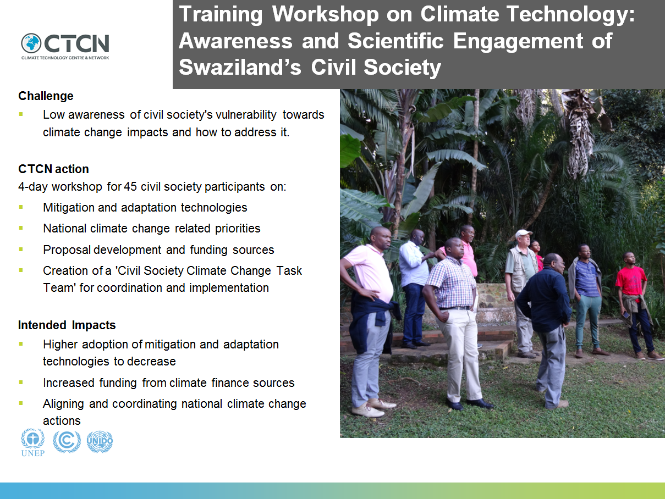

The following slides present the results from the group discussion 2 which was conducted in order to discuss and align civil societies and governments understanding and prioritisation of climate change vulnerabilities and actions to address those.

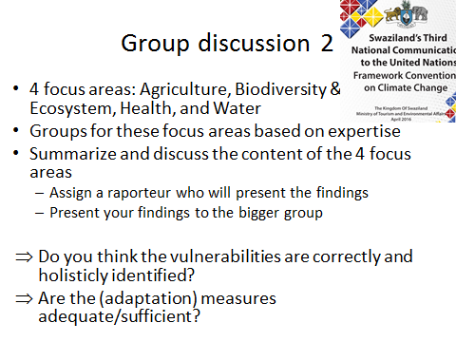

Health Group
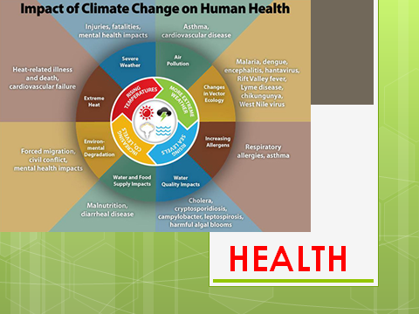
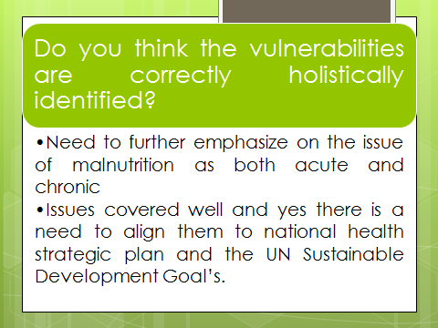
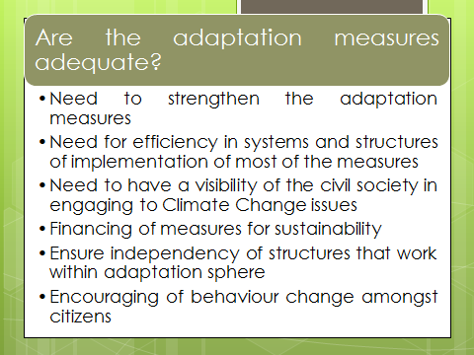

Water Group
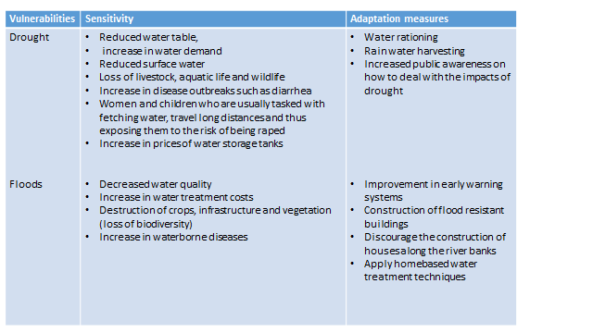
Post-workshop survey
The workshop was evaluated by all participants through a questionnaire which can be found in ANNEX VI.
Evaluation of specific workshop components and overall. Scale from 1 (lowest) to 5 (highest):
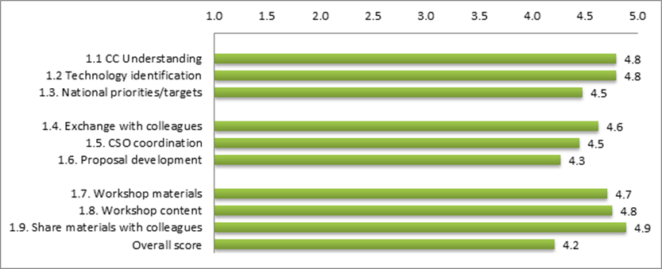
Scores: 1=disagree, 2=somewhat disagree, 3=neutral, 4=agree, 5=fully agree

All components scored on average a value between >4 and 5 which shows that the participants (fully) agree that the training within the respective component was valuable. It can hence be concluded that all predefined outcomes of the workshop have successfully been achieved.
The proposal development shows the relatively lowest score (4.3), which can be explained with a strong focus on Climate Change awareness raising and national priorities and targets which consumed the major share of the time.
The overall score of the workshop (4.2) is slightly below the score of all components.

Spread of scores assigned to components and overall:
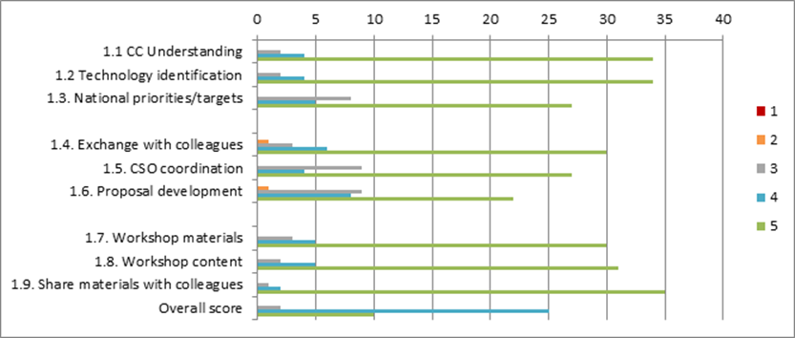
No component has received the lowest score “1” and only 2 components (1.4 and 1.6) have received each one score of “2”. For the proposal development component, the participants were broadly varying in terms of proposal experience. The major share of the participants did not have any experience with proposal writing to access climate finance which is likely reflected through the high number of “4” and “5” scores. These participants were also the target group of this component. On the other side, there were very experienced participants who are currently or have been working on (GCF) funding proposals.
We provided a platform and encouraged participant interaction on multiple exercises and settings to facilitate exchange. It is unfortunate that a participant was not satisfied with the exchange (ranking it at a score of “2”), however, the general score (4.6) and the high number of participants (30) scoring the component with “5” is positive.

5. Information for TA impact description
The information in the table below will be used to produce the CTCN TA Impact Description. The TA Impact description is a 2-page summary document for communication purposes. Please copy information from sections above and technical delivery reports as required.
Challenge: Approx. 500 characters with spaces | Climate change negatively impacts key economic sectors of Swaziland, including energy, water and industrial processes, agriculture, forestry, waste, and human health. NGOs' low awareness of climate change is a significant barrier to effectively addressing these impacts. Climate change education, training and public awareness of national climate change technology challenges and commitments articulated in key national documents are crucial building blocks in remedying these challenges.
CTCN Assistance: 2 to 4 bullet points. Approximately 450 characters with spaces | 4-day workshop for 44 civil society participants on:  - Mitigation and adaptation technologies  - National climate change related priorities  - Proposal development and funding sources  - Creation of a 'Civil Society Climate Change Task Team' for coordination and implementation
Anticipated impact: 2 to 4 bullet points to summarise anticipated impact. Approximately 250 characters with spaces. As a minimum, please include one of the following: i) Quantity of greenhouse gas emissions reduced, avoided or sequestered; or ii) Number of people with increased capacity to adapt to the impacts of climate variability and change. | - Trained 44 civil society participants from 37 different organizations, increased capacity to adapt to the impacts of climate variability.  - Improved climate change response via the creation of a climate change task force for all NGOs in Swaziland.
Linkages and contribution to NDC: 2 to 4 bullet points. Approximately 350 characters with spaces | The NDC recommends a stronger participation of civil society in implementing climate actions. This has been achieved by the technical assistance through:  - Training of 35 NGO/CSO representatives on climate change impacts and technologies to build capacities and initiate an exchange with the NDE  - Showcasing ecosystem based climate change adaptation such as land reforestation which are a strategic priority of the NDC  - Providing a platform for the discussion of national priorities and NDC action development and implementation by civil society
The narrative story: Approximately 1200 characters with spaces | Swaziland’s economic sectors are negatively affected by climate change impacts, like for example the 2015/16 drought which caused dramatic losses in agricultural production and livestock. Despite these experiences, Swaziland’s civil society has a relatively low awareness of climate change issues and actions to employ to reduce impact severity. Climate change is currently not adequately entrenched into NGO activities, and as a result opportunities to benefit from technological and scientific expertise are missed out on.  The training workshop aimed to build awareness and capacities on climate change science as well as mitigation and adaptation technologies. It was attended by 44 civil society participants. Participants were also introduced to various sources of climate funding and proposal development to enable access to the technologies. Furthermore, the workshop provided a platform for exchange between government officials and civil society to receive mutual feedback and discuss national priorities for policies and actions.  On the last day of the workshop, a Climate Task Force with 12 civil society members as well as focal points from both the Ministry of Tourism and Environmental Affairs and National Climate Change Committee, was established. The purpose of this Task Force is to coordinate efforts and support the implementation of climate change work amongst civil society organisations in Swaziland.
Contribution to SDGs: Always include contribution to SDG 13, and to the extent possible, please include contribution to 2 other SDGs, describing the contribution with a few sentence for each SDGs concerned. A complete list of SDGs and their targets is available here: https://sustainabledevelopment.un.org/partnership/register/ | - Goal 2 – End hunger, achieve food security and improved nutrition and promote sustainable agriculture  The TA helped to develop lines of action for promoting climate smart and sustainable agriculture within civil society organisations.  - Goal 5 - Achieve gender equality and empower all women and girls  The TA helped to develop lines of action for mainstreaming gender into climate change activities, recognizing that climate change affects men and women differently.  - Goal 13 – Take urgent action to combat climate change and its impacts  The TA strengthened resilience and adaptive capacity to climate-related hazards through improved education, awareness-raising and human and institutional capacity
Note: Please see example of a TA Impact Description at the following link:
https://www.ctc-n.org/sites/www.ctc-n.org/files/benin_a_ag_forestry.final_.pdf
Annex 1 (for internal use in donor and UN reporting)

A. Standardised CTCN performance indicators for donor and UN internal reporting
Please add quantitative values for indicators relevant to the particular TA in the list below. Non-relevant indicators should be left blank. Please only fill in the table for activities and outputs conducted or produced directly by the CTCN assistance.

CTCN standardised performance indicators | Quantitative value | Qualitative description  List the various elements corresponding to the quantitative value
- Overview
Number of active person-days (not full duration) of technical assistance provided to counterparts or stakeholders by international experts and consultants | 41 | Total time of human resources outlined in the project response plan UNEP DTU experts:  • Finance specialist & climate technology expert: 13.5 days  • Coordinator: 14.5 days
Number of active person-days (not full duration) of technical assistance provided to counterparts or stakeholders by national experts and consultants
Number of for external communication and outreach activities conducted to showcase the assistance (news release, newsletters, articles on website, etc.)
- Events (other than trainings) held as part of the assistance
Number of international and multi-country (at regional or sub-regional level) technology and knowledge sharing events
Number of participants in the events above
Number of national technology and knowledge sharing events
Number of participants in the events above
Number of public-private events related to technologies
Number of participants in the events above
- Training and capacity building activities conducted during the assistance
Number of training sessions and capacity strengthening activities | 3 | 3-day workshop
Number of people who received the training | 44
Number of men | 33
Number of women | 11
Total number of organisations trained | 37
Number of research organisations, laboratories and universities
Number of private companies
Number of cities and local government
Number of communities
Number of ministries | 2
Number of specialised governmental institutions | 7
Number of non-profit organisations | 28
Level of satisfaction of participants after the training (from training feedback form). Categories include: From very satisfied, satisfied, partly not satisfied, not satisfied at all | Very satisfied | Scoring an overall score of 4.2 on a scale from 1 (lowest) to 5 (highest)
Percentage of participants that increased their capacities thanks to the training (from training feedback form). Categories include: Significantly, very, moderately, to none. | Significantly | Scoring an average score of 4.65 on all capacity building related evaluation categories, on a scale from 1 (lowest) to 5 (highest)
Percentage of men | n/a
Percentage of women | n/a
- Tools, technical reports and information material supported by the assistance
Total number of tools, technical reports and information material supported by the assistance (excluding mission, progress and internal reports) | 13 | A total of 13 presentations (information material) were held throughout the workshop
Number of tools strengthened, revised or developed | n/a
Number of technical reports strengthened, revised or created | n/a
Number of other information materials strengthened, revised or created | 13
- Policies, laws and regulations supported by the assistance

Number of policies, strategies, and plans drafted addressing climate change adaptation
Number of policies, strategies, and plans drafted addressing climate change mitigation
Number of documents developed to inform other policies, strategies, and plans on climate change adaptation (sectoral strategies, national development plans, etc.) | 2 | Presentations on climate change adaptation technologies
Number of documents developed to inform other policies, strategies, and plans on climate change mitigation (sectoral strategies, national development plans, etc.) | 1 | Presentations on climate change mitigation technologies
Number of laws, agreements, or regulations drafted addressing climate change adaptation | 1 | MoU of the Civil Society Climate Change Task Team which will address both mitigation and adaptation related issues
Number of laws, agreements, or regulations drafted addressing climate change mitigation | 1
Number of documents developed to inform laws, agreements, or regulations on climate change adaptation
Number of documents developed to inform laws, agreements, or regulations on climate change mitigation
- Institutional strengthening supported by the assistance
Number of institutional arrangements in place to coordinate near and long-term national adaptation plans (NAPs) | 1 | The Civil Society Climate Change Task Team
Number of organisations with increased technical capacity to advance near and long term national adaptation plans (NAPs) which integrate EbA | 35 | Organisations that participated in the workshop
Number of organisations with increased awareness and knowledge among countries to better own and drive national adaptation planning processes | 35 | Organisations that participated in the workshop
- Partnerships and cooperation
Number of private companies directly engaged in the assistance (that partnered with the proponent, the beneficiaries or the CTCN to implement the assistance)
Number of South-South collaboration enabled during or through the assistance, when stakeholders from other countries were involved in the assistance
Number of North-South collaboration enabled during or through the assistance, when stakeholders from other countries were involved in the assistance
Number of Triangular collaboration enabled during or through the assistance, when stakeholders from other countries were involved in the assistance

B. Indicators of anticipated impacts that may occur after the TA is completed
CTCN standardised performance indicators | Quantitative value  Insert the request value and unit | Content  List the elements included in the number provided | Expected timeline  Indicate when the indicator and value are expected to be achieved | Responsible institution  Indicate the institution(s) that will play leading role in enabling the indicators and anticipated values to be achieved
16. Anticipated finance mobilised
- Anticipated amount of public/donor investment mobilised (in USD) from the beneficiary country for climate change activities as a result of the TA | No specific amount of money anticipated, however general capacity for proposal development increased.
- Anticipated amount of public/donor investment mobilized (in USD) from international and regional sources for climate change activities as a result of the TA | See a)
- Anticipated amount of private investment mobilised (in USD) from the beneficiary country for climate change activities as a result of the TA | See a)
- Anticipated amount of private investment mobilised (in USD) from international and regional sources for climate change activities as a result of the TA | See a)
17. Policies
- Anticipated number of policies, strategies, plans, addressing climate change mitigation officially proposed, adopted, or implemented as a result of the TA
Anticipated number of policies, strategies, plans, addressing climate change adaptation officially proposed, adopted, or implemented as a result of the TA.
- Anticipated number of laws, agreements, or regulations addressing climate change mitigation officially proposed, adopted, or implemented as a result of the TA.
Anticipated number of laws, agreements, or regulations addressing climate change adaptation officially proposed, adopted, or implemented as a result of the TA.
- Anticipated laws, policies, regulations, strategies and plans where climate change mitigation will be mainstreamed as a result of the TA
Anticipated laws, policies, regulations, strategies and plans where climate change adaptation will be mainstreamed as a result of the TA
18. Anticipated number of public-private partnerships created
19. Anticipated twinning arrangements created as a result of the TA
20. Anticipated number of technology projects prepared and implemented to support action on low emission and climate-resilient development
21. Anticipated number of strengthened National Systems of Innovation and technology innovation centres in recipient country
22. Anticipated Clean Energy Generation Capacity
Clean supported by the TA that has achieved financial closure
23. Anticipated and projected GHG reductions. Quantity of greenhouse gas (GHG) emissions, measured in metric tons of CO_{2-e}, anticipated to be reduced or sequestered as a result of projects supported by the TA
24. Anticipated clean energy generation capacity supported by the TA that has achieved financial closure
25. Anticipated and projected greenhouse gas emissions reduced or avoided through 2030, in metric tons of CO_{2-e}, from adopted laws, policies, regulations, or technologies related to clean energy/sustainable landscapes as a result of the TA
26. Anticipated number of people improving their livelihood as co-benefits as a result of the TA
27. Anticipated technology types effectively deployed in the country
28. Anticipated UNFCCC processes implemented as a result of the TA (NAMA, NAPA, NDC, etc.)
29. Anticipated Technology Needs Assessments (TNA) and technology Action Plans (TAP) as a result of the TA
30. Anticipated cooperative research, development and demonstration programmes within and between developed and developing country Parties facilitated as a result of the TA
31. Anticipated improved climate change observation systems and related information management in developing country Parties.

Annex 2 (for internal use – to be filled in by the CTCN)
CTCN evaluation
This section will be completed by the relevant CTCN Technology Manager.

- Evaluation of the timeliness of the TA implementation as measured against the timeline included in the response plan;
The implementation was delivered according to the timeline agreed upon at the stage of the response plan design.
- Evaluation of TA quality as defined in the response plan;
The technical assistance consisted in delivering a training in climate priorities and technologies and climate awareness of the NGOs based in Swaziland. The implementation team has shown flexibility, registering the demands of the NDE and request proponent. They also managed to participate in the creation of Climate Change task force in the country.
The results of the satisfaction survey reflect a high degree of satisfaction of the participants.
- Overall performance of the Implementers;
The implementers performed well and according to the requirements set in the response plan.
- Overall engagement of the NDE and Proponent;
The NDE and Proponent were engaged in every step of the way and have shown dedication for the successful implementation of the workshop.
- Lessons learned on the CTCN process and steps taken by the CTCN to improve.
The discussions that took the most time during the design of the response plan were the ones related to the budget allocation, i.e. managing expectations and restricting the activities to the quick response budget. Because the financial limitations of the budget were set at a very initial stage of the response plan design, we were able to engage the NDE and proponent to participate with in-kind contribution and have their support when explaining the DSA reduction.

Source: https://www.humanitarianresponse.info/system/files/documents/files/swaziland_rapid_assessment_summary_report_2016.pdf (accessed: 06/07/2017)

