Technical Assistance Closure Report - Bangladesh
Objective of the technical assistance (TA) Closure Report:
- To communicate publicly in one document a summary of progress made and lessons learned during the TA towards the anticipated impact (sections 1-4).
- To document qualitative and quantitative data collected during TA, for use in donor and UN reporting (Annex 1).

Steps for completing the TA closure report:
- The lead TA implementer submits the closure report at the end of the technical assistance as a final deliverable. The TA closure report will capture outputs, outcomes and impacts of all activities conducted under the TA. Please copy and summarise relevant material from previous TA outputs/deliverables and the Response Plan, as relevant.
- A CTCN Manager will review and revise the closure report before final approval by the CTCN Deputy Director.

Important note on public and internal use of the closure report:
Once approved by the CTCN Deputy Director, the TA closure report will be a public document available on the CTCN website www.ctc-n.org. Selected content will be used for targeted communication activities. Annex 2 is for internal use only and will not be publicly available.

Closure Report for CTCN Technical Assistance

- Basic information
Title of response plan | Monitoring & Assessment of Climate Change Impact on Geomorphology in the Coastal Areas of Bangladesh
Technical assistance reference number | 2016000088
Country / countries | Bangladesh
NDE organisation | Department of Environment, Ministry of Environment, Forest and Climate Change, Government of Bangladesh.
NDE focal point | Dr. A.K.M. Rafique Ahammed
NDE contact information | dg@doe.gov.bd; rafique.ahammed@yahoo.com
Proponent focal point and organisation | Md Saiful Hossain, Bangladesh Water Development Board, se.pffc@bwdb.gov.bd
Designer of the response plan | Kim Wium Olesen, DHI, kwo@dhigroup.com
Implementer(s) of technical assistance | DHI
Beneficiaries | - Bangladesh Water Development Board (BWDB)  - Institute for Water Modelling (IWM)
Sector(s) addressed | Early Warning and Environmental Assessment  Agriculture  Water  Coastal Zones
Technologies supported | Remote sensing & GIS
Implementation start date | 01/10/2019
Implementation end date | 31/12/2020 (project closed prematurely due to COVID-19)
Total budget for implementation | Budget: 140,351 USD (Used 73,040 USD)
Description of delivered outputs and products as well as the activities undertaken to achieve them. In doing so, review the log frame of the original response plan and refer to it as appropriate | An on-site visit was conducted in October 2019. During the 3-day visit, a series of bilateral meetings with key stakeholders in BWDB and IWM was held, in order to assess and evaluate existing capacities in geospatial data handling and satellite image analysis. The bilateral meetings were accompanied by a questionnaire survey distributed amongst a broader group of stakeholders. Despite multiple requests to fill in the survey, the project team never received any responses. Thus, the capacity assessment was based on the minutes of the bilateral meetings.  Subsequent to the capacity assessment, it was concluded that the capacity building components should make best use of existing tools used within BWDB as well as freely available cloud-based resources. A methodological review of satellite-based methods to assess river bank and coastal erosion, as well as soil salinity was consequently documented in a training manual. Test data was prepared for a larger river based and coastal area of interest, where the documented approach was applied. Furthermore, in preparation of the intended on-site capacity building workshop, a series cloud-based training modules was prepared.
Methodologies applied to produce outputs and products | Capacity assessment: On-site visit, Semi structured interviews with BWDB and IWM  Capacity building modules: Intended on site capacity building workshop was cancelled along with the project due to COVID-19.
Reference to knowledge resources | N/A
Deviations | Due to low response rate in the questionnaire survey, the capacity assessment summary report was replaced by a more detailed minutes account of the two bilateral meetings conducted during the on-site visit. Key conclusions on existing capacity is included herein.  Remaining activities and deliverables have been delayed and impacted by COVID-19 and ultimately all outstanding activities on the project have been cancelled on request of the NDE and proponent, as it was deemed impossible to facilitate remaining on-site activities within the project implementation period. As the project was stopped, outstanding deliverables were submitted in draft format.
Anticipated follow-up activities and next steps | As the TA was brought to a premature end due to the COVID-19 pandemic, the intention is to follow up with the proponent about needs and requirements for a continuation of activities through a future TA request.

- Lessons learned
 | Lessons learned | Recommendations
Lessons learned from the CTCN TA process | Training activities require continuous engagement, activation, and participation in preparatory planning processes. | Ask that beneficiaries actively participate in logistics planning (meeting venues, transportation, hotels, etc.) and coordination of field visits. This increases ownership and participation amongst beneficiaries.
Lessons learned related to climate technology transfer | N/A

3. Illustration of the TA and photos
For communication purposes, please provide 2-4 Power Point slides, including illustrations or charts, describing barriers, opportunities, methodology, activities, outputs and achieved results. The illustrations must be copied into the TA Closure report but must also be delivered as power point files. Also, please provide at least five high-resolution pictures in jpg format, capturing technical assistance. The pictures should illustrate how the TA has impacted the lives of the beneficiaries in particular and the communities in general.

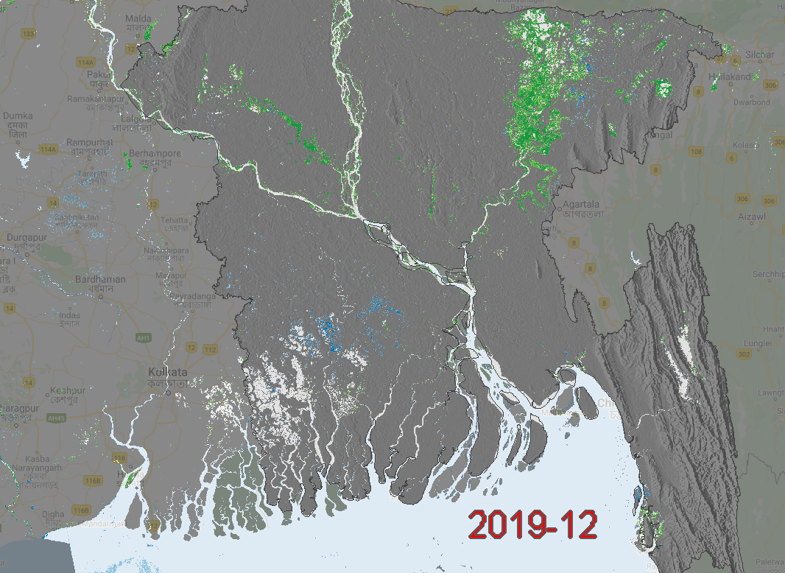
Figure 1 Short term linear regression for the 2 months prior to 2019-12-01. Green is negative change (getting drier) and blue is positive (getting wetter).
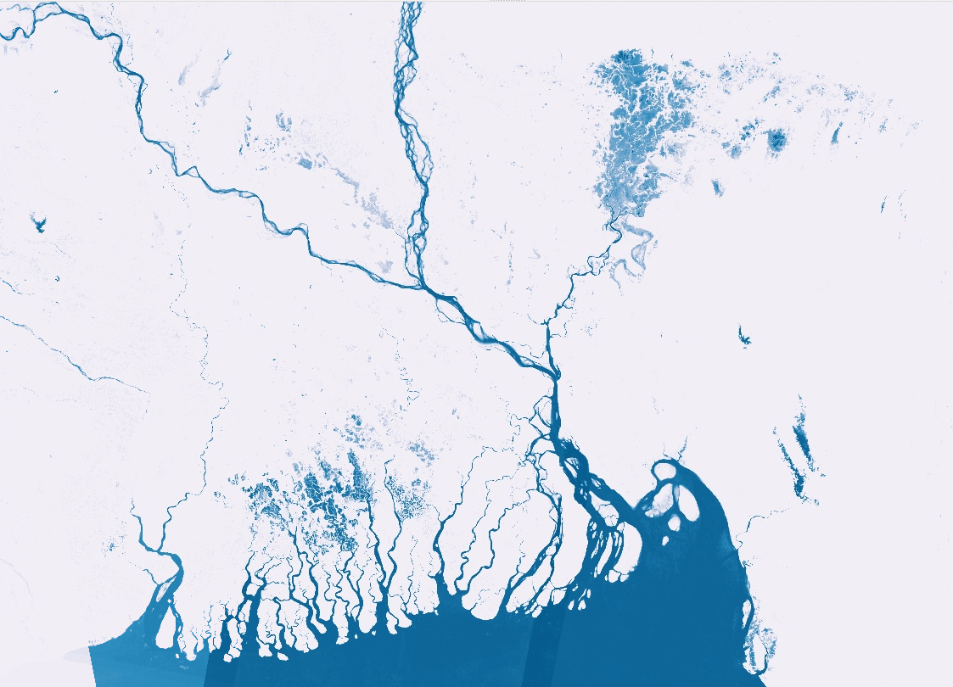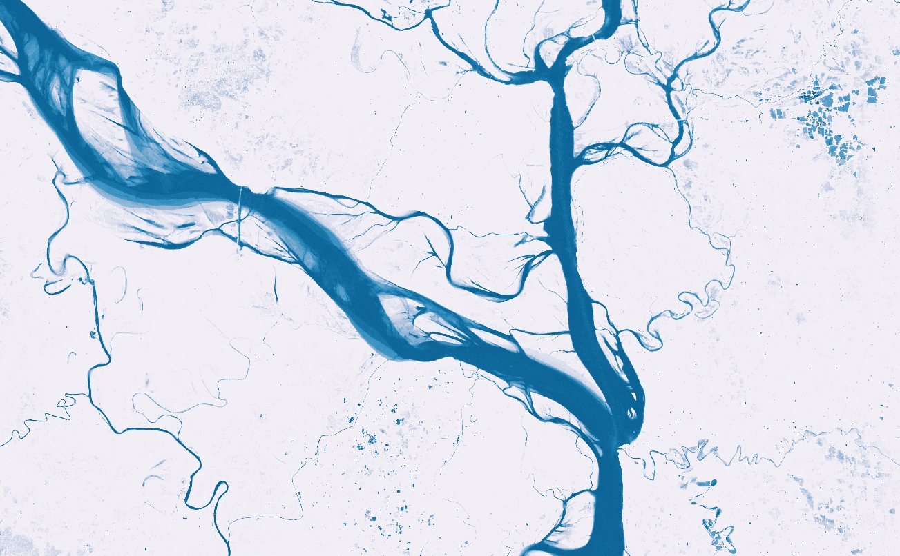
Figure 2 Using monthly time series of Sentinel 1 and Sentinel 2 data, a surface water frequency layer (SWF) can be created by adding the number of water observations and dividing this by the total number of observations for each pixel. This illustrates SWF for Bangladesh (left) and the south of Dhaka (right).
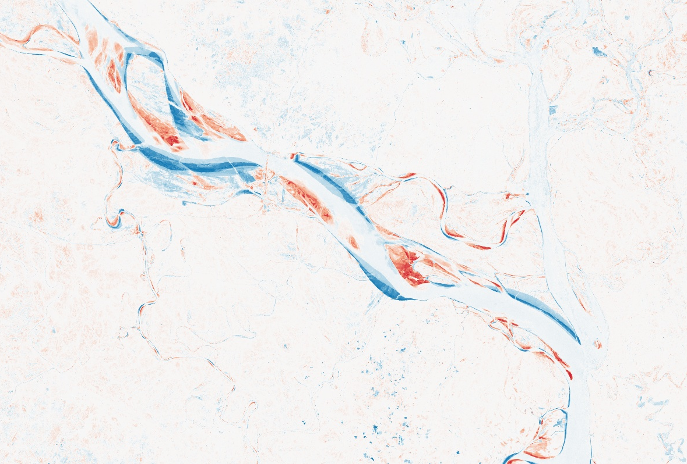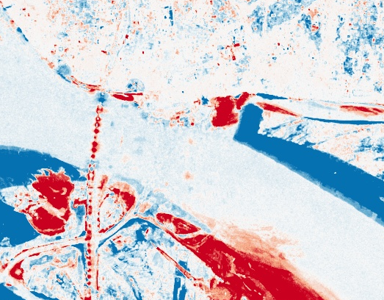
Figure 3 Visualisation of riverbank erosion using linear regression of land-water probability. Red is accretion (negative), Blue is erosion (positive). The left image shows an area south of Dhaka and the right image shows the construction of the Padma bridge.
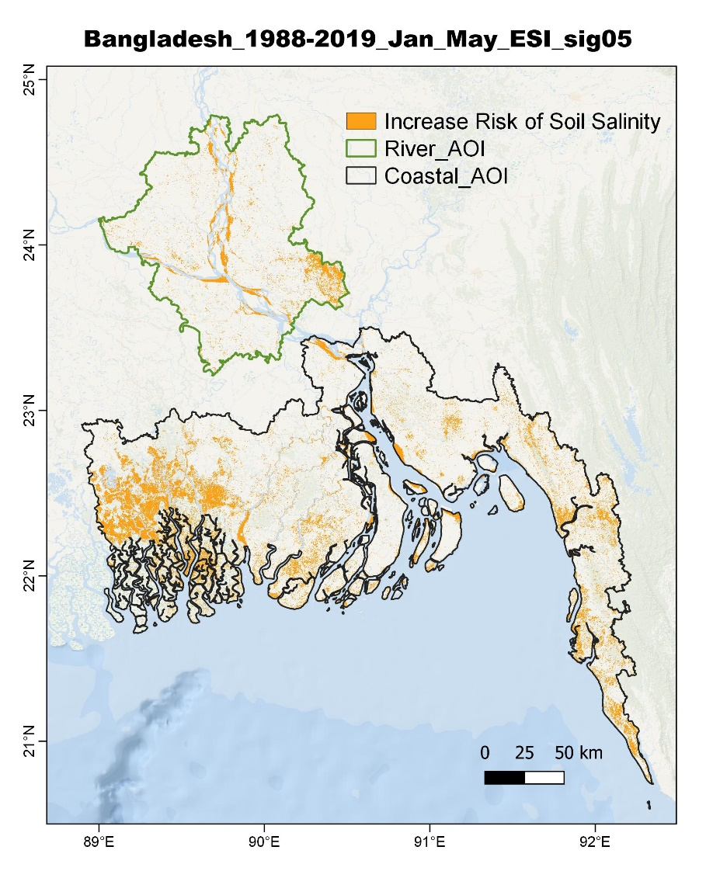
Figure 4 Result from proposed soil salinity mapping approach, in the two areas of interest used for the test data processing. The data is a result of a Landsat-based trend analysis during the dry season (January to May) from 1988 to 2019, which is used to generate an Enhanced Salinity Index (ESI). Linear regression is used to identify areas where increased soil salinity has been observed.

4. Impact Statement
The information in the table below will be used to communicate results and anticipated impacts of this technical assistance publicly. Please copy information from impact statement developed in the M&E Plan and update as relevant.

Challenge | The vulnerability of the coastal population in Bangladesh is on the rise due to climate change. Climate variability and change will accentuate the intrinsic risks: (i) cyclones and storm surges (ii) erosion of river banks, islands and chars, (iii) sea level rise, (iv) salinity intrusion, (v) floods, (vi) droughts, (vii) drainage congestions and (viii) coastal erosion.  A thorough understanding of the impacts of sea level rise and its interaction with the natural morphological processes (e.g. erosion, accretion, subsidence) as well as the anthropogenic changes is required to build resilience and maintain sustainable livelihood for the population in the coastal zone of Bangladesh in order to support the rehabilitation and strengthening of polders and other coastal protection technologies
CTCN Assistance | - Assessment of endogenous capacity in geospatial processing applications and satellite image analysis  - Demonstration, methodological guidelines and technical training in using Earth Observation technologies for impact analysis and early warning of inland bank erosion.  - Demonstration, methodological guidelines and technical training in using Earth Observation technologies for monitoring the dynamics of coastlines and assessing the impact of climate change and storm surges on the coastal zone  - An outline for a Bank Erosion Contingency Planning  The technical training and item 4 were not provided due to premature end of project.
Anticipated impact | The project was intended to establish methodological guidelines and step-by-step workflows for EO assessments of coastal zone dynamics in Bangladesh, and train staff for the development of an early warning capacity for bank erosion attacks, which is one of the most significant risks from climate change. Furthermore, the EO based workflows will allow stakeholders to increase the general understanding of the morphological processes in the coastal zone of Bangladesh and the impacts of climate change on these processes. The project will contribute significantly to develop the technical ability of key stakeholders within relevant government agencies in Bangladesh, including the BWDB, to conduct timely critical analysis of erosion/accretion processes and assessments of climate change impacts using advanced remote sensing methods. The project was expected to contribute to the avoidance of economic losses and loss of livelihood and lives as a result of climate change enhanced risks. The beneficiaries are the population of the delta which today is 42 million and expected to increase to 61 million by 2050.
Co-benefits: Achieved or anticipated co-benefits from the TA | N/A
Gender aspects of the TA | It was the intention to appoint a gender specialist to review capacity assessment reports and training material and make recommendations for strengthened gender focus. In addition, participant selection for the final workshop aimed to ensure a gender representation of at least 70/30 split.  These gender aspects were not addressed due to the premature end of the project.
Anticipated contribution to NDC | N/A
The narrative story | The coastal zone of Bangladesh is prone to multiple threats. Sixty two percent of the coastal land has an elevation less than 3 meters and eighty-three percent is within 5 meters above mean sea level. The flow of the rivers entering the Ganges, Brahmaputra Meghna (GBM) delta is the third largest in the world and river floods occur regularly, often leading to flooding of one third of the country. With a sediment supply of 1 billion tons per year, the GBM delta has the largest sediment supply in the world. This leads to accretion of the land area in the coastal zone, mainly in the Meghna Estuary (approx. 5-10 km²/year in net accretion), and to highly unstable river branches and estuaries.  The large amounts of sediments deposited form loose land masses that subside under natural conditions of over burden pressure. It has been noticed that the subsidence rate may be higher in places due to anthropogenic factors like drainage and ground water extraction. On top of that there are tectonic movements in the deep subsoil, caused by horizontal plate movements. This subsidence rate strongly exacerbates the effect of climate change induced sea level rise.  The coastal zone hosts nearly 42 million people which is projected to grow to 61 million by 2050. The high pace of population growth continues to push millions of people to live in the most low-lying and vulnerable coastal areas.  The Government of Bangladesh’s commitment to develop a safe and inhabitable coastal zone can be dated back to the mid 1960s. Compelled by the call for intensive rice cultivation during the green revolution, the government constructed a series of embankments and polders in order to provide tidal flood protection for coastal population; thereby enabling intensification of crop production and agricultural growth. The system was originally designed to protect the low-lying land against inundation from the high spring tides in monsoon-months. When the polders were initially constructed attention was not given to storm surges that could over-top the polder and thus result in submergence of the protected area and destruction of crops as well as homesteads often killing hundreds of people. The risk has increased due to subsidence of land and embankments, sea level rise and potentially due to a more erratic climate.  A thorough understanding of the impacts of sea level rise and its interaction with the natural morphological processes (e.g. erosion, accretion, subsidence) as well as the anthropogenic changes is required to build resilience and maintain sustainable livelihood for the population in the coastal zone of Bangladesh in order to support the rehabilitation and strengthening of polders and other coastal protection technologies.
Contribution to SDGs  A complete list of SDGs and their targets is available here: https://sustainabledevelopment.un.org/partnership/register/ | SDG 2: Sustainable polders are essential for food security for the almost 42 million people living in the coastal zone of Bangladesh.  - The project aimed to deliver capacity building elements that would allow beneficiaries to make informed decisions management strategies to sustainably manage and maintain polder systems.  SDG 6: Sea level rise will aggravate problems related to salinity intrusion which threatens access to fresh water.  - The capacity building elements aimed to deliver capacity to map salinity intrusion within polder systems and monitor the effects hereof.  SDG 13: Recent cyclones (e.g. Sidr in 2007 and Aila in 2009) have brought substantial damage to the embankments and threaten the integrity of the coastal polders. Sea level rise will further aggravate this threat and increased saline intrusion will affect negatively agriculture in the area.  - The project aimed to deliver capacity to make use of satellite data to develop early warning systems for bank erosion which could add to the resilience of the entire coastal zone.

