Technical Assistance Closure Report Template

Objective of the technical assistance (TA) Closure Report:
- To communicate publicly in one document a summary of progress made and lessons learned during the TA towards the anticipated impact (sections 1-4).
- To document qualitative and quantitative data collected during TA, for use in donor and UN reporting (Annex 1).

Steps for completing the TA Closure report:
- The lead TA implementer submits the closure report at the end of the technical assistance as a final deliverable. The TA closure report will capture outputs, outcomes and impacts of all activities conducted under the TA. Please copy and summarise relevant material from previous TA outputs/deliverables and the Response Plan, as relevant.
- A CTCN Manager will review and revise the closure report before final approval by the CTCN Deputy Director.

Important note on public and internal use of the closure report:
Once approved by the CTCN Deputy Director, the TA closure report will be a public document available on the CTCN website www.ctc-n.org. Selected content will be used for targeted communication activities. Annex 2 is for internal use only and will not be publicly available.

Closure Report for CTCN Technical Assistance

- Basic information
Title of response plan | Technical guidance and support to conduct a technology needs assessment and a technology action plan for Cameroon
Technical assistance reference number | 7000004228
Country / countries | Cameroon
NDE focal point and organisation | M. Timothe Kagonbe  Ministry of Environment, Protection of Nature and Sustainable Development (MINEPDED)
Proponent focal point and organisation | Kevin Enongene  FOKABS INC
Designer of the response plan
Implementer(s) of technical assistance | FOKABS INC  Natural Eco Capita  ARPEDAC
Beneficiaries | Government of Cameroon:  -Ministry of Environment, Protection of Nature and Sustainable Development (MINEPDED)  -Ministry of Energy and Water (MINEE)  -Ministry of Agriculture and Rural Development (MINADER)  -Ministry of Livestock, Fisheries and Animal Husbandry (MINEPIA)
Sector(s) addressed | Agriculture and Energy
Technologies supported | -Solar photovoltaic  -Energy efficient lighting (light emitting diode and compact fluorescent lamp)  -Small hydroelectricity  -Climate monitoring and early warning system  -Borehole  -Biochar
Implementation period and total duration in months | September 2020 to April 2022 (18 months)
Total budget for implementation | 177,000 USD
Description of delivered outputs and products as well as the activities undertaken to achieve them. In doing so, review the log frame of the original response plan and refer to it as appropriate | The main objective of the CTCN’s technical assistance was to provide support to Cameroon to enable the development of a comprehensive Technology Needs Assessment (TNA) and Technology Action Plan (TAP). The activities implemented and products delivered in the course of the technical assistance is provided below.  Activity 1: Institutionalization of a coordination mechanism for the implementation of the TNA. This entailed the elaboration of planning and communication documents, conduction of stakeholder analysis for the TNA process – this was achieved through desk study and interviews with relevant national actors. This activity also comprised of supporting the establishment of a national TNA Committee, and the elaboration and endorsement of a TNA Committee work plan for monitoring and oversight of the TNA process. Deliverables elaborated as part of Activity 1 includes:  • Communication and planning documents of the technical assistance;  • Stakeholder mapping report; and  • Government circular establishing the national TNA Committee, constitution and workplan of the committee  Activity 2: Prioritization of technologies and relevant action for increased access to finance. This activity comprised of a number of tasks. Firstly, sectors and sub-sectors for the TNA were selected through literature review and a consultative workshop involving relevant national actors. Secondly, technologies for fulfilling Cameroon’s TNA were assessed, prioritized and validated. This was achieved through desk review and a stakeholder workshop that employed multi-criteria analysis. Thirdly, technology action plans for climate change adaptation and mitigation were elaborated for the six top-prioritized technologies. Finally, a national consultation workshop to foster national ownership and technology deployment was organized at the end of the technical assistance. Deliverables realized under Activity 2 includes:  • Report on TNA-TAP on alignment with CP and national plans  • Report on analysis of sectoral priorities expressed in national documents.  • Report describing the methodology utilized for sector and subsector selection and prioritization.  • Technology fact sheets  • Set of criteria for MCA exercise  • Workshops reports including a full list of participants, photo documentations.  • Final reports including a mitigation TNA report and an adaptation TNA report.  • Database in most suitable format  • Technology action plans (for six technologies  • Workshop report  • Green Climate Fund concept note for a selected TAP
Methodologies applied to produce outputs and products | -Desk review  -Interview with key stakeholders  -Stakeholder workshops  -Multi-criteria analysis
Deviations | The organization of five TNA Committee meetings was envisaged as part of the TA. However, these were not held partly due to the change in the CTCN focal point which retarded the TA process and inadequate financial resources allocated for the organization of the meeting sessions.
Anticipated follow-up activities and next steps | Following the successful completion of the technical assistance, there is need for the elaborated technology action plan for climate change adaptation and mitigation to be operationalized.  1. The technology action plans should be used by the country to engage with technical and financial partners operating within the country’s jurisdiction in order for the funds required for the implementation of the action plan to be mobilized.  2. As part of the technical assistance, a Green Climate Fund (GCF) concept note has been elaborated. As a GCF accredited entity (AE) has not yet been identified for the concept note, it is important for CTCN and the Government of Cameroon to take steps towards identifying, and engaging with an AE to take up this concept note for submission to the GCF and/or transforming it into a funding proposal. The identification of an AE could be achieved ideally within the first quarter of 2023.

- Lessons learned
 | Lessons learned | Recommendations
Lessons learned from the CTCN TA process | -The provision of capacity building/training to implementers of a TA is an important element for successful delivery of a TA. At the inception phase of the TA, the implementers received a training on the TNA-TAP process, including the steps and methodologies to be employed. This enabled the implementers to effectively conduct the TNA process and elaborate the TAP.  -The existence of a database of technologies established by CTCN was helpful in the TA process. This facilitated access to information on the technologies considered in the TNA process. | -While not all TA will necessitate the provision of training to implementers, where relevant and possible, CTCN should provide training to the implementers at the inception phase of the TA mission. This could also take the form of an experience / knowledge sharing event, during which CTCN or a CTCN partner will share with the implementers their experience or approach to a similar TA assignment.
Lessons learned related to climate technology transfer | -The integration of national circumstances into the TNA-TAP process is important for the identification of relevant technologies that can support a nation’s transition towards a climate resilient and low carbon development pathway. The TNA-TAP process was closely aligned to the country’s revised Nationally Determined Contributions (NDCs) and consequently, the identified and prioritised technologies are those that will meaningfully contribute to the attainment of adaptation and mitigation targets and objectives included in the NDCs.  -While a TAP for the deployment of climate adaptation and mitigation technologies has been developed from the TA, its operationalization depends on the availability of adequate financial resources. | -TA should continuously be aligned to countries’ priorities as expressed in national climate strategic documents, in order to ensure country ownership and sustainability.  -Mobilize international (e.g. GCF) and domestic sources of funding for the implementation of the TAP.

3. Illustration of the TA and photos
For communication purposes, please provide 2-4 Power Point slides, including illustrations or charts, describing barriers, opportunities, methodology, activities, outputs and achieved results. The illustrations must be copied into the TA Closure report but must also be delivered as power point files. Also, please provide at least five high-resolution pictures in jpg format, capturing technical assistance. The pictures should illustrate how the TA has impacted the lives of the beneficiaries in particular and the communities in general.

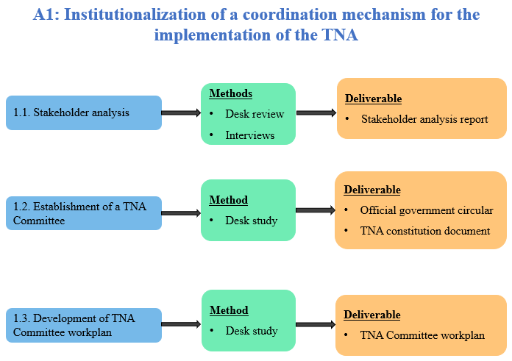

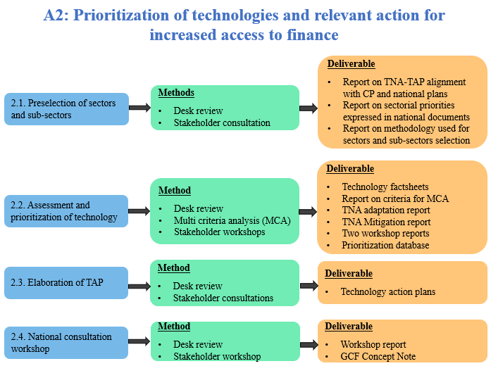

4. Impact Statement
The information in the table below will be used to communicate results and anticipated impacts of this technical assistance publicly. Please copy information from impact statement developed in the M&E Plan and update as relevant.

Challenge | This TA was implemented during the Covid-19 era. The government of Cameroon had imposed shutdowns as a measure to limit the spread of the virus and this culminated in the stalling of activities in the country. Hence, the Covid-19 crisis posed a challenge to the timely completion of this TA as government officials and other stakeholders involved in the TNA process were grappling with the execution or completion of other tasks which were delayed by the Covid crisis.  In the course of the TA, the CTCN focal point was changed. This caused some delays in the process since the transition from the former to the current focal point was not very smooth.
CTCN assistance | - Development of a comprehensive Technology Needs Assessment (TNA) for climate change adaptation and mitigation in Cameroon  - Development of a Technology Action Plan (TAP) of climate change mitigation and adaptation needs identified in Cameroon’s prioritized sectors (energy and agriculture)
Anticipated impact | - Prioritized technologies required to meet the country’s adaptation and mitigation targets identified. The adoption and deployment of these technologies will generate mitigation and adaptation benefits  - Mobilization of financial resources for the implementation of the TAP – GCF concept note elaborated from the TA.
Co-benefits: Achieved or anticipated co-benefits from the TA | Anticipated co-benefits to be generated from the TA includes the following:  - The adoption and deployment of the prioritized technologies will create employment opportunities in the country  - Sustainable Development Goal (SDG) No. 13, “Take urgent action to combat climate change”. The implementation of the TAP will translate in the deployment of the prioritized technologies which constitutes an important step towards addressing climate change.
Gender aspects of the TA | Gender considerations were integrated into the TA in the following ways:; representation of women and men at events (workshops and trainings) and the participation of associations that advance gender and women empowerment; the presence of a renown national and international gender expert within the implementers’ team to ensure gender mainstreaming in the entire TNA-TAP process; the inclusion of approaches for gender inclusiveness as part of the capacity building training on the TNA processes; inclusion of gender dimensions in the identification of sectorial mitigation and adaptation technologies; adoption of a gender-related criterion among the list of criteria employed in the prioritization of technologies; mainstreaming of gender in the TAP and inclusion of a gender assessment of technology for the action plan per sector.
Anticipated contribution to NDC | - The Technological Action Plan (TAP) will enable Cameroon to better assess the implementation cost of its NDCs  - The TNA will enhance the capacity of institutions to allocate appropriate resources and prepare new activities to address climate change issues
The narrative story | Cameroon has as vision to become an emerging economy in 2035 (Vision 2035) and this is translated into the Growth and Employment Strategic Paper (GESP). The country’s NDC is anchored in the Vision 2035 and the vision has as sub-objectives the following: reduction of poverty; attainment of the middle-income country stage; attainment of the New Industrialized State stag; and the consolidation of the democratic process and national unity while respecting the country’s diversity. From an economic stance, the attainment of the Vision 2035 would require sustained growth, a revolution in the agricultural sector based on increased productivity and doubling the contribution of the secondary sector in the GDP structure. However, the impacts of climate change are already visible in Cameroon and this could counteract the country’s effort to address poverty and to advance a diversified and competitive economy, and consequently, undermine the objective of the 2035 Vision. Hence, Cameroon envisaged the development of a TNA as an important action to tackle the developmental challenges in the country posed by climate change.
Contribution to SDGs | SDG 13 – Take urgent action to combat climate change and its impacts: the TA prioritized technologies and developed a TAP whose implementation will achieve climate change adaptation and mitigation benefits  Goal 1 – End poverty in all its forms: Cameroon has as vision to become an emerging economy in 2035 and this vision entails the eradication of poverty. The impacts of climate change are already visible in Cameroon and this undermines the attainment of the Vision 2035 objective. The development of the TNA in a way supports the tackling of development challenges in the country posed by climate change and consequently, will culminate in the fight against poverty in the country.  Goal 5 – Achieve gender equality and empower all women and girls: the TA comprises of strong approach to gender. Throughout the entire TA process, gender issues were taken into consideration, ensuring that men are women took part in the TNA process.

Annex 1 Technical assistance data collection

Please add quantitative and qualitative values for the indicators selected in the M&E plan and monitored throughout the technical assistance in the tables below. Indicators which have been monitored in addition to the proposed indicators below may be added at the end of table A. Non-relevant indicators should be left blank.

- Output and outcome indicators

Indicator  Please note indicators below highlighted as anticipated | Quantitative value  Value and unit | Qualitative description  List the various elements corresponding to the quantitative value as well as timelines and responsible institutions
Number of communication and outreach activities conducted by proponents and implementing partners to showcase CTCN support | Total number of communication and outreach activities | Events (titles):  News release:  Newsletter:  Articles:  Presentations on the results of the TA:  Social media postings:  Etc.
Number of participants in the events above
- Number of men
- Number of women
Number of training sessions and capacity strengthening activities | 1 | Capacity building training on the TNA processes
Number of people who received the training
- Number of men | 10
- Number of women | 8
Total number of institutions trained | 7
- Number of research organisations, laboratories and universities |  | List the name of organisations trained here
- Number of private companies | 1 | S2 Services
- Number of cities and local government |  | List the name of organisations trained here
- Number of communities |  | List the name of organisations trained here
- Number of ministries | 4 | -Ministry of Environment, Protection of Nature and Sustainable Development (MINEPDED)  -Ministry of Livestock, Fisheries and Animal Industries (MINEPIA)  -Ministry of Mines, Industry and Technological Development (MINMIDT)  -Ministry of Scientific Research and Innovation (MINRESI)
- Number of specialised governmental institutions |  | List the name of organisations trained here
- Number of non-profit organisations | 2 | Cameroon Ecology  ADEID
Percentage of participants reporting satisfaction with CTCN training (from CTCN training feedback form) |  | Satisfied= 3+ on 5-pt scale  Indicate breakdown of categories here based on the results of the CTCN training feedback forms
Percentage of participants reporting increased knowledge, capacity and/or understanding as a result of CTCN training (from CTCN training feedback form) |  | Increased knowledge, capacity and/or understanding= 3+ on 5-pt scale  Indicate breakdown of categories here based on the results of the CTCN training feedback forms
- Number of men
- Number of women
Total number of deliverables produced during the assistance (excluding mission, progress and internal reports) | 16
- Number of tools and technical documents strengthened, revised or developed | 3 | TNA report for adaptation  TNA report for mitigation  GCF Concept note
- Number of other information materials strengthened, revised or created (For example training and workshop reports, Power Points, exercise docs etc.) | 13 | -Stakeholder mapping report  -Government circular establishing the national TNA committee  -TNA Committee constitution document  -TNA capacity building workshop report  -TNA Committee workplan  -Report on TNA-TAP on alignment with CP and national plans  -Report on analysis of sectorial priorities expressed in national documents  -Report on the methodology utilized for the selection of sectors and sub-sectors  -Technology factsheets  - Report detailing the set of criteria for MCA exercise  -Technology prioritization workshop report  -Technology prioritization database  -National consultation workshop report (TAP validation workshop)
Total number of policies, strategies, plans, laws, agreements or regulations supported by the assistance | List total number here
- Adaptation related |  | List the type and name of documents supported
- Mitigation related |  | List the type and name of documents supported
- Both adaptation- and mitigation related | 1 | Nationally Determined Contributions
Anticipated number of policies, strategies, plans, laws, agreements or regulations proposed, adopted or implemented as a result of the TA | 1
- Adaptation related |  | List the type of documents anticipated to be proposed, adopted or implemented
- Mitigation related |  | List the type of documents anticipated to be proposed, adopted or implemented
- Both adaptation- and mitigation related | 1 | -Technology Action Plan document
Anticipated number of technologies transferred or deployed as a result of CTCN support | 6 | -Biochar  -Climate Monitoring and early warning systems  -Solar Photovoltaic  -Borehole and silage  -Mini hydroelectricity  -Efficient light bulbs (LED and CFL)
Number of South-South collaborations enabled during or through CTCN TA support |  | List the names of the organisations (excluding the CTCN or TA implementers)
Number of climate technology RD&D related outreach activities
Number of participants in climate technology RD&D related workshops and events |  | Disaggregate by country
- Number of men
- Number of women
Anticipated number of cooperative research, development, and demonstration programmes facilitated as a result of CTCN TA
Number of countries with strengthened National System of Innovation as a result of CTCN support
Number of organisations engaged through CTCN support |  | Disaggregate by type of organisations
Total number of events organized by proponents and implementing partners (excluding capacity building workshops) | 2 | -Technology prioritization workshop  -National ownership workshop (TAP validation workshop)
Number of participants in the events
Number of men | 34
Number of women | 15
Insert any additional indicators here

- Core impact indicators

Please fill in the tables for anticipated impacts of the CTCN assistance. Every technical assistance should contribute to at least one of the indicators below. For guidance on how to report on core indicators see the ‘M&E Guidance Document for TA Implementers’.

Core indicator 1 | Anticipated metric tons of CO₂ equivalent (CO₂e) emissions reduced or avoided as a result of CTCN TA
 | Anticipated metric tons of CO₂ , equivalent emissions reduced or avoided as a result of the TA on annual basis | Anticipated metric tons of CO₂ , equivalent emissions reduced or avoided as a result of the TA in total
Quantitative value
Unit
Methodology

Explain the method or process of verifying the indicator and how data was gathered
GHG assessment boundary

Identify expected post-TA activities, associated effects and assess boundary for quantification of GHG emission reductions
Baseline candidates

Define alternative technologies or practises used in baseline calculation to represent possible alternatives to the project activities
Baseline emissions

Describe baseline scenario and emissions calculated
Assumptions
Describe assumptions made during calculation and quantification of GHG reductions

Core indicator 2 | Anticipated increased economic, health, well-being, infrastructure and built environment, and ecosystems resilience to climate change impacts as a result of technical assistance  Please provide a qualitative description of the anticipated impacts on the categories below
Infrastructure and built environment
Anticipated increased infrastructure resilience (avoided/mitigated climate induced damages and strengthened physical assets)
Ecosystems and biodiversity
Anticipated increased ecosystem resilience (areas with increased resistance to climate-induced disturbances and with improved recovery rates)
Economic  Anticipated increased economic resilience (e.g. less reliance on vulnerable economic sectors or diversification of livelihood) | The deployment of the renewable energy technologies (solar photovoltaic and mini hydroelectricity) would enable the electrification of rural areas not currently connected to the grid. The electrification will enable rural communities to employ the energy for productive uses, diversifying their livelihood sources and reducing their reliance on highly climate sensitive sectors including agriculture
Health and wellbeing  Anticipated increased health and wellbeing of target group (e.g. improved basic health, water and food security) | The roll out and implementation of early warning systems will make available relevant information for the health sector. This information will be used to make predictions and issue warnings about climate-related diseases, enabling citizens to be well prepared in advance and to protect themselves from a disease outbreak. And other climate-induced health issues.

Core indicator 3 | Anticipated number of direct and indirect beneficiaries as a result of the TA
 | Direct beneficiaries | Indirect beneficiaries | Means of verification
Adaptation related | 20% of the nation’s population (5,626,923) | 100% of the population of the country (28,112,888) | From the GCF concept note elaborated from the TA
Mitigation related |  |  | Describe calculation methods and assumptions made
Both adaptation-and mitigation related |  |  | Describe calculation methods and assumptions made

Core indicator 4 | Amount of funding/investment leveraged (USD) as a result of TA (disaggregated by public, private, national, and international sources, as well as between anticipated/confirmed funding)
 | Quantitative value  Value and currency | Qualitative description  List the various elements corresponding to the quantitative value as well as expected timelines and responsible institutions | Methods  Describe method use for quantification of funds leveraged including assumptions made and attention paid to causality, attribution and avoidance of double-counting
Total anticipated amount of funding/investment mobilised or leveraged (USD) as a result of the TA
Anticipated amount of public funding mobilised from national sources (USD)
Anticipated amount of public funding mobilised from international and regional sources as a result of the TA | USD 27,950,000 | Elaborated GCF concept note. Institutions responsible includes the Ministry of Environment and an Accredited Entity (to be determined) | Elaborated GCF concept note from the TA
Anticipated amount of private investment mobilised (in USD) from national sources as a result of the TA
Anticipated amount of private investment mobilised (in USD) from international and regional sources as a result of the TA

Annex 2 (for internal use – to be filled in by the CTCN)
CTCN evaluation
This section will be completed by the relevant CTCN Technology Manager.

- Evaluation of the timeliness of the TA implementation as measured against the timeline included in the response plan;
- Evaluation of TA quality as defined in the response plan;
- Overall performance of the Implementers;
- Overall engagement of the NDE and Proponent;
- Lessons learned on the CTCN process and steps taken by the CTCN to improve.

